Solar Energy

Mansha Ghai (First Author)
University of Wisconsin,
Madison, 53706, USA
Email: ghaimansha@gmail.com

Rajesh Agnihotri
Department of Applied Science
UIET, Kurukshetra University
Kurukshetra-136119, India
Email: ragnihotri2015@kuk.ac.in

Nivedita Agnihotri*
Department of Chemistry
Maharishi Markandeshwar (Deemed to be University)
Mullana-133207, Ambala, India
Email: niveditachem@mmumullana.org

Raman Kumar*
Department of Biosciences and Technology
Maharishi Markandeshwar (Deemed to be University)
Mullana-133207, Ambala, India
Email: ramankumar4@gmail.com

ABSTRACT

Since the Industrial Revolution, harmful compounds have polluted Earth’s air, contributing to global warming. Evidence dating decades back proves that man-made developments serve as the primary source of fossil fuels that warm Earth’s atmosphere. An exponentially growing population correlates with a staggering high demand for energy. Modern-day science is concerned with finding and implementing sustainable methods such as renewable energy. One of the prominent sources is solar energy. There are several methods of producing electricity from the sun’s rays, such as photovoltaic and photoelectrochemical cells and concentrating solar power. The efficiency of each technology varies. These approaches coupled with the optimal conditions serve several purposes for daily life. Some solar energy applications highlighted in this chapter include agriculture, water processes, heating and cooling and advanced technologies.
.
Keywords—Solar energy; Greenhouse gas effect; Photovoltaic (PV) cell; photoelectrochemical cell (PEC); Solar photovoltaic tree (SPVT)

INTRODUCTION

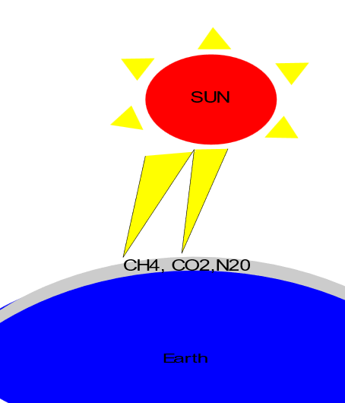
For decades, there has been an upward trend in greenhouse gas emissions from the ignition and application of fossil fuels. The collection of the detrimental gasses emitted from fossil fuels, trapping the sun’s heat and consequently warming the Earth has coined the term greenhouse effect. This effect is depicted in Figure 1, with the most notable gasses that contribute to a warming atmosphere. June, 2023 was considered the warmest June recorded with the global surface temperature 1.05 degrees Celsius above the 20th-century average of 15.5 degrees Celsius (1). One of the driving factors for this higher temperature is an increase in population. More people means using more energy, thus releasing greenhouse gasses into the air. The UN suggests that by 2030 the world’s population could reach 8.5 billion and is projected to reach a staggering 9.7 billion by 2050 (2). Additionally, the world’s energy consumption is 10 terawatts per year and is projected to be 30 TV by 2050. The energy usage from an immense population could cause irreparable ramifications to the environment. A single person’s contribution to climate change is deemed their carbon footprint. In the modern USA, the average carbon footprint is an astounding 16 tons (3).

Figure 1. Greenhouse gas Effect on Earth’s Atmosphere.
Many factors account for the greenhouse gas effect, such as the use of fossil fuels in the form of coal, petroleum, and natural gases. Fuels are the leading source of energy in the 21st centuryand also the primary cause of CO₂ being released into the atmosphere. According to the Environmental Protection Agency, Carbon Dioxide accounts for 65% of Global Greenhouse emissions by gas (4).
It is important to note that during the COVID-19 pandemic, emissions decreased significantly. A survey on CO₂ emissions are highlighted in Table 1 (5). These emissions are in tons per capita; however, countries with high populations such as India and China still lead the world in total carbon dioxide released due to them being hubs of industrial development.
Additionally, several sectors in the economy such as electricity, industry and agriculture, forestry and other land use are attributable to high emissions (5). Thus, utilizing renewable energy not only in the domestic sphere, but in several applications is imperative for the safety of this planet.
Table 1. CO₂ emissions around the World (tons per capita)
S.No. | Country | Emissions
1 | United States | 14.86
2 | Spain | 4.92
3 | China | 8.05
4 | Canada | 14.3
5 | India | 1.93
6 | Australia | 15.09
7 | South Africa | 7.34
8 | France | 4.74
9 | United Kingdom | 5.15
10 | Sweden | 3.42

This greenhouse effect has led researchers to investigate alternative methods of energy production, such as solar,wind, hydropower, etc. Research shows that implementing renewable energy methods serves as a factor to reduce carbon and ecological footprint significantly (6). Solar energy proves to be the most promising renewable source for several reasons. Primarily, solar energy is one of the most abundant sources since the sun is a 1.989 × 10³⁰ kg entity, emitting about 3.8 kW of energy, of which 1.8 kW reaches Earth (7). This high amount of energy can produce electricity to power the entire planet.
Harnessing solar power is not a new concept, humans have been utilizing the suns rays since the early times. For example, utilizing the sun’s rays to ignite a fire. However, the first solar device was not invented until late 19th century by Charles Fritts. Now, solar energy is used for cars, cooking, heating, and every other human application. One of the greatest challenges in implementing solar power at a larger scale are substantially high costs of equipment. However, the cost of production is quite low between 20 and 30 cents/kWh (8).
This chapter provides an overview of solar energy in the modern world. The different methods of production, such as the photovoltaic cell and photoelectrochemical cells, are discussed. Additionally, the vast applications and impact in the modern world are highlighted in this chapter.

SOURCES OF SOLAR ENERGY

The primary source of solar energy is radiation waves from the sun. Radiation is emitted from the sun at 3.8 × 10¹¹ Watt, of which one-third is reflected off Earth’s atmosphere (9). The absorbed radiation is the backbone for several natural processes, such as photosynthesis. Factors such as seasonality, tilt, latitude, and longitude all contribute to how much sunlight reaches the Earth.Trends in solar energy around rhe World are highlighted in Figure 2 (10). In summary, the trends are quite simple to understand hotter areas receive more solar energy. The equator receives the highest amount of solar energy,whereas the north and south pole receive the least. Dry deserts absorb more solar energy than temperate climates.

METHODS OF SOLAR ENERGY PRODUCTION

The sun is one of the most abundant resources on the planet, emitting millions of photons every day. This solar energy is converted into electrical or heat energy, resulting in several applications across the globe. The three fundamentally researched methods are photovoltaic (PV), photoelectrochemical (PEC) and concentrating solar power (CSP) technologies. Solar panels are an essential aspect of each design. Every method has distinct advantages and disadvantages in its ability to harvest energy from the sun in cells to generate

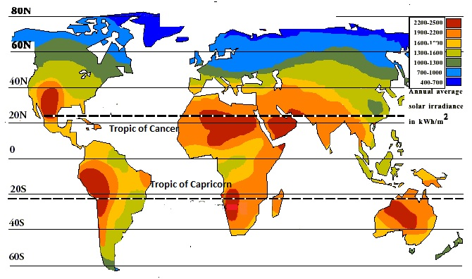
Figure 2. Solar Energy Absorbed Across Earth’s Map
electricity. The nonrenewable nature of these approaches makes them heavily advantageous for the environment. All solar energy has zero-carbon emissions; however, the greatest challenge is fighting costs. The methods have been described below:

Photovoltaic Cell

Dating back to April 1954, the first photovoltaic (PV) cell was discovered paving the way for solar energy production. This method works by absorbing photon energy in the internal nanomaterials of the cell. This energy is transferred to electrons in the outer (valence) shell of the atoms. There are two p and n-type semiconductors with different properties, thus when they are brought into contact with each other, an electrical potential is generated. Only the electrons that get sufficient energy to move from the valence band (VB) to the conduction band (CB) can go on to create a current. The electrons that leave the VB create a “hole” in the VB, allowing valence electrons to flood out as a current of electricity (11). The working of PV cell is shown in Figure 3.

The nanomaterials tend to be silicon-based. Some examples include: Monocrystalline silicon, polycrystalline silicon, microcrystalline silicon, copper indium Di selenide and cadmium telluride are commonly used as semiconductors in photovoltaic systems. These materials come with great advantages to the PV technology, including: potential for increased efficiency, overcoming limitations in existing technology and cost-effectiveness (12). The efficiency of varying nanomaterials is highlighted in table 1. Material from the National Renewable Energy Laboratory regarding PV efficiencies was compiled into a table format in table 2 (13).

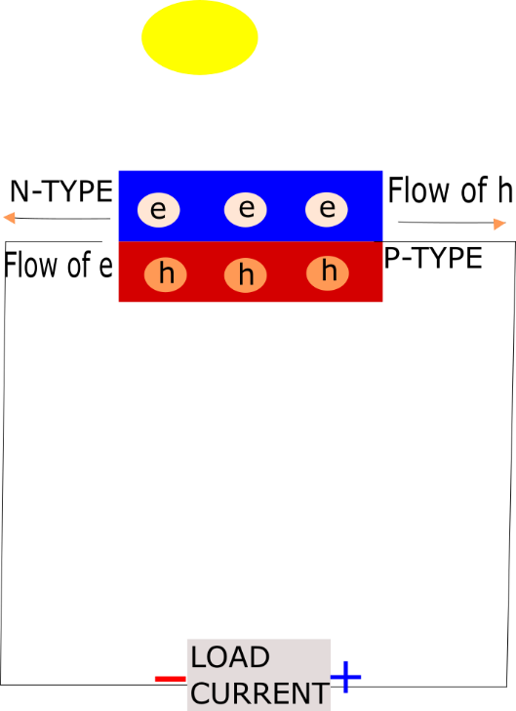
Figure 3. How the Photovoltaic System of Generating Solar Energy Works.

Table 2. PV Cell Efficiencies
Type | Nanomaterial | Efficiency
Crystalline Si Cells | Single crystal (concentrator) | 27.6%
Crystalline Si Cells | Single crystal (non-concentrator) | 26.1%
Crystalline Si Cells | Multicrystalline | 23.3%
Crystalline Si Cells | Silicon Heterostructure (HIT) | 26.8%
Crystalline Si Cells | Thin-Film Crystal | 21.2%
Single-Junction GaAs | Single Crystal | 27.8%
Single-Junction GaAs | Concentrator | 30.3%
Single-Junction GaAs | Thin-Film Crystal | 29.1
Multijunction Cells | Two-Junction (concentrator) | 35.5%
Multijunction Cells | Two-Junction (non-concentrator) | 32.9%
Multijunction Cells | Three-Junction (concentrator) | 44.4%
Multijunction Cells | Three-Junction (non-concentrator) | 39.5
Multijunction Cells | Four-Junction or more (concentrator) | 47.6%
Multijunction Cells | Four-Junction or more (non-concentrator) | 39.2%
Thin-Film Technologies | Copper Indium Gallium Selenide (CIGS) (Concentrator) | 23.3%
Thin-Film Technologies | Copper Indium Gallium Selenide (CIGS) | 23.6%
Thin-Film Technologies | Cadmium Telluride (CdTe) | 22.3%
Thin-Film Technologies | Amorphous Si:H (stabilized) | 14.0%
Emerging PV | Dye-Sensitized | 13%
Emerging PV | Perovskite | 26.1%
Emerging PV | Perovskite/Si Tandem | 33.7%
Emerging PV | Organic | 19.2%
Emerging PV | Organic Tandem | 14.2%
Emerging PV | Inorganic Cells (CZTSSe) | 14.9%
Emerging PV | Quantum Dot | 18.1%
Emerging PV | Perovskite/CIGS tandem | 24.2%

A continuing challenge in this method of production is finding a method to achieve the highest possible efficiency for the lowest possible cost. As mentioned above, one of the most efficient PV devices is the multi-junction cell; however, this material is both complex and expensive. Furthermore, hybrid versions of PV and thermal cells is a keen topic of further research. Several studies have been conducted regarding the efficiency. One example is the PV-T hybrid system developed by Aste et al which yielded a total efficiency of 68.4%. The thermal efficiency was 54.6% and PV efficiency was 13.8% (14). An additional challenge is the duration of sunlight. Since the sun is the primary source of energy, the use of these cells is conditional on its presence, meaning that there will be fluctuations in how much energy is harnessed by season.

Photoelectrochemical Cell
The second common method of solar energy production is through a photoelectrochemical (PEC) cell by water splitting processes. PEC converts solar energy into chemical energy and releases hydrogen in the process of electrolysis in a single photocell. Each cell has one or two semiconductor photoelectrodes, auxiliary metal, and reference photoelectrodes in an electrolyte. Each tool in this machinery plays a critical role in the production of electricity from solar energy. The electrolyte is an electrically conductive medium assisting in transporting holes from the photoelectrode to the counter electrode. Characteristics of an efficient electrolyte (15) include:
- Rapid charge transfer for increased redox reaction
- Lowest optical absorption
- Optical and thermal stability in solar spectrum and temperature zone for electrochemical reactions
- Voltage window dependent on electrolyte
- Concentration of oxidizing and reducing solvent material to support electrodes
- Negligible ohmic losses
- Electrode semiconductors yield no reaction with the electrolyte
- Little environmental toxicity

Similar to the PV cell, holes are generated in the PEC at the working electrode by photon absorption with greater energy than the bandgap (difference between valence and conduction band) of the photoanode semiconductor. An n or p-type semiconductor is utilized as a working electrode with a Platinum counter electrode. In an n-type semiconductor, electrons gather and transfer to the counter electrode by an external circuit. The electrons in this process reduce 2H⁺ into H₂ at the counter electrode. In a p-type semiconductor, photogenerated electrons reduce H⁺ to H₂ in the working electrode; but, in the counter electrode water is oxidized into O₂ and H⁺ (16). Early on, PEC cell efficiencies were quite low, due to the bandgap between oxide photoelectrodes and mismatch with solar spectrum (17). However, implementation of non oxide semiconductors with a smaller band gap significantly increased the efficiency of PECs. The working components of a photoelectrochemical system can be Shown as in Figure 4.
Other factors that impact PEC efficiency include morphology, crystallinity, dimensionality, surface area, porosity and temperature (18).

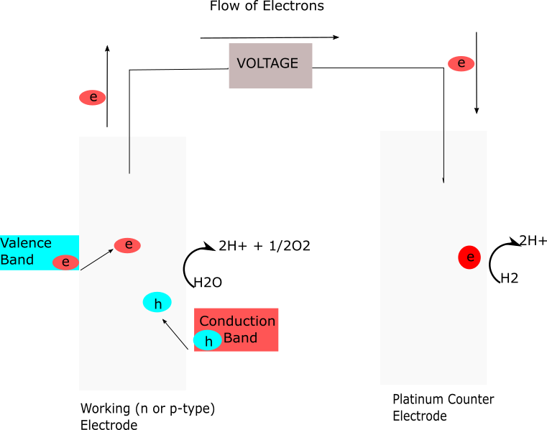
Figure 4. Working components in the Photoelectrochemical System.

Concentrating Solar Power
Concentrated Solar Power (CSP) harnesses direct normal irradiance (DNI) from the sun to create energy. This system consists of a solar field and a power block. In the solar field is a concentrator and a receiver. The concentrator is a set of reflecting mirrors that focuses solar radiation onto a small area on the receiver. The receiver converts the radiation into heat. This heat goes on to the power block, which consists of a heat engine and electric generator. The heat engine operates in a closed cycle and is used to convert thermal energy into mechanical work. These cycles are impacted by temperature, pressure, and density (19). Finally, the electric generator is able to create electricity from this mechanical energy. CSP are also equipped with storage methods, which take leftover heat in the form of thermal storage to be used during later times, such as the night (20).

APPLICATIONS OF SOLAR ENERGY

Solar energy has extensive applications in all fields of science and wellbeing. The power harnessed from solar energy is great, thus leading to the ability to charge phones, homes, offices, and several other commercial areas. It is one of the leading discoveries in the field of renewable energy and has great potential to create a new normal in the future of electric generation.

Agriculture
In areas of high solar radiation and less irrigation, crops are subject to insufficient nutrients necessary for growth. On the other hand, several humid areas also create environmental conditions perfect for insects, animals, and mold to thrive. These factors in the agricultural industry can all be combated with solar energy techniques.
- Crop and Grain Drying
Crop drying consists of enclosing the desired crops into a shed-like structure to cause solar rays to dry crops. The fundamental components of a solar dryer are an enclosure or shed, screened drying trays or racks, and a solar collector (21). Basically, heat is trapped in the collector and moved to the objective drying crop by a fan or natural wind. However, solar dryers tend to be expensive with not immense returns in comparison to competitors of natural gas (22).
- Irrigation Systems
Solar irrigation systems are photovoltaic water pumping systems that are used to release water. They consist of a microprocessor that is stimulated upon solar energy input. The microprocessor controls an electrical motor that causes differential irrigation of water, such as a drip or sprinkle based on the soil moisture level (23). Relative to alternative options such as a diesel generator and electric grid connection, PV water pumping yielded the best results for remote rural areas significantly due to its operational cycle having the lowest cost (24).
The two fundamental types of solar photovoltaic pumping systems are alternating current (AC) and direct current (DC). Each of these systems comes with immense economic and environmental benefits. There is no cost for fuel, maintaining the system, no noise pollution, and no carbon emission. In comparison the AC pumping system’s use of inverters and induction motors serves as more suitable than the DC pumping system. Consequently, AC motors have low capital costs and stronger induction motors, making it more reliable than the DC motors (25).

Water Processes
` Since the days of Louis Pasteur, sanitation of liquids has been an important factor to reduce the spread of pathogens. In many areas, one of the most contaminated parts of nature is water. Thousands of chemicals are dumped each year into lakes, rivers, and oceans. Futuristically, the freshwater supply is going to dramatically decrease over the next few decades causing a water shortage on the planet. In addition to climate change, solar energy is a solution to the contemporary issue of limited water supply. Solar power can be used for detoxification, desalination and disinfection.

- Solar Detoxification
Solar Detoxification is the process in which a strong oxidation reaction yields oxidizers and free radical holes which attack oxidizable contaminants in water. These oxidizers cause the progressive breakdown of molecules, generating CO₂, H₂0 and dilute mineral acids. Water detoxification of mineral solar photocatalytic treatment of paper mill effluent waste using oxidizers such as H₂O₂ dramatically increased the rate of degradation (26).
- Solar Desalination
Solar Desalination is using solar energy to eliminate mineral components in water. In order to combat the future water shortage, researchers are looking to desalinate ocean water to provide freshwater for the general population. Currently, soil desalination is used to serve fresh water for many waters stressed regions; however, further research in this aspect can lead to expansion of this solar technology’s use. The two fundamental methods to perform desalination are direct and indirect solar desalination.
The prominent approach to direct solar desalination is solar still. This technology consists of an airtight basin in which saline water rests, surrounded by an insulated apparatus. Solar energy stimulates water evaporation, and the water condenses on the inner surface of a sloping cover. This condensed water is distilled out as freshwater (27).
Indirect solar desalination consists of solar-powered humidification and dehumidification (HDH), multi-stage flash (MSF), and multi-effect distillation (MED). In comparison, MSF is the more widely utilized thermal technology, contributing to around 21% of worldwide desalination (28).
Solar humidification and dehumidification uses solar collectors and the concept of moisture carrying capacity of air to separate saline water and pure water. There are four types of HDH configurations: closed air, open water cycle; closed air, closed water cycle; open air, open water cycle and open air, closed water cycle (29).
Multi-stage flash (MSF) is an energy intensive process that expends thermal energy generated from solar power to the seawater feed in multiple stages, creating two streams: freshwater and concentrate or brine stream (30). The need for desalination technologies is immensely needed in areas of high solar radiation and little freshwater. However, research in Middle Eastern countries explains how the high energy cost significantly outweighs the benefits of MSF (31). Additional disadvantages to MSF include the high top brine temperature (TBT), increasing fouling and scaling risk, and decreased efficiency requirement makes it relatively less favorable to be combined with solar energy (27).
Multi-effect distillation (MED) is a process that utilizes low-pressure effects (compartments) that provide thermal energy for subsequent vaporization and distillation in the next effect. MED is considered a better alternative than the conventional MSF technology. In comparison to MSF The low top brine temperature (TBT) helps avoid scaling and corrosion problems and increases thermodynamic efficiency. However, optimal performance of this technology depends on several parameters. Changing the number of effects yielded the most impact on the overall performance, with smaller factors such as temperature difference between effects, temperature, feed water temperature and boiler pressure (32). Solar Desalination techniques are discussed further in depth in following chapters.
- Solar Disinfection
Solar Disinfection (SODIS) generates powerful oxidizers and destroys pathogenic water organisms. Basically, scientists fill transparent containers with water and leave it out in the sun for around 6 hours or for 48 hours on cloudy days (33). This consequently eradicates pathogens. SODIS is the cheapest form of water hygiene as its materials are quite miniscule. Some challenges to SODIS include unpredictable weather conditions and limited volume in bottles (34).

Heating and Cooling
Solar energy can also be converted into electricity used to heat and cool areas, much like a furnace or air conditioner does. One of the most important parts of the food industry is to keep food cool and prevent spoilage. Thus, solar energy can be used to make refrigerators and supply electricity to residential or industrial buildings. Some modern technologies include sorption refrigerators and roof-mounted PV systems.

- Sorption Refrigeration
Sorption refrigerators tailor the concepts of adsorption and absorption. Adsorption is a reversible process that indicates the interaction between a substance in the gas and solid phase. Adsorption refrigerators build on the Vander Waal interactions between the vapor molecules of the refrigerant and solid adsorbent to create an adsorbent bed. This adsorbent bed subsequently undergoes pre-heating, desorption, pre-cooling and adsorption to produce a cooling effect (35). Studies regarding which adsorbent concluded that zeolite/water is preferable for air conditioning and activated carbon/ammonia is optimal for ice making, refrigeration and food preservation (36).

Absorption is a reversible process that involves substances changing from one phase to another. The methodology essentially involves a refrigerant gas dissolving into water creating a new liquid that is pumped into a high-pressure environment. This high-pressure liquid goes through a generator where the gas boils off and goes on to cool through reverse Rankine reactions (37). Absorption is the most utilized version of solar refrigeration due to its minimal electric input, greater efficiency, and smaller size (38). Both types of refrigerators can be utilized in several applications such as air conditioning, food refrigeration, ice-making and congelation, and combined systems (39).

- Roof-Mounted PV-System

Several buildings have implemented a roof-mounted PV-System. These are common in areas where no grid is set for electricity supply, meaning alternative resources need to be utilized for everyday functionality. One of the primary examples of the industrial application of solar power is building integrated photovoltaic (BIPVs). These are solar powered systems that can replace conventional roofing practices to supply enough electricity to power the buildings (40). BIPVs are a promising technology in comparison to conventional electricity resources because they have a greater conversion efficiency of thermal energy into electricity, meaning they use less primary energy to produce electricity (41). Additionally, in a European study, BIPV tile price varied between 225 and 500 €/m², which is approximately 200 €/m² than conventional methods (42). BIPV construction is hindered by the lack of awareness and thus a higher price.

Solar Technologies
Utilizing solar energy on a broader scale requires researchers and engineers to think creatively, leading to several unique inventions. To tackle the issue of trying to achieve the most productivity for the fewest cost, technologies are being developed to provide energy for entire cities and urban areas. Of these creations, some of the most notable are solar trees.
- Solar Photovoltaic Tree
The solar photovoltaic tree (SPVT) is a technology that has a trunk and tree-like figure; however, the “leaves” are a PV solar power system. Several components ensure the functionality of SPVT including (43):
  - Nanomaterials in solar modules - Different nanomaterials impact the efficiency of a PV cell, thus impacting the SPVT system. However, silicon is the most prominent form used.
  - Electrical cable: Cables connect the module in a “branch” like way, to provide structure to the SPVT. This can help in extreme weather conditions, such as strong winds, heat waves, etc.
  - LEDs: In times of darkness, the LEDs can serve as a streetlight. In addition, their vibrant colors provide an appealing look to the general public (44).
  - Batteries: Batteries such as lead acid batteries. lithium-ion batteries, lithium-ion polymer batteries, nickel-cadmium batteries etc. (45) are where the energy from the sun is stored for future use.
  - Inverter: converts direct current to alternating current in the PV system and this conversion efficiency is the most important component of the inverter.
  - Stems structure of steel or iron: This part resembles a tree's “tree trunk”, providing great support to the entire system. Additionally, this is the only part that is physically on the ground, meaning that SPVT does not occupy much land. There is no standard structure, engineers try to make this component appealing to the public eye.
Several parameters contribute to the efficiency of an SPVT system in comparison to traditional solar panels and other systems (43). These are highlighted in Figure 5.
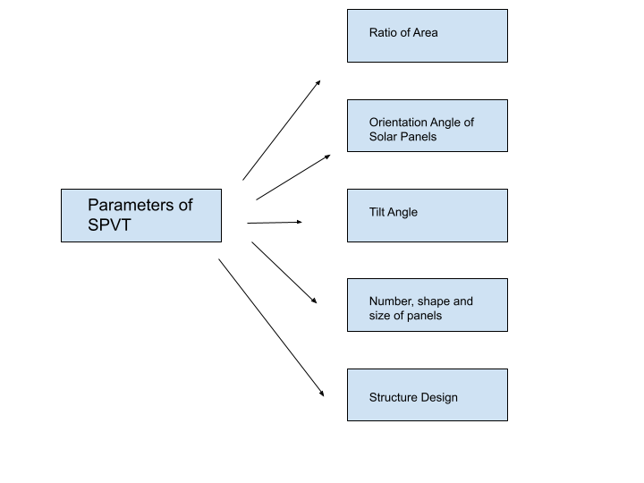
Figure 5. Parameters in the Design of a Solar Photovoltaic Tree System.
Area proportion: This is the ratio of leaves actual area to land footprint area of steel structure. It measures the objective of minimizing ground area.
Angle of Orientation of “leaves”: Similar to tree leaves, the solar panels are variably oriented in order to optimize the amount of energy produced at the given angle of incidence. Consequently, this orientation allows efficient functionality regardless of geography, season, or time of day (46).
Angle of tilt of panels: Tilt of the solar panels does not have the same effect as the angle of orientation. One study showed inconclusive results in that a small tilt angle ± 20 prompted more efficient harnessing of solar energy; however, a higher tilt angle ± 40° worsened results (46)
The direct relationship between irradiance, I on the solar panel and orientation is given by equation 1. Where 𝛽 is the tilt angle, ℽ is the surface azimuth angle, θ-i is the incidence angle and θ-z is the zenith angle (47).
I(β,ℽ)= ,I-_{b.}(,cos(,θ-i.) -/ cos(,θ-z.).) + ,I-_{d.}[(,1 + cos(β) - / 2.] Equation 1

Number, shape, and size of panels: Implementation of two layers in the leaves of the SPVT can harness any escaped sunlight into the second layer, yielding even greater efficiency. Additionally, the shape and size of panels vary; however, the goal is optimization of solar capture.
Structure Design: Height and strength of the structure provide structural integrity as well as the ability to capture more sunlight. Additionally, the design needs to accommodate for shadowing effects which could prevent sunlight from reaching the leaves.
In comparison to traditional PV systems, the solar tree provides greater energy generation because it captures sunlight for higher angles of incidence. For example, in terrestrial areas such as Kuala Lumpur, Bhopal, and Barcelona, energy generation was 17.79&, 41.06%, and 20.97%, respectively better in those regions (48).
There are several configurations, some implemented, others in the design stage, for the SPVT which are highlighted in (49) and briefly discussed below.
- Multi-branch single stem (MBSS) consists of a long column, resembling the tree stem, which branches off at varying heights. Each branch has a solar panel attached to it, with a different angle of orientation, providing for greater energy capture at a different height. However, this is a less efficient design due to the different lengths of tree branches (50)
- Fibonacci Pattern Solar Tree (FPST) consists of a single trunk with branches in which the lengths and angles of the branches follow the Fibonacci pattern. This is one of the most popular configurations of SPVT because it captures sunlight with high efficiency. FPST generated approximately 54% more efficiency than the traditional solar panels, making it a prime candidate for SPVT design (51). This shape consistently provides power; however, its complex design and high costs serve as disadvantages to large scale installations.
- Spiraling Phyllotaxy Solar Tree (SPST) is a technology that creates a large umbrella that captures sunlight very efficiently. However, this technology consumes an immense amount of space and is costly to manufacture (52).
- Hemispherical Dome Solar Tree (HDST) forms a hemispherical dome that is directed by the trajectory of the Sun. In this design, there are 15 panels with 5 facing south, 5 southwest, and 5 southeast. This method provides the best efficiency because it traverses along with the sun, meaning that there is greater solar energy capture.
- Three-Dimensional Geometric Design: consists of a leg on the top of which is a solar panel at a set angle and forms a 3D body. One of the primary advantages to this technology is the lower cost and space required (53).
- Ross Lovegrove Solar Tree (RLST)
- This design of SPVT resembles a bush of grass. There are 10 solar panel headers on top of this cluster that is supported by a body. Teach consists of PV on a circular surface, 1 LED, protection by a diffuser screen, and the poles protected by headers that support the body heads.
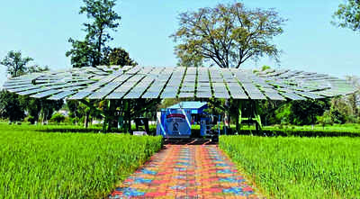
Figure 6. The World’s Largest Solar Photovoltaic Tree located in Ludhiana, India (54).
Additional versions of the SPVT are simple solar tree, smart palm tree, and three PV designs (TVPD). The simple solar tree is the one depicted in figure 6, which is the largest SPVT in the world with 35 solar PV panels, generating around 330 W per panel, summing up to approximately 11,500 W of electricity produced (50). Beyond their design, solar trees can be applied to everyday life. Solar trees are used to charge cell phones, computers, small appliances, and streetlights attached or built into the structure (55).
- Solar Cooker
One of the earliest solar technologies was the solar cooker. It utilizes solar thermal technology to convert heat energy from the sun and apply it to cooking. These cookers can easily be constructed using household items such as cardboard, mud, brick, and aluminum foil (56). One of the greatest drawbacks of any type of solar cooker is the duration it takes to cook is substantially greater than traditional cooking methods.
There are two kinds of solar cookers: box and concentrating solar cookers. Concentrator solar cookers have a crockpot at the focal point a reflective dish facing the sun. Box solar cookers use simple reflecting mirrors to direct the sun’s rays into an insulated container in which a black crockpot will absorb the energy and heat the substance inside of it. In a study conducted in Uttarakhand, India, box solar cookers were implemented for a low cost of $55.01 and yielded 53.21 W cooking power and 52.10% thermal efficiency (57).Factors that impact the effectiveness of the solar cooker is how strong the rays can be diverted towards the crockpot. Several methods have been implemented to increase this efficiency by modifying mirrors and reflectors. The greatest advantage of these solar cookers is their cost-effectiveness.Table 3 shows the effectiveness of different types of solar cookers.
Table 3. Box Solar Cooker
Solar Cooker | Cost ($) | Efficiency | Heat Transfer | Cooking Power | Source
Hot Box Cooker with an added modification of infused cylindrical copper tubes | $39.11 | 53.81% | 56.78 W/m^{2 o}C | 68.81 W | (58)
Modification includes a tracking-type bottom parabolic reflector which helps the efficiency of the cooker | $136 | 12.5% | - | - | (59)
Cooker integrate an innovate parallelepiped shaped vessel to enhance performance | - | 11% | - | 145 W | (60)
Decreased size used light weight insulation | 1385 (INR) | - | 30.1 W/m^{2o}C | 30 W | (61)
Utilized a different tilt angle with a double mirror booster | - | 1 – 3.5% | - | 134.4 W | (62)
Small scale box type solar cooker modified into photovoltaic and thermal hybrid cooker. | $120 | 38% | - | 48.8 W | (63)

Solar cooking yields several advantages to everyone’s health. It is known fact that traditional cooking stoves emit staggering levels of carbon dioxide, impairing one’s health. However, solar cooking is beneficial because it eradicates the use of wood for fuel, thus reducing carbon dioxide emissions as well as limiting deforestation and land erosion (64). Solar cooking also makes the food healthier by eliminating carcinogens that contain smoke and microwave radiation (65).

CONCLUSIONS
Conclusively, solar powered technology is one of the best directions for future energy production. Through versatile methods of production, it is possible to harness solar energy in a variety of ways and create electricity. The examples highlighted in this chapter include photovoltaic, photoelectrochemical, and concentrated solar power cells. The different materials in each of these approaches yield varying efficiencies which are currently being studied. The ability to take the most abundant resource on Earth and reuse it for the greater benefit of society serves to combat climate issues. The several applications highlighted in this chapter include agricultural, water processes, heating and cooling, and technologies. Each innovations has its respective benefit and drawbacks. Current research in the field centers around finding ways to implement renewable solar energy practices at a larger scale. It is considered a myth that renewable energy is unaffordable for many, as solar energy is one of the cheapest forms of renewable energy. Thus, in the pursuit to create a cleaner Earth, solar power is a headlining alternative to fossil fuels. It will prevent the increasing temperature and the dramatic effects that come with a warming globe. Alternative sources of energy like solar energy and the others discussed in this book are the definitive answer to a safer, cleaner and overall better future in the midst of a climate crisis.

REFERENCES

- National Centers for Environmental Information, Global Climate Report, National Oceanic and Atmospheric Administration, 2023. https://www.ncei.noaa.gov/access/monitoring/monthly-report/global/202306
- United Nations, Population, Global Issues 2023. https://www.un.org/en/global-issues/population
- UCAR Center for Science Education, What’s Your Carbon Footprint?, Climate Change Solutions (2017). https://scied.ucar.edu/learning-zone/climate-solutions/carbon-footprint#:~:text=Some%20people%20emit%20much%20more,of%20carbon%20dioxide%20each%20year
- United States Environmental Protection Agency, Global Greenhouse Gas Emissions Data, February 2023. https://www.epa.gov/ghgemissions/global-greenhouse-gas-emissions-data
- H. Ritchie, M.Roser, P. Rosado. CO₂ and Greenhouse Gas Emissions. Published online at Our World In Data.org, 2020. https://ourworldindata.org/co2-and-greenhouse-gas-emissions
- L.Rongrong, W.Qiang, L.lejia, Does renewable energy reduce per capita carbon emissions and per capita ecological footprint? New evidence from 130 countries, Energy Strategy Reviews , Volume 49, Article No. 101121, 2023, https://doi.org/10.1016/j.esr.2023.101121.
- N.L.Panwar,S.C.Kaushik, S.Kothari, Role of renewable energy sources in environmental protection: A review, Renewable and Sustainable Energy Reviews, Volume 15, Issue 3, pp. 1513-1524, 2011, https://doi.org/10.1016/j.rser.2010.11.037.
- S. Rehman, M. A. Bader, S. A. Al-Moallem, Cost of solar energy generated using PV panels, Renewable and Sustainable Energy Reviews, Volume 11, Issue 8, pp 1843-1857, 2007. https://doi.org/10.1016/j.rser.2006.03.005
- T. Book, Solar water heating and the plant engineer, Snow, Plant Engineer's Reference Book (Second Edition),Butterworth-Heinemann, pp 42-1-42-9 , 2002. https://doi.org/10.1016/B978-075064452-5/50097-3.
- M. Saadatmand, G. B. Gharehpetian, A. Moghassemi, J. M. Guerrero, P. Siano and H. H. Alhelou, "Damping of Low-Frequency Oscillations in Power Systems by Large-Scale PV Farms: A Comprehensive Review of Control Methods", IEEE Access, volume 9, pp. 72183-72206, 2021. https://doi.org/10.1109/ACCESS.2021.3078570
- O. K. Simya, P. Radhakrishnan, A. Ashok, Engineered Nanomaterials for Energy Applications, Handbook of Nanomaterials for Industrial Applications, pp 751-767, 2018. https://doi.org/10.1016/B978-0-12-813351-4.00043-2
- T. M. Razykov, C. S. Ferekides, D. Morel, E. Stefanakos, H. S. Ullal, H. M. Upadhyaya, Solar photovoltaic electricity: Current status and future prospects, Solar Energy, Volume 85, Issue 8, pp 1580-1608, 2011. https://doi.org/10.1016/j.solener.2010.12.002
- Best research-cell efficiency chart. NREL.gov. (n.d.). https://www.nrel.gov/pv/interactive-cell-efficiency.html
- N. Aste, C. Del Pero, F. Leonforte, M.Manfren, Performance monitoring and modeling of an uncovered photovoltaic-thermal (PVT) water collector, Solar Energy, Volume 135, pp 551-568, 2016, https://doi.org/10.1016/j.solener.2016.06.029.
- C. Acar, I. Dincer, C. Zamfirescu, A review on selected heterogeneous photocatalysts for hydrogen production. International Journal of Energy Research, Volume 38, Issue 15, pp. 1903-1920, 2014. https://doi.org/10.1002/er.3211.
- B. Bajorowicz, M. P. Kobylański, A. Malankowska, P. Mazierski, J. Nadolna, A. Pieczyńska, A. Zaleska-Medynska. Application of metal oxide-based photocatalysis, Metal Oxide-Based Photocatalysis , pp 211-340 (2018). https://doi.org/10.1016/B978-0-12-811634-0.00004-4.
- F. Decker, S. Cattarin, Photoelectrochemical Cells | Overview, Encyclopedia of Electrochemical Power Sources, pp. 1-9, 2009. https://doi.org/10.1016/B978-044452745-5.00035-6.
- F. Idrees, F. Iqbal, S. Iqbal, S, Shah Amir, H. Joan,. Photoelectrochemical properties for metal oxide–carbon hybrid materials, Metal Oxides, Metal Oxide-Carbon Hybrid Materials, pp. 75-102, 2022, https://doi.org/10.1016/B978-0-12-822694-0.00009-0.
- C.S. Turchi, J. Stekli, P.C. Bueno. Concentrating solar power. Fundamentals and Applications of Supercritical Carbon Dioxide (sCO₂) Based Power Cycles, Woodhead Publishing, pp. 269-292, 2017, https://doi.org/10.1016/B978-0-08-100804-1.00011-6.
- A. Madhlopa, Introduction to concentrating solar power. Solar Receivers for Thermal Power Generation-Fundamentals and Advanced Concepts. Academic Press, pp. 1-45, 2022. https://doi.org/10.1016/B978-0-323-85271-5.00003-3.
- J. Chikaire, F. N. Nnadi, R .N. Nwakwasi, N. O. Anoyoha, O. O. Aja, P. A. Onoh, C. A. Nwachukwu,
Solar Energy Applications for Agriculture, Journal of Agricultural and Veterinary Sciences, 2, 58-62 (2010). http://www.matchinggrants.org/global/pdf/doc122-86.pdf
- S. Mekhilef, S.Z. Faramarzi, R. Saidur, Z. Salam, The application of solar technologies for sustainable development of agricultural sector, Renewable and Sustainable Energy Reviews, Volume 18, pp .583-594, 2013, https://doi.org/10.1016/j.rser.2012.10.049
- N. Kannan, D. Vakeesan, Solar energy for future world: - A review, Renewable and Sustainable Energy Reviews. Volume 62, pp. 1092-1105, 2016, https://doi.org/10.1016/j.rser.2016.05.022.
- K. Meah, S. Flecher, S. Ula, Solar photovoltaic water pumping for remote locations, Renewable and Sustainable Energy Reviews, Volume 12, Issue 2, pp. 472-487, 2008. https://doi.org/10.1016/j.rser.2006.10.008
- K. Benlarbi, L. Mokrani, M. Nait-Said, A fuzzy global efficiency optimization of a photovoltaic water pumping system Solar Energy, Volume 77, pp. 203-216, 2004. https://doi.org/10.1016/j.solener.2004.03.025.
- C. Sattler, L. de Oliveira, M. Tzschirner, A. E. H. Machado, Solar photocatalytic water detoxification of paper mill effluents, Energy, Volume 29, Issues 5-6, pp. 835-843, 2004. https://doi.org/10.1016/S0360-5442(03)00189-0.
- Y. Zhang, M. Sivakumar, S. Yang, K. Enever, M.Ramezanianpour, Application of solar energy in water treatment processes: A review, Desalination, Volume 428, pp. 116-145, 2018, https://doi.org/10.1016/j.desal.2017.11.02
- S. Burn, M. Hoang, D. Zarzo, F. Olewniak, E. Campos, B. Bolto, O. Barron, Desalination techniques-a review of the opportunities for desalination in agriculture, Desalination, Volume 364, pp. 2-16, 2015. https://doi.org/10.1016/j.desal.2015.01.041
- H. Sharon, K.S. Reddy, A review of solar energy driven desalination technologies, Renewable and Sustainable Energy Reviews, Volume 41, pp. 1080-1118, 2015. https://doi.org/10.1016/j.rser.2014.09.002
- M. G. Marcovecchio, S.F. Mussati, P.A. Aguirre, N.J.Scenna, Optimization of hybrid desalination processes including multi stage flash and reverse osmosis systems, Desalination, Volume 182, Issues 1-3, pp. 111-122, 2005. https://doi.org/10.1016/j.desal.2005.03.011
- M. A. Darwish, A. Al,M. Fatiah, R. Abdul,Y. Mahmoud, The MSF: enough is enough, Desalination and Water Treatment, Volume22, Issue 1-3, pp. 193-203, 2010. https://doi.org/10.5004/dwt.2010.1737
- M. Ameri, S. Seif Mohammadi, M. Hosseini, M. Seifi, Effect of design parameters on multi-effect desalination system specifications, Desalination, Volume 245, Issues 1-3, pp. 266-283, 2009, https://doi.org/10.1016/j.desal.2008.07.012
- S. Luzi, M. Tobler, F. Suter, R. Meierhofer, SODIS manual: Guidance on solar water disinfection. SANDEC, Department of Sanitation, Water and Solid Waste for Development: Eawag, Switzerland, pp. 1-18,2016. https://www.sodis.ch/methode/anwendung/ausbildungsmaterial/index_EN.html
- A. Garcia-Gil, R. Valverde, R. A. García-Muñoz, K.G. McGuigan, J. Marugán,Solar water disinfection in high-volume containers: Are naturally occurring substances attenuating factors of radiation?, Chemical Engineering Journal, Volume 399, Article no. 125852, 2020. https://doi.org/10.1016/j.cej.2020.125852
- M. B. Elsheniti, O. A. Elsamni, R. K. Al-dadah, S. Mahmoud, E. Elsayed, K. Saleh, Adsorption Refrigeration Technologies, pp 71-95, 2018. 10.5772/intechopen.73167
- E. E. Anyanwu, N. V. Ogueke, Thermodynamic design procedure for solid adsorption solar refrigerator,Renewable Energy, Volume 30, Issue 1, pp. 81-96, 2005, https://doi.org/10.1016/j.renene.2004.05.005
- R. T. Balmer, Vapor and Gas Refrigeration Cycles, Modern Engineering Thermodynamics, Academic Press, pp. 535-590, 2011. https://doi.org/10.1016/B978-0-12-374996-3.00014-2
- D. S. Kim, C. A. Infante Ferreira, Solar refrigeration options – a state-of-the-art review, International Journal of Refrigeration, Volume 31, Issue 1, pp. 3-15, 2008. https://doi.org/10.1016/j.ijrefrig.2007.07.011
- Y. Fan, L. Luo, B. Souyri, Review of solar sorption refrigeration technologies: Development and applications, Renewable and Sustainable Energy Reviews, Volume 11, Issue 8, pp. 1758-1775, 2007. https://doi.org/10.1016/j.rser.2006.01.00
- C. Ferrara, H. R. Wilson, W. Sprenger, Building-integrated photovoltaics (BIPV), The Performance of Photovoltaic (PV) Systems, Woodhead Publishing, pp. 235-250, 2017, https://doi.org/10.1016/B978-1-78242-336-2.00008-2
- M. Oliver, T. Jackson, Energy and economic evaluation of building-integrated photovoltaics, Energy, Volume 26, Issue 4, pp. 431-439, 2001, https://doi.org/10.1016/S0360-5442(01)00009-3.
- F. Frontini, P. Bonomo, A.Chatzipanagi, M. Van den Donker, G.Verbene, K. Sinapis, W. Folkerts, Building Integrated Photovoltaics—Report 2015. UPSI-SEAC BIPV, Lugano, 2015. https://repository.supsi.ch/7202/
- R. Deep, A. Mishra, A. Agarwal, Comparative Analysis of Solar Panel Output Power: Matrix Vs Tree Form. MAETC Web of Conferences, Volume 307, Article no. 01002, 2020, 10.1051/matecconf/202030701002.
- E. Dimitrokali, J. Mackrill, G. Jones, Y.Ramachers, R. Cain, Moving Away from flat Solar Panels to PVtrees: Exploring Ideas and People's Perceptions, Procedia Engineering, Volume 118, pp. 1208-1216, 2015, https://doi.org/10.1016/j.proeng.2015.08.466.
- S. Sukumaran, K. Sudhakar, Fully solar powered Raja Bhoj International Airport: A feasibility study, Resource-Efficient Technologies, Volume 3, Issue 3, pp. 309-316, 2017, https://doi.org/10.1016/j.reffit.2017.02.001
- N. N. Verma, S. Mazumder, An Investigation of Solar Trees for Effective Sunlight Capture Using Monte Carlo Simulations of Solar Radiation Transport, ASME 2014 International Mechanical Engineering Congress and Exposition, Heat Transfer and Thermal Engineering, Volume 8A, 2014. https://doi.org/10.1115/IMECE2014-36085
- V. Khare, P. Chaturvedi, M. Mishra, Solar energy system concept change from trending technology: A comprehensive review, e-Prime - Advances in Electrical Engineering, Electronics and Energy, Volume 4, Article no. 100183, 2023. https://doi.org/10.1016/j.prime.2023.100183
- F. Hyder, P. Baredar, K. Sudhakar, R. Mamat, Performance and land footprint analysis of a solar photovoltaic tree, Journal of Cleaner Production, Volume 187, pp. 432-448, 2018. https://doi.org/10.1016/j.jclepro.2018.03.249.
- M. Almadhhachi, I.Seres, S. Farkas, Significance of solar trees: Configuration, operation, types and technology commercialization, Energy Reports, Volume 8, pp. 6729-6743 2022. https://doi.org/10.1016/j.egyr.2022.05.015
- F. Hyder, K. Sudhakar, R. Mamat, Solar PV tree design: A review, Renewable and Sustainable Energy Reviews, Volume 82, Part 1, pp. 1079-1096, 2018, https://doi.org/10.1016/j.rser.2017.09.025
- P. Gangwar, R.P. Tripathi, A.K. Singh, Design of Fibonacci Sequence-Based Solar Tree and Analysis the Performance Parameter of Different Phyllotaxy Pattern Based Solar Tree: An Experimental Approach, 62nd International Scientific Conference on Information Technology and Management Science of Riga Technical University (ITMS), pp. 1-6, 2021. 10.1109/ITMS52826.2021.9615248
- P. Gangwar, N. M. Kumar, A. K. Singh, A. Jayakumar, M. Mathew, Solar photovoltaic tree and its end-of-life management using thermal and chemical treatments for material recovery, Case Studies in Thermal Engineering, Volume 14, Article no. 100474, 2019. https://doi.org/10.1016/j.csite.2019.100474.
- N. M. Kumar, S. S. Chopra, M. Malvoni, R. M. Elavarasan, N. Das, Solar Cell Technology Selection for a PV Leaf Based on Energy and Sustainability Indicators—A Case of a Multilayered Solar Photovoltaic Tree. Volume 13, Issue 23, rticle no. 6349, 2020. https://doi.org/10.3390/en13236439\
- R. Nair, India Develops World’s Largest Solar Tree, Mercome India, 2020. https://www.mercomindia.com/india-develops-largest-solar-tree
- E. A. Duque, P. M. Ortíz, A.FIsaza, A. F. Lujan, S. Chica, M. Casamitjana, Design and Construction Consideration of an Artificial Solar Tree made with Guadua angustifolia to charge Mobile Devices in Medellin, Indian Journal of Science and Technology, Volume 11, Issue 15, pp. 1-11, 2018. http://dx.doi.org/10.17485/ijst/2018/v11i15/119013
- P. Droege, S. Teichman, C. Valdes, Solar for Gaza: An Energetic Framework for Renewable Peace and Prosperity for Gaza and Its Greater Region, Urban Energy Transition (Second Edition), Elsevier, pp.75-84, 2018. http://dx.doi.org/10.1016/B978-0-08-102074-6.00018-8
- A. Kumar, A. Saxena, S.D. Pandey, S. K. Joshi, Design and performance characteristics of a solar box cooker with phase change material: A feasibility study for Uttarakhand region, India, Applied Thermal Engineering, Volume 208, Article no. 118196, 2022. https://doi.org/10.1016/j.applthermaleng.2022.118196
- A. Saxena, E. Cuce, G. N. Tiwari, A. Kumar, Design and thermal performance investigation of a box cooker with flexible solar collector tubes: An experimental research, Energy, Volume 206, Article no.118144, 2020. https://doi.org/10.1016/j.energy.2020.118144
- M. A. Tawfik, Atul A. Sagade, Rodrigo Palma-Behnke, Hanan M. El-Shal, W.E. Abd Allah, Solar cooker with tracking-type bottom reflector: An experimental thermal performance evaluation of a new design, Solar Energy, Volume 220, pp. 295-315, 2021. https://doi.org/10.1016/j.solener.2021.03.063
- M. Singh, V.P. Sethi, On the design, modelling and analysis of multi-shelf inclined solar cooker-cum-dryer, Solar Energy, Volume 162, pp. 620-636, 2018, https://doi.org/10.1016/j.solener.2018.01.045.
- S. Mahavar, N. Sengar, P. Rajawat, M. Verma, P. Dashora, Design development and performance studies of a novel Single Family Solar Cooker, Renewable Energy, Volume 47, pp. 67-76, 2012, https://doi.org/10.1016/j.renene.2012.04.013.
- S. Z. Farooqui, Angular optimization of dual booster mirror solar cookers – Tracking free experiments with three different aspect ratios, Solar Energy, Volume 114, pp. 337-348, 2015. https://doi.org/10.1016/j.solener.2015.01.030.
- S. B. Joshi, A.R. Jani, Design, development and testing of a small scale hybrid solar cooker, Solar Energy, Volume 122, pp. 148-155, 2015. https://doi.org/10.1016/j.solener.2015.08.025
- B. Norton, Industrial and Agricultural Applications of Solar Heat, Comprehensive Renewable Energy, Elsevier, Volume 3, pp. 567-594, 2012. https://doi.org/10.1016/B978-0-08-087872-0.00317-6.
- G. Palanikumar, S. Shanmugan, B. Janarthanan, R. Sangavi, P. Geethanjali, Energy and Environment control to Box type Solar Cooker and Nanoparticles mixed bar plate coating with Effect of Thermal Image cooking pot, Materials Today: Proceedings, Volume 18, Part 3, pp. 1243-1255, 2019. https://doi.org/10.1016/j.matpr.2019.06.586.

