Design of Microstrip Anteena for Cognitive radio’s using CST
Aleddula Abhishek Reddy
Assistant Professor, Dept. of ECE, Matrusri Engineering College
abhishek.a.reddy@matrusri.edu.in
Abstract : The Design of Frequency Reusable UWB Microstrip Antenna works operates from 2.96GHz to 14.95GHz where the frequency configurabilkity achieved with the help of feeding lines and transmission lines. The proposed design of single antenna works as two separte antenna as communicationg antenna and sensing antenna with in the narrow bands with tolerable VSWR(<2).
Keywords: Reconfigurability, PEC Switches, Cognitive Radio.

- Introduction
As wireles devices are increasing in todays scenario the need of precise communicating devices are reaquired without loss of the signal strength.With the increase in demand of antenna where the reusabality helps us to configure as we require by modifying the parametres to meet the demand and to fulfill the users requirement [3].One among such antenna is UWB which has promising advantage of consuming less power with high data rates[1-2].The Reconfigurability modifies parameters and can accommodates the features of number of antennas within the same antenna[7].

Microstrip antennas has advantages of low sizes and consumption of less power and inseting switches such as RF MEMS, PEC switches, photoconductive switches, PIN diodes, varactors etc. the proposed design senses the and in the ultra-wideband range, communicates in narrow bands within the ultra-wideband range.[5][6][8].

Cognitive Radios technology which can accomadidate morer number of users by sensing the spectrum within the available bandwidth where a large means of which is idle can be used by user when ever needed.[4]

2 .Proposed Model
The proposed antenna works with frequency reconfigurabilty by changing the surface current distributions on the patch and ground plane with the help of switches as shown in Figure 1. The sensing antenna structrue resembles as elliptical ground plane the communicating antenna has a rectangular patch with slots cut at four edges. The two structures are printed on FR4 epoxy substrate with 4.4 dielectric constant, height (h) 1.6 mm.
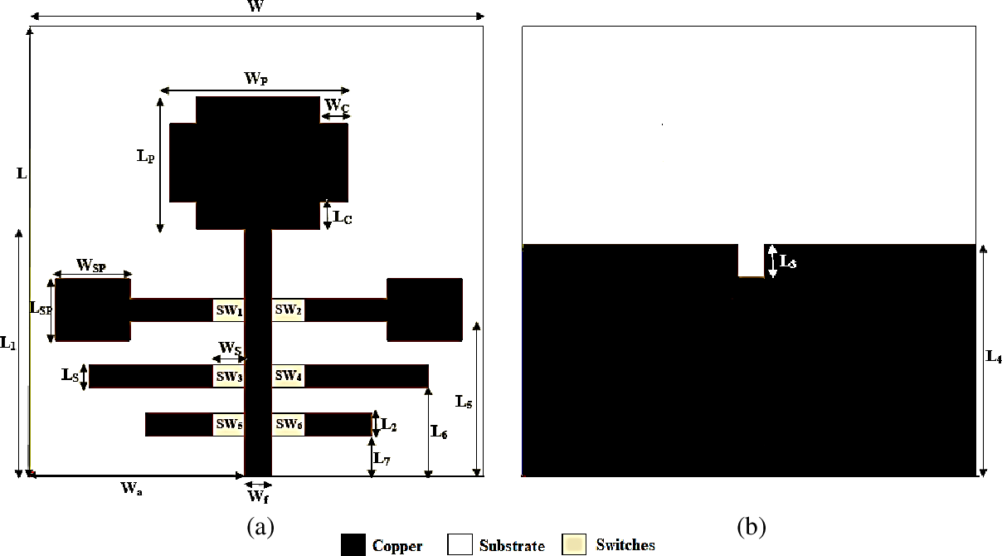
Fig.1 The proposed cognitive radio antenna, (a) Front side (b) Backside

2.1 Design of UWB Sensing Antenna
The sensing antenna contains partial ground plane that allows the antenna to operate in UWB rangewhich has slot at the center that gives impedance matching as shown in Figure 2.

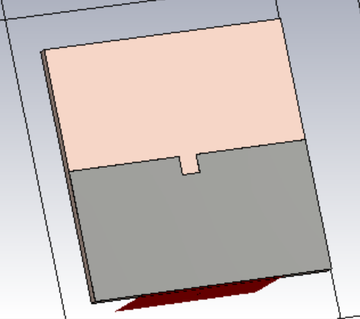
Fig 2.. The sensing antenna.
2.2 Design of Communicating Antenna
The communicating antenna is shown in Figure 3 antenna with slots cut at four edges allows the antenna to operate in UWB. A 50Ω microstrip line is used for feeding the antenna. Six extended transmission lines are printed on FR4 substrate that are connected or disconnected to feedline through PEC switches to achieve frequency reconfigurability.

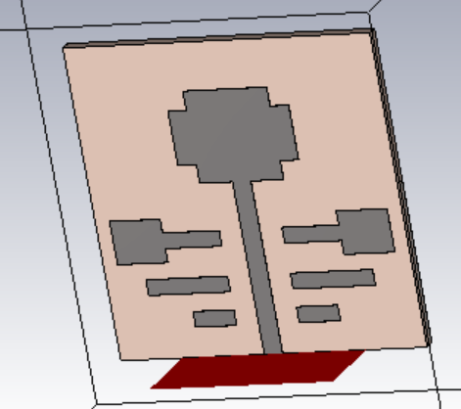

Fig 3. The communicating antenna
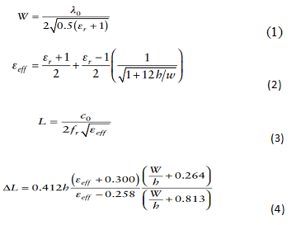
3. Results and dıscussıons
Simultion of proposed antenna is carried out using CST tool where simulated (S11) of -11.872dB is achivesd at 14.946GHz and VSWR of 1.6963 (<2) are shown in Figure 4 & Figure 5 repectively.
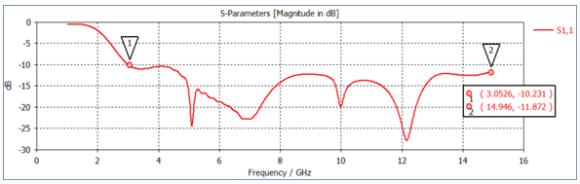
Fig 4. The simulated (S11) parameter

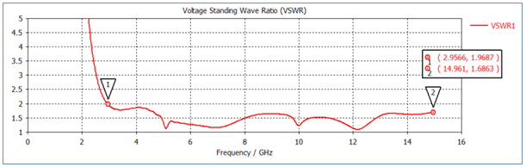

Fig 5 Simulated VSWR
The frequency reconfigurability is achived if atleas one of the PEC switches is Turned ON exhibiting narrow band characteristics opearting from 2.95GHZ to 14.95GHz as shown from Figure 6 to 9.
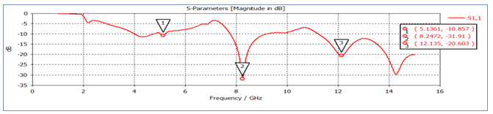
Fig 6. The simulated (S11) parameter versus frequency for Configuration II
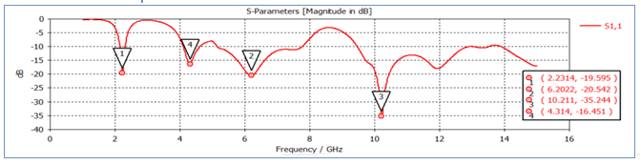
Fig 7. S11 versus frequency for Configuration III
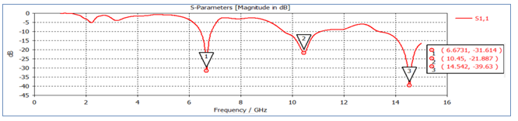
Fig 8 S11 Magnitude vs frequency for confifguration IV
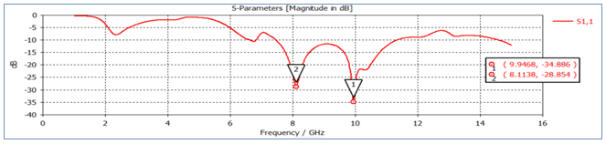
Fig 9 S11 Magnitude vs frequency for confifguration V

The (2D) radiation pattern of the proposed antenna are shown in Figure 10(a) to 10 (e) respectively for frequencies at 5.1 GHz, 8.24GHz ,10.23GHz, 6.66GHz and 9.94GHz respectively
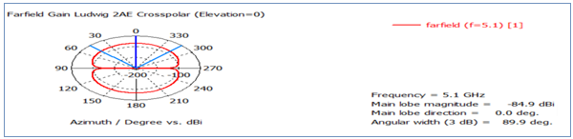
Fig 10(a) 2D radation pattern at 5.1GHz Configuration I
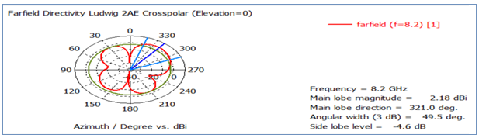
Fig 10(b) 2D radation pattern at 8.2GHz Configuration II
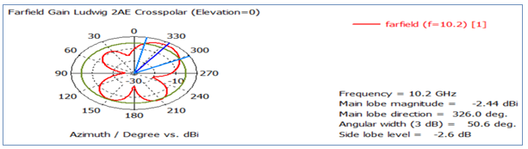
Fig 10(c) 2D radation pattern at 10.2GHz Configuration III
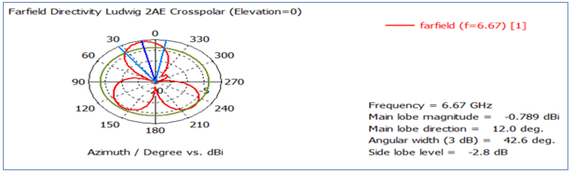
Fig 10(d) 2D radation pattern at 6.67GHz Configuration IV
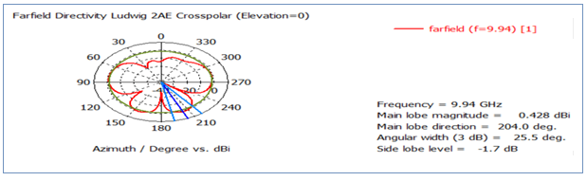
Fig 10(e) 2D radation pattern at 9.94GHz Configuration V

- Conclusion
Both the sensing and communicating antenna has achived using single microstrip patch antenna which is operated in UWB range having narrow bandwidth with achiveable VSWR(<2) and Gain of -11.926 dB.
References
- Liang, X. L., “Chapter 7: Ultra wideband current status and future trends,” Ultra Wideband Antenna and Design, 127–152, 2012.
- Fontana, R., “Recent system applications of short-pulse ultra-wideband (UWB) technology,” IEEE Trans. Microw. Theory Techn., Vol. 52, No. 9, 2087–2104, 2004.
- Li, T., H. Zhai, X. Wang, L. Li, and C. Liang, “Frequency-reconfigurable bow-tie antenna for Bluetooth, WiMAX, and WLAN applications,” IEEE Antennas Wireless Propag. Lett., Vol. 14, 171–174, 2015.
- Tawk, Y., J. Costantine, S. Hemmady, G. Balakrishnan, K. Avery, and C. G. Christodoulou, “Demonstration of a cognitive radio front end using an optically pumped reconfigurable antenna system (OPRAS),” IEEE Trans. Antennas Propag., Vol. 60, No. 2, 1075–1083, 2012.
- Tummas, P., P. Krachodnok, and R. Wongsan, “A frequency reconfigurable antenna design for UWB applications,” 2014 11th International Conference on Electrical Engineering/Electronics, Computer, Telecommunications and Information Technology (ECTICON), 2014.
- Li, F. and T. Wang, “Design of reconfigurable UWB microstrip antenna with MEMS switches,” 2016 IEEE International Conference on Microwave and Millimeter Wave Technology (ICMMT), 740–742, 2016.
- Tawk, Y. and C. Christodoulou, “A new reconfigurable antenna design for cognitive radio,” IEEE Antennas Wireless Propag. Lett., Vol. 8, 1378–1381, 2009.
- Balanis, C. A., Antenna Theory: Analysis and Design, John Wiley Sons, Hoboken, NJ, 2012.

