Futuristic trends in fermentation of milk using plant sources
Ujjwali Bhardwaj , Rekha Rani
2 Rekha Rani, Department of Dairy Chemistry, College of Dairy and Food technology, Agriculture University, Jodhpur, Rajasthan
Abstract
Milk fermentation is mainly associated with the starter culture preparation or being using inoculum containing starter culture. This time milk fermentation has been done using plant source which act either as a probiotic or prebiotic. The main focus in this study was mainly on the capability or properties of plant sources which is used as a starter culture for fermentation of milk i.e. chilli stalks which contain Lactobacillus species. Also, oatmeal used in fermentation of milk which acts as a prebiotic in milk that enhances the growth of probiotic culture that are used for milk fermentation. Milk fermented using plant sources enhance the quality by increasing antioxidant property of the fermented product. Therapeutically, fermented milk products have added health benefits to human individual mainly with their gut health which get enhanced by addition of beneficial microorganism to intestinal gut microbiota by replacing pathogenic microorganism from the gut. Various other benefits have also been observed by the individual consuming fermented milk products like reduction in bad cholesterol level, anti-carcinogenic properties, rise in antioxidant levels, cardiovascular health etc. Precise fermentation techniques are widely accepted on the global basis to provide individuals with quality fermented product which adds nutritional benefits and healthy food habits in humans so that they have well sustained, healthy and well balanced lifestyle free of disease risks regarding foods.
Keywords: Fermentation, Plant sources, Probiotics, Prebiotics, Therapeutic effects

1. Introduction
Fermentation of food products have been practiced since the early ages. The word “fermentation” is derived from latin word “fermentare” which means to leaven. Therefore, fermentation is a biochemical process in which carbohydrate or glucose molecule is broken down into biomolecules which produces primary metabolites, secondary metabolites, enzymes, vitamins etc. The process of fermentation is mostly anaerobic and carried out in the presence of microorgansim that are either present naturally or inoculated in the substrate that undergoes the process of fermentation. Fermentation is carried out in a biovessel known as Fermentor on an industrial scale(fig:1) .French chemist and microbiologist Louis Pasteur in the 19th century used the term fermentation in a narrow sense to describe the changes brought about by yeasts and other microorganisms growing in the absence of air (anaerobically); he also recognized that ethyl alcohol and carbon dioxide are not the only products of fermentation.
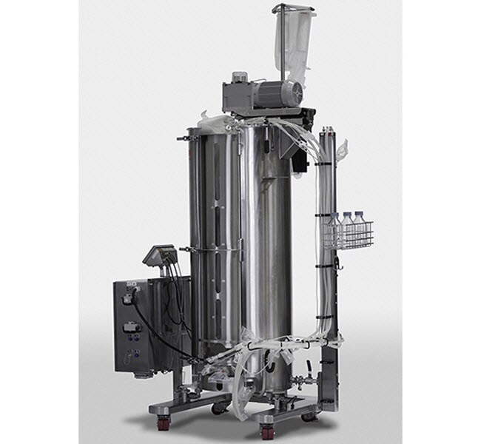

Fig:1 Fermentor

The common groups of microorganisms involved in food fermentations are bacteria, yeasts and moulds. The most important bacteria in the fermentation of foods are the Lactobacillaceae, which have the ability to produce lactic acid from carbohydrates. Other important bacteria are the acetic acid producing Acetobacter (mainly from fermentation of fruits and vegetables) and Bacillus (from fermentation of legumes) species. The beneficial yeasts in terms of desirable food fermentation are from the Saccharomyces family, especially S. cerevisiae.

2. What is the need of using fermentation technology in milk production industry?

With increasing therapeutic effects of fermented food products, consumers are adding fermented milk products containing probiotic culture in their daily food habits. Currently over 400 different commercial names exist for traditionally and industrially produced fermented milk products. The specificity of each type of product is defined by the applied starter cultures, milk quality, and process conditions [25,33,34]. Fermentation processes generally enhance the nutritional interest of many foods and increase the bioavailability of nutrients. The fermentation action of specific lactic acid bacteria (LAB) strains may lead to removal of toxic or antinutritional factors, such as lactose and galactose, from fermented milks to prevent lactose intolerance and accumulation of galactose[45].

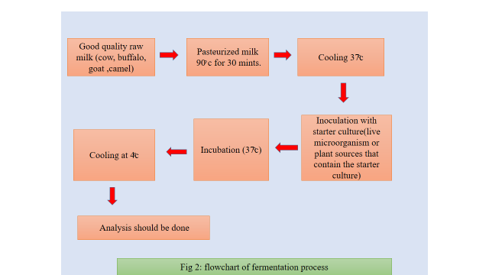

2. Types of fermented milk product
Different types of fermented milk products are obtained by using the process of fermentation. Fermented milk prodcuts that are obtained with using specific starter culture includes yogurt, kefir, acidophilus milk, kumyss(Table 1)
Types of fermented milks. .
Adapted from Codex Alimentarius (2011)

Yogurt | Symbiotic culture of Streptococcus thermophiles and Lactobacillus subsp. delbruckii
Yogurt based on alternative cultures | Culture of Streptococcus thermophiles and all species of Lactobacillus
Acidophilus milk
Kefir | Culture prepared from kefir granules, Lactobacillus kefiri, species of the genus Leuconostoc, Lactococcus and Acetobacter that grow in a close  specific relationship. The kefir granules constitute lactose fermenting yeast (Kluyveromyces marxianus) and lactose-free fermenting yeasts  (Saccharomyces unisporus, Saccharomyces cerevisiae y Saccharomyces exiguus
Kumys | Lactobacillus delbrueckii subsp. Bulgaricus y Kluyveromyces marxianus

3. Fermented milk products having Immunological Properties
Fermented milk products having the probiotic properties enhance the immune system. The growth of benefical microorganism reduces the pathogenic effects inside the body and helps in removing toxins. The health benefits of these microorganisms can be exerted either directly through the interactions of ingested live microorganisms with the host (probiotic effect), or indirectly by ingestion of the microbial metabolites synthesized during fermentation (bioactive effect)[42].
Some of the major health benefits regarding consumption of fermented milk products are below:

3.1 Modulation of intestinal microbiota
Fermented milk products enhances the gut microflora by inducing the growth of benefical microorganism inside the gut and removal of pathogenic microorganism from the intestine. In fact, it is known that the proper maturation of the immune system is connected to the colonization of the intestinal microbiota and especially to some specific species of Bifidobacterium[20].

3.2Anti-carcinogenic effect
The preventive effect of probiotics on the carcinogenesis may be associated with the modulation of the immune response and changes in the intestinal microbiota, preventing the increase of bacteria that become pro carcinogens in carcinogens [13].Fermented milks may modulate the immune system of the mucosa. The administration of fermented products may have an impact on the intestinal microbiota, stimulate immune cells associated to the intestine and it is useful against the intestinal inflammation and colon cancer[13].In addition, Lactobacillus acidophilus isolated from yogurt reduced tumor growth rate and increased lymphocyte proliferation in a mouse model of breast cancer[38].Fermented dairy products induce apoptosis,cell cycle arrest and reduce tumor growth in breast cancer cells; therefore, it may be suitable in the prevention or treatment of breast cancer[43].

3.3 Hypocholesteromic effects
The probiotic yogurt consumption containing Lactobacillus acidophilus and Bifidobacterium lactis caused a significant reduction in cholesterol serum levels compared with ordinary yogurt [3].It is assumed that probiotic bacteria can metabolize cholesterol and thus reduces its resorption in gastrointestinal tract. In vitro and in vivo studies indicates that lactobacilli, bifidobacteria and other milk bacteria assimilate cholesterol, by incorporation into the cellular membranes, deconjugation and precipitation of cholesterol with bile acids.

3.4 Hypotensive effects
The proteolytic activity of milk bacteria during milk fermentation generates hypotensive peptides with a larger number of amino acid units - casokinins and lactokinis[16]. It has been shown that some fermented milks in vitro and in vivo assays and in clinical studies are antihypertensive agents, and their effects in most cases have been attributed to milk peptides. These fermented milks are as effective as synthetic ACE inhibitors. Therefore, they can be considered hypotensive agents because they can be part of the daily diet.
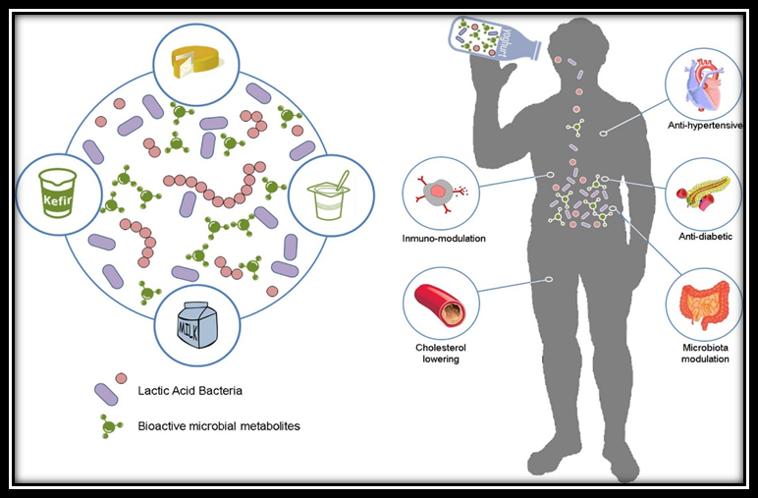
Fig:3 Beneficial effects resulting from the consumption of biofunctional fermented dairy foods. Lactic acid bacteria participating in milk fermentation in situ release and naturally enrich the fermented dairy product with a broad range of bioactive metabolites. Subsequent ingestion of this product can exert important health-promoting activities on the consumer, such as anti-hypertensive, and anti-diabetic, immune-modulatory, anti-cholesterolemic or microbiome modulation[42].

4..Advantages of milk fermentation

Fermented milk products have beneficial impact on human intestinal health. Fermented milk products contain live microorganism in the food products that enhances the enzymatic activity which leads to proper digestion of food inside the digestive system. For maintaining a healthy gut microflora of human individual the recent advancements are taking place in enhancing the role of probiotic and prebiotic. The most common strains of LAB used for fermentation of milk are Streptococcus thermophilus, usually in association with Bifidobacteria, such as Bifidobacterium breve C50, Bifidobacterium lactis, Bifidobacterium longum and Bifidobacterium animalis, or with Lactobacilli such as Lactobacillus acidophilus, Lactobacillus rhamnosus, Lactobacillus johnsonii and Lactobacillus casei[21].In fact, many of the foods containing probiotics and prebiotics are fermented dairy products, such as yogurt, which is the most studied fermented dairy product, kumys, skyr, yakult, and kefir [6,9].

Different types of probiotic products. .
Adapted from McFarland, 2015[32]

Probiotic | Formulation | Evidence based efficacy | References
Bifidobacterium animalis subsp lactis DN-173010 | Yogurt | Constipation | [60]
Lactobacillus casei subsp Shirota | Fermented milk | Constipation, H. pylori infection | [30]
Lactobacillus casei DN-114001 | Fermented drink, yogurt | Antibiotic-associated diarrhea, prevention of  pediatric diarrhea, respiratory infections | [14]
Lactobacillus plantarum 299v (DSM9843) | Fermented oat gruel in fruit  drink, capsules | Irritable bowel syndrome, Clostridium difficile  infection | [29]
Lactobacillus reuteri DSM 17,938 | Capsules, yogurt | Acute pediatric diarrhea, cholesterol | [46]
Lactobacillus rhamnosus GG (ATCC 53013) | Yogurt, capsules | Acute pediatric diarrhea, antibiotic-associated  diarrhea | [27]
Lactobacillus acidophilus +  Bifidobacterium animalis  subsp lactis | Yogurt | Improves in microbiota | [44]

5.What is the need of using plant source for fermentation of milk?
From decades we are using dairy starter culture or LAB cultures for milk fermentation but with recent development in the research are leading to sources other than dairy for fermented milk products like plant sources.
Instead of using starter culture or inoculum for fermentation of milk, these days plant sources are in focus for milk fermentation. New yogurts with plant extracts are currently popular in the dairy market. As consumers are increasingly interested in healthy diets and wellness, with the expectation that food can help them be healthier or may even be capable of preventing illness, probiotic food products made via fermentation of milk, cereals, fruits, and vegetables are receiving attention from scientists as well as consumers[22].
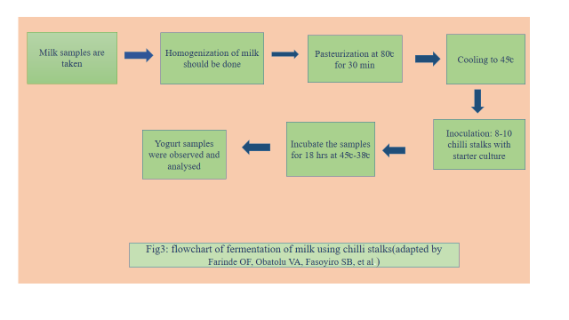
Researches have been done on the addition of chilli stalks for milk fermentation and it is generally practised in colder climate for fermentation. Red chili is a common spice used in many food items and also in various pharmaceutical preparations[4].Capsaicin (8-methyl-N-vanillyl-6-nonenamide), one of the active ingredients in red chili, is known to have several medicinal properties, such as its potential to attenuate hypertension[60]and to suppress tumor growth by inducing apoptosis [37]. Many studies in the medical literature have linked the consumption of chili-enriched meals with increased energy expenditure and oxidation of fats[15].There have been claims that the calyx of capsicums fruits such as chilli, are often rich in various lactobacilli. These natural bacteria create a starter for lacto-fermentation of milk.
In addition capsaisin from the chilli appears to increase the metabolic rate of the lactobacilli [24,47] The stalks (calyx) of chilli (Capsicum spp.) are general removed as waste during food processing. The use of this considered waste in the curding of milk can however change its status from being a waste product to a product of high economic value therefore turning waste to wealth[25]. This will provide an easy access to healthy starter culture in yogurt making instead of using the inoculum culture that is limited in the market.Red chili pepper is also used to induce curdling of milk, particularly in the colder regions or during winters or when starter cultures run out[21]. Oatmeals are being used as a prebiotic culture to enhance the growth of bacteria that is capable to ferment dairy milk. ). Prebitoics are given special attention as they play role of dietary fiber which cannot be compensated by the use of probiotic exclusively. Dietary fiber provide substrate for Intestinal microflora growth and also maintain healthy gut microbiota for smooth working of intestinal digestion. Dietary fiber expands the human digestive tract through water absorption, increasing stool volume, softening stool, stimulating gastrointestinal peristalsis, and relieving constipation. Dietary fiber is known as the seventh major nutrient because of its physiological functions such as lowering of the lipid levels, regulation of sugar metabolism, regulation of intestinal microbes, and reduction of the risk of depression.The composition of milk with cereal grains like oats combines the nutritional supplement or act like nutraceuticals in human individual to maintain the balance of dietary fibers,vitamins and some essential amino acids that is required by human to fight against stressed and diseased condition and ensures a healthy and well balanced scenario of human health with their increasing age and reducing immunity. The production of dairy products with oatmeal will provide the population with a full-fledged dietary and healthy product[57]
Plant sources | microorganism | Fermented product | Therapeutic effect
Chilli stalks | Lactic acid bacteria | Curd | Acts as a probiotic to enhance intestinal health
Red chilli | Lactic acid bacteria | Curd | Probiotic to ehance gut microflora
Oats | Streptococcus thermophiles and L.plantarum | Yogurt | Acts as a prebiotic for starter culture and ehnace dietary fiber to the intestinal digestion

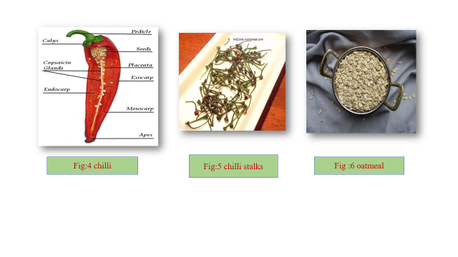
7. Futuristics trends in fermented products
Fermentation are widespread and have blooming platform in food industries nowadays .Recently, precise fermentation emerged as a novel targeted technology for food applications with the aim of providing high-value compounds [8]. This novel technology leverages metabolic engineering tools to serve as a factory of ingredients such as protein, pigments, vitamins, and fats to upgrade the quality of plant-based alternatives [50,59]. Furthermore, fermentation is important for sustainable food solutions and can provide a positive impact on the sustainability index for the food industry [8–5]. Compared to conventional protein sources, biomass fermentation for protein production can rapidly produce a very high protein content among other nutrients. Furthermore, food by-products and wastes can be used as substrates to be transformed in high-value food and feed products [6–9]. This is an environmentally friendly strategy that could encourage a more energy-efficient and sustainable economy.
The global market of plant-based products made using fermentation was valued at USD 329.29 million in 2021 and is expected to reach USD 422.26 million by 2026, with a compound annual growth rate (CAGR) of 5.0% [19,48]. Figure 6 illustrates the evolution of the number of the products launched in the global market during the last two decades (2002–2022). From 2002 to 2012, the number of fermented plant-based products increased, but at a low speed. During the period 2013–2022, this market witnessed an exponential growth and reached a peak in 2021 owing to the expansion of fermented plant-based meat and dairy alternatives [31], and it is expected to keep growing in the forthcoming years. The outbreak of COVID-19 contributed to fueling consumer interest in fermented plant-based products, owing to their health benefits such as boosting immune system performance and ameliorating gut health and inflammatory responses [14,37].
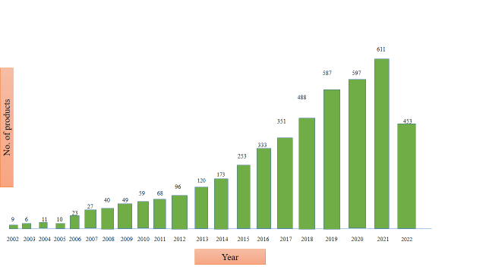
Fig:6 Evolution of launches of fermented plant-based foods in the global market. A search was conducted on Mintel GNPD (Global New Products Database) on 15 September 2022. Date: from 1January 2002, to 15 September 2022.

Attempts to create innovative solutions for healthier diets with alternative proteins have been accelerated with the advent of digital technologies and other advanced related innovations. It was reported that the application of digital technologies, such as AI, smart sensors, robotics, and augmented reality, during fermentation can improve the monitoring and performance of the process [53]. For example, throughout the fermentation process of rice wine, multiple parameters such as temperature, humidity, percentage of sugar and alcohol, and acidity can be measured using IoT, allowing manufacturers t virtually monitor the whole fermentation process online [40]. Incorporation of Industry 4.0 technologies into fermentation facilities, “Fermentation 4.0” has recently been discussed, highlighting its potential to solve relevant problems such as the implementation of complex culture conditions [2]. The implementation of such advanced technologies to achieve automatic detection and control of beer fermentation was recently reviewed and thoroughly discussed [55].
Monitoring the process will offer a better understanding of the synergy among the bacteria/fungi used and how they interact within different media (different raw materials unlike milk). Three-dimensional (3D) cameras and hyperspectral imaging (HSI) would enable real-time monitoring, and thus the process can be adjusted and optimized in real-time during processing [12,36]. For example, in a recent study, HSI was used to predict and quantify the total acid content and reducing sugar content of fermented grains [26]. The application of digital technologies and other advanced innovations has been demonstrably efficient in upgrading the quality and safety of fermented foods and beverages [21,56]
Recent advances in Industry 4.0 technologies have enabled vast progress in precision fermentation due to recent advances in AI, bioinformatics, and systems and computational biology [23,51]. Such advances could offer quality standardization by detecting any potential anomalies in the fermentation process (e.g., mutation), and stable productivity, and thus could be more cost-effective food production methods. Advances in precision fermentation are expected to be key elements in the future to target taste and texture, enhance the shelf-life of plant-based fermented food products, and to mimic their animal counterparts [52–58].

7. Conclusion
This study on using plant source for fermentation of milk mainly draw attention toward the evolution in fermented milk products. Since,the early ages the starter cultures are being in practise for fermentation till nowadays, but there is a limitation of starter cultures on industrial scale and it is also difficult to maintain the culture for a longer period of time as there are chances of contamination of the starter culture species. So, recent advances are suggesting to introduce plant sources in fermentation industry especially chilli, chilli stalks, oatmeals in fermentation of milk. Also fermentation of milk with plant source add therapeutic value to fermented food products that have the ability to enhance immunological properties to fight off various kind of infection and disease. So we can extend the research related to plant sources for fermentation of milk furthermore to gain knowledge about its different probiotic and prebiotic strains that are present in plant sources and also to study more about the nutritional values of functional foods products that produced using plant based fermentation.

References
- Alimentarius, Codex (2011). Milk and milk products (2nd ed.). Rome, Italy: WHO and FAO.144.
- Alarcon, C.; Shene, C. Fermentation 4.0, a Case Study on Computer Vision, Soft Sensor, Connectivity, and Control Applied to theFermentation of a Thraustochytrid. Comput. Ind. 2021, 128, 103431.
- Ataie-Jafari, A., Larijani, B., Alavi Majd, H., & Tahbaz, F. (2009). Cholesterol-lowering effect of probiotic yogurt in comparison with ordinary yogurt in mildly to moderately hypercholesterolemic subjects. Annals of Nutrition and Metabolism, 54(1), 22–27.
- Barceloux, D. G. 2008. Pepper and capsaicin (Capsicum and Piper species). Pages 71–73 in Medical Toxicology of Natural Substances: Foods, Fungi, Medicinal Herbs, Plants and Venomous Animals.John Wiley and Sons Inc., Hoboken, NJ.
- BIS Research Fermented Plant Based Alternatives Market Analysis and Forecast Upto 2026|BIS Research. Available online:https://bisresearch.com/industry-report/fermented-plant-based-alternatives-market.html (accessed on 25 September 2022).
- Bourrie, B. C. T., Willing, B. P., & Cotter, P. D. (2016). The microbiota and health promoting characteristics of the fermented beverage kefir. Frontiers in Microbiology, 7, 1–17.27.
- Boukid, F. Plant-Based Meat Analogues: From Niche to Mainstream. Eur. Food Res. Technol. 2021, 247, 297–308.28. Boukid, F.; Pera, J.; Parladé, J.; Castellari, M. Fungal Bioconversion of Brewery By-Products: Assessment of Fatty Acids and Sterols Profiles. Qual. Assur. Saf. Crop. Foods 2022, 14, 202–211. Foods 2023, 12, 1005 16 of 214.
- Chai, K.F.; Ng, K.R.; Samarasiri, M.; Chen, W.N. Precision Fermentation to Advance Fungal Food Fermentations. Curr. Opin. Food Sci. 2022, 47, 1008815.
- Chen, M., Ye, X., Shen, D., & Ma, C. (2019). Modulatory effects of gut microbiota on constipation: The commercial beverage yakult shapes stool consistency. Journal of Neurogastroenterology and Motility, 25(3), 475–477
- Cicho´ nska, P.; Ziarno, M. Legumes and Legume-Based Beverages Fermented with Lactic Acid Bacteria as a Potential Carrier of Probiotics and Prebiotics. Microorganisms 2022, 10, 91.
- Chakraborty, A.; Bhowal, J. Bioconversion of Jackfruit Seed Waste to Fungal Biomass Protein by Submerged Fermentation. Appl. Biochem. Biotechnol. 2022, 1–14.
- Caporaso, N.; Whitworth, M.B.; Fowler, M.S.; Fisk, I.D. Hyperspectral Imaging for Non-Destructive Prediction of Fermentation Index, Polyphenol Content and Antioxidant Activity in Single Cocoa Beans. Food Chem. 2018, 258, 343–351
- De Moreno De Leblanc, A., & Perdigón, G. (2010). The application of probiotic fermented milks in cancer and intestinal inflammation. Proceedings of the Nutrition Society,69(3), 421–428.
- Dietrich, C. G., Kottmann, T., & Alavi, M. (2014). Commercially available probiotic drinks containing Lactobacillus casei DN-114001 reduce antibiotic-associated diarrhea World Journal of Gastroenterology, 20(42), 15837–15844.
- Diepvens, K., K. R. Westerterp, and M. S. Westerterp-Plantenga. 2007. Obesity and thermogenesis related to the consumption of caffeine, ephedrine, capsaicin, and green tea. Am. J. Physiol.Regul. Integr. Comp. Physiol. 292:R77–R85
- Ebringer, L., Ferencik, M., & Krajcovic, J. (2008). Beneficial health effects of milk and fermented dairy products – review. Folia Microbiologica, 53(5), 378–394.
- Farinde OF, Obatolu VA, Fasoyiro SB, et al. Use of alternative raw materials for yogurt production. Afr J Biotechnol. 2008;7(18):3339-45.
- Finnigan, T.; Needham, L.; Abbott, C. Mycoprotein: A Healthy New ProteinWith a Low Environmental Impact. In Sustainable Protein Sources; Academic Press: Cambridge, MA, USA, 2016; pp. 305–325.
- Fonseca, S.C.; Rivas, I.; Romaguera, D.; Quijal, M.; Czarlewski, W.; Vidal, A.; Fonseca, J.A.; Ballester, J.; Anto, J.M.; Basagana,X.; et al. Association between Consumption of Fermented Vegetables and COVID-19 Mortality at a Country Level in Europe. medRxiv 2020.
- Granier, A., Goulet, O., & Hoarau, C. (2013). Fermentation products: Immunological effects on human and animal models. Pediatric Research, 74, 238–244.
- Gonzalez Viejo, C.; Harris, N.M.; Fuentes, S. Quality Traits of Sourdough Bread Obtained by Novel Digital Technologies and Machine Learning Modelling. Fermentation 2022, 8, 516
- Gupta, S., and Abu-Ghannam, N. (2012). Probiotic fermentation of plant based products: possibilities and opportunities. Crit. Rev. Food Sci. Nutr. 52, 183–199. doi: 10.1080/10408398.2010.499779
- Hassoun, A.; Bekhit, A.E.; Jambrak, A.R.; Regenstein, J.M.; Chemat, F.; Morton, J.D.; Gudjónsdóttir, M.; Carpena, M.; Prieto, A.; Varela, P.; et al. The Fourth Industrial Revolution in the Food Industry—Part II: Emerging Food Trends Trends. Crit. Rev. Food Sci. Nutr. 2022, 1–31.
- Harini P. Vegan Recepies. A blog in tongueticklers.com. 2013;4.
- Iličić M, Milanović S, Carić M (2015): Rhelogy and texture of fermented milk products. In: E. Karpushkin (ed.), Rheology, Principles, Applications and Environmental Impacts, New York: Nova Publisher.
- Jiang, X.; Tian, J.; Huang, H.; Hu, X.; Han, L.; Huang, D.; Luo, H. Nondestructive Visualization and Quantification of Total Acid and Reducing Sugar Contents in Fermented Grains by Combining Spectral and Color Data through Hyperspectral ImaginFood Chem. 2022, 386, 132779.
- Jia, R., Chen, H., Chen, H., & Ding, W. (2016). Effects of fermentation with Lactobacillus rhamnosus GG on product quality and fatty acids of goat milk yogurt. Journal of Dairy Science, 99(1), 221–227.
- Katz, S. E. 2011. The Art of Fermentation. Chelsea Green Publishing, White River Junction, VT.
- Klarin, B., Johansson, M. L., Molin, G., Larsson, A., & Jeppsson, B. (2005). Adhesion of the probiotic bacterium Lactobacillus plantarum 299v onto the gut mucosa in critically ill patients: A randomised open trial. Critical Care, 9(3), R285–R293.
- Maragkoudakis, P. A., Chingwaru, W., Gradisnik, L., Tsakalidou, E., & Cencic, A. (2010).Lactic acid bacteria efficiently protect human and animal intestinal epithelial and immune cells from enteric virus infection. International Journal of Food Microbiology,141(1), S91–S97.
- Mintel Emerging Trends in the Plant-Based Industry|Mintel.Com. Available online: https://www.mintel.com/emerging-plantbased-trends (accessed on 24 September 2022).
- McFarland, L. V. (2015). From yaks to yogurt: The history, development, and current use of probiotics. Clinical Infectious Diseases, 60(2), S85–S90.
- Milanović S, Iličić M, Carić M (2017): Fermentisani mlečni proizvodi, Novi Sad: Tehnološki fakultet.
- Milanović S, Hrnjez D, Iličić M , Kanurić K , Vukić V (2016): Novel Fermented Dairy Products, Chapt. 9. In: KS Ojha, BK Tiwari (eds.), Novel Food Fermentation Technologies, Springer Int. Publ., 165–201.
- Olatide M, Arawande JO, George OO, et al. Pilot study on chilli stalks as a source of non-dairy lactic acid bacteria in yogurt making. Appl Food Sci J. 2019;3(1):5-8.
- 146. Özdo˘gan, G.; Lin, X.; Sun, D.W. Rapid and Noninvasive Sensory Analyses of Food Products by Hyperspectral Imaging: Recent Application Developments. Trends Food Sci. Technol. 2021, 111, 151–165.
- Pramanik, K. C., and S. K. Srivastava. 2012. Apoptosis signal-regulating kinase 1-thioredoxin complex dissociation by capsaicin causes pancreatic tumor growth suppression by inducing apoptosis. Antioxid.Redox Signal. 17:1417–1432.
- Pei, R., Martin, D. A., DiMarco, D. M., & Bolling, B. W. (2017). Evidence for the effects of yogurt on gut health and obesity. Critical Reviews in Food Science and Nutrition, 57(8),1569–1583.
- Quantification of Total Acid and Reducing Sugar Contents in Fermented Grains by Combining Spectral and Color Data through Hyperspectral Imaging. Food Chem. 2022, 386, 132779.
- Research and Markets Fermented Plant-Based Alternatives Market—A Global and Regional Analysis: Focus on Applications,Products, Patent Analysis, and Country Analysis-Analysis and Forecast, 2019–2026. Waste Biomass Valorization 2019, 10, 2487–2496
- Sar, T.; Larsson, K.; Fristedt, R.; Undeland, I.; Taherzadeh, M.J. Demo-Scale Production of Protein-Rich Fungal Biomass from Potato Protein Liquor for Use as Innovative Food and Feed Products. Food Biosci. 2022, 47, 101637.
- Stanton, C., Ross, R. P., Fitzgerald, G. F., and Van Sinderen, D. (2005). Fermented functional foods based on probiotics and their biogenic metabolites. Curr. Opin. Biotechnol. 16, 198–203. doi: 10.1016/j.copbio.2005.02.008
- Sharifi, M., Moridnia, A., Mortazavi, D., Salehi, M., Bagheri, M., & Sheikhi, A. (2017).Kefir: A powerful probiotics with anticancer properties. Medical Oncology,34(11), 1–7.
- Simpson, M. R., Avershina, E., Storrø, O., Johnsen, R., Rudi, K., & Øien, T. (2018). Breastfeeding-associated microbiota in human milk following supplementation with Lactobacillus rhamnosus GG, Lactobacillus acidophilus La-5, and Bifidobacterium animalis ssp. lactis Bb-12. Journal of Dairy Science, 101(2), 889–899.
- Shiby, V. K., & Mishra, H. N. (2013). Fermented milks and milk products as functional foods-A review. Critical Reviews in Food Science and Nutrition, 53(5), 482–496.
- Spinler, J. K., Taweechotipatr, M., Rognerud, C. L., Ou, C. N., Tumwasorn, S., &Versalovic, J. (2008). Human-derived probiotic Lactobacillus reuteri demonstrateantimicrobial activities targeting diverse enteric bacterial pathogens. Anaerobe,14(3), 166–171.
- Sharma SJ, Nair GN, Ramachandran S. Capsicum annuum enhances L-lactate production by lactobacillus acidophilus: implication in curd formation. J Dairy Sci. 2013;96(7):4142-8.
- Shahbazi, R.; Sharifzad, F.; Bagheri, R.; Alsadi, N.; Yasavoli-Sharahi, H.; Matar, C. Anti-Inflammatory and Immunomodulatory Properties of Fermented Plant Foods. Nutrients 2021, 13, 1516.
- Souza Filho, P.F.; Zamani, A.; Taherzadeh, M.J. Edible Protein Production by Filamentous Fungi Using Starch PlantWastewater
- Terefe, N.S. Recent Developments in Fermentation Technology: Toward the next Revolution in Food Production. In Food Engineering Innovations across the Food Supply Chain; Elsevier: Amsterdam, The Netherlands, 2022; pp. 89–106134. Teng, T.S.; Chin, Y.L.; Chai, K.F.; Chen,W.N. Fermentation for Future Food Systems: Precision Fermentation Can Complement the Scope and Applications of Traditional Fermentation. EMBO Rep. 2021, 22, e52680
- Teng, T.S.; Chin, Y.L.; Chai, K.F.; Chen,W.N. Fermentation for Future Food Systems: Precision Fermentation Can Complement the Scope and Applications of Traditional Fermentation. EMBO Rep. 2021, 22, e52680.
- Tyndall, S.M.; Maloney, G.R.; Cole, M.B.; Hazell, N.G.; Augustin, M.A. Critical Food and Nutrition Science Challenges for Plant-Based Meat Alternative Products. Crit. Rev. Food Sci. Nutr. 2022, 1–16.
- Viejo, C.G.; Fuentes, S. Editorial: Special Issue “Implementation of Digital Technologies on Beverage Fermentation”. Fermentation 2022, 8, 127.
- Vošahlík, J.; Hart, J. Measurability of Quality in Fermentation Process of Rice Wine by IoT in the Field of Industry 4.0. Agron. Res. 2021, 19, 1318–1324.
- Violino, S.; Figorilli, S.; Costa, C.; Pallottino, F. Internet of Beer: A Review on Smart Technologies from Mash to Pint. Foods 2020, 9, 950.
- Viejo, C.G.; Fuentes, S. Low-Cost Methods to Assess Beer Quality Using Artificial Intelligence Involving Robotics, an Electronic Nose, and Machine Learning. Fermentation 2020, 6, 104
- V.A. Smirnov, Traditional and non-traditional fillers Dairy industry 2, 56-57 (2018)
- Viejo, C.G.; Fuentes, S.; Hernandez-Brenes, C. Smart Detection of Faults in Beers Using Near-Infrared Spectroscopy, a Low-Cost Electronic Nose and Artificial Intelligence. Fermentation 2021, 7, 117.
- Williams, R.A. Opportunities and Challenges for the Introduction of New Food Proteins. Annu. Rev. Food Sci. Technol. 2021, 12,75–9124.
- Yang, Y. X., He, M., Hu, G., Wei, J., Pages, P., Yang, X. H., & Bourdu-Naturel, S. (2008).Effect of a fermented milk containing Bifidobacterium lactis DN-173010 on Chinese constipated women. World Journal of Gastroenterology, 14(40), 6237–6243.
- Yang, D., Z. Luo, S. Ma, W. T. Wong, L. Ma, J. Zhong, H. He, Z. Zhao, T. Cao, Z. Yan, D. Liu, W. J. Arendshorst, Y. Huang, M. Tepel, and Z. Zhu. 2010. Activation of TRPV1 by dietary capsaicin improves endothelium-dependent vasorelaxation and prevents hypertension. Cell Metab. 12:130–141

