Dining Delights in the Digital World: A Study of Restaurant Website

Suraj Kumar1

B.Tech Scholar

Jaya Rani2*

Assistant Professor CSE

12Department of CSE, Panipat Institute of Engineering and Technology, Panipat, India

1guptasurajkumar577@gmail.com 2*jaya.cse@piet.co.in

ABSTRACT

In an era of digital change, the restaurant business is not immune to the challenges of increasing efficiency and consumer happiness. This chapter focus at a unique approach used by restaurants to reduce manual labour and improve work accuracy. A sophisticated website-based system that maintains customer details and online reservations is crucial to this strategy. This website's user-friendly layout allows clients to easily arrange their eating experiences, minimizing time waste dramatically. Furthermore, this novel technique guarantees that each order is handled individually, and that each reservation is precisely linked to a specific seat at the table. We hope to shed light on the revolutionary influence of this website-related solution on restaurant management, ushering in a new era of simplified operations and increased customer experiences. To make the management and delivery of book a table easier, these systems offer a comprehensive platform that combines user-friendly interfaces and effective functionalities. Frontend technologies define how to book a table using the website's system through the user interface (UI) of a restaurant's website. Front-end developers construct user- friendly, aesthetically pleasing interfaces using HTML, CSS, and JavaScript.

Keywords—website, system design, depolyment, application, book a table, user-friendly interface.

I. INTRODUCTION

In today's fast-paced digital world, the restaurant sector is at the crossroads of tradition and innovation. A new strategy has arisen as restaurants attempt to match their customers' changing expectations while retaining operational efficiency. This chapter provides a ground-breaking strategy for using the power of websites to revolutionize restaurant operations, dramatically lowering manual labour and improving work accuracy. A cutting-edge technology developed to handle customer information and simplify online reservations is at the core of this revolution [1]. This novel solution not only streamlines the process of booking a table for a client, but it also optimizes resource allocation and reduces time waste. We dig into the complexities of this website-related solution and its enormous influence on how restaurants run their operations, ushering in a new era of increased customer experiences and operational excellence [2].

This chapter is based on the restaurant website. Our website-related method is used to cut down on manual labour and improve restaurant job accuracy. The management and upkeep of client records and online reservations are handled by this system. This website's interface has been designed to be user-friendly. so that customers may conveniently schedule a table. This approach drastically cuts down on wasted time. Orders are made one client at a time, and each reservation corresponds to a specific seat at the table [3].

Every person's life includes the internet, as is widely known, and technological growth is altering everything in this world. At the beginning of the modem age, computers were a crucial part of computing. However, as technology improved, everything changed and computers transformed into workstations, supercomputers, and other forms. Everything is now mobile thanks to later developments in mobile technology. Mobility makes everything easier [4].

Over the past two decades, the use of mobile devices has grown significantly, making daily chores easier to execute. Additionally, as a result of the advancement of wireless technology, wireless networks have conquered the whole earth. Now, it's possible to conduct financial and commercial activities swiftly and securely from anywhere at any time [5]. Connections may be created with almost any device using the Internet. They can communicate and exchange the crucial information from anywhere in the world. Since users now use mobile devices instead than browsers to access the internet. There are now new ways to reserve a table on your computer or mobile device. The system is designed with Android users in mind. This app offers the ability to reserve a table [6].

**A. The Rise of Mobile Technology**

The emergence of mobile technology has altered not just the gadgets we use, but also the way we interact with the outside world. Thanks to developments in wireless technology, wireless networks are becoming more prevalent, giving both consumers and corporations more power. Today, swift and safe financial, economic, and social transactions are possible from almost anywhere on the earth [7].

Before becoming a flexible and all-encompassing force, the Internet was bound to desktop computers. It acts as a gateway for virtually any device to access the huge digital universe. A new age of connection and accessibility is enabled by this connectivity, which enables the flow of crucial information [8].

**B. The Shift to Mobile Dining**

In recent years, there has been a tremendous shift in how individuals engage with the Internet. The transition from standard web browsers to mobile devices has been especially noticeable. This transition has opened up interesting opportunities in a variety of businesses, including the restaurant industry. We are at the forefront of a new era in which booking a table has been made simple and convenient by mobile technology [9].

Our revolutionary restaurant management system has been purposefully developed with Android users in mind. The widespread adoption of Android makes it an attractive platform for addressing a large audience. We provide consumers with an unsurpassed degree of simplicity when reserving their chosen tables via our specialized application [10].

**C. Enhancing the Dining Experience**

The seamless integration of online table booking with the restaurant's everyday operations is key to the design of our system. Each reservation is carefully tied to a specific seat at a dining table. This methodical technique guarantees that reservations are handled precisely and accurately. Furthermore, orders are created one at a time for each client, ensuring a personalized and outstanding eating experience [11].

**D. User-Friendly Interface**

We realize the importance of our clients' time in today's fast-paced environment. Our restaurant website has a professionally developed user-friendly layout that prioritizes simplicity and efficiency. Navigating the system and scheduling a table has been simplified, avoiding needless delays and expediting the reservation process. We recognize that a user-friendly experience is critical to ensuring that consumers can use our services quickly and easily [12].

**II. OBJECTIVES OF THE SYSTEM**

The primary goal of the system is to provide a user-friendly solution that efficiently handles the issues that consumers have while booking tables. This goal is critical to achieving the system's ultimate goal. The method is organized in a single phase that is largely focused on the creation of a website [13]. This website serves as the entry point for consumers to begin the table booking process, allowing them to reserve tables online using their mobile or laptop devices. A dependable internet connection is required for this flawless experience, serving as the critical link for the whole table booking procedure [14].

**A. Research Objectives**

* The system's objectives must be achieved to fulfill its overall goal, which is to develop a user-friendly system that resolves the challenges faced by individuals when booking tables.
* The system primarily consists of a single phase, which involves creating a website.
* To initiate the process of booking tables through mobile or laptop devices, the first requirement is to develop a website that enables users to conveniently reserve tables online.
* An interact connection is necessary for the table booking process.

**B. Learning Objectives**

By following the suggested approach, the developer can acquire relevant knowledge and concepts related to constructing and authoring Android-based websites. Rather than relying solely on professional knowledge, the focus is placed on exploring unique ideas and concepts. To successfully create a website that is highly reusable and of high quality within the given timeline, the developer will need to go through various phases of website development, project management, human-computer interface design, usability considerations, and development philosophies, Nevertheless, the primary objective of utilizing mobile computing concepts is to optimize the desired outcomes and ensure user satisfaction, while also reducing the time and effort required to provide a simple solution for online table bookings [15].

* Obtaining expertise in HTML, CSS, Reacts and Nodejs programming language.
* Acquiring a deep understanding of web services and their conceptual framework.
* Developing proficiency in website development, encompassing database management and associated aspects.

**C. Problem Context**

In the era of computer technology, the integration of information and technology has become essential for efficient communication and a fast-paced lifestyle. There is a growing demand for internet services that minimize effort and reduce the need for human intervention. Android phones can play a significant role in alleviating the inconvenience of waiting or being uncertain about finding a place to eat [16]. The existing system lacks thorough research and functionality. Given the current time period, our work has become predominantly mobile. Therefore, there is a need to develop and utilize Android applications that are user-friendly and more effective than the current booking system. Once a table is booked, the restaurant owner receives an email containing the customer's basic details [17].

**III. FUNCTIONALITIES OF SYSTEM**

The specified restaurant management system has a number of important features that help to improve the eating experience and optimize restaurant operations. For starters, it allows consumers to easily reserve tables online by providing their preferred day, time, and number of guests. The technology also keeps specific client records, such as contact information and eating preferences, to help with personalized service [18]. The technology provides accuracy and efficiency in order processing, while also allowing for specific requests and order adaptations. Furthermore, the system optimizes resource allocation by allocating particular seats to reservations, allowing the system to make the most use of available space. Its user-friendly design, which is available through both websites and mobile apps, makes it easier for customers to explore menus and make bookings. The technology drastically decreases waiting times for consumers and workers by automating multiple operations, boosting overall time efficiency [19].

In addition, the system responds to the growing popularity of mobile device usage, particularly Android smart phones, making reservation administration quick and accessible on the move. It makes use of wireless technology and internet access to provide quick and secure communication, ensuring that reservation data and orders are handled as soon as possible [20]. Finally, strong security measures, such as encryption and access restrictions, are put in place to protect customer data and provide the highest level of privacy and security. These integrated functions represent a substantial shift in restaurant operations, ushering in a new era of enhanced customer experiences and operational efficiency [21]. The system presented in this chapter has a number of major features targeted at improving restaurant operations and increasing the customer experience. Among these features are:

**Table.1.** Core Features

|  |  |
| --- | --- |
| **Functionality** | **Description** |
| View menu card | Website visitor can see the menu card, at how much price and which type of dishes provide by Restaurant. |
| View dishes | Some images of dishes are available on website. |
| View rooms | Some images of rooms are available on website. |
| Book a table | User can book a table in advance for further event on by filling the form. |

**Table.2.** Special Features

|  |  |
| --- | --- |
| **Functionality** | **Description** |
| Locate the restaurant | Customers can find the location of restaurant on Website. |
| Contact restaurant | Customers can also contact by mobile and email id, all details are given on website. |

**IV. FINDINGS AND RESULTS**

This results and findings section gives a thorough breakdown of all the pages and sections that can be found on a restaurant's website. The homepage acts as the main entry point and gives visitors their first impression of the website by providing an overview of its purpose and content [22]. The website or company is introduced, along with its aim and objectives, on the About page. The restaurant's meals are listed on the menu page and are divided into special, drinks, and Chinese divisions. The Room figure shows the many kinds of rooms and amenities that are offered. The restaurant's ability to organize events is highlighted under Moments/Events. A visual experience is provided through the gallery area, which features lovely pictures. Customer and employee communication is possible through the Contact page, which also features a Google Map with directions. The "Book a Table" function, which enables clients to reserve tables in advance and guarantee a pleasant eating experience, is the final option. Together, these elements make up the restaurant's website structure, which is both unified and educational [23].

The primary entrance point to a website is the home page. It is intended to give a general summary of the website's content, purpose, and branding because it is the first impression that visitors have of the site. Fig.1. shows the default page or home page of the website. visitors view when navigating the website, which is frequently the initial page.

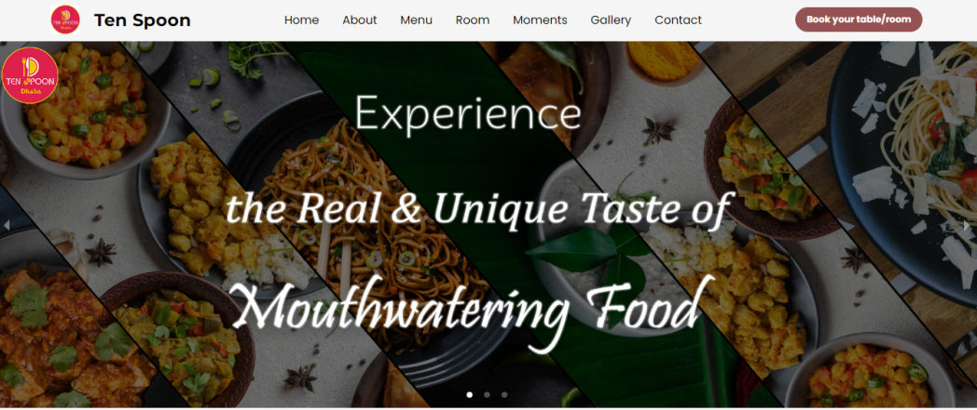

**Fig.1.** Home

An important part of providing website visitors with an in-depth overview of the website or business is the "About" page. Fig.2. corresponds to the About page of the website. This page provides a clear and simple explanation of the purpose, mission, and overall aims of the organisation that is the source of the website. It acts as a window into the essence of the organisation. A comprehensive resource for users looking for an improved understanding of the website's inner workings and distinctive qualities is created by the "About" page's role as a central location for providing essential information and specifications linked to the website.

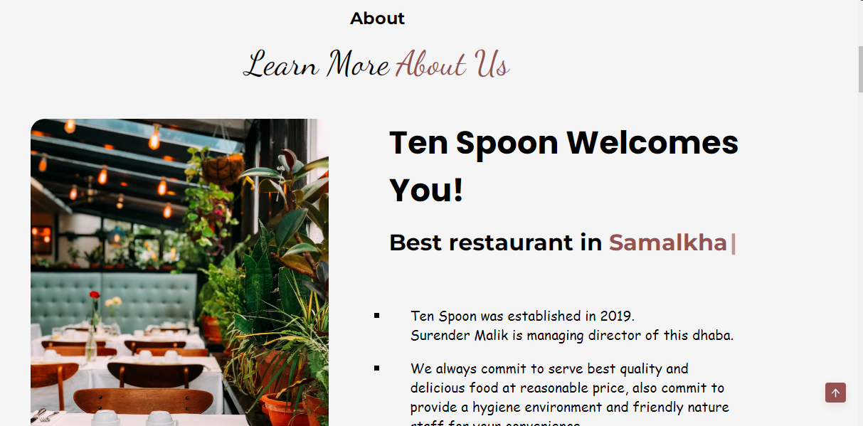

**Fig.2.** About

The "Menu" page, shown in Fig.3, is responsible for giving comprehensive details on the various sorts of food that the restaurant serves. This website is intelligently divided into three separate areas, each of which caters to a different type of gastronomic pleasure. The "Special" cuisine is presented in the first part and includes dishes such the Special Thali, Butter Masala Dosa, and Dahi Bhalla. The second subsection is titled "Beverages," and it includes selections like Vanilla Shake and Hot Coffee. Chinese food is included in the third and final portion, with dishes like spring rolls, chilli potato, and noodles, among others.

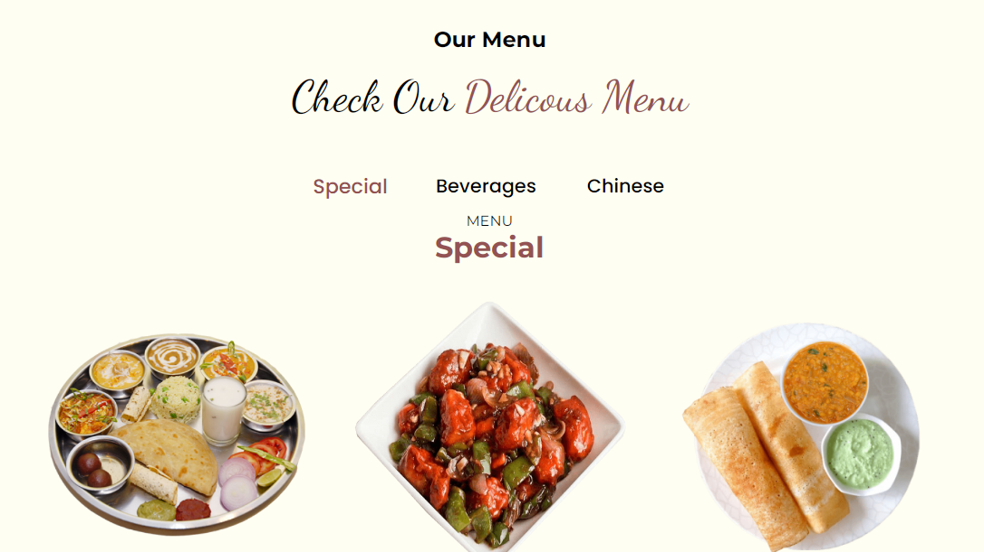

**Fig.3.** Menu

Fig.4 is a helpful visual depiction of the many kinds of rooms that are available and the amenities offered by the restaurant in this context. It corresponds to the "Room" part of the restaurant's website. This graph demonstrates the numerous lodging choices the restaurant provides so that potential customers may make well-informed selections regarding their stay. In essence, Fig.4 is a useful tool for guests curious about the restaurant's housing offerings. They gain a better understanding of the many accommodation alternatives, including any extras or features that come with each kind of room. Potential customers' decision-making process is facilitated by this visual depiction, which also improves their entire experience while thinking about dining at the restaurant.

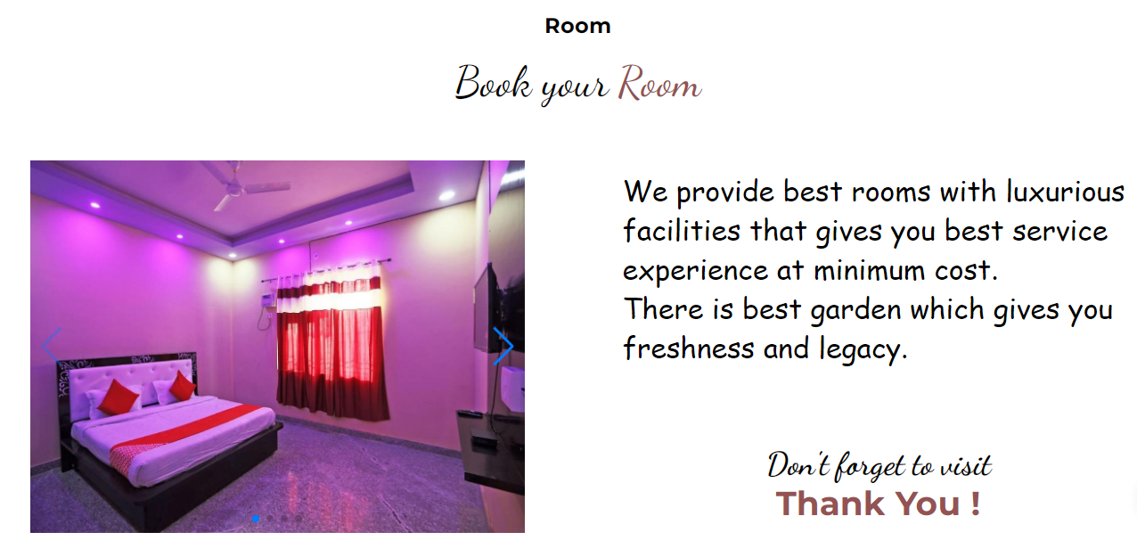

**Fig.4.** Rooms

Fig.5 serves as an illustration of the services and opportunities offered for special occasions and gatherings and corresponds to the "Moments/Events" section of the restaurant's website. This illustration clearly shows that the restaurant provides a variety of event-related services, making it a perfect location for many sorts of gatherings and celebrations. Fig.5 specifically emphasizes the restaurant's potential for happy occasions by showing that it offers spaces for celebrations like birthday parties and wedding anniversaries. It also draws attention to the restaurant's capacity for hosting meetings, portraying it as a flexible venue for both social and professional gatherings. It is clear from the reference to a "appropriate price" that the restaurant provides reasonable pricing for these services, making it a desirable option for potential event organizers.

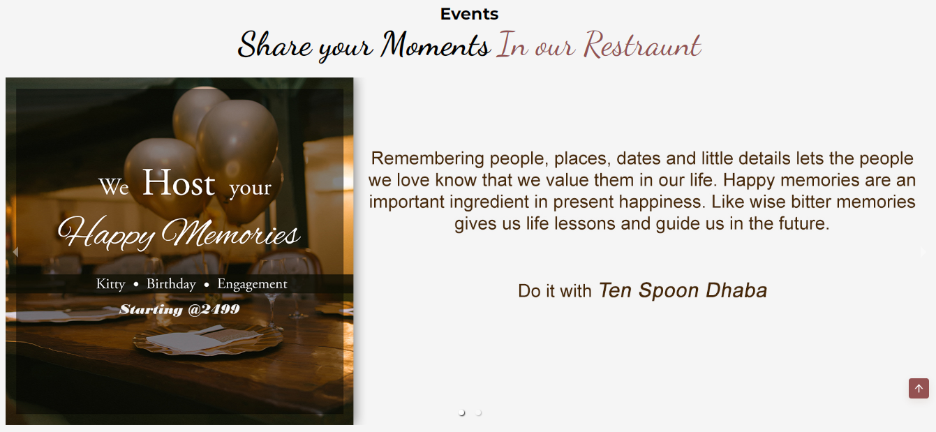

**Fig.5.** Events

This section is correlates to the "Gallery" portion of the restaurant's website and serves as a visual depiction of the restaurant owner's rich and appealing pictures. This illustration efficiently communicates the presence of a dedicated gallery part on the website, which displays a selection of aesthetically beautiful and intriguing photos. The goal of Fig.6 is to present website visitors with a visual feast, allowing them to explore and enjoy the décor, food, and general mood of the restaurant through attractive images. The phrase "beautiful images" suggests that the gallery has been carefully picked to promote the restaurant's aesthetic appeal, maybe including images of delectable cuisine, exquisite decor, and happy customers.

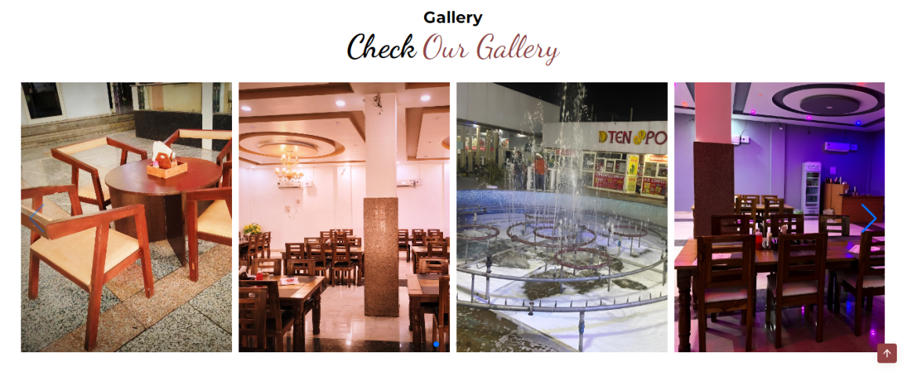

**Fig.6.** Gallery

Fig.7 is associated to the restaurant's website's "Contact" part, and it successfully communicates the presence of a dedicated contact area, allowing visitors to connect with the restaurant's employees for enquiries or information. It also has a useful feature in the shape of a Google Map, which allows guests to easily identify and access the restaurant's real address. This statistic suggests that the restaurant is approachable and customer-friendly, providing an easy means for guests or potential customers to contact the restaurant's personnel for a variety of reasons, such as making reservations, requesting information, or resolving any complaints they may have. The addition of a Google Map boosts the user experience by making it easier to discover the restaurant's actual location, making it more accessible and enticing to guests.

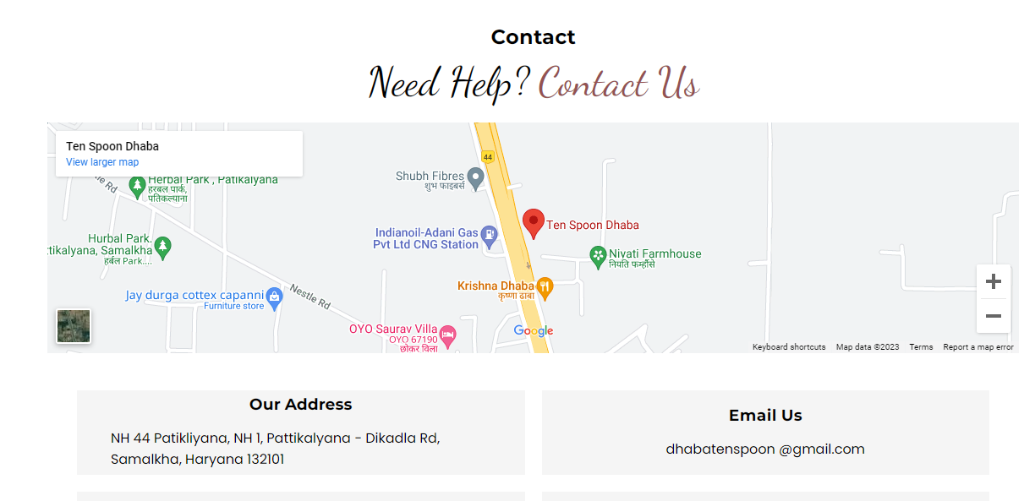

**Fig.7.** Contact

Customers may book a table reservation by using the "Book a Table" tool, which allows them to arrange their dining experience ahead of time. This is especially useful for individuals who want to avoid crowded or hectic periods, assuring a more relaxing and pleasurable dinner. It is consistent with the restaurant's focus on customer happiness and convenience. Fig.8 is linked to the "Book a Table" feature on the restaurant's website, and it graphically expresses the presence of a dedicated page or capability where clients may reserve a table in advance. This statistic represents the restaurant's dedication to providing a convenient and customer-oriented experience. It serves as a clear visual signal that the restaurant priorities its customers' comfort and provides a solution to improve their eating experience by allowing them to reserve tables ahead of time.

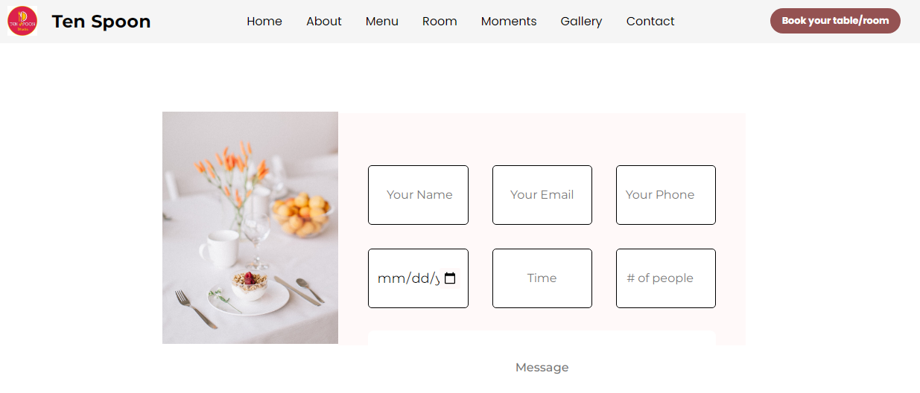

**Fig.8.** Book-Your-Table

**V. BENEFITS OF THE SYSTEM**

The chapter discussed numerous noteworthy benefits that have the potential to alter the future of restaurant management and consumer experiences. First and foremost, the emphasis on improving the user experience through a user-friendly website layout is positioned to make consumer interactions more intuitive and engaging [20]. Incorporating useful user input encourages continuous improvement. Using data analytics provides a huge advantage since it provides deep insights into client preferences and behaviors. This data-driven strategy may help guide menu changes, strategic marketing decisions, and overall company objectives [24].

The adaption of the website and reservation system for mobile accessibility coincides with the present trend of smartphone domination, guaranteeing that clients can easily access and use these services. Integration with social media networks allows you to reach a larger audience and encourages more involvement. Continuous security procedures demonstrate the company's dedication to protecting consumer information and ensuring data privacy. Finally, being current on technology breakthroughs ensures that the website and reservation system remain competitive and up to date, adjusting to the ever-changing digital world. These benefits, when combined, position restaurants for future success by simplifying operations, improving customer experiences, and staying on top of industry developments.

## **Benefits of the System**

This system provides a significant benefit by needing no investment from consumers; it is fully free to use on Android mobile devices, with all features and capabilities available for free. Furthermore, there are no restrictions on the type of interface that may be used, giving users complete freedom. The system is accessible from anywhere, and users may log in from any mobile device using their email and password if they don't have their own. This convenience extends to the opportunity to make table reservations straight from their mobile phones, saving important time and effort. Notably, this helps not only consumers but also restaurant owners, since it encourages an increase in table reservations, which contributes to their financial well-being [25].

**Table.3.** Tangible Benefits

|  |  |  |
| --- | --- | --- |
| **Sr. No.** | **Benefits** | **Description** |
| 1. | No investment | The usage of this system on Android mobile devices of completely free for users. Every component and functionality within the system is provided at no cost. Furthermore, users have the flexibility to utilize any interface that suits their preference, as there are no restrictions imposed on the system. |
| 2. | Accessibility of system | The system can be accessed from any location as long as the user has a mobile device. In the event that the user does not have their mobile device, they can still access their account on any other mobile device entering their email and password. |
| 3. | Accessibility | Users have the convenience of using their mobile phones to reserve a table, thereby saving both their time and energy. |
| 4. | Economic benefit | The ability for users to book tables using their mobile phones is advantageous not only for the customers but also for the restaurant owners, as it enables an increased number of table reservations. |

The advantages of employing this technique are numerous. It really lowers work, especially when we need to reserve a restaurant table for a function. Instead of dealing with the uncertainty of availability upon arrival, we may easily reserve a table in advance, saving us the trouble. Another big benefit is time savings, which allows users to place orders without relying on others, thereby optimizing efficiency [26]. The website's user-friendly interface improves the entire experience by providing adaptive and interactive graphical interfaces. This, in turn, increases customer happiness since the system priorities user-friendliness and intuitiveness. Importantly, users are not required to perform any maintenance, making the system even more user-friendly [27].

**Table.4.** Intangible Benefits

|  |  |  |
| --- | --- | --- |
| **Sr. No.** | **Benefits** | **Description** |
| 1. | Reduces effort | Using this system significantly minimizes our effort. For instance, if we plan to go to a restaurant for a party and upon arriving, find that no tables are available, we can easily overcome this by booking a table in advance through this system. This only requires filling in some details, making the process hassle-free. |
| 2. | Time saving | With this system, users can confidently make the most of their time and no longer need to depend on anyone else to place their orders, ensuring their autonomy and efficiency. |
| 3. | Friendly user interface | The developed website offers end users interactive graphical interfaces that are highly adaptable, ensuring a seamless and user-friendly experience. |
| 4. | Customer Satisfaction | By ensuring a user friendly and intuitive user interface, customer satisfaction will be significantly improved. |
| 5. | Maintainability | There is not any maintain effort by user. |

**VI. CONCLUSION AND FUTURE SCOPE**

The restaurant business is facing the challenges of improving operational efficiency and boosting customer happiness in the face of emerging digital dynamics. This chapter has examined a creative technique used by restaurants to address these issues, with a focus on the deployment of a complex website-based system. This system is critical in simplifying different elements of restaurant administration, with a special emphasis on storing client information and allowing online reservations.

This internet interface's user-friendly design stands out as a vital feature, allowing guests to easily organize their eating experiences while drastically decreasing time waste. One of the most notable advantages of this new technique is its capacity to provide a personalized touch to each consumer. The approach ensures personalized attention and service by painstakingly matching each order to a specific seat at the table. This game-changing website-based solution is set to revolutionize restaurant management practices, ushering in an era of streamlined operations and enhanced client experiences.

Looking ahead, there are various potential routes for future investigation and advancement in this subject. To begin, improving the user experience by constantly refining the website's user-friendly structure and design to make it even more straightforward and engaging for consumers, with the integration of useful user input. Second, using the data generated via the website-based system to get significant insights into customer preferences and behaviors, allowing for informed menu revisions, successful marketing campaigns, and overall data-driven decision-making.

Third, making the website and reservation system mobile-responsive is critical to ensure that consumers can simply access and use these services on their smart phones, which are quickly becoming the key device for online interactions. Furthermore, investigating ways to incorporate social media platforms into the system can broaden its reach and connect with a larger audience. Furthermore, constant upgrades and improvements to security processes are required to protect consumer information and secure data privacy. Finally, remaining current with the newest frontend technologies and trends is critical to keeping the website and reservation system competitive and up to date in an ever-changing digital world.

**References**

[1] E. Brynjolfsson and L. M. Hitt, "Paradox lost? Firm-level evidence on the returns to information systems spending," Management Science, vol. 42, no. 4, pp. 541-558, 1996.

[2] Rajender Kumar, Punit Soni, Anju Gandhi, Stuti Mehla, "An Automated Student Result Management System (SRMS) for Educational Efficiency and Data Security Enhancement," Journal of Data Acquisition and Processing, ISSN: 1004-9037, Vol. 38 (3), 2023, pp.6903-6916, DOI: 10.5281/zenodo.7778413.

[3] A. G. Picciano, "Theories and frameworks for online education: Seeking an integrated model," Online Learning, vol. 21, no. 3, pp. 166-190, 2017.

[4] Rajender Kumar, Punit Soni, Anju Gandhi, Stuti Mehla, "Exploring Artificial Intelligence Transforming Image Creation Based Art.Ai Platform and Its Creative Impact," Journal of Harbin Engineering University, ISSN: 1006-7043  [Vol. 44 No. 8 (2023): Issue 8](https://harbinengineeringjournal.com/index.php/journal/issue/view/32), pp. 1526-1538, 2023.

[5] K. L. Keller, "Conceptualizing, measuring, and managing customer-based brand equity," Journal of Marketing, vol. 57, no. 1, pp. 1-22, 1993.

[6] Rajender Kumar, Vipin Tomar, Punit Soni, & Satveer Kour. (2023). Implementing Data-driven Approach for Institutional Decision-making in Higher Education. International Journal of Wireless & Mobile Networks (IJWMN), 01(01), 01-06.

[7] T. Bodenheimer, "Coordinating care—a perilous journey through the health care system," New England Journal of Medicine, vol. 358, no. 10, pp. 1064-1071, 2008.

[8] Kumar, R., Khanna, R., & Kumar, S. (2022). Technological Transformation of Middleware and Heuristic Approaches for Intelligent Transport System. Autonomous Vehicles Volume 1: Using Machine Intelligence, 61-82.

[9] D. I. Cleland and L. R. Ireland, "Project management: strategic design and implementation," McGraw-Hill, 2007.

[10] Gaba, S., Nagpal, S., Aggarwal, A., Kumar, R., & Kumar, S. (2022, November). An Analysis of Internet of Things (IoT) Malwares and detection based on Static and Dynamic Techniques. In 2022 Seventh International Conference on Parallel, Distributed and Grid Computing (PDGC) (pp. 24-29). IEEE.

[11] P. Bansal, "Evolving sustainably: A longitudinal study of corporate sustainable development," Strategic Management Journal, vol. 26, no. 3, pp. 197-218, 2005.

[12] Kumar, R., Soni, P., Aggarwal, A., Kumar, M., & Mishra, N. (2022). An Analytical Approach for Sustainable Development in Smart Society 5.0 Using Swasthya Sahayak Application. In Decision Analytics for Sustainable Development in Smart Society 5.0: Issues, Challenges and Opportunities (pp. 131-152). Singapore: Springer Nature Singapore.

[13] J. P. Guthrie, "High-involvement work practices, turnover, and productivity: Evidence from New Zealand," Academy of Management Journal, vol. 44, no. 1, pp. 180-190, 2001.

[14] Keshav Garg, R. K., Gupta, A., & Nirwal, A. (2022). What and why you need to know about Non-Fungible Tokens (NFTs). International Journal of Scientific Research in Engineering and Management, 6(6), 1-4. Retrieved from https://ijsrem.com/download/what-and-why-you-need-to-know-about-non-fungible-tokens-nfts/

[15] Chatha, D., Aggarwal, A., & Kumar, R. (2022). Comparative Analysis of Proposed Artificial Neural Network (ANN) Algorithm With Other Techniques. In Research Anthology on Artificial Neural Network Applications (pp. 1218-1223). IGI Global.

[16] Kumar, R., Khanna, R., & Kumar, S. (2021). Vehicular middleware and heuristic approaches for intelligent transportation system of smart cities. In Cognitive Computing for Human-Robot Interaction (pp. 163-175). Academic Press.

[17] Kumar, R., Khanna, R., & Kumar, S. (2018). Deep learning Integrated approach for collision avoidance in Internet of Things based smart vehicular networks. Journal of Advanced Research in Dynamical and Control Systems, 10(14), 1508-1512.

[18] Kumar, R., Khanna, R., & Kumar, S. (2018). An effective framework for security and performance in Intelligent Vehicular ad-hoc network. Journal of Advanced Research in Dynamical and Control System, 10(14), 1504-1507.

[19] Kumar, R., & Kumar, R. (2016). A Comparative Analysis of Performance Metrics of Different Cloud Scheduling Techniques. International Journal of Innovations in Engineering & Technology, 7(2), 222-226. ISSN: 2319-1058.

[20] Sardana, S., & Kumar, R. (2016). Energy Efficient Target Tracking in Wireless Sensor Networks. International Journal of Innovations in Engineering & Technology, 7(2), 271-275. ISSN: 2319-1058.

[21] Gupta, G., & Kumar, R. (2016). Acoustic Channel Modeling and Simulation for Underwater Acoustic Wireless Sensing Networks. International Journal of Computer Applications, 975, 8887.

[22] Kumar, R., Khanna, R., & Verma, P. K. (2014). Middleware Architecture of VASNET and Its Review for Urban Monitoring & Vehicle Tracking. International Journal of Emerging Research in Management & Technology, 3(1), 41-45.

[23] Garg, T., Kumar, R., & Singh, J. (2013). A way to cloud computing basic to multitenant environment. International Journal of Advanced Research in Computer and Communication Engineering, 2(6), 2394-2399.

[24] Kumar, R., Khanna, R., & Kumar, S. (2013). A Proposed work on Node Clustering & Object Tracking Processes of BFOA in WSN. International Journal of Computer Science & Communication, 4(2), 207-212.

[25] R. Kumar , R. Khanna , S. Jangra , and P. K. Verma , “ A study of diverse wireless networks ,” IOSR Journal of Engineering , vol. 2 , no. 11 , pp. 01 – 05 , 2012 .

[26] Kumar, R., Verma, P. K., & Verma, P. K. (2012). Role of Information Communication Technology and its Impact on Health Sector. ijarcs, 1(2), 122-125.

[27] Kumar, R., & Batra, A. (2011). Employing Grid Comparative Strategies in Cloud Computing. IJCSIT-ISSN 0975-9646, 2(5), 2246-2253.