“SPATIO-TEMPORAL JOINT CHANNEL ESTIMATION FOR FDD MASSIVE MIMO”

¹K. Praveen, ²A. S. Keerthi Nayani

^{1,2} Assistant Professor, ECE Department

Matrusri Engineering College, Hyderabad, Telangana state

Abstract

In future 5G communications, Massive MIMO presents a highly efficient system in terms of spectrum utilization and energy consumption. Its potential performance gain depends on accurate channel estimation. Standard channel estimating algorithms are frequently used at base stations (BSs) with a large number of antennas. We take advantage of the spatio-temporal common sparsity found in delay-domain MIMO channels to reduce the pilot overhead. Adaptive structured subspace pursuit (ASSP) technique is utilized to jointly estimate channels corresponding to numerous OFDM signals with a limited number of pilots for improved accuracy. According to simulation data, this suggested method can efficiently estimate channels while lowering pilot overhead and come close to matching the performance of the top oracle least squares estimator.

Keywords: MIMO, OFDM, SCS, FDD, Pilot overhead, Channel estimation
.

Introduction
Recently, significant attention has been directed toward massive MIMO, a technique employing numerous antennas at the base station (BS) to simultaneously serve multiple users, as a promising approach for achieving high-throughput green wireless communications. The potential of massive MIMO to substantially enhance system capacity and energy efficiency through spatial flexibility has positioned it as a crucial enabling technology for the forthcoming energy- and spectrum-efficient 5G communications. Accurate channel state information (CSI) acquisition is imperative for large-scale MIMO systems to carry out functions such as beamforming, resource allocation, and signal detection. However, the extensive number of antennas at the BS results in excessively high pilot overhead, posing a challenge for each user to estimate channels linked to hundreds of transmit antennas. Achieving accurate channel estimates with low pilot overhead, particularly for large frequency division duplex (FDD) multiple-input multiple-output (MIMO) systems, becomes a formidable task. Existing massive MIMO research has often sidestepped this issue by assuming the time division duplex (TDD) protocol, making it easier to acquire CSI in the uplink at the BS and then utilizing channel reciprocity to directly obtain downlink CSI. However, challenges such as short coherence durations and errors in radio frequency chain calibration may compromise the accuracy of uplink-acquired CSI for the downlink. Furthermore, the prevalence of FDD systems in current cellular networks, owing to potential advantages like lower latency and more efficient communications compared to TDD systems, necessitates a comprehensive investigation into the challenging problem of channel estimation to ensure backward compatibility of large MIMO systems based on frequency division multiplexing (FDD) with existing FDD-dominated cellular networks. [7].

Problem statement

In the realm of frequency division duplex (FDD) massive MIMO systems, the considerable quantity of antennas at the base station results in a pilot overhead that is difficult to sustain. This challenge arises because each user is required to estimate channels linked to a significant number of transmit antennas, resulting in an excessively high pilot overhead. As a result, the formidable task in FDD massive MIMO systems is to achieve accurate channel estimation while concurrently keeping the pilot overhead at a manageable level.

Background and Literature

The user grouping and scheduling issues based on two-stage precoding were put forth by YI XU, Guosen Yue, and Shiwen Mao [1], who also highlighted the tremendous potential of massive MIMO systems as a crucial enabling technology for cellular systems that go beyond fourth generation (4G) cellular systems. This opens up a wealth of brand-new research questions for academic and commercial researchers to explore. Jiankang Zhang and Bo Zhang [2] investigated ways to get rid of pilot contamination. A particularly serious drawback in large-scale multi-cell systems is pilot contamination. How to lower pilot overhead was proposed by Ruoyu zhang and Honglin zhao [3]. Recently, there has been increased interest in the massive multiple-input multiple-output (MIMO) system because it is expected to cut costs and boost system throughput.

The CS algorithm by Saadet Simay Yilmaz is examined in this study, focusing on the elimination of users based on channel correlation. The research investigates the capacity and estimation accuracy of large MIMO systems under less-than-ideal transceiver hardware conditions. The analysis is conducted using a novel system model that takes into consideration hardware degradation at each antenna, introducing additional distortion noise inversely proportional to the antenna's signal power. This approach differs from traditional point-to-point MIMO and highlights the advantages of multi-user multiple-input multiple-output (MIMO), such as compatibility with cost-effective single-antenna terminals, independence from a complex scattering environment, and simplified resource allocation, as every active terminal utilizes all time-frequency bins.

Pioneered by L. Lu, G. Y. Li, and A. L. Swindlehurst, massive multiple-input multiple-output (MIMO) wireless communications entails outfitting cellular base stations (BSs) with a remarkably large number of antennas. This method uses relatively simple (linear) processing techniques and has the potential to produce significant gains in both spectrum and energy efficiency. H. Minn and N. Hahir have developed several classes of optimal training signals for frequency-selective channel estimation in the context of MIMO OFDM systems. By utilizing the basic characteristics of the discrete Fourier transform, these ideal training signals are produced, which reduce the mean square error of the channel estimation.

We examine both single and multiple OFDM training symbols, encompassing frequency division multiplexing, time division multiplexing, combinations of these techniques, as well as code division multiplexing in both the frequency and time domains. Multiple optimal pilot tone allocations are available for the transmit antennas. W. Dai introduced the subspace pursuit algorithm [8] as a groundbreaking method for reconstructing sparse signals, both with and without noisy disturbances. When applied to highly sparse signals, the algorithm exhibits low computational complexity similar to orthogonal matching pursuit approaches, and its reconstruction accuracy resembles LP optimization techniques. M. Duarte [9] and Y. Eldar assert that compressed sensing (CS) is an emerging field that has garnered considerable scholarly attention in recent years.
Proposed method
The spatio-temporal joint channel estimation scheme for FDD massive MIMO is proposed in this section.
Non-Orthogonal Pilot Scheme at the BS:
Traditional Nyquist sampling theorem serves as the foundation for the design of orthogonal conventional pilots, which are extensively used in current MIMO systems. In Fig. 3.1, the orthogonal pilots are shown.
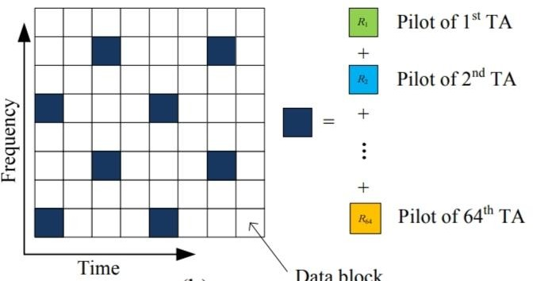
Fig.1. Proposed non-orthogonal pilot design.

SCS-Based Channel Estimation at the User
At the user, after the removal of the guard interval and discrete Fourier transformation (DFT), the received pilot sequence yr ∈ C Np×1 of the rth OFDM symbol can be expressed as yr = P M m=1 dia{pm}F| ξ hm,r 0(N−L)×1 + wr = P M m=1 Pm FL| ξhm,r + wr = P M m=1 Φmhm,r + wr, (4) where Pm= dig{pm}, F ∈ C N×N is a DFT matrix, FL ∈ C N×L is a partial DFT matrix consisted of the first L columns of F, F| ξ ∈ C Np×N and FL| ξ ∈ C Np×L are the sub-matrices by selecting.
For the estimation of channels in extensive MIMO systems, we propose employing the ASSP approach as outlined in approach 1. The recommended ASSP technique, derived from the conventional subspace pursuit (SP) algorithm, leverages the structured sparsity of D to improve the performance of sparse signal recovery. Certain notations in Algorithm 1 require clarification.

Algorithm : Proposed ASSP Algorithm.
Input: Noisy measurement matrix Y and sensing matrix Ψ.
Output: The estimation of channels {hm,t} m=M,t=r+R−1 m=1,t=r .
- Step 1 (Initialization) The initial channel sparsity level s = 1, the iterative index k = 1, the support set Ω k−1 = ∅, and the residual matrices Rk−1 = Y and kRs−1kF = + inf.
- Step 2 (Solve the Structured Sparse Matrix D to (9)) Repeat
- (Correlation) Z = ΨHRk−1 ;
- (Support Estimate) Ω˜ ′k = Ωk−1 𝖴 Π s kZlkF L l=1 ;
- (Support Pruning) ⌣ DΩ˜′k = Ψ † Ω˜′kY; ⌣ D(Ω˜′k) c = 0; Ω˜k = Πs n ⌣ Dl F oL l=1 ;
- (Matrix Estimate) ⌣ DΩ˜k = Ψ † Ω˜ kY; ⌣ D(Ω˜ k) c = 0;
- (Residue Update) Rk = Y − Ψ ⌣ D;
- (Matrix Update) ⌣ D k = ⌣ D; if Rk−1 F > Rk F
- (Iteration with Fixed Sparsity Level) Ω k = Ω˜ k ; k = k + 1; else
- (Update Sparsity Level) ⌣ Ds = ⌣ D k−1 ; Rs = Rk−1 ; Ωs = Ωk−1 ; s = s + 1; end if until stopping criteria are met
- Step 3 (Obtain Channels) Db = ⌣ Ds−1 and obtain the estimation of channels
{hm,t} m=M,t=r+R−1 m=1,t=r according to (4)-(9).

Space-Time Adaptive Pilot Scheme
The co-located antenna array at the base station is the reason behind the spatial common sparsity of MIMO channels. However, such common sparsity might not be ensured for antennas spaced distant in large MIMO with a wide array of antennas. To ensure the spatial common sparsity of wireless MIMO channels in each antenna group, it is advised that NG antenna groups be constructed from M transmit antennas, where MG = M/NG antennas with near spatial distances are allotted to the same antenna group.

Channel Estimation in Multi-Cell Massive MIMO

The channel estimation approach described initially for a single-cell scenario is extended to a multi-cell scenario as expounded in this paragraph [14]. In this configuration of a cellular network, there are L = 7 hexagonal cells, each with K single-antenna users, and a central base station (BS) with M antennas, all sharing the same bandwidth. The users within the central target cell contend with interference from the L-1 neighboring cells surrounding it. To alleviate pilot contamination caused by these interfering cells, a straightforward approach is to employ frequency-division multiplexing (FDM). FDM ensures that the pilot signals from adjacent cells are orthogonal in the frequency domain.

If the channel estimation training duration is shorter than the channel coherence time, the utilization of the FDM approach can effectively eliminate pilot contamination, as noted in reference [15]. However, in multi-cell systems, this method can lead to L times greater pilot overhead compared to single-cell systems. Alternatively, time-division multiplexing (TDM) offers a solution by transmitting pilots from nearby cells in separate time slots. In a multi-cell context employing a TDM system, the pilot overhead matches that of a single-cell setup [16]. It's worth noting that users in the target cell might experience slightly diminished channel estimation performance due to the influence of downlink precoded data from neighboring cells. Despite this marginal reduction in performance, the TDM scheme offers a clear advantage with its significantly reduced pilot overhead compared to the FDM approach.
窗体顶端

窗体底端

Results

Simulation analysis was employed to investigate the channel estimation methodology for FDD massive MIMO systems. The outcome is the MSE performance of the adaptive subspace pursuit (ASP) algorithm, exemplifying the suggested ASSP strategy. This technique is employed to enhance channel estimation performance and can adaptively determine the effective channel sparsity level. It demonstrates a notable reduction in mean square error compared to the ASP algorithm.

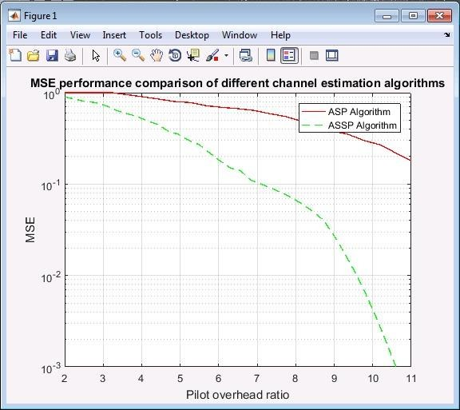

Fig 2. MSE performance comparison of different channel estimation algorithm

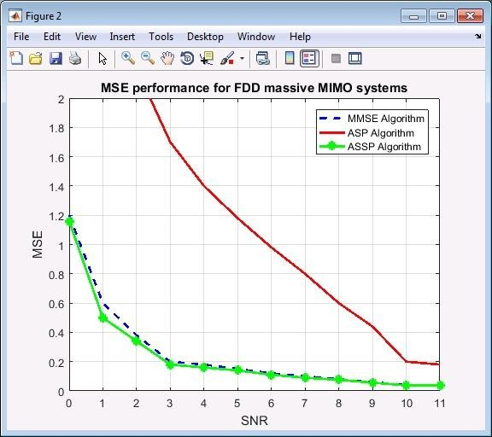

Fig 3. MSE performance for FDD massive MIMO

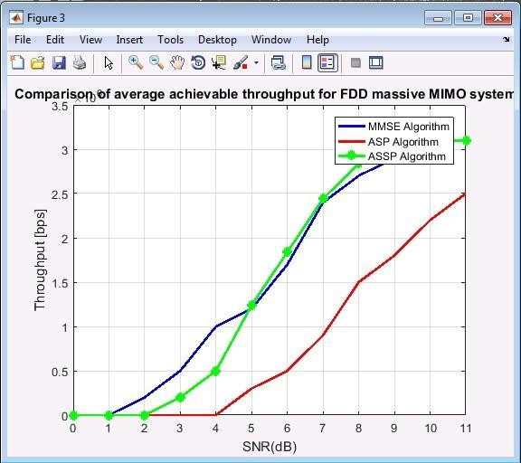
As show in Fig.3 consider Signal to noise ratio and average achievable throughput per user, respectively, average achievable throughput increases as well as signal to noise ratio(SNR) increases. We take into account the ASP algorithm, the ASSP algorithm, and the minimum mean square error (MMSE). We see that the ASSP algorithm outperforms ASP and MMSE in terms of throughput.

Fig 4. Comparison of average achievable throughput for FDD massive MIMO 3

As show in Fig.5 comparison of average achievable throughput for multicell FDD massive MIMO. Average achievable throughput improvements as well as signal to noise ratio (SNR) increases are taken into consideration, along with signal to noise ratio and average achievable throughput per user, respectively. We take into account the ASP algorithm, the ASSP algorithm, and the minimum mean square error (MMSE). We see that the ASSP algorithm outperforms ASP and MMSE in terms of throughput.

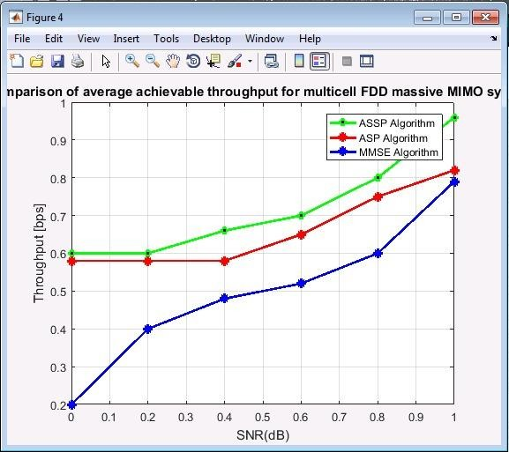

Fig 5. Comparison of average achievable throughput for mult icell FDD massive MIMO
Conclusion
The proposed system aims to minimize pilot overhead in MIMO systems. Within the framework of CS theory, non-orthogonal pilot designs are investigated to achieve accurate channel estimation. Simulation results indicate that the suggested channel estimation system can outperform its competitors in terms of channel estimate performance while significantly reducing pilot overhead. It experiences only minimal performance loss compared to the performance bound.

References
[1]. Erik G .Larsson ,Fredrik Tufvesson and Thomas L.Marzetta proposed “Massive MIMO for Next Generation Wireless Systems”,2014.
[2]. L. Lu, G. Y. Li, A. L. Swindlehurst, A. Ashrith min, and R. Zhang, “An overview of massive MIMO: Benefits and challenges,” IEEE J. Sel. Topics Signal Process., vol. 8, no. 5, pp. 742–758, Oct. 2014
[3]. E. G. Larsson, F. Tufvesson, O. Edfors, and T. L. Marzetta, “Massive MIMO for next generation wireless systems,” IEEE Commun. Mag., vol. 52, no. 2, pp. 186–195, Feb. 2014.
[4]. Y. Nam, Y. Akimoto, Y. Kim, M. Lee, K. Bhattad, and A. Ekpenyong, “Evolution of reference signals for LTE-advanced systems,” IEEE Commun. Mag., vol. 50, no. 2, pp. 132- 138, Feb. 2012
[5]. L. Correia, Mobile Broadband Multimedia Networks, Techniques, Models and Tools for 4G, San Diego, CA: Academic, 2006.
[6]. Jiankang Zhang,Bo Zhang,Shen Chen and Xiaomin Mu proposed”pilot contamination elimination for large-scale multiple antenna aided OFDM signals”,2015.
[7]. YI XU ,GUOSEN YUE and SHIWEN MAO “ two-stage Precoding scheme in which procedure is decompose to intergrouping and intragrouping precoding”,2014.
[8]. Ruoyu Zhang, Honglin zhao and Shaobo jia proposed “reduction of pilot overhead using SJSMP algorithm ”, 2016.
[9]. Saadet Simay Yilmaz and Berna Ozbek proposed “User Selection strategies to achieve spatial diversity”,2020.
[10].W. Dai and O. Milenkovic, “Subspace pursuit for compressive sensing signal reconstruction,” IEEE Trans. Inf. Theory, vol. 55, no. 5, pp. 2230– 2249, May 2009.
[11].M. Duarte and Y. Eldar, “Structured compressed sensing: From theory to applications,” IEEE Trans. Signal Process., vol. 59, no. 9, pp. 4053–4085, Sep. 2009.
[12].C. Qi and L. Wu, “Uplink channel estimation for massive MIMO systems exploring joint channel sparsity,” Electron. Lett., vol. 50, no. 23, pp.1770-1772, Nov. 2014.
[13].J. Choi, D. J. Love, and P. Bidigare, “Downlink training techniques for FDD massive MIMO systems: Open-loop and closed-loop training with memory,” IEEE J. Sel. Topics Signal Process., vol. 8, no. 5, pp. 802–814, Oct. 2014.
[14].S. L. H. Nguyen and A. Ghrayeb, “Compressive sensing-based channel estimation for massive multiuser MIMO systems,” in Proc. IEEE Wireless Communications and Networking Conference (IEEE WCNC’13), Shanghai, China, Apr. 2013.
[15].W. U. Bajwa, J. Haupt, A. M. Sayeed, and R. Nowak, “Compressed channel sensing: A new approach to estimating sparse multipath channels,” Proc. IEEE, vol. 98, no. 6, pp. 1058-1076, Jun. 2010.
[16].Z. Gao, L. Dai, and Z. Wang, “Structured compressive sensing based superimposed pilot design for large-scale MIMO systems,” Electron. Lett., vol. 50, no. 12 pp. 896-898, Jun. 2015.

