Chemistry of Some Fascinating Homoleptic Macrocyclic Polytelluroethers, Tellurometallomacrocycles and Telluraporphyrins; Synthesis and Structural Perspectives
Partha Pratim Das
P. G. Dept. of Chemistry, Magadh University, Bodh-Gaya
Abstract:
Since long back, organic chalcogen hypervalent compounds have garnered a lot of attention. The study of telluranes has attracted much less emphasis even though the structural along with theoretical properties of selenuranes as well as hypervalent sulfuranes have both been extensively investigated. Even pollytelluroether macromolecules are also not so large in number, which is definitely not expected given the better σ-character and lower electronegativity of Te compared to S/Se. The development of unique macrocycles with various core size and metal binding capacities has been facilitated by core-modified porphyrins, in which part of the four N donors are substituted by one or more Te. Te-containing 21- and 23-core modified porphyrins carry out several types of catalysis reactions. In this chapter, few interesting molecules from three different types of tellurmacrocycles, e.g. homopectic macrocyclic polytelluroethers, tellurometallomacrocycles and telluraporphyrins have been discussed briefly from their synthetic and structural viewpoints.

Introduction:
Over the past several decades, organic chalcogen hypervalent molecules have attracted a lot of interest. While the structural along with theoretical characteristics of selenuranes and hypervalent sulfuranes have been investigated in great detail, the chemistry of telluranes has received far less attention. Macrocyclic polytelluroether's crystal structure analysis is especially limited. Telluroether inclusion as donors (TeR₂) within a macrocyclic architecture should result in ligands susceptible to immeasurably extensive coordination chemistry due to Te's reduced electronegativity and consequently better σ-electron-donating characteristics in comparison to Se and/or S. Due to the accessibility of ¹²⁵Te NMR spectroscopy as a potent architectural probe, telluroether chemistry is much more appealing in these circumstances. Research on core-modified porphyrins, where some of the four N atoms are replaced by one or more heteroatoms O, S, Se, or Te, have led to the creation of novel macrocycles with different core dimensions as well as metal ion bonding capabilities. The intriguing category of compounds; Te-containing 21- and 21, 23-core modified porphyrins operates catalysis for the activation of H₂O₂. In these substances, the 21-positioned Te atom is located opposite to NH or S at the 23-position and has taken the spot of one of the pyrrole N-H groups. By donating a lone pair of electrons, the heteroatom at position 23 can aid in the oxidation of the Te donor at position 21. When combined with H₂O₂ and NaBr, meso-Tetraphenyl-21-telluraporphyrins serve as catalysts towards bromination processes. In this chapter, some important macrocyclic homoleptic polytelluroethers, tellurometallomacrocycles and telluraporphyrins have been discussed in details from their synthetic and structural perspectives.
Macrocyclic polytelluroethers (Homoleptic):
1,5-Ditelluracyclooctane (L¹), a unique eight-membered ring Te-macrocycle molecule, was reported¹ [Scheme 1]. The unusual ditelluridedication BF₄⁻ or PF₆⁻ salt, produced by two equivalents of NOBF₄ or NOPF₆ oxidizing the bis-telluride L¹, exhibits oxidizing properties. As an oxidant, the ditelluridedication salt functions as following [Scheme 1]. Diphenyl disulfide was produced in 91% yield when 2 equivalents of benzenethiol and 1 equivalent of the dication were treated in acetonitrile under an argon environment at room temperature for six hours. Similarly to this, when 1,2-diphenylhydrazine is treated with the dication and 1,4-diazabicyclo [2,2,2] octane (DABCO), 80% of the product is converted to azobenzene. Following the pyrolysis of an 8-member ring molecule, as described in Scheme 2, a novel chlorine derivative of a 12-member ring Te-macrocycle with three hypervalent Te^{IV} component [L²] is published², which also serves as an oxidant. By creating Cl⁻ bridges between the molecules, this generates polymeric frameworks in the crystal structure. Similar to the majority of diorgano-Te^{IV} dihalides, topology around the metal center has been distorted trigonal bipyramid, with the two alkyl-C atoms and only lone pair occupying the trigonal plane's three ends and the more electronegative Cl⁻ occupying their typical axial sites [Figure 1]. The <Cl-Te-Cl along with <C-Te-Cl angles seem not to be much distorted by the lone pair of electrons, however the <C-Te-C angles have been brought into closer proximity by the increased volume of lone pairs.
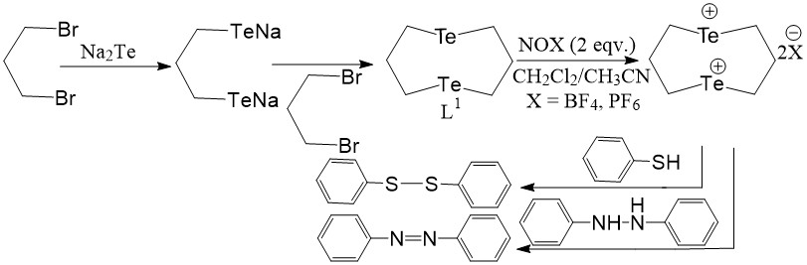
Scheme 1
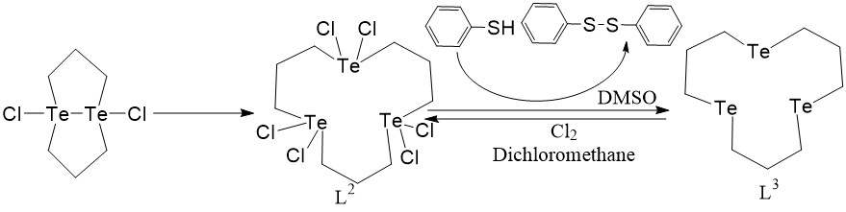
Scheme 2
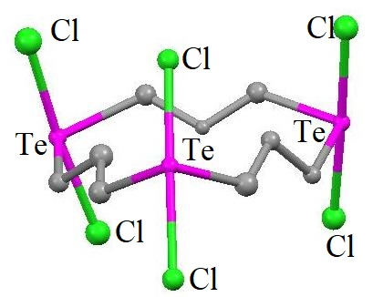  L² | 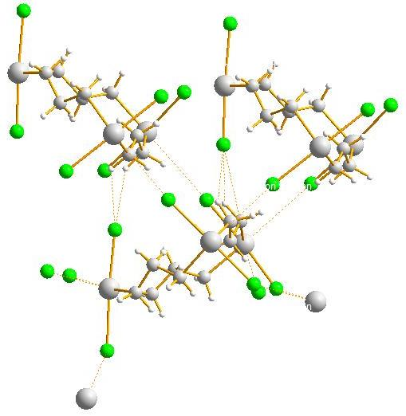
 | H-bonded network of L²
Figure 1
Te and Cl⁻ make several intermolecular interactions, which are typical of Te^{IV} complexes involving halogen-containing ligands, but there's no intramolecular connection between the Te atoms. Te^{IV} has a larger coordination number due to intermolecular interactions compared to what is anticipated by the molecule's stoichiometry. In the presence of Et₃N in DMSO under Argon atmosphere for 10 minutes at 50°C, 6 Equivalent Thiophenol interacted with one Equivalent of L² to produce a disulfide which had 90% yield as the oxidation product along with neutral L³ with a 90% yield as the reduction product, as illustrated in Scheme 2. This's noteworthy to note that L³ produces L² in a good yield when it interacts with Cl₂ in dichloromethane at room temperature.
Te-macrocyclic chelates/ Te-metallomacrocycles:

When mercuric chloride interacts with L⁴, a macrocycle chelate ring with a Te-ligand emerged³. This process is depicted in Scheme 3 represents the initial instance of a crystallographically characterized macrocyclic chelation containing Te-ligand. The coordinating architecture of Hg^{II}, which has bonds to two Cl⁻ along with two Te donors, appears tetrahedral. Te^{II} functions as both a Lewis acid as well as a Lewis base at the same time because of unique presence of Hg-Te and Te.....N connections. Te^{II} exclusively connects to Hg^{II} in above arrangement, ignoring the possibility of Te-N binding to produce a 6-member chelate ring. It demonstrates Te-ligands' high predilection for 'soft' acidic centers. Owing to the N-lone pair's involvement in the development of the intramolecular Te......N connection, the ligand's density has dropped. Every Ag^{I} ion within the polymeric Ag^{I} compound of L⁵ is linked to four Te donors of the four bridging L⁵ in the form of distorted tetrahedral fashion. The entire structure is made up of 24-member metallomacrocycles {[Ag₄(L⁵)₄] units}⁴ [Figure 2]. The structure has non-interacting [BF₄]_{n} anions amid cationic [Ag(L⁵)_{n}]^{n+} layers. The repeating component is [Ag₄(L⁵)₄] ring. In the development of the polymeric composition [Ag(L⁵)]_{n}[BF₄]_{n}, coordination of two Te donors of the ditelluroether, L⁵ to Ag^{I}, are involved. Synthesis method is shown in Scheme 4. L⁶ was formed along with its compounds [MCl₂(L⁶)]₂ (M = Pd or Pt). According to studies of molecular weight along with conductance, the crystal arrangement of [PtCl₂(L⁶)]₂ reveals a bimetallic combination of Pt^{II} with a 20-member metallomacrocycle ring that is stable in solution^{5,6} [Figure 3]. The pair of trans- Cl⁻ donors, the Te atom of one bridging ligand, the N atom from another bridging ligand and the square planar nature of the immediate surroundings around Pd in L⁶ make up the structure of the complex. As a consequence, a metallomacrocycle ring with 20-members is formed [Figure 3]. The synthetic routes are shown in Scheme 5. Similar types of reactions are observed for L⁷. Its synthesis and metal complex formations are displayed in Scheme 6.
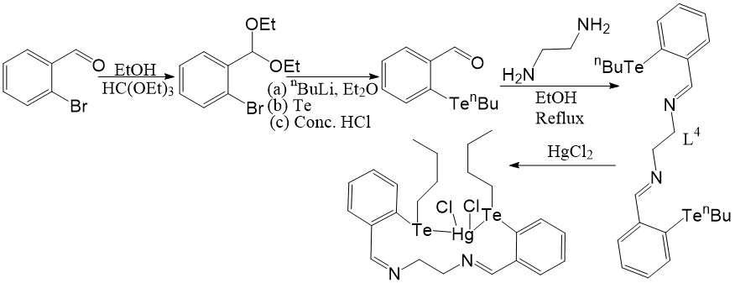
Scheme 3
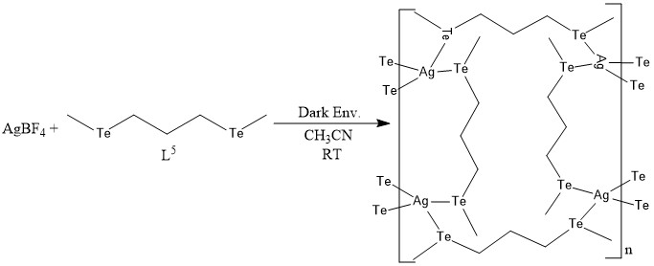
Scheme 4
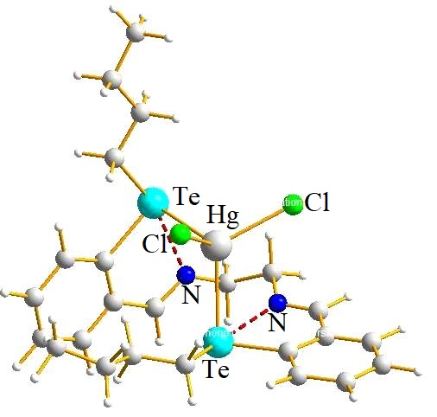 | 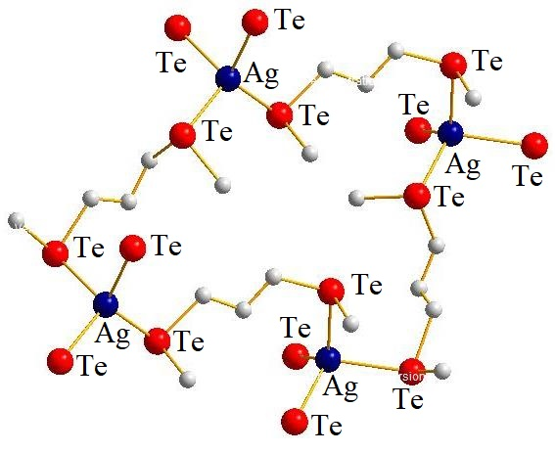
[Hg(L⁴)Cl2] | Repeating unit of [Ag₄(L⁵)₄]_{n}
Figure 2
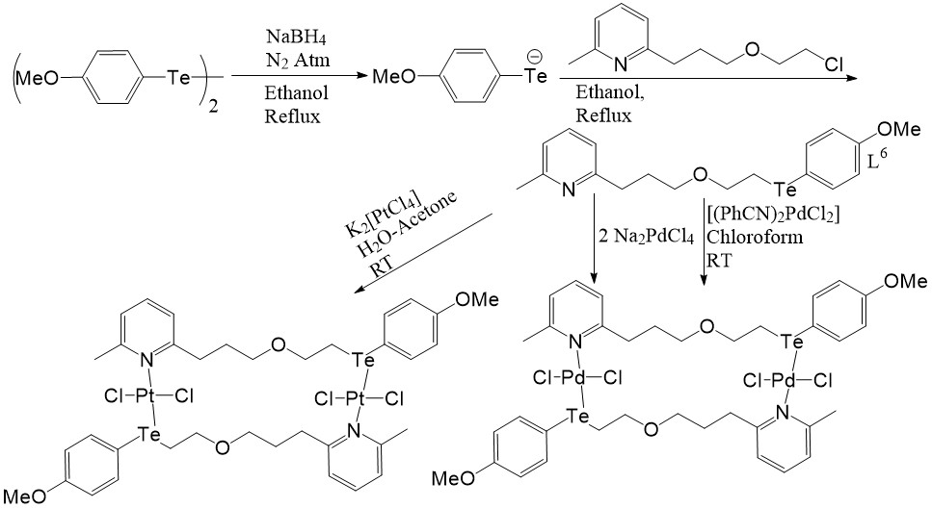
Scheme 5
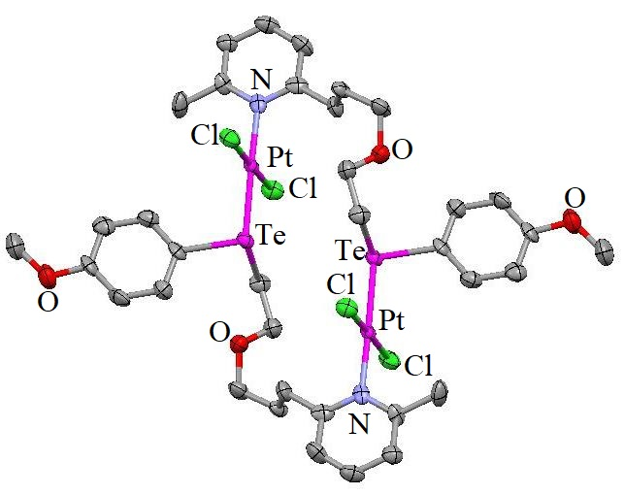 | 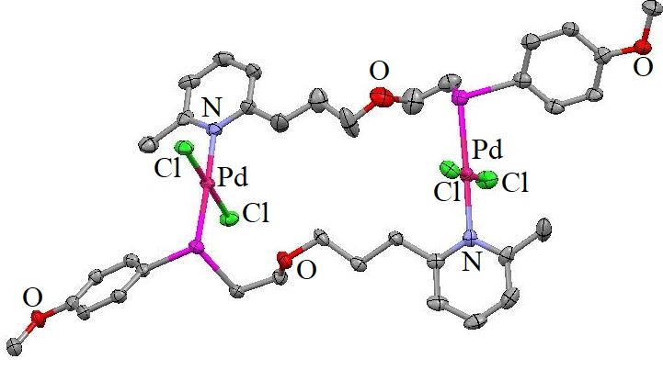
[PtCl₂(L⁶)]₂ | [PdCl₂(L⁶)]₂
Figure 3
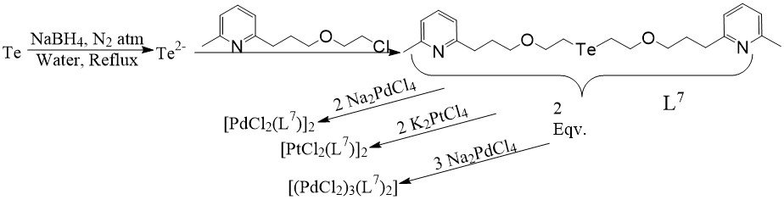
Scheme 6
Telluraporphyrins:
One Te atom is substituted instead of the NH component in the 21-position and is positioned opposing the NH or S atom in the 23-position within several core-modified porphyrins. 21-heteroatom-23-heteroatom interaction is enforced by the increased van der Waals radius of the heteroatoms inside the core-altered porphyrins. L⁸ is the very first published core-modified Te-porphyrin⁷ [Scheme 7]. From the crystal framework, it emerged that the Te.......S spacing (2.65 Å) was unusually low.
In hetero-substituted tetraphenylporphyrins, in which two NH groups in the central region have been substituted by S, Se, and Te, structural investigation reveals unusually close spacing among heteroatoms X and Y (X, Y = S, Se, Te), suggesting the existence of chemical associations among the heteroatoms [Figure 4]. High resolution NMR investigation supports these findings⁸.
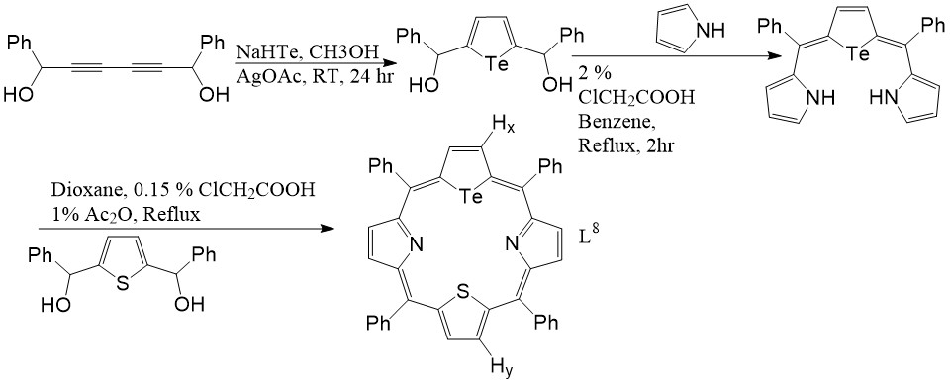
Scheme 7
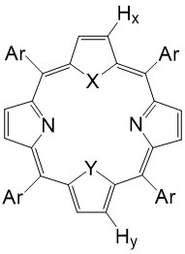 | 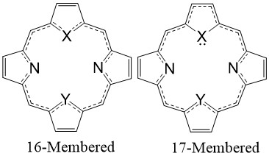
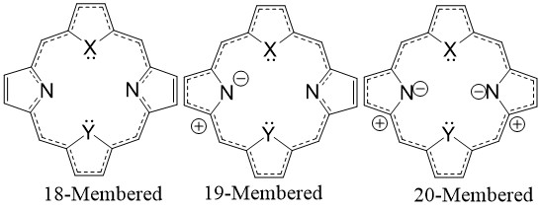
Figure 4
The inner as well as outer aromatic pathways of the porphyrin are altered by this interaction that rises in the sequence of S, Se, and Te and it also affects the chemical shifts of the H atoms; H_{x} and H_{y} along the molecule's edge⁸. The Kekulé structures of porphyrin provide an explanation for this. The potential Kekulé structures involving hetero-substituted porphyrins are depicted in Figure 4. The inner, outer, as well as extended outer aromatic pathways are represented by the 16-, 18-, and 20-member frameworks, respectively. As X......Y interaction grows, less electron density can be found on X and Y to support the interior aromatic route, increasing the statistical significance of the exterior (18-member) aromatic path. Due to their proximity to the exterior aromatic route, H_{x} and H_{y} exhibit downfield shifts in their NMR spectra in comparison with symmetrically substituted porphyrins. Such downfield shifts aren't caused due to heteroatoms' altering electronegativity, as was the case for free heterocycles. Here, H_{x} and H_{y} shifts upfield when the X......Y interaction inside the core is broken, either by protonation or complex formation. Such upfield shifts are caused by heteroatoms' complete electron densities contributing to the interior aromaticity, which lowers the likelihood of exterior aromaticity compared to its interior aromaticity. In L⁸, the Te…..S interaction causes charge transfer from Te to S. Thiophene-H (H_{y}) of L⁸ appears to move upfield in comparison to H_{y} of corresponding thia counterpart, since there is greater interior aromaticity via S in L⁸ relative to the symmetrical thia counterpart. Similar to this, the inner aromatic route on Te has reduced electron density accessible, which causes H_{x} to shift downfield.
In accordance with Scheme 8, the 21-telluraporphyrin L⁹ were produced made. Because of the Te donor's higher diameter compared to a typical porphyrin, the molecular framework of L⁹ exhibits a longer non-bonded N1.........N3 gap, distorting the framework. The porphyrin macrocycle featuring an enormous core heteroatom is virtually planar in spite of its modest Te-N(2) gap [Figure 5]⁹.It demonstrates that, in contrast to the selenaporphyrin analogue, the tellurophene ring is involved in aromatic delocalization. The 21-telluraporphyrins [L⁹⁻¹¹] are generally air sensitive, compared to their thia and selena equivalents, and are capable of being changed into the 21-oxaporphyrins [L¹²⁻¹⁴] by making use of m-chloroperoxybenzoic acid. The generation of a tellurium hydroxyl molecular structure [L¹⁵⁻¹⁷] is how this process moves forward. The pyrrole ring is deprotonated by the O at the Te atom, yielding the molecules L¹⁵⁻¹⁷ containing -OH group at the Te center. It is unique regarding the chemical properties of tellurophene for the Te atom in L⁹⁻¹¹ to easily get oxidised and then getting transformed into furan moieties [L¹²⁻¹⁴] after exposure to a peroxy acid. The behaviors of the macrocycles L⁹⁻¹¹ showed how significantly the porphyrin surroundings might change the tellurophene portion's fundamental activity. Telluroxide O gets protonated via the pyrrole NH trans- to the tellurophene ring, according to the crystal arrangement of L¹⁶, which results in zwitterions containing a -OH group linked to the Te donor. The Te-O linkage passing across the porphyrin plane is L¹⁶'s most intriguing architectural aspect. A weak H-bond is established between the Te-OH unit and the deprotonated N atom of the trans- pyrrol ring, which is tilted away from the plane in the direction of the -OH group.
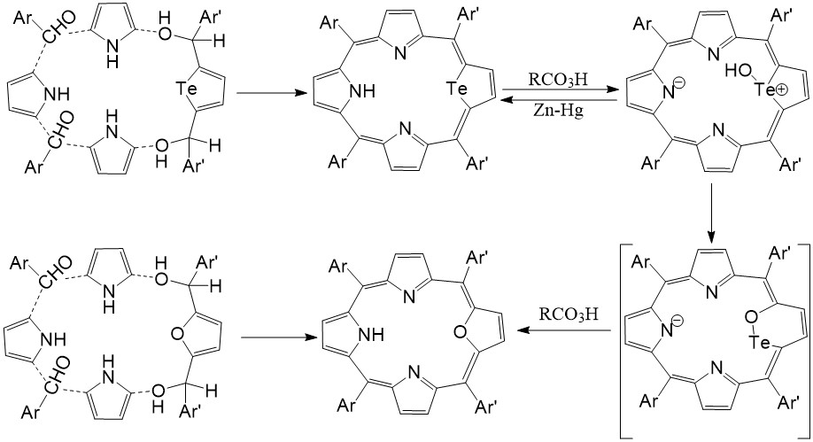
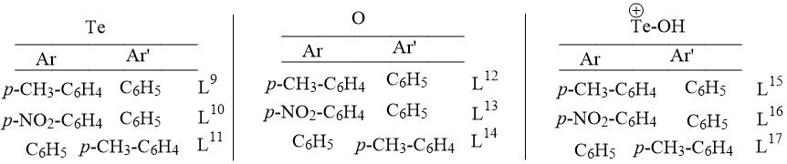
Scheme 8
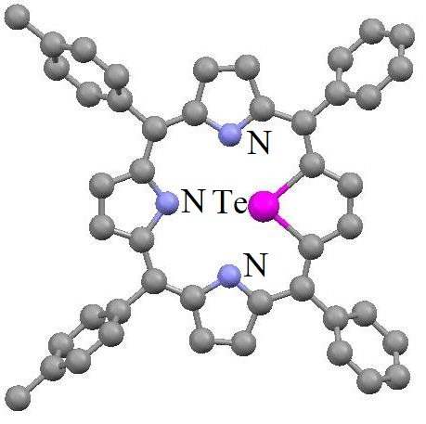 | 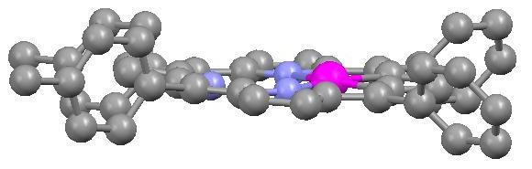
L⁹ (Top View) | Perpendicular L⁹ (Side View)
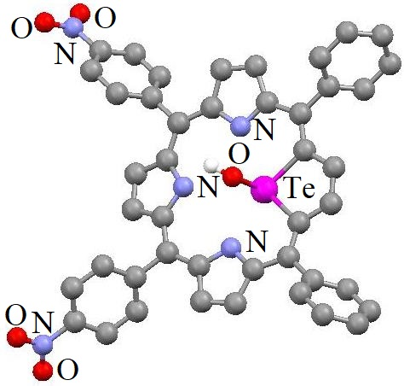 | 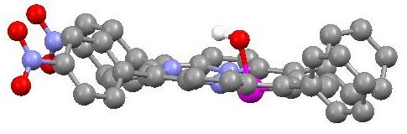
L¹⁶ (Top View) | L¹⁶ (Side View)
Figure 5
L⁹ is an excellent candidate to synthesize a novel molecular structure, aza-deficient porphyrin L¹⁸, by removing the Te donor from L⁹ due to the unstable character of the C-Te-C segment¹⁰ [Scheme 9].
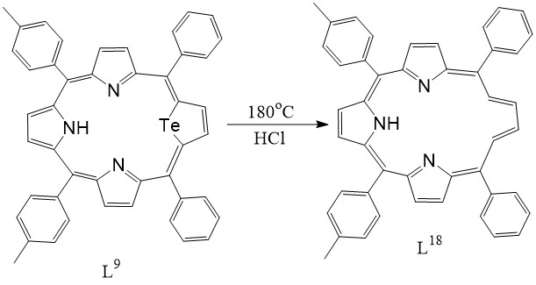 | 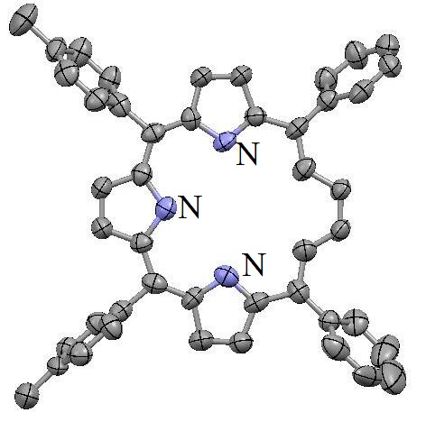
Scheme 9
The catalyst enabling the activation of Hydrogen peroxide (H₂O₂) can be an organotelluride¹¹. Mechanistic investigations have demonstrated that the first oxidation of organotelluride using H₂O₂ results in the formation of the Te^{IV} component; diorganodihydroxytellurane [R₂Te(OH)₂]. The organotelluride is subsequently generated through exchange of ligand, and followed by reductive elimination. Te containing 21- and 21,23-core-modified porphyrins stabilises the Te^{IV} intermediates through obtaining lone pair of electrons from the heteroatom at location 23.
21-telluraporphyrin (L¹⁹) is produced by the reaction between PhCHO, pyrrol, and 2,5-bis(phenylhydroxymethyl)tellurophene [Scheme 10]. The very same interaction, nevertheless, produces the oxidized Te-porphyrin (L²⁰) [Figure 6], byproduct of the chemical oxidation of L¹⁹ with air or H₂O₂, in the presence of light¹². Investigations using spectroscopy as well as cyclic voltammetry confirmed the straightforward aerial oxidation of L¹⁹. Experiments using cyclic voltammetry reveal that L¹⁹ and L⁸ undergo electrochemical oxidation at a greater negative potential compared to their lighter chalcogen counterparts. Such Facile oxidation happens due to bigger dimension of Te donor leading to deviation from planarity for L¹⁹ and L⁸ resulting from interactions in solution of the type 21-Te-23-S/N. Using H₂O₂, the oxidation of L¹⁹ and L⁸ progresses via second order rate constant. Each of these findings point to the significance of 21-telluraporphyrins as potential H₂O₂-activation catalysts. The 23-S/N helps with oxidation and functions as a backward donor to restrict access from one end, allowing oxidizable components to solely engage the Te donor site from the other side.
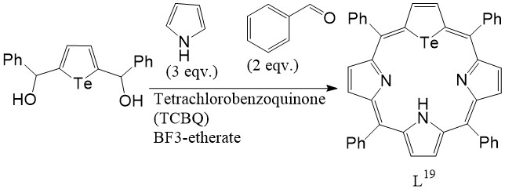 | 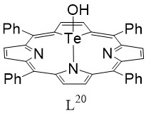
Scheme 10 | Figure 6
Additionally, the substances L⁸ and L¹⁹ serve as catalysts during bromination processes involving H₂O₂ and NaBr reagents. Two situations, as shown in Scheme 11, are possible according to mechanistic investigations. L⁸ is a significantly less effective catalyst compared to L¹⁹. Unexpectedly using H₂O₂ and NaBr, for 21-S/Se-porphyrins or 21,23-S₂/Se₂-porphyrins, bromination of 4-pentenoic acid does not occur catalytically¹³.
Additionally, researchers have produced one unique Te^{IV} derivative, L²², and a Te-porphyrin of type L²¹ [Scheme 26]. There are three tautomeric versions of L²¹ because "H" atom of the -NH- is delocalized over all three pyrrole rings¹⁴ [Scheme 12].When compared to other 21-Te-porphyrins, L²¹'s structural framework [Figure 7] represents a tautomer where the pyrrole N-H cis- to the tellurophene. The porphyrin's center appears planar. L²² is produced by first oxidizing L²¹ to its equivalent telluroxide and then exchanging ligands using Cl⁻ as shown in Scheme 12. The Te-Cl linkages are located in trans-axial orientations, and the framework [Figure 7] exhibits Te in a deformed TBP configuration that is characteristic of R₂Te^{IV}Cl₂. Due to the higher stereochemical impact of the lone pair of electrons, which is evident by studying the <Cl-Te-Cl and <C-Te-C bond angles, the molecular structure is deformed from its perfect TBP shape. The VSEPR model's expectation and the real-world degree of bending in every other Te^{IV} macrocycles are both in agreement with each other. Since Te along with N; in trans- pyrrole, are both out of plane, a non-planar porphyrin center exists that is comparable to L¹⁶ but different from the planar center of L²¹ and L⁹. The non-bonded Te1..........N2 separation in L²² is greater than the equivalent distance in L²¹ because the Te1 and N2 have gone out of the plane in L²². Due to L²²'s tellurophene ring's deviation from planarity, the Te donor atom has no role in porphyrin's aromaticity here.
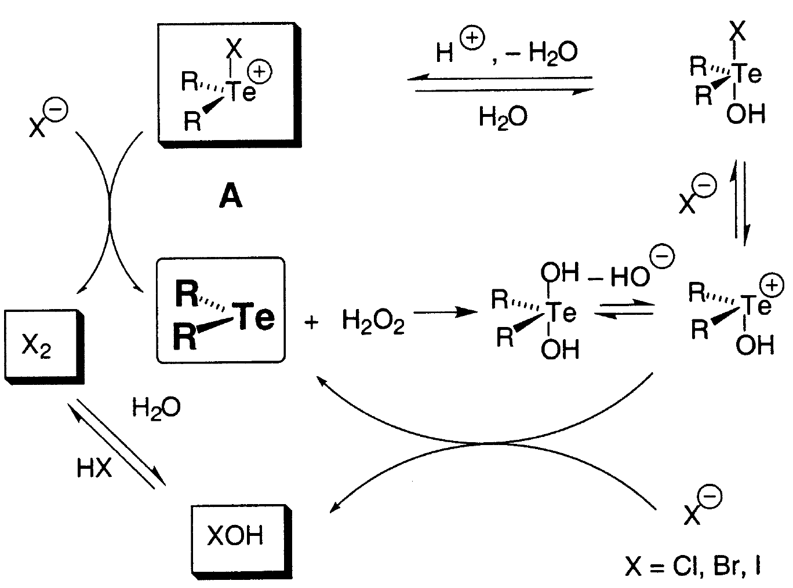
Scheme 11
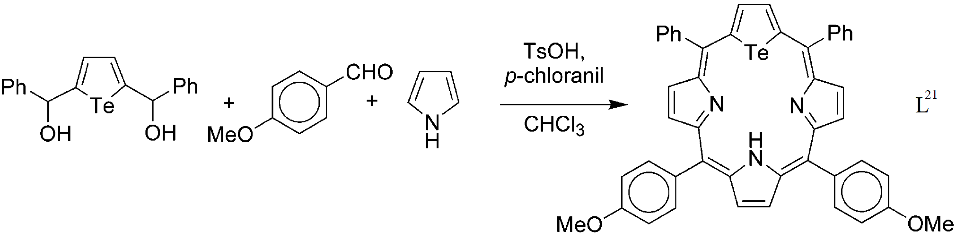
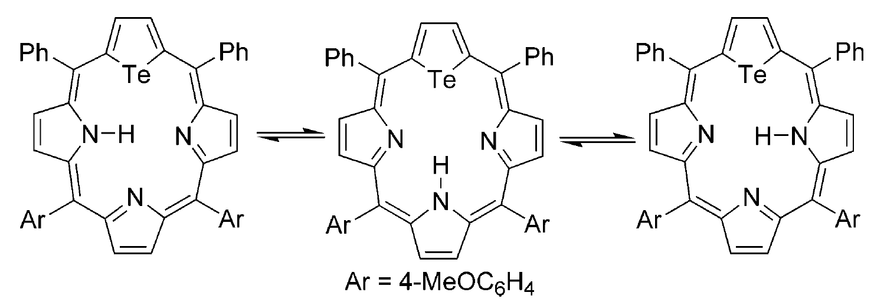
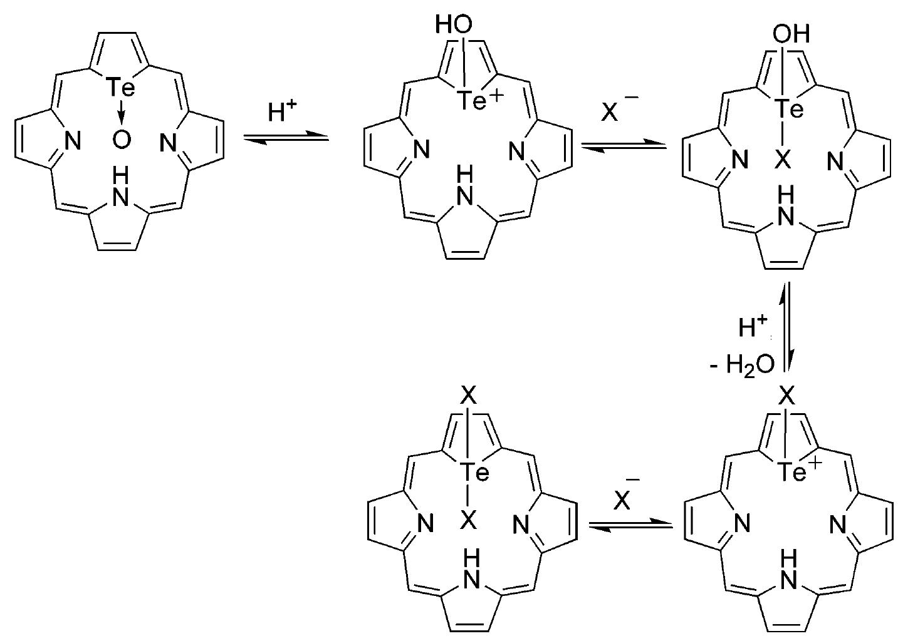
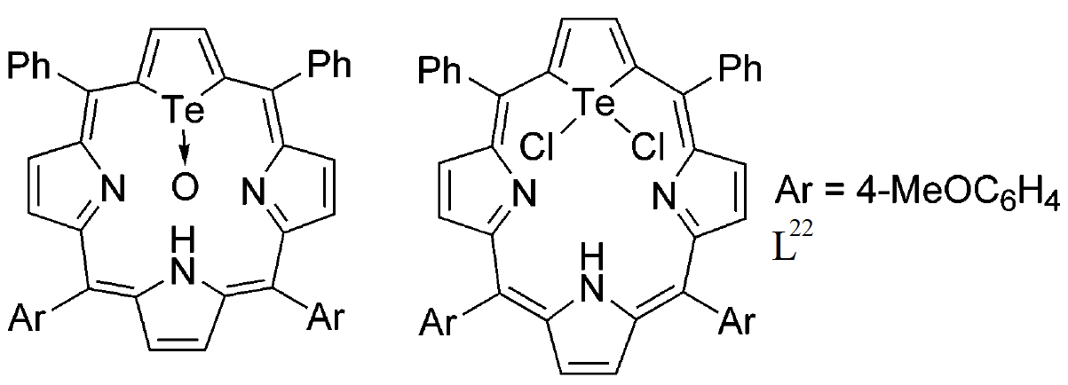
Scheme 12
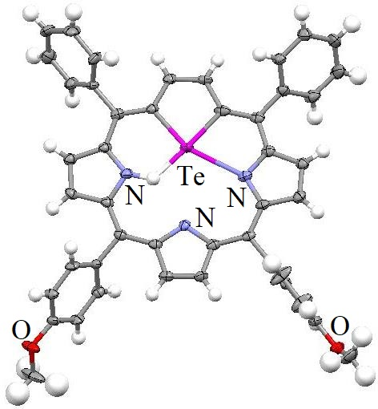 | 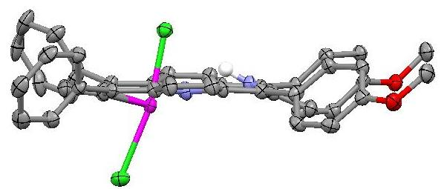
L²¹ | L²² (Side View)
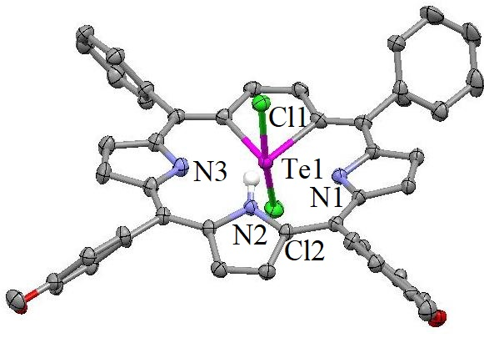
L²² (TopView)
Figure 7
In contrast to the O-/S-/Se- diheteroporphyrin, where both heteroatoms are situated towards the center within the macrocycle; for L²³ one of the tellurophene moiety is coplanar with two nearby pyrrole rings whereas the other tellurophene is reversed and the Te donor atom is pointing out of the macrocycle [Figure 8]¹⁵. The synthesis is shown in Scheme 13. The Te donor's massive diameter and the tellurophene ring's unique morphology as well as electronic structure both contribute to ditelluroporphyrin's distinctive properties. Despite not being aligned with the remainder of the macrocycle in L²³, the flipped ring is nevertheless significantly aromatic. 21,23-ditelluraporphyrin uses the same favoured 18-π-electron conjugation mechanism as those seen in mono-heteroporphyrins. According to Scheme 13, both tellurophene rings rapidly invert in solution. When ditellurophenes are titrated using trifluoroacetic acid (TFA), their configuration undergoes a major transformation that involves a reorganization towards the usual configuration, where both Te donors are pointed concurrently towards the core of the macrocycle. Due to the steric crowding, a substantial puckering of the macrocycle is anticipated, along with significant shifts of both tellurophene rings from the median plane.
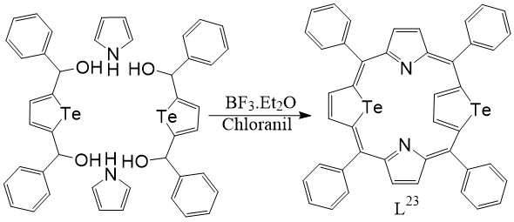
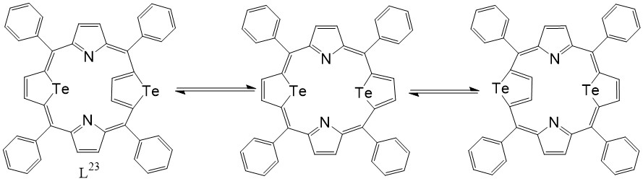
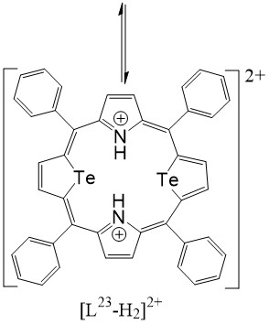
Scheme 13
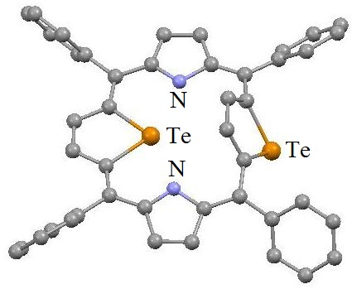 | 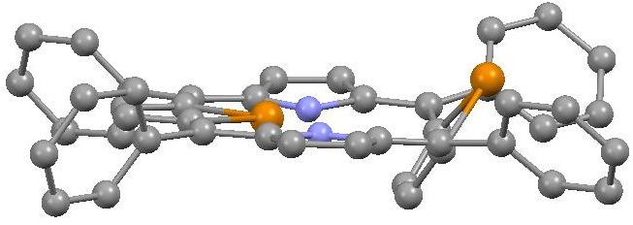
L²³ (Top View) | L²³ (Side View)
Figure 8
Conclusion:
In conclusion, some important homoleptic macrocyclic polytelluroethers and tellurometallomacrocycles or telluro macrocyclic chelates were discussed thoroughly. Later focus was shifted towards telluraporphyrins. The 21- and 21,23-core-modified porphyrins having Te, are an intriguing category of compounds. The stability of the compound depends on its bonding connections among the heteroatoms inside the porphyrin nucleus⁷. For instance, by destroying the inner core communication/ interactions, such as protonation of the N atoms as well as complexation reduce the stability of the species⁸. In essence, the Te donor's massive size occupies its center and hinders endocyclic coupling with metals. When H₂O₂ and NaBr are added for bromination processes, 21-telluraporphyrins serve as catalysts. Inside core-modified Te-porphyrin surroundings, a peculiar change in the reactivity of tellurophene is seen.
References:
- H. Fujihara, T. Ninoi, R. Akaishi, T. Erata and N. Furukawa, “First example of tetraalkyl substituted ditelluridedication salt from 1,5-ditelluracyclooctane”, Tetrahedron Lett. Vol. 32, pp. 4537-4540, 1991.
- Y. Takaguchi, E. Horn and N. Furukawa, “Preparation and X-ray Structure Analysis of 1,1,5,5,9,9-Hexachloro-1,5,9-tritelluracyclododecane [Cl₆([12]aneTe₃)] and Its Redox Behavior”, Organometallics, Vol. 15, pp. 5112-5115, 1996.
- N. AL-Salim, T. A. Hamor and W. R. McWhinnie, “Lewis Acid and Lewis Base Behaviour of a Tellurium(II) Compound: A Mercury(II) Complex of a Bis-telluride Ligand with a 13-Member Macrocyclic Chelate Ring”, J. Chem. Soc., Chem. Commun., Issue 6, pp 453-455, 1986.
- W. F. Liaw, C. H. Lai, S. J. Chiou, Y. C. Horng, C. C. Chou, M. C. Liaw, G. H. Lee and S. M. Peng, “Synthesis and Characterization of Polymeric Ag(I)-Telluroether and Cu(I) –DiorganylDitelluride Complexes: Crystal Structures of [Ag(MeTe(CH₂)₃TeMe)₂]_{n},[BF4]_{n}, [μ₂-MeTeTeMe)Cu(μ-Cl)]_{n}, and [Ag₂(NCCH₃)₄ (μ₂-(p-C₆H₄F)TeTe(p-C₆H₄F))₂][BF4]₂”, Inorg. Chem. Vol. 34, pp. 3755-3759, 1995.
- S. Bali, A. K. Singh, P. Sharma, J. E. Drake, M. B. Hursthouse and M. E. Light, “First example of bimetallic complex of platinum(II) with a hybrid organotellurium ligand [(4-MeOC₆H₄Te)CH₂CH₂OCH₂CH₂CH₂(2-C₅H₄N)] (L¹) containing 20-membered metallomacrocyclering: synthesis and crystal structure”, Inorg. Chem. Commun., Vol. 6, pp. 1378-1381, 2003.
- S. Bali, A. K. Singh, J. E. Drake and M. E. Light, “Multidentate hybrid organotellurium ligands 1-(4-methoxyphenyltelluro)-2-[3-(6-methyl-2-pyridyl)propoxy]ethane (L1) 2-methyl-6-{3-[2-({2-[3-(6-methyl-2-pyridyl)propoxy]ethyl}telluranyl)ethoxy]propyl}pyridine (L2) and their metal complexes: Formation of 20-membered metallomacrocycle by L1”, Polyhedron, Vol. 25, pp. 1033-1042, 2006.
- A. Ulman, J. Manassen, F. Frolow and D. Rabinovich, “Synthesis of new tetraphenylporphyrin molecules containing heteroatoms other than nitrogen. III. tetraphenyl-21-tellura-23-thiaporphyrin: an internally-bridged porphyrin”, Tetrahedron Lett., Vol. 19, pp. 1885-1886, 1978.
- A. Ulman, J. Manassen, F. Frolow and D. Rabinovich, “Synthesis and Properties of Tetraphenylporphyrin Molecules Containing Heteroatoms Other than Nitrogen. 5. High Resolution Nuclear Magnetic Resonance Studies of Inner and Outer Aromaticity”, J. Am. Chem. Soc., Vol. 101, pp. 7055-7059, 1979.
- L. Latos-Grazynski, E. Pacholska, P. J. Chmielewski, M. Olmstead and A. L. Balch, “Alteration of the Reactivity of a Tellurophene within a Core-Modified Porphyrin Environment: Synthesis and Oxidation of 21-Telluraporphyri”, Angew. Chem. Int. Ed. Engl., Vol. 34, pp. 2252-2254, 1995.
- E. Pacholska, L. Latos-Grazynski and Z. Ciunik, “A Direct Link between Annulene and Porphyrin Chemistry–21-Vacataporphyrin”, Chem. Eur. J., Vol. 8, pp. 5403-5406, 2002.
- (a) D. E. Higgs, M. I. Nelen and M. R. Detty, “Iodination of Organic Substrates with Halide Salts and H₂O₂ Using an Organotelluride Catalyst”, Org. Lett., Vol. 3, pp. 349-352, 2001. (b) C. Francavilla, M. D. Drake, F. V. Bright and M. R. Detty, “Dendrimeric Organochalcogen Catalysts for the Activation of Hydrogen Peroxide: Improved Catalytic Activity through Statistical Effects and Cooperativity in Successive Generations”, J. Am. Chem. Soc., Vol. 123, pp. 57-67, 2001.
- M. Abe, D. G. Hilmey, C. E. Stilts, D. K. Sukumaran and M. R. Detty, “21-Telluraporphyrins. 1. Impact of 21,23-Heteroatom Interactions on Electrochemical Redox Potentials, ¹²⁵Te-NMR Spectra, and Absorption Spectra”, Organometallics, Vol. 21, pp. 2986-2992, 2002.
- M. Abe, Y. You and M. R. Detty, “21-Telluraporphyrins. 2. Catalysts for Bromination Reactions with Hydrogen Peroxide and Sodium Bromide”, Organometallics, Vol. 21, pp. 4546-4551, 2002.
- M. Abe, M. R. Detty, O. O. Gerlits and D. K. Sukumaran, “21-Telluraporphyrins. 3. Synthesis, Structure, and Spectral Properties of a 21,21-Dihalo-21-telluraporphyrin”, Organometallics, Vol. 23, pp. 4513-4518, 2004.
- E. Pacholska, L. Latos-Grazynski and Z. Ciunik, “An Unorthodox Conformation of [18]porphyrin-(1.1.1.1) Heteroanalogue-21,23-Ditelluraporphyrin with a Flipped Tellurophene Ring”, Angew. Chem. Int. Ed., Vol. 40, pp. 4466-4469, 2001.

