REVIEW ON OCCULAR DRUG DELIVERY SYSTEM
Dr.Sai koteswar Sarma¹, C.Yamini², C.Lahari³, C.Shantha Lahari⁴
¹Professor, Department of Pharmacognosy, Sri Padmavathi school of pharmacy
^{2,3,4} IV B.Pharm Students of Sri Padmavathi school of Pharmacy
Sri Padmavathi School of Pharmacy, Tiruchanoor, Tirupati,
Andhra Pradesh, 517 502

ABSTRACT

Transport of drugs applied by traditional dosage forms is restricted to the eye, and therapeutic drug concentrations in the target tissues are not maintained for a long duration since the eyes are protected by a unique anatomy and physiology. For the treatment of the anterior segment of the eye, various droppable products to prolong the retention time on the ocular surface have been introduced in the market. On the other hand, direct intravitreal implants, using biodegradable or non-biodegradable polymer technology, have been widely investigated for the treatment of chronic vitreoretinal diseases. There is urgent need to develop ocular drug delivery systems which provide controlled release for the treatment of chronic diseases, and increase patient's and doctor's convenience to reduce the dosing frequency and invasive treatment. In this article, progress of ocular drug delivery systems under clinical trials and in late experimental stage is reviewed.
INTRODUCTION-
The eye is a complex organ with an unique anatomy and physiology. The structure of eye can be divided into two main parts: anterior segment and posterior segment . Anterior segment of the eye occupies approximately one-third while the remaining portion is occupied by the posterior segment. Tissues such as cornea, conjunctiva, aqueous humor, iris, ciliary body and lens make up the anterior portion. Back of the eye or posterior segment of the eye include sclera, choroid, retinal pigment epithelium, neural retina, optic nerve and vitreous humor. The anterior and posterior segment of eye is affected by various vision threatening diseases. Diseases affecting anterior segment include, but not limited to glaucoma, allergic conjunctivitis, anterior uveitis and cataract. While, age-related macular degeneration (AMD) and diabetic retinopathy are the most prevalent diseases affecting posterior segment of the eye.Drug delivery refers to the technology utilized to present the drug to the desired body site for drug release and absorption, or the subsequent transport of the active ingredients across the biological
STRUCTURE OF EYE:
Eye can be partitioned into two divisions the front fragment and the back section in Thestructure of eye. The front fragment stays alive of the cornea, conjunctiva, watery humour, iris, ciliary body, and translucent focal point. These elaborate roughly 33% of the front of the eye. The leftover part for example back section made out of the sclera, choroid, Bruch’s layer, retinal shade epithelium (RPE), nonpartisan retina, and glassy humor. An exhaustive depiction of the life systems and physiology of the eye is introduced beneath.
Anatomy of eye:-
The eye is a spherical structure with a wall consisting of three layers the outer sclera, the middle choroid layer and the inner retina. The sclera is a tough fibrous coating that protects the inner layers. It is white except for the transparent area at the front, the cornea which allows light to enter the eye. The choroid layer situated inside the sclera contains many blood vessels and is modified at the front of the eye as the pigmented iris. The biconvex lens is situated just behind the pupil. The chamber behind the lens is filled with vitreous humour a gelatinous substance occupying 80% of the eye ball. The anterior and posterior chambers are situated between the cornea and iris and lens respectively and filled with aqueous humour. At the back of the eye is light detecting retina.
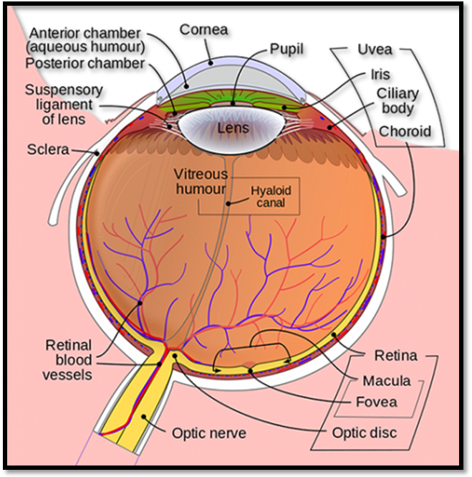
Structure of Eye and its parts

Ocular drug delivery systems;-
Visual medication conveyance framework there are principle issue of fast and exhaustive end of regular eye drops from the eye . This issue brings about loss of enormous measure of medication. Just hardly any measure of medication enters the corneal layer and enter to inward tissue of eye. The primary explanation of medication misfortune incorporates lachrymal waste and medication weakening by tears. This super smoothness diminishes the visual bioavailability and cause undesirable harmful and incidental effect. Yet, late biomaterials and nanotechnology headways have started a significant development in investigation into biodegradable microparticles and nanoparticles, hydrogel, and visual inserts, all of which can contain visual pharmacologic specialists, considering further developed prescription conveyance. Besides, supported discharge drug treatments might diminish the in general financial effect of visual sicknesses by lessening the aftereffects related with current clinical therapies. Visual medication conveyance is progressing dangerously fast, on account of consistently advancing ways to deal with designated conveyance
VISUAL OVERVIEW:-
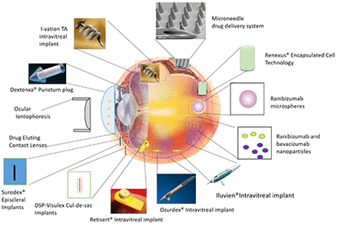

Brand name | Dosage form | Uses
Cauville | 4.5 mg/ml ketorolac tromethamine arrangement (0.45%) in a solitary use vial | Cataract medical procedure
Locris | 2% is an unmistakable, yellow, sterile solution | Allergic conjunctivitis
Ele stat | 0.05% epinastineHCl ophthalmic solution | Allergic conjunctivitis
Ozurdex | 0.7 mg dexamethasone intravitreal visual implant | Retinal vein impediment
Pred Forte | prednisolone acetic acid derivation ophthalmic suspension, USP | Bulbar conjunctiva
Trivaris | 80 mg/ml triamicinoloneacetonide injectable suspension | Sympathetic ophthalmia
Zymar | 0.3% gatifloxacin ophthalmic solution | Bacterial conjunctivitis
Zymaxid | 0.5% gatifloxacin ophthalmic solution | Bacterial conjunctivitis

Ocular Drug Delivery Barriers:
When a dosage form is either administered topically or systemically, it faces multiple obstacles before it reaches its site of action. As a result ocular bioavailability from topically administered drug is usually only 1%-7% of the applied dose. These barriers can be broadly classified as anatomical barriers and physiological barriers
ANATOMICAL BARRIERS; -
When a dosage form is topically administered there are two routes of entry, either through the cornea or via the non-corneal route. The cornea is a very tight multilayered tissue that is mainly composed of five sections: epithelium, bowman’s membrane, stroma, descemet’s membrane and endothelium. Out of these it’s the epithelium which acts as the principal barrier. These 5-6 layers of columnar epithelial cells with very tight junctions create high paracellular resistance of 12-16 kΩ.cm . It acts as a major barrier to hydrophilic drug transport through intercellular spaces. On the other hand stroma, which consists of multiple layers of hexagonally arranged collagen fibers containing aqueous pores or channels allow hydrophilic drugs to easily pass through but it acts as a significant barrier for lipophilic drugs. Thus, for a drug to have optimum bioavailability, it should have the right balance between lipophilicity and hydrophilicity. The remaining layers are leaky and do not act as significant barriers. Non-corneal route bypasses the cornea and involves movement across conjunctiva and sclera. This route is important especially for large and hydrophilic molecules such as peptides, proteins and siRNA . The conjunctiva is more permeable than cornea especially for hydrophilic molecules due to much lower expression of tight junction proteins relative to corneal epithelium. High vascularity of the limbal area renders this route not suitable for drug delivery as the blood vessels remove a large fraction of absorbed dose . Only a small fraction of the dose reaches thevitreous.
PHYSIOLOGICAL BARRIERS: -
The eye’s primary line of defense is its tear ﬁlm. Bioavailability of topically administered drugs is further reduced by precorneal factors such as solution drainage, tear dilution, tear turnover, and increased lacrimation. The lacrimal fluid is an isotonic aqueous solution containing a mixture of proteins (such as lysozyme) as well as lipids. Following topical application, lacrimation is significantly increased leading to dilution of administered dose. This in turn lowers drug concentration leading to diminished drug absorption. Rapid clearance from the precorneal area by lacrimation and through nasolacrimal drainage and spillage further reduces contact time between the tissue and drug molecules. This in turn lowers the exact time for absorption leading to reduced bioavailability. The average tear volume is 7-9 μL with a turnover rate of 16% per minute .Thus drugs administered as eye drops need to be isotonic and non-irritating to prevent significant precorneal loss.
FACTORS AFFECTING;-

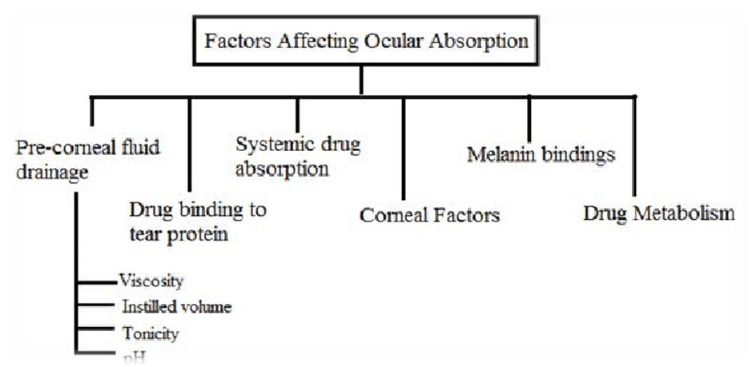

1.solubility
2.lipopilicity
3.molecular weight and size
1. SOLUBILITY;-
Solubility is dependent on the pKa of the drug and pH of the solution. With these parameters one can determine the ratio of ionized to unionized molecules. Usually, unionized molecules can readily permeate biological membranes. As previously shown by our group that the permeability of unionized pilocarpine is almost two fold greater than that of its ionized form. In case of ionized species, their charge can also affect permeability across the cornea. The corneal epithelium bears a negative charge at the pH of lachrymal fluid and hence cationic species tend to penetrate at a faster rate to their anionic counterparts
2.LIPOPHILICITY:-
Lipophilicity and corneal permeability display sigmoidal relationship. This is because of the differential permeability of the different layers of cornea towards lipophilic drugs. As previously mentioned, lipophilic drug tend to permeate easily through the epithelial layers of cornea. But the hydrophilicity of the inner layer of cornea (stroma) requires higher hydrophilicity for optimal permeation. Partition coefficient (Log P) value ranging from 2-4 is found to result in optimum corneal permeation.
3.MOLECULAR WEIGHT AND SIZE;-
The weight and size of a molecules play a critical role in deciding its overall permeability through paracellular route. The diameter of the tight junctions present on corneal epithelium is less than 2 nm. Thus, molecules having molecular weight less than 500 Dalton are able to permeate readily [11]. The paracellular permeability is further limited by the pore density (4.3 × 106/cm2) of corneal epithelium. The conjunctiva has larger paracellular pore diameter thus allowing permeation of larger molecules such as small and medium size peptides (5000-10000 Daltons) [12]. Permeation across sclera occurs through the aqueous pores and molecular size of the solute can be the determining factor. Sucrose (molecular weight-342 Daltons) permeates 16 times faster than inulin (molecular weight-5000 Daltons). Scleral permeability is approximately half of conjunctiva but much higher than cornea.
ADVANTAGES AND DISADVANTAGES OF OCCULAR DRUG DELIVERY SYSTEM; -
ADVANTAGES; -
1.increased residencetime /bio Availability.
2.precision dosing with controlledrelease,avoids pulsate drug delivery.
3.Minimal systemic absorption.
4.administrarion frequency rduced.
5.conjuctival/seleral route to internal Target.
6.better shelf life and no preservatives.
7.increase ocular residence,hence improving bioavailability
8.possibility of providing prolonged drug release and thus better efficacy.
DISADVANTAGES:
1. The very short time the drug stays in the eyes.
2.potential accidental loss
3.movement around the eyescould interfere with vision.
4.Physical and physiological obstacles of placing solid objects on the eye ,foreign body sensation.

Obstacles to Ocular Delivery

Precorneal Barriers

Capacity of Cul-de-sac
Cul-de-sac is a shallow pocket in the lower eyelid where palpebral and bulbar conjunctiva meet in the lower eyelid and the deeper recess in the upper eyelid. The maximum capacity of cul-de-sac is 30 μL in humans. The movement of the lower eyelid to its regular place would reduce this capacity to 70–80%. Inflammation and allergic response of the eye would also minimize capacity of the cul-de-sac . Since the activity of any drug is directly related to its residence time and concentration. The low capacity of cul-del-sac would reduce the concentration of the drug in the eye, thereby reducing the therapeutic activity.

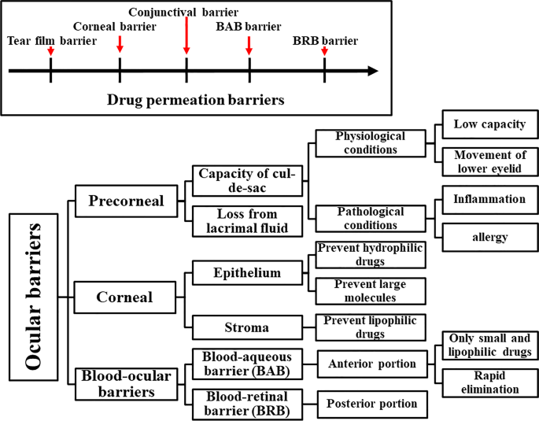

Loss of Drug from Lacrimal Fluid:-
Drainage of the administrated ocular solution is a major barrier in precorneal region. Loss of drug from lacrimal fluid could happen as a result of lacrimation, solution drainage, and non-productive absorption in the conjunctiva . Also, drug metabolism and protein binding would further obstruct drug absorption . Continuous renewal of lacrimal fluid helps maintaining eye hydration, preventing pathogens or dust from retaining on the eye. In order to maintain effective drug activity, residence time of the administrated formula must be sustained which could be achieved by different mechanisms

Corneal Barriers :-
The cornea provides a resistant obstacle to different chemical and mechanical injuries. It also supports light convergence on the retina. It is divided into epithelium, stroma, and endothelium. The epithelium is formed of five to seven layers of firmly linked cells. Stroma is a water-based compact layer. The epithelium is a barrier for hydrophilic drugs and large molecules, whereas the stroma is a barrier for lipophilic drugs . The endothelium preserves the transparency of the cornea and provides selective access for hydrophilic drugs and macromolecules into the aqueous humor. As a general rule, drug molecular weight, charge, degree of ionization, and hydrophobicity influence the corneal permeation. Hence, the trans-corneal permeation is known as rate limiting step for drug transfer from the lachrymal fluid into the aqueous humourBlood-Ocular Barriers.
They prevent the entry of foreign compounds into the blood stream. They are classified into blood-aqueous barrier (BAB) and blood-retinal barrier (BRB). BAB is an anterior portion of the eye that prevents the access of many compounds in the intra-ocular milieu. BAB allows the passage of lipophilic and small drugs. These drugs are eliminated from the anterior compartment faster than hydrophilic and larger molecules. For example, the clearance rate of pilocarpine was found to be faster than inulin . BRB is a posterior portion of the eye that is made of the retinal endothelial cells and the retinal pigment epithelial cells. It prevents the access of dangerous materials, water, and plasma components into the retina .

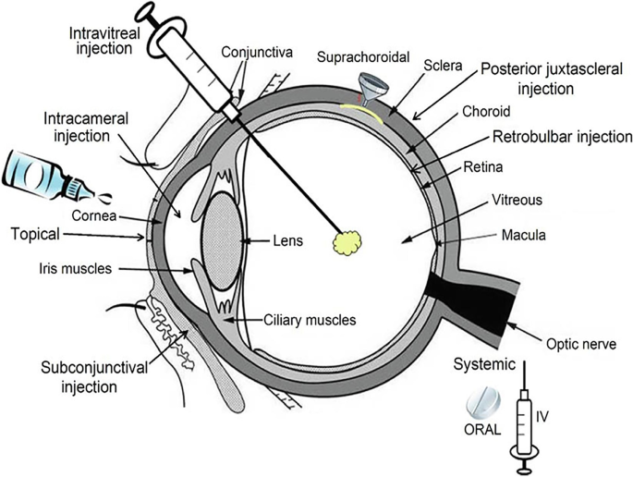

Ocular Diseases:-

Glaucoma
Glaucoma is a famous optic neuropathy disease. Symptoms start with blurred vision that progresses into irreversible blindness in the late stage. It leads to blindness as a result of slow deterioration of optic nerve axon and fatality of retinal ganglion cells. It is commonly connected with elevation in intraocular pressure (IOP) because of irregular formation or obstruction of the aqueous humor . Risk factors include age, race, diabetes, genetics, near-sightedness, migraine, and retinal vascular caliber. Glaucoma is more common in women population as they represent 55% of open angle glaucoma, 70% of angle closure glaucoma, and 59% of all forms of glaucoma in 2010 .Worldwide incidence is estimated at 76 million at 2020 and is expected to elevate to 112 million by 2040.There are two types of glaucoma: open angle and closed angle. Open angle glaucoma has no symptoms and is characterized by enlarging optic disc cupping and visual field that results in elevated prevention of drainage of aqueous humor through trabecular meshwork. However, closed angle is characterized by the elevated pressure resulted from the blockage of outflow pathways . About 76 million people suffered from glaucoma and the number is expected to reach 112 million by 2040.Glaucoma developed as a result of oxidative and nitrative processes. There are many antioxidant enzymes in aqueous humor for example superoxide dismutase, catalase, and glutathione peroxidase. Their level is decreased as a result of aging and that leads to elevated IOP. Change the equilibrium between oxidants and antioxidants influence the progression of glaucoma . Anti-glaucoma drugs help to adjust either aqueous humor formation or drainage. Many studies were published to enhance glaucoma treatment . Abd-Elsalam and ElKasabgy developed topical agomelatine-loaded olaminosomes with remarkable anti-glaucoma activity. Eldeep et al. developed topical proniosomal gel-derived niosomes to improve ocular retention and activity of brimonidine tartrate .

Age-Related Macular Degeneration (AMD)
AMD is one of the main causes of loss of vision in developed countries. It is more frequent above the age of 50 years. About 8.7% of worldwide blindness is initiated by AMD . Nearly 196 million people suffered from AMD at 2020 and the number is expected to reach 288 million by 2040 . It is a multifactorial degenerative complaint involving the posterior segment of the eye. Risk factors include aging, smoking, bad nutrition, high blood pressure, and immobility. There is no remedy for AMD till now, but its progression may be reduced by proper medications . AMD could be divided into two types, dry (atropic or non-exudative) and wet (neovascular or emulative). Irregular angiogenesis (development of new blood vessels) in the retinal epithelium is the main character of AMD and results in drusen (yellow deposits under the retina), atropy, and separation of bruch’smembrane . Many cellular growth factors are increased during angiogenesis due to the irregularities in corresponding metabolic pathways as vascular endothelial growth factor (VEGF), basic fibroblast growth factor (FGF), and epithelial growth factor (EGF). A new approach for treatment of AMD involves juxtascleral injections of anecortave cortisone that showed prolonged release for 6 months in the choroid and retina . Moreover, intravitreal injection of the biodegradable Rho kinase and protein kinase C inhibitor for handling diabetic macular edema and neovascular age-related macular degeneration exhibited prolonged release for about 6 months .

Conjunctivitis
Conjunctivitis is generally the most frequent ocular compliant. It is simply the inflammation of conjunctival tissue. It affects all ages, races, and genders. According to the cause, it may classified into infectious or non-infectious. Infectious conjunctivitis results from microbial infection, while non-infectious conjunctivitis results from allergens and irritants Symptoms of conjunctivitis include eye redness, eye discomfort, tears, and elevated eye secretions. Prevalence of allergic conjunctivitis is nearly 40% of global population Treatments of conjunctivitis include topical administration of antimicrobial (infectious) or anti-inflammatory agents (non-infectious).

Diabetic Retinopathy (DR)
Diabetic retinopathy is particular vascular complication related to both types of diabetes mellitus. About 60% of patients of type II and all patients of type I diabetes have a certain extent of retinopathy after 20 years of diabetes. Oxidative stress and inflammation result from the upregulation of proinflammatory mediators initiated by hyperglycemic disorders are the cause of development of DR. It is the third major trigger to blindness in the USA. After cataract and corneal blindness, the first and second triggers to blindness. It is avoidable if distinguished and cured early plus the effective management of blood glucose and blood pressure It has two types, proliferative and non-proliferative and both of them result eventually in progressive damage to the retina. Nowadays, diabetic retinopathy is managed through laser photocoagulation, vitrectomy, and pharmacological treatments. Laser photocoagulation works by closing the leaky blood vessels and possibly avoids blindness, but results in laser scar. Vitrectomy is a surgical removal of vitreous gel and blood from leaking vessels in the back of the eye, but this procedure provides only short-term relief and does not obstruct further leaking of blood Pharmacological treatments include intravitreous injections of corticosteroids to decrease the swelling of macula. Also, sustained release corticosteroids implant that interferes the inflammatory pathways. Modern management with anti-VEGF agents (Ranibizumab and Aflibercept) prevents the expression of VEGF and thus reduce blood leakage and edema.

Retinoblastoma
Retinoblastoma is a malignant tumor distressing the retina and mainly prevails in children younger than 5 years old. Untreated retinoblastoma leads to blindness and finally mortality (99%). Its frequency is about 1 out of 20,000 live births . Its occurrence rate is equal in both gender. It is caused due to mutation in tumor suppressor gene RB1 encoding for retinoblastoma protein. It could be unilateral (60%) or bilateral (40%. The handling choices of retinoblastoma include radiotherapy, cryotherapy, systemic chemotherapy, and surgery. Latest studies propose that release of compensatory proangiogenic factors and angiogenic blood vessels development are the vital phases for treating retinoblastoma .

Fungal Keratitis
Fungal keratitis occurs only in traumatic cornea, since healthy cornea would not allow any fungal infection. It is caused by different fungus like Candida albicans, Candida glabrata, Candida tropicalis, Candida krusei, and Candida parapsilosis Fungal keratitis represents 40% of the contagious keratitis in developing countries of third world Risk factors may be ocular (trauma, contact lens, prior corneal surgery, and topical corticosteroids) or systemic (diabetes, HIV positivity, and leprosy). Fungal keratitis leads to impaired wound healing, corneal ulceration, and stromal inflammatory infiltration. The corneal inflammation may alter miRNA expression Oral or topical antifungal drugs are used to treat fungal keratitis. Corneal surgery approach could be required when the medicines are useless. In some situations, vision may not be restored even after surgery. Many papers consider the treatment of fungal keratitis. Younes et al. developed topical Sertaconazole nitrate loaded cubosomes and mixed micelles with enhanced safety and antifungal activity.
Fig. 2 Various ocular diseases affecting the two segments of the eye

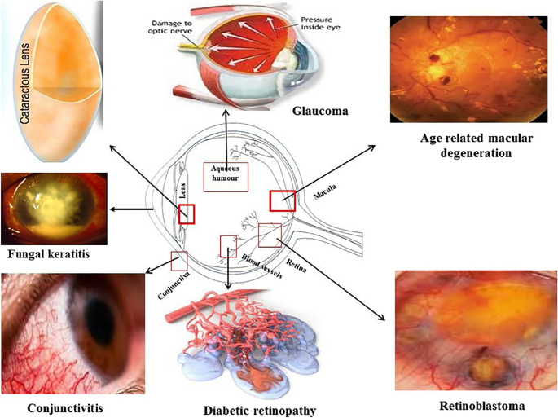
Various occular diseases affecting the two segments of the eye .

Intra ocular barriers
- Tear
The precorneal barrier is tear film which reduces the effective concentration of the administrated drugs due to dilution by the tear turn over (1µl/min), accelerated clearance and binding of the drug molecule to the tear proteins. The dosing volume of instillation is generally 20–50 µl whereas the size of cul-de-sac is only 7–10 µl. The excess volume may spill out on the cheek or exit through the naso lacrimal duct.
- Cornea
The cornea consists of three layers such as epithelium, stroma and endothelium and a mechanical barrier to inhibit transport of exogenous substances into the eye. Each layer possesses a different polarity and a rate limiting structure for drug permeation. The corneal epithelium is lipophilic nature and tight junctions are formed to restrict paracellular drug permeation from the tear film. The stroma is composed of collagen fibrils. The highly hydrated structure of the stroma acts as a barrier to permeation of lipophilic drug molecules. Corneal endothelium is the innermost monolayer of hexagonal shaped cells and acts as a separating barrier between the stroma and aqueous humour. The endothelial junctions are leaky and facilitate the passage of macromolecules between aqueous humour and stroma.
- Conjunctiva
Conjunctiva of eyelids and globe is a thin and transparent membrane which is involved in the formation and maintenance of the tear film. The conjunctiva or episclera is highly supplied with capillaries and lymphatics. Hence administered drugs in the conjunctival space may be cleared through blood and lymph. The conjunctival blood vessels do not form a tight junction barrier which means drug molecules can enter into blood circulation by pinocytosis and convective transport through paracellular pores in the vascular endothelial layer.
- Sclera
The sclera mainly consists of collagen fibres and proteoglycans embedded in an extracellular matrix. Scleral permeability depends on the molecular radius and it decreases roughly exotically with molecular radius. The posterior sclera is composed of a looser weave of collagen fibres than the anterior sclera and the human sclera is relatively thick near the limbus (0.53 ± 0.14 mm), thin at the equator (0.39 ± 0.17 mm) and much thicker near the optic nerve (0.9-1.0mm). The increase of hydrophobic/lipophilic character drugs shows lower permeability in sclera. Hydrophilic drugs may diffuse through the aqueous medium of proteoglycans in fibre matrix pores more easily than lipophilic drugs. The charge of drug molecule may affect its permeability across the sclera. Positively charged drugs may exhibit poor permeability due to their binding to the negatively charged proteoglycan matrix.
- Choroid/Bruch’s membrane
Choroid is one of the most highly vascularized tissues of the body to supply the blood to retina. The choroidal capillary endothelial cells are fenestrated and in humans are relatively large in diameter (20-40 µm). Bruch’s membrane (BM) causes thickening with age. These changes cause increased calcification of elastic fibres increased cross linkage of collagen fibres and increased turn over glycosaminoglycans. The advanced glycation end products and lipofuscin accumulate in BM. Thickness changes of choroid and BM might affect drug permeability from sub conjunctiva space into the retina and vitreous.
- Retina
The barriers restricting drug penetration from the vitreous to the retina is the internal limiting membrane (ILM).The ILM separates the retina and the vitreous and is composed of 10 distinct extracellular matrix proteins. Drug transport across the retinal pigment epithelium (RPE) takes place by transcellular and paracellular routes.
- Blood-Retinal Barrier
Blood retinal barrier (BRB) restricts drug transport from the blood into the retina.BRB is composed of tight junctions of retinal capillary endothelial cells and RPE called iBRB for the inner and oBRB for the outer BRB respectively. The function of iBRB is supported by Muller cells and astrocytes. The retinal capillary endothelial cells are not fenestrated and have a paucity of vesicles.
Methods to overcome barriers
I. Physical methods
1. Iontophoresis
2. Sonophoresis
3. Microneedles
II. Chemical approaches
Physical methods
Physical force-based methods, initially utilized in transdermal drug delivery, generally require a power-driven physical device to deliver energy to the barriers, thereby enhancing transient drug transport.
- Iontophoresis
It is the process in which direct current drives ions into cells/tissues. Iontophoresis, the application of a low-intensity electrical current, enhances drug delivery across biological membranes by causing electro-repulsion and electro-osmosis of the drug molecule. Electro repulsion primarily applies to the movement of ionic drugs, while electro-osmosis can enhance the transport of both neutral and charged molecules by convective solvent flow.
2. Sonophoresis /Ultrasound
It involves the application of a sound field at frequencies higher than 20 kHz to improve drug transport across biological membranes, including ocular barriers. The mechanisms for ultrasound-enhanced drug delivery take into account non-thermal (e.g. cavitation, acoustic streaming, and mechanical stress) and thermal effects with ultrasound parameters, co-administration of microbubbles, and drug characteristics, all having an effect on delivery efficacy.
3. Microneedles
Microneedles (MLs) are micrometer-sized needles, or arrays of such, fabricated by adapting microelectronics tools. Applying MLs to biological membranes can create tiny transport pathways, thereby allowing drugs to permeate across these barriers.
Chemical approaches
Chemical modification of drugs to improve therapeutic efficacy and to enhance various physicochemical properties such as solubility, stability, permeability, and evasion of efflux pump is an established approach in therapeutic drug delivery.
The most important strategies in chemical approaches for ocular delivery are:
Designing ocular drugs that are inactive at sites other than the eye (prodrugs). Designing drugs that undergo sequential metabolic conversion and finally reach the target (retro metabolic design). Chemical modification of a known inactive metabolite or analog to restore the therapeutic activity that transforms back into the inactive metabolite in predictable one-step biotransformation (SD)
Ocular formulations
- Drug delivery systems to the anterior segment of the eye
- Drug delivery systems to the posterior segment of the eye
- Advanced delivery system
- Vesicular drug delivery system
Ophthalmic Inserts
Ophthalmic inserts are sterile preparations with a solid or a semisolid consistency, and whose size and shape are specially designed for ophthalmic application. The inserts are placed in the lower fornix and less frequently, in the upper fornix or on the cornea.
Classification of ocular inserts Based on their solubility behaviour
      - Insoluble inserts
      - Soluble inserts
      - Bioerodible inserts
Insoluble inserts
Insoluble inserts can be classified into two categories such as reservoir system and matrix system
- Reservoir system
  - Diffusional insert or ocuserts
  - Osmotic inserts
- Matrix systems
- Contact lenses
Soluble Ophthalmic inserts
Soluble inserts correspond to the oldest class of ophthalmic inserts. Soluble inserts normally defined as erodible, monolithic polymeric devices that releasing the drug and do not need removal while undergo gradual dissolution.
Types of soluble ophthalmic inserts
a. Based on natural polymers e.g. collagen.
b.Based on synthetic or semi-synthetic polymers

Bio-erodible ocular inserts
These inserts are formed by bio-erodible polymers (e.g., cross-linked gelatin derivatives, polyester derivatives) which undergo hydrolysis of chemical bonds and hence dissolution. The great advantage of these bio-erodible polymers
REFERENCES:
  - JR (October 1973). "Altered bioavailability of drugs in the eye due to drug-protein interaction". Journal of Pharmaceutical Sciences. 62 (10): 1648–53. doi:10.1002/jps.2600621014. PMID 4752109.
  - Ciolino JB, Stefanescu CF, Ross AE, Salvador-Culla B, Cortez P, Ford EM, et al. (January 2014). "In vivo performance of a drug-eluting contact lens to treat glaucoma for a month". Biomaterials. 35 (1): 432–9. doi:10.1016/j.biomaterials.2013.09.032. PMC 3874329. PMID 24094935.
Hide
- v
- t
- e

  - Tashakori-Sabzevar F, Mohajeri SA (May 2015). "Development of ocular drug delivery systems using molecularly imprinted soft contact lenses". Drug Development and Industrial Pharmacy. 41 (5): 703–13. doi:10.3109/03639045.2014.948451. PMID 25113431. S2CID 207465615.
  - Ciolino JB, Hoare TR, Iwata NG, Behlau I, Dohlman CH, Langer R, Kohane DS (July 2009). "A drug-eluting contact lens". Investigative Ophthalmology & Visual Science. 50 (7): 3346–52. doi:10.1167/iovs.08-2826. PMC 4657544. PMID 19136709.
  - Ciolino JB, Hudson SP, Mobbs AN, Hoare TR, Iwata NG, Fink GR, Kohane DS (August 2011). "A prototype antifungal contact lens". Investigative Ophthalmology & Visual Science. 52 (9): 6286–91. doi:10.1167/iovs.10-6935. PMC 3176015. PMID 21527380.
  - Faccia PA, Pardini FM, Amalvy JI (June 2019). "Uptake and release of Dexamethasone using pH-responsive poly(2-hydroxyethyl methacrylate-co-2-(diisopropylamino)ethyl methacrylate) hydrogels for potential use in ocular drug delivery". Journal of Drug Delivery Science and Technology. 51: 45–54. doi:10.1016/j.jddst.2019.02.018. S2CID 104465994.
  - Guzman-Aranguez A, Colligris B, Pintor J (March 2013). "Contact lenses: promising devices for ocular drug delivery". Journal of Ocular Pharmacology and Therapeutics. 29 (2): 189–99. doi:10.1089/jop.2012.0212. PMID 23215541.
  - ^ Jump up to:ª ^{b} ^{c} ^{d} ^{e} ^{f} Hsu KH, Carbia BE, Plummer C, Chauhan A (August 2015). "Dual drug delivery from vitamin E loaded contact lenses for glaucoma therapy". European Journal of Pharmaceutics and Biopharmaceutics. 94: 312–21. doi:10.1016/j.ejpb.2015.06.001. PMID 26071799.
  - Kim HJ, Zhang K, Moore L, Ho D (March 2014). "Diamond nanogel-embedded contact lenses mediate lysozyme-dependent therapeutic release". ACS Nano. 8 (3): 2998–3005. doi:10.1021/nn5002968. PMC 4004290. PMID 24506583.
  - Cope JR, Collier SA, Nethercut H, Jones JM, Yates K, Yoder JS (August 2017). "Risk Behaviors for Contact Lens-Related Eye Infections Among Adults and Adolescents - United States, 2016" (PDF). MMWR. Morbidity and Mortality Weekly Report. 66 (32): 841–5. doi:10.15585/mmwr.mm6632a2. PMC 5657667. PMID 28817556.
  - Center for Devices and Radiological Health (28 October 2019). "Contact Lenses". U.S. Food and Drug Administration (FDA). Retrieved 1 April 2020.
  - Lloyd AW, Faragher RG, Denyer SP (April 2001). "Ocular biomaterials and implants". Biomaterials. 22 (8): 769–85. doi:10.1016/S0142-9612(00)00237-4. PMID 11246945.
  - Alvarez-Lorenzo C, Anguiano-Igea S, Varela-García A, Vivero-Lopez M, Concheiro A (January 2019). "Bioinspired hydrogels for drug-eluting contact lenses". Acta Biomaterialia. 84: 49–62. doi:10.1016/j.actbio.2018.11.020. PMID 30448434.
  - Sridhar M (2003). "Chapter-17 Hyperopic LASIK". Step by step in LASIK Surgery. Jaypee Brothers Medical Publishers (P) Ltd. pp. 153–162. doi:10.5005/jp/books/10819_17. ISBN 978-81-8061-099-8.
  - Li CC, Chauhan A (May 2006). "Modeling Ophthalmic Drug Delivery by Soaked Contact Lenses". Industrial & Engineering Chemistry Research. 45 (10): 3718–3734. doi:10.1021/ie0507934. ISSN 0888-5885.
  - Xu J, Li X, Sun F (February 2011). "In vitro and in vivo evaluation of ketotifen fumarate-loaded silicone hydrogel contact lenses for ocular drug delivery". Drug Delivery. 18 (2): 150–8. doi:10.3109/10717544.2010.522612. PMID 21043996.
  - Peng CC, Burke MT, Carbia BE, Plummer C, Chauhan A (August 2012). "Extended drug delivery by contact lenses for glaucoma therapy". Journal of Controlled Release. 162 (1): 152–8. doi:10.1016/j.jconrel.2012.06.017. PMID 22721817.

