Analysis of Various Machine Learning Approaches for Parkinsons Disease Detection
Ishita Jaiswal, Bramah Hazela, Shikha Singh
Jaiswalishita2002@gmail.com, bramahhazela77@gmail.com, ssingh8@lko.amity.edu
Amity School of Engineering & Technology Lucknow, Amity University Uttar Pradesh
Abstract
Parkinson's disease is a progressive neurological disorder that primarily affects movement and is characterized by a wide range of motor and non-motor symptoms. It is caused by the degeneration of dopamine-producing neurons in the substantia nigra region of the brain. Dopamine is a vital neurotransmitter involved in regulating movement and balance. Consequently, the loss of these neurons disrupts the brain's ability to transmit signals related to motor control. Common motor symptoms include resting tremors, slowness of movement (bradykinesia), rigidity, and postural instability. Non-motor symptoms can encompass mood changes like depression and anxiety, sleep disturbances, constipation, and cognitive impairments. While there is no cure for Parkinson's disease, there are treatments available to manage its symptoms. Medications like levodopa can help boost dopamine levels in the brain. Additionally, physical and occupational therapies, along with lifestyle modifications, can improve the quality of life for those with Parkinson's. If the disease is detected early, it is possible to control the speed of progression of the disease.
In this research paper I have discussed various approaches using efficient Machine Learning algorithms which can detect Parkinson’s at an early stage, thus improving the patient’s life. [1] The Extreme Gradient Boost ML algorithm achieved an accuracy of 95% which is the highest. The other algorithms discussed in this research paper are [2] Support Vector Machine, [3] Artificial Neural Network, [3] K Nearest Neighbour, Random Forest for PD detection. The proposed detection method consists of feature selection and classification processes. Feature Importance and Recursive Feature Elimination methods were considered for feature selection task.

Keywords: ANN, KNN, XG Boost,SVM,ML(Machine Learning)

1. Introduction
Parkinson's disease (PD) is a progressive neurodegenerative disorder that impacts various aspects of body movements, including speech. Dr. James Parkinson first identified this condition in 1817 and referred to it as the 'Shaking Palsy' [6]. Neurodegenerative diseases encompass both hereditary and sporadic conditions characterized by the gradual deterioration of the nervous system [JPND research, 2015]. Among various neurodegenerative diseases like Alzheimer's disease, brain cancer, degenerative nerve diseases, and epilepsy, Parkinson's Disease ranks as the second most prevalent [17].
PD primarily arises from the gradual loss of dopamine-producing neurons in the substantia nigra, a region of the midbrain known as the "movement control centre" as shown in Figure 1. This dopamine loss leads to uncontrolled movements known as hypokinetic movement disorders [18]. While PD is relatively easy to diagnose in advanced stages, effective treatment remains a considerable challenge, with no known cure or definitive medical intervention available.

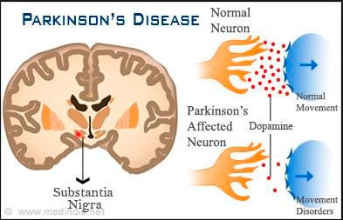
Figure 1: Parkinson’s disease (normal movement vs. movement disorders) [www.medindia.net]

Despite decades of research, the precise causes of PD remain elusive. Many researchers believe that a combination of genetic factors [19] and environmental influences [20] contribute to PD's development. These environmental factors may include exposure to toxins, head injuries, rural living conditions, water quality, manganese exposure, and pesticide exposure, although their impact can vary from person to person. Additionally, PD manifests differently in each affected individual. Table 1 outlines the different stages of PD. The primary motor symptoms include tremors in the hands, arms, legs, jaw, and face, bradykinesia (slowness of movement), limb and trunk rigidity, and impaired balance and coordination [21]. Non-motor symptoms, such as depression and memory loss, can also occur and significantly affect an individual's quality of life [22,23]. Early and accurate diagnosis of PD is crucial due to the challenges associated with its advanced-stage treatment, which may be less effective in halting disease progression. This emphasizes the importance of early detection to improve patient outcomes.

Table 1: Stages of Parkinson’s disease
Stages | Symptoms
Mildest stage (Stage 1) | In this stage, the PD patients have least interference with routine tasks. Tremors and other symptoms are restricted to one side of the body
Moderate stage (Stage 2) | In this stage, symptoms like stiffness, resting tremors and trembling can be sensed on both sides of the body. Also, facial expressions of PD patients may get changed
Mid-stage (Stage 3) | During this stage, major changes like balance loss, decreased flexes in addition with stage II symptoms will be observed in PD patients. Occupational therapy combined with medication may help in decreasing the symptoms
Progressive stage (Stage 4) | The condition of PD patient will get worse in this stage and it becomes difficult for the patient to move without some assistive device like a walker
Advanced stage (Stage 5) | Stage V is the most advanced and debilitating stage of PD. Stiffness in legs may cause freezing when standing. Patients are frequently unable to stand without falling. They may experience hallucinations and occasional delusions

Multiple research studies have consistently identified that more than 90% of Parkinson's disease (PD) patients encounter speech and vocal difficulties, encompassing issues such as dysphonia, dysarthria, monotone, and hypophonia [24][25]. Consequently, one of the early observable symptoms in individuals with Parkinson's (PWP) is the deterioration of their voice.
The assessment of voice presents a straightforward and non-invasive means of analysis. Hence, voice measurement has been employed as a tool to monitor the progression of PD [26][27]. To gauge the advancement of PD, numerous vocal tests have been developed, including sustained phonation’s and continuous speech assessments [28][29]. Telemonitoring and telediagnosis systems have gained widespread usage in the early detection of PD, with most relying on motor disorders associated with PD.

2. DATASETS USED
In this paper various types of datasets like [4] UCI Voice Dataset and [5] Time Series Gait Dataset. The dataset used in the experiments of this study consists of the features obtained from the speech signals of 31 people at the National Centre for Voice and Speech, Denver, Colorado. The dataset was created by Max Little from University of Oxford and donated to UCI Machine Learning Repository [4]. 23 of the 31 people have PD and 8 of them are the control group. There are 195 biomedical voice measurements in the dataset. Table 2 shows the voice measures used in the experiments. Status column in the database defines the class and gets 0 for healthy, 1 for PD. Class distribution of the dataset is shown in Fig. 2. There are 48 healthy phonetics and 147 PD phonetics that belong to 31 people.

Table 2
Feature no | Voice measure | MEANING
1 | MDVP:Fo (Hz) | Average vocal fundamental frequency
2 | MDVP:Fhi (Hz) | Maximum vocal fundamental frequency
3 | MDVP:Flo (Hz) | Minimum vocal fundamental frequency
4 | MDVP:Jitter (%) | Several measures of variation in
5 | MDVP:Jitter (Abs) | fundamental frequency
6 | MDVP:RAP
7 | MDVP:PPQ
8 | Jitter:DDP
9 | MDVP:Shimmer | Several measures of variation in amplitude
10 | MDVP:Shimmer (dB)
11 | Shimmer:APQ3
12 | Shimmer:APQ5
13 | MDVP:APQ
14 | Shimmer:DDA
15 | NHR | Two measures of ratio of noise to tonal
16 | HNR | components in the voice
17 | RPDE | Two nonlinear dynamical complexity
18 | D2 | measures
19 | DFA | Signal fractal scaling exponent
20 | spread1 | Three nonlinear measures of fundamental
21 | spread2 | frequency variation
22 | PPE
23 | status | Health status of the subject: (1) Parkinson’s,  (0) healthy

Neuro-degenerative disease often affects gait and mobility. To understand better the pathophysiology of these diseases and to improve our ability to measure responses to therapeutic interventions, it may be helpful to quantify gait dynamics accurately. The records in database[5q] are from patients with Parkinson's disease (n = 15), Huntington's disease (n = 20), or amyotrophic lateral sclerosis (n = 13). Records from 16 healthy control subjects are also included. The raw data were obtained using force-sensitive resistors, with the output roughly proportional to the force under the foot. Stride-to-stride measures of footfall contact times were derived.
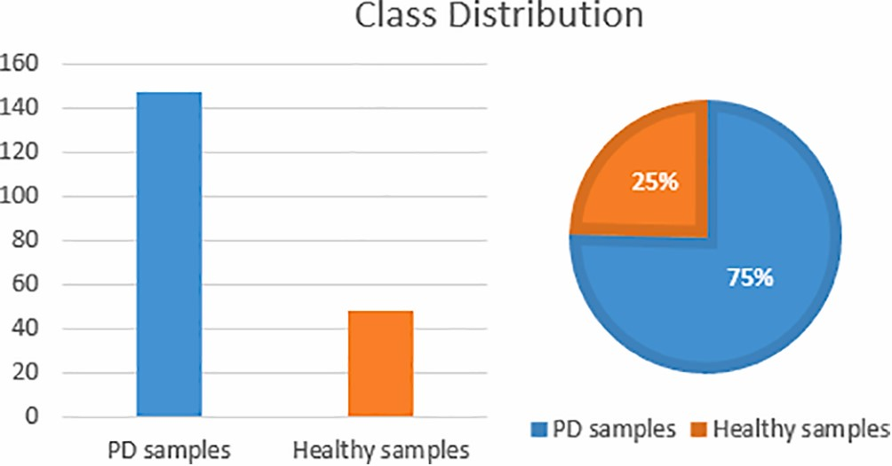
Figure 2: Class distribution of the recorded phonetics in the dataset.

Various Machine Learning Approaches
Approach 1: Prediction of Parkinson’s Disease Using Biomedical Voice Measurements Dataset and XG Boost algorithm
In the research paper [1], the aim is to differentiate Parkinson’s Disease patients from healthy people by detecting dysphonia using Extreme Gradient Boosting (XGBoost) classification algorithm. Numerous studies have established a clear association between Parkinson's Disease and speech-related issues, with a majority of patients manifesting vocal impairments and speech challenges in the initial stages of the disease. Consequently, vocal characteristics emerge as a pivotal factor in the early identification of Parkinson's Disease.
Diagnosing PD, akin to many other neurological disorders, poses a formidable challenge and a substantial financial burden, primarily relying on the expertise of medical professionals. This approach necessitates repeated hospital visits for comprehensive evaluations, causing significant inconvenience to elderly patients. The pressing need for a convenient early diagnostic and treatment model, particularly in underserved remote areas without access to specialized medical practitioners, is evident.
The primary objective of the project was to explore the utility of vocal features in the early detection of Parkinson's Disease. The research endeavours to address the following questions:
- Can biomedical voice measurements accurately predict Parkinson's Disease for early detection?
- Which specific attributes prove critical in the early identification of the disease?
Hypothesis H1 posits that vocal features can indeed serve as a valuable tool for early Parkinson's Disease detection.
Project Architecture
Knowledge Discovery in Databases (KDD) process was used in the project implementation [7]. The process which involves discovering useful knowledge from data has six steps as shown in figure 2 are selection of the data, preprocessing, data transformation, data mining, interpretation/evaluation, and knowledge discovery.

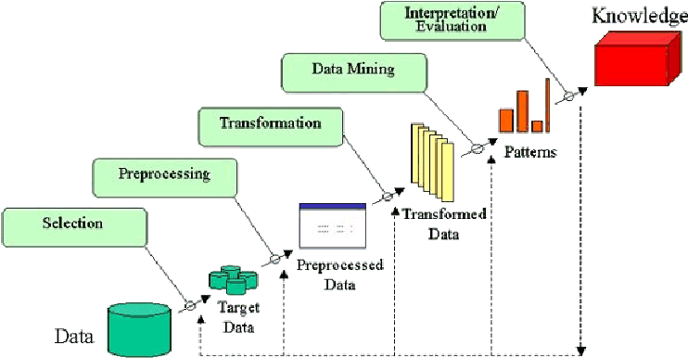
Figure 3 The KDD methodology [7]

XGBoost, a boosting algorithm, has significantly improved optimization by utilizing a second-order Taylor expansion on the loss function while retaining first derivative information. This accelerates model convergence compared to traditional Gradient Boosting Decision Regression trees, which optimize using first-order derivatives. XGBoost also manages model complexity to prevent overfitting by introducing a regularization term into the loss function [8q], making it easier to interpret [9q]. Performance evaluation of the classifier will employ precision and recall metrics, as they provide a balanced assessment, considering the significant consequences of False Negatives.
Python 3.8 was chosen for project implementation due to its flexibility, extensive library support, and open-source nature. Initial exploratory data analysis in a Jupyter Notebook revealed no missing data. The dataset exhibited class imbalance for the target variable, manageable by boosting algorithms. The irrelevant attribute variable was removed. The cleaned data was split into a 90% training and 10% testing set using 3-fold cross-validation due to the dataset's small size.
XGBoost, with various parameter configurations, was applied to determine the optimal estimator. GridSearchCV was employed with scoring set to f1. The best score and parameters were identified for model fitting. Feature importance was extracted post-model fitting using XGBoost's built-in feature extraction capabilities.
To evaluate classifier performance, a confusion matrix was used.
Evaluation of Results
Figure 4 shows that the XGBoost algorithm achieved an overall accuracy of 95%, which outperformed what was reported in [20], precision score of (1.00), and recall of (0.94).


0.9
0.92
0.94
0.96
0.98
1
1.02
Accuracy
Precision
Recall
Bar Plot Representation of
XGBoost Model Metrics
Figure 4 Bar Plot Representation of the result

The precision of the algorithm, which measures its ability not to incorrectly classify negative samples as positive, indicates that it is 100% accurate in identifying individuals without Parkinson's disease. On the other hand, recall, which assesses the algorithm's ability to detect all positive samples, is at 94% in identifying people with Parkinson's disease. Given the data's class imbalance, precision and recall are appropriate metrics. Since correctly identifying individuals with Parkinson's disease is crucial, recall is vital for assessing the model's performance based on domain knowledge.
With a recall value of 0.94, the model effectively detects individuals with Parkinson's disease 94% of the time. This is significant because a low recall value would result in more misdiagnosed patients. False positives are considered more acceptable than false negatives because early detection is critical for disease management. False hope followed by a later Parkinson's diagnosis can negatively impact a patient's health, family, and economic well-being.

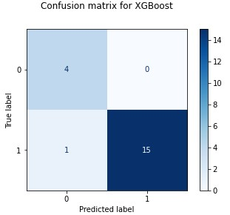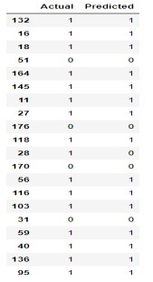

Table 3. Confusion Matrix Table 4. Actual vs Actual Prediction

The confusion matrix in Table 3 presents the classification results on the test data, which include true positives (15), true negatives (4), false positives (0), and one false negative. XGBoost accurately identified 15 people with Parkinson's disease but misclassified one patient. It also correctly identified 4 healthy individuals and made no incorrect Parkinson's disease diagnoses, demonstrating its effectiveness in early detection, which is crucial in Parkinson's disease. Table 4 compares actual vs. predicted values, revealing that patient number 28 was incorrectly diagnosed as not having Parkinson's disease.
In Figure 4, a bar plot displays feature importance based on their f1-score. The most critical features are MDVP:Fo(Hz), MDVP:Fhi(Hz), RPDE, spread2, MDVP:RAP, D2, DFA, PPE, MDVP:APQ, and spread1, as demonstrated in reference [10q].

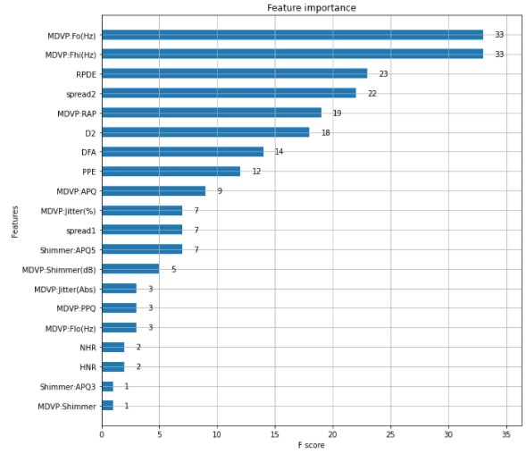
Figure 4. Bar Plot Representation of the result

The project aligns with the hypothesis (H1) that vocal features are valuable for early PD detection. It also effectively addresses the research question of whether Parkinson's Disease can be accurately predicted using biomedical voice measurements, achieving an impressive 95% accuracy. Moreover, Figure 4 provides insights into the most critical features for early disease detection.
This predictive model has the potential to assist healthcare professionals in focusing on these essential features, particularly in underserved remote areas lacking medical experts, to expedite PD detection. Early detection can significantly slow down disease progression and contribute to an improved quality of life for patients.

Approach 2: SVM Based Machine Learning Approach to Identify Parkinson’s Disease Using Gait Analysis
In this study, the objective is to distinguish Parkinson's disease (PD) patients from a dataset that encompasses gait-related features of individuals with PD, healthy controls, Amyotrophic lateral sclerosis (ALS), and Huntington's disease (HD). Huntington's disease is another neurodegenerative condition characterized by both motor and cognitive deterioration. One of its most notable symptoms is the abnormal, writhing movement known as chorea, which significantly impacts gait. A study by Hausdorff et al. [11] utilized fluctuation analysis to assess the correlation between consecutive stride intervals. The study's findings indicated that Huntington's disease patients exhibited more random stride interval fluctuations compared to healthy controls.
ALS is a disorder that leads to muscle weakness and atrophy due to the degeneration of motor neurons. Renowned scientist Stephen Hawking battled ALS. The disease's effect on muscle coordination becomes apparent in gait before it completely hinders muscle activity. Another study by Hausdorff et al. [12q] demonstrated that individuals with ALS exhibit a slower average stride time and reduced walking speed, along with an increase in the measure of stride-to-stride variability.
Clinical Gait data
Human gait refers to the way in which humans move their legs, encompassing activities such as walking, running, skipping, and stepping. Human gait encompasses various patterns of limb movements, velocities, stride times, swing times, and ground contact variations. Numerous factors influence human gait, including age, gender, health conditions, and geographic factors. In the case of Parkinsonian gait, it's marked by rigidity, a forward stooped posture, and slow, short steps.
To enhance the quantitative analysis of gait dynamics, the paper employed a dataset comprising records from individuals with Parkinson's disease (n = 15), Huntington's disease (n = 20), Amyotrophic lateral sclerosis (n = 13), and 16 healthy control subjects. This dataset was sourced from 'The National Institutes of Health-sponsored Research Resource for complex physiological signals' [5q], and it has been previously utilized by researchers such as H. Zheng et al. [13] and Hausdorff et al. [11] [12]. Force measurements were initially obtained, directly proportional to the force exerted on the foot. Subsequently, various measurements of stride-to-stride intervals were conducted using this raw data, from which features related to the gait cycle were extracted.The gait cycle represents the sequence of events between two successive limb contacts. The dataset encompasses 12 features related to the human gait cycle, including:
- Left/Right Stride Interval (seconds): The time taken for one foot to complete an oscillatory action, including both swing and stance intervals.
- Left/Right Swing Interval (seconds): The duration when one foot is off the ground while the other is in contact with the floor.
- Left/Right Swing Interval (%): The percentage ratio of swing time to the stride time (typically around 40%).
- Left/Right Stance Interval (seconds): The time when one foot is in contact with the floor while the other is in the air.
- Left/Right Stance Interval (%): The percentage ratio of stance time to the stride time (usually around 60%).
- Double support interval (seconds): The period when both feet are in contact with the ground.
- Double support interval (%): The percentage of time that double support interval occupies within the stride (typically around 20%).

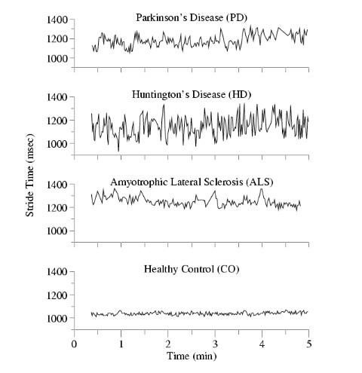
Figure 5. Stride intervals for each class

The Figure 5. Shows the stride times for the patients as well as healthy controls. It is visibly evident that the stride times associated with neuro-degenerative diseases are more erratic and have higher variation. Their correlations and various parameters are computed further in this work.

In this study, some of the twelve features were omitted due to strong correlations among them. Including these correlated features would not enhance the machine learning algorithm and would prolong execution time.
Figure 6 illustrates a correlation matrix of the twelve gait features. It reveals high correlations between left stance interval and left stride interval, right stance interval and right stride interval, and double support interval and the percentage of double support intervals. Additionally, there's complete negative correlation between the percentage of left stance interval and the percentage of left swing interval, as well as between the percentage of right stance interval and the percentage of right swing interval. Given this substantial correlation among these ten features, half of them were excluded to eliminate redundancy. As a result, we did not consider left stance interval, right stance interval, the percentage of double support intervals, the percentage of right swing interval, and the percentage of left swing interval. Instead, we focused on the remaining seven gait characteristics.
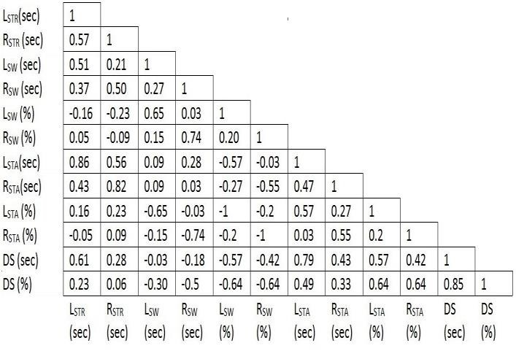
Fig6. Correlational matrix of all 12 features
Feature vectors were derived using various statistical techniques. A set of 13 distinct features, encompassing crossing rates [13], peak-to-peak characteristics [14], and frequencies, were computed for each of the 7 gait characteristics, resulting in a total of 13x7=91 unique feature vectors. These initial vectors underwent further reduction before being assessed using the Support Vector Machine (SVM). The reduction involved calculating the SVM individually for each vector. The SVM employed a Radial Basis Kernel with C=1 and sigma=1. Table 1 below displays the top 7 individual feature vectors that yielded the highest individual classification accuracy.

TABLE 5: TOP 7 INDIVIDUAL FEATURE VECTORS WITH BEST CLASSIFICATION ACCURACY

Feature Vector | Accuracy (%)
Standard deviation of Left Swing Interval (% of stride) | 72.22%
Standard deviation of Right Swing Interval (% of stride) | 69.44%
Standard deviation of Left Swing Interval (sec) | 61.1%
Variance of Right Swing Interval (sec) | 61.1%
Median of Right Swing Interval (sec) | 61.1%
Median of Left Swing Interval (% of stride) | 58%
Variance of Left Swing Interval (% of stride) | 55.55%

Support Vector Machine
The Support Vector Machine (SVM) is a supervised binary classifier that assigns class labels to new data points. It operates by first analysing a dataset with known classes to create a model, which is then used for classifying unknown test samples. The basic SVM is the linear SVM, which aims to separate data points with a maximally wide margin in high-dimensional space, minimizing classification errors by utilizing support vectors, the closest data points to the hyperplane.
SVM can be employed with linear or non-linear transformations, with the Gaussian radial basis function (RBF) kernel being used here. This kernel's equation is expressed as:
k(x,x′)=exp(−2σ2∣x−x′∣2​)
The SVM's parameters, C and σ, were determined through grid search, resulting in C=1000 and σ=10 with the lowest classification error. Data points were standardized before training, and the Sequential Minimal Optimization method was used to find the separating hyperplane.
The dataset was divided into training and testing sets, with MATLAB implementing the SVM.
The obtained results are summarized in the table below. The classifier demonstrated an accuracy of 83.33%, correctly identifying 6 out of 8 PD patients, resulting in a 75% true positive rate and a 25% false negative rate. To further evaluate the classifier's performance, metrics such as sensitivity, specificity, Positive Predictive Value (PPV), and Negative Predictive Value (NPV) were calculated:
- Sensitivity: The proportion of correctly classified positive samples to true positive samples.
- Specificity: The ratio of correctly classified negative samples to true negative samples.
- Positive Predictive Value (PPV): The percentage of correctly classified positive samples to all samples classified as positive.
- Negative Predictive Value (NPV): The percentage of correctly classified negative samples to all samples classified as negative.
The results for selected feature vectors and their respective accuracies are as follows:
- Standard deviation of Left Swing Interval (% of stride): 72.22%
- Standard deviation of Right Swing Interval (% of stride): 69.44%
- Standard deviation of Left Swing Interval (seconds): 61.1%
- Variance of Right Swing Interval (seconds): 61.1%
- Median of Right Swing Interval (seconds): 61.1%
- Median of Left Swing Interval (% of stride): 58%
- Variance of Left Swing Interval (% of stride): 55.55%

TABLE 6 : Results

Parameter | Value (%)
Accuracy | 83.33%
Error Rate | 16.67%
PD True Positive | 75%
PD False Negative | 25%
Sensitivity | 85.71%
Specificity | 75%
Positive Predictive Value | 92.31%
Negative Predictive Value | 60%
ALS False Positive | 0%
control False Positive | 0%
HD False Positive | 30.7%

Approach 3: Parkinson’s Disease Identification using KNN and ANN Algorithms based on Voice Disorder
The study center on the diagnostic potential of voice analysis. Voice-based systems have become a primary focus in recent PD telemedicine research, with various speech signal processing algorithms being employed to extract essential information for PD assessment. These extracted features are then conveyed to machine learning algorithms to construct dependable decision support systems.
Among the commonly used acoustic parameters in acoustic analysis applications, and frequently referenced in the literature, are fundamental frequency (F0), jitter, shimmer, and harmonics-to-noise ratio (HNR).Detection of Parkinson's disease relies on the utilization of different classifiers, each distinguished by specific measurement criteria such as classification accuracy, Matthews's correlation coefficient (MCC), Spearman correlation coefficient, specificity, sensitivity, and F-score (F-measure). Each of these metrics has its respective formula for calculation, aiding in determining the most suitable classifier for the study. To lay the groundwork for these criteria, it is essential to consider the confusion matrix, also known as a contingency table. This matrix serves as a crucial tool for evaluating the performance of a machine learning model, assessing the accuracy of its predictions in classification problems in comparison to ground truth.

Table 7 : Shows the confusion matrix for a two-class classifier.
TABLE 7. CONFUSION MATRIX
 |  | Predicted Class
 |  | Positive | Negative
Actual Class | Positive | (TP) | (FN)
Actual Class | Negative | (FP) | (TN)

- Matthews’s correlation coefficient (MCC):
𝑇𝑃. . 𝐹𝑁
𝑀𝐶𝐶  

ANN Classification
The MATLAB tool, nprtool, was employed for pattern recognition. The dataset[4q] was partitioned into three segments for artificial neural network (ANN) processing:
- Training: Approximately 70% of the dataset (137 data points) was allocated for training, facilitating network learning.
- Validation: During the network development phase, 5% of the dataset was utilized to assess when to conclude the training process.
- Test: To evaluate the network's performance throughout the training and validation phases, 25% of the dataset was reserved for testing.
For a visual representation of the ANN configuration, refer to Figure 7. The regression graphs of the training, validation and test data set are shown in figure 8,10 and 11 respectively. The figure 9 shows the entire regression of the data set.
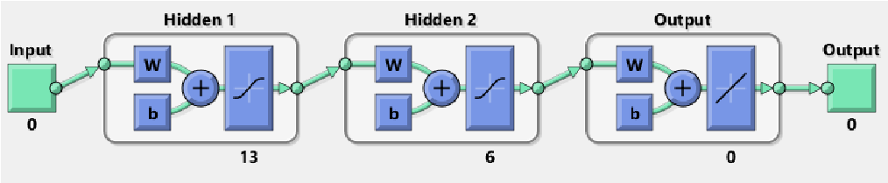
Figure 7

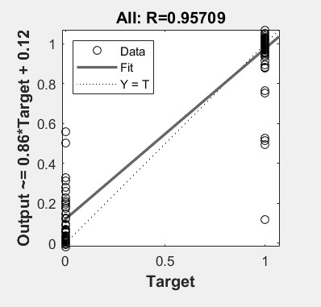
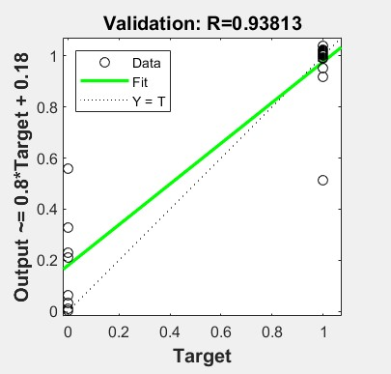
Figure 8 Figure 9

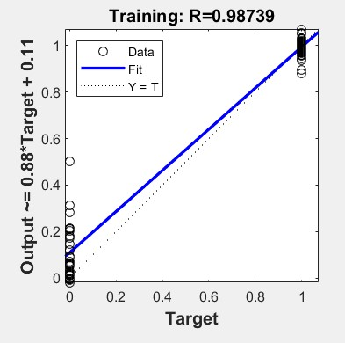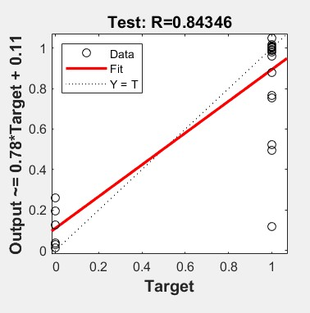
Figure 10 Figure 11
KNN Classification
The dataset was divided into training (70%) and test (30%) subsets. For the classification task, we employed the K-Nearest Neighbors (KNN) method, which involved storing all the training data. To ensure robustness and prevent overfitting, we utilized the ten-fold cross-validation technique, a widely accepted method for assessing predictive system accuracy. This approach allowed us to determine the number of neighbors and the distance function to identify the nearest neighbors. The optimal accuracy of 79% was achieved when using k=1 and the cosine distance metric.
By applying Artificial Neural Networks (ANN), we achieved an impressive 96.7% correct classification rate. In contrast, the KNN method attained an accuracy of 79.31%. Therefore, the ANN classifier outperformed the KNN approach in terms of accuracy.Our findings demonstrate that ANN is more effective than KNN for classifying PD patients, as evidenced by its superior accuracy.

CONCLUSION
In conclusion, the research paper explored various machine learning approaches aimed at the early detection of Parkinson's disease (PD) by using distinct diagnostic features. These approaches leveraged different algorithms and datasets to assess their accuracy in classifying PD patients. Notably, the findings highlight the following key results:
Firstly, the implementation of the Extreme Gradient Boosting (XGBoost) algorithm achieved an impressive accuracy of 95% in voice-based PD detection. This outcome underscores the potential of vocal features as valuable tools for the early diagnosis of the disease, which is crucial for timely intervention.
Secondly, the application of the Support Vector Machine (SVM) to gait-related features led to an accuracy of 83.33% in distinguishing PD patients from individuals with other neurodegenerative conditions and healthy controls. This result emphasizes the significance of specific gait characteristics in the early identification of Parkinson's disease.
Lastly, the comparison of K-Nearest Neighbors (KNN) and Artificial Neural Networks (ANN) for voice disorder analysis revealed the superiority of ANN, achieving a remarkable accuracy of 96.7%. This underscores the potential of ANN in effectively classifying PD patients based on vocal features.
Collectively, these outcomes suggest that machine learning approaches, when harnessed with relevant diagnostic features, hold substantial promise for the early detection of Parkinson's disease. The high accuracies achieved in voice and gait analysis are indicative of the transformative impact these methods can have on early PD diagnosis, ultimately leading to improved patient outcomes and enhanced quality of life. These findings significantly contribute to the growing body of knowledge in the field of PD diagnosis and emphasize the importance of continued research and development in this critical realm of healthcare.

REFRENCES
[1] Oduntan, Ifeoma. (2021). “Prediction of Parkinson's Disease Using Biomedical Voice Measurements Dataset”.
[2] Sachin Shetty and Dr.YS Rao, “SVM Based Machine Learning Approach to Identify Parkinson’s Disease Using Gait Analysis”
[3] Ouhmida Asmae, Raihani Abdelhadi, Cherradi Bouchaib, Sandabad Sara, Sandabad Sara, “Parkinson’s Disease Identification using KNN and ANN Algorithms based on Voice Disorder”
[4] Max A. Little, Patrick E. McSharry, Eric J. Hunter, Lorraine O. Ramig (2008), 'Suitability of dysphonia measurements for telemonitoring of Parkinson's disease', IEEE Transactions on Biomedical Engineering
[5] Hausdorff JM, Lertratanakul A, Cudkowicz ME, Peterson AL, Kaliton D, Goldberger AL. Dynamic markers of altered gait rhythm in amyotrophic lateral sclerosis. J Applied Physiology; 88:2045-2053, 2000.
[6] J. Parkinson,An Essay on Shaking Palsy. London: Whittingham and Rowland Printing, 1817
[7] G .Fayyad, Piatetsky-Shapiro, P. Smyth, and R. Uthurusamy, "From Data Mining to Knowledge Discovery: An Overview", Advances in Knowledge Discovery and Data Mining, AAAI Press / The MIT Press, Menlo Park, CA, 1996, pp.1-34 Available at: http://www2.cs.uregina.ca/~dbd/cs831/notes/kdd/1_kdd.html [Accessed on: Aug. 12, 2021].
[8] Z. Xuchen, F. Yong, and W. Peng, ‘Automatically Predicting Severity of Parkinson’s Disease Using Model Based on XGBoost from Speech’, in 2019 IEEE International Conference on Signal Processing, Communications and Computing (ICSPCC), Dalian, China, Sep. 2019, pp. 1–5. doi: 10.1109/ICSPCC46631.2019.8960722. Available at: https://ieeexplore.ieee.org/document/8960722 [Accessed on: Aug. 12, 2021]
[9] J. A. Hughes, S. Houghten, and J. A. Brown, ‘Models of Parkinson’s Disease Patient Gait’, IEEE J. Biomed. Health Inform., vol. 24, no. 11, pp. 3103–3110, Nov. 2020, doi: 10.1109/JBHI.2019.2961808. Available at: https://ieeexplore.ieee.org/abstract/document/8939380 [Accessed on: Aug. 12, 2021].
[10] A. K. Patra, R. Ray, A. A. Abdullah, and S. R. Dash, ‘Prediction of Parkinson’s disease using Ensemble Machine Learning classification from acoustic analysis’, J. Phys.: Conf. Ser., vol. 1372, p. 012041, Nov. 2019, doi: 10.1088/1742-6596/1372/1/012041.Available at: Prediction of Parkinson's disease using Ensemble Machine Learning classification from acoustic analysis - IOPscience [Accessed on: Aug. 12, 2021].
[11] Hausdorff JM, Mitchell SL, Firtion R, Peng CK, Cudkowicz ME, Wei JY, Goldberger AL. “Altered fractal dynamics of gait: reduced stride-interval correlations with aging and Huntington’s disease”, J Applied Physiology, pp.262-269, 1997.
[12] Hausdorff JM, Lertratanakul A, Cudkowicz ME, Peterson AL, Kaliton D, Goldberger AL. “Dynamic markers of altered gait rhythm in amyotrophic lateral sclerosis”, J Applied Physiology, pp.2045-2053, 2000
[13] Saara Rissanen, Markku Kankaanp, Mika P. Tarvainen2, Juho Nuutinen, Ina M. Tarkka, Olavi Airaksinen and Pasi Karjalainen “Analysis of surface EMG signal morphology in Parkinsons disease”, US National Institute of health, 2008.
[14] Yuya Matsumoto, Masatoshi Seki, Takeshi Ando, Hiroshi Iijima, Masanori Nagaoka, “Analysis of EMG signals of Patients with Essential Tremor Focusing on the Change of Tremor Frequency”, IEEE EMBS, pp.2224-2250, Sep. 2012 .
[15]. D. B. Calne, “Is idiopathic parkinsonism the consequence of an event or a process,” Neurology, Vol. 44, no. 15, pp. 5–5, 1994.
[16]. A. E. Lang and A. M. Lozano, “Parkinson’s disease first of Two parts,” New England J. Med., Vol. 339, pp. 1044–53, 1998.
[17]. A Samii, J. G. Nutt, and B. R. Ransom, “Parkinson’s disease,” Lancet, Vol. 363, no. 9423, pp. 1783–93, 2004.
[18]. L. M. de Lau and M. M. Breteler, “Epidemiology of Parkinson’s disease,” Lancet Neurol., Vol. 5, pp. 525–35, 2006.
[19]. E. M. Morris, “Movement disorder in people with Parkinson disease: A model for physical therapy,” Phys. Ther., Vol. 80, pp. 578–97, 2000.
[20]. A. Schrag, C. D. Good, K. Miszkiel, H. R. Morris, C. J. Mathias, A. J. Lees, and N. P. Quinn, “Differentiation of a typical parkinsonian syndromes with routine MRI,” Neurology, Vol. 54, pp. 697–702, 2000.
[21]. R. Angel, W. Alston, and J. R. Higgins, “Control of movement in Parkinson’s disease,” Brain, Vol. 93, no. 1, pp. 1–14, 1970.
[22]. S. L. Wu, R. M. Liscic, S. Kim, S. Sorbi, and Y. H. Yang, “Nonmotor symptoms of Parkinson’s disease,” Parkinson’s Dis., 2017. DOI:10.1155/2017/4382518.
[23]. T. Yousaf, H. Wilson, and M. Politis, “Imaging the nonmotor symptoms in Parkinson’s disease,” Int. Rev. Neurobiol., Vol. 133, pp. 179–257, 2017
[24].D. J. Gelb, E. Oliver, and S. Gilman, “Diagnostic criteria for Parkinson disease,” Arch Neurol., vol. 56, pp. 33-39, 1999.
[25]. A. Tsanas, M. A. Little, P. E. McSharry, and L. O Ramig, “Accurate telemonitoring of Parkinson's disease progression by non-invasive speech tests,” IEEE transactions on Biomedical Engineering, vol. 57(4), pp. 884-893, 2009.
[26]. S. Sapir, J. L. Spielman, L. O. Ramig, B. H. Story, and C. Fox, “Effects of intensive voice treatment (the Lee Silverman Voice Treatment [LSVT]) on vowel articulation in dysarthric individuals with idiopathic Parkinson disease: Acoustic and perceptual findings,” Journal of Speech, Language, and Hearing Research, vol. 50 (4), pp. 899-912, 2007.
[27]. D. A. Rahn, M. Chou, J. J. Jiang, and Y. Zhang, “Phonatory impairment in Parkinson's disease: evidence from nonlinear dynamic analysis and perturbation analysis,” Journal of Voice, vol. 21(1), pp. 64-71, 2007.
[28]. R. J. Baken, and R. F. Orlikoff, “Clinical measurement of speech and voice,” Cengage Learning, 2000.
[29].P. H. Dejonckere, P. Bradley, P. Clemente, G. Cornut, L. Crevier-Buchman, G. Friedrich, and V. Woisard, “A basic protocol for functional assessment of voice pathology, especially for investigating the efficacy of (phonosurgical) treatments and evaluating new assessment techniques,” European Archives of Oto-rhino-laryngology, vol. 258(2), pp. 77-82, 2001

