Optimized Neural Network Based Classifier for Effective Classification of Power Quality Disturbances

Dr. Swapnil B. Mohod¹, and Prof. Ketki R. Ingole²
¹Department of Electrical Engineering, PRMCEAM, Amravati, India;
²Department of Computer science and Engineering, Sipna College of Engineering and Technology, Amravati, India.
Email: swapnilmohod@gmail.com

Abstract: An exponential increase of nonlinear loads in power-system, mostly consisting of power electronic devices, hampered the quality of power supply. Deterioration of power quality often termed as power quality disturbance. This paper presents a Multilayer Perceptron Neural Network based classifier for effective classification of power quality disturbances. For feature extraction, wavelet transform technique was used. Optimized neural network based classifier using principal component analysis classifies the six types of power quality disturbances with the classification accuracy of 96.72%.
Key words: Artificial intelligence, Fourier transform, Power quality, Wavelet transform, Neural network.
1. Introduction
With the advent of an era demanding a power-system to supply high-rate increase of end users as well as loads with high-efficiency and large productivity, it raised a concern pertaining to the quality of power supply feeding them. Extensive use of sensitive automated control strategies along with sophisticated power electronics equipment for improving system stability and operational efficiency deviates supply from its normal values. The growing complexity of industrial processes as well as system interconnections lead to high inter-dependability, thus results in severe consequences such as huge economic losses if any component fails. In general, the term used to address this quality of supply is ‘Power Quality’ (PQ). PQ, like quality in other goods and services, is difficult to quantify. In an attempt to define PQ, the views of utilities, equipment manufacturers, and customers might be completely different. Utilities consider PQ from the system reliability point of view. Equipment manufacturers, on the other hand, consider PQ as being that level allowing for proper operation of their equipment, whereas customers consider good PQ that ensures the continuous running of processes, operations, and businesses. Thus, a PQ problem is ultimately a consumer-driven issue, and the problem related with PQ can be defined as being “any power problem manifested in voltage, current or frequency deviations that result in failure or misoperation of customer equipment” [1]. The horizon of PQ problem covers a wide spectrum which involves harmonics, voltage sag, voltage swell and momentary interruptions. These disturbances cause problems such as overheating, motor failures, inaccurate metering and malfunctioning of protective equipment. It is important for further understanding and improving power quality to extract features of disturbances from a large number of power signals and to recognize them automatically [2-3]. Researchers working in this domain adopted a variety of methodologies for PQ analysis such as fast Fourier transform (FFT), fractional Fourier transform [4] and wavelet transform [5-9]. Artificial neural networks (ANN), fuzzy logic and support vector machines are also used for the event [10-17]. The issue of power quality disturbance have been addressed using various methodologies like using MLP-neural network, RBF Fault Classifier and Wavelet and ANN [18-25].
In this work, we had presented a Multilayer Perceptron Neural Network based classifier for effective classification of power quality disturbances. We had used the wavelet transform technique for feature extraction. We have used an optimized neural network based classifier which classifies the six types of power quality disturbances. This classifier uses using principal component analysis to identify the type power quality disturbances. The aim is to provide the best classification accuracy.

2. Methodology
Depending on the statistical characteristics of voltage and current, the waveforms of stationary disturbance exhibit time-invariant statistical characteristics, while in case of non-stationary disturbance, these waveforms have time-variant statistical characteristics. In general, these disturbances are further classified as short-duration and long duration voltage variations, voltage imbalance and fluctuations, waveform distortion and power frequency variations. These PQ problems are discussed as below
2.1. Short-Duration Voltage Variations
Any variation in the supply voltage for the duration not exceeding one minute is known as Short-duration voltage variations. This is further classified as:
- Voltage Sags: It is a fundamental decrease in the supply voltage for a duration varying between 0.1 seconds to a minute.
- Voltage Swell: It is an increase of fundamental frequency voltage for a short duration.
- Interruption: It occurs when the supply voltage or load current decrease to less than 0.1 p.u. for a period of time not exceeding 60 seconds [21].
2.2. Long-Duration Voltage Variations
Any variation in the supply RMS voltage at the fundamental frequency for a duration exceeding one minute is known as Long-duration voltage variations. This is further classified as:
- Over Voltage (or Under Voltage): It is a 10% or more increase (or decrease) in RMS voltage for more than one minute.
- Sustained Interruption: In case of zero supply voltage for a time period exceeding one minute, it is termed as ‘Sustained interruption’ [22].
2.3. Voltage Imbalance and Voltage Fluctuation
The condition in which the voltages of three-phase supply are not equal in magnitude and may not even be equally displaced in time is called as voltage imbalance. Voltage fluctuation is defined as a systematic random variation in supply voltage whereas the very rapid change in supply voltage is called as voltage flicker [22].
2.4. Waveform Distortion
This is the steady state deviation in voltage or current waveform from an ideal sine wave. These are observed in following forms [23]:
- D.C. offset: It is the presence of a d.c. voltage or current in a.c. power-system
- Harmonics: A sinusoidal waveform with frequencies that are multiples of frequency at which the supply voltage is designed to be delivered. Its measure is Total Harmonic Distortion (THD) is given as:
(1)
where; V_{n}= magnitude of nth harmonic voltage
V₁= magnitude of fundamental voltage
- Notching: Notches are steady state power disturbances containing sudden spikes which naturally give rise to high-frequency content.
2.5. Power Frequency Variation
These are usually caused by rapid changes in the load connected to the system.
Summary of these faults is as given in Table 1. [12].
Table 1. Summary of PQ Disturbances
PQ disturbances | Types | Causes | Effects
Short-duration voltage variation | Voltage Sag,  Swell  Interruptions | System Faults, Energization of large loads | Ripple in A.C. Motor,
Long-duration voltage variation | Overvoltage  Under voltages  Sustained Interruptions | Switching of a large load, Energization of large capacitor bank | Premature equipment failure due to increase of electrical stress
Voltage imbalance and fluctuation | Voltage Sag,  Swell | Rapid variation in load-current magnitude, High inrush current | Voltage dip Brown-out
Waveform Distortion | D.C. offset  Harmonics  Notching | Geomagnetic disturbances, Poor grounding | Increase in Transformer losses

2.6. Diagnosis of Power Quality Disturbances
Fast diagnosis of PQ disturbances is an important to assist network operators in performing counter measures and implementing suitable PQ mitigation actions. To analyze power signals, various signal processing techniques such as Fourier transformation methods, wavelet transform, and S-transform were applied. Also, artificial intelligence (AI) techniques have found their application in this field of the power systems. Application of hybrid method by embedding above two techniques for diagnostic purposes was also successfully practiced by some researchers.
2.6.1. Fourier Transform (FT)
The connection between time and frequency domains was made by the FT that use orthogonal sinusoidal basis function showing the signal as an expansion. The complicated periodic function was written as the sum of simple waves mathematically represented by sine and cosines using FT [13-14]. Various forms of FT applied for PQ analysis are as follows:
2.6.1.1. Discrete Fourier Transform (DFT)
Fourier Transform applied to signals that repeat themselves in a periodic fashion from negative to positive infinity is most often called the Discrete Fourier Transform. For a finite length discrete signal x[n], its DFT and frequency function is given as in equation (2) and (3) respectively [24];
(2)
(3)
2.6.1.2. Fast Fourier Transform (FFT)
FFT exhibit advantage over DFT, that it reduces the computational complexity from N in DFT to N log N multiplications with same results. [1] came up with a computational breakthrough of FFT which allows the computation of N point DFT as a function of only 2N instead of N2 [2]. The FFT of signal x[n] decomposed into odd and even part can thus be written as,
(4)
FFT is still one of the most commonly used operations in digital signal processor and all modern signals processing to provide a frequency spectrum analysis [15].
2.6.1.3. Short Time Fourier Transform (STFT)
This technique is applied to improve the analysis for signals whose spectrum changes with time. It is calculated by repeatedly multiplying the time series with shifted short time windows and performing a DFT on it. Here the window helps to localize the time-domain data before obtaining the frequency domain information. STFT for continuous time signal is given as;
(5)
Where; x(t)= signal to be transformed, w(t)=window function, = FT of . In case of discrete signal with ‘m’ as discrete time-shift, it can be expressed as in equation (6); [16,17]
(6)
However, STFT of a signal has constant window length which limits non-stationary signal resolution. To overcome this resolution problem using STFT, a signal processing tool, Wavelet Transform (WT), had been widely implemented in PQ analysis. This technique is as discussed further. [18-23]

2.6.2. Wavelet Transform
In Wavelet Transform, a signal is decomposed for detailed analysis with multiple time–frequency resolutions [24,25]. Unlike STFT, the length of the smoothing window of the WT depends on the frequency analyzed. WT is commonly observed in mainly two forms namely: Continuous wavelet transform (CWT) and Discrete wavelet transform (DWT). CWT is given by,
(7)
where; x(t)=signal to be analyzed, is the mother wavelet, s and represent scale and translational parameters respectively.
DWT is a discrete counter of CWT which implements the WT using a discrete set of the wavelet scales and translations obeying some defined rules. DWT decomposes the signal into a mutually orthogonal set of wavelets [26].

2.6.3. Artificial Intelligence
ANN has the capability of non-linear function approximation and had been widely implemented in this domain. As ANN is self-learning system, along with conventional training algorithms, an approach for hybrid algorithms as well as the combined approach of ANN with wavelet and s-transform had been adopted. For industrial applications and recent concepts like distributed generation, ANN has found its application for PQ analysis and improvement.

2.7. Experimental Setup
2.7.1. Data Collection for Design and Optimization of NN-Based Classifier
To detect and classify the PQ disturbances, the Neural Network based classifier was designed and optimized. In the first step for data collection, the experimental setup was done as shown in Figure 1. In our experimentation, the following PQ disturbances are considered,
- Voltage Sag
- Voltage Swell
- Arcing load influence
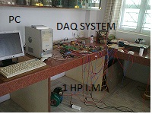
Figure 1. Experimental setup.
Mains fed one HP, single phase, 50 Hz squirrel cage Induction motor made was used for analysis of sag as well swell in the system by switching ON/OFF operation. 230V, single phase, 50Hz, welding machine was used to generate actual arcing load influence in the system, welding electrodes keep short to experience a short circuit phenomenon in the lab. The Tektronix Digital Storage Oscilloscope (DSO), TPS 2014 B, with 100 MHz bandwidth and the adjustable sampling rate of 1GHz was used to capture the current signals. The Tektronix voltage probes of rating 1000 V and bandwidth of 200 MHz approximately, 100 sets of signals were captured with a sampling frequency of 10 kHz, at different mains supply conditions. The experimental setup uses an Advantech data acquisition system having the specifications as PCLD-8710 - 100 KS/s, 12-bit, 16-ch PCI Multifunction Card. Overall to create a weak system inside the laboratory 2 ½ core, 200 meter cable was used so that influence of sag, swell and arc load will be observable.
2.7.2. Feature Extraction for Design and Optimization of NN-Based Classifier
Collected data was analyzed in MATLAB and using wavelet transform, required features are obtained. To demonstrate feature extraction capability of the wavelet by MRA technique, three types of disturbances like Induction motor sag, arc load sag and sag due to welding machine short circuit and swell due to Induction motor switching off along with their crucial features were presented in Figure 2 to Figure 5. For decomposition and reconstruction of measured signal WT uses two functions, Wavelet function ψ and scaling function ф to perform successive decomposition of the signal by MRA technique. Wavelet function ψ serving as high pass filter and generates high-frequency component known as the detailed function (d) and scaling function ф is convolving the signal with a low pass filter which generates low-frequency components known as the approximate function (a) of a decomposed signal.

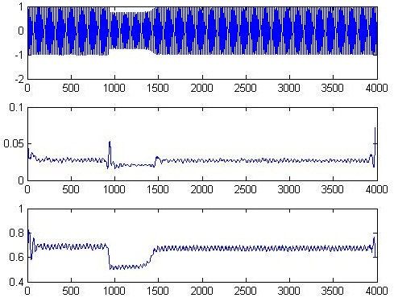
Figure 2. Sag due to Induction Motor Start

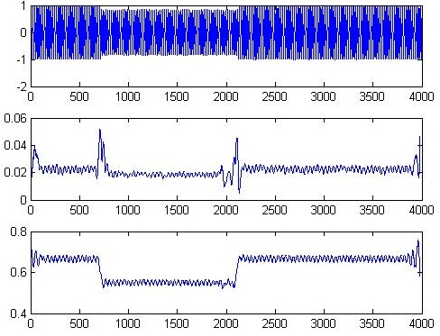
Figure 3. Sag due to welding machine short-circuited

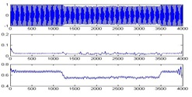
Figure 4. Sag due to arc load of welding machine

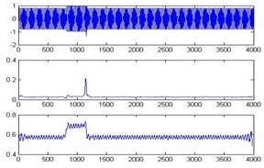
Figure 5. Swell due to Induction Motor off

2.8. Proposed Methodology
2.8.1. Design of MLP based Classifier
Multilayer Perceptron (MLP) Neural Network was proposed as fault classifier. A number of inputs Processing Elements (PE) must be equal to the number of inputs. So, 80 input Processing Elements were used in input layer, six Processing Elements were used in output layer for six conditions. For data processing MATLAB 7.1, Neuro Solution 5.7 and XLSTAT-2010 were used. General learning algorithm used is as follows:

2.8.2. Initialization of Weights
Step 1: Initialize the weights to small random values.
Step 2: While stopping condition is false, do steps 3-10.
Step 3: For each training pair do steps 4-9.

2.8.3. Feed Forward
Step 4: Each input unit receives the input signal xi and transmits this signals to all units in the hidden layer.
Step 5: Each hidden unit (,j=1,…,p) sums its weighted input signals.
(8)
Applying the activation function Z_{j}=f(z_{inj}), here the activation function is and sends this signal to all units in output units.
Step 6: Each output unit ( , k=1,…,m) sums its weighted input signals,
(9)
And apply its activation function to calculate the output signals here the activation function is
(10)

2.8.4. Back Propagation Error
Step 7: Each output unit ( , k=1,…,m) receives a target pattern corresponding to an input pattern error information term is calculated as
Step 8: Each hidden unit ( , j=1,…,p) sums its delta inputs from units in the layer above
(11)
Error information: (12)

2.8.5. Updation of Weight and Biases
Step 9: Each output unit (yk, k=1,…,m) updates its bias and weights (j=0,…,p)
(13)
where is learning rate and is momentum factor
And each hidden unit (, j=1,…,p) updates its bias and weights (i=0,…,n)
(14)
Step 10: Test the stopping condition.
The randomized data were fed to the neural network and were retrained five times with different random weight initialization so as to remove biasing and ensure true learning and generalization for different hidden layers. It was observed that MLP with single hidden layer gives better performance. The number of processing elements (PEs) in the hidden layer was varied. The network was trained and minimum MSE was obtained when 55 PEs were used in the hidden layer as indicated in Figure 6.
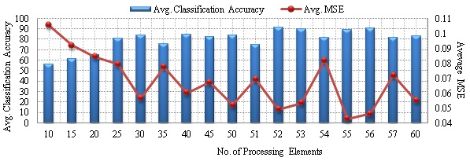
Figure 6. Variation of average MSE on training with number of processing elements in the hidden layer.

The parameters of the hidden layer and output layer i.e. step size and momentum were selected by comparing Average minimum MSE. In hidden layer, the optimum value of step size was 0.5 and momentum was 0.2 Performance was showed in Figure 7.
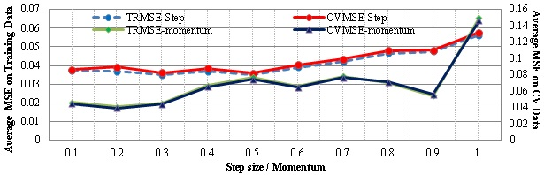
Figure 7. Variation of average minimum MSE on TR, CV dataset with Step size and Momentum

From the above experimentation, selected parameters for MLP NN are given below.
Number of epochs = 5000, Exemplars for training = 70%. Exemplars for cross validation = 15%, Exemplars for testing = 15%.
Proposed NN was trained on various datasets and later validated carefully so as to ensure that its performance does not depend on the specific data partitioning scheme. The performance of the NN should be consistently optimal over all the datasets with respect to MSE and classification accuracy. Finally designed MLP was trained five times with different random weight initialization and tested on Testing dataset, CV dataset and Training dataset. For training and testing the data tagging by percent and data tagging by various groups are used. The algorithm trains the network multiple times, each time omitting a different subset of the data and using that subset for testing. The outputs from each tested subset were combined into one testing report and the model was trained one additional time using all of the data. The set of weights saved from the final training run can then be used for additional testing. To check the learning ability and classification accuracy, the total data were divided into four groups. First two groups (50% data) were tagged as Training data and third and fourth group (each 25%) were tagged for Cross-validation and Testing (1234: 1,2-TR, 3-CV, 4-Test). Similar 24 combinations were prepared and the network was trained and tested for each group. Variation of average minimum MSE and percent data tagged for different error criteria have tested and L2 error criteria have minimum MSE and maximum classification accuracy. Results were showed in Figure 8-11.
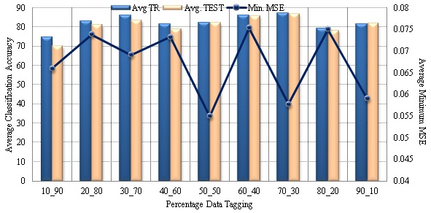
Figure 8. Variation of average minimum MSE with test on Testing and Training dataset and percent data tagged for training.

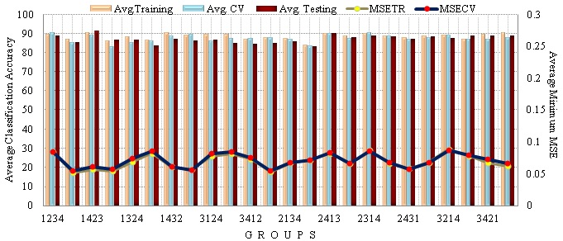
Figure 9. Variation of average minimum MSE with Training and CV with group of dataset.

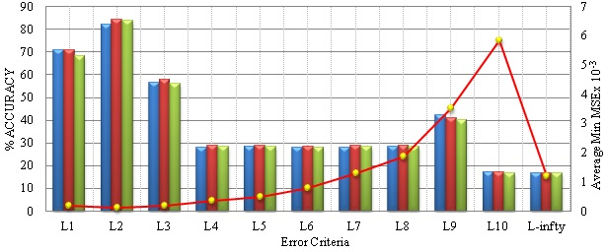
Figure 10. Variation of average minimum MSE and percent data tagged for different error criteria.

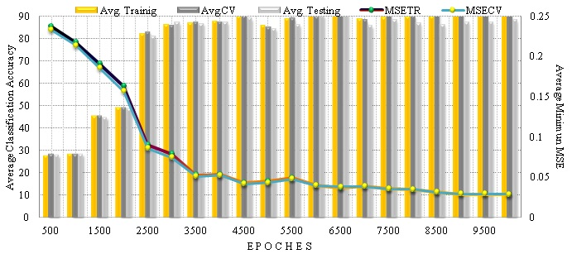
Figure 11. Variation of average MSE on training and CV with Average classification accuracy for number of Epoches.

3. Results and Discussion
One problem appears after the feature extraction that there are too many input features that would require significant computational efforts to calculate and may result in a low accuracy of the monitoring and disturbance diagnosis. The potential improvements can be achieved by first mapping the data into a space of lower dimensionality. Reduction in the dimensionality of the input space and hence, the network can be achieved by principal component (PC) analysis (PCA). PCA was performed by the Pearson rule. Eigen values and percent variability of different PCs was presented in Figure 12.
To get a compact and accurate network structure, an input feature space containing the number of PCs was fed to the network. Gradually, the number of inputs was increased and the network performance was observed carefully in terms of training and CV MSE and classification accuracy. It was observed that CV MSE and training MSE were minimum and classification accuracy was maximum when 15 PCs were selected as input feature space [Figure 13-14].
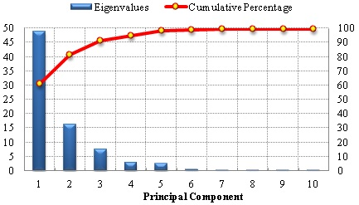
Figure 12. Eigenvalues and percent variability of different PCs.
Adopting the same procedure, the NN model was optimized by several experiments and finally, the required network was designed with following specifications:
- Number of inputs: 15;
- Stopping condition: 5500 epochs;
- Number of hidden layers: 01;
- Number of PEs in the hidden layer: 35;
- Error criterion: L2 norm;
- Hidden Layer:
Transfer function: Tanh Learning Rule: Momentum
Step size: 1.0 Momentum: 0.9
- Output Layer:
Transfer function: Tanh Learning Rule: Momentum
Step size: 1.0 Momentum: 0.7
Optimize classifier is tested on unseen and seen data and final results are as shown in Table 2.
Table 2. Comparative Performances of MLP and MLP - PCA Classifiers
Classifier | Minimum MSE |  | Percent Classification Accuracy
 | TR | CV | TR Data | CV Data | Test Data
MLP | 0.108 | 0.104 | 83.84 | 84.36 | 82.23
MLP PCA | 0.022 | 0.024 | 97.87 | 97.26 | 96.72

4. Conclusion
In recent time, maintaining power quality standards had been a major concern for electric utilities. Researchers in power quality domain confronted a challenge of accurately analyzing the disturbances in it. Transform techniques like discrete and fast Fourier transform gave a basic tool for this purpose. However, to overcome limitations of these transform techniques in case of non-stationary signals, windowed technique like Wavelet, which suits better for feature extraction of waveforms were implemented. Recent approaches implement the artificial intelligence techniques for automating the analysis process. Techniques like artificial neural network and fuzzy logic in combination with mathematical tools improved the diagnostic accuracy to a remarkable level. Also, the application of optimization tool like genetic algorithm helped to optimize the process parameters and hence, further improvement of accuracy. In this paper, we have proposed the NN based classifier to identify the disturbances related to Power Quality. Experimental results confirmed that the designed optimum MLP based classifier’s tests on seen and unseen data showed the classification accuracy of 96.72%.

References
- Hamid EY, Kawasaki ZI. Wavelet-based data compression of power system disturbances using the minimum description length criterion. IEEE Trans Power Deliv 2002; 17 (2): 460–466.
- Dash PK, Panigrahi BK, Sahoo DK, Panda G. Power quality disturbance data compression, detection, and classification using integrated spline wavelet and S- transform. IEEE Trans Power Deliv 2003; 18 (2): 595–600.
- Sharma F, Sharma AK, Sharma A, Sharma N. Recent Power Quality Techniques: A Comparative Study. Canadian Journal on Electrical & Electronics Engineering 2010; 1 (6).
- Pillay P, Ribeiro P, and Pan Q. Power quality modeling using wavelets. IEEE Proceedings of the 7th International Conference on Harmonics and Quality of Power (ICHQP), Las Vegas, NV, USA, 1996.
- Santoso S, Powers EJ, Grady WM, and Hofmann P. Power quality assessment via wavelet transform analysis. IEEE Transaction on Power Delivery 1996; 11 (2): 924–930.
- Faisal M, Mohamed A, Shareef H, Hussain A. Power Quality diagnosis using time frequency analysis and rule based techniques. Expert System with Applications 2011; 38: 12592-12598.
- Zang H, Zhao Y. Intelligent Identification System of Power Quality Disturbance. 2009 WRI Global Congress on Intelligent Systems [Internet]. IEEE; 2009.
- Elango MK, Kumar AN, Duraiswamy K. Identification of power quality disturbances using Artificial Neural Networks. 2011 International Conference on Power and Energy Systems [Internet]. IEEE; 2011
- Huang NT, Zhang YJ, Xu DG, Liu XS, Qi JJ. Power quality disturbances classification by ensemble and hybrid Neural networks. 2010 International Conference on Power System Technology [Internet]. IEEE; 2010
- Hua L, Yuguo W, Wei Z. Power Quality Disturbances Detection and Classification Using Complex Wavelet Transformation and Artificial Neural Network. 2007 Chinese Control Conference [Internet]. IEEE; 2006
- Hu G, Zhu F, Zhang Y. Power Quality Faint Disturbance Identification Using Wavelet Packet Energy Entropy and Weighted Support Vector Machines. Third International Conference on Natural Computation (ICNC 2007) Vol V [Internet]. IEEE; 2007
- Yinghui Kong, Jinsha Yuan, Linlin Che, Tiefeng Zhang. Online power quality disturbances identification using incremental wavelet decomposition and support vector machine. 2008 Third International Conference on Electric Utility Deregulation and Restructuring and Power Technologies [Internet]. IEEE; 2008.
- Wei Liao, Hua Wang, Pu Han. Neural network-based detection and recognition method for power quality disturbances signal. 2010 Chinese Control and Decision Conference [Internet]. IEEE; 2010.
- Ipinnimo O, Chowdhury S, Chowdhury SP. ANN-based voltage dip mitigation in power networks with distributed generation. 2011 IEEE/PES Power Systems Conference and Exposition [Internet]. IEEE; 2011
- Manke PR, Tembhurne SB. Artificial Neural Network Classification of Power Quality Disturbances Using Time-Frequency Plane in Industries. 2008 First International Conference on Emerging Trends in Engineering and Technology [Internet]. IEEE; 2008.
- Morsi WG, El-Hawary ME. A new fuzzy-wavelet based representative quality power factor for stationary and nonstationary power quality disturbances. 2009 IEEE Power & Energy Society General Meeting [Internet]. IEEE; 2009.
- Ming Zhang, Kai-Cheng Li, Wei-Bing Hu. Automated classification of power quality disturbances using the S-transform. 2008 International Conference on Wavelet Analysis and Pattern Recognition [Internet]. IEEE; 2008.
- Reaz MBI, Choong F, Sulaiman MS, Mohd-Yasin F, Kamada M. Expert System for Power Quality Disturbance Classifier. IEEE Transactions on Power Delivery [Internet]. Institute of Electrical and Electronics Engineers (IEEE); 2007 Jul;22(3):1979–88.
- Levitin G, Kalyuzhny A, Shenkman A, Chertkov M. Optimal capacitor allocation in distribution systems using a genetic algorithm and a fast energy loss computation technique. IEEE Transactions on Power Delivery [Internet]. Institute of Electrical and Electronics Engineers (IEEE); 2000 Apr;15(2):623–8.
- Yuan S, Tong W, Tong C, Li Z. A Novel Method for Power Quality Comprehensive Evaluation Based on ANN and Subordinate Degree. 2008 Fourth International Conference on Natural Computation [Internet]. IEEE; 2008.
- Mohod SB, Ghate VN. Techniques for detection of power quality Disturbance waveform – a review. International Journal of Electrical, Electronics and Computer Systems (IJEECS) 2012; 8 (2): 563-567.
- Mohod SB, Ghate VN. MLP-neural network based detection and classification of Power Quality Disturbances. International Conference on Energy Systems and Applications 2015.
- Mohod SB, Ghate VN. Automated Classification and Detection of Power Quality Disturbances Using RBF Fault Classifier. International Journal of Recent Technology and Engineering (IJRTE) 2015; 4 (4): 17-22.
- Mohod SB, Ghate VN. Automatic Recognition System for Power Quality Disturbances Based On Wavelet and ANN. International Journal on Technical and Physical Problems of Engineering (IJTPE) 2015; 7 (24): 1-7.
- Mohod SB, Ghate VN. Comparative analysis of MLP-RBF based networks for detection and classification of power quality disturbances. International Journal Of Engineering Sciences & Research Technology (IJESRT) 2015; 4 (9): 623-641.
- Mohod SB, Parihar VR, Nimkar SD. Hybrid Power System with Integration of Wind, Battery and Solar PV System, IEEE International Conference on Power, Control, System and Instrumentation Engineering (ICPCSI). Sept 2017

