GREEN APPROACH FOR FABRICATION OF ZnO NANO PARTICLES FROM EICHHORNIA CRASSIPES AND ITS ANTI-OXIDANT, ANTIBACTERIAL AND ANTIFUNGAL ACTIVITY

M.MAKESWARI ^{1 ⃰}, M. R. EZHILARASI² and K.ANITHA SHREE³,

1 ⃰. Assistant Professor Department of Chemistry, Sree Saraswathi Thyagaraja College, Pollachi. Tamilnadu, India.

2. Assistant Professor, Department of Chemistry, Dr. NGP. Arts and Science College, Coimbatore, Tamilnadu, India.

3. Assistant Professor, Department of Chemistry, RVS Kumaran Arts and Science College, Ayyalur, Dindigul. Tamilnadu, India.

Mobile No: +919894374056, Corresponding Author E-mail: makeswari.m@stc.ac.in

ABSTRACT
Aquatic weed plant, Eichhornia crassipes is utilized for this synthesis. The nanoparticles were prepared using the Zinc nitrate and plant extract of the Eichhornia crassipes. White coloured paste procured and then desiccated and used for further studies. The characterization of ZnO carried out using FESEM, XRD, EDX, and FTIR. FESEM detects the presence of ZnO nanoparticle’s surface. XRD is applied to predict the size of the nanoparticles was estimated to be 54 nm. EDX results denote the composition of Zinc and Oxygen. Fourier Transform infra red spectra analysis interprets absorption frequency of all functional of synthesized nanoparticle. The thermal activity checked by TGA/DTG. The biological properties of ZnO Nps such as antioxidant, antimicrobial were examined.
Key words: XRD, EDX , TGA/DTG,FESEM, Eicchornia crassipes, ZnONps

INTRODUCTION
Nanotechnology involves various applications of biotechnology [1, 2]. The utilization of metal oxide nanoparticles for antimicrobial, antibacterial, antifungal, anticorrosion activities against various microorganisms is more focused in recent years[3]. The biological activity of nanoparticles hinges on their dimension. The magnitude is very important because they can enter bacterial plasma membrane. Metal oxide nanoparticles give rise to hydrogen peroxide in the cell. This property of metal oxide nanoparticles utilized for lesion rehab [4]. Furthermore, metal oxide nanoparticles used as an antimicrobial agent because of their security, strength and usage against a extensive range of infectious agent bacteria [5]. Phyto chemical compositions of plants generate antioxidant property to the nanoparticles [6].
Nano ZnO particle can be used in various fields due to its special physical, chemical properties and its applications [7,8]. In the manner of many literately studies, plants extract has been suggested as beneficial proxy to other method of synthesis [9].
The extensive growth of this weed plant creates enormous problems like eutrophication,
depletion of oxygen etc. A proper method of disposal is yet to be found. Green synthesis of nanoparticles using Eichhornia crassipes is gaining importance nowadays which may be a better alternative for its disposal by a constructive mean. Green synthesis of ZnO nanoparticles from the aqueous extract of Eichhornia crassipes leaves using NaOH, its characterization and its antibacterial, antifungal, anti-oxidant activity were reported in this work.

EXPERIMENTAL
Materials
Zinc Nitrate hexahydrate, sodium hydroxide,ethanol used in this work was purchased from Merck and sigma-Alrich chemicals respectively.

Preparation of Eichhornia crassipes leaf extract
Eichhornia crassipes leaves collected from kuruchi lakes at Coimbatore, Tamilnadu, India. It was washed with distilled water thoroughly. The plant boiled in distilled water at 50⁰C for 30 minutes and then filtered with using whatmann 40 filterpaper. It was cooled and stored in refrigerator for further studies.

Synthesis of ZnONps from Eichhornia crassipes leaf-extract
Zinc Nitrate used as precursor. 1M Zinc nitrate solution prepared and heated for an hour. It is mixed with plant extract under constant stirring for one hour.Sodium hydroxide was added in the solution for maintain pH range and then stirred for 30 minutes. White precipitate obtained which was filtered and dried.

Characterization of synthesized Eichhornia crassipes leaf- ZnONps
Crystallinity and crystal phases were identified with X-Ray Diffraction [Perkin Elmer] spectrometer. Functional groups in Eichhornia crassipses and the presence of Zinc oxide analysis was done with FTIR [Shimadzu] Spectrometer. Elemental Analysis was done with the Energy Dispersive X-Ray [RONTEC’S EDX system] spectrometer. Particle morphology was analyzed by Scanning Electron Microscope [Model JSM6390LV]. The thermal analysis of ZnO nanoparticles was done by TGA/DTG.

RESULT AND DISCUSSION
X-ray diffraction spectroscopy
XRD results of ZnNPs are illustrated in figure 1. The XRD spectra of ZnNPS depicted the sharp peak at 35⁰,38⁰ and confirm single monoclinic structure. There are no any other peaks shows no impurities present in the synthesized ZnO nano particles. The magnitude of the nano particle is determined by XRD using Debye Scherer equation. The Size of the ZnO NPs is 24-54nm[10].

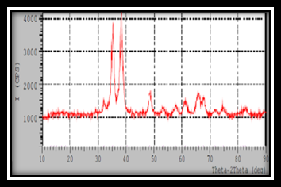
Fig.1. XRD of ZnNPS
FTIR spectroscopy
The FTIR spectrum of ZnNPs was depicted in figure3. The peak at 3440.39 cm⁻¹, 2067.32 cm⁻¹are confirmed the-OH, N-H stretching. The adsorption band at 794 cm⁻¹, 876.48 cm⁻¹ depicted the presence of -CH bending vibration frequency. The frequency band at 1118 cm⁻¹ showed the C-O stretching. The frequency range at 633 cm⁻¹ confirmed the stretching frequency
of ZnONps [11,12].

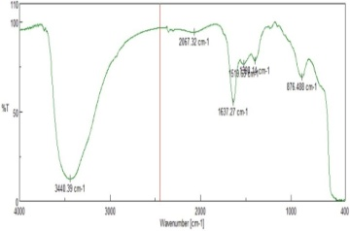

Fig.2. FTIR of ZnNPS

FESEM and EDX Analysis
The ZnO NPs nanoparticles surface was analyzed by FESEM and EDAX analysis with elemental mapping. The FESEM images of ZnO NPs are denoted in the figure 4. ZnO NPs were formed with uniform structures [13]. This property occurred due to polarization, Coulomb force of ZnO NP [14]. In EDAX studies Zn (45.96%), O (52.36%), were the elements present in the ZnO NPS. Figure 3 represents different elemental distribution maps in the ZnO nanoparticles. Figure 4(b) shows the elemental distribution maps, using of ZnO NPS[15].Elements anlaysis of ZnO nanoparticles given in the table1.

TABLE1
ELEMENTAL ANALYSIS OF ZnO NPS
Element | Percentage of weight | Percentage of Atomic
CK | 15.85 | 37.82
OK | 18.67 | 33.44
Cuk | 3.11 | 1.40
ZnK | 12.36 | 27.33

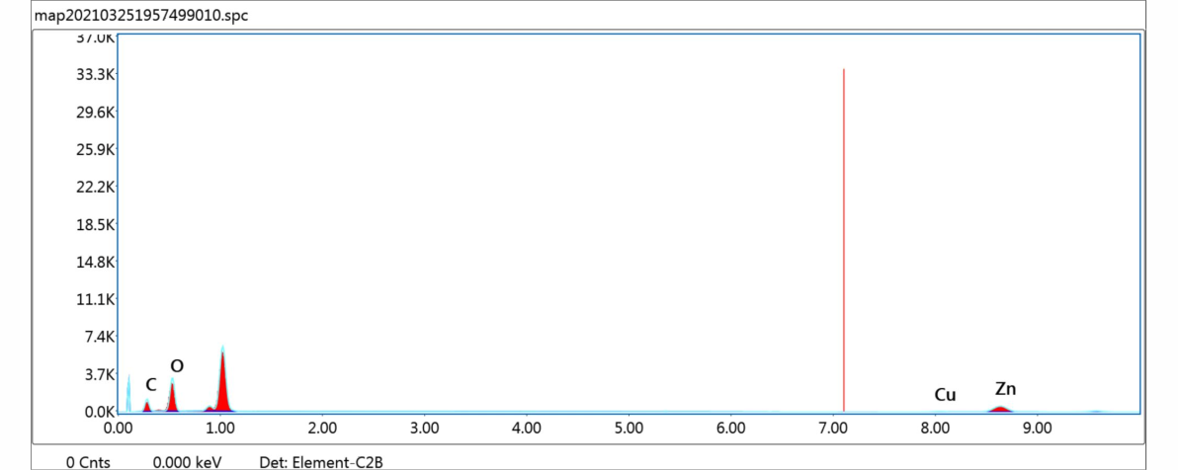
Fig.3. EDX- Elemental Analysis of ZnO Nps

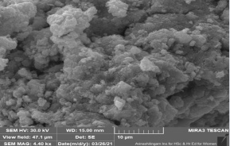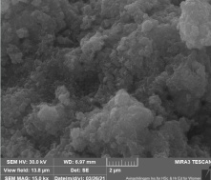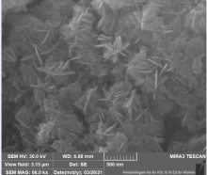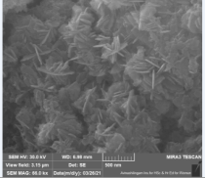
Fig.4. FESEM images of ZnONP

TGA /DTG Analysis
TGA and DTG have been widely used to quantitatively characterize the dehydration and desolvation of solvates and hydrates at constant temperature. The thermal analysis result of ZnO nanoparticles shown in the figure. At 30 to 120 °C, the weight loss that had been noted, it has been related to the vaporization of water molecules. The range of 121 to 300 °C another weight loss, reported due to associated with the burning of extract with chemicals [16]. The temperature range of 300 to 800°C one more weight loss has retained, due to the formation of ZnO .The mass change occurred via -1.35% at temperature .30-120⁰C,-18.24% at temperature 30-800⁰C. -6.66% at temperature121-300⁰C.-10.23% weight loss occurred at temperature 301-800 ⁰C.The least amount of mass changes occurred. So ZnO nanoparticles thermally stable.
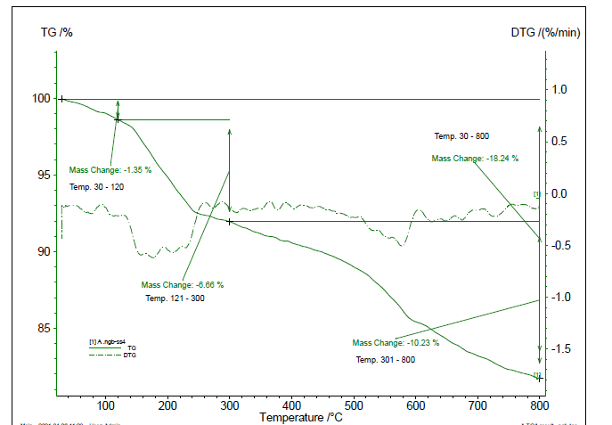
Fig.5. TGA/DTG of ZnO NPS

Anti Oxidant activity

Free radical Scavenging activity
DPPH assay is used to find out antioxidant property. The free radical scavenging activity was calculated as follows

Scavenging Activity%=

ABTS scavenging activity

ABTS assay is used for these studies. The test solution showed good scavenging activity shown in table 2.Increasing concentration of the solution increasing antioxidant activity. The scavenging activity is calculated by using the following formula

Scavenging Activity%=
TABLE –2
ANTIOXIDANT ACTIVITY

Volume (ml) | Concentration (µg) | DPPH Scavenging Activity  (%) | ABTS Scavenging Activity (%)
0.1 | 250 | 27.2 | 95.2
0.2 | 500 | 46.5 | 96.3
0.3 | 750 | 75.1 | 98.4

The results clearly indicate the potential of ZnO nanoparticles [17]. Various phytochemicals such as polyphenols and, flavonoids are already reported in the aqueous extracts of leafs. These chemicals provide antioxidant property to nano particles.

Analysis of Minimum Inhibitory Concentration (MIC)
Antimicrobial susceptibility testing was carried out by MIC, agar well diffusion method. For this antibacterial activity,the test sample was diluted to get series of concentrations from 50mg/ml to 100mg/ml in sterile nutrient broth. The microorganism suspension of 50μl was added to the broth dilutions.For fungal activity, the microorganism suspension of 50μl was added to the broth dilutions The test samples were allowed in Sabouraud dextrose broth and 50 μl of Aspergillus niger spore suspension was also added.

Agar- well diffusion method

Escherichia coli, and Staphylococcus aureus were used to predict antibacterial activity. ZnO NPs had shown a good antibacterial activity against E.Coli. The volume of test samples were taken as 20,40,60µl. The antibacterial activity due to the large surface area of the ZnO nanoparticles.The anti-bacterial activity,concentration of ZnO NPs given in the table4. Another reason for the anti-bacterial potential could be due to the active oxygen species produced by metal oxide particles [18, 19].
TABLE-3
MIC METHOD
Concentration of ZnO NPS mg/µl
Bacteria
Staphylococcus aureus | E.coli
50 | 100

TABLE-4
ZONE OF INHIBITION EFFICIENCY
Volume of samples  (µl) | Zone of inhibition (mm)
Volume of samples  (µl) | Staphylococcus aureus | E.coli
20 | - |  | -
40 | - |  | 1
60 | - |  | 3
+ : No bacterial growth occurred
- : bacterial growth occurred

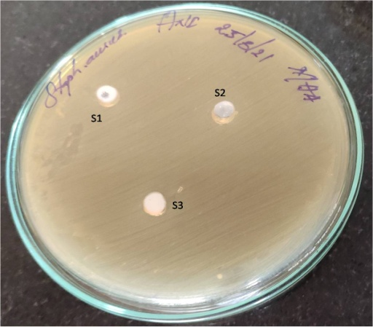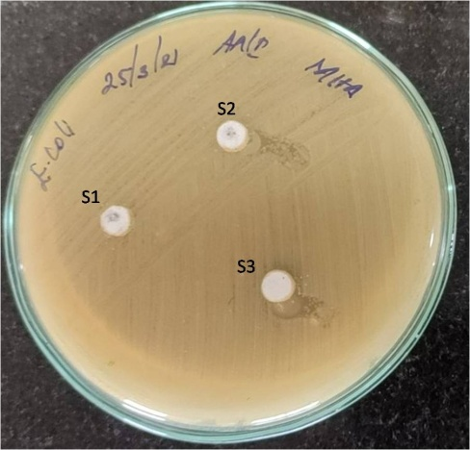

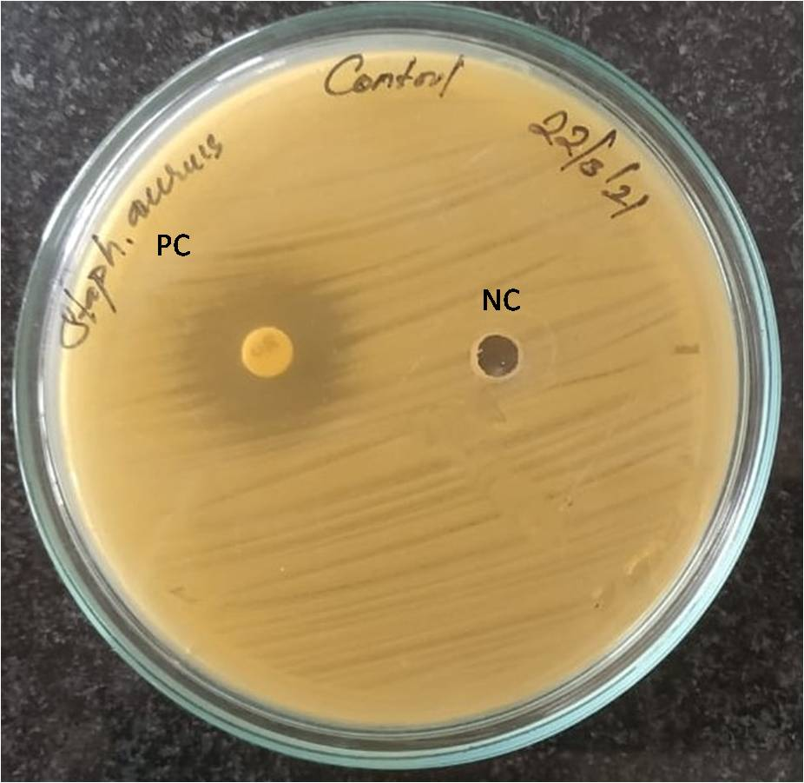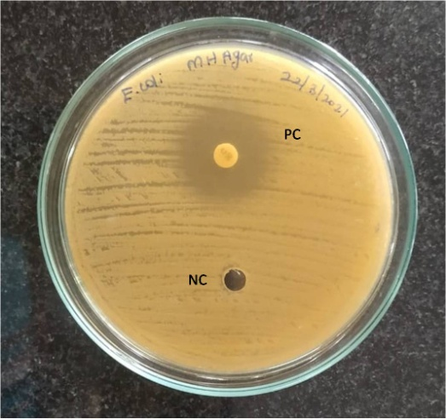
Fig.6. Zone inhibition of Staphylococcus aureus,E.coli

Anti-fungal activity
Lactophenol cotton stain is used for these studies. Antifungual studies tested against Aspergillus niger fungi. Positive sign denotes Spore inhibition caused by test sample [20].The inhibition efficiency was shown in the table5.
TABLE 5
SPORE INHIBITION EFFICIENCY
(Concentration of ZnO NPS mg/l) against Fungi | Sample Name | Spore inhibition of Aspergillus niger
Aspergillus niger | Control (Without test sample) | -
100 | Test sample | +

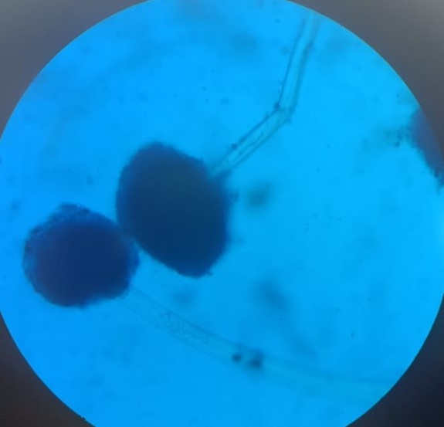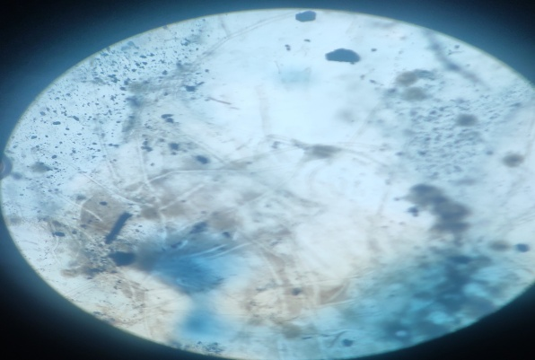
Fig.7 Control (Without test sample) Fig.8.Test sample
This activity reveals the destructions of microbial plasma membrane due to the discharged zinc ions from ZnO NPs[21,22].

CONCLUSION
In the present study on synthesis of zinc oxide nanoparticles using leaf extract of Eichhorrnia crappises. XRD was used to calculate the dimension of the nanoparticles as 54 nm. EDX results show the composition of Zinc is 45.96% and Oxygen is 52.36%, respectively. Fourier Transform Infra Red (FTIR) spectroscopic analysis depicts absorption peak of Zinc Oxide bonding at 633 cm⁻¹.The thermal activity checked by TGA/DTG. FESEM images analysed the surface morphology nanoparticles. ZnO nano particle showed good anti oxidant activity, good antibacterial against E.coli bacteria. The antifungal potential, these nanoparticles showed good activity against tested fungal.

REFERENCES
- Agarwal Happy, Menon Soumya, S. Venkat Kumar, S. Rajeshkumar, R. David Sheba, T. Lakshmi, V. Deepak Nallaswamyd,Phyto-assisted synthesis of zinc oxide nanoparticles using Cassia alata and its antibacterial activity against Escherichia coli, J.Biochemistry and Biophysics Reports, 17 ,208–211, (2019). https://doi.org/10.1016%2Fj.bbrep.2019.01.002
- Tayel, Ahmed A., Noha M. Sorour, Ashraf F. El- Baz, and Wael F. El-Tras. "Nanometals appraisal in food preservation and food- related activities", Food Preservation,484-526,(2017),http://dx.doi.org/10.1016/B978-0-12-804303-5.00014-6.
- Harish Chandra , Deepak Patel , Pragati Kumari, J.S. Jangwanb , Saurabh Yadav,
Phyto-mediated synthesis of zinc oxide nanoparticles of Berberis aristata: Characterization, antioxidant activity and antibacterial activity with special reference to urinary tract pathogens , Materials Science & Engineering :C, 102 ,212–220, (2019). https://doi.org/10.1016/j.msec.2019.04.035

- M. Kaushik, R. Niranjana, Ramar Thangam, Balaraman Madhan, V. Pandiyarasan, C.Ramachandrand, Deog-Hwan Oh, G. Devanand Venkatasubbua,Investigations on the antimicrobial activity and wound healing potential of ZnO nanoparticles, Applied Surface Science, 479 ,1169–1177, (2019). https://doi.org/10.1016/j.apsusc.2019.02.189

- Pankaj Kumar Tyagi, Deepak Gola, Shruti Tyagi, Ankit Kumar ,Mishra, Arvind Kumar, Nitin Chauhan, Anami Ahuja and Sandeep,Synthesis of Zinc oxide nanoparticles and its conjugation with antibiotic:antibacterial and morphological characterization,J. Environmental Nanotechnology, Monitoring & Management,vol14,100391. https://doi.org/10.1016/j.enmm.2020.100391.
- Akl M. Awwad1, Mohammad W. Amer, Nidà M. Salem, Amany O.Abdeen, Green synthesis of zinc oxide nanoparticles (ZnO-NPs) using Ailanthus altissima fruit extracts and antibacterial activity, 6(3),151-159, (2020). https://doi.org/10.5281/zenodo.3559520

- Hany M. Abd El-Lateef . W. A. Albokheet . M. Gouda,Carboxymethyl cellulose/metal (Fe, Cu and Ni)nanocomposites as non-precious inhibitors of C-steel a corrosion in HCl solutions: synthesis, characterization,electrochemical and surface morphology studies,Journal of cellulose,14,8039-8057,(2020), https://doi.org/10.1007/s10570-020-03292-6

- Harish Kumar , Anurag Boora, Ankita Yadav, Rajni, Rahul, Polyaniline-metal oxide-nano-composite as a nano-electronics, optoelectronics,heat resistance and anticorrosive material, Results in Chemistry ,2 ,100046, (2020), https://doi.org/10.1016/j.rechem.2020.100046

- Hoomaan Joz Majidi , Ali Mirzaee , Seid Mahdi Jafari , Mehrasa Amiri ,Mohsen Shahrousvand , Amir Babaei, Fabrication and characterization of graphene oxide-chitosan-zinc oxide ternary nano-hybrids for the corrosion inhibition of mild steel, International Journal of Biological Macromolecules,148,1190-1200,(2020), https://doi.org/10.1016/j.ijbiomac.2019.11.060
- Doaa.A,Ghareeb,SamarR,Saleh,Mohamed G.Seadawy, contract Nanoparticles of ZnO/Berberine complex COVID-19 and respiratory co- bacterial infection in addition to elimination of hydroxychloroquine toxicity", Journal of Pharmaceutical Investigation, 51,735-757,(2021)
https://doi.org/10.1007/s40005-021-00544-w
- Reza Elyaci,Mehdi Bazarganipour ,Preparation and characterizartion of zinc oxide nanoparticles incorporated tragacanth nanofibres for adsorbing fuel sulfur compounds, Polymer Advanced Technologies,33(2),576-583,(2022)
https://doi.org/10.1002/pat.5539

- Jin KyuPark,Esrat JahanRupa,Synthesis of zinc oxide nanoparticles from Gynostemma pentaphyllum extracts and assessment of photocatalytic properties through malachite green dye decolorization under UV illumination-A Green Approach, optik,239,166249,(2021)
https://doi.org/10.1016/j.ijleo.2020.166249

- Meera A P. "Evaluation of Antimicrobial Activity of Bio Synthesised Zinc Oxide Nanoparticles Using Morinda umbellata Leaf Extract", ECS Transactions,104,15953 (2022),https://doi.org/10.1149/10701.15953ecst
- Elahe Darvishi , Danial Kahrizi , Elham Arkan, Comparison of different properties of zinc oxide nanoparticles synthesized by the green (using Juglans regia L. leaf extract) and chemical methods, Journal of Molecular Liquids ,286,110831, (2019), https://doi.org/10.1016/j.molliq.2019.04.108

- Mehdi Hosseinib,, Ali Esrafilia,, Mahdi Farzadkiaa,, Majid Kermania,b, Mitra Gholami, Degradation of ciprofloxacin antibiotic using photo-electrocatalyst process of Ni-doped ZnO deposited by RF sputtering on FTO as an anode electrode from aquatic environments: Synthesis, kinetics, and ecotoxicity study, Microchemical Journal ,154 104663, (2020) ,https://doi.org/10.1016/j.microc.2020.104663.

- Maryam Alkasira , Naser Samadia , Zahra Sabourib , Zahra Mardanic , Mehrdad Khatamid , Majid Darroudi ,Evaluation cytotoxicity effects of biosynthesized zinc oxide nanoparticles using aqueous Linum Usitatissimum extract and investigation of their photocatalytic activity ,Inorganic chemistry communication,119,108066,(2020), https://doi.org/10.1016/j.inoche.2020.108066

- S. Rajeshkumara, S. Venkat Kumara , Arunachalam Ramaiahb, Happy Agarwala , T. Lakshmid , Selvaraj Mohana Roopan, Biosynthesis of zinc oxide nanoparticles using Mangifera indica leaves and evaluation of their antioxidant and cytotoxic properties in lung cancer ,(A549) cells, Enzyme and Microbial Technology,117,91-95,(2018), https://doi.org/10.1016/j.enzmictec.2018.06.009

- Emmanuel E. Imade , Timothy O. Ajiboye , Ayomide E,,Fadiji ,Damian ,Onwudiwe , Olubukola O. Babalola , Green synthesis of zinc oxide nanoparticles using plantain peel extracts and the evaluation of their antibacterial activity , 16 ,e01152, (2022), https://doi.org/10.1016/j.sciaf.2022.e01152

- TugbaGur ,IsmetMeydan ,HamdullahSeckin,MuhammedBekmezci,FatihSen,Green synthesis, characterization and bioactivity of biogenic zinc oxide nanoparticles, Environmental Research, 2004,111897,(2022) https://doi.org/10.1016/j.envres.2021.111897

- NV Reddy,Huizhen Li, Tianyu Hou, MS Bethu,Zhiqing Ren Zhijun Zhang,Phytosynthesis of Silver Nanoparticles Using Perilla frutescens Leaf Extract:Characterization and Evaluation of Antibacterial, Antioxidant, and Anticancer Activities, Antimicrobial Activity, International Journal of Nanomedicine, ,16 ,15–29, (2021), https://doi.org/10.2147/IJN.S265003
- Muthuchamy Maruthupandya, Thillaichidambaram Muneeswaranb , Govindan Rajivgandhic , Franck Querob , Muthusamy Anandd , Ji-Ming Song ,Biologically synthesized copper and zinc oxide nanoparticles for important biomolecules detection and antimicrobial applications, Materials Today Communications 22 ,100766, (2020). https://doi.org/10.1016/j.mtcomm.2019.100766
- MominaSardar,WaqasAhmed, Fungicidal synergistic effect of biogenically synthesized zinc oxide and copper oxide nanoparticles against Alternaria citri causing citrus black rot disease, Saudi Journal of Biological Sciences ,29, 88–95, (2022) https://doi.org/10.1016/j.sjbs.2021.08.067

