Kallikrein related peptidases as Angiogenic targets for Prostate Cancer
Bandi Jyothi
Assistant professor, Department of chemistry
Govt. Degree College for Women Autonomous, Nalgonda, 508001
Telangana State, India
b.jyothi8790@gmail.com

Navaneetha Nambigari
Assistant professor, Department of chemistry
University College of science, Saifabad, Osmania University, Hyderabad, 500007
Telangana State, India
nitha379@gmail.com, navaneeta@osmania.ac.in

ABSTRACT
The largest cause of death in the world and a serious global public health issue, according to research, is cancer. Cancer is characterized by unrestricted tumor cell growth. In the US, it is anticipated that there would be 1.9 million new instances of cancer and 609,360 cancer-related deaths in 2022, or almost 1,670 deaths each day. The growth and metastasis (penetration and proliferation) of malignant tumors depend on angiogenesis, the sprouting of new blood vessels from pre-existing surrounding blood vessels. Endothelial cells move and develop during this process as angiogenic factors interact with receptors to release enzymes that break down the endothelial cell matrix. As a result, angiogenic elements continue to create new blood vessel networks. It is found that KLK-12, KLK-14 and KLK-15 proteins are considered as novel targets against angiogenesis through cleavage of Extra Cellular Matrix (ECM) proteins directly or indirectly through Matrix Metallo Proteinases (MMPs) activation via the Urokinase Plasminogen Activator/ uPA Receptor (uPA/ uPAR) signaling pathway.

Keywords—Angiogenesis, Prostate cancer, Kallikrein related peptidases

- INTRODUCTION
Angiogenesis, a biological process in which new blood vessels are created from pre-existing ones, has been connected to the growth and development of tumors [1, 2]. Researchers are investigating at innovative routes to stop tumor angiogenesis because blood circulation is a requirement for nutrition supply and tumor development. A number of mechanisms that initiate and maintain the growth of tumors have been connected to abnormal blood vessel development [3-5]. Numerous disorders, including tumor growth and cancer, are linked to aberrant angiogenesis. Cancer, rheumatoid arthritis, diabetic retinopathy, psoriasis, and AIDS complications are caused by excessive angiogenesis. Stroke, heart disease, ulcers, scleroderma, and infertility are caused by insufficient angiogenesis [6–13].
Cancer metastasis requires angiogenesis. In malignant tumors, angiogenesis is crucial to the spread of cancer [14]. A series of signaling processes involving biomolecules including vascular endothelial growth factors (VEGFs), kallikreins (KLKs), and several other angiogenesis factors are crucial in the development of tumor angiogenesis [15, 16].
The angiogenic signaling molecules activate the endothelial cells in the vicinity, encouraging the development of new capillaries and speeding up the growth of vascular endothelial cells, which helps supply the tumor with nutrients and oxygen [17, 18]. During the tumor angiogenesis process, the tissues basement membrane is breached, hypoxia results. Endothelial cells are then activated, which causes them to proliferate through the over expression of angiogenesis factors [19–21]. Thus angiogenesis plays a significant role in tumor formation, and makes for an intriguing approach to the development of new cancer drugs [22].
In the US, 1.9 million additional cases and 609,360 cancer-related deaths are anticipated by 2022, or over 1,670 fatalities every day [23].Cancer therapy refers to the use of surgery, radiation, drugs, and other therapies to treat or slow the spread of cancer. There are several cancer treatment options at hand. One treatment or a combination of treatments may be given to a patient, depending on their unique circumstances. Chemotherapy, surgery, radiation, and targeted therapy are only a few of the procedures used today to treat cancer [24].
Angiogenesis is the primary driver of malignant development. In an effort to develop a cancer treatment, researchers from all around the world are currently focused on tumor angiogenesis [32]. Chemotherapy is a process in which chemical substances are utilized to destroy all dividing cells. It is not intended to replace any particular medication. It can cause exhaustion, vomiting, diarrhea, nausea, anemia, infections, loss of taste, and a breakdown in the immune system. It continues to be a well-liked therapeutic choice for cancer patients. Despite advances in anticancer drugs for a range of cancers, resistance to both conventional chemotherapy and targeted therapies continues to be a major worry. Drug resistance, which can be innate or acquired, is what leads to treatment failure and tumor progression. Drug resistance may develop as a result of actions taken by specific cancer cells or by tumor microenvironment-related mechanisms [33]. Drugs that inhibit angiogenesis can promote the tumor vasculature's restoration to normal operation. In order to increase the efficacy of cancer therapy, new potent, target-specific cancer drugs are urgently required [34]. Finding lead compounds that target cancer yet have few negative effects on the body's healthy cells is essential.
The area of medicinal chemistry depends heavily on the discovery of novel drugs and therapeutic molecules. It is necessary to identify and target novel therapeutic targets, such as cancer-causing proteins, and to explore novel biochemical pathways. Based on their faulty biological activity compared to that of a normal cell, angiogenesis-targeted treatments have been identified focusing on certain receptors [43].
Two potential benefits of anti-angiogenic therapy over conventional chemotherapy include the absence of drug resistance and negligible adverse effects on normal tissues. People nevertheless experience the symptoms of the sickness despite certain promising chemotherapeutic medications, prompting to the development of modern remedies.
Current cancer treatments either fail to stop the growth of tumors or are extremely harmful to both healthy and cancerous cells. Since anti-angiogenic drugs are not intended to kill cells but rather to prevent the growth of blood vessels, they have advantages over conventional chemotherapeutics [44].
Worldwide cancer is found to be the principal reason of fatality. Cancer tumour growth and metastasis depend on angiogenesis, the sprouting of fresh blood vessels from existing surrounding blood vessels [45, 46]. This is regulated by activator molecules as a consequence of inputs received from the tumour cells and its surroundings. This is significant in view of the fact that the cancer growth relays on sufficient supply of oxygen and nutrients which is facilitated by the newly formed blood vessels [47]. The mechanism underlying the tumour development is to be understood for the discovery of drugs against cancer. KLK proteins play a key role in various cancers by the formation of new blood vessels involving various pathways [48]. The drug design method using KLK protein as drug targets is a novel strategy in cancer research.
In human body, there are two types of kallikreins, namely tissue kallikrein and plasma kallikrein. The tissue kallikreins (KLKs) contribute to the pathological angiogenesis. KLKs are encoded by genetic material positioned on chromosome 19q13.4. Fascinatingly, the genetic material (named KLKB1) that encodes for the enzyme called plasma kallikrein, is located on chromosome 4q34–35. Plasma kallikrein is known to release kinins. Despite the fact that this enzyme is still known as plasma kallikrein, and it is not considered as the part of the KLK family [49].
Kallikrein gene and protein symbols are represented as KLK (written in Italics) and KLK (written in standard font) respectively [50]. The tissue kallikreins can be classified into 15 proteases. The 15 KLKs are single proteins comprising of 244–282 amino acid residues and reported to have 40% identity among all KLKs. The first elucidated tissue kallikrein was represented as KLK-1; rest of them (KLK-2 to KLK-15) are called kallikrein-related proteases [51, 52]. The 15 human KLKs are conserved serine peptidases and these proteins are pre - pro enzymes. The Pre sequence is having an amino-terminal signal, Pro means a pro-peptide an inactive zymogen and a serine-peptidase domain accountable for its biological activity [53, 54]. In the present study KLK-12, KLK-14 and KLK-15 proteins are considered as novel targets for the discovery of innovative lead molecules against angiogenesis.

Biological pathway of KLK proteins.
The human tissue kallikreins are serine proteases known to express in many cancer types. KLKs are responsible for the tumour angiogenesis, through cleavage of Extra Cellular Matrix (ECM) proteins directly. Indirectly they also can promote tumor growth through Matrix Metallo Proteinases (MMPs) activation via the Urokinase Plasminogen Activator/ uPA Receptor (uPA/ uPAR) signalling pathway [55, 56]. Thus targeting angiogenesis via KLK cascade may provide novel clinical diagnosis for improving cancer survivals. The general biochemical pathway of KLK proteins is shown in Figure 1.

KLK-12 Protein.
Kallikrein like peptidase-12 (KLK-12) protein, found to be expressed in the tissues of breast cancer [57]. It is a Trypsin-like serine peptidase that initiates angiogenesis by cleavage of ECM- associated signalling proteins. Figure 2 depicts that KLK-12 protein mediates the destruction of ECM protein namely the Cysteine Rich angiogenic inducer 61 (CYR61). CYR61 in turn releases VEGF, FGF-2 and TGFβ from its complex to provoke angiogenesis [58]. Blockage of KLK-12 biological action was found to decrease the formation of new blood vessels of micro vascular endothelial cell experimentally [59, 60]. Therefore, the current work considers the KLK-12 protein as a novel target in order to identify new small compounds as a lead against angiogenesis.

KLK-14 Protein.
Among 15 KLK homologues KLK-14 protein is found to be expressed in the tissues of breast, ovarian and prostrate cancers [61]. KLK-14 promotes angiogenesis by degradation of Fibronectin a large multi domain ECM glycoprotein [62, 63]. There by decrease in fibronectin expression or increase in fibronectin degradation leading to the activation of VEGF and stimulate angiogenesis as shown in Figure 3. Hence the present study deals with the identification of inhibitors to stop the process of angiogenesis by inhibiting the interaction of KLK-14 with the fibronectin substrate.

KLK-15 Protein.
Kallikrein like peptidase-15 (KLK-15) protein is found to be expressed in the tissues of prostate cancer [64]. KLK-15 acts on pro-uPA, to convert inactive pro-uPA to convert active uPA (Urokinase-type Plasminogen Activator). The activation of uPA, and its receptor, uPAR (Urokinase-type Plasminogen Activator Receptor), converts plasminogen into plasmin, an active proteolytic enzyme. This release of plasmin by KLK-15 is primarily accountable in support of ECM degradation through MMP pathway, and role in angiogenesis of cancer [65, 66]. The biochemical pathway of KLK-15 is shown in Figure 4.

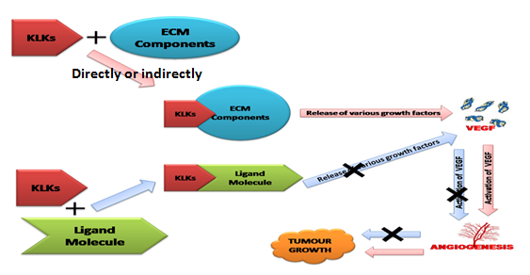
Figure 1: Pathogenesis of the KLK family of proteins in tumor growth: The KLK proteins hydrolyse the ECM components directly or indirectly, thereby releasing various growth factors which upon activation lead to the tumor angiogenesis. Prevention of release and action of growth factors is an attractive drug discovery strategy for cancer.

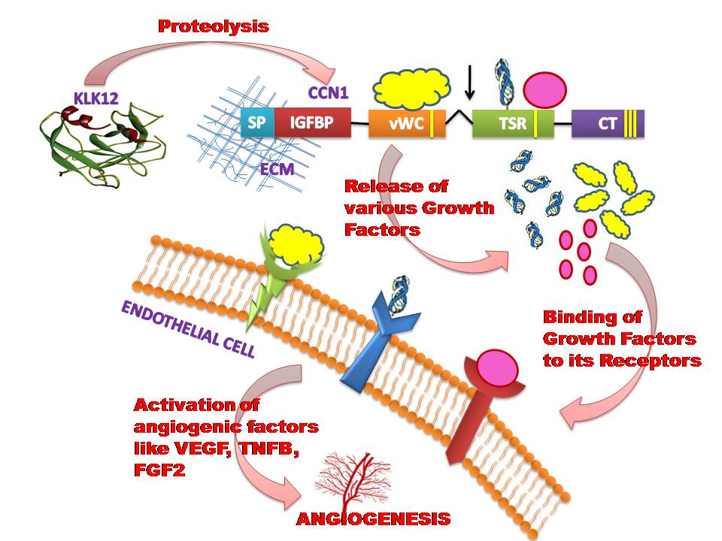
Figure 2: Biochemical pathway of KLK-12 protein: The Proteolysis of CCN1 (CYR61) by KLK-12 protein leads to the release and activation of VEGF, TNFβ and FGF2. Activation of these growth factors lead to tumor angiogenesis. SP: Secretory Signal Peptide, IGFBP: IGF – Binding protein domain, vWC: von Willebrand type C domain, TSP: Thrombospondin domain, CT: Cysteine knot domain, FGF2: Fibroblast Growth Factor2, VEGF: Vascular Endothelial Growth Factor, ECM: Extracellular Matrix, TNFβ: Tumor Necrosis Factor Beta.

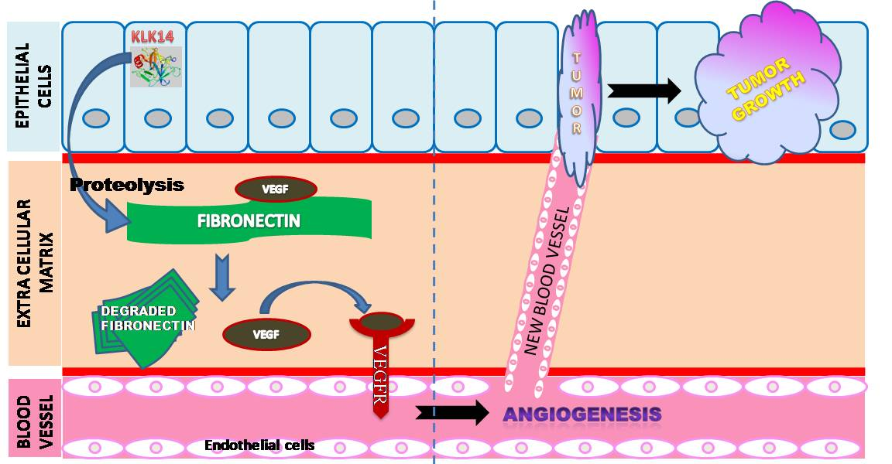
Figure 3: Biochemical pathway of KLK-14 protein: Degradation of fibronectin by KLK-14 protein, leads to the activation of VEGF and VEGFR, which in turn promotes angiogenesis.

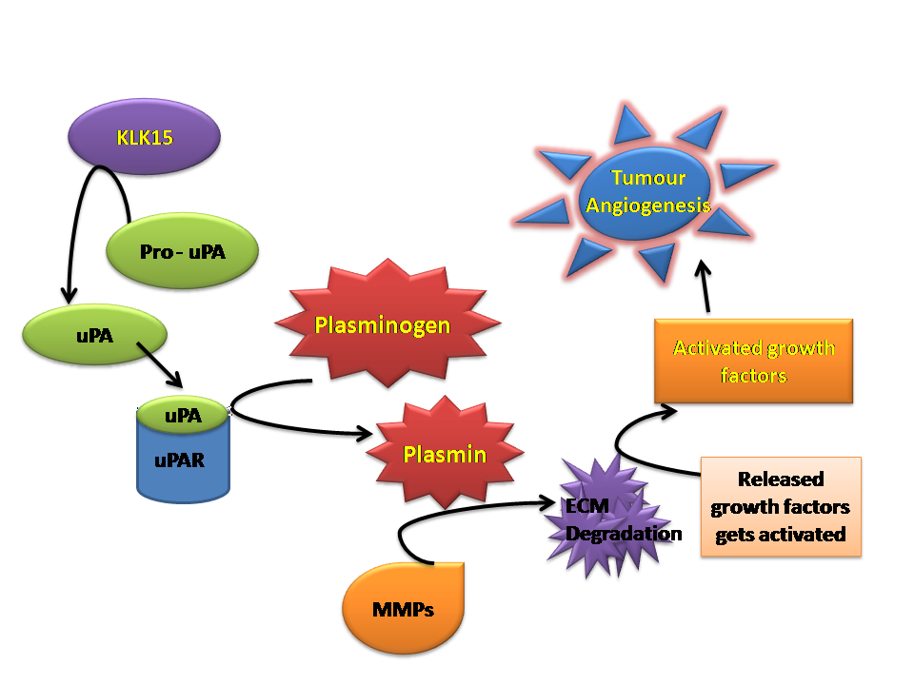
Figure 4: Biochemical pathway of KLK-15 protein:Activation of plasmin by KLK-15 via the uPA and uPAR activation, leading to the degradation of ECM components by MMPs to regulate tumor angiogenesis.

- CONCLUSIONS
The kallikrein related peptidases (KLK-12, KLK-14 and KLK-15) are implicated in tumor angiogenesis. Inhibition of angiogenesis is an important step for cancer prevention. The kallikreins are degrading extracellular matrix (ECM) components directly. They are also inducing angiogenesis in indirect manner through MMP activation pathway or via uPA/ uPAR pathway. The aim of the study is to design competitive inhibitors for KLK proteins against degradation of ECM to prevent angiogenesis and thereby arrest cell cycle progression and tumor formation. The KLK proteins KLK-12 [67], KLK-14 [68], and KLK-15 are treated as novel targets to identify new molecules by applying computer aided drug design protocols. The identified molecules are synthesized and biological activity can be tested. These lead molecules are expected to show strong anti cancer property and are considered as drug candidates against the cancer.

- REFERENCES
[1] Carmeliet, P. (2005). Angiogenesis in life, disease and medicine. Nature, 438(7070), 932-936.
[2] Rivera, L. B., & Bergers, G. (2015). Tumor angiogenesis, from foe to friend. Science, 349(6249), 694-695.
[3] De Palma, M., Biziato, D., & Petrova, T. V. (2017). Microenvironmental regulation of tumour angiogenesis. Nature reviews. Cancer, 17(8), 457–474.
[4] Chung, A. S., Lee, J., & Ferrara, N. (2010). Targeting the tumour vasculature: insights from physiological angiogenesis. Nature reviews. Cancer, 10(7), 505–514.
[5] Jacobs, J. (2007). Combating cardiovascular disease with angiogenic therapy. Drug discovery today, 12(23-24), 1040-1045.
[6] Folkman, J. (1995). Angiogenesis in cancer, vascular, rheumatoid and other disease. Nature medicine, 1(1), 27-30.
[7] Carmeliet, P., & Jain, R. K. (2000). Angiogenesis in cancer and other diseases. Nature, 407(6801), 249-257.
[8] Hummers, L. K., Hall, A., Wigley, F. M., & Simons, M. (2009). Abnormalities in the regulators of angiogenesis in patients with scleroderma. The Journal of rheumatology, 36(3), 576–582.
[9] Creamer, D., Sullivan, D., Bicknell, R., & Barker, J. (2002). Angiogenesis in psoriasis. Angiogenesis, 5(4), 231–236.
[10] Simons, M., & Ware, J. A. (2003). Therapeutic angiogenesis in cardiovascular disease. Nature reviews Drug discovery, 2(11), 863-872.
[11] Ware, J., Simons, M. (1997). Angiogenesis in ischemic heart disease. Nat Med., 3, 158–164.
[12] Gariano, R. F., & Gardner, T. W. (2005). Retinal angiogenesis in development and disease. Nature, 438(7070), 960-966.
[13] Szekanecz, Z., & Koch, A. E. (2007). Mechanisms of Disease: angiogenesis in inflammatory diseases. Nature clinical practice. Rheumatology, 3(11), 635–643.
[14] Tonini, T., Rossi, F., & Claudio, P. P. (2003). Molecular basis of angiogenesis and cancer. Oncogene, 22(42), 6549–6556.
[15] Ferrara, N., Gerber, H. P., & LeCouter, J. (2003). The biology of VEGF and its receptors. Nature medicine, 9(6), 669–676.
[16] Emami, N., & Diamandis, E. P. (2008). Utility of kallikrein-related peptidases (KLKs) as cancer biomarkers. Clinical chemistry, 54(10), 1600–1607.
[17] Coultas, L., Chawengsaksophak, K., & Rossant, J. (2005). Endothelial cells and VEGF in vascular development. Nature, 438(7070), 937–945.
[18] Goel, H. L., & Mercurio, A. M. (2013). VEGF targets the tumour cell. Nature reviews. Cancer, 13(12), 871–882.
[19] Weis, S. M., & Cheresh, D. A. (2011). Tumor angiogenesis: molecular pathways and therapeutic targets. Nature medicine, 17(11), 1359–1370.
[20] Hillen, F., & Griffioen, A. W. (2007). Tumour vascularization: sprouting angiogenesis and beyond. Cancer metastasis reviews, 26(3-4), 489–502.
[21] Gurtner, G. C., Werner, S., Barrandon, Y., & Longaker, M. T. (2008). Wound repair and regeneration. Nature, 453(7193), 314–321.
[22] Albini, A., Tosetti, F., Li, V. W., Noonan, D. M., & Li, W. W. (2012). Cancer prevention by targeting angiogenesis. Nature reviews. Clinical oncology, 9(9), 498–509.
[23] American Cancer Society. (2022). Cancer Facts & Figures 2022. Atlanta: American Cancer Society.
[24] Potente, M., Gerhardt, H., & Carmeliet, P. (2011). Basic and therapeutic aspects of angiogenesis. Cell, 146(6), 873–887.
[25] Wang, Z., Dabrosin, C., Yin, X., Fuster, M. M., Arreola, A., Rathmell, W. K., Generali, D., Nagaraju, G. P., El-Rayes, B., Ribatti, D., Chen, Y. C., Honoki, K., Fujii, H., Georgakilas, A. G., Nowsheen, S., Amedei, A., Niccolai, E., Amin, A., Ashraf, S. S., Helferich, B., Jensen, L. D. (2015). Broad targeting of angiogenesis for cancer prevention and therapy. Seminars in cancer biology, 35, S224–S243.
[26] Folkman J. (2007). Angiogenesis: an organizing principle for drug discovery?. Nature reviews. Drug discovery, 6(4), 273–286.
[27] Kerbel, R. S., & Kamen, B. A. (2004). The anti-angiogenic basis of metronomic chemotherapy. Nature reviews. Cancer, 4(6), 423–436.
[28] Sullivan, R., Alatise, O. I., Anderson, B. O., Audisio, R., Autier, P., Aggarwal, A., Balch, C., Brennan, M. F., Dare, A., D'Cruz, A., Eggermont, A. M., Fleming, K., Gueye, S. M., Hagander, L., Herrera, C. A., Holmer, H., Ilbawi, A. M., Jarnheimer, A., Ji, J. F., Kingham, T. P., Purushotham, A. (2015). Global cancer surgery: delivering safe, affordable, and timely cancer surgery. The Lancet. Oncology, 16(11), 1193–1224.
[29] Baskar, R., Lee, K. A., Yeo, R., & Yeoh, K. W. (2012). Cancer and radiation therapy: current advances and future directions. International journal of medical sciences, 9(3), 193–199.
[30] Haikerwal, S. J., Hagekyriakou, J., MacManus, M., Martin, O. A., & Haynes, N. M. (2015). Building immunity to cancer with radiation therapy. Cancer letters, 368(2), 198–208.
[31] Prise, K. M., & O'Sullivan, J. M. (2009). Radiation-induced bystander signalling in cancer therapy. Nature reviews. Cancer, 9(5), 351–360.
[32] Bergers, G., & Benjamin, L. E. (2003). Tumorigenesis and the angiogenic switch. Nature reviews. Cancer, 3(6), 401–410.
[33] Ravindran Ankathil. (2019). The mechanisms and challenges of cancer chemotherapy resistance: A current overview. European Journal of Molecular & Clinical Medicine, 6(1), 26-34.
[34] Holohan, C., Van Schaeybroeck, S., Longley, D. B., & Johnston, P. G. (2013). Cancer drug resistance: an evolving paradigm. Nature reviews. Cancer, 13(10), 714–726.
[35] Bleicher, K. H., Böhm, H. J., Müller, K., & Alanine, A. I. (2003). Hit and lead generation: beyond high-throughput screening. Nature reviews. Drug discovery, 2(5), 369–378.
[36] Macalino, S. J., Gosu, V., Hong, S., & Choi, S. (2015). Role of computer-aided drug design in modern drug discovery. Archives of pharmacal research, 38(9), 1686–1701.
[37] Kapetanovic I. M. (2008). Computer-aided drug discovery and development (CADDD): in silico-chemico-biological approach. Chemico-biological interactions, 171(2), 165–176.
[38] Ferreira, L. G., Dos Santos, R. N., Oliva, G., & Andricopulo, A. D. (2015). Molecular docking and structure-based drug design strategies. Molecules (Basel, Switzerland), 20(7), 13384–13421.
[39] Ng, L. Y., Chong, F. K., & Chemmangattuvalappil, N. G. (2015). Challenges and opportunities in computer-aided molecular design. Computers and Chemical Engineering, 81, 115-129.
[40] Cavasotto, C. N., & Phatak, S. S. (2009). Homology modeling in drug discovery: current trends and applications. Drug discovery today, 14(13-14), 676–683.
[41] Schenone, M., Dančík, V., Wagner, B. K., & Clemons, P. A. (2013). Target identification and mechanism of action in chemical biology and drug discovery. Nature chemical biology, 9(4), 232–240.
[42] Cao, D., Wang, J., Zhou, R., Li, Y., Yu, H., & Hou, T. (2012). ADMET evaluation in drug discovery. 11. PharmacoKinetics Knowledge Base (PKKB): a comprehensive database of pharmacokinetic and toxic properties for drugs. Journal of chemical information and modeling, 52(5), 1132–1137.
[43] Hait, W. N., & Hambley, T. W. (2009). Targeted cancer therapeutics. Cancer research, 69(4), 1263–1267.
[44] Samant, R. S., & Shevde, L. A. (2011). Recent advances in anti-angiogenic therapy of cancer. Oncotarget, 2(3), 122–134.
[45] Hanahan, D., & Weinberg, R. A. (2011). Hallmarks of cancer: the next generation. Cell, 144(5), 646–674.
[46] Liotta, L. A., & Kohn, E. C. (2001). The microenvironment of the tumour-host interface. Nature, 411(6835), 375–379.
[47] Nishida, N., Yano, H., Nishida, T., Kamura, T., & Kojiro, M. (2006). Angiogenesis in cancer. Vascular health and risk management, 2(3), 213–219.
[48] Emami, N., & Diamandis, E. P. (2007). Human tissue kallikreins: a road under construction. Clinica chimica acta; international journal of clinical chemistry, 381(1), 78–84.
[49] Kalinska, M., Meyer-Hoffert, U., Kantyka, T., & Potempa, J. (2016). Kallikreins - The melting pot of activity and function. Biochimie, 122, 270–282.
[50] Diamandis, E. P., Yousef, G. M., Clements, J., Ashworth, L. K., Yoshida, S., Egelrud, T., Nelson, P. S., Shiosaka, S., Little, S., Lilja, H., Stenman, U. H., Rittenhouse, H. G., & Wain, H. (2000). New nomenclature for the human tissue kallikrein gene family. Clinical chemistry, 46(11), 1855–1858.
[51] Yousef, G. M., & Diamandis, E. P. (2002). Human tissue kallikreins: a new enzymatic cascade pathway?. Biological chemistry, 383(7-8), 1045–1057.
[52] Koumandou, V. L., & Scorilas, A. (2013). Evolution of the plasma and tissue kallikreins, and their alternative splicing isoforms. PloS one, 8(7), e68074.
[53] Lilja H. (1985). A kallikrein-like serine protease in prostatic fluid cleaves the predominant seminal vesicle protein. The Journal of clinical investigation, 76(5), 1899–1903.
[54] Webber, M. M., Waghray, A., & Bello, D. (1995). Prostate-specific antigen, a serine protease, facilitates human prostate cancer cell invasion. Clinical cancer research: an official journal of the American Association for Cancer Research, 1(10), 1089–1094.
[55] Borgoño, C. A., Michael, I. P., & Diamandis, E. P. (2004). Human tissue kallikreins: physiologic roles and applications in cancer. Molecular cancer research: MCR, 2(5), 257–280.
[56] Borgoño, C. A., Michael, I. P., Komatsu, N., Jayakumar, A., Kapadia, R., Clayman, G. L., Sotiropoulou, G., & Diamandis, E. P. (2007). A potential role for multiple tissue kallikrein serine proteases in epidermal desquamation. The Journal of biological chemistry, 282(6), 3640–3652.
[57] Yousef, G. M., Magklara, A., & Diamandis, E. P. (2000). KLK12 is a novel serine protease and a new member of the human kallikrein gene family-differential expression in breast cancer. Genomics, 69(3), 331–341.
[58] Guillon-Munos, A., Oikonomopoulou, K., Michel, N., Smith, C. R., Petit-Courty, A., Canepa, S., Reverdiau, P., Heuzé-Vourc'h, N., Diamandis, E. P., & Courty, Y. (2011). Kallikrein-related peptidase 12 hydrolyzes matricellular proteins of the CCN family and modifies interactions of CCN1 and CCN5 with growth factors. The Journal of biological chemistry, 286(29), 25505–25518.
[59] Puente, X. S., Sánchez, L. M., Overall, C. M., & López-Otín, C. (2003). Human and mouse proteases: a comparative genomic approach. Nature reviews. Genetics, 4(7), 544–558.
[60] Clements, J. A., Willemsen, N. M., Myers, S. A., & Dong, Y. (2004). The tissue kallikrein family of serine proteases: functional roles in human disease and potential as clinical biomarkers. Critical reviews in clinical laboratory sciences, 41(3), 265–312.
[61] Borgoño, C. A., Grass, L., Soosaipillai, A., Yousef, G. M., Petraki, C. D., Howarth, D. H., Fracchioli, S., Katsaros, D., & Diamandis, E. P. (2003). Human kallikrein 14: a new potential biomarker for ovarian and breast cancer. Cancer research, 63(24), 9032–9041.
[62] Richard O Hynes. (1990). Fibronectins. Springer-Verlag. 1-559.
[63] Wijelath, E. S., Rahman, S., Namekata, M., Murray, J., Nishimura, T., Mostafavi-Pour, Z., Patel, Y., Suda, Y., Humphries, M. J., & Sobel, M. (2006). Heparin-II domain of fibronectin is a vascular endothelial growth factor-binding domain: enhancement of VEGF biological activity by a singular growth factor/matrix protein synergism. Circulation research, 99(8), 853–860.
[64] Yousef, G. M., Scorilas, A., Jung, K., Ashworth, L. K., & Diamandis, E. P. (2001). Molecular cloning of the human kallikrein 15 gene (KLK15). Up-regulation in prostate cancer. The Journal of biological chemistry, 276(1), 53–61.
[65] Takayama, T. K., Carter, C. A., & Deng, T. (2001). Activation of prostate-specific antigen precursor (pro-PSA) by prostin, a novel human prostatic serine protease identified by degenerate PCR. Biochemistry, 40(6), 1679–1687.
[66] Borgoño, C. A., & Diamandis, E. P. (2004). The emerging roles of human tissue kallikreins in cancer. Nature reviews. Cancer, 4(11), 876–890.
[67] Jyothi Bandi., Navaneetha Nambigari. (2021). Identification of Novel Anticancer Agent by insilico Methods for Inhibition of KLK-12 Protein. Asian J. Org. Med. Chem., 6(1), 13-23.
[68] Bandi, J., Malkhed, V. & Nambigari, N. (2022). An insilico study of KLK-14 protein and its inhibition with curcumin and its derivatives. Chem. Pap., 76, 4955–4966.

