Plywood Innovations:-A Sustainable Approach to modern life
S.C.Sahoo
Scientist, Institute of wood science and technology, Field Station ,Kolkat
(Indian council of forestry research & education),E-mail –sahoosc@icfre.org

CHAPTER SUMMARY
Plywood is an engineered wood product, plays crucial role in promoting sustainability across various industries This chapter provides an overview the various innovative applications of plywood in modern life, highlighting its role as a sustainable material choice. The main aim of this chapter is to provide enough background information regarding the plywood. its construction ,types ,application etc.Plywood, a versatile engineered wood product, has revolutionized the world design and construction with its unique combination of strength, flexibility and sustainability. This chapter explores regarding the safe and healthy life by using plywood as a furniture material, Challenges and future Direction of Plywood etc. It is further hoped that this chapter encourages researchers to contribute research effort to the wood based composite manufacturing sector.
Introduction
The most widely used engineered wood is plywood, which is created by layering thin veneers of wood with a thermosetting adhesive based on petroleum. It can be used for a variety of things, including flooring, designer furniture, packaging, interiors of homes, offices, and businesses, as well as roofing and walls, molds for concrete constructions, and more. Compared to other forms of engineered wood or untreated wood, it is substantially stronger. The grain of each layer is cross-grained and adhered to the layers below it to create strength. Over other traditional materials, plywood has a number of additional benefits. A couple of these obvious variations are:
- Plywood has an improved resistance against termites
- Plywood is free of pests like borers which damages the material internally
- Plywood is manufactured in standard sizes and uniform thicknesses. This saves a lot of hassle which otherwise consumes lot of time in finishing the product while working.
- Plywood is manufactured by cross-graining of veneer layers. This considerably increases the strength of the plywood plank.
- Plywood is relatively more durable and has a better life than other conventional materials.
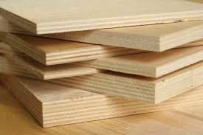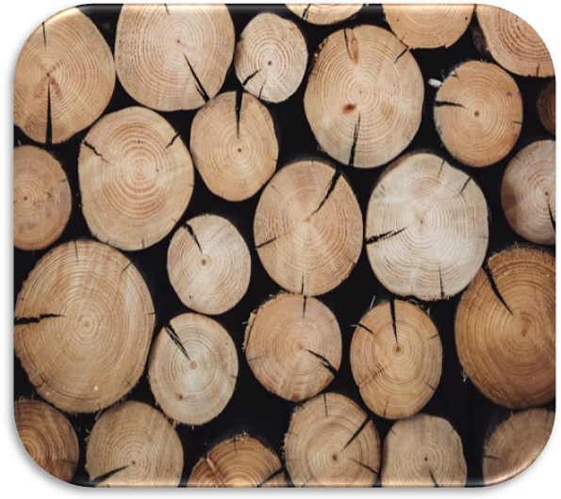
Grade and Types of Plywood:-
Eucalyptus, rubberwood, ash, cedar, spruce, oak, birch, maple, and pine are a few of the common wood species that are used to make plywood. Plywood is a carefully engineered wood that is designed in accordance with the needs and specifications of the final use, and different applications call for the use of different raw materials. This explains why there are numerous grades and thicknesses of plywood available. In order to explicitly learn more about each grade, let's look at a couple of them.
Moisture Resistant (MR) Grade: This is the moisture-resistant grade of commercial plywood that is offered on the market, as the name would imply. Urea Formaldehyde Resins are utilized to adhere the plies together in plywood of the MR grade. This type of plywood is reasonably priced and economical. The important thing to keep in mind is that the MR Grade of plywood is "moisture resistant" rather than "waterproof." Therefore, while the plywood may withstand moisture and humidity, it cannot withstand water. Therefore, this type of plywood shouldn't be used to create furniture or other products that will be in constant contact with or exposed to water. MR grade plywood is the best interior grade plywood for making indoor furniture or goods linked to interior design.
Among many other things, MR grade plywood is frequently used for partitions, bookshelves, mounted cabinets, living room, bedroom, and office furniture.
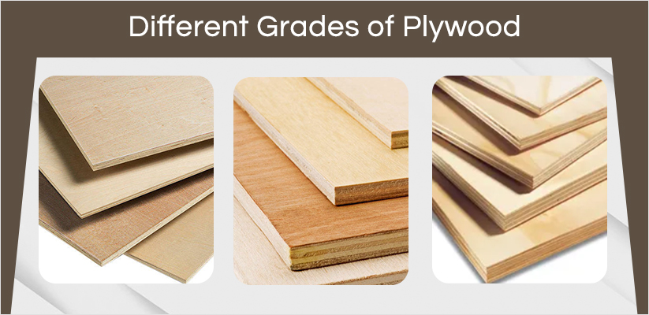
Boiling Water Resistant (BWR) Grade Plywood: Another upgraded grade of water resistant plywood is the boiling water resistant grade. It is more water resistant than plywood of the MR grade. For the veneers of this grade of plywood, phenol formaldehyde adhesive (phenolic resin), a synthetic plastic resin, is utilized as the adhesive. This synthetically created plastic resin aids in enhancing plywood's resistance to water and dampness. This type of plywood can be used for furniture that will likely be used near water or in other humid climates, or that will be exposed to moisture or even become wet sometimes. As an illustration, consider kitchen cabinets, patio furniture, garden furniture, outdoor loungers, dining tables, and other items.
Fire Retardant Grade Plywood: Fire-resistant window coverings The plywood grade has been treated with better fire-retardant chemicals. Although it doesn't make the plywood fire-proof, doing so does enable it to develop strong fire resistance. Kitchen furniture applications, electrical furniture applications, and any other such areas where there is a potential risk of fire hazard are good candidates for this type of plywood.
Boiling Water Proof (BWP) Grade Plywood: Boiling Water Resistant Plywood, sometimes referred to as Marine Grade One of the highest grades of plywood with moisture resistance is plywood. This type of plywood can withstand extended contact with water or moisture. The boiling waterproof synthetic undiluted phenol formaldehyde adhesive is used to join the plywood's veneers. In comparison to other plywood grades, it is a superior grade with much higher quality and strength.
Glue makes up the second essential component of plywood. This is used to join the thin veneers to create a solid finished good. Overall, glue is not the most eco-friendly product available. Plywood is often adhered with a chemical-intensive synthetic resin adhesive. Formaldehyde is a common component of plywood, though it is gradually being phased out. The production of industrial chemicals is generally a messy operation that frequently leads to air pollution.

Is plywood toxic free?
This is entirely dependent on the kind of synthetic glue used to assemble the ply veneers. Plywood is primarily used to make two different sorts of products: plywood for internal usage and plywood for outdoor use. Two distinct adhesives are utilized because of the various environmental factors that these woods will encounter in the future:
Phenol-formaldehyde - for usage outside plywood. Phenol-formaldehyde was first widely utilized to produce products made of plastic that could be molded, but it is now being employed as a wood adhesive. This is a result of the potent chemical connections they forge with the lignin component of the wood and the high degrees of moisture resistance they exhibit.
Urea-formaldehyde - plywood for interior application. The urea glue is made similarly to phenol-formaldehyde, but it is lighter in color and has less weather resistance, making it more appropriate for interior plywood application.
Formaldehyde is the principal hazardous component of these resins. Polyvinyl acetate and other phenol glues can also be used to make plywood adhesive. All of these glues are hazardous in varied degrees and are not eco-friendly. Formaldehyde is hazardous to people and has a range of negative health effects when consumed alone. Numerous studies have linked formaldehyde to increased risk of cancer, headaches, and skin, eye, and respiratory irritation.
On the other hand, there should be little off-gassing when the glue has dried and hardened. In spite of this, some VOCs will eventually leak into the environment. Some ply businesses are currently utilizing soy-based technologies. Soy-based glues still contain certain chemicals to provide a strong bond under all circumstances, therefore they are not entirely natural.
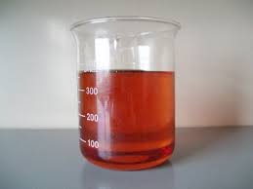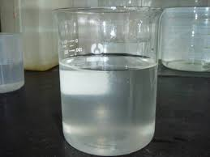

Is plywood biodegradable?
The use of a chemical-based adhesive indicates that plywood is not entirely natural and made from plants. This indicates that plywood cannot decompose. Because the resin will contain additional chemicals, even soy-based adhesives that don't use formaldehyde are not biodegradable.

Emissions
It is possible for plywood manufacturing emissions to have a negative effect on air quality. Particle matter, veneer dryers, and adhesive emissions are three of the main categories of emissions.
When cutting logs, removing bark, sanding plywood, and cutting plywood, wood dust and bits are released into the air as particle (or particulate) matter.
Peeler blocks are created by cutting debarked logs into smaller pieces that are then heated and immersed in a warm water solution. The wet peeler blocks are then cut into thin sheets of wood called veneers. Air contaminants, including organic compounds like methanol, are released from the wood during the drying of the moist veneers. Additionally, various contaminants are generated by fuel combustion from the drying apparatus depending on the method and type of wood used for drying.
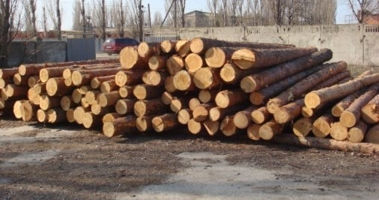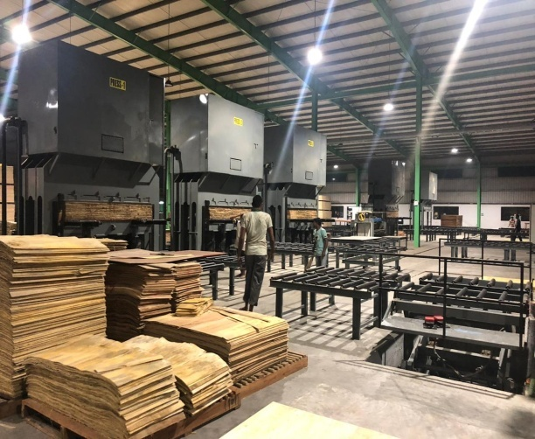
The veneers are heat pressed and adhered after drying to create plywood. Formaldehyde and other air pollutants are released during the gluing and pressing processes.
Natural forests are where natural wood is obtained from and produced, leading to issues with the environment such deforestation. Plywood, on the other hand, is produced from trees that are managed sustainably. A sustainable forest is a system that has been deliberately and expertly managed. It is the end result of a process in which the felled trees are replaced with seedlings to ensure that the forests survive and continue to supply us with natural resources. In many parts of the world, intentional forest farming is also performed to maintain a steady supply of wood for plywood production facilities and preserve natural forests. It has been difficult for countries all over the world to balance the need for wood for commercial purposes with environmental considerations. Despite efforts by the government to stop deforestation, destructive and illegal logging activities continue to be a problem. This is a particular issue in regions that are widely sought after for their premium wood, such as Southeast Asia for tropical plywood.
Typically, plane cutting—in which pieces of wood are cut using basic planes—is employed while creating timbers from wood. However, veneers obtained from the rotational peeling of lumber are used to make plywood. maximizing the use of the available wood. Additionally, it lessens the quantity of waste generated throughout the process. Plywood is formed of veneer and plywood planks, which is more environmentally beneficial (as it generates less waste in the manufacturing process) than regular wooden sheets, which are constructed of lumber sheets. When all of the aforementioned considerations are taken into account, it is simple to conclude that the plywood manufacturing process uses more wood than timber cutting does. With the use of plywood, more furniture may be produced from a given amount of wood. With the use of plywood, more furniture may be produced from a given amount of wood. As a result, using plywood is more environmentally friendly than choosing solid wood. The cherry on top of the cake is plywood's affordability and ease of usage, which is in addition to all of the other benefits it offers. It is a very realistic alternative to explore because of its many applications.
Industrial safety and human behaviour
Due to changes in socioeconomic and cultural conditions brought on by India's growing population, people's lifestyles have altered substantially; giving rise to newer professional and residential cultures and pleasures. Modern structures include fake ceiling panels, partition walls, plastic doors, corrugated plastic roofs, washing machines, refrigerators, air conditioners, televisions, mobile electronic devices, and computer hardware.
There's no denying that life is easier with these additional luxuries. They do, however, also present a greater risk of fire because the majority of them are composed of materials that are more flammable and have higher calorific values. For instance, digital records have replaced paper documents in households and offices. As a result, more plastic, which has a higher calorific value, is being stored and utilized in place of less cellulose. For office area fire safety, cellulosic materials (wood and paper) made up the majority of combustibles (54-69%), followed by plastics (18-22%), textiles (7-8%), and leather (4-6%).
Each year, hundreds of businesses are impacted by fires that cause property damage, injuries, and a loss of client trust. Establishing a fire prevention and training program can help you prevent costly losses, fines for the company, and accidents to your staff and guests. One of the most crucial elements of industrial fire safety is fire safety management. It's crucial to make sure that the building has a fire safety management strategy in place for that to go well.

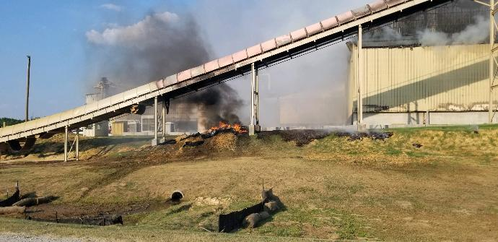
Numerous building codes severely restrict the use of lumber as a building material, in part due to the material's combustibility. Feeling comfortable and choosing the right building materials are both significantly influenced by fire safety.Fire toxicity is the leading cause of mortality and injury from unintentional fires, yet it is also the field of fire science and engineering with the least amount of research.
Plywood made with bio adhesive
Consequently, there has been an increase in interest in the creation of renewable resource-based eco-friendly wood adhesives. Over the past few decades, the synthesis of bio-adhesives generated from such renewable resources as lignin, starch, and plant proteins has seen a tremendous increase in research and innovation in the engineered wood product business. The active functional groups that are used in the production of bio-adhesives are highlighted by the description and discussion of the chemical structure of these biopolymers. The advantages and disadvantages of each biomass are then thoroughly explored. Some techniques have been proposed to alter their chemical structures and to enhance their qualities, such as water resistance and bonding strength, in preparation for their eventual use as wood adhesives..This article also discusses methods used to assess the mechanical properties and penetration behavior of petroleum-based wood adhesives, which are anticipated to be more widely used to assess the potential of bio-based wood adhesives for use in wood composites.
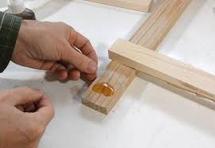
Since 2012, when California adopted the strongest formaldehyde emissions rule in the world. Anything that gives the industry a formaldehyde-free choice and doesn't cost them any more than urea-formaldehyde goods would thrill them, but it must be cost-effective and cannot pose additional toxicity problems. Engineered wood goods created with adhesives containing formaldehyde are particularly useful.They can, however, release formaldehyde and other volatile organic substances. More formaldehyde in the air than the typical indoor background level of 0.03 ppm can result in a variety of health issues, from itchy eyes and noses to an increased risk of cancer
The hazards of formaldehyde have been brought to the attention of regulatory agencies and consumers, and emission levels have been set globally, with the levels deemed acceptable gradually lowering over time. The Japanese emission rate (F****) of 0.04 ppm, which is close to the formaldehyde background level, is the strictest to date .
The development of formaldehyde-free solutions is being compelled by stricter restrictions, but the rise of bio-based adhesives is being propelled by efforts to promote sustainability. Although the volumes are still tiny, they are expanding quickly. Starch, soy, and corn made for 87.0% of the 2014 market volume for bioadhesives, the majority of bioadhesives now available.
They are not entirely bio-based, though, as the majority typically require a petrochemical component for the synthesis of the resin or to create the finished wood products. Anything that gives the plywood and wood-based panel industry a formaldehyde-free alternative and doesn't cost them any more than urea-formaldehyde products will delight them.
Plywood’s Contribution to sustainability:-
The significant contribution of plywood to sustainability and explores the factors are
Plywood contributes to carbon sequestration, the process of capturing and storing carbon dioxide from the atmosphere. As trees grow, they absorb carbon dioxide, and this carbon remains stored within the wood fibers even after processing into plywood. Sustainable forestry practices and responsible sourcing further enhance plywood's carbon sequestration potential, making it a net contributor to reducing greenhouse gas emissions. Plywood is made from wood, a renewable resource that can be sustainably harvested and replanted. By choosing plywood over non-renewable materials, we help mitigate deforestation and reduce the demand for resource-intensive products.
The production of plywood requires less energy compared to the manufacturing of some other building materials, such as steel or concrete. Additionally, advancements in manufacturing techniques have led to improved energy efficiency and reduced waste during the production process. Plywood manufacturing generates less waste compared to traditional lumber processing. The use of wood veneers, which are thin layers peeled from logs, maximizes the yield from each log, reducing waste and optimizing resource use. Plywood also enables efficient utilization of smaller, fast-growing trees that might not be suitable for other construction purposes.
At the end of its life cycle, plywood can be recycled or repurposed into various applications, such as wood-based panels or bioenergy production. This recyclability reduces the burden on landfills and encourages a circular economy approach.Compared to certain synthetic building materials, plywood has a minimal impact on indoor air quality. Low-VOC (volatile organic compound) adhesives are increasingly used in plywood production, reducing off-gassing and creating healthier indoor environments.Plywood's contribution to sustainability encompasses its carbon sequestration potential, renewable nature, energy efficiency, low embodied energy, waste reduction, and more.
Challenges and future Direction of Plywood
Plywood while a versatile and sustainable material, also faces several challenges and opportunities for improvement in the coming years.One of the primary challenges plywood faces is its susceptibility to moisture damage. While modern manufacturing techniques have improved plywood's moisture resistance, there is room for further advancements to make it more suitable for outdoor and high-humidity applications.The use of adhesives in plywood manufacturing, particularly those containing formaldehyde, can lead to indoor air quality concerns.
Efforts are being made to develop low-emission or formaldehyde-free adhesives to address health and environmental issues.Plywood's combustibility limits its use in fire-prone environments. Developing fire-resistant treatments or coatings without compromising its structural integrity could open up new applications in construction and other fields. Variations in wood properties and manufacturing processes can lead to inconsistencies in plywood's strength and quality. Achieving a higher level of material uniformity is essential to ensure predictable and reliable performance.Research into developing adhesives derived from renewable resources, such as plant-based materials, can address concerns about the environmental impact of conventional adhesives and improve the overall sustainability of plywood.
Conclusion:
The chapter concludes by summarizing the key takeaways regarding plywood’s sustainable innovations and its role in shaping modern life .Plywood’s adaptability strength and environmental benefits position it as a valuable assert for sustainable design and construction.The challenges faced by plywood are opportunities for growth and innovation. As a material that aligns with modern society's growing environmental concerns, plywood holds promise as a cornerstone of sustainable design and construction, supporting a greener and more resilient future.

