NSKE (NEEM SEED KERNEL EXTRACT) ON SOLANUM NIGER --- ORGANIC PESTICIDE

Dr. R. Muralidharan and Rajarajan R.
*Assistant Professor
DG Vaishnav College
Chennai,India

ABSTRACT
Pests are a new sense to all the farmers being a vegetable/fruit crop. A natural pesticide is more promising than a chemical one. Neem Seed Kernel Extract (NSKE) is a potential pesticide currently used at a dosage of 1 litre/sqhectar. Controls the yield and the disease infections.

Key words: NSKE.,Organic pesticide,solanum nigrum.

INTRODUCTION
Organic farming is an agricultural system that uses fertilizers of organic origin such as compost manure, green manure (Neem kernel). It originated early in the 20th century in reaction to rapidly changing farming practices.Organic farms provide a “win-win” (high yield and low variability) for environmental sustainability, while conventional farming provided a high crop yield with low variability.
The sale of organic crops is highly regulated and controlled. The environmental impact of organic farming is low and can be seen as a way of cleaning up and improving degraded agricultural land.The concepts of organic agriculture were developed in the early 1900s by Sir Albert Howard, F.H. King and Rudolf Steiner who believed that the use of animal manures (often made into compost), cover crops, crop rotation, and biologically based pest controls resulted in a better farming system.
Howard, an agricultural researcher, gained knowledge from the traditional and sustainable farming practices he encountered there and advocated for their adoption in the West [1].
Solanum nigrum Linn., is a common edible medicinal herb of the Solanaceae family which is native to Southeast Asia and is now widely distributed in temperate to tropical regions of Europe, Asia, and America. Traditionally, it has been used to treat various cancers, acute nephritis, urethritis, leucorrhea, sore throat, toothache, dermatitis, eczema, carbuncles, and furuncle [2].

MATERIALS AND METHOD
PREPARATION OF NEEM SEED KERNEL EXTRACT -NSKE
5 kilogram of the kernel is pounded in a mortar and pestle and soaked in10 liters of distilled water for one day. After 24 hours the solution becomes milky white then detergent soap from Khadi 200g is added stirred with a wooden Planck. Filter through double layer of muslin cloth and make the volume to 100 liter. Finally filtered and stored for further use. The shelf life of this Neem Kernel Extract is one week or seven days (Figure 6).The precautions are the Neem fruits are collected during bearing season and shade dried, the seeds over eight months of age are not used. The seeds stored over and above this age lose their activity and hence not fit for NSKE preparation. Always use freshly prepared Neem seed kernel extract (NSKE).The solution is sprayed after 3.30 pm to get effective results [4]. Extract preparation
NSKE was stirred with the solvent water, 2:1 v/v.
Nano capsules was prepared by dissolving in 10ml of silver nitrate solution.
Experimental plant: Solanum nigrum L

Leaf spot is caused by Cercosporamelongenae which is currently controlled by a chemical agent :Ridomet 1 gm/L applied at 4- 5 days after germination.This NSKE controls not only the leaf spot but also the yield is increased.

Application method
It is applied as a foliar spray on the plant. Various concentrations such as 1, 10, 100, 1000 µg/L with the stock solution having NSKE: water, 2:1 v/v
The spray of NSKE on Solanum nigrum at time intervals of 24 hours, 48 hours and 72 hours showed effective results. The results are shown in Tables 1.

RESULTS
The infected plants were controlled by the Neem seed kernel extract within 24 hours interval and at 100µL.Hence the efficacy of Neem seed kernel extract on the Solanum nigrum is effective on fungus. (Table1)

REFERENCES
1.Ramesh P, Singh M, Subba RA. Organic farming: Its relevance to the Indian context. Current Scientist. 2005; 88(4): 561-568.
2.Teng F., Yuan C. P., Wang P. Study on antioxidant activity of extracts from Solanum nigrum L.berries and analysis of the active ingredients. J. Anhui Agric. Sci. 2014 :42 (19), 6217–6219.
3.Bhowmik PK, Matsui T, Ikeuchi T, Suzuki H. Changes in storage quality and shelf life of green asparagus over an extended harvest season. Postharvest Biol Technol. 2002; 26(3):323-328.
4.Ley SV, Denholm AA, Wood A. The chemistry of azadirachtin. Na Prod Rep.1993;10(2)109-115.

Figure1:Infected plant with Cercospora melongenae

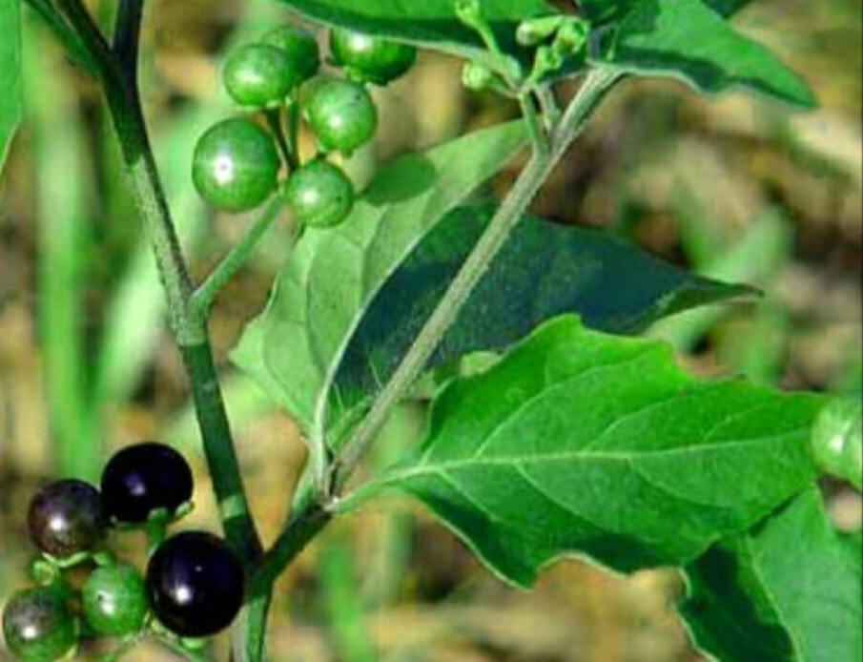

FIGURE2: PREPARATION OF NSKE

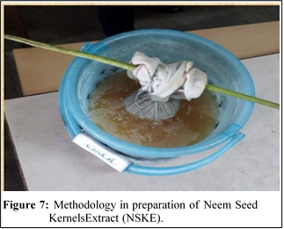

Table1: EFFICACY OF NSKE NANOCAPSULE ON BRINJAL PLANT AFFECTED BY CERCOSPORA MELONGENAE

S.No | Concentration of the extractµL | Time Interval(Hours) | Rate of control% | Positive Control  Ridomet 1gm/lStock%
1 | 100 | 24 | 95 | 100
2 | 100 | 48 | 90 | 100
3 | 1000 | 48 | 85 | 100
4 | 100 | 72 | 80 | 100
5 | 1000 | 72 | 85 | 100

