$H_{k}$**Cordial Labeling of Path, Star and Cycle Graphs**

**1st Jayshree R. Joshi**

Research Scholar, C.U. Shah University,

Assistant Professor in Mathematics,

H. & H. B. Kotak Institute of Science,

Rajkot, India.

[**jrjoshi15@gmail.com**](mailto:jrjoshi15@gmail.com)

**2nd Dharamvirsinh Parmar**   
Assistant Professor in Mathematics,

Bhavan’s Sheth R. A. College of Science,  
 Gujarat University,   
Ahmedabad, India  
[**dharamvir_21@yahoo.co.in**](mailto:dharamvir_21@yahoo.co.in)

# **Abstract**

In this paper we investigate $H_{k}$ cordial labeling of star, path, cycle and use operation such as subdivision, super subdivision and $H$- super subdivision on it, i.e. $S\left(P_{n}\right), SS\left(P_{n}\right) , HSS\left(P_{n}\right),$ $S\left(K_{1,n}\right), SS\left(K_{1,n}\right), HSS\left(K_{1,n}\right),$ $S\left(C_{n}\right), SS\left(C_{n}\right), HSS\left(C_{n}\right)$.

***Keywords*- $H$** cordial labeling, $H_{k}$ cordial labeling, Subdivision, Super subdivision, $H$-Super subdivision of graphs.

# **Introduction**

In the present work we contemplate a finite graph which is connected and undirected. We refer to a dynamic survey of graph labeling by Gallian (2020) for detailed survey on graph labeling. For all other standard terminology and notations we refer to Gross and Yellen[4]. A labeling of a graph $G=(V,E)$ is a mapping that carries vertices, edges or both to the set of labels (usually to the positive or non-negative integers).

A graph $G=(V,E)$ is said to be $H$ cordial graph if there exists a mapping $f$ from edge set to $\left\{-1, 1\right\}$ such that induced mapping $f^{*}$ from vertex set to $\left\{-k, k\right\}$ defined by $f^{*}\left(v\right) = \sum_{e∈I(v)}{f(e)}$, where $I(v)$ is the set of all edges incident to vertex $v$, satisfies the cordiality conditions $\left|e_{f}\left(1\right)-e_{f}\left(-1\right)\right|≤1$ and $\left|v_{f^{*}}\left(k\right)-v_{f^{*}}\left(-k\right)\right|≤1$. Map $f$ is called $H$ cordial labeling of $G$. By extending the concept a graphis $H_{k}$ cordial graph if there exists a mapping $f$ from edge set to $\{±1,±2,…,±k\}$ such that the induced mapping $f^{*}$ from vertex set to $\left\{±1,±2,…,±k\right\}$ defined by $f^{*}\left(v\right) = \sum_{e∈I(v)}{f(e)}$, where $I(v)$ is the set of all edges incident to vertex $v$, satisfies the cordiality conditions $\left|e_{f}(i)-e_{f}(-i)\right|≤1$ and $\left|v_{f^{*}}(i)-v_{f^{*}}(-i)\right|≤1$ for $1≤i≤k .$ Map $f$ is called $H_{k}$ cordial labeling of $G$ and graph $G$ is called $H_{k}$ cordial graph [5].

Barycentric subdivision of graph $G$ is denoted as $S(G)$, obtained by subdividing every edge of graph $G$. [10]. The super subdivision of any graph $G$ denoted by $SS\left(G\right)$ is obtained from graph by replacing every edge of graph by complete bipartite graph $K_{2,m}$ (where $m$ is positive integer)[8].

# **II. Main Result**

***Theorem 2.1*** The star graph ${ K}_{1,n}$ $(n≥2 )$ is $H_{2}$ cordial if $n$ is even.

***Proof*:** Let $V\left(K_{1,n}\right)= \left\{u_{0},u_{i} :1 ≤i≤n\right\}$ and $E({ K}_{1,n})=\left\{u_{0}u_{i}:1 ≤i≤n\right\}$, where $u_{0}$ is apex vertex.

Consider a function $f:E({ K}_{1,n})→\{-2,-1,1,2\}$ defined as

$f\left(u_{0}u_{1}\right)=-2$

$f\left(u_{0}u_{i}\right)= {(-1)}^{i}$; $2≤i≤n$.

**Table 1**

|  |  |  |
| --- | --- | --- |
| $$n≥2$$ | Edge Conditions | Vertex Conditions |
| $n$ is even | $$e_{f}\left(1\right)=\frac{n}{2},e_{f}\left(-1\right)=\frac{n-2}{2}$$ $$e_{f}\left(2\right)=0,e_{f}\left(-2\right)=1$$ | $$v_{f^{*}}\left(1\right)=\frac{n}{2}=v_{f^{*}}\left(-1\right)$$ $$v_{f^{*}}\left(2\right)=0,v_{f^{*}}\left(-2\right)=1$$ |

For $i=1,2$. The $K_{1,n}$ satisfies the condition $\left|e_{f}\left(i\right)-e_{f}(-i)\right|≤1$ and $\left|v_{f}\left(i\right)-v_{f}(-i)\right|≤1$.

Hence, $K_{1,n}$ is $H_{2}$ cordial.

***Illustration 2.2***Figure shows that $K_{1,6}$ is $H_{2}$ cordial graph.

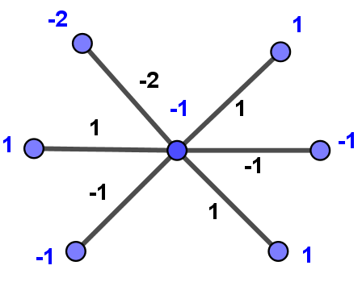

***Theorem 2.3*** Star graph $K_{1,n}$ $\left(n≥2 \right)$ is $H_{3}$ cordial.

***Proof*:** Let $V\left(K_{1,n}\right)= \left\{u_{0},u_{i} :1 ≤i≤n\right\}$ and $E({ K}_{1,n})=\left\{u_{0}u_{i}:1 ≤i≤n\right\}$, where $u_{0}$ is apex vertex.

**Type 1: $n$**  is even, $K_{1,n}$ is $H_{2}$ cordial from Theorem 2.1. Hence it is also admits $H_{3}$ cordial labeling.

**Type 2: $n$**  is odd.

Consider a function $f:E({ K}_{1,n})→\{-3,-2,-1, 1, 2, 3\}$ defined as

$f\left(u_{0}u_{1}\right)=-2$

$f\left(u_{0}u_{1}\right)=-2$

$f\left(u_{0}u_{2}\right)=3$

$f\left(u_{0}u_{i}\right)= {(-1)}^{i+1}$; $3≤i≤n$

**Table 2**

|  |  |  |
| --- | --- | --- |
| $$n≥2$$ | Edge Conditions | Vertex Conditions |
| $n$ is odd | $$e_{f}\left(1\right)=\frac{n-1}{2},e_{f}\left(-1\right)=\frac{n-3}{2}$$ $$e_{f}\left(2\right)=0,e_{f}\left(-2\right)=1$$ $$e_{f}\left(3\right)=1,e_{f}\left(-3\right)=0$$ | $$v_{f^{*}}\left(1\right)=\frac{n-1}{2},v_{f^{*}}\left(-1\right)=\frac{n-3}{2}$$ $$v_{f^{*}}\left(2\right)=1=v_{f^{*}}\left(-2\right)$$ $$v_{f^{*}}\left(3\right)=1,v_{f^{*}}\left(-3\right)=0$$ |

For $i=1,2,3$, the graph satisfies the condition $\left|e_{f}\left(i\right)-e_{f}(-i)\right|≤1$ and $\left|v_{f}\left(i\right)-v_{f}(-i)\right|≤1$.

Hence, $K_{1,n}$ is $H_{3}$- cordial.

***Illustration 2.4 $K_{1,5}$***is $H_{3}$ cordial as shown in Figure.

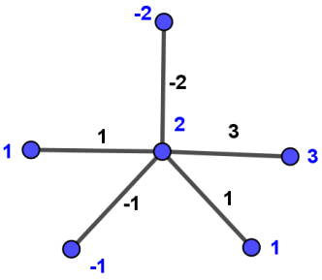

***Theorem 2.5*** The barycentric subdivision graph of a star ( $S(K_{1,n}) (n≥2 )$) is $H_{2}$ cordial if $n$ is odd.

***Proof*:** Let $V( S(K_{1,n}))=\left\{u_{i},{u^{'}}_{i},u_{0};1≤i≤n\right\}$ and $E( S(K_{1,n}))=\left\{u_{0}{u'}_{i},u_{i}{u^{'}}_{i} ;1≤i≤n\right\}$.

Consider a function $f:E( S(K_{1,n}))→\{-2,-1,1,2\}$ defined as

$$f\left(u_{0}{u'}_{1}\right)=-2$$

$f\left(u_{0}{u'}_{i}\right)= {\left(-1\right)}^{i+1}$; $2≤i≤n$

$f\left(u_{i}{u'}_{i}\right)= {(-1)}^{i+1}$; $1≤i≤n$

**Table 3**

|  |  |  |
| --- | --- | --- |
| $$n≥2$$ | Edge Conditions | Vertex Conditions |
| $n$ is odd | $$e_{f}\left(1\right)=n,e_{f}\left(-1\right)=n+1$$ $$e_{f}\left(2\right)=0,e_{f}\left(-2\right)=1$$ | $$v_{f^{*}}\left(1\right)=\frac{n+1}{2}=v_{f^{*}}\left(-1\right)$$ $$v_{f^{*}}\left(2\right)=\frac{n-1}{2},v_{f^{*}}\left(-2\right)=\frac{n+1}{2}$$ |

Hence, $S(K_{1,n})$ is $H_{2}$ cordial.

***Illustration 2.6 $S(K_{1,5})$***is $H_{2}$ cordial as shown in Figure.

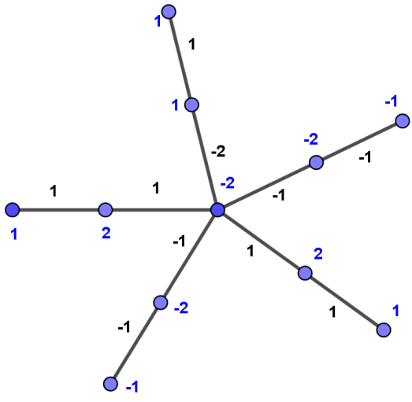

***Theorem 2.7*** The barycentric subdivision graph of a star $S(K_{1,n}) (n≥2 )$ is $H_{3}$ cordial.

***Proof*:** Let $V(S(K_{1,n}))=\left\{u_{i},{u^{'}}_{i},u_{0};1≤i≤n\right\}$ and $E(S(K_{1,n}))=\left\{u_{0}{u'}_{i},u_{i}{u^{'}}_{i} ;1≤i≤n\right\}$.

**Type 1: $n$** is odd.

$S(K_{1,n})$ is $H_{2}$ cordial from Theorem 2.5, it is also admits $H_{3}$ cordial.

**Type 2: $n$** is even.

Consider a function $f:E(S(K_{1,n}))→\{-2,-1,1,2\}$ defined as

$$f\left(u_{0}{u'}_{1}\right)=2$$

$f\left(u_{0}{u'}_{i}\right)= {\left(-1\right)}^{i}$; $2≤i≤n$

$f\left(u_{i}{u'}_{i}\right)= {(-1)}^{i}$; $1≤i≤n$

**Table 4**

|  |  |  |
| --- | --- | --- |
| $$n≥2$$ | Edge Conditions | Vertex Conditions |
| $n$ is even | $$e_{f}\left(1\right)=n,e_{f}\left(-1\right)=n-1$$ $$e_{f}\left(2\right)=1,e_{f}\left(-2\right)=0$$ | $$v_{f^{*}}\left(1\right)=\frac{n+2}{2},v_{f^{*}}\left(-1\right)=\frac{n}{2}$$ $$v_{f^{*}}\left(2\right)=\frac{n}{2},v_{f^{*}}\left(-2\right)=\frac{n-2}{2}$$ $$v_{f^{*}}\left(3\right)=1,v_{f^{*}}\left(-3\right)=0$$ |

Hence, $S(K_{1,n})$ is $H_{3}$ cordial.

***Illustration 2.8 $H_{3}$*** cordial labeling of $S(K_{1,6})$ is demonstrated in Figure.

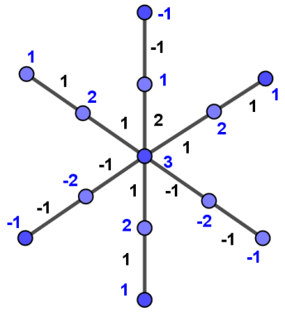

***Theorem 2.9***Super subdivision of star graph ${ SS(K}_{1,n})(n≥2)$ is $H_{3}$ cordial.

***Proof*:** Let $V({ SS(K}_{1,n}))=\left\{u_{i},u_{ij},u_{0};1≤i≤n ,1≤j≤m\right\}$ and $E({ SS(K}_{1,n}))=\left\{u_{0}u_{ij},u_{ij}u_{i};1≤i≤n,1≤j≤m\right\}$, where $u_{0}$ is apex vertex.

Consider a function $f:E({ SS(K}_{1,n}))→\{-2,-1,1,2\}$ defined as

**Type 1: $m$** is even and $n$ is odd

$$f\left(u_{0}u_{11}\right)=-2$$

$$f\left(u_{0}u_{12}\right)=1$$

$$f\left(u_{11}u_{1}\right)=-1$$

$$f\left(u_{12}u_{1}\right)=2$$

$f\left(u_{0}u_{ij}\right)=f\left(u_{ij}u_{i}\right)={(-1)}^{i}$; $2≤i≤n,j=1,2$

$f\left(u_{0}u_{ij}\right)=f\left(u_{ij}u_{i}\right)={(-1)}^{j}$; $3≤j≤m, 1≤i≤n$.

**Table 5**

|  |  |  |
| --- | --- | --- |
| $$n≥2$$ | Edge Conditions | Vertex Conditions |
| $m$ even $n$ odd | $$e_{f}\left(1\right)=mn-1=e_{f}\left(-1\right)$$ $$e_{f}\left(2\right)=1=e_{f}\left(-2\right)$$ | $$v_{f^{*}}\left(1\right)=1=v_{f^{*}}\left(-1\right)$$ $$v_{f^{*}}\left(2\right)=\frac{\left(m+1\right)n-3}{2}=v_{f^{*}}\left(-2\right)$$ $$v_{f^{*}}\left(3\right)=1=v_{f^{*}}\left(-3\right)$$ |

**Type 2: $m$** and $n$ both are even

$$f\left(u_{0}u_{11}\right)=-2$$

$$f\left(u_{0}u_{12}\right)=f\left(u_{11}u_{1}\right)=f\left(u_{12}u_{1}\right)=-1$$

$f\left(u_{0}u_{ij}\right)=f\left(u_{ij}u_{i}\right)={(-1)}^{i}$; $2≤i≤n, j=1,2$

$f\left(u_{0}u_{ij}\right)=f\left(u_{ij}u_{i}\right)={(-1)}^{j}$; $3≤j≤m, 1≤i≤n$

**Table 6**

|  |  |  |
| --- | --- | --- |
| $$n≥2$$ | Edge Conditions | Vertex Conditions |
| $m$ even $n$ even | $$e_{f}\left(1\right)=mn,{ e}_{f}\left(-1\right)=mn-1$$ $$e_{f}\left(2\right)=1,e_{f}\left(-2\right)=0$$ | $$v_{f^{*}}\left(1\right)=1,v_{f^{*}}\left(-1\right)=0$$ $$v_{f^{*}}\left(2\right)=\frac{n\left(m+1\right)}{2}$$ $$v_{f^{*}}\left(-2\right)=\frac{n\left(m+1\right)-2}{2}$$ $$v_{f^{*}}\left(3\right)=1,v_{f^{*}}\left(-3\right)=0$$ |

**Type 3: $m$** and $n$ both are odd

$$f\left(u_{0}u_{11}\right)=-2$$

$$f\left(u_{11}u_{1}\right)=1$$

$f\left(u_{0}u_{i1}\right)=f\left(u_{i1}u_{i}\right)={(-1)}^{i+1}$; $2≤i≤n$

$f\left(u_{0}u_{ij}\right)=f\left(u_{ij}u_{i}\right)={(-1)}^{j}$; $2≤j≤m, 1≤i≤n$

**Table 7**

|  |  |  |
| --- | --- | --- |
| $$n≥2$$ | Edge Conditions | Vertex Conditions |
| $m$ odd $n$ odd | $$e_{f}\left(1\right)=mn,e_{f}\left(-1\right)=mn-1$$ $$e_{f}\left(2\right)=0,e_{f}\left(-2\right)=1$$ | $$v_{f^{*}}\left(1\right)=\frac{n+1}{2}=v_{f^{*}}\left(-1\right)$$ $$v_{f^{*}}\left(2\right)=\frac{mn-1}{2},v_{f^{*}}\left(-2\right)=\frac{mn-1}{2}$$ |

**Type 4: $m$** is odd and $n$ is even

$$f\left(u_{0}u_{11}\right)=2$$

$$f\left(u_{11}u_{1}\right)=-1$$

$f\left(u_{0}u_{i1}\right)=f\left(u_{i1}u_{i}\right)={(-1)}^{i}$; $2≤i≤n$

$f\left(u_{0}u_{ij}\right)=f\left(u_{ij}u_{i}\right)={(-1)}^{j}$; $2≤j≤m, 1≤i≤n$

**Table 8**

|  |  |  |
| --- | --- | --- |
| $$n≥2$$ | Edge Conditions | Vertex Conditions |
| $m$ odd $n$ even | $$e_{f}\left(1\right)=mn,e_{f}\left(-1\right)=mn-1$$ $$e_{f}\left(2\right)=1,e_{f}\left(-2\right)=0$$ | $$v_{f^{*}}\left(1\right)=\frac{n+2}{2},v_{f^{*}}\left(-1\right)=\frac{n}{2}$$ $$v_{f^{*}}\left(2\right)=\frac{mn}{2},v_{f^{*}}\left(-2\right)=\frac{mn-2}{2}$$ $$v_{f^{*}}\left(3\right)=1,v_{f^{*}}\left(-3\right)=0$$ |

Hence, ${ SS(K}_{1,n})$ is $H_{3}$ cordial.

***Illustration 2.10 ${ SS(K}_{1,4})$***with $m=3$ is $H_{3}$ cordial shown in Figure.

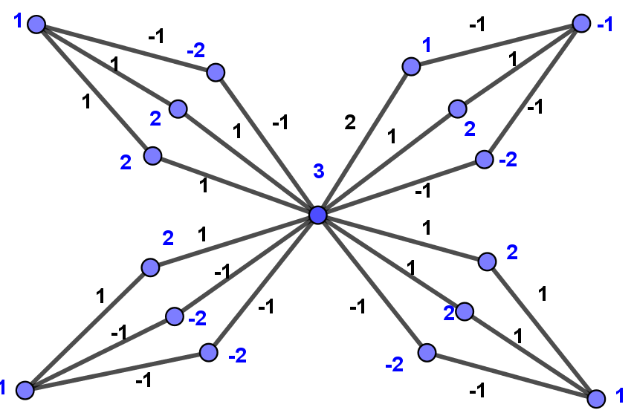

***Theorem 2.11***The $H$-super subdivision of path ${ HSS(K}_{1,n})(n≥2)$ $H_{3}$ cordial.

***Proof*:** Let $V\left( HSS\left(K_{1,n}\right)\right)=\left\{u_{i},u_{ij},u_{0};1≤i≤n ,1≤j≤4\right\}$ and $E\left(HSS\left(K_{1,n}\right)\right) =\left\{u_{0}u_{i1},u_{i}u_{i3},u_{i1}u_{i3},u_{i1}u_{i2},u_{i3}u_{i4};1≤i≤n\right\}$, where $u_{0}$ is apex vertex.

**Type 1: $n$** is odd, consider a function $f:E\left(HSS\left(K_{1,n}\right)\right)→\{-1,1\}$ defined as

$$f\left(u_{0}u_{11}\right)=f\left(u_{11}u_{12}\right)=1$$

$$f\left(u_{1}u_{13}\right)=f\left(u_{13}u_{14}\right)=-1$$

$$f\left(u_{i1}u_{i3}\right)={(-1)}^{i};1≤i≤n$$

$f\left(u_{0}u_{i1}\right)=f\left(u_{i1}u_{i2}\right)=f\left(u_{i}u_{i3}\right)=f\left(u_{i3}u_{i4}\right)={(-1)}^{i+1};2≤i≤n$.

**Table 9**

|  |  |  |
| --- | --- | --- |
| $$n≥2$$ | Edge Conditions | Vertex Conditions |
| $n$ is odd | $$e_{f}\left(1\right)=\frac{5n-1}{2},e_{f}\left(-1\right)=\frac{5n+1}{2}$$ | $$v_{f^{*}}\left(1\right)=\frac{5n+1}{2},v_{f^{*}}\left(-1\right)=\frac{5n-1}{2}$$ $$v_{f^{*}}\left(3\right)=0, v_{f^{*}}\left(-3\right)=1$$ |

Hence $f$ satisfies the conditions of $H_{3}$ cordial labeling in this Type and hence the graph under consideration is $H_{3}$ cordial graph, when $n$ is odd.

**Type 2: $n$** is even, consider a function $f:E→\{-2,-1,1,2\}$ defined as

$$f\left(u_{0}u_{11}\right)=2$$

$$f\left(u_{0}u_{21}\right)=-1$$

$$f\left(u_{i}u_{i3}\right)={(-1)}^{i+1};i=1,2$$

$$f\left(u_{i1}u_{i2}\right)={f\left(u_{i3}u_{i4}\right)=(-1)}^{i};i=1,2$$

$$f\left(u_{i1}u_{i3}\right)={(-1)}^{i+1};1≤i≤n$$

$$f\left(u_{0}u_{i1}\right)=f\left(u_{i1}u_{i2}\right)=f\left(u_{i}u_{i3}\right)=f\left(u_{i3}u_{i4}\right)={(-1)}^{i};3≤i≤n.$$

**Table 10**

|  |  |  |
| --- | --- | --- |
| $$n≥2$$ | Edge Conditions | Vertex Conditions |
| $n$ is even | $$e_{f}\left(1\right)=\frac{5n-2}{2},e_{f}\left(-1\right)=\frac{5n}{2}$$ $$e_{f}\left(2\right)=1,e_{f}\left(-2\right)=0$$ | $$v_{f^{*}}\left(1\right)=\frac{5n}{2}=v_{f^{*}}\left(-1\right)$$ $$v_{f^{*}}\left(2\right)=1,v_{f^{*}}\left(-2\right)=0$$ |

In this Type $f$ satisfies the conditions of $H_{2}$ cordial labeling and hence the graph under consideration is $H_{2}$ cordial graph, when $n$ is even.

Hence, ${ HSS(K}_{1,n})$ is $H_{3}$ cordial as per above Types.

***Illustration 2.12 ${ HSS(K}_{1,4})$***is $H_{2}$ cordial shown in Figure.

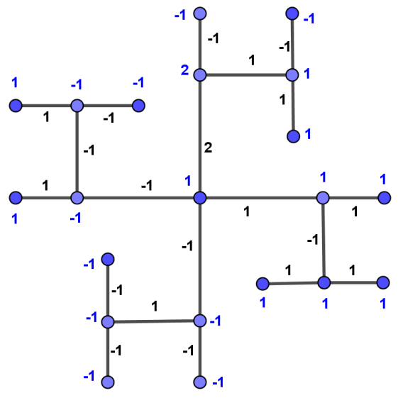

***Theorem 2.13***Path ${ P}_{n}(n≥3)$ is $H_{3}$ cordial.

***Proof*:** Let $P_{n}$ be the path ${ u}_{1}, u_{2}, …,u_{n}$.

Consider a function $f:E(P_{n})→\{-2,-1,1,2\}$ defined as

$$f\left(u_{i}u_{i+1}\right)=\left\{\begin{matrix}1 & ;1≤i≤\left\lceil \frac{n}{2}\right\rceil -1 \\ 2 & ;i=\left\lceil \frac{n}{2}\right\rceil \\ -1 & ;Otherwise \end{matrix}\right.$$

**Table 11**

|  |  |  |
| --- | --- | --- |
| $$n≥3$$ | Edge Conditions | Vertex Conditions |
| $n$ is even | $$e_{f}\left(1\right)=\frac{n-2}{2}=e_{f}\left(-1\right)$$ $$e_{f}\left(2\right)=1,e_{f}\left(-2\right)=0$$ | $$v_{f^{*}}\left(1\right)=2,v_{f^{*}}\left(-1\right)=1$$ $$v_{f^{*}}\left(2\right)=\frac{n-4}{2}=v_{f^{*}}\left(-2\right)$$ $$v_{f^{*}}\left(3\right)=1,v_{f^{*}}\left(-3\right)=0$$ |
| $n$ is odd | $$e_{f}\left(1\right)=\frac{n-1}{2},e_{f}\left(-1\right)=\frac{n-3}{2}$$ $$e_{f}\left(2\right)=1,e_{f}\left(-2\right)=0$$ | $$v_{f^{*}}\left(1\right)=2,v_{f^{*}}\left(-1\right)=1$$ $$v_{f^{*}}\left(2\right)=\frac{n-4}{2},v_{f^{*}}\left(-2\right)=\frac{n-6}{2}$$ $$v_{f^{*}}\left(3\right)=1,v_{f^{*}}\left(-3\right)=0$$ |

Hence, ${ P}_{n}$ is $H_{3}$ cordial.

***Illustration 2.14 $H_{3}$*** cordial labeling of ${ P}_{6}$ is as shown in below Figure.

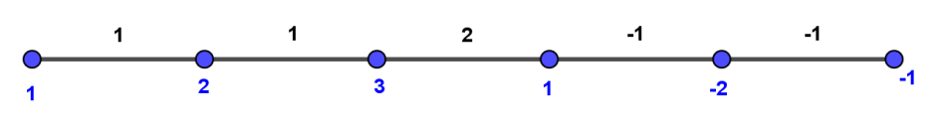

***Remarks 2.15***

Consider path ${ P}_{n}$. As per barycentric subdivision of ${ P}_{n}(n≥2)$ is again a path ${ P}_{2n-1}$ which is also is $H_{3}$ cordial as per Theorem 2.13. Hence we have the following.

***Theorem 2.16***The barycentricsubdivision of path ${ S(P}_{n})(n≥2)$ is $H_{3}$ cordial.

***Theorem 2.17***The super subdivision of path ${ SS(P}_{n})(n≥3)$ is $H_{3}$ cordial.

***Proof*:** Let $V({ SS(P}_{n}))=\left\{u_{i},u_{ij},u_{n};1≤i≤n-1 , 1≤j≤m\right\}$ and $E({ SS(P}_{n}))=\left\{u_{i}u_{ij},u_{ij}u_{i+1}; 1≤i≤n-1, 1≤j≤m\right\}$.

Consider a function $f:E→\{-2,-1,1,2\}$ defined as

**Type 1: $m$** is even and $n$ is odd.

$$f\left(u_{i}u_{i1}\right)=\left\{\begin{matrix}1 & ;1≤i≤\frac{n-3}{2} \\ 2 & ;i= \frac{n-1}{2} \\ -1 & ;Otherwise \end{matrix}\right.$$

$$f\left(u_{i1}u_{i+1}\right)=\left\{\begin{matrix}1 & ;1≤i≤\frac{n-3}{2} \\ -1 & ;Otherwise \end{matrix}\right.$$

$f\left(u_{i}u_{i2}\right)=f\left(u_{i2}u_{i+1}\right)={(-1)}^{i+1}$; $1≤i≤n-1$

$f\left(u_{i}u_{ij}\right)=f\left(u_{ij}u_{i+1}\right)={(-1)}^{j}$; $3≤j≤m.$

**Table 12**

|  |  |  |
| --- | --- | --- |
| $$n≥3$$ | Edge Conditions | Vertex Conditions |
| $m$ is even $n$ is odd | $$e_{f}\left(1\right)=m\left(n-1\right),$$ $$e_{f}\left(-1\right)=m\left(n-1\right)-1$$ $$e_{f}\left(2\right)=1,e_{f}\left(-2\right)=0$$ | $$v_{f^{*}}\left(1\right)=1,v_{f^{*}}\left(-1\right)=0$$ $$v_{f^{*}}\left(2\right)=\frac{\left(m+1\right)\left(n-1\right)}{2}$$ $$v_{f^{*}}\left(-2\right)=\frac{\left(m+1\right)\left(n-1\right)-2}{2}$$ $$v_{f^{*}}\left(3\right)=1,v_{f^{*}}\left(-3\right)=0$$ |

**Type 2: $m$** and $n$ both are even

$$f\left(u_{i}u_{i1}\right)=f\left(u_{i1}u_{i+1}\right)=\left\{\begin{matrix}1 & ;2≤i≤\frac{n}{2} \\ -1 & ;Otherwise\end{matrix}\right.$$

$$f\left(u_{i}u_{ij}\right)=f\left(u_{ij}u_{i+1}\right)=\left\{\begin{matrix}1 & ;j=1,2 ;i=1 \\ -1 & ;j=1,2 ;i=n-1\end{matrix}\right.$$

$$f\left(u_{i}u_{i2}\right)=\left\{\begin{matrix}-2 & ;2≤i≤\frac{n}{2} \\ 2 & ;Otherwise\end{matrix}\right.$$

$$f\left(u_{i2}u_{i+1}\right)=\left\{\begin{matrix}-1 & ;2≤i≤\frac{n}{2} \\ 1 & ;Otherwise\end{matrix}\right.$$

$f\left(u_{i}u_{ij}\right)=f\left(u_{ij}u_{i+1}\right)={(-1)}^{j}$; $3≤j≤m.$

**Table 13**

|  |  |  |
| --- | --- | --- |
| $$n≥3$$ | Edge Conditions | Vertex Conditions |
| $m$ is even $n$ is even | $$e_{f}\left(1\right)=\frac{\left(2m-1\right)\left(n-1\right)+3}{2}$$ $$e_{f}\left(-1\right)=\frac{\left(2m-1\right)\left(n-1\right)+1}{2}$$ $$e_{f}\left(2\right)=\frac{n-4}{2},e_{f}\left(-2\right)=\frac{n-2}{2}$$ | $$v_{f^{*}}\left(1\right)=\frac{n-2}{2},v_{f^{*}}\left(-1\right)=\frac{n-4}{2}$$ $$v_{f^{*}}\left(2\right)=\frac{\left(m-1\right)\left(n-1\right)+5}{2}=v_{f^{*}}\left(-2\right)$$ $$v_{f^{*}}\left(3\right)=\frac{n-4}{2},v_{f^{*}}\left(-3\right)=\frac{n-2}{2}$$ |

**Type 3: $m$** is odd and $n≥3$

$$f\left(u_{i}u_{i1}\right)=\left\{\begin{matrix}1 & ;1≤i≤\left\lceil \frac{n}{2}\right\rceil -1 \\ 2 & ;i=\left\lceil \frac{n}{2}\right\rceil \\ -1 & ;Otherwise \end{matrix}\right.$$

$$f\left(u_{i1}u_{i+1}\right)=\left\{\begin{matrix}1 & ;1≤i≤\left\lceil \frac{n}{2}\right\rceil -1 \\ -1 & ;Otherwise \end{matrix}\right.$$

$f\left(u_{i}u_{ij}\right)=f\left(u_{ij}u_{i+1}\right)={(-1)}^{j}$; $2≤j≤m.$

**Table 14**

|  |  |  |
| --- | --- | --- |
| $n≥3,m$ odd | Edge Conditions | Vertex Conditions |
| $n$ is even | $$e_{f}\left(1\right)=m\left(n-1\right)-1,$$ $$e_{f}\left(-1\right)=m\left(n-1\right)$$ $$e_{f}\left(2\right)=1,e_{f}\left(-2\right)=0$$ | $$v_{f^{*}}\left(1\right)=2,v_{f^{*}}\left(-1\right)=1$$ $$v_{f^{*}}\left(2\right)=\frac{\left(m+1\right)\left(n-1\right)-4}{2}$$ $$v_{f^{*}}\left(-2\right)=\frac{\left(m+1\right)\left(n-1\right)-2}{2}$$ $$v_{f^{*}}\left(3\right)=1,v_{f^{*}}\left(-3\right)=0$$ |
| $n$ is odd | $$e_{f}\left(1\right)=m\left(n-1\right),$$ $$e_{f}\left(-1\right)=m\left(n-1\right)-1$$ $$e_{f}\left(2\right)=1,e_{f}\left(-2\right)=0$$ | $$v_{f^{*}}\left(1\right)=2,v_{f^{*}}\left(-1\right)=1$$ $$v_{f^{*}}\left(2\right)=\frac{\left(m+1\right)\left(n-1\right)-2}{2}$$ $$v_{f^{*}}\left(-2\right)=\frac{\left(m+1\right)\left(n-1\right)-4}{2}$$ $$v_{f^{*}}\left(3\right)=1,v_{f^{*}}\left(-3\right)=0$$ |

Hence, ${ SS(P}_{n})$ is $H_{3}$ cordial.

***Illustration 2.18 ${ SS(P}_{4})$***with $m=5$ is $H_{3}$ cordial shown in Figure.

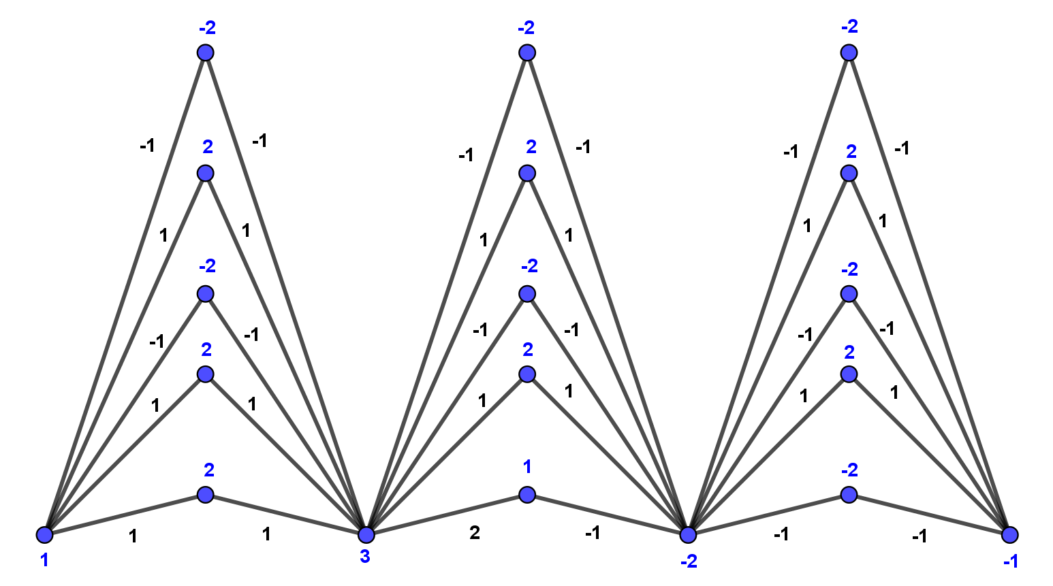

***Theorem 2.19***The $H$-super subdivision of path ${ HSS(P}_{n})(n≥2)$ is ${ H}_{3}$ cordial.

***Proof*:** Let $V(HSS(P_{n}))=\left\{u_{i},u_{ij};1≤i≤n ,1≤j≤4\right\}$ and $E\left(HSS\left(P_{n}\right)\right)=\left\{u_{i}u_{i1},u_{i3}u_{i+1},u_{i1}u_{i3},u_{i1}u_{i2},u_{i3}u_{i4};1≤i≤n-1\right\}.$

Consider a function $f:E(HSS(P_{n}))→\{-2,-1,1,2\}$ defined as

**Type 1: $n$**  is odd.

$$f\left(u_{i}u_{i1}\right)=f\left(u_{i1}u_{i3}\right)=\left\{\begin{matrix}1 & ;1≤i≤\frac{n-1}{2} \\ -1 & ;Otherwise \end{matrix}\right.$$

$$f\left(u_{i+1}u_{i3}\right)=\left\{\begin{matrix}1 & ;1≤i≤\frac{n-3}{2} \\ 2 & ;i=\frac{n-1}{2} \\ -1 & ;Otherwise\end{matrix}\right.$$

$$f\left(u_{i1}u_{i2}\right)=f\left(u_{i3}u_{i4}\right)=\left\{\begin{matrix}-1 & ;1≤i≤\frac{n-1}{2} \\ 1 & ;Otherwise \end{matrix}\right.$$

**Table 15**

|  |  |  |
| --- | --- | --- |
|  | Edge Conditions | Vertex Conditions |
| $n$ is odd | $$e_{f}\left(1\right)=\frac{5n-7}{2},e_{f}\left(-1\right)=\frac{5n-5}{2}$$ $$e_{f}\left(2\right)=1,e_{f}\left(-2\right)=0$$ | $$v_{f^{*}}\left(1\right)=2n-1=v_{f^{*}}(-1)$$ $$v_{f^{*}}\left(2\right)=\frac{n-1}{2}, v_{f^{*}}\left(-2\right)=\frac{n-3}{2}$$ |

Hence $f$ satisfies the conditions $H_{2}$ cordial labeling in this Type.

**Type 2: $n$** is even.

$$f\left(u_{i}u_{i1}\right)=f\left(u_{i+1}u_{i3}\right)= {(-1)}^{i};2≤i≤n-1$$

$$f\left(u_{1}u_{11}\right)=1$$

$$f\left(u_{n}u_{\left(n-1\right)3}\right)=-1$$

$$f\left(u_{i1}u_{i3}\right)=f\left(u_{i3}u_{i4}\right)={(-1)}^{i};1≤i≤n-1$$

$$f\left(u_{i1}u_{i2}\right)={\left(-1\right)}^{i+1};1≤i≤n-1.$$

**Table 16**

|  |  |  |
| --- | --- | --- |
|  | Edge Conditions | Vertex Conditions |
| $n$ is even | $$e_{f}\left(1\right)=\frac{5n-6}{2},e_{f}\left(-1\right)=\frac{5n-4}{2}$$ | $$v_{f^{*}}\left(1\right)=2n-1,v_{f^{*}}\left(-1\right)=2n-2$$ $$v_{f^{*}}\left(2\right)=\frac{n-2}{2}=v_{f^{*}}\left(-2\right)$$ $$v_{f^{*}}\left(3\right)=0, v_{f^{*}}\left(-3\right)=1$$ |

Hence $f$ satisfies the conditions $H_{3}$ cordial labeling in this Type.

Hence, ${ HSS(P}_{n})$ is $H_{3}$ cordial graph.

***Illustration 2.20 $H_{3}$*** cordial labeling of ${ HSS(P}_{5})$ as shown in below Figure.

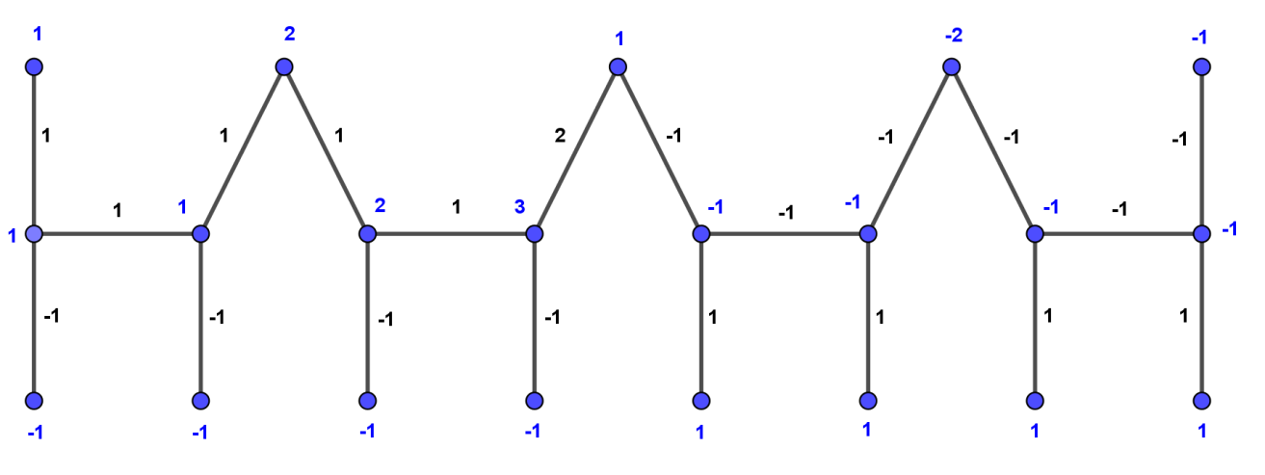

***Theorem 2.21***Cycle ${ C}_{n}(n≥4)$ is $H_{3}$ cordial.

***Proof*:** Let $V(C_{n})=\left\{u_{i};1≤i≤n \right\}$ and $E(C_{n})=\left\{u_{i}u_{i+1},u_{1}u_{n};1≤i≤n-1\right\}$.

Consider a function $f:E(C_{n})→\{-2,-1,1,2\}$ defined as

$$f\left(u_{i}u_{i+1}\right)=\left\{\begin{matrix}1 & ;1≤i≤\left\lceil \frac{n}{2}\right\rceil -1 \\ 2 & ;i=\left\lceil \frac{n}{2}\right\rceil \\ -1 & ;\left\lceil \frac{n}{2}\right\rceil +1≤i≤n-1 \end{matrix}\right.$$

$$f\left(u_{n}u_{1}\right)=-2.$$

**Table 17**

|  |  |  |
| --- | --- | --- |
| $$n≥4$$ | Edge Conditions | Vertex Conditions |
| $n$ is even | $$e_{f}\left(1\right)=\frac{n-2}{2}=e_{f}\left(-1\right)$$ $$e_{f}\left(2\right)=1=e_{f}\left(-2\right)$$ | $$v_{f^{*}}\left(1\right)=1=v_{f^{*}}\left(-1\right)$$ $$v_{f^{*}}\left(2\right)=\frac{n-4}{2}=v_{f^{*}}\left(-2\right)$$ $$v_{f^{*}}\left(3\right)=1=v_{f^{*}}\left(-3\right)$$ |
| $n$ is odd | $$e_{f}\left(1\right)=\frac{n-1}{2},e_{f}\left(-1\right)=\frac{n-3}{2}$$ $$e_{f}\left(2\right)=1=e_{f}\left(-2\right)$$ | $$v_{f^{*}}\left(1\right)=1=v_{f^{*}}\left(-1\right)$$ $$v_{f^{*}}\left(2\right)=\frac{n-3}{2},v_{f^{*}}\left(-2\right)=\frac{n-5}{2}$$ $$v_{f^{*}}\left(3\right)=1=v_{f^{*}}\left(-3\right)$$ |

Hence, ${ C}_{n}$ is $H_{3}$ cordial.

***Illustration 2.22 $H_{3}$*** –cordial labeling of cycle ${ C}_{8}$ is shown in below Figure.

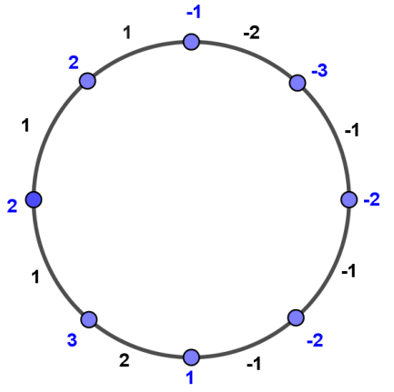

***Remarks 2.23*** Consider cycle ${ C}_{n}$. As per barycentric subdivision of ${ C}_{n}(n≥3)$ is again a path ${ C}_{2n}$ which is also is ${ H}_{3}$ cordial as per Theorem 2.19. Hence we have the following.

***Theorem 2.24***The barycentricsubdivision of cycle ${ S(C}_{n})(n≥2)$ is $H_{3}$ cordial.

***Theorem 2.25*** Thesuper subdivision of cycle ${ SS(C}_{n})(n≥4)$ is $H_{3}$ cordial.

***Proof*:** Let $V(SS(C_{n}))=\left\{u_{i},u_{ij};1≤i≤n ,1≤j≤m\right\}$ and $E(SS(C_{n}))=\left\{u_{i}u_{ij},u_{ij}u_{i+1},,u_{1}u_{nj};1≤i≤n,1≤j≤m\right\}$.

Consider a function $f:E(SS(C_{n}))→\{-2,-1,1,2\}$ defined as

**Type 1: $m$** is even and $n$ is odd.

$$f\left(u_{i}u_{i1}\right)=\left\{\begin{matrix}1 & ;1≤i≤\frac{n-1}{2} \\ 2 & ;i=\frac{n+1}{2} \\ -1 & ;Otherwise \end{matrix}\right.$$

$$f\left(u_{i1}u_{i+1}\right)=\left\{\begin{matrix}1 & ;1≤i≤\frac{n-1}{2} \\ -1 & ;\frac{n+1}{2}≤ i≤n-1\end{matrix}\right.$$

$$f\left(u_{1}u_{n1}\right)=-2$$

$$f\left(u_{1}u_{n2}\right)=2$$

$$f\left(u_{n}u_{n2}\right)=1$$

$f\left(u_{i}u_{i2}\right)=f\left(u_{i2}u_{i+1}\right)={(-1)}^{i+1}$; $1≤i≤n-1$

$f\left(u_{i}u_{ij}\right)=f\left(u_{ij}u_{i+1}\right)={(-1)}^{j}$; $3≤j≤m.$

**Table 18**

|  |  |  |
| --- | --- | --- |
|  | Edge Conditions | Vertex Conditions |
| $m$ is even and $n$ is odd | $$e_{f}\left(1\right)=mn-1,e_{f}\left(-1\right)=mn-2$$ $$e_{f}\left(2\right)=2,e_{f}\left(-2\right)=1$$ | $$v_{f^{*}}\left(1\right)=1,v_{f^{*}}\left(-1\right)=0$$ $$v_{f^{*}}\left(2\right)=\frac{n\left(m+1\right)-3}{2}$$ $$v_{f^{*}}\left(-2\right)=\frac{n\left(m+1\right)-5}{2}$$ $$v_{f^{*}}\left(3\right)=2,v_{f^{*}}\left(-3\right)=1$$ |

**Type 2: $m$** and $n$ both are even.

$$f\left(u_{1}u_{n1}\right)=-2$$

$$f\left(u_{i}u_{i1}\right)=\left\{\begin{matrix}1 & ;1≤i≤\frac{n}{2} \\ -1 & ;Otherwise\end{matrix}\right.$$

$$f\left(u_{i1}u_{i+1}\right)=\left\{\begin{matrix}1 & ;1≤i≤\frac{n-2}{2} \\ 2 & ;i=\frac{n}{2} \\ -1 & ;\frac{n+2}{2}≤ i≤n-1\end{matrix}\right.$$

$f\left(u_{i}u_{i2}\right)=f\left(u_{i2}u_{i+1}\right)={(-1)}^{i+1}$; $1≤i≤n$

$f\left(u_{i}u_{ij}\right)=f\left(u_{ij}u_{i+1}\right)={(-1)}^{j}$; $3≤j≤m,1≤i≤n.$

**Table 19**

|  |  |  |
| --- | --- | --- |
|  | Edge Conditions | Vertex Conditions |
| and $n$ both are even | $$e_{f}\left(1\right)=nm-1=e_{f}\left(-1\right)$$ $$e_{f}\left(2\right)=1=e_{f}\left(-2\right)$$ | $$v_{f^{*}}\left(1\right)=1=v_{f^{*}}\left(-1\right)$$ $$v_{f^{*}}\left(2\right)=\frac{n\left(m+1\right)-4}{2}=v_{f^{*}}\left(-2\right)$$ $$v_{f^{*}}\left(3\right)=1=v_{f^{*}}\left(-3\right)$$ |

**Type 3: $m$** and $n$ both are odd.

$$f\left(u_{1}u_{n1}\right)=-2$$

$$f\left(u_{i}u_{i1}\right)=\left\{\begin{matrix}1 & ;1≤i≤\frac{n-1}{2} \\ 2 & ;i=\frac{n+1}{2} \\ -1 & ;Otherwise \end{matrix}\right.$$

$$f\left(u_{i1}u_{i+1}\right)=\left\{\begin{matrix}1 & ;1≤i≤\frac{n-1}{2} \\ -1 & ;\frac{n+1}{2}≤ i≤n-1\end{matrix}\right.$$

$f\left(u_{i}u_{ij}\right)=f\left(u_{ij}u_{i+1}\right)={(-1)}^{j}$; $2≤j≤m ,1≤i≤n.$

**Type 4: $m$**  is odd and $n$ is even.

$$f\left(u_{i}u_{i1}\right)=\left\{\begin{matrix}1 & ;1≤i≤\frac{n}{2} \\ -1 & ;Otherwise\end{matrix}\right.$$

$$f\left(u_{i1}u_{i+1}\right)=\left\{\begin{matrix}1 & ;1≤i≤\frac{n-2}{2} \\ 2 & ;i=\frac{n}{2} \\ -1 & ;\frac{n+2}{2}≤ i≤n-1\end{matrix}\right.$$

$$f\left(u_{1}u_{n1}\right)=-2$$

$f\left(u_{i}u_{ij}\right)=f\left(u_{ij}u_{i+1}\right)={(-1)}^{j}$; $2≤j≤m,1≤i≤n.$

**Table 20**

|  |  |  |
| --- | --- | --- |
| $$n≥4$$ | Edge Conditions | Vertex Conditions |
| $m$ is odd | $$e_{f}\left(1\right)=nm-1=e_{f}\left(-1\right)$$ $$e_{f}\left(2\right)=1=e_{f}\left(-2\right)$$ | $$v_{f^{*}}\left(1\right)=1=v_{f^{*}}\left(-1\right)$$ $$v_{f^{*}}\left(2\right)=\frac{n\left(m+1\right)-4}{2}=v_{f^{*}}\left(-2\right)$$ $$v_{f^{*}}\left(3\right)=1=v_{f^{*}}\left(-3\right)$$ |

Hence, ${ SS(C}_{n})$ is $H_{3}$ cordial.

***Illustration 2.26 ${ SS(C}_{5})$***with $m=3$ is $H_{3}$ cordial shown in Figure.

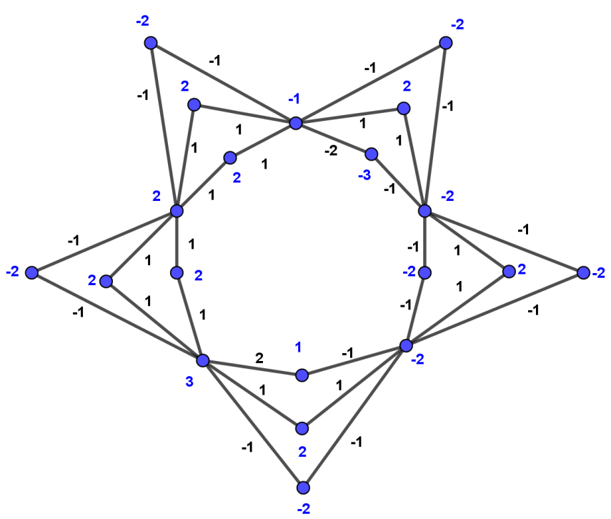

***Theorem 2.27***The $H$-super subdivision of cycle ${ HSS(C}_{n})(n≥3)$ is $H_{2}$ cordial.

***Proof*:** Let $V(HSS(C_{n}))=\left\{u_{i},u_{ij};1≤i≤n ,1≤j≤4\right\}$ and $E(HSS(C_{n}))=\left\{u_{i}u_{i1},u_{i3}u_{i+1},u_{i1}u_{i3},u_{i1}u_{i2},u_{i3}u_{i4},u_{1}u_{n3};1≤i≤n-1\right\}$.

Consider a function $f:E(HSS(C_{n}))→\{-1,1\}$ defined as

**Type 1: $n$**is odd.

$$f\left(u_{i}u_{i1}\right)=\left\{\begin{matrix}1 & ;1≤i≤\frac{n+1}{2} \\ -1 & ;Otherwise \end{matrix}\right.$$

$$f\left(u_{i+1}u_{i3}\right)=f\left(u_{i1}u_{i3}\right)=\left\{\begin{matrix}1 & ;1≤i≤\frac{n-1}{2} \\ -1 & ;Otherwise \end{matrix}\right.$$

$$f\left(u_{1}u_{n3}\right)=1$$

$$f\left(u_{i1}u_{i2}\right)=\left\{\begin{matrix}-1 & ;1≤i≤\frac{n+1}{2} \\ 1 & ;Otherwise \end{matrix}\right.$$

$$f\left(u_{i3}u_{i4}\right)=\left\{\begin{matrix}-1 & ;1≤i≤\frac{n-1}{2} \\ 1 & ;Otherwise \end{matrix}\right.$$

**Table 21**

|  |  |  |
| --- | --- | --- |
|  | Edge Conditions | Vertex Conditions |
| $n$ is odd | $$e_{f}\left(1\right)=\frac{5n+1}{2},e_{f}\left(-1\right)=\frac{5n-1}{2}$$ | $$v_{f^{*}}\left(1\right)=2n=v_{f^{*}}(-1)$$ $$v_{f^{*}}\left(2\right)=\frac{n+1}{2}, v_{f^{*}}\left(-2\right)=\frac{n-1}{2}$$ |

**Type 2: $n$**is even.

$$f\left(u_{i}u_{i1}\right)=f\left(u_{i1}u_{i3}\right)=f\left(u_{i+1}u_{i3}\right)=\left\{\begin{matrix}1 & ;1≤i≤\frac{n}{2} \\ -1 & ;Otherwise\end{matrix}\right.$$

$$f\left(u_{1}u_{n3}\right)=1$$

$$f\left(u_{i1}u_{i2}\right)=f\left(u_{i3}u_{i4}\right)=\left\{\begin{matrix}-1 & ;1≤i≤\frac{n}{2} \\ 1 & ;Otherwise\end{matrix}\right.$$

**Table 22**

|  |  |  |
| --- | --- | --- |
|  | Edge Conditions | Vertex Conditions |
| $n$ is even | $$e_{f}\left(1\right)=\frac{5n}{2}=e_{f}\left(-1\right)$$ | $$v_{f^{*}}\left(1\right)=2n=v_{f^{*}}(-1)$$ $$v_{f^{*}}\left(2\right)=\frac{n}{2}=v_{f^{*}}\left(-2\right)$$ |

Hence, ${ HSS(C}_{n})$ is $H_{2}$ cordial.

***Illustration 2.28 $H_{2}$*** cordial labeling of ${ HSS(C}_{5})$ as shown in Figure.

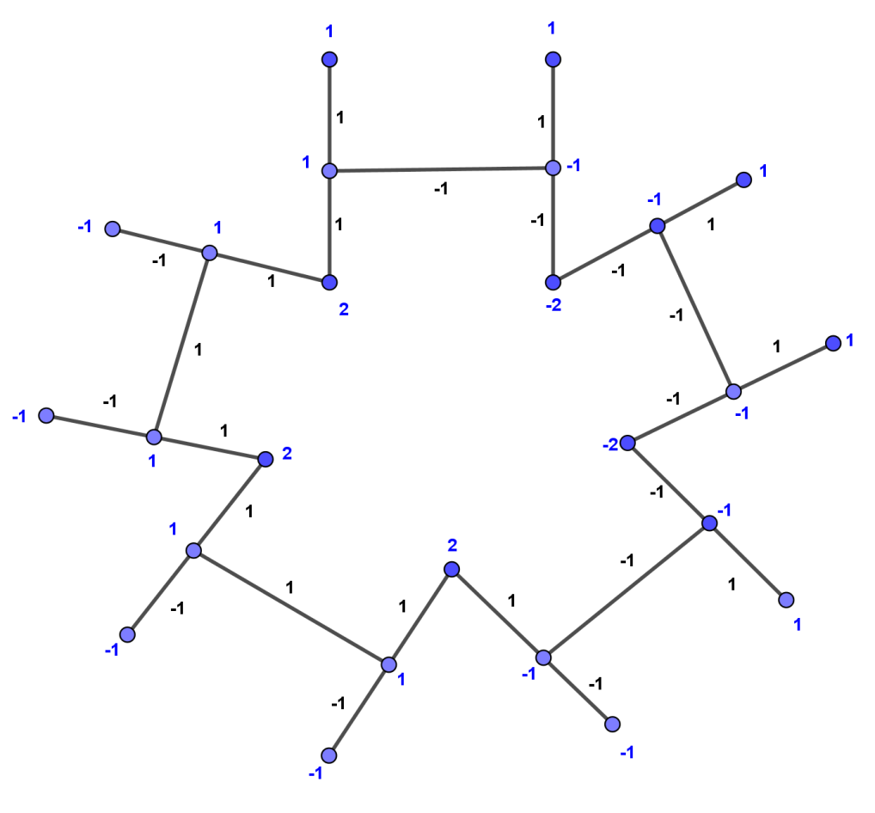

# **III. Conclusion**

Path, star and cycle graph are basic graphs which we have proved to be $H_{k}$–cordial graphs. We have derived the results on these graphs by considering operations such as barycentric subdividion, super subdivision and $H$- super subdivision.

# **iv. References**

1. D. Parmar and J. Joshi, “ $H_{k}$ cordial Labeling of Triangular Snake Graph”, Journal of Applied Science and Computations, vol. 6, 2019, pp. 2118-2123.
2. I. Cahit, “H–Cordial Graphs”, Bull. Inst. Combin. Appl, vol. 18, 1996, pp. 87-101.
3. J. A. Gallian, “A Dynamic Survey of Graph Labeling”, The Electronics Journal of Combinatorics, 2019 ♯𝐷𝑆6.
4. J.Gross and J.Yellen, “*Graph Theory and its applications*”, CRC Press
5. J. R. Joshi and D. Parmar, “ $H_{k}$- Cordial Labeling of $m$-Polygonal Snake Graphs”, Alochana Chakra Journal, vol. 9, no. 4, pp.1924 - 1938, April 2020.
6. J. R. Joshi and D. Parmar, “ $H_{k}$ cordial Labeling of Some Graph and its Corona Graphs”, International Journal of Aquatic Science, vol. 12, no. 2, 2021, pp. 1519 -1534.
7. M. Ghebleh and R. Khoeilar, “A note on: “Hcordial graphs”, Bull. Inst. Combin. Appl, vol. 31, 2001, pp. 60-68.
8. P. Jeyanthi and R. Gomathi, “Analytic Odd Mean Labeling of Super Subdivision and $H$-Super Subdivision of Graphs”, Journal of Emerging Technologies and Innovatives Research, vol. 6, 2019, pp. 541-551.
9. S. Abhirami, R. Vikramaprasad, R. Dhavaseelan, “ Even Sum Cordial Labeling for some new Graphs”, International Journal of Mechanical Engineering and Technology, vol. 9, no. 2, pp. 214-220, February 2018.
10. S. K. Vaidya, K. K. Kanani, P. L. Vihol and N. A. Dani, “ Some Cordial Graphs in the Context of Barycentric Subdivision”, International Journal of Contemporary Mathematical Sciences, vol. 4, no. 30, 2009, pp. 1479-1492.