**Spatio-Temporal dynamic of Peri-Urban area –**

**A case of Jagatpur, Cuttack of Odisha**

Mr. Sujan Maharaj Dr. Jajnaseni Rout

Dept. of Geography Assistant Professor

Ravenshaw University Dept. of Geography

Odisha Ravenshaw University

[1999sujanmaharaj@gmail.com](mailto:1999sujanmaharaj@gmail.com) Odisha

[jajnasenirout@gmail.com](mailto:jajnasenirout@gmail.com)

**Abstract**

Land use means to describe the human activities on the land surface. It signifies the commercial and ethnic activities (e.g., Cultivated, Built-up, Developed, Mining, and Amusing uses) which practised at a certain place. Land cover means physical characteristics (Biotic and Abiotic organisms) like - Water bodies, Vegetation, Soil, and other physical features on the surface of the Earth. Many Factors are responsible for the LU/LC changes are Size of human and livestock, Increase of population, Modern technology used, Non-agricultural activities - construction building for human settlements, Industrialization and Rapid urbanisation. Jagatpur is a locality situated in the north-eastern part of the city of Cuttack of Odisha, India. The Geospatial technology has used for the analysis of the study and the important objective of the study is to find out the dynamic of LU/LC in the peri-urban area as a case study. The Result of the study is applicable every peri-urban area of the country. Unsupervised, NDVI and NDBI methodologies are used for the analysis. The analysis showing that the vegetation area of the study area decreases by NDVI analysis and the Built up area increases by NDBI Analysis. The LU/LC dynamic data showing the agricultural land decreasing and built up land increasing gradually during the year 2002 and 2022.

**Keywords–Geospatial, NDVI, NDBI, LU/LC, Peri-urban**

**Introduction**

Land is the solid part of the External of the World. Land is the basis for topography, vegetation, Natural resources and agricultural purposes and humans are using the land for settlement purposes. According to UN land means “A area of the earth’s global surface, surrounding all qualities of the environment directly exceeding or below this surface containing those of the near-surface weather, the soil and terrain systems, the surface hydrology (shallow lakes, rivers, marshes and swamps), the near-surface sedimentary deposits and related groundwater reserve, the plant and animal populations, the social settlement pattern and physical outcomes of earlier and current human activities”. Land use means to describe the human activities on the land surface. It signifies the commercial and ethnic activities (e.g., Cultivated, Built-up, Developed, Mining, and Amusing uses) which practiced at a certain place. (US EPA).

"Land Cover" is the perceived biophysical protection on the earth's surface (FAO, 1995, 2000). So, Land cover means physical characteristics (Biotic and Abiotic organisms) like - Water bodies, Vegetation, Soil, and other physical features on the surface of the Earth. According to NRSA in the year 1989 , Land Cover as an gathering of biotic and abiotic components on earth’s surface which was one of the most vital properties of the earth classification. Meyer and Turner (1994) stated that "Land Cover is the

physical, chemical or biological classification of

the terrestrial surface, e.g., grassland, forest or solid and land use defines to the human determinations that are related with that cover, e.g., raising cattle, recreation or urban living”.

Land Cover is thus the composition and appearances of land surface essentials and delivers important ecological evidence and other phenomena. This evidence is very vital for many scientific, resource executive and policy drives and for a range of human actions. Land Use and Land Cover is a changeable process. On the world's surface the population is growing rapidly. Because of growing population pressure the land use and land cover design also changed. Due to industrialization and urbanisation the whole land use and land cover pattern is changing excessively. Humans are the most responsible for land cover changes of the surface of the Earth.

Factors are liable for the land Cover changes are -

● Size of human and livestock

● Increase of population

● Modern technology used

● Non-agricultural activities - construction building for human settlements

● Industrialization

● Rapid urbanization.

An indication of such growing built-up areas, declining natural vegetation or dense vegetation. decreasing natural vegetation or dense vegetation in Jagatpur tehsil, Cuttack. And how it is a converted suburban area also mentioned. In the Present study, an effort has been prepared to analyse LULC design by Geospatial information technology. Built-up area of the study area increases day by day; for that it is affected cultivated land, natural vegetation and water bodies (like - ponds) of the study area. With attempted different satellite dataset (like - LANDSAT 8, LISS 3, LANDSAT 7, LANDSAT 5) for detecting the LULC pattern changes of the study area.

**Study Area**

Jagatpur is a locality situated in the north-eastern part of the city of Cuttack in the state of Odisha, India. The geographical coordinates of Jagatpur, Cuttack are approximately 20.46° N latitude and 86.04° E longitude. The river Mahanadi flows through Jagatpur Tehsil. It is situated towards the north-eastern part of the district and is surrounded by the tehsils of Cuttack Sadar, Salipur, and Mahanga. It covers an area of about 92 square kilometre and comprises several villages and towns, including Jagatpur, Balarampur, Padmapur, Bilaipur, and Nuapatna. It is located about 10 kilometres away from the centre of Cuttack city and is known for its industrial area, including many small and medium-scale industries.

The Mahanadi is one of the largest rivers in the state and is a major source of irrigation and hydroelectric power generation. In Jagatpur Tehsil, the Mahanadi River forms the western boundary of the tehsil and provides water for irrigation to the agricultural lands on its banks.

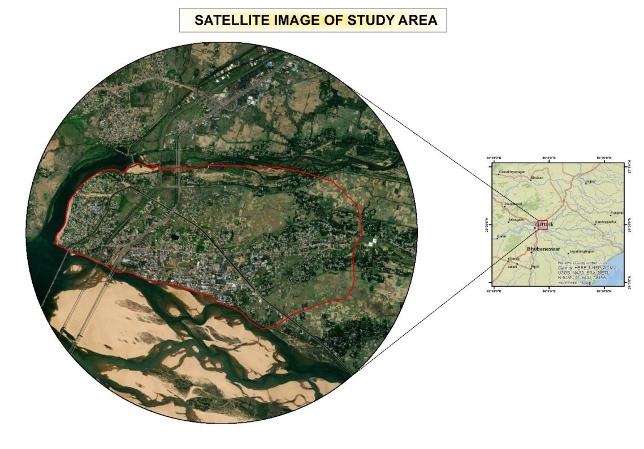

**Figure 1: Location Map**

**Database and Methodology**

The database of the LULC of the research area mainly dependent on the different satellite imageries of 2002, 2012 and 2022. This Land use and Land cover was done through an assimilate or incorporated coverage of LANDSAT and RESOURCESAT satellite images (ETM+, LISS-

3, OLI-TIRS) from the site of USGS Earth Resource observation system data centre and BHUVAN websites. Satellite images were geometrically rectified by survey of India toposheet (Singh, R.K; Et.al, 2018). The satellite images have different path and row.

NDVI: - The Normalized Difference Vegetation Index (NDVI) is the used for vegetation index. NDVI = (NIR – Red) / (NIR + Red) Landsat 7 data, NDVI = (Band 4 – Band 3) / (Band 4 + Band 3) For Landsat 8 data, NDVI = (Band 5 – Band 4) / (Band 5 + Band 4), LISS 3 data, NDVI = (Band 3– Band 2) / (Band 3 + Band 2).

The NDVI value differs from -1 to 1. Greater the value of NDVI reveals great Near Infrared (NIR), means dense greenery. The result always be NDVI = -1 to 0 signify Water bodies NDVI = -0.1 to 0.1 signify Barren rocks, sand, snow. NDVI = 0.2 to 0.5 signify Shrubs and grasslands or senescing crops NDVI = 0.6 to 1.0 represent dense vegetation or tropical rainforest. The NDVI rate can be calculated using raster calculator (map algebra) in ArcGIS (Bahadur Kshetri, T., 2018).

NDBI: - NDBI = (SWIR – NIR) / (SWIR + NIR) For Landsat 7 data, NDBI = (Band 5 – Band 4) / (Band 5 + Band 4) Landsat 8 data, NDBI = (Band 6 – Band 5) / (Band 6 + Band 5), LISS 3 data, NDBI = (Band 5 – Band 4) / (Band 5 + Band 4). The Normalize Difference Build-up Index value lies between -1 to +1 (Bahadur Kshetri, T., 2018).

**Table no. 1: Details characteristics of satellite imageries used in study area**

|  |  |  |  |  |  |  |
| --- | --- | --- | --- | --- | --- | --- |
| **Source** | **Path/Row** | **Local acquisition date** | **Sensor** | **Spatial**  **Resolution** | **Spacecraft** | **Type** |
| USGS | 139(P),046(R) | 2002-04-20 | ETM+ | 30m | LANDSAT-7 | TIFF |
| BHUVAN | 106(P),O58(R) | 2012-03-14 | LISS-3 | 23.5m | RESOURCESAT-1 | TIFF |
| USGS | 139(P),046(R) | 2022-5-21 | OLI/TIRS | 30m | LANDSAT-8 | TIFF |

The ArcGIS software is used for data processing and validation of the data. The Geospatial technology has used extensively. The GPS used for the ground truthing of the study area. The study area is the growing area of Cuttack city.

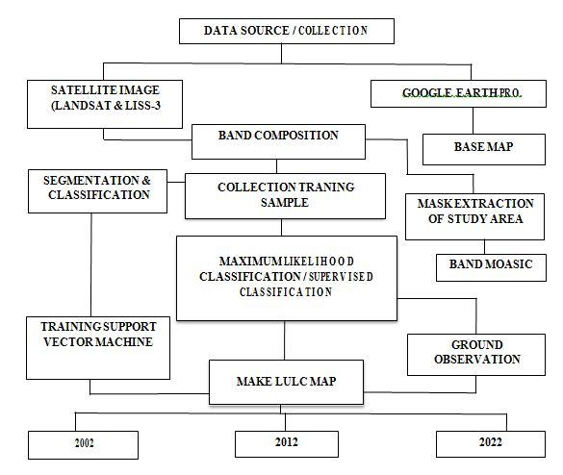

**Figure 2: Flow chart showing the Methodology**

**Discussion**

In the year 2002 the area has 25% of Urban and 31% of Agricultural land. Vegetation and Fallow land are 16% and 21% respectively in the year 2002. But while the population attracted this area for employment opportunity due to industrial development, the built up area increases in the year 2012 and 2022 as 27% and 39% respectively. The education institutions are also increased which is one of the reason for population growth. Due to industrial pollution the agricultural production also decreases which impose the farmers for change their occupation and many agricultural lands turn into fallow land.

Table 1 and Figure 3 shows the fallow land is increasing during the year 2002 and 2022. Though Cuttack city is bounded with two rivers, one is largest river of Odisha i.e. Mahanadi and another is its distributary Kathajodi, the peri-urban area is Jagatpur, Trishulia and Balikuda which are situated outside of river but adjacent to Cuttack and also in Municipality area.

Change detection analysis shows that there is increased built-up area of Jagatpur, Cuttack. The built-up area increased by 14.07%, fallow land area increased by 1.20%, the vegetation increased by 5.3 % from 2002 to 2022. Whereas agricultural land has decreased by – 15.83% and water bodies decreased by 0.72% from 2002 to 2022.

Spatial variation analysis is a procedure of classifying and visualizing the pattern of spatial variation in a particular variable or occurrence across a geographical area. It involves the use of various analytical approaches and methods to explore and understanding the spatial relationship between different variables.

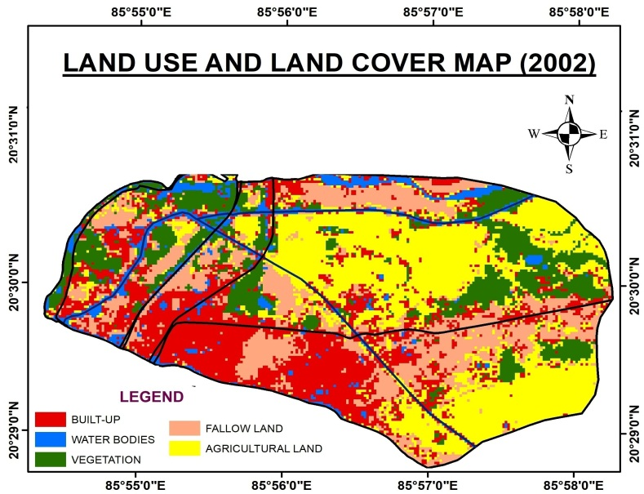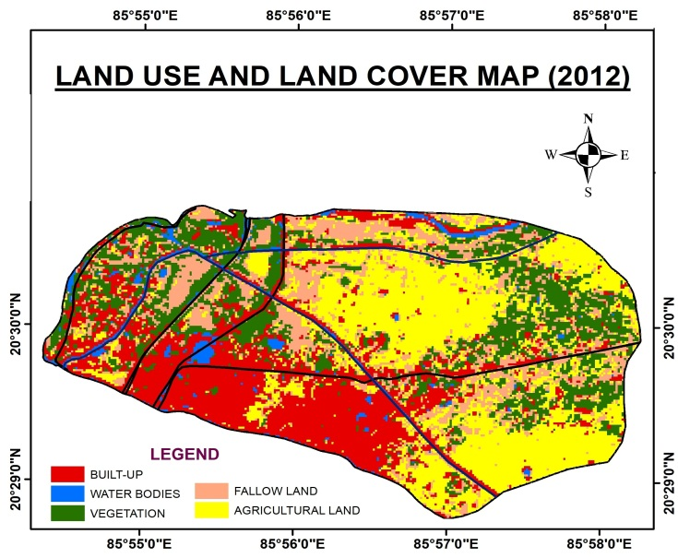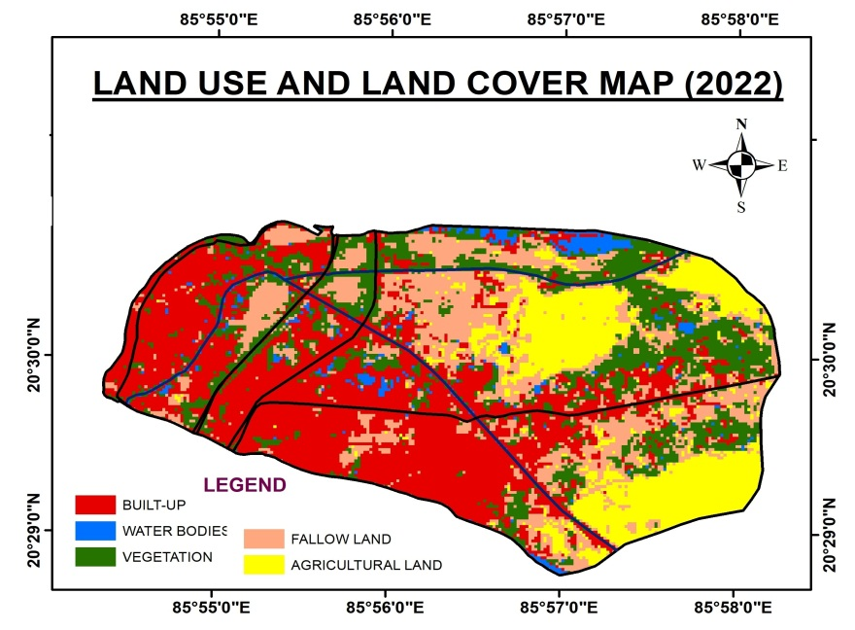

**Figure 3: Spatio-Temporal LU/LC analysis**

**Table no. 2: Time series LU/LC Area**

|  |  |  |  |  |  |  |
| --- | --- | --- | --- | --- | --- | --- |
| **Classes** | **Area in ha. (2002)** | **Area in %** | **Area in ha. (2012)** | **Area in %** | **Area in ha. (2022)** | **Area in %** |
| Built-up | 440.27 | 25 | 462.19 | 27 | 684.57 | 39 |
| Water bodies | 121.44 | 7 | 54.44 | 3 | 49.12 | 3 |
| Vegetation | 270.23 | 16 | 373.59 | 22 | 352.20 | 20 |
| Fallow land | 357.18 | 21 | 317.04 | 18 | 378.03 | 22 |
| Agricultural land | 546.99 | 31 | 529.59 | 30 | 272.11 | 16 |

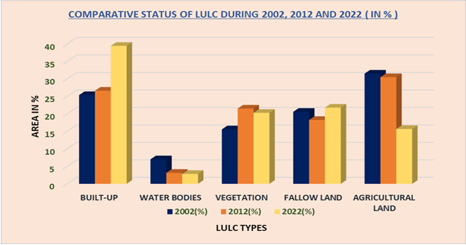

**Figure 4: Spatio-Temporal LU/LC Area analysis**

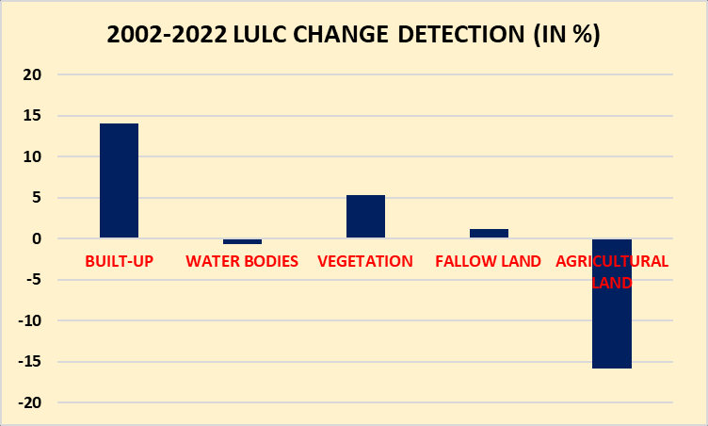

**Figure 5: Showing the LU/LC dynamic area**

**Table no 3: NDVI value of the Jagatpur area (2002 – 2022)**

|  |  |  |  |  |
| --- | --- | --- | --- | --- |
| **Year** | **Minimum** | **Maximum** | **Mean** | **S.D.** |
| **2002** | **-0.003** | **0.289** | **0.122** | **0.04** |
| **2012** | **-0.18** | **0. 4** | **0.143** | **0.05** |
| **2022** | **-0.004** | **0.43** | **0.21** | **0.05** |

**Table no. 4: NDBI value of the Jagatpur area (2002 – 2022)**

|  |  |  |  |  |
| --- | --- | --- | --- | --- |
| **Year** | **Minimum** | **Maximum** | **Mean** | **S.D.** |
| **2002** | **-0.16** | **0.14** | **0.048** | **0.044** |
| **2012** | **-0.27** | **0.12** | **-0.006** | **0.044** |
| **2022** | **-0.25** | **0.11** | **-0.038** | **0.049** |

The Table no. 3 and 4 indicates that the vegetation area of the study area decreases by NDVI analysis and the Built up area increases by NDBI Analysis.

**Conclusion**

As population pressure is increasing the land cover pattern of the study area changing continuously. Land use land cover is a significant aspect of the earth surface and plays a serious part in sustaining human livelihood and biodiversity. Land use land cover describes the away in which human use and manage the land. LULC (Land use and Land cover) in Remote Sensing denotes to the classification and mapping of the earth’s surface based on the types of land use and land cover present in the study area.

The study clearly established and show that the Geospatial techniques can be a influential tool planning and evolution of land use / land cover fluctuations of any assumed area (Singh, M.P.B., et.al, 2022). As population pressure is increasing, the Land use Land cover pattern also changing in every peri-urban area but the infrastructure development, sanitation issues, drainage issues etc. are occurring.

**References**

• Bahadur Kshetri, T., 2018, “NDVI, NDBI & NDWI Calculation Using Landsat 7, 8”, Publicado en.

•

• [Gupta, R., 2014, “The pattern of urban land-use changes: A case study of the Indian cities.](https://journals.sagepub.com/doi/abs/10.1177/0975425314521539)” [Environment and Urbanization Asia, 5(1), pp:83-104.](https://journals.sagepub.com/doi/abs/10.1177/0975425314521539)

• [Karakayaci, Z., 2016, “The Concept of Urban Sprawl and its Causes”, Journal of](https://www.researchgate.net/publication/307443639_THE_CONCEPT_OF_URBAN_SPRAWL_AND_ITS_CAUSES) [International Social Research, 9(45).](https://www.researchgate.net/publication/307443639_THE_CONCEPT_OF_URBAN_SPRAWL_AND_ITS_CAUSES)

• [Krishna, H., 2018, “Study of normalized difference built-up (NDBI) index in automatically mapping urban areas from Landsat TM imagery”, Int. J. Eng. Sci, 7, pp:1-8.](https://www.researchgate.net/profile/Hari-Krishna-Karanam/publication/339230287_STUDY_OF_NORMALIZED_DIFFERENCE_BUILT-UP_NDBI_INDEX_IN_AUTOMATICALLY_MAPPING_URBAN_AREAS_FROM_LANDSAT_TM_IMAGERY/links/5e452846a6fdccd9659fd875/STUDY-OF-NORMALIZED-DIFFERENCE-BUILT-UP-NDBI-INDEX-IN-AUTOMATICALLY-MAPPING-URBAN-AREAS-FROM-LANDSAT-TM-IMAGERY.pdf)

• [Kumar, A., Chaudhary, S. and Negi, M.S., 2019, “A study of spatio-temporal landuse/land cover change dynamics in Rudraprayag District, (Garhwal Himalaya) using Remote Sensing and GIS”, Journal of Global Resources, 5(02), pp:61-69.](https://www.researchgate.net/publication/334895364_A_STUDY_OF_SPATIO-TEMPORAL_LANDUSE_LAND_COVER_CHANGE_DYNAMICS_IN_RUDRAPRAYAG_DISTRICT_GARHWAL_HIMALAYA_USING_REMOTE_SENSING_AND_GIS)

• [Kumar, R. and Gantayat, A., 2015, “Assessment of Spatio-Temporal Change of Landuse and Land-Cover in IB Valley Coalfield Using Remote Sensing and GIS” (Doctoral dissertation).](http://ethesis.nitrkl.ac.in/7473/)

• [Majumder, B., 2011, “Land use and land cover change detection study at Sukinda Valley using Remote Sensing and GIS (Doctoral dissertation).](https://core.ac.uk/download/pdf/53187849.pdf)

• [Mundhe, N.N. and Jaybhaye, R.G., 2014, “Impact of urbanization on land use/land covers change using Geo-spatial techniques”, International Journal of Geomatics and Geosciences, 5(1), pp: 50-60.](https://www.researchgate.net/publication/281320790_Impact_of_urbanization_on_land_useland_covers_change_using_Geo-spatial_techniques)

• [Mundhe, N.N. and Jaybhaye, R.G., 2018, “ A Spatio-Temporal Analysis of Urbanization in India”, IJRAR-International Journal of Research and Analytical Reviews, 5(4), pp:30-](https://scholar.google.com/citations?user=Wgdfa9YAAAAJ&hl=ja) [37.](https://scholar.google.com/citations?user=Wgdfa9YAAAAJ&hl=ja)

• [Roy, P.S. and Roy, A., 2010, “Land use and land cover change in India: Remote Sensing](https://www.researchgate.net/publication/235987981_Land_Use_and_Land_Cover_Change_A_Remote_Sensing_GIS_Perspective) [& GIS perspective”, Journal of the Indian Institute of Science, 90(4), pp: 489-502.](https://www.researchgate.net/publication/235987981_Land_Use_and_Land_Cover_Change_A_Remote_Sensing_GIS_Perspective)

* [Singh, R.K., Singha, M., Singh, S.K., Debjeet, P.A.L., Tripathi, N. and Singh, R.S.,](https://www.acarindex.com/eurasian-journal-of-forest-science/land-useland-cover-change-detection-analysis-using-remote-sensing-and-gis-of-dhanbad-distritct-india-884923) [2018, “Land use/land cover change detection analysis using remote sensing and GIS of](https://www.acarindex.com/eurasian-journal-of-forest-science/land-useland-cover-change-detection-analysis-using-remote-sensing-and-gis-of-dhanbad-distritct-india-884923) [Dhanbad distritct, India”, Eurasian Journal of Forest Science, 6(2), pp:1-12.](https://www.acarindex.com/eurasian-journal-of-forest-science/land-useland-cover-change-detection-analysis-using-remote-sensing-and-gis-of-dhanbad-distritct-india-884923)
* [Tali, J.A., Divya, S. and Murthy, K., 2013, “Influence of urbanization on the land use change: a case study of Srinagar City”, American Journal of Research Communication,](http://www.usa-journals.com/wp-content/uploads/2013/06/Tali_Vol17.pdf) [1(7), pp: 271-283.](http://www.usa-journals.com/wp-content/uploads/2013/06/Tali_Vol17.pdf)
* [Zafar, S.M., 2014, “Spatio-temporal analysis of Land Cover/land use changes using geoinformatics: A Case Study of Margallah Hills National Park”, Indian Journal of](https://scholar.google.com/citations?user=spCbZ7IAAAAJ&hl=en) [Science and Technology, 7(11), pp.1832-41.](https://scholar.google.com/citations?user=spCbZ7IAAAAJ&hl=en)

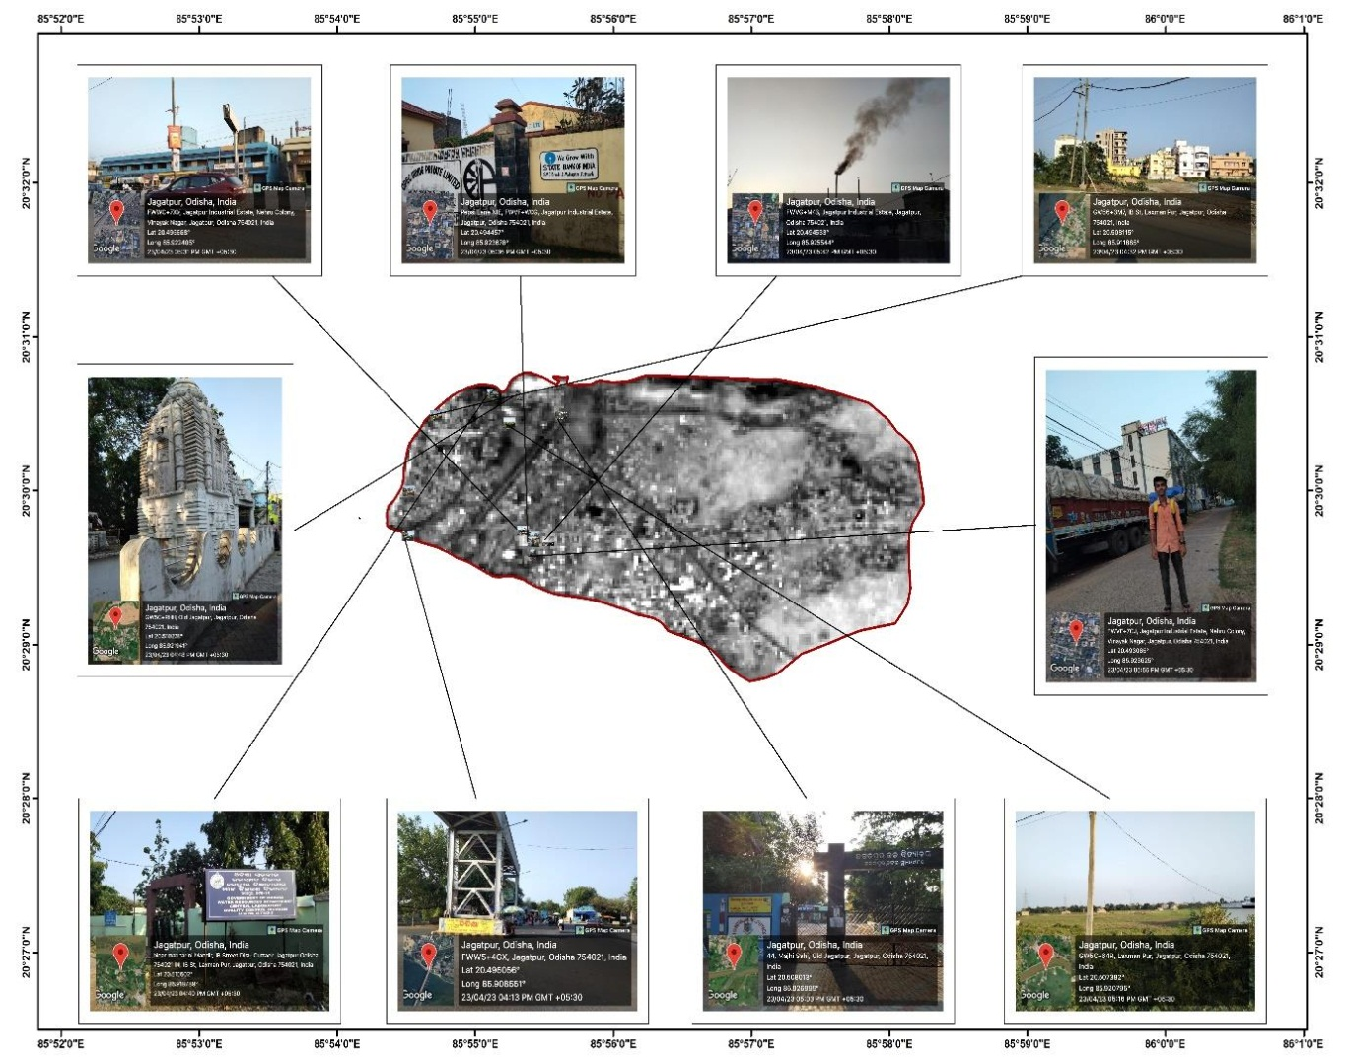

**Figure 6: Showing the Geo-tagging photographs during Ground Truthing**