AI-POWERED HEALTHCARE TECHNOLOGY: A POST PANDEMIC CRITICAL REVIEW

Dr. S. SAROJINI M.Com., M.Phil., Ph.D.
Assistant Professor, Commerce, Dr. G.R. Damodaran College of Science, CBE-14
Dr. J. NITHYA M.Com., M.Phil., M.B.A., Ph.D.
Associate Professor, Commerce, Dr. N.G. P Arts and Science College, CBE-48
Ms. SWATHY S
B. Com BPS, Dr. N.G. P Arts and Science College, Coimbatore-48
Mr. SARAN R
B. Com BPS, Dr. N.G. P Arts and Science College, Coimbatore-48

ABSTRACT

The escalation added with complication of information in health support technology at present would be dominating increasingly in this field of healthcare. In several ways the AI is already being empowered by customers, manufacturers and facilitators of health care, and life sciences corporations. The predominant areas include application involved in diagnosis and treatment, in and out patient information, official activities in hospital. Even though there are several instances and challenging scenarios in which the technology of Artificial Intelligence can perform healthcare job far better than human beings, execution element will prevent extensive automation of healthcare expert jobs for a significant period. ChatGPT help reducing efforts to understand patients’ symptoms by providing alternative ways solving their problems. Ethical issues while using the application of AI in health care sector is also discussed. AI is being used to improve the accuracy of cancer diagnosis, to create new drugs and treatments. AI chatbots are used to provide information related to the patient support and education. Key Words: Artificial intelligence, life sciences, diagnosis, automation, ChatGPT
Key Words: Artificial intelligence, life sciences, diagnosis, automation, ChatGPT

INTRODUCTION:

The magic wand of Artificial intelligence (AI) and equivalent knowledges are rising in predominant in all arena of trade, economics and society, and are started with raising surge of all possible methods of healthcare today. These new wand of technologies have the amazing capacity to transmute more features of patient care, along with support to managerial processes within Medicare providers, payer and medicinal organizations. There are previously remarkable instances which prove that AI can execute far better than humans at critical healthcare jobs, which always starts in diagnosing or identifying disease. Today, structured programs are by now performing radiologists at noticing malignant tumors, and administrating the researchers that the ways to build cohorts for expensive clinical and medicinal trials. Humankind believes that AI replaces humans or doctors in wider medical process domains. In this paper, we discuss both the potential that Artificial Intelligence offers to automate aspects of care that is provided to the patients.
AI-POWERED CHATBOTS IN HEALTHCARE
AI chatbots are being used to provide information related to patient support and education. For example, Babylon Health's chatbot has been used by over 2 million patients in the UK, and it has been shown to be effective in reducing wait times and improving patient satisfaction.
AI IN DRUG DISCOVERY
AI is being used to create new drugs and treatments. For example, Insilico Medicine uses AI to predict the effects of new drug candidates on human cells, and it has already identified several promising new drug targets.
AI IN CANCER DIAGNOSIS
AI is being used to improve the accuracy of cancer diagnosis. For example, Google AI has developed an AI system that can detect breast cancer with 99% accuracy, and it is currently being used in clinical trials.
AI IN PERSONALIZED MEDICINE
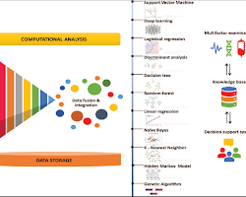
AI is being used to personalize medicine. For example, IBM Watson Health's Oncology Suite used AI to scrutinize patient data and recommend the best treatment plan for each individual patient.
These are lot of peculiar examples that AI is used in hospital industries. As this proven technology endures to positive surge, soon we can expect to increasing innovative and effective application of AI in the healthcare Industry.
Here are some additional figures and facts about AI in healthcare:
- According to the report by Grand View Research, one of the global market for AI in the healthcare field is expected to reach the target of $6.6 billion by the end of 2026.
- In 2020, there were over 1,000 AI-powered healthcare startups.
- AI is being used in over 200 different healthcare applications.
- AI is being used to improve patient care in over 50 countries.
These figures and facts show that AI is rapidly becoming a mainstream technology in the healthcare industry. As AI trend follows to develop, so we can expect to see even more widespread adoption of AI in healthcare in the near future.
There are a few real-world examples of AI in healthcare:
- Google AI has developed an AI system that can detect breast cancer with 99% accuracy. The system, called DeepVariant, analyzes medical images to identify cancer cells. It is currently being used in clinical trials, and it has the potential to revolutionize the early detection of breast cancer.
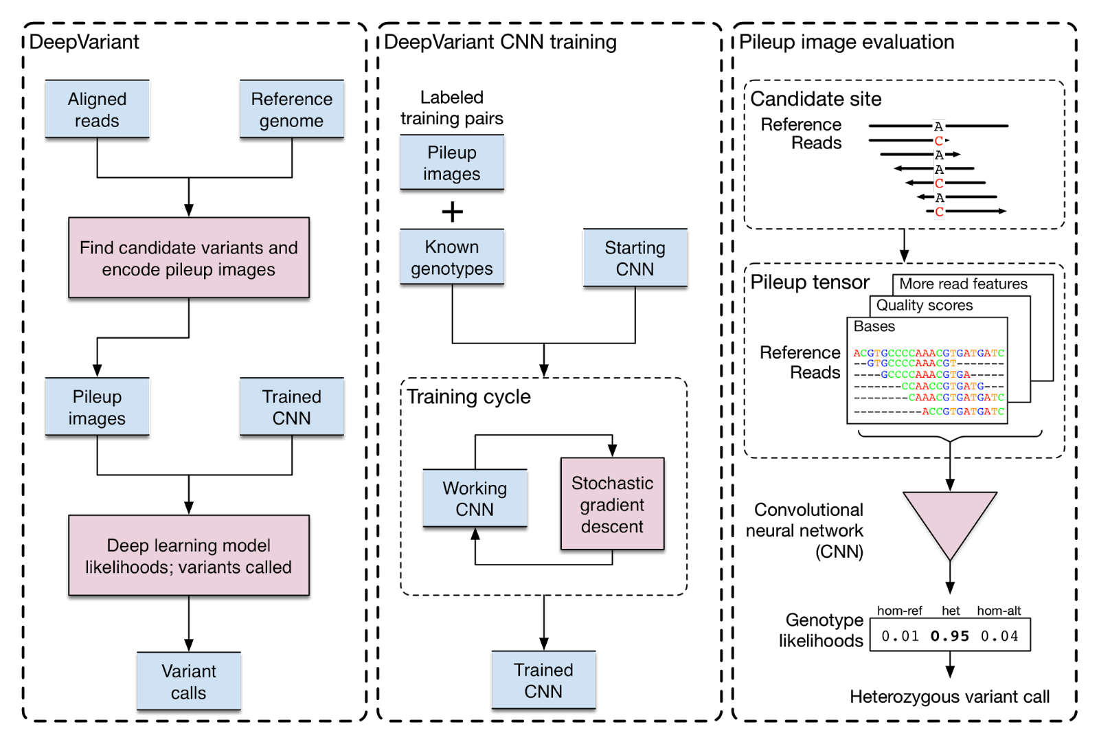 Source:ai.googleblog.com
Google AI DeepVariant
IBM Watson Health Oncology Suite
IBM Watson Health's Oncology Suite use AI to interpret patients data and recommend the best treatment plan for each individual patient. The system takes into account a patient's medical history, genetic information, and other factors to create a personalized treatment plan. It is currently being used in hospitals around the world, and it has the potential to improve the outcomes of cancer treatment.
Babylon Health chatbot
Babylon Health's chatbot has been used by over 2 million patients in the UK. The chatbot can answer patient questions, provide education on health topics, and even help patients book appointments. It has been shown to be effective in reducing wait times and improving patient satisfaction.
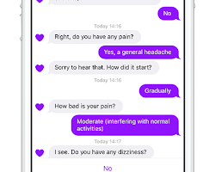techcrunch.com:
INSILICO MEDICINE USES AI TO PREDICT THE EFFECTS OF NEW DRUG CANDIDATES ON HUMAN CELLS:
The company's AI platform, called Genotype-Tissue Expression (GTEx), analyzes large datasets of patient observation data set to work on new drug targets and develop new treatments. 
. It has already identified several promising new drug targets, and it is currently working with pharmaceutical companies to develop new drugs.
These are lot of examples that provide live witnesses about the AI usage in healthcare today. As this incredible AI technology remains to develop, the health care industry expect to see even more innovative and effective application in the years to come.

TYPES OF ARTIFICIAL INTELLIGENCE OF SIGNIFICANCE TO HEALTHCARE

AI is a complex technology, and most of the technology have instant implication to the medical care field, including particular process and task, support very extensively in the field. Some weird AI techniques of extraordinary standing to healthcare are also elaborate and mentioned as down.

MACHINE LEARNING – PECULIAR NETWORKS AND DEEP LEARNING

Machine learning is an analytical method for attaching model to data and to ‘hit the books’ by teaching model with data. The technology of Machine learning is one among the supreme usual forms of AI.

Fig: 1 Machine learning in Healthcare

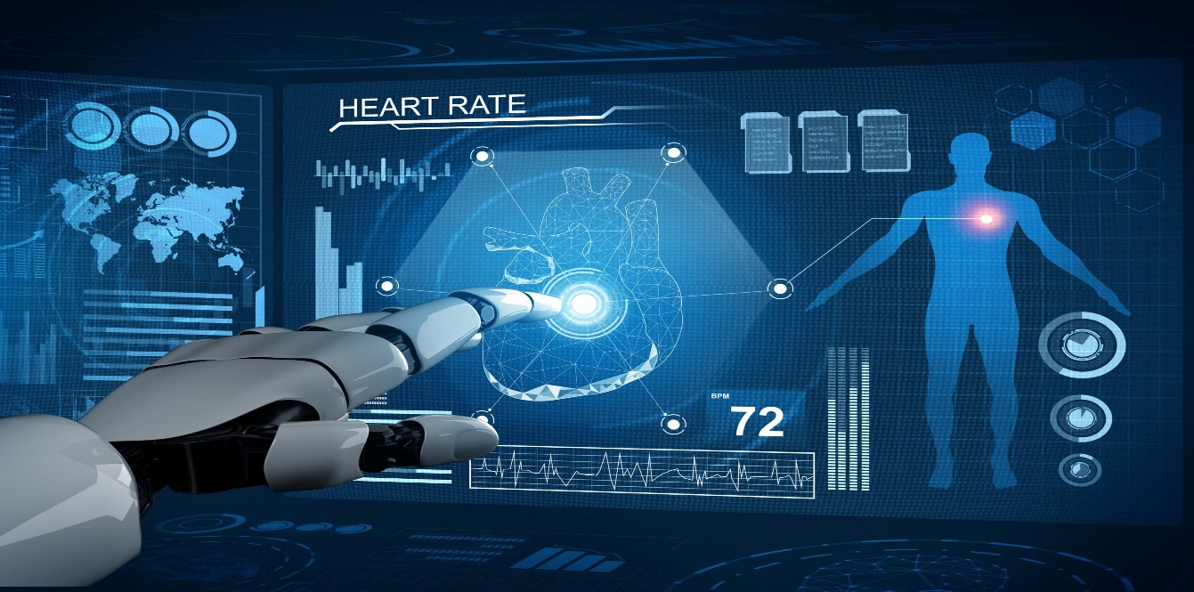

According to Deloitte survey in 2018 by 1,100 US manager whose establishments were previously handling with AI techniques, 63% of medicinal and pharmacy companies were engaging machine learning in their production industries. This massive technique at the core of many approaches to AI techniques and it too has many versions.

PHYSICAL ROBOTS

Physical robots in medical care are identified by more than 2 lakhs industrial robots are installed every year in patient care around the world. They pre -programmed tasks of lifting, keeping back in the previous positions, welding or bringing together the objects in places like working place and warehouses, and delivery in process Further , robots become engaged with humans and are more conveniently trained for a desired task.

Fig: 2 Corporeal Robots in Healthcare

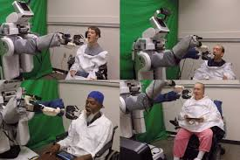

They are programmed to be more knowledgeable, as other AI coded capabilities are being used in their ‘chip’ (CPU). In future we may witness rapid improvements and innovation that’s reflected in other areas of AI would be named as physical robots, which could be the future so the robots could easily viewed on the nook and corner of the world. Many companies started to invest billions of dollar into the installation process of the robots. But we cannot say the result of the robots will be 100 percent.

THE FUTURE OF AI IN HEALTHCARE

We accept as true that AI has a main ACTION in the medical treatments and health offerings in the future. The version of machine learning, starter point ahead the development of precision medicinal sector, widely agreed fact. Although early efforts through AI of precision in diagnosis process and appropriate treatment endorsement have proven already. AI with few challenges have provided the simultaneous advances in Artificial Intelligence for image scrutiny, looks likely positive in radiology and pathology images which would be patterned at some point by a machine with AI. The technique of Speech and text acknowledgement are already put in place for seizure of clinical notes of patients, which again witness further advancements.

Fig: 3 Applications of AI in Healthcare

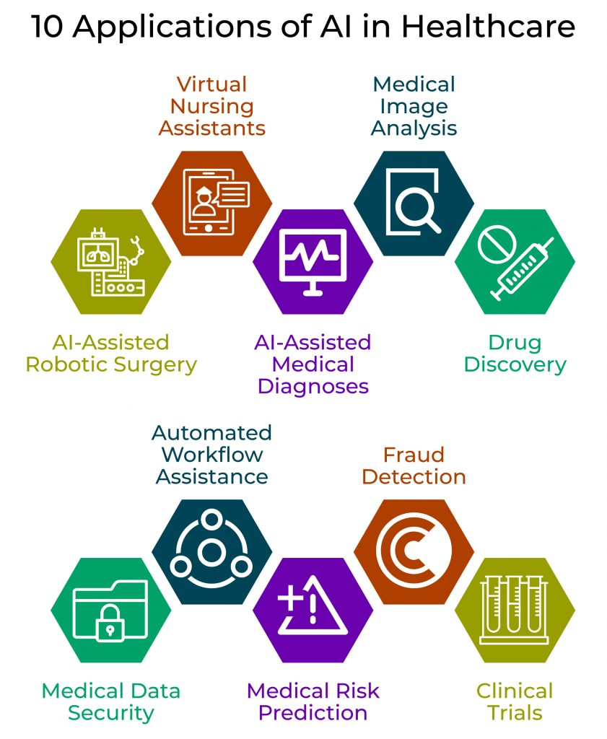

ChatGPT

Our research is also aimed at the Chat-GPT. For instance, people are occupied to improve give response to people who use our conclusion aid on antidepressants (http://MeAgainMeds.com). Today, when ChatGPT gives antidepressants, it narrates very universal advice. We need to type it very specific to be definite. Google Brain has equipped ChatGPT more specific by keeping fit further. The specific version of Google Brain also approved the U.S. Medical Licensing Exam. Thus, it has more information and is more specific to the assessment. The system we are planning will be skilled to do so.

CONCLUSION:
There are previously a number of real health care scenarios signifying that AI methodology better the humans at critical healthcare jobs, in diagnosing and identifying disease. Today, structured programs are by now performing radiologists at noticing malignant tumors, and administrating the researchers to build cohorts for expensive clinical trials. Humankind believes that AI methods replaces humans or doctors in wider medical domains. It’s vibrant that AI systems will not swap human doctors in a huge scale, but rather would upsurge the exertions to good care for patients. In coming years, human doctors might move in on the responsibilities and job specifications and designs that draw to idiosyncratic special human skills like emotion, compassion, reliance and enlarged integration to a positive patient care.

REFERENCES:

Deloitte Insights State of AI in the enterprise. Deloitte, 2018
Lee SI, Celik S, Logsdon BA, et al. A machine learning approach to integrate big data for precision medicine in acute myeloid leukemia. Nat Commun 2018;9:42.
Ross C, Swetlitz I. IBM pitched its Watson supercomputer as a revolution in cancer care. It's nowhere close. Stat 2017.
www.statnews.com/2017/09/05/watson-ibm-cancer.

