"AN INTELLIGENT MOBILE AGENT SYSTEM FOR SUDDEN INFANT DEATH SYNDROME MONITORING"

¹P. Sravani, ²R. Srikanth reddy, ³Asma afree,⁴ B. Vishwasree
¹Assistant Professor, ^{2,3,4} BE Students , ECE Department

Matrusri Engineering College, Hyderabad, Telangana state

Abstract
One of the most vulnerable diseases in infants is the Sudden Infant Death Syndrome (SIDS). The SIDS is a type of disease that can quickly take out the life of the infant. It is therefore important to monitor the infant continuously so that this disease can be detected and avoided. In this regard we are developed a intelligent mobile agent system. The main goal of this system is to reduce the response time in an SIDS scenario. The Wearable device is embedded with many sensors that are capable of measuring the body position, heart beat rate, breathing rate and temperature of the infant. After a minimal data processing, this set of information is sent via GSM technology. If any critical event occurs it will send the message to the mobile. This chapter presents a design of a Baby Monitoring System based on the GSM network. A prototype is developed which gives a reliable and efficient baby monitoring that can play a vital role in providing better infant care and in the detection of SIDS, as the disease could be life threatening to the infant.
Keywords: Sudden Infant Death Syndrome (SIDS), Intelligent mobile agent system

Introduction
The term sudden infant death syndrome (SIDS) was first proposed in 1969 in order to focus attention on a subgroup of infants with similar clinical features whose deaths occurred unexpectedly in the postnatal period ^{[2]}. Today the definition of SIDS refers to death in a seemingly healthy infant younger than 1 year of age whose death remains unexplained after a thorough case investigation including a complete autopsy, review of medical and clinical history, and death scene investigation ^{[3]}. SIDS is typically associated with a sleep period with death presumed to have occurred during sleep itself or in the transition between sleep and waking. This led to application of the terms “cot” or “crib” death; however, these terms are rarely used today. Furthermore, while the definition is inclusive of infants up to 1 year of age, approximately 95% of SIDS deaths occur in the first six months of life with a peak incidence in infants aged between 2 to 4 months ^{[4]}.

Objectives
To develop a portable and efficient monitoring kit for parents to monitor their infant from any place using GSM technology.

Methodologies
An intelligent method for preventing sudden infant death based on Arduino system consist of intelligent software co operated with hardware components such as sensors to sense and detect important physical signals i.e. infant breath, infant temperature and heart rate and accordingly pass these recorded data to Arduino device, which analyzes the data. In addition, parents will wirelessly receive Messages via Global System for Mobile communication (GSM) in real time. Such message will carry the recorded data as well as a warning when problems occurred. This system acts as a reliable and efficient real time infant monitoring system that can play a vital role in reducing the risk of SIDS and save an infant’s life.

Introduction of the Project
The designed system plays a vital role in reducing the risk of SIDS and save an infant’s life and it consist of sensors to sense and detect important physical signals i.e. infant breath, infant temperature and heart rate accordingly pass these recorded data to Arduino device as shown in fig 2. Further parents will receive Messages through GSM module., Such message will carry the recorded data as well as a warning when problems occurred. The fig 1 shows Belief, Desire and Intention (BDI) architecture in which decision making depends upon the manipulation of data structures of the agent. In the process four agents developed those are Decision maker agent, Sleep- Wake up agent, Ambulance agent, Warning agent, and Sensors agent. As per the proposed design, the agents communication process can be done through SMS. Data coupling diagrams and agent acquaintance diagrams were used to select the agents their roles are:
The decision maker agent intelligently analyses the output of the sensors status agent for the following purposes, (i) reach a decision regarding current sensors status, (ii) inform the parent about their infant status (in sleeping mode or waking up),(iii) inform the parent about any abnormal circumstances of their infant i.e. high temperature, irregular pulse rate, lack of oxygen.

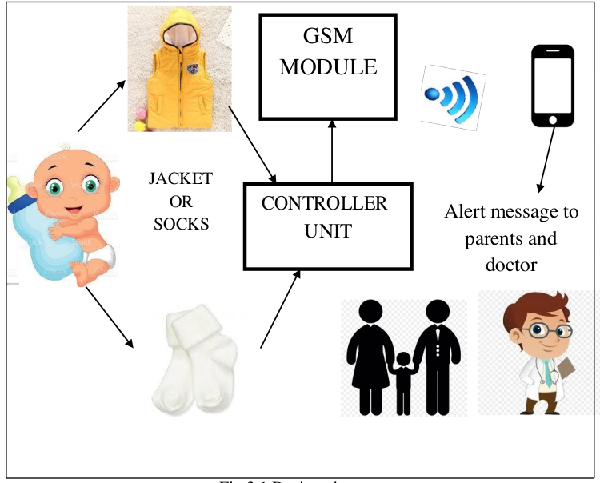
Fig 1 Designed system

Wearable device

Power supply
Motion detector
Pulse rate sensor
GSM

module
Temperature sensor

ARDUINO UNO

microcontroller
Carbon sensor
Fig. 2 Wearable device of baby
Fig 3.2 wearable device of
baby
Sensor
agent
Ambulance
agent
Sleep- waking
agent
Decision making
agent

Mobile agent’s infant monitoring
Mobile network
Hardware sensory input for mobile agent
Fig 3 Agent interaction diagram

The Sleep- Wake up agent initiated to receive the collected data from the motion sensor then summaries the status of the infant, the infant sleeps with no motion, the agent counts its respiration frequency and, in favorable conditions, pulse rate. Based on this and in case of any slight movements, the parent will be informed by a message. On the other hand, wake-up condition is characterized by long term movements of high amplitude.
An algorithm is proposed to determine any critical case based on the sensory inputs as following.
- Receive all sensors reading by sensors agent.
- Analyze such readings.
- Based on previous step, do the following:
The normal action will be recorded, if the readings in normal range which will be decided by physician, otherwise the readings in abnormal range but not in critical, the parent will be informed via message.
  - As per the physician decision, if the readings in abnormal range and critical a critical message will be passed to ambulance services holding the infant address as well as his/her medical record.

Schematic Diagram
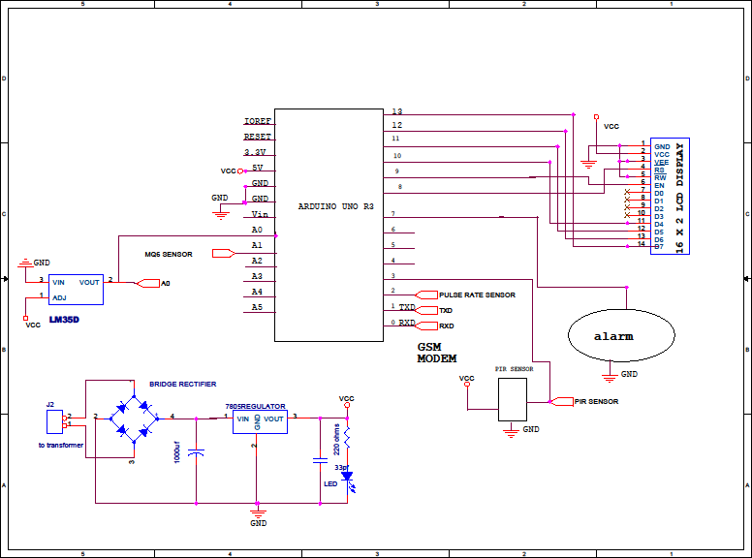
The schematic diagram of the designed system is shown in the below fig.4 . The integration of both software and hardware is done in order to reach the objective. The final prototype is as shown in fig.5

Fig. 4 Schematic diagram

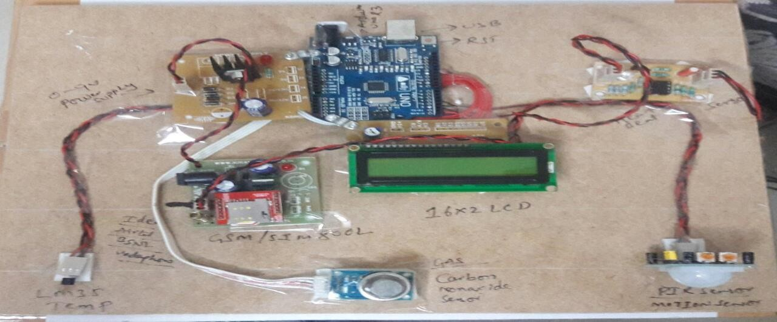
Fig.5 Prototype
The flowchart as shown in fig.6 describes the process of working of the intelligent mobile agent system. The designed system follows the steps as shown in the flowchart.
Start
Setup and initialize all devices (Arduino,
sensors, LCD, GSM)
Taking i/p’s from sensors and giving it to
arduino
80> H.B> 150
Y
N
Y
N
Y
H.B> 0
N
If Temp>50
If E==2
If CO2>150
If H.B==?

H.B=
=0
Displays temp
level. E.g: Temp is 32deg
No PIR
alert
Display c02 level
Displays heart beat
Temp alert msg to parents and doctor. E.g: over body temperature Temp: 69 deg
Motion alert msg to parents. E.g. Baby is moving
CO2 level alert msg to parents and doctor. E.g. CO2=159
Displays “please connect”
Alert msg to parents and doctor with H.B
per minute
Fig. 6 Flowchart

In the first step, setup and initialize all the devices like arduino, sensors, GSM, LCD. After that the sensors senses the parameters and these inputs will be given to arduino UNO. Arduino analyzes the data given by the sensors depending on the code embedded into it.
There are four sensors used, they are temperature sensor, carbon sensor, heartbeat sensor, motion detector. The threshold levels of the parameters sensed are mentioned in the code. The threshold level of temperature sensor is 50 degree’s, carbon sensor is 150ppm, heart beat is 80-150 beats per minute, motion detector is 2 movements. According to these levels, the normal and critical condition can be determined. Above these levels can be dangerous to the infants. So the message will be sent to parents and different agents depending on the condition of baby via GSM. In this way the designed system works.

Results

The software code developed using embedded C has been successfully compiled using Arduino IDE software without any errors as shown in the fig.7.
Fig. 7. software compilation
A multi-agent system provides a good solution for autonomous monitoring in real time. It approach provides a powerful platform for modeling and solving real world problems such as SIDS problem. By providing efficient decision by the system helps to improve current SIDS treatment methods . This process is most promising way to communicate about the medical conditions of the infant by using GSM module. Samples of achieved results from the prototype are illustrated in Fig. 8


Fig. 8 Sample results

Conclusion
An intelligent infant monitoring system using multi agents approach is Capable of detecting unexpected events and register several physiological parameters. With a small amount of hardware a huge number of parameters can be measured which improve the users experience and safety of the infant. Thus with this system, we can reduce the risk of SIDS and save an infant life.
In future it can improve the system by placing the cloud storage center into a web server and allowing the users to retrieve information without having to be connected to the gateway.

References
    - Research on sudden infant death Syndrome (SIDS), National Institutes of Health, Available online: http//www.nih.gov, 10 December, 2017.
    - Beckwith JB, editor. Discussion of terminology and definition of the sudden infant death syndrome. In: Sudden infant death syndrome: Proceeding of the second international conference on the causes of sudden death in infants. Seattle: University of Washington Press, 1970.
    - Willinger M, James LS, Catz C. Defining the sudden infant death syndrome (SIDS): Deliberations of an expert panel convened by the National Institute of Child Health and Human Development. Pediatr Pathol. 1991;11(5):677- 84. https://doi.org/10.3109/15513819109065465. [PubMed] A. M. Fonseca, et al, “A sudden infant death prevention system for babies”, 2014 IEEE 16th International Conference on e-Health Networking, Applications and Services (Healthcom), Natal, 2014, pp. 525-530.
    - 5.Fleming PJ, Blair PS, Pease A. Sudden unexpected death in infancy: Aetiology, pathophysiology, epidemiology and prevention in 2015. Arch Dis Child. 2015;100(10):984-8. https://doi.org/10.1136/archdischild-2014-306424.
    - Abdel Rahman Alkharabsheh, “An Intelligent Mobile Agents System for Sudden Infant Death Syndrome Monitoring”, 2018.
    - 6.Norvenius SG. Some medico-historic remarks on SIDS. Acta Paediatr Suppl. 1993;82 Suppl 389:3-9. https://doi.org/10.1111/j.1651-2227.1993.tb12863.x.
    - 10.Krous HF. The pathology of sudden infant death syndrome: An overview. In: Sudden infant death syndrome: Medical aspects and psychological management. Eds Culbertson JL, Krous HF, Bendell RD. London: Edward Arnold, 1989. p. 18-47.
    - Budiman P.A. Rohman, Muhammad BagusAndra, Masahiko Nishimoto, “A Compact Infant Monitoring System using UWB Radar and Environmental Sensors”,2019.
    - Yves Rimet, Yves Brusquet, Dominique Ronayette, Christian Dageville, Marc Lubrano, Eric Mallet, Caroline Rambaud, Christian Terlaud , Jerome Silve , Olivier Lerda Larissa I. Netchiporouk , Jean- Luc Weber, “Surveillance of infants at risk of apparent life threatening events (ALTE) with the BBA bootee: a wearable multi parameter monitor”,2007.
    - E.Abirami, S, Karthika, “Design of Infant Monitoring System to reduce Risk of Sudden Infant Death Syndrome”,2017.

