SELF MONITORING AND CLEANING SYSTEM FOR
SOLAR PANEL
Karpagam N ¹, Sridhar M S ², Boobaesh S ³ and Santhosh S ⁴
¹ Professor, ^{2,3,4} Student
Department of Electrical and Electronics Engineering,
Velammal College of Engineering and Technology,
Madurai, 625009, India.
E-mail: ¹ n.karpagam@vcet.ac.in*, ² smartsri2002@gmail.com,
³boobaesh123@gmail.com, ⁴ santhoshfrizzera@gmail.com

Abstract: In India, Both urban and rural residents have had significant problems with the supply of energy. One of the main issues the world is now dealing with is energy. Fuel wood and agricultural waste supply 60% to 70% of the country's energy requirements. Solar energy, a renewable energy source with a lot of potential, is radiated by the sun. Renewable energy is essential to replacing the usage of petroleum-based electric energy. The utilisation of solar energy must be increased as it is now a source of renewable energy. Solar PV modules are typically employed in dusty environments, such those seen in tropical nations like India. Dust accumulates on the module's front surface, blocking incident sunlight.. It lowers the module's ability to generate electricity. If the module is not cleaned for a month, the power output might drop by up to 50%. The cleaning system, which was created, uses embedded code to clean the module. The power efficiency of the PV modules will be increased by cleaning off the dust.

Keywords: Solar panel, digital sensors, photovoltaic Conversion, Analog to Digital conversion

1. INTRODUCTION
The sun emits energy at an extremely large rate hence there’s abundant vacuity of solar energy in the nature. The world's energy requirements could be further than adequately met if all solar energy could be converted into forms that could be used. However, due to atmospheric factors like the influence of shadows, dust, and temperature, this isn’t doable. Solar panels can transfigure solar energy into further usable energy forms. Interest in renewable energy, especially solar energy, which generates electricity without releasing any carbon dioxide, is at an each-time high. The photovoltaic method of employing solar energy has been regarded as the most promising volition for supplying the world's rising energy requirements.
Due to environmental factors, solar panels' effectiveness is restricted, hence it’s crucial to monitor variables like temperature, humidity, and dust. In this environment, exploration has been done on the effectiveness of solar panels with and without dust buildup. The developed system covers the design and implementation of a dust-cleaning system based on microcontrollers. The project's primary goal is to give solar panels an independent dust cleaning system.

2. Theory of Operation
There is a lot of way to change it in different ways, like improving its performance by using water spray and surface brush cleaners. Sensors have the ability to alter this. In this project, electricity was provided via a power supply; however, this could be changed by using solar panels as a power source. Silicon brushes can be used in areas with the longest cleaning lives. A better and wider range of micro-controllers can take the place of Arduino program. For necessary cleaning tasks, it can also be controlled by remote controllers. Belt drives can take the place of a rack system. Despite the fact that our project went perfectly and was operating as initially intended, There are still a lot of enhancements that can be done to make it more efficient, completely automated, capable of detecting dust and overheating, and a battery-operated, day-to-night gadget.

3.COMPONENTS USED
3.1 MICRO CONTROLLER
The fundamental component of this procedure is the microcontroller. The sensor parameters and actuators can only be monitored and controlled by one device. In this case, we are choosing a microcontroller of the PIC kind. When compared to a simple controller, the controller includes a few unique characteristics. The controller contains analogue to digital conversion, pulse width generation, and inbuilt erasable program memory.

3.2 MAGNETIC REED SENSOR
The magnetic reed sensor, which is used to regulate the motor distance, is nothing more than a magnetically activated switch. The reed sensor is positioned at each end of the frame, and when the motor reaches a specific end, it will alert the controller and halt. To operate, the switch requires a magnetic field. At each end of the sliding frame, a pair of magnets will be positioned. The block diagram is shown in fig.1
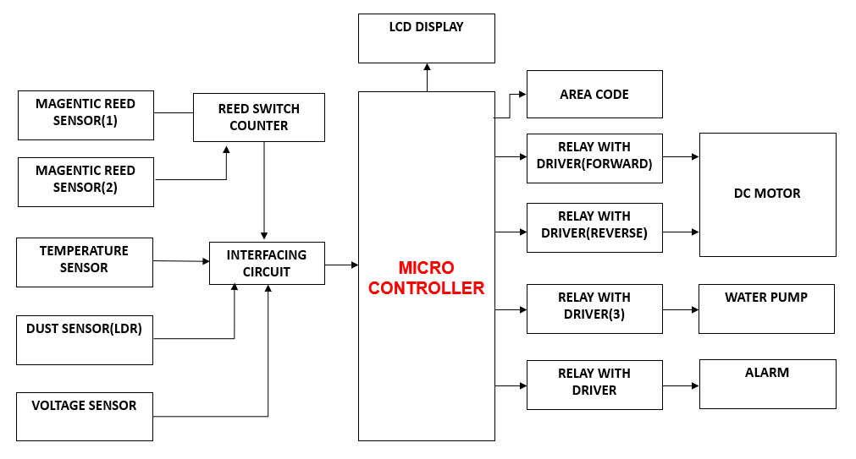
Fig.1 Block Diagram of Self Monitoring and Cleaning System of Solar Panel
3.3 RELAY DRIVER
Relays are switches that operate electrically. A relay driver circuit is a sort of circuit that drives a relay, helping the circuit perform as it should. The relay switch then operates according to the needs of the circuit and opens or closes as necessary. The Relay Driver is shown in fig.2
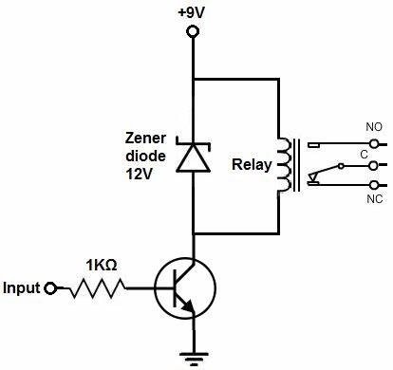
Fig.2: Relay Driver Circuit

3.4 INTERFACING UNIT
When we execute an instruction, the microprocessor must access the memory in order to read the data and instruction codes that are stored there. To read from and write to registers, the memory and the CPU both need certain signals. A few crucial components that must match the signals from the CPU and memory needs are part of the interface procedure. Therefore, the interfacing circuit should be created in a way that it fits the microprocessor signal needs with the memory signal requirements.

3.5 DUST SENSOR
To assess the amount of dust surrounding a panel, a dust sensor is employed. The sensor is built utilising a voltage divider circuit with an analogue output that allows for accurate reading of the value. The voltage level will be converted into digital via the controller's internal analogue to digital conversion circuit.

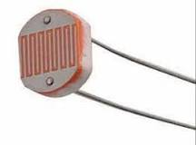
Fig.3:Light dependent resistor

3.6 TEMPERATURE SENSOR
Precision integrated-circuit temperature sensors, the LM35 sensor's output voltage is directly proportional to temperature in Celsius (Centigrade). Because of the LM35's low output impedance, linear output, and exact intrinsic calibration, it is particularly simple to interface with readout or control circuitry. It may be used with plus and negative power supplies as well as single power supply. The operating temperature range for the LM35 is between -55° and +150°C. The arrangement is shown in Fig . 4
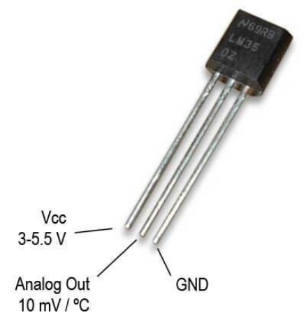
Fig. 4 : Temperature Sensor

3.7 LCD DISPLAY
LCD Display is display ongoing condition of the controller and buzzer circuit will be intimate to the user about the cleaning process is activated or not. The LCD display is shown in fig. 5
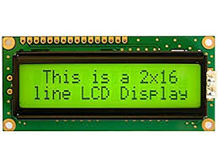
Fig.5: LCD display

3.8 VOLTAGE SENSOR
A voltage sensor is a sensor that determines and keeps track of an object's voltage level. Voltage sensors can identify the level of either AC or DC voltage. Voltage serves as the sensor's input, and its outputs can be switches, analogue voltage signals, current signals, or aural signals. Sensors are tools that can detect and respond to specific electrical or optical impulses. The use of current sensor and voltage sensor techniques has emerged as a fantastic replacement for traditional current and voltage measuring techniques. The voltage sensor circuit diagram & hardware structure is shown in fig.6

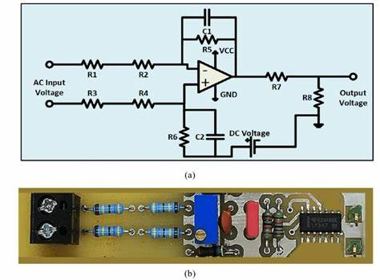
Fig.6:(a) Voltage sensor circuit diagram
(b) Hardware Structure

3.9 LIMITATION

- It would be necessary to alter the rolling brush, which is made of electrostatic cloth.
- It would also be necessary to scale it up for a bigger project (for example, by increasing the motor's torque).
- It would also be ineffective for sticky dust and unable to remove dust from corners.
- The sticky dust has to be scrubbed away with a strong brush or by mopping.

3.10 PROTOTYPE OF SOLAR PANEL CLEANING SYSTEM
Self Monitoring and Cleaning System of Solar Panel is shown in fig.7

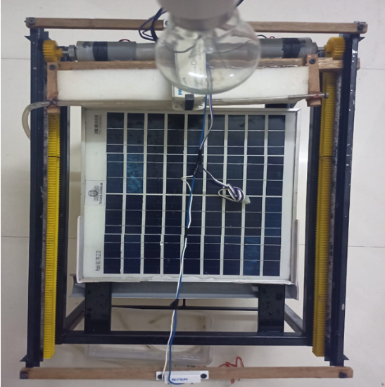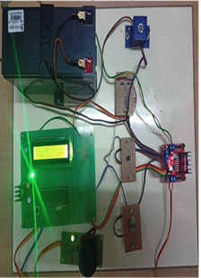

Fig.7: Model of Self Monitoring and Cleaning System of Solar Panel

4. WORKING PRINCIPLE
Microcontroller is the main unit of this process. The only device can monitor and control the sensor parameters and actuators. Here, we are selecting a PIC type microcontroller unit. The controller has some quite features when comparing with the basic type of controller. The controller has internal erasable program memory, analog to digital conversion and pulse width generation.
Magnetic reed sensor is nothing but a magnetic activated switch which is used to control the motor distance. The reed sensor is placed at both end of frame when motor reaches the particular end the sensor will notify controller
and stop the motor. The switch needs a magnetic field to activate itself. Pair of magnets will be placed at the both end of sliding frame.
DHT11 sensor is used to calculate temperature and relative humidity. The one wire communication based sensor has low cost and higher efficiency. Update rate of the sensor is only limitation and it’ll take more than 1000 millisecond to update their internal characteristics. Controller activates the timer module and updates the sensor parameter within a second of interval.
Dust sensor is used to determine the level of dust which is surrounded a panel. The sensor is constructed by using light depend resistor and voltage divider circuit will given an analog output to read value accurately. Controller internal analog to digital conversion circuit will convert the voltage level into digital.
Solar panel output voltage is feed backed to the controller to identify the generation voltage. The voltage divider circuit will protect the controller from higher voltage reading. Controller collects all sensor parameters and activates the motor when the values are abnormal. Water pump will sprinkle the water to the panel and the brush will clean a water as well as dust which are located in panel.
LCD Display is display ongoing condition of the controller and buzzer circuit will be intimate to the user about the cleaning process is activated or not.
In addition, the count of the cleaning process is also displayed in the LCD display after the completion of cleaning as well as the area code of the system is also shown in the control room /LCD display.

- METHODOLOGY
5.1 DURING NORMAL CONDITION
Under normal weather, voltage and temperature from the PV panel is monitored using voltage sensor and temperature sensor. Voltage, temperature, Area code and count are displayed in the LCD Display.
5.2 DURING LOW EFFICIENCY
Under the presence of dust on the PV panel, LDR detects whether it is day or night. during day time, if the output voltage is low, signal from the LDR and Voltage sensor is given to the controller through the interfacing circuit and the system starts cleaning the panel and the count is incremented.
During night time, output from the LDR is not given to the controller so that system doesn’t have to clean the panel.
5.3 DURING TEMPERATURE EXCEEDING
Whenever the temperature exceeds the particular limit, Signal from the temperature sensor is given to the controller. Based on that signal, The System starts cleaning the panel to decrease the temperature by pumping water via the water pump. Alarm runs to indicate the entire cleaning process and the count is incremented.

5.4 DURING FAULT CONDITIONS
Whenever fault occurs or Input power supply is low during the cleaning process, The Cleaning System goes to the initial position with the help of motor drive after the problem is rectified.

- OUTPUT AND RESULT

Solar Panel Cleaning System is tested under different conditions of shading, dust environment and high temperature. The output voltage and temperature of the solar panel were observed and provided in Table 1. It is observed that with the developed Self Monitored Cleaning System. The efficiency (η) of the solar panel was increased.

S.  No | Shading or Dust  (Yes/No) | Cleaning Time  (sec) | Water Sprinkling  (Yes/No) | No. of Count | Voltage(V) |  | η | Temperature
 |  |  |  |  | Before  Cleaning | After Cleaning | (%) | Before  Cleaning | After  Cleaning
1 | No | 8 | No | 1 | 7 | 10.6 | 88.3 | 25°C | 25°C
1 | Yes | 10 | No | 1 | 5.3 | 8.9 | 74.1 | 25°C | 25°C
2 | No | 10 | No | 1 | 7.8 | 10 | 83.3 | 30°C | 30°C
2 | Yes | 13 | No | 2 | 7.4 | 11.3 | 94.16 | 30°C | 30°C
3 | No | 12 | Yes | 1 | 10 | 11.7 | 97.5 | 35°C | 25°C
3 | Yes | 14 | Yes | 2 | 8 | 11 | 91.6 | 35°C | 25°C
4 | No | 13 | Yes | 1 | 9.7 | 11.9 | 99.1 | 40°C | 27°C
4 | Yes | 16 | Yes | 2 | 8.8 | 10.6 | 88.3 | 40°C | 27°C
5 | No | 14 | Yes | 2 | 10 | 11.8 | 98.4 | 43°C | 28°C
5 | Yes | 17 | Yes | 3 | 8 | 10.9 | 90.8 | 43°C | 28°C
6 | No | 17 | Yes | 2 | 10.6 | 11.7 | 97.5 | 46°C | 30°C
6 | Yes | 20 | Yes | 3 | 8.4 | 12 | 100 | 46°C | 30°C

Table 1: Observation of Voltage and Operating Conditions of Solar Panel Cleaning System

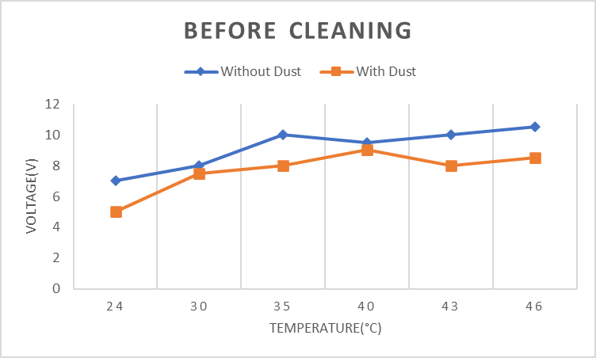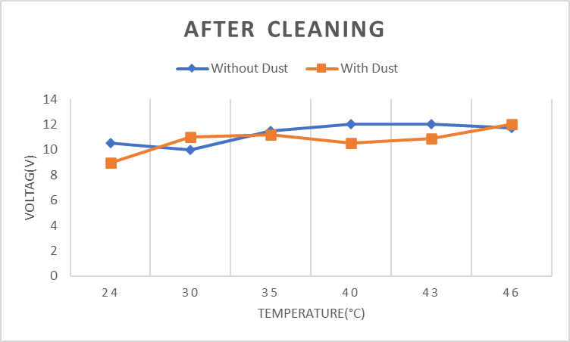
Fig.8:(a) Efficiency of Panel Before and After Cleaning

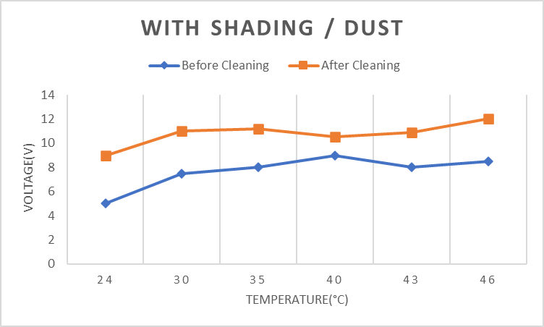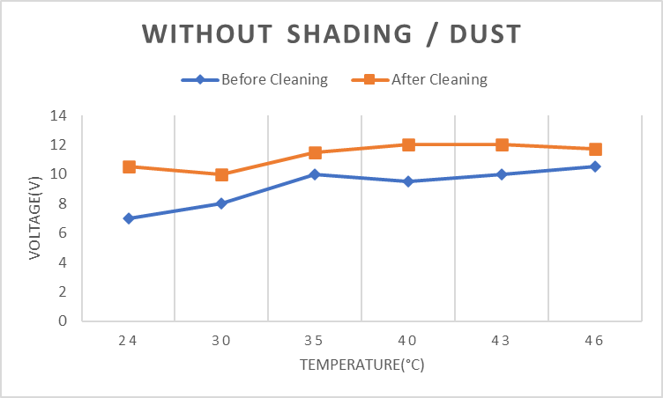
Fig.8:(b) Efficiency of Panel With and Without Shading / Dust

The final output for Self Monitoring and Cleaning System of PV Panel is given in fig.8

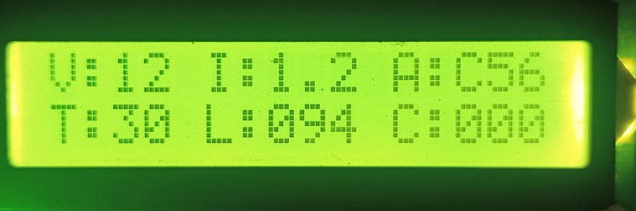

Fig.9(a): Sensor Parameters under normal condition

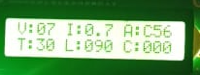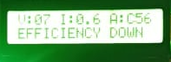
Fig.9(b): Low efficiency Cleaning Process

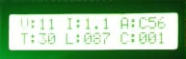
Fig.9(c):Increasing of Count After Cleaning

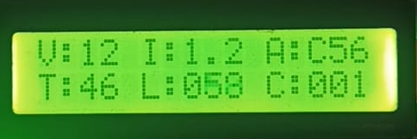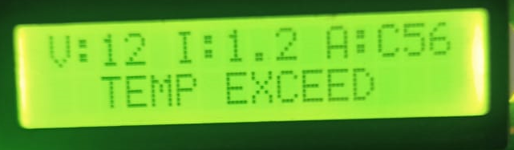
Fig.9(d): Temp Limit Exceed Cleaning Process

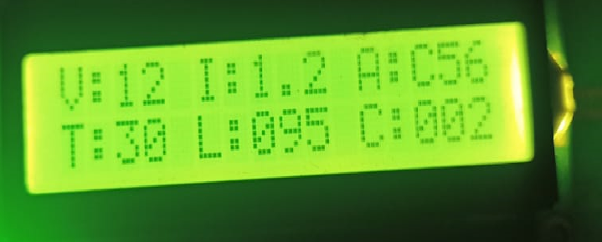
Fig.9(e):Increasing of Count After Cleaning with water
Fig.9: Main Results from the Self Monitoring and Cleaning System of
Solar Panel

6. Conclusion
Presently available automatic cleansers primarily target big arrays and are frequently unhappy for installation on lower arrays, similar as domestic rooftops. This implies that individualities with limited space simply need to make a lower array, making our offer extremely profitable for those lower spots. Our technology may be fitted for solar panels on roofs. The design parameters were originally taken into account when creating the solar panel cleaning system. Following testing of our model, the following findings were drawn the rack and pinion system functions as intended. The direct selector system performed admirably and successfully satisfied the necessary design parameter. Although the encounter did an excellent job of cleaning, the sticky dust was too tenacious for it to remove. It's necessary to clear the sticky dust with a strong encounter or by mopping. As a consequence, the cleaning operation stops the solar panel's face dust from originally erecting before it gets too sticky to remove. As we all know, prevention is better than cure.
7. References

- Gupta, V.; Sharma, M.; Pachauri, R.; Babu, K.N.D. Design and development of self-cleaning PV sliding system. Clean Energy 2022, 6, 392–403.
- Pagani, V.H.; Los, N.A.; Maidana, W.; Leitão, P.; Casaro, M.M.; Nascimento, C.B. Soiling Monitoring Modelling for Photovoltaic System. In CONTROLO 2020; Lecture Notes in Electrical Engineering; Springer: Cham, Switzerland, 2021; Volume 695, pp. 592–601.
- S.Alagoz and Y.Apak,”Removal of spoiling materials from solar panel surfaces by applying surface acoustic waves,”J.Cleaner Production,vol.253,2020,119992.
- Mohamed, M.; Attia, M.A.; Asim, A.M.; Abdelaziz, A.Y.; Kanwar, N. Optimization of cleaning frequency and dust accumulation effect on photovoltaic panels. J. Interdiscip. Math. 2020, 23, 53–68.
- Winston, D.P.; Ganesan, K.; Kumar, B.P.; Samithas, D.; Baladhanautham, C.B. Experimental investigation on output power enhancement of partial shaded solar photovoltaic system. Energy Sources Part A Recovery Util. Environ. Eff. 2020, 1–17.
- Hashim, N.; Mohammed, M.N.; AL Selvarajan, R.; Al-Zubaidi, S.; Mohammed, S. Study on Solar Panel Cleaning Robot. In Proceedings of the 2019 IEEE International Conference on Automatic Control and Intelligent Systems, I2CACIS 2019, Selangor, Malaysia, 29 June 2019; pp. 56–61.
- K.P.Amber et al., “A self-cleaning device for pole mounted solar photovoltaic installations,”Thermal Science, vol.23,no.2A,pp.739-49-2019.
- Attia, O.H.; Adam, N.M.; As’Arry, A.; Rezali, K.A. Removal of Dust from the Solar Panel Surface using Mechanical Vibrator. J. Physics Conf. Ser. 2019, 1262, 012021.
- Aditya Sinha. Automatic Solar Tracker with Pre-Installed Panel Cleaner.ijariit.2017; 3(5): pp. 232-238.
- V. A. Ballal, Prof. R. M. Autee. Dual axis solar panel and panel cleaningsystem.icrisem.2016; pp. 265-271.

