BALANCING SOIL HEALTH: THE ROLE OF CROP RESIDUE MANAGEMENT
Monika S. Bhavsar and Vijay Gabhane
Department of Soil Science and Agricultural chemistry, Dr. Panjabrao Deshmukh
Krishi Vidyapeeth, Akola, Maharashtra, India
Abstract
Crop residues are rich source of plant nutrients, hence have the potential to improve the resource use efficiency along with sustainability of the agro-ecosystem. How we manage and increase the fertility of soil is one of important issue in world It has been reported that soil organic carbon and soil matter is the most important indicator of soil quality and soil health. Crop residue management is important method of sequestering C in soil and increasing the soil OM content and giving protection against erosion. It is also beneficial for agricultural sustainability. This chapter mainly summarized how crop residue management affects soil organic carbon (SOC), soil organic matter (SOM), Proper use of crop residue can increase or maintain the physical and chemical properties, microbial activity and improve the quality of soil Knowledge and assessment of changes (positive or negative) in SOC and SOM with time is still needed to evaluate the impact of different management practices.
Keywords: Crop residue, Crop residue management, Soil health, Benefits of residue management
- Introduction
Crop residues are materials left on cultivated land after the crop has been harvested. Retention of crop residues after harvesting is considered to be an effective soil health management practice. Crop residues (CR) have been historically labelled as "wastes," yet they hold the potential to be a precious resource akin to "black gold" due to their inherent value as natural organic matter. Soil organic matter (SOM) stands as a cornerstone of soil quality and CR serves as the precursors to SOM. Recently, soil degradation and declining quality have become pressing concerns due to the misuse of agricultural practices, monoculture cultivation, excessive application of chemical inputs, and contamination from anthropogenic activities including mining, metal processing, and electronics manufacturing [1,2,3].Many studies have reported that crop residue incorporation benefits the improvement of soil quality [4,5,6].
Crop residue retuning into field after harvesting has been suggested as sound management practice due to the benefits in enhancing soil quality and productivity. Returning crop residues to soil is the most economical and ecological means of conserving soil and water for sustaining crop production [7]. Crop residues serve as a source of nutrients, help in maintaining soil organic carbon (SOC) and subsequently improve overall soil quality [8]. This is because, by retaining leftover crop material like stubble, husks, stems, straws, leaves, etc., a protective cover on soil, a barrier is formed. These materials contain carbon that enhances the organic carbon content of the soil on decomposition. Instead of being treated as a waste material that leaks greenhouse gasses into the atmosphere, it can improve soil fertility with the addition of carbon in the soil through sustainable crop residue management.
Crop residues contribute to the maintenance of soil organic carbon (SOC) stores, a key component of soil fertility and soil-based climate change mitigation strategies. Since last two decades, people are taking interest to improve the quality of soil throughout the world. They recognize the fragility of natural resources, or the need of their protection to sustain development. Now a days, scientists developed many technologies to sustain soil health, soil quality and for increasing food production. Among of them, residue management is the technology which is beneficial for soil and crop yield.
Soil organic matter, a major sink for carbon, is controlled by many factors that have complex interactions. The management of crop residues is of primary importance. Reduced tillage and no-tillage practices result in a significant build-up of soil organic matter because they greatly reduce the rates of decomposition of both the native soil organic matter and of the crop residues. The crop residues decompose slower because most remain on the soil surface where there is less biological activity, and the native soil organic matter decomposes slower because there is less tillage for aerating the soil and for breaking the aggregates that expose organic compounds to the soil microorganisms. Crop residues, however, are highly variable. Although most crop residues contain about 40 percent carbon, the nitrogen contents range from very low to more than 3.5 percent. For carbon to be stabilized in the soil as organic matter, there must be adequate nitrogen available in the system and this factor is frequently overlooked. Climate is often the most critical factor determining the sustainability and enhancement of soil organic matter. As temperatures increase, organic matter decomposition, particularly in frequently tilled soils, is greatly accelerated. As precipitation decreases, there is less biomass produced for replenishing decomposed carbon. Consequently, soil organic matter maintenance becomes increasingly difficult in particularly in hot and arid areas. Semiarid regions comprise almost 40% of the world's land area, so managing crop residues in these fragile areas is important in relation to the global C picture.

- Crop residue potential in India
The Ministry of New and Renewable Energy, Govt. of India (2009) has estimated that about 500 Mt of crop residues are generated every year. The generation of crop residues is highest in UP (60 Mt) followed by Punjab (51 Mt) and Maharashtra (46 Mt). Among different crops, cereals generate maximum residues (352 Mt), followed by fibres (66Mt), oilseeds (29 Mt), pulses (13 Mt) and sugarcane (12 Mt). The cereal crops contribute 70%, while rice crop alone contributes 34% and wheat ranks second with 22% of the crop residues.
Table:1. Crop residue potential in India
Crops | Residues (Mt)
Cereals | 352
Pulses | 13
Oilseeds | 29
Sugarcane | 12
Fibers | 66
(Source:- [9]The MNRE, Govt. of India 2009)
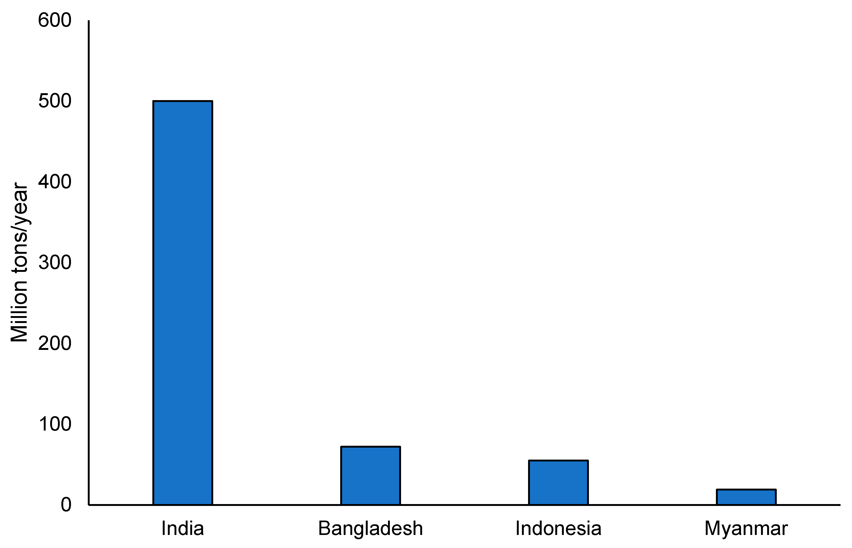

Figure 1. Agricultural waste generation in India compared to other select nations (source: modified from National Policy for Management of Crop Residues (NPMCR) [10]

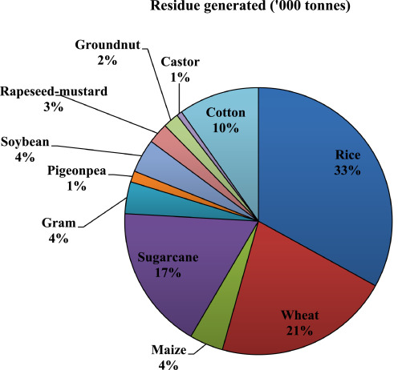
Fig.1.Percentage of dry biomass share from different crop residue in India[11] (Jain et al., 2018).

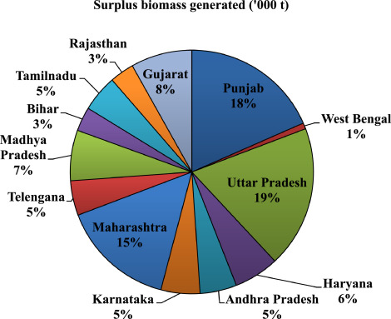
Fig.2.Percentage of dry surplus crop biomass generated in important states of India[11](Jain et al., 2018).

Table:2. State wise (major states) crop residue generated, residue surplus and burned in India
States | Residues generation (Mt) | Residues surplus (Mt) | Residue burned (Mt)
Uttar Pradesh | 59.97 | 13.53 | 21.92
Punjab | 50.75 | 24.83 | 19.65
Maharashtra | 46.45 | 14.67 | 7.42
Andhra Pradesh | 43.89 | 6.96 | 2.73
Karnataka | 33.94 | 8.98 | 5.66
West Bengal | 35.93 | 4.29 | 4.96
(Source:- [9]The MNRE, Govt. of India 2009)
Table:3. Nutrient potential of different crop residues in India
Crop residues | N (%) | P₂O₅ (%) | K₂O (%) | Total | Tonne/Tonne residue
Rice | 0.61 | 0.18 | 1.38 | 2.17 | 0.0217
Wheat | 0.48 | 0.16 | 1.18 | 1.82 | 0.0182
Sorghum | 0.52 | 0.23 | 1.34 | 2.09 | 0.0209
Maize | 0.52 | 0.18 | 1.35 | 2.05 | 0.0205
Pearl millet | 0.45 | 0.16 | 1.14 | 1.75 | 0.0175
Barley | 0.52 | 0.18 | 1.30 | 2.00 | 0.0200
Finger millet | 1.00 | 0.20 | 1.00 | 2.20 | 0.0220
Pulses | 1.29 | 0.36 | 1.64 | 3.29 | 0.0329
Oilseed | 0.80 | 0.21 | 0.93 | 1.94 | 0.0194
Groundnut | 1.60 | 0.23 | 1.37 | 3.20 | 0.0320
Sugarcane | 0.40 | 0.18 | 1.28 | 1.86 | 0.0186
Potato tuber | 0.52 | 0.21 | 1.06 | 1.79 | 0.0179
Total | 8.71 | 2.48 | 14.67 | 26.16 | 0.2616
Source:[12] Tandon (2003)

- Characteristics of crop residues
- Composition
Crop residues are mainly composed of cellulose (40– 50 wt %), hemicellulose (15–25 wt %), lignin (20–30 wt %), protein and soluble sugars (glucose, fructose,)[13].Cellulose is a biopolymer composed of monomeric glucose unit bonded with 1,4-β-glycosidic linkage. It is presented in the form of parallel-aligned microfibril chains in the plant cell wall linked by hydrogen bonding among the chains. Hemicellulose has complicated composition (xylans, xyloglucan, arabinoxylans and glucomannans). Lignin is a phenolic complex polymer formed by cross linking of three major components: p-coumaryl, coniferyl, and sinapyl alcohols. In cell walls, cellulose is surrounded by a monolayer of hemicellulose and embedded in a matrix of hemicellulose and lignin, which form stable complex 3-dimensional structure.
- Nutrient content
Crop residues are a potential source of plant nutrients and their beneficial effects on soil fertility and productivity can be harnessed by recycling them into the soil that on an average 30–35% of applied nitrogen and phosphorus and 70– 80% of potassium accumulates in the crop residues of food crops. About 40% of N, 30–35% of P, 80–85% of K, and 40– 50% of the S uptake by rice remains in the vegetative parts at maturity. Similarly, about 25–30% of N and P, 35–40% of S, and 70–75% of K uptake is retained in wheat residue. Moreover, crop residues are the primary source of organic matter (as C constitutes about 40% of the total dry biomass) which is indispensable for sustaining agricultural ecosystems. However, they depend upon the soil conditions, crop management, variety as well as season that determine the nutrient concentration in crop residues (Table 3).
- Loss of nutrients
It is estimated generally crop residues of different crops contains 80% of Nitrogen (N), 25% of Phosphorus (P), 50% of Sulphur (S) and 20% of Potassium (K). It is also estimated that burning of one tonne of crop residue account for loss of the nutrient 5.5 kg Nitrogen, 2.3 kg phosphorus, 25 kg potassium and 1.2 kg sulphur besides, complete loss of organic carbon and polluting atmosphere and increase greenhouse gas emission that led to climate change. If the crop residues are incorporated or retained in the soil itself, soil gets enriched in above mentioned nutrients, particularly with organic carbon and also meets food for soil microorganism and plant nutrients.

Impact of crop residues burning
- Straw burning provides ash rich in P and K. Decline in microbial population is the reason for poor enzymatic activity.
- Heat generated due to burning influences number, richness and distribution of micro-organism leads to change in enzymatic activity.
- Loss of carbon due to burning is reason for lower N and S content
- Burning of the residue leads to rapid mineralisation of soil organic carbon and release of GHGs and soot particles which are highly disadvantageous.
- One tonne straw on burning releases 3 kg particulate matter, 60 kg CO, 1460 kg CO₂ ,199 kg ash and 2 kg SO₂ . Besides other light hydrocarbons, volatile organic compounds (VOCs) and semi-volatile organic compounds (SVOCs) including polycyclic aromatic hydrocarbons (PAHs) and polychlorinated biphenyls (PCBs).
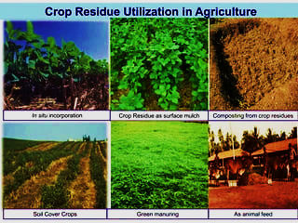

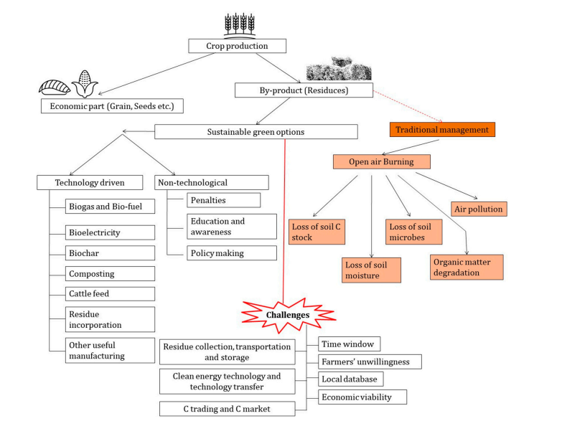
Fig3. Schematic overview and strategies for efficient crop residue management [14](Sarkar et al., 2020)
- Crop residue management

- In-situ Crop residue management
In-situ crop residue management is the practice of leaving crop residue in its natural state on the field. While lowering the danger of pests and diseases, in-situ management techniques can assist in maintaining the health and fertility of the soil.
Several of the techniques used to manage in-situ crop residues are listed below:
- Mulching is the practice of leaving crop residue on the soil surface to protect the soil from erosion and retain moisture. Mulching also helps to suppress weeds and provides nutrients to the soil.
- No-till farming involves planting crops without disturbing the soil. Crop residue is left on the soil surface, and seeds are planted through it. This method helps to conserve soil moisture and reduce soil erosion.
- Strip-till farming is similar to no-till farming but involves tilling only a narrow strip of soil where the seeds will be planted. Crop residue is left on the soil surface in between the tilled strips. This method helps to conserve soil moisture and reduce soil erosion and help in providing a suitable environment for seed germination.
- Cover crops are planted in between cash crops to provide ground cover and add nutrients to the soil. Cover crops can also be left on the soil surface as a form of mulch.
- Crop rotation involves alternating the type of crops grown on a field each season. This method can help to reduce soil erosion and nutrient depletion thereby improving soil health.

- Ex-situ Crop residue management
Ex-situ management of crop residue refers to the removal of agricultural waste from the field for use as compost, firewood, or animal feed. Ex-situ management techniques offer a natural source of nutrients for the soil and can assist lower air pollution brought on by burning agricultural leftovers. These ex-situ crop residue management techniques are frequently employed:
- Biomass power generation: Crop residues can be used as a source of fuel for biomass power generation. This method involves burning crop residues to produce electricity or heat.
- Animal feed: Crop residues can be used as a source of animal feed, particularly for livestock such as cattle, sheep, and goats. Crop residues can be baled and stored for use as animal feed during the dry season when forage is scarce.
- Composting: Crop residues can be composted to produce a nutrient-rich soil amendment. This method involves collecting the crop residues and mixing them with other organic materials such as manure, leaves, and grass clippings. The compost can then be used to improve soil fertility and structure.
- Biochar production: Biochar is a type of charcoal that is produced by heating crop residues in the absence of oxygen. Biochar can be used as a soil amendment to improve soil fertility, water retention, and crop productivity.
- Industrial uses: Crop residues can be used in various industrial processes, such as the production of paper, textiles, and building materials.

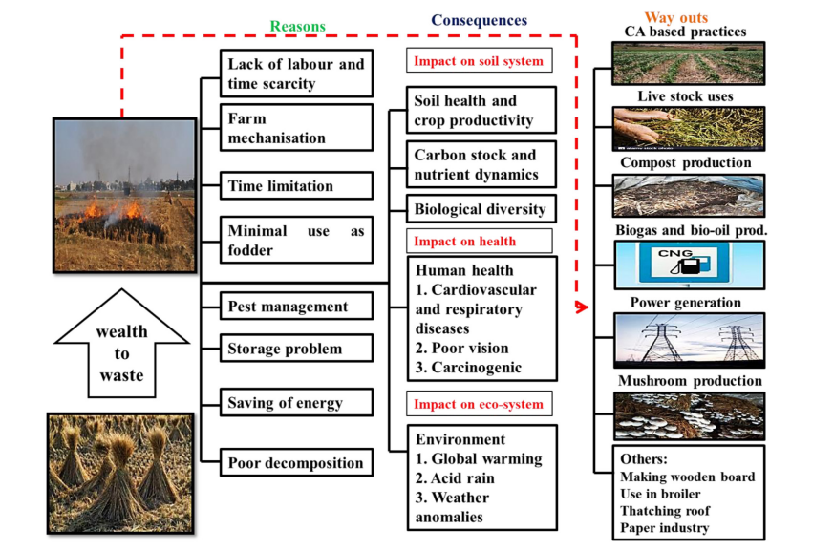
Fig. 4. A comprehensive overview of risk and innovations technologies in crop residue management.[15](Dutta et al.,2022)
- Effect of crop residue management on soil health

- Effect on physical property of soil
Zhao et al. observed that the soil bulk density in the 0–20 cm layer decreased by 5.7% after 7 years of maize and wheat straw input. In addition, straw return treatments decreased the soil bulk density in both the soil layers (0–20 cm, 20– 40 cm) [13]. Returning crop residues to soil can improve soil physical properties by increasing soil moisture content, decreasing bulk density, and increasing total porosity and aggregate stability [16,17,18]. Crop residue returning can increase soil moisture content by reducing surface runoff and direct evaporation, improving soil saturated water conductivity and water infiltration [19]. Soil total porosity is one of the basic physical properties of the soil and an index for evaluating soil fertility and productivity. The soil porosity increases when mixing crushed crop residues with the soil through deep ploughing. When compared to no wheat straw treatment, wheat straw returning significantly (P < 0.05) increased the soil porosity in the 0–10 cm, 10–20 cm, and 20–30 cm soil layers by 5.06%, 5.21%, and 2.75% in 2019, respectively [20]. Residue returning can improve soil structure [21]. [22] has shown that mulching of crop residue or partial incorporation of residue in soil by conservation tillage increases the infiltration by reducing surface sealing and decreasing runoff velocity. The mulch retention could be more beneficial to increase soybean yield and water storage [23] compared with another returning mode (RR without cover crops) showed the impact of cover crop and crop residue removal on bulk density, SOC infiltration, retention rate of water and productivity. They showed that returning the cop residue increased SOC and decreased bulk density of soil. They concluded that when crop residues applied in the field, it add soil carbon, soil nutrient by which fertility and crop productivity would be increased [24] reported that retention and incorporation of residue caused a significant increment in total water stable aggregates (15.65%) in 0-15cm in surface soil and 7.53% in sub-surface soil (15–30 cm), which depicted that the use of crop residue, can increase 2.1-fold higher water stable aggregates as compared to the other treatments without residue incorporation/retention. Under zero tillage crop residues reduced evaporation and maintained moisture fluctuations. However, at the time of harvest different types of tillage system did not show any major influence on the content of moisture while it was higher and reduced at the time of initial tillage and subsequent tillage operations [25]. Conservation management practice produced more benefit under those areas where concentration of SOC was found lower such as in Mediterranean soils as reported by [26] and those areas where stockless croplands predominated [27];[28] . The incorporation of rice residue along with different organic manures and fertilizer like, Rice residue, Vermicomposting, green manure, BGA, Azospirillum, and urea, DAP, MOP had improved the physico-chemical properties of soil i.e. there is the reduction in bulk density and increased the soil porosity and organic carbon status of the soil [29].
- Effect on soil available nutrients and crop yield
Many scientists reported that straw of crop is full of organic carbon and nutrient, so it is important organic fertilizer which can replace the chemical fertilizers [30,31,32,33]. .In some studies, it is also reported that the yield of rice was reduced in first 3 years of straw incorporation 30 days prior to rice planting due to crop residue applied in field caused immobilization of soil nitrogen. But in later years, it did not affect the yield. Recycling of CRs can influence the availability of nitrogen to the crop. Nutrient availability and carbon storage depend on soil organic matter (SOM) content. C/N ratio of CRs dictates the N mineralization-immobilization dynamics. Application of legume residues with a low C/N ratio can result in N mineralization, whereas cereal residues with a high C/N composition can temporarily immobilize N during the decomposition process [34,35] in soil. Crop straw incorporation improves soil organic carbon and soil nutrients contents. It is beneficial for recycling nutrients residue, ploughing is important in immobilization of nutrients (especially nitrogen), and the better ratio of C:N needs to be corrected by applying extra nitrogen fertilizer at the time of residue incorporation [36]. Denitrification losses of mineral nitrogen fertilizer can also be greater when residues are left on the surface due to higher soil moisture content and if fertilizers are not properly incorporated [37] .Application of 75% N +100% P+15 kg K (inorganic) +15 kg K through gliricidia resulted in improvement in soil fertility with higher soybean yield and concluded that the integrated application of 75% N +100% P+ 50% K through chemical fertilizer and 50% K through gliricidia green leaf manuring at 30 DAS resulted in improvement in soil fertility and yield of soybean grown in Vertisols [38]. [39] concluded that conjunctive application of 100% NP + 10 kg K (inorganic) + 20 kg K ha⁻¹ through gliricidia green leaf manuring at 30 DAS resulted in improvement in soil fertility and yield of cotton grown in Vertisols under rainfed conditions. The application of 100% NP + 10kg K (inorganic) +20 kg K through gliricidia was found to be beneficial for higher yield and nutrient uptake by cotton in Vertisols[40]. Incorporation of rice residues 5 t∙ha⁻¹ significantly improved the soil available nitrogen, phosphorus and potassium than no rice residue treatment in the 0 – 15 cm soil layer [41]
3)Effect on soil organic carbon content
Crop residues contain about 40% organic carbon, which can regulate soil properties and improve soil stability through the formation of large aggregates. The soil organic carbon content increased by 52% and 50% with a treatment of 5% (w/w) raw garlic stalk in 2016 and 2017, respectively [42]. Increase in biomass both above ground biomass and root biomass induce the C input and considerable progress could be made in this connection, especially by selection of deep-rooting species and varieties. Crop residue management is another important method of sequestering C in soil and increasing the soil OM content [43]. Crop residue returning can also reduce organic carbon loss [44].The residue derived from crops is considered ''the greatest source of soil organic matter'' [45] for agricultural soils. Crop residue release of essential nutrient elements in soil as well as emission of CO₂ into the atmosphere are controlled by the mineralization of organic matter in soil [46,47,48],making it the most important process occurring in soil. Crop residue retention is crucial for increasing and/or maintaining soil organic carbon (SOC) levels; however, soil type may control its effect. The results obtained by [49] indicated that straw incorporation significantly increased the organic carbon concentration and storage levels compared to without straw incorporation, where the increase was probably associated with the amount of crop residues incorporated into the soil, as suggested previously [50].Crop residue returns organic matter to the soil where it is retained through a combination of physical, chemical, and biological activities that interact and affect soil quality, including nutrient cycling . Incorporation of crop residues may be a sustainable and cost effective management practice to maintain the soil ecosystem, the organic carbon of soil levels and to increase soil fertility in European agricultural soils [51]. Mulch farming and plant cover are specific land management practices allowing both coverage of the soil by specific plants, giving protection against erosion, and providing biomass residues to increase soil OM [52] (FAO, 2001). The study revealed that surface application as well as incorporation of rice residues improved the organic carbon than no rice residues[41] .
4)Effects on enzyme activities and carbon pools:-
Residue addition improves soil microbial activity by providing better physio-chemical conditions for microbial growth. Moderate soil temperature with sufficient moisture proves highly beneficial for the microbes to grow. The residues added are basically food source for the microbes but, one important point is as rice or wheat straw have very high C: N ratio (70–100:1) so, along with residue inorganic N fertiliser should be added to avoid N-immobilisation [53]. Residue addition showed significantly higher microbial biomass carbon (MBC), enzymatic activity like dehydrogenase and phosphatase over the burned plots [54,55]. [56] observed that crop residues protect the soil from wind and water erosion and high sun’s radiation under zero tillage, propitiating soil bio-diversity and enzymatic activity, while improving nutrient efficiency, water economy and soil structure.
Incorporation of crop residues into soil significantly changes the labile pool of soil organic matter [57]. Soil labile carbon pools are considered the soil quality indicators and are influenced by CR management practices [58,59]. It is reported that continuous residue incorporation for three years significantly increases the light carbon fraction in the soil, which has a great contribution to total soil organic carbon [60]. The proportions of the different labile fractions of the SOC might be altered by the type, quantity, and quality of residue or straw of residues and/or green manure straw that are incorporated into the soil in cropping systems [61] .[62] evaluate the effect of the retention of different types of crop residues on SOC and labile fractions, a long-term rice-based crop rotation experiment was established with five different winter cropping practices: (1) rice-fallow (RF), (2) rice–wheat (RW), (3) rice–potato with rice straw mulch (RP), (4) rice–green manure (Chinese milk vetch; RG), and (5) rice–oilseed rape (RO). The RP treatment had comparatively higher content of DOC, HWC, MBC, and KMnO₄-C than the other treatments in both 0–10 cm and 10–20 cm depths. The RW treatment had higher KMnO₄-C content but lower MBC and POC content than the other treatments. The RO treatment had lower MBC content compared to the other treatments, while the opposite results were found in the RG treatment. Furthermore, the DOC content was improved by the winter crop growth. The changes in labile SOC might be attributable to the types of residues retained.
[63] reported all crop sequences improved microbial biomass C and dehydrogenase activity in the soil following rice straw incorporation as it acts as a source of food and energy for microbes. Different crop sequences, except rice-wheat, also improved the counts of bacteria, fungi and actinomycetes in soil.[64] maximum increase microbial biomass Carbon was quantified in NPK+ Paddy straw treatment as compared to NPK+FYM or NPK+ GM, which might be due to the presence of decomposition resistant fiber fractions in NPK + paddy straw and also reported the highest activity of dehydrogenase (DHA) in rice straw incorporated treatment as compared to rice straw removal.
The ability to capture atmospheric N and subsequently store it in the soil would have resulted in a low C:N ratio in its residue, accelerating the N availability, which is required for rapid residue conversion from a C pool into a particulate C fraction[65]. [66] reported that long term integrated use of 50% N through FYM/gliricidia + 50% N through fertilizers + 100% P₂O₅ ha⁻¹ shows significantly highest Soil microbial biomass carbon, CO2 Evolution, Dehydrogenase Activity, Alkaline Phosphatase of Vertisols under rainfed condition.
Adding farmyard manure/gliricidia in combination with NPK enhanced Very labile C, potassium permanganate oxidizable C and microbial biomass C were the most sensitive and responsive C fractions to INM practices under cotton– greengram intercropping in Vertisols of semi-arid climates[67] . The INM treatments, where 50 % N was substituted by Gliricidia [(N + NGli)PK] or FYM [(N + NFYM)PK], demonstrated significantly higher dehydrogenase, alkaline phosphatase, and microbial biomass carbon under the cotton-greengram intercropping system in semi-arid Vertisols[68]
Table 4 : Effect of potash management through gliricidia green leaf manuring on biological properties of soil and carbon status of soil of Rainfed Cotton under Semi-arid Agroecosystem
Treatment | SMBC (mg kg⁻¹ soil) | CO₂ evolution (mg 100 g⁻¹ soil) | Alkaline phosphatase (µg p-nitrophenol g-¹ 24 hr⁻¹) | DHA (µg TPF g⁻¹ 24 hr⁻¹) | OC (g kg⁻¹ | SOC stock Mg ha⁻¹
T₁ - Control | 110.28 | 24.57 | 128.62 | 16.78 | 4.59 | 13.52
T₂ - 100% RDF (60:30:30 NPK kg ha⁻¹) | 126.12 | 30.80 | 138.13 | 20.88 | 5.63 | 16.35
T₃ - 100% NP + 15kg K(inorganic) + 15 kg K through gliricidia | 174.76 | 48.40 | 191.50 | 29.13 | 6.01 | 17.16
T₄ - 100% NP + 10 kg K (inorganic) + 20 kg K through gliricidia | 184.59 | 49.50 | 196.77 | 30.55 | 6.27 | 17.77
T₅ - 100% NP + 30 kg K through gliricidia | 170.32 | 46.57 | 183.08 | 28.18 | 6.01 | 16.80
T₆ -75% N + 100% P + 15 kg K (inorganic) + 15 kg K through gliricidia | 162.80 | 40.33 | 175.71 | 25.71 | 5.75 | 16.19
T₇ -75% N + 100% P + 30 kg K through gliricidia | 152.57 | 35.20 | 167.20 | 24.84 | 5.39 | 15.34
T₈ - 50% N +100% P + 30 kg K through gliricidia | 146.36 | 34.83 | 165.70 | 23.45 | 5.52 | 15.84
T₉ - 100% K through gliricidia | 131.02 | 32.63 | 153.32 | 21.66 | 5.08 | 14.69
SE (m) ± | 5.53 | 2.15 | 6.64 | 1.02 | 0.02 | -
CD at 5% | 16.59 | 6.46 | 19.90 | 3.07 | 0.05 | -
[69]Gabhane et al.,2020
A field experiment was conducted to study the integrated effect of potash application through gliricidia green leaf manuring on productivity of cotton and soil fertility in Vertisols. The results indicated that ,the application of 100% NP + 10 kg K (inorganic) + 20 kg K through gliricidia recorded significantly higher soil microbial biomass carbon (184.59 mg kg⁻¹ soil) over all other treatments. It might be due to the supply of additional mineralizable and readily hydrolyzable carbon due to organic manure application which resulted in higher microbial activity vis-a-vis microbial biomass carbon. The significantly higher CO₂ evolution in soil was observed under the treatment T_{4..}The increased metabolically active microbial biomass could have resulted in increased soil respiration rate by the application of gliricidia green leaf manuring. It is indicative of the nutrient turn over at higher carbon expenses met through added organic carbon. the alkaline phosphatase activity showed statistically significant improvement under T₄ treatment. The significantly higher activities of alkaline phosphatase in the T₄ treatment soils may be due to the enhanced microbial activity and diversity of phosphate solubilizing bacteria due to green manure input over the years. The significantly higher dehydrogenase activity was observed in same treatment. The stronger effects of gliricidia on dehydrogenase activity might be due to the more easily decomposable components of crop residues on the metabolism of soil microorganisms and due to the increase in microbial growth with addition of carbon substrate. It was observed that, the organic carbon increased with potash application through gliricidia. The higher values of organic carbon content in treatments T₄ and T₃ may be due to higher addition of biomass into the soil . Direct incorporation of organic matter, better root growth and more plant residues addition might be the possible reasons for increase in organic carbon content. Carbon storage in soils is the balance between the input of dead plant material (leaf and root litter) and losses from decomposition and mineralization processes. SOC is thus an extremely valuable natural resource. The highest increase in SOC stock was observed in treatments T_{4.}

Benefits of sustainably managing crop residue
Considered waste to some, recycling residue from crops can become a valuable resource that enriches the farm in 3 main areas:
Soil benefits:
- Improves physical properties of soil that help with water-holding capacity and drainage.
- Lessens incidences of erosion
- Helps retain ideal soil temperature
- Improves the soil acidity and availability of micronutrients
- Beneficial for soil microbial life
- High-quality organic matter content
- Soil carbon enhancement
Agronomic benefits:
- Retains soil productivity
- Recycles nutrients from the soil
- Better root proliferation
Economic benefits:
- Can improve crop yields
- Generates new income sources with carbon farming
- Carbon farming gives new profit sources to farmers by getting as much carbon back into the soil instead of letting it emit into the air where it causes extreme weather events and rapid climate change. In fact, carbon farming benefits the farm beyond carbon sequestration.
Crop residue management is but one of the several farm practices farmers can incorporate to increase soil carbon storage.
Other ways are:
- Reduced fertilizer application
- Reduced tillage
- Improved residue management
- Eliminating bare fallows
- Increased production of cover crops
- Sowing companion crops
- Agroforestry
- Improved task efficiency
- Improved water management
- Fuel-use efficiency
Conclusion
Crop residues are carbon-rich materials that contain much nitrogen, phosphorus, potassium and microelements. Crop residue input is a sustainable way of improving soil quality without disturbing its biological balance. The crop residue offers ecologically sound alternatives for meeting soil nutrient requirements, crop productivity and environmental quality. These crop residues increase the SOC and nitrogen mineralization and their decomposition can increase the contents of organic carbon and available phosphorus, potassium in soils, which can provide nutrients for microorganisms and crops. In addition, soil moisture, aggregate stability, and porosity can also be improved. Crop residues improves soil structure, increases biodiversity, enhance SOC sequestration capacity and partially replace fertilizer input. Addition of nutrients from organic crop residues should be synchronized with crops demand and crop residue management for soil organic carbon, and crop yield. The residue has complex effects on physical, chemical and biological properties of soil. Crop residues addition in soil enhancing soil organic matter, quantity, and availability of essential nutrients and soil moisture, promoting biotic activity and, thus, overall soil health. Thus, the crop residue management practices should be selected to enhance crop yields with sustainable soil environment.
References
- Simansky V, Kovacik P.(2015) Long-term effects of tillage and fertilization on pH and sorption parameters of haplic luvisol. J Elementology.20(4):1033–1040.
- Struijk M, Whitmore AP, Mortimer SR.(2020) Obtaining more benefits from crop residues as soil amendments by application as chemically heterogeneous mixtures. Soil. 6(2):467–481.
- Cheng S, Chen T, Xu WB.(2020) Application research of biochar for the remediation of soil heavy metals contamination: a review. Molecules. 25(14):21.
- Lal R.(2005)World crop residues production and implications of its use as a biofuel. Environ Int.31(4):575–584.
- Zhao XL, Yuan GY, Wang HY. (2019) Effects of full straw incorporation on soil fertility and crop yield in rice-wheat rotation for silty clay loamy cropland. Agronomy. 9(3):12.
- Li JQ, Ye XH, Zhang YL. (2021).Maize straw deep-burying promotes soil bacteria community abundance and improves soil fertility. J Soil Sci Plant Nutr.11. DOI:https://doi.org/10.1007/s42729-021-00451-x.
- Wilhelm WW, Johnson JMF, Douglas KL, Lightle DT.(2007) Corn stover to sustain soil organic carbon further constrains biomass supply. Agron J. 99, 1665–1667 .
- Choudhary M, Datta A, Jat HS, Yadav AK, Gathala MK, Sapkota TB, Das AK, Sharma PC, Jat ML, Singh R, Ladha JK.(2018) .Changes in soil biology under conservation agriculture based sustainable intensification of cereal systems in Indo Gangetic Plains. Geoderma 313, 193–204 .
- MNRE (2009) Ministry of new and Renewable energy. (https://mnre.gov.in/filemanager/annual-report/2009-2010/EN/index.htm
- Jain, N., Sehgal., V.K. ,Singh, S., Kaushik, N. (2018) Estimation of Surplus Crop Residue in India for Biofuel Production. Technology Information, Forecasting and Assessment Council(TIFAC).New Delhi.
- NPMCR (National Policy for Management of Crop Residues). Incorporation in Soil and Mulching Baling/Binder for Domestic/Industrial as Fuel. Government of India Ministry of Agriculture Department of Agriculture & Cooperation. Available online: http://agricoop.nic.in/sites/default/files/NPMCR_1.pdf (accessed on 10 February 2020)
- Tandon HLS. (2003) Organic Fertilizers and Biofertilizers- A techno-commercial source book. Fertilizer Development and Consultation Organization, New Delhi 191.
- Zhao HL, Shar AG, Li S,(2018) Effect of straw return mode on soil aggregation and aggregate carbon con tent in an annual maize-wheat double cropping system. Soil Tillage Res. ;175:178–186.
- Sarkar Sukamal , Milan Skalicky , Akbar Hossain , Marian Brestic, Saikat Saha, Sourav Garai , Krishnendu Ray and Koushik Brahmachari .(2020). Management of Crop Residues for Improving Input Use Efficiency and Agricultural Sustainability. Sustainability,12, 9808
- Duttaa, Asik , Abhik Patra , Kali K. Hazra , Chaitanya P. Nath , Narendra Kumar , Amitava Rakshit . (2022).A state of the art review in crop residue burning in India: Previous knowledge, present circumstances and future strategies. Environmental Challenges 8 ,100581
- Zhao XL, Yuan GY, Wang HY, (2019) Effects of full straw incorporation on soil fertility and crop yield in rice-wheat rotation for silty clay loamy cropland. Agronomy. ;9(3):12.
- Brankatschk G, Finkbeiner M.(2015) Modeling crop rotation in agricultural LCAs — challenges and potential solutions. Agric Syst. ;138:66–76.
- Lou YL, Liang WJ, Xu MG, (2011) Straw coverage alleviates seasonal variability of the topsoil microbial bio mass and activity. Catena. ;86(2):117–120
- Jin ZQ, Shah TR, Zhang L, (2020) Effect of straw returning on soil organic carbon in rice–wheat rotation system: a review. Food and Energy Secur. ;9(2):13.
- Zhao J, Liu Z, Gao F,(2021). A 2-year study on the effects of tillage and straw management on the soil quality and peanut yield in a wheat–peanut rotation system. J Soils Sediments. ;21(4):1698–1712.
- Yao, S.; Teng, X.; Zhang, B.(2015) Effects of rice straw incorporation and tillage depth on soil puddlability and mechanical properties during rice growth period. Soil Tillage Res. , 146, 125–132.
- .Box Jr, J. E., Bruce, R. R. and Agassi, M. (1996).The effect of surface cover on infiltration and soil erosion. Soil erosion, conservation and rehabilitation, 67: 107-123.
- Chalise, K.S., S. Singh, B. Wegner, S. Kumar, J.D. Pérez-Gutiérrez, S. Osborne, T. Nleya, J. Guzman, and J.S. Rohila. (2019) Cover crops and returning residue impact on soil organic carbon, bulk density, penetration resistance, water retention, infiltration, and soybean yield. Agron. J. 111:99–108. doi:10.2134/agronj2018.03.0213.
- Choudhury, S. G., Srivastava, S., Singh, R., Chaudhari, S. K., Sharma, D. K., Singh, S. K. and Sarkar, D. (2014) Tillage and residue management effects on soil aggregation, organic carbon dynamics and yield attribute in rice–wheat cropping system under reclaimed sodic soil. Soil and Tillage Research, 136: 76-83
- Srivastava, A.P., Panwar, J.S. and Garg, R.N. (2000). Influence of tillage on soil properties and wheat productivity in rice (Oryza sativa)-wheat (Triticum aestivum) cropping system. Indian Journal of Agricultural Sciences, 70(4): 207-210
- Aguilera, E., Lassaletta, L., Gattinger, A. and Gimeno, B.S. (2013). Managing soil carbon for climate change mitigation and adaptation in Mediterranean cropping systems: a meta-analysis. Agriculture, Ecosystems and Environment, 168: 25–36
- Kismanyoky, T. and Toth, Z. (2010). Effect of mineral and organic fertilization on soil fertility as well as on the biomass production and N utilization of winter wheat (Triticum aestivum L.) in a long- term cereal crop rotation experiment (IOSDV). Archives of Agronomy and Soil Science, 56 : 473–479
- Spiegel, H., Dersch, G., Baumgarten, A. and Hosch, J. (2010). The International organic nitrogen longterm fertilisation experiment (IOSDV) at Vienna after 21 years. Archives of Agronomy and Soil Science, 56: 405–420.
- Kumar Vomendra ,Anurag, RN Singh, Rahul Kumar and Kulendra Jaiswal.2020.Effect of rice residues and organics source on physico-chemical properties of the soil. International Journal of Chemical Studies . 8(4): 3214-3217
- Duiker, S. W. and Lal, R. (1999). Crop residue and tillage effects on carbon sequestration in a Luvisol in central Ohio. Soil and Tillage Research, 52(1): 73-81.
- Saroa, G. S. and Lal, R. (2003) Soil restorative effects of mulching on aggregation and carbon sequestration in a Miamian soil in central Ohio. Land Degradation and Development, 14(5): 481-490.
- Tan De-shui., Ji-yun, J. I. N., Shao-wen, H.U. A.N.G., Shu-tian, L.I. and Ping, H.E. (2007) Effect of long-term application of K fertilizer and wheat straw to soil on crop yield and soil K under different planting systems. Agricultural Sciences in china, 6(2) 200-207.
- Bakht, J., Shafi, M., Jan, M.T. and Shah, Z. (2009) Influence of crop residue management, cropping system and N fertilizer on soil N and C dynamics and sustainable wheat (Triticum aestivum L.) production. Soil and Tillage Research, 104(2): 233-240.
- Govaerts B, Sayre KD, Ceballos-Ramirez JM, Luna-Guido ML, Limon-Ortega A, Deckers L, Dendooven L (2006) Conventionally tilled and permanent raised beds with different crop residue management: effects on soil C and N dynamics. Pl Soil 280: 143-155.
- Aulakh MA, Doran JW, Walters DT, Mosier AR, Francis DD (1991) Crop residue type and placement effects on denitrification and mineralization. Soil Sci Soc Am J 55: 1020-1025
- Yadvinder-Singh, B.S. and Timsina, J. (2005) Crop residue management for nutrient cycling and improving soil productivity in rice-based cropping systems inthe tropics. Advances in Agronomy, 85: 269-407.
- Aulakh MS, Rennie DA, Paul EA (1984) Gaseous nitrogen losses from soils under zero-till as compared with conventional till management systems. J Environ Qual 113: 130-136
- Yadv Jaipal, VV Gabhane, Ajay Shelke, Arti Rathod, Usha Satpute and Ashwini Chandel.2020. Effect of potash management through gliricidia green leaf manuring on soil fertility and yield of soybean in Vertisols. Journal of Pharmacognosy and Phytochemistry 9(2): 1033-1037
- Fulzele Anant ,V.V Gabhane, Shivani Regulwar, M.M Ganvir, Jaipal Yadav and Ajay Shelke. 2021.Soil fertility and nutrient balance as influenced by potash management through gliricidia green leaf manuring in rainfed cotton on vertisols The Pharma Innovation Journal ; 10(8): 601-604
- Satpute Usha, VV Gabhane, SA Jawale and VH Jadhao.2019.Impact of potash application through glyricidia green leaf manuring on yield and nutrient uptake by cotton in Vertisols. Journal of Pharmacognosy and Phytochemistry 8(3): 4111-4114
- Brar Amandeep Singh,,Parmodh Sharma, Charanjit Singh Kahlon, Ujagar Singh Walia.2019. Influence of Rice Residue Management Techniques and Weed Control Treatments on Soil Available Plant Nutrients in Rice-Wheat Cropping System. American Journal of Plant Sciences, 10, 55-64
- Ali A, Ghani MI, Haiyan D, (2020). Garlic substrate induces cucumber growth development and decreases Fusarium wilt through regulation of soil microbial community structure and diversity in replanted dis turbed soil. Int J Mol Sci. ;21(17):20.
- Lal, R. (1997). Residue management, conservation tillage and soil restoration for mitigating greenhouse effect by CO2- enrichment. Soil & Tillage Research 43: 81-10
- Chen S, Xu CM, Yan JX, (2016) The influence of the type of crop residue on soil organic carbon fractions: an 11-year field study of rice-based cropping systems in southeast China. Agric, Ecosyst & Environ. 223:261–269.
- Tisdale S L, Nelson W L, Beaton J D (1985) Soil Fertility and Fertilizers. Macmillan Publishing Company, New York
- Raiesi F. (2006).Carbon and N mineralization as affected by soil cultivation and crop residue in a calcareous wetland ecosystem in Central Iran. Agr Ecosyst Environ. 112, 13–20 .
- Guntinas ME, Leiros MC, Trasar-Cepeda C, Gil-Sotres F.(2012) Effects of moisture and temperature on net soil nitrogen mineralization: A laboratory study. Euro J Soil Biol. 48, 73–80
- Sarma B, Farooq M, Gogoi N, Borkotoki B, Kataki R, Garg, A.(2018) Soil organic carbon dynamics in wheat - green gram crop rotation amended with Vermicompost and Biochar in combination with inorganic fertilizers: A comparative study. J. Clean. Prod. 201, 471–480.
- Zhang, P., Chen, X., Wei, T., Yang, Z., Jia, Z., Yang, B. and Ren, X. (2016) Effects of straw incorporation on the soil nutrient contents, enzyme activities, and crop yield in a semiarid region of China. Soil and Tillage Research, 160: 65-72.
- Malhi, S. S., Nyborg, M., Goddard, T. and Puurveen, D. (2011). Long-term tillage, straw management and N fertilization effects on quantity and quality of organic C and N in a Black Chernozem soil. Nutrient Cycling in Agroecosystems, 90(2): 227-241.
- Powlson, D.S., Riche, A.B., Coleman, K., Glendining, M.J. and Whitmore, A.P. (2008). Carbon sequestration in European soils through straw incorporation: limitations and alternatives. Waste Management, 28: 741–746
- Food and Agriculture Organization. (2001). Soil carbon sequestration for improved land management. World Soil Resources Reports 96, Rome
- Chauhan, B.S., Mahajan, G., Sardana, V., Timsina, J., Jat, M.L., (2012). Productivity and sustainability of the rice–wheat cropping system in the Indo-Gangetic Plains of the Indian subcontinent: problems, opportunities, and strategies. In: Advances in Agronomy. Academic Press, pp. 315–369. doi:10.1016/B978-0-12-394278-4.00006-4 117
- Kumar, A., Kushwaha, K.K., Singh, S., Shivay, Y.S., Meena, M.C., Nain, L., (2019a). Effect of paddy straw burning on soil microbial dynamics in sandy loam soil of Indo-Gangetic plains. Environ. Tech.Innov. 16, 100469. doi:10.1016/j.eti.2019.100469.
- Kumar, V., Gathala, M.K., Saharawat, Y.S., Parihar, C.M., Kumar, R., Kumar, R., Nayak, H.S., (2019c). Impact of tillage and crop establishment methods on crop yields, profitability and soil physical properties in rice–wheat system of Indo-Gangetic Plains of India. Soil Use Manage 35, 303–313. doi:10.1111/sum.12473.
- Blevins, R.L., and Frye, W.W. (1993). Conservation tillage: an ecological approach to soil management. Advances in agronomy (USA), 56:111-1.
- Wang, W.J.; Dalal, R.C.; Moody, P.W. (2004). Soil Carbon Sequestration and Density Distribution in a Vertosol Under Different Farming Practices. Soil Res. 42, 875–882.
- Blair G J, Lefroy R D B and Lisle L (1995) Soil carbon fractions based on their degree of oxidation, and the development of a carbon management index for agricultural systems. Aust J Agric Res. 46:1459-66.
- Plaza-Bonilla D, Alvaro-Fuentes J and Cantero-Martinez C (2014) Identifying soil organic carbon fractions sensitive to agricultural management practices. Soil Till Res. 139: 19-22.
- Conteh, A.; Blair, G.J.; Rochester, I.J. (1998). Soil Organic Carbon Fractions in a Vertisol Under Irrigated Cotton Production as Affected by Burning and Incorporating Cotton Stubble. Soil Res. , 36, 655–667.
- Poeplau, C., Don, A., (2015). Carbon sequestration in agricultural soils via cultivation of cover crops—a meta-analysis. Agric. Ecosyst. Environ. 200, 33–4
- Chen Song , Chunmei Xu , Jinxiang Yan, Xiaoguo Zhang, Xiufu Zhang, Dangying Wang .(2016).The influence of the type of crop residue on soil organic carbon fractions: An 11-year field study of rice-based cropping systems in southeast China / Agriculture, Ecosystems and Environment 223 :261–269
- Chandra R (2011) Effect of summer crops and their residue managements on yield of succeeding wheat and soil properties J Indian Soc Soil Sci. 59:37-42
- Basak N, Datta A, Mitran T, Mandal P and Mani P K (2016) Impact of organic and mineral inputs onto soil biological and metabolic activities under a long-term rice-wheat cropping system in sub-tropical Indian Inceptisols. J Environ Biol. 37:83-89.
- Singh Yadvinder , B.-S. Timsina. (2005) J. Crop Residue Management for Nutrient Cycling and Improving Soil Productivity in Rice-Based Cropping Systems in the Tropics. Adv. Agron. 2005, 85, 269–407.
- Chandel Ashwini, V.V Gabhane, D.V Mali, R.S Patode and M.B Nagdeve .2018. Long term effect of integrated nutrient management on soil biological properties and productivity of cotton + greengram intercropping system in vertisols. International Journal of Chemical Studies 6(4): 1537-1541
- Ramteke Pratik, Vijay Gabhane , Prakash Kadu , Vilas Kharche, Shyam Jadhao, Anil Turkhede , Ravindra Chary Gajjala.2023. Long-term nutrient management effects on organic carbon fractions and carbon sequestration in Typic Haplusterts soils of Central India. Soil Use Manage. ;00:1–20. DOI: 10.1111/sum.12950
- Gabhane V.V., Pratik Ramteke , G. Ravindra Chary , R.S. Patode , M.M. Ganvir , Anita Chorey , A.R. Tupe .2023.Effects of long-term nutrient management in semi-arid Vertisols on soil quality and crop productivity in a cotton-greengram intercropping system. Field Crops Research 303 (2023) 109115. https://doi.org/10.1016/j.fcr.2023.109115
- Gabhane, V.V., R.S. Patode, A.B. Turkhede, Usha Satpute, M.B. Nagdeve and R.S. Mali .2020. Integrated Effect of Potash Management through Gliricidia Green Leaf Manuring and Mineral Fertilizer on Productivity of Rainfed Cotton and Soil Fertility in Vertisols under Semi-arid Agroecosystem. Indian J. Dryland Agric. Res. & Dev. 35(2): 1-11

