Phase Change Heat Storage Materials in Scheffler Reflector: An Insightful Sustainable Study of Renewable Energy

Virendra Singh Rana ¹  Assitant Professor, ICFAI TECH SCHOOL  The ICFAI University, Dehradun,  INDIA  virendra.rana@iudehradun.edu.in | Mohit Kumar Arya ⁴  Assitant Professor, ICFAI TECH SCHOOL  The ICFAI University, Dehradun,  INDIA  mohit.arya@iudehradun.edu.in | Dr.Nishant Mathut³  Assitant Professor, ICFAI TECH SCHOOL  The ICFAI University, Dehradun,  INDIA  nishant.m@iudehradun.edu.in
Dr.Ram Karan Singh²
Seniort Professor, ICFAI TECH SCHOOL
The ICFAI University, Dehradun,
INDIA
vc@iudehradun.edu.in

ABSTRACT
Energy is the requirement for the people to cater their basic necessities. Biomass, fossil and other carbon based fuels are the primary sources of natural energy. These carbon based fuels are limited and have negative impact on the environment. There is an urgent need of clean and environmental – friendly innovative energy technologies. Solar energy can be a feasible solution for the sustainable development especially when the world is facing environmental, population and economic growth problems. The Scheffler is a special solar concentrator device which can reach high temperature within a short interval of time. The heat retention capability of Scheffler can be increased significantly by assembling a heat storage unit in it. In this study, thermo-physical properties (density, melting point and thermal conductivity) of different thermal storage materials (bricks, concrete, water, Phase Change Material (PCM), Latent Heat Storage Material (LHS), aluminum, iron, molten salts, silicon etc.) are compared which are used to store the heat energy for a longer period. It is observed that the heat capacity of LHS is much higher as compared to other storage materials which makes Scheffler to store heat for extended duration and using it in a sustainable way. Results and reports are highlighted in a comparative format using tables and graphs to analyze the effect of properties like density, melting point, thermal conductivity on the specific heat of a LHS material. High heat retention material’s need is predicted to rise in the future, as it can fill the energy scarcity of the people especially for cooking and can help in achieving the various sustainable development goals.
Keywords—Scheffler, Sustainable Development, Phase Change Materials, Latent Heat Storage, Sustainable Development Goals.

Introduction
The world fossil fuel reserves are limited and will be exhausted up to 2088. A large portion of the population in many countries still depends on the carbon fuels such as biomass, wood and other hydrocarbons [1]. Burning of these carbon based fuels releases a good amount of green house and other harmful gases [2]. Thousands of years are required for the formation of fossil fuels and a rapid rate of their consumption can results in their depletion. Alternates of these energy should be searched in order to meet the essential energy requirement of the people [3]. Renewable sources of energy especially solar energy can be good options, which are clean in nature and do not pollute the environment [4]. There are many ways or devices by which solar energy can be harnessed like solar heaters, panels, concentrators etc. and the combinations of these. These devices can be used for applications like heating or cooling, generation of power, cooking and also in those areas which requires high temperature. A Scheffler reflector is a powerful solar device which is used to concentrate sunrays at a fixed focus (Refer figure 1). In order to maintain a fixed focus it has to track the movement of Sun daily and seasonally [5]. The tracking mechanism of Scheffler to trace the Sun’s path can be manual or automatic. The sequence of operation of a Scheffler can be understood from the figure 1. The Sun rays falling on the reflector is directed towards a fixed focus (receiver), which will absorbs the incoming rays in the form of heat which can be used for various purposes. The receiver can be coated with a material having high heat retention capability. Primarily it is used for cooking but it can be used be used in cremation, power generation, process industries, desalination etc. [6], [7] also which requires high heat input. It is used in community kitchen in order to cook food for a large number of people. Brahma Kumari built the largest solar kitchen in the world which can cook 38,500 meals per day. Solar energy is the input for Scheffler, so there will be difficulty in its running during non-sunny days or during night. This problem can be mitigated by using heat storage materials, which can retain the absorbed heat for a long duration and enable Scheffler’s working for an extended length of time.
This research paper will proceed as: Part II discusses types of heat storage materials and properties which are suited to be used in Scheffler reflector and compares the desired qualities of heat storage materials. Part III discussed challenges occurred during heat generation using Phase Change Materials. This will be followed by a discussion of the results and the potential need for phase change materials for solar thermal energy storage in future.
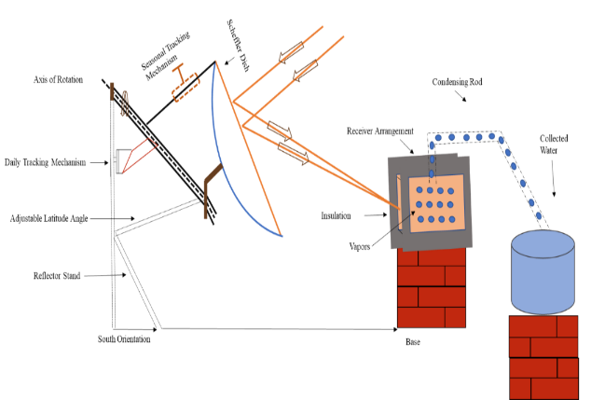
Fig. 1: Scheffler Reflector used for desalination of water

Phase Change Material in Scheffler Reflector

There are primarily two methods for storing heat: without changing the phase and changing the phase [8]. Phase change heat storage seems to be more inviting than sensible heat storage techniques as it can store more heat for a given unit volume and the temperature remains unchanged during the transfer process. By adding heat to a substance its temperature increases and thermal energy is simply stored in that substance [9], [10]. This energy might be extracted from the specified medium as the temperature decreased. Additionally, they can operate in a range of temperatures and support a wide range of applications. The melting point should be high in comparison to the system’s typical temperature. A phase change material should have the following properties:
  - There shouldn't be much volume change as phases change.
  - The material should have a high latent heat capacity [11].
  - It must not react with the container in which it is contained and must not be corrosive.
  - When transitioning between phases, it shouldn't lose its thermos-physical properties too soon [12].
  - The environment shouldn't be harmed.
  - The substance ought to be reasonably priced [13].
  - It need to be simple to get to.
  - It shouldn’t catch fire when operating at higher temperature.

The thermos physical characteristics of non-latent heat storage materials and those of latent heat storage materials (LHS) are shown in Table 1, respectively. These characteristics include density, melting and boiling points, thermal conductivity, and heat capacity.

Table 1: Thermo-Physical Properties of Various Materials [11]
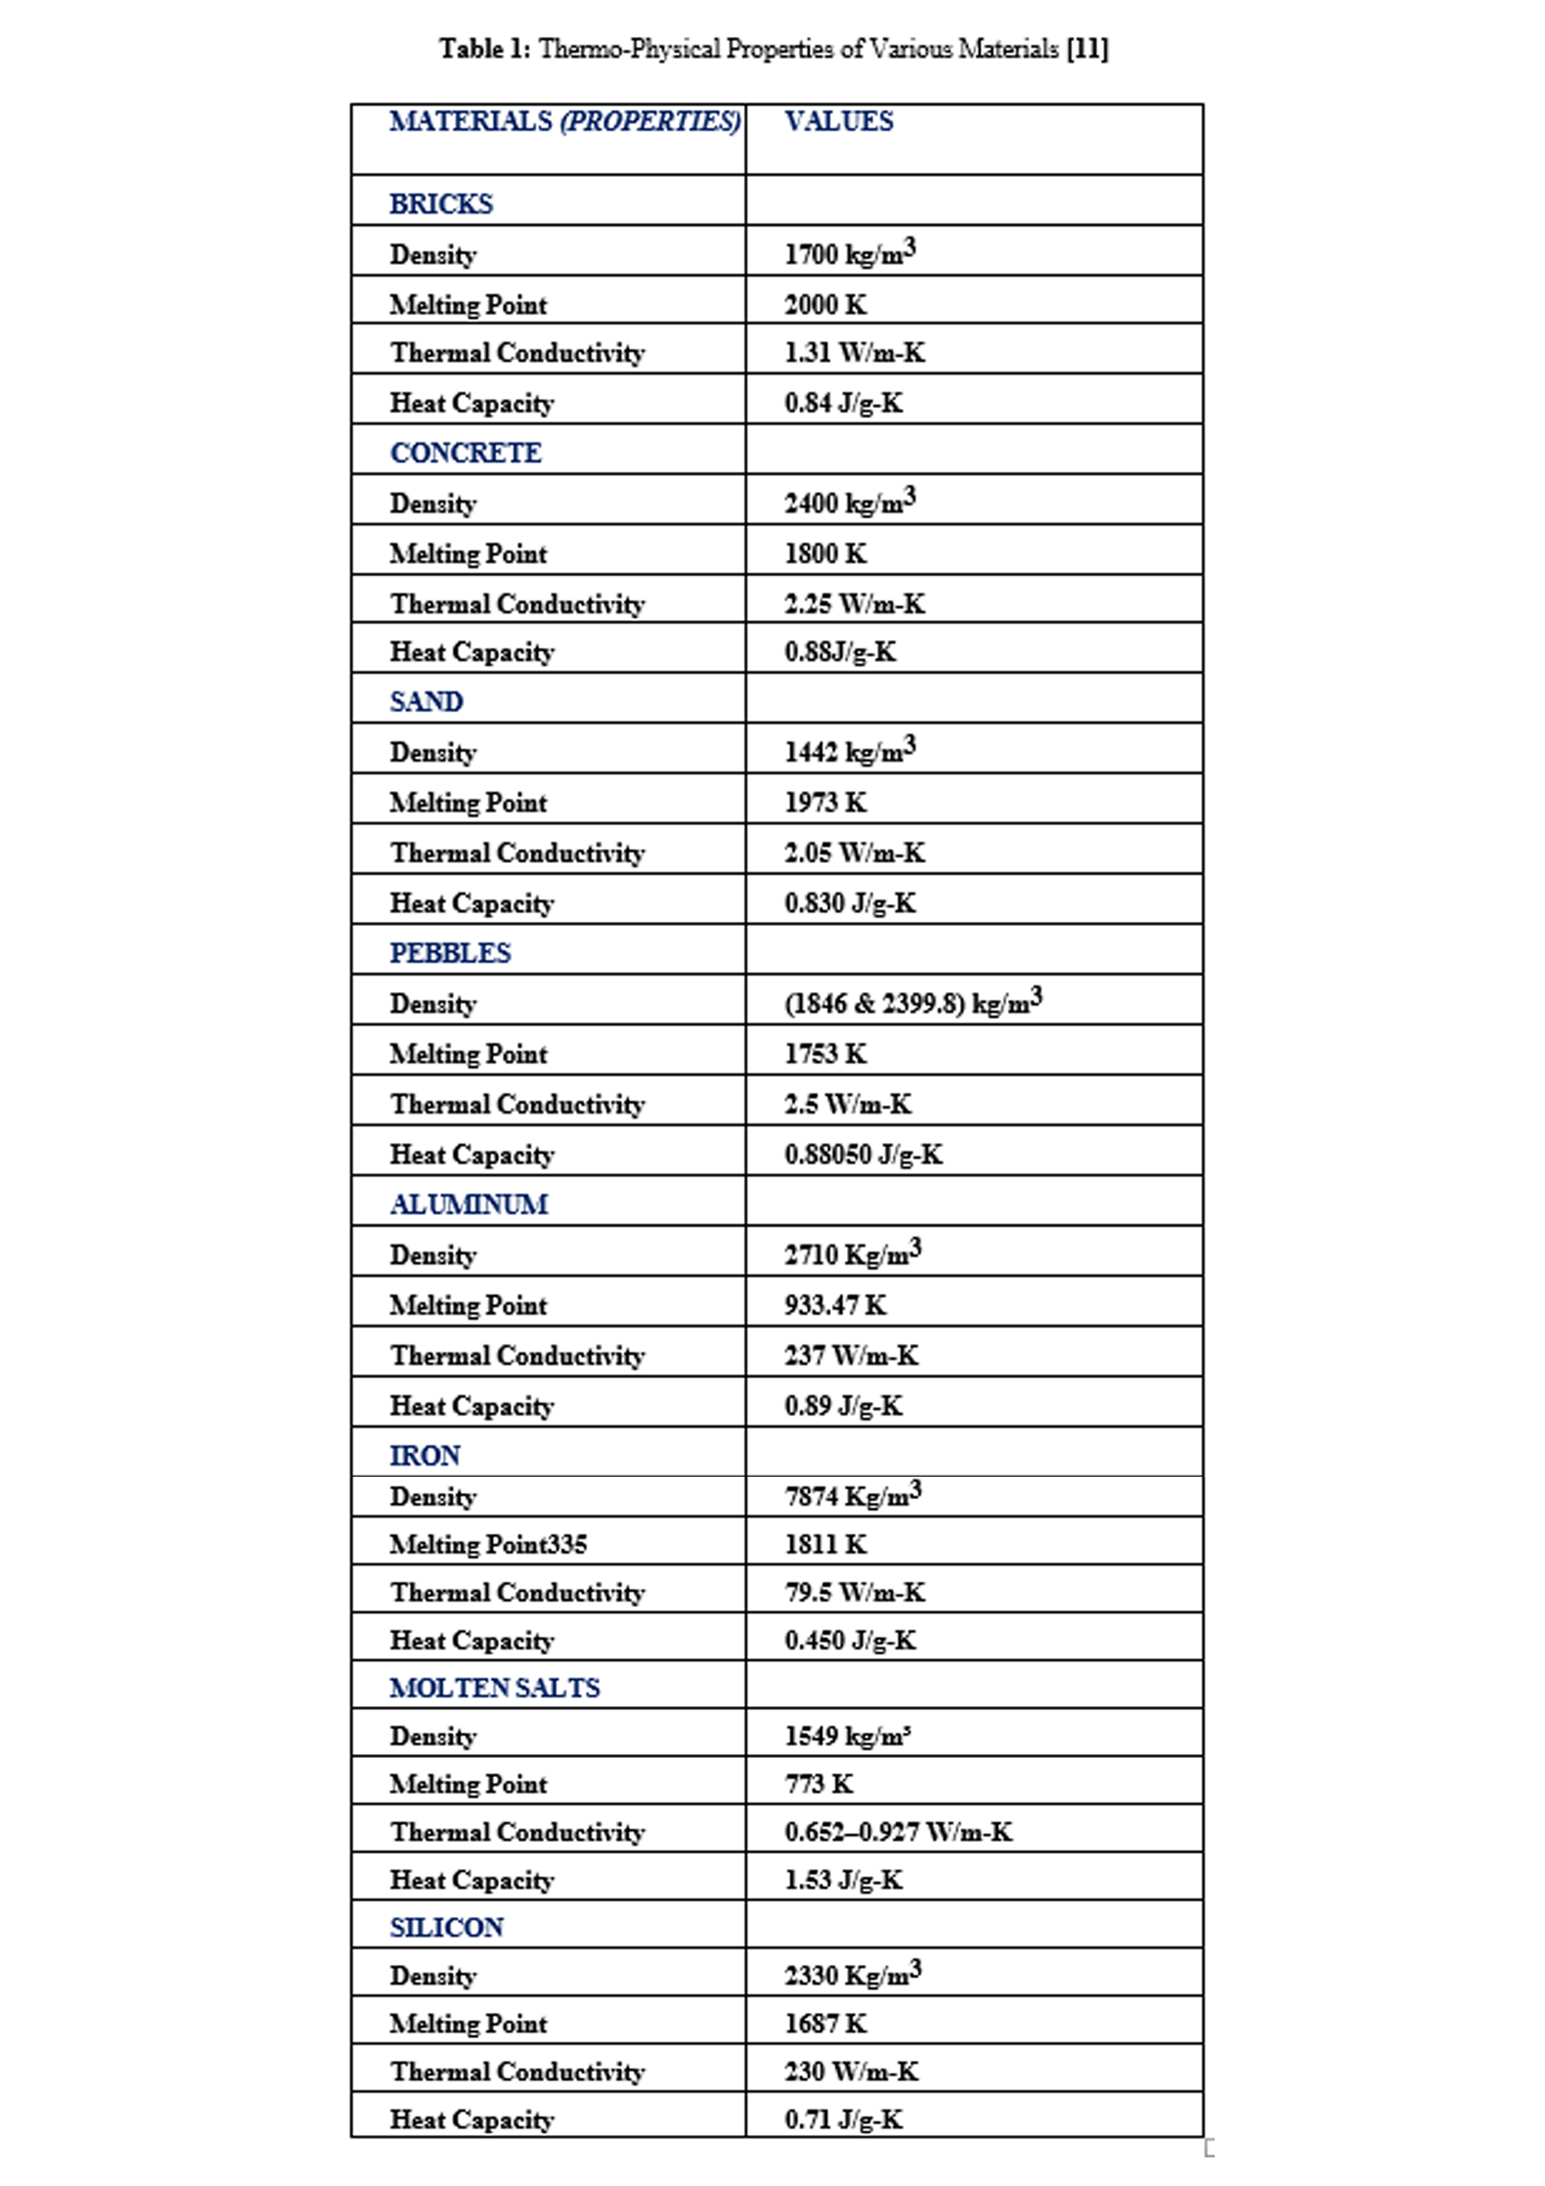

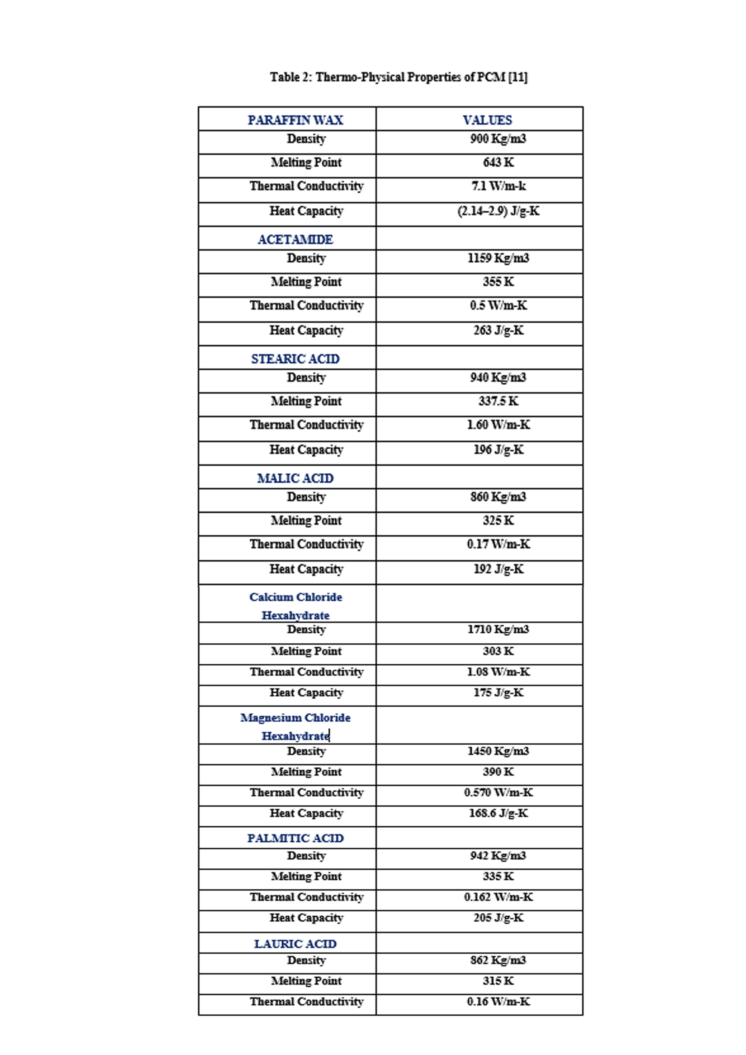

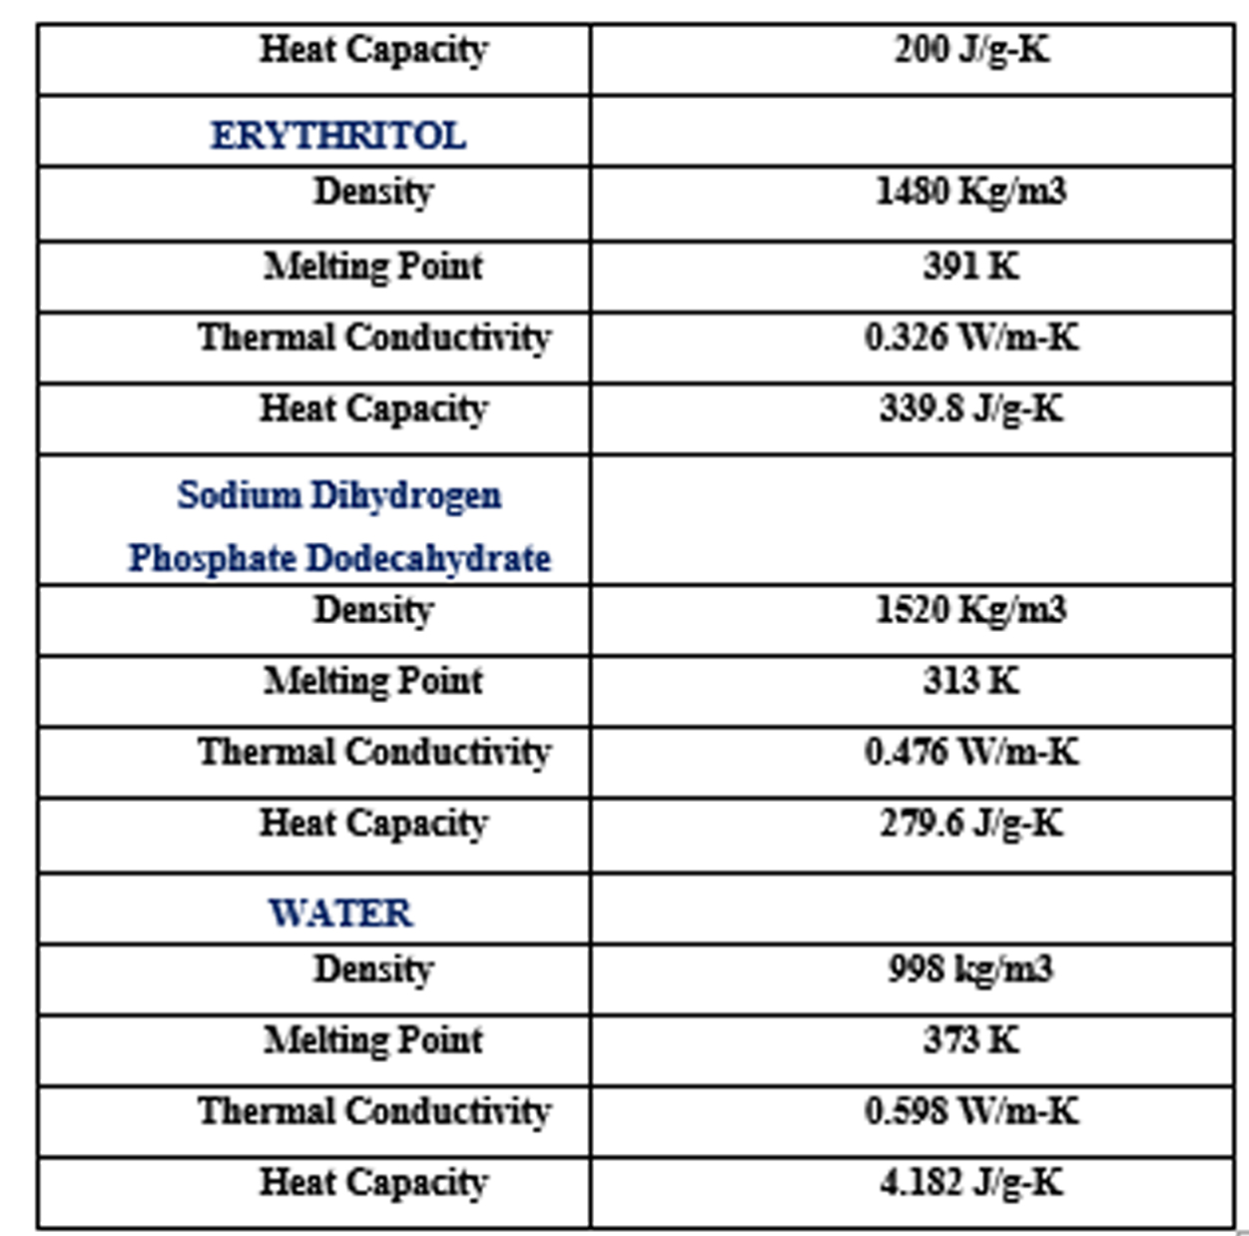
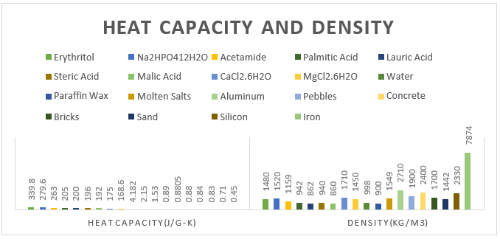
Fig. 3: Graph between heat Capacity and Density
As shown in Fig. 3, the density of non LHS materials for example iron (7874 Kg/m3), aluminium, (2710 Kg/ m3) pebble (1900 Kg/ m3), silicon (Kg/m3) etc. is higher but their heat capacity is much lower (0.45 J/gK, 0.89 J/gK, 0.88 J/gK, 0.71 J/gK respectively) than the LHS materials[7], [14]. So, density is not a function of heat capacity among all the materials but a high dense material will occupy less space as compared to the less dense material as already discussed. A material (LHS) which will have good heat capacity and a compromised density like Acetamide (263 J/g-K and 1159 Kg/m3), Erythritol (339.8 J/g-K and 1480 Kg/m3), Sodium Dihydrogen Phosphate Dodecahydrate (279.6 J/g-K and 1520 Kg/m3) etc. can be a good heat storing option for a Scheffler Reflector as depicted by Table 2.
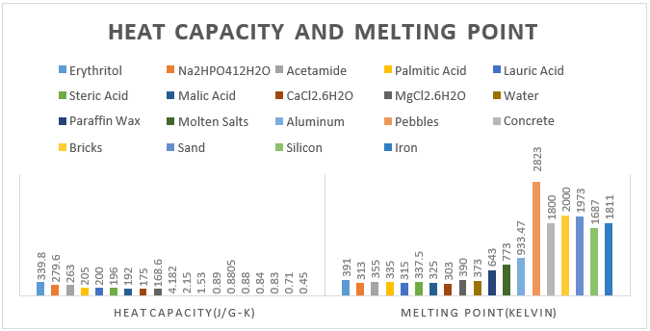
Fig. 4: Graph between Heat Capacity and Melting point

From the Fig. 4 it is depicted that generally the materials having low melting point are having high heat capacity. Iron and brick are having high melting point, 1811 K and 2000 K but have low heat capacity, 0.45 J/g-K and 0.84 J/g-K. PCM materials (except water) like acetamide and lauric acid have low melting point, 355 K and 315 K but have very high heat capacity, 263 J/g-K and 200 J/g-K which makes them a good choice for applying as a heat storage material for Scheffler.

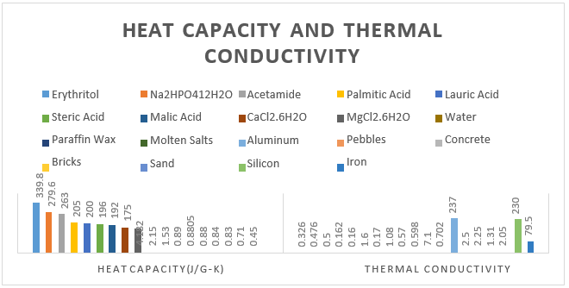
Fig. 5: Graph between Heat Capacity and Thermal Conductivity

As shown in the Fig. 5, the thermal conductivity of PCM material is very low as compared to other general material like aluminium (237 W/m-K), silicon (230 W/m-K), iron (79.5 W/m-K), etc. So, it has been found that the LHS material like acetamide (0.5 W/m-K) and erythritol (0.326 W/m-K) which are having good heat storage properties will have poor thermal conductivity.

Challenges

- Security

Safety is a crucial factor when choosing a material for a heat storage unit, thus it makes sense to use one with superior LHS properties and greater safety [15]. Some organic materials, such as paraffin and non-paraffin, are suitable LHS compounds even though they are combustible by nature [16]. As a result, they are often limited to low-temperature uses, including as building heating and cooling.

- High Cost For Large Energy Density

Due to the great density of energies it can store, thermochemical storage is one of the options, although the unit and the process are rather expensive [17]. Because it is less expensive, particularly in applications requiring solar heat, thermal storage is chosen over it [18].

- PCM Selection Criterion

A PCM with the necessary thermo-physical characteristics cannot be synthesized [19]. While some substances, like paraffin, are more favorable for low-temperature applications, others, including metals and fatty acids, are suitable for high-temperature uses [20].

- Storage Material Reactivity

Although some substances, such as salt compounds[21] and metallic alloys (often used in solar applications)[22], have excellent heat storage capacity and low associated costs, their corrosiveness and rapid temperature decrease render them unsuitable for use as a heat storage substance for Scheffler designing[23].

CONCLUSION
The operation of the Scheffler reflector has shown a key role in the creation of heat energy and using it as a primary source of renewable energy. In order to generate heat for applications, requiring a wide range of temperature, the dish's size can be varied. The management and control of generated heat in Scheffler also depend on the type of materials used for heat storage unit. In this study, a variety of heat storage materials were examined and contrasted with regard to thermos-physical characteristics such density, melting point, thermal conductivity, and heat capacity for managing heat over a longer period of time.
A Phase Change Material (PCM) is a substance that emits or absorbs enough energy during a phase transition to provide useful heating or cooling and are recognized for their high heat capacity, holding heat for the extended length of time. Latent heating may store the same quantity of heat in a lesser volume than specific heat storage because latent heat of a substance is substantially larger than specific heat of the same substance. According to the findings, LHS materials like acetamide, erythritol, Sodium Dihydrogen Phosphate Dodecahydrate etc. have high heat capacity as compared to other heat storage materials. From the results it is also clear that specific heat is not directly proportional to the density but a high-density material will occupy less space in thermal storage unit. So, a compromised materials like Acetamide (263 J/g-K and 1159 Kg/m3), Erythritol (339.8 J/g-K and 1480 Kg/m3) and Sodium Dihydrogen Phosphate Dodecahydrate (279.6 J/g-K and 1520 Kg/m3) etc. can be a good heat storing choice for a Scheffler Reflector. Study also suggests that materials having low melting/boiling point will have high heat capacity for example Acetamide and lauric acid have low melting point 355 K and 315 K respectively but have very high heat capacity 263 J/g-K and 200 J/g-K respectively. Findings highlighted materials with higher value of specific heat are having lower thermal conductivity. Hence LHS materials are capable of storing large heat and can be considered as the best choice amongst all material used in heat storage unit for Scheffler reflector.

LHS material has a lot of potential applications in the Scheffler reflector field. The scientific or industrial domain should implement exclusive awareness policies in order to improve the market visibility and practical applications of the material. Although thermochemical energy storage systems have produced useful results, the technique is currently too expensive to support building the Scheffler model.

References

[1] M. Aniket and M. Akhade, “REVIEW OF SCHEFFLER REFLECTOR”.
[2] R. Patel and V. Patel, “Scheffler reflector for cooking application: a review,” International Journal of Ambient Energy, vol. 43, no. 1. Taylor and Francis Ltd., pp. 2606–2618, 2022. doi: 10.1080/01430750.2020.1758778.
[3] A. Kumar, O. Prakash, and A. K. Kaviti, “A comprehensive review of Scheffler solar collector,” Renewable and Sustainable Energy Reviews, vol. 77, pp. 890–898, Sep. 2017, doi: 10.1016/J.RSER.2017.03.044.
[4] B. K. Jayasimha, “Application of Scheffler Reflectors for Process Industry”.
[5] M. Kim and P. Schwartz, “An Inexpensive Scheffler Reflector for Developing Nations,” 2013.
[6] S. Santosh Junare, S. Vilas Zamre, and M. Madhukar Aware, “Scheffler Dish and its Applications,” p. 2017, [Online]. Available: http://www.ijritcc.org.
[7] D. S. Reddy, M. K. Khan, M. Z. Alam, and H. Rashid, “Design charts for Scheffler reflector,”Solar Energy, vol. 163, pp. 104–112, Mar. 2018, doi: 10.1016/J.SOLENER.2018.01.081.
[8] F. Hassan et al., “Recent advancements in latent heat phase change materials and their applications for thermal energy storage and buildings: A state of the art review,” Sustainable Energy Technologies and Assessments, vol. 49, Feb. 2022, doi: 10.1016/j.seta.2021.101646.
[9] S. F. Ahmed et al., “Integration of phase change materials in improving the performance of heating, cooling, and clean energy storage systems: An overview,” Journal of Cleaner Production, vol. 364, Sep. 2022, doi: 10.1016/j.jclepro.2022.132639.
[10] B. Cárdenas and N. León, “High temperature latent heat thermal energy storage: Phase change materials, design considerations and performance enhancement techniques,” Renewable and Sustainable Energy Reviews, vol. 27, pp. 724–737, 2013, doi: 10.1016/J.RSER.2013.07.028.
[11] S. S. Chandel and T. Agarwal, “Review of current state of research on energy storage, toxicity, health hazards and commercialization of phase changing materials,” Renewable and Sustainable Energy Reviews, vol. 67. Elsevier Ltd, pp. 581–596, Jan. 01, 2017. doi: 10.1016/j.rser.2016.09.070.
[12] P. B. Salunkhe and D. Jaya Krishna, “Investigations on latent heat storage materials for solar water and space heating applications,” Journal of Energy Storage, vol. 12, pp. 243–260, Aug. 2017, doi: 10.1016/J.EST.2017.05.008.
[13] A. B. Lingayat and Y. R. Suple, “Review on Phase Change Material as Thermal Energy Storage Medium: Materials, Application,” vol. 3, pp. 916–921, Accessed: Aug. 18, 2022. [Online]. Available: www.ijera.com.
[14] D. Aydin, S. P. Casey, and S. Riffat, “The latest advancements on thermochemical heat storage systems,” Renewable and Sustainable Energy Reviews, vol. 41, pp. 356–367, Jan. 2015, doi: 10.1016/J.RSER.2014.08.054.
[15] P. B. Salunkhe and D. Jaya Krishna, “Investigations on latent heat storage materials for solar water and space heating applications,” J Energy Storage, vol. 12, pp. 243–260, Aug. 2017, doi: 10.1016/J.EST.2017.05.008.
[16] A. B. Lingayat and Y. R. Suple, “Review On Phase Change Material As Thermal Energy Storage Medium: Materials, Application,” vol. 3, pp. 916–921, Accessed: Aug. 18, 2022. [Online]. Available: www.ijera.com
[17] D. Aydin, S. P. Casey, and S. Riffat, “The latest advancements on thermochemical heat storage systems,” Renewable and Sustainable Energy Reviews, vol. 41, pp. 356–367, Jan. 2015, doi: 10.1016/J.RSER.2014.08.054.
[18] A. H. Abedin, “A Critical Review of Thermochemical Energy Storage Systems,” The Open Renewable Energy Journal, vol. 4, no. 1, pp. 42–46, Aug. 2011, doi: 10.2174/1876387101004010042.
[19] K. Y. Leong, M. R. Abdul Rahman, and B. A. Gurunathan, “Nano-enhanced phase change materials: A review of thermo-physical properties, applications and challenges,” J Energy Storage, vol. 21, pp. 18–31, Feb. 2019, doi: 10.1016/J.EST.2018.11.008.
[20] G. Ferrer, A. Solé, C. Barreneche, I. Martorell, and L. F. Cabeza, “Corrosion of metal containers for use in PCM energy storage,” Renew Energy, vol. 76, pp. 465–469, Apr. 2015, doi: 10.1016/J.RENENE.2014.11.036.
[21] I. N. Ozeryanaya, “Corrosion of metals by molten salts in heat-treatment processes,” Metal Science and Heat Treatment, vol. 27, no. 3, pp. 184–188, Mar. 1985, doi: 10.1007/bf00699649.
[22] W. Ding, A. Bonk, and T. Bauer, “Corrosion behavior of metallic alloys in molten chloride salts for thermal energy storage in concentrated solar power plants: A review,” Frontiers of Chemical Science and Engineering 2018 12:3, vol. 12, no. 3, pp. 564–576, Oct. 2018, doi: 10.1007/S11705-018-1720-0.
[23] A. A. Nene, S. Ramachandran, and S. Suyambazhahan, “Design and analysis of solar thermal energy storage system for Scheffler solar concentrator,” Comptes Rendus de l’Academie Bulgare des Sciences, vol. 72, no. 10, pp. 1321–1325, 2019, Accessed: Aug. 18, 2022.[Online].Available:http://inis.iaea.org/Search/search.aspx?orig_q=RN:51004309

