Green synthesis, Characterization and Antibacterial, Antifungal, Antioxidant, Antidiabetic and Anticancer properties of CeO₂ nanoparticles
P. Baskaran¹, B.Srividhya², R. Subramanian³, N. Renuka²
¹Department of Physics, Government Arts College –Veppanthattai, Perambalur, Tamilnadu.
²KSR College of Technology, Trichengode, Tamil Nadu 637 215
³R. Subramanian, Department of Chemistry, Sun Arts and Science College, Tiruvannamalai 606755
²Maths and Natural Science, Abu dhabi Men’s College, Higher College of Technology, Abu dhabi, UAE.

Abstract
Green synthesis of various metal and metal oxide nanoparticles for various applications drew the attention of researcher around the world. Ceria nanoparticles (CeO₂ NPs) or ceria can be synthesized using various plant and biological sources including bacteria and fungi. Ceria nanoparticles are one of the important bioactive nanoparticles due to their efficiency against various pathogenic bacteria, fungi, and cancer cells. In this chapter, it is aimed to discuss the potential of ceria and their antibacterial, antifungal, anticancer, antidabetic, and anti-inflammatory activities. Definitely, this study may useful to the scientific society to understand the importance of Ceria nanoparticles.
Keywords: Ceria nanoparticles, Plant extract, Green synthesis, Biosynthesis, Biological Activities.
1. Green synthesis
Nanoparticles (NPs) are nanostructures used in nanotechnology that range in size from 1 to 100 nm. These nanoparticles are used in many areas of science and technology and exhibit peculiar physiochemical properties [1]. Nanoparticles have their potential applications in agricultural, food, energy harvesting, environmental remediation, cosmetics and medicine. It has been studied that the nanoscience given the solution for the preparation of antibacterial and antifungal surfaces in foils used as a packing materials for food products. Though various metal oxide nanoparticles have been reported in literature, CeO₂ NPs have drawn the attention due to its regenerative antioxidant property [2]. CeO₂ NPs have been used in fuel cells, toxic gas converters, catalysts, sensors, electrochromic thin films for glass polishing [3]. CeO₂ NPs have been synthesized by chemical methods such as coprecipitation, sonochemical, hydrothermal and microwave-hydrothermal methods [4]. Potential applications of nanoceria prepared with different plant extracts have been reported for various medical applications such as anti-inflammatory, antiapoptotic, radiation protection, cancer therapy, neurodegenerative diseases, tissue regeneration, endometriosis and eye diseases [5].
However, the risks connected with physical and chemical methods are harmful to the environments and even to human beings. Moreover, it is consider the safety and interaction of nanoparticles with biological system when it is prepared by harmful physical or chemical methods. Synthesis of metal, bimetallic, metal oxide, bimetal oxide and metal-metal oxide nanocomposites using extracts of various parts of plants is known as green synthesis. This synthesis produces no toxic byproducts, making it an environmentally beneficial process [6]. Shaidatul Najihah Matussin et al. graphically represented (Figure 1) the various applications in the fields of environment and biological activities of CeO₂ NPs [7].
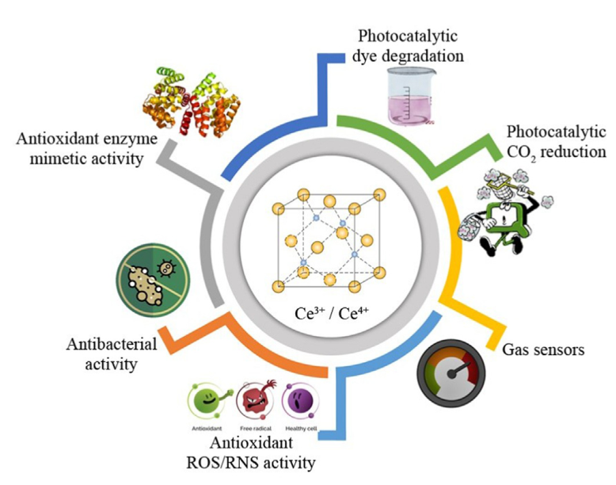
Figure 1. Various applications of ceria nanoparticles [7]
It is known that trees, herbs, shrubs, bacteria, Algae, and Fungi are rich in phytochemicals such as Phenolics, Flavonoids, Phenolic Acids, Carbohydrates, alkaloids, Lignin. These phytochemicals are freely soluble in water or hot water. They also contain water insoluble compounds such as sterols and terpenoids. Different parts of plants can be used as reducing agent when the extract is prepared in hot water. Natural materials used as reducing agent is represented in Figure 2.
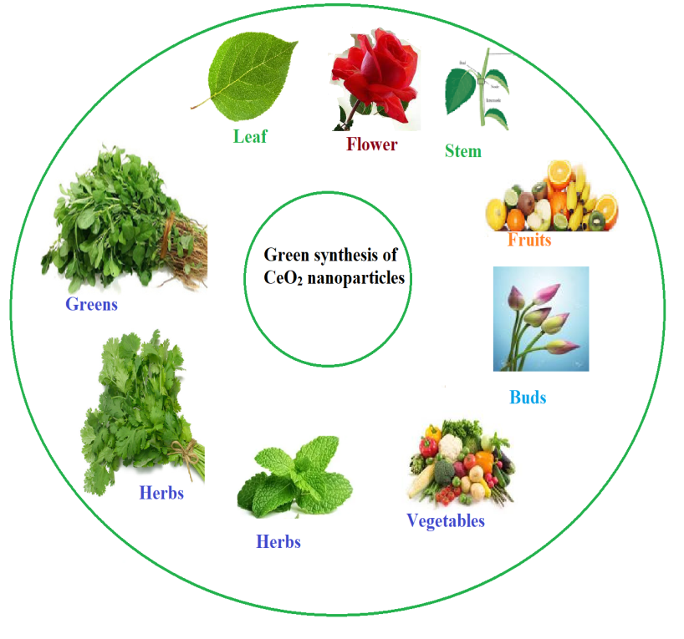
Figure 2. Green synthesis of CeO₂ nanoparticles using various parts of plants
Various metal oxide nanopartiles such as ZnO, CuO, ZrO₂, TiO₂, Fe₂O₃, Co₃O₄, and CeO₂ have been synthesized for various applications. Among other metal oxide, CeO₂ NPs have been most extensively studied due to their unique surface properties, stability, and biocompatibility [8] CeO₂ is used in the fabrication of sensors, catalysis, therapeutics agents, drug delivery careers, and anti-parasitic ointments [9]. CeO₂ NPs is synthesized via two methods, such as physical and chemical methods. However, both methods use chemicals such as sodium hydroxide or ammonium hydroxide as reducing agent to produce nanoparticles. These chemicals are toxic to environment and human health [10]. Whereas the natural sources such as plant extract, biological extracts and microbes are safe and less toxic method, which methods are called as green synthesis [11]. These natural extracts are rich in secondary metabolites, especially water soluble biomolecules, which are believed to be responsible for the reduction metal salts into respective nanoparticles [12, 13].
Various parts of plants such as leaves, flower, and stem have been used for the synthesis of CeO₂ NPs [14]. Leaves are especially rich in phenolic compounds when compared with other parts of the plant extract. Therefore, leaf extract predominantly used in the green synthesis of various metal oxides [15, 16]. The metal salt solution is reduced into nanoparticles through phytochemicals whose synthesis is first confirmed through colour change from colorless to yellowish and brownish, and then the structure of the nanoparticles confirmed by various spectroscopic and imaging techniques [17].
1.2. Biosynthesis
Biosynthesis classified into Microbes and other biological sources. Microbes are rich source of secondary metabolites. Among the metal oxide nanoparticles, CeO₂ NPs with various shapes and sizes have been produced using microbes such as Curvularia lunata, Humicola sp, Fusarium solani and Aspergillus niger [18-21].
Curvularia lunata extract is used to synthesize spherical shaped CeO₂ NPs with size ranges from 5–20 nm. Spherical shaped CeO₂ NPs of size ranges from 20–30 nm were made using Fusarium solani extract which showed effective growth inhibition and biofilm formation of pathogenic bacteria strains. Shadab Ali Khan observed the biosynthesis of spherical shaped (12–20 nm) CeO₂ NPs by using a fungus Humicola capping agent [19]. Bacterial Bacillus subtitles extract is also used to synthesis CeO₂ NPs with spherical shaped NPs with an average size of 8 nm. The bacterial stabilized CeO₂ NPs exhibit good antioxidant activity. Despite, all these microbial route of synthesis has certain drawbacks such as the high probability of pathogenicity, laborious culturing, and contamination issues. Egg protein, Honey, Agarose, Starch, Polyethylene glycol, Chitosan, and Pectin are some of the biological sources used for the fabrication of CeO₂ NPs [22-27], Acalypha indica [28], Petroselinum crispum [29] Gloriosa superba [30], Aloe barbadensis [31], Olea europaea [12], Hibiscus sabdariffa [32], and Azadirachta indica [33], Manilkara zapota fruit peel extract [34], aqueous extract of Salvadora persica [35], and olocasia esculenta [36] are some of natural and biological sources used in the synthesis CeO₂ NPs.
2. Synthesis of CeO₂ NPs
Cerium nitrate hexahydrate (Ce(NO₃)₃⋅6H₂O) [31], Cerium (III) acetate hydrate [37] and Cerium chloride heptahydrate [28] are commonly used precursor for the synthesis of CeO₂ NPs. Few researchers have used sodium hydroxide as reducing agent. Most of the researchers have not given any information regarding the reducing agent. Some researchers used ammonia solution as reducing agent [22]. They did not express the clear details about the usage of sodium hydroxide. Various concentrations (0.01, 0.1, 0.2, and 0.5M) of cerium nitrate are used as a precursor. General schematic diagram of green synthesis of CeO₂ NPs is shown in Figure 3.
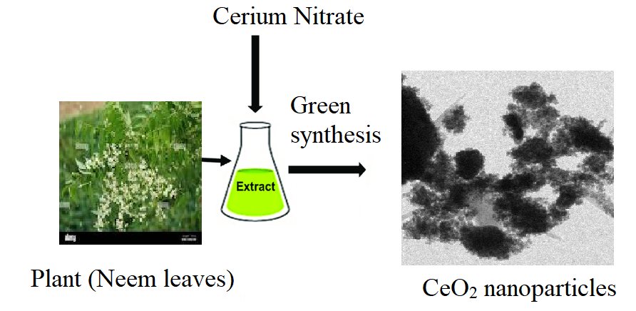
Figure 3. Green synthesis method of CeO₂ nanoparticles using plant extract
2.1. Characterization techniques
Structure of the green/biosynthesized CeO₂ can be confirmed by various spectroscopic techniques such as UV-Visible spectroscopy (UV-Vis), Fourier transform infrared spectroscopy (FTIR), X-ray diffraction (XRD), Scanning Electron Microscopy (SEM), Energy dispersive X-ray diffraction study (EDAX), Transmission Electron Microscope coupled with Selected Area Diffraction (SAED), and X-ray photoelectron spectroscopy (XPS). Absorption and functional group identification can be done by UV-Vis and FTIR. Formation of particles and elemental composition of can be analyzed by SEM-EDAX. Shape, size and morphology can be analyzed by TEM images. Average size of the particles can be calculated from the XRD data. Oxidation state of Ce³⁺ and Ce⁴⁺ can be identified by XPS spectroscopy. And many more advance techniques nowadays available for the analysis of structural studies.
2.2. Structural confirmation of CeO₂ NPs
Structure of green synthesized CeO₂ NPs is confirmed by various spectral techniques. UV-Visible is a primary method to confirm its structure. The optical properties of CeO₂ NPs are analyzed using UV-Vis DRS spectroscopy. The energy difference between valence band and conduction band is called as bandgap energy. Electron density is high in valence band and less is conduction band. Sharma et al. reported bandgap energy Azadirachta indica stabilized CeO₂ NPs (2.57eV), which is smaller than the bulk (3.19 eV) [33]. The bandgap energy is crucial for deciding the semiconductor’s performance and photocatalyst. The electrons jump from the valance band to conduction band is caused by small bandgap energy. However, higher bandgap energy will inhibit electron jump so it will block the flow of electrons [38, 39].
3. Biological activities
CeO₂ NPs having various biological activities due to their size, shape, morphology and surface area. They act as Antioxidant, Antibacterial and Anticancer agent against various pathogenic bacteria, various radicals produced in human body, and against various cancer cells.
3.1. Antibacterial activity
Many researchers have studied the antibacterial and antifungal activities of CeO₂ NPs against many pathogenic bacteria such Escherichia coli, Staphylococcus aureus, Pseudomonas aeruginosa, and Bacillus subtilis. It was proved that CeO₂ NPs at the concentration of 10 µg/mL to 50 µg/mL able to inhibit the growth of bacteria.
Arumugam et al. synthesiszed CeO₂ NPs using Gloriosa superba L and tested the antibacterial efficiency against Staphylococcus aureus, Streptococcus pneumoniae and Bacillus subtilis, Pseudomonas aeruginosa, Proteus vulgaris and Klebsiella pneumonia [30]. Similarly, Munusamy et al (2014) have derived CeO₂ NPs using Curvularia lunata and tested the antibacterial efficiency against Staphylococcus aureus and Streptococcus pneumonia, E.coli, Proteus vulgaris, Klebsiella pneumonia, Shigella dysenteriae and Pseudomonas aeruginosa [18]. Kunga Sugumaran et al (2016) evaluated the antibacterial activity of CeO₂ NPs against Staphylococcus aureus, Pseudomonas aeruginosa, Escherichia coli and Klebsiella pneumonia [20].
Gusliani Eka Putri et al. have synthesized CeO₂ NPs using Moringa oleifera leaf extract as reducing agent. Authors have studied antibacterial and antifungal activities of these nanoparticles E.coli and P. aeruginosa as Gram negative bacteria, and C. albicans and A. fumigatus as fungi [40]. They also included many bacteria and fungi in their article for the purpose of comparison. Antibacterial activity mechanism of CeO₂ NPs is shown in Figure 4.
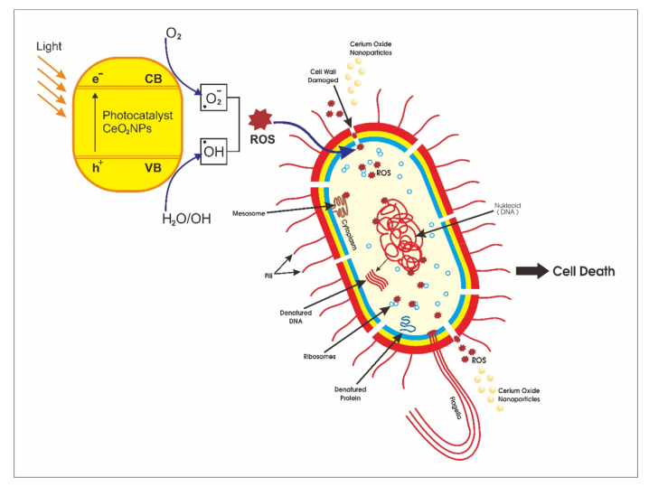
Figure 4. Mechanism of antibacterial activity of CeO₂ NPs [41]
The antibacterial activity of CeO₂ NPs primarily depends upon the electrostatic attraction between positively charged NPs and negatively charged bacterial cell surface and it is crucial for the activity of NPs as a bactericidal agent. The interaction is also responsible for reactive oxygen species (ROS) generation, which ultimately leads to bactericidal effect [41]. ROS include the highly reactive hydroxyl radical, singlet oxygen, and the least toxic superoxide anion radical, contributing to the major oxidative stress in biological systems [42]. ROS production is closely related to the efficiency of a photocatalyst, depending on the generation rate, rate of migration, and energy levels of the photoexcited electron-hole pairs. The photo-generated electrons and holes cause reduction and oxidation processes to produce hydroxyl radicals. These hydroxyl radicals are a very reactive oxidant to the organic biomolecules such as DNA nucleic acid, proteins, and lipids. The interaction of superoxide anions in water contents produces indirectly singlet oxygen, which is the mean mediator of the phototoxicity caused by the damage of treated tissues. These photo-generated hydroxyl radicals such as superoxide anion and singlet oxygen known as the reactive [34].
3.2. Antifungal activity
The fungicidal properties of the nanoceria have been tested against Aspergillus niger, Humicola sp., Curvularia lunata A. flavus, F. solani. The antifungal efficacy is evaluated by the zone of inhibition shown around the fungal inoculated wells in the petriplates. Nanoceria possess good antifungal activity against tested fungal strains in concentration from 25 to 100 μg/mL. The mechanism of antifungal activity of nanoceria is due to the generation of reactive oxygen species (ROS) and surface charge attraction. ROS was generated due to metal stress environment which causes oxidative damage to cell wall lipids and leads to cell death. In another way, the electromagnetic attraction exists between the negatively charged cell surface and positively charged Ce³⁺ on nanoceria surface helps the CeO₂ enter the cell wall and generate ROS in the cytoplasm and create oxidative stress to cell death [11].
3.3. Antioxidant activity
Constantly produces free radical species produced through cellular respiration and other physical processes due to oxidation. Antioxidant activities of CeO₂ NPs have been studied using Ferric reducing antioxidant power (FRAP) assay, DPPH free radical scavenging assay, Hydroxyl radical (OH⁻) Scavenging activities. The natural antioxidants present in the human body decrease in efficiency due to the oxidative process that happens in the body. However, the natural antioxidants present within the system fail to compensate for ROS production. Free radicals or singlet electron-carrying species bind to proteins, mRNA, enzymes, and endomembrane systems and speed up their lipid peroxidation, which changes their chemical nature and properties. The equilibrium between the formation and destruction of various free radical species is maintained by natural antioxidant mechanisms. Additionally, antioxidants are crucial in the management of oxidative stress, degenerative diseases, and autoimmune diseases like arthritis. We divide antioxidants into two categories based on their nature: (1) synthetic antioxidants taken orally, and (2) natural antioxidants produced by the body. However, in the case of health issues, the natural antioxidant system becomes weak, and the content of free radical species increases in the body [43, 44].
3.4. Antidiabetic activity
In India, diabetic is type chronic disease facing lots of problem in terms of various health aspects. It gives trouble many old aged people as well as youngster also. Therefore, we are in a position to find out the suitable medicine to overcome the diabetic. Many nanomaterials have been applied and evaluated for the antdiabetic activity. In this connection, CeO₂ NPs found to be a potential metal oxide nanoparticle can be used to combat the diabetic mellitus. The green synthesized CeO₂ NPs able to inhibit α-amylase, which is responsible for diabetic mellitus. Inhibitors from natural sources are of interest such as leaves of different plants due to their inhibitory potential against the target enzymes, which may be due to the presence of specific phenols [45]. Hence, CeO₂ NPs related anti-diabetic treatment indicates inhibitory effects on glycogenolysis and gluconeogenesis, mechanisms that are active during the fasted state [46].
3.5. Anticancer activity
Nowadays, cancer is serious diseases among the public publocIn this study, the cytotoxic effect of synthesized CeO₂ NPs was measured through MTT assay against colon (HT‐29) cancer cell line. The result of the cytotoxic effect of CeO₂ NPs (0–800 μg/mL) was reported. Similarly, CeO₂ NPs showed the same results against the HT‐29 cell line [47]. (Miri, M. Sarani 2018). M.J. Akhtar et al. studied the anticancer activity of CeO₂ NPs on MCF‐7 and HT‐1080 cell lines at the concentrations of 200 μg/mL of CeO₂ NPs have been studied the cytotoxic effect of CeO₂ NPs against L929 cell line using MTT assay [23, 48].
The natural antioxidant system continually works to diminish and balance oxidative species numbers inside the body. However, in the case of ailments or any disorder, when the natural antioxidant system fails to compensate for ROS production and to diminish them, an oxidative stress condition arises in the body. Free radicals or singlet electron-carrying species bind to proteins, mRNA, enzymes, and endomembrane systems and accelerate their lipid peroxidation or nonselective bonding, which changes their chemical nature and properties. The antioxidants interact with free radical species, break their cascade through pairing, and provide protection against oxidative damage (Figure 5) [43].

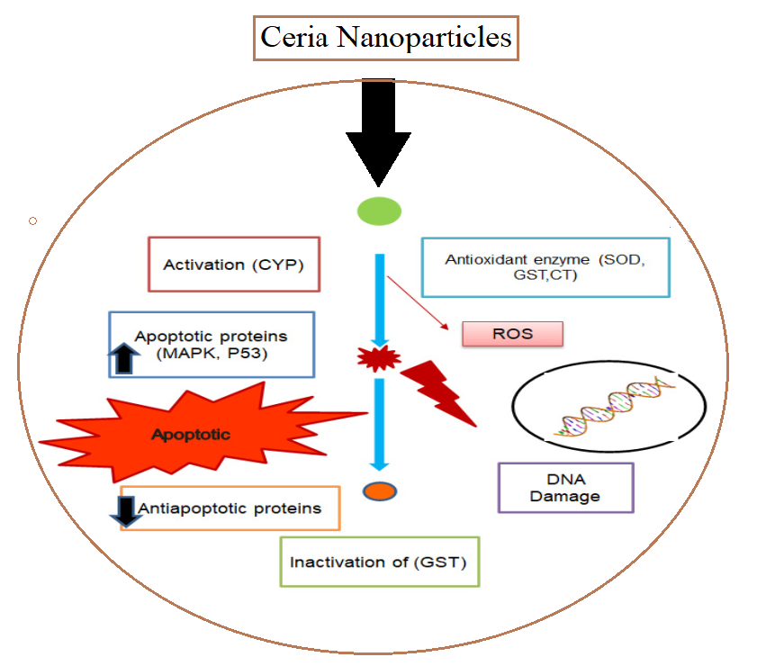
Figure 5. Antioxidant potential of cerium oxide nanoparticles (Maarij Khan et al. 2022)
Abdolhossein Miri et al. (2019) have evaluated anticancer activity of CeO₂ NPs against colon cancer cell lines through MTT (3‐(4,5‐dimethylthiazol‐2‐yl)‐2,5‐diphenyltetrazolium bromide) assay [36]. They proved that CeO₂ NPs at the rate 800 μg/mL able to kill the colon cancer cell line in vitro method. Rahdar et al. (2019) have reported the cytotoxic effect against MCF-7 breast cancer lines of Fe-doped ceria NPs exhibited and proved as a potential of an anticancer agent [49]. Sridharan et al. (2019) reported anticancer activity of nanoceria on breast cancer cell (MCF 7) in the IC₅₀ value was 298.17 µg/ml [50].
3.6. Anti-infammatory activity
CeO₂ NPs has radical scavenging and auto regeneration mechanisms, which provide them the exclusive potential to be considered as an anti-inflammatory agent [51]. Anti-inflammatory enzymes like iNOS expression cause rapid generation of free radicals in the body; protein in the iNOS gets activated by ROS, and macrophages produce NO. As ROS depletion can result in pathological effects, and they are important for normal cellular functions. When the CeO₂ NPs were tested on J774A.1 cell, it suppresses iNOS and ROS production; thus, acting as an anti-inflammatory agent [51]. (Hirst et al. 2009).
5. Conclusions
In conclusion, it is possible to synthesize CeO₂ NPs by a simple and eco-friendly method. The phytochemicals present in the plant extract, bacteria, fungi extract and other biological sources is responsible for the reduction of cerium salt into ceria nanparticles. Various phytochemicals such as phenols, flavonoids, carbohydrates, alkaloids and other phenolic compounds mainly responsible for the bioreduction process. The green or biosynthesized CeO₂ NPs can be by UV–Vis DRS, PL, FTIR, XRD, SEM-EDAX and TEM-SAED pattern analysis. The synthesized CeO₂ NPs showed bactericidal effect against pathogenic bacteria. Similarly, green synthesized CeO₂ exhibited antifungal, antioxidant, antidiabetics and anticancer activities. Therefore, CeO₂ NPs can be used as an suitable candidate for the development drug for various diseases.

References
- V. Mohanraj, Y. Chen, Trop. J. Pharm. Res. 5 (2006) 561–573.
- A. Dhall, W. Self, Antioxidants 7 (2018) 97.
- C. Sun, H. Li, L. Chen, Energ, Environ. Sci. 5 (2012) 8475–8505.
- S. Rajeshkumar, P. Naik, Biotechnol. Rep. 17 (2018) 1–5.
- S. Das, J.M. Dowding, K.E. Klump, J.F. McGinnis, W. Self, S. Seal, Nanomed 8 (2013) 1483–1508.
- G. Sharmila, C. Muthukumaran, H. Saraswathi, E. Sangeetha, S. Soundarya, N. Manoj Kumar, Ceram. Intl. 45 (2019) 12382–12386.
- S. N. Matussin, M. H. Harunsani, M. M. Khan, J. Rare Earths 41 (2023) 167-181.
- L. He, Y. Su, J. Lanhong, Jiang Lanhong, S. Shi, J Rare Earths. 33 (2015) 791–799.
- Carl Walkey, Soumen Das, Sudipta Seal, Joseph Erlichman et al. Environ Sci. 2 (2015) 33–53.
- R. Magudieshwaran, Junki Ishii, Krishna Chandar Nagamuthu Raja, Chiaki Terashima et al. Mater Lett. 239 (2019) 40–44.
- K. Mohan Kumar, M. Mahendhiran, M. Casales Diaz, N. Hernandez-Como et al. Mater Lett. 214 (2018) 15–19.
- Qaisar Maqbool, Mudassar Nazar, Sania Naz, Talib Hussain et al. Int J Nanomedicine. 11 (2016) 5015–5025.
- Ajey Singh, Imtiyaz Hussain, N.B. Singh, Himani Singh, Ecotoxicol. Environ. Saf. 182 (2019) 109410.
- H. Nadaroglu, H. Onem, A. Alayli Gungor, IET Nanobiotechnol. 11 (2017) 411–419.
- P. Nithya, B. Murugesan, J. Sonamuthu, S. Samayanan, S. Mahalingam S. Ceram. Int. 2019.
- M. Sultan Irshad, M. H. Aziz, M. Fatima, Saif Ur Rehman1, M Idrees et al. Mater. Res. Express. 2019.
- A. Rajan, A. Rajan, A. John, D. Philip, AIP Conf Proc. 2015 (2019) 020008.
- S. Munusamy, K. Bhakyaraj, L. Vijayalakshmi, A. Stephen, V. Narayanan, Int. J. Innov. Res. Sci. Eng. 2 (2014) 318.
- S. A. Khan, A. Ahmad, Mater. Res. Bull. 48 (2013) 4134–4138.
- K. S. Venkatesh,a K. Gopinath,b N. S. Palani,b A. Arumugam,b Sujin P. Jose,c S. Asath Bahadura and R. Ilangovan RSC Adv. 6 (2016) 42720–42729.
- K. Gopinath, V. Karthika, C. Sundaravadivelan, S. Gowri & A. Arumugam J Nanostructure Chem. 5 (2015) :295–303.
- Majid Darroudi, Mina Sarani, Reza Kazemi Oskuee, Ali Khorsand Zak, Hasan Ali et al. Ceram. Int. 40 (2014) 2041–2045.
- Kargar H, Ghasemi F, Darroudi M. Ceram. Int. 41 (2015) 1589–1594.
- Majid Darroudi, Seyed Javad Hoseini, Reza Kazemi Oskuee, Hasan Ali Hosseini et al. Ceram. Int. 2014;40(5):7425–7430.
- Ece Alpaslan‡, Hilal Yazici‡, Negar H. Golshan‡, Katherine S. Ziemer‡, and Thomas J. Webster, ACS Biomater Sci Eng. 1 (2015) 1096–1103.
- Ajeet Kaushik; Pratima R. Solanki; M. K. Pandey; Sharif Ahmad; Bansi D. Malhotra Appl. Phys. Lett. 95 (2009) 173703.
- Sandeep N Patil, Jayasinh S Paradeshi, Prapti B Chaudhari, Satyendra J Mishra, Bhushan L Chaudhari Appl Biochem Biotechnol. 180 (2016) 638–654.
- S. K. Kannan, M. Sundrarajan, Int. J. Nanosci. 13 (2014) 1450018.
- A. M. Korotkova, P. O. Borisovna, G. I. Aleksandrovna, K. D. Bagdasarovna et al. Curr. Nanomater. 4 (2019) 176–190.
- A. Arumugam, C. Karthikeyan, A. S. Haja Hameed, K. Gopinath et al. Mater. Sci. Eng., C, 49 (2015) 408–415.
- G. Sai Priya, A. Kanneganti, K. Anil Kumar, K. Venkateswara Rao, S. Bykkam, Intl. J. Sci. Res. Publication, 4 (2014) 1–4.
- N. Thovhogi, A. Diallo, A. Gurib-Fakim, M. Maaza, J. Alloys Compd. 647 (2015) 392–396.
- J. K. Sharma, P. Srivastava, S. Ameen, M. S. Akhtar, S. K. Sengupta, G. Singh, Mater. Res. Bull., 91 (2017) 98–107.
- Dasari Ayodhya, Anilkumar Ambala, G. Balraj, Marri Pradeep Kumar, P. Shyam, Results Chem. 4 (2022) 100441
- Abdolhossein Miri, Majid Darroudi, Mina Sarani, Appl Organometal Chem. (2019) 5308.
- Nor Monica Ahmad, NorAishah, J. Nanotechnol. (2023) Article ID 9572025.
- Maensiri S, Masinghboon C, Laokul P, Jareonboon W, Promarak V, Anderson PL, et al. Cryst Growth Des. 7 (2007) 950–955.
- Calvache-Munoz J, Prado FA, Rodrıguez-Paez JE. Colloids Surfaces A Physicochem. Eng. Asp. 529 (2017) 146-159.
- Singh KRB, Nayak V, Sarkar T, Singh RP. RSC Adv 2020;10:27194-214.
- Gusliani Eka Putri, Yetria Rilda, Syukri Syukri, Arniati Labanni et al. J. Mater. Res. Technol. 15 (2021) 2355-2364.
- M.V. Arasu, R. Thirumamagal, M.P. Srinivasan, N.A. Al-Dhabi et al. J. Photochem. Photobiol. B: Biology 173 (2017) 50–60.
- T. Xia, M. Kovochich, M. Liong, L. Madler et al. ACS Nano 2 (10) (2008) 2121–2134.
- Ciofani, G.; Genchi, G.G.; Liakos, I.; Cappello et al. Pharm. Res. 30 (2013) 2133–2145.
- Khan, M.; Mashwani, Z.-u.-R.; Ikram, M.; Raja, N.I. et al. Nanomaterials 12 (2022) 2117.
- N. Bala, S. Saha, M. Chakraborty, M. Maiti et al. RSC Adv. 5 (2015) 4993–5003.
- K. Shanker, J. Naradala, G.K. Mohan, G.S. Kumar et al. RSC Adv. 7 (59) (2017) 37158–37167.
- A. Miri, M. Sarani, Ceram. Int. 4 (2018) 12642.
- M. J. Akhtar, M. Ahamed, H. A. Alhadlaq et al. J. Colloid Interface Sci. 453 (2015) 21.
- A. Rahdar, M. Aliahmad, M. Samani, M. HeidariMajd et al. Ceram. Intl. 45 (2019) 7950–7955.
- M. Sridharan, P. Kamaraj, Vennilaraj, J. Arockiaselvi et al. Mater. Today: Proceedings 36 (2021) 914-919.
- A. Gojova, J.-T. Lee, H. S. Jung, B. Guo et al. Inhalation Toxicol. 21 (2009) 123–130.
- S. M. Hirst, A. S. Karakoti, R. D. Tyler, N. Sriranganathan et al. Small, 5 (2009) 2848–2856.

