THE FIVE BASIC SOCIAL INSTITUTIONS SHAPING HUMAN SOCIETIES
Dr. Arunima Konar
Assistant Professor
Department of Agricultural Economics,
School of Agricultural Sciences, Sister Nivedita University
Email id: arunima.k@snuniv.ac.in
INTRODUCTION
Social institutions play a crucial role in the structure of human societies, providing a framework for behaviour in specific aspects of social life. A social institution refers to a comprehensive and interconnected system of social norms designed to uphold fundamental social values, ensuring the survival and stability of a community. Although the methods of establishing and the complexities of these institutions may vary across different societies, there are five fundamental social institutions that are present in all human groups.
FUNCTIONS OF SOCIAL INSTITUTIONS
Social institutions play crucial roles in shaping and maintaining the structure and functioning of societies. These institutions are established to address specific societal needs and serve various functions that contribute to the overall stability and organization of communities. Some of the primary functions of social institutions include:
- Social Order and Stability:
Institutions such as governments, legal systems, and law enforcement agencies establish rules and regulations that maintain social order and stability. They provide a framework for resolving conflicts and maintaining peace within society.
- Socialization:
Family, education systems, and religious institutions play essential roles in socializing individuals. They impart values, beliefs, norms, and behaviours necessary for effective participation in society and culture.
- Economic Production and Distribution:
Economic institutions, including businesses, banks, and financial systems, facilitate the production, distribution, and exchange of goods and services. They help to ensure the proper functioning of the economy and the allocation of resources.
- Education and Knowledge Transmission:
Educational institutions are responsible for transmitting knowledge, skills, and cultural values from one generation to the next. They prepare individuals for various roles and responsibilities in society.
- Healthcare and Well-being:
Healthcare institutions and systems provide medical services and support to maintain the health and well-being of individuals and communities.
- Regulation of Reproduction and Family Formation:
Family and marriage institutions govern rules around reproduction, marriage, and family formation. They regulate relationships, parenting, and inheritance.
- Religious and Spiritual Guidance:
Judicial systems and correctional institutions enforce laws and regulations, uphold justice, and respond to criminal activities. They aim to protect society from harm and maintain a fair and just community.
- Social Control and Justice:
Religious institutions provide spiritual guidance, support moral values, and offer a sense of meaning and purpose to individuals and communities.
- Media and Communication:
Media institutions play a significant role in informing and shaping public opinion. They facilitate communication and the exchange of information within society.
- Social Support and Welfare:
Social welfare institutions offer support to vulnerable members of society, such as the elderly, disabled, or economically disadvantaged, providing assistance for their well-being.
- Recreation and Entertainment:
Entertainment and recreational institutions provide opportunities for leisure and enjoyment, contributing to the overall quality of life.
- Cultural Preservation and Expression:
Cultural institutions, such as museums, libraries, and cultural centres, preserve and promote cultural heritage and expression, contributing to the identity of a community or society.
THE FIVE BASIC SOCIAL INSTITUTIONS
Social institutions are the building blocks of human societies, representing the organized and structured systems that govern various aspects of human life. These institutions have evolved over time to meet the needs of individuals and communities, providing a framework for social order and cooperation. The five basic social institutions are basically the pyramid of five basic social institution. These are,
- Family Institution (Family):
Family is considered as a building block of a society. The family institution is the foundational unit of society, serving as the primary socializing agent for individuals. Families provide emotional support, nurture, and care to children, guiding them through the process of learning cultural norms, values, and behaviours. Additionally, families are responsible for the transmission of intergenerational knowledge and traditions. Moreover, families play a vital role in forming personal identities, shaping one's worldview, and influencing social dynamics within communities.
- Religious Institution (Religion):
Religious institutions play a significant role in shaping the moral and spiritual fabric of societies. They provide guidance on ethical principles, values, and beliefs, influencing individual behaviour and community cohesion. Religion often serves as a source of comfort during challenging times and contributes to a sense of purpose and meaning in life. Moreover, religious institutions promote social solidarity by bringing people together through shared rituals, practices, and celebrations.
- Educational Institution (Education):
Education is a fundamental social institution that imparts knowledge, skills, and values necessary for personal and societal development. Formal education systems, such as schools and universities, equip individuals with academic expertise, critical thinking abilities, and practical life skills. Education promotes social mobility by providing opportunities for personal growth and upward socioeconomic mobility. Furthermore, it fosters a sense of national identity and cohesion by nurturing a shared culture and history.
- Economic Institution (Economy):
The economic institution is responsible for the production, distribution, and exchange of goods and services within a society. It encompasses various economic systems, including capitalism, socialism, and mixed economies, each influencing resource allocation and wealth distribution differently. Economic institutions create employment opportunities, drive innovation, and fuel economic growth. Additionally, they help satisfy individuals' material needs and contribute to the overall standard of living in a society.
- Political Institution (Government):
Political institutions are responsible for governing societies and maintaining social order through the establishment and enforcement of laws and regulations. Governments, political parties, and legal systems are crucial components of this institution. Political institutions provide a framework for decision-making, conflict resolution, and protection of individual rights and freedoms. Moreover, they represent the voice of the people and are accountable for safeguarding the collective well-being of the society they govern.
Although all sociologists agree on the big five, many consider other segments of society to be social institutions as well – aging, the media, health care, social welfare, work, gender and others.
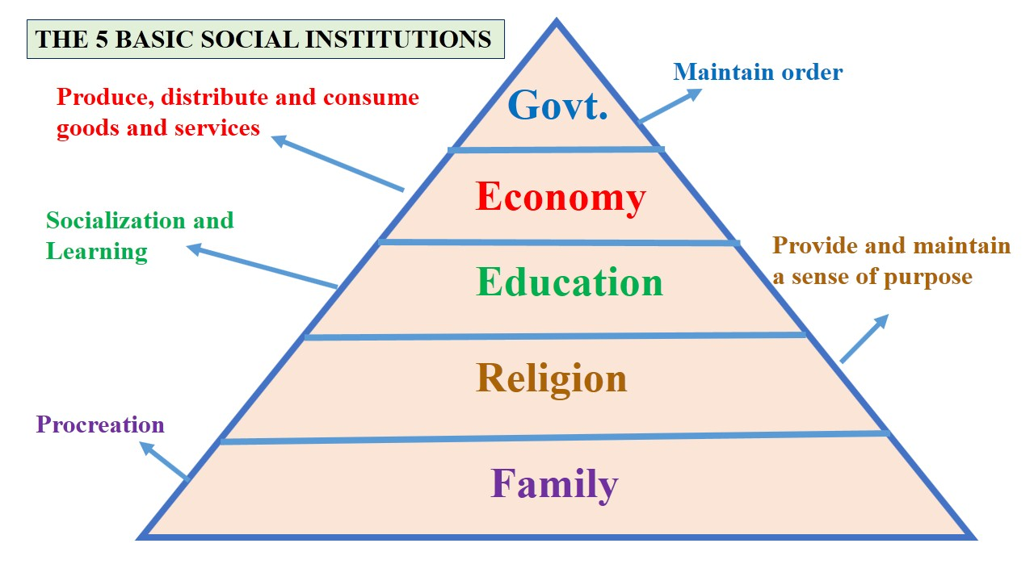
Social institutions are the foundation upon which human societies are built. Each institution plays a unique and essential role in shaping the values, norms, and interactions within communities. The family institution shapes personal identities and lays the groundwork for socialization, while the education institution equips individuals with the knowledge and skills needed to thrive in society. The economic institution determines how resources are allocated and wealth is distributed, impacting people's livelihoods and opportunities. Political institutions provide the framework for governance and the maintenance of social order, while religious institutions offer spiritual guidance and promote communal harmony.
Understanding the functions of these five basic social institutions is crucial for comprehending the complexities of societies and identifying ways to address societal challenges effectively. By recognizing and supporting these institutions' roles, we can work towards building more inclusive, just, and cohesive societies for the betterment of all individuals.
These functions often intersect and overlap, and different societies may emphasize specific institutions based on their cultural values, historical development, and contemporary challenges. The collective functioning of these social institutions helps maintain social cohesion, order, and progress within a society.
THE CRUCIAL ROLE OF FAMILY IN SOCIETY'S ECONOMIC DEVELOPMENT
The role of a family in society is paramount for economic development. Families serve as the basic building blocks of any community, shaping the values, work ethic, and skills of their members. A strong and supportive family environment fosters stability and emotional well-being, enabling individuals to focus on education and career advancement. Moreover, families often provide essential social safety nets and financial support, empowering individuals to take risks, invest in their future, and contribute positively to the economy. In this way, the foundation of a thriving society rests upon the strength and cohesion of its families.
Family values
Values encompass a set of intangible principles, beliefs, and emotions that shape our perception of what is significant in life. They serve as a moral compass, guiding our actions based on notions of righteousness, goodness, and desirability. Although values themselves are not observable, their influence is evident in our behaviour and choices. These values can either be positive, such as freedom, courtesy, love, respect, and honesty, fostering a harmonious society, or negative, such as dishonesty, envy, selfishness, and corruption, which can hinder social progress and well-being.
Importance of family values system
- Family values play a crucial role in shaping and guiding the behaviour of family members, fostering a sense of responsibility, respect, and empathy within the household. It helps the family to make decisions.
- It act as a source of confidence and strength, offering unwavering support and a sense of belonging that empowers individuals to face life's challenges with determination and resilience.
- It serve as a powerful motivator for action, inspiring individuals to strive for their goals, pursue personal growth, and contribute positively to both their family and society as a whole.
THE IMPACT OF RELIGIOUS INSTITUTIONS ON SOCIETAL ECONOMIC DEVELOPMENT
Religious institutions, with their profound impact on societies, can play a significant role in economic development.
- Firstly, these institutions often promote ethical values and moral principles that guide individuals' behaviours in economic activities. Such values, rooted in compassion, honesty, and fairness, contribute to the establishment of a trustworthy business environment, fostering better business practices and reducing corruption.
- Secondly, religious institutions often engage in charitable and welfare activities, providing assistance to the less fortunate and marginalized members of society. This can help alleviate poverty and promote social cohesion, creating a more stable and harmonious society where economic growth can thrive.
- Moreover, religious institutions can act as a unifying force, transcending cultural and ethnic differences, and bringing people together to work towards common economic goals. This sense of community and shared purpose can foster collaboration and mutual support among individuals and businesses, leading to increased productivity and innovation.
- Furthermore, religious institutions frequently invest in education and skill development, empowering individuals with knowledge and tools to participate more actively in the economy. This investment in human capital can lead to a more skilled and capable workforce, driving economic progress.
- Lastly, religious tourism can boost local economies significantly. Places of religious significance often attract pilgrims and tourists, creating employment opportunities and stimulating economic growth in the surrounding areas.
Overall, the role of religious institutions in societies' economic development is multifaceted, encompassing ethical guidance, social welfare initiatives, community cohesion, investment in education, and contributions to the tourism sector. When these aspects are nurtured and harnessed positively, religious institutions can become valuable partners in promoting sustainable economic growth and fostering a more inclusive and prosperous society.
THE CRUCIAL ROLE OF EDUCATION IN ECONOMIC DEVELOPMENT
Education plays a fundamental and transformative role in the economic development of societies. It serves as the cornerstone for human capital development, empowering individuals with knowledge, skills, and expertise that are crucial for participating effectively in the workforce. A well-educated population is more adaptable to technological advancements and innovation, driving productivity and economic growth. Education enhances the overall productivity of the workforce by enabling individuals to engage in higher-value-added activities and fosters entrepreneurship, leading to the creation of new businesses and job opportunities. Additionally, education contributes to the reduction of poverty and income inequality as it equips individuals with the tools to break the cycle of poverty and pursue better economic prospects. Moreover, educated societies tend to make more informed decisions, leading to better governance and more sustainable economic policies. As education continues to expand opportunities and unlock human potential, its role in promoting economic development becomes increasingly indispensable for building prosperous and resilient nations.
The positive impact of education on an individual in society:
The positive impact of education on an individual in society is profound and far-reaching. Education equips individuals with knowledge, critical thinking skills, and a broader understanding of the world, enabling them to make informed decisions and contribute meaningfully to their communities. Educated individuals are more likely to secure better employment opportunities and higher-paying jobs, improving their own economic well-being and that of their families. Moreover, education fosters personal growth and self-confidence, empowering individuals to set and achieve ambitious goals. This, in turn, can inspire others and create a ripple effect of positive change within the community. Education also promotes social cohesion by encouraging tolerance, empathy, and respect for diverse cultures and perspectives. Educated individuals are more likely to engage in civic activities, participate in democratic processes, and advocate for social justice and equality. Overall, education plays a pivotal role in uplifting individuals, fostering social progress, and driving sustainable development in society.
THE VITAL ROLE OF ECONOMIC INSTITUTIONS IN SOCIETY
Economic institutions play a vital role in society as they form the backbone of a functioning and prosperous economy. These institutions encompass various entities such as banks, stock markets, regulatory bodies, and financial organizations that facilitate the flow of resources, capital, and goods. One of their primary functions is to ensure stability and predictability in economic activities, providing a framework for businesses and individuals to make decisions with confidence. They establish rules, regulations, and property rights that foster a conducive environment for investment, entrepreneurship, and innovation. Moreover, economic institutions facilitate the allocation of resources, ensuring that goods and services are distributed efficiently to meet the needs and demands of the population. By encouraging competition, preventing monopolies, and promoting fair trade practices, they enhance market efficiency and consumer welfare. The effective functioning of economic institutions contributes to job creation, income generation, and overall economic growth, leading to improved living standards and enhanced societal well-being. In essence, economic institutions are critical components that shape the economic landscape and lay the foundation for sustainable development and progress in society.
THE CRUCIAL ROLE OF POLITICAL INSTITUTIONS (GOVERNMENT) IN SOCIETY
The role of political institutions, particularly the government, in society is paramount as they are responsible for governing and maintaining order within a nation. Governments provide the framework for making and enforcing laws, ensuring social cohesion, and safeguarding the rights and interests of their citizens. They play a crucial role in the allocation of resources, taxation, and public spending, which directly influence the overall economic well-being of the country. Through various policies and regulations, governments can promote economic growth, address issues such as poverty and inequality, and foster a stable business environment that encourages investment and entrepreneurship. Political institutions also take charge of public services, including education, healthcare, and infrastructure development, essential for enhancing the quality of life and human capital of the population. Moreover, governments represent their nations on the international stage, engaging in diplomacy, trade negotiations, and addressing global challenges. Overall, the role of political institutions is to create an enabling environment where individuals can thrive, and societies can progress toward greater prosperity, social justice, and sustainable development.
THE IMPACT OF GOVERNMENT IN AN ECONOMY
The impact of government in an economy is multifaceted, influencing various aspects that shape the overall economic landscape. Here are a few key points outlining the impact:
- Economic Policy:
Governments formulate and implement economic policies that aim to promote growth, stability, and sustainability. These policies can include fiscal measures such as taxation and public spending, as well as monetary policies that control the money supply and interest rates.
- Regulation and Market Efficiency:
Governments play a crucial role in regulating markets to prevent monopolies, unfair practices, and promote healthy competition. Effective regulation ensures market efficiency, consumer protection, and a level playing field for businesses.
- Infrastructure Development:
Governments invest in infrastructure projects such as roads, bridges, and utilities, which not only create jobs and stimulate economic activity but also improve the overall business environment, attracting investment and supporting economic growth.
- Social Welfare:
Through various social welfare programs, governments aim to alleviate poverty, provide support to vulnerable populations, and reduce income inequality. These programs can have significant effects on the overall well-being of citizens and their participation in the economy.
- Education and Human Capital:
Governments invest in education and skill development, building a capable and productive workforce. A well-educated population is essential for technological advancement, innovation, and overall economic progress.
- Trade and International Relations:
Governments negotiate trade agreements, tariffs, and economic partnerships with other nations, influencing the flow of goods, services, and investments, and shaping the country's integration into the global economy.
The impact of government in an economy is immense. Its policies and decisions can significantly influence economic growth, employment, inflation, and overall prosperity. By creating a conducive environment for businesses to thrive, promoting social welfare, and investing in human capital and infrastructure, governments can play a pivotal role in fostering sustainable economic development and improving the lives of their citizens. However, the effectiveness of government policies relies on sound planning, prudent decision-making, and adaptability to changing economic circumstances. Striking the right balance between interventions and allowing market forces to operate is crucial for achieving optimal economic outcomes.
CONCLUSION:
The five basic social institutions - family, religion, education, economy and government- form the foundation upon which human societies are built and function. Each institution plays a distinct and vital role in shaping the lives of individuals and the collective fabric of communities. The family provides a nurturing environment, fostering values and emotional support. Education empowers individuals with knowledge and skills, driving personal growth and economic development. The government establishes order, enforces laws, and safeguards the welfare of its citizens. The economy facilitates the production and distribution of resources, driving economic prosperity and progress. Religion provides spiritual guidance and moral principles, influencing the values and behaviours of its followers. Together, these institutions interconnect and influence one another, moulding the social, economic, and cultural landscape of human societies. Recognizing and understanding the significance of these institutions is essential for building sustainable, inclusive, and harmonious societies that thrive and evolve to meet the challenges of the future.
REFERENCES:
Acharya, Hemlata. 1974. ‘Changing Role of Religious Specialists in Nasik —The Pilgrim City’, in ed. RAO, M.S.A., An Urban Sociology in India : Readerand Source Book. Orient Longman, New Delhi, pp. 391-403.
Apple, Michael W. 1979. Ideology and Curriculum. Routledge and Kegan Paul, LONDON.
Chugtai, Ismat. 2004. Tiny’s Granny in Contemporary Indian Short Stories; Series 1. Sahitya Akademi, New Delhi.
Dube, Leela. 2001. Anthropological Explorations in Gender: Intersecting Fields. Sage Publications, New Delhi.
Durkheim, Emile. 1956. Education and Sociology. The Free Press, New York.
Pathak, Avijit. 2002. Social Implications of Schooling: Knowledge, Pedagogy and Consciousness. Rainbow Publishers, Delhi.
https://simplysociology.com/social-institution.html
https://www.amyglenn.com/SOCI/Social%20Institutions%20%20Education%20and%20Religion.pdf
https://www.shareyouressays.com/essays/essay-on-functions-of-social-institutions/86561
https://www.ipl.org/essay/Role-Of-Social-Institutions-In-Education PKBJR9NFJ4D6#:~:text=Education%20helps%20people%20get%20good,people%20acquire%20skill%20most%20required.

