SYNTHESIS AND APPLICATIONS OF POLYMER CLAY NANOCOMPOSITES
Ramesh S¹ and Anthuvan Babu S²
¹Department of Chemistry, R.M.D Engineering College, Kavaraipettai 601206, Tamilnadu, India.
²Department of Chemistry, Adhiyamaan College of Engineering, Hosur – 635130, Krishnagiri, Tamilnadu, India.

ABSTRACT
The term polymer nanocomposites (PNC) refers to a novel class of composite materials where at least one of the dispersed particle dimensions falls under the nanoscale (10–100 nm). They blend the ideas of composites and materials that are nanoscale in size. The properties of these nanosized materials differ from normal materials because grains, fibers, and plates with a surface area only a few nanometers across have a vastly enhanced surface area. They can be created using easy and affordable methods, and frequently exhibit qualities that are better than those of traditional microscale composites due to the high contact between the components. Clay minerals and layered silicates are widely employed nowadays as reinforcing elements to enhance numerous polymer characteristics. The primary advantages of minerals such as clay as reinforcing materials include their low density, wide availability, affordable price, high aspect ratio, and significant specific surface area, that greatly improves the characteristics of polymers. The detoxification of chromium from industrial effluents at various levels (ppb to μg) assumes considerable importance. In the current work, we discuss the synthesis and various uses of clay-based organic polymer nanocomposites made of polyurethane and poly (ethylene-co-vinyl acetate).
Keywords: Nanocomposites, Montmorillonite, Clay, Polyurethane, Poly (ethylene-co-vinyl acetate), Gas permeability, Fire retardant.

1.1. Introduction to Polymer Nanocomposites
Polymers are large molecules which are made up of covalently bonded smaller units, that is called monomers or repeating units. The interesting mechanical properties of polymeric materials depends on this specific molecular structure. For the last few decades, the elements such as wood, metals, and ceramics have been replaced by the increased extensive use of polymers [1]. This is mostly because polymers have provided additional advantages over traditional materials, such as productivity, simplicity of processing, as well as cost reduction [2]. The polymeric materials are highly resistant to meet the high demands on stiffness and strength for many applications in automotive, aerospace, electrical, infrastructure, microelectronics, construction, chemical, and medical industries [3, 4]. The use of thermoplastic polymers such as Polyurethane, Poly(ethylene-co-vinyl acetate) PEVA, and polystyrene have received much commercial and academic attention in the past.
Generally, the term polymer encompasses a large group of synthetic and natural materials along with a broad variety of properties. In our everyday life, polymeric materials are ubiquitous and plays an essential role because of the extraordinary variety of properties. Based on physical nature and the scale at which the property is defined, the polymer properties are mainly classified into many types. The uniqueness of its component monomers is the most fundamental property of a polymer. The arrangement of these repeating unit within the polymer at the scale of a mono chain which describes the microstructure of polymer properties. The behaviour of continuous macroscopic material of polymer is determined by these basic structural properties, which play an important role in establishing the polymer's bulk physical properties. At the macroscopic level, how various physical forces interact with polymer sections, and how the bulk polymer interacts with other solvents and chemicals which express the chemical properties of the polymer.
Nowadays, many scientists have focused on nanoscale structural materials such as nanoclusters, nanotubes, nanowires, and nanocomposites due to their size-dependent properties and low dimensionality and that are distinct from those conventional and bulk counterparts. They are enabled to alter for a broad range of applications. A type of materials known as nanocomposites is formed by the appropriate combination of more than one nanosized objects or nanoparticles. These are obtained by some proper technique, which results in materials with distinctive physical properties and broad potential application in various areas. The different sizes and nature of inorganic nanoparticles have been combined with the polymers, which result in a number of exciting nanocomposites, unique physical properties along with wide potential application. Based on the combination of the different nanoscale materials, such as hybrid organic-inorganic materials show potential systems for different applications because of their extraordinary properties. During the last few years, have attracted more attention towards the combination of organic polymers with nanoscale inorganic moieties which have a high potential for future applications. The two moieties are combined in countless different ways and there many methodologies to combine them into one material.
The desirable characteristics of the generated nanocomposite are determined by the filler size, synthesis methods, and inorganic material properties. The need for unpolluted surrounding the researcher is focussed on the development of polymer nanocomposite (PNC) materials because of their increasing concern for the environment. PNCs materials are a developing type of composite materials when the mechanical characteristics of heterogeneous composites have been contrasted. The PNCs are specifically economic with environmental benefits and are fully recyclable. The great challenge in the fabrication of PNCs is the small difference in the melting temperature between the clay fillers and the organic polymer matrix.
Inorganic filler and organic polymer composite materials are more important because of their unexpected properties which occur from the synergism between components of the properties. These materials are produced in a variety of ways, the most notable of which being the incorporation of inorganic fillers into organic polymer matrix. Because of the remarkable change in characteristics such as heat, mechanical, then magnetic, and electrical when compared to natural polymers, these materials have generated a lot of interest. [5].
1.2. Formation of Nanocomposite from the Constituents

Nanocomposites are classified into many types based upon the nature of combination between the organic and inorganic components, (Figure 1.1 a-c). The inorganic particle gets encased in an organic matrix in the first type. The second one is the confinement of organic polymer into an inorganic template. Moreover, in the above case the formation of nanocomposites are only some encapsulation or entrapment than simple mixing or blending. The organo-inorganic hybrid materials such as the coating of transition metal oxide nanomaterial over organic polymer conductor have attractive for electrochemical applications due to they improve the electronic conducting properties. When inorganic materials are incorporated with polymer, the chemical interactions between the two moieties depends on, weak (hydrogen-bonds, Vander Waals force, hydrophilic-hydrophobic balance); strong (ionic covalent, coordination) bond of the two components., such as ease of handling and better performance of the final product [6]. Generally, the dispersion of inorganic clay nanoparticles in the monomers, the in situ polymerization techniques has better advantages and a superior performance of the final product.
In order to get good dispersion in the matrix phase polymer or increase the interaction of the polymers and the inorganic nanoparticles is done by modifying the functional groups of the inorganic nanoparticles (Figure 1.1a). The introduction of nanofiller is that the inorganic nanoparticles are mixed into the matrix conducting polymer as shown in Figure 1.1b. The most interesting synthesis of nanocomposites is the encapsulation of various metal and metal oxide nanoparticles into the conducting polymers matrix. The properties such as chemical, physical, thermal, mechanical, and biological of these materials differ from those conventional polymers (Figure 1.1c). The solution and melt blending techniques are the simplest method in which the direct addition of the nanofiller into the polymer can be done. However, the biggest challenge is to fully disperse inorganic clay nanoparticles into the matrix phase polymer due to the agglomeration of nanoparticles have strong tendency. In general, to enhance the dispersion of the inorganic nanoparticles clay into a polymer phase matrix is done by surface modification of the inorganic nanoparticles which gives strong interfacial interaction between the clay nanoparticles and matrix phase polymer (Figure 1.2).
The Composite is solid multiphase materials, which are produced by one or more component. It is formed through a combination of physical, structural chemical of properties of materials. These composite materials differ from other multi-component systems such as blends and alloys in their characteristics. The weight, durability, rigidity, permeability, electrical, sustainability, and optical properties of composite materials are difficult to separate into independent components. In most cases, the scattered phase is combined of the phase of matrix to create a composite with better qualities than the isolated phase. The preparation method and optimal design of composite materials are critical for meeting the particular qualities for engineering applications.

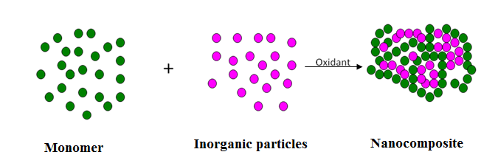
Figure 1.1. (a) Formation of polymer nanocomposite via insitu Polymerisation.
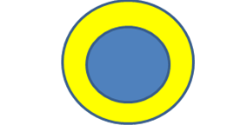
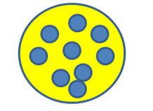
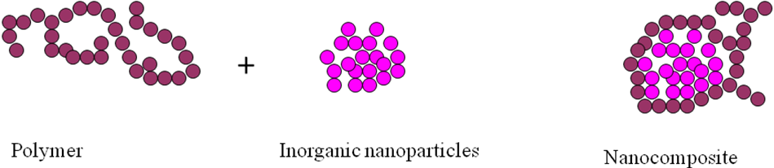
Figure 1.1. (c) Organic polymer is confined to an organic template.
Figure 1.1. (b) Inorganic particles are embedded in a polymer matrix.

Figure 1.2. Polymer nanocomposite formed using polymer and inorganic nanoparticles.
Polymer nanocomposite material is constructed by the mixture of polymer and natural (or) synthetic inorganic like clay filler typically 10 Å – 100 Å. It is used as a filler to improve the significant properties of organic polymer or decrease the cost of materials. The conventional filler like talk, fibber, CaCl₂ requires applying a more quantity in the polymer matrix to improve the composite properties like fragility or loss of opaqueness. The properties like electrochemical, mechanical, thermal are depended on the aspect ratio of width to height of the filler [7]. The nanofiller with high aspect ratio such as clay, nanofibers, nanotubes have great attention today, because of their unique functional properties. Filler having nanoscale dimensions and high aspect ratio dispersed in polymer phase matrix mains to the dramatic improvement in the polymer characteristics at low volume fraction filler.
1.3. Chemistry of Chromium
Nowadays, the existence of heavy metal in the surrounding is a significant concern because of their affinity to bioaccumulate and toxicity at low concentration in the food chain. The collection of metalloids and metals having with greater than 6 g cm⁻³ of atomic density is the termed as ‘Heavy metals’. The majority of heavy metals are known as primary concern pollutants and causing possible long-term and short-term undesirable effects in the environment. In industries, the heavy metals are used in various applications and it has resulted in water bodies the amount of metal pollution was increased [8]. Generally the elements like Cr, Cu, Cd, Hg, Pb, Zn and Ni which are recognized as high atomic density elements create pollution, toxicity problems in the environment [9].
The French scientist Nicholas-Louis Vauquelin discovered chromium oxide from the Siberian minerals crocoite (PbCrO4) in 1797. He hypothesized chromium as a distinct and separate element. In 1798, Vauquelin heated chromic oxide with charcoal and isolated the metallic Cr. He invented Chromium as a new periodic element which has a unique colour and distinct properties. The metal Chromium is called as a transition element with atomic number 24. Chromium is present in-group 6B in the periodic table, which is the sixth most abundant transition metal and around 122 ppm of the Earth's 21st most prevalent element [10]. Chromium metal is a glossy, silvery, and rigid as well as brittle in nature. The metal Cr has a density of around 7.19 g cm⁻³ and its melting point around 2180K and , the boiling point is 2944K respectively, which is comparatively low when compared to other transition elements in the periodic table. Chromium has a wide range of oxidation state from –2 state to +6 state.
The most important ore of chromium is chromite FeCr₂O₇. Cr (VI) is known as a highly sensitive, as it causes various human health effects. When it is compound with leather products, it can cause skin rash problems. Further when Cr(VI) is breathed can cause nose irritation and nose bleeds. The other health problems like ulcer, respiratory problems, kidney and liver injury, high lung tumour, and finally death are caused by chromium VI metal element. The metal chromium is both valuable and harmful. The mammalian metabolism that occurs in the body is an critical trace element is Chromium(III). In addition to insulin, it is used to control diabetes, and It is in charge of lowering blood glucose levels. Chromium(III) is obtained from a mixture of foods like cheese, liver, Brewer’s yeast, cereals, whole grain items of bread, and broccoli. Metallic Cr compounds are widely employed in electroplating, pigments, leather bronzing, metal dying, catalysis, wood fortification, electronic and electrical types of equipment. Through Cr (V) undergo oxidation again by OH radicals that are speculated to be caused by molecules of hydrogen peroxide that are close within the cell [11].
1.4. Chemistry of Heavy Metals, Toxicity and their Remediation Methods
Heavy metals constitute naturally occurring metals that originated throughout the earth's crust and have a density that is greater than a water molecule. Metals and metal-containing compounds are used in anthropogenic activities like mining, smelting operations, industrial production, domestic and agricultural product. The human contact of this process affects the health and contaminates the environment. Many studies have shown that reactive oxygen species generation and oxidative stress play a significant role in the toxicity and carcinogenicity of metals such as cadmium, cobalt, chromium, lead, Hg and Arsenic . Because of their extreme toxicity, these five elements are among the key be concerned metals with significant municipal health effects. Even at lower levels of disclosure, they are all systemic toxins known to cause widespread organ harm.
Mercury exists in several forms: organic mercury compounds, inorganic mercury compounds, and Elemental or metallic mercury. The exposed elemental mercury evaporates at room temperature to be changed into a toxic vapour. Mercury have three oxidation states: Hg (0), (+1) and (+2) respectively [12]. Mercury is used in the medical filed like dental fillings and scientific products like manometers, thermometers, and barometers. The main application use of mercury is in electrical equipment sectors such as fluorescent lamps, and preparation of mercury batteries [13]. The methyl group attached with mercury have more chemical properties which accumulate in flora and fauna. It is extremely harmful to the central and peripheral neurological systems. Inhaling mercury vapour has a negative impact on the neurological, digestive, and immunological systems. Together with catalyze, peroxidase, superoxide dismutase, cytochrome c oxidizes, ferroxidases, and monoamine oxidize, copper is a key cofactor for several oxidative stress-related enzymes. Copper has the attribute of being potentially hazardous due to transitions between Cu(II) and Cu(I), which result in the formation of superoxide and hydroxyl radicals. Furthermore, high copper exposure has been linked to cellular damage in humans, culminating in Wilson disease.
The environmental production agency of US has recommended the permitted level of Chromium in wastewater and industrial process. The wastewater coming out from homes and industries should be less than 2 ppm and 100 ppm respectively. It has also recommended the permitted level of mercury in drinking water should be less than two micrograms per litre. Generally, heavy metal of human poisoning is treated by chelating agents which Metals that are toxic are converted to inert chemical forms. These chelates can be defaecated without interaction and remove beneficial minerals from the body, and there is no side effect [14]. Heavy metals contaminated by soil can be remediated by the following techniques. They are isolation, extraction, immobilization, and toxicity reduction, which are varied depending on the contaminant and characteristics of the heavy metals. In the isolation process, caps, ground barrier, and membranes are used to quarantine the soil contamination. The mobility of heavy metal contaminants has used in the immobilization process to hinder and change the properties of the soil. The highly toxic heavy metal ions are converted into less toxic metals by chemical redox reaction, which is used in the toxicity reduction method. Extraction or physical separation method is a mechanical separation of heavy metal contaminant. This process uses corresponding chemicals, temperature, electrolysis to extract heavy metal contaminants from the soil.
Due to the consumer and industrial waste, the heavy metal may enter into water bodies which breakdown the soil. They release contaminated heavy metals into rivers, lakes, streams, and underground water bodies. Because as the metal solubility increases the metal particle become more mobile when the pH value of the water bodies fell. Hence soft water containing metals are more toxic. Some elements like V, Mn, Fe, Co, Cu, Zn are essential for human health. The above metal deficiency may increase the weakness of heavy metal poisoning. Nowadays the removal of heavy metals from the environment water and soil has created an interest in many researchers as it can be produced green environment revolution.
1.5. Clay Minerals
Because of their structure, which is made up of 1 nm thick silicate layers including alumina sheets with varying proportions and interlayer distance, clay minerals are additionally referred to as layered silicates or phyllosilicates. These clay nanoparticles have additional benefits over conventional macro, or microparticles (eg: glass, carbon fibbers) because of their surface area and more aspect ratio enhanced adhesion between clay and polymers they also the low quantity of loading to attain similar properties [15]. Clay which has layered silicates are hydrophilic in nature.
The silica and alumina sheet undergo condensation in a particular ratio and result in three different types of minerals clay which are, 1:1 type, 2:1 type and 2:2 types.
(i) 1:1 Type Clay Minerals
One sheet of tetrahydral silica and one sheet of octahydral alumina are condensed to form this 1:1 variety of clay mineral (Figure 1.3). It is otherwise called as two sheet or dimorphic minerals. The hydroxyl group of alumina sheet are held by hydrogen bonding with oxygen of silica sheet in the layer. These sheet do not have isomorphic substitution, hence does not have any charge on it. The water molecule are occupied the space between the cation and anion of alumina and silica sheets. The common example of this group is Kaolinite, perlite, Hallosite (Figure 1.4).
(ii) 2:1 Type Clay Minerals
One octahedral alumina sheet is joined in a 2:1 ratio to two tetrahedral silica plates to create this form of 2:1 clay mineral. It is otherwise called as trimorphic or three sheet minerals which comes under smectite family. These two layers are held by Vander Waals force. Each layer in this type is negative charged due to isomorphic substitution of aluminium ion with iron, manganese, lithium ion in octahedron sheet and silica ion with aluminium ion in tetrahedron sheet. The metal ion present in interlayer space is balanced by negative ion present in layers. eg: Montmorillonite, Hectorite, Saponite.
(iii) 2:2 Type Clay Minerals
Tetramorphic four-layer minerals are the name for the 2:2 type structure. It is formed by alternate condensation of alumina or magnesium octahedron sheets and silica tetrahedron sheets. A well-known example is chlorite minerals.
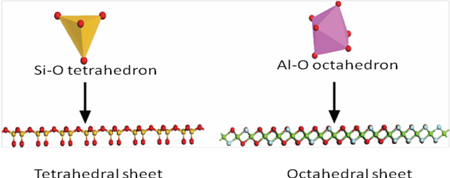

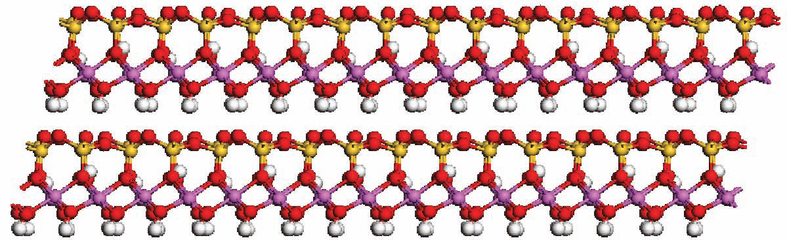
Figure 1.3. Tetrahedral sheet of Silica and octahedra sheet of Alumina.

Figure 1.4. Kaolinite of 1:1 Type clay minerals structure.
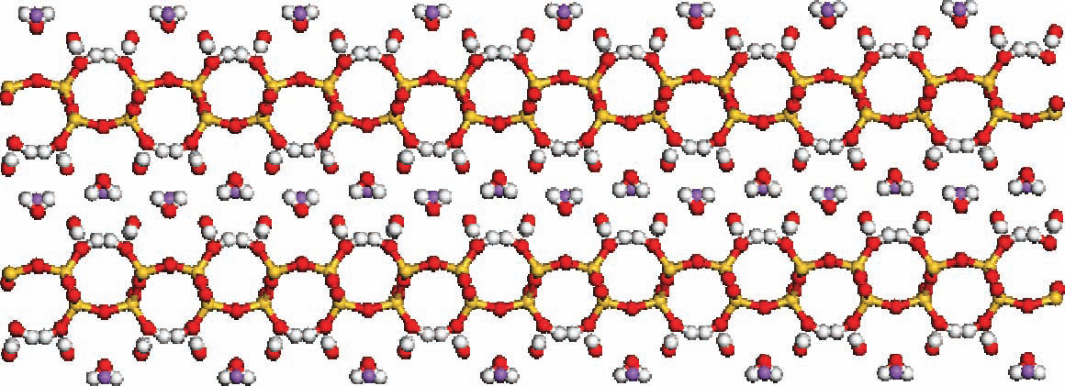

Figure 1.5. Kanemite of Layered silicic acids structure.
(iv) Layered Silicic Acids
Layered silicic acids are natural clay minerals. This type of clay minerals is made up of many layers of silicon tertahedron which are very thick. The fundamental structure of layered silicate contains hydrated alkali metal cations in the interlayer space. The interlayer regions contain silanol group which support organic modified functional group in that interlayer regions (Figure 1.5). This type of clay minerals have superior intercalation properties like smectite clay, which is one of the potential member for the preparation of organic polymer built nanocomposites. The chemical formula, examples of various clay and characteristic parameter of different types of clay are given in Table 1.1.
1.6. Montmorillonite (MMT)
Montmorillonite is one of the important 2:1 type clay layered mineral. This layered structure is formed by combination of two tetrahedral silica layers with one aluminium octahedral layers. The tetrahedral silica sheet contains oxygen atom to share octahedral aluminium sheet which provide negative charge to overall lattice structure (Figure 1.6). The surface of MMT structure is negative charged which attract cations like Na⁺, Ca⁺, Fe⁺ ions from other chemicals. These layers are held by Vander Waals force. The MMT of the silicate layer is planar structure, rigid in nature about 1 nm in thickness with large energetic surface range (700-800 m²/g) and large aspect ratio. D-spacing and basal spacing refers to the distance between the interlayer and single layer thickness. The total amount of the absorbed ions like (K⁺, Na⁺, Ca²⁺, and Mg²⁺) into the inter gallery of clay sheets at pH exact value of 7 is referred as cation exchange capacity. The measurement of a mill mol/100g of multilayer silicate is used to compute it. The ability to hydrate, swell, and disperse is stronger the more negative charge [16].
MMT is one of the most important clay for synthesising polymer clay nanocomposites when compare with other clay due to irregular structure, cation exchange capacity and the ability to swelling character. MMT have significant attention as a greener catalyst in many organic synthesis process. MMT is used in chemical waste reduction, control waste hazard, reduced energy consumption, reduced raw materials and also to reduce the process cost. It is used as adsorption of toxic heavy metals including As, Co, Cr, Pb, Mn, Ni and Cd. It is also used in improving the drug delivery system, adsorption of dyestuff, resistance to tooth decay, support of health and growth, water adsorption, heat resistance and cation exchange capacity.

Table 1.1. Classification of different types of Clays minerals.
S. NO. | Clay Minerals | Formula of Chemicals | CEC  (mequiv/100 gm) | Length of Particles (nm) | Substitution/  Charge
1 | 1:1 clay  Kaolinite  Halloysite | Al₂Si₂O₅(OH)₄  Al₂Si₂O₅(OH)₄.2H₂O | 1-10  1-30 | 30-40  30-40 | Neutral  Neutral
2 | 2:1 clay  Montmorillonite  Hectorite | M_{x}(Al_{4−x}Mg_{x})Si₈O₂₀(OH)₄  M_{x}(Mg_{6−x}Li_{x})Si₈O₂₀(OH)₄ | 120  130 | 110-160  210-310 | Octahedral/ Negative  Octahedral/ Negative
3 | 2:2 Clay  Chlorite | (Mg, Fe)₄Al₄Si₂O₁₀(OH)₈ | 10-40 | 1-100 | Tetrahedral/ Negative
4 | Layered silicic acid  Kanemite | Na₂Si₄O₉·5H₂O | 10-100 | 1-100 | Tetrahedral/ Negative
5 | Organo modified clay  Cloisite 25 A | 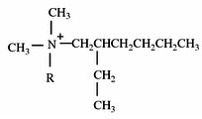 | 95 | 1-100 | Tetrahedral/ Negative

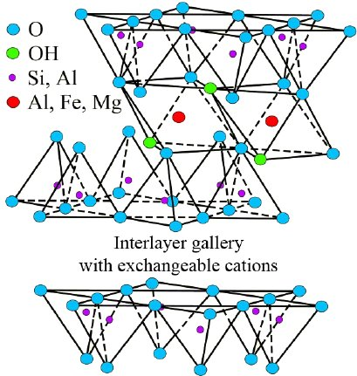

Figure 1.6. Structure of montmorillonite.

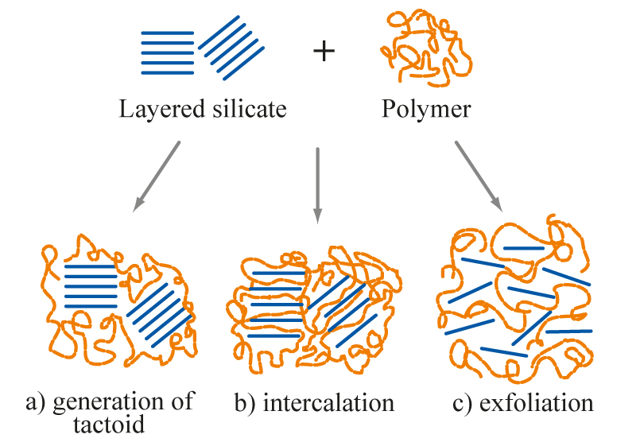

Figure 1.7. Intercalated and exfoliated nanocomposites from layered silicates and polymers.
1.7. Surface Modification of clay
Due to its unique cationic change intercalation and expansion capabilities, the clay mineral montmorillonite (MMT) has gained significant attention. MMT is a member of the 2:1 type of phyllosilicate mineral, and its crystal structure is made up of two sheets of silicon tetrahedra sandwiching an Al polyhedron octahedron layer that is only a few nanometers thick. Because the large aspect ratio and surface area improved bonding between clay and polymers, these clay nano particles offer greater advantages than the conventional macro or micro particles (e.g., glass, carbon fibers), with a lesser quantity of loading to obtain identical qualities. Clay-based bedding silicates have a deliquescent tendency.
Most organic polymers have hydrophobic properties. Due to the hydrophilic multilayer silicates minerals and hydrophobic polymers' inherent incompatibility, dispersion of clays in the majority of polymers is difficult to achieve. The surface of the pure clay minerals must be modified to be suitable with organic polymers in order to generate an unbeatable compound polymeric clay nano composite. Through a particle-exchange reaction between interlayer cations and quaternary grouping alkyl Al or aliphatic phosphonium cations, this alteration is completed. This change widens the d-spacing and promotes compound polymer diffusion towards the inner layer space [17].
1.8. Organic modification of clays
The organically modified pyllosillicate is known as organoclay which is obtained from natural clay minerals. The original inter layer cations such as Al³⁺ present in the clay exchange to polymer produced organophillic surface is made up of polymer organic moieties with covalent bond. The inter layer spacing of clay is reduced due to the ion exchange which changes the chemical characteristic of clay that is varied with polymer through in-situ or mixing polymerization. If the alumina silicate layer is well ordered and lying parallel to one other, it is separated from polymer chain then the system is classified as intercalated nanocomposite [18]. If these layers are randomly ordered and opposite to each other, the polymer chain is not separated and not so significant it is classified as exfoliated nano composites. The organic modified clay surfactant have higher basal spacing, due to this it acts as an effective material for adsorption. The high surface area, and high amount of aspect ratio of organo clay surface is combined with polymer chain to be used the remove heavy metals and oils from industrial effluents.
1.9. Polymer Clay nanocomposites
In recent years, both industry and academia have come to recognize polymer/clay nanocomposite as a new class of materials. When compared to other common macro and small composites, polymeric clay nanocomposites have drawn a lot of interest because they offer superior prospects for mechanical, chemical, thermal, barrier, and flame retardant qualities. The unit category of polymer clay nanocomposites consists of a number of phase materials, each of which is mixed with at least one dimension that falls within the size range of 1-100 nm. By incorporating one-dimensional nanoclay platelets into a large polymer matrix, polymeric clay nanocomposites are produced. The following three polymerization methods are used to create clay-based polymer and biopolymer nanocomposites.
(i) In situ polymerization techniques:
In this process, monomer in the liquid form are intercalated into clay sheets. This type of polymerization takes place within the layered clays which expands the d spacing of clay particle. This polymerization technique is initiated through heat, radiation, initiators and suitable catalyst. This method has produced exfoliated nanocomposites which provides a good attraction between the clay and polymer.
(ii) Melt intercalation polymerization techniques:
In this method, the organoclay is directly blended with thermoplastic polymer chain within the melted state. This polymerization process has produced either exfoliated or intercalated nanocomposites, because the surface of organo clay layer easily attracts with the thermoplastic polymer matrix and clay is easily diffused with this polymer chain. These techniques have more advantages than other methods because of its fast processing. Generally twin screw extrusion and injection moulding process are used to produce improved stress, strain and elongation at break properties.
(ii) Solution polymerization techniques:
In this method, the polymer is dispersed in acetone, water, and other appropriate solvents before being spread in clay. A intercalated polymer nanocomposite is synthesized through this method which has more potential because polymer has low or without polarity [19].
The structure of clay polymer nanocomposite depends on nature of clay, modifier of organic substance, polymer chain and preparation techniques. The above characteristics decide the exfoliation and intercalation of organic matrix polymer into layered filler galleries. The different polymer/clay nanocomposites structure are given below.
(i) Phase separated structure:
The phase separated polymer clay nanocomposites are obtained from organic polymer is combined with unmodified clay. Here the clay particles are diffused as aggregates within the polymer chain. The properties of the prepared nanocomposites have conventional micro structure.
(ii) Intercalated structure:
By inserting a polymer chain between the clay layer's interlayer spaces, intercalated nanocomposites are created. As the electrostatic tension between the layers of clay has lessened due to the polymer chain, the d spacing between the clay sheets has increased. Hence the obtained nanocomposites have ordered morphology, multilayer and better interaction.
(iii) Exfoliated structure:
This kind of polymer clay nanocomposites have clay layers that are isolated from the polymer matrix either collectively or individually. According to Figure 1.7, the clay layers are spaced apart by more than 80 A° and are randomly distributed along the polymer chain.
The resulting polymer-clay nanocomposites' characteristics are greatly enhanced by the processing method. Numerous genres of literature claim that solution mixing produces superior outcomes to melt mixing. One of the biggest challenges in melt mixing is still the dispersal of clay grains in the polymer matrix. Many consumer items, including barrier film materials, drink packaging, coatings that protect bottle applications, and adhesives moulding compounds, use polymer/clay nanocomposite. Clay minerals are widely employed as reinforcing elements to enhance the heat, mechanical, gaseous barrier, flames retardancy, dyeability, and numerous other characteristics of polymers. Clay minerals are frequently used as reinforcing materials due to their low price, density, great availability, favourable aspect ratio, and wide surface area, which are all increased by the polymer's characteristics.

1.10. Polyurethane nanocomposites preparations and its applications
Polyurethane (PU) is a type of block copolymers. It is formed by the polyaddition reaction of a diol or polyol, a diisocyanate or polyisocyanate and a chain extender. Only a small number of isocyanates, mostly aromatics like toluene diisocyanate (TDI), 4,4′-methylene bis (phenyl isocyanate) (MDI), and a few aliphatic or cycloaliphatic compounds like 4,4′-diisocyanate dicyclohexylmethane (H12MDI), are frequently used to prepare polyurethanes (PUs). Among the above, the blocked isocyanates are high reactivity of isocyanates, and their better stability. When exposed to the temperature, the blocked isocyanates deblocks and then reacts with OH or NH2 functional group co-reactants to produce thermally stable polyurethane [20]. Diisocyanates are less flexible than polyols in terms of chemical composition, utility, and molecular weight. However, the most widely utilized materials in the synthesis of PUs are polyether and polyester polyols.

The two essential procedures for the synthesis of PU are as follows:
(i) One-shot process: This method combines the simultaneous mixing of the basic components (polyol, diisocyanate, chain extender, and catalyst) to produce PU in a single step. Here it requires a comparable reactivity for various hydroxyl and isocyanate compounds, which is a very exothermic reaction.
(ii) Prepolymer process: This is a two-stage method, in which the first stage is the preparation of prepolymer by using the polyol and diisocyanate of average molecular weight of about 20,000. Based on the stoichiometry of the raw materials, the pre organic polymer can be hydroxyl-terminated or NCO-terminated. In the second step, to get a high molecular weight PU by reacting the prepolymer with a main chain extender.
Generally, PU is classified based on various properties such as a flexible and soft, rigid and hard, solid or open cellular which may be thermosetting or thermoplastic. PUs can be divided mostly into two categories. The two types of PU are aromatic and aliphatic, respectively, depending on the form of diisocyanate utilized. In general, aliphatic PUs provide exceptional optical clarity, excellent adhesion, and weather resilience. However, although having higher strength and toughness than aliphatic PU grades, aromatic PUs have less effective weather resistance.
PUs are primarily divided into three groups depending on the kind of polyol used: (i) polyester-based, (ii) polyether-based, and (iii) polycaprolactone-based. Although polyester-based PUs exhibit poor hydrolytic stability, they exhibit high mechanical qualities, thermo-oxidative rigidity, abrasion resistance, and chemical resistance. Polyether-based PUs, on the other hand, offer outstanding hydrolytic reliability and adaptability. However, the thermo-oxidative durability of PU based on polyether is not as good as PU based on polyester. The durability and resistance of polyester-based PUs are combined in polycaprolactone-found PUs. In comparison to polyether-based PUs, polyester-based PUs function better at low temperatures and have a reasonably good resistance to hydrolysis.
Hard and soft components make up the block copolymer known as PU. The primary cause of greater gas permeability through PU sheets or coatings is phase separation, which happens as a result of thermal instability between these segments. Polyurethanes (PUs) are extraordinary and adaptable polymeric materials with exceptionally balanced characteristics Coatings, adhesives, sealants, flexible or stiff foams, varnishes, paints, leathers, rubber, textiles, films, biomimetic materials, with a host of other products are some of the various uses for PUs. The intrinsic permeability of PUs to gases and vapors such as O2, N2, CO2, He, and other volatile substances is a significant drawback despite their diverse features. The gas barrier property of PUs is significantly less effective than that of other polymeric barrier systems. However, based on the arrangement and morphology of PU, the permeability of various gases into PU films/membranes differs significantly. By tweaking the PU-chemistry or altering its morphology, as well as by carefully choosing the constituents, composition, and production circumstances, it is possible to improve the gas barrier characteristic of PU to a certain extent.
The structure of the method for moving gases via a membrane made of polymers or sheet is depicted in Figure 1.8. The gases first become adsorbed or soluble on the membrane's or film's surface, and then they diffuse through it. The gas molecules reside in the free volume spaces produced by the Brownian movement of chains of polymers or thermal agitation during absorption on an unstructured polymeric membrane or film. The gas molecules move through the linked, open regions during diffusion, however. Diffusion therefore depends upon the size and quantity of free volume gaps within the polymer. The dynamic volume at rest produced by the segmental movement of the chain of polymers determines the gas diffusivity.

Figure 1.8. Gas permeation through (a) polymer, (b) polymer with micro-additives, and (c) polymer nanocomposite.

While the interaction of gas molecules with polymeric chains determines the solubility [21]. The gas permeation process is influenced by the size, shape, structure, the orientation, and amount of crystallinity of the crystallites in semicrystalline polymeric membranes and films. PU is a kind of semicrystalline polymer with only a small amount of hard segments or crystalline part. The more soft segments there are in the PU structure, the more free space is created and the more quickly gases diffuse across PU films and membranes. The polymer nanocomposites respond similar to a semicrystalline polymers in terms of gas permeability. Impermeable nano-platelets are spread in a polymer matrix in gas barriers polymer nanocomposites, which reduces gas diffusion by giving gas molecules a longer winding route. Activated diffusion process is the most widely accepted hypothesis of gas transport across a nonporous polymeric barrier. The molecular size of fluid gases, temperature, humidity, and the type of plastic being utilized all have an impact on gas transmission by induced diffusion mechanisms. In general, the quantity of pinholes and the amount of pressure difference between the film's two sides both influence the gas flow rate [22].

1.11. Poly (ethylene-co-vinyl acetate) (PEVA) composites
Ethylene-vinyl acetate is otherwise called as PEVA. It is a copolymer of vinyl acetate (VA) and ethylene. The vinyl acetate's content weight percentage is very important to decide the property of polymer, which varies from 10 to 40 %, and the remaining content is ethylene percentage. Based on vinyl acetate content in EVA copolymer, which classified into three types are as follows,
The first one is based on vinyl acetate content proportion around up to 4% which is called as VA modified polyethylene. This is a thermoplastic co-polymer like low- density polyethylene and considers as non-toxic. They have improved property such as gloss, flexibility, and softness than the low-density polyethylene. If the vinyl acetate content is approximately 4 to 30% it is known as thermoplastic elastomeric material. This thermoplastic EVA copolymer has properties of rubber and which is not vulcanized. At low temperature, these materials are tight, with 11% Vinyl Acetate are applied as hot melt adhesives. If the VA content is of a higher proportion that is higher than 40%, it is known to as EVA rubber [23].
PEVA copolymer is prepared over the free radical polymerization of ethylene and VA by high amount of pressure, and temperature reactors are followed by batch processing to remove residual monomer is shown in Figure 1.9. The flexible, soft, and polar amorphous vinyl acetate blocks that make up the domain structure of EVA copolymers are composed of rigid as well as partially crystalline polyethylene blocks.
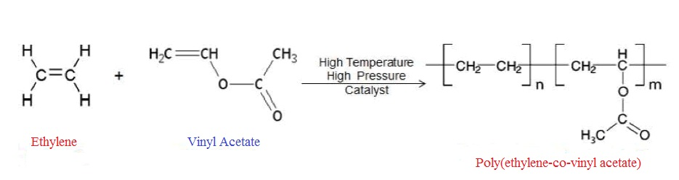

Figure 1.9. Formation of Poly(ethylene-co-vinyl acetate).
The polyethylene fibers that make up the PEVA copolymer that create the crystalline areas are disrupted by the first action. The polarity of the acetoxy chain on one side is what causes the second impact caused by vinyl acetate content. The polarity of the polymerization increases along with the amount of vinyl acetate present. The rise in polarity raises some intriguing characteristics, though less obviously than the decrease in crystallization; more importantly, it is the cause of the vast range of uses for EVA copolymers. Other than melt viscosity, molecular weight (MW) have a significant impact on other properties. However, it should be noted that the impact of other structural elements usually affects the effect. EVA offers the added benefit of having strong adhesion and good material compatibility. The main uses of EVA copolymers include packaging film, adhesive or paper protective coatings, cable and wire insulating material, textiles aid, moulding and extrusion, and foam, and soundproofing sheet [24]. Generally speaking, paper, wood, plastic, rubber, metals, and coated metals are just a few of the many substrates that EVA-based hot-melt glues are utilized on.
The addition of vinyl acetate into the ethylene polymerization method produces a copolymer which have a lesser crystallinity than pure ethylene homopolymer. These organic polymers with lower crystallinity have lower melting temperatures, a lower heat-stop temperature, and less rigidity, tearing strength, and flexibility. Compared to Low-Density Polyethylene (LDPE), EVAs have higher clarity, low-temperature mobility, stress-crack resistance, and strength at impact but lower high-temperature characteristics. The atomic oxygen, water vapor, and CO2 permeability of ethylene vinyl acetate polymers is higher. EVA's chemical resistance is comparable to that of LDPE, with greater VA content EVA resins having somewhat improved resistance to lubricants like oil and grease. Exposure to a temperature above 130ºC causes loss of acetic acid, which leaves behind a structure more susceptible to attack by oxygen. This is more noticeable in higher VA resins, in which a combination of temperature and exposure time can produce significant degradation. Higher VA resins are flexible and soft with outstanding durability as well as excellent stress-crack resistance in EVA resins; these characteristics are permanent; they do not dissipate over time due to the depletion of liquid plasticizer. EVA resin properties vary from comparable to LDPE to that of highly plasticized PVC with increasing VA content. [25]. This is not the case with PVC resins. They are real thermoplastics and can be reprocessed without waste, except for resins that are cross-linked during processing to achieve enhanced elastomeric properties.
EVA copolymers are employed in numerous extrusions, compounding, and moulding processes. Flexible hose and tubing, parts for footwear, wire-and-cable compounding, toys, athletic goods, colour concentrates, extruded gaskets, automotive parts (like energy-absorbing bumper components), gaskets for coating plastic lenses, and cap and closure seats are a few examples of typical end uses. The EVA resins are employed in flock or textile laminated counter and canvas box toes in footwear applications. Sandals and the midsoles of athletic or casual shoes are made of foamed and cross-linked EVA. EVA compares favourably in space-filling characteristics with such other soft thermoplastics as plasticized PVC. EVA has a specific gravity of 0.95 to 1.0 as compared to 1.2 for PVC, which gives it a space-filling advantage per unit weight of 20%. The flame retardant characteristics of prepared Poly(ethylene-co-vinyl acetate) nanocomposites are analysed by calorimeter which shows better results even with low percentage of clay.
Conclusion
In this work reported that short analysis of adsorption of heavy metals chromium, permeability of O₂, N₂ gas and fire-retardant properties of different weight percentage of clay polymer nanocomposites. These materials are prepared from various techniques and applied in different tannery waste effluents in industries. The new methodology is applied to polymer nanocomposite to overcome the difficulties of existing techniques. Solution polymerization, microwave assisted, conventional methods are generally used to prepare a nanocomposite. Dependent upon the types of polymer, clay, organic modifier the preparation methodology are varied with selectivity and sensitivity. The application of synthesized nanocomposites depends on types of the polymer (organic, biopolymer) and modified clay. The novel nanocomposite materials use new methods for reducing gas permeability, fire retardant and adsorption of chromium which focuses on the factors of availability, eco friendly, decomposable, recovery solvent. The montmorillonite clay is surfactant modified by using triocylamine and it is used as an adsorbent for heavy chromium metal present in tannery wastewater treatment. Gas permeability properties of polyurethane and Flame retardant properties of Poly(ethylene-co-vinyl acetate) clay nanocomposites is synthesized by solution polymerization method.

References
[1] M. B. Armand, Polymer Electrolytes, Ann. Rev. Mater. Sci., 1986, 16, 245-261.
[2] M. Watanabe, T. Endo, A. Nishimoto, K. Miura, and M. Yanagida, High ionic conductivity and electrode interface properties of polymer electrolytes based on high molecular weight branched polyether, J. Power Sources., 1999, 81, 786-789.
[3] A. Nishimoto, K. Agehara, N. Furuya, T. Watanebe, and M. Watanebe, High ionic conductivity of polyether-based network polymer electrolytes with hyperbranched side chains, Macromolecules., 1999, 32, 1541-1548.
[4] J. M. Tarascon, and M. Armand, Issues and challenges facing rechargeable lithium batteries, Nature., 2001, 414, 359-367.
[5] M. Alexander and P. Dubois, Polymer-layered silicate nanocomposites: preparation, properties and use of a new class materials, Mater. Sci. Eng. R. Rep., 2000, 28, 1-63.
[6] P. Malakul, K. R. Srinivasan, and H. Y. Wang, Metal adsorption and desorption characteristics of surfactant-modified clay complexes, Ind. Eng. Chem. Res., 1998, 37, 4296-4301.
[7] S. Kalidhasan, S. Sricharan, M. Ganesh, and N. Rajesh, Liquid-Liquid extraction of chromium(VI) with tricaprylmethylammonium chloride using isoamylalcohol as the diluent and its application to industrial effluents, J. Chem. Eng. Data., 2010, 55, 5627-5633.
[8] D. Mohan, and CU. Jr. Pittman, Arsenic removal from water/wastewater using adsorbents- A critical review, J. Hazard. Mater., 2007, 142, 1-53.
[9] R. Saha, R. Nandi, and B. Saha, Sources and toxicity of hexavalent chromium, J. Coord. Chem., 2011, 64, 1782-1806.
[10] M. M. Chumchal, T. R. Rainwater, S. C. Osborn, A. P. Roberts, M. T. Abel, G. P. Cobb, P. N. Smith, and F. C. Bailey, Mercury speciation and biomagnifications in the food web of Caddo lake, Texas and Louisiana, USA, a subtropical freshwater ecosystem, Environ. Toxicol. Chem., 2011, 30, 1153-62.
[11] Y. Liu, Z. Xu, and S. M. Kuznicki, Development of a novel mercury cartridge for mercury analysis, Energ. Fuels., 2010, 24, 10-17.
[12] T. Duan, X. Song, J. Xu, P. Guo, H. Chen, and H. Li, Determination of Hg(II) in waters by on-line preconcentration using Cyanex923 as a sorbent-cold vapour atomic absorption spectrometry, Spectrochim. Acta., 2009, 61, 1069-1073.
[13] Q. H. Zeng, A. B. Yu, G. Q. Lu, and D. R Paul, Clay-based polymer nanocomposites: research and commercial development, J. Nanosci. Nanotechnol., 2005, 5, 1574-92.
[14] P. Yuan, M. Fan, D. Yang, M. Hongping He, D. Liu, A. Yuan, J. X. Zhu, and T. H. Chen, Montmorillonite - supported magnetite nanoparticles for the removal of hexavalent chromium[Cr(VI)] from aqueous solutions, J. Hazard. Mater., 2009, 166, 821-9.
[15] F. Bergaya, and G. S. Lagaly, Surface modification of clay minerals, Appl. Clay. Sci., 2001, 19, 1-78.
[16] S. S. Ray and M. Okamoto, Polymer/Layered silicate nanocomposites: a review from preparation to processing, Prog. Polym. Sci., 2003, 28, 1539-641.
[17] M. Darder, M. Colilla, and E. Ruiz-Hitzky, Chitosan - clay nanocomposites:application as electrochemical sensors. Appl. Clay Sci., 2005, 28, 199-208.
[18] D. K. Chattopadhyay, and K.V.S.N. Raju, Structural engineering of polyurethane coating for high performance applications, Prog. Polym. Sci., 2007, 35, 352-418.
[19] G. V. R. Reddy, M. Joshi, B. Adak, and B. L. Deopura, Studies on the dyeability and dyeing mechanism of polyurethane/clay nanocomposite filaments with acid, basic and reactive dyes, Coloration. Technol., 2018, 134, 117-125.
[20] I. S. Stefanovic, M. Spirkova, S. Ostojic, P. Stefanov, V. B. Pavlovic, and M. V. Pergal, Montmorillonite/poly(urethane-siloxane) nanocomposites: morphological, thermal, mechanical and surface properties, Appl. Clay. Sci., 2017, 149, 136-146.
[21] H. M. Lee, B. J. Park, H. J. Choi, R. K. Gupta, and S. N. Bhattachary, Preparation and rheological characteristics of Ethylene-Vinyl Acetate Copolymer/Organoclay Nanocomposites, J. Macromol. Sci. Pt B., 2007, 46, 261-73.
[22] Y. Zhong, D. Janes, Y. Zheng, M. Hetzer, and D. D. Kee, Mechanical and oxygen barrier properties of organoclay-polyethylene nanocomposite films. Poly. Eng. Sci., 2007, 47, 1101-107.
[23] R. Wilson, S. M. Georage, J. M. Hanna, S. P. Tomas, S. Anil kumar, and S. Thomas, Clay Inetcalation and its influence on the Morphology and Transport Properties of EVA/Clay Nanocomposites., J. Phys. Chem. C., 2012, 116, 20002-14.
[24] W. S. Wan Ngah, S. Fatinathan, Adsorption of Cu(II) ions aqueous solution using chitosan beads, chitosan - GLA beads and chitosan-alginate beads, Chem. Eng. J., 2008, 143, 62-72.
[25] X. J. Hu, J. S. Wang, Y. G. Liu, X. Li, G. M. Zeng, Z. L. Bao, X. X. Zeng, A. W. Chen, and F. Long, Adsorption of chromium (VI) by ethylenediamine-modified cross- linked magnetic chitosan resin: isotherms, kinetics and thermodynamics, J. Hazard. Mater., 2011, 185, 306-14.

