ITRAQ: A Proteomic Approach for Quantification of Protein and Data Analysis
Komal G Lakhani¹, Sheetal Gupta² and G. V. Marviya³

¹Department of Biotechnology, College of Agriculture,
Junagadh Agricultural University, Junagadh-362 001
²Department of Genetics and Plant Breeding

Maharana Pratap University of Agriculture & Technology, Udaipur -313004
,
School of Science, Gujarat University, Ahemdabad-380 009
³Krishi Vigyan Kendra, Junagadh Agricultural University, Targhadia (Rajkot)- 360 023
Email: komallakhani2706@gmail.com

Abstract: Proteins are large, complex molecules and are considered the basis of life as they perform a wide range of functions in living organisms, including structural support, enzymatic catalysis, signaling, and regulation of gene expression. Proteomics, a branch of molecular biology, helps understand the comprehensive analysis of proteins, particularly their structures, functions, interactions, and abundances within a biological system. Over the years, several quantitative proteomic methods have been developed to measure protein abundances and compare protein expression levels between different conditions or samples. This facilitated studying dynamic changes in the proteome in response to various stimuli. Isobaric Tags for Relative and Absolute Quantification (iTRAQ) is a groundbreaking technique that has revolutionized proteomic research. iTRAQ is a bottom-up approach and shotgun-based quantitation technique that enables simultaneous identification and relative quantification of hundreds of proteins in up to eight different biological samples in a single experiment with the use of mass spectrometry. This review paper aims to provide a comprehensive overview of the iTRAQ technique, highlighting its principles, experimental workflow, data analysis strategies, and its applications in various fields.

Keywords: Proteomics, protein quantification, mass spectrometry, iTRAQ, data analysis

Introduction:
Since the beggining of biological research, dynamic role of biomolecules to sustain life has been well documented. In 1838, Berzelius proposed these molecules title “protein” to emphasize their significance [1]. The word protein derived from Greek term, proteios, meaning “the first rank”. The proteome refers to the entire set of proteins that are produced or expressed by a cell, tissue, or organism at a specific time or under specific conditions. Proteins are large, complex molecules that perform a wide range of functions in living organisms, including structural support, enzymatic catalysis, signaling, and regulation of gene expression. In comparison to genomics, proteomics offers a greater grasp of the composition and operation of the organism. However, it is considerably more challenging than genomic due to change in response to various factors such as developmental stages, environmental conditions, and disease states [2]. It is influenced by the genetic information encoded in the genome, but additional factors like post-translational modifications and protein interactions also contribute to the complexity of the proteome. Studying the proteome is important for understanding biological processes and functions, as proteins are the primary effectors of cellular activities [3]. The proteome of eukaryotic cells is quite striking in its complexity due to post-translational modification and dynamic range [4,5]. Prokaryotic proteins have a variety of characteristics, such as variations in abundance, size, and a propensity either attract or repel water , which makes it challenging to analyze them [6]. In addition to the quantity of corresponding mRNA, which is a key factor in determining protein abundance, the host organism's ability to control and regulate translation also plays a significant role in biological processes. In order to fully describe a biological system, proteomics proves to be the most important set of data [7].
In 1996, Marc Wilkins coined term “proteomics” to refer to the complete set to proteins coded by a genome [8]. The broad study of proteins known as proteomics focuses on understanding the proprties of proteome, encompassing protein expression, roles of protein, expression profile, post-translational modifications and protein-protein interactions in driving cellular processes under stress as well as control condition [9, 10, 11]. Proteomics entails understanding the proprties of proteome, encompassing protein expression. Proteomic plays a vital role in prediction and detection of disease as well as developement of drug as a targeted molecule. The proteome undergoes variation periodically, between different cells, and in reaction to external triggers. Plant responses to stress and the intricacy of biochemical processes are both studied using a proteomics method [12, 13]. Plant stress proteomics offers the capacity to locate potential candidate genes that could be utilised to genetically modify plants to withstand stressors. Under abiotic stresses, plants always experience a noticeable change in protein expression. A proteomic approach will be very helpful in elucidating the role of protein accumulation under stress conditions and its association with stress tolerance [14, 15, 16].

Among the omics approaches, genomics and transcriptomicsare valuable, but have a limitation of providing indirect measurements of cellular conditions that not accurately reflect changes in proteins. A change in posttranslational modifications (PTMs), such as phosphorylation and protein degradation, is not mentioned in data. Hence, purely relying on genomic data does not provide a complete understanding of the disease mechanisms. Investigation of proteomic changes related to a disease frequently aids in understanding the mechanisms behind the disease, as well as pinpointin valuable biomarkers and targets for treatment. These proteins rarely exhibit either total "presence" or total "absence". It is more likely that they will have varying degrees of abundance. To measure these changes accurately and sensitively, it is essential to adopt an appropriate methodology.

The use of shotgun proteomics methodologies allows for detection of proteins that are either increased or decreased in levels under certain conditions, which can be investigated from various cells and tissues. The process of multiplexing Itraqt is simple and allows for the analysis of upto eight distinct samples in a single experiment. The purpose of this chapter is to explain considerable depth the iTRAQ methodology in laboratory , thee extent of its functionality and pipeline for data analysis of iTRAQ.
The goals of proteomics are diverse and include:

1. Protein identification and characterization: Proteomics aims to identify and describe proteins present in a sample, including their amino acid sequences, post-translational modifications, and three-dimensional structures. This information provides insights into protein function and their roles in biological processes.

2. Protein quantification: Proteomics techniques allow for the measurement of protein abundance levels in different samples or under different conditions. By comparing protein quantities, researchers can identify proteins that are differentially expressed and gain insights into cellular responses and disease mechanisms.

3. Protein-protein interactions: Proteomics helps in elucidating the interactions between proteins, identifying protein complexes, and understanding how proteins interact to carry out specific cellular functions. This information aids in unraveling complex biological networks and signaling pathways.

4. Biomarker discovery: Proteomics plays a crucial role in the identification of protein biomarkers, which are specific proteins or protein patterns that can indicate the presence or progression of a disease. Biomarkers have potential applications in disease diagnosis, monitoring treatment responses, and developing personalized therapies.
Overall, proteomics provides a comprehensive approach to studying proteins, enabling a deeper understanding of cellular processes, disease mechanisms, and the development of new diagnostics and therapeutics.

Types of Proteomics:

Proteomics can be categorized into different types based on the specific aspects of protein analysis and the goals of the study. Here are some commonly recognized types of proteomics:

- Expression Proteomics: Expression proteomics aims to analyze and compare protein expression levels between different samples or conditions. It involves the identification and quantification of proteins to understand changes in protein abundance. Techniques such as mass spectrometry-based quantitative proteomics and protein microarrays are commonly used in expression proteomics [17].

- Structural Proteomics: Structural proteomics focuses on determining the three-dimensional structures of proteins. It involves techniques such as X-ray crystallography, nuclear magnetic resonance (NMR) spectroscopy, and cryo-electron microscopy (cryo-EM). Structural proteomics provides insights into protein folding, conformational changes, and interactions with ligands or other molecules [18].

- Functional Proteomics: Functional proteomics aims to understand the functions of proteins in a biological system. It involves investigating protein-protein interactions, post-translational modifications (PTMs), enzymatic activities, and cellular localization. Techniques such as protein microarrays, yeast two-hybrid assays, and phosphoproteomics are used in functional proteomics [19].

- Interaction Proteomics: Interaction proteomics focuses on studying protein-protein interactions. Itinvolves identifying and characterizing protein interaction networks, protein complexes, and signaling pathways. Techniques used in interaction proteomics include yeast two-hybrid assays, co-immunoprecipitation (Co-IP), and affinity purification coupled with mass spectrometry [20].

Techniques of Proteomics:
In the field of proteomics, many approaches are being utilized and developed to enable quantitative comparison of samples between states. These can be categorised into mass spectrometry-based or gel-based approaches. According to comparative research, each approach in proteomics has advantages and disadvantages and complements one another. Isobaric Tags for Relative and Absolute Quantitation (iTRAQ), a shotgun technique, is one methodology that has attracted more attention [21, 22]. In comparison to other techniques like 2DE [23], ICAT [24], and DIGE [25], iTRAQ provides greater quantitative repeatability, higher sensitivity and has numerous applications in proteomics research [26].

 Gel based:

  - SDS-PAGE (sodium dodecyl sulphate–polyacrylamide gel electrophoresis)
  - 2-DE (Two-dimensional gel electrophoresis)

Off gel base

  - LC ( Liquid Chromatography)

Quantitative proteomics

  - iTRAQ (Isobaric tags for relative and absolute quantitation)
  - ICAT (Isotope-coded affinity tag)
  - SILAC (Stable Isotope Labeling by Amino acids in Cell culture)

Mass spectrometry

  - MALDI - TOF (matrix-assisted laser desorption ionization time-of-flight mass spectrometry )
  - LC-MS (Liquid chromatography–mass spectrometry)
  - CE-MS (Capillary electrophoresis–mass spectrometry)

Isobaric tag for relative and absolute quantitation:

- Applied Biosystems Incorporation created the isobaric tag for relative and absolute quantitation, or iTRAQ, in 2004. iTRAQ is one of the most popular and very simple method for proteome investigation.
- iTRAQ is a bottom-up approach and shotgun-based quantitation technique that enables simultaneous identification and relative quantification of hundreds of proteins in up to eight different biological samples in a single experiment with use of mass spectrometry.

Principle and workflow of iTRAQ:

The isobaric tagging reagents consist of a unique charged reporter group, a peptide reactive group, and a neutral balance group. This technique enables rapid protein identification and relative quantification at the MS/MS level by utilizing peptide fragments and low mass reporter ions [27]. All of the peptides in a specific sample digest are labelled by the peptide reactive group, which covalently joins an iTRAQ reagent isobaric tag with each lysine side chain and N-terminus group of a peptide. The iTRAQ reporter ions are released during collision-induced dissociation (CID), and their relative intensities are used to quantify proteins.

Components used in iTRAQ

- Isobaric Tag : The MS-based method known as iTRAQ uses four isobaric, isotope-coded tags to mark the proteins via their N-terminal and allows for relative and absolute protein quantification in up to four cell preparations. A reporter group, a balancing group, and an amine-specific reactive group make up the three main parts of the iTRAQ tag molecular backbone.
- Protein samples: The samples whose proteins need to be quantified by iTRAQ procedure.
- Trypsin digestion: Trypsin is a proteolytic enzyme that breaks down proteins at the C-terminus of arginine and lysine residues, with the exception of when proline is present after those residues. As a result, huge protein samples can be divided into manageable peptide fragments.
- Peptide fragments: The smaller fragments obtained upon cleavage of the protein samples after trypsin digestion.
- iTRAQ label: The N-terminus of all peptides is labelled by a protein reactive group in the iTRAQ reagent, which also includes free amine groups on lysine side chains, a neutral balance component, and a reporter group. The labels are isobaric due to the differing isotope distributions between the reporter and balance groups, which allows for their detection in MS upon fragmentation and release.
- SCX purification: To eliminate any unbound iTRAQ reagent and to simplify the peptide mixture, tagged peptides are separated on a strong cation exchange column.

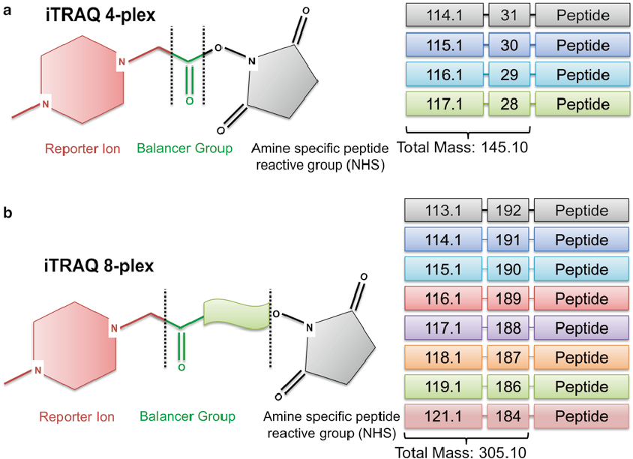

Fig. 1: Chemical structures for iTRAQ ( a ) 4-plex and ( b ) 8-plex isobaric tags. Balancer + reporter ions add up to 145 Da in 4-plex and 304 Da in 8-plex experiments. In 8-plex, reporter mass of 120 is not present as it will give erroneous quantitation since phenylalanine immonium ion is also observed at a mass of 120 Da
Source: Aggarwal and Yadav, 2015 [28]

- LC-MS/ MS analysis: The reverse phase liquid chromatography is used to further purify the iTRAQ- labeled peptides that are obtained, and tandem mass spectrometry is used to analyze them. In order to determine the relative abundances of the peptides, each tag causes the release of a unique mass reporter ion following peptide fragmentation.

Workflow of iTRAQ:

1. Sample preparation:
The protein sample was extracted from cell/tissue and extracted samples were digested with trypsin to break down the protein samples into smaller peptide fragments. Unless lysine and arginine residues are followed by a proline residue, the trypsin cleaves proteins at their C-terminal regions. The 1-DE was used to assess efficiency of the digestion process. The simplest method for desalting, a small amount of protein solution with centrifugal filters C₁₈ tips with various MWCB membrane.

2. iTRAQ labelling:

The peptide ts generated are separated by SDS-PAGE to simplify the mixture and then tagged with the iTRAQ label [29]. The iTRAQ reagent consists of a reporter group, a balance portion and a peptide reactive group that interacts with the N-terminus of the peptide or free amino group of lysine residues, giving it an overall mass of 145. The reporter group used to label each peptide sample is unique, with mass varying between, thereby enabling the labeling and quantification of four samples simultaneously. This has been further improved to allow labeling of eight samples simultaneously.

Amount of sample isobaric labeling is a key parameter is the amount of material that can be labeled with isobaric reagents. Labelling too many samples would waste the isobaric reagents and labeling too few samples would result in inadequate labeling because of a lack of tags. In research involving the characterization of protein post-translational modifications (PTMs), it is imperative to label as much material as possible because the quantity of beginning materials directly correlates with the number of PTM sites found and quantified [30].

Concentration of peptide and protein for labelling:

Samples can be calculated either before or after digestion (at the protein or peptide level). The amino acid analysis (AAA), Lowry protein assay, bicinchoninic acid (BCA) protein assay, Bradford protein assay, Qubit fluorescence assay, or ultraviolet (UV) absorbance can all be used to determine the protein content [31, 32]. Depending on the sample composition, the best protein assay technique should be chosen because some components can impede the results of particular protein assays. Using UV absorbance at 280 or 205 nm, AAA, the BCA peptide assay, or peptide concentration can be calculated [33].

3. Fractionation:

For a quantitative proteomic analysis, fractionating isobaric-labeled peptides provides various benefits, including a reduction in sample complexity, an increase in coverage of complicated proteomes, and an improvement in the analytical dynamic range of the samples. As the interferences from precursor ions depend on the complexity of the sample and the quantity of coeluting peptides, it also partially affects the ratio compression of isobaric labelling [34]. The isobaric-labeled peptides are fractionated using chromatographic techniques as High-pH RPC [35, 36], strong cation exchange chromatography [37], or HILIC [38] in order to expand the proteome coverage and decrease sample complexity. Despite the fact that SCX chromatography has strong orthogonality to the acidic pH reversed-phase LC, it necessitates a further desalting step after the fractionation, which causes sample loss and extends the processing time for samples.

The labelled samples are then combined, poured into a column in the direction shown, and allowed to run through the column before being collected in the empty beaker below. The purpose of getting rid of any extra unbound iTRAQ reagent, the pooled samples are purified on a powerful cation exchange column. The IPG gel strips rehydrated for 15 minutes using the peptide IPG strip rehydradation and sample poured into each well. The peptides are electrofocused and peptide fractions removed after focusing, and the wells were then rinsed. The washing solutions were then combined with the matching peptide fraction.
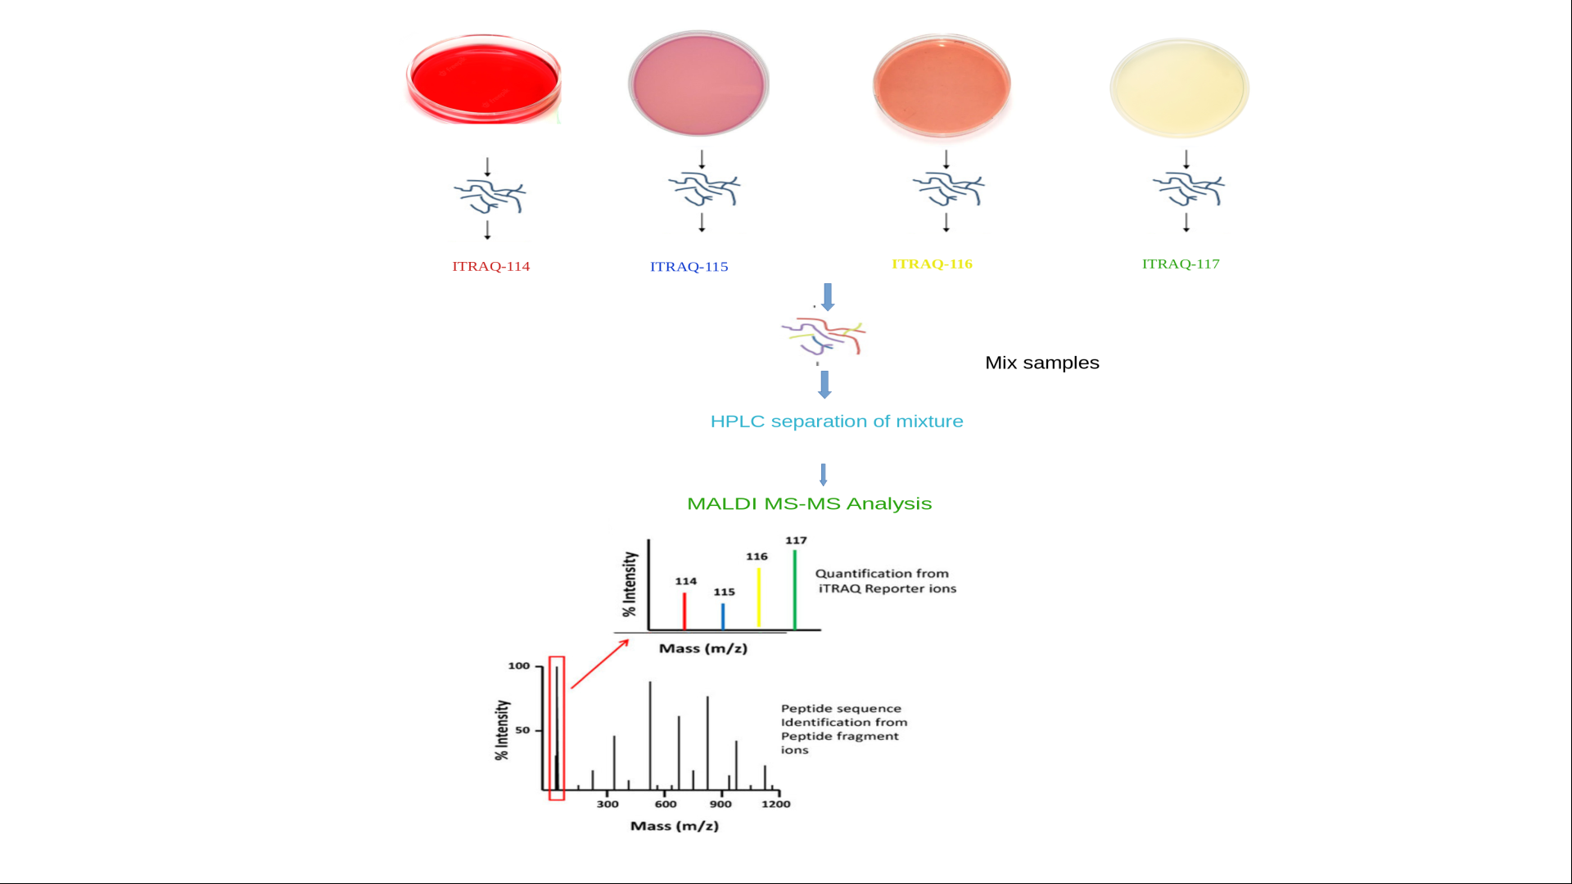

Fig. 2: Workflow of iTRAQ

4. Separation:

The "injector" should be inserted into the sample with the plunger lowered and injected into the column. It must be demonstrated that liquid flows via the tube that connects the "pump" and the "column”.The colour of the column must change once the liquid is flowing, and it must be demonstrated that the liquid has passed through the tubing at the outlet. The SCX-purified peptides are further purified using reverse phase liquid chromatography, in which the sample is run through a column containing a packed stationary phase matrix that only adsorbs specific analyte molecules. MS is used to further characterise the eluted fractions.

5 LC-MS /MS analysis:

It was initially difficult to analyze samples with MS that had been isobarically labelled. However, isobaric-labeled peptide-based quantitative proteomics investigations have become commonplace analyses thanks to the quick advancement of MS technology. It was initially only possible to analyze isobaric-labeled samples using mass analyzers that could detect low mass range ions, such as tandem time-of-flight (TOF/TOF) or quadrupole-time-of-flight (Q-TOF) [39, 40]. Isobaric labelling uses fragment ions from the low m/z range of the MS2 spectra for peptide quantification.

Following purification, the labelled peptide fragments are analyzed by MS/MS. The reporter groups' various masses enable the identification of the peptide fragments. Fragmentation results in the loss of the reporter group. iTRAQ now allows for the relative quantification of up to eight samples. Analyzing samples that have been isobarically labelled requires that certain MS specifications. The best configurations for various LC-MS/MS systems should be identified for collision energies, isolation windows, instrument voltages, and ion target settings depending on the isobaric tags used, the sensitivity and speed of the MS instrument, and the chromatographic resolution [41].

6. Peptide Spectra analysis:

In addition field for PMF, the MS/MS data analysis software offers other inputs including Quantitation, MS/MS tolerance, peptide charge, instrument, etc. They need the user's input on the experimental parameters employed, such as the protein name, alterations, and enzyme cleavage, as well as the desired search criteria, such as taxonomy and peptide tolerance. The NCBI, MSDB, and SwissProt protein databases are frequently used while processing MS data to retrieve sequence data. The data file produced by MS is submitted and a search is run. The search is run after the data file produced by MS is uploaded.

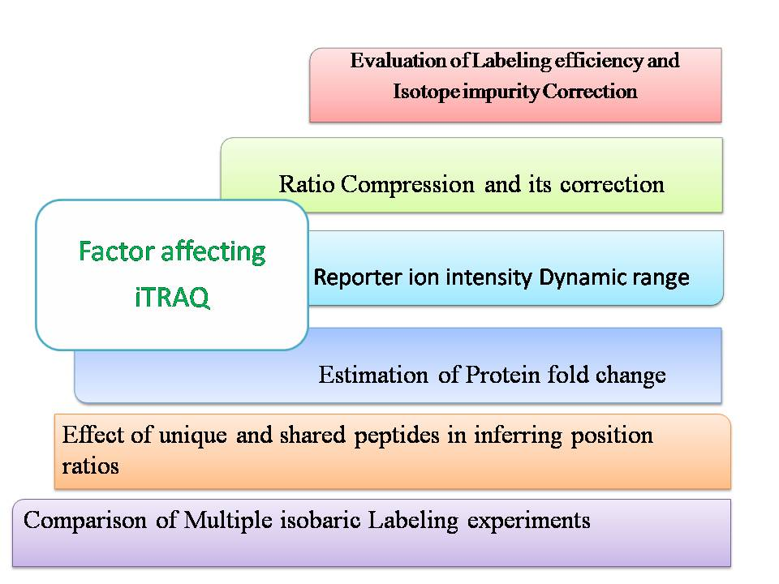
Data analysis:
Protein identification and quantification, isobaric labeling data are analyzed with proteomic software after MS data capture. Data from isobaric labeling can be analyzed using a variety of proteomic programmes. There are certain programmes designed expressly for the analysis of isobaric labelling data, including MSnbase [42], OCAP [43], Isoprot [44], PQPQ [45], MaxQuant [46], and LIQ-iQUANT [47].
Two procedure are employed to process the MS raw files during data analysis: one for protein identification and the other for protein quantification. After that, the results of the two procedures are combined to create a protein list with identification and quantification details. The quantitation process entails a number of phases, including pre processing of the data, area and error calculations, isotopic correction, ratio calculations, determining protein abundances, and statistical analyses for group comparisons. It is important to remember that quantification happens at the level of the spectrum, which represents peptides rather than proteins.

Preprocessing of data and Database Search:

The removal of low-quality spectra from the data is necessary for accurate quantification. For the purpose of removing low quality data, data preparation comprises selecting peaks and removing noise from the MS/MS spectra. Compared to quantitation, which just requires a very small amount of data filtering in order to calculate an exact area, this processing can be very different. The quantitative accuracy of isobaric labelling is greatly influenced by the co-isolation of interfering precursor ions in the MS/MS selection window. This phase just calls for baseline correction and noise removal below the signal-to-noise threshold. While clean and processed spectra are beneficial for identification, too much processing may damage quantitation. Therefore, it is advised to use profile mode data for quantitation whereas, central data should be used for identification.
For peptide and protein identification, a number of database search techniques, including X!Tandem [48], Mascot [49], MassWiz [50], OMSSA [51], and Paragon [52] can be employed.

Reporter Area and error calculation:

The raw peak areas are integrated, and the estimation error for the area is computed. This stage necessitates the accurate identification of the reporter ion peaks in a specified low-mass m/z band (100-125 Da) within a tolerance range. After determining the peak area, the quantification error is calculated to account for any potential errors that might occur during area calculation. Error (E) can be determined by referring to ProteinPilot help manual.
E=√I
where,
I= total intensity computed for a single reporterion.
Various software applications employ distinct error models could produce marginally varied outcomes [53, 54, 55]. In general, the software utilize a specific error model includes its documentation due to the absence of a general agreement. The i-Tracker reference provides a comprehensive explanation of how to calculate errors.

Isotope correction:

The intensity of each reporter ion includes overlapping isotopic contributions from nearby tags because the isobaric labelling reagents are not completely pure, and isotope correction should be applied to the reporter ion intensities using the reagent purity values [56, 57]. The apparent change in protein expression would be distorted by the uncorrected data, whereas the isotopic correction would aid in precise quantification [56]. As a result, the isotope correction table has been introduced to the data analysis pipeline by some tools, including PD, PEAKS Q, Census, and MilQuant. The real area can be determined for each batch's purity values 16 and 32 purity values for 4-plex and 8-plex , respectively which correspond to the percentages of each reporter ion with masses that varied by +2, +1, 2, and -1 Da.

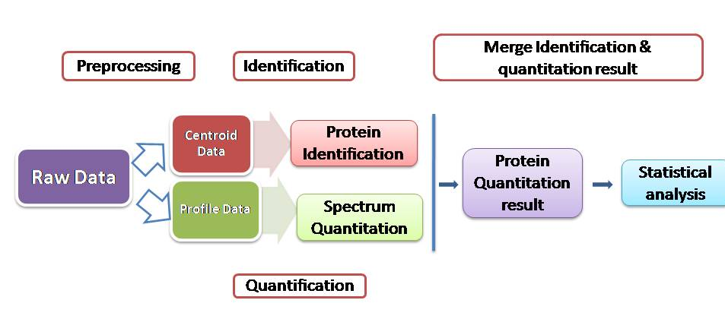
Fig. 3: iTRAQ data analysis workflow with identification and quantification

Data normalization:
It is necessary to normalize the data to reduce any variability brought on by experimental
parameters, such as protein extraction, digestion efficiency, and isobaric labelling efficiency, before using the protein quantification data for additional studies. Data with insufficient or improper normalisation can lead to inaccurate results. To normalise the data, a variety of algorithms have been created. A global normalisation, for example, is based on correction factors obtained from the total or median peak intensities of all reporter ions, or based on computing ratios by taking the median, arithmetic averages, or intensity-weighted averages [58].
The peak normalization applied as,
T_{N} = T_{R/}/ T_{Total}

Where,
T_{N} = Normalized peak area
T_{R} = true area of the reporter ion
T_{Total} = Total of all true area for all reporter ions

The data is normalized by PD v2.1 (and later versions) using the overall peptide amount and the specific protein amount. The latter adds up the abundance values of all the peptides found in each channel, and then uses the abundance value from the channel with the highest overall abundance to normalize the abundance values of the other channels' peptides [59].

Estimating Bias and Variance:

The root mean square error (RMSE) was used to assess the peptide quantification error. The RMSE represents a weighted average of the variations between the mass spectrometry-measured values (y2) and the ideal values (y1). The measured values were scaled to the same level in order to make the RMSE independent of the signal strength. By dividing the measured values by the slope of the regression line comparing the measured values to the ideal values, scaling was performed. A regression technique known as scaling factor, robust linear regression, which is less susceptible to outliers, was used to determine the slope [60]. The bias was investigated by plotting the iTRAQ peptide ratios against the minimum peptide intensity.

Protein Identification and Quantitation:
All MS data were gathered using MicrOTOFcontrol, and DataAnalysis (Bruker Daltonics) was used for analysis. To identify proteins, Mascot v2.3.01 (Matrix Science)was used. The database known as the Universal Protein Resource (UniProt) [61] served as a guide.
Quantification of protein is the end result of many proteomics investigations. This task is entirely dependent on the accuracy of the processes that have already been covered, particularly the results of the peptide quantification and protein inference steps.

Methods for peptide and protein quantitation:

The first involves determining several ratios from the protein's peptides, then adding up these ratios to get a single fold change. Although label-free ways have been added to the usage of this technique, which is frequently used in stable isotopic labelling [62]. Its key benefit is the ability to calculate the protein ratio's standard deviation from the peptide ratios. The second method involves determining a single fold change at the protein level after estimating the protein abundance from its peptides. A statistical estimator typically converts peptide ratios into protein ratios by determining the most pertinent protein ratio from the distribution of peptide ratios. The robust statistics is an alternative approach based on the postulate that ratio of spectrum are various measures of protein ratios [63]. Thus, a large number of measurements will boost the reliability of the protein ratios. There are also intensity-based approaches, although they can result in significant inaccuracies [64].

The peptide ratio and error can be obtained by combining the ratios and errors computed at the spectra level in one of three methods [65]:
1. Average-based: Following a database search, all of the spectra corresponding to the same peptide will be averaged to provide the peptide ratio and error.
2. Median based: Peptide ratios are calculated based on the median of all the spectral ratios that belong to a certain peptide. If the spectrum counts are even, the geometric mean will be the median in this case.
3. Score-based: In this method, the peptide ratio and error will be determined by the ratio and error of the spectra that best define the provided peptide and combine the peptide ratios and errors to obtain the corresponding protein ratios and errors.

The following three techniques can be coupled after identify the peptide ratios and errors to obtain the corresponding protein ratios and errors:
1. Average: The protein ratio and error is determined as the average of all peptide ratios and errors.
2. Median: The protein ratio and error are used to generate the median for all peptide ratios and errors.
3. Weighted average: The protein ratio (PR) is computed as follows [66]:

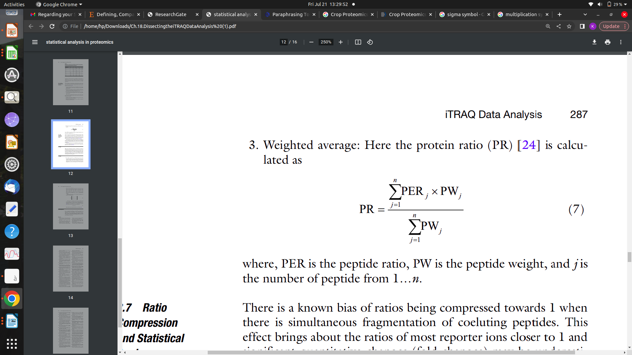

Where,

PER = Peptide ratio
PW = Peptide weight and
j = Number of peptide from 1…n

Ratio Compression:
There is a known tendency towards ratios being compressed towards 1 when coeluting peptides fragment concurrently. This has the consequence of bringing most reporter ion ratios closer to 1, which can lead to big quantitative changes (fold changes) being underestimated and missed. The right mass spectrometry and careful separation can overcome these problems.
The bias and unpredictability resulting from differing intensities in isobaric tags is another issue. Area estimates for low-intensity peaks have larger inaccuracy, and vice versa. In order to address this issue, a model known as variance-stabilizing normalisation (VSN) has been proposed.

Statistical significance analysis and data mining:
Quantitative proteomic experiments aim to compare protein expression levels between different groups. Data mining and functional interpretation of datasets pose analytical challenges. Many software tools automatically output protein abundance ratios, but lack proper algorithms for statistical analysis, data mining, and visualization. These issues are usually resolved using statistical platforms like MATLAB, R, or dedicated software packages. A statistical test is used to estimate a p value and a specified cut-off, determining significant protein changes. The two-sample t test is the most common statistical test used to evaluate differences between groups. If the first hypothesis is not met, log-transformation can be used to convert the observed abundance distribution into a more symmetric distribution. Nonparametric tests, such as permutation tests or the two-sample Kolmogorov-Smirnov test, are useful when sample size is low. If the second hypothesis is not met, the one-sample t test is used.
Advantages & Disadvantages of iTRAQ

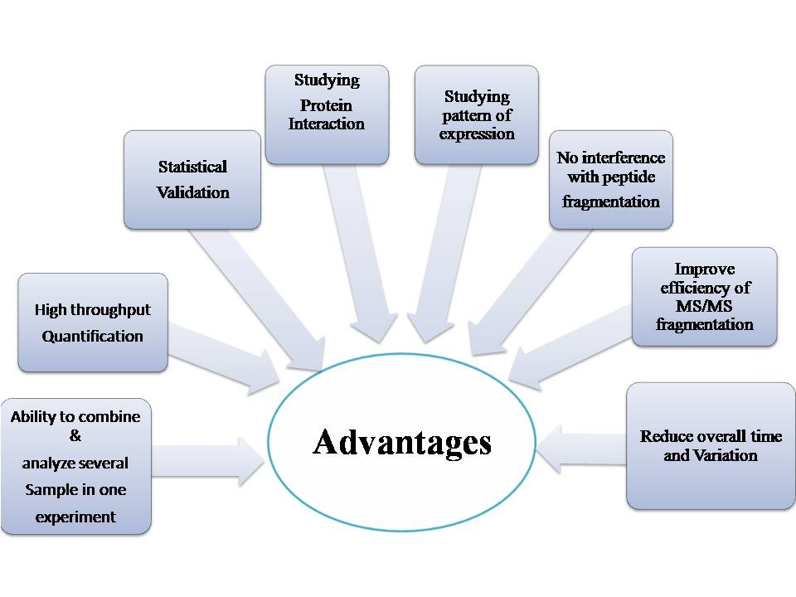
Disadvantages:

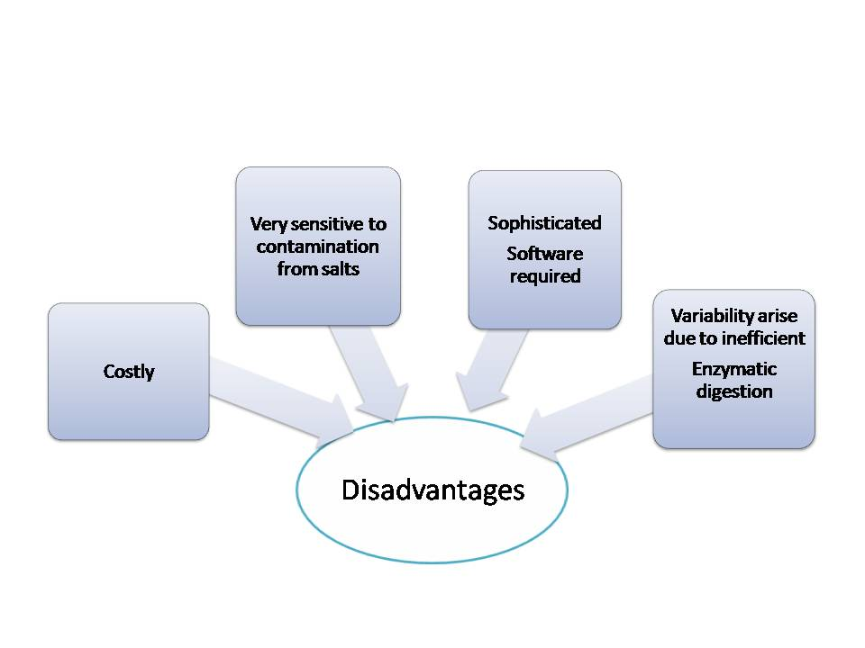

References:

- Cristea, I. M., Gaskell, S. J., & Whetton, A. D. (2004). Proteomics techniques and their application to hematology.Blood, 103(10), 3624–3634. https://doi.org/10.1182/blood-2003-09-3295.
- Holman, J. D., Dasari, S., & Tabb, D. L. (2013). Informatics of protein and posttranslational modification detection via shotgun proteomics. Methods of Molecular Biology, 2013;1002:167–179.
- Al-Amrani, S., Al-Jabri, Z., Al-Zaabi, A., Alshekaili, J., & Al-Khabori, M. (2021). Proteomics: Concepts and applications in human medicine. World Journal of Biological Chemistry, ,12(5), 57-69. https://doi.org/10.4331/wjbc.v12.i5.57.
- Krishna, R. G., & Wold, F. (1993). Post-translational modification of proteins.Advances in Enzymology and Related Areas of Molecular Biology, 67, 265–298. https://doi.org/10.1002/9780470123133.ch3.
- Aslam, B., Basit, M., Nisar, M. A.,Khurshid, M. Rassol, M. H. (2017). Proteomics: Technologies and Their Applications. Journal of Chromatographic Science, 55(2), 182–196. https://doi.org/10.1093/chromsci/bmw167.
- Pandey, A., & Mann, M. (2000). Proteomics to study genes and genomes. Nature, 405(6788), 837–846. https://doi.org/10.1038/35015709.
- Cox, J., & Mann, M. (2007). Is proteomics the new genomics?. Cell,130(3), 395–398. https://doi.org/10.1016/j.cell.2007.07.032.
- Wilkins, M. R., Sanchez, J. C., Gooley, A. A., Appel, R. D., Humphery-Smith, I., Hochstrasser, D. F., & Williams, K. L. (1996). Progress with proteome projects: why all proteins expressed by a genome should be identified and how to do it. Biotechnology & Genetic Engineering Reviews, 13, 19–50. https://doi.org/10.1080/02648725.1996.10647923
- Lundberg, E., & Borner, G. H. (2019). Spatial proteomics: a powerful discovery tool for cell biology. Nature Reviews Molecular Cell Biology, 20(5), 285-302.
- Hashiguchi A., Ahsan N., & Komatsu S. (2010). Proteomics application of crops in the context of climatic changes. Food research international, 43(7), 1803-1813. https://doi.org/10.1016/j.foodres.2009.07.033.
- Nam, M. H., Huh, S. M., Kim, K. M., Park, W. J., Seo, J. B., Cho K., Kim, D.Y., Kim, B.G., & Yoon, I. I. (2012). Comparative proteomic analysis of early salt stress-responsive proteins in roots of SnRK2 transgenic rice. Proteome Science, 10, 1-19. https://doi.org/10.1186/1477-5956-10-25.
- Mertins, P., Qiao, J. W., Patel, J., Udeshi, N. D., Clauser, K. R., Mani D. R., Burgess, M.W., Gillette, M.A., Jaffe, J.D., & Carr, S.A. (2013). Integrated proteomic analysis of post-translational modifications by serial enrichment. Nature Methods, 10(7), 634–637. https://doi.org/10.1038/nmeth.2518.
- Aghaei, K., & Komatsu S. (2013). Crop and medicinal plants proteomics in response to salt stress. Frontiers in Plant Science, 4, 8. https://doi.org/10.3389/fpls.2013.00008.
- Ghosh, D. & Xu, J. (2014). Abiotic stress responses in plant roots: a proteomics perspective. Frontiers in plant science, 5, 6. https://doi.org/10.3389/fpls.2014.00006.
- Witzel, K., Weidner, A., Surabhi, G. K., Borner A., & Mock, H. (2009). Salt stress-induced alterations in the root proteome of barley genotypes with contrasting response towards salinity. Journal of experimental botany, 60(12), 3545–3557. https://doi.org/10.1093/jxb/erp198.
- Hossain Z., Nouri M. Z., & Komatsu S. (2012). Plant cell organelle proteomics in response to abiotic stress. Journal of Proteome Research, 11(1), 37-48. https://doi.org/10.1021/pr200863r.
- Perez-Clemente R. M., Vives V., Zandalinas S. I., Lopez-Climent M. F., Munoz V., & Gomez-Cadenas A. (2013).Biotechnological approaches to study plant responses to stress. BioMed Research International, 2013.
- Hinsby, A. M., Olsen, J. V., Bennett, K. L., & Mann, M. (2003). Signaling initiated by overexpression of the fibroblast growth factor receptor-1 investigated by mass spectrometry. Molecular & Cellular Proteomics: MCP, 2(1), 29–36. https://doi.org/10.1074/mcp.m200075-mcp200.
- Hu, J., Rampitsch, C., & Bykova, N. V. (2015). Advances in plant proteomics toward improvement of crop productivity and stress resistancex. Frontiers in Plant Science, 6, 209. https://doi.org/10.3389/fpls.2015.00209.
- Kamal, A. H., Rashid, H., Sakata, K., & Komatsu, S. (2015). Gel-free quantitative proteomic approach to identify cotyledon proteins in soybean under flooding stress. Journal of Proteomics, 112, 1–13. https://doi.org/10.1016/j.jprot.2014.08.014.
- Monti, M., Orrù, S., Pagnozzi, D., & Pucci, P. (2005). Interaction Proteomics. Bioscience Reports, 25, 45–56. https://doi.org/10.1007/s10540-005-2847-z.
- Karp, N. A., Huber, W., Sadowski, P. G., Charles, P. D., Hester, S. V., & Lilley, K. S. (2010). Addressing accuracy and precision issues in iTRAQ quantitation. Molecular & Cellular Proteomics: MCP, 9(9),1885–1897. https://doi.org/10.1074/mcp.M900628-MCP200.
- Lau, E., Lam, M. P., Siu. S. O., Kong, R. P., Chan, W. L., Zhou, Z., Huang, J., Lo, C., & Chu, I. K. (2011) Combinatorial use of offline SCX and online RP–RP liquid chromatography for itraq-based quantitative proteomics application. Molecular BioSystems, 7(5), 1399-1408.
https://doi.org/10.1039/C1MB05010A.
- O’Farrell, P. H. (1975). High resolution two-dimensional electrophoresis of proteins. Journal of Biological Chemistry, 250(10), 4007–4012.
- Gygi, S. P., Rist, B., Gerber, S. A., Turecek, F., Gelb, M. H. & Aebersold, R. (1999). Quantitative analysis of complex protein mixtures using isotope-coded affinity tags. Nature Biotechnology, 17(10), 994–999.
- Hamdan, M. & Righetti, P. G. (2002). Modern strategies for protein quantification in proteome analysis: Advantages and limitations. Mass Spectrometry Reviews, 21(4), 287–302.
- Ye, H., Hill, J., Kauffman, J., & Han, X. (2010) Qualitative and quantitative comparison of brand name and generic protein pharmaceuticals using isotope tags for relative and absolute quantification and matrix-assisted laser desorption/ionization tandem time-of-flight mass spectrometry. Analytical Biochemistry, 400(1), 46–55.
- Evans, C., Noirel, J., Ow, S. Y., Salim, M., Pereira-Medrano, A. G., Couto, N., Pandhal, J., Smith, D., Pham, T. K., Karunakaran, E., Zou, X., Biggs, C. A., & Wright, P. C. (2012). An insight into iTRAQ: where do we stand now?. Analytical and Bioanalytical Chemistry, 404(4), 1011–1027. https://doi.org/10.1007/s00216-012-5918-6.
- Aggarwal, S., & Yadav, A. K. (2016). Dissecting the iTRAQ Data Analysis. In: Jung, K. (eds) Statistical Analysis in Proteomics. Methods in Molecular Biology, 1362. Humana Press, New York, NY. https://doi.org/10.1007/978-1-4939-3106-4_18.
- Qin, J., Zhang, J., Wang, F., Wang, J., Zheng Z, et al. (2017). iTRAQ protein profile analysis of developmental dynamics in soybean [Glycine max (L.) Merr.] leaves. PLOS ONE, 12(9), e0181910. https://doi.org/10.1371/journal.pone.0181910
- Possemato, A.P., Paulo, J. A., Mulhern, D., Guo, A., & Gygi S.P. (2017). Beausoleil S.A. Multiplexed phosphoproteomic profiling using titanium dioxide and immunoaffinity enrichments reveals complementary phosphorylation events. Journal of Proteome Research, 16,1506–1514. https://doi.org/10.1021/acs.jproteome.6b00905.
- Datki Z., Olah Z., Macsai L., Pakaski M., Galik B., Mihaly G., et al. (2019). Application of BisANS fluorescent dye for developing a novel protein assay. PLoS One, 14(4), e0215863. https://doi.org/10.1371/journal.pone.0215863.
- Wiśniewski, J. R., & Gaugaz, F. Z. (2015). Fast and sensitive total protein and Peptide assays for proteomic analysis. Analytical chemistry, 87(8), 4110–4116. https://doi.org/10.1021/ac504689z.
- Anthis, N. J., & Clore, G. M. (2013). Sequence-specific determination of protein and peptide concentrations by absorbance at 205 nm. Protein science : a publication of the Protein Society, 22(6), 851–858. https://doi.org/10.1002/pro.2253.
- Yang, Y., Qiang, X., Owsiany, K., Zhang, S., Thannhauser, T. W., & Li, L. (2011).Evaluation of different multidimensional LC–MS/MS pipelines for isobaric tags for relative and absolute quantitation (iTRAQ)-based proteomic analysis of potato tubers in response to cold storage. Journal of Proteome Research, 10(10), 4647–4660. https://doi.org/10.1021/pr200455s.
- Gilar, M., Olivova, P., Daly, A.E., & Gebler, J. C. (2005). Two-dimensional separation of peptides using RP-RP-HPLC system with different pH in first and second separation dimensions. J Sep Sci. 28(14), 1694–1703. https://doi.org/10.1002/jssc.200500116.
- Wang, Y., Yang, F., Gritsenko, M. A., Wang, Y., Clauss, T., Liu, T., Shen, Y., Monroe, M. E., Lopez-Ferrer, D., Reno, T., Moore, R. J., Klemke, R. L., Camp, D. G., 2nd, & Smith, R. D. (2011). Reversed-phase chromatography with multiple fraction concatenation strategy for proteome profiling of human MCF10A cells. Proteomics, 11(10), 2019–2026. https://doi.org/10.1002/pmic.201000722.
- Peng, J., Elias, J. E., Thoreen, C. C., Licklider, L. J., & Gygi, S. P. (2003). Evaluation of multidimensional chromatography coupled with tandem mass spectrometry (LC/LC-MS/MS) for large-scale protein analysis: the yeast proteome. Journal of Proteome Research, 2(1), 43–50. https://doi.org/10.1021/pr025556v,
- Boersema, P. J., Mohammed, S., & Heck, A. J. (2008). Hydrophilic interaction liquid chromatography (HILIC) in proteomics. Anal Bioanal Chemistry, 391(1), 151–159. https://doi.org/10.1007/s00216-008-1865-7.
- Ross, P. L., Huang, Y. N., Marchese, J. N., Williamson, B., Parker, K., Hattan, S., Khainovski, N., Pillai, S., Dey, S., Daniels, S., Purkayastha, S., Juhasz, P., Martin, S., Bartlet-Jones, M., He, F., Jacobson, A., & Pappin, D. J. (2004). Multiplexed protein quantitation in Saccharomyces cerevisiae using amine-reactive isobaric tagging reagents. Molecular & Cellular Proteomics : MCP, 3(12), 1154–1169. https://doi.org/10.1074/mcp.M400129-MCP200.
- Choe, L., D'Ascenzo, M., Relkin, N. R., Pappin, D., Ross, P., Williamson, B., Guertin,S., Pribil, P., & Lee, K. H. (2007). 8-plex quantitation of changes in cerebrospinal fluid protein expression in subjects undergoing intravenous immunoglobulin treatment for Alzheimer's disease. Proteomics, 7(20), 3651-3660. https//doi.org/10.1002/pmic.200700316.
- Williamson, J. C., Edwards, A. V., Verano-Braga, T., Schwa¨mmle, V., Kjeldsen, F., Jensen, O. N., & Larsen, M. R. (2016). High-performance hybrid Orbitrap mass spectrometers for quantitative proteome analysis: observations and implications. Proteomics, 16(6), 907–14. https://doi.org/10.1002/pmic.201400545.
- Gatto, L., & Lilley, K. S. (2012). MSnbase — an R/Bioconductor package for i,obaric tagged mass spectrometry data visualization, processing and quantitation. Bioinformatics (Oxford, England), 28(2), 288-289. https://doi.org/10.1093/bioinformatics/btr645.
- Wang, P. Yang, P., & Yang, J. Y. (2012). OCAP: an open comprehensive analysis pipeline for iTRAQ. Bioinformatics (Oxford, England), 28(10), 1404-1405. https://doi.org/10.1093/bioinformatics/bts150.
- Griss, J., Vinterhalter, G., & Schwämmle, V. (2019). IsoProt: a complete and reproducible workflow to analyze iTRAQ/TMT experiments. Journal of Proteome Research, 18(4), 1751-1759. https://doi.org/10.1021/acs.jproteome.8b00968.
- Forshed, J., Johansson, H. J., Pernemalm, M., Branca, R. M., Sandberg, A., & Lehtio, J. (2011). Enhanced information output from shotgun proteomics data by protein quantification and peptide quality control (PQPQ). Molecular & Cellular Proteomics, 10(10), M111.010264. https://doi.org/10.1074/mcp.M111.010264.
- Cox, J., & Mann, M. (2008). MaxQuant enables high peptide identification rates, individualized p.p.b.-range mass accuracies and proteome-wide protein quantification. Nature Biotechnology, 26(12), 1367- 1372. https://doi.org/10.1038/nbt.1511.
- Onsongo, G., Stone, M. D., Van Riper, S. K., Chilton, J., Wu, B., Higgins, L., Lund, T. C., Carlis, J. V., & Griffin, T. J. (2010). LTQ-iQuant: a freely available software pipeline for automated and accurate protein quantification of isobaric tagged peptide data from LTQ instruments. Proteomics, 10, 3533-3538. https://doi.org/10.1002/pmic.201000189.
- Craig, R., & Beavis, R. C. (2004) TANDEM: matching proteins with tandem mass spectra. Bioinformatics, 20(9), 1466–1467. https://doi.org/10.1093/bioinformatics/bth092.
- Perkins, D. N., Pappin, D. J., Creasy, D. M., & Cottrell, J. S. (1999). Probability-based protein identification by searching sequence databases using mass spectrometry data. Electrophoresis, 20(18), 3551–3567. https://doi.org/10.1002/(SICI)1522-2683(19991201)20:18<3551::AID-ELPS3551>3.0.CO;2-2.
- Yadav, A. K., Kumar, D., & Dash, D. (2011). MassWiz: a novel scoring algorithm with target-decoy based analysis pipeline for tandem mass spectrometry. Journal of Proteome Research, 10(5), 2154–2160. https://doi.org/10.1021/pr200031z.
- Geer, L. Y., Markey, S. P., Kowalak, J. A., Wagner, L., Xu, M., Maynard, D. M., Yang, X., Shi, W., & Bryant, S. H. (2004). Open mass spectrometry search algorithm. Journal of Proteome Research, 3(5), 958–964. https://doi.org/10.1021/pr0499491.
- Shilov, I. V., Seymour, S. L., Patel, A. A., Loboda, A., Tang, W. H., Keating, S. P., Hunter, C. L., Nuwaysir, L. M., & Schaeffer, D. A. (2007). The Paragon Algorithm, a next generation search engine that uses sequence temperature values and feature probabilities to identify peptides from tandem mass spectra. Molecular & cellular proteomics : MCP, 6(9), 1638–1655. https://doi.org/10.1074/mcp.T600050-MCP200.
- Boehm, A. M., Putz, S., Altenhofer, D., Sickmann, A., & Falk, M. (2007). Precise protein quantification based on peptide quantification using iTRAQ. BMC Bioinformatics, 8, 214. https://doi.org/10.1186/1471-2105-8-214.
- Shadforth, I. P., Dunkley, T. P., Lilley, K. S., & Bessant, C. (2005) i-Tracker: for quantitative proteomics using iTRAQ. BMC Genomics, 6, 145. https://doi.org/10.1186/1471-2164-6-145.
- Lin, W. T., Hung, W. N., Yian, Y. H., Wu, K. P., Han, C. L., Chen, Y. R., Chen, Y. J., Sung, T. Y., & Hsu, W. L. (2006). Multi-Q: a fully automated tool for multiplexed protein quantitation. Journal of proteome research, 5(9), 2328–2338. https://doi.org/10.1021/pr060132c.
- Ow, S. Y., Salim, M., Noirel, J., Evans, C., Rehman, I., & Wright, P. C. (2009). iTRAQ underestimation in simple and complex mixtures: "the good, the bad and the ugly". Journal of Proteome Research, 8(11), 5347–5355. https://doi.org/10.1021/pr900634c.
- Werner, T., Becher, I., Sweetman, G., Doce, C., Savitski, M. M., & Bantscheff, M. (2012). High-resolution enabled TMT 8-plexing. Analytical Chemistry, 84(16), 7188–7194. https://doi.org/10.1021/ac301553x.
- Zou, X., Zhao, M., Shen, H., Zhao, X., Tong, Y., Wang Q., Wei, S., & Ji, J. (2012). MilQuant: a free, generic software tool for isobaric tagging-based quantitation. Journal of Proteomics, 75(17), 5516–5522. https://doi.org/10.1016/j.jprot.2012.06.028.
- Chen, J., Li, S., Ge, Y., Kang, J., Liao, J. F., Du, J. F., Tian, J., Xie, X., & Li, F. (2021). iTRAQ and PRM-Based Proteomic Analysis Provides New Insights into Mechanisms of Response to Triple Therapy in Patients with Rheumatoid Arthritis. Journal of Inflammation Research, 14, 6993–7006. https://doi.org/10.2147/JIR.S340351.
- Hultin-Rosenberg, L., Forshed, J., Branca, R. M., Lehtiö, J., & Johansson, H. J. (2013). Defining, comparing, and improving iTRAQ quantification in mass spectrometry proteomics data. Molecular & Cellular Proteomics, 12(7), 2021-2031. https://doi.org/10.1074/mcp.M112.021592.
- Bairoch, A., Apweiler, R., Wu, C. H., Barker, W. C., Boeckmann, B., Ferro, S. et al. (2005). The universal protein resource (UniProt). Nucleic Acids Research, 33(Database issue), D190-D195. https://doi.org/10.1093/nar/gkm895.
- Old, W. M., Meyer-Arendt, K., Aveline-Wolf, L., Pierce, K. G., Mendoza, A., Sevinsky, J. R., Resing, K. A., & Ahn, N. G. (2005). Comparison of label-free methods for quantifying human proteins by shotgun proteomics. Molecular & Cellular Proteomics : MCP, 4(10), 1487–1502. https://doi.org/10.1074/mcp.M500084-MCP200.
- Burkhart, J. M., Vaudel, M., Zahedi, R. P., Martens, L., & Sickmann, A. (2011). iTRAQ protein quantification: a quality-controlled workflow. Proteomics, 11(6), 1125–1134. https://doi.org/10.1002/pmic.201000711.
- Carrillo, B., Yanofsky, C., Laboissiere, S., Nadon, R., & Kearney, R. E. (2010). Methods for combining peptide intensities to estimate relative protein abundance. Bioinformatics (Oxford, England), 26(1), 98–103. https://doi.org/10.1093/bioinformatics/btp610.
- D'Ascenzo, M., Choe, L., & Lee, K. H. (2008). iTRAQPak: an R based analysis and visualization package for 8-plex isobaric protein expression data. Briefings in Functional Genomics & Proteomics, 7(2), 127–135. https://doi.org/10.1093/bfgp/eln007.
- Gan, C. S., Chong, P. K., Pham, T. K., & Wright, P. C. (2007). Technical, experimental, and biological variations in isobaric tags for relative and absolute quantitation (iTRAQ). Journal of Proteome Research, 6(2), 821–827. https://doi.org/10.1021/pr060474i.

