Unlocking Learning Potentials: The Impact of Digital Portfolios in Education
Dr Vikas Raval
.
Abstract:
The chapter examines how technology is being used in education, with a focus on how digital portfolios are being used as a pedagogical tool to promote student learning. The introduction focuses on how technology has transformed many facets of life and how it has integrated with language learning. It introduces the idea of a digital portfolio, which is defined as a digital collection of artefacts that represents the experiences, successes, and reflections of a person or organisation. The move from traditional hard-copy portfolios to digital portfolios is covered in the article, along with the advantages that were seen in students' learning behaviours and technical abilities. It highlights the need of integrative learning, in which students actively look for links between knowledge from the past and the present to promote deep comprehension.

Key Words:
Technology in Education, Digital Portfolios, Pedagogical Tool, Student Learning, Integrative Learning, Language Learning, Digital Collection

1 INTRODUCTION:
The introduction of technology almost two decades ago has made our lives more meaningful in all respects. From military, economic, entertainment to education, the exchange of knowledge provided by technology has allowed people to acquire more knowledge where everything has become transparent, fast and mobile. In education, for example, teachers and students are learning new trends and skills in using technology in teaching and learning.

Technology is an introspective tool that allows students to expand their oral expression, acquire a new language, learn about intercultural perspectives and interact with knowledge of the content. As technology helps students shape their world in new ways, a new approach to teaching ESL is needed regarding high-tech development and the paradigm shift of students. Therefore, technology has become increasingly part of the study of language. This is particularly true since the creation of a digital portfolio can develop the multimedia technological skills of teachers and students.
According to Lorenzo and Ittleson (2005),
A Digital-portfolio is a digitized collection of artefacts, including demonstrations, resources, and accomplishments that represent an individual, group, or institution. This collection can be comprised of text-based, graphic, or multimedia elements archived on a CD-Rom or DVD. . . . E-portfolios encourage reflection. (p. 2)

The following are what Garrison (Garrison & Ring, 2013) identifies as components
of what she calls a “true Digital Portfolio”:
• It is digital.
• It contains evidence of the author’s experiences and accomplishments.
• It contains reflection.

The objective of this module is to help you understand and facilitate the creation of supplementary learning portfolios for students that are designed to advance student learning.

2. FROM HARD-COPY PORTFOLIOS TO DIGITAL PORTFOLIOS
Hard-copy portfolios generally contain a collection of artefacts that represent a student's work. Students are asked to collect their best work and sometimes reflect on this work.

The fields of writing, visual arts, architecture and graphic design have long used the portfolio, assembled in file folders or notebooks, to serve as an example and showcase of a student's work. Student portfolios in these and other fields have proven to be an excellent way to help students demonstrate their skills. Portfolios have become a central way to demonstrate student learning and encourage the expansion of a student-centered environment. The movement included more active strategies to increase and deepen learning.
Through the process of creating a Digital Portfolio, it is found that students developed a variety of learning habits and skills we did not see when they were creating hardcopy portfolios. Labissiere and Reynolds (2004) outline the added benefits:
A Digital Portfolio requires the development of several skill sets, each of which enhances the student’s ability to engage more deeply with what has already been learned. For example, hyperlinking, which is the primary activity of building a website, forces students to make new connections with what has previously been learned. Such hyperlinking practices, we argue, encourage metacognitive skills development. (pp. 2–3)

Difference in Hard copy versus Digital Portfolio

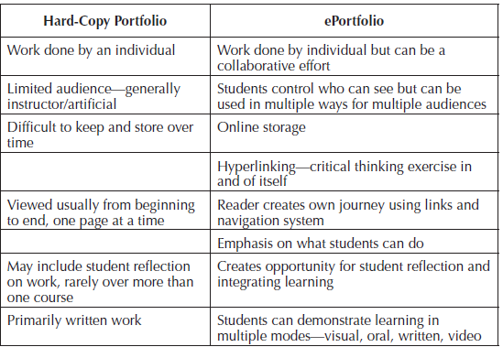

(Patton, 2003)
3. BACKGROUND AND LEARNING CONTEXT FOR DIGITAL PORTFOLIOS:
The most convincing reasons for using learning Digital Portfolios come from research on learning, on how the brain works, and on motivation. The concept of transformational learning comes from the work of Jack Mezirow. In an overview article of the theory, E.W. Taylor (2007) explains:

Mezirow does not see transformative learning as an “add-on” educational practice or technique. He sees it as the very essence of adult education, such that the goal of adult education is “to help the individual become a more autonomous thinker by learning to negotiate his or her own values, meanings, and purpose rather than uncritically acting on those of others” (Mezirow 1997, p. 11). . . .
Significant learning involves the transformation of meaning structures through an ongoing process of critical reflection, discourse, and acting on one’s beliefs.
(Taylor, 2007, p. 12)

In higher education, we are committed to produce graduates who are self-directed learners and autonomous thinkers, we often fall short in these efforts.
Ryan and Deci’s (2000) research finds that when we do something because it is inherently enjoyable or interesting or intrinsically motivating, we produce higher quality learning. Environments in which students experience a sense of competence, autonomy, and relatedness especially nurture good learning and foster intrinsic motivation.
Research on learning and the brain (e.g., Bransford, Brown, & Cocking, 1999; Halpern & Hakel, 2000; Tagg, 2004; Zull, 2002) supports the idea that we need to teach for one goal: long-term learning with the ability to apply that learning. To achieve that goal, faculty must know where students are in their understanding of the content area, and students need to understand how learning actually happens. Chickering and Gamson (1987) said students “must talk about what they are learning, write about it, relate it to past experiences, and apply it to their daily lives.

Digital Portfolios, then, as a pedagogical tool, offer rich opportunities to engage students by leveraging the practices we know promote deep learning. Most important, Digital Portfolios are a living document, a discussion between the student and teacher, student and colleagues, student and the world. Students can create a Digital Portfolio in groups, sharing ideas, talents, and critiques, and determining standards based on real peer work and evidence in work of excellence in diverse fields.

4. WHAT IS INTEGRATIVE LEARNING ?
Integrative learning system like Digital Portolio such as this is necessary for us to be successful in our complex world. We need to integrate our learning throughout our lives.
All learning is integrative learning. We survive in the world because we are able to make connections between what we have learned in the past to what we are learning in the future. Learning mathematical tables at the very early stage builds the skills necessary for us to do multiplication in later grades. When we are faced with solving a multiplication or division problem, we can call up and use the knowledge we have about tables to help us solve our current problem.
To be able to engage in integrative learning, one must seek to see connections. In reality, connections are always there; we just don’t always see them. Seeing oneself as a learner—motivated and capable of putting ideas together—is an important part of using integrative learning.
Integrative learning requires students to be motivated and intentional in their efforts to learn. Huber and Hutchings (2004) explain integrative learning as follows:
One of the great challenges in higher education is to foster students’ abilities
to integrate their learning across contexts and over time. . . . The capacity to
connect is central . . . whether focused on discovery and creativity, integrating and interpreting knowledge from disciplines, [or] applying knowledge through real-world engagements. (p. 1)

[An] emphasis on integrative learning can help undergraduates put the pieces together and develop habits of mind that prepare them to make informed judgments in the conduct of personal, professional, and civic life. (p. 13)

It is proposed that the concept of surface and deep learning is related to the concept
of integrative learning. Surface learning occurs when students focus their attention on what is needed to pass a particular class. Deep learning, on the other hand, occurs when students engage more fully with the content. Definitely, the students intentionally employ deep learning strategies with the goal of being able to integrate their knowledge.

5 THE DIGITAL PORTFOLIO IN STUDY PROGRAM

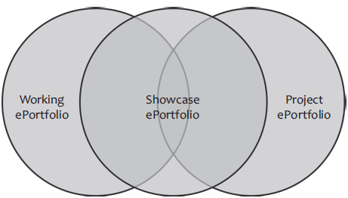
(Patton, 2003)
Of course, all the learning outcomes in the course are important, and the Digital Portfolio provides a pathway for students to demonstrate their competencies in all or some of them . It also provides a platform to make sense of how they all fit together.

In a working Digital Portfolio the students are asked to collect all or much of their assignments in the course as well as reflect on their learning through directed reflection prompts. These artifacts can be housed in the working Digital Portfolio. The goal of the working Digital Portfolio is to help students create a space where they can collect and reflect on a lot of artifacts and content. To create a showcase, students have to have something to select, so the collection and reflection part is a very important process.
Students can create a project or task Digital Portfolio, which is focused on representing the process and product of a particular project assigned in a course or program. These can be individual or small-group Digital Portfolios. For example, instead of a traditional lab book assignment, students may create a Digital Portfolio to document the process of an experiment, including the process and the outcome.
Most Digital Portfolio assignments are typically cumulative representations of a student’s work in a course or program. They showcase the student’s work and can be the finished product. These portfolios represent the select, reflect, and assess part of the Digital Portfolio process. In a showcase portfolio, students select their best work and invite feedback and conversation.

6 THE DIGITAL PORTFOLIO PROCESS
How we structure and support the development of any type of Digital Portfolio is important. Whatever the activity, it is important to develop the opportunities to become involved in the Digital Portfolio process. Early in the development of Digital Portfolios, they were more than just a technological tool. Helen Chen (Cambridge, Chen, & Ketcheson, 2004) coined the term folio thinking, which refers to the notion that a Digital Portfolio implies “a process of planning, keeping track of, making sense of, and sharing evidence of learning and performance.” B. L. Cambridge (2001) lists three steps students can use in creating a Digital Portfolio—collect, select, and reflect—which serves as the foundation for facilitating the Digital Portfolio process or folio thinking in the courses or programs.
Integrative learning digital portfolio process
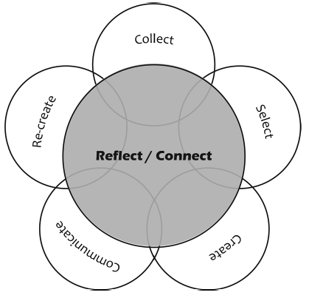
(Patton, 2003)

At the center of the process is reflection and connection. Integrative learning happens when we purposefully establish connections across time and context. Reflection is the mechanism that allows us to make these connections. As reflection is in the centre, activities and opportunities devoted to helping students make connections should be at the forefront of the activities
Collect refers to having students gather artefacts that could be used in their Digital Portfolios. In the context of a course, this means encouraging the students to keep copies of their assignments, their work in the course, and other things that are related to their learning (images, research articles, links to relevant websites, and unique ideas).
The select part of the process relates especially to the development of showcase
Digital Portfolios as well as some forms of project Digital Portfolios. Depending on the purpose and audience of the Digital Portfolio, students can select artefacts that represent their best work, or in some cases they may choose work that shows a progression.
The Create aspect of the Digital Portfolio process includes making the Digital Portfolio, using technology to build it, and making decisions about its architecture and structure.
The Communicate part of the Digital Portfolio process asks students to reflect on the purpose of the Digital Portfolio and consider their audience as they create it. After all, most Digital Portfolios are created for someone. In addition, a Digital Portfolio is not a one-way form of communication; it demands dialogue or feedback about the contents. This is evident when a student submits a Digital Portfolio assignment in a course and receives feedback from the instructor.
The conversation that ensues from the Digital Portfolio leads to the re-create part of the process, in which new thinking and revision or the impetus to create a new Digital Portfolio occurs, perhaps going from a working Digital Portfolio to a showcase Digital Portfolio.

7 HOW TO COMMUNICATE EFFECTIVELY IN DIGITAL PORTFOLIOS
As we often hear, the medium is the message (McLuhan, 1964), and this is especially true in a Digital Portfolio as well as in other kinds of student work. Let us discuss the concept of digital presence and digital identity, its importance, and the role of the Digital Portfolio in establishing one’s digital identity.

7.1 Digital presence
Websites such as Facebook and LinkedIn, and blogging sites (Blogger, Wordpress, Tumblr) are widely used. Whether we like it or not, this digital content is often part of the first impression we make on our current and future friends, colleagues, and employers.
Students need to learn to manage their presence on the Internet. Digital Portfolios help students to manage their digital presence by creating a digital identity that reflects their values, skills, and accomplishments.
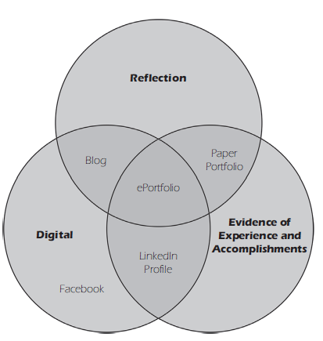
(Patton, 2003)

The center of the Venn diagram represents the Digital Portfolio, the intersection of evidence of experiences and accomplishments and reflection in a digital medium. In creating a Digital Portfolio, students have the ability to master all three of these areas. Other forms of a web presence offer a more limited view of an individual

8 CONSIDERING DESIGN ISSUES IN CREATING THE DIGITAL PORTFOLIO
Students should consider the following regarding the design of their Digital Portfolio
Think about what you put in the URL:
- For a student learning Digital Portfolios, it is probably best to use his or her name. MyPortfolio, MyFirstYear, FinalPort does not provide specific information.
Think about what each page on the Digital Portfolio looks like:
- Include white space. Reading online is difficult if web pages are just a long series of text. It is helpful to have white space between paragraphs and text and illustrations to break up text.
  - makes reading more legible
  - increases comprehension of what one is reading
- Include a relevant illustration or two on each page; text only is not very welcoming or compelling.
- Think about your writing. Use short sentences and short paragraphs. Consider using bulleted lists when appropriate on your pages..
- Make sure your welcome statement is clear. Let your reader know what your Digital Portfolio is about. Remember, use white space, illustrations, and short sentences and paragraphs.
9. CREATING THE DIGITAL PORTFOLIO
Let us discuss some basic ideas the student should consider when thinking about creating Digital Portfolios.
Implementation model
The integrative learning Digital Portfolio framework is helpful in thinking about how to begin implementing Digital Portfolios.
1. What is your goal for the Digital Portfolio?
We want to stress that you should not begin to think about using Digital Portfolios with the question of which platform to use. The most important thing is to determine how you want to use the Digital Portfolio, the practices, and the process.
2 Assessment: Student, program, or institutional? How measured? After clarifying your goal for the Digital Portfolio, consider how you will assess the Digital Portfolio. You will think about how you will grade the Digital Portfolio in your course, and you may need to think about assessment of the Digital Portfolio beyond your classroom for departmental or institutional purposes.

Implementation model
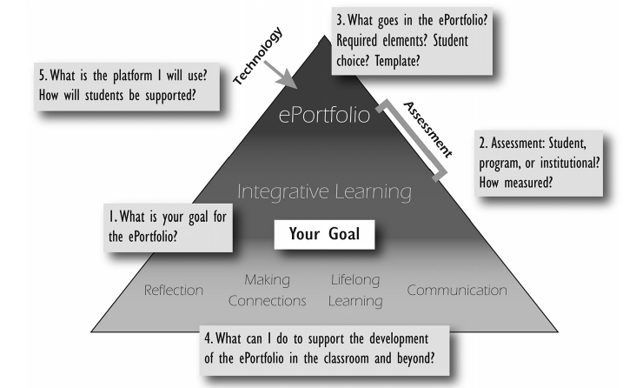
(Patton, 2003)

3 What goes in the Digital Portfolio? Required elements? Student choice? Template?
Once you are clear about your goals for the Digital Portfolio and have thought about how you will measure students’ achievement of those goals, you can then identify what should be in the Digital Portfolio. What are the required elements you will want to see in the Digital Portfolio?
4 What can I do to support the development of the Digital Portfolio in the classroom and beyond? The faculty should think about the classroom strategies and activities that can support students in reaching the learning goals and building their Digital Portfolio. Again, these practices are the foundation of an integrative Digital Portfolio.
5. What is the platform I will use? How will students be supported? Answering the questions 1–4 will help you get to the final step: deciding on a platform to use for your Digital Portfolio assignment. Without answering the preceding questions, it is impossible to know which features your platform needs to include.

10 INDIVIDUAL FACULTY ADOPTION OF DIGITAL PORTFOLIOS FOR CLASS OR PROJECT-BASED DIGITAL PORTFOLIOS

A large range of software platforms to create Digital Portfolios is currently available. Some of them are free to use, and some can be purchased with learning management systems (LMSs) like Blackboard or Desire to Learn. Others are self-standing platforms that can work with certain other systems like LMSs, Google, Banner, or PeopleSoft. Each platform operates in specific ways. So how do you decide what to use? The very structure of a system makes decisions for you. Every platform can do certain things.
Many faculties begin with a free software Digital Portfolio system, such as
• Google Sites (https://sites.google.com)
• Weebly (www.weebly.com)
• WordPress (http://wordpress.org)
• Wix (www.wix.com)
All these platforms contain instructions on how to build websites using their site. For more ideas or if you have questions, search the Internet for a multitude of answers. While the search results may not necessarily be the best or the most up-to-date, they can point you in the right direction. YouTube is also a good resource to create your own tutorials for your students to use. YouTube videos and other already developed tutorials using these platforms can easily be found on the web ready to adapt for your purposes.
11 DIGITAL PORTFOLIO STRUCTURE
Structure | Description | When Activity happens in class | Activities/Assignments that demonstrate learning | Reflections | Completed
Welcome page/introduction to digital portfolio
Learning goals/outcomes
1
2
3
4
5
6
Philosophy statement or “Who am I?”
(digital identity)
Resume
Contac
Information

To create the structure for your Digital Portfolios, recall your thinking on and planning how to integrate Digital Portfolios and integrative learning Students can create their Digital Portfolio shell at the beginning of the class and add activities and assignments in the appropriate places as the class progresses.

Conclusion:
In this module, we discuss the concept of integrative learning and how Digital Portfolio can be an excellent tool for advancing the students. The incorporation of Digital Portfolio of integrative learning is not simply to ask students to collect artefacts and upload them to a website, it is a complex process that requires dedication to apply learning science to establish the connections they need in a vital way and allow them to integrate and deepen their learning.

References:
Arum, R., & Roksa, J. (2011) Academically adrift: Limited learning on college campuses. Chicago, IL: University of Chicago Press.
Ash, S. L., & Clayton, P. H. (2009). Learning through critical reflection: A tutorial for
service-learning students. Raleigh, NC: Author.
Association of American Colleges and Universities. (2007a). College learning for the
new global century. Washington, DC: Author
Bolton, G. (2010). Reflective practice: Writing and professional development. London, UK: Sage.
Boud, D., Keogh, R., & Walker, D. (Eds.). (1985). Reflection: Turning experience into
learning. London, UK: Routledge.
Cambridge, D. (2010). ePortfolios for lifelong learning and assessment. San Francisco, CA: Wiley.
Dweck, C. S. (1999). Self-theories: Their role in motivation, personality, and development. Philadelphia, PA: Psychology Press.
Gibbs, G. (1988). Learning by doing: A guide to teaching and learning. Oxford, UK:
Oxford Polytechnic Further Education Unit.
McLuhan, M. (1964). Understanding media: The extensions of man. New York, NY:
McGraw-Hill.

