MOLECULAR DOCKING AND ADME PREDICTIONS OF SYNTHESIS OF NOVEL PYRIMIDINE DERIVATIVES AND THEIR POTENT ANTIMICROBIAL STUDIES
¹M.R.Ezhilarasi ,¹P.Kavitha, ¹R.Menaka,and ²M.Makeswari
1. Assistant Professor, Dr.N.G.P.Arts and Science College, Coimbatore -641 048, Tamil Nadu, India
2. Assistant Professor, Sree Saraswathi Thyagaraja College, Pollachi -642 107, Tamil Nadu, India
Email: mrezhilarasi@gmail.com , & makeshvu3@gmail.com
Abstract
A series of novel pyrimidine compounds were framed and chemically prepared and it was in expected yields. The synthesized compounds skeletal structures were characterized by the spectral characterization like IR spectra, NMR spectra, Antimicrobial studies and Elemental analysis. Computational studies of docking and ADME properties are to investigate those probable binding affinity of these anticancer agents and toxic properties of the target compounds. All the compounds showed the good docking score values. Especially compound BCT-7 and 8 have the similar and better docking score value of 8.3 kcal/mol.
Key words: Pyrimidine derivatives, spectral characterization, Molecular docking studies, ADME predictions, 1OQA protein.
1. INTRODUCTION
Current days, syntheses of novel bioactive molecules are very important in medical scenario. The alpha and beta unsaturated ketones are important class of starting materials in organic synthesis [1-4]. The chalcones is the parent compounds to build a various of heterocyclic compounds. Enones in chalcone moiety possesses a favorable antimicrobial [5-7], anti-inflamatory [8], antimalarial [9, 10], antileithshmanial [11], antioxidant [12], antitubercular [13, 14], anticancer [15-17] and their biological activities [18, 19]. Heterocyclic compounds are widely occurred in nature and it plays a important part in metabolism because their carbon skeletal structural sub-units are appeared in many natural products, including vitamins, antibiotics, hormones, and alkaloids as well as agrochemicals dyes [20].Pyrimidine derivatives represents most active roles in several biological processes. In particular, pyrimidine nucleus can be found in a broad variety of antibacterial and antitumor agents, as well as in agrochemical and veterinary products [21]. Pyrimidine are highly deficient aromatic compounds, these compounds are used as electron withdrawing part in push pull molecules [22, 23]. It has intra-molecular charge transfer and also has the molecule backbone; these compounds also induce luminescence properties [24]. Current literature survey explains pyrimidine moiety possess a good nonlinear material [25].
Docking is a key tool computer aided drug development. In docking process, the ligand that binds to a particular protein to change their conformation to get an overall best fit for molecules. The dominant role is the protein ligand binding interaction in drugs. Here Ligand is a micro molecule; it will combine with protein binding portions. There were many potential conformations in which binding may occur. They are known as binding modes [26-28]. In present drug development, the molecular docking is mainly handed down for interpretation of drug receptor interaction. Docking gives facts about drug receptor interactions and is frequently cast-off to identify the binding of micro drug candidates to their protein targets.
The Quantitative structure activity relationship study, ADMET is the developed models for the identification of medicinal chemistry properties. These properties can have the following properties like partition coefficient, aqueous solubility [29], absorption and permeability [30], blood brain barrier (BBB) penetration [31], plasma protein binding [32], metabolism [33], hERG inhibition [34], excretion [35], P-glycoprotein (P-gp) efflux, physiologically based pharmacokinetic (PBPK) modelling and toxicity [36,37]. Pharmacophore and homology modeling have also adopted, to allow improve prediction of metabolism and toxicity [38, 39]. Now a day, ADMET predictions are low throughput and apparently not informative to identify the drugs probability of success; given the high failure rate of compounds at all stages of development [40]. Drug discovery companies are look around for the aware of ADMET process, move forward the chain of early discovery. Before going to synthesis we have to predict the ADMET applications weather the synthesized compounds obey the drug ability. In the few years ago, number of computational methods has been developed for ADME predictions [41, 42, 43]. So, we have to carry the ADME properties using swiss ADME and Molinspiration online toolkit respectively. The central point of this project is to design and synthesis of novel Pyrimidine compounds, and these compounds have not been previously reported. The synthesized molecules structure was characterized by FT-IR, 1H & ¹³C NMR spectral data and elemental analysis. At lost, the synthesized compounds also elucidate their biological and ADME applications. Docking predictions was carried using Breast Cancer protein.
2. INSTRUMENTAL METHODS
2.1. Instruments
Melting point determinations compounds are identified by MELT-TEMP apparatus and Schimadzu FT-IR spectrometer used to record the Infra-red spectral values. BRUCKER 400 MHz NMR spectrometer used to record the proton and carbon NMR of synthesized compounds, during recording the CDCl₃ is used as the solvent along with internal standard TMS. The TLC plates coated with silica gel used for monitored the reactions. The silica gel and all other laboratory grade chemicals, solvents were purchased and used.
2.2. General Procedure for the compounds (BC 1-8)
The 250ml Erlenmeyer flask taken with 3g of NaOH immersed in the 40 ml of ethyl alcohol keeps the mixture in the stirrer, stirring is continued until the NaOH completely dissolved. Then the same mole of substituted aldehydes and 4-acetyl biphenyl weighed. The aldehyde poured into the Erlenmeyer flask make complete dissolve in the ethanol solution and then added the acetophenone in that mixture and stirred it for 3 hours in ice-cold condition. The reaction completion is checked by TLC plates coated with silica-gel. The yellow mass precipitate obtained were transferred into 500 ml beaker contained ice cubes and kept it in the refrigerator for one night. Finally, the precipitate filtered, washed, dried and purified from rectified siprit.
2.3. General Procedure for the synthesis of 4-(5-(4-aryl)-6-biphenyl -2-yl)-3, 4-dihydropyrimidin-2-(1H)-thiones (BCT 1-8)
The equimolar quantity of BC derivatives in the 60ml of ethanol, and then add catalytic amount of sodium acetate and 0.50 M of thiourea and the mixture condensed for 10-12 hours. The reaction was checked by thin layer chromatography plate, and then the content allowed to cooled and transferred into the beaker contained crushed pieces of ice. The beaker kept aside for overnight. The resultant products BCT was separated using funnel, dried and re-crystallized from ethanol. The Purity were checked using TLC plate with the P.E. & EA (9:1) solvent mixture.
2.4. Computational (in-silico) Studies
ADME Prediction
The ADME values of FCPR are predicted by using swissadme online tool. The satisfactory values in the ADME study of the synthesized compounds theoretically showed up the pharmacological property of the synthesized BCTs and also lead the compounds to next level studies. This study gave the basic information of the compounds such as MW, Hy-A, Hy-D, Log p o/w, Log S, TPSA, M.Ref., bioavailability score and other information to understand the pharmacological activity of the synthesized FCPR compounds. The above given properties can influences the pharmacological effect of the FCPR compounds. Other than that the percentage of absorption of the target products were calculated by the following mathematical expression.
% of Abs = 0.345-(109*TPSA)
The other medicinal parameters values of the synthesized compounds also findout by swissadme tool. The parameters are absorption in BBB, p-substrate, cytochrome P-450 enzymes, PAINS and Brenk filters and also gave information about the five basic rules Lipinski, Ghose, Verber, Egan and Muegge. These rules are theoretical era to find out the pharmacological activity of the synthesized compounds. At final it also gave the information about Leadlikeness capability of the compounds.
2.5. Insilico Docking Predictions
Insilico studies of the BCT 1-8 target molecules were done by Autodock software. The docking studies to find out binding efficiency of our synthesized compounds with the selected proteins from pathogenic origin. Here, we analysis the binding efficacy of BCT 1-8 compounds with one breast cancer protein (1OQA). Docking study also gave information about H-bonding interactions along with bond length values, hydrophobic interactions and other bonding interactions.
2.6. Biological (in-vitro) Screening
Antimicrobial evaluation was carried for BCT 1-8 derivatives using disk diffusion method. The various bacterial strains were used for biological screening. The antimicrobial screening procedure was carried out by literature survey method [17].
3. RESULTS AND DISCUSSION
3.1. Chemistry
The preparation protocols followed to get the starting materials and final compounds are depicted in Scheme-1, the starting materials BC 1-8 were synthesized in expected yields by reaction with substituted aromatic aldehyde and 4-acetylbyphenyl in sodium hydroxide under conditions reaction. These BC 1-8 are subjected to addition reactions with Thiourea and catalytic amount of sodium hydroxide to give the corresponding 4-(5-(4-aryl)-6-biphenyl -2-yl)-3,4-dihydropyrimidin-2-(1H)-thiones derivatives BCT 1-8 in good yields.
Scheme-1

The skeletal structure of the thio pyrimidine derivatives were elucidated .Elemental analysis of compound BCT 1 C_{obs}=70.11, C_{cal} =70.01: H_{obs} = 4.55, H_{cal} = 4.53:N_{obs} = 7.43, N_{cal} = 7.45: S_{obs} = 8.51, S_{cal} = 8.60 : Cl_{obs} = 9.41, Cl_{cal} = 9.39) are consistent with the proposed molecular formula (C₂₂H₁₇ClN₂S). The physical properties of the BCT 1-8 produced in the Table-1.
Table 1: Physical characterizations of BCT (1-8)
Compound | Substitution | Molecular Formula | Molecular Weight | Melting Point in ºC | Yield in % | Colour | Elemental Analysis value in %
BCT-1 | 4-Cl | C₂₂H₁₇ClN₂S | 376.90 | 152-154 | 57 | Yellow | C_{obs}=70.11, C_{cal} =70.01: H_{obs} = 4.55, H_{cal} = 4.53:N_{obs} = 7.43, N_{cal} = 7.45: S_{obs} = 8.51, S_{cal} = 8.60 : Cl_{obs} = 9.41, Cl_{cal} = 9.39
BCT-2 | 4-Br | C₂₂H₁₇BrN₂S | 421.35 | 112-114 | 52 | Yellow | C_{obs}=62.71, C_{cal} =62.61: H_{obs} = 4.07, H_{cal} = 4.12:N_{obs} = 6.65, N_{cal} = 6.62.48: S_{obs} = 7.61, S_{cal} = 7.59: Br_{obs} = 18.96, Br_{cal} = 18.95
BCT-3 | 4-F | C₂₂H₁₇FN₂S | 360.45 | 128-130 | 56 | Dark Yellow | C_{obs}=73.31, C_{cal} =73.25: H_{obs} = 4.75, H_{cal} = 4.75:N_{obs} = 7.77, N_{cal} = 7.79: S_{obs} = 8.90, S_{cal} = 8.85: F_{obs} =5.27, F_{cal} = 5.31
BCT-4 | 4-H | C₂₂H₁₈N₂S | 342.46 | 152-154 | 64 | Dark Yellow | C_{obs}=77.16, C_{cal} =77.64: H_{obs} = 5.30, H_{cal} = 5.02:N_{obs} = 8.18, N_{cal} = 8.10: S_{obs} = 9.36, S_{cal} = 9.32
BCT-5 | 4-CH₃ | C₂₃H₂₀N₂S | 356.48 | 126-128 | 60 | Yellow | C_{obs}=77.49, C_{cal} =77.69: H_{obs} = 5.65, H_{cal} = 5.23:N_{obs} = 7.86, N_{cal} = 7.76: S_{obs} = 8.99, S_{cal} = 8.46
BCT-6 | 4-OCH₃ | C₂₃H₂₀N₂OS | 372.48 | 162-164 | 62 | Yellow | C_{obs}= 74.16, C_{cal} = 74.63: H_{obs} = 5.41, H_{cal} = 5.26:N_{obs} = 7.52, N_{cal} = 7.90 : O_{obs} = 4.30, O_{cal} = 4.76 : S_{obs} = 8.61, S_{cal} = 8.63
BCT-7 | Furan | C₂₀H₁₆N₂OS | 332.42 | 114-116 | 66 | Yellow | C_{obs}= 72.26, C_{cal} = 72.98: H_{obs} = 4.85, H_{cal} = 4.84:N_{obs} = 8.43, N_{cal} = 8.75: O_{obs} = 4.81, O_{cal} = 9.65: S_{obs} = 18.55, S_{cal} = 9.61
BCT-8 | 2,3-Cl | C₂₂H₁₆Cl₂N₂S | 411.35 | 144-146 | 62 | Yellow | C_{obs}= 64.24, C_{cal} = 64.21: H_{obs} = 3.94, H_{cal} = 3.38:N_{obs} = 6.81, N_{cal} = 6.80: S_{obs} = 7.80, S_{cal} = 7.78

3.2. Spectral Analysis
IR Spectral results
In this spectral study, spectrum of the BCT-1 shows (Fig-1) a strong frequency band at 3295.56 cm⁻¹is assigned to NH₂ of pyrimidine. The band at 1569.41 cm⁻¹is attributed to C=N of pyrimidine.The C-N stretching appeared at sharp peak at 1353. 83cm⁻¹. The C=S peak in thiourea moiety was appeared at 1180 cm⁻¹ which is in good deal with the value for thioformaldehyde. In thiocarbonyl derivatives the presence of the C=S group is linked to elements other than nitrogen, the stretching frequency is generally appeared in the region from 1025–1225 cm⁻¹. The absorption at 3056.78 and 2961.18 is the appearance of aromatic and aliphatic CH stretching. The FT-IR spectrum values of the other compounds of these derivatives are given below Table-2.
Table 2: FT-IR absorption frequency values of the compounds BCT 1-8
Entry | NH₂ stretching | C=N | C-N | C=S | Aliphatic C-H | Aromatic C-H | Aromatic ring stretching
BCT-1 | 3295.56 | 1569.41 | 1353. 83 | 1180 | 2961.18 | 3056.78 | 645,743,810
BCT-2 | 3293.60 | 1559.95 | 1360.65 | 1175.50 | 2918.46 | 3052.78 | 685,748,810
BCT-3 | 3398.60 | 1571.12 | 1354.06 | 1171.67 | 2997.12 | 3049.66 | 695.25,748.68,792.10
BCT-4 | 3190.20 | 1559.08 | 1378.50 | 1196.55 | 2958.24 | 3045.58 | 656.39,746.87,793.81
BCT-5 | 3201.45 | 1584.55 | 1377.189 | 1197.92 | 2982.06 | 3051.13 | 653.30,699.71,794.19
BCT-6 | 3201.84 | 1584.36 | 1377.40 | 1198.19 | 2961.09 | 3048.14 | 700.17,793.96
BCT-7 | 3198.10 | 1583.70 | 1377.07 | 1196.47 | 2960.26 | 3045.52 | 656.56,700.26,726.22
BCT-8 | 3198.10 | 1583.70 | 1377.07 | 1196.47 | 2960.26 | 3045.82 | 656.56,700.26,726.22

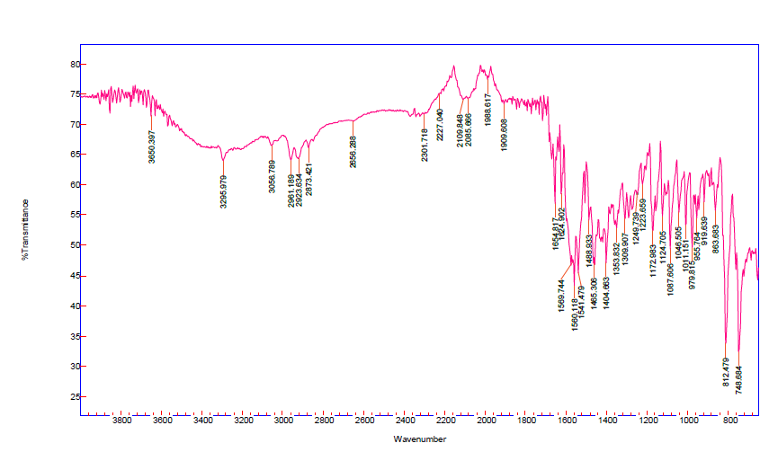 Fig 1: FT-IR Spectrum of the Compound BCT-1
The Proton NMR results
The BCT 1-8 compounds were further authenticated by ¹H NMR Spectra. ¹H NMR spectrum of the compound BCT-1 shows that the signal at 6.280 ppm and it is assigned to H₅ proton of pyrimidine moiety. The NH proton appeared at 3.035 ppm. The ArH’s appear at 6.799 ppm to 8.182 ppm. The proton NMR value of BCT-1 is given below.
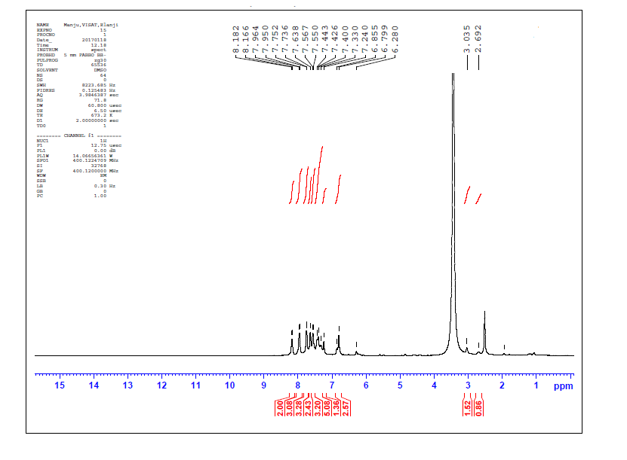
Fig 2: Proton NMR of BCT-1
Table 3: Proton NMR spectral values of the synthesized compound BCT 1-8
Entry | H-5 of pyrimidine moiety | NH proton | Aromatic protons
BCT-1 | 6.280 | 3.035 | 6.799-8.182
BCT-2 | 6.182 | 3.102 | 6.281-7.882
BCT-3 | 6.232 | 3.088 | 7.286-8.484
BCT-4 | 6.134 | 3.098 | 7.276-7.987
BCT-5 | 6.242 | 3.034 | 6.862-7.991
BCT-6 | 6.381 | 3.044 | 7.284-7.886
BCT-7 | 6.252 | 3.036 | 7.045-7.883
BCT-8 | 6.241 | 3.022 | 7.791-7.886

The Carbon NMR results
The¹³C NMR of BCT-1 showed that the ¹³C resonance appeared at in the region of 163.58 ppm is assigned to C-4 carbon. The ¹³C resonance at 188.43 ppm is assigned to C=S carbon. The ¹³C resonance at 113.93 ppm is attributed to C-5 carbon of pyrimidine ring. Benzylic carbon appeared at 55.05 ppm. The region from 122.32 ppm to 130.94 ppm is unambiguously assigned to Ar C’s. The Ipso carbons appear at 144.48, 136.20 pm, 133.61 ppm. From the FT-IR, ¹H NMR, ¹C NMR spectral studies in BCT-1, the assignments of the target molecules are verified. The¹³C NMR spectrum of compound BCT-1 is given below.

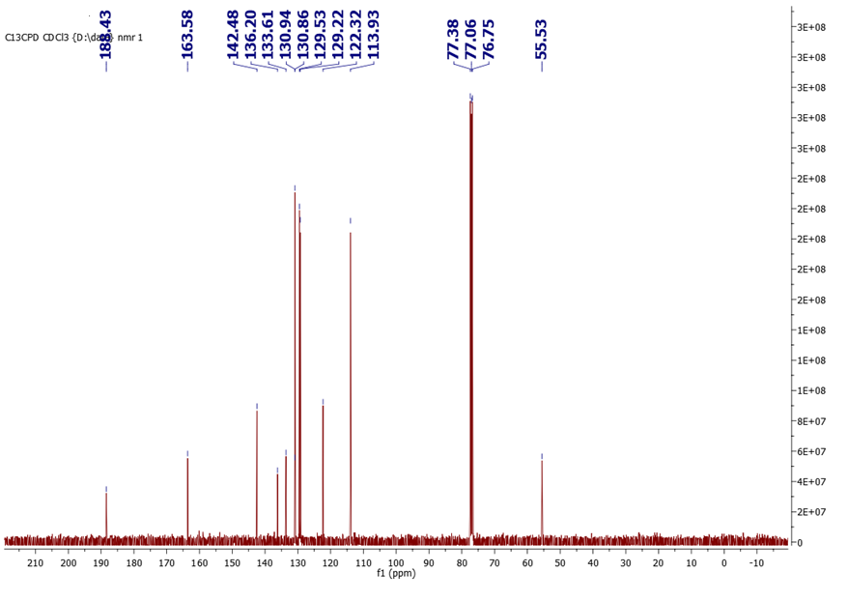
Fig 3: ¹³C NMR spectrum of the compound BCT-1

Table 4: ¹³C NMR Spectral values of the synthesized compounds BCT 1-8
Entry | C=S | C-4 carbon of pyrimidine | C-5 carbon of pyrimidine | benzylic carbon | Aromatic carbons | Ipso carbons | Substitutions
BCT-1 | 188.43 | 163.58 | 113.93 | 55.05 | 122.32 - 130.94 | 144.48, 136.20, 133.61 | -
BCT-2 | 190.45 | 164.89 | 115.67 | 55.78 | 127.98-130.10 | 143.28, 132.20, 131.61 | -
BCT-3 | 200.01 | 166.56 | 115.78 | 56.05 | 123.98-129.10 | 142.48, 134.20, 133.56 | -
BCT-4 | 189.34 | 165.12 | 114.28 | 56.98 | 126.94-129.67 | 143.46, 136.45, 133.57 | -
BCT-5 | 192.98 | 163.98 | 117.32 | 56.78 | 122.68-129.10 | 142.48, 134.78, 133.86 | 21.86
BCT-6 | 186.99 | 164.24 | 112.78 | 56.11 | 120.82-130.24 | 141.48, 136.20, 132.65 | 55.06
BCT-7 | 197.89 | 167.66 | 116.01 | 55.89 | 121.68-130.78 | 144.24, 136.32, 133.46 | -
BCT-8 | 200.04 | 169.55 | 117.98 | 55.94 | 121.98-129.89 | 140.48, 136.20, 134.24 | -

3.3. Insilico Studies Result
ADME predictions were determined for the target compounds (BCT 1-8) by Swiss ADME online software. Determine the success is not for fair one. Acceptable ADME predictions are better identification drug molecule. From those predictions, we have calculated the medicinal chemistry and pharmacokinetics parameters. Pharmacokinetics property plays important role in this study. Target compounds all of them associated with Lipinski rule of five. BCT-7 showed better TPSA values. This compound also produces good log P value. Other compounds ADME values are produced in Table-5,6,7,8.

TABLE 5: ADME PREDICTION VALUES OF BCT 1-8 USING Swiss ADME
Compound | Substituents | log P | log S | M.W | TPSA | Hy-A | Hy-D | MR
Rule | - | Less than 5 | - | Less than 500 | - | Less than 10 | Less than 5 | -
BCT-1 | Cl | 3.7 | -5.99 | 376.9 | 56.15 | 0 | 2 | 120.119
BCT-2 | Br | 3.81 | - 6.31 | 421.35 | 56.15 | 0 | 2 | 122.88
BCT-3 | F | 3.39 | -5.4 | 342.46 | 56.15 | 0 | 2 | 115.18
BCT-4 | H | 3.39 | - 5.4 | 342.46 | 56.15 | 0 | 2 | 115.18
BCT-5 | CH3 | 3.73 | -5.7 | 356.48 | 56.15 | 0 | 2 | 120.15
BCT-6 | OCH3 | 3.69 | -5.47 | 372.48 | 65.38 | 1 | 2 | 121.67
BCT-7 | FURAN | 3.19 | -4.74 | 332.42 | 69.29 | 1 | 2 | 107.45
BCT-8 | 2,3 DICHLORO | 3.81 | -6.58 | 411.35 | 56.15 | 0 | 2 | 125.2

TABLE 6: PHARMACOKINETICS STUDY FOR THE SYNTHESIZED COMPOUND (BCT-1-8) BY Swiss ADME
Compound | GI  absorption | BBB | P-gp substrate | CYP1A2 inhibitor | CYP2C19 inhibitor | CYP2C9 inhibitor | CYP2D6 | CYP3A4 | log Kp (cm/s)
BCT-1 | High | Yes | No | Yes | Yes | Yes | No | Yes | -4.65
BCT-2 | High | Yes | No | Yes | Yes | Yes | No | Yes | -4.88
BCT-3 | High | Yes | No | Yes | Yes | Yes | No | Yes | -4.89
BCT-4 | High | Yes | No | Yes | Yes | Yes | No | Yes | -4.89
BCT-5 | High | Yes | No | Yes | Yes | Yes | No | Yes | -4.72
BCT-6 | High | Yes | Yes | Yes | Yes | Yes | No | Yes | -5.09
BCT-7 | High | Yes | Yes | Yes | Yes | Yes | Yes | Yes | -5.49
BCT-8 | High | Yes | No | Yes | Yes | Yes | No | Yes | -4.42

TABLE 7: DRUG LIKENESS PROPERTIES FOR THE SYNTHESUZED COMPOUNDS (BCT 1-8) BY SwissADME
Compounds | Lipinski’s | Ghose | Veber | Egan | Muegge | Bioavailability
BCT-1 | Yes | No | Yes | No | No | 0.55
BCT-2 | Yes | No | Yes | No | No | 0.55
BCT-3 | Yes | No | Yes | No | No | 0.55
BCT-4 | Yes | No | Yes | No | No | 0.55
BCT-5 | Yes | No | Yes | No | No | 0.55
BCT-6 | Yes | No | Yes | No | No | 0.55
BCT-7 | Yes | No | Yes | No | No | 0.55
BCT-8 | Yes | No | Yes | No | No | 0.55

TABLE 8: MEDICINAL CHEMISTRY PROPERTIES FOR THE SYNTHESIZED COMPOUNDS (BCT 1-8) BY Swiss ADME
Compound | Pains | Brenk | Lead likeness | Synthetic Accessibility
BCT-1 | zero | one | No, two | 3.97
BCT-2 | zero | one | No, two | 4.02
BCT-3 | zero | one | No, one | 4.01
BCT-4 | zero | one | No, one | 4.01
BCT-5 | zero | one | No, two | 4.11
BCT-6 | zero | one | No, two | 4
BCT-7 | zero | one | No, one | 4.15
BCT-8 | zero | one | No, two | 4.09

The tables -5,6,7,8 explains the drug ability properties of (BCT 1-8). From the pharmacokinetic properties, BCT 1-8 have high Gastro intestinal absorption. In Blood Brain Barrier (BBB), there is No permeability values excluded BCT 6 and 7. However, most of them BCT 1-8 exhibited the inhibition to Cytochrome P450 isomers (CYP2C19). Similarly, CYP3A4 also inhibit BCT 1-8 compounds. The range from -4.42 to -4.65 is the log K_{p}. The drug ability carried based the Lipinski’s, Ghose, Veber and Bioavailability score. Same bioavailability score appeared for BCT 1-8. BCT-1-8 was obeying the Lipinski’s rule of five. The filter ghose have one violation WLOGP>5.9 for BCT 1-8. BCT 1-8 obey veber rules without any violation. BCT 1-8 accepted the Muggee and Egan rules. In the medicinal chemistry property, BCT 1-8 exhibited they accept all the filters, in leadlikeness properties, BCT 1-8 produced violations like MW, and log p. All the compounds have the synthetic ability value between 3.03-3.34. From these values (BCT 1-8) are also acceptable criteria for medicinal chemistry property.
3.4. Molecular Docking Studies
Docking were examined for amino pyrimidines (BCT 1-8) using Breast cancer protein 1OQA. This protein was collected from PDB file. Table-9 expresses the docking results. From the result of In-silico studies, BCT-7 shows acceptable docking score (-8.3) compared with ciprofloxacin (-7.8 kcal/mol). BCT 7 and 8 have one C-H-B interactions with the amino residues, which are GLN A:104, it has four hydrophobic interaction with amino residue HIS A:69, PRO A: 103,PRO A:59 and ILE:102. From the result of docking studies, eight BCT 1-8 shows higher docking score (kcal/mol). The images 2-Dimensional and 3Dimensional &Docking score of the BCT 1-8 are given in Table- 9 and 10 .The protocols were carried by literature method [12].
Table 9: Docking Score of the synthesized compounds BCT 1-8
Entry | Docking Score
BCT-1 | -7.5
BCT-2 | -7.3
BCT-3 | -7.6
BCT-4 | -7.6
BCT-5 | -7.4
BCT-6 | -7.4
BCT-7 | -8.3
BCT-8 | -8.3

Table 10: The 2D and 3D images of BCT 1-8
Entry | 2-Dimensional images | 3Dimensional images
BCT-1 | 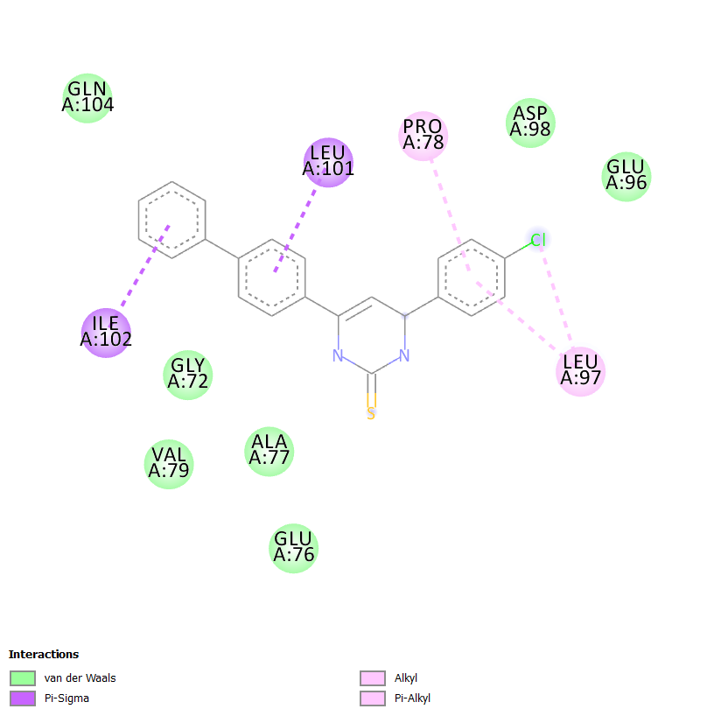 | 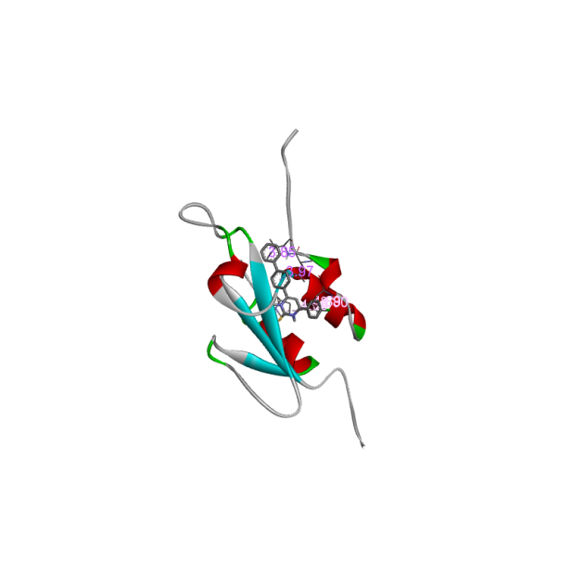
BCT-2 | 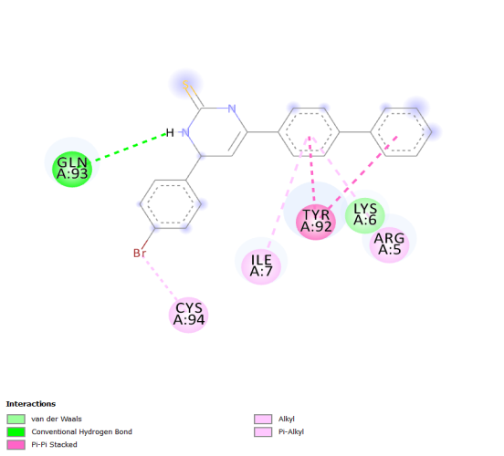 | 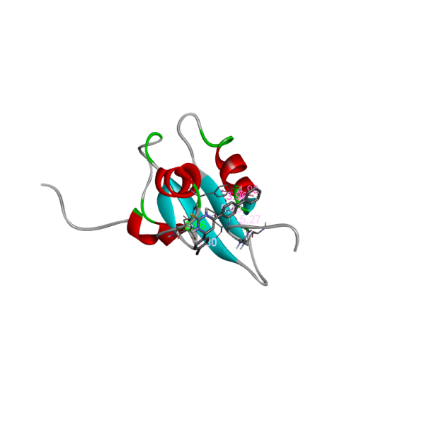
BCT-3 | 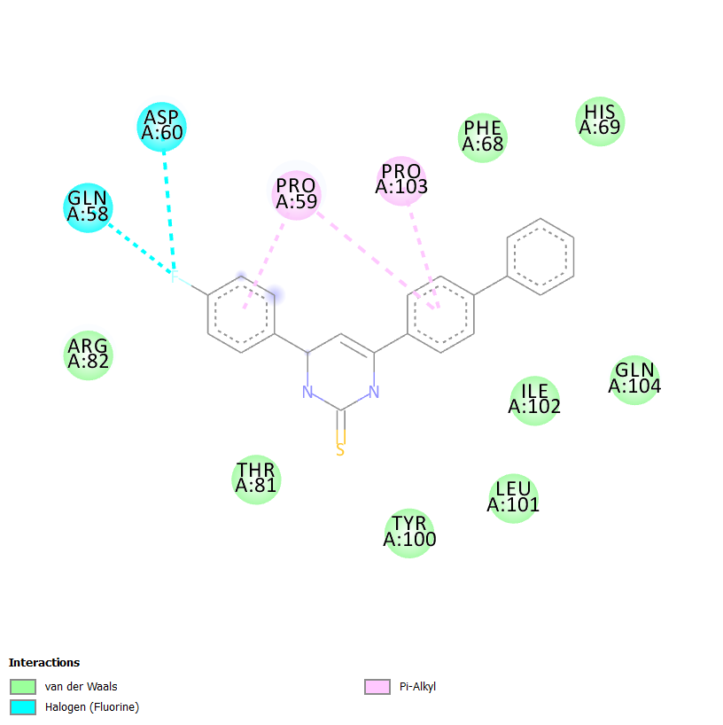 | 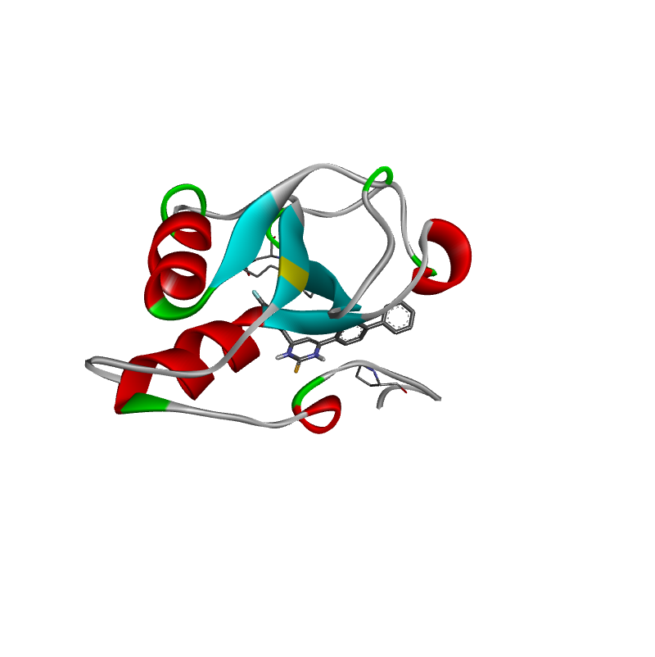
BCT-4 | 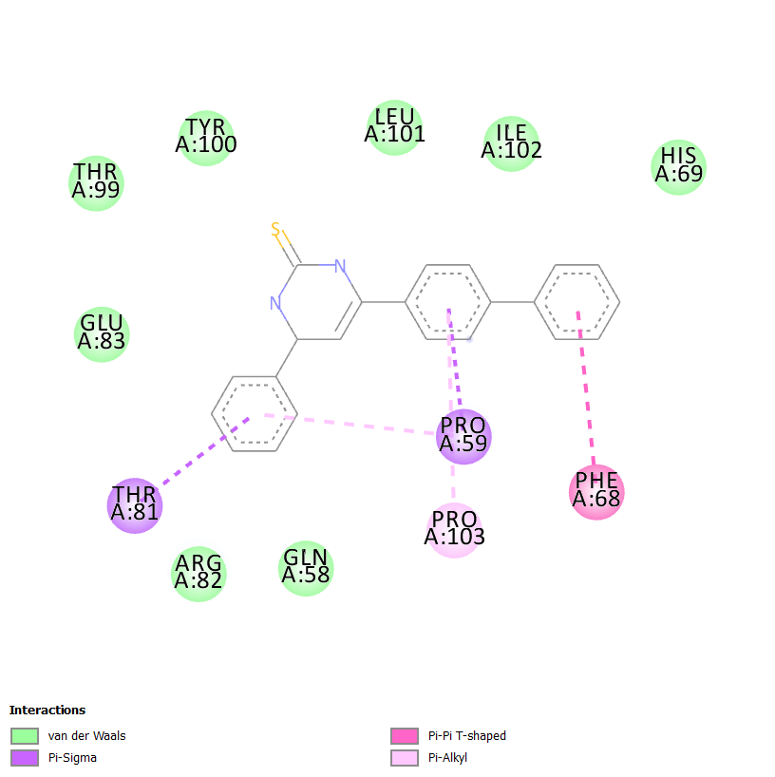 | 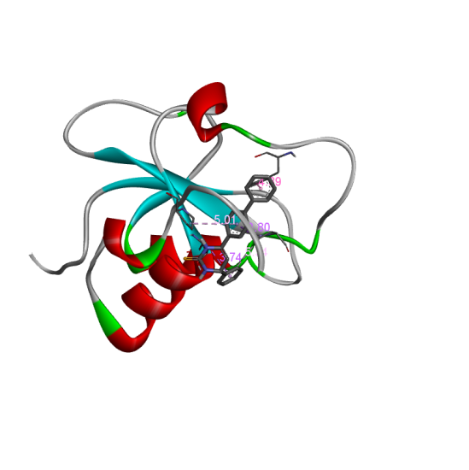
BCT-5 | 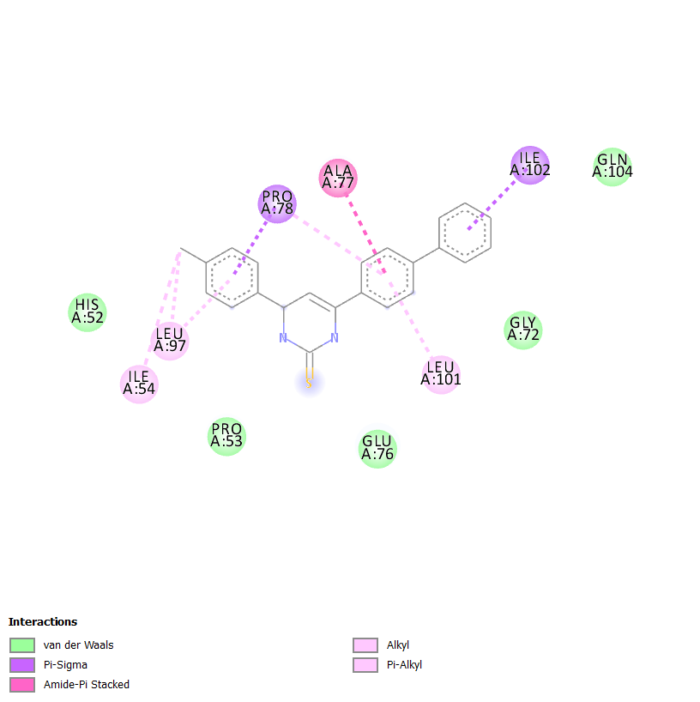 | 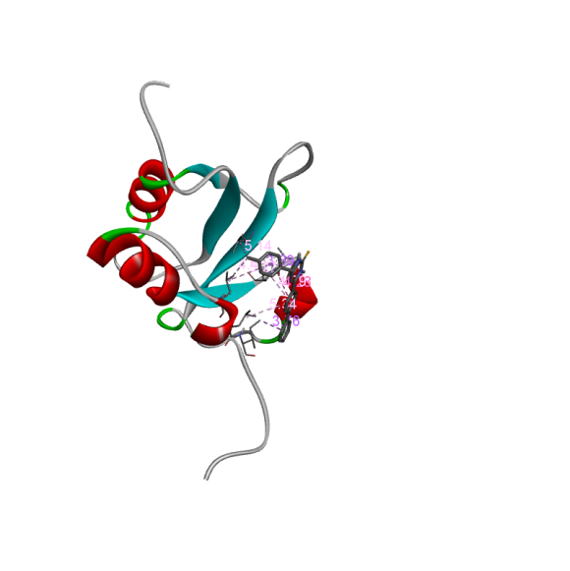
BCT-6 |  | 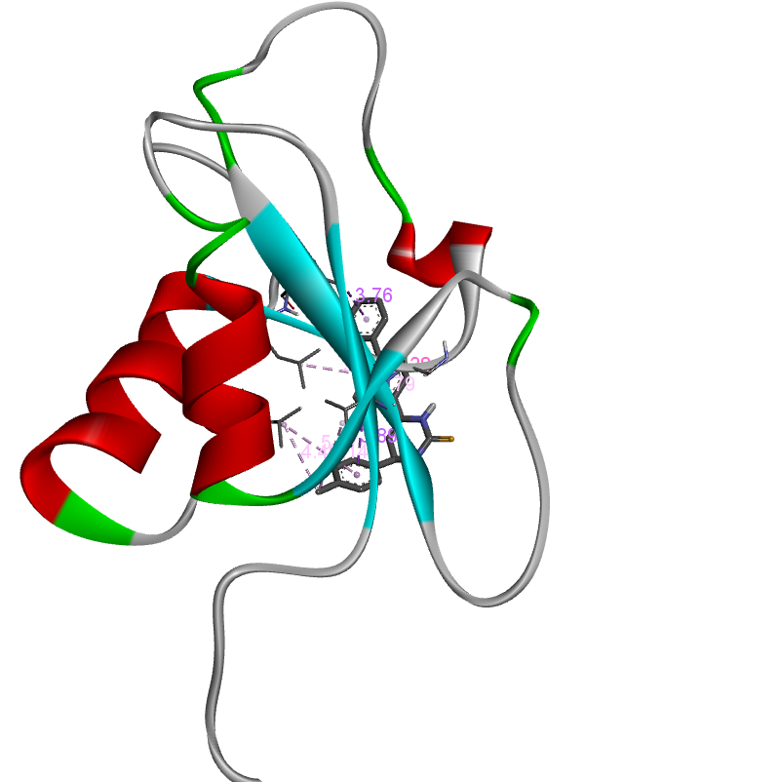
BCT-7 | 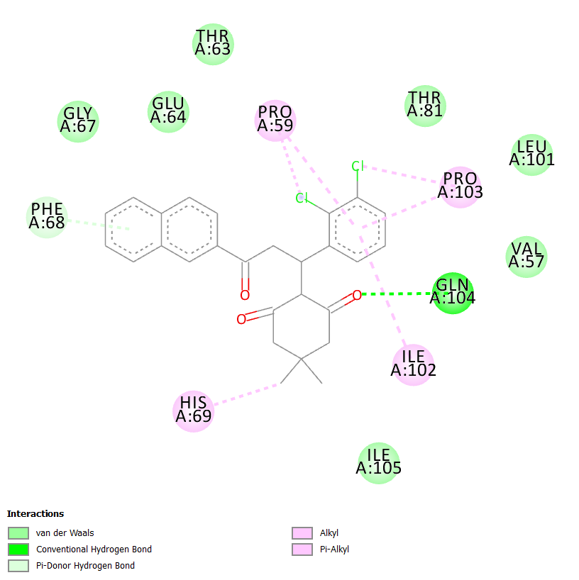 | 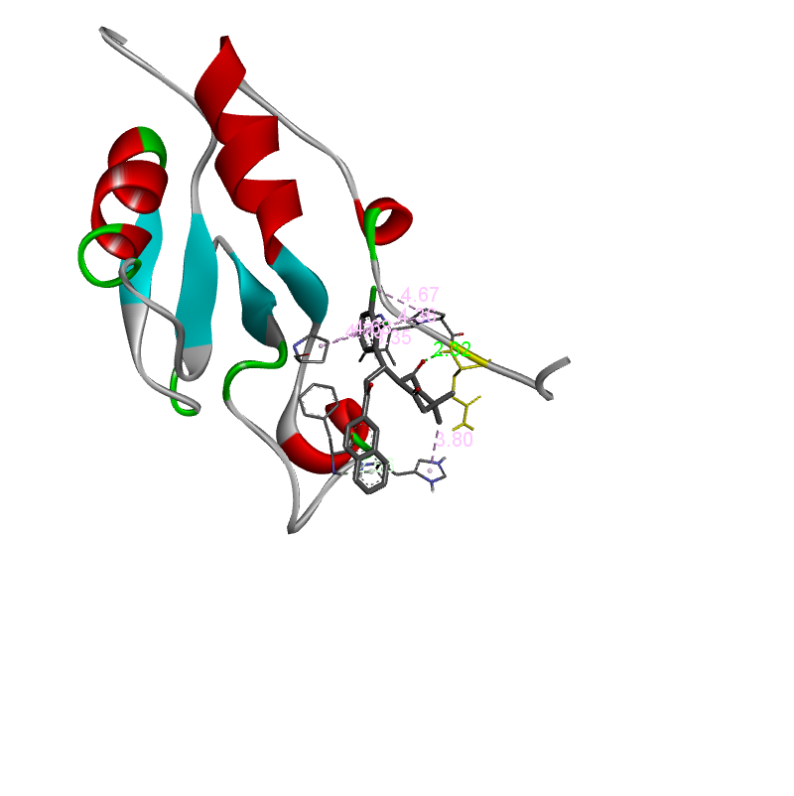
BCT-8 |  | 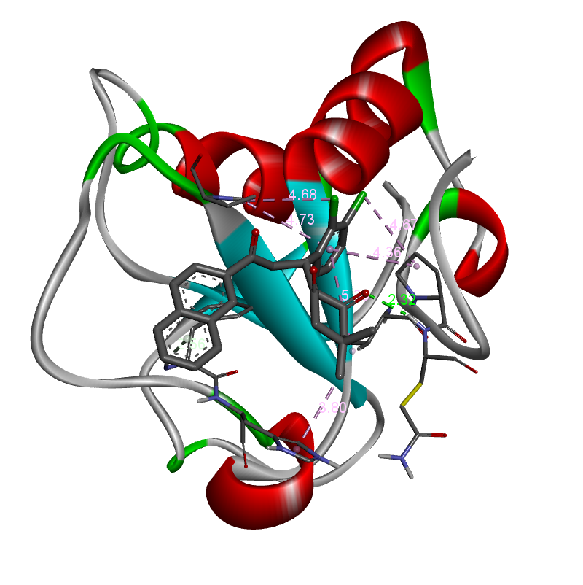

3.5. Antimicrobial activity:
Bacterial study
Antibacterial study performed (BCT 1-8) against the bacterial strains, From the results (Table-11); BCT-3 electron with drawing compound (F) exhibited good zone of inhibition (20 mm) against S.aureus and BCT-2 electron withdrawing compound (Br) shows excellent zone of inhibition (24 mm) against S. pyogenes. Compound BCT-3 (Fluoro substitution) produced excellent zone of inhibition (24 mm) against E.coli. Compound BCT-3 has excellent zone of inhibition (25 mm) compared with standard drug against P.aeruginosa. From the antibacterial evaluation, the electro withdrawing group (F & Br) has excellent activity. Because of the F, Br group directly attached with Pyrimidine moiety of BCT-3 and BCT-4.The electron withdrawing group present on the pyrimidine part were increased the antibacterial potential against S.pyogenes.
Fungal study
Antifungal study performed (BCT 1-8) against candida albicans. From the Antifungal results idendified in (Table-11), BCT-3 give good antifungal activity (14 mm) which was compared with standard drug Clotrimazole (24 mm). The BCT 1-8 are moderately active. The electron withdrawing group directly tied with Pyrimidine part of BCT-3 enhanced the antifungal potential against C.albicans.

Table 11: Antimicrobial study BCT 1-8 at 1.0 mg/ml.
Entry | Substituents | Bacterial strains |  |  |  | Fungal Strain
Entry | Substituents | S.aureus | S. pyogenes | E. Coli | P.aeruginosa | Candida albicans
BCT-1 | Cl | 15 | 21 | 18 | 16 | -
BCT-2 | Br | 14 | 24 | 16 | 17 | 14
BCT-3 | F | 20 | 22 | 24 | 25 | 16
BCT-4 | H | 16 | 24 | 20 | 16 | 13
BCT-5 | CH3 | 16 | 19 | 18 | - | -
BCT-6 | OCH3 | 17 | 18 | 17 | 16 | -
BCT-7 | FURAN | 16 | 16 | 17 | 20 | 11
BCT-8 | 2,3 DICHLORO | 16 | 17 | 16 | 10 | 10
Ciprofloxacin/Chlotrimazole | - | 26 | 17 | 19 | 22 | 24

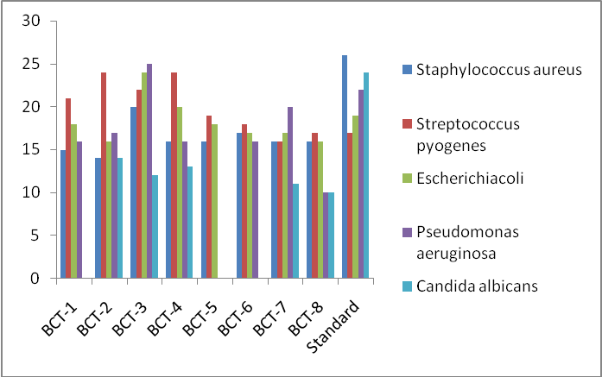
Figure 5: Antimicrobial activity of isolated compounds BCT 1-8
4. CONCLUSION
The structurally diverse compounds BCT 1-8 were synthesized by cyclization method. The BCT 1-8 were characterized by IR and NMR, and it was the good deal with target compounds. Compound BCT-3 showed excellent activity against microbial strains. The insilico predictions are performed for BCT 1-8, and the result indicated that compound BCT-7 and 8 were better active and have the highest score value of 8.3 kcal/mol. ADME properties also carried out for eight amino pyrimidine derivatives. From the ADME results proved the acceptance of Lipinski rule of five. We conclude that the BCT 1-8 are lead compounds and are suitable to be drugs.

REFERENCES
1. Y.H. Zaki, M.S. Al-Gendey and A.O. Abdelhamid, Chem. Cent. J., 12,70 (2018);
https://doi.org/10.1186/s13065-018-0439-9
2. T.S. Straub, Tetrahedron Lett., 36, 663 (1995);https://doi.org/10.1016/0040-4039(94)02346-D
3. E.D. Bergmann, D. Ginsburg and R. Pappo, Michael Reaction, The Organic Chemistry, Wiley (1959).
4. S.R. Sandlar and W. Karo, Organic Functional Group Preparations, Elesvier: New York, edn 2 (2013).
5. Y.R. Prasad, A.L. Rao and R. Rambabu, J. Chem., 5, 461 (2008); https://doi.org/10.1155/2008/876257
6. S.N. López, M.V. Castelli, S.A. Zacchino, J.N. Domínguez, G. Lobo,J. Charris-Charris, J.C.G. Cortés, J.C. Ribas, C. Devia, A.M. Rodríguez and R.D. Enriz, Bioorg. Med. Chem., 9, 1999 (2001); https://doi.org/10.1016/S0968-0896(01)00116-X
7. B. Baviscar and S. Patel, Asian Res. Chem., 1, 67 (2008).
8. F. Herencia, M.L. Ferrandiz, A. Ubeda, J. Dominguez, J.E. Charris, G.M. Lobo and M.J. Alcaraz, Bioorg. Med. Chem. Lett., 8, 1169 (1998); https://doi.org/10.1016/S0960-894X(98)00179-6
9. X. Wu, P. Wilairat and M.-L. Go, Bioorg. Med. Chem. Lett., 12, 2299 (2002);
https://doi.org/10.1016/S0960-894X(02)00430-4
10. A. Agarwal, K. Srivastava, S.K. Puri and P.M.S. Chauhan, Bioorg. Med.Chem. Lett., 13, 6226 (2005);https://doi.org/10.1016/j.bmc.2005.06.052
11. T. Narender, T. Khaliq, Shweta, Nishi, N. Goyal and S. Gupta, Bioorg.Med. Chem., 13, 6543 (2005);https://doi.org/10.1016/j.bmc.2005.07.005
12. J.-H. Cheng, C.-F. Hung, S.-C. Yang, J.-P. Wang, S.-J. Won and C.-N.Lin, Bioorg. Med. Chem., 16, 7270 (2008); https://doi.org/10.1016/j.bmc.2008.06.031
13. Y.-M. Lin, Y. Zhou, M.T. Flavin, L.-M. Zhou, W. Nie and F.-C. Chen,
Bioorg. Med. Chem. Lett., 10, 2795 (2002); https://doi.org/10.1016/S0968-0896(02)00094-9
14. P.M. Sivakumar, S.P. Seenivasan, V. Kumar and M. Doble, Bioorg. Med.
Chem. Lett., 17, 1695 (2007); https://doi.org/10.1016/j.bmcl.2006.12.112
15. M.Z. Gibson, M.A. Nguyen and S.K. Zingales, Med. Chem., 14, 333
(2018); https://doi.org/10.2174/1573406413666171020121244
16. U.M. Kocyigit, Y. Budak, M.B. Gurdere, F. Erturk, B. Yencilek, P. Taslimi, I. Gülçin and M. Ceylan, Arch. Physiol. Biochem., 124, 61 (2018); https://doi.org/10.1080/13813455.2017.1360914
17. V. Kanagarajan, M.R. Ezhilarasi and M. Gopalakrishnan, J. KoreanChem. Soc., 55, 256 (2011);https://doi.org/10.5012/jkcs.2011.55.2.256
18. K. Vijayakumar, M.R. Ezhilarasi and M. Goplakrishnan, Org. Med. Chem. Lett., 1, 8 (2011);
https://doi.org/10.1186/2191-2858-1-8
19. C. Zhuang, Wen Zhang, C. Sheng, W. Zhang, C. Xing and Z. Miao, Chem Rev., 117, 7762 (2017); https://doi.org/10.1021/acs.chemrev.7b00020
20.. A. Ansari, A. Ali, M. Asif and S. Shamsuzzaman, New J. Chem., 41, 16 (2017);
https://doi.org/10.1039/C6NJ03181A
21. D.J. Brown, Pyrimidines and their benzo derivatives, in: A.R. Katritzky, C.W. Rees (Eds.), Comprehensive Heterocyclic Chemistry, vol. 3, Pergamon Press, Oxford, 1984, pp. 57-155, http://dx.doi.org/10.1016/B978-008096519-2.00035-7.
22. S. Achelle, N. Ple, Pyrimidine ring as building block for the synthesis of functionalized-conjugated materials, Curr. Org. Synth. 9 (2012) 163-187, http://dx.doi.org/10.2174/ 157017912799829067.
23. A Attanasi Orazio, Domenico Spinelli, Targets in Heterocyclic Systems vol. 17, Italian Society of Chemistry, 2013, pp. 1e37. https://hal-univ-rennes1.archives-ouvertes.fr/hal-01059402.
24. Sylvain Achelle, Samia Kahlal, Alberto Barsella, JeanYves Saillard, Xiaoyang Che, et al., , Elsevier 113 (2015) 562-570, http:// dx.doi.org/10.1016/j.dyepig.2014.09.028. .
25. S. Ebtehal, Y. Al-Abdullah, C. Sheena Mary, Yohannan Panicker, Nasser R. El-Brollosy, Ali A. El-Emam, Christian Van Alsenoy, Abdulaziz A. Al-Saadi, Spectrochim. Acta Part A Mol. Biomol. Spectros. 133 (2014) 639-650, http://dx.doi.org/ 10.1016/j.saa.2014.06.042.
26. A.R. Ali, E.R. El-Bendary, M.A. Ghaly and I.A. Shehata, Eur. J. Med.Chem., 75, 492 (2014); https://doi.org/10.1016/j.ejmech.2013.12.010
27. R. Chinnamanayakar, E. Mr, P. B and K. M, Asian J. Pharm. Clin. Res.,12, 311 (2019);
https://doi.org/10.22159/ajpcr.2019.v12i3.30481
28. A.M. Vijesh, A.M. Isloor, S. Telkar, T. Arulmoli and H.-K. Fun, Arab.J. Chem., 6, 197 (2013); https://doi.org/10.1016/j.arabjc.2011.10.007
29. E. Ashry, Z. Din, Z. Soomro, W. Rahman, M. Shah, Y. Kilany, L.Naesens and A. Boraei, Lett. Org., 11, 168 (2014); https://doi.org/10.2174/1570178610666131118222358
30. J.C. Dearden, Exp. Op. Drug Disc., 1, 31 (2006); https://doi.org/10.1517/17460441.1.1.31
31. F. Lombardo, E. Gifford and M. Shalaeva, Mini Rev. Med. Chem., 3,861 (2003); https://doi.org/10.2174/1389557033487629
32. S. Kulkarni, J. Zhu and S. Blechinger, Xenobiotica, 35, 955 (2005);
https://doi.org/10.1080/00498250500354402
33. J. Gola, O. Obrezanova, E. Champness and M. Segell, QSAR Comb.Sci., 25, 1172 (2006);
https://doi.org/10.1002/qsar.200610093
34. S.R. Johnson and W. Zheng, AAPS J., 8, 27 (2006); https://doi.org/10.1208/aapsj080104
35. J.C. Dearden, J. Comput. Aided Mol. Des., 17, 119 (2003); https://doi.org/10.1023/A:1025361621494
36. D.F.V. Lewis, Y. Ito and P.S. Goldfarb, Drug Dev. Res., 66, 19 (2005);
https://doi.org/10.1002/ddr.20040
37. C. de Graaf, N.P.E. Vermeulen and K.A. Feenstra, J. Med. Chem., 48,2725 (2005);
https://doi.org/10.1021/jm040180d
38. J.C. Dearden, Expert Opin. Drug Metab. Toxicol., 3, 635 (2007);
https://doi.org/10.1517/17425255.3.5.635
39. A. Ali, M. EI Badawy, R. Shah, W. Rehman, Y. EI kilany, E.S.H. EI Ashry and N. Tahir, Der Chemica Sinica, 8, 446 (2017).
40. Molinspiration Cheminformatics Brastislava, Slovak Republic, available from: http://www.molinspiration.com/egibin/properties,2014.
41. M.H. Shaikh, D.D. Subhedar, L. Nawale, D. Sarkar, F.A.K. Khan, J.N.Sangshetti and B.B Shingate, Med. Chem. Commun., 6, 1104 (2015);https://doi.org/10.1039/C5MD00057B
42. Y.H. Zhao, M.H. Abraham, J. Le, A. Hersey, C.N. Luscombe, G. Beck,B. Sherborne and I. Cooper, Pharm. Res., 19, 1446 (2002); https://doi.org/10.1023/A:1020444330011
43. S. Singh, A.K. Gupta and A. Verma, Res. J. Pharm. Biol. Chem. Sci., 4,
876 (2013).

