Drug delivery systems based on amphiphilic Polysaccharides: An update and future perspectives

Sutapa Mandal, Tuhin Ghosh*

Department of Chemistry (UG & PG), Durgapur Government College, Durgapur-713214, Paschim Bardhaman, West Bengal, India

Corresponding author’s e-mail:tuhinghoshbuchem@gmail.com

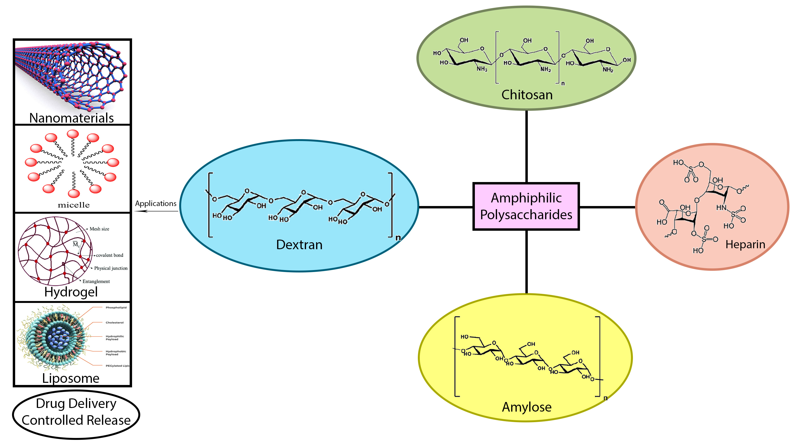
Graphical Abstract

Abstract
Over the past two decades, a novel opportunity namely naturally occurring polysaccharides have been widely investigated pharmaceutically for the purpose of delivery of various therapeutic agents. The polysaccharides and its self-assembly are the most popular techniques for drug delivery systems and more importantly in the absence of solvents. The different drug delivery systems like micelles, nanoparticles, liposomes and hydrogel are the product of intermolecular or intramolecular associations of the various polymeric amphiphilic polysaccharides in water. This review briefly provides an insight of the recent successes of key polymeric polysaccharides, especially those constructed for pharmaceutical applications in controlled drug delivery. The chitosan polysaccharides have been specially illustrated due to its unique properties and accelerated progress in biomedical applications.

Keywords: polysaccharides, chitosan, heparin, dextran, pH responsive, drug delivery

Introduction
The term drug delivery has gained increasing importance in the modern era and this method of formulation and administration a pharmaceutical active compound to produce a therapeutic effect has advanced. Advances in healthcare drug delivery systems, specifically novel opportunities associated with both physical and chemical properties of the drug together with the polysaccharides, have opened a new research field of polysaccharide based nanoparticles. Now the routes of drug delivery goes through the mechanism engaged with the drug delivery to the expected site of the body for suitable release or absorption, or the consequent carry of the drugs in the cell membranes to the desired site of action. There have been a lot of reports in this field with an aim to produce benign drug delivery systems and adequate findings on the unique properties, specifically aiming to biocompatibility, non-toxicity, anti-microbial and bio-adhesive properties facilitate sustained drug delivery at target sites of action.
Carbohydrate molecules that contain repeated units of either the same or different monosaccharide units are referred to as the term polysaccharides (Fig. 1.). The polysaccharides may have various structures with a broad diversity and property due to the presence of a number of functional reactive groups, change in molecular weight (MW), and sugar composition. They can now be split into positively charged polysaccharides (such as pectin, alginate, etc.) and negatively charged polysaccharides (such as polyelectrolytes and non-polyelectrolytes) (chitosan, etc.). Due to the various functional groups in their chains, polysaccharides are amenable to chemical and biological modification to produce their derivatives. Due to the presence of polar functional groups in their structures, these are readily available, extremely safe, stable, non-toxic, inexpensive to process, biodegradable, and hydrophilic. The presence of these characteristics in polysaccharides as well as its derivatives reports nanoparticles and stimuli sensitive as drug delivery materials [1].
The applications and synthesis of nanoparticles has increased immensely with an emphasis on those that are conjugated from natural polysaccharides in the applications as drug delivery systems. But during the formulation of these stimuli sensitive nanoparticles containing natural polysaccharides, obstacles were reported regarding appropriate use of organic solvent, otherwise which may lead to precipitation, emulsification and polymerization like phenomena. This limitation was overcomed by the introduction of hydrophobic groups. When hydrophobic groups are chemically added to natural polysaccharides, the resulting amphiphilic polysaccharides exhibit self-association in aqueous solution as a result of the interactions between and/or within the molecules of the hydrophobic molecules. Modern drug delivery agents like micelles, nanoparticles, microspheres, liposomes, and hydrogels are created as a result of this process.
The most commonly used polysaccharide polymers used in pharmaceutical applications are chitosan, dextran, heparin, pullulan, hyaluronic acid and amylose. Of these, Chitosan is noted to be the polymer in focus that has been widely used as micro- and nanoparticles in drug delivery systems. This review provides an overview and updates on the various drug delivery systems based on stimuli responsive natural polysaccharide polymers and its derivatives. The various methods of preparation and characterization of selective natural polysaccharides based micro- and nanoparticles are illustrated. The usefulness of these particles in parental and non-parental drug delivery in thermo-and pH-responsive environment is compared to various metal based nanoparticles.

Polysaccharides

Dextran
Dextran is a generic term for the complex polysaccharides comprising a family of glucans comprised of polymeric chains of α-D-glucopyranosyl moiety. It is a bacterial exopolysaccharide, neutral and biodegradable in nature comprising of mainly glucose subunits. It is mostly soluble in polar and other organic solvents, the property which is utilized for the synthesis of various composites by blending it with the polymers, that are water repelling in nature. Dextran has a strong affinity for bile acids, covalently by the help of ester linked bonds, as the bile acids are naturally occurring compounds with steroid molecules containing both hydrophobic and hydrophilic end. The resulting amphiphilic conjugates shows a better compatibility with suitable bio-macromolecular systems.
The amphiphilic dextran in the self-associated assembly produced micelles with dextran grafted with cholic acid of 130 nm size starting with concentration greater than 0.2 mg/ml and with dextran grafted with deoxycholic acid of 150 nm size. It was affirmed that the hydrophobic interactions occurred mainly intramolecularly between the large macromolecule and hard bile acid side chains from the viscometric measurements of the aqueous solutions of amphiphilic dextrans. However, it was noted that amphiphilic dextran cannot self-associate into micelles after a concentration of 6 mg/ml [2]. Additionally, it was discovered that dextran may graft with lauryl chains (C12), and various DS were recorded (2.7, 4 and 7%). Poly-β-cyclodextrin and the resulting amphiphilic dextran were able to spontaneously self-associate to form stable supramolecular nanoparticles [3-5]. At room temperature, the drug-containing poly-β-cyclodextrin aqueous solution and hydrophobized dextran solutions were loaded into the nano-assemblies.

Hyaluronic acid
It is the naturally occurring substance made of anionic, non-sulfated glycosaminoglycan that is present in the fluids of the eye and bone joints. It controls certain functions in the epidermis and is present in the connective and neural tissues. Hyaluronic acid is also crucial for the re-epithelialization process, which is primarily what allows a wound to heal properly and necessitates coordinated basal keratinocyte migration and proliferation at the site of the lesion. It is positioned at the basal layer of the epidermis in relatively high concentrations in the normal skin. It was said to undergo chemical modification by binding with dioleoylphosphatidylethanolamine (DOPE) for 24 hours at 37 ⁰C with EDC chloride acting as a coupling agent, followed by ultrafiltration [6] to produce the end product. Hyaluronic acid that has been hydrophobically modified is employed in gene therapy in the form of lipoplexes [6, 7].

Amylose
Amyloses are the class of polysaccharides produced from repeated α-D-glucopyranosyl sub-units linked together by α-(1,4) glycosidic bonds. The C-1 positions of the glucose molecules are connected to the C-4 of the other. The usual range of glucose subunits is 300 to 3000 or more. The amylose often manifests as starch and glycogen. A complex polysaccharide called a starch is made up of several monomeric units of glucose that are bonded together by glycosidic linkages. A pure starch is made up of the molecules amylose and amylopectin. The plant stores the extra glucose in the form of starch. Amylose typically accounts for 30% of the starch that plants store. The enzyme that converts the starch molecule into less complex sugars is called -amylase. Commercially, the emulsifier and thickening industries greatly benefit from the use of amylose. It acts as a marker in laboratories, particularly for the iodine test, for the presence and concentration of starch. By graphiting with linoleic acid [8], amylose was chemically altered in two ways:
(i) The first technique comprised heating the amylose solution in DMSO to 90 ⁰C and adding linoleic acid. Following the dissolution of the linoleic acid, water was added, and the mixture was incubated at the crystallisation temperature for 15 min with vigorous stirring to finish the complex formation. The amylose-linoleic acid complexes were then separated by freeze drying after the suspension was cooled to 20 ⁰C. The complexes were centrifuged as before after being thrice rinsed with an ethanol:water solution to get rid of any remaining uncomplexed linoleic acid. When amylose and linoleic acid were grafted together, spherical micelles might form through self-association.
(ii) KOH and HCl solution were used in the second technique that was developed [9]. Different crystallisation temperatures of amylose and linoleic acid solutions in 0.01 M KOH preheated to 90 ⁰C were combined; the mixture was then neutralised with 10ml of 0.1 M HCl. The combination was then maintained for 24 hours at the designated crystallisation temperature. All samples were then centrifuged, and the precipitate was twice cleaned with a 50:50 solution of ethanol and water to get rid of any simple linoleic acid residues. After being freeze-dried, the complexes eventually produced elongated nanoparticle forms.

Pullulan
The fermentation of black yeast yielded this specific class of non-ionic polysaccharide polymer. Due to its distinctive properties, which include maltotriose units, also known as α-1,4- and α-1,6-glucan, Aureobasidium pullulans is currently used in the food and pharmaceutical industries. Maltotriose has three glucose units that are united by a α-1,4 glycosidic connection, whereas subsequent maltotriose units are joined by a α-1,6 glycosidic bond. Pullulans are being studied for their non-toxic, non-immunogenic, non-carcinogenic, and non-mutagenic properties in a variety of biomedical applications, including gene delivery, targeted drug therapy, tissue engineering, wound healing, and diagnostic uses like perfusion, receptor, and lymph node target specific imaging, as well as vascular compartment imaging. Pullulan has a special linkage between - α- (1→4) and α-(1→6) that gives it physical characteristics including adhesiveness and fiber-forming capacity. The polysaccharide is primarily used by the cell to withstand desiccation and predation and to enable the diffusion of chemicals into and out of the cell.
Pullulans can also be chemically altered to form hydrogel nanoparticles that contain cholesterol-bearing self-aggregates, in which the pullulan chains are non-covalently connected together by cholesteryl moieties. When the DS of the cholesteryl moiety increased, the diameters of the self-aggregates shrank, but the number of pullulans containing cholesterol that could aggregate into a single nanoparticle was almost DS-independent [10]. At a temperature of 50–60 ⁰C for 12–24 h, the resulting amphiphilic pullulan is only marginally soluble in water. Interestingly, the formed nanoparticles are thermosensitive. Porphyrin, bilirubin, and the anticancer drug adriamycin were among the hydrophobic compounds that the cholesterol-bound pullulans were able to mix with [11].

Heparin
The most commonly available anti-coagulant (blood thinner) available in the market and recommended by doctors that arrest blood clotting conditions especially during the post-surgical procedures. The composition of heparin is a mixture of polysaccharide chains in linear chain consisting of polysaccharide with acidic groups such as SO₄⁼ or N-CH₃COO⁻ groups. The quantity of sulfate groups in the saccharide units is directly linked with the anticoagulant properties of heparin. Heparin has a molecular weight of 12,000 D on average [12–13] and is made up of trisulfated diasaccharide repeating units. Heparin's structure is complicated since it contains extra diasaccharide structures [14–17]. The biological activity of heparin is influenced by its chain size and level of sulfation. Deoxycholic acid and heparin with various DS were used to create spherical and monodisperse heparin-based nanoparticles with the goal of chemically altering heparin [18]. Heparin nanoparticles containing deoxycholic acid were encased in negatively charged heparin shells. Five to nine amphiphilic heparin chains made up a hydrophobic domain in the conjugates, according to an estimate of the mean amount of deoxycholic acid that aggregated per hydrophobic microdomain made using fluorescence quenching techniques with cetylpyridinium chloride [19].

Chitosan
The linear heteropolymer of N-acetyl-D-glucosamine and D-glucosamine in chitosan polysaccharide is joined by β-(1-4) glycosidic linkages. This polymer is produced when chitin is partially deacetylated. Natural sources of chitin include the shells of numerous insects and crustaceans including lobster, prawns and crab. The degree of acetylation (DA) and its management are crucial aspects of chitin and chitosan from a property standpoint. Chitin is insoluble in aqueous and many organic solvents, while chitosan is protonated by the amine groups on the polymer molecule, making it hydrophilic and soluble in acidic liquids. Additionally, chitosan is said to be biocompatible and further broken down by lysozymes, a few lipases, and proteases [20].
The mucoadhesive characteristics of chitosan are represented by the interaction between the positive charges of the amine and the negative charges of the membrane proteins in its structure [21]. The well-known antibacterial and antiparasitic properties of chitosan have also been described [22]. By grafting hydrophobic groups, chitosan can be chemically altered with the goal of making it a drug delivery system. The three various kind of reactions that can be employed to N-acylate chitosan are discussed: (Fig. 2)
Type-1: Chitosan was N-acylated in a solution of pyridine and chloroform with oleoyl chloride present (Fig. 2a) at room temperature for 2 h and then refluxed for 10 h. The product was added to methanol, and after it precipitated, it was filtered and dried for 24 h under a vacuum. Using infrared spectroscopy, the degree of N-acylation—measured as the number of oleic acid groups per 100 N-acetyl-D-glucosamine units of chitosan—was investigated [23-24].
Type-2: In this type of reaction, carboxylic acid along with coupling agents such as 1-Ethyl-3-(3-dimethylaminopropyl) carbodiimide (EDC) (Fig. 2b) was treated with the fatty acid viz., stearic (C₁₈C₃₆O₂), linoleic (C₁₈H₃₂O₂) and oleic (C₁₈H₃₄O₂) [25-28] acids, where the carboxyl groups was converted to a reactive intermediate ester that can be used to acylate the chitosan's principal amine groups. After grafting deoxycholic acid onto chitosan in the presence of EDC, a group [25, 29-30] observed that the aggregates created were able to load up 49.6% of doxorubicin (a topoisomerase II inhibitor used as an anticancer treatment).
Type-3: The reaction between acid anhydrides [acetic (C4), propionic (C6), lauric (C24), palmitic (C32) and stearic (C36) anhydrides] in dimethyl sulfoxide (DMSO) to obtain the N-carboxyacyl-chitosan derivates [31–33] (Fig. 2c). The resulting amphiphilic chitosans were water soluble. New physicochemical features include grafting a hydrophobic group onto chitosan to provide various drug delivery systems, as well as self-association with polysaccharides in water, buffers, or acetic acid solution (0.1 M) spontaneously [34–39] or under sonication [5,25,40–43].
Self-association of chitosan-containing stearic acid lead to the formation of micelles [26,44]. According to other findings [27,45], chitosan and linoleic acid were coupled by an EDC-mediated reaction. The surfaces of the micelles were further cross-linked by glutaraldehyde [26,27,43] or sodium tripolyphosphate [45] to make drug-loaded and shell cross-linked nanoparticles because these modified chitosans were insoluble at neutral pH. It is known that water-insoluble medicines prefer to be loaded into the hydrophobic core of micelles. We discovered amphiphilic chitosan-based micelles that included the well-known medications ibuprofen [39], doxorubicin [44], paclitaxel [26,40,46-48] and the amphiphilic adriamycin [49]. Hydrogels are formed by controlling chitosan concentrations, molecular weight and DS (Fig. 3).
For topical medication delivery, chitosan hydrogels physically cross-linked with stearic, palmitic, myristic, or lauric acids were used. The two most crucial variables that must be regulated in order to make hydrogels are viscosity and water absorption capacity. The hydrogel's higher viscosity ensures that it remains in touch with the skin for a longer period of time, while its ability to swell is essential for the drug's ability to load and release. The elastic characteristics of the hydrogels were calculated using the rheological data. The hydrogel viscosity was shown to increase and the swelling characteristics to decrease when the hydrophobic group chain length rose from laurate to stearate [50-51].

Conclusion
This review emphasizes on the recent works on mostly thermo- and pH-sensitive polysaccharides and their applications in drug delivery process. After comprehensive examination, it is possible to draw the conclusion that, in contrast to other polysaccharides, the derivatives of chitosan, heparin, and amylose have been potentially investigated and used. Changes have been made, and it has been discovered that polysaccharides, particularly chitosans, self-associate in aqueous media to generate unique polymeric micelles, nanoparticles, and hydrogels wherever it is thought essential. These novel discoveries may be used to encapsulate and release active medications.

Conflict of Interest
The writers affirm that they do not have any financial conflicts of interest with regard to publishing this work with any publisher.

References
[1]. F. Camponeschi, A. Atrei, G. Rocchigiani, L. Mencuccini, M. Uva and R. Barbucci, Gels 1, 3 (2015).
[2]. Y. Gao, R. Wang, L. Zhao and A. Liu, J. Drug Targeting, 29(9), 1 (2021).
[3]. Z. Ma, J. Yao, Y. Wang, J. Jia, F. Liu and X. Liu, Food Hydrocolloids, 125, 107367 (2021).
[4]. W. Yang, M. Wang, L. Ma, H. Li and L. Huang, Carbohydr. Polym. 99, 720 (2014).
[5]. C.C. Carrion, M. Nasrollahzadeh, M. Sajjadi, B. Jaleh, G.J. Soufi and S. Iravani, Int. J. Biol. Macromol., 178, 193 (2021).
[6]. G. Huang and H. Huang, Drug Deliv., 25 (1), 766 (2018).
[7]. S. Shen H. Li and W. Yang, Drug Deliv., 21, 501 (2014).

[8]. X. Cai, L. Yang, L.M. Zhang, Q. Wu, 345(7), 922 (2010).
[9]. A.R. Mohamed Wali, J. Zhou, S. Ma, Y. He, D. Yue, J.Z. Tang and Z. Gu, Int. J.
Pharm. 525(1), 191 (2017).
[10]. A.G. Grigoras, Environ. Chem. Lett. 17, 1209 (2019).
[11]. R.S. Singh, N. Kaura, V. Ranab and J.F. Kennedy, Carbohydr. Polym. 171, 102
(2017).
[12]. C. Vasile, D. Pamfil, E. Stoleru and M. Baican, Molecules. 25(7), 1539 (2020).
[13]. Y. Liang and K.L. Kiick, Acta Biomater. 10(4), 1588 (2014).
[14]. L. Saunders and P.X. Ma, Macromol. Biosci. 19, 1 (2019).
[15]. Y. Zeng, Y. Xiang, R. Sheng, H. Tomás, J. Rodrigues, Z. Gu, H. Zhang, Q. Gong
and K. Luo, Bioactive Materials, 6(10), 3358 (2021).

[16]. V.D. Prajapati, G.K. Jani and S.M. Khanda, Carbohydr. Polym. 95, 540 (2013).
[17]. R.S. Singh, N. Kaura and J.F. Kennedy, Carbohydr. Polym. 123, 190 (2015).
[18]. A. Kikuchi, M. Kawabuchi, M. Sugihara, Y. Sakurai and T. Okano, J. Control. Release 47, 21 (1997).
[19]. S.N. Pawar and K.J. Edgar, Biomaterials 33, 3279 (2012).
[20]. N.V. Majeti and R. Kumar, React. Funct. Polym. 46, 1 (2000).
[21]. K. Kurita, Polym. Degrad. Stab. 59, 117 (1998).
[22]. I.A. Sogias, Biomacromol. 9, 1837 (2008).
[23]. E.I. Rabea, Biomacromol. 4, 1457 (2003).
[24]. Y-Y. Li, J. Appl. Polym. Sci. 102, 1968 (2006).
[25]. C. Le Tien, J. Control. Release 93, 1 (2003).
[26]. K.Y. Lee, J. Control. Release 51, 213 (1998).
[27]. N. Mamidi and R.M.V. Delgadillo, Colloids and Surfaces B: Biointerfaces, 204, 111819 (2021).
[28]. M. Sajjadi, M. Nasrollahzadeh and H. Ghafuri, J. Organomet. Chem. 1, 121959
(2021).
[29]. E. Dashtimoghadam, H. Mirzadeh, F.A. Taromi and B. Nyström, Polymer, 54, 4972
(2013).
[30]. C.C. Toma, A. Aloisi, V. Bordoni, R. Di Corato, M. Rauner, G. Cuniberti, L.G.
Delogu and R. Rinaldi, Biomacromol. 19, 3560 (2018).
[31]. X. Li, J. Tang, L. Bao, L. Chen, F.F. and Hong, Carbohydr. Polym. 178, 394
(2017).
[32]. A.T. Iacob, F.G. Lupascu, M. Apotrosoaei, I.M. Vasincu, R.G. Tauser, D. Lupascu,
S.E. Giusca, I.D. Caruntu and L. Profire, Pharmaceutics, 13, 587 (2021).
[33] W.B. Wang, J.X. Xu and A.Q. Wang, Express Polym. Lett. 5, 385 (2011).
[34] C. Pinto Reis, R.J. Neufeld, A.J. Ribeiro and F. Veiga, Nanomedicine 2, 8 (2006).
[35]. P. Fouladian, F. Afinjuomo, M. Arafat, A. Bergamin, Y. Song, A. Blencowe and S.
Garg, Pharmaceutics, 12, 444 (2020).
[36] F. Maestrelli, M. Garcia-Fuentes, P. Mura and M.J. Alonso, Eur. J. Pharm.
Biopharm. 63, 79 (2006).
[37] J.W. Lee, J.H. Park and J.R. Robinson, J. Pharm. Sci. 89, 850 (2000).
[38] Y.K. Lee and D.J. Mooney, Prog. Polym. Sci. 37, 106 (2012).
[39] S.N. Pawar and K.J. Edgar, Biomaterials 33, 3279 (2012).
[40] Y. Freile-Pelegrín and E. Murano, Bioresour. Technol. 96, 295 (2005).
[41] E. Amici, A.H. Clark, V. Normand and N.B. Johnson, Biomacromol. 3, 466 (2002).
[42] N. Yamaguchu, L. Zhang, B.S. Chae, C.S. Palla, E.M. Furst and K.L. Kiick, J. Am. Chem. Soc. 129, 3040 (2007).
[43] S.H. Kim and K.L. Kiick, Macromol. Rapid Commun. 31, 1231 (2010).
[44] P. Calvo, C. RemunanLopez, J.L. VilaJato and M.J. Alonso, J. Appl. Polym. Sci. 63, 125 (1997).
[45] R. Barreiro-Iglesias, R. Coronilla, A. Concheiro and C. Alvarez-Lorenzo, Eur. J. Pharm. Sci. 24, 77 (2005).
[46] X.Z. Shu and K.J. Zhu, Eur. J. Pharm. Biopharm. 54, 235 (2002).
[47] A. Kikuchi and T. Okano, Adv. Drug Deliv. Rev. 54, 53 (2002).
[48] T.M. Aminabhavi, S.A. Agnihotri and B.V.K. Naidu, J. Appl. Polym. Sci. 94, 2057 (2004).
[49] J.P. Preetha, K. Karthika, N.R. Rekha and K. Elshafie, J. Chem. Pharm. Res. 2, 528 (2010).
[50] S.H. Yu, S.J. Wu, D.W. Tang, Y.C. Ho, F.L. Mi, T.H. Kuo and H.M. Sung, Carbohydr. Polym. 87, 531 (2012).
[51] L.N. Hassani, F. Hendra and K. Bouchemal, Drug Discovery Today 17, 608 (2012).

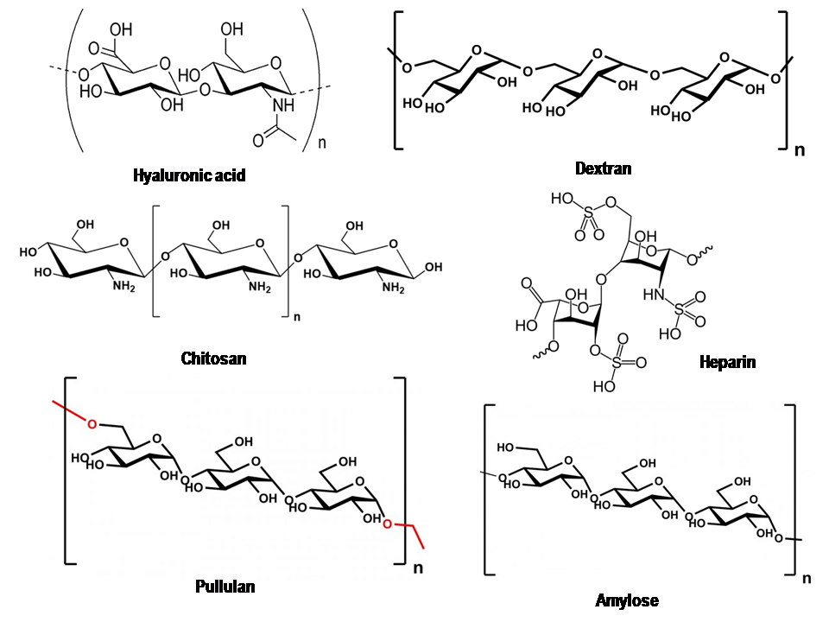

Figure-1: Structure of polysaccharides.

Figure-2: Different methods of N-acylation of Chitosan. Reproduced from Ref. [51]

Figure-3: Schematic representation of various drug delivery systems produced by self association of polysaccharides in aqueous solution. Reproduced from Ref. [51]

