DISASTER MANAGEMENT

Dr Ranjana Singh
Prof & HOD
Dept of Community Medicine
Noida international Institute of Medical Sciences
Gautam Buddh Nagar
CM13.1 Concept of disaster management
CM13.1 | Define and describe the concept of Disaster management | K | KH | Y | Lecture, Small group discussion | Written / Viva voce |  | General Surgery . General medicine
CM 13.2 | Describe disaster management cycle | K | KH | Y | Lecture, Small group discussion | Written / Viva voce |  | General Surgery, General medicine
CM 13.3 | Describe manmade disasters in the world and in India. | K | KH | Y | Lecture, Small group discussion | Written / Viva voce |  | General Surgery . General medicine
CM 13.4 | Describe the details of the National Disaster management Authority. | K | KH | Y | Lecture, Small group discussion | Written / Viva voce |  | General Surgery . General medicine

Annually, catastrophic events and emergencies wreak havoc on individuals, communities, and entire societies across the globe. Alarmingly, prognostications indicate a looming increase in their frequency in the years to come.
A disaster is defined as a "sudden or great misfortune" or simply "any unfortunate event." To be more specific, a disaster can be defined as an occurrence marked by an unforeseen timing and profoundly destructive outcomes. These explanations highlight the presence of three fundamental elements: abruptness, unpredictability, and severe repercussions.
Disaster happens when a “community is not appropriately resourced or organized to withstand the impact ,and whose population is vulnerable because of poverty ,exclusion or socially disadvantaged in some way”(mizutori,2020) [1] .A disaster is a significant disturbance that unfolds over a varying duration, leading to extensive losses in terms of human lives, assets, economies, and the environment. Importantly, these losses surpass the capacity of the impacted community or society to manage using their own available resources.
Disaster
D- Disruption
I – Induced
S- Situation
- After
T-Transformation of
E-Ecological
R- Response
Disasters are classified into three types: naturals, man-made, and hybrid disasters. It is believed that the three disaster types cover all disastrous events. No definition of disaster is universally accepted.
Natural hazards are naturally occurring physical phenomena. Changes to our climate and environment are already contributing to an increase in the frequency, intensity and unpredictability of severe weather events. And while there are now fewer large-scale conflicts between countries, other forms of conflict and violence are on the rise around the world.
A natural disaster is a major adverse event resulting from natural processes of the Earth; examples include firestorms, dust storms, floods, hurricanes, tornadoes, volcanic eruptions, earthquakes, tsunamis, storms, and other geologic processes.
They can be: Natural hazards are physical phenomena that occur naturally. Alterations in our climate and environment are presently playing a role in elevating the occurrence, severity, and unpredictability of extreme weather incidents. Although there is a decrease in major conflicts between nations, alternative forms of conflict and violence are surging on a global scale.

- Geophysical: a hazard originating from solid earth (such as earthquakes, landslides and volcanic activity)
- Hydrological: caused by the occurrence, movement and distribution of water on earth (such as floods and avalanches)
- Climatological: relating to the climate (such as droughts and wildfires)
- Meteorological: relating to weather conditions (such as cyclones and storms)
- Biological: caused by exposure to living organisms and their toxic substances or diseases they may carry (such as disease epidemics and insect/animal plagues)

Man-made and technological hazards are events that are caused by humans and occur in or close to human settlements. They include complex emergencies, conflicts, industrial accidents, transport accidents, environmental degradation and pollution.
Classification :
Disasters are also, broadly classified as “natural “and “man: made.”
- Natural disasters
- Meteorological disasters: Storms, cyclones, hailstorms, hurricanes, tornados, typhoons, snow storms, cold spells, heat waves, and droughts
- Topological disaster: Earthquakes, avalanches, landslides, and floods
- Biological disasters: Epidemics of communicable diseases (e.g.COVID-19) and insect swarms (e.g. Locust swarms)

- Man- made disasters
- Accidents: Transportation accidents (land, air, and sea), collapse of buildings, dams, and other structures, mine disasters, and technological failures such as mishap at a nuclear power station or leak at a chemical plant causing pollution of atmosphere
- Civil disturbances: Riots and demonstrations
- Warfare: Conventional warfare (bombardment, blockage, or siege) and non- conventional warfare (nuclear, biological and chemical warfare, guerrilla warfare, and terrorism)
- Large scale human displacement: Forced movements of a large number of persons (refugees), usually across borders

Natural hazards are physical phenomena that occur naturally. Alterations in our climate and environment are presently playing a role in elevating the occurrence, severity, and unpredictability of extreme weather incidents. Although there is a decrease in major conflicts between nations, alternative forms of conflict and violence are surging on a global scale.
Natural disaster is a major adverse event resulting from natural processes of the Earth;Examplesinclude firestorms, duststorms, floods, hurricanes, tornadoes, volcanic eruptions, earthquakes, tsunamis, storms, and other geologic processes. A natural disaster can cause loss of life or damage property,_{[2]} and typically leaves some economic damage in its wake, the severity of which depends on the affected population's resilience and on the infrastructure available_{.[3]}

CM 13.2 Describe disaster management cycle

Disaster management
Disaster management is how we deal with the human, material, economic or environmental impacts of said disaster, it is the process of how we “prepare for, respond to and learn from the effects of major failures”. Though often caused by nature, disasters can have human origins.
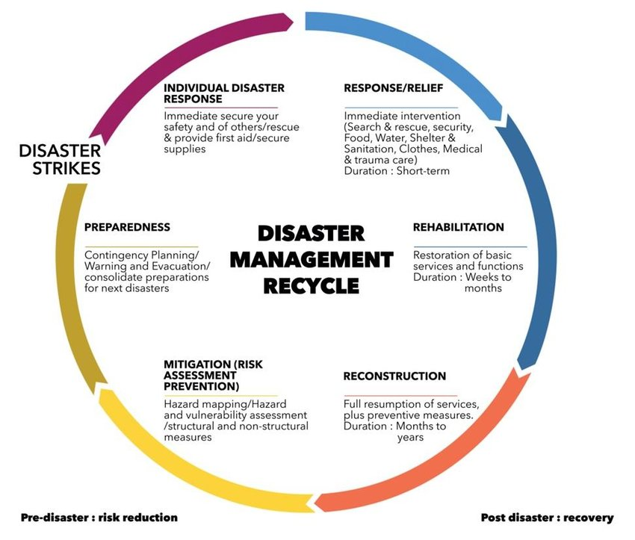

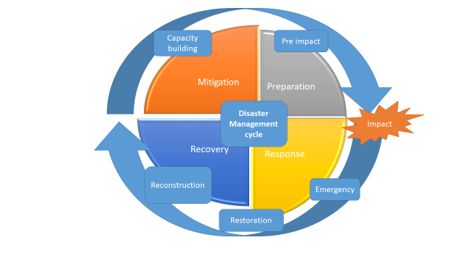

The disaster management process consists of four distinct phases.
1. Mitigation: In this initial stage, the focus is on reducing the likelihood and negative impacts of disasters. Efforts include public education to raise awareness about potential calamities and how individuals can prepare themselves. Structural projects are undertaken with the goal of minimizing casualties and property damage in the event of a disaster.
2. Preparedness: This is the second phase, which concentrates on enhancing government-led readiness to handle emergencies, particularly life-saving activities. Activities encompass the development of plans, establishment of communication systems, public education, and conducting drills.
3. Response: In the third phase, known as the response stage, the disaster management team takes immediate actions to preserve lives and limit the number of affected individuals. This involves providing transportation, shelter, and food to those impacted. Repairs are initiated, and temporary solutions, such as temporary housing, are sought.
4. Recovery: The final stage of disaster management occurs after the disaster has subsided and damage has been inflicted. During recovery, efforts are directed towards restoring people's livelihoods and infrastructure. Short-term and long-term recovery strategies are considered, with the ultimate goal of returning the affected population to a state of normalcy or even improvement. Public education continues to emphasize the importance of health and safety, allowing for the implementation of long-term solutions.
Emergency managers think of disasters as recurring events with four phases: Mitigation, Preparedness, Response, and Recovery.

The disaster management process is split into four stages.

Prevention- Preparedness(Pre-disaster phase) | Response- Intervention(Disaster) | Restoration- Recovery (post-disaster phase)
Strengthening research Scapacity | Decision making system- mobilization | Relief measures
Hazard-vulnerability assessment | Coordination of involved authorities | Temporary housing
Risk assessment | Communications | Social support
Vulnerability reduction | Assessment of extent of disaster impact | Financial assistance to the affected population
Compilation of regulations- codes | Search and rescue operations | Informing affected population
Spatial planning – urban planning | First- aid treatment and medical care | Control of rumor diffusion
Institutional framework | Immediate care of injuries | Reopening of public services
Financial resources | Mitigation of damage induced by geodyamic phenomena | Management of public health issue
Strengthening resources and means | Evaluation of aftershock sequence and related phenomena | Psychological support of affected population
Volunteers education and training | Evaluation of aftershock sequence and related phenomena | Proposals for interventions
Education-informing general public | Informing affected population- media | Actions for special sectors (industry,tourism, environment)
Communication planning – media | Volunteers coordination and cooperation | Evaluation of actions-
Compilation of operational plans | International assistance | Improvement of operational plans
Table – top exercise |  | Insurance against earthqukes
Field training exercise
Strengthening preparedness

CM 13.3: Describe manmade disasters in the world and in India.

According to the International Federation of Red Cross & Red Crescent Societies, man-made disasters are incidents triggered by human actions, typically taking place in or near human communities, and frequently stemming from environmental or technological emergencies.Man-Made Disasters.

This can include:
- Environmental Degradation
- Pollution
- Accidents (e.g. Industrial, Technological and Transport usually involving the production, use or transport of hazardous materials)
Man-made disasters refer to highly perilous occurrences instigated by human activities. Instances of such man-made disasters encompass incidents like chemical spills, release of hazardous materials, explosions, chemical or biological attacks, nuclear explosions, train accidents, plane crashes, and groundwater contamination. Additionally, communities face vulnerabilities from extremist groups employing violence against both individuals and assets. These disasters often result in fatalities, injuries, and property damage. Below, you'll find valuable resources aimed at aiding environmental health professionals in the planning process and in educating the public on matters related to man-made disasters.
Man-made disasters refer to highly perilous occurrences instigated by human activities. Instances of such man-made disasters encompass incidents like chemical spills, release of hazardous materials, explosions, chemical or biological attacks, nuclear explosions, train accidents, plane crashes, and groundwater contamination. Additionally, communities face vulnerabilities from extremist groups employing violence against both individuals and assets. These disasters often result in fatalities, injuries, and property damage. Below, you'll find valuable resources aimed at aiding environmental health professionals in the planning process and in educating the public on matters related to man-made disasters. Man-made disasters arise as a result of either technological or human-induced hazards. These hazards encompass situations such as stampedes, fires, transportation mishaps, industrial accidents, oil spills, terrorist assaults, and nuclear explosions or radiation leaks. This category may also encompass acts of war and intentional attacks, along with scenarios related to global warming, nuclear warfare, and bioterrorism

Chernobyl nuclear power plant accident
The Chernobyl nuclear power plant accident led to severe radioactive contamination in the area, resulting in health issues due to radiation exposure for populations in Ukraine, Belarus, the Russian Federation, and even parts of Europe. The absence of a well-structured disaster management plan had a significant impact on the mental well-being of the affected residents. Those exposed to radiation, especially as children, reported various neuropsychological and psychological problems, including self-rated poor health, clinical and subclinical depression, anxiety, and post-traumatic stress disorder.
Many resettled individuals struggled to adapt to their new circumstances and continued to experience high levels of stress, particularly related to unemployment and a sense of limited control over their lives. Numerous older resettled individuals still expressed a desire to return to their former homes. Recognizing the enduring consequences of this disaster on local communities and neighboring countries, the United Nations General Assembly, on December 8, 2016, designated April 26 as International Chernobyl Disaster Remembrance Day.
Biological disasters result from processes or phenomena of organic origin or are transmitted by biological vectors, encompassing exposure to pathogenic microorganisms, toxins, and bioactive substances that can lead to loss of life, injuries, illnesses, property damage, livelihood and service losses, social and economic disruption, and environmental harm. Examples of biological disasters include outbreaks of epidemic diseases, plant or animal contagions, insect infestations, and other similar events.
Biological disasters can manifest as:
• Epidemics that affect a disproportionately large number of individuals within a On December 2, 1984, an explosion occurred at the Union Carbide insecticide plant in Bhopal, India, resulting in the release of 45 tons of methyl isocyanate gas, which spread to nearby towns and led to the immediate deaths of over 3,000 people. Subsequently, the estimated death toll, according to Britannica, ranged from 15,000 to 20,000, with approximately 500,000 individuals affected by exposure to the gas.
Following the incident, it was reported that the gas leak was inadequately addressed, leaving over 300 metric tons of waste at the site even decades later, as of 2016. Consequently, it is believed that chemical runoff has contaminated the local drinking water, potentially causing chronic health issues and birth defects, as indicated by some experts.
In 2004, the Indian government was mandated to supply clean water to residents due to groundwater contamination, and in 2010, seven former Union Carbide employees were convicted of negligence related to the event.

Biological disasters may be in the form of: -
Epidemic affecting a disproportionately large number of individuals within a population, community, or region at the same time, examples being Cholera, Plague, Japanese Encephalitis (JE)/Acute Encephalitis Syndrome (AES); or,
Pandemic is an epidemic that spreads across a large region, that is, a continent, or even worldwide of existing, emerging or re-emerging diseases and pestilences, example being Influenza H1N1 (Swine Flu) & Covid 19. 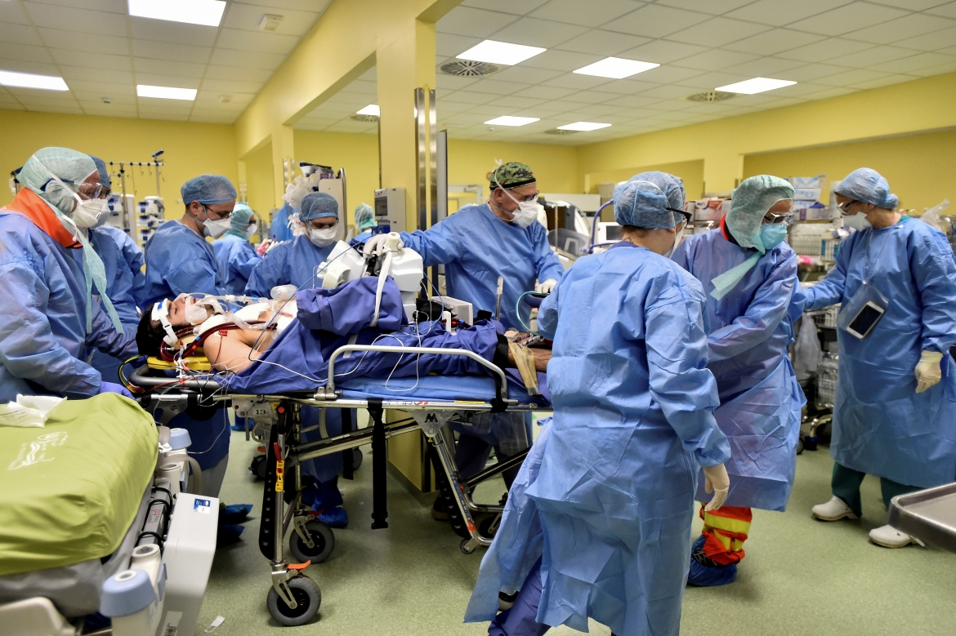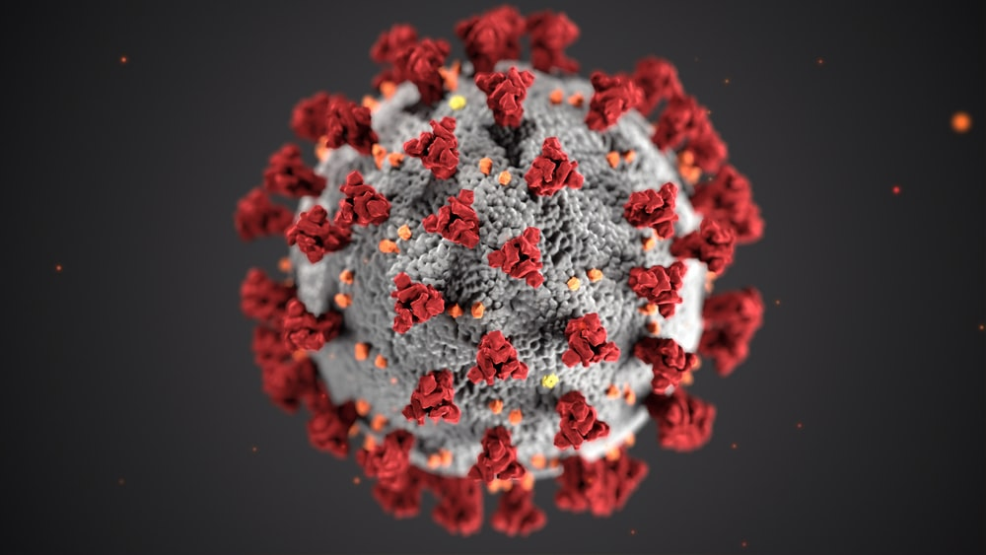
Covid-19 pandemic
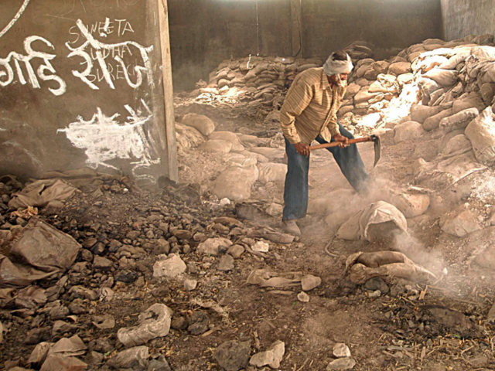
December 2, 1984, an explosion at the Union Carbide insecticide plant in Bhopal
On December 2, 1984, an explosion occurred at the Union Carbide insecticide plant in Bhopal, India, resulting in the release of 45 tons of methyl isocyanate gas, which spread to nearby towns and led to the immediate deaths of over 3,000 people. Subsequently, the estimated death toll, according to Britannica, ranged from 15,000 to 20,000, with approximately 500,000 individuals affected by exposure to the gas.
Following the incident, it was reported that the gas leak was inadequately addressed, leaving over 300 metric tons of waste at the site even decades later, as of 2016. Consequently, it is believed that chemical runoff has contaminated the local drinking water, potentially causing chronic health issues and birth defects, as indicated by some experts.
In 2004, the Indian government was mandated to supply clean water to residents due to groundwater contamination, and in 2010, seven former Union Carbide employees were convicted of negligence related to the event.

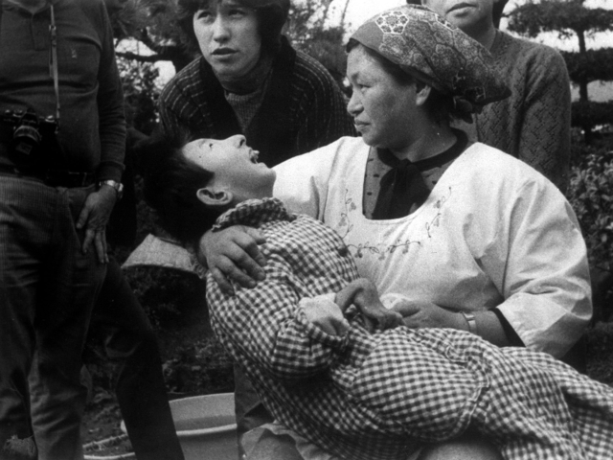
1932 to 1968, The Chisso Corporation, a Japanese fertilizer company, release destimated 30 tons of methylmercury bay off of Minamata City Between 1932 and 1968, the Chisso Corporation, a Japanese fertilizer company, discharged wastewater containing approximately 30 tons of methylmercury into the bay near Minamata City. This toxic chemical contaminated the fish in the bay, which were then consumed by humans, leading to cases of mercury poisoning known as Minamata disease. The illness manifests with symptoms like seizures and muscle spasms. Approximately 3,000 individuals have been officially recognized as victims of this disease, with an additional 2,000 seeking recognition.
Various legal actions have resulted in compensation for certified victims of Minamata disease, and in 2017, the United Nations established the Minamata Convention on Mercury to mitigate the risk of mercury poisonings and environmental pollution.
Between 1932 and 1968, the Chisso Corporation, a Japanese fertilizer company, discharged wastewater containing approximately 30 tons of methylmercury into the bay near Minamata City. This toxic chemical contaminated the fish in the bay, which were then consumed by humans, leading to cases of mercury poisoning known as Minamata disease. The illness manifests with symptoms like seizures and muscle spasms. Approximately 3,000 individuals have been officially recognized as victims of this disease, with an additional 2,000 seeking recognition.
Various legal actions have resulted in compensation for certified victims of Minamata disease, and in 2017, the United Nations established the Minamata Convention on Mercury to mitigate the risk of mercury poisonings and environmental pollution.
Bioterrorism Bioterrorism involves the deliberate release or spread of biological agents, such as bacteria, viruses, insects, fungi, or toxins, with the intent to cause illness or death in humans, animals, or plants. These agents can exist naturally or be modified by humans, similar to how they are manipulated in biological warfare. Additionally, modern agribusiness faces the risk of anti-agricultural attacks by terrorists, known as agro-bioterrorism, which can severely harm both the economy and consumer confidence.
Bioterrorism entails the intentional dissemination of viruses, bacteria, toxins, or other harmful agents to induce disease or fatalities. While these agents typically exist in nature, they can be altered to enhance their pathogenicity, resistance to existing treatments, or their ability to spread in the environment. Biological agents can be transmitted through air, water, or food. Bioterrorism is attractive to terrorists because it is challenging to detect, and its effects may not become apparent for several hours to days. Some bioterrorism agents, like smallpox, can be transmitted between individuals, while others, like anthrax, cannot. Bioterrorism is favored because it is relatively accessible and cost-effective, easily disseminated, and can generate widespread fear and panic beyond its immediate physical impact. Nevertheless, military leaders have recognized limitations in using bioterrorism as a military tool, as it is challenging to control its effects only on the enemy without affecting friendly forces. Instead, bioweapons are primarily employed by terrorists to create mass panic and disrupt a state or country.
Technological advancements, including genetic engineering, have raised concerns about the potential capabilities of future bio-terrorists. Some discussions also revolve around using agents that do not harm humans but disrupt the economy, with examples like foot-and-mouth disease (FMD) virus, which can cause substantial economic damage and public concern without significant human infection, as observed in the 2001 and 2007 FMD outbreaks in the UK.

Nuclear: Do's & Dont's
DO's
- Go indoors. Stay inside.
- Switch on the radio/television and look out for public announcements from your local authority.
- Close doors/windows.
- Cover all food, water and consume only such covered items.
- If in the open, cover your face and body with a wet handkerchief, towel, dhoti or sari. Return home, change/remove clothes. Have a complete wash and use fresh clothing.
- Extend full cooperation to local authorities and obey their instructions completely -- be it for taking medication, evacuation, etc.
- You must be aware of nuclear radiation hazard. Discuss on Nuclear radiation safety among children and family members, to reduce their fear of radiation.

Dont's
- Do not panic.
- Do not believe in rumours passed on by word of mouth from one person to another.
- Do not stay outside/or go outside.
- As far as possible, AVOID water from open wells/ponds; exposed crops and vegetables; food, water or milk from outside.
- Do not disobey any instruction of the district or civil defence authorities who would be doing their best to ensure the safety of you, your family and your property.

Biological: Do's & Dont's

BEFORE THE DISASTER
- Plan for Family Biological Disaster Plan.
- Preparation by ensuring Prevention measures:-
  - Personal cleanliness - daily bath, don’t grow long nails and wear clean clothes.
  - Hand Hygiene (Wash hands with soap and water before preparing food or eating, after passing stools, coughing or sneezing). The steps of hand washing are:-

Step 1 : Wash palms and fingers
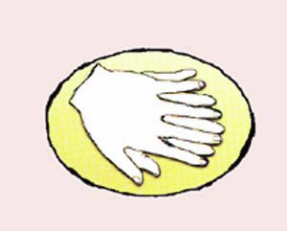

Step 2 : Wash back of hands.
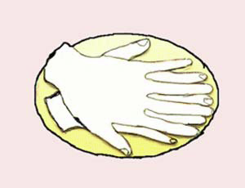

Step 3: Wash fingers and knuckles
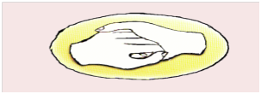

Step 4: Wash thumbs
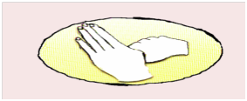
Step 5: Wash fingertips
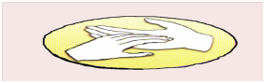
Step 6: Wash wrists
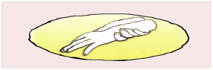

  - Eat nutritious and balanced food
  - Immunisation state should be up to date
  - Prevent overcrowding
  - Good ventilation
  - Protect from hot and cold weather
  - Health Education
  - Surveillance
- Take a First Aid and Cardio-Pulmonary Resuscitation (CPR) training
- Subscribe to a Medical Insurance Plan

DIARRHOEAL GROUP OF DISEASES INCLUDING CHOLERA
Do’s
- Hand Hygiene.
- Encourage drinking of water from a safe source or water that has been disinfected (chlorinated). Add bleaching powder in all community wells at regular intervals. Use water pumped out from India Mark II hand pumps, if installed in the village/community.
- Drink boiled potable water in an emergency that has been boiled for at least 15 minutes and consumed it the same day.
- Promote storage of water in narrow mouthed container.
- Cook food thoroughly especially meat, poultry, eggs and seafood until it is steaming and eat it while it is still hot.
- Ensure cooked meat and poultry is safe and no part of the meat discoloured or foul smelling, or in the case of egg, their shells are not cracked.
- If food is not eaten immediately, reheat cooked until it is steaming hot prior to serving.
- Keep food items covered.
- Increase fluid intake as soon as diarrhoea starts by drinking ORS solution or home-made preparation of Table Salt 5 grams (1 teaspoon) in and 20 grams (4 teaspoons) of Sugar dissolved in 1 litre of drinking water.
- Encourage banana eating, which provides potassium.
- Continue feeding children when they are sick and to continue breastfeeding if the child is being breast fed.
- Refer the diarrhoea case to the nearest health facility in case of the following: Child is irritable, restless or lethargic or unconscious: eating or drinking poorly; child has marked thirst; child has fever or blood in stool.
Don’ts
- Do not drink water from unsafe sources.
- Do not eat uncooked food unless it is peeled or shelled.
- Do not leave cooked food at room temperature longer than 2 hours.
- Do not consume cut fruits from vendors.
- Do not defecate in open area.
- Do not give access to rats and houseflies in your premises.

RESPIRATORY GROUP OF DISEASES LIKE TUBERCULOSIS, INFLUENZA, CHICKENPOX, MENINGITIS
Do’s and Don’ts:
- Avoid close contact with people who are having respiratory illness.
- The sick person should stay at home, and avoid going into the community, school/office, public places for at least 24 hours after symptoms have resolved.
- Sick persons at home should keep distance from others.
- Respiratory Hygiene/Cough Etiquette.
- Cover the nose/mouth with a handkerchief/ tissue paper when coughing or sneezing which should be disposed off in dustbins;
- Perform hand hygiene (e.g., frequent hand washing with soap and water, alcohol-based hand rub, or antiseptic hand wash) and thoroughly dried preferably using disposable tissue/ paper/ towel after contact after having contact with respiratory secretions and contaminated objects/materials.
- Triple layer surgical Mask of standard and certified make should be worn by Suspected/ probable/confirmed cases of influenza or by the care provider in home care settings and close family contacts of such cases undergoing home care.
- Get plenty of sleep, be physically active, manage your stress, drink plenty of fluids, and eat nutritious food.
- Avoid smoking.
- Persons who have difficulty breathing or shortness of breath should seek immediate medical attention and report to the nearby hospital.
- If sick persons must go into the community (e.g., to seek medical care), then they should wear a face mask or use a handkerchief or tissues to cover any coughing and sneezing so as to reduce the risk of spreading the infection in the community.
- Immunization status should be upto date as per National Universal Immunisation Programme.

MOSQUITO BORNE DISEASES LIKE MALARIA, DENGUE, FILARIA, CHIKUNGUNYA
Do’s
- Follow “sun-down sleeves-down” approach. Wear clothes that cover arms and legs.
- Prevent water collections on ground and other places to prevent malaria breeding.
- Empty water containers at least once a week.
- Remove water from coolers from time to time.
- Cover and seal any septic tanks.
- Use Mosquito Nets preferably Insecticide Treated Bed Nets (ITBN).
- Apply insect repellants while sleeping to keep away mosquitoes.
- Seek medical advice in case of rashes, mental irritation or unconsciousness..

Don’ts
- Do not encourage children to wear shorts and half sleeved clothing.
- Do not allow water to stagnate.
- Do not allow discarded items to accumulate such as tires, tubes, empty coconut shells, household items and objects wherein water may collect.
- Do not bathe in village ponds and allow cattle to take bath in the same pond.

Chemical Disaster

Chemicals, which form the foundation of modern industrial systems, have become a significant focal point for disaster management across government, the private sector, and the wider community. Chemical disasters can be highly distressing, causing harm to individuals and leading to casualties, as well as causing damage to the environment and property. The entities most susceptible to the risks posed by chemical disasters encompass industrial facilities, their employees, hazardous chemical transport, nearby residents, adjacent structures, occupants, and the surrounding community. Chemical disasters can originate from various sources and circumstances such as-
- Process and safety systems failures
  - Human errors
  - Technical errors
  - Management errors
- Induced effect of natural calamities
- Accidents during the transportation
- Hazardous waste processing/ disposal
- Terrorist attack/ unrest leading to sabotage

CM 13.4 Describe the details of the National Disaster Management Authority.

National Policy on Disaster Management The objectives include:
1. Fostering a culture that emphasizes prevention, preparedness, and resilience through knowledge, innovation, and education.
2. Encouraging the use of mitigation measures that blend technology, traditional knowledge, and environmental sustainability.
3. Integrating disaster management into the planning process for development.
4. Establishing institutional and legal frameworks to facilitate a regulatory environment and compliance system.
5. Creating an efficient system for identifying, assessing, and monitoring disaster risks.
6. Developing modern forecasting and early warning systems supported by responsive and reliable information technology.
7. Ensuring an effective response and relief effort with a compassionate approach to the needs of vulnerable segments of society.
8. Using reconstruction as an opportunity to construct disaster-resistant infrastructure and habitats to ensure safer living conditions.
9. Cultivating a productive and proactive partnership with the media in the realm of disaster management.

The objectives are:
• Promoting a culture of prevention, preparedness and resilience at all levels through knowledge, innovation and education.
• Encouraging mitigation measures based on technology, traditional wisdom and environmental sustainability.
• Mainstreaming disaster management into the developmental planning process.
• Establishing institutional and techno-legal frameworks to create an enabling regulatory environment and a compliance regime.
• Ensuring efficient mechanism for identification, assessment and monitoring of disaster risks.
• Developing contemporary forecasting and early warning systems backed by responsive and fail-safe communication with information technology support.
• Ensuring efficient response and relief with a caring approach towards the needs of the vulnerable sections of the society.
• Undertaking recon struction as an opportunity to build disaster resilient structures and habitat for ensuring safer living.
• Promoting a productive and proactive partnership with the media for disaster management.
Ministries Responsible for Disaster Management

Disaster Type | Nodal Ministry
Natural disasters (other than drought) | Ministry of Home Affairs
Drought relief | Ministry of Agriculture
Air accidents | Ministry of Civil Aviation
Railways accidents | Ministry of Railways
Chemical disaster | Ministry of Environment and Forests
Biological disasters | Ministry of Health
Nuclear disasters | Department of Atomic Energy
The National Disaster Management Authority (NDMA) in India, led by the Prime Minister, serves as the highest authority for disaster management in the country. The Disaster Management Act of 2005 mandates the establishment of NDMA and the creation of supportive structures at the state and district levels. NDMA's role includes formulating policies, plans, and guidelines for disaster management. India's goal is to foster a culture of prevention, mitigation, preparedness, and response, mobilizing the collective efforts of government agencies, non-governmental organizations, and community involvement. This involves implementing a technology-driven, proactive, multi-hazard, and multi-sectoral approach to build a safer, disaster-resilient, and dynamic India.
The NDMA logo symbolizes the aspirations of this national vision, which aims to empower all stakeholders in enhancing the effectiveness of disaster management in India. NDMA comprises five major divisions: Policy & Plans, Mitigation, Operations & Communications, Information & Technology, and Administration and Finance.
The National Disaster Management Authority (NDMA) (4) headed by the Prime Minister of India, is the apex body for Disaster Management in India. Setting up of NDMA and the creation of an enabling environment for institutional mechanisms at the State and District levels is mandated by the Disaster Management Act, 2005. NDMA is mandated to lay down the policies, plans and guidelines for Disaster Management. India envisions the development of an ethos of Prevention, Mitigation, Preparedness and Response.
The Indian government strives to promote a national resolve to mitigate the damage and destruction caused by natural and man-made disasters, through sustained and collective efforts of all Government agencies, Non-Governmental Organizations and People’s participation. This is planned to be accomplished by adopting a Technology-Driven, Pro-Active, Multi-Hazard and Multi-Sectoral strategy for building a Safer, Disaster Resilient and Dynamic India.
The NDMA Logo reflects the aspirations of this National Vision, of empowering all stakeholders to improve the effectiveness of Disaster Management in India. NDMA has 5 major divisions viz. Policy & Plans, Mitigation, Operations & Communications & Information & Technology, Administration and Finance.

Multiple Choice Questions
- All of the following are examples of natural disasters, except
- Meteorological disasters (b) Topological disasters
- Aviation disasters (d) Tsumami

- All of the following are elements of disaster management , except:
- Disaster treatment (b) Disaster preparedness
(c)Disaster response (d) Disaster recovery

- Measures aimed at reducing the impact of a natural or man- made disaster on a nation or community are collectively known as:
- Disaster response (b) Disaster mitigation
(c) Disaster recovery (d) Disaster prevention
- Relief, rehabilitation, and reconstruction are essential components of:
- Disaster mitigation (b) Disaster response
(c) Both of the above (d) None of the above

5.The insecticidal method of choice for controlling mosquitoes and sand flies during disaster situations is:
- Space spraying (b) Knockdown spraying
(c) Indoor residual spraying (d) Ground spraying

6.Health – care planning for fairs and festivals will be covered under which of the following branches of medicine?
(a)Disaster medicine (b) Emergency medicine
(c) Mass gathering medicine (d) Critical care medicine
7.Measures aimed at reducing the impact of a natural or man- made disaster on a nation or community are collectively known as:
- Disaster response (b) Disaster mitigation
(c) Disaster recovery (d) Disaster prevention
8.The nodal peripheral unit for providing medical relief in times of disasters will be:
- Subcenter (b) Anganwadi
(c) Primary Health Centre (d) District hospital

9.The insecticidal method of choice for controlling mosquitoes and sand flies during disaster situations is:
(a) Space spraying (b) Knockdown spraying
(c) Indoor residual spraying (d) Ground spraying

References:
1. https://mailchi.mp/aa69f29216e7/an-update-from-mami-mizutori-un-secretary-generals-special-representative-for-disaster-risk-reduction-4801514?e=67449bf6d0
2."1.Billion-Dollar Weather and Climate Disasters: Overview | National Centers for Environmental Information (NCEI)". www.ncdc.noaa.gov.
3.G. Bankoff, G. Frerks, D. Hilhorst (eds.) (2003). Mapping Vulnerability: Disasters, Development and People. ISBN 1-85383-964-7.
4.https://ndma.gov.in

