**FUTURISTIC TRENDS IN AGRICULTURE ENGINNERING AND FOOD SCIENCES WITH SPECIAL REFERENCE TO NANOAGRONOMY**

# Introduction

The economic backbone of the most of the developing countries is observed to be agriculture, that eventually provides food and nutrition to lead a better life. The ecological climatic change that is activated by biotic and abiotic stress impairs the elusive balance of the food production and its associated environment (Tohgasaki et al., 2019). This consequently leads to the failure of crop production in a reliable and effective manner. Meanwhile the worldwide food demand is expected to reach to 70% approximately by the year 2050 due to increasing pupulation. Hence it is significant to develop innovative and futuristic agricultural technologies for obtaining food security with enhanced plant productivity, since environmental complexities may arise because of several ineffective and conventional farming and fertilization operations (Mali, Raj, & Trivedi, 2020).

t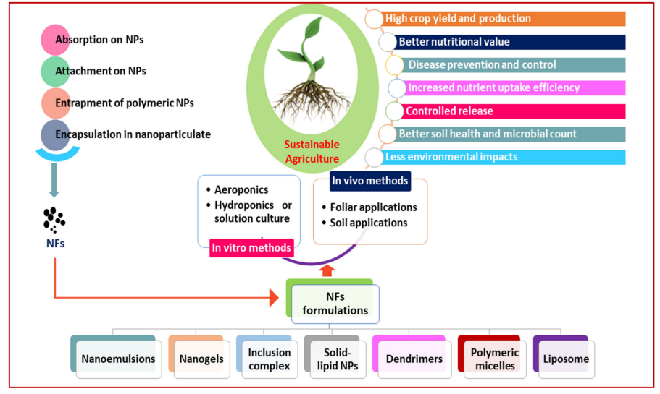

Figure 1 An overview of nano-fertilizer application in agriculture. NPs = nano-particles; NFs = nano-fertilizers (Tohgasaki et al., 2019).

The nutrition utilisation efficiency has been observed to be an significant metric for the evaluation of nutrient bio availablity and agricultural production in plants. In general the fertilizers provide the essential nutritions for optimising the productivity of the crop. These fertilizers were applied usually through the soil surface or it is being mixed with irrigational activities which eventually leads to the atmospheric damage and other harm to the ecosystem and the associated water bodies. The hydroponic technology is where employed for growing certain crops under greenhouse that consumes exponentially high consumption of energy and water. This criteria is found to be neither sustainable nor economical and the addition of harmful fertilizers might cause groundwater contamination and eutrophication (Vecchio, Agnusdei, Miglietta, & Capitanio, 2020). These consequences leads to adverse health effects to the human and animals. While considering the scenarios it is necessary to adopt innovative agriculture interventions and implementation to meet the Global foot security systems, why you diversity and climatic condition. At present the utilisation of fertilizer has been proposed to be nearly 20 percentage less by the year 2013 through efficient farm practices and enhanced productivity (Tohgasaki et al., 2019).

Futuristic agriculture has been observed to be depend on the prompt utilisation of Nano enabled fertilizers and pesticides which is now becoming the globally accepted advanced method for crop yield enhancements. Such healthier Agro eco system with the sustainable environmental effects will be analysed in this chapter. Accordingly this chapter also examine the recent trends in organised and engineering activities in agriculture,emphasized with nanotechnology and improved delivery systems. The efficiency of such advanced agriculture activity were here in pooled with to enrich the understanding of the researchers (Finger, Swinton, El Benni, & Walter, 2019).

In recent days agriculture sector is subjected to various problems like urbanisation, inappropriate use of cultivating land soil,water, misutilization and improper management of fertilizers and pesticides and run off. The prevailing natural resources are tickle factors in the growth and development of Economics scenario which part time to hunger and poverty of Huge population globally and locally. Agriculture which is the science of crops soil and livestock and also functioning as the economic boon for any country has to be necessarily and urgently focused to enhance the social welfare in rural and urban livelihood (Tohgasaki et al., 2019). The accessibility of natural resources like the quality of soil and water is continuously declining in agriculture and developed a huge economic loss. Continuous agriculture stress is found to be constantly increasing because of for food overpopulation and elevated usage of insecticides pesticides her besides and heavy metals in the soil. These issues or challenges could be solved by the adoption of new technology known as nanotechnology which includes Nano biosensors for changing the food system and improve the agricultural product quality. Accordingly adoption of this technology's will also boost up the national economy with the sustainability cost effectivity accuracy sensitivity and with eco friendly measures (Arvanitis & Symeonaki, 2020).

Nano agro technology has vulnerable potential in developing the impact in the area of environment health and Agriculture. These Nano based biosensors will provide increased specificity in sensitivity and deduction time that is also use your friendly and could able to detect the desirable analyte. The nano biosensors identify indirect and direct footl borne pathogens pesticides microorganisms, toxins,veterinary drugs, heavy metals and other contaminants in the food (Primožič, Knez, & Leitgeb, 2021). Additionally the nanobiosensors could able to also monitor the quality of food and soil, antibiotic resistance and crop stress. All these aspects revealed that nanotechnology could be greatly helpful to derive an healthy agriculture that enhances the soil, crop and livestock productivity and reduces the complications in feeding the increasing populations.

# NANOTECHNLOGY IN AGRICULTURE

Nanomaterials in agriculture are frequently employed as nano biosensors with improved potential applications in environemntal, clinical and agriculture. Accordingly this section focusses on the prospects, trends and challenges of nanobiosensor in the field of agriculture (van der Wouden et al., 2017). The progress obtained in the development of crop health through nanotechnology enhances the hassle free detection of herbicides, pesticides and soil testing. The nanoparticles are uses a potential diagnostic tool in the detection of the plant pathogens.Some of them are discussed briefly

**Determination of pathogen**

In the developing countries like India, the contaminated foods associated with pathogenic foodborne bacteria is the predominant reason in concerning the public illness both globally and locally. Food industries needs defence measures against the food borne illness that has to be incorporated with precise laboratory conditions before the outbreak of harmful pandemics (Vázquez-Núñez, Molina-Guerrero, Peña-Castro, Fernández-Luqueño, & de la Rosa-Álvarez, 2020). This could be eassily obtained by the utilization of nanobiosensor in the detection of pathogens, food contaminants, banned dyes, antibiotics, adulterants,harmones and allergens. There exists no analytical measures in the determination of food samples. In order to overcome such problems, the nanobiosensor is found to be hoghly promising for rapid identification in any malfunction on the food chain processeing like storaging, distributing and processing of the food (Wang, Wang, & Li, 2023).

**Detection of Mycotoxins**

Mycotoxins are the fungal modes that has been derived from toxic chemicals.These chemicals are natural contaminations observed in the animal feed products and foot stuffs and the possess major threat to the human health. The toxins are generally known to be nephro toxic, hepato toxins, carcinogenic and mutagenic and some of the examples are aflatoxins,zearalenone,ochratoxin. Because of these concerns is of first getted device like Nano biosensors with analytical opportunities that easily determine the contaminated foods and animal fee is required especially for the first identification of traceable quantity of mycotoxins. Micro toxins are found to be huge threat to the health of humans and the consequently influences the food products, crops, feed particularly in rainy season and consequently leads to the decrease in the global economy (Wu, Yi, Fang, & Tsang, 2018).

**Detection of Insecticides, Pesticides and herbicides**

The pesticides are chemical agents that protects the animals, the herbicides controls weeds, and the fungicide controls the fungal species and finally the insecticide controls the insects. However these application in heavy dose leads to toxicity of the animal and human health. The conventional technologies in the detemination of pesticides are not satisfactory mainly due to various disadvantages. In order to overcome these scenarios, nanobiosensor has been employed to detemine the peticides. They not only identify the harmful food contaminants and ahemical agents, but they also detect the biological contaminants such as veterinary residues in the food particles. They are even utilized for the evaluation and management of the quality and safety of the food (Borji, Ayoub, Al-Hindi, Malaeb, & Hamdan, 2020).

The Agro nanotechnology provides several advantages to the farmers by prominent food production. Further they also help the farmer with the help of food Industry through enhanced food processing, preserving and storageing with better packaging. The Nano biosensors with efficient Nanomaterials are developed for the determination of plant pathogens and examining the soil quality for improving the health of the investigated plant. It is also found that the nanobio sensors would be effectively used to for supporting the sustainable agriculture through improved crop productivity (Anil, Ibraheem, Meshni, Preethanath, & Anil, 2022). Accordingly the enhanced determination of the pesticides food pathogens antibiotics and other harmful containmants has to be necessarily done with the help of Nano biosensors to eradicate the threat to human health. The biological analyte detection will promisingly meet the quality of the food both locally and globally (Mangla, Kaul, Thakur, & K Shukla, 2021).

# AGRICULTURE AND NANO-FERTILIZERS

Nano composts are fundamental in the cutting edge farming that have fitting details and conveyance systems in guaranteeing ideal take-up in plants. Such nanoscale composts decline the supplement misfortune on account of draining and synthetic adjustments may be forestalled to work on the NUE and ecological quality through investigating nanoparticle in view of a few metal oxides and metals for agro applications. The nanoscale particles have a very small size and can be absorbed by ionic salts or bulk particles in a variety of ways. Here the significant benefits are deeply discussed. The appropriate utilization of nano enables fertilizers could able to improve the nutrient delivery effectiveness in plants since the nano fertilizers has been prooved to produce targeted release and decreasing of fertilizer application with elevated NUE (Usman et al., 2020).

**Nano-Fertilizers Mitigate Abiotic Stresses**

Nano fertilizers had dramatically extended an elevation in the biological system operation because of the nanoscale size and huge surface area that supports the development and growth of the plant under abiotic and biotic stress such as salinity, drought, alkalinity, minerals, temperature and metal toxicity. The process of photosynthesis is a crucial metabolic activity in crops and is observed to more susceptible to stress such as salinity, nutritional deprivation, drought and heat as rubisco, photosystem II and ATP synthase becomes the primary target. The responses of plant defense to abiotic stress were establised with silicon di oxide nanoparticles for improving transpiration, pigments of photosynthesis and carbonic anhydrase activities in the pumpkin plants. The titanium di oxide were discovered in altering the photoreductional activity and blocks the linolenic acid in biosynthetic pathway chain situated in the chloroplasts for the evolution of oxygen. The cellular organeels develop reactive oxygen species under stress as the predominant synptom of abiotic stress. These plants possess enzymatic machinery for dealing with the oxidative stress from the environment. Consequently these plants suffer from the effects of failure of defense system. By the activation of particular genes, collection of osmolytes,a nd supply of free aminoacids and nutrients, the nanomaterials serves to alleviate the stress (Kaul & Sharma, 2022).

Numerous nanometerials has been extended to obtain genuine promises in crop and agricultural productivity but that established scientific knowledge in green revolution need intensive research for the welfare of global wide foot security. In this era of adverse environmental variables with climatic change associated with the increasing population need sustainable life on the planet earth so recent advances of nano pesticides has to be explored for obtaining precision agriculture correlated with economic variability and ecological impacts. The imapcts has to be noticed that they improved production of food grinds with the high cost but with the increased synthetic and artificial facial fertilizers has been observed to severely imperative system. Hence these troubles of agriculture has to be eradicated to safeguard our Agricultural zones with the more interest. These nano fertilizers has promising and innovative approach in maintaining the physiological fitness of the crop plants the integrity approaches of several parameters has been found to be important to explore another green revolution to adopt a healthy ecosystem (Yaqoob et al., 2020).

# RECENT INNOVATIONS AND TRENDS

The process of agriculture pollution needs more intensive agriculture practices that was free from the limitations of conventional agriculture practices that degrades the ecosystem environment and land. Further these conventional techniques produces several byproducts that increases the substantial use of chemicals in the pesticides and fertilizers this eventually contaminates the irrigational water causing more damage to agriculture. The presence scenario of agriculture is becoming more unsustainable the nanotechnology provide resourceful and innovative frontiers in the field of agriculture sector by contributing various practical applications with the larger possibility of significant impacts on sustainability with the improved crop growth. A recent research (Khan, Naushad, Al-Gheethi, & Iqbal, 2021)shows to be effective in obtaining positive result with the use of nanotechnology and the improved efficiency of the agriculturally inputs with the possible solutions to the already prevailing problems such a prospective usage of nanoscale agrochemicals has to be transformed to concern free under toxic free products which are friendly to human health this section will provide an insight in the recent advancements of the agro chemicals and nanotechnology which will provide a revolution in agriculture sector. Accordingly the implementation barriers also discussed

**Nanotechnology towards sustainable agriculture**

The bioremediation of water and soil with the use of nanomaterials will help greatly in the mantenance and sustainability by eradicating toxic compounds from soil surface and subsequently improve the natural quality of the soil. The nanomaterial based electrochemical and optical sensors were employed for the detection of environmental pollutants and heavy metals in the soil media.

Various process like homogenisation, milling ultrasound emulsification and microfluidization are used for the generation of the nanoparticle. The milling is the commonly employed traditional method to gring or breakdown of the materials in obtaining the nano size with mechanical energy. The examples are the fine wheat flour producton, green tea powder production that obtains high water binding capacity in improving the antioxidative characteristics respectively.

The homogenisation is very ols technique in the decrease of fat globules in the milk and for the adjustment of the emulsions. Conversely, high tension homogenisation is more productive in growing fine emulsions exposed to high pressure. The development of yogurts, creams, syrups, malted drinks, icing, flavored oils, fillings, and salad dressing dressing make use of the improved mouthfeel and texture created by the microfluidization, size reduction, and emulsion formation processes. Lately, the focused energy ultrasound waves are utilization of nanoemulsification by cavitation.

A few food fixings are found to of nano size in their regular structure like casein, milk protein and changes from engineered nanoparticles. The majority of the proteins have a globe-shaped structure with a range of 10 to 100 nm. The contrast between the polysaccharides, lipids, and lipids is less than 1 nm. The nanostrucutres proteins, nanocomposities, nanoemulsion and liposomes are the major huge nanostructures in the food frameworks since they upgrade the bioavailability, assurance of bioactive materials and helps in the controlled delivery.

**Nanosensors: detection of pathogens and contaminants**

The sensing approaches gained better momentum since they offer extensive range of application in the food related and agricultural sectors. The nanosectors could grealty help in the enhancement of the crop yeilds through the management of the agriculltural soil and water and identifying the existence of chemical fertilizers and pesticides, moisture content, soil nutrients and contaminants like excess fertilizers, plant pathogens, pesticide residues and heavy metals. The nanosensors have advantages over the traditional sensors and aprameters such as large surface to volume ratio, compact size, real time detection,selectivity and sensititvity (Chebbi et al., 2021).

**Postharvest loss reduction**

In the highly developed countries, more than 40 % of the foods such as roots, cerelas, tubers, oil crops, pulses, vegetables, fish meat, fruit and dairy that occurs at trade and customer stages. Whereas in the developing countries, more than 40% of the food loss occurs during post harvesting sage and processing points.

The newly harvested and moistorous unpreserved yeilds will rapidly deteriote the attacks on the microorganisma. The new and advanced technologies like ht einvestigated scenario could able to held to decrease the lost of post harvesting. The nanotechnological application could able to reduce the post harvest loss through innovative design on packaging the ingredients with minimum quantity of active bioelements, improve mechanical and gasoues propertes with the decreased impacts on the sensor characteristics of fruits and vegetables.

**Nanotechnology and gene sequencing**

Additionally, the application of nanotechnology made gene sequencing simpler, which enhanced the identification and application of traits in plants and altered their capacity to respond to environmental stresses and diseases. It has been demonstrated that quantum dots and nanoparticles are excellent biological markers.. (Chebbi et al., 2021).

**Food processing**

Nano based food added substances, nanoencapsulation, nanosensors, nanoparticles-based shrewd dispersion frameworks, nano-pressing, meds, and medical care are only a couple of instances of the various uses of nanotechnology in food creation and handling (Rashidi and Khosravi-Darani, 2011). Biopolymer frameworks, emulsions, basic arrangements, and related colloids give productive conveyance frameworks, and its applications additionally incorporate the development of exemplifications. Nanotechnology in modern food handling is gaining traction, particularly for flavor or scent enhancement, food surface or value enhancement, and more modern gelation or consistency expanding specialists. (Duncan, 2011). Food nanotechnology emphasizes the combination of restrictive nanometer-scale structures for use in a variety of applications, including conveyance plans, food communication surfaces with selective shallow properties, food portrayal devices, microfluidic instruments, sensor innovation, and nanocomposite coatings, among others. (Sadeghi et al., 2017)

**Packaging**

The food framework benefits greatly from bundles. The ability to safeguard food from actual harm and quality degradation is one of the many significant capabilities. The packaging should be safer, uninvolved, prudent, frothy, successfully superfluous or reusable, stable away and transport conditions, areas of strength for and genuine maltreatment. The nature of food is impacted by the bundling material's arrangement and type. Nanomaterials can additionally foster the packaging properties of packaging stuff with lightweight, more grounded wrap, heat check, and various properties. Food bundling makes extensive use of nanotechnology and is widely publicized. (Chebbi et al., 2021). According to Duncan (2011), the worldwide market for food and drink bundling in view of nanotechnology was assessed to be 4.13 billion USD in 2008 and arrive at 7.3 billion USD by 2014. Different metal and metal oxide nanoparticles are presented to various powerful squeezing applications.

**Nanotubes in food and agriculture**

According to Scott (2005), Nanotubes are like Buckyballs with two sides that are decorated with more atomic groups to form a hollow carbon tube in the typical hexagonal shape. Nanotubes are utilized in medical devices, alumina, sports equipment, and food handling hardware due to their adaptable and solid nature at high temperatures. (Rashidi and Khosravi-Darani, 2011).

**Quantum Dots (QDs) and Carbon Nanomaterials as Prospective Materials for Detection of Plant Pathogen**

Quantum spots are little nm in width, fluorescent, generally round, glasslike particles of semiconductors, which are limited in every one of the three spatial aspects. QDs can give a choice as opposed to business applications. In different fields, QDs are viewed as possible devices for the careful discovery of a particular organic marker. (Chebbi et al., 2021). They were used really in naming cells, cell following, imaging, and DNA disclosure in vivo (Sharon et al. 2010). Nanomaterials of carbon have been made to impact electrochemical examination terminal so they have an influence as a sensor (Sharon and Sharon 2008). They found the pesticide residue in the plants.

# APPLICATIONS

In particular, the technological and policy levels have inquired about the long-term effects of growing crops with "miracle seeds" in conjunction with fertilizer, watering, and chemical pesticides. Harvesting in the field of nanotechnology has the potential to increase productivity while restoring ecosystems that have been damaged by current developments to their initial flawless state.

Precision farming generally represents a change in farm management philosophy. The amount of compost and organic pesticides required for each individual farm area will be estimated with the help of nanosensors. As a result, there will be appropriate input use, safer goods, and a more effective economy. Farmers can maintain their farms with exact oversight and remark on the plants' demands in an accurate way with the aid of nanosensors. Personalized farming could effectively utilize farming-related natural assets like water, fertilizers, and chemicals with the aid of nanosensors and nano-based adaptive delivery mechanisms. The managers of farms might immediately find crop pests or signs of adverse conditions like drought by applying nanomaterial, global positioning systems, and satellite photography of landscapes. Using pesticide sprays or irrigation systems would automatically be adjusted once a pest or a drought were recognized. Viruses affecting plants and the amount of soil minerals may also be detected using field-distributed nanosensors. Plants will quickly and utilize entirely nano nutrients. To reduce fertilizer use and environmental contamination, nano encapsulation slowly releasing pesticides has also gained popularity. Extraordinary water adsorbents, which are nanotechnology products, play a significant role in preserving and storing drinking water in tropical and humid areas. Numerous uses of nanotechnology exist in the utilization of crops and farming machinery, including the manufacturing of resilient mechanical assemblies using nano-coating and the utilization of bio-sensors in intelligent devices for mechanical-chemical herbicide control; fabrication of nano conceal for bearings to reduce friction; utilization in machine organization and growing crops equipment to improve their resistance to towards deterioration and corrosion and ultraviolet light rays; the creation of renewable energies and the reduction of ecological pollutants through the use of nanotechnologies. Nanotechnology has additionally shown its capacity to alter the genetic makeup of plants used for agriculture, aiding in their continued growth.

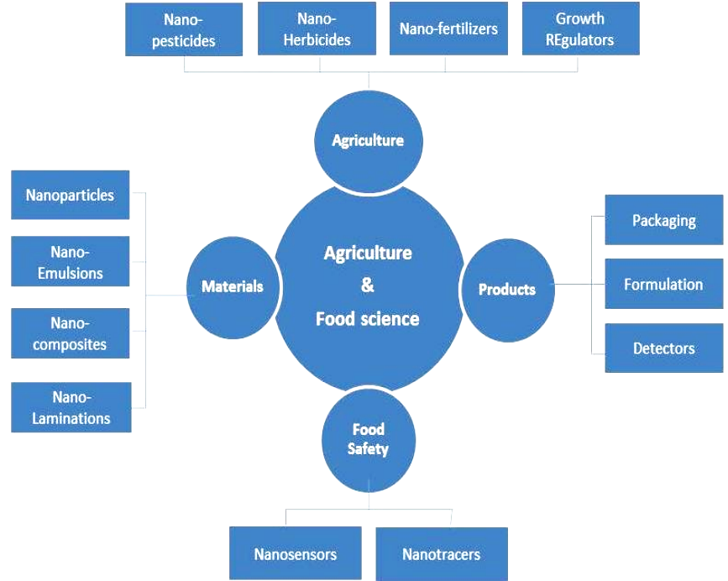

Figure 2 Applications of nanotechnology in agri-food sector (Chebbi et al., 2021)

**Controlled environment agriculture**

In the fight against infectious agents and various crop diseases like Pythium, Aschochyta, Fusarium etc, the agriculture sector will benefit from cutting-edge delivery systems and intelligent sensors (Agarwal et al, 2020 and 2022). Before long, minuscule reactant will be ready to help the viability of bug sprays and herbicides, empowering the utilization of lower sums. With the application of alternative (renewable) sources of energy, controls, or accelerators to minimize contamination and remove harmful contaminants, nanotechnologies are going to safeguard the environment significantly (Mali et al., 2020). Managed environmental agribusiness is a type of farming that is commonly practised in the United States, the European Union, and Japan. It effectively uses modern methods for controlling crops. The current state of CEA technology makes it a great starting point for applying nanotechnology in the agricultural sector. Nano technological equipment for CEA that offers "scouting" features could significantly enhance the grower's capacity to figure out the optimal moment of harvest for each harvest, the nutritional value of the resizing, and avoid nutritional complications, for example, microorganism or chemical contamination. This is because the majority of the control and surveillance systems have already been in place.

**Precision farming**

With the use of specific measures and monitoring of the environment, precision agriculture aims to increase produce (crop productivity) while reducing input (fertilizers, insecticides, herbicides, etc.). Computing devices, transnational positioning satellite systems, and tools for remote sensing are used in precise agriculture to assess localized environmental variables, evaluate whether products are developing as efficiently as possible or precisely pinpoint the kind and position of issues. It is possible to fine-tune sowing, fertilizer, chemicals in nature, and water consumption to reduce operating expenses and enhance productivity, all of which are advantageous to the farmer. Centralized data can be used to evaluate the state of the soil and the development of plants.

With the help of this technology, store owners can recognize expired foods and receive a reminder to place a fresh purchase order. By 2010, the worldwide market in sensors is expected to reach $7 billion US dollars. By combining biotechnology and nanotechnology, sensors will grow more sensitive, enabling quicker reactions to surrounding perturbations. In healthcare, approaches are highly regarded because they may allow medications to be administered more gradually, at particular points in the physique, or in response to outside stimuli (Vecchio et al., 2020). Those nano-, including micro-formulations, are currently being developed and granted patents by agricultural and food manufacturers like Monsanto Corporation, Syngenta, and Kraft, which have potential uses in insecticides, vaccinations, veterinarian medicine, and scientifically enhanced foods. Several designs for nano- and microcapsules include:

• Slow release – When a material needs to be delivered slowly into the body, the capsule delivers its payload gradually over time (Finger et al., 2019).

• Quick-release – When a capsule comes into contact with something, like a leaf or an herbicide, its outer shell cracks.

• Specific release – When a molecule's receptors interact with a particular chemical, such as when it comes into contact with a tumour or amino acids in the human tissues, its outer layer is intended to rupture.

• Moisture release – When water is present (such as in soil), the shell disintegrates, and the insides are released (Arvanitis & Symeonaki, 2020).

• Heat-release – Only when the surrounding temperature rises over a particular level does the shell begin to release components.

• pH release – Only specific acidic or alkaline environments, such as those found in the alimentary tract or inside cells, cause nanocapsules to disintegrate.

• Ultrasound release – By using an external ultrasonic frequency, the container is broken.

• Magnetic release – When subjected to a magnetic field, a magnetized particulate in the capsule causes its outermost layer to break (Barla et al.).

• DNA nanocapsule – The capsule sneaks a brief stretch of foreign DNA entering an existing cell. When it breaks free, it commandeers the cell's expression of a particular protein (which is employed in DNA vaccinations (Tohgasaki et al., 2019).

**Encapsulating control**

With the aid of nanotechnologies, businesses can modify a capsule's exterior shell's physical characteristics to regulate how quickly the medication is released.

***Table 1 Top ten applications of nanotechnologies in the developing countries*** (Lee et al., 2019) (Yadav et al., 2019)

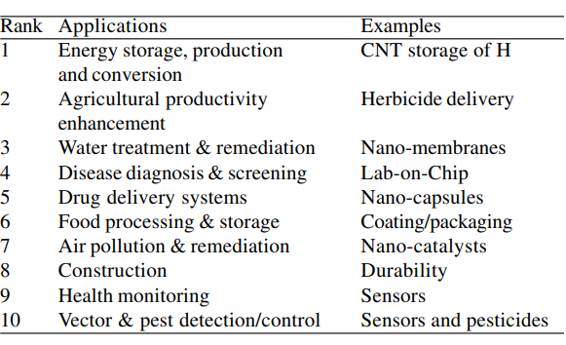

**Food packaging**

Demanding fresh, safe, and nutritious foods with an extended shelf life and simple containers for handling is constantly up to the buyer. Traditional food packaging products present significant issues with waste and are challenging to decompose as recyclable items. Whereas biomass-based materials have been used in food wrapping, questions remain regarding their usefulness and price. Biopolymers, such as fibre and its substitutes, polyester fibres, plant-based fats, and gelatines, have been demonstrated to give essential mechanical strength, superior reinforcing, and barrier qualities when using nanomaterial in packaging materials.

According to (Primožič et al., 2021),polymer micro-composites have demonstrated incredible promise as an inhibitor against gases (such as O2 or CO2) and vapours of water. As a result of (Ashfaq, Khursheed, Fatima, Anjum, & Younis, 2022) and (Mei & Wang, 2020) development of various clay composites with decreased water vapour transfer rate (WVTR) and comparative permeability, the field is now making significant strides. Additionally, nanocomposite motion pictures made of clay and thermoplastic starch (TPS) have been developed, and the findings are intriguing. To produce lighter, tougher plastics with improved resistance to heat and insulating qualities, nano composites like nylon 6 were further created. Food packaging has seen success with the usage of nano-clays or silicon dioxide, such as the substance and aqueous alumina-silicate laminated clay. Nano clays have enhanced structural and barrier qualities, higher degradation rates, and glass transition temperatures. Packaging for food also uses nanotubes of carbon (CNTs) made of polyamide, consequently polyvinyl alcohol, and propylene. Kraft Brands' "electronic tongues" creation is a remarkable accomplishment. It is essentially a collection of nano sensors that alter colour as gases are released from food as it spoils, clearly indicating whether or not the meal is alive or not. When food is packaged, these nano sensors are incorporated. Nano barcodes may additionally be employed for tracking and monitoring food (Singh et al., 2023). Cornell University researchers created fluorescent-based nano barcodes with probes for detecting several farm diseases. Even untrained individuals can use a site detector to find pathogens. The idea of an "electronic nose" (E-nose), which functions similarly to the physiological nose in fragrance detection and odorous substance concentration when eating food, is identical. Gas sensor nanoparticles, primarily ZnO, are present. The method of operation depends on the resistance profile of various gases, each of which emits a distinct signal for identification.

**Nano-assisted bioremediation of contaminated soils**

Bioremediation is an in-situ, regular, conservative, ecologically mindful, and versatile technique for sterilizing perilous pollutants. ( Natural and inorganic).The long treatment times, limited toxin accessibility, low remediation effectiveness in extensively polluted soils brought on by the harmful effect of contaminants on living organisms (bacteria, fungi, plants, etc.), and production of hazardous products may restrict its effectiveness (van der Wouden et al., 2017). Challenges of this environmentally friendly method can be overcome by combining the use of NMs with biological remediation. However, NMs have been employed for chemical site clean-up for the past 20 years. The incorporated (nano-bio) technique shall be used to remediate contaminated soils simultaneously or in an orderly manner.

**BIOREMEDIATION**

**Nanomaterials for bioremediation of organic pollutants**

A significant advancement in the purification of soils impacted with organic matter is the combination of two highly successful remediation techniques (nano-bio). Highly reactive NMs can be used to dechlorinate and dehalogenate recalcitrant organic contaminants, which biotechnology can then remedy effectively. For instance, (Chen, Chen, Jia, & Yan, 2022) investigated the viability of combining an oxidative process employing palladium (Pd)/Fe with a biological remediation procedure to clean up a solution (5 g L1) polluted with triclosan compounds (2,4,4′-trichloro-2′-hydroxydiphenyl ether, among other TCS). During anaerobic circumstances, Pd/nFe led triclosan to rapidly undergo a reductive dechlorination process by generating 2-phenoxyphenol as the sole by-product. The enzyme laccase generated by T. versicolor was then used to reduce 2- 2-phenoxyphenol while syringaldehyde, a naturally occurring redox arbitrator, was present. (Vázquez-Núñez et al., 2020)They evaluated the use of consolidated Pd/Fe0 nanoparticles with bimetallics (CMCPd/nFe0) subsequently followed by Sphingomonas sp. strains bioremediation procedures for treating lindane (gamma-hexachlorocyclohexane)-contaminated topsoil. The stimulatory effect of tiny particles upon the bacterium S sp. strain led to enhanced growth of bacteria and the substance breakdown efficiency (1.7–2.1 times) in the combination system, according to the researchers. To remediate PCBs (Aroclor 1248), Le et al. (2015) assessed the interaction potential between oxidation of chemicals by small particles and biological degradation. In the initial step, the bimetallic nanoparticle Pd/nFe was used to dechlorinate 99% tri-, 92% tetra-, and 84% penta-, with 28% hexachlorinated biphenyls. Burkholderia xenovorans decomposed the residual biphenyls in the subsequent stage. Burkholderia xenovorans did not experience any adverse effects from nanoparticles (Borji et al., 2020). By making organic pollutants more bioavailable to the bioagents utilized for remediation, nanomaterials may also aid in the bioremediation of organic contaminants from soil. Plants could acquire tiny nanoparticles and pollutants attached to the NMs. Furthermore, modified transmembrane permeability brought on by phytotoxic NMs could encourage the transport of organic contaminants. De La Torre-Roche et al. (2012) looked into the effects of fullerene exposure on the build-up of DDE (a compound of DDT) in the following crops cultivated in vermiculite medium: squash for winter (Cucurbita pepo L.), soybeans, and tomato plants. All kinds of plants greatly enhanced their uptake of DDE (30 to 65%) after exposure to fullerene. One of the potential mechanisms of improved absorption was postulated by them to be the co-uptake between NMs and contaminants. NMs could have an impact on bioremediation by lowering the toxicity of pollutants to bio agents, in addition to influencing the bioavailability/bioaccumulation of naturally occurring impurities. The effect of Ni/Fe nanoparticles that are bimetallic on the absorption and cytotoxicity of polybrominated diphenyl ethers, or PB, to Chinese cabbage was researched by (Wu et al., 2018).Using NMs significantly decreased the toxic effects of PBDEs on living plants. This shows that NMs and bioremediation could be combined to minimize both the adverse effects of soil pollutants and NMs in plant life. However, coupling can also make a pollutant more harmful by having a synergistic effect. Carbon nanotubes (CNTs) have a detrimental effect on Chlorella vulgaris cultivated in diuron-contaminated soil, according to (Li et al., 2021).

**Nanomaterials for bioremediation of inorganic pollutants**

Nanomaterial’s can considerably increase the phytoremediation effectiveness of heavy metals in polluted soils. (Wang et al., 2023) looked into how soil-borne cadmium formation by soybean cultivars was affected by nanoparticles of titanium dioxide (TiO2). By shielding crops from oxidative injury and quenching free radicals generated due to Cd toxicity, TiO2 treatment increased Cd absorption in plants. It decreased the harmful effect of Cd on soybean seeds. As an improved remediation method, (Anil et al., 2022) investigated the combined effects of nano-hydroxyapatite (NHAP) along with nano-carbon black (NCB) on the removal of lead (Pb) by the phytoextraction process by the ryegrass (Lolium temulentum L.) via soils in an agricultural experiment. NHAP or NCB significantly reduced the harmful effects of Pb on ryegrass, and ryegrass's capacity for phytoextraction was boosted.

Compared to NCB, NHAP was found to be more effective for in situ clean-up of Pb-contaminated soils. Nanoparticles can reduce plant metal toxicity by controlling gene expression linked to metallic stress, oxidative damage, water equilibrium, cell membrane emergence, photosynthetic channels, and dividing cells. ( (Kumar et al., 2019) claimed that NMs could alter the porousness of cell walls, the expression of transporter genes, and the co-transportation of contaminants with NMs to increase the levels of excessive metals in Arabidopsis. On the other hand, NMs have been found to have detrimental effects on the effectiveness of phytoremediation. For instance (Kumar et al., 2019)found that the combined influence of graphene dioxide (GO) and Cd resulted in worsened toxicity of Cd in Microcystis aeruginosa by increasing ROS formation. It is important to note that various NMs have varying effects on the absorption or toxicity of heavy metals in plants.

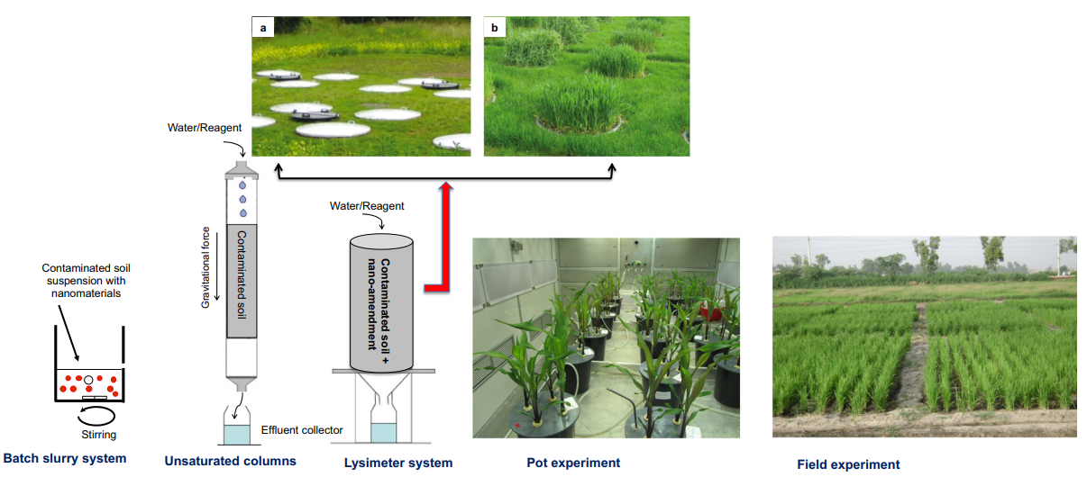

Figure 3 Different phases of experimental setup used for laboratory to field application to investigate remediation of contaminated soil (Mahesha, Guddaraddi, Reddy, & GV, 2023).

While column experiments were chosen because they better reflected actual field conditions, batch testing is performed here to maximize remedial effectiveness when mixing. Lysimeter measurements are often conducted in the field in sizable soil pillars with either bare (a) or vegetated (b) ground. Plant research can be done in pot trials under regulated conditions. The best studies are conducted in the field through field testing. Figures A and B are taken from UGT-Gmbh, and the batch and the column configurations are modified from (Usman et al., 2020).

Various plant species experience further developed seed germination process stand setting up, development, and yield creation when nanoparticles are applied at pre-streamlined rates (Kaul & Sharma, 2022). Due to the production of resilient to stress DNA, nanomaterial also provide plant tolerance against various biotic and abiotic stimuli.

# CONCERNS AND PRACTICAL CHALLENGES

To address current issues with human wellness, the development of cells and advancement, including a lack of food and changing climates, advanced scientific treatments such as nanomaterial are required. In this sense, a diet that includes affordable, secure, and appropriate amounts of nutrient-dense food is crucial (Xing, Magdouli, Zhang, & Koubaa, 2020). However, because our diet is unsafe and contaminated, it needs to be protected with hygiene and security measures.

Traditional procedures (TLC, HPLC, LC-MS, etc.) are obtainable but require expensive monitoring labour and are challenging.

When food is kept at ambient temperature for an extended period, it quickly develops bacteria and changes chemically, becoming toxic food. Food spoilage may occur due to improper storage, chemical alterations, or several bacteria and fungi that cause foodborne illnesses or poisoning from foods worldwide. Additionally, applying pesticides in food preservation to lengthen the shelf life of food contributes to sickness. In this situation, it is essential to have a method for identifying fresh or excellent food.

Fruit and food inspection by colour and scent is doable but costly, time-consuming, and ineffective. Nucleoacids, antigens, enzymes, carbohydrates, lipids, and proteins are nanoscale materials utilized in biological systems. In contrast, using manufactured nanomaterials has given rise to possible worries about latent toxicological risks affecting agriculture, our surroundings, and healthcare or human health. There needs to be more data on the toxicity of using nanosensors. Therefore, researchers, scholars, and legislative and regulatory bodies worldwide must describe and analyse the nanoparticles employed in nano biosensors.

The key area for agricultural improvement is the difficulties connected to conservation, food hygiene and safeguards, and warming temperature.

# The disintegration of the formulation elements in the spraying container and blockage of the sprayer nozzles are two more real-world issues that arise during the spraying pesticides in the field. Recent nano-sized fungicides (100 nm, BannerM AXX, Syngenta) avoided spray tank clogging due to their tiny size, did not require interaction, and were not suspended in the sprayed tank.

# Additionally, because of its nano-size, this antifungal didn't separate from its surroundings for up to a year, unlike fungicides that usually necessitate circulation at regular intervals to avoid tank blockage.

The most effective way to apply fertilizer in the right amounts is to optimize nutrient absorption and minimize contamination. The substrate, agricultural product, drainage type, and administered nutrient all play a role in deciding how to apply fertilizer. Run-off issues stemming from leaching and moisture from soil dissolution plague current broadcasting, banding, and side getting dressed, and dusted techniques.

Biological colloidal material, molecular fractions, and substance fractions can combine with NMs, spreading them into the liquid and solid stages of the soil's environment (Mangla et al., 2021). However, because the majority of study has been done in water systems, more is needed regarding what happens to and behaves of NMs in the soil system. In actuality, investigations in soil suspensions have primarily been used to infer how NMs behave in soil ecosystems.

NMs may change physically, chemically, or biologically after entering the soil, determined by their makeup and interaction with different substrate elements. (Organic and inorganic). Clustering is the primary physical process that arises dynamically while NMs are released into the soil microenvironment. The accessible circumference of NMs is decreased by collection, which impacts their susceptibility. Additionally, larger aggregates will move less easily through a porous medium, changing how reactive and behaving NMs become.

The eventual destination and actions of NMs are significantly influenced by soil organic matter (SOM), mainly via Adsorption capacities and stability.

Nanomaterial might be hazardous to soil bacteria as well. However, the composition, size of particles, dosage, concentration, and characteristics of nanoparticles, as well as the kind of soil or moisture content, all affect how poisonous the substances are.

# SOLUTIONS

To create effective, versatile, stable, economical, and sustainable nanomaterial, research collaboration amongst institutions examining various applications of nanomaterial is essential (Yaqoob et al., 2020). That also makes it easier to finish the information regarding the function, course, conduct, and evaluation of NMs' Eco toxicity. Crop plants can expand and produce more when NMs are applied, although each plant may respond differently. Therefore, careful research must be done into evaluating and optimizing nanomaterial for various plant species before they can be used commercially. Tuning the characteristics and durability of nanoparticles allows for customization of how they behave and perform. Therefore, continuing advancement in creating new and enhanced synthesis techniques with exact visibility into the substance's composition will be beneficial in increasing their effectiveness.

The function of NMs in bioremediation procedures ought to be investigated to generate comprehensive remediation solutions. Additionally, most research on nano-assisted agriculture relies on controlled tests, and there needs to be more information on how they might be used in actual farming. More field-level understanding would be beneficial for the large-scale application of nano-based techniques. The freshness of foods like dairy products, meat, and fruits can be determined using sophisticated devices like biosensors and electrical sensors. Additionally, food freshness can be detected via pH, moisture, and gas sensors.

Additionally, vitamins, antimicrobial agents, food deterioration, and microbial pollutants, which are commonly present, can all be detected using nano biosensors.

In various nano biosensors, nanostructured materials like carbon nanotubes, metallic nanoparticles, entangled polymers, and small particles may be employed to detect food goods at an early production stage, over-storage, and throughout shipment if they are improperly produced.

**Detoxification or remediation of harmful pollutants**

For the elimination of arsenic, artificial things clay nano minerals can be used without the use of costly laboratory supplies. The water that needs to be purified percolates down a hydrotalcite column. According to (Sidarenka et al., 2023), this approach may be used with filter candles or leaching through porous pots, a technique used in many impoverished nations to remove microorganisms from water for consumption. Arsenic can be eliminated utilizing zinc oxide nanoparticles and a point-of-source filtration system. The microscopic zero-valent ironing board is the most commonly used category of nanomaterial’s that can be utilized to remove contaminants from soil or rainwater. Nanoscale zeolites, metallic oxides, carbon-based nanotubes and fibres, amino acids, different noble metals (primarily as bimetallic nanoparticles), and titanium dioxide are further nanoparticles that might be employed in decontamination. Organic particulates and herbicides, such as dichlorodiphenyltrichloroethane (DDT), endosulfan, Malathion and chlorpyrifos, can be removed from water using nanoparticle filters. In affluent nations, nanoparticle filtration is being utilized to clean up waste sites (Khan et al., 2021).

**Zeolites for water retention**

These crystalline aluminium silicates occur as natural substances. Zeolite's extremely porous characteristics and the form of capillary suction it produces help water infiltration as well as retention in the soil. It is an excellent supplement for non-wetting soils that helps water distribute through soils by serving as an organic hydrating agent. This significantly boosts the ability of sandy soils to retain rainwater and improve the permeability of clay-based soils. Increasing soil capacity to hold water may enhance crop yield in drought-prone locations (Chebbi et al., 2021). Zeolite will enrich the soil's ability to hold onto minerals and provide better crops with additional uses.

**Nanocoatings and nanofeed additives**

TiO2 nanoparticles used in poultry homes as a self-sanitizing photo-catalytic overlay have the potential to oxidize and eliminate microorganisms when exposed to sunlight and moisture. Reducing the number of foodborne diseases may be possible by using poultry feed containing nanoparticles that bind harmful germs (Huchchannanavar, Ramesh, Ravishanakar, & Govindappa, 2019).When the surface is subjected to sunlight or ultraviolet light, the unique photocatalytic characteristics of the tiny TiO2 particles are triggered. TiO2 oxidizes germs and kills them when there is light and humidity present. As soon as there is sufficient light to activate the photocatalytic action, the material that has been coated continues to be self-sanitizing. The Canadian Food Inspection Agency has authorized the surface coating. Self-cleaning and disinfecting nanocoatings are used in Denmark as part of the Chicken and Hen Infection Program (CHIP) (Lee et al., 2019). Decontamination and cleaning are more effective thanks to the perfect nanoscale surface. At some point, Danish researchers are additionally focusing on nanosilver-containing coatings that do not require UV light to activate them. Biofilm development is halted by the ions from nanosilver. Nanosilica with surface modifications that are both lipophilic and hydrophobic can be extensively exploited as new medications to treat nucleus polyhedrosis viruses (BmNPV), a big issue in the silkworm business. Bombyx mori (the silk worm) has amply demonstrated that tiny particles may encourage the manufacturing of even more fibroin, which may help produce carbon nanotubes in future generations. Aflatoxin can injure chickens, but altered small particles (montmorillonite nanocomposite) can lessen these effects. Prospective development of quicker and more environmentally friendly insecticides should be the focus of investigations with nanoparticles and insect suppression (Yadav et al., 2019).

# NANOTECHNOLOGY IN AGRICULTURE FOR SECURITY OF LIVELIHOODS

Everyone agrees that nanotechnology has a place in agriculture, especially when it comes to improving the lives of the impoverished in third-world countries. According to the WTO, a growing percentage of developing nations have embraced intellectual property rights due to the Declaration on the Trade-Related Features of Intellectual Property Rights, of the three founding principles of the 1994 trade pacts.

There are more worldwide than US patent applications for all kinds of nanotechnologies. These patents are primarily from advanced nations that are pioneers in nanotechnology, including the USA, Western European countries, Japan, South Korea, and Australia. Only significant growing economies in the underdeveloped world—like the People's Republic of China—have created technology that has received patents thus far. Future strengthening of the rights to intellectual property framework could result in a knowledge gap between developed and developing countries. Although it is effective at addressing issues connected to poor input usage efficiency, shortages of water, unsanitary environments, and other subjects shared by impoverished nations, agronomic nanotechnologies are a technique that can benefit them more (Mahesha et al., 2023). Nevertheless, if it is understood that the potential expenses associated with acquiring farm technology might be more than that of producing it locally in an environmentally friendly way, developing countries can benefit from nanotechnology.

Nanoparticles offer enormous potential for use in horticulture. Agriculture-related nanotechnology applications have just recently become the subject of discussion. However, given that traditional agricultural methods are becoming increasingly ineffective and that human requirements surpass the potential of the natural environment on Earth, we are forced to investigate the use of nanotechnology in all facets of agriculture. Implementing new technologies is widely acknowledged as essential to building national wealth (Elizabath, Babychan, Mathew, & Syriac, 2019). Bio nanotechnology, a nanoformulation of agricultural products, detection and prevention of diseases and insect pests, comprehending the workings of interactions between hosts and parasites at the molecular level, development of next-generation chemical treatments and safe transportation companies, storage and promotional materials of food and food components, and strengthening the infrastructure are all areas where nanotechnology anticipates to break through. Applying modern concepts like the idea of disorder and the theory of strings combined with revisiting our grasp of the theoretical underpinnings of the system that produces food throughout the Earth's geosphere (pedosphere)-biosphere-atmosphere spectrum could offer fresh opportunities.

*Table 2 Product based applications in agro industry*  (Ma, Zhang, Liu, & Li, 2020)

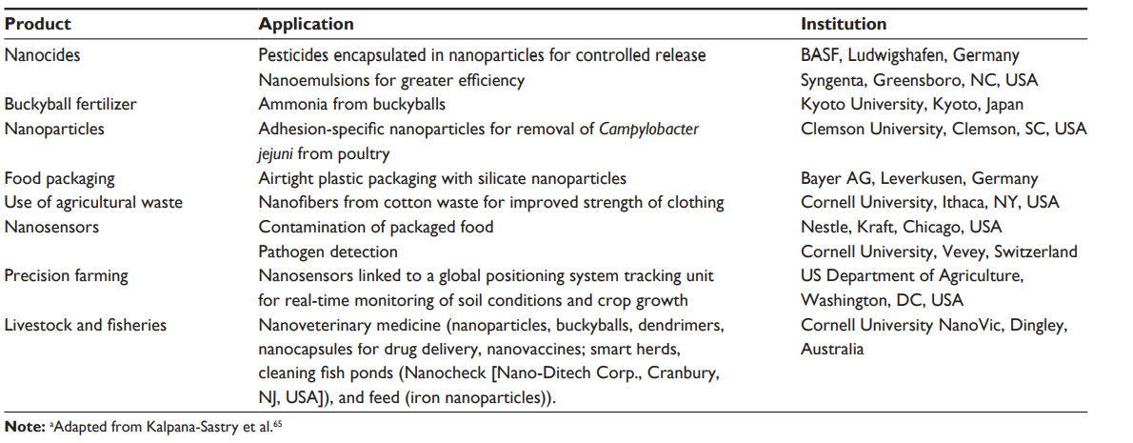

An in-depth knowledge of science, manufacturing and resource technology, and familiarity with the farming and food production system are prerequisites for working with nanotechnologies. The difficulty of this task may inspire creative minds to pursue a career in agriculture. Human resources require complex training to succeed in the field; therefore, novel educational applications, particularly at the graduate school level, are desperately needed (Ndlovu, Mayaya, Muitire, & Munyengwa, 2020). According to the National editors, it requires an invention about 20 years to leave the lab and become commercially viable. It may take several decades for nanotechnology in agriculture to transition from the laboratory to the field, primarily because it has to mitigate the problems in the biotechnology field. This requires consistent financing, awareness on the side of scientific administration and legislative planners, as well as fair standards for this emerging profession to flourish.

INDUTRIAL EXPERIENCES

The electrospun nanofibers have filtration, medication administration, and wound dressing applications. Agriculture's utilization of electrospun nanofibers is still in its very early stages. The effectiveness and effects of pesticides and fertilizers on the environment depend on how they are applied. Pesticides are currently sprayed using either ultra-light capacity nozzles for regulated particle distribution to smaller particles (3-28 mm) generating drift from the spray or knapsack fact, that deliver huge droplets (9-66 mm) that contribute to splash back loss. Droplet size restrictions may be bypassed by utilizing NP-encapsulated and nanosized pesticides, resulting in more effective spraying and a decrease in splash and drift from the spray losses.

**Advancement in crop biotechnology industry**

Herbicides can penetrate cuticles and tissues with the help of nanocapsules, allowing for a steady, regular release of the active ingredients. These can function as "enchantment bullets," as they contain chemical herbicides, which are substances that target specific plant portions to release their material. A 3 nm mesoporous silicon particulate was used by (Ma et al., 2020) to transfer DNA and drugs into segregated plant cells. Chemically coated mesoporous silica nanoparticles serve as carriers for genes introduced into plants; they prompt the plant to transport the tiny particles across the cell barriers, wherever the genetic material is added and activated precisely and regulated, without any adverse side effects. This method was initially used to establish DNA in tobacco and maize plants successfully.

# PUBLIC ACCEPTANCE OF NANOTECHNOLOGY IN AGRICULTURE

Use of nanotechnology is fundamental, given the large numbers of individuals overall who keep on lacking admittance to safe water, solid wellsprings of energy, medical care, training, and other essential human advancement needs. The Millennium Development Goals of the United Nations have established targets for meeting these requirements since 2000. A growing number of government, scientific, and institutional reports in recent years have concluded that nanotechnology has the potential to significantly help alleviate poverty and achieve the Millennium Development Goals, albeit with caution regarding the risks that nanotechnology poses to developing nations.

In a popular assessment study, respondents in the USA didn't consider the dangers and advantages of nanotechnology freely, and saw nanotechnology as generally nonpartisan, safer, and more gainful than various different advancements, like hereditarily changed organic entities, pesticides, substance sanitizers, and human hereditary designing. On the other hand, it was thought to be more risky and less beneficial than hydroelectric power, solar power, vaccination, computer screens, and solar power. Notwithstanding, regardless of the public acknowledgment, we should recall that we have minimal comprehension of the destiny, transport, and conduct of designed nanoparticles in the climate (counting soils and the hydrosphere) beyond their unique business or modern areas. Nanoparticles' potential effects on the environment are difficult to predict given our current knowledge. When they are made and used in agriculture, they need to be handled with more caution than commercial or industrial products.

*Table 3 Relevant applications and examples in agricultural nanotechnology and succesfull applications at small scale or R&D stage*  (Elizabath et al., 2019)*.*

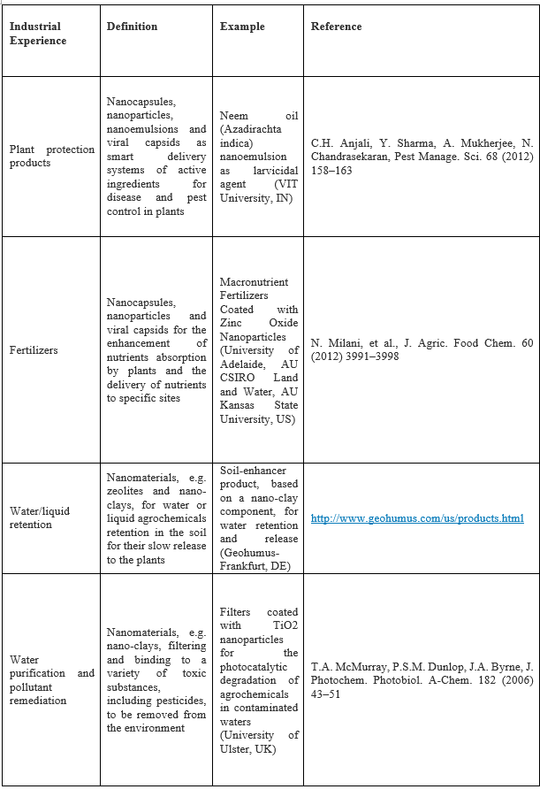

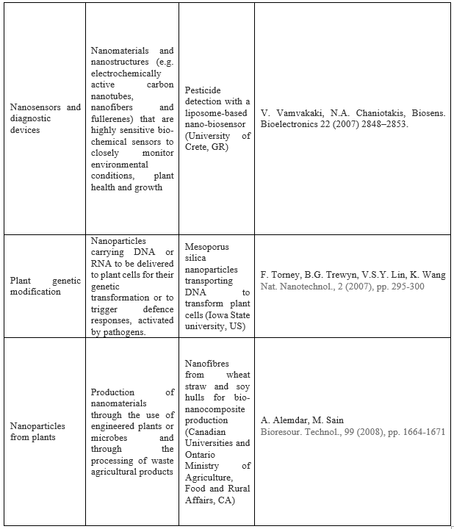

Exposure to engineered nanoparticles may have different effects than exposure to nanoparticles that are naturally occurring. Due to their size or protective coatings, engineered nanoparticles may be able to bypass the body's defenses more effectively. Also, the wellbeing and ecological dangers raised because of the openness to designed nanoparticles need further review. Future agricultural nanotechnologies appear quite intriguing and promising. However, the potential dangers associated with using nanoparticles in agriculture are the same as those associated with any other industry. Through the quick appropriation of nanoparticles to food items, whether it is in the actual food or part of the bundling, nanoparticles will practically come in immediate or circuitous contact with everybody. The likelihood could be that "the consolidation of nanotech and biotech might project obscure results on soil, wellbeing, biodiversity and the climate. Since there is no normalization for the utilization and testing of nanotechnology, items integrating the nanomaterials are being created without check. Although it is well known that these materials can enter the body, no information is available regarding their potential effects. While there is no proof of damage to individuals or the climate at this stage, nanotechnology is a new and developing area of study that could make a lot of mischief due its as yet uncertain synthetic properties. With the ongoing application and progressions soon to come, nanotechnology will significantly affect where that horticulture will take.

# In every possible field, scientists are blazing a new path for a new technology and investigating every possible means of enhancing existing approaches. In the field of farming, there are as yet numerous conceivable outcomes to investigate and a lot of potential with up-coming items and strategies. In this manner, broad examinations are expected to comprehend the system for nanoparticles materials harmfulness and their effects on common habitat.

# SUMMARY

Despite the fact that many fields fall under the umbrella of agriculture, nanotechnology in agriculture has gained momentum over the past ten years thanks to a lot of public funding. However, despite this, the rate of development is sluggish. This could be ascribed to: an exceptional nature of homestead creation, what capabilities as an open framework by which energy and matter are traded uninhibitedly; the size of interest of info materials continuously being monstrous conversely, with modern nanoproducts; a shortfall of command over the information nanomaterials conversely, with modern nanoproducts (eg, the PDA) and in light of the fact that their destiny must be considered on the geosphere (pedosphere)- biosphere-hydrosphere-climate continuum; the delay of arising advances arriving at the ranchers' field, particularly given that many arising economies are reluctant to spend on development; and the lack of foresight caused by the fact that agricultural education has not attracted a sufficient number of brilliant minds from all over the world, as well as the possibility that personnel from related disciplines do not have an understanding of the production systems used in agriculture. Assuming that these issues are dealt with, nanotechnologic mediation in cultivating has splendid possibilities for

* working on the productivity of supplement use through nanoformulations of manures, breaking yield boundaries through bio nanotechnology,
* observation and control of irritations and sicknesses,
* developing new pesticides and their carriers, comprehending molecular mechanisms of host-parasite interactions,
* safeguarding and bundling of food and food added substances,
* strengthening of natural fibers,
* removing pollutants from water and soil,
* extending the shelf life of flowers and vegetables,
* dirt based nanoresources for accuracy water the board,
* reclaiming salt-affected soils and stabilizing surfaces prone to erosion

It is necessary to address the effects of nanoparticles, including their potential danger, toxicity issues, and environmental concerns. In the coming years, foods derived from nanotechnology are likely to expand the formulation and production of functional foods. The food processing industry as a whole could be ruled by nanotechnology if specific rules and regulations are established to address the technology's various safety issues. Due to its capacity to find amicable solutions at both the micro and macro levels, it is anticipated that nanotechnology will become the advanced technology with an infinite growth rate by 2050 to solve the majority of industrial and societal issues.

**References**

Agarwal C., Chen W., Varshney R. K., Vandemark G. (2022). Linkage QTL mapping and genome-wide association study on resistance in chickpea to Pythium Ultimum . Front.Genet. 13. doi: 10.3389/fgene.2022.945787

Agarwal, C., Chen, W., Coyne, C., & Vandemark, G. (2020). Identifying sources of resistance in chickpea to seed rot and seedling damping‐off caused by metalaxyl‐resistant Pythium ultimum. Crop Science, csc2.20424. https://doi.org/10.1002/csc2.20424

Anil, A., Ibraheem, W. I., Meshni, A. A., Preethanath, R. S., & Anil, S. (2022). Nano-hydroxyapatite (nHAp) in the remineralization of early dental caries: A scoping review. *International journal of environmental research and public health, 19* (9), 5629.

Arvanitis, K. G., & Symeonaki, E. G. (2020). Agriculture 4.0: the role of innovative smart technologies towards sustainable farm management. *The Open Agriculture Journal, 14* (1).

Ashfaq, A., Khursheed, N., Fatima, S., Anjum, Z., & Younis, K. (2022). Application of nanotechnology in food packaging: Pros and Cons. *Journal of Agriculture and Food Research, 7*, 100270.

Borji, H., Ayoub, G. M., Al-Hindi, M., Malaeb, L., & Hamdan, H. Z. (2020). Nanotechnology to remove polychlorinated biphenyls and polycyclic aromatic hydrocarbons from water: a review. *Environmental Chemistry Letters, 18*, 729-746.

Chebbi, M., Azambre, B., Monsanglant-Louvet, C., Marcillaud, B., Roynette, A., & Cantrel, L. (2021). Effects of water vapour and temperature on the retention of radiotoxic CH3I by silver faujasite zeolites. *Journal of Hazardous Materials, 409*, 124947.

Elizabath, A., Babychan, M., Mathew, A. M., & Syriac, G. M. (2019). Application of nanotechnology in agriculture. *Int. J. Pure Appl. Biosci, 7* (2), 131-139.

Finger, R., Swinton, S. M., El Benni, N., & Walter, A. (2019). Precision farming at the nexus of agricultural production and the environment. *Annual Review of Resource Economics, 11*, 313-335.

Huchchannanavar, S., Ramesh, B., Ravishanakar, G., & Govindappa, M. (2019). Application of nanotechnology in food and feed: A. *IJCS, 7* (4), 1180-1185.

Kaul, I., & Sharma, J. G. (2022). Nanotechnology for the bioremediation of organic and inorganic compounds in aquatic ecosystem/marine ecosystem. *Journal of Applied Biology and Biotechnology, 10* (6), 22-33.

Khan, S., Naushad, M., Al-Gheethi, A., & Iqbal, J. (2021). Engineered nanoparticles for removal of pollutants from wastewater: Current status and future prospects of nanotechnology for remediation strategies. *Journal of Environmental Chemical Engineering, 9* (5), 106160.

Kumar, V., Parihar, R. D., Sharma, A., Bakshi, P., Sidhu, G. P. S., Bali, A. S., . . . Gyasi-Agyei, Y. (2019). Global evaluation of heavy metal content in surface water bodies: A meta-analysis using heavy metal pollution indices and multivariate statistical analyses. *Chemosphere, 236*, 124364.

Lee, S., La, T.-M., Lee, H.-J., Choi, I.-S., Song, C.-S., Park, S.-Y., . . . Lee, S.-W. (2019). Characterization of microbial communities in the chicken oviduct and the origin of chicken embryo gut microbiota. *Scientific reports, 9* (1), 6838.

Ma, X., Zhang, X., Liu, H., & Li, Z. (2020). Highly efficient DNA-free plant genome editing using virally delivered CRISPR–Cas9. *Nature Plants, 6* (7), 773-779.

Mahesha, K., Guddaraddi, A., Reddy, H., & GV, S. K. (2023). Unleashing the Potential of Nanotechnology in Agriculture. *Advanced Innovative Technologies in Agricultural Engineering for Sustainable Agriculture*, 97.

Mali, S. C., Raj, S., & Trivedi, R. (2020). Nanotechnology a novel approach to enhance crop productivity. *Biochemistry and Biophysics Reports, 24*, 100821.

Mangla, B., Kaul, V., Thakur, N., & K Shukla, S. (2021). A Review on Harnessing Nanomaterials as Promising Materials Interface. *Advanced Materials Letters, 12* (7), 1-16.

Ndlovu, N., Mayaya, T., Muitire, C., & Munyengwa, N. (2020). Nanotechnology applications in crop production and food systems. *Int. J. Plant Breed, 7* (1), 624-634.

Primožič, M., Knez, Ž., & Leitgeb, M. (2021). (Bio) Nanotechnology in food science—food packaging. *Nanomaterials, 11* (2), 292.

Sidarenka, A. V., Leanovich, S. I., Kalamiyets, E. I., Vieira, D. E., Cardoso, J. P., Tedim, J., & Salak, A. N. (2023). Commercial synthetic hydrotalcite as an adsorbent nanomaterial for removal of bacteria from contaminated water. *Environmental Engineering Research, 28* (3).

Singh, R., Dutt, S., Sharma, P., Sundramoorthy, A. K., Dubey, A., Singh, A., & Arya, S. (2023). Future of nanotechnology in food industry: Challenges in processing, packaging, and food safety. *Global Challenges, 7* (4), 2200209.

Tohgasaki, T., Shitomi, Y., Feng, Y., Honna, S., Emura, T., Hidaka, K., . . . Endo, M. (2019). A photocaged DNA nanocapsule for controlled unlocking and opening inside the cell. *Bioconjugate Chemistry, 30* (7), 1860-1863.

Usman, M., Farooq, M., Wakeel, A., Nawaz, A., Cheema, S. A., ur Rehman, H., . . . Sanaullah, M. (2020). Nanotechnology in agriculture: Current status, challenges and future opportunities. *Science of the Total Environment, 721*, 137778.

van der Wouden, C. H., Cambon‐Thomsen, A., Cecchin, E., Cheung, K.-C., Dávila‐Fajardo, C. L., Deneer, V. H., . . . Karlsson, M. O. (2017). Implementing pharmacogenomics in Europe: design and implementation strategy of the ubiquitous pharmacogenomics consortium. *Clinical Pharmacology & Therapeutics, 101* (3), 341-358.

Vázquez-Núñez, E., Molina-Guerrero, C. E., Peña-Castro, J. M., Fernández-Luqueño, F., & de la Rosa-Álvarez, M. G. (2020). Use of nanotechnology for the bioremediation of contaminants: A review. *Processes, 8* (7), 826.

Vecchio, Y., Agnusdei, G. P., Miglietta, P. P., & Capitanio, F. (2020). Adoption of precision farming tools: The case of Italian farmers. *International journal of environmental research and public health, 17* (3), 869.

Wang, Q., Wang, L., & Li, R. (2023). Trade protectionism jeopardizes carbon neutrality–decoupling and breakpoints roles of trade openness. *Sustainable Production and Consumption, 35*, 201-215.

Wu, J., Yi, Y., Fang, Z., & Tsang, E. P. (2018). Effects of biochar on phytotoxicity and translocation of polybrominated diphenyl ethers in Ni/Fe bimetallic nanoparticle-treated soil. *Environmental Science and Pollution Research, 25*, 2570-2579.

Xing, D., Magdouli, S., Zhang, J., & Koubaa, A. (2020). Microbial remediation for the removal of inorganic contaminants from treated wood: Recent trends and challenges. *Chemosphere, 258*, 127429.

Yadav, S. K., Lal, S., Yadav, S., Laxman, J., Verma, B., Sushma, M., . . . Sharma, V. (2019). Use of nanotechnology in agri-food sectors and apprehensions: an overview. *Seed Res, 47* (2), 99-149.

Yaqoob, A. A., Ahmad, H., Parveen, T., Ahmad, A., Oves, M., Ismail, I. M., . . . Mohamad Ibrahim, M. N. (2020). Recent advances in metal decorated nanomaterials and their various biological applications: A review. *Frontiers in chemistry, 8*, 341.