A review of segmentation techniques on medical images

Sajeev Ram Arumugam
Department of Computer Science and Engineering,
Sri Krishna College of Engineering and Technology,
Coimbatore, India
imsajeev@gmail.com

Sankar Ganesh Karuppasamy
Department Of Computer Science And Engineering,
Vel Tech Rangarajan Dr. Sagunthala R&D Institute of Science and Technology,
Chennai, india.
prof.sankarganesh@gmail.com

P Sheela Gowr
Department of Computer Science and Engineering,
Vels Institute of Science, Technology & Advanced Studies,
Chennai, India
psheelagowr85@gmail.com
V. Rajeshram
Department of Computer Science and Engineering
M.Kumarasamy College of Engineering,
Karur, India
rajeshram107@gmail.com

Abstract: A recent development in medical image processing called medical image segmentation has dramatically increased healthcare long-term viability. In the field of object recognition, it is currently a prominent research topic. Image segmentation is a technique that splits a computerized image into numerous sections simplifying further processing by decreasing the complication of the original image. Segmentation outcomes fundamentally impact all subsequent image analysis procedures, including object representation and description, feature measurement, and more advanced tasks like object classification. Thus, image segmentation is the crucial technique for enabling the discovery, characterization, and visualization of the regions of interest in any medical image. In addition to being complex and prolonged, the clinician manual segmentation of the medical image is also not very precise, mainly in light of the budding scope of medical imaging processes and the irresistible volume of medical images that want to be analyzed. Therefore, it is vital to explore current image segmentation techniques utilizing automated algorithms that are defined and demand the smallest amount of user input, particularly for medical images. Identifying and isolating the anatomical structure during the segmentation process is vital. The significance of image segmentation in extracting decision-making information is projected in this study, and existing medical imaging methods are discussed with numerous research breakthroughs.
Keywords: Segmentation, Computed Tomography (CT), Magnetic Resonance Imaging (MRI), X-Rays, Nuclear Medicine, Image Processing, Thresholding.

I. Introduction:

Images of interior body structures are produced by medical imaging for use in study and therapy in science and medicine. This method seeks to control and recognize disorders. Consequently, millions of images are produced each year for various diagnostic objectives. Medical imaging creates images of interior body structures without using intrusive methods. These graphics were created using quick processing and mathematical energy conversion to signals. Those signals are changed into digital images [1]. Medical imaging processing is the term for computer-based image processing. The processes include image obtainment, storage, and representation. The image measures a witnessed sight's features, such as illumination or colour. Digital images provide several benefits, such as rapid and cost-effective processing, quick storage and transmission, instant evaluation processes, and flexible manipulation.
An image processing approach involves using technology to modify a digital image. It is now feasible to keep images due to the creation of numerous image scaling algorithms. With this approach, several rules should be implemented in the images simultaneously. Either 2D or 3D graphics can accommodate a variety of dimensions. The initial image-processing techniques were generated in the 1960s [2]. Image processing had become quicker and more economical since the 1970s when computers became widely available. In the 2000s, image processing improved speed, cost, and simplicity.
Medical image analysis aims to highlight some distinctive details in an image. The purpose is to assist the radiologist in performing an appropriate disease diagnosis and treatment. Necessary measures must work well, including accuracy, F-measure, precision, recall, sensitivity, and specificity. These measuring methods are instrumental in medical image analysis. Medical images, transportation, home design, and many more industries are all included in the broad field of image segmentation [3]. Among the most crucial linkages in medical image breakdown, it is primarily used to segment and examine the sections of medical images that are of interest to offer a solid technological guarantee for correctly identifying diseases.
Traditional medical image segmentation methods include boundary extraction, threshold-based segmentation, and categorization according to region. However, learning manual features using conventional methods when dealing with massive objects or big data is challenging [4]. Since deep learning (DL) has become more prevalent, traditional segmentation techniques have become less effective in assisting physicians with accurate disease diagnosis and treatment. As a result, using the DL approach in image segmentation can increase its reliability and accuracy and set a firm foundation for its quantitative analysis and 3D visualization.

II. Background

A. Classification of digital images
A digital image represents an original image that a computer can save and work with numerical values. The image is broken into tiny sections known as pixels to be converted into numbers. The imaging equipment stores a number, or a limited group of integers, that identify a pixel's characteristics, such as its brightness or colour. The rows and columns of the numbers' arrangement represent the vertical and horizontal positions of the image pixels. Digital photographs have several advantages over traditional ones, including sending them electronically relatively instantly and converting them readily between different media.
There are two primary sorts of images in digital images. A four-sided arrangement of periodically sampled values called pixels is called a raster image. Digital images frequently have complex colour differences and are challenging to see. Due to the size of their pixels, digital images have a predetermined resolution. Due to some missing data, the quality of the digital images degrades during the scaling process. Due to their vibrant colour palettes, digital images are primarily used in photographs. The resolution is managed by the camera that captures the image. The digital images come in a variety of forms, including PCX (Paintbrush), TIFF (Tag Interleave Format), BMP (Windows Bitmap), and PNG (Portable Network Graphics), among others.

B. Clinical Needs of Medical Imaging
A critical step in the medical diagnosis and treatment process is medical imaging. A radiologist examines the obtained clinical data and creates a report summarising their conclusions. The prescribing doctor establishes a diagnosis and a treatment strategy based on the radiology report and the images. Medical imaging is frequently requested during a patient's follow-up to ensure their medication is successful [5]. Additionally, visuals become crucial in advanced surgical planning. Multiple techniques are called medical imaging when describing how the biological species is seen. The data given by each method is specific to the area of the body that is being examined for probable illness, injury, or the effectiveness of medical treatment.
Medical imaging is essential in many medical settings and at all significant levels of health care. Diagnostic imaging services are necessary for validating, assessing, and documenting the development of different diseases and the efficacy of various treatments. Health practitioners trained to use imaging technology are typically in limited supply, and many low- and lower-middle-income countries cannot afford it. We have certainly all aware of a few of the several medical imaging techniques [6]. It included Positron Emission Tomography (PET), Computed Tomography (CT), Magnetic Resonance Imaging (MRI), and many others. When trying to find cancer, medical imaging is beneficial. Early detection is essential to increase the likelihood of recovery from such a terrible disease. Medical imaging enables the early detection of malignancies by medical professionals. The approach is less disruptive, and the identification is also more effective. The patient's costs are decreased due to the decrease in intensive, in-patient treatments.

C. Medical Imaging Systems
Medical practitioners and researchers use high-frequency sound waves, magnetic fields (MRI), and electromagnetic radiation in medical imaging devices to collect the required data. Breast thermography and molecular imaging are medical imaging modalities, such as scintigraphy and PET scanning [7]. Mobile radiography and MRI technology are used in security, emergency response, and healthcare. Over the past century, medical imaging has significantly lowered that difficulty. Medical imaging is taking images of the human body's interior to help with diagnosis and therapy. Public health has been dramatically impacted by it.
Regarding the progression of the illness condition that has previously been diagnosed and is undertaking a treatment plan, these methods benefit patient follow-up. Ultrasound and X-rays are used in the more significant part of imaging procedures. All hospital treatment levels entail using these imaging techniques [8]. Additionally, they play a crucial role in preventative health and public health medicine, the provision of clinical services, and even pain management. Getting the proper diagnosis is the primary goal. In a clinical environment, medical imaging modalities are critical in diagnosing the patient's condition and formulating a comprehensive treatment strategy.
X-Rays
X-ray imaging is used to visualize the interior body parts. The images depict bodily features in shades of black and white. It is because several tissues take radiation in diverse ways. Calcium in the core takes up the utmost x-rays, and the core looks white [9]. Flesh and supple tissues have a greyish look and take up little. Lungs look black because air takes up the least. One may wear a component to protect particular body parts during an X-ray. An X-ray only exposes people to a minimal amount of radiation. Figure 1. Shows the X-Ray image of the chest part of our body. One of the most distinct advantages of X-rays is checking for fractures; however, there are other applications.
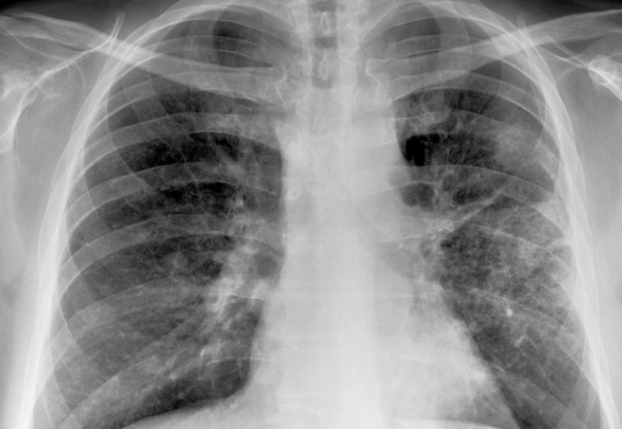
Figure 1: X-Ray Image
CT Scan
Medical professionals utilize computed tomography to examine the body's frameworks. Using X-rays and technology, a CT scan creates images of a body cross-section. The technology takes images that show minute "slices" of the joints, muscles, organs, and blood vessels for medical specialists to examine the body in depth.[10]. CT scans distribute the X-ray 360 degrees all over the person through a doughnut-shaped tube. The gathered information offers a thorough 3D representation of the body's interior. Figure 2. Shows the CT image. A CT scan has many uses, but it helps check on patients right away who might have severe injuries from car accidents or other trauma. A CT scan may show almost all body parts, and it can also be used to plan therapeutic, surgery, or chemo and find diseases and injuries.

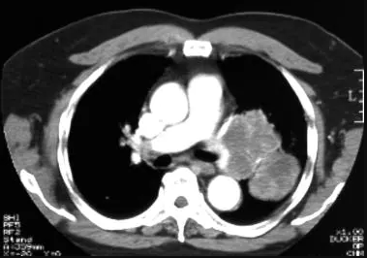
Figure 2: CT Image
MRI
The soft tissues of the body can be imaged using MRI scanners. MRI can distinguish between the brain's white and grey matter and detect arteries and malignancies. MRI doesn't use X-rays or any other radioactivity; it is the preferred imaging process when continual imaging is essential for treatment, especially in the brain. However, MRI costs high than CT scanning or X-ray imaging [11]. A unique type of MRI (fMRI) is the functional MRI of the brain. It produces visual depictions of the blood flow to specific brain areas. It investigates the brain's structure and identifies regions reliable for essential purposes [12]. It helps neurosurgeons locate the precise language and motor control areas in the brains of potential brain surgery patients. Functional MRI can evaluate the injury for disorders like Alzheimer's or head injuries.
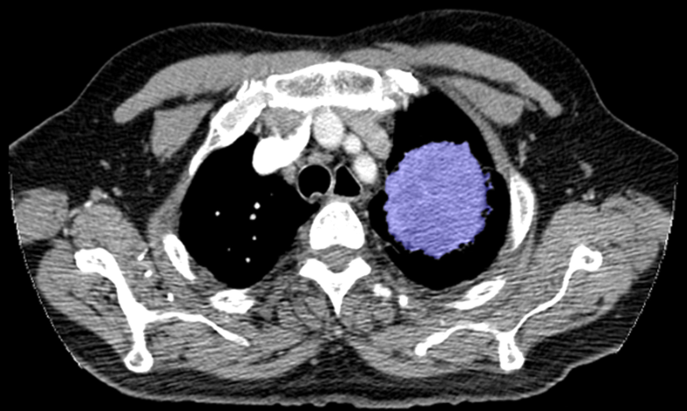
Figure 3: MRI Image
Nuclear Medicine
Nuclear medicine is a division of radiology that utilizes minute quantities of radioactive substances to study organ structure and function [13]. Nuclear medicine imaging includes many different areas of study. It had chemistry, biology, physics, arithmetic, and computer science. In radiology, abnormalities that manifest themselves very early in developing a disease, such as thyroid cancer, are widely observed and treated. Nuclear medicine is depicted in Figure 4. When a patient receives a radioactive tracer, nuclear medicine imaging technology produces images by detecting radiation from diverse physical regions. A physician gets the digitally produced images. Radioactive tracers are frequently shot through a vein in nuclear medicine. They might be administered orally for particular examinations. A patient typically receives very little radiation in a conventional nuclear medicine scan.

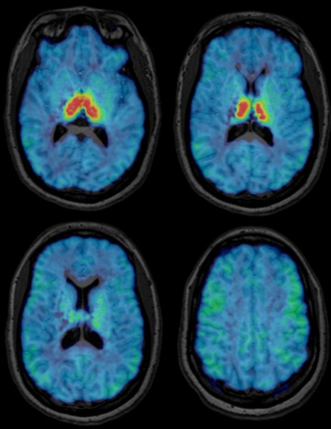
Figure 4: Nuclear Medicine
PET
Positron emission tomography is one of the nuclear medicine methods that keep track of the autolysis of the cells in various body tissues. Contrary to popular belief, PET integrates nuclear medicine with biochemical analysis [13]. PET may be used with CT or MRI for more conclusive information on malignant tumours and other lesions. The PET/CT scanner, a more recent innovation, syndicates PET and CT technologies. Figure 5. Shows PET image. PET assesses organ and tissue functions using minute amounts of radioactive materials known as radiotracers, a specialized camera, and a PC. PET exposes the early stage of the disease before conventional imaging tests by identifying modifications at the cellular level.
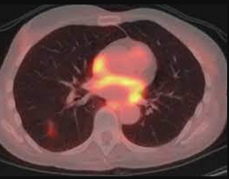
Figure 5: PET Image
III. Methodologies

This part briefly overviews several popular techniques recently discussed in medical image segmentation. We describe each method in detail and give an outline of its application. Although each strategy is discussed separately, specific segmentation problems are frequently solved by combining several techniques. Most image segmentation techniques we'll discuss may be formulated as optimization problems, where the goal is to minimize an energy or cost function specific to the application. Mining areas of interest from image data is known as medical image segmentation [14]. The primary reason for segmenting the data is to pinpoint the body regions necessary for a specific study. One of the main advantages of medical image segmentation is that highlighting only relevant regions enables a more detailed study of structural data.
With segmentation, undesirable scan elements like air may be eliminated, and tissues like bone and soft tissues can be distinguished. Scientists and doctors can create several segmented masks for subsequent research when combined with different software processing choices. When working with CT, MRI, and other types of scans, segmentation often creates a mask utilizing information from the background image. Depending on the assignment, developers can access their scans in 2D or 3D [15]. In several aspects of computer-aided diagnosis, medical image segmentation is crucial. Researchers are drawn to use novel medical image-processing algorithms because of the significant investment in and development of medical imaging modalities.

A. Image Segmentation
An image segmentation method divides a digital image into smaller chunks, reducing the nature of the image and making every segment easier to handle or analyze. Segmentation involves applying labels to individual pixels to distinguish the image's products, persons, or other significant features. Image segmentation is frequently used for object detection. When processing the entire image, it is common to practice performing an image segmentation approach to identify specific items in an image [16]. It is used in numerous situations that arise in the real world, such as face recognition and identification in security cameras, picture analysis for medical purposes, computer vision for self-driving automobiles, and satellite image analysis.
Image segmentation is viewed as an initial stage in several pattern recognition applications. Successful uses of neutrosophy in image segmentation have emerged in the medical field over the past ten years. We can separate a particular group of pixels from an image using image segmentation algorithms, give them labels, and then categorize additional pixels using these labels. We can define boundaries, draw lines, and separate particular objects from an image's other entities. The labels you produce from segmentation can be applied in machine learning for supervised and unsupervised training.

B. Working on Image Segmentation
Image segmentation creates an outcome from input images. A mask specifies each pixel's object class with numerous elements. Standard image segmentation algorithms include grouping methods like edges and histograms. Color is a sample of a common heuristic. To achieve a similar look for the image background, graphic designers use a green screen [17]. It allows for background identification and regeneration during post-processing. Based on sharply contrasting values, the program determines pixel boundaries. Traditional image segmentation techniques that apply these criteria can be rapid and straightforward. Still, they typically require much fine-tuning to account for specific use cases via manually made heuristics. They are not often precise enough to be used with detailed imagery. Figure 6. Shows the process of image segmentation.
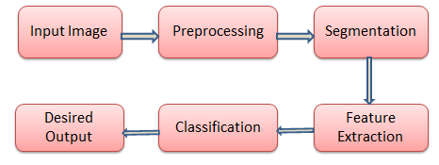
Figure 6: Workflow of Image Segmentation
More recent segmentation methods use deep and machine learning to improve flexibility and accuracy. Machine learning-based image segmentation techniques use model training to progress the program's ability to distinguish essential characteristics [18]. For image segmentation applications, deep neural network technology is highly successful. For image segmentation, several neural network implementations and designs are appropriate. They frequently share identical essential modules:
• An encoder is a collection of layers that extracts visual information using more in-depth, targeted filters.
• A decoder is a group of layers that progressively converts the output of the encoder into a segmentation mask following the pixel resolution of the input image, so if the encoder has previous knowledge of similar work, it may be able to use that expertise to perform segmentation jobs.
• The model can recognize characteristics at various scales with skip connections—multiple long-range neural network connections—enhancing model accuracy.

C. Types of Image Segmentation
- Semantic Segmentation
In semantic segmentation, pixels in an image are organized depending on semantic classes. The segmentation model does not reference background info or data; each pixel relates to a specific category [19]. The problem statement for this technique is usually ambiguous, especially when numerous instances are combined into a single class. Semantic segmentation does not offer specific information on intricate images.
- Instance Segmenatation
Pixels are categorized using instances of an object as part of instance segmentation. This method divides similar or overlying areas depending on the object boundaries rather than knowing which class the area corresponds to [20].
- Panoptic Segmentation
Instance and semantic segmentation are typically combined in a more contemporary type of panoptic segmentation. By anticipating the identity of each object, it differentiates between each instance of every object in the image. Panoptic segmentation is helpful for many goods needing information to function [21].

D. Image Segmentation Classification
- Edge-Based Segmentation
A standard technique for processing images that identifies the borders of several objects allows for identifying associated entities in an image by utilizing the data from the edges. Edge detection helps reduce images' size and makes analysis easier by removing extraneous data. The segmentation algorithms find edges based on differences in contrast, texture, colour, and saturation. Edge chains, composed of links, can be used by distinct boundaries to illustrate the edges of items in an image accurately. Figure 7. shows the output of edge-based segmentation.
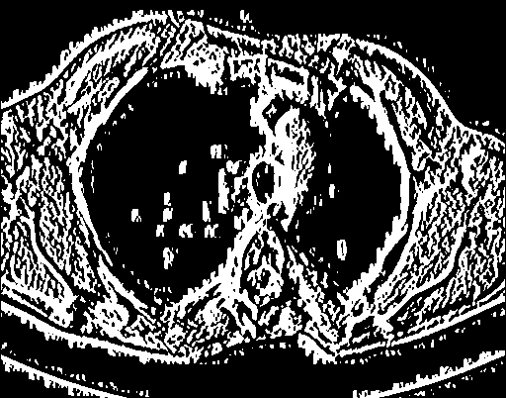
Figure 7: Edge-Based Segmentation
- Threshold-Based Segmentation
The most basic technique for segmenting images is thresholding, which divides pixels according to how dense they are relative to a specified value. It is appropriate to segment incidents that are more intense than backdrops or other objects. In low-noise photos, the threshold can function as a continuous. Dynamic thresholds may be used in certain situations. [22]. A binary image is created via thresholding, which splits a grayscale image into two categories depending on their relation to the threshold. Figure 8. shows the output of threshold-based segmentation.

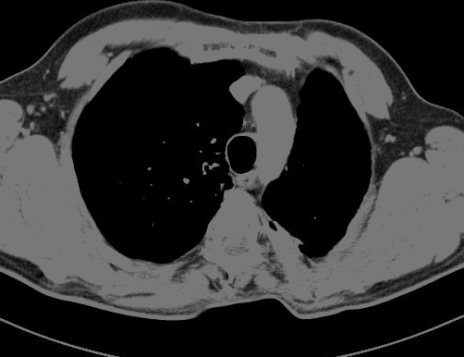
Figure 8: Threshold-Based Segmentation
- Region-Based Segmentation
Region-based segmentation divides an image into regions with related features. The algorithm locates each region using a seed point comprising a pixel group [23]. After finding the seed points, the approach can either increase areas by accumulating additional pixels or decrease them and merge them with other points. Three key ways are required for region-based image segmentation.

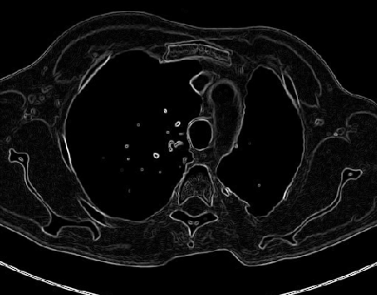
Figure 9: Region-Based Segmentation
- Region Growing
The foundation of region-growing methods is that adjacent pixels inside an area have similar values. One pixel is often evaluated by its neighbours. When a similarity criterion is satisfied, the pixel is connected to one or more of its neighbours in the cluster. Input for this method can alternatively be a collection of seeds. The seeds identify each of the segmentation objectives [24]. The zones are incrementally increased by comparing the neighbouring unallocated pixels. The disparity between a pixel's intensity value and the neighbourhood's mean is used as a similarity metric. This procedure is repeated until every pixel has been allocated to a group. The outcomes depend on the selection of seeds because the growing seeded region needs seeds as input data and noise in the image can make the seeds improperly positioned.
- Region split and merge approach
The divide and merge image segmentation technique relies on a quadtree information depiction, which splits an image into four quadrants with an appropriate examination of the uneven design image section. If the neighbouring images are split and described as uniform, they are brought together by a single image created from the four adjacent images. The following method is repeated until the additional region-level division is unnecessary [25]. We treat each pixel as a separate region in the region merging technique. We choose a region as the seed region to determine whether nearby regions are comparable based on predefined rules. If they are equivalent, we combine them into a single region and continue to create the segments of the entire image. Region merging and splitting are iterative procedures. Typically, an image is split into as many regions as possible in the first step of region splitting. Then the regions are combined to create a high-quality segmented version of the original image.
- Cluster-Based Segmentation
Algorithms for unsupervised classification are used to uncover secret knowledge in images. They enhance human perception by emphasizing clusters, shadings, and patterns. The process splits images into sets of pixels with the same qualities and splits data into chunks, comparable grouping items into sets [26]. In this segmentation type, we group adjacent pixels. The segmentation by clustering can be carried out using either the Clustering by Divisive or the Clustering by Merging methods. Figure 10. shows cluster-based segmentation.

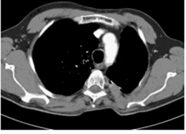
Figure 10: Cluster-based Segmentation
- Watershed Segmentation
Watershed segmentation methods use pixel illumination to define elevation and understand images. The regions between the watershed lines are marked by lines forming ridges and basins using this method. It separates images into various zones based on pixel height, grouping pixels with the same grey value [27]. Simple thresholding and contour detection will not yield accurate results when segmenting complex images. Hence the watershed method is used. Figure 11. shows watershed segmented image.

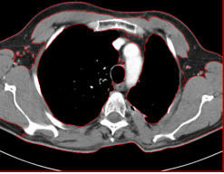
Figure 11: Watershed Segmentation
- Model-Based Algorithms
It has been determined that model-based approaches are most likely the best methods for image analysis in conjunction with a model. This model details the structure's future shape and existence [28]. This approach is more durable when it comes to image artifacts compared to traditional algorithms.
- Markov Random Field Models
The challenge of Markov Random Fields in Image Segmentation is reduced to labelling pixels in a general platform known as image labelling. The main objective is to show how to build an MRF segmentation model that can be used widely, to expand its multiscale and hierarchical implementations further, and to combine them into a multilayer model [29]. Finding the segmentation that fits the MRF model most closely requires minimizing the function.
- Atlas-Based Approach
The atlas-based segmentation may separate the image when there is no clear relationship between the brightness of different regions and individual pixels. It may result from the absence of a boundary, excessive noise, or the requirement to segment items with the same texture [30]. If the spatial relationship between these objects, other objects, or their morphometric data incorporates information about their differences, the atlas-based segmentation is anticipated to do a good job. They frequently gauge an object's form or detect morphological variations between patient populations.
The atlas-based segmentation is applied when the grey level intensities data is preliminary and objective evaluation is hard to provide. Since it depends on the user, it cannot be seen as an objective evaluation whenever physical or semi-manual segmentation is employed as the benchmark [31]. Segmentation qualities can be achieved with a suitable atlas and adequate plastic transformation. If we wish to segment an item within an image using atlas-based segmentation, we must first have an atlas and then specify the registration process.
- Artificial Neural Networks
It is a mathematical representation of neurons based on biological neural networks, like human brain cells. The node is a small neuron that may be equipped with particular functional components. Synaptic weight-based communication linkages link these nodes together [32]. The two essential characteristics of neural networks are training and learning. The initial stage of neural networks is referred to as the speculating phase. The more frequently the neural network is trained, the more relevant the results will be concerning the test image. The weights associated with the interconnecting neurons vary throughout learning to provide feedback. Neural networks classified as supervised and unsupervised learning are used in the learning process. Fuzzy neural networks produce better segmentation results that are noise-resistant. Figure 12. shows the output of an artificial neural network.
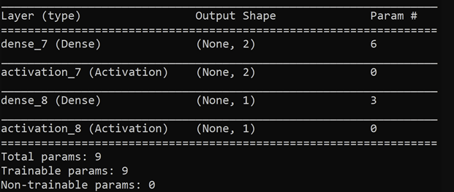
Figure 12: Segmentation using artificial neural network
- Graph Cut Approach
The core concept behind the graph cut method is to divide the image into the foreground and background using tools from graph theory. According to graph theory, every pixel represents a node, and the edges connect those nodes. To connect the source, connecting links use a node's likelihood of being in the foreground or background with a weight associated with that [33]. The weight encourages comparable pixels to remain in the same segment while encouraging differing pixels to form separate components.
A basic cut separates the foreground from the background with the least amount of work. The cost function represents the boundary and region attributes, regarded as a flexible grouping for segmentation with certain significant limitations. The global optimization is recalculated when the complicated rules are altered, considering the new restrictions when the cost function is specified. Edges are the weighted linking nodes, and cut pixels are the graph's nodes. They calculate the global optimal minimum cut to extract the object and background from the image.
- Lattice Boltzmann Method
The simulation method that relies on the microscopic clarification of the macroscopic physical process is the Lattice Boltzmann method, widely used in kinetic theory to model diverse systems. By using the characteristics of a cluster of particles that are assumed to perform correspondingly rather than the behaviour of a distinct particle, LBM attempts to bond the breach between the macroscopic and microscopic scales [34]. Each particle collection is represented by a distributive function, which is provided. The solution region is divided into lattices in LBM. The particle dispersal is located at each node of the lattice. Some of these particles go toward the neighbouring node in a specific direction.

IV. Evaluation Metrics

It can be challenging to evaluate segmentation because classification accuracy and localization correctness must be considered. The objective is to determine how closely the predicted and annotated segmentation differ. The Medical Image Segmentation literature from the past 30 years contains various evaluation measures. However, only a few scores have been proven reliable and applied consistently. This process examines and illustrates the behaviour of the following typical segmentation evaluation metrics:
- F-measure based metrics
- Sensitivity and Specificity
- Accuracy
- Receiver Operating Characteristic and the area under the ROC curve
- Cohen's Kappa
- Average Hausdorf Distance

F-measure based Metrics
Among the most common metrics for the assessment process in computer vision is the F-measure, commonly known as the F-score. It is based on precision and sensitivity by scoring how closely the predicted segmentation matches the actual segmentation. However, considering accuracy also penalizes false positives, a typical problem in datasets with extreme class imbalance. The Intersection-over-Union (IoU), also known as the Jaccard index, and the Dice similarity coefficient (DSC), also known as the F1 score, are widely used metrics based on the F-measure.
……………(1)

……………(2)

Sensitivity and Specificity
Specificity and sensitivity are entrenched in specific measures for attainment review, particularly in the medical field. The sensitivity for pixel classification emphasizes the ability to detect real positives. In contrast, specificity assesses the ability to identify genuine negative classes accurately. Although sensitivity is a legitimate and well-liked indicator, it is less sensitive than F-score-based metrics for precise technique assessment. If the specificity is not fully understood, it may lead to an incorrect segmentation metric. The specificity shows how well a model can identify a background class in an image. Specificity ranges near one are normal because a significant portion of the pixels is marked as background compared to the Region of Interest.
…………..(3)
………….(4)

Accuracy
Regarding evaluation criteria for statistics, accuracy is among the most widely recognized. It is described as the ratio of precise predictions to all other predictions, including precise positive and negative ones. But, due to the significant class imbalance in segmentation, using accuracy is severely discouraged. The accuracy metric will always produce an erroneous high score due to genuine negative inclusion. Accuracy results are frequently more significant than 90% or even near 100%, even while predicting the segmentation of a whole image as the background class. As a result, the deceptive accuracy metric is unsuitable for segmentation assessment, and its use in scientific evaluations is strongly prohibited.
……(5)

ROC and the area under the ROC curve
The ROC curve is a line diagram that shows how well a classifier performs at various discrimination thresholds and can be used to diagnose problems. The true positive rate (TPR) against the false positive rate measures effectiveness (FPR). In the medical field, a widely recognized benchmark statistic for contrasting different classifiers is the area under the ROC curve and assessing diagnostic tests and clinical trials. The AUC measure is now widely used for evaluating machine learning classifiers. AUC values of 0.5 can be viewed as a random classifier; it must be emphasized.
…….(6)

Cohen's Kappa
Cohen's Kappa, which varies from -1 to +1 and denotes a random classifier, quantifies the agreement brought on by probability in the same way as the AUC value. It has become prominent in the machine learning industry thanks to its ability to apply to datasets with imbalances. Recent research found that it still substantially corresponds to higher balanced datasets scores. Furthermore, it does not permit the evaluation of predictive performance or comparison across various sampled datasets.
……….(7)
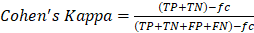………(8)

Average Hausdorf Distance
A metric based on spatial distance is called the Hausdorf distance (HD). It calculates the separation between two sets of points, such as the expected segmentation and the ground truth, and it allows rating localization similarity by emphasizing border delineation. Exact contour prediction is crucial, particularly in segmentation jobs that are more difficult and detailed. The symmetric Average Hausdorf Distance is used in most applications instead of HD since it is less susceptible to outliers. The extreme concerning the directed average Hausdorf distance d(I,J) and its converse direction d(J,I) defines the symmetric AHD, where I and J stand for the actual segmentation and the predicted segmentation, respectively, and ||i-j|| stands for a distance function similar to the Euclidean distance.
………..(9)
…………..(10)

Conclusion
The accuracy, precision, and computing speed of segmentation methods will be improved in future work in segmenting medical images and the number of manual interventions. Accuracy and precision can be increased using prior knowledge from atlases and integrating discrete and continuous-based segmentation approaches. Multiscale processing and parallelizable techniques like neural networks are potential strategies for improving computational efficiency. Applications for real-time processing will place a premium on computational efficiency. Image segmentation in therapeutic contexts is perhaps the most crucial issue surrounding it. Computerized segmentation techniques are currently being used more frequently for computer-assisted diagnosis and radiation planning after already proving useful in research applications. Automated segmentation techniques are unlikely to take doctors' positions, but they will play a significant role in medical picture analysis. Segmentation methods will be beneficial in fields like computer-integrated surgery, where viewing anatomy is crucial.

References
[1] S. K. Zhou et al., “A review of deep learning in medical imaging: imaging traits, technology trends, case studies with progress highlights, and future promises,” Proc. IEEE, vol. 109, no. 5, pp. 820–838, 2021, doi: 10.1109/JPROC.2021.3054390.
[2] R. Aggarwal et al., “Diagnostic accuracy of deep learning in medical imaging: a systematic review and meta-analysis,” npj Digit. Med., vol. 4, no. 1, 2021, doi: 10.1038/s41746-021-00438-z.
[3] M. H. Hesamian, W. Jia, X. He, and P. Kennedy, “Deep learning techniques for medical image segmentation: achievements and challenges,” J. Digit. Imaging, vol. 32, no. 4, pp. 582–596, 2019.
[4] N. Siddique, S. Paheding, C. P. Elkin, and V. Devabhaktuni, “U-net and its variants for medical image segmentation: A review of theory and applications,” Ieee Access, vol. 9, pp. 82031–82057, 2021.
[5] D. R. Sarvamangala and R. V Kulkarni, “Convolutional neural networks in medical image understanding: a survey,” Evol. Intell., vol. 15, no. 1, pp. 1–22, 2022.
[6] L. Alzubaidi et al., “Novel transfer learning approach for medical imaging with limited labeled data,” Cancers (Basel)., vol. 13, no. 7, p. 1590, 2021.
[7] E. H. Houssein, M. M. Emam, A. A. Ali, and P. N. Suganthan, “Deep and machine learning techniques for medical imaging-based breast cancer: A comprehensive review,” Expert Syst. Appl., vol. 167, p. 114161, 2021.
[8] E. Korot et al., “Code-free deep learning for multi-modality medical image classification,” Nat. Mach. Intell., vol. 3, no. 4, pp. 288–298, 2021.
[9] J. Malone, “X-rays for medical imaging: Radiation protection, governance and ethics over 125 years,” Phys. Medica, vol. 79, pp. 47–64, 2020.
[10] A. Oulefki, S. Agaian, T. Trongtirakul, and A. K. Laouar, “Automatic COVID-19 lung infected region segmentation and measurement using CT-scans images,” Pattern Recognit., vol. 114, p. 107747, 2021.
[11] S. Wang et al., “Review and prospect: artificial intelligence in advanced medical imaging,” Front. Radiol., vol. 1, p. 781868, 2021.
[12] W. Yin, L. Li, and F.-X. Wu, “Deep learning for brain disorder diagnosis based on fMRI images,” Neurocomputing, vol. 469, pp. 332–345, 2022.
[13] H. Hricak et al., “Medical imaging and nuclear medicine: a Lancet Oncology Commission,” Lancet Oncol., vol. 22, no. 4, pp. e136–e172, 2021.
[14] R. Aggarwal et al., “Diagnostic accuracy of deep learning in medical imaging: A systematic review and meta-analysis,” NPJ Digit. Med., vol. 4, no. 1, pp. 1–23, 2021.
[15] J. Pellico, P. J. Gawne, and R. T. M. de Rosales, “Radiolabelling of nanomaterials for medical imaging and therapy,” Chem. Soc. Rev., vol. 50, no. 5, pp. 3355–3423, 2021.
[16] T. A. Soomro et al., “Image Segmentation for MR Brain Tumor Detection Using Machine Learning: A Review,” IEEE Rev. Biomed. Eng., 2022.
[17] N. Kheradmandi and V. Mehranfar, “A critical review and comparative study on image segmentation-based techniques for pavement crack detection,” Constr. Build. Mater., vol. 321, p. 126162, 2022, doi: https://doi.org/10.1016/j.conbuildmat.2021.126162.
[18] A. Iqbal, M. Sharif, M. Yasmin, M. Raza, and S. Aftab, “Generative adversarial networks and its applications in the biomedical image segmentation: a comprehensive survey,” Int. J. Multimed. Inf. Retr., vol. 11, no. 3, pp. 333–368, 2022, doi: 10.1007/s13735-022-00240-x.
[19] Y. Mo, Y. Wu, X. Yang, F. Liu, and Y. Liao, “Review the state-of-the-art technologies of semantic segmentation based on deep learning,” Neurocomputing, vol. 493, pp. 626–646, 2022.
[20] A. M. Hafiz and G. M. Bhat, “A survey on instance segmentation: state of the art,” Int. J. Multimed. Inf. Retr., vol. 9, no. 3, pp. 171–189, 2020.
[21] B. Cheng et al., “Panoptic-deeplab: A simple, strong, and fast baseline for bottom-up panoptic segmentation,” in Proceedings of the IEEE/CVF conference on computer vision and pattern recognition, 2020, pp. 12475–12485.
[22] K. K. Gupta, P. Pahadiya, and S. Saxena, “Detection of cancer in breast thermograms using mathematical threshold based segmentation and morphology technique,” Int. J. Syst. Assur. Eng. Manag., vol. 13, no. 1, pp. 421–428, 2022.
[23] J. Fang, H. Liu, J. Liu, H. Zhou, L. Zhang, and H. Liu, “Fuzzy region-based active contour driven by global and local fitting energy for image segmentation,” Appl. Soft Comput., vol. 100, p. 106982, 2021.
[24] S. H. Abdulla, A. M. Sagheer, and H. Veisi, “Breast cancer segmentation using K-means clustering and optimized region-growing technique,” Bull. Electr. Eng. Informatics, vol. 11, no. 1, pp. 158–167, 2022.
[25] T. Zhang, G. Lin, W. Liu, J. Cai, and A. Kot, “Splitting vs. merging: Mining object regions with discrepancy and intersection loss for weakly supervised semantic segmentation,” in European Conference on Computer Vision, 2020, pp. 663–679.
[26] P. M. S. Raja, “Brain tumor classification using a hybrid deep autoencoder with Bayesian fuzzy clustering-based segmentation approach,” Biocybern. Biomed. Eng., vol. 40, no. 1, pp. 440–453, 2020.
[27] S. Lou, L. Pagani, W. Zeng, X. Jiang, and P. J. Scott, “Watershed segmentation of topographical features on freeform surfaces and its application to additively manufactured surfaces,” Precis. Eng., vol. 63, pp. 177–186, 2020.
[28] A. Darwish, D. Ezzat, and A. E. Hassanien, “An optimized model based on convolutional neural networks and orthogonal learning particle swarm optimization algorithm for plant diseases diagnosis,” Swarm Evol. Comput., vol. 52, p. 100616, 2020.
[29] Y. Li et al., “A comprehensive review of Markov random field and conditional random field approaches in pathology image analysis,” Arch. Comput. Methods Eng., vol. 29, no. 1, pp. 609–639, 2022.
[30] P. Eskandari and S. B. Shokouhi, “Automated Atlas-Based Segmentation of Breast Region in 3-D Magnetic Resonance Imaging (MRI) Using FCM Method,” Int. J. Electr. Comput. Sci., vol. 3, no. 1, pp. 28–34, 2021.
[31] M. L. H. Milo, T. B. Nyeng, E. L. Lorenzen, L. Hoffmann, D. S. Møller, and B. V Offersen, “Atlas-based auto-segmentation for delineating the heart and cardiac substructures in breast cancer radiation therapy,” Acta Oncol. (Madr)., vol. 61, no. 2, pp. 247–254, 2022.
[32] R. Wang, S. Chen, C. Ji, J. Fan, and Y. Li, “Boundary-aware context neural network for medical image segmentation,” Med. Image Anal., vol. 78, p. 102395, 2022.
[33] M. A. Devi, J. I. Sheeba, and K. S. Joseph, “Neutrosophic graph cut-based segmentation scheme for efficient cervical cancer detection,” J. King Saud Univ. Inf. Sci., vol. 34, no. 1, pp. 1352–1360, 2022.
[34] K. J. Petersen and J. R. Brinkerhoff, “On the lattice Boltzmann method and its application to turbulent, multiphase flows of various fluids including cryogens: A review,” Phys. Fluids, vol. 33, no. 4, p. 41302, 2021.

