Guardians of Biodiversity: Unveiling the Plant Diversity and Structural Dynamics of Maruthi Mala Hills, Kollam District, Kerala
Dr Sofia S*
* Assistant Professor, Dept. of Botany, Fatima Mata National College (Autonomous), Kollam, Kerala.

ABSTRACT
Ecology embodies the intricate connections forged between organisms and their physical surroundings, accompanied by the intricate flow of matter and energy within biological systems. The intricate interplay among organisms, their environment, and each other constitutes the core focus of ecological study. Within a specific habitat, a blend of species coexisting due to their shared ability to thrive in the same conditions gives rise to a community. Phytosociological investigations stand as a vital necessity for safeguarding biodiversity and the integrity of natural plant communities. These investigations serve as indispensable components for comprehending historical transformations and forecasting future developments. The environmental security of a nation finds its footing in the well-being of its forested regions, given that forest ecosystems harbor significant proportions of the world's biodiversity. Phytosociological research remains pivotal not only for the preservation of natural plant communities and biodiversity but also for tracing the historical trajectory of change and predicting future trends. Advanced nations often possess these foundational studies, which are articulated through the aid of vegetation maps. However, many of these forests confront substantial human-induced disruptions, necessitating meticulous management interventions to ensure the overarching harmony of biodiversity and sustainability. In the current exploration, in-depth studies were conducted on phytosociology and species diversity within Kerala's Kollam district. The primary objective of this phytosociological analysis is to unravel the intricate fabric of floristic vegetation, estimating the richness and diversity of species thriving within the study area.
Key Words: Phyto sociology, Biodiversity, Species, Density, Frequency

Introduction
Ecology encompasses the intricate connections existing between organisms and their surrounding physical environment, as well as the intricate movement of matter and energy within biological systems. The intricate interplay among organisms, their environment, and each other constitutes the core focus of ecological study. Within a specific habitat, a collection of species coexisting due to their shared ability to thrive in the same conditions gives rise to a community. While the significance of species within such a community varies, certain invasive species stand out due to their size and rapid growth, leading them to reshape the habitat and exert authority over the growth of other species within the community. Ecology primarily focuses on how abiotic and biotic factors exert directional effects on the growth, distribution, behavior, and survival of organisms (Stone and Frayer, 2018). The relationships within ecosystems are intricate and multifaceted. Organisms interact with each other through various mechanisms, including predation, competition, symbiosis (mutually beneficial interactions), and mutualism (interactions where both organisms benefit).
Conducting phytosociological investigations becomes imperative for the preservation of biodiversity and native plant communities (Rahees et al., 2019). These studies constitute crucial elements in comprehending historical and future transformations (Hamzaoglu, 2006; Rao et al., 2020). In an ecosystem, every living organism relies on and engages with both the non-living (abiotic) and living (biotic) elements of its surroundings. The abiotic constituents encompass fundamental inorganic elements and substances like water, carbon dioxide, calcium, oxygen, carbonates, phosphates, and a variety of organic compounds generated from the actions or demise of organisms. On the other hand, the biotic factors encompass plants, animals, and microorganisms, all of which interact in a manner fundamentally hinged on energy exchange.

Phytosociological investigations play a crucial role in safeguarding biodiversity and the integrity of natural plant communities (Rahees et al., 2019). These investigations serve as indispensable components for comprehending historical and future transformations (Hamzaoglu, 2006; Rao et al., 2020). The well-being of a nation's forested areas is intricately linked to its environmental security (Curtis and McIntosh, 2020), as forest ecosystems encompass diverse portions of the Earth's biodiversity (Batles et al., 2001). The preservation of biodiversity is intrinsically tied to the pursuit of sustainable forest management (Gamble, 1936). Research underscores that the long-term viability of forest ecosystems hinges significantly on plant diversity and its associated sociological characteristics. Given the widespread human impact on forests worldwide, proactive management interventions are imperative to uphold overall biodiversity and sustainability (Kumar et al., 2019).

Given that plants serve as sources of sustenance and habitats for various organisms (Das et al., 2020), the overall richness of forest diversity hinges on the diversity of its plant life. The vigor of a forest is inherently tied to its assortment of plant species, making information pertaining to its composition, diversity, and ecological characteristics vital for effective conservation planning and execution. The influence of tree species extends to regulating the growth of other vascular plants by controlling sunlight availability on the forest floor. Analyzing and estimating tree diversity, which reveals interplays of habitat, vegetation, physiology, species makeup, and community dynamics, constitutes valuable datasets for guiding forest management strategies (Battles et al., 2018). Documenting and employing baseline data about changes in communities and ecosystems are pivotal for predicting the outcomes of disturbances, including restoration and harvesting methods, on the diversity and richness of flora (Sarkar, 2021).
In contrast to the ongoing accumulation of biodiversity, the concealed sectors of the range have witnessed a gradual decline in biodiversity due to human activities (Krishnamoothy et al., 2019). Investigating the attributes, taxonomy, relationships, and distribution of plant communities, along with outlining the population dynamics of each species and their interrelations within the community, proves beneficial. Biogeographical studies that delve into both historical and prospective changes in natural plant communities are indispensable for comprehending biodiversity conservation. Developed countries often possess these foundational studies (Hamzaoglu, 2018) and employ tree maps for delineation (Tel et al., 2020). However, many of these forests are significantly impacted by human actions and require meticulous management interventions to uphold overall biodiversity and sustainability (Kumar et al., 2020).
The current study focuses on phytosociological analysis and species diversity within Kerala's Kollam district. The primary goal of this analysis is to grasp the floristic and vegetative characteristics and to quantify the richness and diversity of species within the study area. Maruthi mala plants assume an ecological role that includes safeguarding water bodies, preserving wildlife habitats, and naturally purifying polluted systems through decomposition, contributing to environmental stability and purification (Chandran et al., 2020). They serve as breeding sites for various bird and mammal species. Despite the dense clustering of trees, they play a significant part in carbon cycling, diminishing atmospheric CO2 levels. The presence of reservoirs elevates humidity, inducing cooling effects. Some ecosystems, through water retention in bodies like ponds or rivers, even aid in mitigating forest fire risks. Maruthi Mala Hills have been found to enhance soil physicochemical properties through litter accumulation (Santana et al., 2021).

The comprehension of ecological richness and preservation necessities of any region necessitates a grasp of plant diversity and the changing structural dynamics. Within this context, the current investigation delves into the captivating expanse of Maruthi Mala Hills, situated in Kollam District, Kerala. These hills are renowned for their exceptional ecosystem, encompassing a wide array of plant species and intricate structural variations that play a vital role in upholding the local biodiversity.
Nestled in the picturesque Kollam District of Kerala, the Maruthi Mala Hills have long been acknowledged as an ecological hotspot due to their assortment of plant species and the ever-shifting configurations of their structural makeup. The region's ecological significance emanates from its diverse altitudinal gradients, varying soil compositions, and distinct microclimates, providing an ideal habitat for numerous plant species to flourish.
The comprehension of Maruthi Mala Hills' plant diversity and structural dynamics is of paramount importance for multiple reasons. Firstly, it contributes to our understanding of Kerala's distinctive biodiversity, augmenting our grasp of the intricate ecological nuances present in this Western Ghats locale. Secondly, gaining insights into the structural dynamics of plant communities allows for the evaluation of ecosystem health and stability, and the identification of potential susceptibilities to environmental fluctuations.
This study aims to comprehensively document the spectrum of plant diversity in Maruthi Mala Hills and delve into the patterns of its vegetation's structure. Through rigorous field surveys and advanced analytical methodologies, we aspire to pinpoint predominant plant species, quantify their prevalence, and scrutinize the factors influencing their distribution and coexistence.
The outcomes of this investigation are anticipated to significantly contribute to the domains of ecology, biodiversity conservation, and environmental management. Additionally, the amassed information will facilitate the formulation of efficacious conservation strategies and sustainable land utilization practices for Maruthi Mala Hills, thereby safeguarding its distinctive plant diversity and conserving the delicate equilibrium of its structural dynamics.
This study aspires to illuminate the significance of safeguarding natural habitats like Maruthi Mala Hills, not solely for the advantage of the local ecosystem and flora, but also for the general well-being of the community and the planet at large. By recognizing and conserving the intricate interplay between plant diversity and structural dynamics, we move a step closer to promoting a harmonious coexistence between nature and humanity.
An ecological community is a group of different species living and interacting in the same habitat. These species often share ecological tolerances and coexist within the same environment. Communities can vary greatly in terms of species diversity and interactions. Invasive species are non-native organisms that are introduced to a new ecosystem. They can have detrimental effects on native species and the ecosystem as a whole. Invasive species often lack natural predators or controls in their new environment, allowing them to grow and spread rapidly.
Some invasive species can significantly alter the habitat they invade. They might outcompete native species for resources, disrupt natural food chains, and even modify physical aspects of the environment, such as soil composition or water quality. This can lead to a decline in native species and ecosystem imbalances.
While invasive species can have negative impacts, there are also species known as keystone species that play a crucial role in maintaining ecosystem structure and function.
Keystone species have a disproportionate impact on their environment relative to their abundance. Removing a keystone species can lead to cascading effects throughout the ecosystem. Understanding the complexities of ecological relationships is essential for effective conservation and ecosystem management. By studying these relationships, scientists can develop strategies to protect native species, control invasive species, and restore ecosystems that have been disrupted.
Overall, ecology provides insights into how the natural world functions and how the interactions between organisms and their environment shape ecosystems. It's a multidisciplinary field that combines biology, chemistry, physics, and other sciences to understand the intricate web of life on Earth.
Maruthi Mala Hills (Muttara Hills)
Maruthi Mala Hills, also known as Muttara Hills, can be found nestled in the village of Muttara. This quaint village is situated within the Kottarakkara block of the Kollam district in Kerala, India. Positioned 24 km to the east of the district's central hub, Kollam, and merely 3 km away from Kottarakkara, it stands at a distance of 65 km from the state capital, Thiruvananthapuram. The expansive territory of Maruthi Mala hill covers an area exceeding 37 acres, adorned with an assortment of trees and a vibrant avian population. Notably, Maruthi Mala Hills stands out as an eco-tourism destination within the Kollam district of Kerala, boasting a richly varied ecosystem.

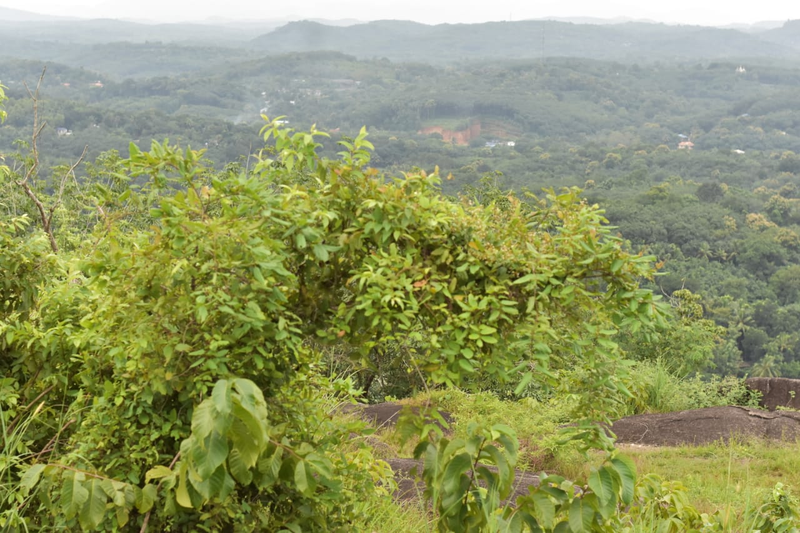
Figure 1.1: Study Site – Maruthi Mala Hills
The dominant plant species found here are Phyllanthus emblica, L., Eupatorium odoratum, L., Mimosa pudica, L., Premna odorata, Frac., Leucas aspera, L. There is no doubt that these will influence their performance in productive ecosystems. Heavy metal-mediated pollution affects the development and biochemical activities of soil microorganisms that can directly or indirectly affect other plants and animals in the ecosystem.
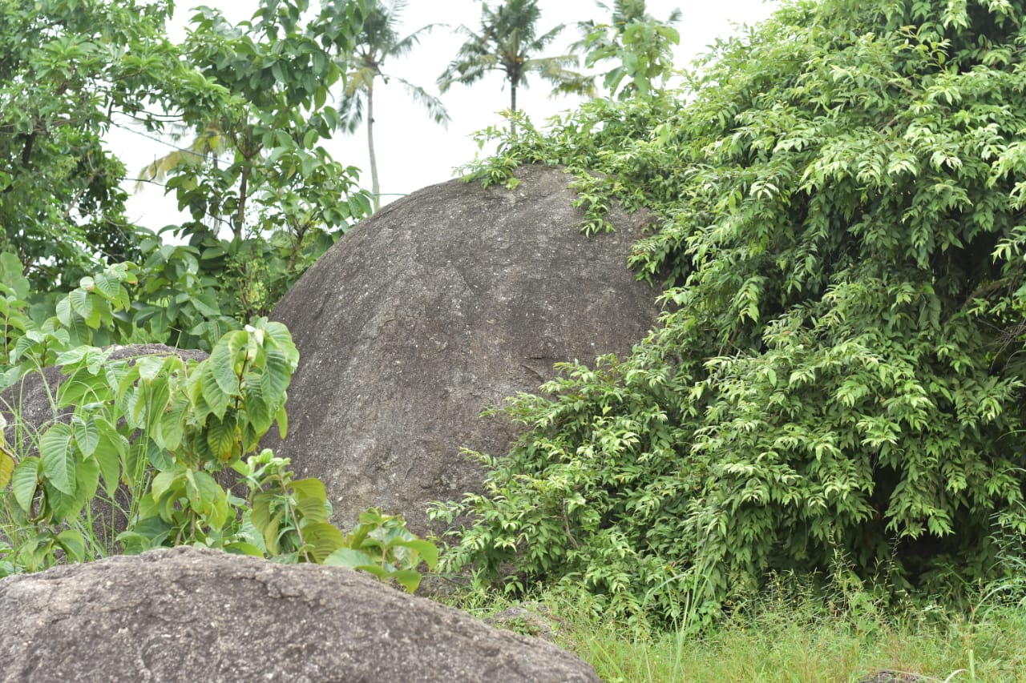
Figure 1.2: Study Site – Maruthi Mala Hills
This research encompasses an examination of the flora and plant community structure of Maruthi Mala Hills in Kollam District, Kerala. The floral analysis entails an assessment of the overall composition of vegetation within the designated area. Additionally, the phytosociological analysis involves the utilization of established phytosociological methodologies and Diversity Indices to delve into the plant community's structure and diversity.

1.1. Objectives
1. To analyse the present status of vegetation in Maruthi Mala Hills
2. To develop Phytosociological inventory of the flora

Review of Literature
Plants manifest assemblages of taxonomically diverse entities, encompassing multiple unrelated angiosperm families and exhibiting various adaptations (Hogarth, 2019; Abeysinghe et al., 2020). Among ecosystems, forests emerge as the world's most productive and biologically significant, offering structural shelter to both plants and animals (Alongi, 2021).
Comprehensive inventories and assessments of diversity prove indispensable for comprehending the current state of diversity and promoting biodiversity conservation. Globally, inventory and diversity studies are undertaken at various scales to bridge gaps in our understanding of biodiversity.
In a study by Jonathan et al. (2019), the diversity of economically significant plants along the central Kerala coast was examined. They identified the highest frequency and density for Ocimum tenuiflorum, L. and the highest abundance for Capsicum annum, L. The findings indicated the suitability of native plants for cultivation, plantation, and horticultural production in coastal areas.
Ramya et al. (2020) conducted a phyto-societal examination within the tropical moist deciduous forest of Manar Beit, identifying nineteen tree species belonging to 13 families. Notably, Pongamia pinnata, L., and Terminalia arjuna, L., exhibited the highest quality index, signifying their dominance. Various community indices—such as Shannon diversity, Simpson index, Margaleff index, Menhinick's index, and evenness of community tree species—reflected the biodiversity status of tree species. Notably, Dalbergia latifolia, L., and Santalum album, L., were categorized as endangered species, as determined from ecological surveys of sample plots.
Uddin et al. (2020) conducted a phytosociological investigation of plant diversity within a natural and protected subtropical forest in Manipura. Their study documented a total of 79 tree and shrub species across 35 families. Various quantitative attributes—such as frequency, density, basal area, important value index (IVI), and distribution pattern—were evaluated. Among the findings, Schima wallichii and Lantana camara stood out as dominant tree and shrub species within the natural forest.
Anwar et al. (2020) undertook a phytosociological examination of the Peruvian mountain rain forest. They utilized the Sorensen index to create a cluster for assessing bioclimatic conditions' similarity and parallelism, leading to the identification of distinct communities and phytosociological units within Peru. They detailed seven associations, grouped under the novel class "Saurauio peruvianae-Condaminetalia corymbosae" within the new class "Morello pubescentis, Myrsinetea coriaceae," and also described two associations featuring "Pruno rigidae-Oreopanacetea floribundae."
Usharani et al. (2018) conducted a phytosociological exploration of weed communities in organic and traditional vegetable growing systems within the Alagoas state of Brazil. Quantitative characteristics such as frequency, density, abundance, relative frequency, relative density, similarity index (SI), and importance value index (IVI) were evaluated for each species. They identified and categorized 299 weed species across 11 botanical families, including Amaranthaceae, Asteraceae, Commelinaceae, Cyperaceae, Euphorbiaceae, Malvaceae, Molluginaceae, Phyllantaceae, Poaceae, Rubiaceae, and Solanaceae.
Kunwar et al. (2020) conducted a phytosociological inquiry in the Darchula and Baitadi districts of Nepal's Kailash Sacred Landscape. Their research aimed to understand how plant resource utilization aligns with plant and habitat availability, accessibility, and crop diversity. The study employed phytosociological indicators to assess plant availability and plant use values for assessing accessibility. They discovered that ecological indicators like Shannon diversity and species richness, along with cultural indicators such as preference for specific products and recognition, influenced the use value of plants across various categories, such as medicinal and non-medicinal.
Kunev et al. (2020) examined the vegetation of Wadi al-Kuf nursery reserve areas in Palestine's Hebron region. They documented 82 species, including 16 endemics, distributed across 90 plant occurrences. The study employed the Braun-Blanquet method analysis and phytosociological investigations, utilizing Salvador Rivas Martinez's land classification to analyze bioclimatic and physical climate factors. Their statistical treatment produced two main cluster groups: Group (A), comprising climate-influenced forests, copses, and high scrublands, and Group (B), including climate-influenced pine copses.
Manzoor and Jazeeb (2021) undertook a vegetation analysis across four Village Common Forests (VCF) within Khagrachori district, Chittagong Hill Tracts, Bangladesh. They employed a quadratic method (10x10 m) over three sites on the hill's base, middle, and top. The study identified 124 species across 44 families, with Oroxylum indicum standing out as the dominant species according to the Significance Index (IVI). Indices like Shannon-Wiener Diversity Index (H′), Simpson Index (Ds), and Uniformity Index (EI) were also recorded. The VKF in Khagrachor district accommodated eight Least Concerned (LC) and three Threatened (T) species of the country, with Euphorbiaceae being the most dominant family, followed by Moraceae and Rubiaceae.
Timub et al. (2020) presented a phytosociological examination of wheat crop weeds in Tehsil Raja, Swabi District, Pakistan. Employing 200 quadrats (1x1 m) in 20 randomly selected wheat fields, they evaluated quantitative attributes like density, frequency, and cover for each weed species. The study recognized 20 weed communities based on the prominence of the three leading species, and Sorensen's index gauged the similarity between these weed communities.
Patel (2021) conducted a phytosociological analysis of weeds in agricultural crop fields in Sami Taluka, Patan District, Gujarat, India. The study employed density, frequency, and abundance to assess plant species distribution. They identified 47 weed plant species from 45 genera and 21 families. The ecological parameters of abundance, density, and frequency were used to determine species distribution. Dicotyledonous species accounted for 40 species, while Monocotyledonous species totaled 7, with Asteraceae leading in family representation with 8 species.
Patel (2020) conducted a phytosociological study on tree species within Gujarat's Sebhargog region, Vadgam Taluka, Banaskantha District, India. They reported 34 tree species, with Acacia nilitica, Butea monosperma, and Acacia chundra being the most dominant. Delonix regia, Morinda tomentosa, and Moringa oleifera were the least represented. Ecological parameters like Relative Frequency (RF), Relative Density (RD), Abundance (A), Importance Value Index (IVI), and Girth at breast height (GBH) were employed to determine species distribution.
Huma et al. (2019) conducted a phytosociological classification of Peruvian vegetation, identifying 218 associations within 34 phytosociological classes, including four previously undescribed classes. The study employed phytosociological plots alongside an abundance dominance index for assessment.

Materials and Methods
Ecosystems of Kerala have indigenous characteristics compared to the ecosystem of other regions. An attempt has been made in the present study to unlock the ecological imbalance of ecosystem in Maruthi Mala Hills, Kollam District through scrutinising structural dynamics and diversity, which will help to provide guidance for conservation and scientific management of the locations.
3.1. Ecological Studies
3.1.1 Study Area
The study site Maruthi Mala Hills in Kollam District, Kerala, the southwest cost of India. Sampling location is shown in Fig. 3.1.1. Maruthi Mala Hills is situated between 8⁰57’18” N and 76⁰45’30” E.
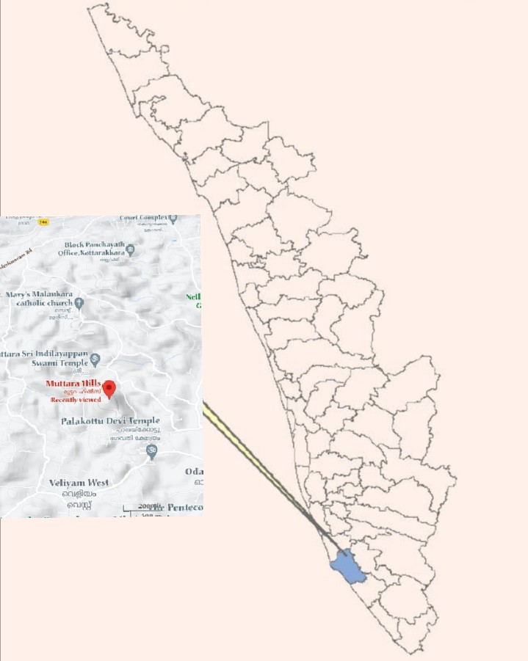
Figure. 3.1.1: Selected Study Site

    - Phytosociology of Plants
The distribution patterns of plants in Maruthi Mala Hills studied using species area estimation and quadrat analysis. The main purpose of the phytosociological analysis is to understand the floristic vegetation, to estimate the species richness and diversity, existing in the studied site. Phytosociological studies were carried out using quadrat method. The value of percentage frequency, frequency class, density, abundance, relative frequency, relative density, Importance Value Index (IVI) and Various Diversity Indices were calculated by using formula given by Misra and Puri (1973).
- Density.
Density =Total number of individuals of a species in all quadrats
Total number of quadrats studied
- Frequency (%).
Frequency (%) = Number of quadrats in which the species occurred
Total number of quadrats studied X 100
- Abundance.
Abundance = Total number of individuals of a species in all quadrats
Total number of quadrats in which the species occurred
- Importance Value Index
IVI = Relative frequency + Relative abundance + Relative density

- Relative density.
Relative density = Number of individual of the species
Number of individual of all the species X 100
- Relative frequency.
Relative frequency = Number of occurrence of the species
Number of occurrence of all the species X 100
- Relative abundance.
Relative abundance = = Total no.of species
Total no.of individual of all species recorded x100
Species richness, diversity and dominance indices
Species richness, diversity and dominance were analysed by using the methods of Margalef's index of richness, Shannon's diversity index, Simpson's index of dominance and Pielou’s Evenness Index.

- Margalef’s index of richness
‘Margalef’s index of richness’ (Dmg)
Dmg = (S-1)/ In N
Where,
S = Total number of species.
N = Total number of individuals.
- Shannon–Weaver index of diversity
H’ = – Σ pi In pi
Where, H’ = Shannon index of diversity
pi = the proportion of important value of the ith species ( pi =ni / N, ni is the important value index of ith species and N is the important value index of all the species).
- Simpson index of Dominance
D = Σ ( pi)2
Where, D = Simpson index of dominance
pi = the proportion of important value of the ith species ( pi = ni / N, ni is the important value index of ith species and N is the important value index of all the species).
- Pielou’s Evenness Index

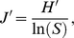
Where, J’ = Pielou’s evenness Index
H′ represents the observed value of Shannon index
S is the total number of species observed.
Observation and Results
Plant diversity inventories in ecosystems have mostly been focused on trees, shrubs and herbs because these species diversity is an important aspect of forest ecosystem diversity. Long-term ecological research sites have become fundamental tools in the study of community and ecosystem dynamics in ecosystems worldwide. Phytosociological analysis of natural vegetation is recognized as an efficient and appropriate method to select out useful plant species from natural communities.
4.1. Plant Vegetation
The Plant vegetation of the studied site was analysed to assess the composition and distribution pattern of species. The common plant species observed in Maruthi Mala Hills was Phyllanthus emblica, L., Mimosa pudica, L., Premna odorata, Franc., Eupatorium odoratum, L.
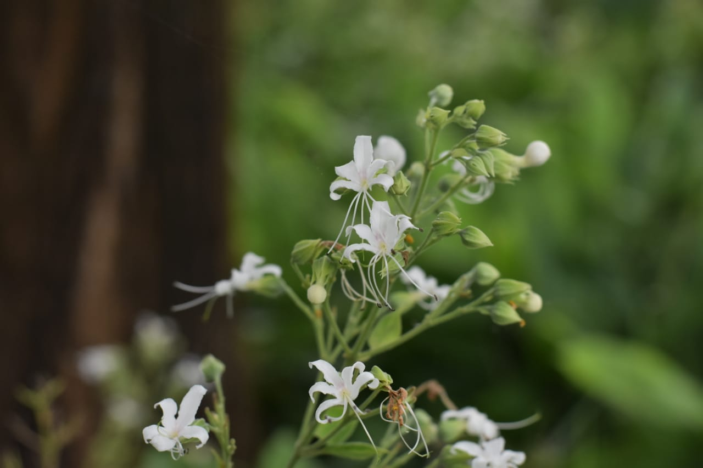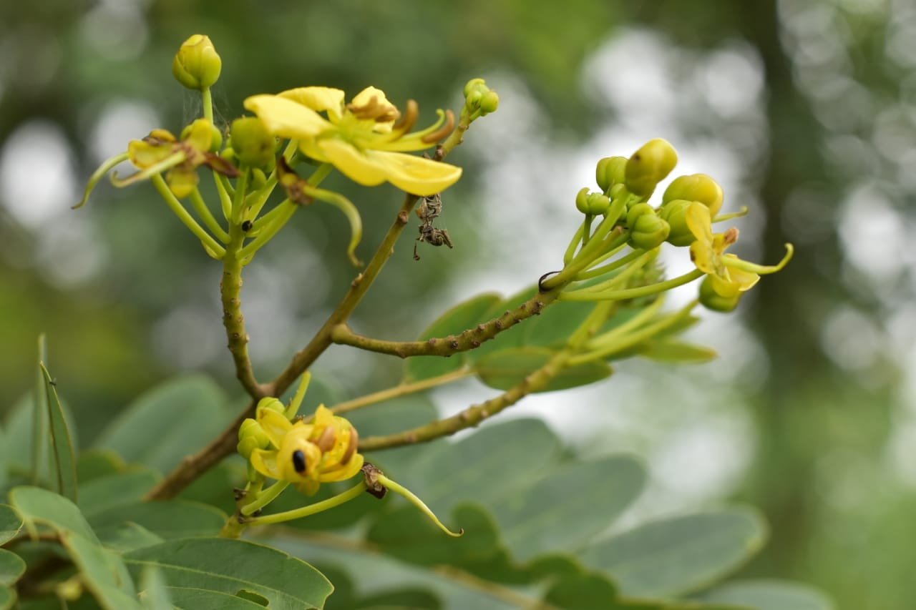
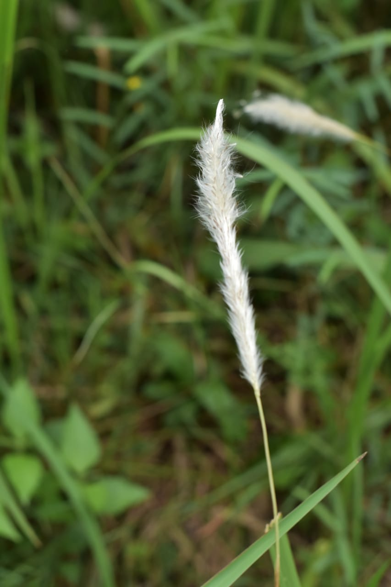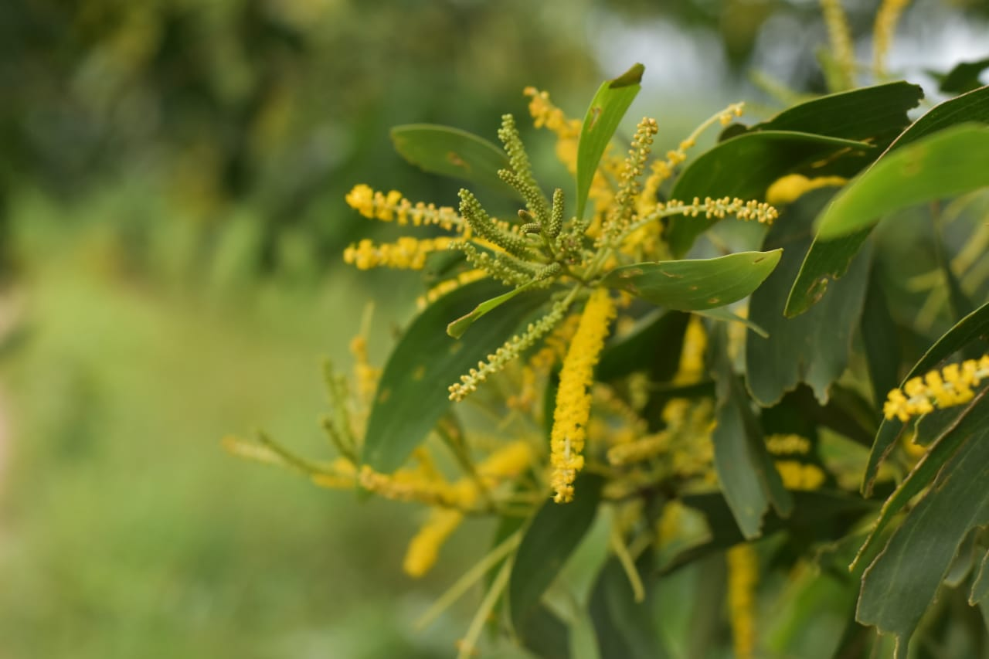
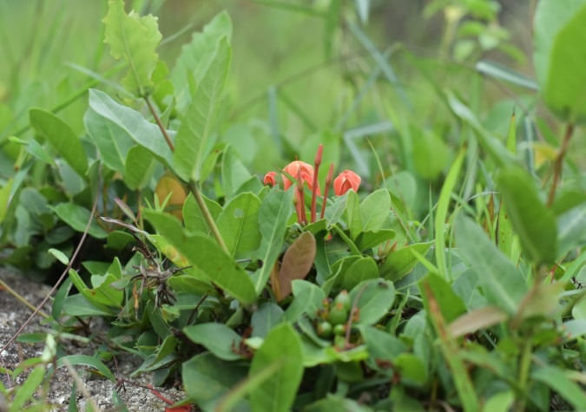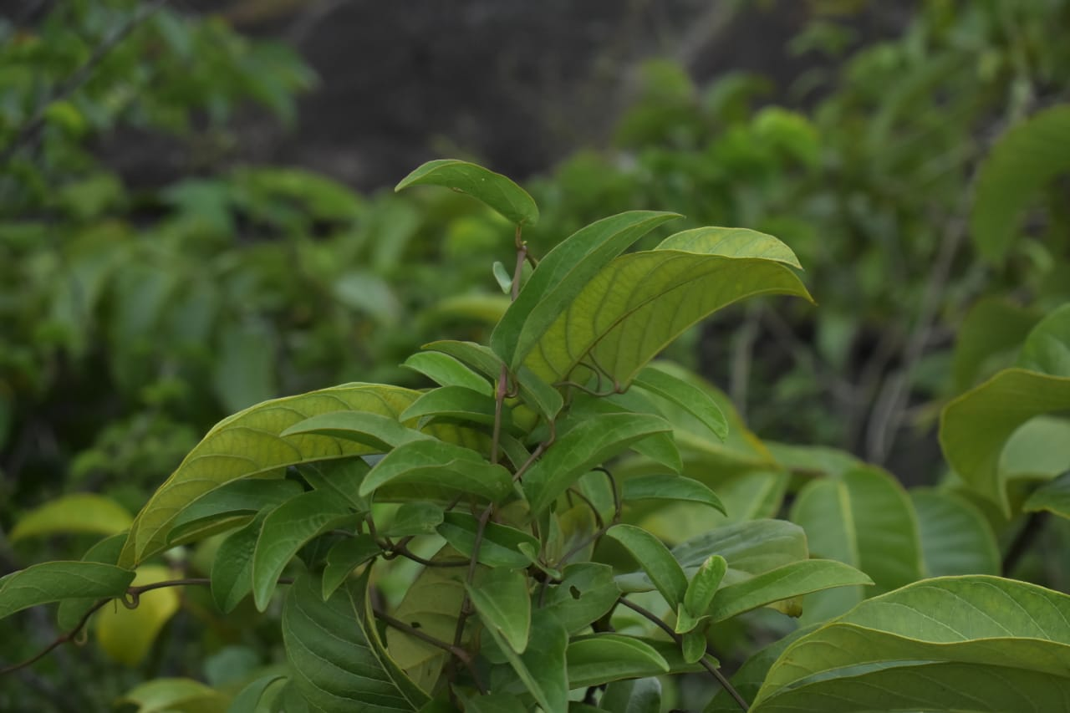
Plate 4.1. Selected plant species of Maruthi Mala Hills
  - Floral Composition
The plant species were found in association with ferns, grasses and herbaceous weeds of different angiosperm families in the studied site. 46 species were found in Maruthi Mala Hills. These 46 species are distributed over 45 genera and 21 families. The observations are depicted in table 4.2.1 with their morphological appearance.
Table 4.2.1: Plants with their Families and Habit
Sl No. | Botanical Name | Family | Habit
1 | Sesbania spp. (Scop. ) | Fabaceae | Tree
2 | Melastoma malabathricum (Linn) | Melastomataceae | Shrub
3 | Crotalaria retusa(Linn) | Fabaceae | Shrubby herb
4 | Bambusa bambos (Voss ,Linn) | Poaceae | Culms
5 | Alfalfa(Linn) | Fabaceae | Herb
6 | Leucas aspera (Willd) | Lamiaceae | Herb
7 | Calycopteris floribunda (Roxb., Lam.,Poir.) | Combretaceae | Climbing shrub
8 | Wrightia religiosa(Teijsm, Binn., Hook. f.) | Apocynaceae | Shrub
9 | Tephrosia purpurea(Pers.) | Fabaceae | Shrub
10 | Ziziphus jujuba(Mill. ) | Rhamnaceae | Shrub
11 | Adiantum aureum(Linn) | Pteridaceae | Fern
12 | Desmodium paniculatum (Linn,DC.) | Fabaceae | Climber
13 | Eulobus californicus(Nutt.,Torr.,A.Gray) | Ongraceae | Herb
14 | Phyllanthus emblica(Linn) | Phyllanthaceae | Tree
15 | Eupatorium odoratum(Linn,R.M. king,H.Rob) | Asteraceae | Shrub
16 | Mimosa pudica(Linn) | Fabaceae | Herb
17 | Cassia fistula(Linn) | Fabaceae | Tree
18 | Morinda tinctoria(Roxb.) | Rubiaceae | Tree
19 | Ixora coccinea(Linn) | Rubiaceae | Shrub
20 | Diospyros ebenum (J.Koenig) | Ebenaceae | Tree
21 | Terminalia catappa(Linn) | Combretaceae | Tree
22 | Ficus religious(Linn) | Moraceae | Tree
23 | Canthium spinosum (OK) | Rubiaceae | Shrub
24 | Acacia auriculiformis(A.Cunn. ex Benth) | Fabaceae | Tree
25 | Adananthera pavonina(Linn) | Fabaceae | Tree
26 | Millettina pinnata(Panigrahi) | Fabaceae | Tree
27 | Hemidesmus indicum(R.Br.) | Apocynaceae | Shrub
28 | Senna occidentalis(Link.) | Fabaceae | herb
29 | Naregamia alata(Wight&Arm) | Meliaceae | Shrub
30 | Sonneratia alba(Sm.) | Lythraceae | Tree
31 | Ichnocarpus frutescens (W. T.Aiton) | Apocynaceae | Shrub
32 | Premna odorata(Blanco) | Lamiaceae | Shrub
33 | Ficus bengalensis(Linn) | Moraceae | Tree
34 | Psidium guajava(Linn) | Myrtaceae | Tree
35 | Canthium coromandelicum(Linn) | Rubiaceae | Shrub
36 | Gmelina arborea (Roxb.) | Lamiaceae | Tree
37 | Pedalium murex, L.(Linn) | Pedaliaceae | Herb
38 | Cassia mimosoides(Hemsl.) | Fabaceae | Shrub
39 | Memecylon umbellatum (Burm.) | Melastomataceae | Shrub
40 | Ceratotheca sesamoides (Endl.) | Pedaliaceae | Herb
41 | Tuenera ulmifolia(Linn) | Passifloraceae | Shrub
42 | Rhynchosia minima(Linn, DC.) | Fabaceae | Herb
43 | Holarrhena pubescens (Wall., G. Don) | Apocynaceae | Tree
44 | Bignonia peltata, B.Otto & A.Dietr. (Govaerts) | Bignoniaceae | Tree
45 | Bridelia micrantha(Hochst.,Baill) | Phyllanthaceae | Tree
46 | Phyllodium pulchellum(Linn,Desv.) | Fabaceae | Shrub

  - Phytosociological Studies
The Phytosociological Studies were carried out at Maruthi Mala Hills. Vegetation consists of 45 genera and 46 species belonging to 21 families. List of families along with the number of genera and species found are depicted in table 4.3.1. The data of the most common species at the studied site with their percentage frequency, density, abundance, relative frequency, relative density, relative abundance and IVI value of the species are given in table 4.3.2.
Table 4.3.1: List of families along with the number of genera and species
Sl No. | Name of Family | No. of Genera | No. of Species
1 | Fabaceae | 13 | 14
2 | Rubiaceae | 4 | 4
3 | Lamiaceae | 3 | 3
4 | Poaceae | 1 | 1
5 | Melastomaceae | 2 | 2
7 | Combretaceae | 2 | 2
8 | Apocynaceae | 4 | 4
9 | Rhamnaceae | 1 | 1
10 | Pteridaceae | 1 | 1
11 | Onagraceae | 1 | 1
12 | Phyllanthaceae | 2 | 2
13 | Asteraceae | 1 | 1
14 | Ebenaceae | 1 | 1
15 | Moraceae | 2 | 2
16 | Meliaceae | 1 | 1
17 | Lythraceae | 1 | 1
18 | Myrtaceae | 1 | 1
19 | Pedaliaceae | 2 | 2
20 | Passifloraceae | 1 | 1
21 | Bignoniaceae | 1 | 1

Table 4.3.2: List of most common species of plants at Maruthi Mala Hills
Sl. No. | Plant species | F/RF | A/RA | D/RD | IVI
1 | Sesbania spp. (Scop. ) | 75/6.3 | 4.8/32 | 3.6/0.73 | 69.4
2 | Melastoma malabathricum (Linn) | 87.5/3.69 | 2.4/18 | 2.1/0.47 | 40.5
3 | Crotalaria retusa(Linn) | 75/5.21 | 4/26 | 3/0.64 | 57.3
4 | Bambusa bambos(Voss ,Linn) | 75/5.21 | 4/26 | 3/20.64 | 57.3
5 | Alfalfa(Linn) | 62.5/2.6 | 2.4/13 | 1.5/0.33 | 28.6
6 | Leucas aspera(Willd) | 93/9.13 | 5.25/46 | 5.25/1.06 | 10.5
7 | Calycopteris floribunda (Roxb., Lam.,Poir.) | 62.5/2.6 | 2.4/13 | 1.5/0.33 | 28.6
8 | Wrightia religiosa(Teijsm, Binn., Hook. f.) | 50/3.69 | 4.25/18 | 2.1/0.46 | 40.5
9 | Tephrosia purpurea(Pers.) | 75/2.17 | 1.6/11 | 1.25/0.27 | 23.9
10 | Ziziphus jujuba(Mill. ) | 75/3.04 | 2.3/15 | 1.75/0.42 | 33.4
11 | Adiantum aureum(Linn) | 75/5.06 | 3.8/25 | 2.8/0.6 | 55
12 | Desmodium paniculatum (Linn,DC.) | 62.5/3.04 | 2.8/15 | 1.75/0.42 | 33.4
13 | Eulobus californicus(Nutt.,Torr.,A.Gray) | 78/5.28 | 3.4/26 | 3/0.64 | 57.3
14 | Phyllanthus emblica(Linn) | 97/11.9 | 8.1/60.9 | 6.8/1.42 | 31.68
15 | Eupatorium odoratum(Linn,R.M. king,H.Rob) | 87.5/5.25 | 5/38 | 4.3/1.02 | 83.68
16 | Mimosa pudica(Linn) | 86/10.2 | 6.7/52 | 5.8/1.19 | 22.5
17 | Cassia fistula(Linn) | 62.5/3.69 | 3.4/18 | 2.1/0.45 | 40.5
18 | Morinda tinctoria(Roxb.) | 62.5/3.69 | 3.4/18 | 2.1/0.45 | 40.5
19 | Ixora coccinea(Linn) | 62.5/3.69 | 3.4/18 | 2.1/0.45 | 40.5
20 | Diospyros ebenum (J.Koenig) | 62.5/2.82 | 2.6/14 | 1.6/0.34 | 31.6
21 | Terminalia catappa(Linn) | 75/4.34 | 3.3/22 | 2.5/1.37 | 37.8
22 | Ficus religious(Linn) | 50/1.52 | 1.75/17 | 9.6/2.07 | 16.74
23 | Canthium spinosum (OK) | 62.5/3.91 | 3.6/19 | 2.25/0.48 | 42.9
24 | Acacia auriculiformis(A.Cunn. ex Benth) | 62.5/2.39 | 2.2/12 | 1.37/0.22 | 26.3
25 | Adananthera pavonina(Linn) | 75/3.69 | 2.8/18 | 2.1/0.45 | 40.5
26 | Millettina pinnata(Panigrahi) | 50/2.39 | 2.75/12 | 1.37/0.29 | 26.3
27 | Hemidesmus indicum(R.Br.) | 62.5/2.39 | 2.2/12 | 1.37/0.29 | 26.3
28 | Senna occidentalis(Link.) | 75/2.39 | 1.8/12 | 1.37/0.29 | 26.3
29 | Naregamia alata(Wight&Arm) | 75/3.91 | 3/19 | 2.25/0.27 | 42.9
30 | Sonneratia alba(Sm.) | 62.5/3.69 | 3.4/18 | 2.12/0.48 | 40.5
31 | Ichnocarpus frutescens (W. T.Aiton) | 87.5/4.33 | 2.8/22 | 2.5/0.52 | 47.91
32 | Premna odorata(Blanco) | 100/3.47 | 7.6/67 | 7.6/1.63 | 48.1
33 | Ficus bengalensis(Linn) | 62.5/2.82 | 2.6/14 | 1.62/0.34 | 31
34 | Psidium guajava(Linn) | 75/2.61 | 2/13 | 1.5/0.29 | 28.68
35 | Canthium coromandelicum(Linn) | 62.5/2.82 | 2.8/15 | 1.75/0.38 | 31.2
36 | Gmelina arborea (Roxb.) | 62.5/3.26 | 3/16.6 | 1.87/0.4 | 35.92
37 | Pedalium murex, L.(Linn) | 62.5/3.47 | 5.3/17.7 | 2/3.4 | 38.24
38 | Cassia mimosoides(Hemsl.) | 75/3.91 | 3/19.9 | 2.25/2.19 | 43.08
39 | Memecylon umbellatum (Burm.) | 37.5/1.73 | 2.6/18.8 | 1/0.88 | 19.06
40 | Ceratotheca sesamoides (Endl.) | 75/3.47 | 2.6/17.7 | 2/0.4 | 38.24
41 | Tuenera ulmifolia(Linn) | 62.5/2.61 | 2.4/13.3 | 1.5/0.37 | 28.74
42 | Rhynchosia minima(Linn, DC.) | 62.5/2.82 | 2.6/14.4 | 1.62/0.44 | 31.08
43 | Holarrhena pubescens (Wall., G. Don) | 62.5/2.39 | 2.2/12.1 | 1.37/0.37 | 26.32
44 | Bignonia peltata, B.Otto & A.Dietr. (Govaerts) | 75/4.13 | 3.1/21 | 2.37/0.16 | 45.5
45 | Bridelia micrantha(Hochst.,Baill) | 75/6.52 | 4.6/33.2 | 3.75/0.66 | 71.84
46 | Phyllodium pulchellum(Linn,Desv.) | 75/4.24 | 3.3/22.1 | 2.5/0.48 | 47.82
(A-abundance, F-Frequency, D-Density, RA-Relative Abundance, RF-Relative Frequency, RD-Relative Density, IVI-Important Value Index)
Most number of plants observed in Fabaceae family with 14 species, followed by Apocyanaceae and Rubiaceae with for 4 species each. Other than this there is Lamiacae which is seen to have 3 species. Plants from Melastomataceae, Phyllanthaceae, Combretaceae, Pedaliaceae and Moraceae families is seen to have 2 species each in the given habitat. Poaceae, Bignoniaceae, Rhamnaceae, Passifloraceae, Pteridaceae, Ongracaeae, Asteraceae, Myrthaceae, Ebenaceae, Meliaceae, Lyranthraceae was found to be in an abundance of one each.
From the collected samples, the frequency was highest in Premna odorata (100), Phyllanthus emblica (97) and lowest in Adiantum aureum (75), Ziziphus jujuba (75). The relative frequency was observed the most in Phyllanthus embilca (11.9), Leucas aspera (10.2) and lowest in Terminalia catappa (4.39), Eupatorium odoratum (5.25).
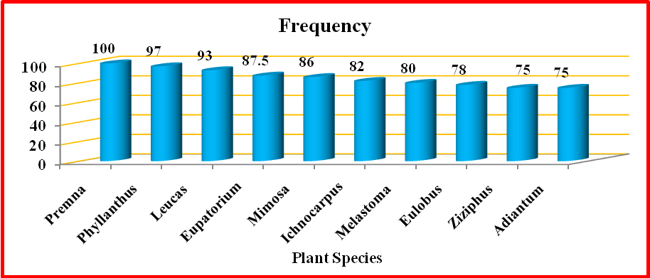
Fig. 4.3.1: Frequency of Selected plant species
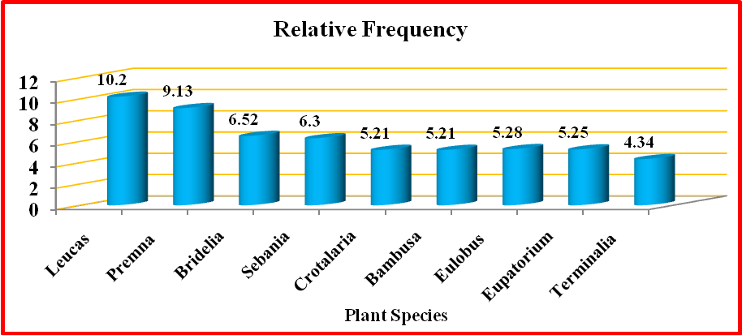
Fig. 4.3.2: Relative Frequency of Selected plant species
Abundance was maximum in Phyllanthus emblica (8.1), Premna odorata (7.6) and minimum in Bambusa bambos (4), Crotalaria retusa (4). Relative abundance of the isolates was most observed in Phyllanthus emblica (60.9), Premna odortata (67) and lowest observed in Adianthum aureum (25), Bambusa bambos (26).
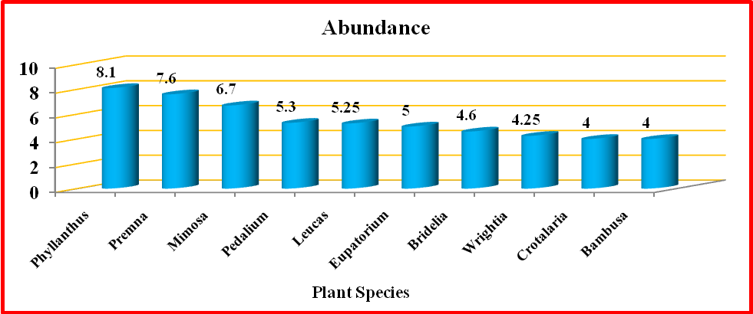
Fig. 4.3.3 : Abundance of Selected plant species
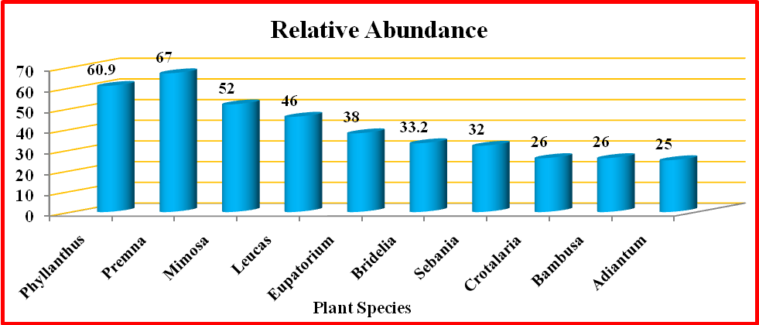
Fig. 4.3.4 : Relative Abundance of Selected plant species
Ficus religiousa (9.6), Premna odorata (7.6) is the most densely seen species in Maruthi Mala Hills. Likewise, Bambusa bambos (3) and Crotalaria retusa (3) with lowest density. Pedalium murex (3.4), Cassia fistula (2.19) have the highest relative density and Bridelia micrantha (0.66) and Eupatorium odortam (1.02) has the lowest relative density.
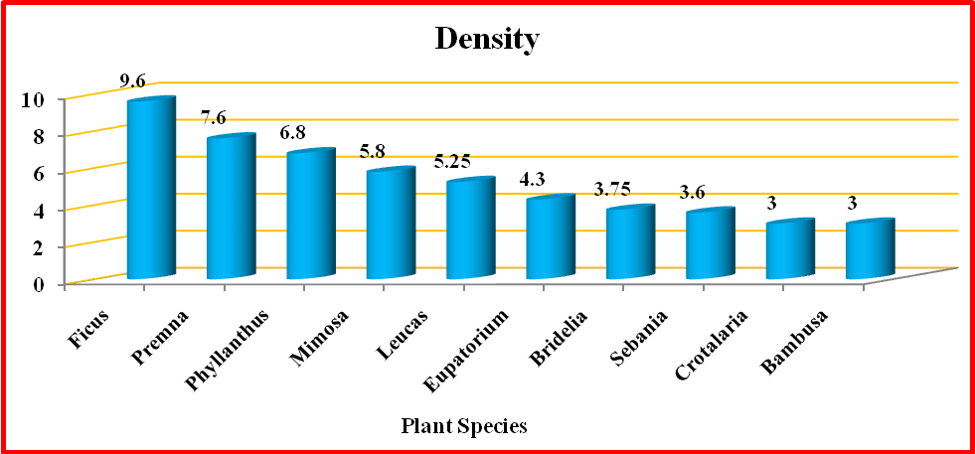
Fig. 4.3.5 : Density of Selected plant species
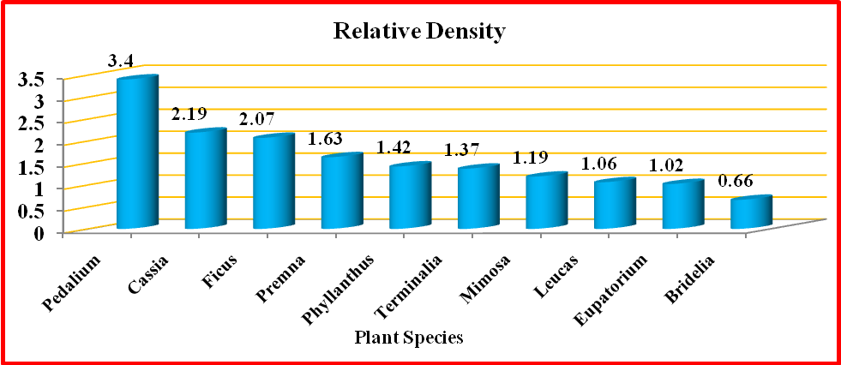
Fig. 4.3.6: Relative Density of Selected plant species
Eupatorium odoratum (83.68) and Bridelia micrantha (71.84) has the most abundant IVI value while Cassia mimosoides (43.08) and Bignonia peltata (45.5) has the lowest IVI value
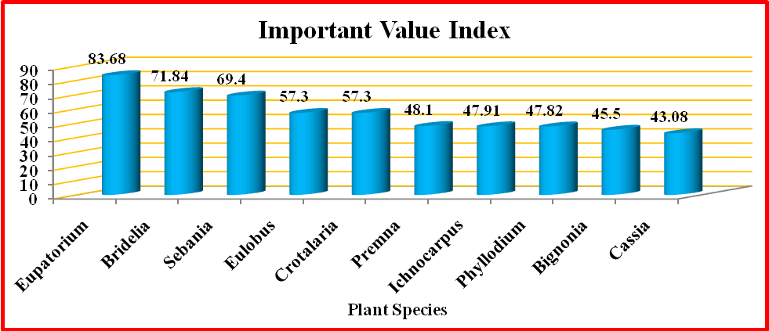
Fig. 4.3.7: Important Value Index of Selected plant species
Diversity indices of plants in the studied site showed that the highest Shannon Weiner index (3.36), Simpson's index (27.73), Margalef's (4.93) and Pielon's (1.46) Indices Diversity indices are shown in Figure 4.2.9.
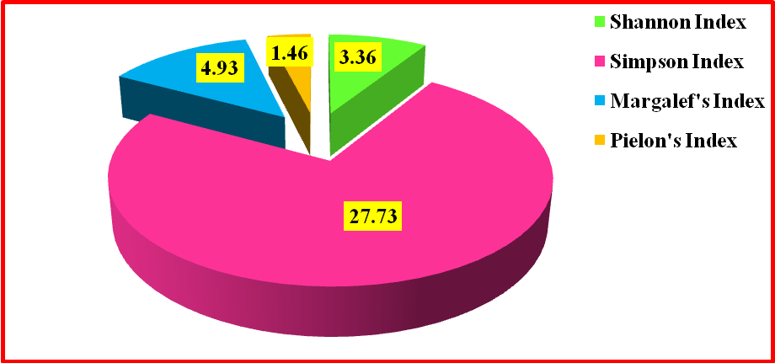
Fig. 4.3.8 : Diversity Indices of Selected plant species

Discussion
The flora of a region holds a pivotal role in the environment, influencing both ecosystem richness and human health. It's imperative to utilize plant resources appropriately across various scales – from countries to villages – to preserve flora availability and diversity. Assessing floral diversity plays a crucial role in understanding existing plant varieties. Urbanization has adverse effects on natural flora and fauna, necessitating the documentation of biodiversity to prevent their extinction. Urbanization, habitat fragmentation, anthropogenic pressures, and pollution contribute to the decline of rural and indigenous natural vegetation, which is vital for a healthy environment.
Various researchers conducted a floristic survey in Udumalpet Taluk of Tiruppur District, Tamil Nadu, focusing on documenting plant species in different rural habitats. Notable species in the area included Selaginella wightii Hieron., Marsilea quadrifolia L., Azolla sp., Marchantia sp., Funaria sp., and several fungi. Species were categorized as herbs, shrubs, climbers, and trees. However, the area's presence of windmills for electricity generation had an impact on both natural vegetation and cultivated fields.
Flora refers to a comprehensive list of plant species present in a geographical region. Different geological and ecological zones across the globe contribute to diverse floristic compositions. Loss of natural forests is evident, reflecting a decline in species quantity and genetic diversity within populations.
Another study focused on the floristic diversity and ecological characteristics of the flora in Kharawo Talash, Dir Lower, Khyber Pakhtunkhwa, Pakistan. This region boasts a rich diversity of medicinal plants, many of which are wild and belong to various genera and families. Despite this richness, forest cutting, overexploitation, and lack of awareness have led to significant losses in medicinal resources. Excessive uprooting of valuable medicinal plants by untrained locals contributes to the extinction of these species. Extinction also results from soil erosion, habitat loss, and disruptions in ecosystem functioning.
Biodiversity hotspots are characterized by high endemic species counts, species richness, and increased habitat loss. Deforestation arises from agricultural expansion, logging, and mining activities, significantly impacting tropical forests. Population fragmentation affects species differently based on life history traits such as gene flow, dispersal strategy, mating systems, isolation degree, and population tree density. Genetic diversity plays a vital role in the survival of plant species and influences ecosystem organization and dynamics.
A study by Saikat Mondal et al. (2019) explored the inventory, phytosociology, and diversity of vegetation in Gunjan Ecological Park's pit lake in West Bengal, India. The park's diverse plant forms contribute to its unique character, with 100 species across 41 families, including trees, herbs, shrubs, and climbers. The aquatic flora included 13 families, 13 genera, and 14 species. The study involved quadrats and considered physico-chemical parameters' impact on species distribution.
Harikesh et al. (2020) assessed floristic diversity and vegetation structure in three community forests in southwest Haryana, highlighting various plant species in each category. These studies emphasize the importance of phytosociological research, which aids in understanding species interactions, ecosystem processes, and the impacts of natural and anthropogenic disturbances. Different indices help assess diversity patterns, although their application requires awareness of their strengths and limitations.
Human activities such as climate change, air pollution, technological advancements, and land development have driven an increased focus on biodiversity conservation. Rapid deforestation, driven by agriculture, logging, and mining, puts numerous species at risk of extinction. Effective conservation management requires stringent regulations and international cooperation.
Plant ecology underscores the climate's role in global vegetation distribution. Within vegetation types, edaphic variation plays a crucial role in controlling plant diversity and distributions. Understanding the relationship between edaphic factors and plant diversity is essential for predicting responses to environmental changes.
In summary, these studies shed light on the importance of flora in ecosystems and human well-being. They underscore the need for effective conservation strategies and highlight the intricate interplay between various ecological factors that influence plant diversity and distribution.
The results provide valuable insights into the plant diversity and structural dynamics of Maruthi Mala Hills in Kollam District, Kerala. The data showcases the abundance and distribution of various plant species along with their Importance Value Index (IVI), which is a key metric for assessing the ecological significance of each species within the ecosystem.
Sesbania spp. (Scop.): Sesbania species emerge as a dominant plant with a relatively high Importance Value Index (IVI) of 69.4. This indicates their significant contribution to the overall ecological structure of Maruthi Mala Hills. Their high frequency (F/RF) and relative abundance (A/RA) reinforce their importance in the ecosystem.
Melastoma malabathricum (Linn): Melastoma species demonstrate a considerable IVI of 40.5, indicating their substantial presence in the area. While their frequency and relative frequency are relatively high, their dominance (D/RD) value suggests that they are not as dominant as Sesbania species.
Eupatorium odoratum (Linn, R.M. king, H. Rob): Eupatorium odoratum exhibits a remarkably high IVI of 83.68, making it one of the most ecologically significant species in Maruthi Mala Hills. Its high dominance (D/RD) value suggests that it plays a critical role in shaping the vegetation structure.
Bridelia micrantha (Hochst., Baill): Bridelia micrantha also emerges as a significant species with a high IVI of 71.84. Its dominance in the area, reflected in the dominance value, further underscores its ecological importance.
Premna odorata (Blanco): Premna odorata shows a substantial IVI of 48.1, indicating its noteworthy contribution to the plant diversity and structural dynamics of the hills.
Overall, the study reveals a diverse range of plant species in Maruthi Mala Hills, with certain species displaying higher ecological importance and dominance. These results are crucial for understanding the overall health and resilience of the ecosystem. The reference to the data source or publication provided with the table allows readers to access more detailed information and validation of the results presented.
The findings of this study can serve as a valuable baseline for conservation efforts, guiding the implementation of sustainable management practices and ensuring the preservation of the rich plant diversity and structural dynamics in Maruthi Mala Hills for future generations.

Summary and Conclusion
The present study “Plant Diversity and Structural Dynamics of Maruthi Mala Hills, Kollam District, Kerala, India“ was carried out to analyse the current status of floral diversity at Maruthi Mala hills. Flora of a region is considered as an essential part of the environment that determines the wealth of ecosystem and human. Floral diversity has an important activity to assess the existing flora. Among the plant samples collected from Maruthi Mala Hills, there are erect, spreading plant, ferns, shrubs, herbs, trees etc. In the quadrats study, the most number of plants observed were in Fabaceae with 14 species. The topography of the area is hilly terrain. The investigation showed that the plant species of this area were highly threatened by the population pressure and urbanisation.
The phytosociological studies revealed that Phyllanthus emblica, L. was the dominating species and also has maximum abundance at Muttara hills. Phytosociological characters like abundance, frequency and density were highly influenced by the biotic stress at the study site. The quantitative characters and their relative values had a pivotal role as indicators of anthropogenic disturbances, so this study helps to identify the repercussions of human activities to native plant species of Maruthi Mala hills. The analysis about the various species of plants in the area gave us a wide range of idea about the critical resources to be conserved in the near future. It is possible not only by the positive interaction of people but also the government need to take steps to supervise Maruthi Mala Hills and should transform it into an ecologically important Eco-Tourism Spot.

References
1.Abbas Hussain Shah,Ghulam Mujtaba Shah, Khalid Rasheed Khan, Khanda Amber, Manzoor Hussain, Mujtaba Shah.2019.A Comprehensive Survey of Floristic Diversity Evaluating The Role of Institutional Gardening In Conservation of plant. International Journal of Bioscience,14 (3).325-339
2. Abeysinghe P.D., 2020. Antibacterial Activity of some Medicinal Mangroves against Antibiotic Resistant Pathogenic Bacteria. Indian Journal of Pharmaceutical Sciences. 72 (2):149-282.
3. Abohassan, R.A., Okia, C.A., Agea, J.G., Kimondo, J.M., McDonald, and M.M., 2020. Perennial biomass production in arid mangrove systems on the Red Sea coast of Saudi Arabia. Environ. Res. J. 6 (1), 22—31
4. Alongi, D.M., 2021. Mangrove forests: resilience, protection from tsunamis, and responses to global climate change. Estuarine, Coastal and Shelf Science. 76: 1–13.
5. Ana Cano Ortiz etal2020.Phytosociological study, diversity and conservation status of the cloud forest in the Dominian republic plants 9,741.1-30
6. Ana Claudia Araiyo, Neil Brummit, Timothy Harris.2020. Areas of plant diversity-What do we know Plants, People, Planet,3(1).33-34
7. Anushka shah.2020. Modern Technology For Sustainable Forest Management in India.382.
8. Anwar, M., Akhtar, N., & Khalid, S. 2020. 63. Phytosociological study of weeds of wheat crop under edaphic variation: A case study from district Swabi, Khyber Pakhtunkhwa, Pakistan. Pure and Applied Biology (PAB), 9(1), 640-649.
9. Arun Christy and Binu Thomas. 2020. Phytodiversity of chasmophytic habitats at Olichuchattam Waterfalls, Kerala, India. Journal of Threatened Taxa, 12(9).16099- 16109
10. A.Vel Murugan. 2019. Coastal Floral Diversity and its significance. Coastal Ecosystem of the Tropics – Adaptive Management. 73-89
11. Batles, J.J., A.J. Shlinsky, R.H. Barret, R.C. Heald and B.H. Allen-Diaz. 2018. The effects of forest management on plant species diversity in a Sierran conifer forest. Forest Ecology and Management 146. 211–222
12. Bin Yang etal .2020.Contributions to the flora of Myanmar from 2000 – 2019.plant diversity 42.292-301
13. Biodiversity hotspots . 2021. ENVIS Centre, Ministry of Environmental and Forest, Govt. of India
14. Breidenbach et al. 2018. Genetic Diversity of Dominant PlantSpecies in Tropical Land-Use SystemsIn Sumatra, Indonesia .Tropical Conservation Science,11.1–14
15. Catherine M. Hulshof et al. 2020. The edaphic control of plant diversity. Global Ecol. Bio. Geogr. 00:1–17
16. Chandran, M. V., Gopakumar, S. and Mathews, A. 2020. Comparative phytosociological assessment of three terrestrial ecosystems of Wayanad Wildlife Sanctuary, Kerala, India. Journal of Threatened Taxa, 12(5).15631-15645.
17. Curtis J.T and Mclntosh R.P. 2020. The interrelations of certain analytic and synthetic phytosociological characters. Ecology, 31(3).435-455.
18. Das, D., B.K. Pramanik and S.K. Mollay.2020. A Model Classical Ecological report on Vegetaton dynamics in Gorumara Natonal Park in West Bengal, India. International Journal Pharmacy & Biomedical Research, 2(2).1–14.
19. Debnath Palit, Saikat Mondal.2019.Inventory of Plant Species, Phytosociology and Species Diversity of Gunjan Ecological Park Pit Lake, West Bengal, India. International Journal Of Scientific Research,8(2).1990-2006
20. Dr. Sincy Joseph. 2021.Ethnobotanical Survey of Medicinal Plants in Urdhook hills, Kuttiady, Kozhikode District, Kerala. IJCRT. 9.2320-2882
21. Gamble J.S. 1936. Flora of the presidency of Madras, Adland and Son Ltd. 1-3
22.Guillaume Papuga ORCID Icon. 2019.Variation in floral morphology in a hybrid complex of Cyclamen in Sardinia.51-61
23. Hamzaoglu, E. 2019. Phytosociological studies on the steppe communities of East Anatolia. Ekoloji 15(61): 29–55.
24. Hamzaoglu E. 2018. The steppe vegetation of Dinek Mountain (kirikkale) Gazi University Journal of Science.17.1-13.
25. Harikesh et al. 2020. Floristic diversity and vegetation Analysis of the community forests of South-West Haryana, India.Current Botany, 11. 51-59
26. Harikesh, Himanshi, Somveer Jakhar. 2020. Floristic diversity and vegatation analysis of the community forests of south-west Haryana, India. Research article, 11.51-59
27. Hazrat et al.2020; Floristic diversity and ecological characteristics of Flora of Kharawo Talash, Dir lower, Khyber Pakhtunkhwa, Pakistan. BIOSCIENCE RESEARCH, 17(2).681-687
28. Hogarth, P.J., 2019. The Biology of Mangroves and Sea grasses. – University press Inc. Oxford, New York
29. Huma Qureshi, Muhammed GULBAZ Arshad and Yamin Bibi, (2019). Invasive flora of Pakistan: a critical analysis, Interational Journal of Biosciences, 4(1):407-424.
30. Jashanpreet Kaur, Rajni Sharma, Pushp Sharma. 2020.Florastic Composition and distribution pattern of herbaceous plant diversity in fallow lands of the central district of Punjab, India. Journal of Threatened taxa 12, 15864-15880
31. Jeeshna M V.2020. Floristic and Phytosociological Studies of The Sacred Groove, Kayyath Nagam Kavu, Kannur District Kerala, India. Research in Plant Science,8(1).1-6
32. Jihang Huang et al. 2020. Floristic Composition and plant diversity in distribution areas of native species congeneric with Betulahalophila in Xinjiang, Northwest China. Nature Conservation 42.1–17.
33. Jonathan, M.P., Srinivasalu, S., Thangadurai, N., Ayyamperumal T., Armsrtrong- Altrin, J.S., Ram-Mohan, V., 2019. Contamination of Uppanar River and Coastal Waters off Cuddalore, Southeast Coast of India. Environ. Geol. 53, 139–1404.
34. Kamble, V.V. and R.B. Yele. 2020. Floristic Survey of Monocotyledonous Plants from Man Tehsil of Satara District (Maharashtra) India. Journal of Global Biosciences,9(4).7149-7159
35. Krishnamurthy, Prakash YL, Nanda HM, Krishnappa A, Dattaraja HS, and Suresh HS,. 2019. Vegetation structure and floristic composition of a tropical forests in Bhadra Wildlife Sanctuary , Karnataka, India. Tropical Ecology,51(2). 235-246.
36. Kumar A, Bruce G.M, Ajai S. 2019. Tree species diversity and distribution patterns in tropical forests of Garo Hills. Current Science. 91:1370-81
37. Kunev, G., Tzonev, R., Tsiripidis, I., &Pachedjieva, K. 2020. Phytosociological study of submontane genistoid scrub communities from the South eastern Balkans. Acta Botanica Croatica, 79(2).
38. Kunwar, R. M., Fadiman, M., Thapa, S., Acharya, R. P., Cameron, M., and Bussmann, R. W. 2020. Plant use values and phytosociological indicators: implications for conservation in the Kailash Sacred Landscape, Nepal. Ecological Indicators, 108, 105679.
39. Leandro T. A. Vieira et al.2019.A biogeographic and evolutionary analysis of the flora of the North-eastern cerrado, Brazil. Plant ecology and diversity,12.478-488.
40.Manzoor, J., &Jazib, M. J. (2021). Distribution Pattern and Phytosociological study of Trees Associated with Agroforestry in Poonch District of Jammu and Kashmir, India. Journal of Bioresource Management, 8(1), 8.
41. Md. Ashikur Rahman Laskar, Tahidul Islam.2021.Floral diversity of abandoned mansions and the influence of soil properties on these unique vegetation. Research Square 1,1-23
42. Mehdi Heydari, et al. 2020. Biodiversity, a review of the concept, measurements, opportunities and challenges. Journal of Wildlife and Biodiversity. X-X
43. Minchen,Xue-Yong Zhao,Xiao-An Zuo.2019.Comparative Pollen Limitation And Pollinator Activity Of Carragana Korshinskii Kom In Natural And Fragmen Habitats. Science of The Total Environment,654.1056-1063
44. Mukunda Dev Behera, Soumit Kumar Behera, Subrat Sharna.2019.Recent Advances In Biodiversity And Climate Change Studies In India. Biodiversity and Conservation,28.1943-1951
45. Nikhil Agnihotri, Sippy Dassani, T.K Sharma. 2020. Present status and conservation strategies of biodiversity in India. International Research Journal On Advanced Science Hub,2.2582-4376
46. Nisreen Husain, Touseef Hussain Trak, Deepti Chauhan. 2020. Florastic diversity of Jammu and Kashmir, India. International Journal of Advanced Science and Technology, 29,2358-2386.
47. Pankaj Sharma etal.2014.Floristic Diversity and Distribution Pattern of Plant Communities along Altitudinal Gradient in Sangla Valley, Northwest Himalaya.The scientific world journal.2014, 1-11
48.Patel, A. H. (2021). Phytosociological analysis of tree species of Sebhargog region of reserve forest of Vadgam Taluka in North Gujarat, India. Life sciences leaflets, 132, 1-9.
49. Patel, A. S. (2020). 3. Phytosociological study of some weeds in agriculture crop field in Sami Taluka by S D Patel and HM ANT. Life sciences leaflets, 123, 29-TO.

50. Pathiyil Arabhi, Maya Chandrasekharan Nair. 2019. Seasonal vegetation shift and wetland dynamics inVulnerable granitic rocky outcrops of Palghat Gap of Southern Western Ghats, Kerala, India. Journal of Threatened Taxa11(12) :14518–14526
51. Peter Raven, Mathis Wackernagel.2020.Maintaining biodiversity will define our long term success. Plant Diversity,42.211-220
53. Radha, R. Nagaraj, C. Udhayavani, K. Sivaranjani. 2020.A survey on the floral diversity of rural areas in Udumalpet Thaluk, Tiruppur district, Tamilnadu, India. Bangladesh J. Plant Taxon, 27.137-152
54. Pratikshya Kandel. 2019. Plant diversity of the Kangchenjunga Landscape, Eastern Himalayas. Plant Diversity,41.153-165
55. Qing Tang. 2019. Full-Length Reference Floral Transcriptome of Boehmeria tricuspis Provides Insights into Apomeiosis and Polyploidy Genomics. International journal of genomics.1-13
56. Radha .2020. A survey on the floral diversity of rural areas in Udumalpet Taluk, Tirupur District, Tamil Nadu, India. Bangladesh J. Plant Taxon, 27(1): 137‒152
57. Rahees N, Kiran M, and Vishal V. 2019. Phytosociological analysis of mangrove forest at Kadalundi-Vallikkunnu community reserve, Kerala. Inter J Sci Tech Vol. 3:2154–2159
58. Ramya, E. K., and Mownika, S. S. S. 2020. Phytosociological assessment of tree vegetation in tropical moist deciduous forest of veerakkal area, Nilgiris, Western Ghats, India. Indian Journal of Ecology, 47(2), 480-484.
59. Rao, S.D., P.P. Murthy and O.A. Kumar 2020. Plant biodiversity and phytosociological studies on tree species diversity of Khammam District, Telangana State, India. Journal of Pharmaceutcal Sciences and Research 7(8): 518–522.
60. Richard T. Corlett. 2016. Plant Diversity in a Changing World: Status, Trends, and Conservation Needs. Plant Diversity 38.10-16
61. Richard T. Corlett.2020. Safeguarding our future by protecting biodiversity. Plant Diversity 42.221-228
62. Saikat Mondal et al. 2019.Inventory of Plant Species, Phytosociology and Species Diversity ofGunjan Ecological Park Pit Lake, West Bengal, India. IJSRR 2019, 8(2).1990-2006
63. Sanjay Singh Chauhan. 2018. Phytosociological Analysis Of The Flora Of Madhav National Park, Shivpuri [M.P.]. Original Research Paper,School of Studies in Botany, Jiwaji University, Gwalior. (M.P), India 7: 2277 – 8160
64. Sanjeet kumar, Raj kumari, Supriya devi. 2020.Floral diversity of Sambhav, Nayagrah, Odisha, India, Ambika Prasad. Research foundation.
65. Santana, J. P., da Rocha, P. A., da Silva Oliveira, E. V., Prata, A. P. N., and Ribeiro, A. S. 2021. Phytosociology of the shrub-arboreal stratum of the Ibura National Forest, North eastern Brazil: are 35 years sufficient to promote the regeneration of a forest fragment?. Neotropical Biology and Conservation, 15, 89.
66. Sarkar, A.K. 2021. Ecological Studies of Tree Vegetaton of Ramshai Forest Range, Gorumara Natonal Park, India. Research Journal of Biological Sciences 5(7): 53–59.
67. Saujanendra Swain, Suhita Chakrabarty, Zomuankima, Vanlalh Mangaia. 2020. Domestication of wild plant diversity in home gardens for culinary and curative use by the tribal women farmers in Mizoram, India. Biodiversity international journal, 4.155-159
68. Shanmugam et al. 2016. Floral Diversity of Vaigai River in Thiruppuvanam Region of Sivagangai District, Tamil Nadu, Southern India. Int. J. Curr. Res. Biosci. Plant Biol. 2016, 3(2): 96-105
69.Sukumaran et al. 2018. Phytosociological studies of the sacred groove of Kanyakumari district, Tamilnadu, India. Tropical plant research, 5(1). 29 – 40
70. Stone W. C and Frayer J. R. A., 2018. A Botanical study of pasture mixtures. Sci., Aric., Vol. 15:777-805.
71. Sukumaran, S., Brintha, T.S.S. &Jeeva, S. 2019. Diversity of flowering plants in Kurusumala of Thiruvananthapuram district, Kerala, India. I3 Biodiversity. 3, 303.
72.Taranisen Panda, Bikram Kumar Pradhan, Rabindra Kumar Mishra, SrustiDhar Rout, Raj Ballav Mohanty. 2020.Angiosperm diversity in Bhadrak region of Odisha, India. Journal of threatened taxa 12.15326-15354
73.Tarun Kumar Thakur . 2020.Land use land cover change detection through geospatial analysis in an Indian Biosphere Reserve. Trees, Forests and People, 2.100018
74. Tel AZ, TatliA.and Varol,O. 2020. Phytosociological structure of Nemrut Mountain (Adiyaman/Turkey). Turkish Journal of Botany. 34: 417-434.
75.Tiimub, B. M., Kuffour, R. A., Tiimob, R. W., Kuuyeni, C. A., Tiimob, E. L., and Tiimob, E. N. 2020. Sacred groves as potential ecotourism sites at Tolon and Diare in Northern Region, Ghana. Journal of Sustainable Tourism and Entrepreneurship, 1(3), 195-215.
76. Uddin, M. N., Hossain, M. M., Karim, M. S., Siriwong, W., & Boonyanuphap, J. 2020. The phytosociological attributes of village common forests in Chittagong Hill Tracts, Bangladesh. Songklanakarin Journal of Science & Technology, 42(4).
76. Usharani, L., Sophia, M., Behera, N., & Gupta, A. (2018). Studies on the life form and biological spectrum of Konthoujam Sacred Grove in Manipur, India.
77. Velmurugan Ayyamet al .2019.Coastal Ecosystems of the Tropics – Adaptive Management.Costal region of tropics .80-599.

