Synthesis and Characterization of MoO₃ Nanorods
Neha Desai, Rajesh Kavade
Department of Chemistry, K.B.P. Mahavidyalaya Pandharpur
Email id of corresponding author :- nehadesai323@gmail.com
Abstract:-
In this study, we synthesized MoO3 nanoparticles via chemical bath deposition. The synthesized MoO3 nanoparticles adapt well to the hexagonal crystal structure. Morphological studies show the existence of nanorods with hexagonal crystal structure. Optical studies have shown that the difference in direct absorption is in the ultraviolet region. The analysis showed the presence of molybdenum and oxygen in the composite nanoparticles.
Keywords :- MoO₃, CBD, nanorods
Introduction:-
In recent years, transition metal oxides (TMOs) have attracted wide attention in materials science due to their various crystalline phases and properties. Nanocrystalline transition metal oxides such as TiO2, MoO3 and ZnO are the most studied by researchers worldwide. Among transition metal oxides, molybdenum oxide (MoO3) exhibits an excellent chemical composition with unique chemical, electrical, electronic and catalytic properties.
MoO₃ is the most produced product of molybdenum worldwide than any other molybdenum compound due to the comparative instability of molybdenum oxides of lower oxidation states.
MoO₃ exhibits different crystal phases such as orthorhombic (α-MoO3) and hexagonal (h-MoO3). Of the two hexagonal forms, MoO₃ is metastable, with the orthorhombic form of MoO3 being more thermodynamically stable than any other form.
Molybdenum oxide (MoO3) has excellent structural, chemical, electrical, catalytic and optical properties. Their perovskitelike structure makes them suitable candidates for optoelectronic applications. Many studies have been conducted to better understand the optical, structural and morphological properties of MoO3. Possible applications of MoO3 include sensors, catalysts, fuel cells, solar cells, supercapacitors, storage, etc. takes place.

Experimental:-
Chemical bath deposition method is used for the synthesis of MoO3 nanomaterials. In a typical synthesis ammonium heptamolybdate tetrahydrate (AHM) and conc. Nitric acid (HNO₃) is used as a precursor for the reaction.
Place 15 mL of 0.05 M AHM solution into the reaction bath in the experimental setup. Using a heating jacket to slowly raise the temperature of the solution to 500°C. 5 mL
of concentrated HNO₃ was added dropwise to it with constant stirring to obtain a clear solution. The pure solution is then stirred for 15 min, and the reaction bath temperature is kept at 700 °C for 30 min to obtain yellow white MoO3 precipitate. The reaction mixture was then cooled to room temperature. Finally, Whatman No. Filter out the hMoO3 precipitate using 1. 42 filter papers using a Buchner funnel. Then, the precipitate was washed with hot distilled water and the product was dried in a hot oven at 500 °C for 2 hours.

Growth and reaction mechanism: -
The growth of CBD nanoparticles follows Ostwald's law of growth. According to Ostwald's law of growth, small crystallite populations sacrifice themselves to form larger crystallites. Therefore, the first seed kernel is produced by Ostwald ripening. Then the nuclei combine to form a multinuclear center. Efficient growth of nanoparticles is possible due to the maturation of many nucleation sites. Therefore, achieving the desired morphological control of nucleation or development is extremely important. Thus, we achieved the growth of MoO3 nanorods by controlling the absence of CBD. Nanorods are onedimensional in nature and have a hexagonal cross-section. One dimensional nanomaterials have a higher surface area. So they suggest catalytic activity. The reactions that occur are as follows;

Optical Study:-
To study the optical properties of MoO3, the absorption light of h-MoO3 and a-MoO3 in the range of 190 to 700 nm was recorded on a UV spectrophotometer, and the absorption spectrum clearly showed that MoO3 is strong in the UV region. The difference in the structure of MoO3 is calculated from the absorption equation. The λmax value of h-MoO3 was found to be 280 nm, and the λmax value of α-MoO3 was found to be 300 nm. It is clearly seen from the λmax values ​​of the two samples that the difference between MoO3 is close to 3eV. From this we can understand that MoO3 is a widely used semiconductor material

Fig 1: (a) Graph of h- MoO₃ ( Wavelength vs Absorbance) (b) Graph of α MoO₃ (Wavelength vs Absorbance).
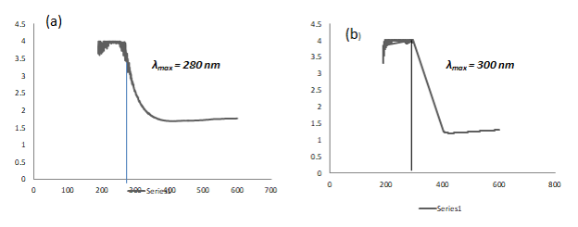

Structural Study:-

The structural study aspects of MoO₃ nanoparticles was determined by using X-Ray diffraction. XRD pattern of the samples h-MoO₃ is shown in figure 2,
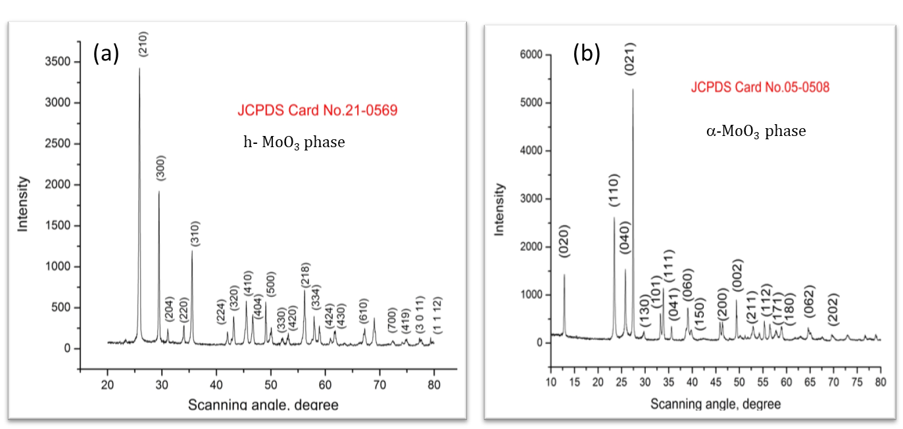
Fig 2. XRD pattern of h-MoO₃

The crystal structure and phase identification of MoO₃ sample was carried out by using X-ray diffraction analysis. Here we have synthesized h-MoO₃ nanoparticles. All the peaks in the XRD are well indexed to the JCPDS card no. 21-0569. No extra peaks due to impurity are seen.
The crystallite size is calculated by using equation,
D= 0.9λ/βCosƟ
The crystallite size is calculated by using most intense (210) peak. The crystallite size of h-MoO₃ is 35nm.

Morphological study:-
The morphology of nanomaterials plays a fundamental role in the physical and chemical properties of nanomaterials. To study the morphological aspects of MoO3 nanoparticles. The surface morphology of both h-MoO3 was characterized by SEM analysis. The image below clearly shows the presence of 1D hexagonal rods. All the nanorods are assembled together to form a nanoflower-like structure. The size of each nanoflower is about 1 micron.

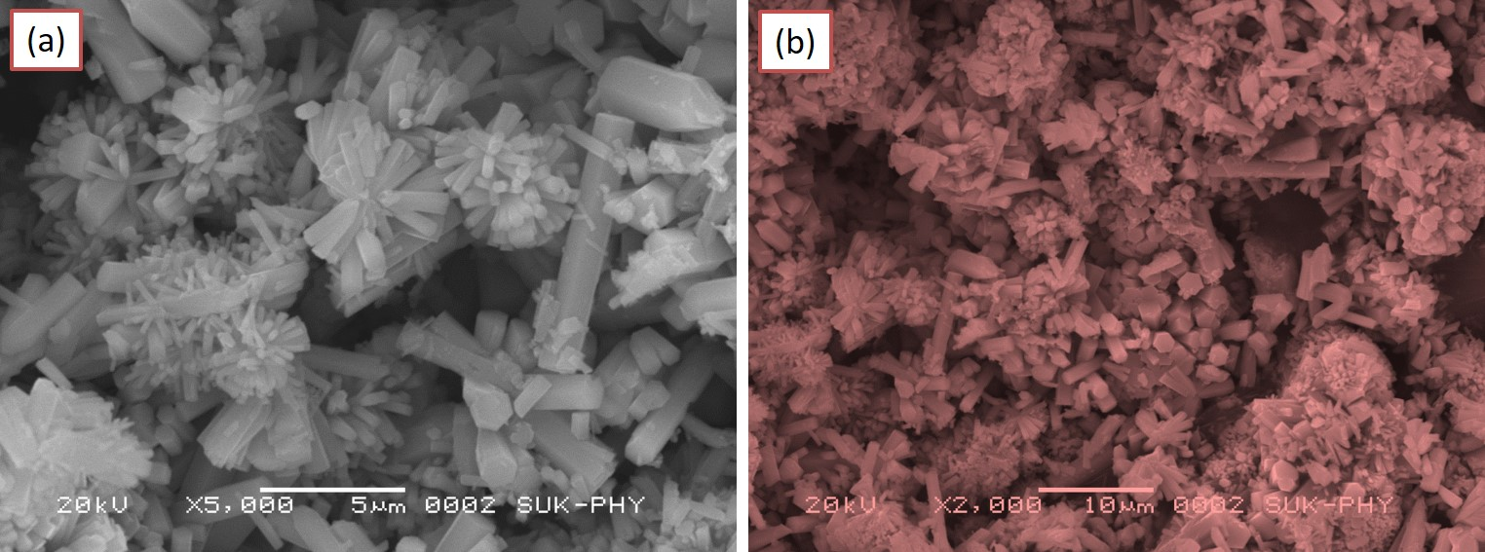
Fig.3 SEM micrographs of MoO3 nanorods
Compositional analysis:-
In order to confirm the composition of a nanomaterial EDS analysis is carried out. The presence of Mo and O in synthesisednanopowder is shown in the EDS spectra.
The observed and actual atomic percentage is in good agreement.
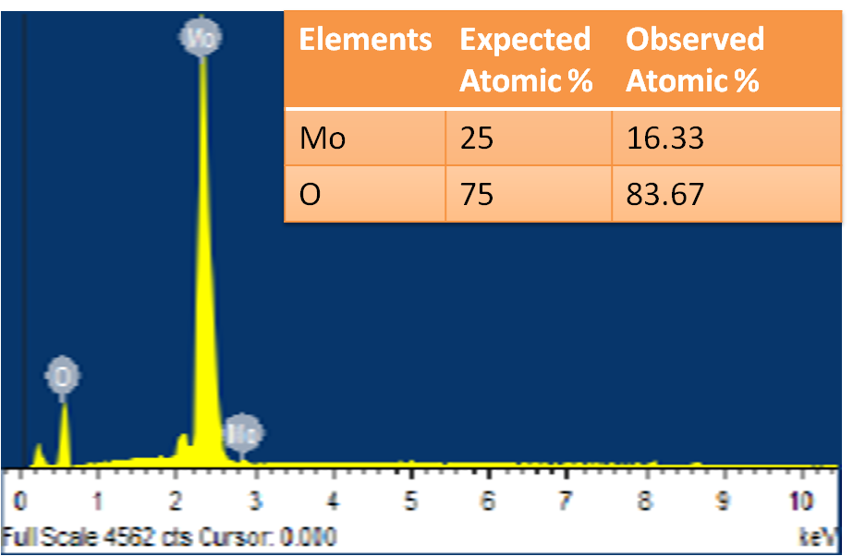
EDS spectrum of MoO₃ thin film
Conclusions:-
The MoO₃nanopowder is synthesized by chemical bath deposition. The structural study shows hexagonal crystal structure. The SEM micrographs reveals nanorod like structure. The EDS spectra confirms presence of molybdenum and oxygen. The optical study reveals the absorption in the Ultra violet region. All these properties reveals that MoO3 is a better candidate for gas sensing.
References:-
- Trans. Nonferrous Met. Soc. China 33(2023) 2155−2167.
- Results in OpticsVolume 11, May 2023, 100374
- Int. J. Electrochem. Sci., 15 (2020) 9824 – 9837.
- Materials Science in Semiconductor ProcessingVolume 150, 1 November 2022, 106974
- International Journal of Hydrogen EnergyVolume 47, Issue 47, 1 June 2022, Pages 20475-20493
- Arabian Journal of ChemistryVolume 15, Issue 9, September 2022, 104083
- Reference id - IIPER1655365759

