STRENGTHENING FPOs FOR WOMEN's EMPOWERMENT THROUGH RENEWABLE AND SUSTAINABLE ENERGY: A STUDY IN BIHAR
*Dr MVK. Srinivas Rao & **Divya Bharti
ABSTRACT
In Bihar, majority of total landholdings (about 97%) and farmers (about 76 %) belong to Small and Marginal Catagory. The establishment and promotion of FPOs are useful to states like Bihar in India because of their agricultural dependence and backwardness. Renewable energy generation will be a great tool for women empowerment though their active participation in FPOs via, canalizing their active participation towards generation of renewable energy along with their regular agricultural activities. This paper examines the status of women empowerment through FPOs and how renewable energy generation strategy would be helpful to create more incomes. The data has been collected through interview schedules from 120 FPO members, identified by convenient random sampling technique and analyzed by using appropriate statistical tools and revealed that FPOs would help to provide income to the house wives, and recognition in the society by reducing the household vulnerability and to provide better women empowerment. Renewable energy generation is the best source to generate power and incomes, which could be taken as a strategy to develop women empowerment via, Renewable energy plants establishment in villages of Bihar to the FPO women members with Govt. financial and technical support. This study has been conducted to understand the possibilities to create the above opportunities to women farmers and FPO members in Rural Bihar to improve women empowerment in this region. Based on the findings policy options are given.

Key words: Renewable Energy, Sustainable energy, Small and marginal farmers (SMFs) , Women Empowerment, Farmer Producer Organization (FPO), Small Farmers' Agri-Business Consortium (SFABC), FPO Ecosystems, Minimum Support Price

*Secretary, BN Entrepreneurs Research and Development Society, Visakhapatnam, AP, India & Incubator, Ministry of MSME, New Delhi.
** Assistant Professor, School of Commerce and Management Studies Sandip University, Sijoul, Madhubani, Bihar

BACKGROUND AND RATIONALE:
The Farmer Producer organizations (FPOs) are considered to be wonderful growth engines in rural Bihar. (Gurung, R. and Choubey, M. 2023). The contribution of women in economic activities is high in Bihar and playing multiple roles in the civilization: creative, generative and public that not fully recognized as financial influence. Government makes policy on women involvement of economy in every activity especially in FPOs business actions but not benefited as expected. The total FPOs registered in Bihar are 356 that include 217 NABARD FPOs, followed by 38 SFAC- FPOs, and 101FPOs registered by IAs under CSS for formation & Promotion of 10,000 FPOs but the active FPOs with more women participation are 163. Hence there is a need to improve lot of measures from Govt. of Bihar to increase active FPOs with more women participation. At the same time, the primary objective for deploying renewable energy in India is very important in several respects. Mainly, to advance economic development via, improving access to energy. Sustainable development is possible by use of sustainable energy. The government of India has to formulate several rules, packages, and create a conducive situation to attract foreign investments to incline up the country in the renewable energy market at a rapid rate. It is expected that the renewable energy sector can make a big number of local jobs (Kumar. J, C.R., Majid, M.A 2020). If we are able to syndicate these two forces and dynamisms sources together that would make delightful outcomes and accommodating the women empowerment and economic development in India.

2. The Conceptual Issues:
2.a. Farmers Producer Organizations:
A Producer Organization (PO) is a legal entity created as per the existing acts by the promoters of these entities including farmers, milk producers, fishermen, weavers, rural artisans, craftsmen. A PO can be a manufacturer company, a cooperative society or any other lawful form which provides for allocation of profits/welfares among the members. If these entities created by exclusively by the members of local farmers, known as Farmer Producer Organizations (FPOs). The FPOs with more women members are considered to be women FPOs. The role of FPO is to act as an accumulator for member farmers including from inputs to output which will improve the economy of scale and negotiating power. Currently 2389 FPO's have been on roomed on e-NAM platform. FPOs bring together the cooperative values of mutual benefits to its members along with a corporate supremacy structure, and have become the preferred legal form for farmer cooperatives. The FPOs ecosystem in Bihar has grown rapidly during the period 2019-2022 with formation of 791 FPCs (www.enam.gov.in). The objectives of the FPO scheme are to provide support for the promotion of Farmer Producer Organizations through the qualified Resource Institutions (RIs), to promote economically feasible and self-governing FPOs, to provide the required assistance and resources, to enable farmers in accessing the markets through their FPOs, both as purchasers and vendors, to make a policy environment for investments in FPOs to influence their production and marketing strength.
2.b: FPOs in India: An overview:
Till recently, there has been no serious effort made by Govt. and Non Govt. organizations towards the development of rural India with the help of incorporating small and marginal formers with high proportion of women farmers via FPOs and other cooperatives as a strategy initiative and create wonderful options for employment creation, income generation, women empowerment and regional development with high level of living standards. But now, the local, state and central Govts have been working earnestly to create the same via supportive ecosystems and several Nodal agencies.
2.b.1: The Frame of FPO Ecosystems in India:
The framework of FPO Ecosystems in India has typically been divided in to two parts, via, establishment of various FPO, and designing operational construction and activities of the same. Currently the FPOs are getting support from SFAC, NABARD NCDC and NAFED. The National Board for FPO (NBFPO) would act as the apex organization for promotion and development of all forms of producer organizations in the country, followed by The NBFPO that would also work in similar fashion. In the current digital era, technology helps in improving operative competence and appropriate watching of the business activities.

2.b.2: State wise details of FPOs in India:
As per the State wise particulars of FPOs in India under the scheme of formation and promotion of 10,000 FPOs by SFAC s on 21-7-23, Uttar Pradesh has occupied I position by having 789 FPOs, out of 3599 FPOs in India, followed by FPOs of Madhya Pradesh 342, Bihar 290, Rajasthan 220, Maharashtra 210, Andhra Pradesh 206, Assam 166, Odessa 162, West Bengal 158 and so on. On the other hand, some state has very less FPO registrations via, Mizoram and Meghalaya 134each, Manipur 10 and Nagaland 8.
Table 2.1: State wise details of FPOs in India
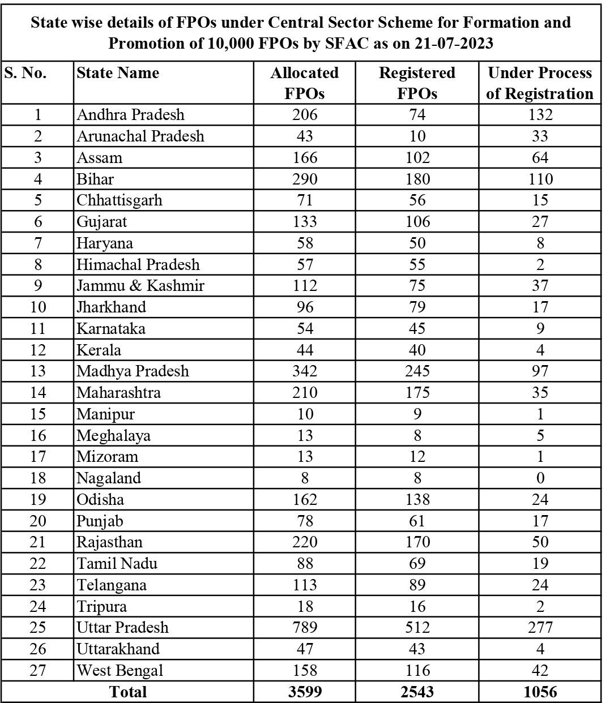
Source: http://sfacindia.com
2.b.3: FPOs in Bihar:
FPOs are promoted by Small Farmers Agri-Business Consortium, followed by National Bank for Agriculture and Rural development, NGOs and private players. Nearly 7374 FPOs are mobilized across India.

Table 5.1: FPOs in Bihar
S.NO | District | NABARD FPOs |  | SFAC FPOs |  | NRLM FPOs |  | Total
S.NO | District | No of FPOs | % | No of FPOs | % | No of FPOs | % | No of FPOs | %
1 | Araria | 02 | 1.69 |  |  |  |  | 02 | 1.23
2 | Arwal | 02 | 1.69 |  |  |  |  | 02 | 1.23
3 | Aurangabad | 03 | 2.54 |  |  |  |  | 03 | 1.84
4 | Banka | 01 | 0.85 |  |  | 01 | 14.28 | 02 | 1.23
5 | Begusarai | 01 | 0.85 |  |  |  |  | 01 | 0.61
6 | Bhagalpur | 01 | 0.85 |  |  |  |  | 01 | 0.61
7 | Bhojpur | 05 | 4.24 |  |  |  |  | 05 | 3.07
8 | Buxar | 01 | 0.85 |  |  |  |  | 01 | 0.61
9 | Darbhanga | 04 | 3.39 |  |  |  |  | 04 | 2.45
10 | East Champaran | 02 | 1.69 |  |  |  |  | 02 | 1.23
11 | Gaya | 03 | 2.54 | 02 | 5.26 |  |  | 05 | 3.07
12 | Gopalganj | 03 | 2.54 |  |  |  |  | 03 | 1.84
13 | Jamui | 08 | 6.78 |  |  |  |  | 08 | 4.90
14 | Jehanabad | 02 | 1.69 |  |  |  |  | 02 | 1.23
15 | Katihar | 02 | 1.69 |  |  |  |  | 02 | 1.23
16 | Khagaria | 02 | 1.69 |  |  | 01 | 14.28 | 03 | 1.84
17 | Kishanganj | 04 | 3.39 |  |  |  |  | 04 | 2.45
18 | Lakhisarai | 02 | 1.69 |  |  |  |  | 02 | 1.23
19 | Madhubani | 04 | 3.39 |  |  |  |  | 04 | 2.45
20 | Munger | 08 | 6.78 |  |  |  |  | 08 | 4.90
21 | Muzaffarpur | 06 | 5.08 | 06 | 15.79 | 02 | 28.57 | 14 | 8.59
22 | Nalanda | 10 | 8.47 | 03 | 7.89 | 01 | 14.28 | 14 | 8.59
23 | Nawada | 13 | 11.02 |  |  |  |  | 13 | 7.98
24 | Patna | 02 | 1.69 | 05 | 13.16 |  |  | 07 | 4.29
25 | Purnia | 02 | 1.69 | 02 | 5.26 | 01 | 14.28 | 05 | 3.07
26 | Saharsa | 03 | 2.54 |  |  | 01 | 14.28 | 04 | 2.45
27 | Samastipur | 04 | 3.39 |  |  |  |  | 04 | 2.45
29 | Saran | 02 | 1.69 |  |  |  |  | 02 | 1.23
30 | Sheohar | 02 | 1.69 |  |  |  |  | 02 | 1.23
31 | Sitamarhi | 03 | 2.54 |  |  |  |  | 03 | 1.84
32 | Supaul | 02 | 1.69 |  |  |  |  | 02 | 1.23
33 | Vaishali | 07 | 5.93 |  |  |  |  | 07 | 4.29
34 | West Champaran | 03 | 2.54 |  |  |  |  | 03 | 1.84
34 | East Champaran |  |  | 13 | 34.21 |  |  | 13 | 7.98
35 | Hajipur |  |  | 01 | 2.63 |  |  | 01 | 0.61
36 | Katihar |  |  | 02 | 5.26 |  |  | 02 | 1.23
37 | Rohtas |  |  | 01 | 2.63 |  |  | 01 | 0.61
 | Total | 118 | 100.00 | 38 | 100.00 | 07 | 100.00 | 163 | 100.00
 | Per cent- Horizontal |  | 72.39 |  | 23.32 |  | 4.29 |  | 100.00
Source: Author Compilation
The FPOs in Bihar with active women participation is steadily increasing. About 72.39 % of the FPOs are supported by NABARD, followed by SFAC (about 23.32 %) and NRLM (about 4.29 %)

2.c: Women Empowerment:
Women’s empowerment is nothing but encouraging women’s intelligence of self-confidence, their capacity to limit their own choices, and their right to stimulus social change for themselves and others. It is the process of enhancing an individual’s or group’s capacity to make purposive choices and to renovate those choices into desired actions and outcomes and obtaining basic chances for demoted people, either directly by those people, or through the help of non-marginalized who share their own access to these chances.
3. Renewable and Sustainable Energy:
The Renewable and sustainable energy is continually substituted and never run out. This includes, solar energy, hydropower, bioenergy, geothermal, ocean energy, and wind energy. Sustainable energy refers to energy that meets the needs of the present generations without bargaining the ability of future generations to meet their own needs. Hence, Renewable energy is energy that is formed and replaced naturally. Sustainable energy, on the other hand, is energy that reliably meets both the short- and long-term needs of a society.The main source of Renewable energy are Sunlight and wind whereas, sustainable energies are hydroelectricity, biomass, geothermal, wind, wave, tidal and solar energies which maintains the natural environment. Its installations are made out of environment-friendly materials. On the other hand, Fossil fuels - coal, oil and gas are non-renewable resources that take hundreds of millions of years to form. Women formers can improve their living standards with the help of regenerating renewable energy from the abounded sources like wind and solar powers available at their fields with the help of govt. support agencies.

4. Energizing Farmer Producer Organizations:

By March 2019, 7,374 FPCs were formed with a total paid-up-capital (PUC) of ₹860.18 crore. In 2021, the ministry of agriculture and farmers’ welfare launched a central scheme to promote 10,000 farmer producer organizations with an allocation of ₹6,865 Cr. Government schemes such as Dena Shakti Scheme, Pradhan Mantri Mudra Yojana may be tweaked to for easy access to capital for women FPCs. NITI Aayog’s Moving the Needle program through The Women Entrepreneurship Platform can explicitly target women led FPCs. As per the RBI guidelines under PSL norms for easier access to capital for all women FPOs with practically no collateral . is key for women empowerment in Rural India, followed by Increasing digital literacy through training and capacity building of women farmers through their FPOs, Leadership and governance training of such FPOs play an important role in creating the right eco system.

5. The Concept of Minimum Support Price:
Minimum Support Price (MSP) is a form of market interference by the Government of India to insure agricultural producers against any shrill fall in farm prices. The minimum support prices are a guarantee price for their produce from the Government. The major objectives are to support the farmers from distress sales and to procure food grains for public distribution.
Figure 5.1: Minimum Support Price for the farmers in India
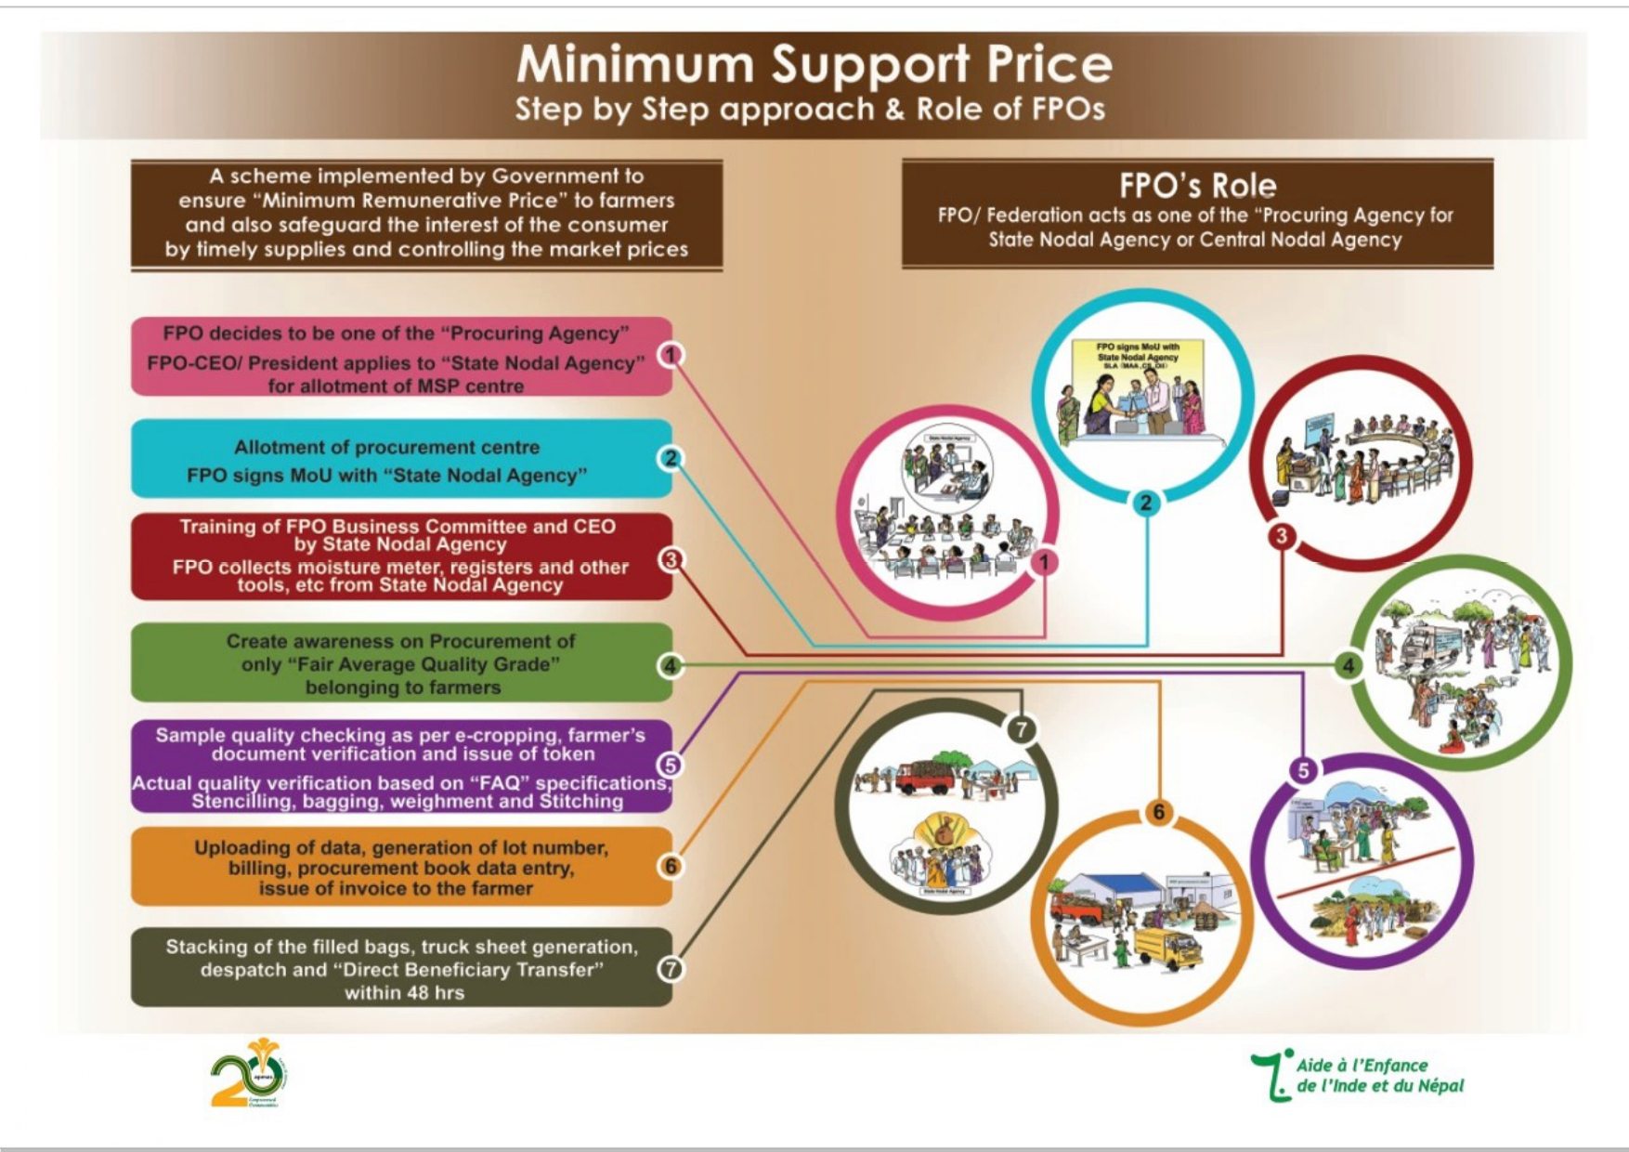
Source: www.vikaspedia.in

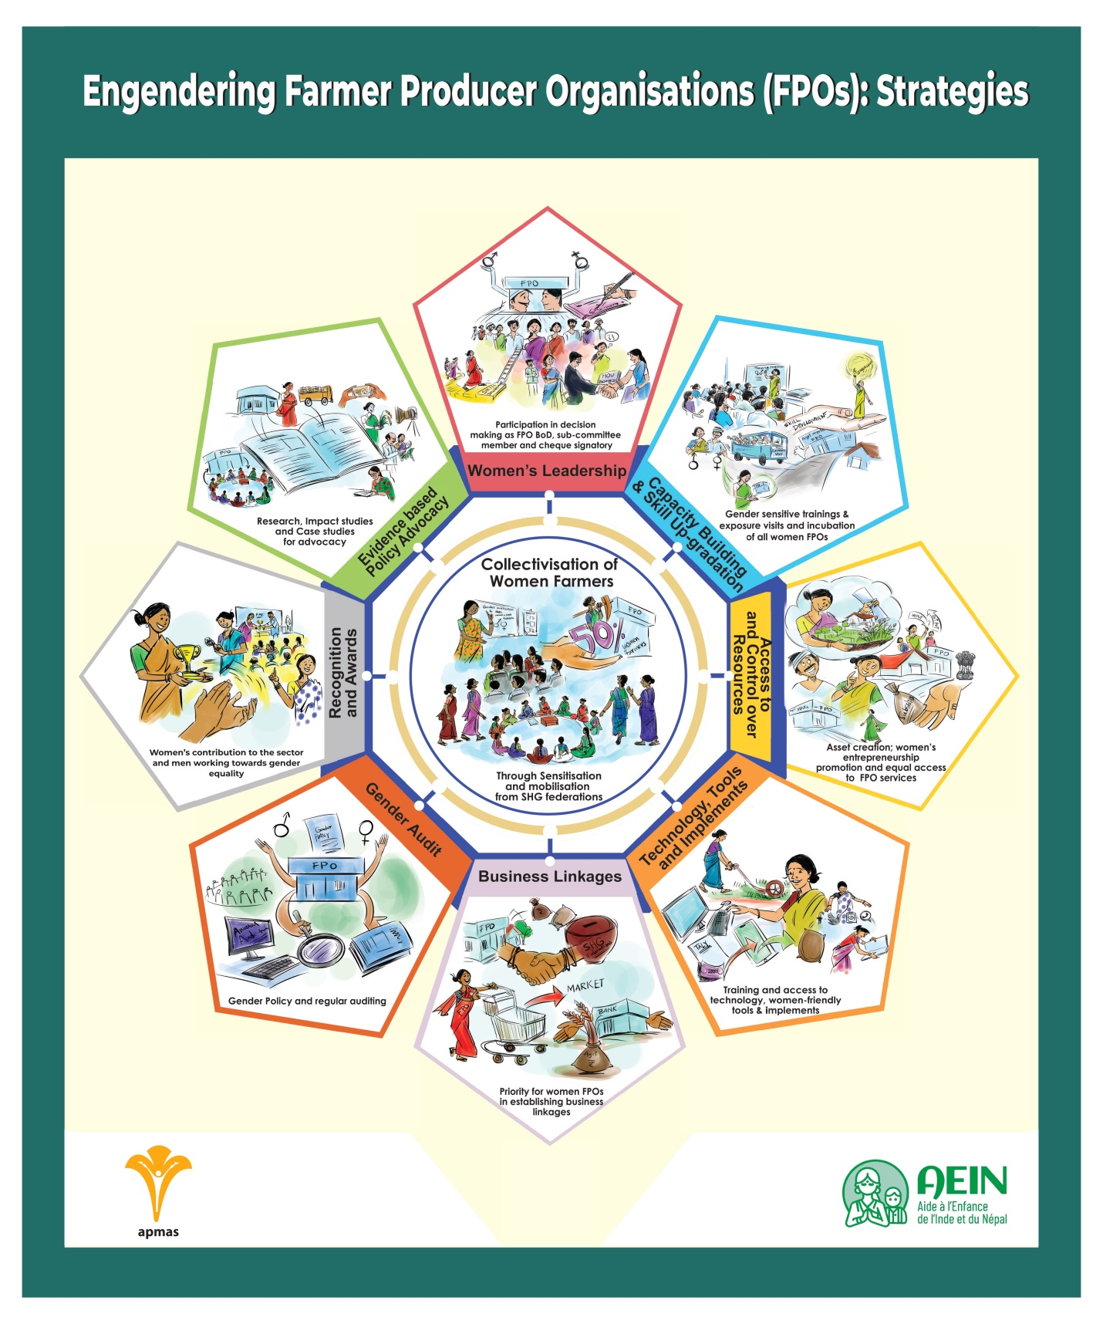

6. Factors affecting the Participation of Women in FPOs:

Education, farming experience, farming as the primary occupation, size of landholding, access to Internet, distance to the nearest market, medium level of social participation, extension contact, transportation facility and strategy to enlarge the scale of action in future are the major descriptive variables that have statistically significant impact on the farm households' participation in FPOs (Gurung, R. and Choubey, M 2023). The savings, training and age of women entrepreneurs would play kvery important role in developing women FPOs in India.

7. CHALLENGES OF FPO WOMEN:
Women dominate various spheres of farming but as a matter of fact that their contribution have largely been neglected. There are about 7,374 FPCs in the country. Of this, about 3 percent (or 220 were women’s FPCs. About 90% of these FPOs, women’s participation sustained to be miserable. The main problems are Gender and social norms restricting women’s mobility and financial empowerment; Poor knowledge of agricultural practices and crop production are also other significant challenges faced by women members of FPOs.
8. Need for the Study:
There is a need to promote women FPOs to ensure success and better income. The FPO’s should support its member farmers through information, training, and access to new technologies to meet the challenge of climate change etc. there isa need to know how the FPOs would beneficial for economic development of women farmers who are the members in FPOs. As the Renewable energy multiplies the employment opportunities and incomes, it is necessary to encourage the activities of FPOs by supporting them to take Renewable and Sustainable energy plants as their business strategy. Hence, there is need to study the topic for better women empowerment in rural India with special reference to Bihar, and also to find out how these energy sources would serve a strategic income sources to women FPOs in Rural Bihar.
9. REVIEW OF LITERATURE:
Women are playing very important role in hill agriculture. The dimensions of women empowerment and livelihood, wellbeing as a consequence of association with Farmers Producer Company is very important to develop the standards of the living. It was found that the FPO has a positive impact on the livelihood well-being of hill farm women associated with them. The MUPC can act as a model for sustainable development of rural livelihood. The other organizations can learn from the model they followed, the good practices they perform to enhance efficiency of organization and betterment of poor farmers of India, especially poor rural women working in hilly area (Mukherjee, et al 2020). Agriculture is an important component of rural livelihoods. Women play a pivotal role in all agricultural operations from planting through harvesting to post-harvest processing and marketing (www.teriin.org). Traditionally, providing agricultural services has been viewed as a male-dominated enterprise in India. Hence, the fruits of steadily growing farm mechanization practices were expected to be reaped predominantly by male farmers. (www.irri.org). Effective linkages among farmers play a crucial role in fostering growth within the agriculture sector. The FPO in Bihar demonstrates stronger associations with government institutions and officials (www. epubs.icar.org.in).

10. OBJECTIVES OF THE STUDY:
The overall objective of this research paper is to assess the role of FPOs in women empowerment in Bihar. In line with this, following specific objectives are framed.
- To examine the role of FPOs in improving socio-economic condition of women.
- To identify the factors influencing the participation of women in FPOs in the study area.
- To trace out the facilitating factors and challenges for the women empowerment through FPOs.
- To know the synergy of Women FPOs and Renewable Energy generation for better women empowerment.
11. METHODOLOGY ADOPTED:
For this research paper, in Bihar has been selected purposively. To select the sample enterprises and respondents, stratified random sampling technique was used. At the beginning, the existing enterprises in the study are classified in to three categories such as manufacturing, service and trade sectors. Then 120 sample enterprises units were selected randomly from three sectors. Both primary and secondary data were collected to address the objectives and accomplish the research from different sources. Primary data was collected through pre tested structured interview schedule. The collected data was compiled and analyzed by using Descriptive statistics.

12. RESULTS AND DISCUSSION:
The profile of the sample FPOs women members reveals that majority (34.71%) of the sample women found within the age of 26-30 years, followed by 31-35 years (23.14%). 60.33% of FPOs are run by married women and 22.31% are by unmarried women, majority (39.67%) of the respondents have completed their secondary school education followed by junior grade (28.10%). Around half (48.76%) of the sample women members have the family size of 4 to 6 which implies business owners have higher number of family size which gives them burden in searching livelihood options. It is evident from the survey results, one third (33.88%) of the FPOs members have engaged in marketing activities of the agricultural product. service activities such as selling snacks, tea and coffee, secretarial service, beauty salon, managing pension, bar and restaurants etc. Other 33.06% are engaged in Agri processing manufacturing activities. Remaining 33.06% have engaged in other trade activities.
About 57% of the total sample had not engaged in any activities and they were having the position as members. Only 43% have engaged in various FPO activities. They are creating good no of employment opportunities in the days to come. About 90.90% of women have got full time work in FPO activities. The remaining (9.10%) works in their business as part time basis since they engaged in other home activities. This indicates that FPOs are playing a significant role in creating employment for women which will pave the road for women empowerment.
About 45.5% of sample women have other sources of income. The same results depict that majority (67.27%) of them have the income source from their husbands, 20% from house rents and 12.73% from other sources. Hence it is inferred that other sources of income also contribute to their total income for 45.5% of the respondents. The most important factor in women empowerment is decision making on family expenditure. As results indicates, majority (57.85%) of the sample women entrepreneurs decide on family expenditure by themselves and with their husbands (39.67%) respectively after they involved in FPOs. It shows that women FPO members are largely independent in making decisions concerning their household expenditure, This indicates that involving in the enterprises create the opportunity for decision making in a partnership basis which is a sign of getting recognition for women in the family with their husbands. Therefore, whenever decision making increases ultimately women seem to be empowered. The decision making by their husband alone in taking decision on medication reduced tremendously (54.55%). Hence it is inferred that FPOs play a vital role in empowering the women in taking care of their health aspect by providing opportunity to improve their economic status so that they can be free from the control of women in home itself. During the survey, most of the women reported that they have overcome from domination from the family. Previously most of them engaged in household activities such as caring their children, cooking food, cleaning the house and serving the elderly people etc. Also it was found that importance was given to the male compare to the female. Such situation has been changed after generating income from FPOs reported by sample women. Only insignificant percentage of them disagreed the argument. Hence it can be inferred that most of the sample women entrepreneurs have over come from such dominancy. Women FPO members are expected to benefit in terms of income generation, employment creation, access and control over resource, secure family livelihoods and other socio-economic benefit from FPOs. The overall benefits acquired by the women indicates that they have enjoyed so many benefits after starting their own business which are secured family livelihood in terms of meeting family expenditure for nutritional food, dress, education and other costs, increased decision making in family matters etc. The other significant advantage is social involvements on behalf of the family as well as in the community. To summarize, women who engaged in FPOs have got different types of benefits that support economic development and social wellbeing for them. The most significant benefits in the enterprises are secured family livelihood, social involvements, acquiring skill and knowledge of business, access to information, freedom from domination and access to income. Training is an important ingredient to improve the skill of the women to carry out the activities efficiently. Also training facilitate the women to utilize their resources appropriately for the purpose for which it was indented and leads to run a profitable venture. Moreover, training session will help them to interact with other members as well as outsiders so that they improve their confidence level since they have inferiority complex to mingle with others. Majority (63.33%) of them got the training on FPOs and their activities solving technical problems strengthen business skills (56.57%), leadership skills (50%), ways and means of saving (43.33%) and business management (36.67%) respectively. The respondents also take training on entrepreneurial knowledge, improving organizational capacity and employee management etc. Training components enable women in the FPOs to develop their new skill and knowledge that support their specific ventures. About 30% each of FPOs run their activities in the rental building and structure attached to home. The remaining are doing their activities in the home with space (16%), home without space (11%), open space (5.8%), no fixed location (2%) and others (5%) respectively. Therefore, the premises are one of the problems for the expansion and development of FPO activities in this region.

Most FPO women entrepreneurs sell their products to the customers who come to the market where they sell the products. About 79.3% of respondents have not access to market linkage. Only 20.7% of them have access to market linkage According to them, market linkage increase sale of products and services which makes them profitable enterprises and also support them in terms of reliable source of inputs and customers.

13. CONCLUSION AND RECOMMENDATIONS:
FPO provides employment to the poor, house wives, students and unemployed who have no other means of income and opportunity in the formal sectors. Women in the FPOs have ability to make decisions on their family matters, followed by family livelihood, freedom from domestic domination, sanction for social involvement, acquiring skill and knowledge of business which support them for empowerment. Although FPO’s are significant in terms of reducing the household vulnerability in terms of nutrition, cloths, education and other expenses, they are also facing some problems. Many of them are not reaching their growth potential due to various factors mainly lack of market linkage, business premises, high material cost, lack of finance and others. Many of the constraints of women in FPOs face cannot be addressed with single intervention. Therefore, greater attention needs to be paid to the development of the sector in general and promoting women owned FPOs in particular

REFERENCES:
- UNFPA, (2008), ‘Gender inequality and women’s empowerment’, Biharn society of population studies, Addis Ababa, Bihar.
- Devesh Roy et al (2020), TCI-TARINA Policy Brief No. 15
- https://pib.gov.in/PressReleaseIframePage.aspx?PRID=1806232
- https://enam.gov.in/web/stakeholders-Involved/fpos
- https://www.worldvision.com.au/womens-empowerment
- https://www.oecd.org/development/womens-economic-empowerment.htm
- https://naarm.org.in/wp-content/uploads/2022/04/FPO-Policy-Paper.pdf
- https://www.nabard.org/demo/auth/writereaddata/File/FARMER%20PRODUCER%20ORGANISATIONS.pdf
- https://www.manage.gov.in/publications/knowledgeseries/womenFPOs.pdf
- https://www.thehindubusinessline.com/opinion/boosting-women-led-fpos/article65204277.ece
- Mukherjee, et al (2020), Assessment of livelihood wellbeing and empowerment of hill women through Farmers Producer Organization: A case of women based Producer Company in Uttarakhand, Indian Journal of Agricultural Sciences. 90. 1474-81. 10.56093/ijas.v90i8.105945, www. researchgate.net/publication/348355977.
- https://www.teriin.org/sites/default/files/2020-05/women-in-agriculture-dp.pdf
- https://www.irri.org/news-and-events/news/women-introduce-mechanized-farming-bihar
- https://www.nafpo.in/wp-content/uploads/2021/12/NAFPO-Gender-Equitable-Transformation-of-Agriculture-_FPO-Guidelines.pdf
- https://www.microsave.net/2023/05/24/the-impact-of-climate-change-on-farmers-in-bihar-and-how-farmer-producer-organizations-can-help-them-adapt/
- https://publications.azimpremjiuniversity.edu.in/3401/1/Farmer-Producer-Companies-Report-2-Azim-Premji-University-2022.pdf
- https://vikaspedia.in/agriculture/market-information/minimum-support-price
- https://www.indiafilings.com/learn/scheme-for-promotion-of-fpo/
- http://sfacindia.com/UploadFile/Statistics/State%20wise%20summary%20of%20registered%20FPOs%20under%20Central%20Sector%20Scheme%20for%20Formation%20and%20Promotion%20of%2010,000%20FPOs%20by%20SFAC%20as%20on%2021-07-2023.pdf
- Gurung, R. and Choubey, M. (2023), "Determinants of agricultural households to join farmer producer organisations (FPOs) in Northeast India: evidence from Sikkim", International Journal of Social Economics, Vol. 50 No. 4, pp. 465-477. https://doi.org/10.1108/IJSE-04-2022-0216
- https://www.livemint.com/opinion/online-views/the-future-of-farmer-producer-companies-could-be-brightened-11664296144959.html
- https://idronline.org/the-10000-farmer-producer-organisations-scheme-ignores-women-farmers/
- https://www.policycircle.org/society/women-in-farmer-producer-organisation/
- https://www.dhyeyaias.com/current-affairs/daily-current-affairs/boosting-women-led-fpos
- https://www.dhyeyaias.com/current-affairs/daily-current-affairs/boosting-women-led-fpos
- https://www.ideasforindia.in/topics/agriculture/the-10000-fpos-scheme-ignores-women-farmers.html
- http://sfacindia.com/PDFs/Roundtable-Jaipur-Proceedings-Final.pdf
- http://sfacindia.com/Aboutus.aspx
- https://www.adecesg.com/resources/blog/renewable-energy-or-sustainable-energy/
- Kumar. J, C.R., Majid, M.A (2020). Renewable energy for sustainable development in India: current status, future prospects, challenges, employment, and investment opportunities. Energ Sustain Soc 10, 2, https://doi.org/10.1186/s13705-019-0232-1
- Şalvarlı, Mustafa & Salvarli, Huseyin. (2020). For Sustainable Development: Future Trends in Renewable Energy and Enabling Technologies. 10.5772/intechopen.91842, https://www.researchgate.net/publication/344732395_For_Sustainable_Development_Future_Trends_in_Renewable_Energy_and_Enabling_Technologies
- https://www.thehindubusinessline.com/economy/agri-business/why-renewable-energy-is-key-to-the-success-of-fpos/article37578273.ece

