PAKHIBITAN BIRD & WILDLIFE SANCTUARY, JALPAIGURI DISTRICT, WEST BENGAL: IT’S IMPORTANCE BASED ON AVIAN DIVERSITY

Arjan Basu Roy, Lina Chatterjee, Debarpan Datta, Tarak Samanta
Nature Mates–Nature Club, 6/7, Bijoygarh, Kolkata 700032, West Bengal, India
CORRESPONDING AUTHOR: Lina Chatterjee (pakhibitan2019@gmail.com)
Abstract:
Conservation of the biodiversity of the protected areas is often challenging due to lack of data. Extinction and loss of biodiversity can be prevented only if we have the data of the basic units that are species and their relationships. Preparing a checklist of fauna or flora of a particular area may not be always interesting but can be very important for scientific research. With this view, a study was carried out from 2015-2021(only in the winter season) in recently declared (2016) Pakhibitan Bird & Wildlife Sanctuary (that is Gajoldoba wetland), West Bengal. This is a small hamlet situated on the upper part of Teesta Barrage in the Dooars region of Jalpaiguri district. The waterbody of Pakhibitan Bird & Wildlife Sanctuary is important for the presence of unique migratory birds those have flocked through the Central Asian Flyway (CAF) to this forest-surrounded, landlocked water body because of the construction of the dam. In the current effort, a checklist of both waterbirds and landbirds were prepared living in and close to wetlands. A total 124 species of birds from 14 orders and 37 families were identified. Of them, 77 bird species from 10 orders and 18 families that are directly dependent upon or connected to the concerned wetland were identified throughout the study period. The order Passeriformes (32 species) and the family Anatidae (23 species) are the most speciose group in this study area. According to the IUCN Red Data Book (2022-2), 06 species were Near Threatened (NT), 04 species Vulnerable (VU), 01 species Endangered (EN) and rest of the species are under Least Concerned (LC) category. 50% of the bird species from Pakhibitan Bird & Wildlife Sanctuary were found to be resident species during this survey. In this water body, 44% and 6% of species are migratory and local migrants, respectively.

Key words: Pakhibitan Bird & Wildlife Sanctuary, Avifauna, Protected areas, West Bengal

Introduction:
According to Ramsar Convention Wetlands are important globally, particularly as a habitat for waterfowl. Later, Under the text of the Convention (Article 1.1), wetlands are defined as: “areas of marsh, fen, peatland or water, whether natural or artificial, permanent or temporary, with water that is static or flowing, fresh, brackish or salt, including areas of marine water the depth of which at low tide does not exceed six metres” (Matthews 1993). Wetlands are essential habitats that are linked socially and physically to processes taking place across a much larger area and facilitating the migration of aquatic species and enhancing local species diversity (Amezaga et al. 2002). They have unique biotic communities where diverse plants and animals are adapted in the shallow and dynamic water regimes (Weller 1999). Wetland loss and degradation have harmed waterbirds that rely on wetlands for survival. However, carefully managed wetlands can provide alternate or complementary habitats for waterbirds and other associate birds by mitigating the negative consequences of wetland loss and degradation (Ma et al. 2010; Brandolin et al. 2013). One such important managed wetland is Pakhibitan Bird & Wildlife Sanctuary (that is Gajoldoba wetland), in the Northern part of West Bengal, India. It is a small hamlet situated in the Dooars region of the Himalayan foothills of Jalpaiguri district. It is present in the upper part of Teesta Barrage, the first reservoir that was built in the Teesta basin for irrigation purposes. Thousands of migratory birds have flocked through the Central Asian Flyway (CAF) to this forest-surrounded, landlocked water body as a result of the construction of the dam.
Materials and methods
Study Area:
Pakhibitan Bird & Wildlife Sanctuary is located between 26°45'6.61"N latitude and 88°34'33.36"E longitude at the eastern side of Teesta barrage (Fig. 1). The area is about 148 ha (Ghosh 2021). The average temperature in this area ranges from 6.90C (min) to 32.80C (max), and annual rainfall is about 3160mm. About 78% of the region's precipitation falls during the monsoon (June to September), and only 0.98% falls during the winter (December to February). This Bird & Wildlife Sanctuary reaches its maximum water level during the winter period because most of the barrage's gates are being shut down, (Datta 2011). It is a tiny picturesque village about 40 km away from Siliguri in the Dooars region of West Bengal, India. The New Jalpaiguri Junction railway station is approx. 33km away from Pakhibitan Bird & Wildlife Sanctuary. This dam construction project was laid by Late Jyoti Basu, former Chief Minister of West Bengal, on 19th January 1987. It is surrounded by the dense tropical woodland forests of Baikunthapur. Another forest is situated beside the eastern side of the river Teesta known as Apalchand Forest. It is located in Malbazar of Jalpaiguri district.

Methods:
The survey was done in the winter season one day in a week from 2015 to 2021. The checklist of the species were noted by direct observation method from 6.00 A.M. to 4.00 P.M. Birds were watched by boat. Olympus binoculars (10x50) were chosen for close-up species observation. Species photography was done with a Nikon B600 camera. The checklist of birds was prepared by following Grimmett et al. (2016). The IUCN status of the birds were done by following https://www.iucnredlist.org/. Based on their movements and seasonality of occurrence, birds were classified into three groups, such as Migratory (M), Local Migrant (LM) and resident (R).
Result:
According to the results of the current investigation, 124 different bird species representing 14 different orders and 37 different families have been spotted in the study region. The order Passeriformes was the most dominant order (15 families with 32 species) followed by Anseriformes (1 family with 23 species), Charadriiformes (7 families with 21 species), Accipitriformes (2 families with 12 species), and Pelecaniformes (2 families with 11 species), Gruiformes (1 family with 6 species), Coraciiformes (2 families with 4 species). In case of Ciconiiformes, Falconiformes, Podicipediformes and Suliformes everyone comprised by one family with 3 species each and in case of Caprimulgiformes, Columbiformes, Cuculiformes comprised by one family one species each (Table 1). Among the 124 species, 77 species of birds from 10 orders and 18 families are directly dependent on or related to the concerned wetland. The order Passeriformes (32 species) and the family Anatidae (23 species) are the most speciose group have been documented throughout the research period.
Table 1: List of observed species from Pakhibitan Bird & Wildlife Sanctuary from the duration of 2015 to 2021.
Sl. No. | Common English Name | Scientific Name | IUCN Status | Migration Status | Depended on Waterbodies
Order: Anseriformes
Family: Anatidae
1 | Lesser Whistling-duck | Dendrocygna javanica (Horsfield, 1821) | LC | R | WA
2 | Cotton Pygmy-Goose | Nettapus coromandelianus (Gmelin, 1789) | LC | R | WA
3 | Bar-headed Goose | Anser indicus (Latham, 1790) | LC | M | WA
4 | Bean Goose | Anser fabalis (Latham, 1787) | LC | M | WA
5 | Greylag Goose | Anser anser (Linnaeus, 1758) | LC | M | WA
6 | Common Shelduck | Tadorna tadorna (Linnaeus, 1758) | LC | M | WA
7 | Ruddy Shelduck | Tadorna ferruginea (Pallas, 1764) | LC | M | WA
8 | Gadwall | Mareca strepera (Linnaeus, 1758) | LC | M | WA
9 | Eurasian Wigeon | Mareca penelope (Linnaeus, 1758) | LC | M | WA
10 | Northern Shoveler | Spatula clypeata (Linnaeus, 1758) | LC | M | WA
11 | Mallard | Anas platyrhynchos Linnaeus, 1758 | LC | M | WA
12 | Garganey | Spatula querquedula (Linnaeus, 1758) | LC | M | WA
13 | Northern Pintail | Anas acuta Linnaeus, 1758 | LC | M | WA
14 | Common Teal | Anas crecca Linnaeus, 1758 | LC | M | WA
15 | Red-crested Pochard | Netta rufina (Pallas, 1773) | LC | M | WA
16 | Common Pochard | Aythya ferina (Linnaeus, 1758) | VU | M | WA
17 | Ferruginous Pochard | Aythya nyroca (Güldenstädt, 1770) | NT | M | WA
18 | Tufted Duck | Aythya fuligula (Linnaeus, 1758) | LC | M | WA
19 | Falcated Duck | Mareca falcata (Georgi, 1775) | NT | M | WA
20 | Common Merganser | Mergus merganser Linnaeus, 1758 | LC | M | WA
21 | Red-breasted Merganser | Mergus serrator Linnaeus, 1758 | LC | M | WA
22 | Smew | Mergellus albellus (Linnaeus, 1758) | LC | M | WA
23 | Common Goldeneye | Bucephala clangula (Linnaeus, 1758) | LC | M | WA
Order: Podicipediformes
Family: Podicipedidae
24 | Little Grebe | Tachybaptus ruficollis (Pallas, 1764) | LC | R | WA
25 | Great-crested Grebe | Podiceps cristatus (Linnaeus, 1758) | LC | M | WA
26 | Black-necked Grebe | Podiceps nigricollis Brehm, 1831 | LC | M | WA
Order: Ciconiiformes
Family: Ciconiidae
27 | Asian Openbill | Anastomus oscitans (Boddaert, 1783) | LC | R | WA
28 | Lesser Adjutant | Leptoptilos javanicus (Horsfield, 1821) | VU | R | WA
29 | Black Stork | Ciconia nigra (Linnaeus, 1758) | LC | M | WA
Order: Pelecaniformes
Family: Threskiornithidae
30 | Glossy Ibis | Plegadis falcinellus (Linnaeus, 1766) | LC | LM | WA
31 | Red-naped Ibis | Pseudibis papillosa (Temminck, 1824) | LC | R | WA
Family: Ardeidae
32 | Indian Pond Heron | Ardeola grayii (Sykes, 1832) | LC | R | WA
33 | Grey Heron | Ardea cinerea Linnaeus, 1758 | LC | R | WA
34 | Purple Heron | Ardea purpurea Linnaeus, 1766 | LC | R | WA
35 | Cattle Egret | Bubulcus ibis (Linnaeus, 1758) | LC | R
36 | Intermediate Egret | Ardea intermedia Wagler, 1829 | LC | R | WA
37 | Great Egret | Ardea alba Linnaeus, 1758 | LC | R | WA
38 | Little Egret | Egretta garzetta (Linnaeus, 1766) | LC | R | WA
39 | Yellow Bittern | Ixobrychus sinensis (Gmelin, 1789) | LC | R | WA
40 | Black Bittern | Ixobrychus flavicollis (Latham, 1790) | LC | R | WA
Order: Suliformes
Family: Phalacrocoracidae
41 | Little Cormorant | Microcarbo niger (Vieillot, 1817) | LC | R | WA
42 | Indian Cormorant | Phalacrocorax fuscicollis Stephens, 1826 | LC | LM | WA
43 | Great Cormorant | Phalacrocorax carbo (Linnaeus, 1758) | LC | LM | WA
Order: Columbiformes
Family: Columbidae
44 | Spotted Dove | Spilopelia suratensis (Gmelin, 1789) | LC | R
Order: Cuculiformes
Family: Cuculidae
45 | Greater Coucal | Centropus sinensis (Stephens, 1815) | LC | R
Order: Accipitriformes
Family: Accipitridae
46 | Black Kite | Milvus migrans (Boddaert, 1783) | LC | R
47 | Himalayan Griffon | Gyps himalayensis Hume, 1869 | NT | R
48 | Eurasian Marsh Harrier | Circus aeruginosus (Linnaeus, 1758) | LC | M
49 | Indian Spotted Eagle | Clanga hastata (Lesson, 1831) | VU | R
50 | Steppe Eagle | Aquila nipalensis Hodgson, 1833 | EN | M
51 | Booted Eagle | Hieraaetus pennatus (Gmelin, 1788) | LC | M
52 | Eastern Imperial Eagle | Aquila heliaca Savigny, 1809 | VU | M
53 | Shikra | Accipiter badius (Gmelin, 1788) | LC | R
54 | Pied Harrier | Circus melanoleucos (Pennant, 1769) | LC | M
55 | Long-legged Buzzard | Buteo rufinus (Cretzschmar, 1827) | LC | M
56 | Short-toed Snake Eagle | Circaetus gallicus (Gmelin, 1788) | LC | R
Family: Pandionidae
57 | Osprey | Pandion haliaetus (Linnaeus, 1758) | LC | M | WA
Order: Falconiformes
Family: Accipitridae
58 | Common Kestrel | Falco tinnunculus Linnaeus, 1758 | LC | M
59 | Peregrine Falcon | Falco peregrinus Tunstall, 1771 | LC | M
60 | Red-necked Falcon | Falco ruficollis Swainson, 1837 | LC | M
Order: Gruiformes
Family: Rallidae
61 | White-breasted Waterhen | Amaurornis phoenicurus (Pennant, 1769) | LC | R | WA
62 | Ruddy-breasted Crake | Zapornia fusca (Linnaeus, 1766) | LC | R | WA
63 | Baillon's Crake | Zapornia pusilla (Pallas, 1776) | LC | R | WA
64 | Common Moorhen | Gallinula chloropus (Linnaeus, 1758) | LC | R | WA
65 | Eurasian Coot | Fulica atra Linnaeus, 1758 | LC | LM | WA
66 | Grey-headed Swamphen | Porphyrio porphyrio (Linnaeus, 1758) | LC | R | WA
Order: Charadriiformes
Family: Charadriidae
67 | Northern Lapwing | Vanellus vanellus (Linnaeus, 1758) | NT | M | WA
68 | Red-wattled Lapwing | Vanellus indicus (Boddaert, 1783) | LC | R
69 | River Lapwing | Vanellus duvaucelii (Lesson, 1826) | NT | R | WA
70 | Pacific Golden Plover | Pluvialis fulva (Gmelin, 1789) | LC | M | WA
71 | Little-ringed Plover | Charadrius dubius Scopoli, 1786 | LC | R | WA
72 | Kentish Plover | Charadrius alexandrinus Linnaeus, 1758 | LC | LM | WA
73 | Lesser Sand Plover | Charadrius mongolus Pallas, 1776 | LC | M | WA
Family: Jacanidae
74 | Bronze-winged Jacana | Metopidius indicus (Latham, 1790) | LC | R | WA
75 | Pheasant-tailed jacana | Hydrophasianus chirurgus (Scopoli, 1786) | LC | R | WA
Family: Scolopacidae
76 | Common Greenshank | Tringa nebularia (Gunnerus, 1767) | LC | M | WA
77 | Common Redshank | Tringa totanus (Linnaeus, 1758) | LC | M | WA
78 | Wood Sandpiper | Tringa glareola Linnaeus, 1758 | LC | M | WA
79 | Common Sandpiper | Actitis hypoleucos Linnaeus, 1758 | LC | M | WA
80 | Little Stint | Calidris minuta (Leisler, 1812) | LC | M | WA
81 | Temminck's Stint | Calidris temminckii (Leisler, 1812) | LC | M | WA
Family: Recurvirostridae
82 | Black-winged Stilt | Himantopus himantopus (Linnaeus, 1758) | LC | LM | WA
Family: Laridae
83 | Pallas’s Gull | Larus ichthyaetus (Pallas, 1773) | LC | M | WA
84 | Brown-headed Gull | Larus brunnicephalus Jerdon, 1840 | LC | M | WA
85 | Black-headed Gull | Larus ridibundus Linnaeus, 1766 | LC | M | WA
Family: Glareolidae
86 | Small Pratincole | Glareola lactea Temminck, 1820 | LC | R | WA
Family: Burhinidae
87 | Great Thick-knee | Esacus recurvirostris (Cuvier, 1829) | NT | LM | WA
Order: Caprimulgiformes
Family: Apodidae
88 | Asian Palm Swift | Cypsiurus balasiensis (Gray, 1829) | LC | R
Order: Coraciiformes
Family: Alcedinidae
89 | White-breasted kingfisher | Halcyon smyrnensis (Linnaeus, 1758) | LC | R | WA
90 | Common kingfisher | Alcedo atthis (Linnaeus, 1758) | LC | R | WA
91 | Pied Kingfisher | Ceryle rudis (Linnaeus, 1758) | LC | R | WA
Family: Meropidae
92 | Asian Green Bee-eater | Merops orientalis Latham, 1802 | LC | R
Order: Passeriformes
Family: Dicruridae
93 | Black Drongo | Dicrurus macrocercus Vieillot, 1817 | LC | R
Family: Artamidae
94 | Ashy Woodswallow | Artamus fuscus Vieillot, 1817 | LC | R
Family: Sturnidae
95 | Common Myna | Acridotheres tristis (Linnaeus, 1766) | LC | R
96 | Jungle Myna | Acridotheres fuscus (Wagler, 1827) | LC | R
97 | Asian Pied Starling | Gracupica contra (Linnaeus, 1758) | LC | R
Family: Corvidae
98 | House Crow | Corvus splendens Vieillot, 1817 | LC | R
99 | Large-billed Crow | Corvus macrorhynchos Wagler, 1827 | LC | R
Family: Hirundinidae
100 | Barn Swallow | Hirundo rustica Linnaeus, 1758 | LC | LM | WA
Family: Laniidae
101 | Brown Shrike | Lanius cristatus Linnaeus, 1758 | LC | M
102 | Grey-backed Shrike | Lanius tephronotus (Vigors, 1831) | LC | M
103 | Long-tailed Shrike | Lanius schach Linnaeus, 1758 | LC | R
Family: Alaudidae
104 | Sand Lark | Alaudala raytal (Blyth, 1844) | LC | R
105 | Bengal Bushlark | Mirafra assamica Horsfield, 1840 | LC | R
Family: Cisticolidae
106 | Plain Prinia | Prinia inornata Sykes, 1832 | LC | R
107 | Zitting Cisticola | Cisticola juncidis (Rafinesque, 1810) | LC | R
108 | Common Tailorbird | Orthotomus sutorius (Pennant, 1769) | LC | R
Family: Ploceidae
109 | Baya Weaver | Ploceus philippinus (Linnaeus, 1766) | LC | R
Family: Estrildidae
110 | Scaly-breasted Munia | Lonchura punctulata (Linnaeus, 1758) | LC | R
111 | Tricolored Munia | Lonchura malacca (Linnaeus, 1766) | LC | R
Family: Acrocephalidae
112 | Clamorous Reed Warbler | Acrocephalus stentoreus (Hemprich & Ehrenberg, 1833) | LC | M
113 | Paddyfield Warbler | Acrocephalus agricola (Jerdon, 1845) | LC | M
Family: Locustellidae
114 | Striated Grassbird | Megalurus palustris Horsfield, 1821 | LC | R
Family: Muscicapidae
115 | White-capped Water-redstart | Phoenicurus leucocephalus (Vigors, 1831) | LC | R
116 | Common Stonechat | Saxicola torquatus (Linnaeus, 1766) | LC | R
Family: Pycnonotidae
117 | Red-vented Bulbul | Pycnonotus cafer (Linnaeus, 1766) | LC | R
Family: Pycnonotidae
118 | Citrine Wagtail | Motacilla citreola Pallas, 1776 | LC | M | WA
119 | White Wagtail | Motacilla alba Linnaeus, 1758 | LC | M | WA
120 | White-browed Wagtail | Motacilla maderaspatensis Gmelin, 1789 | LC | R | WA
121 | Grey Wagtail | Motacilla cinerea Tunstall, 1771 | LC | M | WA
122 | Rosy Pipit | Anthus roseatus Blyth, 1847 | LC | M
123 | Paddyfield Pipit | Anthus rufulus Vieillot, 1818 | LC | R
124 | Olive-backed Pipit | Anthus hodgsoni Richmond, 1907 | LC | R

Note: The IUCN Red List of Threatened Species status (EN- Endangered, NT-Near Threatened, VU- Vulnerable, LC- Least Concern); Residential status (R- Resident, LM- Local Migrant, M- Migratory); Depended on waterbodies (WA- Water Associated).
Anatidae (23 species) was the family with the highest abundance, accounting for 18.55% of all observations. Following this were the families Accipitridae (11 species), which accounted for 8.87% of the total, Ardeidae (9 species), which accounted for 7.26%, Charadriidae and Motacillidae (7 species), which each accounted for 5.65%, and Rallidae and Scolopacidae (7 species), which each accounted for 4.84%. Each of the following families—Alcedinidae, Ciconiidae, Cisticolidae, Falconidae, Laniidae, Laridae, Phalacrocoracidae, Podicipedidae, and Sturnidae (3 species)—contains 2.42% of the total individuals. 1.61% of each are made up by the following families: Acrocephalidae, Alaudidae, Corvidae, Estrildidae, Jacanidae, Muscicapidae, and Threskiornithidae (2 species). The remaining 14 families, which each had one species, contributed everyone just 0.81% of the observations (Fig 2).
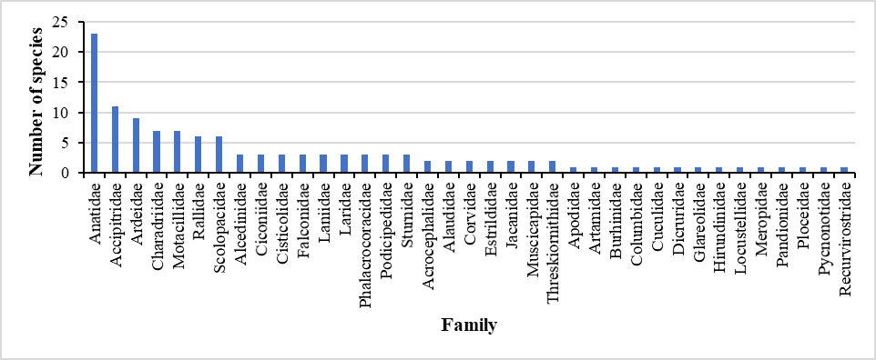
Fig 2: Family-wise distribution of avifauna in Pakhibitan Bird & Wildlife Sanctuary.
Based on the IUCN Red List status among the 124 species of avifauna 113 species were Least Concern (LC), 6 species were Near Threatened (NT) which includes Ferruginous Pochard, Falcated Duck, Himalayan Griffon, Northern Lapwing, River Lapwing and Great Thick-knee. The four Vulnerable (VU) species were Common Pochard Indian Spotted Eagle, Imperial Eagle, and Lesser Adjutant. Steppe Eagle that was Endangered (EN), found in the study area.
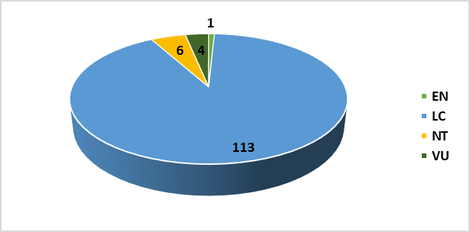
Fig 3: IUCN Red List of Threatened Species
The Residential status of observed species shows that 50% of the total species were resident (R) and 44% species contributed as a migratory (M). Rest 6% birds were local migrant (LM) (Fig 4). Compared to the residential status coming of winter visitor birds number are close to the resident bird number which means during the winter season lots of migratory birds aggregate in this place.
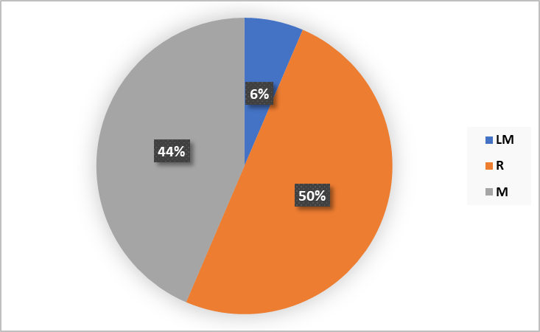
Fig 4: Residential status of avifauna in Pakhibitan Bird & Wildlife Sanctuary
Discussion:
From this result Pakhibitan Bird & Wildlife Sanctuary is highly rich in avifaunal diversity. The previous studies have been done by Datta (2011) who reported 80 species of birds. Later Ghosh (2021) documented 69 species during late winter season. So, the present findings revealed that the diversity of avifauna continue increase in this wetland by comparing their studies.
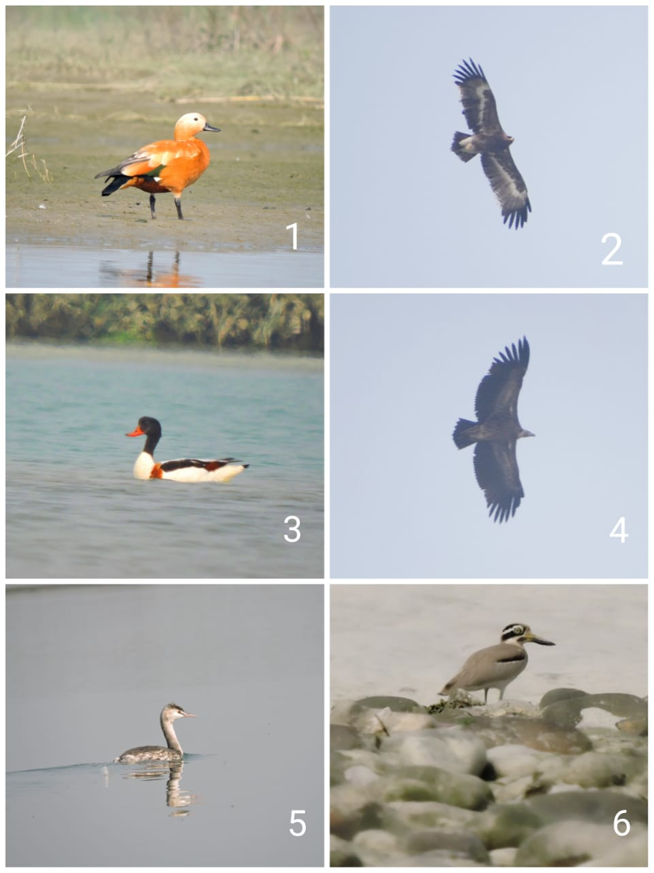
Photoplate 1: Some recorded species of Pakhibitan Wildlife Sanctuary- 1. Ruddy Shelduck (Tadorna ferruginea), 2. Steppe Eagle (Aquila nipalensis), 3. Common Shelduck (Tadorna tadorna), 4. Himalayan Griffon (Gyps himalayensis) 5.Great-crested Grebe (Podiceps cristatus) 6. Great Thick-knee (Esacus recurvirostris).
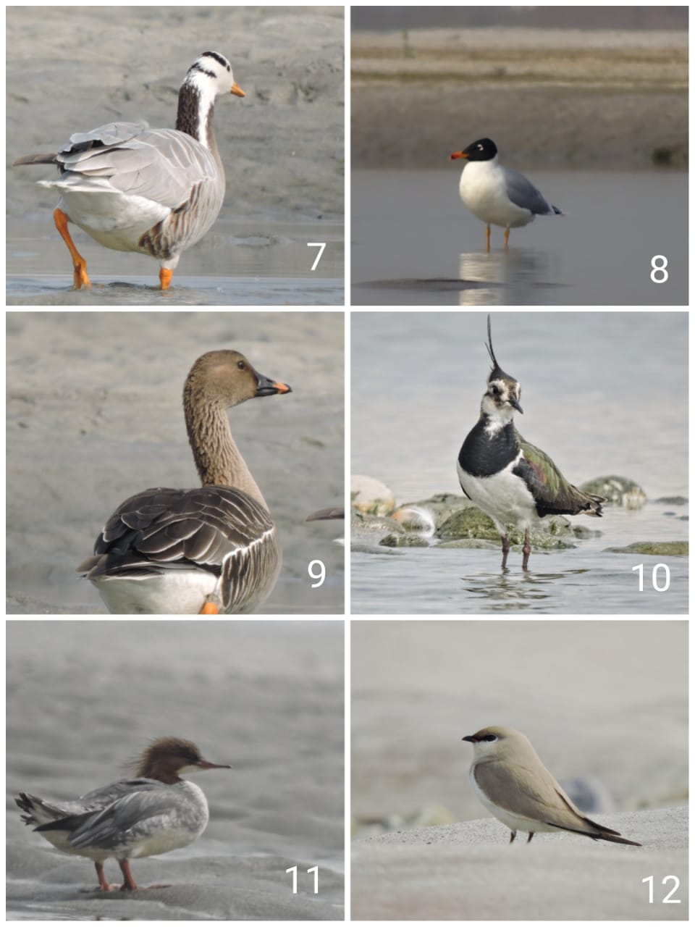
Photoplate 2: Some recorded species of Pakhibitan Wildlife Sanctuary- 7. Bar-headed Goose (Anser indicus), 8. Pallas’s Gull (Larus ichthyaetus), 9. Bean Goose (Anser fabalis) 10. Northern Lapwing (Vanellus vanellus), 11. Common Merganser (Mergus merganser), 12. Small Pratincole (Glareola lacteal).

During the winter season, migratory birds congregate with a greater variety and among the 124 species, 23 species were under the Anatidae family which were ducks and geese. Bean Goose Anser fabalis was the rare sighted species, previously Ghosh, (2021) also reported this. Common Merganser Mergus merganser and Red-breasted Merganser Mergus serrator are only found in the Pakhibitan Bird & Wildlife Sanctuary throughout the West Bengal state. There are only few records of Smew Mergellus albellus and Common Goldeneye Bucephala clangula and also not commonly seen in other waterbodies in West Bengal. Among the Podicipedidae family, Black-necked Grebe Podiceps nigricollis also have a few records in this bird sanctuary. It is also a good place for raptor birds in the Winter season. The raptor birds were Osprey Pandion haliaetus, Eurasian Marsh Harrier Circus aeruginosus, Indian Spotted Eagle Clanga hastata, Steppe Eagle Aquila nipalensis, Booted Eagle Hieraaetus pennatus, Imperial Eagle Aquila heliaca, Common Kestrel Falco tinnunculus, Pied Harrier Circus melanoleucos, Eurasian Marsh Harrier Circus aeruginosus, Long-legged Buzzard Buteo rufinus, Peregrine Falcon Falco peregrinus, Red-necked Falcon Falco ruficollis and Short-toed Snake Eagle Circaetus gallicus. Himalayan Griffon Gyps himalayensis is a scavenger near threatened bird was also recorded from the study area.
Conclusion:
The diversity of birds is very much satisfactory in this wetland. But, if the fishing and tourism in this activity continue rise the diversity of birds may be decrease. Be careful to the mixing of agricultural waste water does not mixed with the wetland which may affected the water associated birds. If the water level rise in the wetland in such case the dabbler birds may be face the problem of collecting their food from bottom substrata. So the local peoples, researchers and authorities need careful to maintain and conserve such pleasant habitats.
Acknowledgments:
We sincerely thank Professor Bulganin Mitra of Ramakrishna Mission Vivekananda Centenary College for helping to prepare the manuscript and for offering technical advice as and when it was needed. The boatman has provided numerous forms of assistance in taking us through the wetland, which the authors respectfully thank. The team of Nature Mates-Nature Club is also thanked for their assistance.

References:
- Matthews, G. V. T. (1993, March). The Ramsar Convention on Wetlands: its history and development. Gland: Ramsar Convention Bureau. 37-38.
- Amezaga, J. M., Santamaría, L., & Green, A. J. (2002). Biotic wetland connectivity—supporting a new approach for wetland policy. Acta oecologica, 23(3), 213-222.
- Weller, M. W. (1999). Wetland birds: habitat resources and conservation implications. Cambridge University Press.
- Brandolin, P. G., Ávalos, M. A., & De Angelo, C. (2013). The impact of flood control on the loss of wetlands in Argentina. Aquatic Conservation: Marine and Freshwater Ecosystems, 23(2), 291-300.
- Ma, Z., Cai, Y., Li, B., & Chen, J. (2010). Managing wetland habitats for waterbirds: an international perspective. Wetlands, 30, 15-27.
- Ghosh, K. (2021). Late winter study on Avifaunal Diversity from two different regions of North Bengal in India. Indian J. Applied & Pure Bio. Special Volume, 82, 88.
- Datta, T. (2011). Human interference and avifaunal diversity of two wetlands of Jalpaiguri, West Bengal, India. Journal of Threatened Taxa, 2253-2262.
- Grimmett, R., Inskipp, C., & Inskipp, T. (2016). Birds of the Indian Subcontinent: India, Pakistan, Sri Lanka, Nepal, Bhutan, Bangladesh and the Maldives. Bloomsbury Publishing.
- IUCN (2023). The IUCN Red List of Threatened Species. Version 2022-2. https://www.iucnredlist.org. Accessed 04 June 2023.

