BIOREMEDIATION
Mahenthiran R  Department of Microbiology, Dr. N.G.P. Arts and Science College,  Corresponding author: Assistant professor, Department of Microbiology, Dr.N.G.P. Arts and Science College,  Coimbatore- 641048, Tamil Nadu, India.  e- mail: Mahenthiran.r@gmail.com | Durgadevi L  Department of Microbiology, Dr. N.G.P. Arts and Science College,  Ph.D. Scholar, Department of Microbiology, Dr.N.G.P. Arts and Science College,  Coimbatore- 641048, Tamil Nadu, India.  e- mail: deeptisuren@gmail.com | Aruna Varsini K  Department of Microbiology, Dr. N.G.P. Arts and Science College,  Ph.D. Scholar, Department of Microbiology, Dr.N.G.P. Arts and Science College,  Coimbatore- 641048, Tamil Nadu, India.  e- mail:arunvarsini@gmail.com

ABSTRACT
Nowadays the globalenvironment is facing a highly critical situation due to the growing cities, industries, and increasing population in the limited natural resource. The growth of the population reflects the drastic changes in the environment. There is a use of a highly developed environmental management system and biotechnological technology to remove the contaminants from natural resources known as bioremediation. Bioremediation is one of the most considered and useful alternative methods for eradicating contamination from nature for sustainable waste management. Today’s recent advancement of technologiesmultiplies the bioremediation process for production of the natural resource from recycling waste material. This chapter covers detailed notes about bioremediation and its principles in the working process and the types of methods involved in contaminated areas and the role of microbes in the remediation process and their applications.
Keywords: Bioremediation, contamination, microbes, methods, applications.

I. INTRODUCTION
Over the years, human activities have led to the release of hazardous substances into the soil, water, and air, resulting in widespread environmental degradation. Bioremediation is a promising and eco-friendly approach to tackle various pollution problems. Bioremediation, derived from "bio" (life) and "remediation" (restoration), is a cutting-edge and sustainable technique that utilizes the remarkable abilities of living organisms to naturally clean up and mitigate pollution in our environment. The fundamental principle behind bioremediation lies in the metabolic potential of these living organisms, which can break down complex contaminants into simpler and less harmful compounds through natural biochemical processes. This not only helps in restoring the contaminated environment but also promotes a self-sustaining cycle that fosters ecological balance. Bioremediation comes in various forms, including biodegradation, phytoremediation, and bioaugmentation. Each method targets specific types of pollutants and environmental conditions. As research and technological advancements continue to enhance our understanding of bioremediation processes, their applications are becoming more widespread. From cleaning up oil spills to remediating industrial waste sites and even managing pollutants in urban areas, bioremediation is reshaping the way we approach environmental conservation.

Various physicochemical techniques have been widely used for the removal of pollutants from the environment, but these techniques are often not practical, due to factors such as high maintenance and operational costs, and the production of secondary contaminants that have a high toxicity. One promising technique for removing pollutants is known as biological remediation, with advantages over other methods in terms of removal efficiency, eco-friendly process, and low operational and maintenance cost. The bioremediation process utilizes microorganisms such as fungiand bacteria to remove or modify pollutants. Microalgal technology has also shown to be a promising approach to sustainable dealing with pollutants. The microalgae application has other benefits due to its production growth rate which can be faster in wastewater than freshwater and simultaneously produces valuable products like biofuel, pigments, nutraceuticals, and aquatic feedstock from biomass generated.

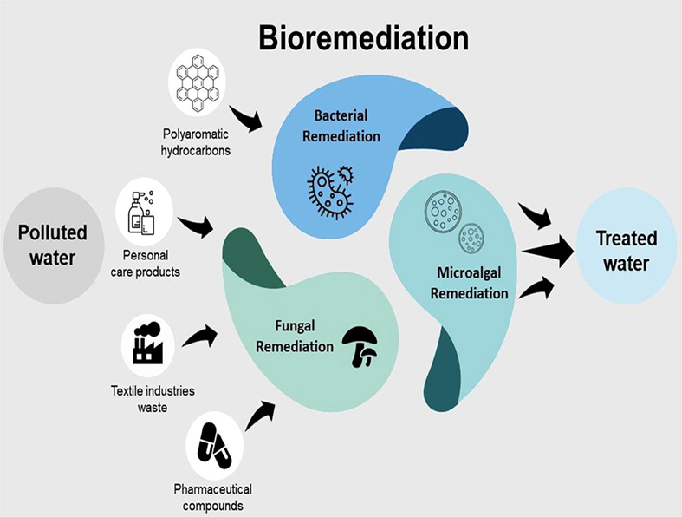
Fig 1:Bioremediation

I. CATEGORIES OF BIOREMEDIATION
Biological remediation can be categorized into two types
- Microbial remediation
- Phytoremediation

A. Microbial Remediation
Microorganisms are well known for their ability to break down a huge range of organic compounds and absorb inorganic substances. Currently, microbes are used to clean up pollution treatment in processes known as bioremediation. Different microbial systems like bacteria, fungi, yeasts, and actinomycetes can be used for the removal of toxic and other contaminants from the environment. Microorganisms are readily available, rapidly characterized, highly diverse, omnipresent, and can use many noxious elements as their nutrient source. They can be applied in both in-situ and ex-situ conditions. The bacteria that can degrade major pollutants include Pseudomonas, Aeromonas, Moraxella, Beijerinckia, Flavobacteria, chlorobacteria, Nocardia, Corynebacteria, Acinetobacter, Mycobacteria, Modococci, Streptomyces, Bacilli, Arthrobacter, Aeromonas, and Cyanobacteria.

B. Phytoremediation
Phytoremediation is a bioremediation process that uses various types of plants to remove, transfer, stabilize, and or destroy contaminants in the soil and groundwater. There are different types of phytoremediation mechanisms. (fig.2) They are
- Rhizosphere biodegradation
- Phyto-stabilization
- Phyto-accumulation (also called phytoextraction)
- Hydroponic Systems for Treating Water Streams (Rhizofiltration).
- Phyto-volatilization
- Phyto-degradation
- Hydraulic Control
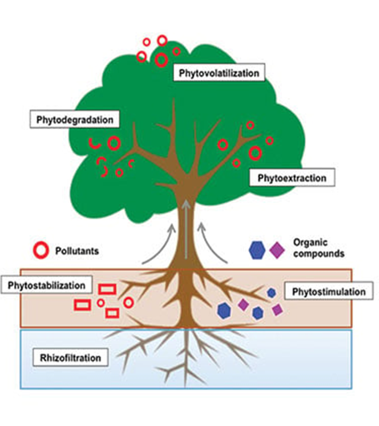
Fig 2.Phytoremediation

I. METHODS OF BIOREMEDIATION
Bioremediation techniques encompass a variety of approaches that utilize living organisms to clean up contaminated environments. Each technique is tailored to the specific type of pollutant, the nature of the contaminated site, and the desired remediation outcomes. There are different methods of bioremediation
- Natural attenuation or intrinsic bioremediation
- Biostimulation
Technologies can be generally classified as in situ or ex situ. Bioremediation (fig.3)
- In Situ bioremediation
- Ex Situ bioremediation
A.Natural attenuation or intrinsic bioremediation or Bio-attenuation
Bioremediation occurs on its own without adding anything (fig 7).
B. Biostimulation
Bioremediation is spurred on via the addition of fertilizers to increase the bioavailability within the medium. (fig. 4).
C. In Situ Bioremediation
In Situ, Bioremediation is a bioremediation technique that involves treating the contaminated material at the site without removing it. This approach utilizes naturally occurring or introduced microorganisms to degrade, transform, or remove pollutants in their original location. In Situ bioremediation is particularly applicable to contaminated soil and groundwater, as well as some surface water and sediment environments.
D. Ex Situ Bioremediation
Ex-situ bioremediation is a type of environmental remediation technique used to clean up contaminated sites by removing the pollutants and treating them outside of their original location. Unlike in situ bioremediation, where the cleanup process occurs in the same place as the contamination, ex-situ bioremediation involves excavating orremoving contaminated materials and treating them elsewhere.

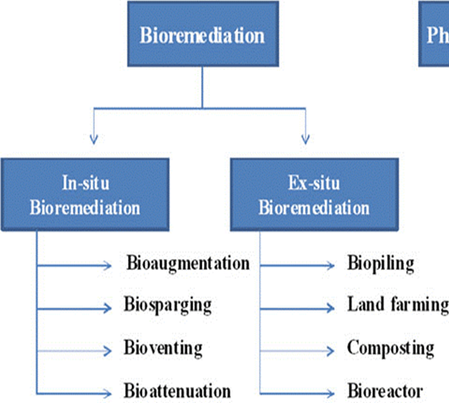
Fig 3. Methods of bioremediation
C)In Situ bioremediation
Bioaugmentation:
Bioaugmentation involves introducing specific strains of microorganisms (bacteria, fungi, or other microbes) to the contaminated site to enhance the natural degradation of pollutants. These introduced organisms may be more efficient at breaking down the particular contaminants present (fig 4).

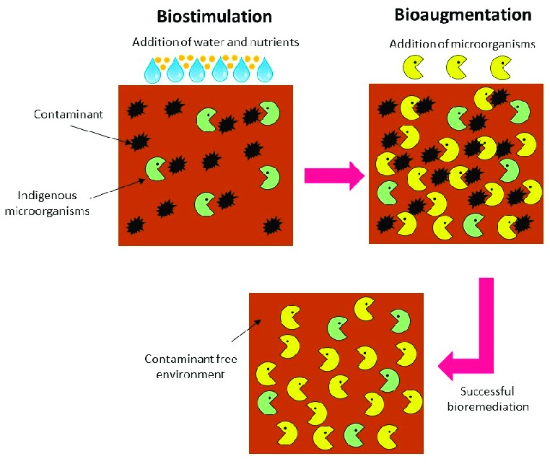
Fig4 Biostimulation and bioaugmentation

Bioventing
Bioventing is a technique used to treat soil contaminated with volatile organic compounds (VOCs). Air and oxygen are pumped into the soil to enhance the activity of aerobic microorganisms that can metabolize the contaminants (fig 5).
Biosparging:
Similar to venting, sparging is used to remediate groundwater contaminated with VOCs. Air or oxygen is injected into the saturated zone to promote microbial degradation of the pollutants (fig 6).
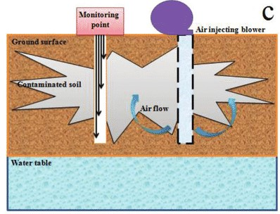
Fig 5.Bioventing

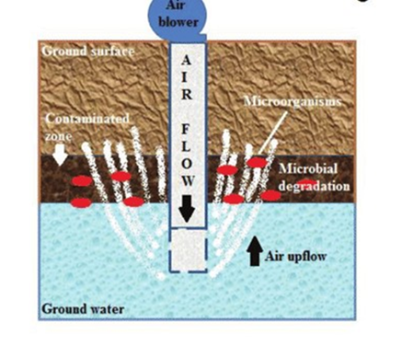
Fig 6.Biosparging



Fig.7 Bioattenuation

D) Ex Situ Bioremediation

Biopiling:
Biopiling involves the containment of contaminated soil in a specially constructed treatment area. The soil is then actively managed and mixed to create favorable conditions for microbial degradation. This method often includes aeration, moisture control, and nutrient addition to enhance microbial activity (fig 8).

Landfarming:
In landfarming, contaminated soil is spread out over a prepared area and periodically tilled to mix in oxygen and promote microbial degradation of the pollutants. Nutrients may also be added to enhance microbial activity. This method is suitable for treating petroleum hydrocarbon-contaminated soils. (fig 9).

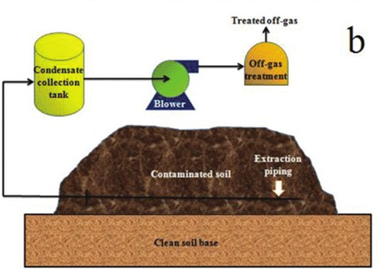
Fig.8 Biopiling

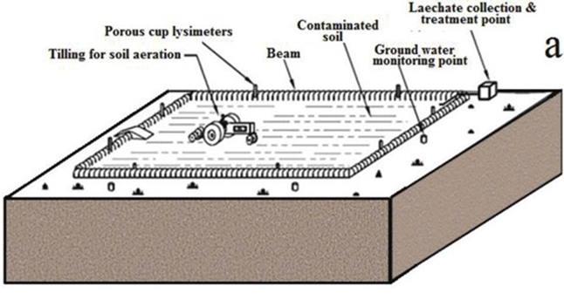
Fig.9 Landfarming

Composting:
Composting is a form of ex-situ bioremediation mainly used for organic contaminants. The contaminated material, such as soil or organic waste, is mixed with bulking agents like wood chips or yard waste to create compost. During the composting process, naturally occurring microorganisms break down the contaminants (fig 10).
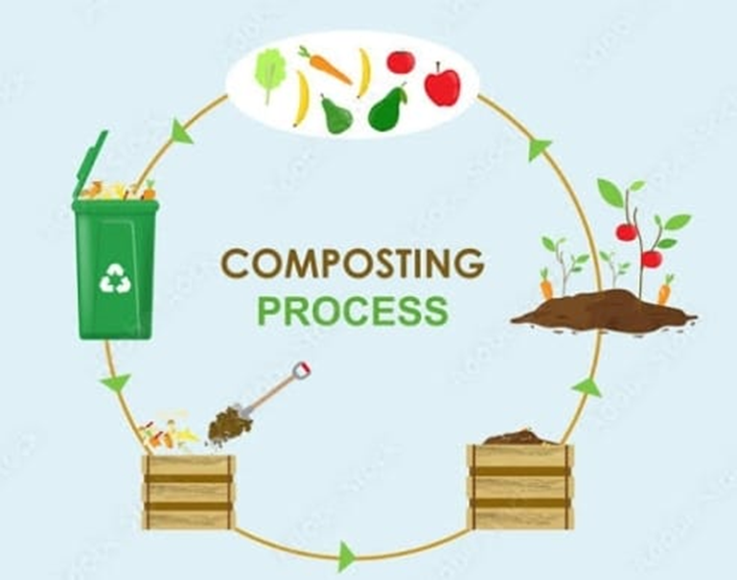
Fig.10 composting
Bioreactors:
Bioreactors are enclosed containers where contaminated materials, such as soil or water, are treated with specific strains of microorganisms. The environmental conditions within the bioreactor are carefully controlled to optimize biodegradation (fig 11)
.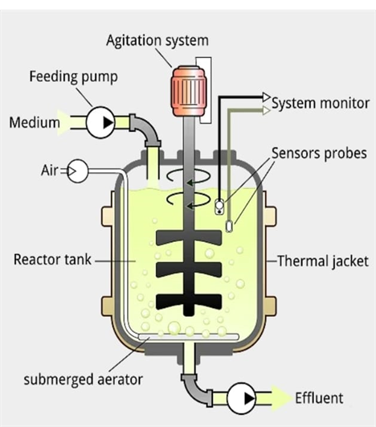
Fig.11 Bioreactor

II.APPLICATIONS OF BIOREMEDIATION
Bioremediation has been widely applied in various environmental cleanup scenarios due to its cost-effectiveness, sustainability, and ability to harness natural biological processes. Some of the key applications of bioremediation include
Oil Spill Cleanup:
Bioremediation has been successfully used to clean up oil spills in marine and terrestrial environments. Microorganisms, such as certain bacteria and fungi, are employed to break down the hydrocarbons present in the spilled oil, effectively reducing its impact on ecosystems.

Contaminated Soil Remediation:
Bioremediation is applied to treat soils contaminated with various pollutants, including petroleum hydrocarbons, solvents, pesticides, and heavy metals. Microorganisms in the soil naturally degrade these contaminants when provided with appropriate conditions and nutrients.

Groundwater Cleanup:
In cases where groundwater is contaminated, bioremediation techniques can be employed to stimulate the growth of indigenous microorganisms that can degrade the pollutants in place or pump the groundwater to an ex-situ treatment system.
Wastewater Treatment:
Bioremediation is used in wastewater treatment plants to remove organic pollutants from industrial and municipal wastewater. Microorganisms in activated sludge systems break down organic matter, reducing its environmental impact before the treated water is discharged.
Landfill Remediation:
Bioremediation is applied to treat waste materials in landfills, particularly the degradation of organic wastes. This can reduce the production of harmful landfill gasses and the leaching of pollutants into thesurrounding soil and groundwater. Published in Archives of Petroleum & Environmental Biotechnology 2019.
Mining Site Cleanup:
Abandoned mining sites often contain elevated levels of heavy metals and other toxic compounds. Bioremediation, particularly using plants or microorganisms, can help stabilize or remove these contaminants from the soil and water.
Biodegradable Waste Management:
Bioremediation processes can be employed to treat biodegradable organic waste, such as food waste, agricultural residues, and yard waste, in composting facilities, reducing the environmental burden of waste disposal.
Brownfield Redevelopment:
Bioremediation is utilized in redeveloping brownfield sites, where past industrial activities have left contaminants in the soil and groundwater. By cleaning up the contamination, these sites can be repurposed for new developments.
Bioremediation of Contaminated Water Bodies:
Polluted water bodies, such as rivers, lakes, and ponds, can be treated using bioremediation techniques. Floating treatment wetlands and other systems can harness the abilities of plants and microorganisms to remove pollutants from the water.

Some examples of microorganisms that are involved in bioremediations in different types of pollutants in the environment. (Table.1).

Table.1 Microorganisms and their applications in different contaminant site

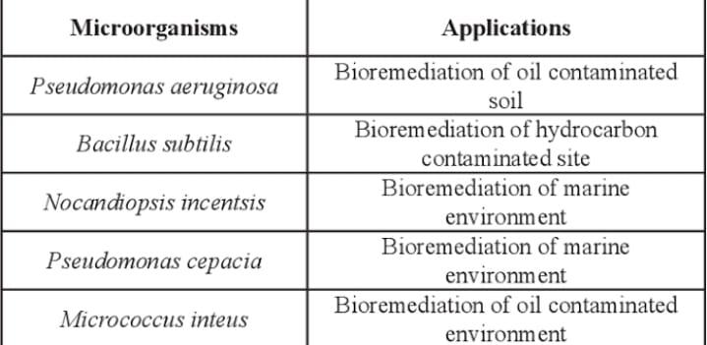

REFERENCES

- Jim C Philp, Ronald M Atlas, Colin J Cunningham, Bioremediation Napier University, Edinburgh, UK, and Contaminated Land,15thMarch 2009.
- Babak Pakdaman Sardrood, Chapter 1 An Introduction to Bioremediation, January 2013
- Bradley, In situ and ex situ of bioremediation technologies for remediation of contaminated sites,2003.
- Biological methods applied for remediation of polluted waters an Interreg-IPA Cross-border Cooperation Romania-Serbia page.no 1 of 17.
- Santanu Maitra,Ex-situ bioremediation an overview © 2018 Life Science Informatics Publication All rights reserved Peer review under responsibility of Life Science Informatics Publications 2018 Nov – Dec RJLBPCS 4(6) Page No.422,
- Modupe S. Ayilara1,2,3 and Olubukola O. BabalolaBioremediation of environmental wastes: the role of microorganisms, 30 May 2023.
- Pranay Sadawarti, bioremediation an effective way to environmental sustainability, April 2023,In book: Interdisciplinary approaches and strategies for sustainable development (pp.258-264).

- Jot Sharm, Advantages and Limitations of In Situ Methods of Bioremediation, Recent Advances in Biology and Medicine Sep 26, 2019.

- Pankaj Kumar Jain,Vivek Bajpai,Biotechnology of bioremediation-A review January 2012.

- Tapan Kumar Mohanta, National Institute of Plant Genome Research, India. Yugal Kishore Mohanta North Orissa University, India .Nibedita Mohanta North Orissa University, India.Chapter 16, Role of Biotechnology in bioremediation,January 2019.

- N. Sharma, M. Lavania, B. Lal, Microbes and their secondary metabolites, agents in bioremediation of hydrocarbon contaminated sites.

- Assessment and Remediation Research Centre, Edinburgh, UKBioremediation of Waste Gases and Polluted Soils - Scientific Figure on ResearchGate. Available from: https://www.researchgate.net/figure/Types-of-bioremediation-techniques_fig1_345803851 [accessed 28 Jul, 2023]

- PatilAmruta, Bioaugmentation - In-situ Bioremediation Technique - Environment Notes,Mar 20,2023.

- Bioremediation methods-(a) landfarming, (b) biopile, (c) bioventing, (d) bioslurping, and (e) biosparging. Petroleum Degradation: Promising Biotechnological Tools for Bioremediation - Scientific Figure on ResearchGate. Available from: https://www.researchgate.net/figure/Bioremediation-methods-a-landfarming-b-biopile-c-bioventing-d-bioslurping-and_fig4_322994319 [accessed 28 Jul, 2023]

- Soil Bioremediation: Overview of Technologies and Trends - Scientific Figure on ResearchGate. Available from https://www.researchgate.net/figure/Comparison-between-Bioaugmentation-and-Bioaugmentation-and-Biostimulation-techniques-adapted-from-84_fig5_344716349 [accessed 28 Jul, 2023]

