Mulberry (Morus spp.): the ultimate plant for sustainable development
Ritwik Acharya
Department of Sericulture
Raiganj University
Raiganj, North- Dinajpur, West Bengal- 733134
e mail- rittik.acharya@gmail.com

ABSTRACT
Mulberry (Morus spp.), a member of the Moraceae family, is identified as a special plant because of its wide geographic distribution across continents, its versatility in cultivation, many uses for its leafy foliage, and its benefits in safety measures of the environment like eco-restoration of the degraded soil, bioremediation of polluted specific sites, water conservation, soil erosion prevention, and improvement of air quality through carbon sequestration. In order to battle the issue of ongoing environmental degradation and population expansion, policymakers and scientists have begun to pay attention to the further exploitation of mulberry through the creation of diverse products in the pharmaceutical, food, and healthcare industries other than its use as the feed of Bombyx mori larvae in sericulture. As mulberry is used in the pharmaceutical and food industries and in environmental safety measures, it is appropriate to refer to it as the plant ideal for sustainable development. All the crucial mulberry traits were compiled in this review article in order to evaluate it as the perfect plant for ensuring a sustainable future.
Keywords: Mulberry; Sustainable development; Environmental safety; Eco-restoration; Sericulture.

- INTRODUCTION
Immense population growth, degraded ecosystem, and food resource constraints are the biggest challenges to deal with in this 21st century. The world was protected and home to a huge diversity of species before people began to colonise it [1]. Since, the 19th century, as a result of increasing urbanisation and growth in the human population, large quantities of hazardous gases, liquid chemicals, and non-biodegradable solid waste have been released into the environment from our own residences, cars, and businesses [2]. Wastes including plastic, pesticides, and artificial fertilisers have gotten into the soil and water, reducing the fertility and in turn, the number and variety of soil microorganisms and decomposers as well as lowering agricultural production has resulted [3]. Population growth and environmental degradation ultimately lead to lesser agricultural production and poor crop quality, resulting in human dietary deficiencies. It is already a severe global concern, especially in regions where the food is unvarying.
Mulberry is a common and cost-effective woody plant (Genus: Morus; Family: Moraceae). Mulberry is the most important element of the sericulture industry, which employs many people in India, Bangladesh, China, Pakistan, and many other nations of Asia because the monophagous silkworm (Bombyx mori L.) only naturally consumes mulberry leaf [4]. Its great economic significance outside of sericulture is a result of its many distinctive and unusual characteristics.
The role of Mulberry in ecological sustainability is now a great point of interest for scientists across the globe. Many of the tree species are effectively used for phytoremediation of land contaminated with hazardous chemicals [5]; some are effective at removing dangerous substances from air and water [6]; some are used for eco-restoration and soil conservation [7] and some are as only economic crops. It is clear that no single plant or tree species possesses all the qualities necessary for environmental protection, economic growth, advancement of human health, or industrial exploitation. However, the mulberry (Morus spp.) has all these qualities, making it the most advantageous plant in our plant collection for the purpose of sustainability. Hence, it is referred to as "Kalpa Vriksha" in India due to its many useful functions since ancient days [8].
Mulberry has massive potential as a food resource and a key component for the pharmaceutical industry. The Mulberry is now used industrially since every component of it is used to prepare a variety of items in the food and healthcare industries [9, 10]. Fresh mulberry fruits are rich in carbohydrates, which can be found as simple sugars, starch, soluble and insoluble fibres, or both. They contain a lot of water and a few calories. Fruits are mostly discovered to include iron, vitamin C, a good amount of potassium, vitamin E, and vitamin K. Alongside that, they contain a lot of plant substances like anthocyanins, which give them their colour and have beneficial health effects. Fruits can also lower blood cholesterol levels, enhance blood sugar levels, and help avoid fatty liver disease. Fruits have been shown to be useful in lowering oxidative stress, which can lower the risk of developing cancer. Mulberry leaves also possess the same qualities as the fruit. According to recent research, mulberry leaves have a high concentration of bioactive substances, primarily alkaloids, flavonoids, -aminobutyric acid (GABA), and phenolic acids [11]. These substances have antioxidation properties that work well [12, 13], and they also lower blood sugar levels [14, 15], reduce hypertension [16], stop atherosclerosis [17], and have anti-inflammatory properties [18]. Mulberry contains bioactive substances such as 1-deoxynojirimycin (DNJ), which appears to be a potent -glycosidase inhibitor and has also demonstrated promising therapeutic potential for reducing several illnesses, particularly type II diabetes [19, 20]. Recent studies also looked into the highly intriguing mulberry tyrosinase inhibitory activity. The most widely recognised species of the genus Morus in this regard are the red mulberry (Morus rubra), black mulberry (Morus nigra), and white mulberry (Morus alba) [21].
Mulberry is almost cosmopolitan in its global distribution and it is possible to cultivate mulberry in different forms of land like mountains, valleys, and plains under rainfed as well as in irrigated conditions [22] and also in harsh conditions like humid and semi-arid lands; with varied modes (tree, dwarf, and bush). According to Huang and Wang (2012) [23] and Qin et al. (2012) [24], it has the greatest impact on environmental protection through the eco-restoration of degraded lands, bioremediation of polluted sites, air purification through carbon sequestration, and soil and water conservation through its deeply rooted dense network of root systems. By virtue of the physiologically active components found in the leaf, stem, and root sections, mulberries are also recognised as a medicinal plant that can improve and enhance human life [25, 26].
It is reasonable to refer mulberry as the ideal plant for eco-sociological sustainability due to its aforementioned qualities. In this article, the significance of mulberries is discussed in relation to environmental safety, human health promotion, and animal husbandry (Fig. 1).
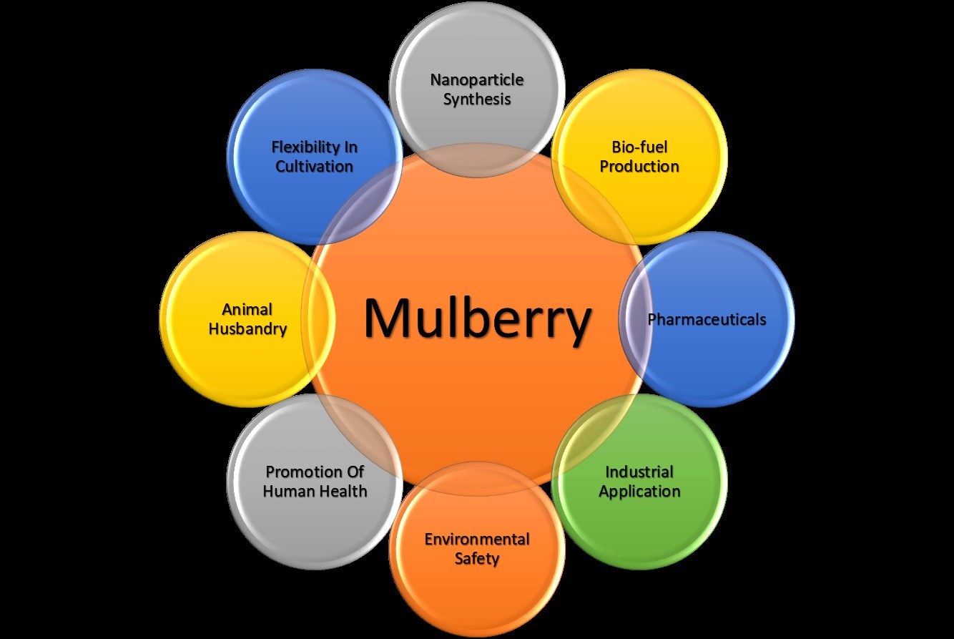
Fig. 1 Multidimensional utilities of mulberry

- MULBERRY IN ENVIRONMENTAL SAFETY
Mulberry nowadays considered as an extremely important plant in eco-restoration and environmental safety (Fig. 2). Mulberry plants can adapt to environments contaminated with a variety of soil pollutants like cadmium, lead, and copper [27- 29]. This is due to their salient features of perennial and woody nature, deep and wide spreading nature of root system, and high biomass production [30]. Mulberry plants grown in the tree mode are more favourable for soil and water conservation [31]. Due to its high rate of carbon sequestration, this plant species is also well-suited for removing atmospheric gaseous carbon pollution [32].
Mulberry plants may flourish in fertile soil that is deep, sandy, or clayey and porous, as well as in barren soil that is coarse in texture and deficient in nutrients [33]. Mulberry can endure dry and harsh environmental conditions because of its strong, deep root system, which creates a highly tangled, dense network of secondary and tertiary roots in any type of soil [23]. These qualities also made the mulberry plants resistant to wind currents and sand storms. This made it possible to grow mulberry trees even in waste areas that were heavily polluted or in areas that were higher up and more exposed to strong wind currents.
Mulberry plant is fast-growing, highly heterozygous, and perennial. It is better suited for growing in a variety of settings with varying elevations, soil, temperatures, and pH levels. Because it can withstand floods, droughts, and wind currents, mulberry is thought to be the best tree species for landscaping in cities. With an annual rainfall range of 600 to 2500 mm, it can be grown both in irrigated and rain-fed environments. In different land types, including plain, hilly, valleys, and sloppy places, mulberry can easily be farmed. It can be grown in cities along highway medians, riverbanks, flood plains, public gardens, field crop edges, street trees, and in recreation club areas. It can also be grown in public parks and public gardens [24]. Mulberry plantations can be used for reforestation to achieve a number of benefits, including the ability to restore soil carbon, maintain soil water holding capacity, prevent soil erosion during floods and water logging conditions, improve soil nutrients, nurture soil microflora, improve air quality, and withstand wind currents and sand storms [32, 34, 35]. The intercropping of grass, vegetables, or other cash crops with mulberry plantations is also possible which results in better eco-restoration [24, 36]. For instance, mulberry plantations have shown promise in a number of areas, including soil improvement [37], air quality improvement [32], soil and water conservation [36] and sustaining unfavourable environmental conditions [38- 39]. They also play a significant economic role (Datta, 2000). Mulberry is thus recognized as a green afforestation tree species and is frequently chosen as a plant for afforestation activities throughout the world [40].
Mulberry plants have huge potential to uptake carbon pollutants and heavy metal pollutants from the soil due to a massive rhizosphere network [41], while mulberry leaves have a strong ability to absorb air pollutants from the atmosphere like carbon dioxide, carbon monoxide, hydrogen fluoride, sulfur dioxide, and chlorine [32, 42]. According to Lu and Jiang (2003) [43], mulberry trees can absorb 5.7 g of sulfur dioxide per kilogram of dried leaves, and they may also take in significant amounts of sulfur dioxide gas each day. Mulberry is therefore categorized as a type of tree that is resistant to sulfur dioxide pollution [24]. Mulberry roots have a specialised architecture with a larger diameter near the stem followed by rapid shrinking in size; they have a long rope-like structure made up of secondary and tertiary roots as well as root hairs that allow them to absorb large amounts of carbon pollutants from the soil [37, 44].
Mulberry plants grown as trees are said to be better suited for soil and water conservation [31]. Until now up to 10–20% reduction in runoff during flooding in lands maintained with mulberry plantations has been noticed [36]. In comparison to slope lands, the yearly runoff in mulberry plantation sites on plain lands can be decreased by 38% for under-5-year-old plants and by 91% for under-10-year-old plants, respectively [31]. According to studies, soils that have been planted with mulberry plants have a greater potential to retain water than open ground [33, 42]. When compared to other plant species, the mulberry's deep and wide-spreading root system has allowed soils to retain and keep water at higher rates. Mulberry trees are said to have a deep, intricate root structure that increases soil shear strength and, as a result, the mulberry-planted fields can resist soil- erosion.
The mulberry's deep and extensive root system has a heavy phyto-accumulation capacity. In an experiment by Hashemi and Tabibian (2018) [38] after adding mercury nitrate to the soil in three different concentrations (30, 50, and 70 mg/L), two-year-old Morus nigra saplings were planted there and allowed to develop for eight months. After 8 months it was noted that mulberry saplings have shown tremendous phytoaccumulation capacity, alongside that it was also noted that the absorption of mercury metal was recorded lesser in leaf and stem portions whereas, it was significantly higher in root parts.
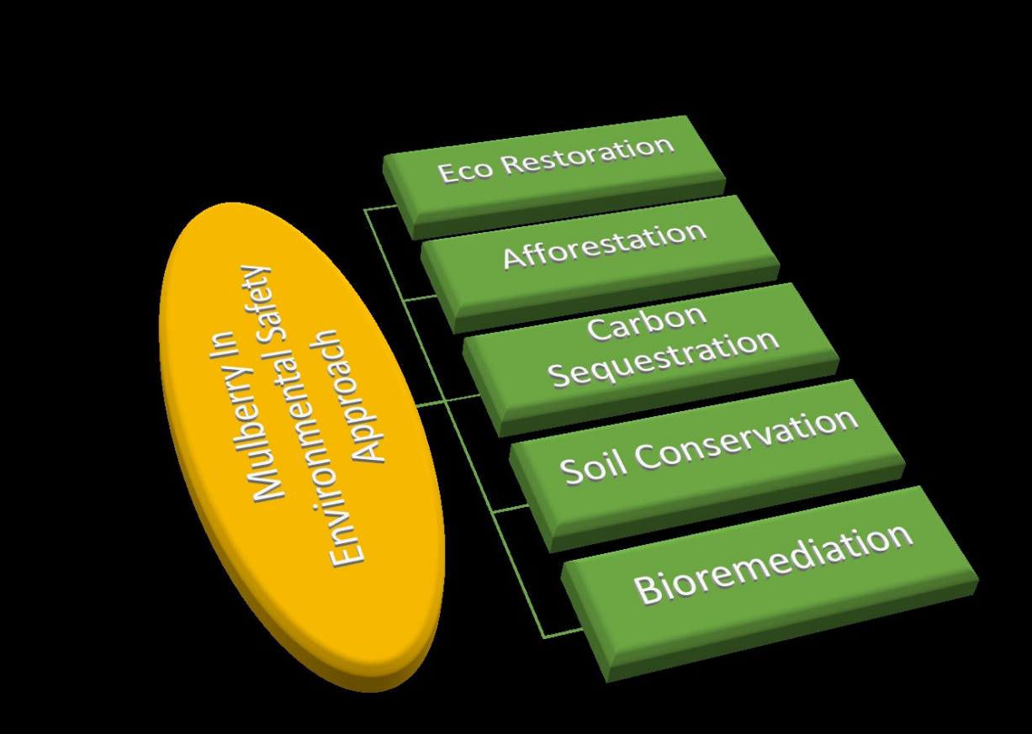
Fig.2. Various role of mulberry in environmental aspects

- MULBERRY AS FOOD AND VALUE-ADDED PRODUCTS
Exploration of novel natural food sources has been prompted by rising consumer demand, but it is important to remember that the food item must fulfil health benefits and dietary requirements. In this regard, it is clear that mulberry fruits are already well-known worldwide for their delectable flavour, making them excellent for consumption either in their natural state or as a component in products with additional value. They can also be used in cooking. Its strong nutritional value and low-calorie content are helping it gain popularity among customers in addition to its great taste. There is also a great deal of potential to use other mulberry components as a source for processed foods. This has caused mulberry to be more in demand, even in the food manufacturing industry. The main functions of mulberry as a food and value-added product are explained in Fig. 3.
The fruit of the mulberry tree can be utilised straight away to make soft drinks and jam [42]. Because they are packed with vitamins, amino acids, and other minerals including Zn, Ca, Mn, and Fe as well as pectin and fibrin, fresh mulberry fruits are widely regarded for their beneficial effects on human health. Mulberry leaf is used to make dhokla, pakoda, tea and a variety of other delectable delicacies [45]. Mulberries are an excellent resource for the food business because they are well-liked vegetables with high sugar content. It can be used to make fruit juice pulp, fruit wine, fruit sauce, fruit powder, bread, cakes, fruit drinks, and even chocolate. Mulberry fruits can be used to make many kinds of tonics, syrups, wine and amaretto in fresh, dried, or frozen forms. Oil can also be made from mulberry seed. Mulberry fruits that are still immature and unripe can be utilised to make chutney [46]. Famous Turkish dishes "Kome" and "Pestil" are made by combining mulberry, walnuts, honey, and flour [47, 48]. Mulberry juice has been shown to be useful for healthy skin and in the prevention of throat infection when stored under cold storage for six months to a year [49]. In China, mulberry paste, also known as "sangshengao," is used to brew tea and has been found to be useful in enhancing liver and kidney function, vision, and hearing. The Iranian people love adding dried mulberry fruit as a sweetener to their black tea. Young mulberry leaves are consumed as vegetables in a few specific places in China [21]. Because it shields cells from the effects of ageing, fruit powder of mulberry is consumable as an anti-ageing supplement. Additionally, it lowers cholesterol levels and improves the digestive system's ability to absorb carbohydrates. Mulberry wine, often known as a "lady's drink" in Europe, is made from overripe mulberry fruit. The anthocyanin from M. rubra used to colour yoghurt has no differences from strawberry-flavoured yoghurt [50]. In pastry M. alba extract can be used in addition to chokeberry, buckwheat hulls, buckwheat flour, and inulin [51]. Using mulberry plant methanolic extraction, minced meat's shelf life can be extended [52]. Fruits from M. alba can also be used to make spiced squash and savoury appetisers [53].
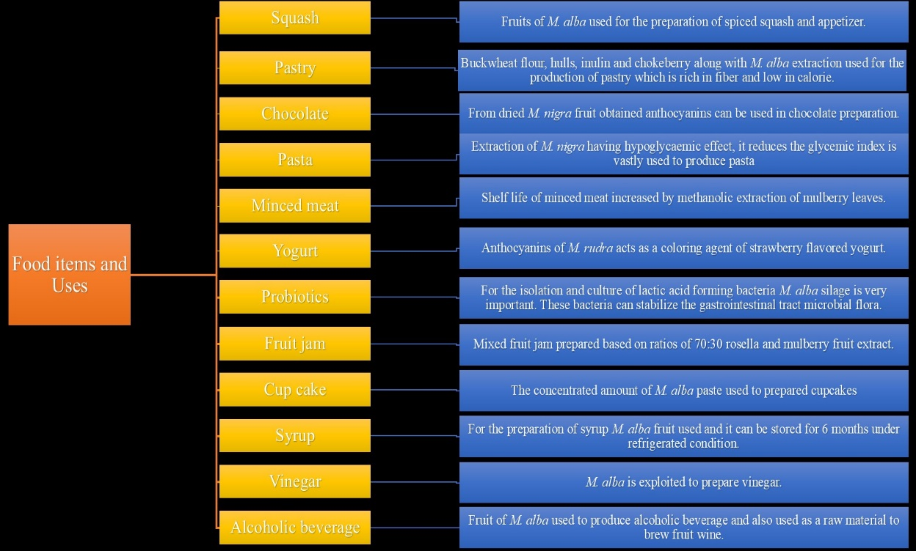
Fig. 3. Mulberry as food and related value-added products

- MEDICINAL IMPORTANCE OF MULBERRY
Mulberry leaves include amino acids, volatile oils, sugars, rutin, quercetin, vitamins, and microelements, all of which have a variety of pharmacological effects, including lowering blood sugar, acting as an antihypertensive, antihyperlipidemic, and bacteriostatic agent. [54] Different types of mulberry have bioactive substances that can lengthen life.[25]. Scientists have explored the various medicinal utilities of mulberry plants, and they have reported that many biochemical substances, including hydroxymoricin, albafuran, albanol, morusin, and kuwanol, which are isolated from mulberry plants, play a significant role in the pharmaceutical industry.[55-57] The pharmaceutical research and industry have become interested in the medicinal characteristics of mulberry plants due to their valuable medical properties. A summary of the medicinal importance of mulberry is explained in Fig. 4.
Every single portion of the mulberry plant including the leaves, fruits, flowers, stems, bark and roots are utilised in herbal therapy to treat a variety of diseases. There are numerous names for mulberry herbal supplements, including noni, nhau, mengkudu, hog's apple, wild pine, caribe, and nono. Each of these titles relates to mulberry tree-derived goods with comparable advantages and dangers. Mulberries are a great supplier of potassium, which the body needs to produce the energy required to run cells. Mulberry components may also have the ability to repair cell damage and boost the immune system [58]. Mulberry plants have powerful chemical elements that can be used as at-home remedies for a variety of human illnesses. As scavengers for oxidants present in the body, secondary metabolites such as phenols, flavonoids, and anthocyanins play a crucial function [59]. A variety of mulberry products are used to treat a variety of conditions, including oxidative stress, vaginal discharge or menstrual issues, depression, migraines, sinusitis, throat soreness, urinary tract infections, cancer, cataracts, hyperglycemia, inflammation, and kidney disorders [60]. Because of its anti-oxidant properties, mulberry is also used to prevent heart disease, strokes, and to lessen the effects of ageing. Mulberry can hydrate and encourage the creation of bodily fluid. One ounce of ripe mulberry fruits can be consumed daily for multiple health benefits. This product is appropriate for all ages and has a light aroma and sweet flavour. Drinking mulberry juice helps hydrate the body's fluids and improve eyesight in someone who suffers from dry eyes and frequently uses their eyes for work. Mulberry plants are rich in healthy nutrients like vitamins and minerals that can treat chronic digestive tract disorders, increase gastric juice secretion, enhance assimilation and digestion, increase appetite, and stop abdominal distention and constipation. Mulberry is especially well suited for chronic hepatitis, Alzheimer's disease, and gastroenteritis [61, 62].
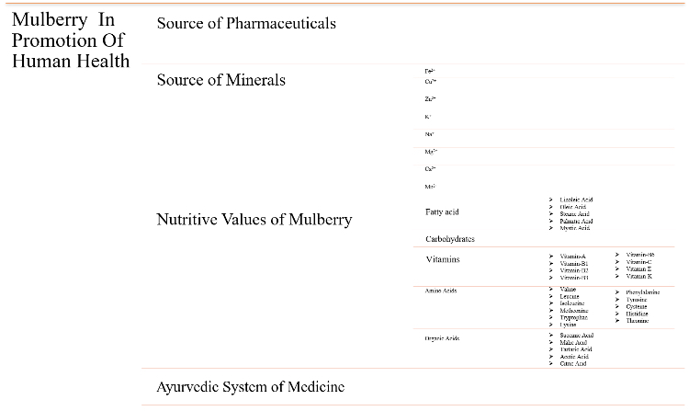
Fig. 4. Multipurpose utilities of mulberry related to human health and medicine

- USE OF MULBERRY IN ANIMAL HUSBANDRY
In modern agriculture concept, an integrated farming system has the potential to quadruple the income of the farming community. Governmental organizations also advocated this system. There are numerous models of integrated farming. Most models combine crop production with the raising of livestock. But as the world's population and industrialisation grow, so does the requirement of available land for growing green forage to feed cattle is also increasing. Because they don't require as much maintenance as fodder crops do, such as regular irrigation and a lot of fertilizer, some tree species are used as an alternative to feed domestic animals. They can be grown as a border plantation or on any wasteland, hilly terrain, or river/canal bund. Amongst many of the tree species, mulberry species has proven as a good source of nutrition as forage to cattle, especially for ruminant animals. Mulberry plants can be grown as a shrub or a tree and are found in a variety of agroclimatic zones, from tropical to temperate ones. Since they are the only food supply for silkworms, they are mostly farmed for silkworm production. In India, China, and Korea, domestic animals were given its residual leaves and branches in addition to using it to raise silkworms [63] (Fig. 5). In general, mulberry leaves have high digestibility and are a good source of protein, carbs, and minerals. Young mulberry leaves have biochemical contents of 20–23% crude protein, 8–10% total sugar, and 12–18% minerals [64, 65]. The age and season of the mulberry leaf may affect this. In addition to its nutritional value, its availability in the majority of nations makes it a popular choice for dairy cattle as green fodder. In poorer nations, grasses and cereal straws are frequently utilized as animal feed. However, these animal feeds do not provide well-balanced dietary supplements. For a healthy diet, these meals occasionally include green grasses as a supplement. The production of green grasses is nevertheless constrained by a lack of available land resources. Mulberry leaves in particular, as well as other cereal straws, provide a sufficient supplement as a result. Mulberry leaves are an excellent animal feed, especially for dairy cattle and monogastric animals due to their high digestibility and palatability [65]. Lamb development rate was increased when mulberry leaves were supplemented with ammoniated rice straw [66]. Similarly, adding mulberry leaves to the meal improved the body weight of sheep by up to 3.44% [67]. Mulberry leaves have been used as animal feed in numerous nations, including France, Italy, and Latin America]. Many researches revealed the use of mulberry leaves as animal feed in many nations, including France, Italy, and Latin America [68, 69]. Highly digestible and palatable mulberry leaves can also increase milk production in dairy animals. After 60 days of feeding mulberry leaves, the protein content of both cow and goat milk increased to 36.75%, while the carbohydrate content was 56.46% and 59.26%, respectively. After feeding mulberry leaves for 60 days, the lipid content of cow milk increased by 4.5%, and that of goat milk by 4.9% [65]. Similar findings were made by Datta et al. (2002) [70], who discovered that mulberry feeding increased milk output and milk fat content in cows. When the mulberry leaf was partially substituted for commercial concentrate when feeding growing pigs and rabbits, the economic benefits, including a decrease in the cost of commercial feeding, were also noted [64, 71]. When mulberry leaves were given to poultry birds as feed, numerous studies reported improved yolk colour, an increase in beta-carotene, and an increase in vitamin K [72, 73]. When mulberry leaf and Trichantera gigantea leaves were used as a protein source in a diet along with other energy sources like rice bran, molasses, and cassava root meal, improvements in growth and reproductive performance were noted in animals. This was in contrast to a diet consisting of commercial concentrates and grasses [74].
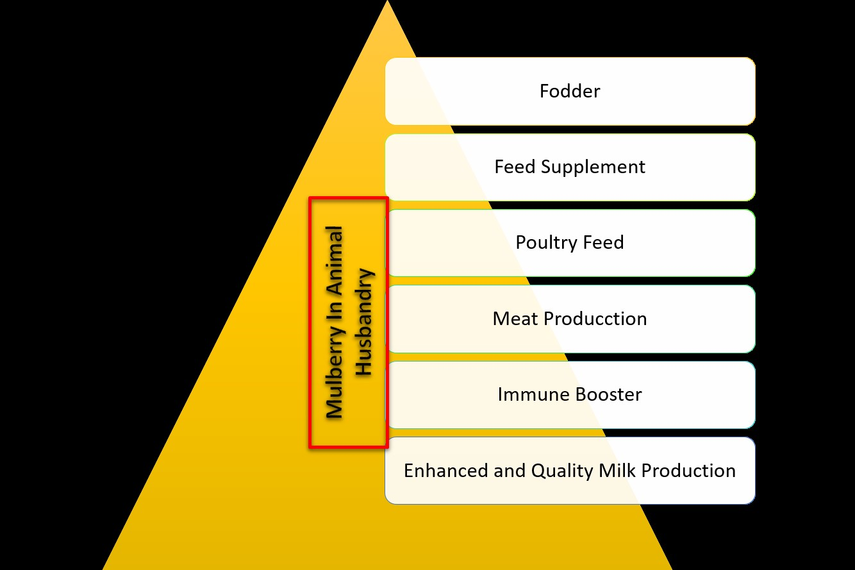
Fig. 5. Utility of mulberry in animal husbandry

- CONCLUSION
Mulberry plays a significant role in environmental cleanup through bioremediation and carbon sequestration. The results, should provoke the appropriate authorities to recommend this plant species for plantation drives across cities and urban areas (as it can be grown all over the world) along the roadsides and in social forestry for increasing the green cover and reducing pollution. Mulberry trees should potentially be used to address ecological challenges because ecological safety and sustainable development are currently significant elements of global security. Mulberry is a versatile plant with many uses in the food and medicinal industries. Due to its low-calorie content, this plant can be used to create hypo-caloric dishes as well as be added to other foods as a new component to improve their useful qualities. Mulberry is successfully used to create a variety of products, including jelly, jam, vinegar, wine, tea, squash, syrup, and many other products. This helps businesspeople use the plant's fruits, leaves, and other parts more effectively. Mulberry is one of the main components of numerous conventional formulas that are offered all over the world. Recent studies have shown that Morus spp and its bioactive phytochemicals have significant biomedical activities, including antioxidants, anti-diabetic, hypolipidemic, anti-obesity, antihypertensive, and anti-atherosclerosis. An in-depth investigation is still needed for a few biologically new chemicals found in mulberry plants that have not yet been identified. History could be written if mulberry were properly studied, explored, and used in the food and pharmaceutical industries. Simultaneously, more attention should be placed by academics and businesspeople on the mulberry's potential for widespread use in industries like animal husbandry, which might result in increased economic opportunity for people.
REFERENCES
- Bowman, D. M. J. S., Balch, J. K., Artaxo, P., Bond, W. J., Carlson, J. M., & Cochrane, M. A. (2009). D‟ Antonio. CM, DeFries, RS, Doyle, JC, Harrison, SP, Johnston, FH, Keeley, JE, Krawchuk, MA, Kull, CA, Marston, JB, Moritz, MA, Prentice, IC, Roos, CI, Scott, AC, Swetnam, JW, van der Werf, GR & Pyne, SJ, 481-484.
- Minghua, Z., Xiumin, F., Rovetta, A., Qichang, H., Vicentini, F., Bingkai, L., & Giusti, A. (2009). Municipal solid waste management in Pudong new area, China. Waste management, 29(3), 1227-1233.
- Abdel-Shafy, H. I., & Mansour, M. S. (2018). Solid waste issue: Sources, composition, disposal, recycling, and valorization. Egyptian journal of petroleum, 27(4), 1275-1290.
- Vijayan, K., Tikader, A., Weiguo, Z., Nair, C. V., Ercisli, S., and Chi-Hua Tsou. "Morus." Wild crop relatives: genomic and breeding resources: tropical and subtropical fruits (2011): 75-95.
- Hashemi, S. A., & Tabibian, S. (2018). Application of Mulberry nigra to absorb heavy metal, mercury, from the environment of green space city. Toxicology Reports, 5, 644-646.
- Raskin, I., & Ensley, B. D. (2000). Phytoremediation of toxic metals. John Wiley and Sons.
- Dongmei, S., Xiping, L., & Lizhi, L. (2005). Study on functions of soil and water conservation by mulberry hedgerow intercropping of purples soil slopping farmland in three gorges reservoir region. Journal of Soil and water conservation, 19(3), 75-79.
- Acharya, R., Bagchi, T., & Gangopadhyay, D. (2022). Mulberry as a Valuable Resource for Food and Pharmaceutical Industries: A Review. Medicinal Plants.
- Yang, X., Yang, L., & Zheng, H. (2010). Hypolipidemic and antioxidant effects of mulberry (Morus alba L.) fruit in hyperlipidaemia rats. Food and Chemical Toxicology, 48(8-9), 2374-2379.
- Zhang, H., Ma, Z. F., Luo, X., & Li, X. (2018). Effects of mulberry fruit (Morus alba L.) consumption on health outcomes: A mini-review. Antioxidants, 7(5), 69.
- Yu, Y., Li, H., Zhang, B., Wang, J., Shi, X., Huang, J., ... & Deng, Z. (2018). Nutritional and functional components of mulberry leaves from different varieties: Evaluation of their potential as food materials. International Journal of Food Properties, 21(1), 1495-1507.
- Arabshahi-Delouee, Saeedeh, and Asna Urooj. "Antioxidant properties of various solvent extracts of mulberry (Morus indica L.) leaves." Food chemistry 102, no. 4 (2007): 1233-1240.
- Katsube, T., Imawaka, N., Kawano, Y., Yamazaki, Y., Shiwaku, K., & Yamane, Y. (2006). Antioxidant flavonol glycosides in mulberry (Morus alba L.) leaves isolated based on LDL antioxidant activity. Food chemistry, 97(1), 25-31.
- Asano, N., Oseki, K., Tomioka, E., Kizu, H., & Matsui, K. (1994). N-containing sugars fromMorus alba and their glycosidase inhibitory activities. Carbohydrate research, 259(2), 243-255.
- Jeszka-Skowron, M., Flaczyk, E., Jeszka, J., Krejpcio, Z., Król, E., & Buchowski, M. S. (2014). Mulberry leaf extract intake reduces hyperglycaemia in streptozotocin (STZ)-induced diabetic rats fed high-fat diet. Journal of Functional Foods, 8, 9-17.
- Yang, N. C., Jhou, K. Y., & Tseng, C. Y. (2012). Antihypertensive effect of mulberry leaf aqueous extract containing γ-aminobutyric acid in spontaneously hypertensive rats. Food Chemistry, 132(4), 1796-1801.
- Harauma, A., Murayama, T., Ikeyama, K., Sano, H., Arai, H., Takano, R., ... & Yokode, M. (2007). Mulberry leaf powder prevents atherosclerosis in apolipoprotein E-deficient mice. Biochemical and Biophysical Research Communications, 358(3), 751-756.
- Park, E., Lee, S. M., eun Lee, J., & Kim, J. H. (2013). Anti-inflammatory activity of mulberry leaf extract through inhibition of NF-κB. Journal of Functional Foods, 5(1), 178-186.
- Hu, X. Q., Jiang, L., Zhang, J. G., Deng, W., Wang, H. L., & Wei, Z. J. (2013). Quantitative determination of 1-deoxynojirimycin in mulberry leaves from 132 varieties. Industrial crops and products, 49, 782-784.
- Hu, X. Q., Thakur, K., Chen, G. H., Hu, F., Zhang, J. G., Zhang, H. B., & Wei, Z. J. (2017). Metabolic effect of 1-deoxynojirimycin from mulberry leaves on db/db diabetic mice using liquid chromatography–mass spectrometry based metabolomics. Journal of Agricultural and Food Chemistry, 65(23), 4658-4667.
- Jan, B., Parveen, R., Zahiruddin, S., Khan, M. U., Mohapatra, S., & Ahmad, S. (2021). Nutritional constituents of mulberry and their potential applications in food and pharmaceuticals: A review. Saudi journal of biological sciences, 28(7), 3909-3921.
- Srivastava, S., Kapoor, R., Thathola, A., & Srivastava, R. P. (2003). Mulberry (Morus alba) leaves as human food: a new dimension of sericulture. International Journal of Food Sciences and Nutrition, 54(6), 411-416.
- Huang, F., & Wang, D. (2012). The introduction to mulberry to ecological restoration. North Seric, 33(4), 52-54.
- Jian, Q., Ningjia, H., Yong, W., & Zhonghuai, X. (2012). Ecological issues of mulberry and sustainable development. Journal of resources and ecology, 3(4), 330-339.
- Venkatesh Kumar, R., & Chauhan, S. (2008). Mulberry: life enhancer. Journal of Medicinal Plants Research, 2(10), 271-278.
- Bao, T., Xu, Y., Gowd, V., Zhao, J., Xie, J., Liang, W., & Chen, W. (2016). Systematic study on phytochemicals and antioxidant activity of some new and common mulberry cultivars in China. Journal of Functional Foods, 25, 537-547.
- Peng, X., Yang, B., Deng, D., Dong, J., & Chen, Z. (2012). Lead tolerance and accumulation in three cultivars of Eucalyptus urophyllaXE. grandis: implication for phytoremediation. Environmental Earth Sciences, 67, 1515-1520.
- Wani, Z. A., Ahmad, Z., Asgher, M., Bhat, J. A., Sharma, M., Kumar, A., ... & Anjum, N. A. (2023). Phytoremediation of Potentially Toxic Elements: Role, Status and Concerns. Plants, 12(3), 429.
- Zhou, M., Chen, Q., Bi, J., Wang, Y., & Wu, X. (2017). Degradation kinetics of cyanidin 3-O-glucoside and cyanidin 3-O-rutinoside during hot air and vacuum drying in mulberry (Morus alba L.) fruit: A comparative study based on solid food system. Food Chemistry, 229, 574-579.
- Vijayan, K., Chakraborti, S. P., & Roy, B. N. (2000). Plant regeneration from leaf explants of mulberry: Influence of sugar, genotype and 6-benzyladenine.
- Du, Z. H., Liu, J. F., Liu, G., Hu, Z. Z., & Zhang, J. F. (2001). Study on mulberry trees as both water and soil conservation and economy trees. Guangxi Seric, 38(3), 10-12.
- Lu, M., Wang, R. Q., & Qi, X. S. (2004). Reaction of planting tree species on chlorine pollution in the atmosphere. Journal of Shandong University, 39(2), 98-101.
- Han, X., Shen, T., & Lou, H. (2007). Dietary polyphenols and their biological significance. International journal of molecular sciences, 8(9), 950-988.
- Zhang, G., Yang, J., Zhao, X., Feng, K., & Gao, X. (1997). Study on the root system distribution mulberry and its characteristics of soil and water conservation. Sci. Seric, 23, 59-60.
- Lin, T. B., Li, Y. G., & Lv, Z. Q. (2008). Advances in the research and development on the synthesize utilization of mulberry resources. Bulletin of Sericulture, 39(3), 1-4.
- Shi, D. M., Lu, X. P., & Liu, L. Z. (2005). Study on functions of soil and water conservation by mulberry hedgerow intercropping of purple soil slopping farmland in three gorges reservoir region. Journal of Soil Water Conservation, 19(3), 75-79.
- Farrar, J. L. (1995). Trees of the northern United States and Canada. Iowa State University Press.
- Hashemi, S. A., & Tabibian, S. (2018). Application of Mulberry nigra to absorb heavy metal, mercury, from the environment of green space city. Toxicology Reports, 5, 644-646.
- Dai, Y. W., Zhu, H., Du, H. Z., Zhang, J., & Wen, B. (2009). An evaluation on economic value and ecological function of mulberry resources. Protection forest science and technology, 1, 78-80.
- Wang, H., Meng, B., & Han, H. (2010). The discussion on mulberry as a green afforestation tree species. North Sericulture, 31(1), 45-47.
- Olson, P. E., & Fletcher, J. S. (1999). Field evaluation of mulberry root structure with regard to phytoremediation. Bioremediation Journal, 3(1), 27-34.
- Ghosh, A., Gangopadhyay, D., & Chowdhury, T. (2017). Economical and environmental importance of mulberry: a review. International Journal of Plant and Environment, 3(2), 51-58.
- Lu, M., & Jiang, F. Q. (2003). Reaction of trees planting to combined pollution of sulfur dioxide and lead. Urban Environment & Urban Ecology, 16(6), 23-25.
- Bunger, M. T., & Thomson, H. J. (1938). Root development as a factor in the success or failure of windbreak trees in the southern high plains. Journal of Forestry, 36(8), 790-803.
- Srivastava, S., Kapoor, R., Thathola, A., & Srivastava, R. P. (2006). Nutritional quality of leaves of some genotypes of mulberry (Morus alba). International journal of food sciences and nutrition, 57(5-6), 305-313.
- Jalikop, S. H., Shivashankara, K. S., & Kumar, R. (2011). Variability in mulberry (Morus spp.) accessions for plant and fruit traits and antioxidant properties. Acta horticulturae, 890(890), 267-272.
- Yildiz, O. (2013). Physicochemical and sensory properties of mulberry products: Gümüşhane pestil and köme. Turkish Journal of Agriculture and Forestry, 37(6), 762-771.
- Ercisli, S., & Orhan, E. (2007). Chemical composition of white (Morus alba), red (Morus rubra) and black (Morus nigra) mulberry fruits. Food chemistry, 103(4), 1380-1384.
- Buhroo, Z. I., Bhat, M. A., Malik, M. A., Kamili, A. S., Ganai, N. A., & Khan, I. L. (2018). Trends in development and utilization of sericulture resources for diversification and value addition. International Journal of Entomological Research, 6(1), 27-47.
- Byamukama, R., Andima, M., Mbabazi, A., & Kiremire, B. T. (2014). Anthocyanins from mulberry (Morus rubra) fruits as potential natural colour additives in yoghurt. African Journal of Pure and Applied Chemistry, 8(12), 182-190.
- Komolka, P., Górecka, D., Szymandera-Buszka, K., Jędrusek-Golińska, A., Dziedzic, K., & Waszkowiak, K. (2016). Sensory qualities of pastry products enriched with dietary fiber and polyphenolic substances. Acta Scientiarum Polonorum Technologia Alimentaria, 15(2), 161-170.
- Yazdankhah, S., Hojjati, M., & Azizi, M. H. (2019). The antidiabetic potential of black mulberry extract-enriched pasta through inhibition of enzymes and glycemic index. Plant Foods for Human Nutrition, 74(1), 149-155.
- Hamid, H., & Thakur, N. S. (2017). Development of appetizer (spiced squash) from mulberry (Morus alba L.) and its quality evaluation during storage. Journal of Applied and Natural Science, 9(4), 2235-2241.
- Shengqin, Z. (2003). Chen Wu. A review on chemical constituents, pharmacological activity and application of mulberry leaves. J Chem Indus Forest Products, 1, 22-25.
- Andallu, B., Suryakantham, V., Srikanthi, B. L., & Reddy, G. K. (2001). Effect of mulberry (Morus indica L.) therapy on plasma and erythrocyte membrane lipids in patients with type 2 diabetes. Clinica Chimica Acta, 314(1-2), 47-53.
- Andallu, B., & Varadacharyulu, N. C. (2003). Antioxidant role of mulberry (Morus indica L. cv. Anantha) leaves in streptozotocin-diabetic rats. Clinica chimica acta, 338(1-2), 3-10.
- Singhal, B. K., Khan, M. A., Dhar, A., Baqual, F. M., & Bindroo, B. B. (2010). Approaches to industrial exploitation of mulberry (Mulberry sp.) fruits. J Fruit Ornam Plant Res, 18(18), 83-99.
- Doi, K., Kojima, T., Makino, M., KIMURA, Y., & FUJIMOTO, Y. (2001). Studies on the constituents of the leaves of Morus alba L. Chemical and pharmaceutical bulletin, 49(2), 151-153.
- Song, W., Wang, H. J., Bucheli, P., Zhang, P. F., Wei, D. Z., & Lu, Y. H. (2009). Phytochemical profiles of different mulberry (Morus sp.) species from China. Journal of agricultural and food chemistry, 57(19), 9133-9140.
- Naowaboot, J., Pannangpetch, P., Kukongviriyapan, V., Kongyingyoes, B., & Kukongviriyapan, U. (2009). Antihyperglycemic, antioxidant and antiglycation activities of mulberry leaf extract in streptozotocin-induced chronic diabetic rats. Plant Foods for Human Nutrition, 64, 116-121.
- Shih, P. H., Chan, Y. C., Liao, J. W., Wang, M. F., & Yen, G. C. (2010). Antioxidant and cognitive promotion effects of anthocyanin-rich mulberry (Morus atropurpurea L.) on senescence-accelerated mice and prevention of Alzheimer's disease. The Journal of nutritional biochemistry, 21(7), 598-605.
- MD, S. (2002). World distribution and utilization of mulberry and its potential for animal feeding. Mulberry for Animal Production.
- Sujathamma, P., G. Savithri, and K. Kavyasudha (2013). Value addition of mulberry (Morus spp). International Journal of Emerging Technologies in Computational and Applied Sciences 5 (4), 352-356.
- Sánchez, M. D. (2001). Mulberry as animal feed throughout the world. In Proceedings of a workshop entitled" Mulberry for Animal Feed in China" organized by the Food and Agriculture Organization of the United Nation & Zhejiang University, People's Republic of China, 2001 (pp. 1-7).
- Venkatesh Kumar, R., Gautam, C., Shobha, N., & Lingappa, R. S. (2015). Use of mulberry leaves as supplementary food in cow and goat to improve milk production. Int. J. Appl. Res, 1, 81-84.
- Liu, J., Yao, J., Yan, B., Yu, J. Q., Shi, Z. Q., & Wang, X. Q. (2002). The nutritional value of mulberry leaves and their use as supplement to growing sheep fed ammoniated rice straw. In FAO electronic conference on mulberry for animal production (morus1-l) (pp. 1-16).
- Jayal, M. M., & Kehar, N. D. (1962). A study on the nutritive value of mulberry (Morus indica) tree leaves. Indian Journal of Dairy Science, 15, 21-27.
- Maymone, B., Tiberio, M., & Triulzi, G. A. (1959). Ricerche comparative sulla digeribilita delle foglie di gelso nelle larve di Bombyx mori e negli animali superiori. Annali dell’Istituto Sperimentale Zootecnico di Roma, 6, 1-28.
- Armand, D., & Meuret, M. (1995). Culture en sec et utilization en élevage de Morus alba “Kokuso 21” en provence. Rapport Final (1991–1994). Selection and utilization of cultivated fodder trees and shrubs in Mediterranean extensive livestock production systems. INRA, Avignon, France.
- Datta, R. K., Sarkar, A., Rama Mohan Rao, P., & Singhvi, N. R. (2002). Utilization of mulberry as animal fodder in India. FAO Animal Production and Health Paper (FAO).
- Trigueros, R. O., & Villalta, P. (1997). Evaluación del uso de follaje deshidratado de morera (Morus alba) en alimentación de cerdos de la raza Landrace en etapa de engorde. San SV, 150-155.
- Tateno, H., Yatabe, T., & Iso, M. (1999). Studies on foliage of unused resources. Effects of mulberry leaves on egg production as a poultry food. Bulletin of Ibaraki Prefectural Poultry Experiment Station, 33, 15-20.
- Sudo, M., H. Kuramoto, and M. Iso. "Studies on functional poultry eggs. Effects of mulberry leaves on quantity and quality of eggs." Bulletin of Ibaraki Prefectural Poultry Experiment Station 35 (2000): 15-17.
- Thu Ha, L., Suc, N. Q., Van Binh, D., Thi Bien, L., & Preston, T. R. (1996). Replacing concentrates with molasses blocks and protein-rich tree leaves for reproduction and growth of rabbits. Livestock Research for Rural Development, 8(3), 33-37.

