Investigation of Structural, Electronic and Magnetic Properties of XYZ Half-Heusler Compounds Using TB-LMTO Method

R. Umamaheswari, G. Kalpana
Department of Physics, Anna University, Chennai, India. mahi77.r@gmail.com
G. Jaiganesh
Excel Instruments, Gala No. 9/10, Building No. 2, Dias Industrial Estate, Vasai East, Sativali Naka – 401208.

Abstract

Within the framework of the Tight-Binding Linear Muffin-Tin Orbital (TBLMTO) method, we investigate the structural, electronic, and magnetic properties of XYZ (X = Li, Na, K, and Rb; Y = Mg, Ca, Sr, and Ba; Z = C, Si, Ge, and Sn) compounds in the half-Heusler structure. The study involves calculating the ground state properties, such as lattice parameter and bulk modulus, through total energy calculations based on the Tight-Binding Linear Muffin-Tin Orbital method. Our results from spin-polarized calculations reveal that a significant number of compounds studied exhibit the desirable half-metallic ferromagnetic (HMF) property, with an integer magnetic moment of 1.0 μ_{B} per formula unit at their equilibrium volume. The origin of the magnetic moment is found to be primarily associated with the p-like states of Z atoms. Moreover, the half-metallicity is observed over a wide range of lattice constants, making these half-Heusler alloys highly intriguing for potential applications in the field of spintronics.

Keywords: Half-Heusler alloys, TBLMTO calculations, Spintronics materials, Magnetic properties, electronic band structure.

- INTRODUCTION

The field of spintronics has witnessed a surge in research interest due to the pursuit of new materials with high spin-polarization, which is essential to fully unlock the potential of spintronic devices [1]. Among the promising candidates, half-metallic ferromagnets (HMF) have emerged as compelling materials with exceptional electronic structures, offering the ideal characteristics for spintronics applications. These materials exhibit metallic behavior for one electron spin and insulating or semiconducting behavior for the other, resulting in 100% spin-polarized electronic density of states at the Fermi level. The concept of half metallicity was first predicted by de Groot et al. [2] in the case of the half-Heusler compound NiMnSb, and since then, numerous reports have explored the possibility of HMF behavior in various materials, including ferromagnetic metallic oxides [3-4], Heusler compounds [5-6], dilute magnetic semiconductors [7-8], binary transition metal pnictides [9], and chalcogenides with zinc-blende (ZB) structures [10].
Heusler alloys, with both full-Heusler (X₂YZ) and half-Heusler (XYZ) compositions, have drawn considerable attention as potential HMF materials. The half-Heusler compounds, in particular, offer distinct advantages over other materials, such as high Curie temperatures and good lattice matching with wide bandgap semiconductors like GaAs. Heusler compounds were first discovered by Heusler in 1903, where the full-Heusler compounds crystallize in the L21 structure and the half-Heusler compounds crystallize in the C1b structure, with X and Y sites occupied by transition metals and Z sites by main group elements [11]. Extensive theoretical and experimental investigations have been conducted on both full-Heusler and half-Heusler compounds, and many of them have been predicted to exhibit HMF properties [12-16].
In recent times, a new class of materials has emerged, devoid of any transition metals, yet still capable of achieving spin-polarization. These d⁰ or sp HMF materials, as they are known, owe their spin-polarization to the presence of anion p-like electrons, making them promising candidates for spintronics applications. Geshi et al. [17] and Kusakabe et al. [18] were among the first to predict HMF behavior in certain sp materials, such as CaP, CaAs, and CaSb, in zinc-blende structures. Subsequent studies have investigated the electronic and magnetic properties of alkali-metal and alkaline earth metal compounds with main group (sp) elements, revealing more potential candidates for HMF materials [19-26].
Only few studies have been performed on the ferromagnetic properties of half-Heusler alloys without any transition metal. Chen et al. [27] predicted that GeKCa and SnKCa exhibit HMF in half-Heusler structure. The magnetic properties of RbSrX and XCsBa (X = C, Si and Ge), LiCaC and NaCaCcompounds are studied by Rozale et al. [28], Lakdja et al. [29] and Umamaheswari et al.[30] respectively and it was found that these materials exhibit HMF with an integer magnetic moment of 1μ_{B}. These studies intensified our research interest to search for new HMF materials in half- Heusler structure without any transition metals.
In this context, the focus of this paper is to explore the electronic structure and magnetic properties of hypothetical XYZ compounds in the half-Heusler structure using the Tight-Binding Linear Muffin-Tin Orbital (TBLMTO) method. Unlike previous investigations, this study examines the stability of the ferromagnetic (FM) state through both spin-polarized and spin-unpolarized calculations. By systematically analysing the properties of these materials, we aim to identify potential half-Heusler alloys without any transition metals that exhibit HMF behavior. The following sections will delve into the computational details (Section II), the results of our calculations and their discussions (Section II), and conclude with final remarks (Section IV).

- COMPUTATIONAL METHODOLOGY

The investigation of the structural, electronic, and magnetic properties of XYZ (X = Li, Na, K, and Rb; Y = Mg, Ca, Sr, and Ba; Z = C, Si, Ge, and Sn) compounds is performed using the tight-binding linear muffin-tin orbital (TB-LMTO) method within the atomic-sphere approximation (ASA). The TB-LMTO method, proposed by Andersen [31] and later developed by Andersen and Jepsen [32], involves an exact transformation of Andersen's linear muffin-tin orbitals to localized short-ranged or tight-binding orbitals. This method has been widely employed in materials research for its accuracy in describing the electronic structure and properties of complex systems.
The potential is calculated under the local spin density approximation (LSDA), employing the parameterization scheme of von Barth and Hedin [33]. Additionally, combined correction terms are incorporated to account for non-spherical shapes of atomic cells and the truncation of higher partial waves (l > 2) inside the spheres. This helps to minimize errors in the TB-LMTO method and ensures a reliable description of the electronic properties of the compounds under study.
To maintain the crystal symmetry without compromising accuracy, empty spheres are introduced at appropriate positions to achieve close packing. In this calculation, the maximum overlap between atomic spheres is set to approximately 16%, ensuring an optimal representation of the electronic states within the system.
For the integration over the Brillouin zone (k space), the tetrahedron method is employed with its latest version, which effectively avoids mis-weighing and corrects errors arising from the linear approximation of bands inside each tetrahedron [34]. A mesh of 16×16×16 points is used in the irreducible wedge of the Brillouin Zone to ensure a well-converged result. Both energy (E) and wavevector (k) convergence are carefully verified to guarantee the reliability of the calculated properties.
In solving the Kohn-Sham equations, the scalar-relativistic approximation is employed, considering all relativistic effects except for spin-orbit coupling. This choice allows us to focus on the fundamental electronic and magnetic properties of the XYZ compounds without the computational overhead introduced by including spin-orbit coupling.
By applying the TB-LMTO method with these computational settings and incorporating the necessary correction terms, we aim to obtain a comprehensive understanding of the structural, electronic, and magnetic characteristics of the XYZ compounds in the half-Heusler structure.

- RESULTS AND DISCUSSION

- Structural properties
In general, half-Heusler phases are cubic ternary intermetallic compounds with the general formula XYZ, which crystallize in a non-centrosymmetric cubic MgAgAs (C1b)-type structure with the space group F-43m. The structure consists of three interpenetrating face-centred cubic (fcc) lattices of X, Y, and Z atoms, arranged at the positions r1 = (0.5, 0.5, 0.5), r2 = (0, 0, 0), and r3 = (0.25, 0.25, 0.25) in units of the cubic lattice constant a. The half-Heusler phases are derived from the true Heusler phases X₂YZ by removing one X atom and leaving a vacant site. This structural configuration is maintained through covalent bonding, which involves the transfer of s electrons from the X and Y metals to the p shell of the Z element. Extensive literature discusses the crystalline structure (C1b) and different types of atomic arrangements (α, β, γ-phases) within this structure [35-39].
To determine the stable phase of the XYZ compounds among the three different phases (α, β, γ-phases) in the C1b-type structure, total energy values as a function of unit cell volume are calculated in the first step. The results indicate that all the compounds are more stable in the α-phase compared to the β and γ-phases. Consequently, the calculations are focused solely on the α-phase. To explore the possibility of ferromagnetism in these compounds, both spin-polarized (FM) and spin-unpolarized (NM) calculations are performed for all the compounds in the α-phase. As illustrated in Fig. 1(a) and (b) for the LiSrSi compound, it is observed that, for most compounds, the FM state exhibits lower energy than the NM state, suggesting that the FM state is more stable.
The equilibrium lattice parameter is determined by fitting the total energy as a function of volume to the Birch equation of state [40]. The predicted lattice parameters, bulk moduli, and the total energy differences (spin-polarization energy, ΔE = ENM – EFM) between the NM and FM states are listed in Table 1 (a-d), alongside available theoretical results. The calculated lattice constants are slightly underestimated, and the bulk moduli are overestimated when compared to other theoretical values [27, 28]. This deviation can be attributed to the use of the local density approximation (LDA) in contrast to other approximations (e.g., GGA) employed in other studies. The lattice parameter increases while the bulk modulus decreases with increasing atomic number from X = Li to Rb, Y = Mg to Ba, and Z = C to Sn. A positive value of ΔE indicates that the FM state is energetically more stable than the NM state, while ΔE = 0 signifies no spin-polarization of energy states around the Fermi level. Based on the table, it is observed that compounds like LiMgZ (Z = C, Si, Ge, and Sn), LiBaC, NaBaC, KMgSn, NaMgZ, and XBaZ (X = Li, Na, K, and Rb; Z = Si, Ge, and Sn) exhibit non-magnetic behavior (ΔE = 0), whereas other compounds in this series display ferromagnetic characteristics (ΔE = positive value).
Before investigating the electronic and magnetic properties, it is essential to calculate the formation energy of these hypothetical compounds, which indicates their stability with respect to decomposition into bulk constituents. The formation energy (ΔH) is calculated using the following expression,

where, $E_{\text{Total}}^{\text{XYZ}}$ refers to the total energy of the crystal or primitive cell used in the present calculations and a, b and c refer to the number of X, Y and Z atom respectively. $E_{\text{solid}}^{X}$, $E_{\text{solid}}^{Y}$and $E_{\text{solid}}^{Z}$ are the total energy of the pure elemental constituents.
The calculated heat of formation (ΔH) is presented in Table 1 (a-d), and a negative value implies that the titled compounds will not decompose once they have been formed, further supporting their stability. The cubic MgAgAs-type structure of the XYZ half-Heusler compounds, with their diverse atomic arrangements, is thoroughly examined, and the stable α-phase is identified for detailed investigations. The existence of ferromagnetism is assessed through spin-polarized and spin-unpolarized calculations, revealing the magnetic properties of the compounds. Furthermore, the calculated lattice parameters, bulk moduli, and formation energies provide critical insights into the structural stability and electronic behavior of these intriguing materials.

- Electronic and magnetic properties

The spin-polarized band structure and density of states (DOS) calculations are performed for all compounds at their equilibrium lattice parameters. Due to the similarity in their electronic structures, representative band structures for the NM, HMF, and nearly HMF systems are shown for LiMgC, LiSrSi, and RbSrSi compounds, respectively, as illustrated in Fig. 2 (a-c).
From Fig. 2 (a), it is evident that the compounds LiMgZ (Z = C, Si, Ge, and Sn), LiBaC, NaBaC, KMgSn, NaMgZ, and XBaZ (X = Li, Na, K, and Rb; Z = Si, Ge, and Sn) exhibit non-magnetic behavior (NM). This is characterized by the absence of spin-polarization of energy states around the Fermi level (E_{F}), and both spin channels exhibit metallic behavior with no magnetic moment.
Conversely, spin-polarized calculations of the remaining compounds, such as XMgC (X = Na - Rb), XMgZ (X = K, Rb; Z = Si, Ge), RbMgSn, XCaZ, and XSrZ (X = Li - Rb; Z = C - Sn), reveal spin-splitting of energy states near the Fermi level, indicating the presence of ferromagnetism (FM) in these compounds. Furthermore, in most of the compounds exhibiting ferromagnetism (except LiCaSn, RbSrZ (Z = Si, Ge, and Sn), and RbCaGe compounds), the minority spin channel is metallic, while the majority spin channel is semiconducting with an energy gap around the Fermi level (Fig. 2 (b)). Thus, these compounds exhibit half-metallic ferromagnetic (HMF) behavior with an integer magnetic moment of 1μ_{B}, which is a characteristic feature of HMFs. The total magnetic moment follows the Slater-Pauling behavior, relating the total number of valence electrons and total spin magnetic moments for half-metallic alloys. In the mentioned XYZ systems, N↓ = 3 and Z_{t} = 7, leading to a total magnetic moment of M_{t} = 1μ_{B}.
In Fig. 2 (b), it can be observed that the top of the majority-spin valence band slightly crosses the Fermi level, indicating metallic behavior in both spin channels. The same trend is observed in LiCaSn, RbCaGe, and RbSrZ (Z = Ge and Sn) compounds. Despite spin-splitting around the Fermi level, the metallic behavior in both channels suggests the absence of HMF property at their equilibrium volume, and the calculations show that these compounds have a non-integer magnetic moment, making them FM and metallic in nature.
To determine the HM (half-metallic) gap and majority spin band gap, the band structure of LiSrSi is discussed here for clarity (Fig. 2(b)). It can be observed that the top of the majority-spin valence band is at 0.30 eV, and the majority-spin conduction bands are at 1.17 eV. The spin-flip gap or HM gap is the minimum of these two values, and for LiSrSi, the HM gap is 0.30 eV. The HM gap (EHM) and majority spin band gap (E_{g}↑) for the mentioned compounds are listed in Table 2 (a-d), and these values are slightly smaller when compared with available theoretical values [27, 28]. This discrepancy is due to the use of LSDA, which delocalizes the electrons more compared to GGA-PBE exchange correlation. The non-zero HM gaps for these compounds (Table 2(a-d)) confirm their true HMF nature. Additionally, it is observed that the majority spin band gap becomes smaller as we move along the 4th column (C → Si → Ge → Sn) of the periodic table.
To elucidate the origin of the magnetic moment, the spin-polarized total and partial density of states (DOS) of all the compounds are calculated at their equilibrium lattice constants. The overall DOS profile for XYZ compounds is similar, and for illustration, the spin-dependent total and partial DOS of LiSrSi are shown in Fig. 3. By comparing the partial DOS with the band structure diagram (Fig. 2(b)), it is observed that the lower band corresponds to the 2s-like states of the anion (Si), and the following band near the Fermi level is a hybridization of 2p-like states of the anion with 4d and 4s-like states of the cation (Sr) and 2s-like state of the cation (Li). In the minority spin channel, the 2p-like states of the anion are partially filled, resulting in crossing the Fermi level and exhibiting metallic behavior. Conversely, in the majority spin channel, the 2p-like states of the anion are completely filled with three electrons, leading to a position within the valence band and a semiconducting behavior. This leads to 100% spin-polarization of energy states around the Fermi level, creating HMF behavior. It is further shown that the band near the Fermi level mainly originates from the 2p-like states of the anion and exhibits strong spin-polarization around the Fermi level due to the hybridization of the 2p-like state of the anion and 4d-like state of the cation (Sr). Thus, the magnetic moment in this compound mainly originates from the 2p-like states of the anions, and the calculated magnetic moment for this compound is 1.0 μ_{B} per formula unit.
This electronic configuration of XYZ compounds can be understood based on their seven valence electrons: X (ns1), Y (ns2), and Z (ns2, np2). X and Y atoms donate their ns state electrons to Z-np states. The low-energy bands around -6 eV below the Fermi level in the majority-spin and minority-spin channels (Fig. 2(b)) are occupied by two valence electrons of ns-like states of Z. Additionally, three valence electrons fully occupy the three majority-spin bands near the Fermi level, while the remaining two electrons partially fill the corresponding three minority-spin bands, leaving one hole, resulting in a total magnetic moment of 1μ_{B} per formula unit. The calculated total and partial magnetic moments are given in Table 2 (a-d), and it can be seen that the primary contribution to the total magnetic moment comes from the p-like states of the anion (Z) atom, while the magnetic moment of the other atoms is small. This arises from the hybridization between the p-like states of the anion and d-like states of the cation (Y). In these compounds, the unpaired electrons are located in well-defined states, and thus, magnetism is due to localized electrons.
The compounds LiCaSn, RbCaGe, and RbSrZ (Z = Si, Ge, and Sn) are FM and metallic in nature at their equilibrium volume and exhibit HMF properties at an expanded volume. For example, the spin-polarized total DOS of RbSrGe at its optimized and expanded volumes are shown in Fig. 4(a & b). From these figures, it is observed that at its expanded volume, there is a semiconducting gap in the majority spin channel and band overlap in the minority spin channel. This indicates that at their expanded volume, spin-splitting occurs around the Fermi level, and true HMF with 1.0 μ_{B} appears when their volume becomes large enough. However, at their equilibrium volume, even though there is spin-polarization around the Fermi level, it exhibits nearly HMF properties by having a non-integer magnetic moment. The calculated lattice constant (a_{ex}) where the HMFs exist at an expanded volume, total magnetic moment, half-metallic gap, and majority spin gap for LiCaSn, RbSrZ (Z = Si, Ge, and Sn), and RbCaGe compounds at their expanded volume are given in Table 3.
In the titled compounds, mainly the compounds containing Ca and Sr show the HMF property due to the presence of unoccupied 3d and 4d states of Ca and Sr, which are close in energy to the occupied p-like states of the Z atom. As a result, p-d hybridization is strong enough when compared to the situation in Mg, where the 3d states are much higher in energy. Additionally, in Ba-based compounds, 4f bands occur in the unoccupied states when compared to 3d and 4d states of Ca and Sr. Therefore, in Mg and Ba-based compounds, p-d hybridization is very weak, and the spin-splitting around the Fermi level is also very small. Consequently, most Mg and Ba-based compounds in the mentioned XYZ series are non-magnetic.
The overall results of the electronic and magnetic properties of XYZ compounds are summarized in Table 4. A ‘-’ symbol indicates that the system is non-magnetic and metallic, a ‘+’ symbol denotes that the system is HMF at its equilibrium volume, and ‘Δ’ signifies that the system is HMF at its expanded volume.

- Robustness of half-metallicity
To assess the stability of half-metallicity, it is crucial to investigate how the total magnetic moment varies with changes in the lattice constant. This study is carried out for the aforementioned half-metallic compounds. As an example, Fig. 5 illustrates the variation of total magnetic moment as a function of the lattice constant for XCaC and XSrC (X = Li-Rb) compounds. Remarkably, it can be observed that the total magnetic moment remains constant until the lattice constant is compressed to a critical value, which is a characteristic feature of robust half-metallicity. The corresponding critical lattice constant values are provided in Table 2(a-d). This behavior indicates that the half-metallicity is robust and persists over a range of lattice constants for these compounds. To conclude, the investigation of total magnetic moment variations with lattice constant contraction confirms the robust nature of half-metallicity in the studied compounds. This robustness is a significant aspect as it implies that these materials maintain their half-metallic ferromagnetic properties under certain compressive strain conditions.

- CONCLUSION

In conclusion, our investigation focused on exploring new half-metallic ferromagnets (HMFs) without the presence of any transition metal. We systematically studied the electronic structure and magnetic properties of the XYZ (X = Li-Rb; Y = Mg-Ba and Z = C-Sn) compounds in half-Heusler structure using the TB-LMTO method.
Our total-energy calculations consistently revealed that the ferromagnetic (FM) state is more energetically favourable than the non-magnetic (NM) state for the majority of compounds in this series. Additionally, the negative values of the formation energy of these compounds indicated their inherent stability, implying that they are unlikely to decompose once formed.
Through detailed spin-polarized calculations, we identified several compounds that exhibit the highly sought-after half-metallic ferromagnetic properties. Specifically, compounds such as XMgC (X = Na - Rb), RbMgSn, XMgZ, XBaC (X = K, Rb; Z = Si, Ge), XCaZ, XSrC (X = Li - Rb; Z = C, Si), XCaGe, XSrZ (X = Li - K; Z = Si - Sn), and XCaSn (X = Na - Rb) showed the half-metallic ferromagnetic behavior, characterized by large half-metallic gaps (with values of up to 0.536 eV for LiCaC). The calculated total magnetic moment of 1μ_{B} per formula unit predominantly originates from the localized p-like states of the Z atoms.
The presence of large half-metallic gaps, combined with the stability of the half-metallicity with respect to lattice contraction, makes these compounds exceptionally promising candidates for potential applications in spintronics. These materials hold significant potential for spintronic devices and technologies, offering the advantage of efficient spin-polarized current transport. The robustness of their half-metallicity, even under lattice compression, enhances their practicality and utility in various spintronics applications.
Our findings contribute to the search for new half-metallic ferromagnetic materials without transition metals, expanding the repertoire of potential candidates for spintronics applications and further advancing the field of materials science and technology.

REFERENCES

- I. Žutić, J. Fabian, S. D. Sarma, "Spintronics: Fundamentals and applications," Rev. Mod. Phys. 76, 323 (2004).
- R. De Groot, F. Mueller, P. Van Engen, K. Buschow, "New class of materials: Half-metallic ferromagnets," Phys. Rev. Lett. 50, 2024-2027 (1983).
- Y. S. Dedkov, U. Rüdiger, G. Güntherodt, "Evidence for the half-metallic ferromagnetic state of Fe3O4 by spin-resolved photoelectron spectroscopy," Phys. Rev. B 65, 064417 (2002).
- S. P. Lewis, P. B. Allen, T. Sasaki, "Band structure and transport properties of CrO2," Phys. Rev. B 55, 10253 (1997).
- S. Picozzi, A. Continenza, A. Freeman, "Co2MnX (X= Si, Ge, Sn) Heusler compounds: An ab initio study of their structural, electronic, and magnetic properties at zero and elevated pressure," Phys. Rev. B 66, 094421 (2002).
- A. Kellou, N. Fenineche, T. Grosdidier, H. Aourag, C. Coddet, "Structural stability and magnetic properties in X2AlX′(X= Fe, Co, Ni; X′= Ti, Cr) Heusler alloys from quantum mechanical calculations," J. Appl. Phys. 94, 3292-3298 (2003).
- L. Kronik, M. Jain, J. R. Chelikowsky, "Electronic structure and spin polarization of MnxGa1-xN," Phys. Rev. B 66, 041203 (2002).
- H. Akai, "Ferromagnetism and its stability in the diluted magnetic semiconductor (In, Mn)As," Phys. Rev. Lett. 81, 3002 (1998).
- E. Şaşioglu, I. Galanakis, L. Sandratskii, P. Bruno, "Stability of ferromagnetism in the half-metallic pnictides and similar compounds: a first-principles study," J. Phys. Condens. Matter 17, 3915 (2005).
- W.-H. Xie, Y.-Q. Xu, B.-G. Liu, D. Pettifor, "Half-metallic ferromagnetism and structural stability of zincblende phases of the transition-metal chalcogenides," Phys. Rev. Lett. 91, 037204 (2003).
- I. Galanakis, P. Mavropoulos, "Spin-polarization and electronic properties of half-metallic Heusler alloys calculated from first principles," J. Phys. Condens. Matter 19, 315213 (2007).
- E. Shreder, S. Streltsov, A. Svyazhin, A. Makhnev, V. Marchenkov, A. Lukoyanov, H. Weber, "Evolution of the electronic structure and physical properties of Fe2MeAl (Me= Ti, V, Cr) Heusler alloys," J. Phys. Condens. Matter 20, 045212 (2008).
- T. Block, M. Carey, B. Gurney, O. Jepsen, "Band-structure calculations of the half-metallic ferromagnetism and structural stability of full- and half-Heusler phases," Phys. Rev. B 70, 205114 (2004).
- K. Özdogan, I. Galanakis, E. Şaşioglu, B. Aktaş, "Search for half-metallic ferrimagnetism in V-based Heusler alloys Mn2VZ (Z= Al, Ga, In, Si, Ge, Sn)," J. Phys. Condens. Matter 18, 2905 (2006).
- B. Nanda, I. Dasgupta, "Electronic structure and magnetism in half-Heusler compounds," J. Phys. Condens. Matter 15, 7307 (2003).
- H. Luo, Z. Zhu, G. Liu, S. Xu, G. Wu, H. Liu, J. Qu, Y. Li, "Ab-initio investigation of electronic properties and magnetism of half-Heusler alloys XCrAl (X= Fe, Co, Ni) and NiCrZ (Z= Al, Ga, In)," Physica B: Condensed Matter 403, 200-206 (2008).
- M. Geshi, K. Kusakabe, H. Nagara, N. Suzuki, "Synthetic ferromagnetic nitrides: First-principles calculations of CaN and SrN," Phys. Rev. B 76, 054433 (2007).
- K. Kusakabe, M. Geshi, H. Tsukamoto, N. Suzuki, "New half-metallic materials with an alkaline earth element," J. Phys. Condens. Matter 16, S5639 (2004).
- G. Gao, K. Yao, E. Şaşıoğlu, L. Sandratskii, Z. Liu, J. Jiang, "Half-metallic ferromagnetism in zinc-blende CaC, SrC, and BaC from first principles," Phys. Rev. B 75, 174442 (2007).
- G. Gao, K. Yao, "Half-metallic sp-electron ferromagnets in rocksalt structure: The case of SrC and BaC," Appl. Phys. Lett. 91, 082512 (2007).
- C. -W. Zhang, "Half-metallic ferromagnetism in the zinc-blende MC (M= Li, Na and K)," J. Phys. D: Appl. Phys. 41, 085006 (2008).
- C.-W. Zhang, S.-S. Yan, "Half-metallic ferromagnetism in wurtzite MC (Ca, Sr, Ba and Mg)," Solid State Commun. 149, 387-392 (2009).
- E. Yan, "Half-metallic properties in rocksalt and zinc-blende MN (M = Na, K): A first-principles study," Physica B: Condensed Matter 407, 879-882 (2012).
- M. Moradi, M. Rostami, M. Afshari, "Half-metallic ferromagnetism in Wurtzite MS (M= Li, Na, and K)," Can. J. Phys. 90, 531-536 (2012).
- G. Jaiganesh and G. Kalpana, "First-principles study of structural, electronic and magnetic properties of AeX (Ae = Be, Mg, Sr, Ba; X = Si, Ge, and Sn) compounds." Journal of magmetism and magnetic materials, 326, 66-74 (2013).
- G.Jaiganesh, R.D. Ethiraj, G.Kalpana and M.Rajagopalan, “Ab-initio band structure calculations of half-metallic calcium pnictides, Physica Status Solidi (b), 244(12),4643-4650,(2007)
- J. Chen, G. Gao, K. Yao, M. Song, "Half-metallic ferromagnetism in the half-Heusler compounds GeKCa and SnKCa from first-principles calculations," J. Alloys Compd. 509, 10172-10178 (2011).
- H. Rozale, A. Amar, A. Lakdja, A. Moukadem, A. Chahed, "Half-metallicity in the half-Heusler RbSrC, RbSrSi and RbSrGe compounds," J. Magn. Magn. Mater. (2013).
- A. Lakdja, H. Rozale, A. Chahed, O. Benhelal, "Ferromagnetism in the half-Heusler XCsBa compounds from first-principles calculations (X = C, Si, and Ge)," J. Alloys Compd. (2013).
- R. Umamaheswari, D.Vijayalakshmi and G. Kalpana, "First Principle calculations of structural, electronic and magnetic properties of half-Heusler LiCaC and NaCaC compounds, " Physica B, Condensed matter,448, 256-259 (2014).
- H. L. Skriver, "The LMTO Method," Springer, Heidelberg (1984).
- O. K. Anderson and O. Jepsen, "Explicit, First-Principles Tight-Binding Theory," Phys. Rev. Lett. 53, 2571-2574 (1984).
- V. von Barth and L. Hedin, "A Local Exchange-Correlation Potential for the Spin Polarized Case," J. Phys. C: Solid State Phys. 5, 1629-1642 (1972).
- O. Jepsen and O. K. Anderson, "The Electronic Structure of h.c.p Ytterbium," Solid State Commun. 9, 1763-1767 (1971).
- A. E. Carlsson, A. Zunger, D. M. Wood, "Electronic structure of LiZnN: Interstitial insertion rule," Phys. Rev. B 32, 1386-1389 (1985).
- G.Jaiganesh, T.Merito Anto Britto, R.D. Ethiraj and G.Kalpana, "Electronic and structural properties of NaZnX(X=P,As,Sb) an Ab-initio study" J. Phys.: Condens. Matter 20, 085220 (8pp) (2008).
- T. Gruhn, "Comparative ab initio study of half-Heusler compounds for optoelectronic applications," Phys. Rev. B 82, 125210 (2010).
- D. Kieven, R. Klenk, S. Naghavi, C. Felser, T. Gruhn, "I-II-V half-Heusler compounds for optoelectronics: Ab initio calculations," Phys. Rev. B 81, 075208 (2010).
- R. Umamaheswari, M. Yogeswari, G. Kalpana, "Ab-initio Investigation of Half-Metallic Ferromagnetism in half-Heusler Compounds XYZ (X= Li, Na, K and Rb; Y= Mg, Ca, Sr and Ba; Z= B, Al and Ga)," J. Magn. Magnetic Materials, 350, 167-170, (2014)
- F. Birch, "Finite strain isotherm and velocities for single-crystal and polycrystalline NaCl at high pressures and 300 °K," J. Geophys. Res. 83, 1257-1268 (1978).

Figure Captions:
Fig. 1. Total energy per molecule vs. relative volume for (a) cubic α, β, and γ-structures and (b) NM and FM states of cubic α-structure of LiSrSi.

Fig. 2. Spin-dependent electronic band structure of (a) LiMgC, (b) LiSrSi, and (c) RbSrSi compounds at their equilibrium volume. The Fermi level is set to zero.

Fig. 3. Spin-dependent (a) total and (b) partial density of states of LiSrSi at equilibrium volume. The Fermi level is set to zero.

Fig. 4. Spin-dependent total density of states of RbSrGe (a) at its equilibrium volume and (b) at its expanded volume. The Fermi level is set to zero.

Fig. 5. Total magnetic moment (μ_{B}) as a function of lattice constant a (Å) for XYC (X = Li, Na, K, and Rb; Y = Ca and Sr) compounds.

Table Captions:
Table 1(a-d). Lattice parameter (a) in Å, bulk modulus (B0) in GPa, total energy difference (ΔE = ENM – EFM) in meV, and Heat of formation (ΔH) in meV for (a) XYC, (b) XYSi, (c) XYGe, and (d) XYSn compounds.

Table 2(a-d). Total and partial magnetic moment in μ_{B}, Half-metallic gap (E_{HM}), majority spin band-gap (E_{g}↑) in eV for XYZ compounds at their equilibrium volume and critical lattice constant (a_{cr}) in Å for XYZ compounds.

Table 3. Lattice constant (aex) in Å, total magnetic moment in μ_{B}, half-metallic gap (EHM) in eV, and majority spin band-gap (E_{g}↑) in eV at expanded volume for LiCaSn, RbCaGe, and RbSrZ (Z = Si - Ge) compounds.

Table 4. Calculated magnetic properties of XYZ compounds in half-Heusler structure. A ‘–’ represents that a system is non-magnetic, ‘+’ means that a system is HMFs at its optimized volume, and a ‘Δ’ means that a system is HMFs at its expanded volume.

Figure 1.
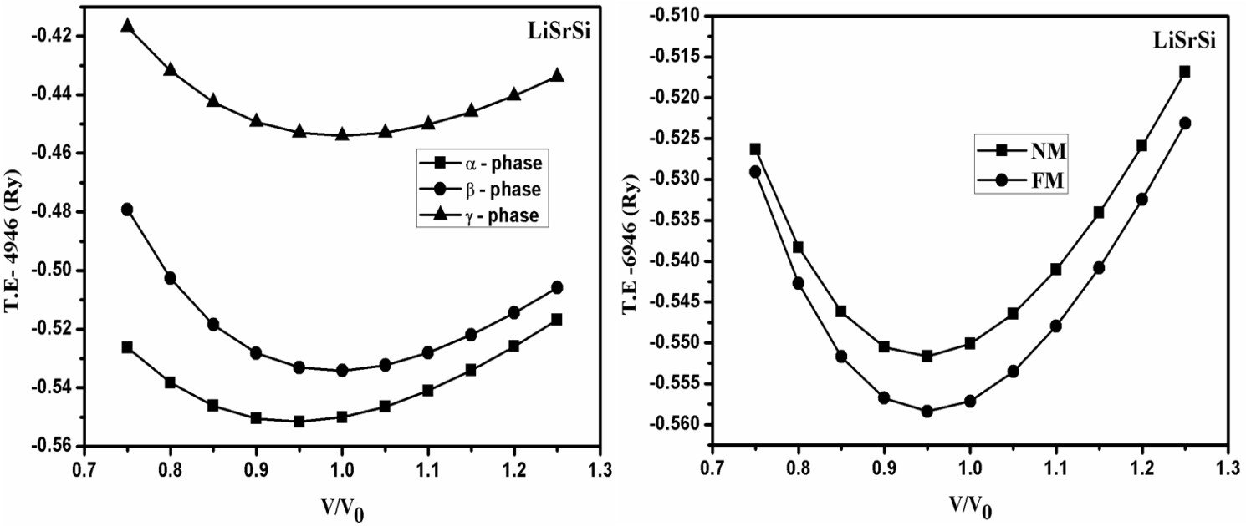
a)

b)

Fig. 2.
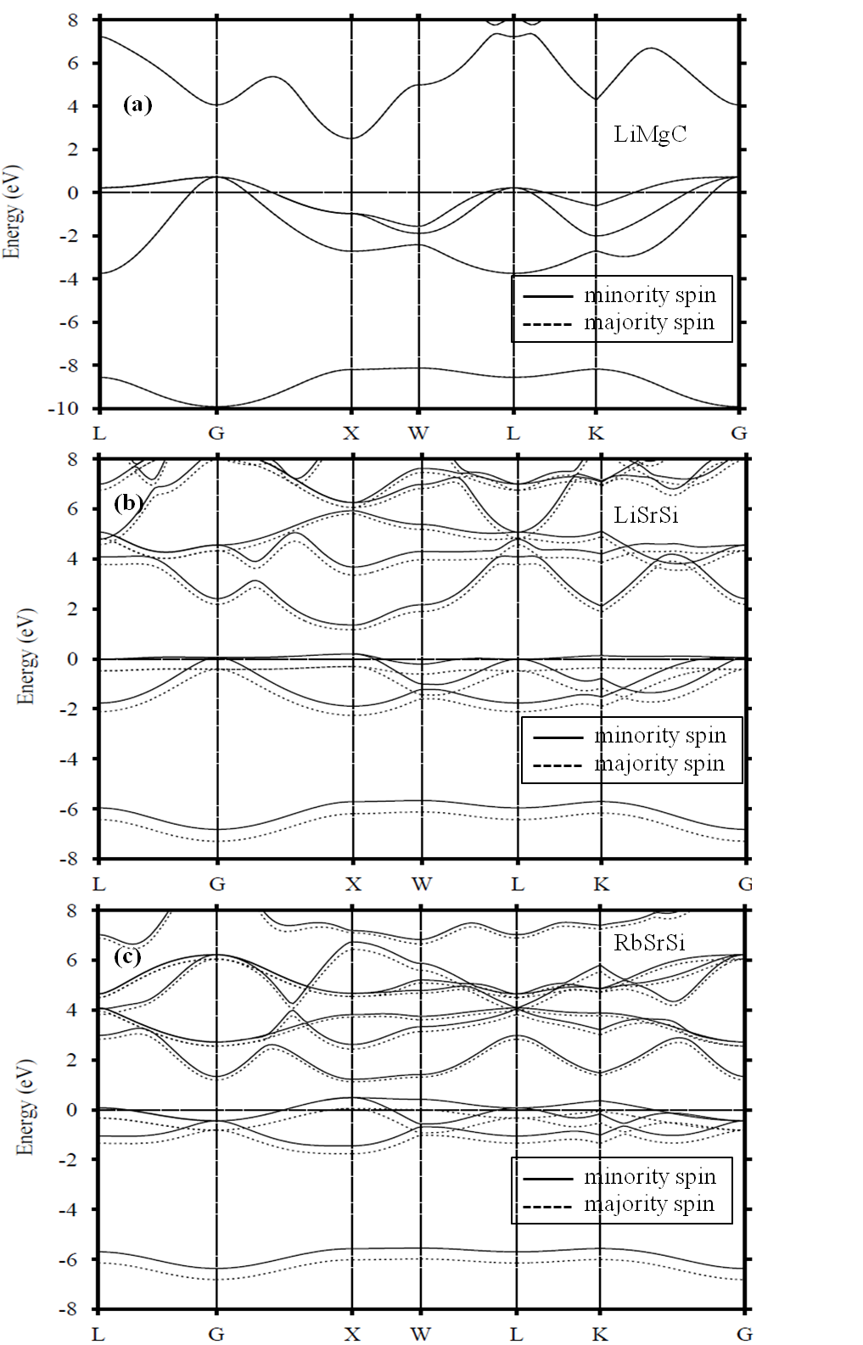

Fig. 3
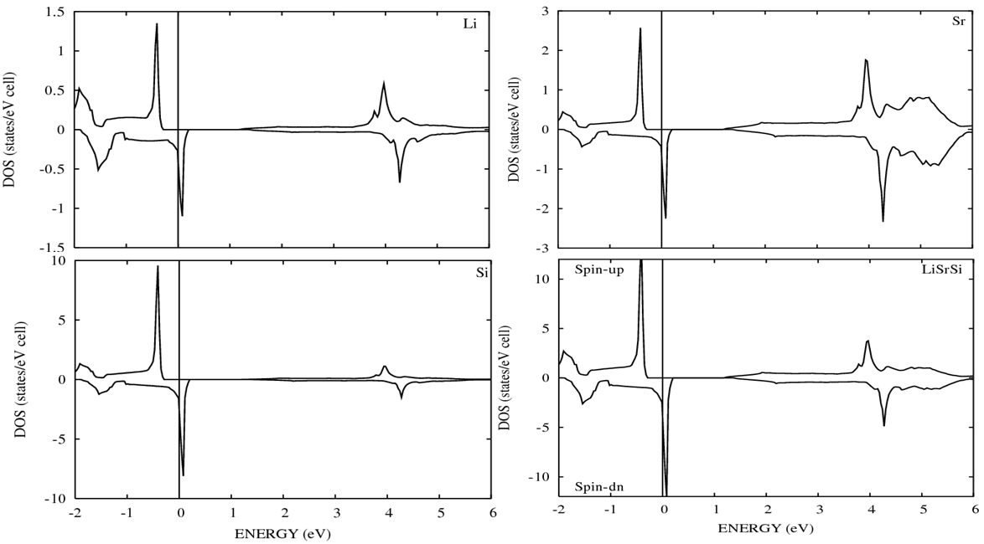

Fig. 4

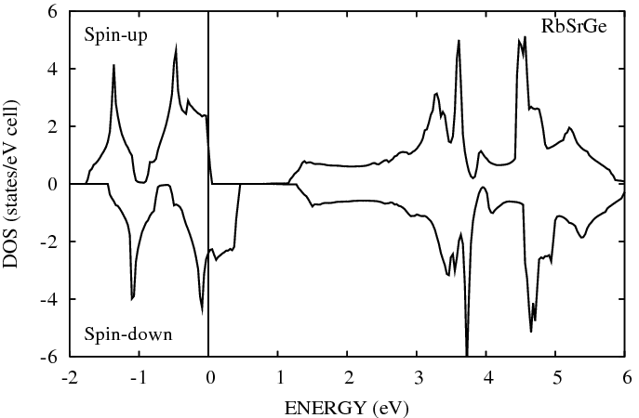
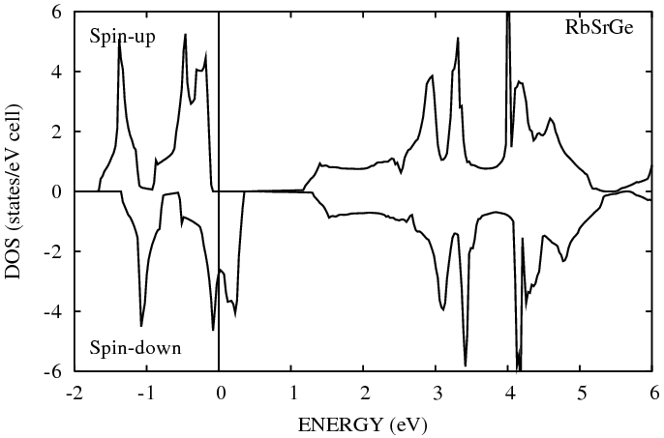

Fig. 5
(Å)

Table 1 (a).
XYC | A |  | B₀ |  | ΔE | ΔH
XYC | NM | FM | NM | FM | ΔE | ΔH
LiMgC | 5.16 | - | 86.51 | - | 0 | -9.20
NaMgC | 5.60 | 5.60 | 67.00 | 66.36 | 53.62 | -7.88
KMgC | 6.08 | 6.12 | 40.92 | 42.60 | 139.61 | -5.95
RbMgC | 6.29 | 6.36 | 40.13 | 35.67 | 71.10 | -5.64
LiCaC | 5.64 | 5.66 | 52.69 | 55.60 | 146.7 | -8.62
NaCaC | 5.94 | 5.97 | 51.32 | 52.14 | 137.9 | -7.84
KCaC | 6.30 | 6.34 (6.56) ª | 30.20 | 30.71 | 61.98 | -6.85
RbCaC | 6.49 | 6.51 | 38.52 | 36.68 | 34.93 | -5.91
LiSrC | 5.83 | 5.95 | 21.31 | 35.80 | 17.53 | -8.11
NaSrC | 6.14 | 6.20 | 38.37 | 38.51 | 61.23 | -7.83
KSrC | 6.46 | 6.50 | 28.94 | 28.40 | 46.39 | -7.14
RbSrC | 6.73 | 6.74 (6.87) ^{b} | 34.91 | 33.41 | 47.70 | -6.12
LiBaC | 6.25 | - | 44.90 | - | 0 | -8.78
NaBaC | 6.45 | - | 41.88 | - | 0 | -8.49
KBaC | 6.83 | 6.85 | 32.23 | 31.33 | 20.01 | -7.98
RbBaC | 7.10 | 7.09 | 21.05 | 21.32 | 57.48 | -7.32

ª Ref. [27]
^{b} Ref. [28]

Table 1 (b).

XYSi | A |  | B₀ |  | ΔE | ΔH
XYSi | NM | FM | NM | FM | ΔE | ΔH
LiMgSi | 6.15 | - | 45.48 | - | 0 | -0.94
NaMgSi | 6.49 | - | 39.84 | - | 0 | -0.49
KMgSi | 7.01 | 6.99 | 26.07 | 25.36 | 34.54 | -0.22
RbMgSi | 7.17 | 7.18 | 23.17 | 25.02 | 100.27 | -0.21
LiCaSi | 6.60 | 6.59 | 35.45 | 35.40 | 48.98 | -0,83
NaCaSi | 6.91 | 6.90 | 31.85 | 32.53 | 81.20 | -0.44
KCaSi | 7.30 | 7.30 (7.52) ª | 24.19 | 24.87 | 66.00 | -0.32
RbCaSi | 7.35 | 7.41 | 14.06 | 14.14 | 13.62 | -0.28
LiSrSi | 6.82 | 6.83 | 25.74 | 27.50 | 91.67 | -0.85
NaSrSi | 7.10 | 7.12 | 26.78 | 27.73 | 81.39 | -0.62
KSrSi | 7.47 | 7.51 | 23.30 | 22.62 | 38.00 | -0.27
RbSrSi | 7.54 | 7.58 (7.83) ^{b} | 16.92 | 15.80 | 1.46 | -0.09
LiBaSi | 7.18 | - | 27.08 | - | 0 | -1.37
NaBaSi | 7.36 | - | 25.51 | - | 0 | -1.44
KBaSi | 7.74 | - | 21.87 | - | 0 | -1.13
RbBaSi | 7.89 | - | 19.50 | - | 0 | -0.96
ª Ref. [27]
^{b} Ref. [28]

Table 1 (c).

XYGe | A |  | B₀ |  | ΔE | ΔH
XYGe | NM | FM | NM | FM | ΔE | ΔH
LiMgGe | 6.17 | - | 43.31 | - | 0 | -3.26
NaMgGe | 6.52 | - | 37.59 | - | 0 | -2.82
KMgGe | 7.06 | 7.05 (7.22) ª | 25.20 | 24.53 | 18.61 | -2.14
RbMgGe | 7.23 | 7.24 | 22.34 | 23.91 | 92.76 | -1.26
LiCaGe | 6.63 | 6.62 (6.84) ª | 34.48 | 34.30 | 44.64 | -3.05
NaCaGe | 6.92 | 6.92 (7.16) ª | 30.58 | 31.29 | 72.86 | -2.74
KCaGe | 7.33 | 7.36 (7.58) ª | 23.82 | 24.41 | 60.79 | -2.26
RbCaGe | 7.37 | 7.43 | 12.94 | 13.05 | 2.95 | -2.04
LiSrGe | 6.85 | 6.87 | 25.44 | 27.22 | 84.88 | -3.06
NaSrGe | 7.11 | 7.14 | 25.92 | 26.77 | 76.42 | -2.92
KSrGe | 7.50 | 7.55 | 22.61 | 21.70 | 31.62 | -2.51
RbSrGe | 7.62 | 7.64 (7.88) ^{b} | 18.11 | 16.78 | 4.47 | -2.33
LiBaGe | 7.22 | - | 26.69 | - | 0 | -3.67
NaBaGe | 7.39 | - | 24.83 | - | 0 | -3.75
KBaGe | 7.77 | - | 21.13 | - | 0 | -3.53
RbBaGe | 7.94 | - | 18.91 | - | 0 | -3.27
ª Ref. [27]
^{b} Ref. [28]

Table 1 (d).
XYSn | A |  | B₀ |  | ΔE | ΔH
XYSn | NM | FM | NM | FM | ΔE | ΔH
LiMgSn | 6.54 | - | 36.42 | - | 0 | -1.22
NaMgSn | 6.88 | - | 31.86 | - | 0 | -0.91
KMgSn | 7.37 (7.57) ª | - | 22.60 | - | 0 | -0.42
RbMgSn | 7.58 | 7.56 | 20.61 | 21.21 | 59.91 | -0.38
LiCaSn | 6.99 (7.23) ª | 6.99 | 29.32 | 29.13 | 3.76 | -1.03
NaCaSn | 7.30 (7.53) ª | 7.29 | 26.78 | 26.72 | 39.65 | -0.80
KCaSn | 7.70 (7.99) ª | 7.71 | 21.10 | 21.50 | 59.32 | -0.49
RbCaSn | 7.80 | 7.85 | 16.66 | 16.49 | 24.32 | -0.29
LiSrSn | 7.25 | 7.24 | 23.64 | 24.22 | 68.28 | -1.10
NaSrSn | 7.50 | 7.51 | 22.39 | 23.30 | 77.14 | -0.99
KSrSn | 7.87 | 7.91 | 19.83 | 19.73 | 44.31 | -0.76
RbSrSn | 7.97 | 8.00 | 16.00 | 15.03 | 3.156 | -0.66
LiBaSn | 7.55 | - | 23.47 | - | 0 | -2.18
NaBaSn | 7.73 | - | 21.94 | - | 0 | -2.30
KBaSn | 8.13 | - | 18.36 | - | 0 | -1.75
RbBaSn | 8.25 | - | 16.33 | - | 0 | -1.73

ª Ref. [27]

Table 2 (a).
XYC | M_{X} | M_{Y} | M_{C} | M_{I} | M_{TOT} | E_{HM} | E_{g} | a_{cr}
NaMgC | 0.06 | 0.07 | 0.87 | -0.01 | 1.0 | 0.16 | 2.0 | 4.78
KMgC | 0.06 | 0.04 | 0.91 | -0.01 | 1.0 | 0.33 | 0.93 | 5.44
RbMgC | 0.08 | 0.05 | 0.88 | -0.01 | 1.0 | 0.11 | 0.34 | 6.00
LiCaC | 0.07 | 0.11 | 0.82 | -0.01 | 1.0 | 0.54 | 2.27 | 5.03
NaCaC | 0.06 | 0.10 | 0.85 | -0.01 | 1.0 | 0.48 | 2.00 | 5.19
KCaC | 0.07 | 0.08 | 0.87 | -0.02 | 1.0 | 0.25 (0.38) ª | 1.44 | 5.79
RbCaC | 0.05 | 0.05 | 0.93 | -0.04 | 1.0 | 0.10 | 0.82 | 5.83
LiSrC | 0.08 | 0.13 | 0.79 | -0.01 | 1.0 | 0.18 | 2.08 | 5.73
NaSrC | 0.05 | 0.11 | 0.85 | -0.02 | 1.0 | 0.27 | 1.42 | 5.80
KSrC | 0.05 | 0.10 | 0.87 | -0.03 | 1.0 | 0.20 | 1.25 | 5.87
RbSrC | 0.04 | 0.08 | 0.92 | -0.04 | 1.0 | 0.13 (0.31) ^{b} | 0.53(1.05) ^{b} | 6.23
KBaC | 0.03 | 0.10 | 0.90 | -0.04 | 1.0 | 0.07 | 0.48 | 6.52
RbBaC | 0.04 | 0.10 | 0.88 | -0.03 | 1.0 | 0.12 | 0.25 | 6.46
ª Ref. [27]
^{b} Ref. [28]

Table 2 (b).
XYSi | M_{X} | M_{Y} | M_{Si} | M_{I} | M_{TOT} | E_{HM} | E_{g} | a_{cr}
KMgSi | 0.08 | 0.14 | 0.74 | 0.02 | 1.0 | 0.09 | 1.11 | 5.97
RbMgSi | 0.10 | 0.14 | 0.73 | 0.02 | 1.0 | 0.32 | 0.75 | 6.55
LiCaSi | 0.09 | 0.16 | 0.69 | 0.03 | 1.0 | 0.14 | 1.19 | 5.51
NaCaSi | 0.08 | 0.17 | 0.72 | 0.01 | 1.0 | 0.27 | 1.26 | 5.92
KCaSi | 0.07 | 0.15 | 0.75 | 0.01 | 1.0 | 0.19 (0.29) ª | 1.13 | 6.83
RbCaSi | 0.10 | 0.16 | 0.73 | 0.01 | 1.0 | 0.00 | 1.08 | 7.31
LiSrSi | 0.10 | 0.16 | 0.70 | 0.03 | 1.0 | 0.30 | 1.47 | 6.26
NaSrSi | 0.08 | 0.16 | 0.72 | 0.02 | 1.0 | 0.26 | 1.38 | 6.54
KSrSi | 0.07 | 0.15 | 0.75 | 0.01 | 1.0 | 0.10 | 1.13 | 7.26
RbSrSi | 0.08 | 0.14 | 0.68 | 0.00 | 0.91 | - (0.14) ^{b} | - (0.94) ^{b} | 7.68
ª Ref. [27],
^{b} Ref. [28]

Table 2 (c).
XYGe | M_{X} | M_{Y} | M_{Ge} | M_{I} | M_{TOT} | E_{HM} | E_{g}↑ | a_{cr}
KMgGe | 0.09 | 0.15 | 0.72 | 0.03 | 1.0 | 0.02 (0.02) ª | 0.50 | 6.001
RbMgGe | 0.13 | 0.19 | 0.66 | 0.02 | 1.0 | 0.015 | 0.34 | 6.630
LiCaGe | 0.12 | 0.18 | 0.66 | 0.04 | 1.0 | 0.12 (0.03) ª | 1.25 | 5.531
NaCaGe | 0.09 | 0.18 | 0.70 | 0.02 | 1.0 | 0.23 (0.19) ª | 1.28 | 6.004
KCaGe | 0.09 | 0.16 | 0.72 | 0.02 | 1.0 | 0.16 (0.28) ª | 1.15 (1.21) ª | 6.924
RbCaGe | 0.09 | 0.16 | 0.66 | 0.01 | 0.93 | - | - | 7.457
LiSrGe | 0.12 | 0.17 | 0.67 | 0.04 | 1.0 | 0.28 | 1.52 | 6.296
NaSrGe | 0.09 | 0.17 | 0.71 | 0.03 | 1.0 | 0.23 | 1.38 | 6.634
KSrGe | 0.09 | 0.16 | 0.73 | 0.01 | 1.0 | 0.07 | 1.00 | 7.309
RbSrGe | 0.07 | 0.15 | 0.070 | 0.00 | 0.94 | - (0.12) ^{b} | - (0.90) ^{b} | 7.709
ª Ref. [27]
^{b} Ref. [28]

Table 2 (d).
XYSn | M_{X} | M_{Y} | M_{Sn} | M_{I} | M_{TOT} | E_{HM} | E_{g}↑ | a_{cr}
RbMgSn | 0.09 | 0.15 | 0.72 | 0.04 | 1.0 | 0.16 | 0.43 | 6.73
LiCaSn | 0.07 | 0.12 | 0.38 | 0.03 | 0.58 | - | - | 8.63
NaCaSn | 0.10 | 0.22 | 0.65 | 0.03 | 1.0 | 0.10 (0.08) ª | 1.13 | 6.18
KCaSn | 0.09 | 0.18 | 0.69 | 0.03 | 1.0 | 0.21 (0.27) ª | 1.19 (1.23) ª | 7.16
RbCaSn | 0.11 | 0.18 | 0.68 | 0.02 | 1.0 | 0.03 | 1.11 | 7.72
LiSrSn | 0.12 | 0.18 | 0.64 | 0.05 | 1.0 | 0.21 | 1.38 | 6.53
NaSrSn | 0.10 | 0.19 | 0.67 | 0.03 | 1.0 | 0.26 | 1.37 | 6.87
KSrSn | 0.09 | 0.17 | 0.70 | 0.03 | 1.0 | 0.09 | 1.16 | 7.66
RbSrSn | 0.08 | 0.15 | 0.61 | 0.02 | 0.87 | - | - | 8.10

ª Ref. [27]

Table 3.
XYZ | a_{ex} (Å) | M_{TOT} (μB) | E_{HM} (eV) | E_{g}↑ (eV)
LiCaSn | 8.740 | 1.0 | 0.024 | 0.320
RbCaGe | 7.572 | 1.0 | 0.018 | 0.894
RbSrSi | 7.680 | 1.0 | 0.033 | 1.028
RbSrGe | 7.868 | 1.0 | 0.030 | 0.591
RbSrSn | 8.179 | 1.0 | 0.010 | 0.960

Table 4.

 | C | Si | Ge | Sn | C | Si | Ge | Sn
LiMg | - | - | - | - | LiSr | + | + | +
NaMg | + | - | - | - | NaSr | + | + | +
KMg | + | + | + | - | KSr | + | + | +
RbMg | + | + | + | + | RbSr | + | Δ | Δ
LiCa | + | + | + | Δ | LiBa | - | - | -
NaCa | + | + | + | + | NaBa | - | - | -
KCa | + | + | + | + | KBa | + | - | -
RbCa | + | + | Δ | + | RbBa | + | - | -

