ISOLATION OF PHYTOCONSTITUENTS FROM Myxopyrum serratulum A.W Hill
T.Sheelarani ¹* and V. Gopal ²
1. Assistant Professor, Sri Ramachandra Faculty of Pharmacy
Sri Ramachandra Institute of Higher Education and Research (DU), Porur, Chennai.
2. Professor, Mother Teresa Post graduate institute of Health sciences, Pondicherry.

ABSTRACT
The Present work was done in 70% ethanolic extract to isolate the isolate the phytoconstituents from Myxopyrum serratulum A.W Hill using column chromatography. Medicinal herb was reported to hold number of therapeutic values which belongs to family Oleaceae. It is a large woody climbing shrub with quadrangular stems. The roots of the herb are extensively used to treat wounds, inflammation, scabies etc. Using the single leaf of herbarium, iridiod glycosides have been isolated. Pentacyclic terpenoid like Ursolic acid was isolated and re-crystallized. Sophisticated instruments like UV, IR, NMR, and MASS was used to characterize the phytoconstituents. HPTLC finger printing was also carried out to determine Rf value of the compound and compared with reference standard.
Keywords - Ursolic acid, UV, IR, NMR, MASS, HPTLC

I. Introduction
Natural products produced from different materials have a greater significance and amazing source for new drug chemical entities for drug development process ^{[1]} . Major source of any pharmacological action may be due to the incidence of phytoconstituents.
Medicinal herbs generate an wide variety of products with highly dissimilar structures. These are commonly termed “secondary metabolites” in contrast to the “primary metabolites” which are important for plant growth and development. Secondary metabolites were previously regarded as “waste products” devoid of physiological function. About 30 years ago based on chemical ecology, it became evident that these medicinal herb fulfill important functions by interaction between plants and their biotic and abiotic environment. They can provide as defense compounds against herbivores, as flower pigments that attract pollinators, or signal molecules. Natural products have a powerful impact on human culture in addition to physiological function and used throughout human history ^{[2]}.
Secondary metabolites such as terpenoids, steroids, fatty acid derivatives, alkaloids, phenyl propanoids, non ribozomal polypeptides, enzyme cofactors etc. To isolate phytoconstituents, chromatography plays a vital role. Compound are seperated from the mixture and purified by column method. Separation of components purely depends upon the extent of adsorption to adsorbent. Adsorbent is a solid material packed in a vertical column made of glass /metal with a knob at the bottom end.
Characterization of isolated constituent can be carried out using UV, IR, NMR and Mass spectroscopic methods. UV method is widely used because it can analyze organic compound containing one or more chromophoric group, because organic compound can absorb radiation in UV region.
In IR, when infrared light passes through a sample containing organic compound some of the vibrations will be absorbed some will be transmitted through the sample. IR can termed as a vibrational spectroscopy. Different bonds (C–C, C=C, C≡C, C–O, C=O, O–H and N–H) have various vibrational frequencies. In an organic molecule various kinds of bonds are present, they can be detected in the characteristic frequency in the infrared spectrum.
NMR is related to the magnetic properties of the hydrogen atom, the proton, the carbon, and an isotope of carbon. It depicts the researchers by giving a clear picture of what the positions of these nuclei present in the molecule.
Mass Spectroscopy is used to determine the molecular weight of the compound and it also provides abundant information for the structural elucidation of the compounds when tandem mass spectrometry is applied. HPTLC finger printing is useful for the characterization identifier for that particular entity.

II. Materials and Methods
Good collection practices was followed and fresh aerial parts of Myxopyrum serratulum were collected in September 2012 from Tirunelveli, Tamil Nadu, India. Authentication was done by Botanist Prof. Jayaraman, Director, Plant Anatomical Research Centre, Tambaram, Chennai. A voucher specimen has been deposited in Sri Ramachandra Medical College and Research Institute for further reference. (Voucher specimen number: PARC/2013/3604). The medicinal herb were shade dried and coarsely powdered (Sieve No 40)
Column chromatography was carried out using silica gel 60-120 mesh (SISCO research, Mumbai) while TLC was performed by silica gel 60 F₂₅₄ with layer thickness 0.2 mm .
Melting points were recorded using Sunbim melting point apparatus. UV was recorded using Perkin Elmer UV spectrophotometer.IR spectra were obtained using KBr discs on Perkin Elmer FTIR spectrophotometer. ¹H and ¹³C NMR spectra were recorded on JEOL spectrometer at 500 and 125 MHz, respectively with DMSO as solvent. Mass spectra were obtained using Agilent MSD VL mass spectrometer.
2.1 Extraction of plant materials
The air dried powder (800 g) was extracted with 70 % ethanol. The obtained extract was concentrated to dryness and the residue was suspended in water, which was partitioned with petroleum ether and ethyl acetate. The presence of terpenoids was identified in ethyl acetate fraction using TLC with corresponding spray reagents.

2.2 Isolation of Compound
Adsorbent is suitably moistened with solvent and packed in the column with a cotton at the bottom. Components to be separated is positioned on the top of packed adsorbent with a second cotton in between. Solvent system is poured into the column over the sample mixture. To collect the fractions a collecting beaker is placed at the bottom of column .
Ethyl acetate fraction was subjected to column on silica gel bed using chloroform-methanol (10: 8) as the eluting solvent to produce thirty five fractions (F₁-F₃₅). Fractions between (F₁₆-F₂₄) contained the major compound with a few minor constituents. The similar fractions were combined and the resultant product was washed with hexane. Recrystallization was done using methanol. Compound obtained was white powder (65 mg) with the melting point of about 282-284ºC.
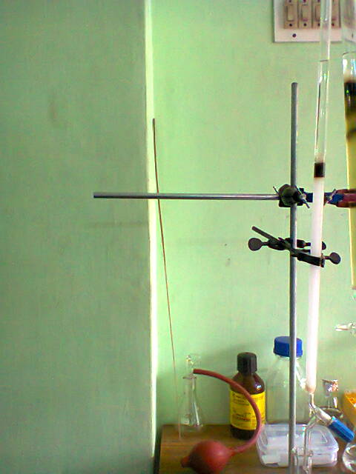
Figure 1 Isolation process using column chromatography
2.3 TLC PROFILE
Sample : 70 % Ethanol extract
Stationary phase : Silica gel 60 mesh
Mobile phase : Toluene: Ethyl acetate: Formic acid (9: 1: 0.5)
R_{f} value : 0.7
Detecting Agent : Vanillin in sulphuric acid
2.4 Chemical Test
- Test for triterpenoids: Take 1 ml of sample in a clean test tube to it add tin (one bit) and thionyl chloride. Presence of triterpenoids is indicated by presence of pink color.
- Liebermann Burchard Test: Add a few mg of sample and dissolved in chloroform and then add acetic anhydride followed by sulphuric acid. Presence of terpenoids is indicated by presence of pink color

2.5 HPTLC analysis
HPTLC finger printing was performed on a 10 x 10 cm pre activated silica gel 60GF 254 plate. Extract were applied to the plate as 6 mm wide band with an automatic TLC applicator Linomat5 with N₂ flow, 8 mm from the bottom. Densitometric scanning was performed on CAMAG scanner. The plates were prewashed with methanol and activated at 60°C for 5 min. Slit dimension was kept at 5mm x 0.45mm and 20 mm/s scanning speed was employed. The mobile phase was chosen after running various trials (Toluene, toluene: ethyl acetate and ethyl acetate: methanol) and 10 ml of mobile phase. Linear ascending development was performed in 20 x 10 cm twin glass chamber saturated with the mobile phase at 60°C ^{[3]} and it is given in Table 1.

2.6 Chromatographic Condition

Standard | Ursolic acid (Sigma Aldrich, Chennai)
Stationary phase | Silica gel GF₂₅₄
Mobile phase | Chloroform: Methanol (9.5 : 0.5)
Derivatizing agent | 5 % sulphuric acid in methanol
Scanning wavelength | 510 nm
Sample concentration | Myxopyrum serratulum (50 mg/ml  Isolated compound (2 mg/ml)  Ursolic acid (0.1 mg/ml)
Development mode | Ascending mode
Table 1 Chromatographic condition of HPTLC

III. Results and Discussion
Terpenoids are the chemically attractive groups of secondary metabolites with over 30,000 known compounds including steroids ^{[4].} Wide variety of terpenes have biological activities and are widely used to treat human ailments. Anticancer drug like Taxol and antimalarial drug like Artemisinin are the most well-known terpene-based drugs ^{[5]}

3.1 Examination of Isolated Compound
The 70 % ethanolic extract was subjected to column chromatography. From the collective fractions, a white powder was isolated and re-crystallized.
Description - White powder
Solvent system - Toluene: Ethyl acetate: Formic acid (9:1:0.5)
Detecting Agent - Vanillin-Sulphuric acid
Melting Point - 282-284ºC
R_{f} Value - 0.7

3.2 Characterization of the isolated compound
Characterization of isolated compound was done by using UV, IR, NMR and Mass techniques.
UV spectroscopy
Isolated sample was dissolved in methanol and scanned between 200-400 nm. Spectrum of the isolated sample was given in the Figure 2.

Infrared Spectroscopy
The isolated compound showed the following absorption peaks, 3434 cm⁻¹ which corresponds to OH stretching, 2931 & 1694 cm⁻¹ corresponds to carboxylic acid (carbonyl group), 2931 cm⁻¹ corresponds to CH (Str) Superimposed on OH (Str), 1385 cm⁻¹ corresponds to Gem dimethyl group C(CH₃)₂, 1043 cm⁻¹ corresponds to the C-O (Str), 1043 & 998 cm⁻¹ corresponds to C-OH band and 998 & 663 cm⁻¹ corresponds to OH (def) it is represented in Figure 3.

Nuclear Magnetic Resonance Spectroscopy (NMR)
¹H NMR : δ 5.13 (t, J=3.5Hz, 1 H), 4.36 (t, J=5 Hz, 1 H), 4.30 (d, J=5.5 Hz, 1 H), 3.47-3.39 (m, 1 H), 3.02-2.98 (m, 1 H), 2.11 (d, J= 11Hz, 1H), 1.92 (qd, J=13, 4.5Hz, 1H), 1.89-1.77 (m, 3 H), 1.60-1.43 (m, 10 H), 1.34-1.25 (m, 4 H), 1.08-0.99 (m, 5 H), 0.95-0.87 (m, 11 H), 0.82 (d, J=6.5Hz 1 H), 0.75 (s, 3 H), 0.68 (s, 3 H) represented in Figure 4
¹H NMR spectrum of the sample showed one proton broad signal at δ 5.12 assigned to Vinylic proton. One proton singlet at δ 2.5 attributed to OH of COOH. One proton doublet at δ 2.1 represents the presence of hydroxyl group. The signals below indicate the presence of 7 methyl protons in the structure.

¹³C-NMR : δ ppm: 178.99 (C-28); 138.58 (C-13); 125.21 (C-12); 77.31 (C-3); 55.24 (C-5); 52.84 (C-18); 47.48 (C-9); 47.29 (C-17); 42.11 (C-14); 40.47 (C-8); 39.97 (C-20); 39.81 (C-19); 39.64 (C-4); 39.56 (C-1); 38.70 (C-10); 36.99 (C-22); 33.17 (C-15); 30.65 (C-7); 28.72 (C-23); 28.00 (C-21); 2745 (C-2); 24.36 (C-11); 23.73 (C-27); 23.33 (C-16); 21.53 (C-30); 18.47 (C-6); 17.47 (C-29); 17.38 (C-24); 16.54 (C-25); 15.68 (C-26)

In ¹³C-NMR, a peak at δ 178.99 attributed to carboxylic group at the position C-28. The chemical shift value at δ 125.21 and δ 138.58 represented resonance olefinic carbons in C-12 and C-13. The chemical shift value at δ 77.31 represented carbinol carbon in the structure (Figure 5).

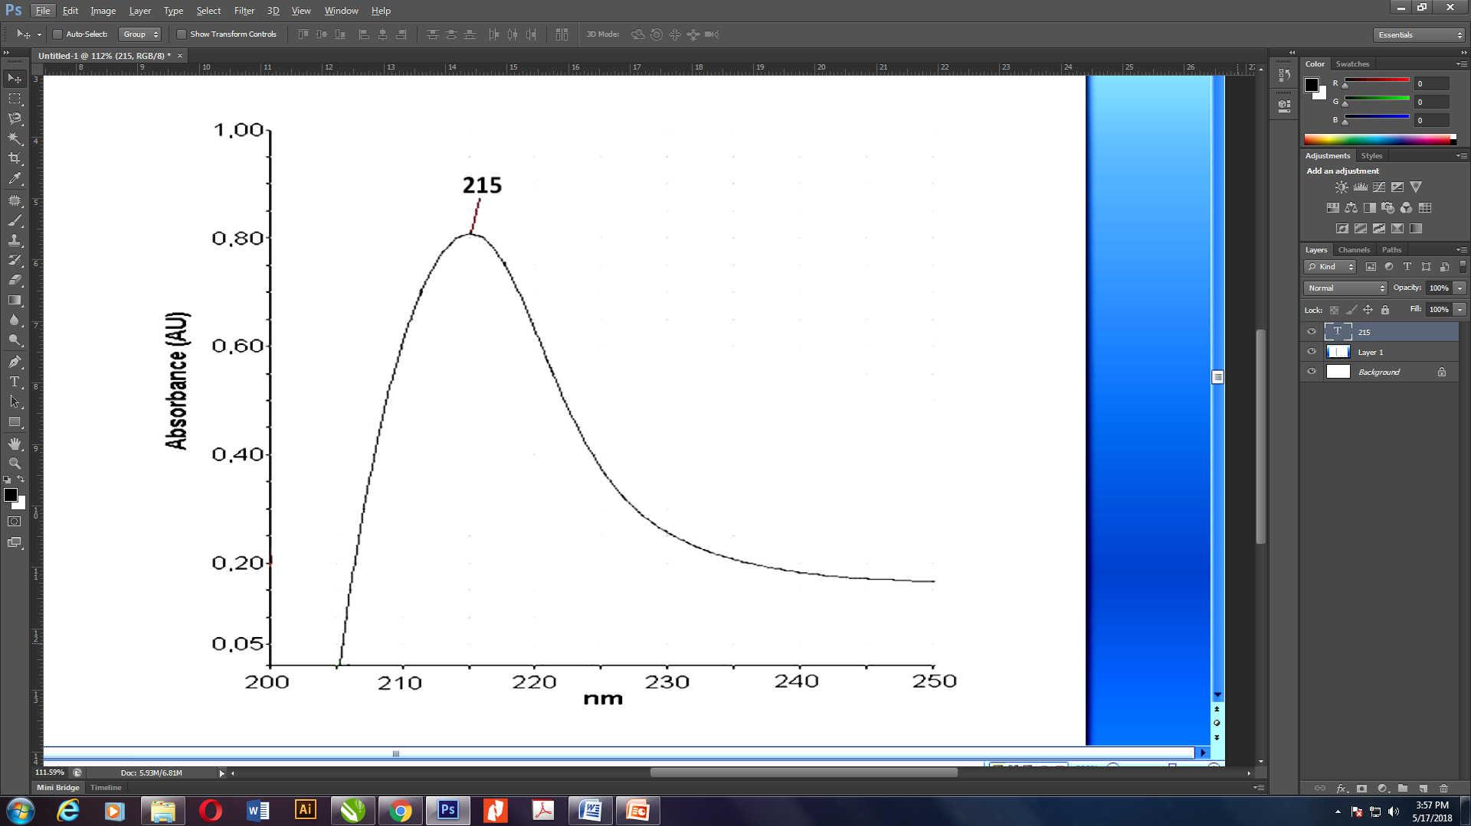
Figure 2 UV Spectra of isolated 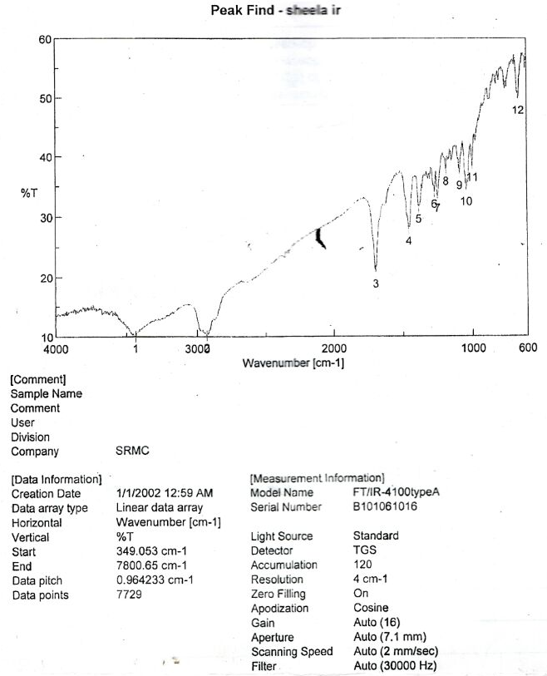
Figure 3 IR Spectra of Isolated Compound

WAVE NUMBER (cm⁻¹) | FUNCTIONAL GROUP
3434 | OH (Str)
2931 & 1694 | Carboxylic acid(carbonyl group)
2931 | CH (Str) Superimposed on OH (Str)
1385 | Gem dimethyl group, C(CH₃)₂
1043 | C-O (Str)
1043 & 998 | C-OH Band
998 & 663 | OH (def)

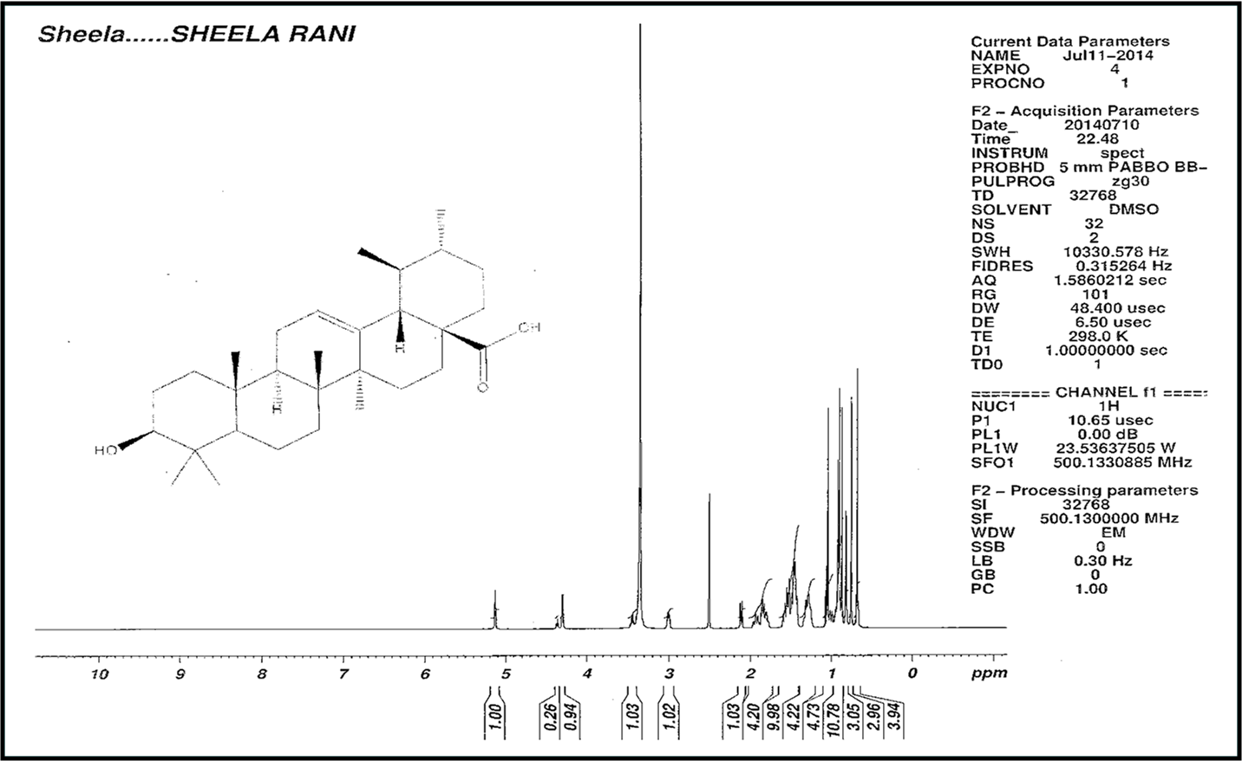
Figure 4 ¹H NMR of Isolated Compound

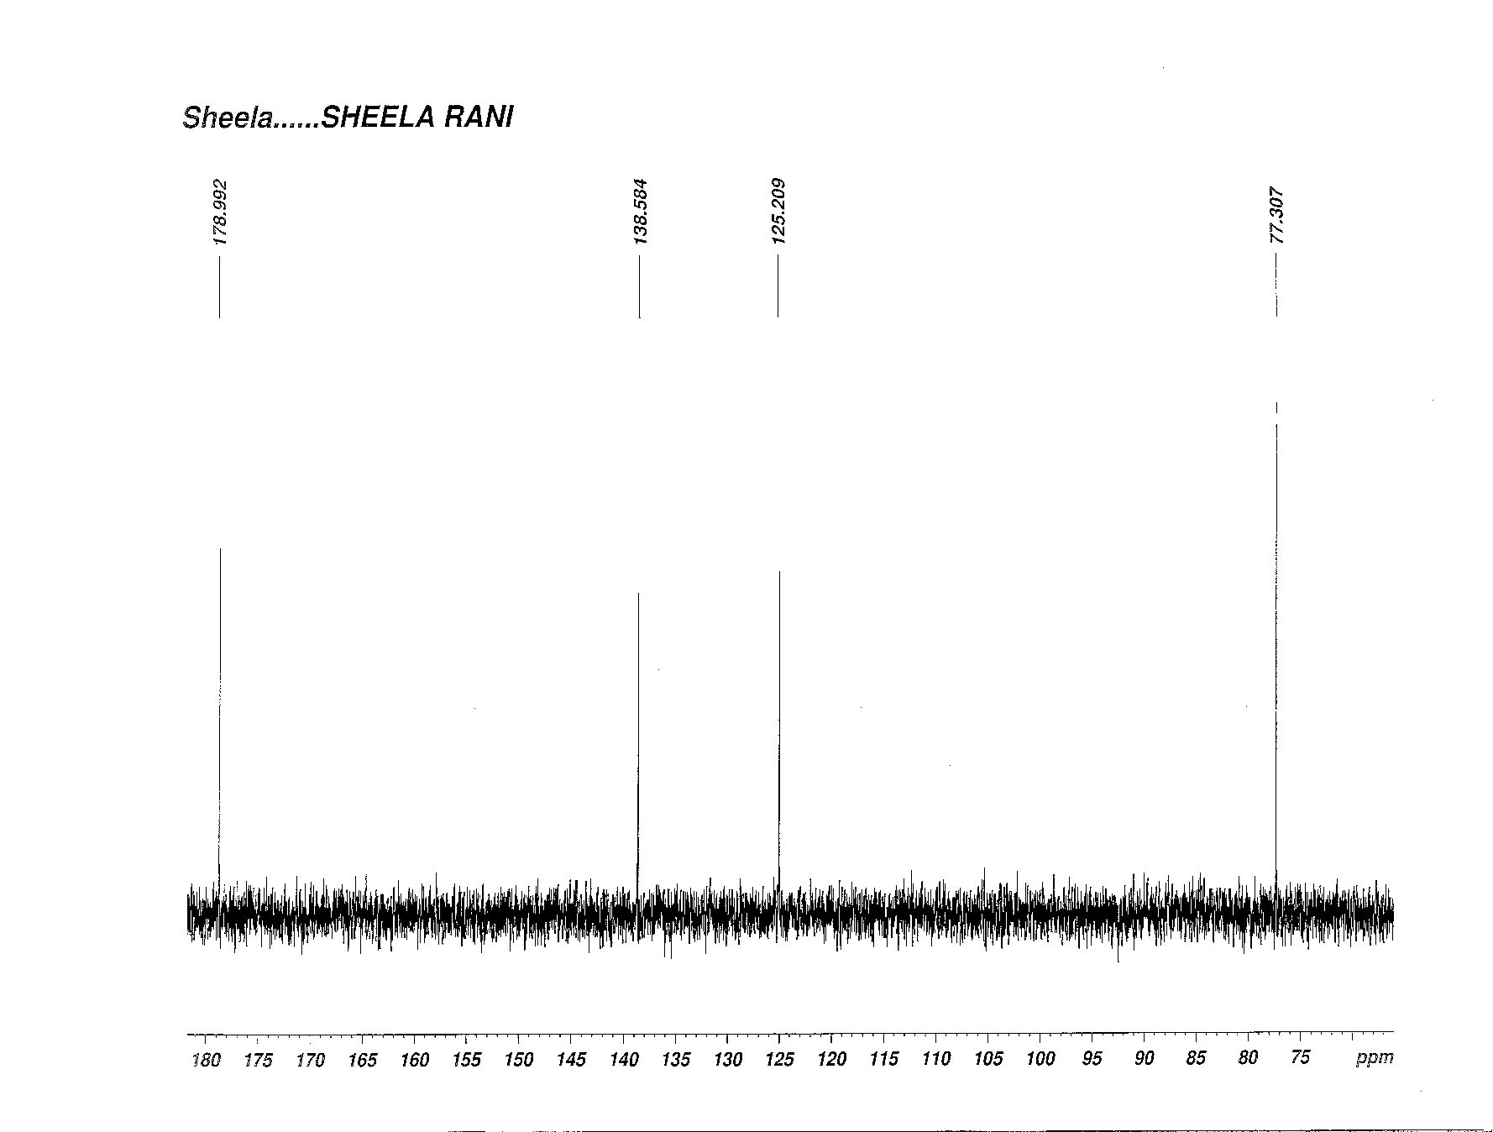
Figure 5 ¹³C NMR of Isolated Compound

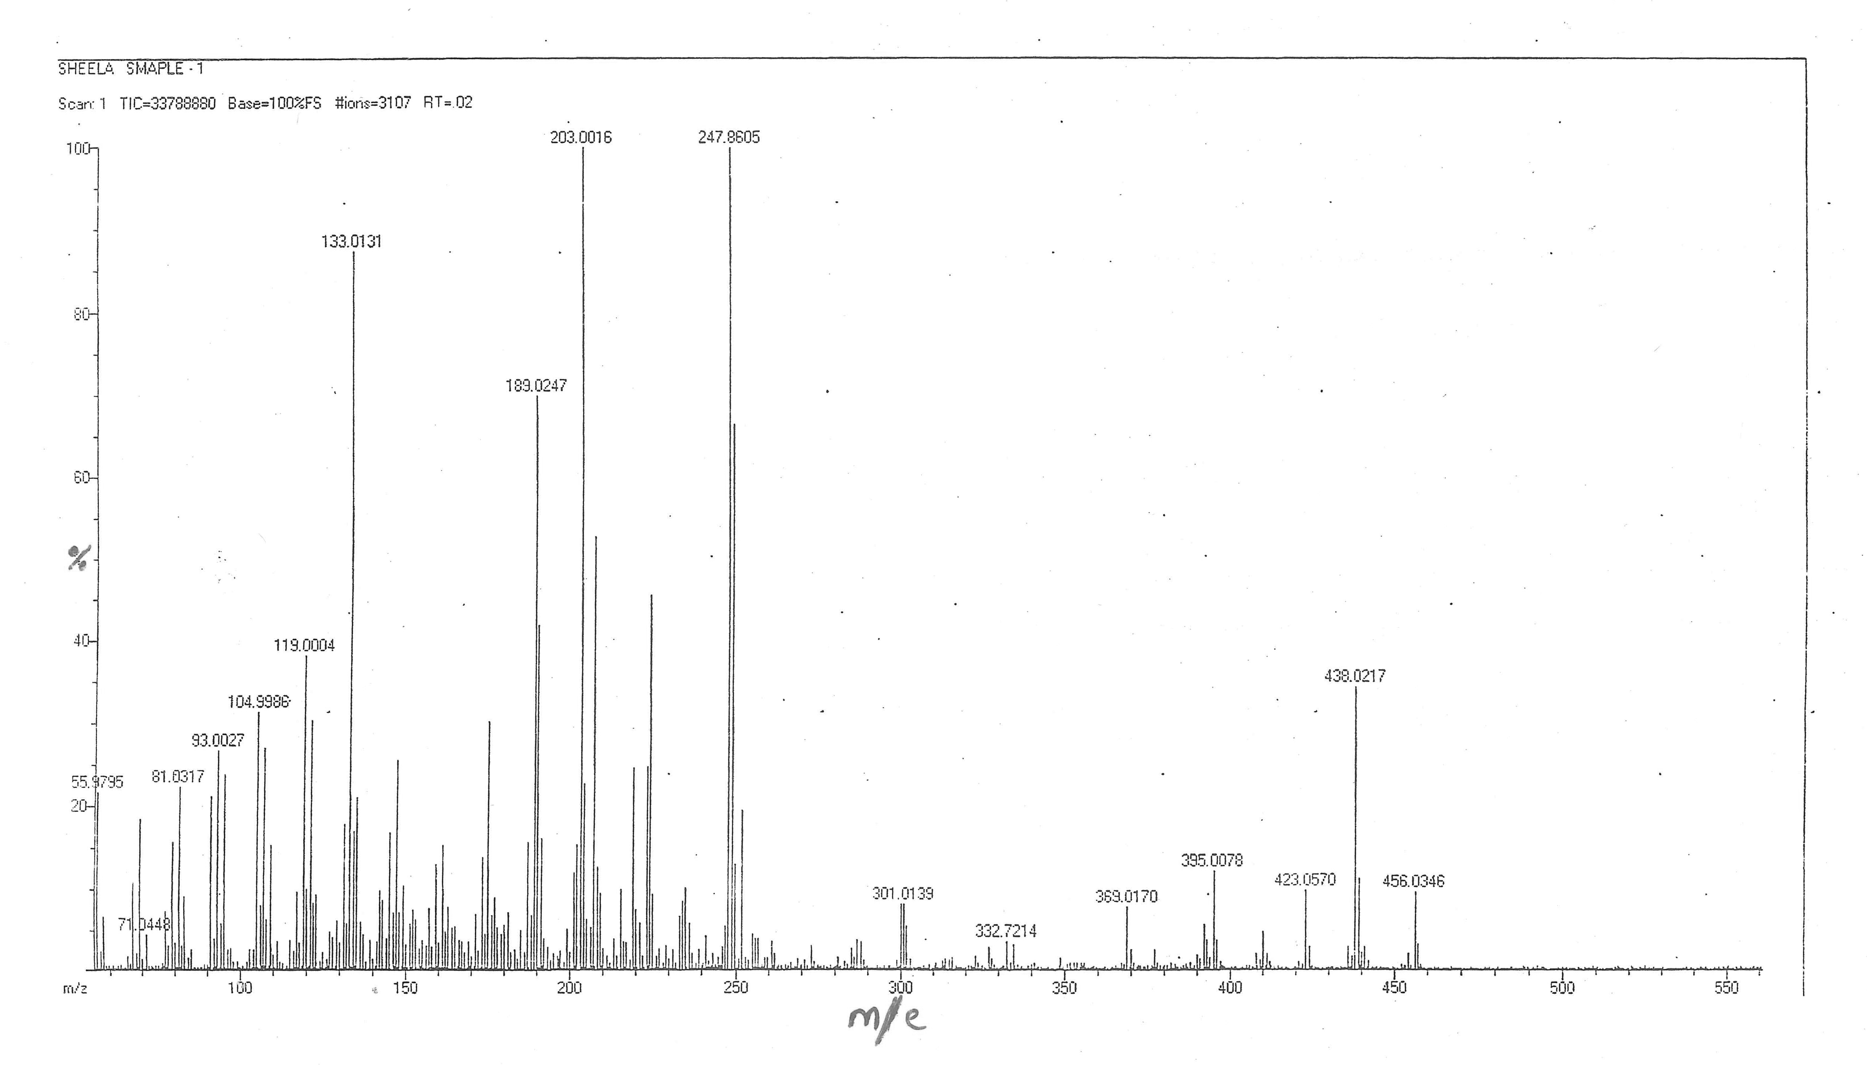
Figure 6 Mass Spectra of Isolated Compound

Mass spectrometry
Mass spectra of isolated sample was shown in Figure 6. Mass spectrum showed the M+ peak at m/e 456.03 that corresponds to molecular formula C₃₀H₄₈O₃ and fragmented peaks at 438.02, 423.05, 247.86, 203.00, 189.02 and 133.01.
Structure of isolated sample/compound was found out by spectroscopic techniques like UV, IR, NMR and Mass spectra. Data showed from characterization indicates that the compound is a pentacyclic triterpenoid, Ursolic acid.

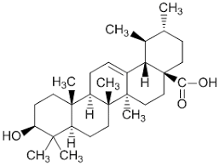
Figure 7 Structure of Isolated Compound -Ursolic acid
Molecular Formula : C₃₀ H₄₈ O₃
IUPAC NAME : 3β-Hydroxy-urs-12-ene-28-oic acid.

HPTLC finger printing of standard, isolated compound and extract
HPTLC finger print of Ursolic acid was taken and the R_{f} value was found to be 0.4. Similarly the HPTLC finger print of 70 % ethanolic extract & isolated sample were taken. The chromatogram of 70 % ethanolic extract showed 8 peaks in the range of R_{f} value 0.12 to 0.76. Among the peaks the 6th peak with R_{f} value of 0.4 with percentage area of 69.3 confirms the occurrence of Ursolic acid in ethanolic extract.
HPTLC finger print of isolated sample showed 4 peaks with the range of R_{f} values from 0.16 to 0.77. Among the peaks the 3rd peak at R_{f} value 0.42 corresponds to the standard Ursolic acid (R_{f} value - 0.4) with percentage area of 86.55. It confirmed that the isolated compound is Ursolic acid (Table 2).

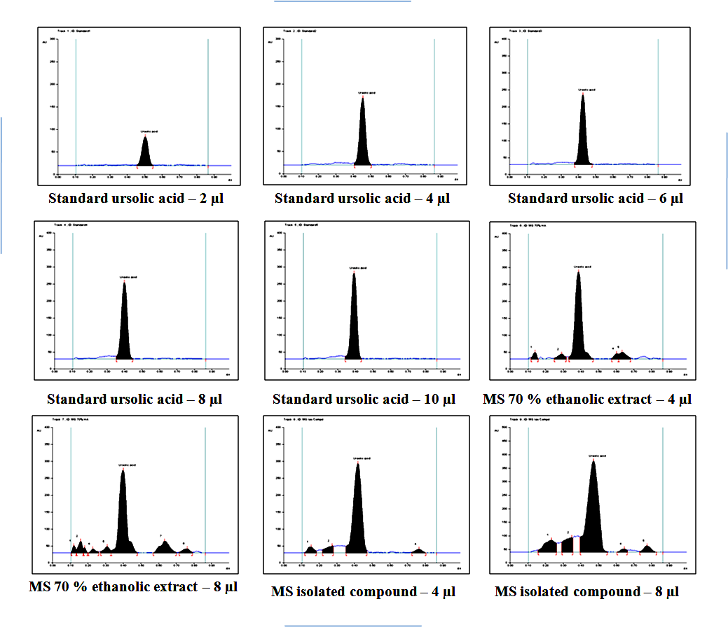

Figure 8 HPTLC chromatogram of standard, isolated compound and extract

Track | Peak | Start  R_{f} | Start  Height | Max R_{f} | Max  Height | Height % | End R_{f} | End  Height | Area | Area %
4 | 1 | 0.35 | 7.9 | 0.4 | 225.1 | 100 | 0.45 | 0.4 | 6770.7 | 100
7 | 6 | 0.33 | 6.5 | 0.4 | 243.9 | 62.5 | 0.48 | 1 | 9322 | 69.3
8 | 3 | 0.35 | 19.6 | 0.42 | 263.7 | 84.5 | 0.47 | 7 | 11087.6 | 86.55

Table 2 HPTLC profile of extract and isolated compound

IV. Conclusion

Ethanolic extract was subjected to column for the isolation of phytoconstituents as they found to have significant pharmacological activity when compared to other extracts . Spectral studies confirmed that the isolated sample is Ursolic acid. Ursolic acid is a pentacyclic terpene compound that has various pharmacological activities such as anti-inflammatory ^{[6,7]} antitumor ^{[8,9]} antioxidant ^{[10]} hypoglycemic, antiulcer and anti-lipidemic activity.

Ursolic acid was reported to be isolated from various plants including Malus domestica^{[11],} Ocimum sanctum ^{[12],} Diospyros melanoxylon, Vitex negundo^{[13],} Cornus officinalis ^{[14 ]} and Thymus vulgaris ^{[15]}

Isolation of Ursolic acid and characterisation by spectral studies is the significant outcome of this work.

References
[1] McCurdy CR, Scully SS. Analgesic substances derived from natural products (natureceuticals). Life Sciences. 2005 Dec 22;78(5):476-84.
[2] Dayan FE, Duke SO. Biological activity of allelochemicals. Plant-derived natural products: synthesis, function, and application. 2009:361-84.
[3] Rai S, Mukherjee K, Mal M, Wahile A, Saha BP, Mukherjee PK. Determination of 6‐gingerol in ginger (Zingiber officinale) using high‐performance thin‐layer chromatography. Journal of separation science. 2006 Oct;29(15):2292-5
[4] Wang G, Tang W, Bidigare RR. Terpenoids as therapeutic drugs and pharmaceutical agents. Natural products: drug discovery and therapeutic medicine. 2005:197-227.
[5]Çitoğlu GS, Acıkara ÖB. Column chromatography for terpenoids and flavonoids. Chromatography and its applications: INTECH Rijeka. 2012 Mar 16:13-49
[6] Safayhi H, Sailer ER. Anti-inflammatory actions of pentacyclic triterpenes. Planta medica. 1997 Dec;63(06):487-93.
[7] Baricevic D, Sosa S, Della Loggia R, Tubaro A, Simonovska B, Krasna A, Zupancic A. Topical anti-inflammatory activity of Salvia officinalis L. leaves: the relevance of ursolic acid. Journal of ethnopharmacology. 2001 May 1;75(2-3):125-32.
[8] Tu HY, Huang AM, Wei BL, Gan KH, Hour TC, Yang SC, Pu YS, Lin CN. Ursolic acid derivatives induce cell cycle arrest and apoptosis in NTUB1 cells associated with reactive oxygen species. Bioorganic & medicinal chemistry. 2009 Oct 15;17(20):7265-74.
[9] Yamaguchi H, Noshita T, Kidachi Y, Umetsu H, Hayashi M, Komiyama K, Funayama S, Ryoyama K. Isolation of ursolic acid from apple peels and its specific efficacy as a potent antitumor agent. Journal of Health Science. 2008;54(6):654-60.
[10] Saraswat B, Visen PK, Agarwal DP. Ursolic acid isolated from Eucalyptus tereticornis protects against ethanoltoxicity in isolated rat hepatocytes. Phytotherapy Research. 2000 May;14(3):163-6.
[11] Frighetto RT, Welendorf RM, Nigro EN, Frighetto N, Siani AC. Isolation of ursolic acid from apple peels by high speed counter-current chromatography. Food Chemistry. 2008 Jan 15;106(2):767-71.
[12] Vetal MD, Lade VG, Rathod VK. Extraction of ursolic acid from Ocimum sanctum leaves: Kinetics and modeling. Food and bioproducts processing. 2012 Oct 1;90(4):793-8.
[13]Chandramu C, Manohar RD, Krupadanam DG, Dashavantha RV. Isolation, characterization and biological activity of betulinic acid and ursolic acid from Vitex negundo L. Phytotherapy Research: An International Journal Devoted to Pharmacological and Toxicological Evaluation of Natural Product Derivatives. 2003 Feb;17(2):129-34.
[14] Jang SE, Jeong JJ, Hyam SR, Han MJ, Kim DH. Ursolic acid isolated from the seed of Cornus officinalis ameliorates colitis in mice by inhibiting the binding of lipopolysaccharide to Toll-like receptor 4 on macrophages. Journal of agricultural and food chemistry. 2014 Oct 8;62(40):9711-21.
[15] Rowe EJ, Orr JE, Uhl AH, Parks LM. Isolation of oleanolic acid and ursolic acid from Thymus vulgaris, L. Journal of the American Pharmaceutical Association (Scientific ed.)1949 Mar 1;38(3):122-4.

