CONVERSION OF AMERICAN SIGN LANGUAGE TO TEXT USING DEEP LEARNING FOR FEATURE EXTRACTION

SWAMINATHAN S, K. REVANTH PAVAN KUMAR, L. SHIVA PRASAD REDDY,
NAGARAPU KARTHIK,

Abstract

This project describes a vision-based system for identifying people's hand gestures (Deaf people) and communicating more successfully with non-Deaf people. This method aims to recognize deaf people's ASL (American Sign Language) gestures and translate them into Text. After a thorough analysis, the best potential technique to convert real-time American Sign Language into text with the Transfer Learning Approach using Alexnet and classification algorithms in MATLab software is described. The most popular convolution neural network, or CNN, for object recognition is AlexNet. Transfer learning typically speeds up and simplifies network fine-tuning compared to starting from zero and building a network with random initialised weights. Using fewer training images, you can quickly apply learned features to a fresh task. The accuracy of the three methods used for classification (SVM, KNN, and Naive Bayes) will then be assessed, and the one with the highest accuracy that does most effectively for our project will be chosen.
Existing System
1] Nelson, Ann, K. J. Price, and Rosalie Multari [2] exhibited a web-based ASL interpretation system made up of Convolutional Neural Networks (CNN) that provides a practical solution for real-time interpretation of 29 ASL signs, including 26 alphabet signs and three additional signs (space, 'delete,' and 'nothing'). To achieve this degree of precision in automated sign translation, two factors must be present: 1) high-quality input pictures; and 2) a huge quantity of input images 2) start with a pre-trained model (VGG16), and 3) adapt the model to the image collection.

2] Bhumika Gupta, Pushkar Shukla, Ankush Mittal [11 proposed a model that recognises static photographs of Indian Sign Language signed alphabets. Unlike other sign languages' alphabets, such as American Sign Language and Chinese Sign Language, the Indian sign language alphabet is both single-handed and double-handed. As a result, the model first categorises them as single- handed or double-handed to assist identification. Two types of features, HOG and SIFT, are extracted and merged in a single matrix for a training set of pictures for all categories.
Proposed System
In this project, we are going to prepare a model, which is used to convert the American Sign Language into Text in real time. Three classifiers are used to classify and divide them into the respective category. Using the Three classifiers, We calculate the accuracy for each classifier separately and finally based on the maximum accuracy we decide what is to use in real time for fast and accurate results.
Methodology

The working model of the system is depicted as flow chart in above slide. The next sections go through each level of the system model.
- Dataset Creation
- Feature Extraction using Alexnet
- Classification using Naive Bayes
- Classification using KNN
- Classification using SVM
1. Dataset Creation
The Dataset contains images of the American Sign Language alphabet from A to Z . The resolution of images is set to 227x227x3. This Dataset is used for Training the network and also used as Test images. The size of the dataset is around 46000 images to get better accuracy and output.
2. Feature Extraction using Alexnet
Alexnet is the most extensively used Convolution Neural Network (CNN) for object identification. The design includes 5 convolutional layers, 3 max-pooling layers, 2 normalization layers, 2 fully connected layers, and 1 SoftMax layer. It takes Multiple parameters into consideration before the extraction of the image. It plays an important role in real-time applications.
The following steps are followed to Reuse the Pretrained Network:
- Load data
- Load Pretrained Network
- Replace the Final Layers
- Train Network
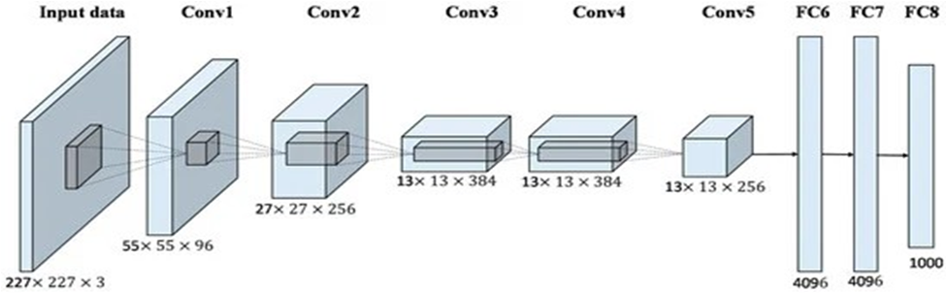
3. Classification using Naive Bayes
The Naive Bayes algorithm is a supervised learning method based on the Bayes theorem for classification problems. As a probabilistic classifier, it provides predictions based on the probability that an element will happen. The Bayes theorem, often known as Bayes' rule or Bayes' law, is a mathematical formula that is used to evaluate the likelihood of a hypothesis given some previous information. This is determined by conditional probability.

The formula of Bayes' theorem is given as:
P(A|B)= (P(B/A)P(A))÷P(B)
4. Classification using KNN
K-Nearest Neighbour is one of the simplest Machine Learning algorithms based on Supervised Learning technique. KNN algorithm assumes the similarity between the new case/data and available cases and puts the new case into the category that is most similar to the available categories. K-NN algorithm stores all the available data and classifies a new data point based on the similarity. This means when new data appears then it can be easily classified into a well suited category by using K- NN algorithm. KNN algorithm can be used for Regression as well as for Classification but mostly it is used for the Classification problems. KNN is a non-parametric algorithm, which means it does not make any assumption on underlying data. It is also called a lazy learner algorithm because it does not learn from the training set immediately instead it stores the dataset and at the time of classification, it performs an action on the dataset.
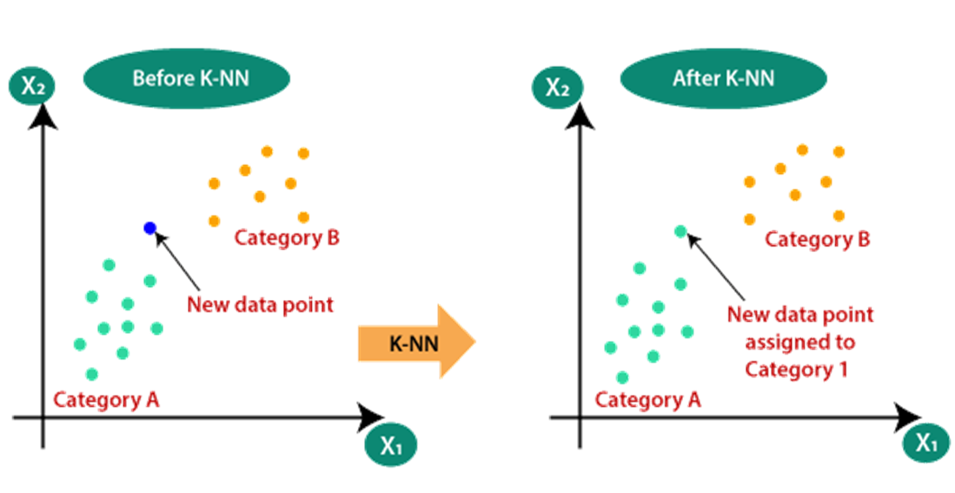
5. Classification using SVM
Support Vector Machine or SVM is one of the most popular Supervised Learning algorithms, which is used for Classification as well as Regression problems. However, primarily, it is used for Classification problems in Machine Learning. The goal of the SVM algorithm is to create the best line or decision boundary that can segregate n-dimensional space into classes so that we can easily put the new data point in the correct category in the future. This best decision boundary is called a hyperplane.
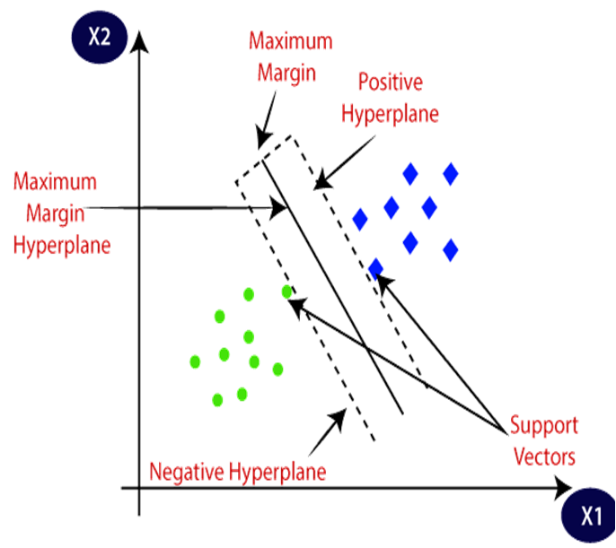
RESULTS

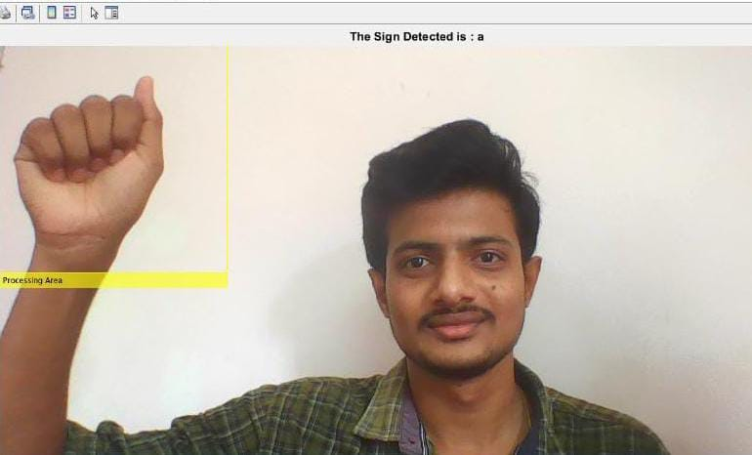

Fig 1 - Detection of Sign A into Text using Live camera as input

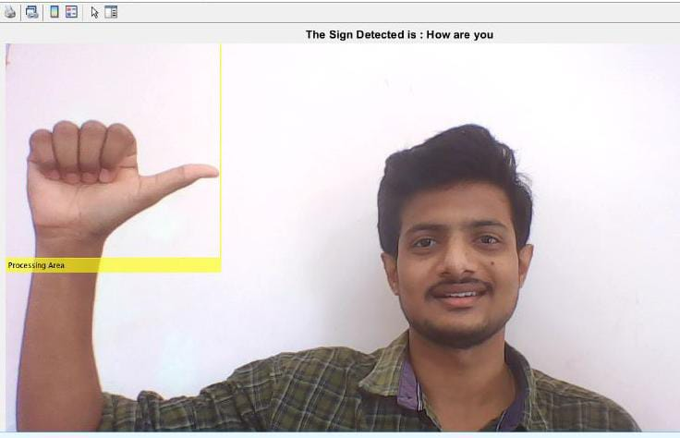
Fig 2 - Detection of Sign Sentence How are you into Text using Live camera as input

CONCLUSION

We have created a dataset for ASL Sign language and prepared the code for training and testing of images in the dataset by using the pretrained Alexnet network for Feature extraction and Different Machine learning models (SVM, KNN, Logistic regression) for Classification and training. Also verified the result using test images in the dataset and as well as using the live camera signs taken as input data.

The Future Advancements in this project is to implement this model using Hardware Equipment. The Conversion of Sign language into Speech is to be implemented.

REFERENCES

- Patwary, Muhammed J. A. & Parvin, Shahnaj & Akter, Subrina. (2015). Significant HOGHistogram of Oriented Gradient Feature Selection for Human Detection. International Journal of Computer Applications. 132. 20-24. 10.5120/ijca2015907704.
- Ann Nelson, KJ Price , Rosalie Multari (2019) ASL Reverse Dictionary - ASL Translation Using Deep Learning.
- Dumitrescu, & Boiangiu, Costin-Anton. (2019) A Study of Image Upsampling and Downsampling Filters. Computers. 8. 30. 10.3390/computers8020030.
- Saeed, Khalid & Tabedzki, Marek & Rybnik, Mariusz & Adamski, Marcin (2010) K3M: A universal algorithm for image skeletonization and a review of thinning techniques. Applied Mathematics and Computer Science. 20. 317-335. 10.2478/v10006-010-0024-4.
- Mohan, Vijayarani. (2013) Performance Analysis of Canny and Sobel Edge Detection Algorithms in Image Mining. International Journal of Innovative Research in Computer and Communication Engineering. 1760-1767. M. Young, The Technical Writer’s Handbook. Mill Valley, CA: University Science, 1989.
- Tzotsos, Angelos & Argialas, Demetre. (2008) Support Vector Machine Classification for Object-Based Image Analysis. 10.1007/978-3-540- 77058-9_36.
- Mishra, Sidharth & Sarkar, Uttam & Taraphder, Subhash & Datta, Sanjoy & Swain, Devi & Saikhom , Reshma & Panda, Sasmita & Laishram, Menalsh. (2017) Principal Component Analysis. International Journal of Livestock Research. 1. 10.5455/ijlr.20170415115235.
- Evgeniou, Theodoros & Pontil, Massimiliano. (2001) Support Vector Machines: Theory and Applications. 2049. 249-257. 10.1007/3-540- 44673-7_12

