Distributional Records of Family Tubulicrinaceae from District Chamba of Himachal Pradesh
Dr. Poonam Sabrwal¹, Miss Sumit²
¹Assistant Professor Botany Government College Chamba, Himachal Pradesh
²Assistant Professor Botany Government College Chamba, Himachal Pradesh
¹Email of 1st and corresponding author: poonamriddham777@gmail.com
Keywords: Basidiomycota, Tubulicrinaceae, Western Himalayas, Corticioid Fungi
ABSTRACT
The purpose of the present chapter is to illustrate 10 taxa (Hyphodontia alutaria, H. arguta, H. pallidula, H. rimosissima, H. sambuci, Tubulicrinis chaetophorus, T. orientalis, T. strangulates, Xylodon asper and X.spathulata) belonging to 3 genera (Hyphodontia, Tubulicrinis and Xylodon) of family Tubulicrinaceae based on samples gathered from several areas in the Chamba district of Himachal Pradesh. Out of the taxa described Hyphodontia rimosissima is new additions to the mycofloristic diversity from district Chamba of Himachal Pradesh.
INTRODUCTION
The corticioid fungal family Tubulicrinaceae is distinguished by its members' resupinate, adnate basidiocarps, which can be crustose, ceraceous, or membranous. The hymenial surface can be smooth, tuberculate, grandinoid, odontoid, or hydnoid in appearance. The hyphal system of the basidiocarps can be dimitic or monomitic. Septa are clamped on generative hyphae while skeletal hyphae thick walled. The basidiocarps may or may not have anciliary components. The basidia can be 2 to 4 sterigmate, clamped at the base, clavate, subclavate, subcylindrical, or stalked. The basidiospores are smooth, thin-walled, ellipsoid, broadly ellipsoid, cylindrical, subcylindrical and allantoid in shape. The basidiospore wall is negative to Cotton Blue and Melzer's reagent.
During the fungal forays conducted in various sub divisions of Chamba district in the years 2013-2018 many specimens of family Tubulicrinaceae were gathered based on macromorphological and microscopic characteristics and getting comparison with the literature, these were made identified and described as 10 taxa which belongs to 10 genera of the family Tubulicrinaceae (1, 2, 3, 4, 5, 6, 7, 8, 9, 10, 11, 12, 13,14, 15, 16, 17, 18, 19 and 20). The present chapter provides an account of Family Tubulicrinaceae from district Chamba of Himachal Pradesh, based on 10 species spread over three genera. These 10 taxa include Hyphodontia alutaria, H. arguta, H. pallidula, H. rimosissima, H. sambuci, Tubulicrinis chaetophorus, T. orientalis, T. strangulates, Xylodon asper and X. spathulata).Of the ten taxa described H. rimosissima is new addition to district Chamba of Himachal Pradesh.
MATERIALS AND METHODS
The current research is based on samples that were gathered from various locations in the district Chamba in H.P. between years of 2012 and 2018. Using a hammer and a chisel, the basidiocarps and some of the substrate were collected. With the aid of a hand lens, the informations regarding the type of hymenium, margins, color etc. were carefully noted. The spore prints on the glass slide were obtained using a moist piece of the basidiocarps. These specimens were dried using an electric dryer or the sun. The dried basidiocarps were packaged in bond paper envelopes with the necessary information on a typical herbarium label.
By preparing the crush mounts and V. S. of the basidiocarps in 3% KOH solution, water, 1% pholxine, Melzer's reagent (1.5gm KI+ 0.5gm Iodine + 20gm Chloral hydrate + 20ml Distilled water), 1% cotton blue, 1% congo red and the micromorphological details of the collected specimens were examined. A compound microscope with (100X, 400X, and 1000X) magnifications aided with a camera lucida was used and the outline of the microscopic structures was traced. All samples have been placed in the herbarium at the Punjabi University, Patiala (PUN) Department of Botany. The color references are in accordance with Kornerup and Wanscher (1978).
TAXONOMIC DESCRIPTIONS
Family Tubulicrinaceae Jülich, Bibliotheca Mycologica 85: 392 (1981).
The hymenial surface of basidiocarps is resupinate, adnate, effused, hispid, tuberculate, grandinoid, odontoid, and occasionally inconspicuous. dimitic or monomitic in the hyphal system. Generative hyphae have clamp on septa. Skeletal hyphae are thick-walled, aseptate. There are auxiliary components. Basidi are with 2 to 4 sterigmata, having clamp at the base, clavate to subclavate to subcylindrical to stalked. Basidiospores that range in shape from ellipsoidal to broadly ellipsoidal to subglobose to allantoid to cylindrical are smooth have thin walls and are negative to Cotton Blue and Melzer's reagent.
Key to the genera:
1. Lycocystidia present.................................................................................. Tubulicrinis
1. Lycocystidia absent......................................................................................................2
2. Sterile elements present..........................................................................Hyphodontia
2. Sterile elements absent, but cystidioles present..............................................Xylodon

I. Hyphodontia J. Erikss., Symbolae Botanicae Upsalienses 16: 101 (1958).
The hymenial surface of basidiocarps is smooth to tuberculate to grandinoid to odontoid to hydnoid. Basidiocarps resupinate, adnate and effused. Dimitic or monomitic in the hyphal system. thin- to thick-walled generative hyphae with or without clamped septa. Aseptate, thick-walled skeletal hyphae. Cystidial elements (Capitate cystidia, septocystidia, spathulate cystidia, lagenocystidia, and septocystidia) may or may not be present. Basidia are 4-sterigmate, clavate to subclavate to subcylindrical, septa with or without clamp at the base, occasionally with suburniform constriction. Basidiospores ellipsoid to broadly ellipsoid to subglobose to suballantoid to allantoid, thin-walled, smooth, negative to both Melzer’s Reagent as Cotton Blue.
1. Hyphodontia alutaria (Burt) J. Erikss., Symbolae Botanicae Upsalienses 16 (1): 104 (1958). - Peniophora alutaria Burt, Annals of the Missouri Botanical Garden 12 (3): 332 (1926).
Basidiocarps resupinate, annual, adnate, effused that can reach a thickness of 200 µm in vertical section; hymenium is smooth to grandinoid in both fresh and dry states; grayish orange to brownish orange both in fresh as well as dry conditions; margins that are fibrillose. Generative hyphae are subhyaline, smooth, septate, clamped; horizontal, ≤ 4.2 µm wide, thin- to thick-walled, less branched in the subicular zone; ≤ 3 µm wide vertical, richly branched, thin-walled in the subhymenial zone. Cystida of two types (i) Hyphoid cystidia capitate, with a basal clamp, measuring 37-78 × 4.9-6.1 µm, thick-walled, gradually thinning towards the apex, smooth to encrusted with resinous encrustation, and protruding up to 30 µm from the hymenial surface. (ii) Lagenocystidia are composed of thin hyphal ends that abruptly narrow into the needle-like apical part, with a basal clamp, 18–37× 2.7–4.4 µm, thin-walled, encrusted apical part, 3.9µ m; embedded in or occasionally protruding slightly from the hymenium. Basidia are clavate to subcylindrical, 13–18 × 4.9–5.5 µm, with suburniform constriction; sterigma are ≤ 4.9 m long. Basidiospores 3.6–5.4 × 3–3.6 µm, smooth, broadly ellipsoid, thin-walled, negative to both Melzer’s Reagent and Cotton Blue.
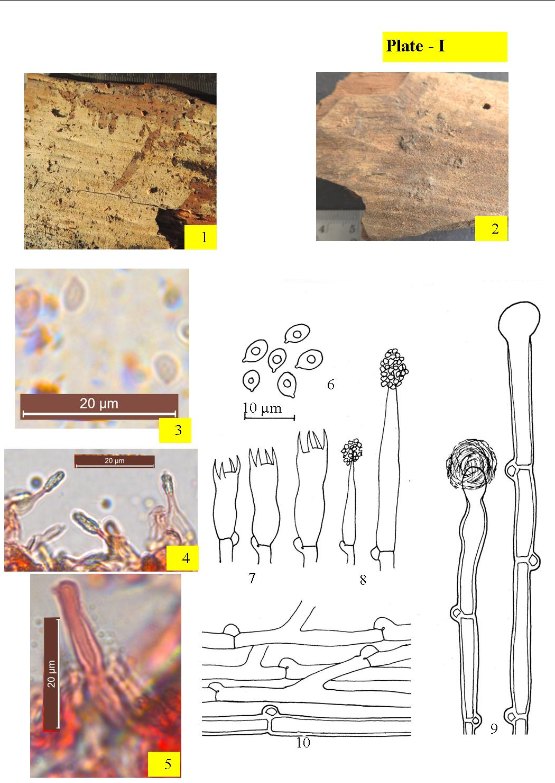
Images. 1– 10. Hyphodontia alutaria :1-2. Basidiocarp showing hymenium (1. Fresh, 2. Dry); 3-5. Photomicrographs (3. Basidiospores, 4. Lagenocystidia, 5.Capitate cystidium); 6-10. Line diagrams [6. Basidiospores; 7. Basidia, 8. Lagenocystidia, 9. Capitate cystidia, 10.Generative hyphae]

Collections observed – India, H. P.: Chamba, Churah, Bhandal, on stem of Picea smithiana, Poonam 10134 (PUN), August 14, 2014; Churah, Bhandal, on stump of Cedrus deodara, Poonam 10700 (PUN), August 15, 2014; ,Churah, Bhandal, on stump of Picea smithiana, Poonam 10701 (PUN), August 14, 2014; Bharmour, Manimahesh, Tosh ka got, on log of Pinus. roxburghii, Poonam 10702 (PUN), September 2, 2016; Bharmour, Manimahesh, Tosh ka got, on angiospermous sticks, Poonam10703 (PUN), September 3, 2016; Bharmour, Manimahesh, Tosh ka got, on angiospermous twigs, Poonam 10706 (PUN), September 4, 2016.
Remarks – H. alutaria is a redescribed species from district Chamba. Earlier Rattan (1977) described it from district Shimla and Chamba (Himachal Pradesh), Dhingra (2005) from Arunachal Pradesh, Singh (2007) from district Kullu (Himachal Pradesh), Dhingra et al.(2011) from Eastern Himalyas, Kaur (2012) form districts Solan and Shimla (Himachal Pradesh ) Sharma (2012) from district Uttarakhand and Dhingra et al. (2014) from different localities of Himachal Pradesh, Samita (2014) from U.K., Kaur (2017) from district Shimla (Himachal Pradesh), Devi (2019) from district Kangra (Himachal Pradesh).

2. Hyphodontia arguta (Fr.) J. Erikss., Symbolae Botanicae Upsalienses 16 (1): 104 (1958). - Hydnum argutum Fr., Systema Mycologicum 1: 424 (1821). Plate–II

Basidiocarps resupinate, annual, adnate, effused that can reach a thickness of 200 µm thick in vertical section.; hymenium odontoid both when fresh as well as dry conditions; grayish yellow to grayish orange, marginsvaries from pruinose to fibrillose, paler concolorous. Generative hyphae ≤ 3.3 µm wide, subhyaline, septate, clamped, smooth; horizontal, less branched, thin- to thick-walled in the subicular zone; vertical, richly branched, thin-walled in the subhymenial zone. Cystidial elements of two types (i) Hyphoid capitate, with basal clamp measuring 61–75 × 3.8–6.1 µm, thick-walled, gradually thinnin towards the apical part; enclosed to somewhat projecting. (ii) Lagenocystidia comprises of hyphal ends abruptly narrowing into a needle like apical part, with basal clamp, 29–45 × 2.7–3.3 µm, encrusted apical part ≤ 3.5 µm, thin-walled. Basidia varies from clavate to subcylindrical, having suburniform constriction, 13–18 × 4.9–5.5 µm; sterigma are ≤ 4.9 µm long. Basidiospores 4.4–5.6 × 3–3.8 µm, ellipsoid to broadly ellipsoid, smooth, thin-walled, , negative to both Melzer’s Reagent and Cotton Blue.

Collections observed – India, H.P.: Chamba, Churah, Bhandal, on angiospermous stem, Poonam 10138 (PUN), August 15, 2014; Dalhousie canttt, on stem of Cedrus deodara, Poonam 10687 (PUN), September 14, 2014; Churah, Bhandal, on stem of Cedrus deodara, Poonam 10688 (PUN), August 15, 2014; Churah, Bhandal, on stem of C. deodara, Poonam 10689 (PUN), August 15, 2014; Churah, Bhandal, on stem of C. deodara, Poonam 10696 (PUN), August 15, 2014; Churah, Bhandal, on stem of C. deodara, Poonam 10697 (PUN), August 15, 2014; Churah, Bhandal, on stem of C. deodara, Poonam 10698 (PUN), August 15, 2014; Churah, Bhandal, on stump of C. deodara, Poonam 10694 (PUN), August 15, 2014; Chamba, Chaned, on stump of Pinus roxburghii, Poonam 10690 (PUN), September 25, 2016; Chamba, Chaned, on stump of P. roxburghii, Poonam 10691 (PUN), September 25, 2016; Chamba, Kandu, on stem of P. roxburghii, Poonam 10692 (PUN), September 25, 2016; Chamba, Kandu, on stem of P. roxburghii, Poonam 10693 (PUN), September 25, 2016; Chamba, Hardaspura, on stem of P. roxburghii, Poonam 10695 (PUN), September 27, 2016.
Remarks –It is being redescribed from district Chamba. Earlier Rattan (1977) described it from districts Kullu, Chamba and Shimla (Himachal Pradesh), Dhingra, Kaur (2012) form district Shimla (Himachal Pradesh), Sharma (2012) from Uttarakhand, Ranadive (2013) from Maharashtra and Dhingra et al. (2014) from different localities of Himachal Pradesh, Samita (2014) from U.K., Sharma (2017) from J&K Devi (2019) from district Kangra (Himachal Pradesh).
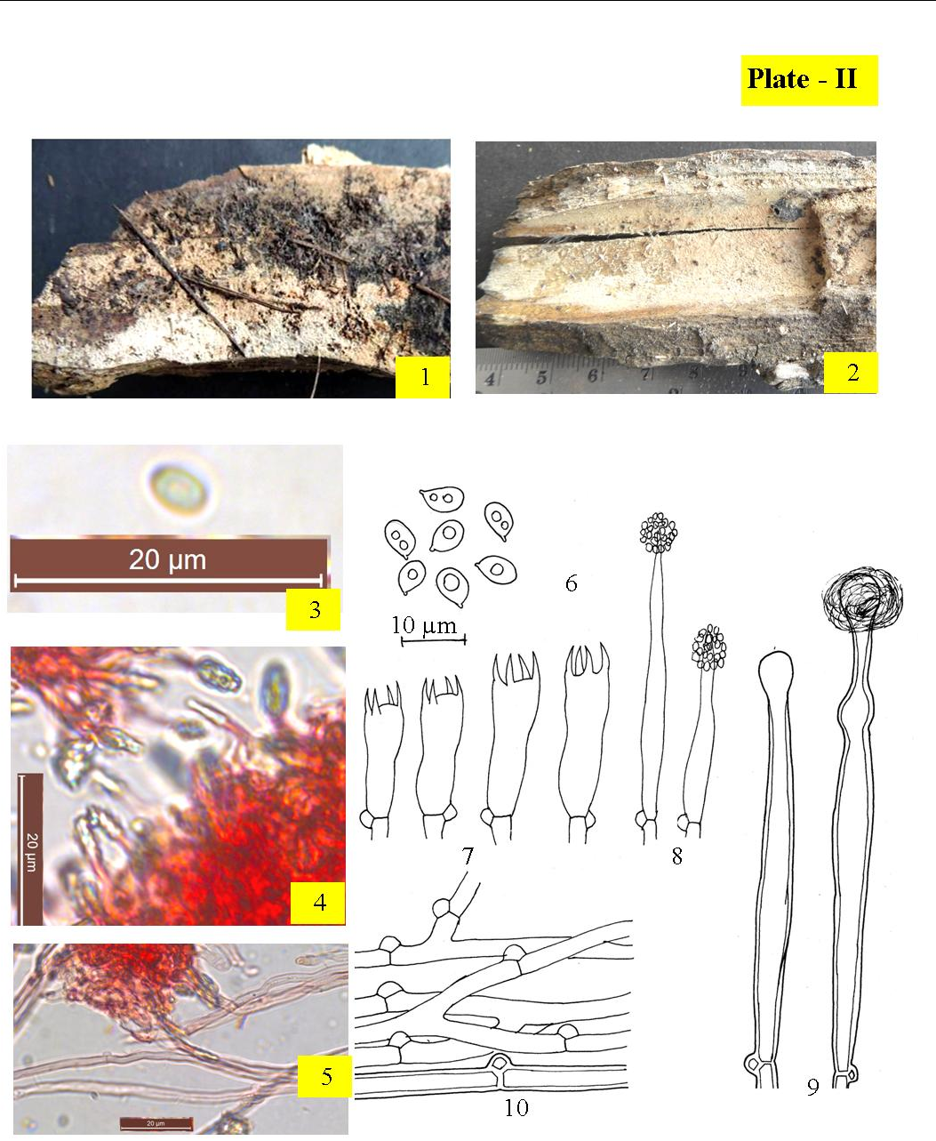
Images. 1– 10. Hyphodontia arguta :1-2 Basidiocarps showing hymenium (1. Fresh, 2. Dry); 3-5. Photomicrographs (3. Basidiospore, 4. lagenocystidia; 5.Generative hyphae); 6-10. Line diagrams [6. Basidiospores; 7. Basidia, 8. lagenocystidia, 9. Capitate cystidia, 10.Generative hyphae].

3. Hyphodontia pallidula (Bres.) J. Erikss., Symbolae Botanicae Upsalienses 16 (1): 104 (1958). - Gonatobotrys pallidula Bres., Annales Mycologici 1 (2): 127 (1903).
Plate –III
Basidiocarps annual, resupinate, adnate, effused, that can reach a thickness of 200 µm in vertical section; hymenium are smooth to tuberculate both when fresh as well as dry conditions; yellowish whitish to pale yellowish to grayish orange when fresh, pale orange to grayish orange after drying, margins varies from pruinose to fibrillose, paler concolorous. Generative hyphae smooth, subhyaline, septate, clamped; horizontal, ≤ 3.8 µm wide, richly branched thick-walled in the subicular zone; vertical, ≤ 2.2 µm wide, less branched, thin-walled in the subhymenial zone. Cystidial elements cylindrical to subcylindrical, 57–81 × 11–12 µm, thick-walled hyphoid except at the apex, oftenely with constrictions, apically obtuse or somewhat capitate, septate, clamped; projecting up to 30 μm out of the hymenial surface. Basidia clavate, sinuous, 13–18 × 3.8–5.5 µm; sterigma ≤ 4.4 µm long. Basidiospores 4.2–5.4 × 2.2–3.3 µm, ellipsoid to broadly ellipsoid, with oily contents, thin-walled, smooth, negative to both Melzer’s Reagent and Cotton Blue.

Collections observed – India, H.P.:: Chamba, Khajjiar, Kalatop, on sticks of Pinus roxburghii, Poonam 10710 (PUN), October 13, 2012; Khajjiar, Kalatop, on sticks of P. roxburghii, Poonam 10711 (PUN), October 13, 2012; Chamba, Kolhari, on sticks of Rosa macrophylla, Poonam 10712 (PUN), September 11, 2014; Chamba, Churah, Bhandal, on sticks of R. macrophylla, Poonam 10713 (PUN), August 15, 2014; Chamba, Churah, Bhandal, on sticks of R. macrophylla, Poonam 10714 (PUN), August 15, 2014; Chamba, Churah, Bhandal, on sticks of R. macrophylla, Poonam 10715 (PUN), August 15, 2014; Chamba, Bharmour, Manimahesh, Tosh ka got, on stick of Juglans regia, Poonam 10716 (PUN), September 4, 2016.
Remarks – H. pallidula is reported for the first time from tehsils Bharmour and Churah in the district Chamba. Earlier it have been described by Rattan (1977) from districts Kullu and Chamba (Himachal Pradesh), Lalji (2003) from Uttarakhand, Dhingra (2005) reported it from Eastern Himalyas, Singh (2007) reported it from district Sirmaur and Shimla (Himachal Pradesh) Kaur (2012) form district Shimla and Kullu (Himachal Pradesh.), Ranadive (2013) reported it from Maharashtra, Samita (2014) from U.K., Sharma (2017) from J&K Devi (2019) from district Kangra (Himachal Pradesh)
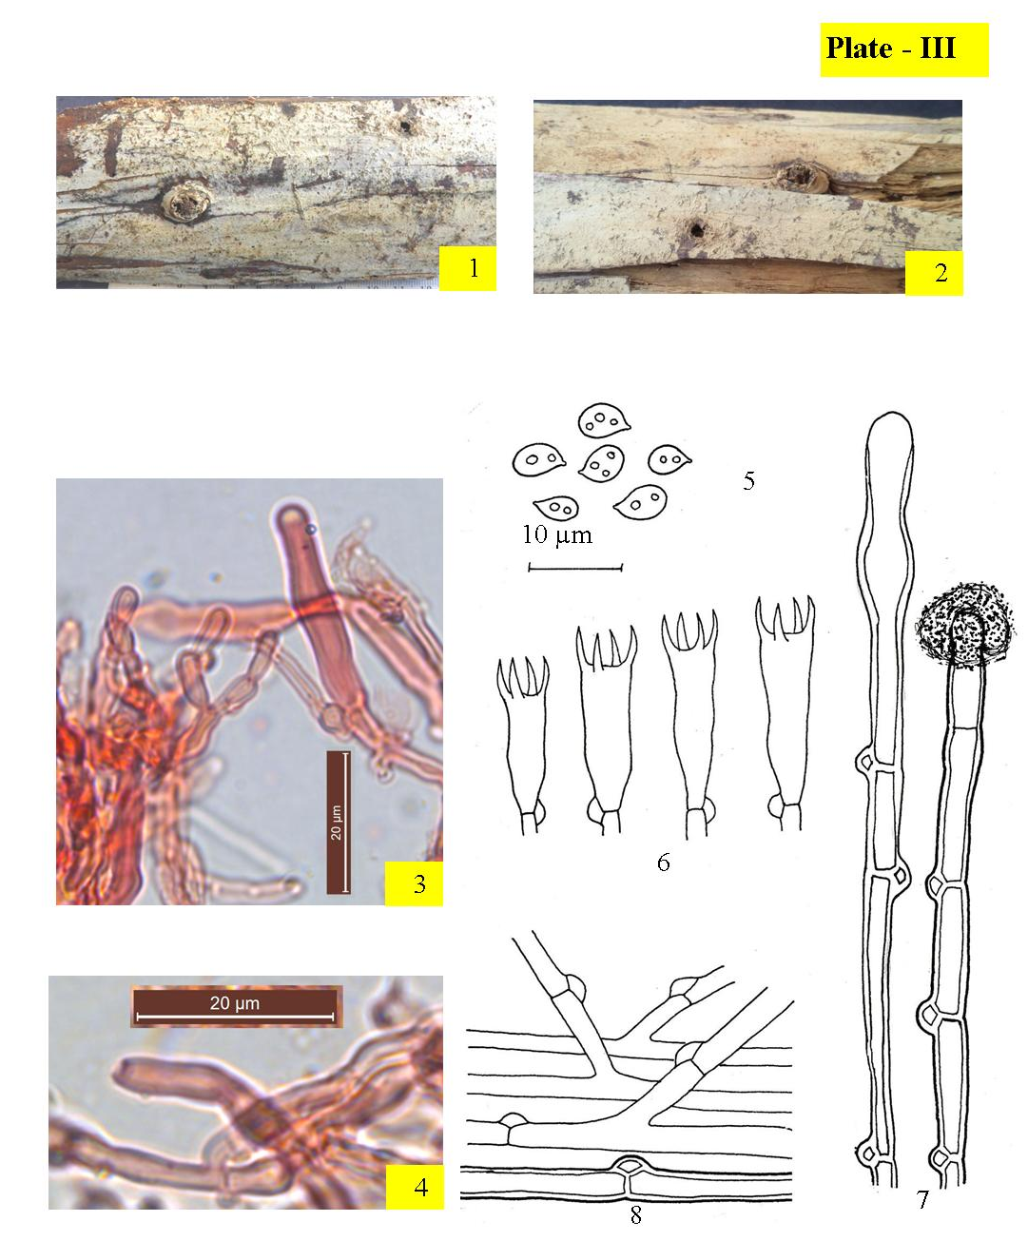
Images. 1– 8. Hyphodontia pallidula :1-2.Basidiocaros showing hymenium(1. Fresh, 2. Dry); 3-4. Photomicrographs (3. Capitate cystidium, 4. Generative hyphae); 5.-8.Line diagrams [5. Basidiospores; 6. Basidia, 7. Cystidia ,8.Generative hyphae]

4. Hyphodontia rimosissima (Peck) Gilb., Evolution in the higher Basidiomycetes: 300 (1971). - Odontia rimosissima Peck, Annual Report on the New York State Museum of Natural History 50: 114 (1897). Plate –IV
Basidiocarps resupinate, annual, adnate, effused, that can reach a thickness of 320 µm in vertical section; hymenium smooth to odontoid both when fresh as well as dry conditions; yellowish whitish to pale yellow when fresh, pale yellowish gray to grayish yellow upon drying, margins fibrillose, paler concolorous. Generative hyphae ≤ 2.3 µm wide, with abundant crystalline encrustation that dissolves in 3% KOH solution, subhyaline, septate, clamped, , thin-walled; horizontal, lesser branched in the subicular zone; vertical, richly branched in the subhymenial zone. Cystidial elements absent. Numerous capitate hyphal ends present in hymenium, with basal clamp, 26–28 × 2.2–3.8 µm, resinous encrustation normaly present at the apical part that which get dissolves in 3% KOH solution. Basidia subclavate to clavate, constricted to sinuous, with oliy contents, 16–21 × 4.4–5 µm; sterigma upto ≤ 3.8 µm long. Basidiospores 4.4–6.1 × 3.5–5.µm, broadly ellipsoid, smooth, thin-walled, negative to both Melzer’s Reagent and Cotton Blue.

Collections observed – India, H.P.: Chamba, Bharmour, Manimahesh, Tosh ka got, on Pinus roxburghii stump, Poonam 10137 (PUN), September 4, 2016.
Remarks – H. rimosissima is being reported for the first time from district Chamba. Kaur and Dhingra et al. (2012) reported it from district Kangra (H.P.)

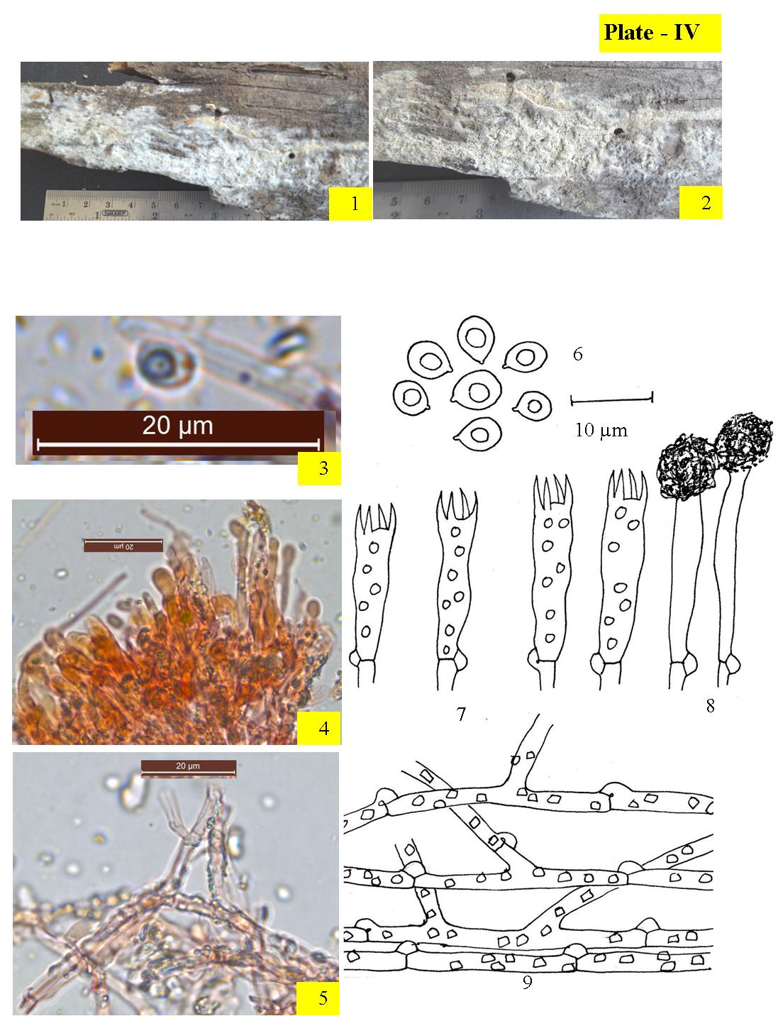
Images. 1– 9. Hyphodontia rimosissima :1-2.Basidiocarps showing hymenium (1. Fresh; 2. Dry); 3-4. Photomicrographs (3. Basidiospore; 4. A portion of V.S. of sporophore, 5. Encrusted generative hyphae); 6-9. Line diagrams [6. Basidiospores, 7. Basidia,8. Encrusted capitate hyphal ends, 9. Generative hyphae]

5. Hyphodontia sambuci (Pers.) J. Erikss., Symbolae Botanicae Upsalienses 16 (1): 104 (1958). - Corticium sambuci Pers., Neues Magazin für die Botanik 1: 111 (1794). Plate–V
Basidiocarps resupinate, annual, adnate, effused, that can reach a thickness of 240 µm in vertical section; hymenium smooth to rough both when fresh as well as dry conditions; chalky whitish to orange white while fresh, yellowish gray to grayish orange on drying, margins fibrillose, paler concolorous. Generative hyphae subhyaline, septate, clamped; horizontal, ≤ 3.5 µm wide, less branched, thick-walled, smooth in the subicular zone; vertical, ≤ 2.2 µm wide, richly branched, thin-walled, encrusted in the subhymenial zone. Cystidial elements capitate, with basal clamp, 27–37 × 4.4–5.5 µm, thin-walled, with crystalline encrustation. Basidia subclavate to clavate, 17–28 × 3.3–6.6 µm; sterigma are ≤ 3.8 µm. Basidiospores 4.4–6.1 × 3.5–5 µm, smooth, broadly ellipsoid, thin-walled, negative to both Melzer’s Reagent and Cotton Blue.

Collections observed – India, H.P.: Chamba, Khajjiar, on twigs of Cedrus deodara, Poonam 10140 (PUN), August 15, 2013; Churah, Langera, on sticks of Rosa macrophylla, Poonam 10705 (PUN), August 15, 2014; Churah, Manjeer, on sticks of R. macrophylla, Poonam 10707 (PUN), August 15, 2014; Churah, Salooni, on twigs of R. macrophylla, Poonam 10708 (PUN), August 15, 2014; Churah, Salooni, on sticks of R. macrophylla, 10709 (PUN), August 15, 2014; Bhalai, Sundla on sticks of Adhatoda vasica, Poonam 10704 (PUN), October 13, 2015.
Remarks __ Hyphodontia sambuci is being described for the first time from tehsils Bharmour and Pangi in district Chamba. Previously Dhingra (1989) described it from Arunachal Pradesh, Natrajan & Kolandvelu (1998) described it from Tamil Nadu, Lalji (2003) from U.K., Dhingra (2005) from Eastern Himalayas, Singh (2007) from district Shimla, Solan and Kullu (Himachal Pradesh) Priyanka (2012) from districts Chamba and Kangra (Himachal Pradesh), Ranadive (2013) from Maharashtra, Samita (2014) from U.K., Dhingra et al. (2014) also from various localities of H.P., Sharma (2017) from J & K, Kaur (2018) from from district Shimla (Himachal Pradesh) and Devi (2019) from district Kangra (Himachal Pradesh).
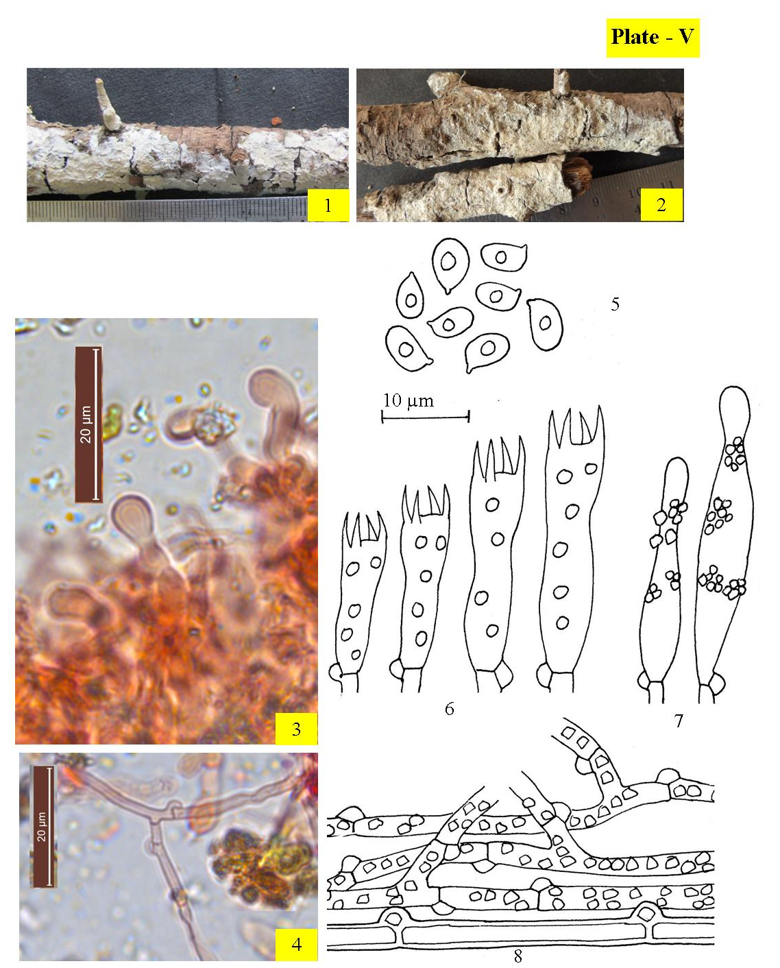
Images. 1– 8. Hyphodontia sambuci :1-2. Basidiocarps showing hymenium (1. Fresh, 2. Dry); 3-4. Photomicrographs (3. Capitate cystidia, 4. Generative hyphae); 5-8. Line diagrams [5. Basidiospores; 6. Basidia, 7. Capitate cystidia, 8. Generative hyphae]
II. Tubulicrinis Donk, Fungus 26: 13 (1956).
Basidiocarps annual resupinate, loosely adnate to effused, sometimes inconspicuous; hymenium varies from porulose to smooth pulveraceous to hispid to somewhat tuberculate. Hyphal system is monomitic. Generative hyphae are with clamped septa, thin- to thick-walled. Sterile elements (lyocystidia/hyphoids) usually present. Basidia clavate to subclavate, somewhat stalked, 4–sterigmate, septa with clamp at the base. Basidiospores varies from cylindrical to allantoid to suballantoid to subglobose to ellipsoid, thin-walled, smooth, negative to both Melzer’s Reagent and Cotton Blue.

1. Tubulicrinis chaetophorus (Höhn.) Donk [as 'chaetophora'], Fungus, Wageningen 26: 14, (1956). - Hypochnus chaetophorus Höhn., Sber. Akad. Wiss. Wien, Math.-naturw. Kl., 111: 1007 (1902). Plate –VI
Basidiocarps resupinate, annual, adnate, effused, that can reach a thickness of 320 µm in section; hymenium smooth to hispid both when fresh as well as dry conditions; yellowish white to pale yellow in fresh state, yellowish gray to grayish orange when drying, margins fibrillose, paler concolorous. Generative hyphae smooth, subhyaline, septate, clamped; horizontal, ≤ 4 µm wide, thin- to thick-walled, lesser branched in the subicular zone; vertical, ≤ 2.8 µm wide, thin-walled, richly branched in the subhymenial zone. Sterile elements of 2 types: (i) Lyocystidia cylindrical, gradually tapering towards pointed tip, with rooted base, capillary lumen narrow, with basal clamp, 88–102 × 10–11 µm, slightly amyloid; projecting upto ≤ 30 µm out of the hymenial surface (ii) Capitate cystidial elements hyphoid, sinuous, with basal clamp, 20–22 × 2.7–3.8 µm, thin-walled; embedded in the hymenium. Basidia varies from clavate to subclavate, somewhat sinuous, with oily contents, 16–21 × 5.5–6.1 µm; sterigma upto ≤ 5.5 µm long. Basidiospores 4–5.5 ×2.4–3.5 µm, ellipsoid to broadly ellipsoid, smooth, thin-walled, negative to both Melzer’s Reagent and Cotton Blue.
Collections observed – India, H.P.:: Chamba, Bharmour, Holi, on twigs of Pinus roxburghii Poonam 10381 (PUN), August 23, 2015.
Remarks – Tubulicrinis chaetophorus is being reported for the first time from tehsil Bharmour in the Chamba district. Previously it was reported by Thind and Rattan (1970) from district Chamba (Himachal Pradesh) Rattan (1977) from J&K, Singh (2007), Priyanka (2012) and Kaur (2018) from district Shimla (Himachal Pradesh).
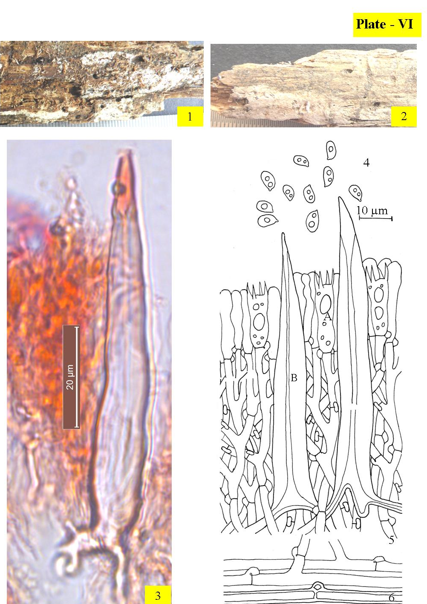
Images. 1– 6. Tubulicrinis chaetophorus :1-2. Basidiocarps showing hymenium(1. Fresh, 2. Dry); 3. Photomicrograph showing lycocystidium; 4-6. Line diagrams [4. Basidiospores; 5. Reconstruction showing a portion of hymenium and subhymenium ( A. Basidium, B. lycocystidium); 6.Generative hyphae]
2. Tubulicrinis orientalis Parmasto, Eesti NSV Teaduste Akadeemia Toimetised 16: 393(1967). Plate –VII
Basidiocarps resupinate, annual, adnate, effused, that can reach a thickness of 150 µm in vertical section; hymenium smooth both when fresh as well as dry states; grayish orange to brownish orange both in fresh as well as dry conditions, margins fibrillose, paler concolorous. Generative hyphae ≤ 3 µm wide, smooth, subhyaline, septate, clamped, thin-walled; horizontal, lesser branched in the subicular zone; vertical, richly branched in the subhymenial zone. Lyocystidia cylindrical, capillary lumen narrow, with basal clamp, 79–89 × 6–9 µm, encrusted in the upper part except the apical tip, slightly amyloid; projecting ≤ 70 µm out of the hymenium. Basidia clavate, sinuous, 14–16 × 3–5 µm; sterigma upto ≤ 3.6 µm long. Basidiospores 4.1–6.3 × 2.1–3.5 µm, ellipsoid to suballantoid, smooth, thin-walled, negative to both Melzer’s Reagent and Cotton Blue.
Collections observed – India, H.P.: Chamba, on the track from Lakkar Mandi towards Khajjiar, on decaying gymnospermic wood, Poonam 10765 (PUN), November 4, 2013.
Remarks – It is being reported here as as a rereported species from district Chamba. Priyanka (2012) as well Dhingra et al. (2014) reported it from district Chamba (Himachal Pradesh).

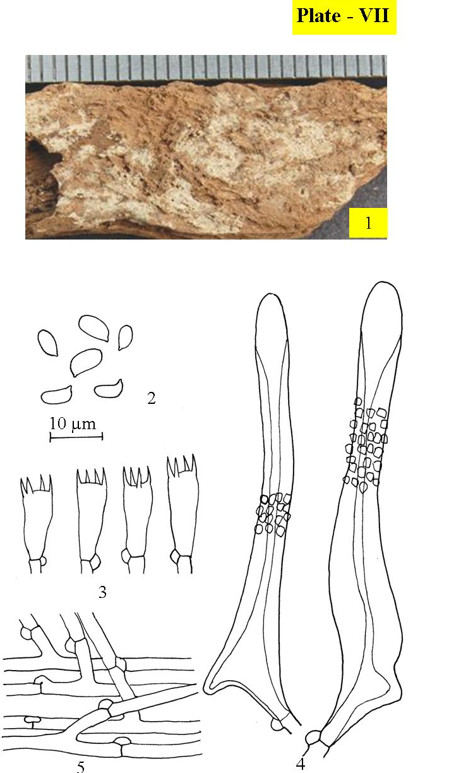
Images. 1– 5. Tubulicrinis orientalis :1. Basidiocarps showing hymenial surface; 2-5. Line diagrams [2. Basidiospores; 3. Basidia, 4. Lycocystidia, 5.Generative hyphae

3. Tubulicrinis strangulatus K.H. Larsson & Hjortstam, Mycotaxon 26: 438, (1986).
Plate –VIII
Basidiocarps annual resupinate, adnate, effused, that can reach a thickness of 180 µm in vertical section; hymenium porulose to smooth both in fresh as well as dry conditions; margins fibrillose, paler concolorous.Generative hyphae ≤ 3.3 µm wide, smooth, subhyaline, septate, clamped,; horizontal, lesser branched in the subicular zone; vertical, richly branched, thin- to thick-walled in the subhymenial zone. Lyocystidia cylindrical, capillary lumen narrow, that widens towards the apical part, having basal clamp, 56–119 × 6.3–9.1 µm, with crystalline ecrustation around neck, which dissolves in 3% KOH solution, slightly amyloid. Basidia clavate, somewhat stalked, constricted, 15–20 × 4.4–6.1 µm; sterigma upto ≤ 3.3 µm long. Basidiospore 4.9–7.7 × 2.2–3.5µm, allantoid to suballantoid, smooth, thin-walled, negative to both Melzer’s Reagent as well Cotton Blue.

Collections observed – India, H.P.: Chamba, Banikhet, on gymnospermous log, Poonam 10382 (PUN), August 16, 2014.
Remarks – It is a redescribed species from district Chamba. Earlier it was described by Dhingra and Sood (1992) from district Chamba (Himachal Pradesh), Kaur (2012), Singh (2007) and Kaur (2018) from district Shimla (Himachal Pradesh) Dhingra et al. (2014) from districts Shimla and Chamba (Himachal Pradesh).
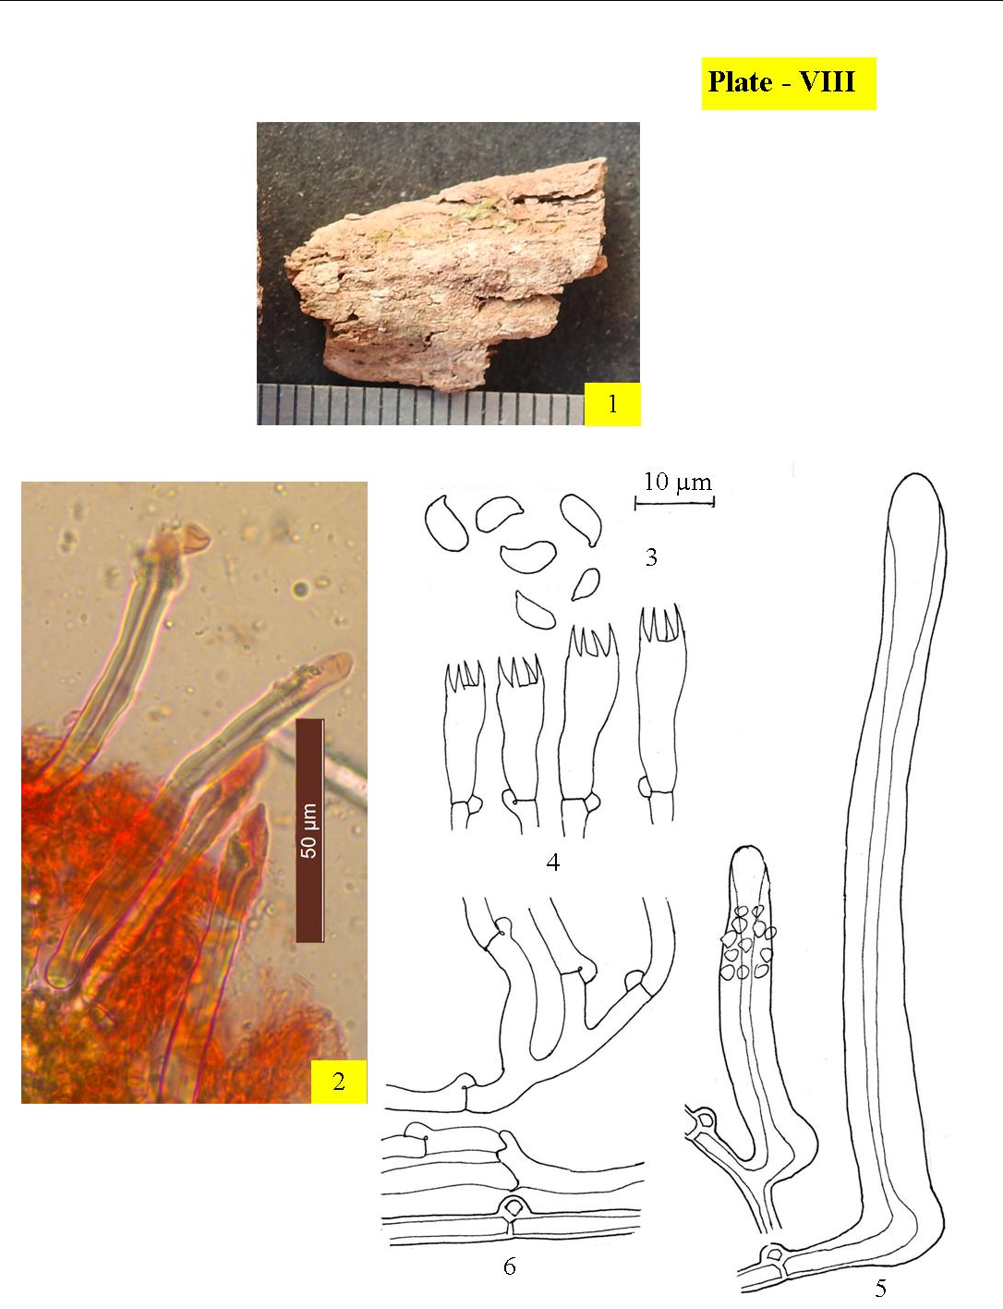
Images. 1– 6. Tubulicrinis strangulatus :1. Basidiocarp showing hymenium; 2-3. Photomicrographs (2. Lycocystidia); 3-6. Line diagrams [3. Basidiospores; 4. Basidia, 5. Lycocystidia, 6.Generative hyphae]

III. Xylodon (Pers.) Gray, Observationes mycologicae 2: 267, (1818).
Basidiocarps resupinate, adnate, effused; hymenium smooth to odontoid. Hyphal system is monomitic. Generative hyphae are septate clamped. Hyphal ends capitate, spathulate or tubular. Basidia are clavate to subclavate to subcylindrical, 4–sterigmate, septa with clamp at the base. Basidiospores ellipsoid to broadly ellipsoid to subglobose, smooth, thin-walled, negative to both Melzer’s Reagent as well Cotton Blue.

1. Xylodon asper (Fr.) Hjortstam & Ryvarden, Synopsis Fungorum 26: 34 (2009).- Grandinia aspera Fr., Hymenomycetes europaei: 627(1874). Plate–IX
Basidicarps resupinate, annual , adnate, effused, can reach a thickness of 320 µm thick in section; hymenium odontoid both in fresh as well dry conditions; orange white to grayish orange both in fresh as well as on drying, margins fibrillose, paler concolorous. Generative hyphae subhyaline, smooth, septate, clamped, thin- to thick-walled, ≤ 3.2 µm wide, horizontal, lesser branched in the subicular zone; ≤ 2.3 µm wide, vertical, richly branched in subhymenial zone. Cystidoles obtuse to capitate, up to 32 × 3.8 μm, with or without resinous encrustation. Basidia clavate, constricted to somewhat sinuous, 14–21 × 4.4–5.5 µm, sterigmata ≤ 4.4 µm long Basidiospore 4.9–6.4 × 4–4.8, broadly ellipsoid to subglobose, thin-walled, smooth, negative to both Melzer’s Reagent and Cotton Blue.

Collections observed – India, H.P.: Chamba, Churah, Bhandal, on stump of Pinus smithiana, 10184 (PUN), August 17, 2014.
Remarks– Xylodon asper a rereport from district Chamba, has earlier been described from various districts of Himachal Pradesh as well as other localities of India. Previously Rattan (1977) described it from district Shimla (Himachal Pradesh), Natrajan & Kolandvelu (1998) from Tamil Nadu, Singh (2007) from district Chamba and Sirmaur (Himachal Pradesh.), Sharma (2012) from U.K., Kaur (2012) District Shimla (Himachal Pradesh) Ranadive (2013) from Maharashtra, Samita (2014) from Kaur (2018) from district Shimla (Himachal Pradesh), Dhingra et al. (2014) from various localities of H.P. and Sharma (2017) also reported it from J&K.
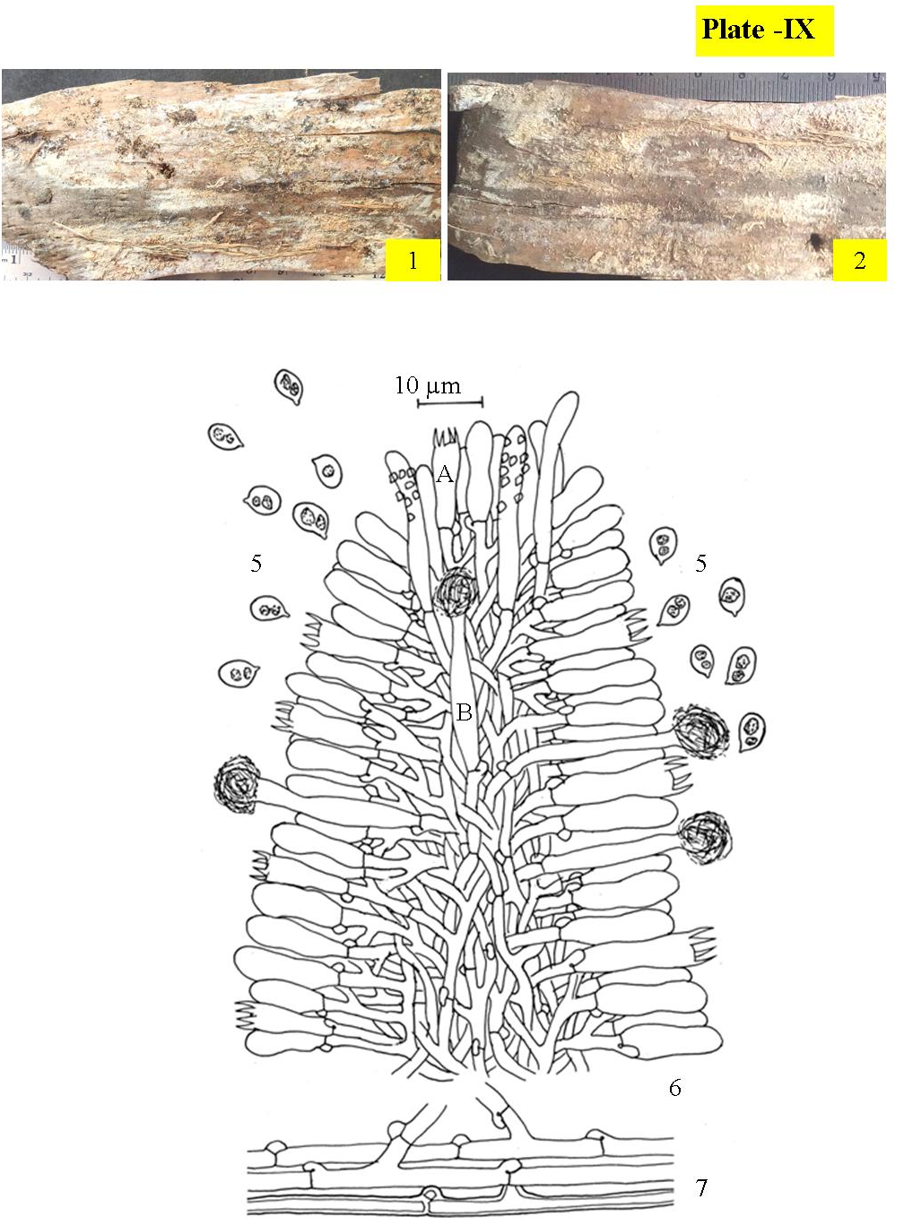
Images. 1– 5. Xylodon asper :1-2. Basidiocarp showing hymenium(1. Fresh, 2. Dry); 3-5. Line diagrams [3. Basidiospores; 4. Reconstruction showing a portion of aculeus ( A. Basidium, B. Capitate hyphal ends); 5.Generative hyphae]
2. Xylodon spathulata (Schrad.) Kuntze, Revisio generum plantarum 3 (2): 541 (1898). - Hydnum spathulatum Schrad., Spicilegium Florae Germanicae: 178, t. 4:3 (194). Plate –X
Basdiocarps resupinate, annual, adnate, effused, can reach upto160 µm in vertical section; hymenium smooth to odontoid both in fresh as well as dry states; grayish orangish to brownish orange both in fresh as well as dry conditions, margins fibrillose, paler concolorous. Generative hyphae are ≤ 2.7 µm wide, subhyaline, septate, clamped; horizontal, less branched, thick-walled, smooth in the subicular zone; vertical, richly branched, thin-walled, with resinuous encrustation in subhymenial zone. Ancillarry elements of two types: (i) Capitate hyphal ends with basal clamp, 24–32 × 3.3–4.4 µm, thick-walled, having resinous deposits at the apex; enclosed to somewhat projecting (ii) Spathulate gloeocystidia with basal clamp, 19–34 × 4–6.5 µm, thin-walled, tapering towards the tip, usually constricted, with oily contents negative to sulphovanillin
Basidia subclavate to clavate, havin suburniform constriction, 14–18 × 4.4–5 µm; sterigma ≤ 3.3 µm long. Basidiospore 4–5.6 × 2.4–4, broadly, smooth, thin-walled, acyanophilous, inamyloid.
Collections observed – India, H.P.: Chamba, on way to Lakkar Mandi from Kalatop, on stump of Cedrus deodara, Poonam 10554 (PUN), October 12, 2013.
Remarks – Xylodon spathulata is a redescribed species from district Chamba. The only earlier report from district Chamba is by Kaur (2012).
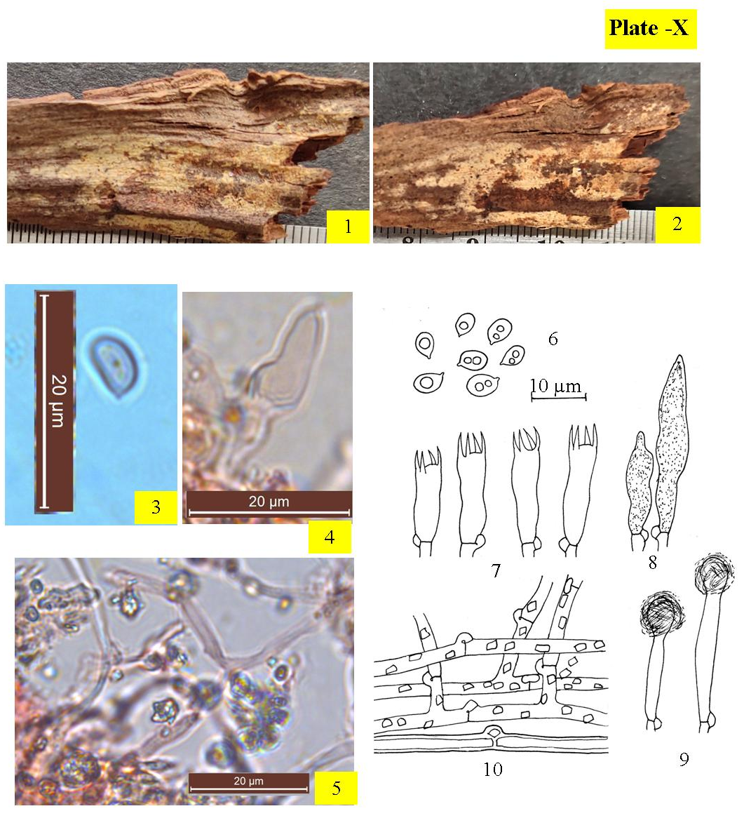
Images. 1– 10. Xylodon spathulata:1-2. Basidiocarp showing hymenium(1. Fresh, 2. Dry); 3-5. Photomicrographs (3. Basidiospores, 4. Spathulate gloeocystidium, 5.Generative hyphae); 6-8. Line diagrams [6. Basidiospores; 7. Basidia, 8. Spathulate gloeocystidium, 9. Capitate Cystidia, 10.Generative hyphae]
ACKNOWLEDGEMENTS
The authors acknowledge the provision of necessary laboratory space by the head of the Botany department of Punjabi University Patiala, as well as financial support from the University Grants Commission in New Delhi through the DRS-SAP DSA level-I program and comments from Prof. Nils Hallenberg of Gothenburg.
REFERENCES
1. Devi, R. 2019.Taxonomic studies on poroid and resupinate non-poroid Agaricomycetes of district Kangra (Himachal Pradsh). Ph.D. Thesis. Panjabi University, Patiala. 554pp.
2. Dhingra, G.S. 2005b. Genus Hyphodontia John Erkss. in the Eastern Himalaya. J. Ind. Bot. Soc. 84: 118–122.
3. Dhingra, G.S., Priyanka and Kaur, J. 2011. A checklist of resupinate, non–poroid Agaricomycetes fungi from North–East India and Bhutan. Synopsis Fungorum 29: 22–70.
4. Dhingra, G.S., Singh, A.P., Kaur, J., Priyanka, Kaur, H., Rani, M., Sood, S., Singla, N., Kaur, H., Jain, N., Gupta, S., Kaur, M., Sharma, J., Rajnish and Kaur, G. 2014. A checklist of resupinate, non–poroid Agaricomycetous fungi from Himachal Pradesh, India. Synopsis Fungorum 32: 8–37.
5. Kaur, J. 2012. Studies on resupinate, non–poroid Agaricomycetous fungi from Himachal Pradesh. Ph.D. Thesis. Panjabi University, Patiala. 256pp.
6. Kaur, G. 2017. Taxonomic studies on poroid and resupinate non–poroid Agaricomycetous fungi of Punjab and adjoining areas. Ph.D. Thesis. Punjabi University, Patiala. 256pp.
7. Kaur, M. 2018. Systematic Studies On Resupinate Non–Poroid Hymenomycetous Fungi From District Shimla (H.P.) & Evaluation of Selected Taxa for Ligninolytic Activity. Thesis. Punjabi University, Patiala. 303pp
8. Kornerup, A. and Wanscher, J.H. 1978. Metheun’s Handbook of colours, IIIrd Ed. Metheun and Co. Ltd. London. 252pp.
9. Lalji, K. 2003. Mycoflora associated with multipurpose tree species of North–West India. Ph.D. Thesis. Panjabi University, Patiala. 254pp.
10. Mycobank. 2023. Fungal databases. Nomenclature and species banks. [Accessed: 25/07/2023] http://www.mycobank.org.
11. Natrajan, K. and Kolandavelu, K. 1998. Resupinate Aphyllophorales of Tamil Nadu, India. 131pp.
12. Poonam, 2020. Taxonomic studies on the Corticioid fungi from district Chamba (Himachal Pradesh). Thesis. Punjabi University, Patiala. 431pp.
13. Poonam, Singh, A.P. and Dhingra, G.S. 2022. Diversity of Corticioid fungi Belonging to family Meruliaceae in Chamba district of Himachal Pradesh. Springer: 165–197.
14. Priyanka, 2012. Studies on resupinate Polyporales (Agaricomycetes) of Himachal Pradesh. Ph.D. Thesis. Punjabi University, Patiala. 226pp.
15. Ranadive, K.R. 2013. An overview of Aphyllophorales (wood rotting fungi) from India. Int. J. Curr. Microbiol. App. Sci. 2(12): 112–139.
16. Rattan, S.S. 1977. The resupinate Aphyllophorales of the North Western Himalaya. Bibliotheca Mycologica 60, Cramer, Germany. 427pp.
17. Singh, A.P. 2007. Resupinate Aphyllophoraceous Fungi associated with some tree species of Himachal Pradesh and Punjab. Ph.D. Thesis. Punjabi University, Patiala. 258pp.
18. Samita. 2014. Systematic studies on resupinate, non-poroid Agaricomycetes of Uttarakhand. Ph.D. Thesis. Punjabi University, Patiala. 331pp.
19. Sharma, J.R. 2012. Aphyllophorales of Himalaya. Botanical Survey of India, Calcutta. 590pp.
20. Sharma, J. 2017. Taxonomic studies on resupinate non-poroid Agaricomycetous fungi from Jammu division (J&K). Ph.D. Thesis, Punjabi University, Patiala. 270pp.

