INTRODUCTIONTOMACHINE AND MECHANISM
Simply speaking, “A machine is a device which received energy in some availableform and utilizes it to do some particular type of work” or “A machine may beregarded asanagentfortransmittingormodifying energy”.

THEMACHINE
A machine is a set of parts with the ability to convey power in a regulated way and the ability to carry out productive work. A machine is composed of several kinematically connected linkages.
A machine is an arrangement of resilient entities (links or components) with successfully restricted relative movements that is used to convert other types of energy into energy that is mechanical or to transport and change available energy to do a specific type of work.

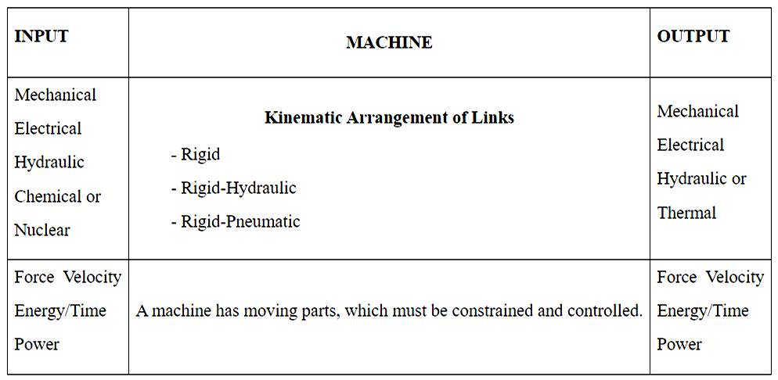

MachineArrangement
It will be discovered that every machine consists of a system of linked components (links or elements) that, when one is forced to move, they all get a motion, the relationship of which to the first relies on the kind of connections (i.e. joints).

The linkages might be pneumatic, hydraulic, or rigid. The source of power might be nuclear, mechanical, electrical, hydraulic, or chemical. Mechanical, electrical, hydraulic, or thermal power may be produced.

Machines that include:

Receives thermal energy and converts it into mechanical energy.

Electric motor-Changes electric energy into mechanical energy.

A pump-Input electric power and output hydraulic power.

Most machines take mechanical energy and modify it so that it may be utilised to do a specific purpose for which it was created; popular examples of such machines are hoists, lathes, screw jacks, etc.

It should be mentioned that a machine needs to be able to do useful tasks. Unless the intended intention was just to create heat, a chain of kinematically connected links set in motion with no output link and simply converting input energy to friction heat is not a machine.
MACHINES' CLASSIFICATION
1. Mechanical energy-generating devices that transform various sources of energy into mechanical work
For instance, consider steam engines, steam turbines, IC engines, gas turbines, water turbines, etc.
2. Machines that convert mechanical energy into other forms of energy are sometimes referred to as converting machines.
Examples: Electric generators,air or hydraulic pumps,etc.
3. Machinesforutilizingmechanicalenergyintheperformanceofusefulwork.
Examples: Lathe,and other machine tools,etc.
The presence of a number of pieces (links or elements) is necessary for the transmission and modification of energy inside the machine. These parts are chosen in such a way that they will create the desired motion and transport the forces to which they are subject safely, enabling the machine to effectively do its work.
The field of "Theory of Machines," or "The Theory of Machines," is concerned with the study of the relative motion between the various components of a machine and the forces that act on them.
DIFFERENCE BETWEEN MACHINE AND MECHANISM
A mechanism in kinematics is a method for communicating, regulating, or restricting relative movement. Rigid bodies joined by joints are the main component of mechanics. It may alternatively be described as a group of resilient bodies that are joined and fashioned in a way that allows them to move in definite relation to one another.A machine is made up of a number of hard or resistant bodies that are arranged and linked to move.
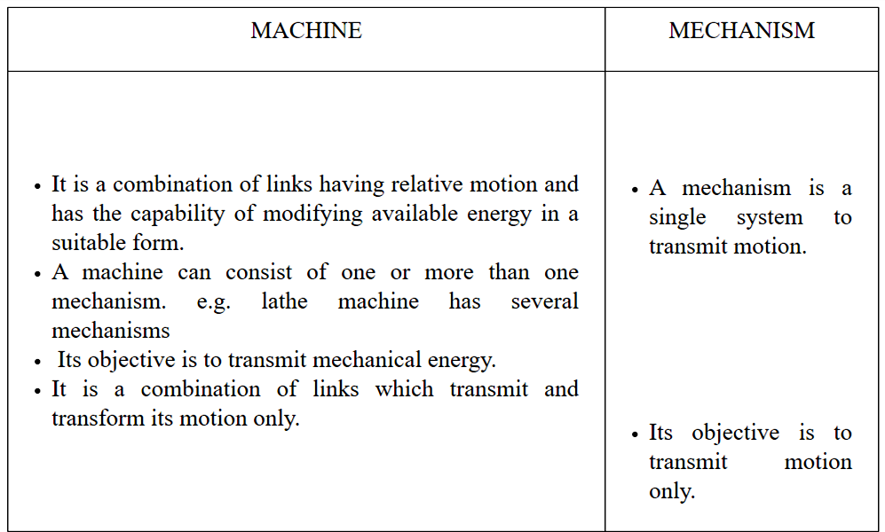

The IC engine and slider crank mechanism serve as a straightforward illustration of a machine and mechanism.Using a slider crank mechanism, a crank's rotating action is transformed into a slider's sliding motion. However, in an internal combustion engine, a similar process is employed to transform the mechanical energy present in the piston into the necessary torque at the crank shaft.

KINEMATICANALYSISOFMECHANSIM
When put into action, several mechanisms each have their unique set of outputs. Calculating the location, velocity, and acceleration at different spots on the mechanism allows for the examination of the mechanism. Calculating the forces and stresses operating on the various components of the mechanism is not necessary for the study of velocity and acceleration at any location on the mechanism. In other words, we don't need to take the cross sectional area or strength of the component elements into account while analysing the motion of a certain mechanism. Furthermore, it makes no difference if the components are cast. the use of iron, wood, or any other material for motion analysis.
Pictorial AND ANALYTICAL METHOD: Two different approaches, referred to as graphical and analytical techniques, may be used to analyse the Mechanism. Each strategy has benefits and cons of its own.The graphical technique is simple to use and provides a visual representation of how a system operates. But analytical approaches are better suited to issues that are more complicated. We may decide how we wish to approach the issue at hand. High-speed computers has made analytical approaches a particularly effective tool for resolving difficult issues. Due to their convenience and simplicity, we will focus on graphic approaches in this course.
DESIGN SYNTHESIS
To determine the size of the pieces, we will use stress analysis together with other design criteria like bending, fatigue, etc.A mechanism can be synthesised using one of two methods. In the first method, the dimensions of a mechanism's pieces are determined by taking into account the load, stress, bending, etc. in each component.In the second method, the components' dimensions are first presummated before the analysis is completed to determine the strength of the component. The majority of engineers choose the second synthesis approach.

KINEMATICSOFMECHANISM

It entails the analysis of the relative movements of different mechanisms' components without taking into account the forces causing such motions.It is the study from the geometric point of view by which we may determine the displacement, velocity, and acceleration at the different positions on the components of a mechanism.

DYNAMICSOFMECHANISM
It involves the calculations of the forces impressed upon various parts of a mechanism. Static and kinetic forces can be used to categories the forces acting on a machine. When all of the component sections of the system are in equilibrium, forces are studied in static. Whereas in kinetics, inertia forces that may result from the combination of mass and motion of the pieces are studied.

LINK

PLANER MECHANISM

A link is described as a single component that can be a single resistant body or a collection of resistant bodies connected by rigid joints and moving in relation to other components of the machine. Kinematic link and element are additional terms for links. Links and component pieces of a mechanism are two different things. If there is no relative motion between any two sections of the mechanism, then those portions can be viewed as one link.
Example: Any machine's frame is regarded as a single link since its diverse components do not move relative to one another. There is no relative motion in the frame itself, as can be seen in the slider crankmechanism below, thus it is regarded as one link (link 1). Here, the connecting rod is at link 3 and the crank is in link 2. Since link 4 has no relative motion, it is the slider or piston. By taking into account the concept of a connection, many complicated systems may therefore be described by a straightforward configuration diagram.

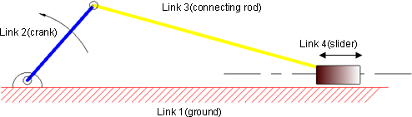

Fig:2.1Slidercrankmechanism

TYPESOFLINKS:Links can be classified into Binary,Ternary,andQuaternaryetc.dependinguponitsendsonwhichrevoluteorturningpairscanbeplaced.

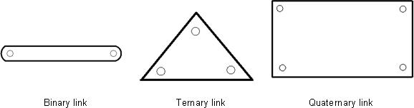

Fig.2.2Typesoflinks
According to their nature, the linkages can also be divided into rigid, flexible, and fluid categories.suchas
Rigidlinkisthelinkwhichdonotdeformwhiletransmittingthemotion
Belts, chains, and other types of flexible links can deform while transferring motion without impairing their ability to do so.
Fluid links, including hydraulic jacks, brakes, and lifts, convey motion using fluid pressure.
RIGIDBODY
A rigid body is one that does not flex when a force is applied, or whose distance between two locations on the body remains constant. No body is completely rigid in practise, but we presume it to be rigid in our analysis to make things easier.
RESISITANTBODY
A body that isn't rigid yet behaves like one while operating in a machine is said to be resistant. In actuality, there is no such thing as a stiff body.
KINEMATICPAIR
A link between rigid entities that allows for relative motion between them is known as a kinematic pair. The relative locations of any two selected points on the chosen link cannot vary if the links are intended to be stiff in kinematics. In other words, it is viewed as one connection and the relative positions of any two points remain unchanged. This rigidity enables the placement of several complicated shaped linkages with straightforward schematic representations for kinematic and synthesis study of mechanisms.

CLASSIFICATIONOFPAIRS
Kinematicpairscanbeclassifiedaccordingto
a) Typeofcontactbetweenelements
b) Typeofrelativemotion
c) NatureofconstraintorTypeofclosure
a) Typeofcontactbetweenelements
LowerPairs:Lower pairs of linkages are those with surface or area contact between the members.Thesurfacesincontactofthetwolinksaresimilar.
Examples:Nutturningonascrew,shaftrotatinginabearing,universaljoint,etc.
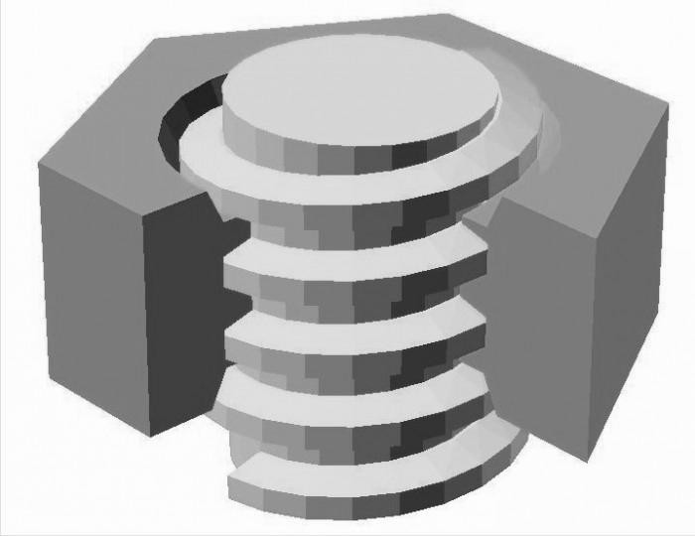

Fig.2.3Nutandscrew(lowerpair)
HigherPair: The term "higher pair" refers to a pair of links that are connected by a point or line junction. The contact surfaces between the two connections are distinct.
Examples include wheels that roll on surfaces, cam and follower pairs, gears with teeth, ball and roller bearings, etc.

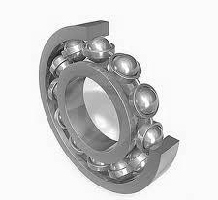

Fig.2.4ballandrollerbearing(higherpair)

a) Type of relative motion
SlidingPair:When two pairs have sliding motion relative to each other.
Examples include a rod in a rectangular hole or a piston and cylinder.
TurningPair: A turning pair is created when one element spins around another one.
examples: spinning crank at crankpin, shaft in bearing.
ScrewPair:Thisisalsoknownashelicalpair.When two elements are paired up, their relative motion occurs along a helical curve.
Examples: Screwjack, Nut-and-Screw Repair as Shown in Figure 2.4
RollingPair:Whenoneelementisfreetorollovertheotherone.
Examples: The motion of a wheel on a level surface, as seen in Figure 2.5.
Sphericalpair:Whenoneelementmoverelativetotheotheralongasphericalsurface.
Examples:Ballandsocketjoint

Explanation
In the slider crank mechanism (Fig. 2.6), the ground (link 1) and the crank (link 2) create a turning pair. Similarly, the connecting rod (link 3), slider (link 4), and crank (link 2) similarly create turning pairs. In relation to the ground (link 1), the slider (link 4) reciprocates and forms a sliding pair.

Fig.2.5Slidercrankmechanism
It should be emphasised that the slider crank system depicted here is just for kinematic analysis and synthesis purposes; the real physical manifestation of the mechanism will differ and be more complex than that depicted.A unique technique will be used for developing the machine component.

Nature ofConstraintorTypeofclosure
Closedpair: The two components entirely encircle one another..
Example: Nut and screw pair Mechanism
Open Pair: When an external force has been used to keep them from being separated.
Example: cam and follower pair Mechanism

DEGREEOFFREEDOM

DEGREEOF FREEDOM
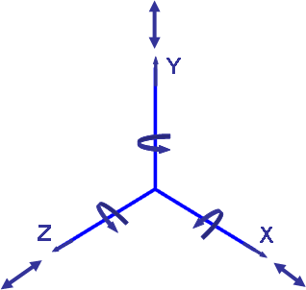
An object in space has six degrees of freedom. Translatory motion along X,Y, and Z axis(3D.O.F.)Rotary motion about X,Y, and Z axis(3D.O.F)

Fig.2.6Degreeoffreedom

The rigid body possesses six degrees of freedom (DOF) in space, but owing to linkage formation, one or more DOFs are lost since there is a restriction on the body.Since the body must be fixed in some manner in order for the connection to be conceivable, the total number of constraints cannot be zero.As a result, freedom is granted by

DOF=6-(Numbersof Restraints)

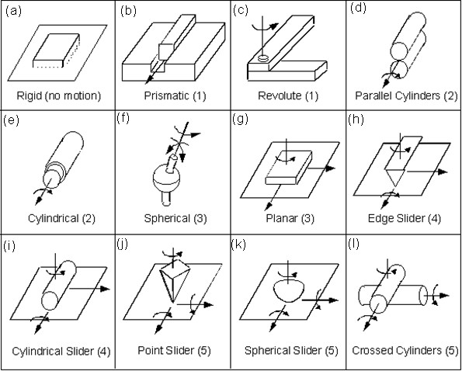

Fig.2.7Pairshavingvaryingdegreeoffreedom

S.  No. | GeometricalShapesinvolved | Restraintson |  | Degreeoffreedom | Totalrestraints
S.  No. | GeometricalShapesinvolved | Translatorymotion | Rotarymotion
(a) | Rigid | 0 | 0 | 0 | 6
(b) | Prismatic | 2 | 3 | 1 | 5
(c) | Revolute | 3 | 2 | 1 | 5
(d) | Parallelcylinders | 2 | 2 | 2 | 4
(e) | Cylindrical | 2 | 2 | 2 | 4
(f) | Spherical | 3 | 0 | 3 | 3
(g) | Planer | 1 | 2 | 3 | 3
(h) | Edgeslider | 1 | 1 | 4 | 2
(i) | Cylindricalslider | 1 | 1 | 4 | 2
(j) | Pointslider | 1 | 0 | 5 | 1
(k) | Sphericalslider | 1 | 0 | 5 | 1
(l) | Crossedcylinder | 1 | 0 | 5 | 1

Table2.1

Figure | ExplanationforDOF
2.9 a | (0) AsthereisnomotionhenceDOFiszero
2.9 b | (1)Asmovement ispossibleonlyinZdirection.
2.9 c | (1) AsitcanrevolvearoundYaxis
2.9 d | (2) AsoneelementcanmoveinZaxis&alsorevolvearoundZaxis
2.9 e | (2) AselementinsidecanrevolvearoundZaxisandalsomoveinZaxis
2.9 f | (3) AselementcanrevolvearoundX,Y&Zaxis
2.9 g | (3) AselementcanrevolvearoundYaxis&canmoveinZ&Xaxis
2.9 h | (4)AselementcanrevolvearoundZ&Yaxis&canmoveinYaxis
2.9 i | (4)AselementcanrevolvearoundZ&Yaxis&canmoveinZ&Xaxis
2.9 j | (5)AsanelementcanrevolvearoundX,Y&Zaxis&canmoveinX&Zaxis
2.9 k | (5)AselementcanrevolvearoundX,Y&Zaxis &canmoveinX&Zaxis
2.9 l | (5)As elementcanrevolvearoundX,Y&Zaxis&canmoveinX&Zaxis
Table2.2

KINEMATIC CHAIN
a) Kinematic chain: A kinematic chain is an arrangement of links joined by joints or pairs, where relative movements between the links are both feasible and defined.

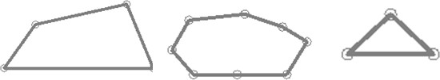

a. kinematicchain b.nonkinematicchain c.redundantchainFig.2.8 kinematicchains

- Non-kinematic chain: A chain is considered non-kinematic if the motion of one link causes the motion of further links to continue indefinitely. Due to the fact that if we move one link in the chain, the other links might move into an endless position, this indefinite motion is necessary.
- Redundant chain: There is no motion possible in the redundant chain. It can be observed from the figure 2.9cthatthis chain is locked due to its geometry.

DEGREEOF FREEDOMINAMECHANISM
Degreesoffreedomofamechanisminspacecanbeexplainedasfollows:Let
N =total number of links in a mechanism
F =degrees of freedom
J₁ =numberofpairs havingonedegreeoffreedom
J₂ =numberofpairs having two degree of freedom and soon.Whenoneofthelinksisfixedinamechanism

Then,thenumberofthemovablelinksare = N-1
Degreesoffreedomof(N-1)movablelinks =6(N-1)
Each pair of one-degree-of-freedom links imposes five restrictions on the mechanism, lowering its degrees of freedom by five (since each moveable link has six). This is due to the fact that the mechanism is also subject to a restriction on any of the links. Other pairings with 2, 3, 4, and 5 degrees of freedom place limits on the mechanism to lower its degree of freedom.

Then, theDOF canbegivenby
F=6(N-1)-5J₁-4J₂-3J₃-2J₄-1J₅
The majority of the mechanisms we often analyse are two-dimensional in nature, like the slider-crank mechanism, which allows for translational motion along two axes with just one constraint and rotating motion around only one axis with two restraints.Therefore, a two-dimensional system has three general restrictions. With the aid of Figure 2.10, it can be demonstrated that a link has three degrees of freedom in two dimensions.
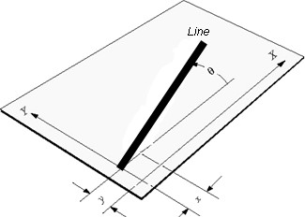

Fig.2.9alineinaplanehasthreeDOF:x, y,θ
Therefore, for plane mechanism, the following relation can be used for degrees offreedom,

F=3(N-1)-2J₁-1J₂
This formula is referred to as the "Grueseler Criteria for Degrees of Freedom of Plane Mechanism." It should be noted that Gruebler's criteria does not account for the geometry of the mechanism, which might lead to inaccurate predictions. Inspection is thus advised in some instances to determine the levels of freedom.
Example:2.1 Findthedegreeoffreedomofthemechanismgivenbelow.
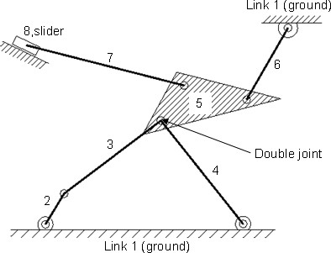

Fig.2.10
Solution:
Numberoflinks=8

Numberspairshavingonedegreesoffreedom=10bycountingHowtocalculatepairs
Pair1 Link1(ground)and link 2constituteasingleturningpairPair2 Link2 andlink3 constitute asingle turningpair
Pair3 Link 3 and link 5 constitute a single turning pairPair4 Link 4 and link 5 constitute a single turning pairPair5 Link 5 and link 6 constitute a single turning pairPair6 Link6andground(link1)constituteaturningpairPair7 Link5andlink7 constitute aturningpair
Pair8 Link7andlink8constituteaturningpair
Pair9 Link 8 and ground (link 1) constitute a sliding pairPair10 Link4andground(link1)constituteaturningpair

There is only one word J1 used since it signifies the pair with the one degrees of freedom because all the computed pairs have a single degree of freedom.
J₁=10 (asallpairshaveonedegreeoffreedom)F=3(N-1)-2J₁-1J₂

DOF=3(8-1)-2×10=1
The degree of freedom is one for this mechanism.
Example2.2Find the degree of freedom of the mechanism given below.

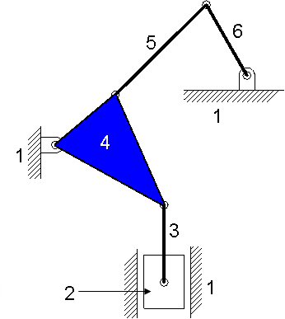

Fig.2.11
Solution:
Numberof links= 6
NumberofPairs= 7
J₁= 7 (sixturningpairs andoneslidingpair)

DOF=3(6-1)-2×7=1
Thedegreeoffreedomisone.
Example2.3:Findthemobilityordegreeoffreedomofthefollowingmechanism.

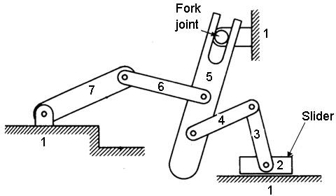

Fig.2.12
Solution:
Numberof links= 7
NumberofPairs= 8
J₁= 7 (sixturningpairs andoneslidingpair)
J₂= 1 (ForkjointistwoDOFjoint)

DOF=3(7-1)-2×7-1×1=3
Thedegreeoffreedomisone.

FOURBARMECHANISM
A simple and often used mechanism is the four bar linkage, which is seen in figure 2.13 below. Furthermore, almost all of plane one degree of freedom (DOF) mechanism have "equivalent" 4 bar mechanisms. The two rotating links (2 and 4) on the four-bar structure have fixed pivots. One of the levers would be an output tilt, while the other would be an input rotation. The ground link (1) serves as the fixed pivot for the two levers, and the coupler link serves as the connection(3).

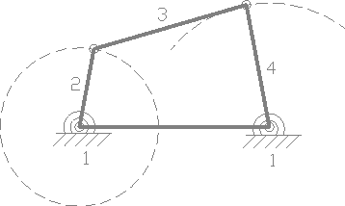

Fig.2.13fourbarmechanism
Crank(2)-agroundpivotedlinkwhichiscontinuouslyrotatable.
Rocker (4) - a ground pivoted link that is only capable of oscillating between twolimitpositionsandcannot rotatecontinuously.
Coupler(3)-alinkoppositetothefixedlink.

1. A link cannot function as a four bar linkage if its length is more than the total of the lengths of the other three connections.

2. The linkage is referred to as a class-1 four bar linkage if the total of the lengths of the biggest and shortest links is smaller than the total of the lengths of the remaining two of them.

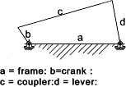

Fig.2.14crankrocker
Infig2.14thelinksadjacenttotheshortestlinkbisfixed.Themechanismsuchobtainedisknownascrank-leverorcrank rockermechanism.
Iftheshortestlinkbisfixed,themechanismobtainediscrank-crankordoublecrankmechanism.
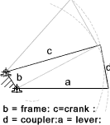

Fig.2.15doublecrank
Ifthelinkoppositetotheshortestlinkisfixedthenthemechanismisknowasdouble-rockeror doublelevermechanism.
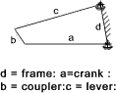

Fig.2.16doublerocker
INVERSIONSOFSLIDERCRANKMECHANISM
When we set various KinematicChain links, we receive distinct mechanisms, and this phenomena is referred to as mechanism inversion. An inversion of a slider crank mechanism is as follows:

FirstInversion
This inversion is obtained when link 1 is fixed (as shown in fig 2.17) and links 2and 4aremadethecrank and thesliderrespectively.
Application: Thismechanism is commonly used in I.C. engines, steam enginesand reciprocatingcompressormechanism.
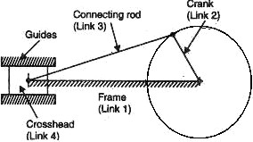

Fig.2.17reciprocating engine
SecondInversion

A slider mechanism's second inversion is produced by fixing link 2. The second inversion is used in the gnome engine or rotary engine mechanism. It is an internal combustion engine with rotating cylinders of the V design that is utilised as an aviation engine. The rotary engine typically has seven cylinders in a single plane. All connecting rods from the pistons are attached to the fixed crank (link 2) at this point.The complete assembly of cylinders, pistons, and connecting rods rotates about axis O in a mechanism when the pistons reciprocate in the cylinders. The crankshaft rotates as a result of this rotation of the entire mechanical system.
Application:Rotary engine mechanism or gnome engine

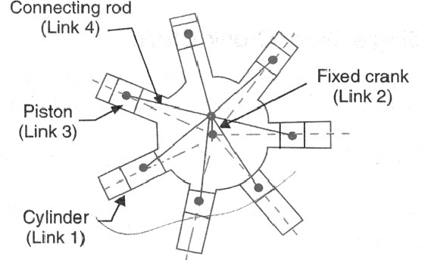

Fig.2.18rotaryengine
ThirdInversion

We may get the third inversion (as shown in fig.2.19) by repairing the slider crank mechanism's link 3 (connecting rod). It is utilised in toys as well as lifting engine mechanisms. Its construction's primary benefits for hoisting applications are that it provides for a straightforward means of providing steam to the cylinder.
Application: It is used in hoisting engine mechanism and also in toys
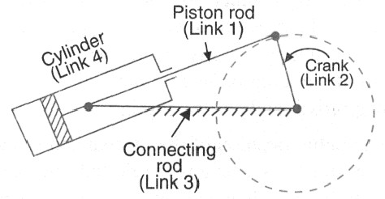

Fig.2.19oscillatingcylinderengine
FourthInversion
We can get the fourth inversion of the slider crank by repairing link 4 of the slider crank mechanism. Fixing a slider entails both a fixation of its location and a fixation of its rotation. The cylinder will need to be slotted in this situation so that the piston pin of the connecting rod may pass through when the cylinder glides over the piston. Due to this challenge, the cylinder and piston forms are switched as seen in the image below.
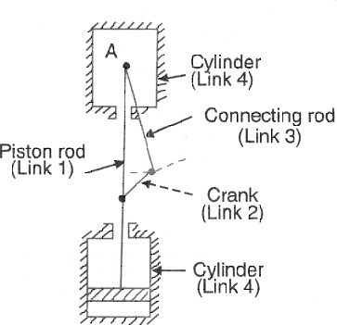

Fig.2.20pen Pendulam pump
Application: hand pump

