BIOMARKERS

Dr. Suchitra S. Mishra (Corresponding Author)
( M. Pharm, Ph.D.)
Assistant professor and Research Associate (Pharmaceutics)
Dadasaheb Balpande College of Pharmacy, Besa, Nagpur. 440037
( M.S.) India
9146945512
suchitramishra36@yahoo.com

Dr. Sachin Kumar Jain ( M. Pharm, Ph.D.)
Professor (Pharmacognosy)
Oriental College of Pharmacy and Research Oriental University,
Indore, ( M.P.) India
9424443869
ABSTRACT
Biomarkers have enormous scientific and clinical value and interest in medical profession. Biomarkers can be used throughout the illness. The markers can be used for screening and risk assessment prior to diagnosis. At diagnosis, symptoms can predict the degree, level, and choice of inceptive therapy. They can be utilized during treatment to observe and select therapy and status of disease recurrence. Recent advancement in genomics, proteomics, and molecular pathology have led to number of biomarkers in therapeutic field. In upcoming days, technically modified biomarkers will be incorporated into medical practice to help "personalize" treatment and prevent disease. The utilization and recognition of biomarkers in medical field has a major impact on area of clinical practice. In this section, we discuss the origin, definitions, classification, properties, and identification of biomarkers. In addition, we discussed here the crucial role of biomarkers in diagnosis and therapeutic use in different medical conditions which has been reviewed over the past decade.
Keywords: Biomarkers, epidemiology, medicine, monitoring, pharmacology/toxicology

- INTRODUCTION

Currently, the biomarkers have secured great importance in medical and pharmaceutical field, determining drug action mechanisms, examining early performance indicators of toxicity and development, and identifying patients who will respond to treatment. In addition, many tools capable of determining this complexity have emerged throughout science and the use of such information in perticular medicine is increasing [1]. Biomarkers are currently used in personal drug or therapy treatment and to evaluate the safety of drugs. [2,3]. Chapter of the National Academy of Sciences Report (USA NRC, 1989b) uses the term "biomarker" broadly to include virtually any measure that indicates that it may be biological and potentially hazardous, chemical or toxic.The measured response can be functional, physical, biochemical or molecular interactions at the cellular level. [4] Biomarkers produced by diseased organs (such as tumors) or by the body in response to disease. Biomarkers can be used throughout the disease process.The markers can be used for screening and risk assessment prior to diagnosis. Once diagnosed, symptoms can determine the level, degree, and choice of initial treatment. They can then be used to monitor treatment, select additional treatments, or monitor disease recurrence [5]. Therefore, identification of biomarkers includes all diagnostic tests, imaging procedures, and other objective measurements of the patient. Biomarkers can also change clinical endpoints, reducing the time and cost of Phase I and II clinical trials. Biomarkers cover a wide spectrum of human health and have been used since the dawn of understanding of human anatomy, physiology and pathological conditions. So why are biomarkers getting so much importance today ? Genetics, genomics, proteomics, modern imaging techniques and other high-throughput techniques permits to analyse number of markers than ever before. In addition, we gain a better understanding of the disease, the goals of intervention, and the impact of pharmacological agents. [6]

- HISTORY OF BIOMARKERS

The term "biomarker" was first used in 1973 by Rho et al. With or without special biological properties. However, the term is older, being used by Mundcourt in 1949 for "biochemical marker" and Porter in 1957 for "biomarker". The term "surrogate" has been used as alternative word for biomarker from 1980s. The concept of “representative” means “without a doubt” [7,8,9]. Representative endpoints or surrogate markers are defined as biomarkers of disease progression [10]. Studies have shown that the importance of using a "biomarker" increases over other concepts [11]. The term "biomarker" is an abbreviation for "biomarker". Biomarkers, or biomarkers, were defined by the National Institutes of Health Biomarker Definition Working Group in 2000 [12]. According to this, biomarkers are indicators of biological processes and pathogenic organisms or responses to drugs that are frequently measured. It is widely accepted as the universal definition of pharmacological biomarkers. Also, as the US Food and Drug Administration (FDA) states, a biomarker, is a measurable indicator that can play a role throughout disease; research and development of treatment; disease, diagnosis and provision of care; or disease progression or response to treatment [13]. Thus, biomarkers can be defined as specific substances associated with normal biological processes, pathogenic processes, or biological responses to external influences or chemicals or group of drug agents, but do not include drugs or their metabolites present in the body tissue[6,14]. The concept of using biomarkers to diagnose disease and modify therapy dates back to the early days of medicine. The use of urethroscopy - examining a patient's urine for signs of infection - dates back to the 14th century or earlier, when doctors routinely examined patients' urine for color and deposits [15].In the 1960s, researchers observed that some patients with chronic myeloid leukemia (CML), a type of leukemia in which adult myeloid cells multiply in the bone marrow, had a cancer-related genetic mutation, a short version of chromosome 22. is is. It is called the Philadelphia Chromosome, which is due to mutation between chromosomes 9 and 22. Researchers used this chromosome as a biomarker in patients shows benefit from drugs (tyrosine kinase inhibitor) that target abnormal proteins [16]. In the late 1980s, researchers discovered that HIV could be used as a marker of infection and subsequently to measure the effectiveness of antiretroviral therapy. Viral load indicates that patients receiving the combination therapy have a lower viral load than those receiving immunosuppressive therapy, thus again having a positive effect in slowing the disease.Finally, viral load biomarkers are used to design and evaluate highly active antiretroviral drugs (HAART), which are among the many drugs used by many people living with HIV today. Perhaps the most famous biomarker in recent drug development history is the discovery of the HER-2 gene and its receptor in the mid-1980s. The HER-2 receptor is overexpressed on cancer cells in 20-30% of cancer patients. The anticancer drug trastuzumab (Heretic) was prepared to target the HER-2 receptor in overexpressing patients and has been successful in reducing the risk of breast cancer in many women [5]. People with diabetes can check their blood sugar levels with a glycated hemoglobin (HbA1c) test, which shows blood sugar levels over the past some weeks. Liver function tests (LFT) to evaluate liver toxicity and prostate specific antigen (PSA) to assess cancer and disease risk. These historical biomarkers have been used as part of clinical practice from decades. [17,18]

III. CHARACTERISTICS OF AN IDEAL BIOMARKER [4, 6, 19]
- An ideal biomarker should be accurate, reproducible and superior
- Easy to sample
- Should be safe and easy to measure.
- Clinical trials should be cost-effective and a good treatment should be found to update biomarkers.
- Biomarkers should provide evidence supporting a reasonable basis for their use. Evidence indicates that some measure or change occurs in a physiological or pathological process within a short period of time. ➢
- Reliable, capable analysis for measuring biomarkers. Changes in biomarkers should be detected with accuracy, precision, robustness, and reproducibility; ➢
- Energy efficiency means no interference or adverse effects to avoid inconvenience or inconvenience to healthy people or ill. ➢
- Simplicity means easy to use and low cost of equipment. The simplicity makes it widely accepted in medicine and medicine.

IV.CLASSIFICATION OF BIOMARKERS
Biomarkers have been classified on the basis of different parameters, as follows
A. Based on genetic biology: Type 0 - Natural history markers, Type 1 - Drug activity markers, Type 2 - Surrogate markers.
B. Based on characteristics: Imaging biomarker, Cellular biomarker, Molecular biomarker
C. Based on Clinical applications:, Diagnostic biomarker, Prognostic biomarker, Therapeutic biomarker [15,19]

- Based on genetic biology (Genetic Biomarker):[15,20,21,22]
Biomarkers with biophysical properties that allow measurement in pathological samples (such as plasma, serum, cerebrospinal fluid, bronchoalveolar dissection and tissues), nucleic acid-based biomarkers such as gene changes or polymorphisms, and many gene expression molecules. Over the years, genetic (DNA mutations, DNA single nucleotide polymorphisms, karyotype) changes have been used as diagnostic biomarkers. The MarkerDB database contains 26374 genetic biomarkers and 154 karyotype biomarkers. DNA biomarkers are the largest collection of biomarkers associated with more than 319 diseases. Genetic biomarkers can be measured in the DNA of all nucleated cells extracted from biological samples, especially cancer cells, because cancerous cells are capable of altering the change.
(Type 0) - Natural history markers:
A disease's natural history marker that longitudinally corresponds with recognised clinical parameters.
(Type 1) - Drug activity markers:
A marker that accurately reflects the impact of a therapeutic intervention based on how it works.
Type 2) - Surrogate markers:
A surrogate end point is a marker created to act as a stand-in for a clinical end point. It is believed to forecast whether there will be clinical benefit or not based on epidemiology, therapeutics, pathophysiology, or other scientific information.

- Based on Characteristics

a. Imaging Biomarkers:[23]
Biomarkers are indicators that measure biological processes in the body, pathological processes, or the body's response to treatment. Imaging-based biomarkers use a variety of techniques to capture images of anatomical and physiological changes in the body. They are generally non-invasive and produce intuitive, multidimensional results. They can produce good and valuable information and are generally good for patients.

X-Ray: X -ray technology has been in use for over 100 years and almost in biomedicine to identify markers.
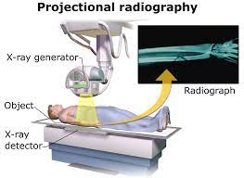
Figure 1: X-ray Machine

Computed Tomography (CT): Also known as computed axial tomography. The 2D image is then converted to a 3D image. Introduced in the 1970s, CT expanded its use.
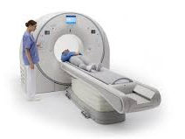
Figure 2: CT Scanner

Magnetic Resonance Imaging (MRI): MRI can distinguish soft tissues better than tomography.The first MR image was released in 1973. Additionally, optical imaging is often used more and more in drug discovery and preclinical evaluations, and in human clinical applications such as treating CT scans.
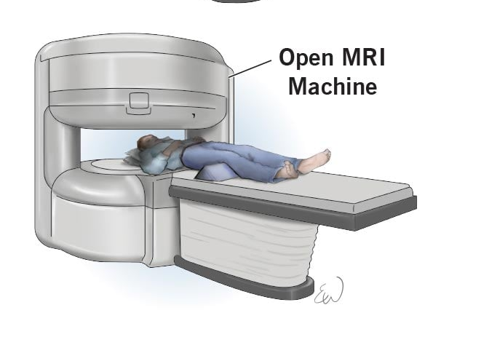
Figure 3: MRI ScannerV

Positron Emission Tomography (PET): It provides 3D images of the region of interest. The first PET machine was introduced in the early 1970s.
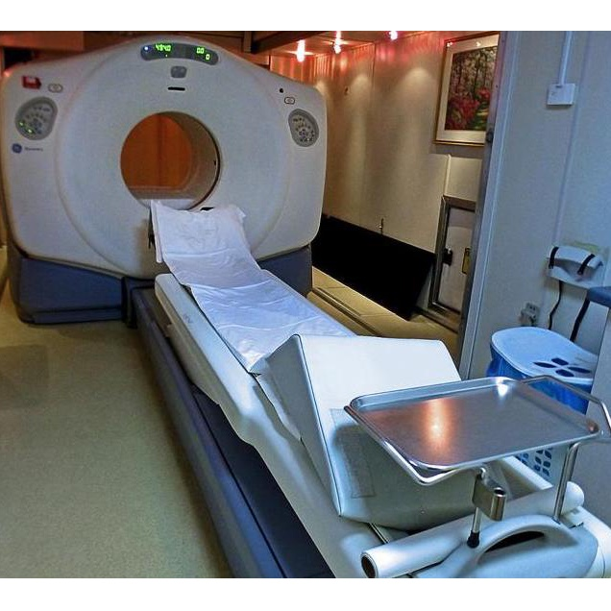
Figure 4: PET Scanner

b. Cellular Biomarkers
Biomarkers that can be measured biologically are known as cellular biomarkers, and they may be employed in both clinical and laboratory investigations. Blood, bodily fluids, or soft tissue cellular biomarkers are frequently examined and assessed for prognosis or likelihood of responding to a particular treatment. With the use of these biomarkers, it is possible to separate, group, count, and characterise cells according to their morphological and physiological characteristics. [24, 25].

c. Molecular Biomarkers [26,27,28,29]
Molecular biomarkers are indicators based on proteomic and genomic methods.They are important for diagnosis and have applications in epidemiological screening, randomized clinical trials, disease prevention, surveillance and control. Molecular biomarkers are characterized by their biophysical properties, which can be quantified in biological samples, including plasma, plasma-like fluid (Cervical), broncho-vascular lavage fluid (BVL), and biopsy samples. These biomarkers contain molecules ranging in size from small molecules (peptides) to large molecules (proteins), such as proteins and lipid metabolites, as well as nucleic acids such as DNA and RNA, among others. There are three main types of molecular biomarkers: chemical, lipid, and protein.

Chemical biomarkers:Chemical biomarkers contain information about birth through metabolic or genetic diseases such as cancer, disability and metabolic diseases, infectious diseases, nutritional foods, drugs, chemicals, and pollution.In total, 1089 drug biomarkers were associated with 448 diseases and 106 outcomes in the Molecular Biomarkers Online Database (MarkerDB). Many biomarkers can be measured quantitatively and accurately with efficacy and safety [30,32].

Protein biomarkers: Protein biomarkers are useful for identifying many biological changes. They can be used as indicators of changes in inflammation, immunity and stress or other diseases such as cancer, diabetes, heart disease, neurological disease and other conditions. The MarkerDB database represents 142 protein biomarkers covering more than 160 diseases [30,31,33]

- Based on Clinical Applications:
Disease-related biomarkers may indicate whether the disease is already present, whether there is a threat of disease, or how the disease arose in a patient.

- Diagnostic biomarker:
It serve as a way to identify a disease. ( For example, cardiac troponin myocardial infarction). These biomarkers are used to identify diseases such as use of cardiac troponin for diagnosis of myocardial damage, 3-hydroxy fatty acid profile for Planctomyces, glycans as cancer biomarkers, visceral fat and change metabolism Glutamate, catechin challenge, mortality in patients with heart disease, cystatin-C for glomerular filtration, liver-type fatty acid-binding protein (L-FABP) as a diagnostic biomarker to predict kidney damage.[31, 34, 35, 36, 37].

- Prognostic biomarker:
Prognostic biomarkers are associated with results like, overexpression of Her-2 in breast cancer or EGFR in cancer indicates a poor prognosis. Such markers are often the basis for designing clinical trials to include or identify patients. Prognostic biomarkers provide information about the disease by screening and monitoring the disease and measuring the increase or decrease in the internal precursors that the disease may reach. For example, blood pressure and cholesterol (for heart disease), N-acetyl-beta-D-glucosaminidase (for heart failure and kidney failure), D-serine (for ketamine for antidepressants), and osteocalcin (for bone and healthy bone metastases). have been used as prognostic biomarkers [31,38,39,40,41].

- Therapeutic biomarker:Vani et. al.,
These are useful in the treatment of illness and show importance in monitoring the response and treatment of stress or illness. Clinical biomarkers are proteins such as miRNAs and exosomes that can be used for therapy. Takamura et al. using malondialdehyde-modified LDL. As a good indicator of clinical outcome in patients after endovascular intervention for peripheral arterial disease. Clinical studies of D-serine demonstrate its effectiveness as a clinical biomarker in patients with schizophrenia and depression. As a tumor biomarker, Ca15-3 can be used to monitor breast cancer therapy. [39, 42-48]

V.APPLICATIONS OF BIOMARKER

The applications of biomarkers in area of medicines are mainly the disease diagnosis, and treatment which have been greatly expanded now days. It may be of different types, such as physical, physiological, and histological. Perhaps the biochemical biomarkers are most relevant to early clinical research and derived from body fluids, suitable for early investigators. Molecular biomarkers of safety have been used in preclinical and clinical research for many years. [51]. Accurate diagnosis is important in chronic diseases, the treatment of which may require the use of drugs for many years, especially in cases where treatment has serious side effects. In these cases, biomarkers have become important as they can confirm difficult diagnoses and also make them possible. Many diseases, such as Alzheimer's disease or rheumatoid arthritis, often begin early asymptomatically. In these asymptomatic patients, actual symptoms may be more or less severe. In these cases, biomarkers help identify high-risk individuals in a timely and reliable manner so that they can be treated as soon as possible before or after the illness. This could be a sample of blood taken by a doctor, a urine or saliva sample, or even a drop of blood collected from a patient's fingertip for frequent blood sugar monitoring.[49, 50]

- Covid-19 [51 - 63]
The novel coronavirus disease (SARS-CoV-2 or COVID-19) first emerged in Wuhan city, China in December 2019. COVID-19.Unfortunately, this new virus has caused more than a million infections and deaths worldwide. In the study reported by Pu et al., deep learning techniques and high-resolution tomography images were used as biomarkers to examine the parameters associated with COVID-19. The findings suggest that certain biomarkers may not be able to distinguish all cases of COVID-19 in the filter from community-acquired pneumonia. However, image analysis can identify a small fraction of COVID-19 patients because certain images can distinguish more than non-COVID-19 patients. Biomarkers of myocardial injury or heart disease, particularly cTnI, cardiac troponin T (cTnT) and D-dimer, have demonstrated their potential in the prediction, diagnosis and treatment of COVID-19.High serum amyloid A, C-reactive protein, urea and creatinine (kidney biomarkers), ferritin and lactate dehydrogenase levels have been used as biomarkers in the diagnosis of COVID-19.

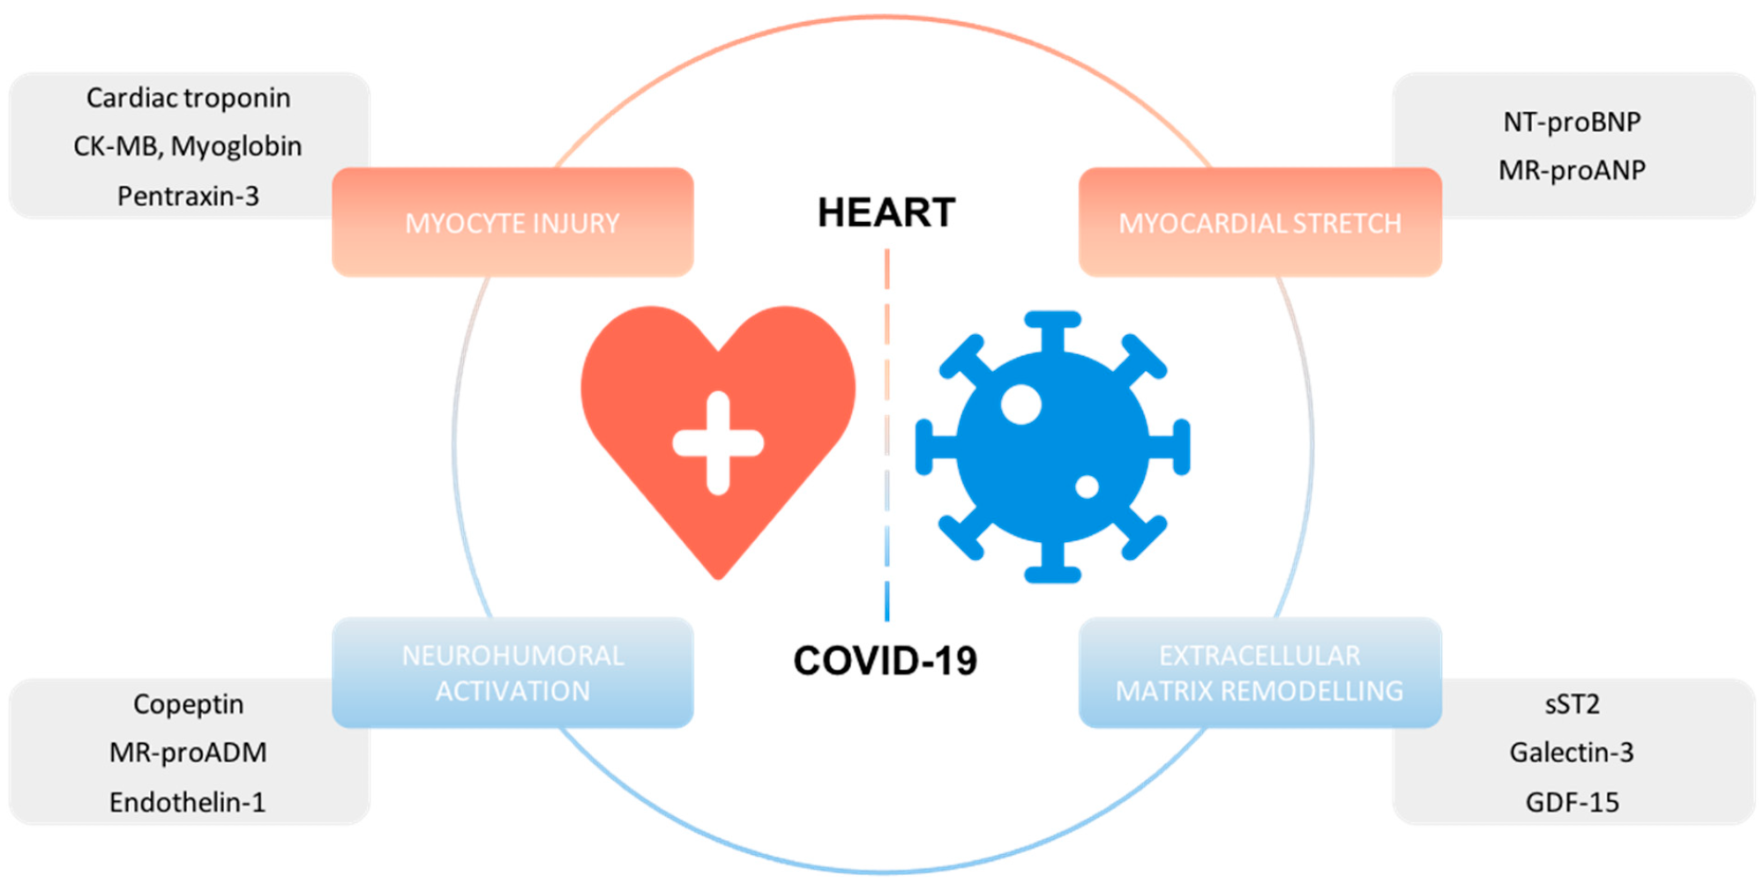

Figure 5: biomarkers of COVID-19

- Cancer [10, 64 -77]
Cancer is the leading cause of death worldwide and is a contagious disease that occurs when it metastasizes to the remaining organs.fear of the body. Cancer biomarkers play an important role in improving our understanding and knowledge of cancer processes in clinical practice, enabling the development of better diagnoses and reducing the number of acute toxicity lines. They were designed to assess cancer risk, examine interactions between tumors, and influence tumor and cell viability. Proteins, metabolites, nucleic acids and extracellular vesicles can be identified in the urine, which is an important part of the biopsy fluid.

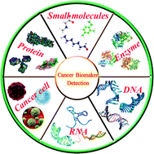

Figure 6 : Cancer Biomarkers

- Disorders of Skeletal Muscles and Bone [78 - 84]
Skeletal muscles can be disrupted throughout age by workout, contracture, injury, immunodeficiency, or muscle decay. MRI and proton magnetic resonance spectroscopy have been used to check the GNE myopathy, which is a sparse skeletal muscle dystrophy. In addition, MRI and biomarkers are the identifying tools to detect the changes in adipose and fibrous tissues. Measurement of pyridinoline, deoxypyridinoline and osteocalcin to anticipate future bone disease with their clinical results. A well known biomarker, Plasma interleukin-6 has been used for inflammation and can be used to predict chronic changes in growth retardation, joint pain, and hip dysplasia. Fourier transforms infrared spectroscopy as a biomarker for primary mitochondrial myopathy and other mitochondrial diseases. This device is a rapid, non-invasive, non-destructive, sensitive and specific biomarker test which needs less amount of samples. The amino acids, like cysteine, methionine, taurine and glutathione, which are important components of skeletal muscle, can be utilize for treatment and identification of skeletal muscle distrophy. Research objective may identify how to use MRI technology to evaluate osteoarthritis and outcomes of cartilage and cartilage treatment in osteoarthritis. In this context, MRI has proven promising in diagnosing soft tissue swelling and cartilage damage in rheumatoid arthritis. If found to be a reproducible biomarker, MRI can be used to help identify the potential of new treatments, determine dosage, and stratify patients for risk with early assessment.

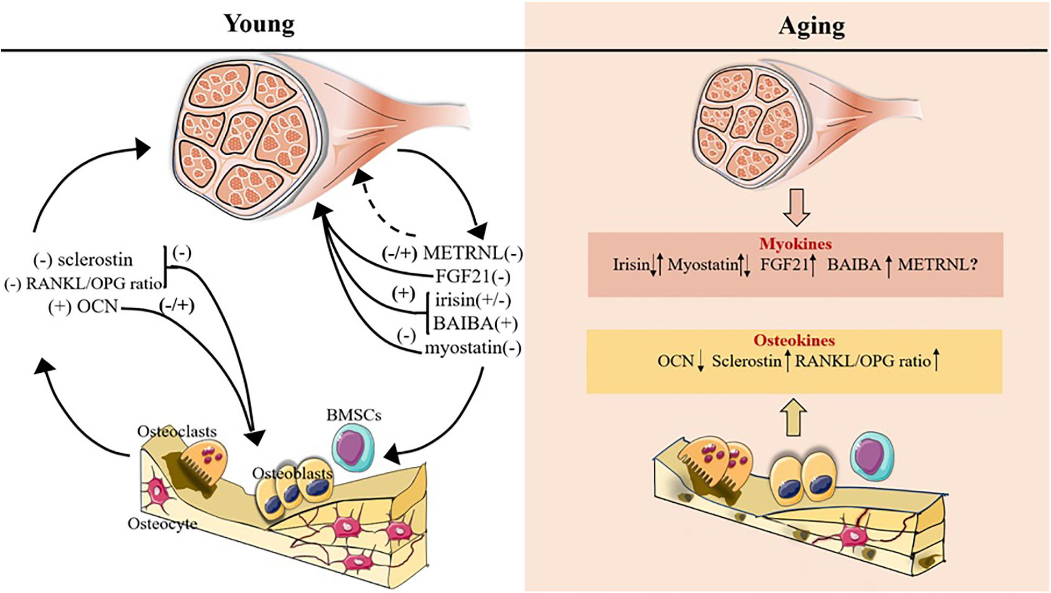

Figure 7: Biomarkers of arthritis

- Heart failure [23, 85 - 99]
New ideas for evaluating heart disease and its treatment are needed to facilitate the development of new treatments. Intravenous ultrasound (IVUS), MRI, or multislice CT can be used to assess central function parameters to assess the progression of atherosclerosis and prevent heart failure. The development of these strategies to measure progress will require a thorough assessment of the current state of knowledge about measurement methods, standard measures, and appropriate testing to measure association with treatment response. Heart failure (HF) is a disease with multiple phenotypes caused by multiple cardiac and extracardiac pathophysiological mechanisms. Emergency and specialized testing in the emergency room can be important to quickly "diagnose" heart failure. Image biomarkers provide important information about the function and abnormal functioning of the heart, but reading these biomarkers does not identify subclinical and initial of heart failure. Protein biomarkers currently used to predict heart failure prognosis are released from the heart, indicating the heart's value as tissue-specific damage or other brain-based responses to heart failure. Natriuretic peptide (NP), For example, measurements of brain natriuretic peptide (BNP) and BNP N-terminal prohormone and cardiac troponin are involved in the American Heart Association and European Society of Cardiology guidelines for the management and diagnosis of heart disease. The utility of NT-proBNP and BNP biomarkers in various heart failures (such as congestive heart failure or congestive heart failure) has been investigated in several studies, given the strong evidence for their increasing value. Other diagnostic biomarkers, like biomarkers of oxidative stress (eg, oxidative stress), growth factor-15), cardiovascular (eg, galectin-3) and inflammation (eg, soluble ST2 receptor) may be added to the treatment of heart disease. Recent advances in genetic analysis have opened new avenues to study the pathophysiology of cardiovascular diseases and paved the way for the development of gene-based biomarkers. A new approach to identify DNA/RNA-based biomarkers using omics technology that can identify genome-wide (GW) and transcriptome-wide (TW) genetic variants. Omics analysis can understand the molecular mechanisms behind the disease and identify genes that could help identify patients with heart failure. New biomarkers of heart failure may promote widespread use of biomarkers, improving identification and treatment, and therefore patient care. There is interest in various methods because they are more useful than single biomarkers for improving risk stratification and increasing the accuracy of cardiovascular disease.

- Chronic Obstructive Pulmonary Diseases [15]
High resolution computed tomography of the thorax may be useful in the evaluation of disease in COPD, in which emphysema is an important component, particularly emphysema. Complications associated with alpha 1 antitrypsin deficiency. While data to date indicate that high-resolution CT (HRCT) can provide reliable assessment of lung structures in fewer patients than it would take time to tell the difference between a diagnosis of pneumonia or death, it still remains uncertain.

- Neurocognitive Diseases: [100, 101]
Currently, the treatment of chronic neurological diseases such as Parkinson's and Alzheimer's is based on recent symptoms, whose progression may require years of monitoring. Functional imaging such as FDG-PET as a measure of glucose metabolism may provide biomarkers to quantify early, subtle changes in disease. Focusing on the use of new techniques to evaluate and respond to measures for neurocognitive diseases and depression may also lead to new ways to monitor treatment for these problems. For example, evaluation of amyloid content from PET scans alongside MRI measurements may be the best methods to demonstrate the effects of Alzheimer's treatment.Markers that provide early disease information can make prevention efforts more effective.

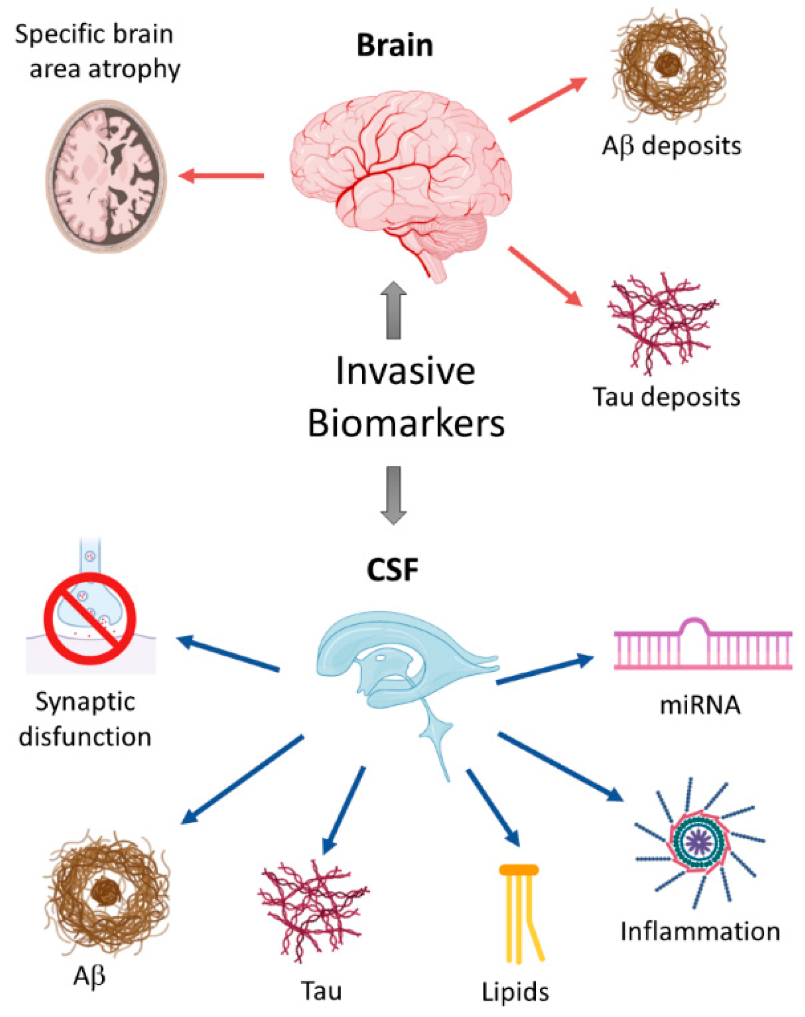

Figure 8: Biomarkers of Alzheimer's Disease

- Kidney Disease [102 - 106]
The role of the kidney is to filter the blood, produce urine, remove toxins and maintain the volume of different fluids in the body. Microalbumin, N-acetyl-β-glucosaminidase, fatty acid binding protein, and cysteine-rich protein have been used successfully as biomarkers of kidney disease. Hepcidin-25, an iron-binding protein associated with acute kidney injury, can be used as a new kidney biomarker in blood and urine in the diagnosis of renal dysfunction after cardiac surgery.Novel Synthetic Antibodies Against Polypyrrole/Multiwalled Carbon Nanotubes on Carbon Screen Printed Electrodes Designed to Detect the Renal Biomarker Cystatin C in Clinical Practice. Recently, the FDA approved a panel of 6 standard biomarkers for the detection of preclinical ASO, including clusterin for urinary creatinine, cystatin C, kidney injury molecule 1, N-acetyl-β-D-glucosaminidase, intermediate Granulocyte gelatinase-associated lipocalin and osteopontin. Confirmed. induced kidney pathology. D-serine levels in blood and urine are often used as dual biomarkers to indicate kidney function and disease.

- Liver disease [107 - 112]
The liver is an essential part of the body that performs many important functions such as digestion, distribution of food, conversion and storage of food into energy, helping to filter toxins and removing toxins from the blood. There are many liver diseases such as hepatitis, hepatitis, cancer, cirrhosis, hemochromatosis, Wilson's disease, fascioliasis, liver failure and autoimmune diseases. Liver disease can be caused by many factors and conditions, including diseases, medications, alcohol, and toxins. Symptoms of hepatitis vary according to the occurrence and severity of the infection and can be easily confused with other conditions, but usually include yellowing of the skin and pores, soft, dark urine, swelling of the stomach and legs, easy bruising and vomiting.Liver disease is often difficult to diagnose; however, the use of biomarkers facilitates the diagnosis and follow-up of liver disease. Liver damage can be confirmed by liver tests, including albumin, alanine aminotransferase, lactate dehydrogenase, aspartate aminotransferase, alkaline phosphatase, and gamma-glutamyltransferase. Section Alanine aminotransferase is a surrogate biomarker that is highly specific for liver disease and can be detected in blood. Hyaluronic acid, bilirubin, cytokines, laminin and fibroblast growth can be used as biomarkers of the liver.
- Gastrointestinal Disorders [113 - 121]
Gastrointestinal Disorders are diseases of the entire human digestive system, from the mouth to the anus. Metabolic intermediates are useful biomarkers for the diagnosis of intestinal diseases using non-invasive methods. Organic compounds such as acetone, ammonia, ethanol, indole, carbon disulfide, 2,3-butanedione and acetic acid can be used as biomarkers. These low molar mass drugs are produced in the digestive tract, pass through the bloodstream, reach the lungs and appear in the respiratory tract, and are analyzed by GC-MS techniques. Calprotectin is used as a non-invasive biomarker in the treatment of active inflammatory bowel disease (IBD) and digestive system diseases.Lactoferrin is a laboratory biomarker used to diagnose Clostridium difficile. MicroRNA, surface acoustic waves, carbon black polymer composites, carbon black polymer composites, metal oxide semiconductors, etc. such as electronic noses have been used to identify intestinal diseases. Fatty acid-binding proteins have also been evaluated as diagnostic biomarkers for inflammatory bowel disease. Urine metabolomics, such as tricarboxylic acids and amino acids, are different in IBD patients and healthy people and may serve as non-invasive biomarkers of gastrointestinal disease. Most of the potential biomarkers currently studied have not yet been validated and approved for real-world clinical use to screen or diagnose certain gastrointestinal diseases; however, the future of biomarkers looks risky.While some studies have shown positive results for different biomarkers, the heterogeneity of the findings raises our questions. Therefore, extensive research and clinical trials using methods developed by multicenter consortia are needed.

Specific Organ Biomarkers Tests [51]
Liver Function: Transaminases , bilirubin, alkaline phosphates.
Kidney Function Serumcreatinine, creatinine clearence, cystatinC.
Skeletal Muscle Marker: Myoglobin.
Cardiac Muscle Injury: CK-MB, teroponinI (or) T.
Bone markers: Bone specific alkaline phosphates.

V
VI. BIOMARKER AS AN EMERGING TOOL [122 - 125]

Throughout the entire process of developing new drugs, biomarkers are helpful. Biomarkers have historically been used in drug development projects as a time taking method that uses residual samples and funds, frequently producing partial or insufficient data.

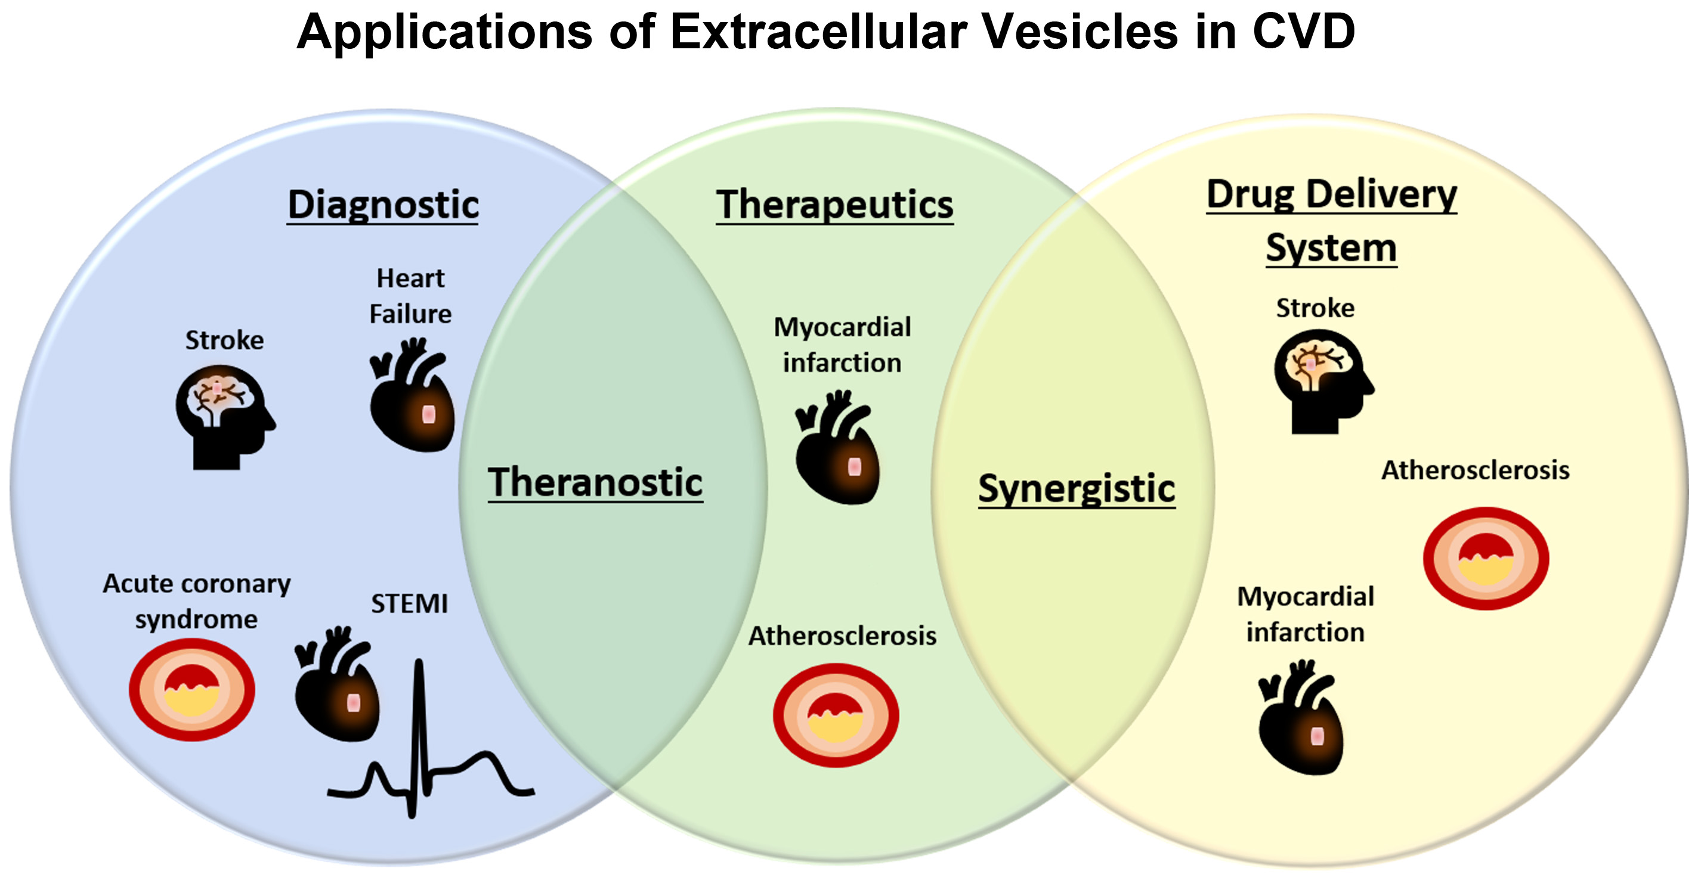

Figure 9: Biomarkers in Drug Research

Nevertheless, they are now being incorporated into every level of the development process, from:Vt. al.,
- ✓ Target discovery
- ✓ Evaluation of drug activity
- ✓ Understanding mechanisms of action
- ✓ Toxicity and safety evaluation
- ✓ Internal decision making
- ✓ Clinical study design
- ✓ Diagnostic tools
- ✓ Understanding disease processes
Research on biomarkers will eventually play a significant role in the process of developing new therapeutics. Biomarker research will eventually become an integral part of the drug development process. The ultimate goal is to create high efficacy in less expenssive manner. Although it is still early days and there are many questions to be answered, the promise of biomarkers is bright. The clinical development of gefitinib, an oral epidermal growth factor receptor tyrosine kinase inhibitor (EGFR TKI), is a challenging example of biomarker development. During the performance of large randomized trials, changes in biomarkers will become the rule rather than the exception.Although the initial candidate biomarker is evaluated early in the development phase, knowledge grows exponentially as research and clinical information is widely published and clinical information is linked to action. Translation work increases. Biomarkers that identify prodromal manifestations can lead to early diagnosis or enable determination of the outcome of interest in the early stages of the disease. Biomarkers are used as biomarkers that represent subclinical symptoms, disease stages, or disease surrogate outcomes. Biomarkers used for screening or diagnosis also often represent the outcome of the disease. Identification of individuals who should be affected or who are in the early stages of the disease, possible use of biomarkers such as reducing disease heterogeneity in clinical trials or infection studies, and influence the history of the disease, including the following stages: induction, incubation. and discovery, the purpose of clinical trials.Its efficiency and accuracy outweigh the difficulty of obtaining tissue from patients. In research and practice, diagnostic tests for diseases are used with increasing frequency. In diagnostic work, the data collection from various origins, which carry the reports of diagnosis, leads to the main goal of increasing the risk of diagnosis. Diagnostic tests may be performed less frequently for other reasons (such as assessing disease severity, predicting disease onset, or monitoring response to certain treatments): severe disease predicts disease severity. Another advantage of this diagnosis is that it reduces the heterogeneity of the disease in clinical trials or epidemiological survey, causing a better communication of the history of the disease involved, which includes the induction, incubation, and detection phase.

VII. BIOMARKER DEVELOPMENT PROCESS [19]
The biomarker development process begins with the identification of biomarkers in healthy and sick samples and progresses through multiple iterative steps. A development procedure that incorporates numerous various components of regulatory integration Acts is required to make sure that efficient, evidence-based biomarker development for clinical and research is still necessary. The field is rapidly changing due to continued and fastly growth in computing, analytics and measurement. The biomarker development process includes the following stages: preanalytical and analytical validation, clinical validation, regulatory approval, and clinical varification. In the pre-evaluation stage, indicators are standardized and qualitative procedures, storage and collection are reviewed.Analytical validation for a biomarker to ensure that analysis metod is reproducible, reliable, and has an appropriate specificity and sensitivity enhancement. Biomarkers have been associated with clinical and biological products through relevance (level of evidence). However, there are some difficulties in the development of biomarkers, for example:
- The scientific background of biomarkers are not always investigated, making it difficult to identify and accept biomarkers in upcoming days. In addition, it is important not to misinterpret biomarker observations and not to associate biomarkers with disease.
- Due to long term studies and analysis clinical, the cost of biomarker will increase.
- The formulation and characterization of biomarkers often requires significant time and resources. More evidence for benefit-risk analysis is often required for appropriate reasons as compare to be a part of the authorization process for medicinal products.

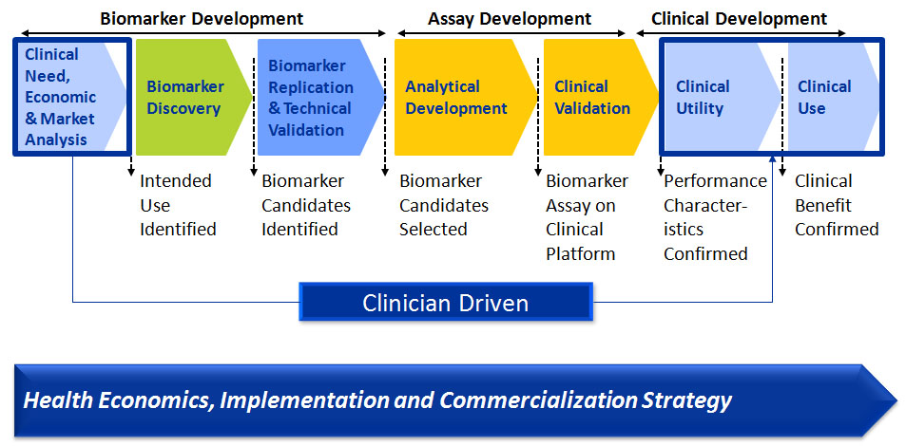

Figure 10. Biomarker Development Process

VIII. CONCLUSION

Biomarkers are part of new medical tools and are essential for the diagnosis and therapy of different medical clinical conditions. They have many advantages to study many aspects of disease, develop drugs, and monitor the effects of therapy. Biomarkers promise to provide more sensitive and specific testing than existing measurements, improve decision making, and contribute to the development of treatment. Further efforts are being made to take a look at the properties of biomarke to discover novel biomarkers to improve health and develop better treatments. However, because the mechanisms leading to disease pathogenesis are often complex, it is easier to identify beneficial biomarkers for observing drug response, diagnosis, and follow-up of diseases to better understand disease-associated abnormalities and chemical processes.Gathering this information is a challenge for physicians and primary health care professionals and others involved in biomarker analysis. The distinction between potential biomarkers and reliable biomarkers that can be used worldwide to guide important clinical and commercial decisions is one of the biggest challenges in the biomarker field. Biomarkers, which are changes in tissues or body fluids, provide a powerful way to understand chronic diseases with their use in at least 5 areas such as screening, diagnosis, follow-up, predicting disease ocurrence and clinical care. Biomarkers that identify prodromal manifestations can lead to early diagnosis or enable determination of the outcome of interest in the initial of the disease. Biomarkers are used as biomarkers to represent subclinical symptoms, disease stages, or surrogate disease outcomes. Biomarkers are specific only to a particular drug or disease, so development costs should be carefully considered. Good biomarkers should influence clinical assessment to improve patient care. Treatment decisions based on accurate test results should be more valuable than those based on false positive or negative results. Biomarkers should reduce costs and adverse effects while preventing mortality in a risk management environment. The validity of a biomarker is determined by comparing it with an ideal biomarker and investigating its properties.

IX. REFERENCES

[1] A. De Gramont, S. Watson, L.M. Ellis, J. Rod´on, J. Tabernero, A. De Gramont, S.R. Hamilton, Pragmatic issues in biomarker evaluation for targeted therapies in cancer, Nat. Rev. Clin. Oncol.2015; 12 197–212, https://doi.org/10.1038/nrclinonc.2014.202.
[2] V.R. Beasley, J.M. Levengood, Principles of Ecotoxicology, Veterinary Toxicology, Elsevier Inc., 2012, pp. 831–855.
[3] A. Godfrey, B. Vandendriessche, J.P. Bakker, C. Fitzer-Attas, N. Gujar, M. Hobbs, Q. Liu, C.A. Northcott, V. Parks, W.A. Wood, Fit-for-purpose biometric monitoring technologies: leveraging the laboratory biomarker experience, Clin. Transl. Sci. 14 (2021) 62–74, https://doi.org/10.1111/cts.12865.
[6] International Programme on Chemical Safety, Environmental Health Criteria 155. Biomarkers And Risk Assessment: Concepts And Principles. Published by United Nations Environment Programme, the International Labour Organlaation, and the World Heanh Organization
[5]Thomson R. Nature Reviews Drug Discovery. FDA drug approvals: a year of flux. 2008; 7: 107.
[6] Kumar M, Sarin S. Biomarkers of diseases in medicine. Current trends in science.2009; 403-417.
[7] M.S. García-Guti´errez, F. Navarrete, F. Sala, A. Gasparyan, A. Austrich-Olivares, J. Manzanares, Biomarkers in psychiatry: concept, definition, types and relevance to the clinical reality, Front. Psychiatr.2020; 11, 432, https://doi.org/10.3389/fpsyt.2020.00432.
[8] K. Porter, Effect of homologous bone marrow injections in x-irradiated rabbits, Br. J. Exp. Pathol.1957; 38. 401–412.
[9] B.D. Mundkur, Evidence excluding mutations, polysomy, and polyploidy as possible causes of non-Mendelian segregations in Saccharomyces, Ann. Mo. Bot. Gard. 36 (1949) 259–280, https://doi.org/10.2307/2394394.
[10] J.K. Aronson, Biomarkers and surrogate endpoints, Br. J. Clin. Pharmacol.2005; 59. 491, https://doi.org/10.1111/j.1365-2125.2005.02435.x.
[11] J.K. Aronson, R.E. Ferner, Biomarkers—a general review, Curr. Protoc. 2017 76. 9, https://doi.org/10.1002/cpph.19.
[12] B.D.W. Group, A.J. Atkinson Jr., W.A. Colburn, V.G. DeGruttola, D.L. DeMets, G.J. Downing, D.F. Hoth, J.A. Oates, C.C. Peck, R.T. Schooley, Biomarkers and surrogate endpoints: preferred definitions and conceptual framework, Clin. Pharmacol. Ther.2001; 69. 89–95, https://doi.org/10.1067/mcp.2001.113989.
[13] J. MacNamara, D.J. Eapen, A. Quyyumi, L. Sperling, Novel biomarkers for cardiovascular risk assessment: current status and future directions, Future Cardiol.
2015; 11: 597–613, https://doi.org/10.2217/fca.15.39.
[14] F. Gil, A. Pla, Biomarkers as biological indicators of xenobiotic exposure, J. Appl. Toxicol.2001; 21: 245–255.
[15] Vani M, Harathi P , Khantamneni P. Biomarkers In Disease Diagnosis. American Journal of PharmTech Research. 2016; 6(2); 38-53.6(
[16]Thompson ML, Zucchini W. On the statistical analysis of ROC curves. Stat Med. 1989;
8: 1277-1290.
[17] Bang H, Egerer K, Gauliard A, Lüthke K, Rudolph PE and Fredenhagen G. Mutation
and citrullination modifies vimentin to a novel autoantigen for rheumatoid arthritis.
Arthritis Rheum. 2007; 56 (8): 2503-2511.
[18] Mathsson L, Mullazehi M, Wick MC, Sjöberg O, van Vollenhoven R, Klareskog L and
Rönnelid J. Antibodies against citrullinated vimentin in rheumatoid arthritis: higher
sensitivity and extended prognostic value concerning future radiographic progression as
compared with antibodies against cyclic citrullinated peptides. Arthritis Rheum. 2008;
58(1): 36-45.
[19] Bodaghi A, Fattahi N, Ramazani A. Biomarkers: Promising and valuable tools towards diagnosis,
prognosis and treatment of Covid-19 and other diseases. Heliyon. 2023; 9 e-13323.
[20] D.S. Wishart, B. Bartok, E. Oler, K.Y. Liang, Z. Budinski, M. Berjanskii, A. Guo, X. Cao, M. Wilson, MarkerDB: an online database of molecular biomarkers, Nucleic Acids Res. 2021; 49: D1259–D1267.
[21] D. Corella, J.M. Ordovas, Biomarkers: background, classification and guidelines for applications in nutritional epidemiology, Nutr. Hosp. 2015: 31: 177–188.
[22] J. Sharifi-Rad, A. Sureda, G.C. Tenore, M. Daglia, M. Sharifi-Rad, M. Valussi, R. Tundis, M. Sharifi-Rad, M.R. Loizzo, A.O. Ademiluyi, Biological activities of essential oils: from plant chemoecology to traditional healing systems, Molecules 2017; 22: 70.
[23] Wong DF. Imaging in drug discovery preclinical, and early clinical development. J
Nucl Med. 2008; 49(6): 26N-28N.
[24] J. Sharifi-Rad, A. Sureda, G.C. Tenore, M. Daglia, M. Sharifi-Rad, M. Valussi, R. Tundis, M. Sharifi-Rad, M.R. Loizzo, A.O. Ademiluyi, Biological activities of essential oils: from plant chemoecology to traditional healing systems, Molecules 22 (2017) 70.
[25] S.E. Eggener, R.B. Rumble, A.J. Armstrong, T.M. Morgan, T. Crispino, P. Cornford, T. van der Kwast, D.J. Grignon, A.J. Rai, N. Agarwal, Molecular biomarkers in localized prostate cancer: ASCO guideline, J. Clin. Oncol. 2020; 38: 1474–1494.
[26] M. Pospelova, V. Krasnikova, O. Fionik, T. Alekseeva, K. Samochernykh, N. Ivanova, N. Trofimov, T. Vavilova, E. Vasilieva, M. Topuzova, Potential molecular biomarkers of central nervous system damage in breast cancer survivors, J. Clin. Med. 11 (2022) 1215.
[27] C. Pico, F. Serra, A.M. Rodríguez, J. Keijer, A. Palou, Biomarkers of nutrition and health: new tools for new approaches, Nutrients 11 (2019) 1092.
[28] A. Rosenwald, G. Wright, W.C. Chan, J.M. Connors, E. Campo, R.I. Fisher, R.D. Gascoyne, H.K. Muller-Hermelink, E.B. Smeland, J.M. Giltnane, The use of molecular profiling to predict survival after chemotherapy for diffuse large-B-cell lymphoma, N. Engl. J. Med. 346 (2002) 1937–1947.
[29] A. Lukas, A. Heinzel, B. Mayer, Biomarkers for Capturing Disease Pathology as Molecular Process Hyperstructure, bioRxiv, 2019, 573402.
[30] D.S. Wishart, B. Bartok, E. Oler, K.Y. Liang, Z. Budinski, M. Berjanskii, A. Guo, X. Cao, M. Wilson, MarkerDB: an online database of molecular biomarkers, Nucleic Acids Res. 49 (2021) D1259–D1267.
[31] K. Dhama, S.K. Latheef, M. Dadar, H.A. Samad, A. Munjal, R. Khandia, K. Karthik, R. Tiwari, M. Yatoo, P. Bhatt, Biomarkers in stress related diseases/disorders: diagnostic, prognostic, and therapeutic values, Front. Mol. Biosci. 91 (2019).
[32] J. Patron, A. Serra-Cayuela, B. Han, C. Li, D.S. Wishart, Assessing the performance of genome-wide association studies for predicting disease risk, PLoS One 14 (2019), e0220215.
[33] E.W. Karlson, S.-C. Chang, J. Cui, L.B. Chibnik, P.A. Fraser, I. De Vivo, K.H. Costenbader, Gene–environment interaction between HLA-DRB1 shared epitope and heavy cigarette smoking in predicting incident rheumatoid arthritis, Ann. Rheum. Dis. 69 (2010) 54–60.
[34] O.F. Laterza, R.C. Hendrickson, J.A. Wagner, Molecular biomarkers, Drug Inf. J. 41 (2007) 573–585.
[35] J.J. Brocks, A. Pearson, Building the biomarker tree of life, Rev. Mineral. Geochem. 59 (2005) 233–258.
[36] O. Aizpurua-Olaizola, J.S. Torano, J.M. Falcon-Perez, C. Williams, N. Reichardt, G.-J. Boons, Mass spectrometry for glycan biomarker discovery, Trends Anal. Chem. 100 (2018) 7–14.
[37] M.J. Kailemia, D. Park, C.B. Lebrilla, Glycans and glycoproteins as specific biomarkers for cancer, Anal. Bioanal. Chem. 409 (2017) 395–410.
[38] C.G. Jungbauer, C. Birner, B. Jung, S. Buchner, M. Lubnow, C. von Bary, D. Endemann, B. Banas, M. Mack, C.A. Boger,
Kidney injury molecule-1 and N-acetyl- ß-d-glucosaminidase in chronic heart failure: possible biomarkers of cardiorenal syndrome, Eur. J. Heart Fail. 13 (2011) 1104–1110.
[39] M.-A.B. MacKay, M. Kravtsenyuk, R. Thomas, N.D. Mitchell, S.M. Dursun, G.B. Baker, D-Serine, Potential therapeutic agent and/or biomarker in schizophrenia and depression? Front. Psychiatr. 10 (2019) 25.
[40] S.T. Anderson, L.J. Kidd, A.J. Barton, R.M. Greer, Serum bone biomarkers osteocalcin and pyridinoline in mares during pregnancy and lactation, and in foals during early post-natal life, Res. Vet. Sci. 118 (2018) 34–40.
[41]Szodoray P, Szabó Z, Kapitány A, Gyetvai A, Lakos G, Szántó S Szücs G and Szekanecz Z. Anti-citrullinated protein/peptide autoantibodies in association with genetic and environmental factors as indicators of disease outcome in rheumatoid arthriti Autoimmun Rev. 2009.
[42] N. Carlomagno, P. Incollingo, V. Tammaro, G. Peluso, N. Rupealta, G. Chiacchio, M.L. Sandoval Sotelo, G. Minieri, A. Pisani, E. Riccio, Diagnostic, predictive, prognostic, and therapeutic molecular biomarkers in third millennium: a breakthrough in gastric cancer, BioMed Res. Int. 2017 (2017).
[43] N.S. Verber, S.R. Shepheard, M. Sassani, H.E. McDonough, S.A. Moore, J.J. Alix, I.D. Wilkinson, T.M. Jenkins, P.J. Shaw, Biomarkers in motor neuron disease: a state of the art review, Front. Neurol. 10 (2019) 291.
[44] K. Sidhom, P.O. Obi, A. Saleem, A review of exosomal isolation methods: is size exclusion chromatography the best option? Int. J. Mol. Sci. 21 (2020) 6466.
[45] L.-L. Lin, H.-C. Huang, H.-F. Juan, Discovery of biomarkers for gastric cancer: a proteomics approach, J. Proteome Res. 75 (2012) 3081–3097.
[46] T. Takamura, T. Tsuchiya, M. Oda, M. Watanabe, R. Saito, R. Sato-Ishida, H. Akao, Y. Kawai, M. Kitayama, K. Kajinami, Circulating malondialdehyde modified low-density lipoprotein (MDA-LDL) as a novel predictor of clinical outcome after endovascular therapy in patients with peripheral artery disease (PAD), Atherosclerosis 263 (2017) 192–197.
[47] U. Manne, R.-G. Srivastava, S. Srivastava, Keynote review: recent advances in biomarkers for cancer diagnosis and treatment, Drug Discov, Today Off. 10 (2005) 965–976.
[48] R. Gupta, S. Soni, An overview on inflammatory biomarkers for diabetes mellitus, Madridge J. Diabetes 3 (2019) 64–66.
[49] Waaler E. On the occurrence of a factor in human serum activating the specific
agglutintion of sheep blood corpuscles. APMIS. 2007; 115 (5): 422–438.
[50] Bang H, Egerer K, Gauliard A, Lüthke K, Rudolph PE, Fredenhagen G, Berg W, Feist
E, Burmester GR. Mutation and citrullination modifies vimentin to a novel autoantigen
for rheumatoid arthritis. Arthritis Rheum. 2007 ; 56(8):2503-11.
[51] Häupl T, Stuhlmüller B, Grützkau A, Radbruch A and Burmester GR. Does gene
expression analysis inform us in rheumatoid arthritis. Ann Rheum Dis. 2010; 69: 37-42.
[52] M. Aboughdir, T. Kirwin, A. Abdul Khader, B. Wang, Prognostic value of cardiovascular biomarkers in COVID-19: a review, Viruses 12 (2020) 527.
[53] M.T. Huyut, F. Ilkbahar, The effectiveness of blood routine parameters and some biomarkers as a potential diagnostic tool in the diagnosis and prognosis of Covid-19 disease, Int. Immunopharm. 98 (2021), 107838.
[54] M. Huyut, Automatic Detection of Severely and Mildly Infected COVID-19 Patients with Supervised Machine Learning Models, IRBM, 2022.
[55] A. Zarei, S.T. Fardood, F. Moradnia, A. Ramazani, A review on coronavirus family persistency and considerations of novel type, COVID-19 features, Eurasian Chem. Commun. (2020) 798–811.
[56] J. Pu, J. Leader, A. Bandos, J. Shi, P. Du, J. Yu, B. Yang, S. Ke, Y. Guo, J.B. Field, Any unique image biomarkers associated with COVID-19? Eur. Radiol. 30 (2020) 6221–6227.
[57] T. Guo, Y. Fan, M. Chen, X. Wu, L. Zhang, T. He, H. Wang, J. Wan, X. Wang, Z. Lu, Cardiovascular implications of fatal outcomes of patients with coronavirus disease 2019 (COVID-19), JAMA Cardiol 5 (2020) 811–818.
[58] R.M. Inciardi, L. Lupi, G. Zaccone, L. Italia, M. Raffo, D. Tomasoni, D.S. Cani, M. Cerini, D. Farina, E. Gavazzi, Cardiac involvement in a patient with coronavirus disease 2019 (COVID-19), JAMA Cardiol 5 (2020) 819–824.
[59] W. Ji, G. Bishnu, Z. Cai, X. Shen, Analysis Clinical Features of COVID-19 Infection in Secondary Epidemic Area and Report Potential Biomarkers in Evaluation, MedRxiv, 2020.
[60] T.T. Yip, J.W. Chan, W.C. Cho, T.-T. Yip, Z. Wang, T.-L. Kwan, S.C. Law, D.N. Tsang, J.K. Chan, K.-C. Lee, Protein chip array profiling analysis in patients with severe acute respiratory syndrome identified serum amyloid a protein as a biomarker potentially useful in monitoring the extent of pneumonia, Clin. Chem. 51 (2005) 47–55.
[61] B.M. Henry, G. Lippi, Chronic kidney disease is associated with severe coronavirus disease 2019 (COVID-19) infection, Int. Urol. Nephrol. 52 (2020) 1193–1194.
[62] K. Kaushal, H. Kaur, P. Sarma, A. Bhattacharyya, D.J. Sharma, M. Prajapat, M. Pathak, A. Kothari, S. Kumar, S. Rana, Serum ferritin as a predictive biomarker in COVID-19. A systematic review, meta-analysis and meta-regression analysis, J. Crit. Care 67 (2022) 172–181.
[63] Y. Han, H. Zhang, S. Mu, W. Wei, C. Jin, C. Tong, Z. Song, Y. Zha, Y. Xue, G. Gu, Lactate dehydrogenase, an independent risk factor of severe COVID-19 patients: a retrospective and observational study, Aging (Albany N.Y.) 12 (2020), 11245
[64] N. Fattahi, M.-A. Shahbazi, A. Maleki, M. Hamidi, A. Ramazani, H.A. Santos, [64]Emerging insights on drug delivery by fatty acid mediated synthesis of lipophilic prodrugs as novel nanomedicines, J. Contr. Release 326 (2020) 556–598.
[65] S. Kalave, N. Hegde, K. Juvale, Applications of nanotechnology-based approaches to overcome multi-drug resistance in cancer, Curr. Pharmaceut. Des. 28 (2022) 3140–3157.
[66] M. Dadar, K. Dhama, H. Iqbal, A. Munjal, R. Khandia, K. Karthik, S. Sachan, S.K. Latheef, H.A. Samad, S.K. Joshi, Molecular signatures of biomarkers in cancer development, diagn osis, and its prognostic accuracy, Curr. Biomark. 6 (2016) 89–96.
[67] M. Gion, M. Daidone, Circulating biomarkers from tumour bulk to tumour machinery: promises and pitfalls, Eur. J. Cancer 40 (2004) 2613–2622.
[68] F. Bray, J. Ferlay, I. Soerjomataram, R.L. Siegel, L.A. Torre, A. Jemal, Global cancer statistics 2018: GLOBOCAN estimates of incidence and mortality worldwide for 36 cancers in 185 countries, CA, Cancer J. Clin. 68 (2018) 394–424.
[69] V. Kulasingam, E.P. Diamandis, Strategies for discovering novel cancer biomarkers through utilization of emerging technologies, Nat. Clin. Pract. Oncol. 5 (2008) 588–599.
[70] C. Paoletti, D.F. Hayes, Molecular testing in breast cancer, Annu. Rev. Med. 65 (2014) 95–110.
[71] M.J. Duffy, Tumor markers in clinical practice: a review focusing on common solid cancers, Med. Princ. Pract. 22 (2013) 4–11.
[72] R. Scatena, Advances in Cancer Biomarkers: from Biochemistry to Clinic for a Critical Revision, Springer, 2015.
[73] T. Li, Y. Zheng, H. Sun, R. Zhuang, J. Liu, T. Liu, W. Cai, K-Ras mutation detection in liquid biopsy and tumor tissue as prognostic biomarker in patients with pancreatic cancer: a systematic review with meta-analysis, Med. Oncol. 33 (2016) 1–16.
[74 L. Giovanella, M.L. Garo, L. Ceriani, G. Paone, A. Campenni’, F. D’Aurizio, Procalcitonin as an alternative tumor marker of medullary thyroid carcinoma, J. Clin. Endocrinol. 106 (2021) 3634–3643.
[75] S. Li, X. Yang, J. Yang, J. Zhen, D. Zhang, Serum microRNA-21 as a potential diagnostic biomarker for breast cancer: a systematic review and meta-analysis, Clin. Exp. Med. 16 (2016) 29–35.
[76] B. Ye, D.W. Cramer, S.J. Skates, S.P. Gygi, V. Pratomo, L. Fu, N.K. Horick, L.J. Licklider, J.O. Schorge, R.S. Berkowitz, Haptoglobin-α subunit as potential serum biomarker in ovarian cancer: identification and characterization using proteomic profiling and mass spectrometry, Clin. Cancer Res. 9 (2003) 2904–2911.
[77] D. Fernandez-Lazaro, J.L. García Hernandez, A.C. García, A. Cordova Martínez, J. Mielgo-Ayuso, J.J. Cruz-Hernandez,
Liquid biopsy as novel tool in precision medicine: origins, properties, identification and clinical perspective of cancer’s biomarkers, Diagnostics 10 (2020) 215.
[78] M. Tabebordbar, E.T. Wang, A.J. Wagers, Skeletal muscle degenerative diseases and strategies for therapeutic muscle repair, Annu. Rev. Pathol. 8 (2013) 441–475.
[79] C.-Y. Liu, J. Yao, W.C. Kovacs, J.A. Shrader, G. Joe, R. Ouwerkerk, A.K. Mankodi, W.A. Gahl, R.M. Summers, N. Carrillo, Skeletal muscle magnetic resonance biomarkers in GNE myopathy, Neurology 96 (2021) e798–e808.
[80] J.R. Dahlqvist, P. Widholm, O.D. Leinhard, J. Vissing, MRI in neuromuscular diseases: an emerging diagnostic tool and biomarker for prognosis and efficacy, Ann. Neurol. 88 (2020) 669–681.
[81] T.C. Lund, T.M. Doherty, J.B. Eisengart, R.L. Freese, K.D. Rudser, E.B. Fung, B.S. Miller, K.K. White, P.J. Orchard, C.B. Whitley, Biomarkers for prediction of skeletal disease progression in mucopolysaccharidosis type I, JIMD rep 58 (2021) 89–99.
[82] J. Gervasoni, A. Primiano, F. Marini, A. Sabino, A. Biancolillo, R. Calvani, A. Picca, E. Marzetti, S. Persichilli, A. Urbani, Fourier-transform infrared spectroscopy of skeletal muscle tissue: expanding biomarkers in primary mitochondrial myopathies, Genes 11 (2020) 1522.
[83] T. Rehman, M.A. Shabbir, M. Inam-Ur-Raheem, M.F. Manzoor, N. Ahmad, Z.W. Liu, M.H. Ahmad, A. Siddeeg, M. Abid, R.M. Aadil, Cysteine and homocysteine as biomarker of various diseases, Food Sci. Nutr. 8 (2020) 4696–4707.
[84]Egerer K, Feist E and Burmester G. The Serological Diagnosis of Rheumatoid Arthritis
– Antibodies to citrullinated Antigens. Dtsch Arztebl Int 2009; 106(10): 159-163.
[85] M.A. Esteve-Pastor, V. Roldan, J.M. Rivera-Caravaca, I. Ramirez-Macias, G.Y. Lip, F. Marin, The use of biomarkers in clinical management guidelines: a critical appraisal, Thromb. Haemostasis 119 (2019) 1901–1919.
[86] S.T. DeKosky, P.M. Kochanek, A.B. Valadka, R.S. Clark, S.H.-Y. Chou, A.K. Au, C. Horvat, R.M. Jha, R. Mannix, S.R. Wisniewski, Blood biomarkers for detection of brain injury in COVID-19 patients, J. Neurotrauma 38 (2021) 1–43.
[87] K. Inai, Biomarkers for heart failure and prognostic prediction in patients with Fontan circulation, Pediatr. Int. 64 (2022), e14983.
[88] C.L. Heslop, J.J. Frohlich, J.S. Hill, Myeloperoxidase and C-reactive protein have combined utility for long-term prediction of cardiovascular mortality after coronary angiography, J. Am. Coll. Cardiol. 55 (2010) 1102–1109.
[89] M.B. Rivara, C.K. Yeung, C. Robinson-Cohen, B.R. Phillips, J. Ruzinski, D. Rock, L. Linke, D.D. Shen, T.A. Ikizler, J. Himmelfarb, Effect of coenzyme Q10 on biomarkers of oxidative stress and cardiac function in hemodialysis patients: the CoQ10 biomarker trial, Am. J. Kidney Dis. 69 (2017) 389–399.
[90] A.T.F. Members, J.J. McMurray, S. Adamopoulos, S.D. Anker, A. Auricchio, M. Bohm, K. Dickstein, V. Falk, G. Filippatos, C. Fonseca, ESC guidelines for the diagnosis and treatment of acute and chronic heart failure 2012: the task force for the diagnosis and treatment of acute and chronic heart failure 2012 of the European society of Cardiology. Developed in collaboration with the heart failure association (HFA) of the ESC, Eur. Heart J. 33 (2012) 1787–1847.
[91] R.R. van Kimmenade, J.L. Januzzi Jr., Emerging biomarkers in heart failure, Clin. Chem. 58 (2012) 127–138.
[92] R. De Caterina, V. Dean, K. Dickstein, G. Filippatos, M. Tendera, P. Widimsky, J.L. Zamorano, ESC Guidelines for the diagnosis and treatment of acute and chronic heart failure 2008, Eur. J. Heart Fail. 10 (2008) 933–989.
[93] S. Masson, R. Latini, I.S. Anand, S. Barlera, L. Angelici, T. Vago, G. Tognoni, J.N. Cohn, V.-H. Investigators, Prognostic value of changes in N-terminal pro-brain natriuretic peptide in val-HeFT (valsartan heart failure trial), J. Am. Coll. Cardiol. 52 (2008) 997–1003.
[94] P. Bettencourt, A. Azevedo, J. Pimenta, F. Frioes, S. Ferreira, A. Ferreira, N-terminal–pro-brain natriuretic peptide predicts outcome after hospital discharge in heart failure patients, Circulation 110 (2004) 2168–2174.
[95] F. Hartmann, M. Packer, A.J. Coats, M.B. Fowler, H. Krum, P. Mohacsi, J.L. Rouleau, M. Tendera, A. Castaigne, S.D. Anker, Prognostic impact of plasma N terminal pro–brain natriuretic peptide in severe chronic congestive heart failure: a substudy of the Carvedilol Prospective Randomized Cumulative Survival (COPERNICUS) trial, Circulation 110 (2004) 1780–1786.
[96] D. Logeart, G. Thabut, P. Jourdain, C. Chavelas, P. Beyne, F. Beauvais, E. Bouvier, A.C. Solal, Predischarge B-type natriuretic peptide assay for identifying patients at high risk of re-admission after decompensated heart failure, J. Am. Coll. Cardiol. 43 (2004) 635–641.
[97] D. Stolfo, E. Stenner, M. Merlo, A. Porto, C. Moras, G. Barbati, A. Aleksova, A. Buiatti, G. Sinagra, Prognostic impact of BNP variations in patients admitted for acute decompensated heart failure with in-hospital worsening renal function, Heart Lung Circ. 26 (2017) 226–234.
[98] C.W. Yancy, M. Jessup, B. Bozkurt, J. Butler, D.E. Casey Jr., M.M. Colvin, M.H. Drazner, G.S. Filippatos, G.C. Fonarow, M.M. Givertz, ACC/AHA/HFSA focused update of the 2013 ACCF/AHA guideline for the management of heart failure: a report of the American college of Cardiology/American heart association task force on clinical practice guidelines and the heart failure society of America, J. Am. Coll. Cardiol. 70 (2017) 776–803.
[99] Z. Liu, C. Ma, J. Gu, M. Yu, Potential biomarkers of acute myocardial infarction based on weighted gene co-expression network analysis, Biomed. Eng. Online 18 (2019) 1–12.
[100] Craig-Schapiro R, Fagan AM and Holtzman DM. Biomarkers of Alzheimer's disease.
Neurobiol Dis. 2009; 35(2): 128-140.
[101] Galasko D. New approaches to diagnose and treat Alzheimer‘s disease: a glimpse of the
future. Clin Geriatr Med. 2001; 17: 393-410.
[102] P.R. Baker, Pathophysiology of Inherited Metabolic Disease, Nutrition Management of Inherited Metabolic Diseases, Springer, 2015, pp. 35–45.
[103] S.Y. Cho, M. Hur, Hepcidin-25 as a novel kidney biomarker for cardiac surgery-associated acute kidney injury, J. Lab. Med. 41 (2021) 355.
[104] R.S. Gomes, B.A. Gomez-Rodríguez, R. Fernandes, M.G.F. Sales, F.T. Moreira, R.F. Dutra, Plastic antibody of polypyrrole/multiwall carbon nanotubes on screen-printed electrodes for cystatin C detection, Biosensors 11 (2021) 175.
[105] Å. Sandelius, J. Basak, M. Holtta, S. Sultana, G. Hyberg, A. Wilson, P. Andersson, M. Soderberg,
Urinary kidney biomarker panel detects preclinical antisense oligonucleotide-induced tubular toxicity, Toxicol. Pathol. 48 (2020) 981–993.
- A. Hesaka, S. Sakai, K. Hamase, T. Ikeda, R. Matsui, M. Mita, M. Horio, Y. Isaka, T. Kimura, D-Serine reflects kidney function and diseases, Sci. Rep. 9 (2019) 1–8.
[107] T. Watanabe, Physiological and Pathological Interactions between Liver and Kidney, the Liver in Systemic Diseases, Springer, 2016, pp. 221–249.
[108] S. Fu, D. Wu, W. Jiang, J. Li, J. Long, C. Jia, T. Zhou, Molecular biomarkers in drug-induced liver injury: challenges and future perspectives, Front. Pharmacol. (2020) 1667.
[109] D.R. Dufour, J.A. Lott, F.S. Nolte, D.R. Gretch, R.S. Koff, L.B. Seeff, Diagnosis and monitoring of hepatic injury. II. Recommendations for use of laboratory tests in screening, diagnosis, and monitoring, Clin. Chem. 46 (2000) 2050–2068.
[110] I. Arsik, J.K. Frediani, D. Frezza, W. Chen, T. Ayer, P. Keskinocak, R. Jin, J.V. Konomi, S.E. Barlow, S.A. Xanthakos, Alanine aminotransferase as a monitoring biomarker in children with nonalcoholic fatty liver disease: a secondary analysis using TONIC trial data, Children 5 (2018) 64.
[111] O.A. Gressner, C. Gao, Monitoring fibrogenic progression in the liver, Clin. Chim. Acta 433 (2014) 111–122..
[112] M. Paquette, D. Gauthier, A. Chamberland, A. Prat, E.D.L. Rolfe, J.J. Rasmussen, L. Kaduka, N.G. Seidah, S. Bernard, D.L. Christensen, Circulating PCSK9 is associated with liver biomarkers and hepatic steatosis, Clin. Biochem. 77 (2020) 20–25.
[113] F. Kong, R. Singh, Disintegration of solid foods in human stomach, J. Food Sci. 73 (2008) R67–R80.
[114] M. Rondanelli, F. Perdoni, V. Infantino, M.A. Faliva, G. Peroni, G. Iannello, M. Nichetti, T.A. Alalwan, S. Perna, C. Cocuzza, Volatile organic compounds as biomarkers of gastrointestinal diseases and nutritional status, J. Anal. Chem. (2019)..
[115] A. Amann, B. de Lacy Costello, W. Miekisch, J. Schubert, B. Buszewski, J. Pleil, N. Ratcliffe, T. Risby, The human volatilome: volatile organic compounds (VOCs) in exhaled breath, skin emanations, urine, feces and saliva, J. Breath Res. 8 (2014), 034001.
[116] C.W. McMahon, R. Chhabra, The role of fecal calprotectin in investigating digestive disorders, J. Lab Precis. Med 3 (2018) 1–6.
[117] A.L. Shane, R.K. Mody, J.A. Crump, P.I. Tarr, T.S. Steiner, K. Kotloff, J.M. Langley, C. Wanke, C.A. Warren, A.C. Cheng, Infectious Diseases Society of America clinical practice guidelines for the diagnosis and management of infectious diarrhea, Clin. Infect. Dis. 65 (2017) e45–e80.
[118] S. Kumstel, H. Janssen-Peters, A. Abdelrahman, G. Tang, K. Xiao, N. Ernst, E.H.U. Wendt, R. Palme, N. Seume, B. Vollmar, MicroRNAs as systemic biomarkers to assess distress in animal models for gastrointestinal diseases, Sci. Rep. 10 (2020) 1–14.
[119] A.D. Wilson, Application of electronic-nose technologies and VOC-biomarkers for the noninvasive early diagnosis of gastrointestinal diseases, Sensors 18 (2018) 2613.
[120] S.S. Ho, J.I. Keenan, A.S. Day, The role of gastrointestinal-related fatty acid-binding proteins as biomarkers in gastrointestinal diseases, Dig. Dis. Sci. 65 (2020) 376–390.
[121] I. Sarosiek, R. Schicho, P. Blandon, M. Bashashati, Urinary metabolites as noninvasive biomarkers of gastrointestinal diseases: a clinical review, World J. Gastrointest. Oncol. 8 (2016) 459.
[122]Loukopoulos P, Shibata T, Katoh H, Kokubu A, Sakamoto M, Yamazaki K, Kosuge T, Kanai Y, Hosoda F, Imoto I, Ohki M, Inazawa J , Hirohashi S. Genome-wide array based comparative genomic hybridization analysis of pancreatic adenocarcinoma: Identification of genetic indicators that predict patient outcome. Cancer Science 2007; 98: 392-400.
[123] Mittleman B. The Biomarkers Consortium: Advancing Medical Science. Foundation for the National Institutes of Healthttp://www.fnih.org/Biomarkers%20Consortium/ Biomarkers_home.shtml. Accessed June 15, 2007.
[124] Caldwell GW. The new pre-clinical paradigm: compound optimisation in early and late phase drug discovery, Curr. Top. Med. Chem. 2001; 1: 353-366.
[125] Gordis L. Epidemiology and public policy. In: Epidemiology (Gordis L, Ed), Philadelphia. 1996. pp 247–256.

2)

