Green synthesis, Characterization and Biological Properties of CeO₂ nanoparticles
P. Baskaran¹, B.Srividhya², R. Subramanian³, N. Renuka²
¹Department of Physics, Government Arts College –Veppanthattai, Perambalur, Tamilnadu.
²KSR College of Technology, Trichengode, Tamil Nadu 637 215
³R. Subramanian, Department of Chemistry, Sun Arts and Science College, Tiruvannamalai 606755
²Maths and Natural Science, Abu dhabi Men’s College, Higher College of Technology, Abu dhabi, UAE.

Abstract
Green synthesis of various metal and metal oxide nanoparticles for various applications drew the attention of researcher around the world. Ceria nanoparticles (CeO₂ NPs) or ceria can be synthesized using various plant and biological sources including bacteria and fungi. Ceria nanoparticles are one of the important bioactive nanoparticles due to their efficiency against various pathogenic bacteria, fungi, and cancer cells. In this chapter, it is aimed to discuss the potential of ceria and their antibacterial, antifungal, anticancer, antidabetic, and anti-inflammatory activities. Definitely, this study may useful to the scientific society to understand the importance of Ceria nanoparticles.
Keywords: Ceria nanoparticles, Plant extract, Green synthesis, Biosynthesis, Biological Activities.
1. Green synthesis
Nanoparticles (NPs) are nanostructures used in nanotechnology that range in size from 1 to 100 nm. These nanoparticles are used in many areas of science and technology and exhibit peculiar physiochemical properties [1]. Nanoparticles have their potential applications in agricultural, food, energy harvesting, environmental remediation, cosmetics and medicine. Nanoscience provided solution for the packing materials in food products. Among the metal oxide, CeO₂ NPs have been attracted by the researcher due to their properties and applications [2]. Applications of CeO₂ NPs have been explored in fuel cells, gas sensor, and catalysts [3]. CeO₂ NPs have been synthesized using various physical, chemical and biological methods [4]. Numerous medical uses, including anti-inflammatory, anti-apoptotic, radiation protection, cancer therapy, neurological illnesses, tissue regeneration, endometriosis, and eye problems, have been suggested for the potential use of nanoceria made with diverse plant extracts [5].
However, the risks connected with physical and chemical methods are harmful to the environments and even to human beings. Furthermore, when nanoparticles are produced via physical or chemical methods, it is necessary to evaluate their safety and interaction of nanoparticles with biological systems. Synthesis of metal, bimetallic, metal oxide, bimetal oxide and metal-metal oxide nanocomposites using extracts of various parts of plants is known as green synthesis. This synthesis produces no toxic byproducts, making it an environmentally beneficial process [6]. Matussin et al. graphically represented (Figure 1) the various applications in the fields of environment and biological activities of CeO₂ NPs [7].
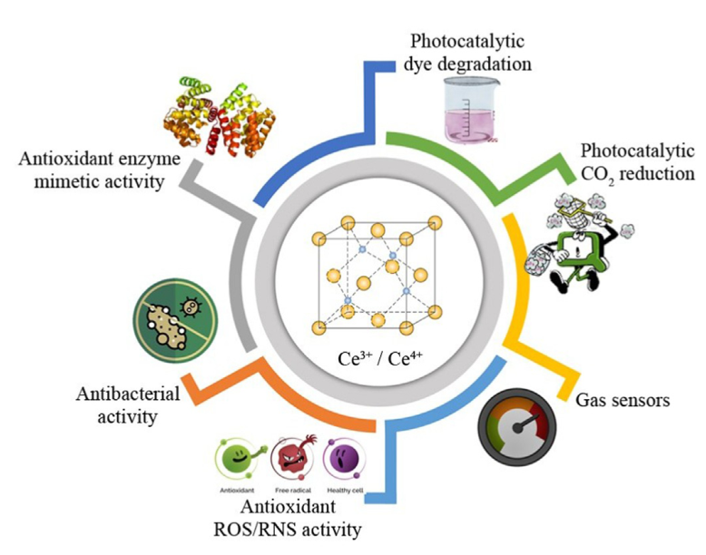
Figure 1. Various applications of ceria nanoparticles [7]
It is known that trees, herbs, shrubs, bacteria, Algae, and Fungi are rich in phytochemicals such as Phenolics, Flavonoids, Phenolic Acids, Carbohydrates, alkaloids, Lignin. These phytochemicals are freely soluble in water or hot water. They also contain water insoluble compounds such as sterols and terpenoids. Different parts of plants can be used as reducing agent when the extract is prepared in hot water. Natural materials used as reducing agent is represented in Figure 2.
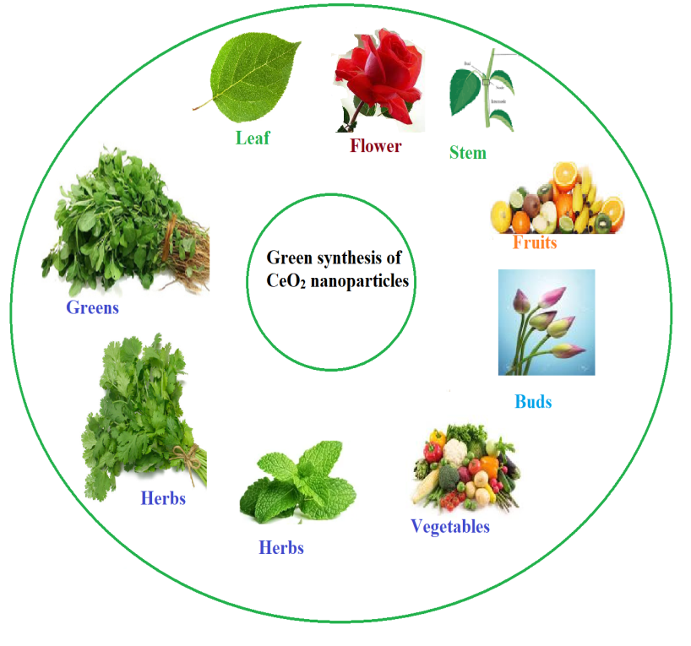
Figure 2. Green synthesis of CeO₂ nanoparticles using various parts of plants
Various metal oxide nanopartiles such as ZnO, CuO, ZrO₂, TiO₂, Fe₂O₃, Co₃O₄, and CeO₂ have been synthesized for various applications. The CeO₂ NPs have been most extensively studied due to their surface properties and biocompatibility [8, 9]. However, both methods use chemicals such as sodium hydroxide or ammonium hydroxide as reducing agent to produce nanoparticles [8, 9]. These chemicals are toxic to environment and human health [10]. Whereas the natural sources such as plant extract, biological extracts and microbes are safe and less toxic method, which methods are called as green synthesis [11]. These natural extracts are rich in secondary metabolites, especially water soluble biomolecules, which are believed to be responsible for the reduction metal salts into respective nanoparticles [12, 13].
Various parts of plants such as leaves, flower, and stem have been used for the synthesis of CeO₂ NPs [14]. Leaves are especially rich in phenolic compounds when compared with other parts of the plant extract. Therefore, leaf extract predominantly used in the green synthesis of various metal oxides [15, 16]. The metal salt solution is reduced into nanoparticles through phytochemicals whose synthesis is first confirmed through colour change from colorless to yellowish and brownish, and then the structure of the nanoparticles confirmed by various spectroscopic and imaging techniques [17].
1.2. Biosynthesis
Biosynthesis classified into Microbes and other biological sources. Microbes are rich source of secondary metabolites. Among the metal oxide nanoparticles, CeO₂ NPs with various shapes and sizes have been produced using microbes such as Curvularia lunata, Humicola sp, Fusarium solani and Aspergillus niger [18-21].
Spherical CeO₂ NPs with size ranges from 5–20 nm were synthesized using Curvularia lunata extract. Fusarium solani extract stabilized spherical CeO₂ NPs of size ranges from 20–30 nm were prepared for the purpose of antibiofilm against many pathogenic bacteria. Spherical shape CeO₂ NPs with the size range of 12–20 nm using a fungus Humicola extract as capping agent [19]. Bacteria, Bacillus subtitles extract was also used to synthesis the spherical CeO₂ NPs with an average size of 8 nm, which exhibited good antioxidant activity. Egg protein, Honey, Agarose, Starch, Polyethylene glycol, Chitosan, and Pectin are some of the biological sources used for the fabrication of CeO₂ NPs [22-27], Acalypha indica [28], Petroselinum crispum [29] Gloriosa superba [30], Aloe barbadensis [31], Olea europaea [12], Hibiscus sabdariffa [32], and Azadirachta indica [33], Manilkara zapota fruit peel extract [34], aqueous extract of Salvadora persica [35], and Olocasia esculenta [36] are some of natural and biological sources used in the synthesis CeO₂ NPs.
2. Synthesis of CeO₂ NPs
Cerium nitrate hexahydrate (Ce(NO₃)₃⋅6H₂O) [31], Cerium (III) acetate hydrate [37] and Cerium chloride heptahydrate [28] are commonly used precursor for the synthesis of CeO₂ NPs. Few researchers have used sodium hydroxide as reducing agent. Most of the researchers have not given any information regarding the reducing agent. Some researchers used ammonia solution as reducing agent [22]. They did not express the clear details about the usage of sodium hydroxide. Various concentrations (0.01, 0.1, 0.2, and 0.5M) of cerium nitrate are used as a precursor. General schematic diagram of green synthesis of CeO₂ NPs is shown in Figure 3.
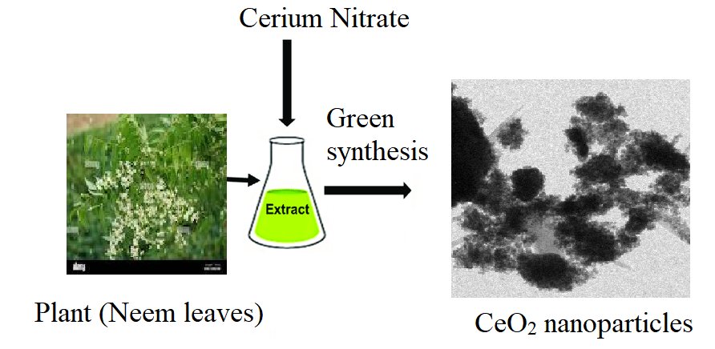
Figure 3. Green synthesis method of CeO₂ nanoparticles using plant extract
2.1. Characterization techniques
Structure of the green/biosynthesized CeO₂ can be confirmed by various spectroscopic techniques such as UV-Visible spectroscopy (UV-Vis), Fourier transform infrared spectroscopy (FTIR), X-ray diffraction (XRD), Scanning Electron Microscopy (SEM), Energy dispersive X-ray diffraction study (EDAX), Transmission Electron Microscope coupled with Selected Area Diffraction (SAED), and X-ray photoelectron spectroscopy (XPS). Absorption and functional group identification can be done by UV-Vis and FTIR. Formation of particles and elemental composition of can be analyzed by SEM-EDAX. Shape, size and morphology can be analyzed by TEM images. Average size of the particles can be calculated from the XRD data. Oxidation state of Ce³⁺ and Ce⁴⁺ can be identified by XPS spectroscopy. And many more advance techniques nowadays available for the analysis of structural studies.
2.2. Structural confirmation of CeO₂ NPs
Structure of green synthesized CeO₂ NPs is confirmed by various spectral techniques. UV-Visible is a primary method to confirm its structure. The optical properties of CeO₂ NPs are analyzed using UV-Vis DRS spectroscopy. The energy difference between valence band and conduction band is called as bandgap energy. Electron density is high in valence band and less is conduction band. Sharma et al. reported bandgap energy Azadirachta indica stabilized CeO₂ NPs (2.57eV), which is smaller than the bulk (3.19 eV) [33]. The bandgap energy is crucial for deciding the semiconductor’s performance and photocatalyst. The electrons jump from the valance band to conduction band is caused by small bandgap energy. However, higher bandgap energy will inhibit electron jump so it will stop the flow of electrons [38, 39].
3. Biological activities
CeO₂ NPs having various biological activities due to their size, shape, morphology and surface area. They act as Antioxidant, Antibacterial and Anticancer agent against various pathogenic bacteria, various radicals produced in human body, and against various cancer cells.
3.1. Antibacterial activity
Many researchers have studied the antibacterial and antifungal activities of CeO₂ NPs against many pathogenic bacteria such Escherichia coli (E. coli), Staphylococcus aureus (S.aureus), Pseudomonas aeruginosa (P.aeruginosa), and Bacillus subtilis (B.subtilis). It was proved that CeO₂ NPs at the concentration of 10 µg/mL to 50 µg/mL able to inhibit the growth of bacteria. Arumugam et al. synthesiszed CeO₂ NPs using Gloriosa superba L and tested the antibacterial efficiency against S. aureus, Streptococcus pneumonia (S.pneumonia) and B. subtilis, P. aeruginosa, Proteus vulgaris (P.vulgaris) and Klebsiella pneumonia (K.pneumonia) [30]. Similarly, Munusamy et al (2014) have derived CeO₂ NPs using Curvularia lunata and tested the antibacterial efficiency against S. aureus. S. pneumonia, E.coli, P. vulgaris, K. pneumonia, Shigella dysenteriae (S.dysenteriae) and P. aeruginosa [18, 20].
Moringa oleifera leaf extract was used as a reducing as well as stabilizing agent, which exhibited antibacterial and antifungal activities against E.coli, P. aeruginosa, C. albicans and A. fumigatus [40]. They also included many bacteria and fungi in their article for the purpose of comparison. Antibacterial activity mechanism of CeO₂ NPs is shown in Figure 4.
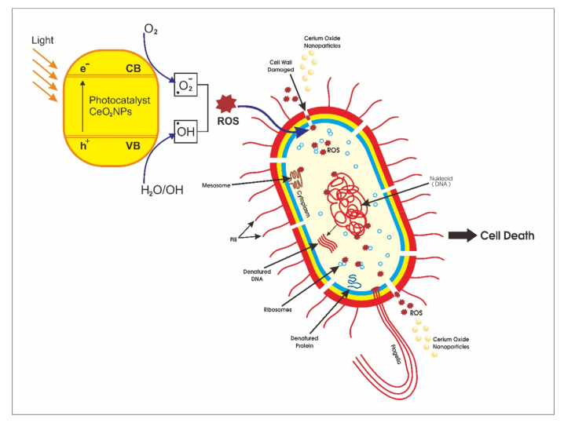
Figure 4. Mechanism of antibacterial activity of CeO₂ NPs [41]
The electrostatic attraction between positively charged NPs and negatively charged bacterial cell surfaces, which is responsible for antibacterial activity of CeO₂ NPs. Reactive oxygen species (ROS) are produced as a result of the interaction, which eventually has a bactericidal impact [41]. The most significant oxidative stress in biological systems is caused by ROS, which include the highly reactive hydroxyl radical, singlet oxygen, and the least deadly superoxide anion radical [42]. These hydroxyl radicals are an extremely reactive oxidant to organic biomolecules like proteins, lipids, and DNA nucleic acid. Singlet oxygen, the common mediator of the phototoxicity brought on by the damage to treated tissues, is produced indirectly through the interaction of superoxide anions in water contents. These photogenerated hydroxyl radicals, also known as the reactive and superoxide anion and singlet oxygen [34].
3.2. Antifungal activity
The fungicidal properties of the nanoceria have been tested against Aspergillus niger, Humicola sp., Curvularia lunata A. flavus, F. solani. CeO₂ NPs showed good antifungal activity against tested fungus at the concentrations of 100 μg/mL. The mechanism of antifungal activity of CeO₂ NPs is due to the generation of reactive oxygen species (ROS) and surface charge attraction. Due to the metal stress environment, ROS was produced, which causes oxidative damage to the lipids in cell walls and ultimately results in cell death. In a different way, the electromagnetic attraction between the positively charged Ce³⁺ on the surface of CeO₂ NPs and the negatively charged cell surface allows CeO₂ to infiltrate the cell wall, produce ROS in the cytoplasm, and cause oxidative stress that leads to cell death [11].
3.3. Antioxidant activity
Free radical species produced through cellular respiration and other physical processes due to oxidation. Antioxidant activities of CeO₂ NPs have been studied using Ferric reducing antioxidant power (FRAP) assay, DPPH free radical scavenging assay, Hydroxyl radical (OH⁻) Scavenging activities. The natural antioxidants present in the human body decrease in efficiency due to the oxidative process that happens in the body. However, the natural antioxidants present within the system fail to compensate for ROS production. Proteins, mRNA, enzymes, and endomembrane systems attach to free radicals carrying species and speed up their lipid peroxidation, which alters their chemical composition and properties. Natural antioxidant processes keep the balance between the creation and eradication of diverse free radical species. Additionally, antioxidants are crucial in the management of oxidative stress, degenerative diseases, and autoimmune diseases like arthritis. Based on their types, we split antioxidants into two groups: (1) synthetic antioxidants consumed orally, and (2) natural antioxidants produced by the body. However, when there are health problems, the body’s natural antioxidant system deteriorate and the amount of free radical species rises [43, 44]. The antioxidants interact with free radical, break their cascade through pairing, and provide protection against oxidative damage (Figure 5).
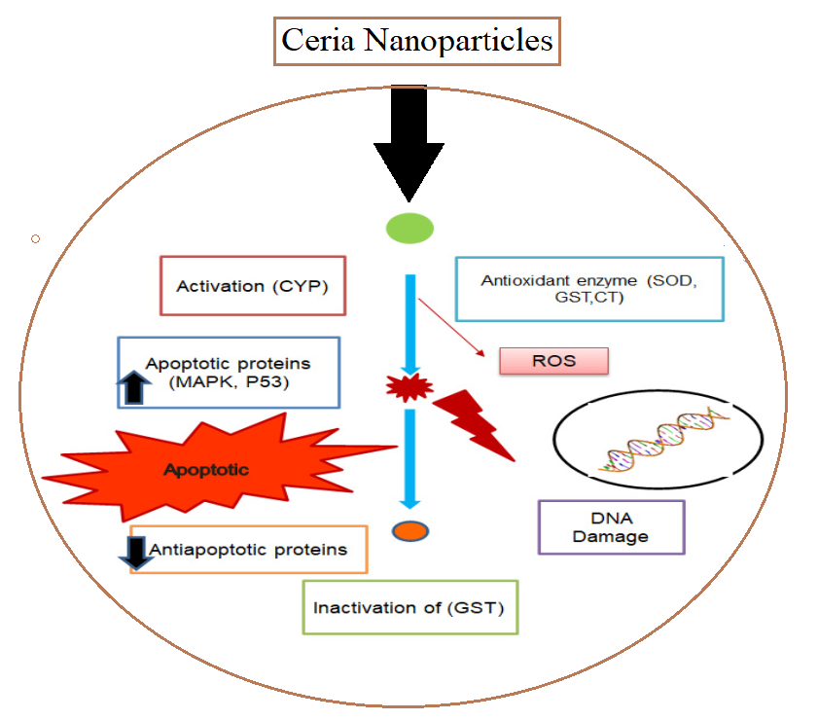
Figure 5. Antioxidant potential of cerium oxide nanoparticles [40]
3.4. Antidiabetic activity
In India, diabetic is type chronic disease facing lots of problem in terms of various health aspects. It gives trouble many old aged people as well as youngster also. Therefore, we are in a position to find out the suitable medicine to overcome the diabetic. Many nanomaterials have been applied and evaluated for the antdiabetic activity. In this connection, CeO₂ NPs found to be a potential metal oxide nanoparticle can be used to combat the diabetic mellitus.
The α-amylase, the enzyme that causes diabetes mellitus, can be inhibited by the green CeO₂ NPs that were generated. Because of their ability to block the target enzymes, natural sources of inhibitors, such as the leaves of various plants, are of interest [45]. This potential may be related to the presence of particular phenols. Thus, anti-diabetic treatment including CeO₂ NPs suggests inhibitory effects on glycogenolysis and gluconeogenesis, mechanisms that are active when a person is fasting [46].
3.5. Anticancer activity
Nowadays, cancer is serious diseases among the people due various food habits and other chronic disease. The cytotoxic effect of biosynthesized CeO₂ NPs was determined using MTT ((3-[4,5-dimethylthiazol-2-yl]-2,5 diphenyl tetrazolium bromide) assay against colon (HT‐29) cancer cell line. The result of the cytotoxic effect of CeO₂ NPs in the concentration range of 0–800 μg/mL. Anticancer activity of CeO₂ NPs against HT‐29 cell line also reported [47]. Similarly, Akhtar et al. reported the anticancer activity of CeO₂ NPs against MCF‐7 and HT‐1080 cell lines (200 μg/mL) [48].
Abdolhossein Miri et al. (2019) have evaluated anticancer activity of CeO₂ NPs against colon cancer cell lines through MTT (3‐(4,5‐dimethylthiazol‐2‐yl)‐2,5‐diphenyltetrazolium bromide) assay [36]. They proved that CeO₂ NPs at the rate 800 μg/mL able to kill the colon cancer cell line in vitro method. Rahdar et al. (2019) have reported the cytotoxic effect against MCF-7 breast cancer lines of Fe-doped ceria NPs exhibited and proved as a potential of an anticancer agent [49]. Sridharan et al. (2019) reported anticancer activity of nanoceria on breast cancer cell (MCF 7) in the IC₅₀ value was 298.17 µg/ml [50].
3.6. Anti-infammatory activity

CeO₂ NPs have the unique potential to be thought of as an anti-inflammatory drug due to their radical scavenging and auto regeneration capabilities [51]. The body quickly produces free radicals as a result of anti-inflammatory enzymes like iNOS expression; when ROS activate the protein in iNOS, macrophages release NO. Since ROS are crucial for normal cellular processes and their depletion might have detrimental repercussions. Since ROS are crucial for normal cellular processes and their depletion might have detrimental repercussions. When CeO2 nanoparticles were tested on J774A.1 cells, they reduced the generation of iNOS and ROS, acting as an anti-inflammatory agent [52].
5. Conclusions
In conclusion, it is possible to synthesize CeO₂ NPs by a simple and eco-friendly method. The phytochemicals present in the plant extract, bacteria, fungi extract and other biological sources is responsible for the reduction of cerium salt into ceria nanparticles. Various phytochemicals such as phenols, flavonoids, carbohydrates, alkaloids and other phenolic compounds mainly responsible for the bioreduction process. The green or biosynthesized CeO₂ NPs can be by UV–Vis DRS, PL, FTIR, XRD, SEM-EDAX and TEM-SAED pattern analysis. The synthesized CeO₂ NPs showed bactericidal effect against pathogenic bacteria. Similarly, green synthesized CeO₂ exhibited antifungal, antioxidant, antidiabetics and anticancer activities. Therefore, CeO₂ NPs can be used as an suitable candidate for the development drug for various diseases.
References
- V. Mohanraj, Y. Chen, Trop. J. Pharm. Res. 5 (2006) 561–573.
- A. Dhall, W. Self, Antioxidants 7 (2018) 97.
- C. Sun, H. Li, L. Chen, Energ, Environ. Sci. 5 (2012) 8475–8505.
- S. Rajeshkumar, P. Naik, Biotechnol. Rep. 17 (2018) 1–5.
- S. Das, J.M. Dowding, K.E. Klump, J.F. McGinnis, W. Self, S. Seal, Nanomed 8 (2013) 1483–1508.
- G. Sharmila, C. Muthukumaran, H. Saraswathi, E. Sangeetha, S. Soundarya, N. Manoj Kumar, Ceram. Intl. 45 (2019) 12382–12386.
- S. N. Matussin, M. H. Harunsani, M. M. Khan, J. Rare Earths 41 (2023) 167-181.
- L. He, Y. Su, J. Lanhong, Jiang Lanhong, S. Shi, J Rare Earths. 33 (2015) 791–799.
- Carl Walkey, Soumen Das, Sudipta Seal, Joseph Erlichman et al. Environ Sci. 2 (2015) 33–53.
- R. Magudieshwaran, Junki Ishii, Krishna Chandar Nagamuthu Raja, Chiaki Terashima et al. Mater Lett. 239 (2019) 40–44.
- K. Mohan Kumar, M. Mahendhiran, M. Casales Diaz, N. Hernandez-Como et al. Mater Lett. 214 (2018) 15–19.
- Q. Maqbool, M. Nazar, S. Naz, T. Hussain et al. Int J Nanomedicine. 11 (2016) 5015–5025.
- A. Singh, I. Hussain, N.B. Singh, Himani Singh, Ecotoxicol. Environ. Saf. 182 (2019) 109410.
- H. Nadaroglu, H. Onem, A. Alayli Gungor, IET Nanobiotechnol. 11 (2017) 411–419.
- P. Nithya, B. Murugesan, J. Sonamuthu, S. Samayanan, S. Mahalingam S. Ceram. Int. 2019.
- M. Sultan Irshad, M. H. Aziz, M. Fatima, Saif Ur Rehman1, M Idrees et al. Mater. Res. Express. 2019.
- A. Rajan, A. Rajan, A. John, D. Philip, AIP Conf Proc. 2015 (2019) 020008.
- S. Munusamy, K. Bhakyaraj, L. Vijayalakshmi, A. Stephen, V. Narayanan, Int. J. Innov. Res. Sci. Eng. 2 (2014) 318.
- S. A. Khan, A. Ahmad, Mater. Res. Bull. 48 (2013) 4134–4138.
- K. S. Venkatesh,a K. Gopinath,b N. S. Palani,b A. Arumugam,b Sujin P. Jose,c S. Asath Bahadura and R. Ilangovan RSC Adv. 6 (2016) 42720–42729.
- K. Gopinath, V. Karthika, C. Sundaravadivelan, S. Gowri & A. Arumugam J Nanostructure Chem. 5 (2015) :295–303.
- M. Darroudi, M. Sarani, R. K. Oskuee, A. K. Zak, H. Ali et al. Ceram. Int. 40 (2014) 2041–2045.
- H. Kargar, F. Ghasemi, M. Darroudi, Ceram. Int. 41 (2015) 1589–1594.
- M. Darroudi, S. J. Hoseini, R. K. Oskuee, H. A. Hosseini et al. Ceram. Int. 40 (2014) 40
7425–7430.
- E. Alpaslan, H. Yazici, N. H. Golshan, K. S. Ziemer, T. J. Webster, ACS Biomater. Sci. Eng. 1 (2015) 1096–1103.
- A. Kaushik, P. R. Solanki, M. K. Pandey, S. Ahmad, B. D. Malhotra Appl. Phys. Lett. 95 (2009) 173703.
- S. N Patil, J. S Paradeshi, P. B. Chaudhari, S. J. Mishra, B. L Chaudhari, Appl Biochem Biotechnol. 180 (2016) 638–654.
- S. K. Kannan, M. Sundrarajan, Int. J. Nanosci. 13 (2014) 1450018.
- A. M. Korotkova, P. O. Borisovna, G. I. Aleksandrovna, K. D. Bagdasarovna et al. Curr. Nanomater. 4 (2019) 176–190.
- A. Arumugam, C. Karthikeyan, A. S. Haja Hameed, K. Gopinath et al. Mater. Sci. Eng., C, 49 (2015) 408–415.
- G. Sai Priya, A. Kanneganti, K. Anil Kumar, K. Venkateswara Rao, S. Bykkam, Intl. J. Sci. Res. Publication, 4 (2014) 1–4.
- N. Thovhogi, A. Diallo, A. Gurib-Fakim, M. Maaza, J. Alloys Compd. 647 (2015) 392–396.
- J. K. Sharma, P. Srivastava, S. Ameen, M. S. Akhtar, S. K. Sengupta, G. Singh, Mater. Res. Bull., 91 (2017) 98–107.
- D. Ayodhya, A. Ambala, G. Balraj, M. P. Kumar, P. Shyam, Results Chem. 4 (2022) 100441
- A. Miri, M. Darroudi, M. Sarani, Appl Organometal Chem. (2019) 5308.
- N. M. Ahmad, N. Aishah, J. Nanotechnol. (2023) Article ID 9572025.
- S. Maensiri, C. Masinghboon, P. Laokul, W. Jareonboon, V. Promarak, P. L. Anderson et al. Cryst Growth Des. 7 (2007) 950–955.
- J. Calvache-Munoz, F. A. Prado, J. E. Rodrıguez-Paez, Colloids Surfaces A Physicochem. Eng. Asp. 529 (2017) 146-159.
- K. R. B. Singh, V. Nayak, T. Sarkar, R. P. Singh, RSC Adv 2020;10:27194-214.
- G. E. Putri, Y. Rilda, S. Syukri, A. Labanni et al. J. Mater. Res. Technol. 15 (2021) 2355-2364.
- M.V. Arasu, R. Thirumamagal, M.P. Srinivasan, N.A. Al-Dhabi et al. J. Photochem. Photobiol. B: Biology 173 (2017) 50–60.
- T. Xia, M. Kovochich, M. Liong, L. Madler et al. ACS Nano 2 (10) (2008) 2121–2134.
- G. Ciofani, G. G. Genchi, I. Liakos, Cappello et al. Pharm. Res. 30 (2013) 2133–2145.
- M. Khan, Z. U. R. Mashwani, M. Ikram, N. I. Raja et al. Nanomaterials 12 (2022) 2117.
- N. Bala, S. Saha, M. Chakraborty, M. Maiti et al. RSC Adv. 5 (2015) 4993–5003.
- K. Shanker, J. Naradala, G.K. Mohan, G.S. Kumar et al. RSC Adv. 7 (59) (2017) 37158–37167.
- A. Miri, M. Sarani, Ceram. Int. 4 (2018) 12642.
- M. J. Akhtar, M. Ahamed, H. A. Alhadlaq et al. J. Colloid Interface Sci. 453 (2015) 21.
- A. Rahdar, M. Aliahmad, M. Samani, M. HeidariMajd et al. Ceram. Intl. 45 (2019) 7950–7955.
- M. Sridharan, P. Kamaraj, Vennilaraj, J. Arockiaselvi et al. Mater. Today: Proceedings 36 (2021) 914-919.
- A. Gojova, J.-T. Lee, H. S. Jung, B. Guo et al. Inhalation Toxicol. 21 (2009) 123–130.
- S. M. Hirst, A. S. Karakoti, R. D. Tyler, N. Sriranganathan et al. Small, 5 (2009) 2848–2856.

