A Novel Slotted MIMO Antenna for 5G mm-wave Communication

Chandrasekhar Rao Jetti¹ | Srinivasa Rao U² | Akhila Yadlapalli³
Associate Professor | Associate Professor | UG Student
Department of ECE | Department of ECE | Department of ECE
Bapatla Engineering College, Bapatla | Bapatla Engineering College, Bapatla | Bapatla Engineering College, Bapatla
Andhra Pradesh-522102, India | Andhra Pradesh-522102, India | Andhra Pradesh-522102, India
jettychandu@gmail.com | usrao75@gmail.com | akilay285@gmail.com
Sai Sindhu Raja⁴ | Karthikesh Yangala⁵ | Sai Teja Sanaka⁶
UG Student | UG Student | UG Student
Department of ECE | Department of ECE | Department of ECE
Bapatla Engineering College, Bapatla | Bapatla Engineering College, Bapatla | Bapatla Engineering College, Bapatla
Andhra Pradesh-522102, India | Andhra Pradesh-522102, India | Andhra Pradesh-522102, India
rajasaisindhu01@gmail.com | karthikeshyangala100@gmail.com | saitejasanaka@gmail.com

Abstract – A novel tiny two-element MIMO (multiple-input multiple-output) antenna is presented for 5G mm-wave communication. The antenna has dimensions of 4.8 × 12 × 0.508 mm³ and is composed of the Rogers RT/duroid 5880 (tm) substrate, which has a loss tangent of 0.0009 and a dielectric of 2.2. The proposed antenna features a slotted ground at the base and two U-shape patches on top of the substrate. To excite the patches, a 50-ohm microstrip line feed is used. For better impedance performance, each radiating patch has a 1.3 × 0.2 mm² rectangular strip and a couple of rectangular slots. A U-shaped element enables the first operating band at 26.8GHz from 26.3 to 27.50GHz. Cutting hexagonal slots into the ground creates the next operating band at 48.7GHz, which spans 48.1 to 49.45GHz. The suggested MIMO antenna's isolation is improved by slots on the ground and radiating elements that are orthogonally positioned. The results manifests that the suggested antenna is appropriate candidate for 5G mm-wave communications.

Index Terms - 5G mm-Wave, impedance, isolation and multiple-input multiple-output.

I. Introduction
There is a raising need for very higher data rate with extremely minimal latency and spectrum in wireless applications because of the widespread adoption of wireless communication networks. Fifth-generation (5G) mobile standard has a number of benefits over the current 4G system, including faster data transmission speeds, increased spectrum efficiency, decreased latency, and good device connectivity and stability.

The FCC split the spectrum of frequencies into three bands: <1GHz, sub-6 GHz, and mm-wave bands in order to support 5G. There is an excess of spectrum available in mm-wave frequency ranges greater than 24 GHz, allowing for extremely large capacity, extremely high throughput, and extremely low latency. As a result, several antennas for 5G mm-wave are being introduced. Multiple-input multiple-output (MIMO) is a promising technology for 5G applications [1-4]. Using MIMO technology, which doesn't need any additional spectrum or transmission power, offers the potential to increase data rate and efficiency. The communication channel's two endpoints of a MIMO system both have several antennas.
In MIMO systems, mutual coupling is possible because antenna elements are spaced closely together [11]. Hence, it is challenging to increase isolation or decrease mutual coupling between antennas that are close together. Many investigations have been conducted in order to improve isolation or decrease mutual coupling in MIMO antenna systems [5-15]. The aforementioned antennas offer acceptable isolation, but they are too large and have complicated designs. Thus, a simple, miniature MIMO antenna with isolation enhancement is required for 5G mm-wave communication.
For 5G mm-wave applications in the n257, n258 and n262 bands, the disclosed invention proposed a new, small, isolation-enhanced 2-element MIMO antenna. This research introduces a unique 26.8/48.7GHz compact MIMO antenna for 5G mm-wave applications. The antenna is fed by a 50-ohm microstrip feedline and comprises 12 x 4.8 x 0.508 mm³. The antenna consists of two orthogonally positioned elements on top of a substrate, and on the backside is a ground with tiny hexagonal and rectangular slots. The antenna has good impedance matching and isolation properties and operates at 26.8 GHz and 48.7 GHz. The antenna design, the findings, and the conclusions are covered in the following sections.

II. Dual-Band mm-wave Antenna Design
The dual-band U-shaped MIMO antenna's ideal geometry for 5G mm-wave applications is depicted in Fig.1. Ansoft HFSS was used to do simulations, dimension optimization, and the proposed antenna design. The 50-ohm microstrip line is fed by the MIMO antenna, which has dimensions of 12 × 4.8 × 0.508 mm³ and is established on a Rogers RT/duroid 5880 (tm) dielectric. The substrate's thickness is 0.508mm, its loss tangent is 0.0009, and its relative permittivity is 2.2. The proposed antenna consists of a slotted ground at the bottom and two U-shaped elements placed orthogonally on top of the substrate. A couple of slots (1.465 × 0.325 mm², 0.78 × 0.325 mm²) are added to each radiating patch to improve the MIMO antenna's impedance performance. The operating band was created at 26.8GHz, which spans from 26.3GHz-27.5GHz, using the rectangular slots. A pair of hexagonal slots with a dimension of 2.8 × 2.425 mm² each are carved from the ground in order to achieve another resonance band at 48.7GHz from 47.6GHz-50.1GHz. Fig.2(a). shows the proposed MIMO's impedance matching characteristics (S11 & S22 parameters). It is observed that the antenna operates with good impedance matching at 26.8 GHz and 48.7 GHz (S11<-10dB). In this study, two techniques are employed to produce high isolation between antenna ports or minimal mutual coupling between radiating parts. These methods consist of the perpendicular placement of U-shape components and the utilisation of a tiny, ground slot (4.7 × 0.3 mm²). Fig.2(b) shows the recommended antenna's isolation parameters (S12 & S21). Throughout the working bands, the aerial provides enhanced isolation of more than 26 dB.
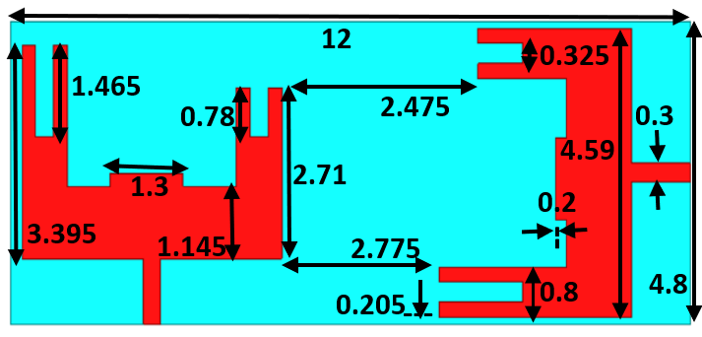
(a)
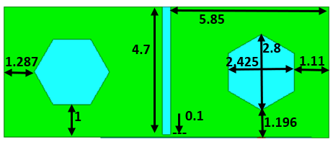
(b)
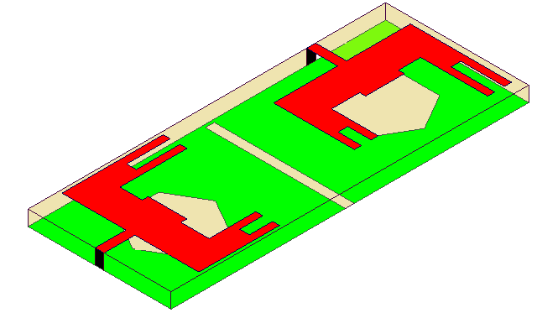
(c)
Fig.1. Dual-band mm-wave antenna with sizes; (a) top layer, (b) bottom layer and (c) dimetric view.
III. Results AND DISCUSSION
Fig.2. displays the suggested MIMO antenna’s S-parameters, comprising S11, S12, S21, and S22 results. The proposed antenna has good impedance matching behaviour (S11 and S22-10dB) and operates at two mm-wave bands, namely 26.8 GHz and 48.7 GHz. The MIMO antenna in Fig.2(b). also offers strong isolation at the 26.8 GHz and 48.7 GHz bands, S12, S21>26dB. How effectively an antenna's impedance is matched is determined by a test known as the voltage-standing wave ratio (VSWR). The lower the VSWR, the better the impedance matching. The suggested antenna's VSWR is 1.26 at 26.8 GHz and 1.19 at 48.7 GHz, as shown in Fig.3.
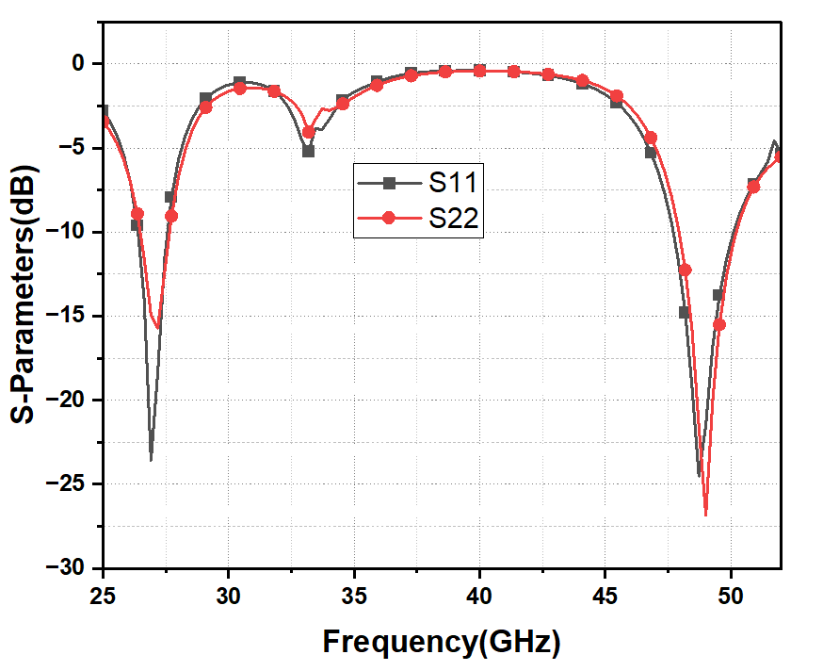
(a)
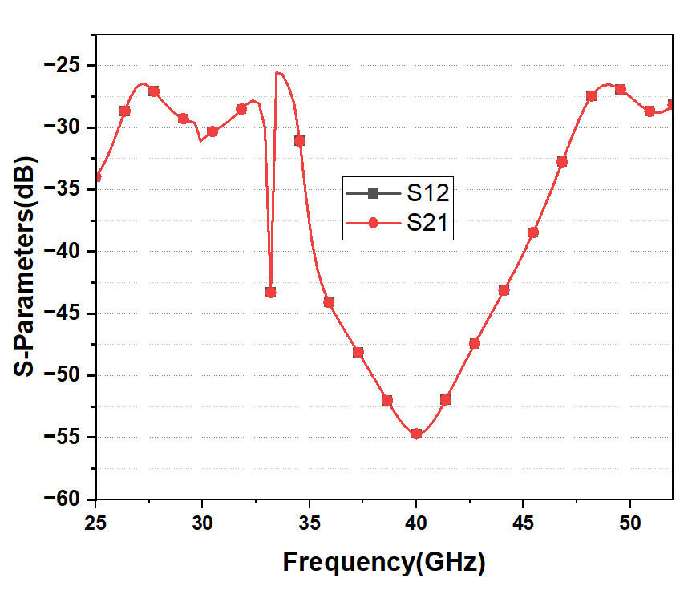
(b)
Fig.2. Dual band mm-wave antenna S-parameter results; (a) return loss, (b) mutual coupling.
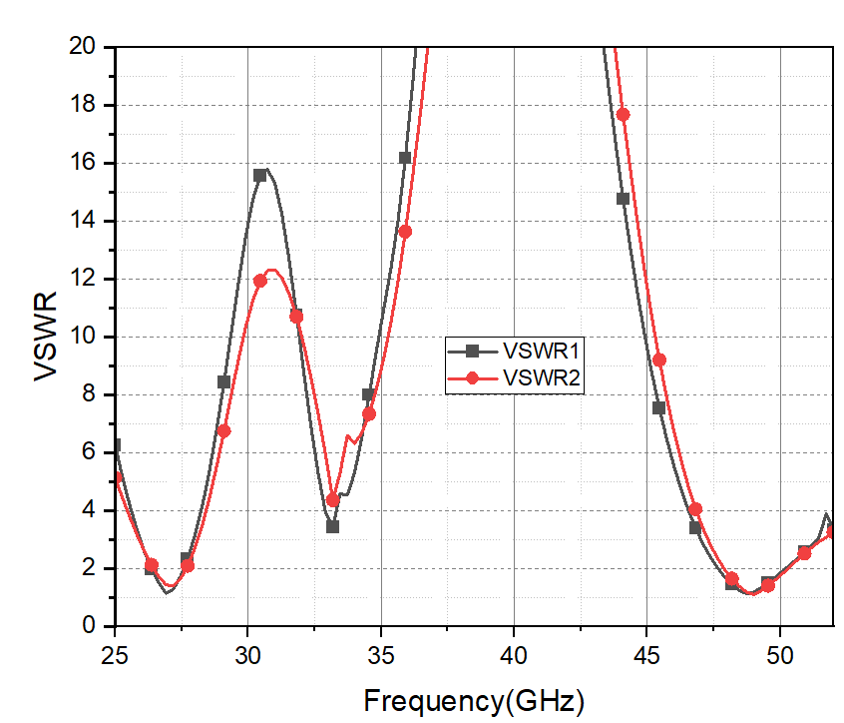
Fig.3. Dual band mm-wave antenna VSWR plot

The 2-D radiation characteristics at 26.8 GHz and 48.7 GHz in the E-plane and H-plane are shown in Fig. 4. At the operating bands, the antenna provides omnidirectional H- and bidirectional E-plane patterns. The peak gain results of the suggested configuration are shown in Fig.5. Peak gains of 7.1dBi at 26.8GHz and 5.4dBi at 48.7GHz are noted.

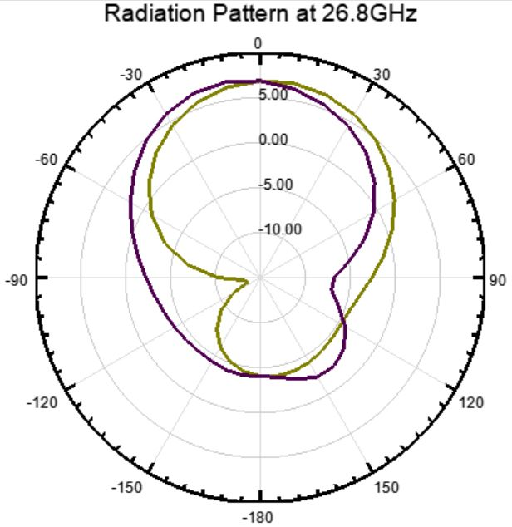

(a)

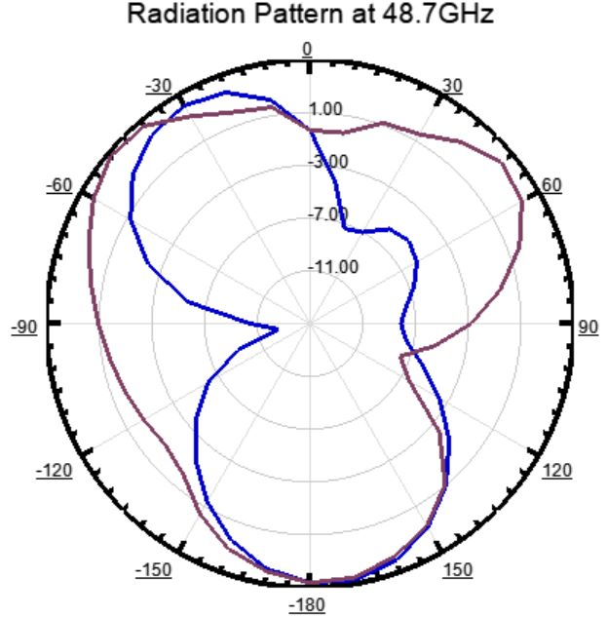
(b)
Fig.4. Radiation patterns at (a) 26.8 GHz, (b) 48.7GHz
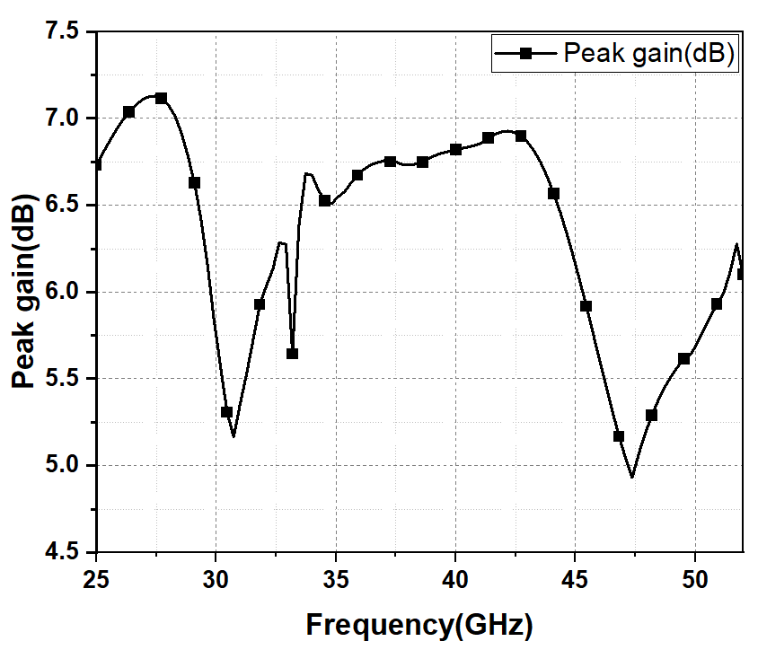
Fig.5. The Peak Gain plot

At both resonating frequencies, the surface current distribution patterns for the proposed antenna are examined in Fig.6. The current density function at 26.8 GHz is shown in Fig.6(a) and (b). Along the feed as well as the left side of the antenna patch, the current fluctuation is at its maximum. The first resonant band corresponds to the length of the existing path. In a similar manner, Fig.6(c) and (d), displays the surface current density of the second resonant frequency band at 48.7 GHz. The provided figure makes it clearly evident that the current density is greater on the same and opposite sides of the feeding arrangement.

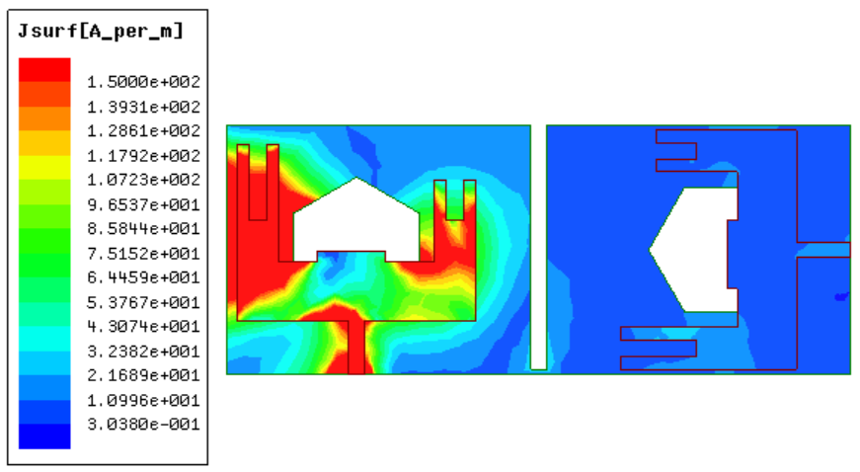
(a)
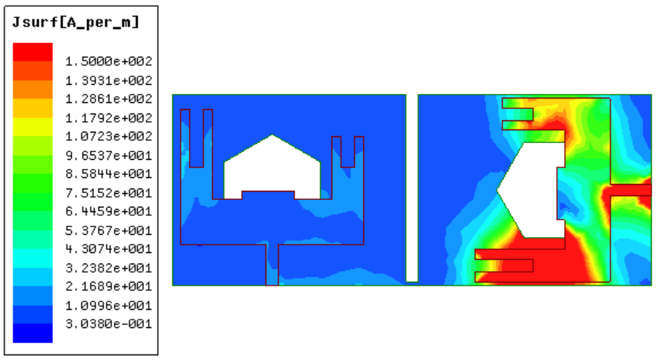
(b)
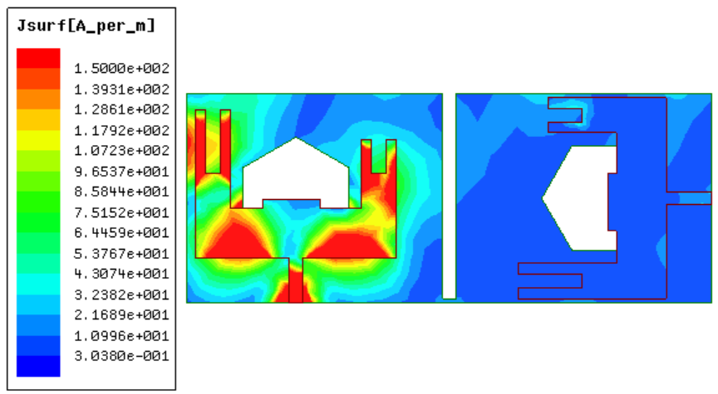
(c)
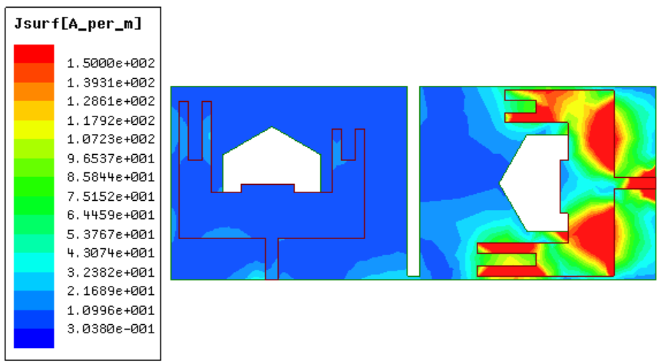
(d)
Fig.6. Surface Currents When: (a) Port-1 is excited at 26.8GHz, (b) Port-2 is excited at 26.8GHz, (c) Port-1 is excited at 48GHz and (d) Port-2 is excited at 48GHz
IV. Conclusion
This paper presents a portable dual-band MIMO design for 5G mm-wave communication. The antenna, which measures 12 x 4.8 x 0.508 mm³, is constructed of Rogers RT/duroid 5880 (tm) substrate. The proposed antenna comprises of a slotted ground at the bottom of substrate and two orthogonally positioned elements on top. A slot on each radiating element and hexagonal cuts on the ground are employed to induce resonances at 26.8 GHz and 48.7 GHz, respectively. In order to realise port isolation, the elements are located orthogonally. Moreover, a little rectangular opening in the ground is used to significantly enhance isolation. The antenna exhibits omnidirectional radiation patterns, strong isolation of more than 26dB, peak gains of 7.1 dBi at 26.8 GHz, and 5.4 dBi at 48.7 GHz. Diversity performance parameters for the proposed structure include return loss <-10dB and VSWR <2. The results firmly depict that the recommended design is a good fit for 5G mm-wave applications.
References
- Sabek, A. R., Ali, W. A., & Ibrahim, A. A. (2022). Minimally coupled two element MIMO antenna with dual band (28/38 GHz) for 5G wireless communications. Journal of Infrared, Millimeter, and Terahertz Waves.
- FCC Takes Steps to Make Millimeter Wave Spectrum Available for 5G, Federal Communications Commission, 2019
- Rappaport, T.S., Xing, Y., MacCartney, G.R., Molisch, A.F., Mellios, E. and Zhang, J., “Overview of millimeter wave communications for fifth-generation (5G) wireless networks with a focus on propagation models”, IEEE Transactions on antennas and propagation, 65(12), pp.6213-6230, 2017.
- Niu Y, Li Y, Jin D, Su L, Vasilakos AV., “A survey of millimeter wave communications (mm-Wave) for 5G: opportunities and challenges”, Wireless networks. 2015 Nov; 21 8:2657-76.
- Dong, P., Zhang, H., Li, G. Y., Gaspar, I. S., & NaderiAlizadeh, N. (2019). Deep CNN-based channel estimation for mm-Wave massive MIMO systems. IEEE Journal of Selected Topics in Signal Processing
- Soltani, S. and R. D. Murch, “A compact planar printed MIMO antenna design,” IEEE Trans. Antennas Propag., Vol. 63, 1140-1149, 2015.
- Aliakbari, H., Abdipour, A., Costanzo, A., Masotti, D., Mirzavand, R., & Mousavi, P. (2017). ANN‐based design of a versatile millimetre‐wave slotted patch multi‐antenna configuration for 5G scenarios. IET Microwaves, Antennas & Propagation
- Hussain, Niamat, Wahaj Abbas Awan, Wael Ali, Syeda Iffat Naqvi, Abir Zaidi, and Tuan Tu Le., “Compact wideband patch antenna and its MIMO configuration for 28 GHz applications,” AEU-International Journal of Electronics and Communications 132, 153612, 2021.
- Ali, Wael, Sudipta Das, Hicham Medkour, and Soufian Lakrit., “Planar dual-band 27/39 GHz millimeter-wave MIMO antenna for 5G applications,” Microsystem Technologies 27, 1 283-292, 2020.
- Jetti, C.R. and Nandanavanam, V.R., “Trident-shape strip loaded dual band-notched UWB MIMO antenna for portable device applications,” AEU-International Journal of Electronics and Communications, 83, pp.11-21, 2018.
- Ikram, Muhammad, Yifan Wang, Mohammad S. Sharawi, and Amin Abbosh. “Dual band circular MIMO antenna system for 5G wireless devices,” In 2018 IEEE International Symposium on Antennas and Propagation & USNC/URSI National Radio Science Meeting, pp. 247–248.IEEE, 2018.
- Sabek AR, Ali WA, Ibrahim AA. “Minimally Coupled Two-Element MIMO Antenna with Dual Band (28/38 GHz) for 5G Wireless Communications”, Journal of Infrared, Millimeter, and Terahertz Waves. 2022 May 19:1-4.
- Roh, W., Seol, J. Y., Park, J., Lee, B., Lee, J., Kim, Y., ... & Aryanfar, F. (2014). Millimeter-wave beamforming as an enabling technology for 5G cellular communications: Theoretical feasibility and prototype results. IEEE communications magazine.
- Mneesy, T. S., Hamad, R. K., Zaki, A. I., & Ali, W. A. (2020). A novel high gain monopole antenna array for 60 GHz millimeter-wave communications. Applied Sciences, 10(13), 4546.
- Ibrahim, A. A., & Ali, W. A. (2021). High gain, wideband and low mutual coupling AMC-based millimeter wave MIMO antenna for 5G NR networks. AEU-International Journal of Electronics and Communications, 142, 153990.

