**Endophytic bacteria and their potential applications in agriculture**

**Debajani Das1, Tikendrajit Baro1, Samudra Brahma2, Deepanka Saikia3** **and Sandeep Das1\***

**1Department of Biotechnology, Bodoland University, Kokrajhar, Assam, India-783370**

**2Department of Food engineering and Technology, Central Institute of technology, Kokrajhar, Assam, india-783370**

**3Department of Agricultural Engineering, Centurion University of Technology & Management, Odisha, India-761211**

**\*Corresponding author’s email address:** sandeep_dna2003@yahoo.co.in

**Abstract**

Endophytic bacteria are those which live inside the plant tissue without harming the plants and can be isolated from almost all parts of the plant like roots, leaves, stems, fruits, seeds, flowers etc. These microbes were found to help the host plant in disease management, environmental stress tolerance and also help the plant in their growth and development. Previousy, it was suggested that the use of endophytic bacteria as a biofertilizer can replace the use of several agrochemicals in agriculture. Endophytic bacteria like *Herbaspirillum sp*., *Methylobacterium* *sp*., and *Brevundimonas* *sp*. isolated from tea plant showed distinct plant growth promoting activities. The main aim of this chapter is to discuss about the endophytic bacteria isolated from different plants and their growth promotion activities. Additionally, it will be discussed about how endophytic bacteria help plants to cope with different environmental stresses and manage their diseases.

Keywords: Endophytic bacteria; biofertilizer; stress tolerance; disease management; plant growth promotion activity.

1. **INTRODUCTION**

Agricultural practises that use chemical fertilisers have a negative impact on soil quality and thus promote environmental pollution. In an effort to decrease the usage of chemical fertilisers, researchers have recently placed a great deal of emphasis on producing microorganism-based biofertilizer. Endophytes are a class of microorganisms that live inside healthy plants without causing any plant disease. Microbiologists are paying more and more attention to endophytes. De Bary (1866) first offered the definition of an endophyte as "any organism that grows within plant tissues," which is distinct from an epiphyte that lives on the surface of plants (1). Numerous investigations revealed that endophytes are crucial for plant disease resistance, the manufacture of secondary metabolites, the control of plant growth, and the ability to survive environmental stresses (2). Endophytic bacteria spend at least a portion of their life cycles inside the tissues of plants without causing any disease signs. Some of them are referred to as plant growth-promoting bacteria (PGPB), which have both direct and indirect effects on agriculture. The direct mechanisms that lead to encouraging plant growth include the creation of phytohormones, nitrogen fixation, ACC (1-aminocyclopropane-1-carboxylate) deaminase activity, phosphate or zinc solubilization, and uptake of iron by siderophore formation (3). The internal tissues of plants are constantly colonised by bacterial endophytes, which are present in almost all plants in the globe and can be isolated from surface disinfected plant tissues (4). Endophytic bacteria can be isolated from sterile plant tissues such as roots, stems, and leaves, as well as from flowers, fruits, and seeds. Previous study showed that in compared to other organs like roots and stems, leaves were shown to have a higher concentration of endophytic bacteria (5). The diversity of endophytic bacteria depends on the host plant age, genotype, geographical location, climatic conditions, method used to study these bacteria, nature of plant host species, type of soil etc (6).

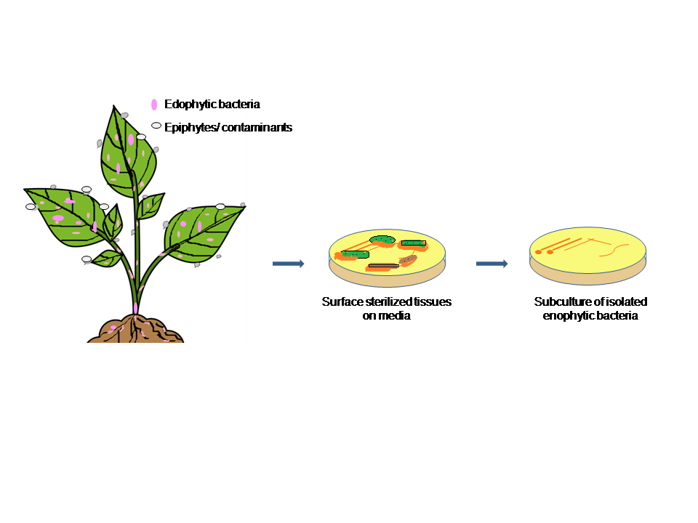

**Fig 1: Isolation of endophytic bacteria**

These microorganisms can form a mutualistic association with the host plant by sharing nutrients and protection (7). Endophytic bacteria which complete all or a portion of their life cycle inside the host plants with no visible harm or sickness (8). Plants and microorganisms can coexist in a variety of beneficial ways, including mutualism, commensalism, symbiosis, cohabitation, biofilms, and others (9). There are still many unknowns regarding how endophytic bacteria interact with their host plants. Although many isolates appear to have favourable effects on their hosts, including encouraging host development and biologically controlling phytopathogens (10).

In the majority of underdeveloped nations, medicinal plants are extremely important for health care and disease treatment (11). The isolation of uncommon and intriguing endophytes with unique bioactive chemicals is anticipated to come from medicinal plants (5). The generation of bioactive metabolites is thought to be significantly influenced by the evolutionary genetic recombination between medicinal plants and the accompanying microbes (12). Endophytic bacteria were found to help the host plant by enhancing plant nutrient absorption and producing phytohormones that are connected to growth and stress. These microorganisms can enhance plant health by using antibiotics, hydrolytic enzymes, nutrient restriction, and plant defence priming to target pests and diseases (6). Some novel antibiotics produced by endophytic bacteria *Streptomyces sp*. are effective against multidrug-resistant bacteria. Endophytes produce antimicrobial substances which are safe for humans, poisonous to pathogens, and environmentally friendly (13). To isolate endophytic bacteria from various plant tissues, surface sterilization plays an important role to remove contaminants as well as epiphytic bacteria. By plating the final sample wash water onto culture media, the effectiveness of surface sterilization and the total elimination of contaminating microorganisms can be verified by the absence of any microbial growth (12). The main aim of this chapter is to discuss about the endophytic bacteria isolated from different plants and their growth promotion activities. Additionally, it will be discussed how endophytic bacteria help plants to cope with different environmental stresses and manage their diseases.

1. **Plant growth promotion activity**

Under certain climatic conditions, plant productivity and health can be enhanced by plant growth-promoting bacteria (PGPB) that interact symbiotically with their host plants. *Brevibacillus sp*. isolated from *Achillea fragrantissima*, a desert medicinal plant was found to produce a high amount of ammonia and IAA. Also the endophytic bacterial isolates from *Fagonia mollis* Delile and *Achillea fragrantissima* were found to solubilize (14). A medicinal plant *Momordica charantia* L. roots were used to isolate endophytic bacteria such as *Bacillus licheniformis*, *Bacillus sp*., *Agrobacterium tumefaciens*, *Bacillus subtilis* and *Lysinibacillus fusiformis*. These microorganisms except *Agrobacterium tumefaciens* were found positive for positive for phosphate solubilization, IAA production and siderophore production (15). *Herbaspirillum spp*. and *Methylobacterium spp*. isolated from from tea cultivar of Zijuan and *Bradyrhizobium spp*. isolated from tea cultivar of Yunkang-10. These three genus showed nitrogen fixing ability and other PGP activities like P-solubilisation, siderophore, IAA production, and ACC deaminase (16). A total of 70 endophytic bacteria were isolated from tea leaves and most of the isolates showed different plant growth promting activities. The greatest level of IAA, 367.59 g/mL, was produced by *Curtobacterium citreum* out of all the other isolates among 70 endophytic bacteria. Other isolates like *Pseudarthrobacter enclensis*, *Enterobacter wohouensis*, *Microbacterium testacum* were also able to produce a good amount of IAA (17). *Bacillus altitudinis*, *Enterobacter wohouensis*, *Staphylococcus haemolyticus*, *Staphylococcus argenteus*, *Bacillus safensis*, *Curtobacterium citreum* etc isolated from tea leaves showed phosphate solubilization ability. *Bacillus altitudinis*, *Priestia megaterium*, *Microbacterium testacum*, *Neobacillus niacin* were able to show siderophore production abiity (17). Previously, endophytic bacteria were isolated from medicinal plant, *Glycosmis pentaphylla* and isolates showed plant growth promotion activities like ammonia production, phosphate solubilization, IAA production (5). Endophytic bacteria isolated from the roots of local rice plant from Indonesia showed a very effective result in IAA production and phosphate solubilisation (18).

1. **Disease management**

The creation of biological agents becomes a crucial component of research in order to manage infections in agriculture instead of using chemical fertiliser. Diseases in plants directly affect on crop productivity as well as economic losses (19). Endophytic bacteria play a significant role in the destruction of phytopathogens by creating antimicrobial substances, siderophores, and systemic resistance through the creation of pathogenesis-related proteins and defence enzymes to prevent disease development by phytopathogens (9). Endophytes often compete with pathogenic microorganisms for niche and nutrition, namely niche exclusion, is a promising mechanism for the use of endophytes in plant disease control (1). By using antibiotics, hydrolytic enzymes, nutrient restriction, and priming plant defences against pathogens and pests, endophytic bacteria can enhance plant health (6). Several endophytic bacteria isolated from different host plant especially from medicinal plant showed anti-microbial activity against several pathogenic microbes. *Rhizophora mucronata* Lam, a mangrove plant, produced 18 bacterial endophytes, of which 12 exhibited strong activity against *Bacillus cereus* and 9 had action against *Pseudomonas aeruginosa*. The isolates of this plant can be use to develop a biological agent which can work against *B*. *cereus* (20). *Bacillus subtilis*, endophytic bacteria isolated from the root of pearl millet. *B*. *subtilis* showed activity against *Sclerospora graminicola* which causes downy mildew disease of pearl millet (21). Endophytic bacterial strains isolated from chilli showed great antimicrobial activity against 4 pathogens namely, *Sclerotium rolfsii*, *Fusarium oxysporum*, *Colletotrichum capsici*, *Pythium sp*. Most of the isolates showed activity against *Pythium sp*. (22).

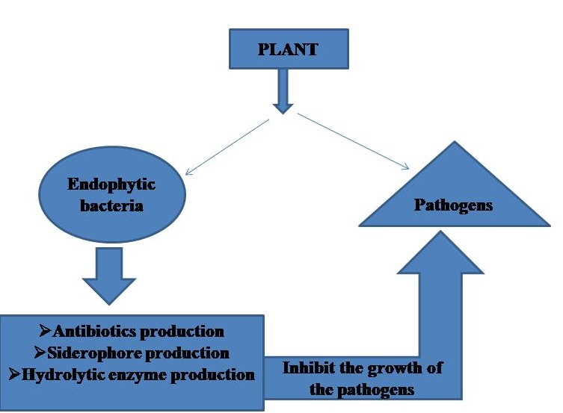

**Fig 2: Flow chart of disease management by endophytic bacteria**

1. **Stress tolerance**

Endophytes are also employed in agriculture as a stress-reducing agent. Endphytes mitigate the negative impacts of abiotic stresses like drought and salinity (15). Endophytic bacteria isolated from *Momordica charantia* L showed salt tolerance activity upto 10% NaCl (Table 1). In the saline-affected area, strains having a tolerance of 10% NaCl can enhance plant development (15). The four endophytic bacteria namely, *Enterobacter*, *Achromobacter*, *Bacillus*, and *Stenotrophomonas*, were isolated from *Oryza sativa* plants that had been grown in a salty environment. These four isolates were found to tolerate NaCl from 1.37 to 2.57 mol/L concentration (23). *Priestia aryabhattai* isolated from *Triticum aestivum* L. was able to tolerate high concentration of NaCl and drought (Table 1). This isolate also showed good results against heavy metals like Cd of 1200 µg ml-1; Cr of 1000 µg ml-1; Cu of 1000 µg ml-1; Pb of 800µg ml-1; Hg of 30µg ml-1 (24). As multi-stress reducers, bioremediation agents, and crop growth boosters in crucial crops, *Pelomonas aquatic* and *Solibacillus silvestris* have prospective uses (25). It was reported that the endophytic bacteria, *Burkholderia phytofirmans* was involved in inducing cold tolerance in grapevine plants. Also, *Alicyclobacillus acidocaldarius* was able to tolerate heat stress by expressing heat shock protein, Hsp70 (26).

**Table 1: Different endophytic bacteria from same or different plant and their plant growth promotion activities**

|  |  |  |  |  |  |
| --- | --- | --- | --- | --- | --- |
| **Plant** | **Endophytic bacteria** | **Applications** | | | **Reference** |
| **Plant growth promotion activity** | **Disease management** | **Stress management** |  |
| *Momordica charantia* L. | *Bacillus licheniformis*, *Bacillus sp*., *Bacillus subtilis* and *Lysinibacillus fusiformis* | phosphate solubilization, IAA production and siderophore production |  |  | [15] |
| *Momordica charantia* L. | *Bacillus licheniformis* and *Bacillus subtilis* |  |  | Able to tolerate 10% NaCl | [15] |
| *Camellia sinensis* | *Curtobacterium citreum*, *Pseudarthrobacter enclensis*, *Enterobacter wohouensis*, *Microbacterium testacum* | IAA production |  |  | [17] |
| *Camellia sinensis* | *Bacillus altitudinis*, *Enterobacter wohouensis*, *Staphylococcus haemolyticus*, *Staphylococcus argenteus*, *Bacillus safensis*, *Curtobacterium citreum* | Phosphate solubilization |  |  | [17] |
| *Camellia sinensis* | *Bacillus altitudinis*, *Priestia megaterium*, *Microbacterium testacum*, *Neobacillus niacin* | Siderophore production |  |  | [17] |
| Pearl millet | *Bacillus subtilis* |  | Manage downy mildew disease caused by *Sclerospora graminicola* |  | [21] |
| *Oryza sativa* | *Enterobacter*, *Achromobacter*, *Bacillus*, and *Stenotrophomonas* |  |  | 1.37 to 2.57 mol/L NaCl concentration | [23] |
| *Triticum aestivum* L. | *Priestia aryabhattai* |  |  | 18% NaCl,  15% drought,  Heavy metals like Cd, Cr, Cu, Pb and Hg | [24] |
| *Ananas comosus* | *Bacillus sp*. *Providencia sp*. *and Staphylococcus sp*. |  |  | Drought tolerance | [27] |

1. **Conclusions and Future perspectives**

In this chapter, we have mentioned different endophytic bacteria isolated from different plants. Endophytic bacteria showed several biological activities including plant growth promotion activity, stress tolerance activity and the ability of endophytic bacteria to fight against harmful pathogens. Here, we discussed, different salt tolerant endophytic bacteria like *Priestia aryabhattai*, *Enterobacter*, *Achromobacter*, *Bacillus*, *Stenotrophomonas*, *Bacillus licheniformis*, *Bacillus subtilis* etc. It was found that the endophytic bacteria present inside the plants grows in stressed environment were expressed some genes to fight against environmental abuse like temperature, salinity, drought etc. We have also mentioned some endophytic bacteria having plant growth promoting activity, siderophore production ability, stress tolerant ability and have disease management ability. Endophytic bacteria also found to tolerate heavy metals like Cd, Cr, Cu, Pb, Hg etc.

Utilising biological fertilizers will help to minimise the usage of chemical fertilizers in agriculture. Developing a viable biofertilizer from endophytic bacteria is an intriguing idea. A detailed investigation of the interactions between plants and endophytic bacteria may help to better understand how these microorganisms benefit plants. Previously, several endophytic bacteria were reported which have plant growth promotion activity like phosphate soubilization, nitrogen fixation, IAA production, ammonia production etc. By isolating and identifying different endophytic bacteria from different plants there will be chances to isolate some important endophytic bacteria having plant growth promotion activity. Apart from plant growth promotion activity endophytic bacteria were found to suppress some plant pathogens. Therefore, by studying these microbes we can isolate some bioactive compounds which have ability to control different plant diseases. Some endophytic bacteria were found to tolertate environmental stresses like temperature, drought, salinity etc. And previously researchers stated that these characteristics of endophytic bacteria help the host plant to survive under environmental stress. Therefore, endophytic bacteria play an important role in agriculture by restoring good bacteria in soil, help the plant to fight against environmental abuse and also protect the host plant from disease causing pathogens.

**References**

1. Xia, Y., Liu, J., Chen, C., Mo, X., Tan, Q., He, Y., ... & Zhou, G. (2022). The multifunctions and future prospects of endophytes and their metabolites in plant disease management. Microorganisms, 10(5), 1072.
2. Yan, X., Wang, Z., Mei, Y., Wang, L., Wang, X., Xu, Q., ... & Wei, C. (2018). Isolation, diversity, and growth-promoting activities of endophytic bacteria from tea cultivars of Zijuan and Yunkang-10. *Frontiers in microbiology*, *9*, 1848.
3. Pitiwittayakul, N., Wongsorn, D., & Tanasupawat, S. (2021). Characterisation of Plant Growth-Promoting Endophytic Bacteria from Sugarcane and Their Antagonistic Activity against Fusarium moniliforme. *Tropical Life Sciences Research*, *32*(3), 97.
4. Santoyo, G., Moreno-Hagelsieb, G., del Carmen Orozco-Mosqueda, M., & Glick, B. R. (2016). Plant growth-promoting bacterial endophytes. *Microbiological research*, *183*, 92-99.
5. Das, D., & Das, S. (2022). Isolation and characterisation of endophytic bacteria present in the leaves of Glycosmis pentaphylla (Retz.) Correa. *Plant Science Today*, *9*(sp2), 36-40.
6. Afzal, I., Shinwari, Z. K., Sikandar, S., & Shahzad, S. (2019). Plant beneficial endophytic bacteria: Mechanisms, diversity, host range and genetic determinants. *Microbiological research*, *221*, 36-49.
7. Lacava, P. T., Bogas, A. C., & Cruz, F. D. P. N. (2022). Plant growth promotion and biocontrol by endophytic and rhizospheric microorganisms from the tropics: a review and perspectives. Frontiers in Sustainable Food Systems, 6, 796113.
8. Liu, H., Carvalhais, L. C., Crawford, M., Singh, E., Dennis, P. G., Pieterse, C. M., & Schenk, P. M. (2017). Inner plant values: diversity, colonization and benefits from endophytic bacteria. Frontiers in microbiology, 8, 2552.
9. Singh, M., Srivastava, M., Kumar, A., Singh, A. K., & Pandey, K. D. (2020). Endophytic bacteria in plant disease management. In Microbial endophytes (pp. 61-89). Woodhead Publishing.
10. Costa, L. E. D. O., Queiroz, M. V. D., Borges, A. C., Moraes, C. A. D., & Araújo, E. F. D. (2012). Isolation and characterization of endophytic bacteria isolated from the leaves of the common bean (Phaseolus vulgaris). Brazilian Journal of Microbiology, 43, 1562-1575.
11. Baro, T., & Das, S. (2022). In vitro propagation and somaclonal variation study of Phlogacanthus thyrsiformis Nees an ethnic medicinal plant. Plant Science Today, 9(sp2), 18-23.
12. Aswani, R., Jishma, P., & Radhakrishnan, E. K. (2020). Endophytic bacteria from the medicinal plants and their potential applications. In Microbial Endophytes (pp. 15-36). Woodhead Publishing.
13. Singh, M., Kumar, A., Singh, R., & Pandey, K. D. (2017). Endophytic bacteria: a new source of bioactive compounds. *3 Biotech*, *7*, 1-14.
14. ALKahtani, M. D., Fouda, A., Attia, K. A., Al-Otaibi, F., Eid, A. M., Ewais, E. E. D., ... & Abdelaal, K. A. (2020). Isolation and characterization of plant growth promoting endophytic bacteria from desert plants and their application as bioinoculants for sustainable agriculture. Agronomy, 10(9), 1325.
15. Singh, R., Pandey, K. D., Singh, M., Singh, S. K., Hashem, A., Al-Arjani, A. B. F., ... & Kumar, A. (2022). Isolation and characterization of endophytes bacterial strains of Momordica charantia L. and their possible approach in stress management. Microorganisms, 10(2), 290.
16. Yan, X., Wang, Z., Mei, Y., Wang, L., Wang, X., Xu, Q., ... & Wei, C. (2018). Isolation, diversity, and growth-promoting activities of endophytic bacteria from tea cultivars of Zijuan and Yunkang-10. Frontiers in microbiology, 9, 1848.
17. Kabir, M. H., Unban, K., Kodchasee, P., Govindarajan, R. K., Lumyong, S., Suwannarach, N., ... & Khanongnuch, C. (2023). Endophytic Bacteria Isolated from Tea Leaves (Camellia sinensis var. assamica) Enhanced Plant-Growth-Promoting Activity. Agriculture, 13(3), 533.
18. Sudewi, S., ALA, A., & FARID, M. (2020). The isolation, characterization endophytic bacteria from roots of local rice plant Kamba in, Central Sulawesi, Indonesia. Biodiversitas Journal of Biological Diversity, 21(4).
19. Peng, Y., Li, S. J., Yan, J., Tang, Y., Cheng, J. P., Gao, A. J., ... & Xu, B. L. (2021). Research progress on phytopathogenic fungi and their role as biocontrol agents. *Frontiers in Microbiology*, *12*, 670135.
20. Maulani, B. I. G., Rasmi, D. A. C., & Zulkifli, L. (2019, December). Isolation and characterization of endophytic bacteria from mangrove Rhizophora mucronata Lam. and antibacterial activity test against some pathogenic bacteria. In Journal of Physics: Conference Series (Vol. 1402, No. 3, p. 033038). IOP Publishing.
21. Sangwan, P., Raj, K., Wati, L., & Kumar, A. (2021). Isolation and evaluation of bacterial endophytes against Sclerospora graminicola (Sacc.) Schroet, the causal of pearl millet downy mildew. Egyptian Journal of Biological Pest Control, 31, 1-11.
22. Amaresan, N., Jayakumar, V., & Thajuddin, N. (2014). Isolation and characterization of endophytic bacteria associated with chilli (Capsicum annuum) grown in coastal agricultural ecosystem.
23. Jhuma, T. A., Rafeya, J., Sultana, S., Rahman, M. T., & Karim, M. M. (2021). Isolation of endophytic salt-tolerant plant growth-promoting rhizobacteria from Oryza sativa and evaluation of their plant growth-promoting traits under salinity stress condition. Frontiers in Sustainable Food Systems, 5, 687531.
24. Shahid, M., Zeyad, M. T., Syed, A., Singh, U. B., Mohamed, A., Bahkali, A. H., ... & Pichtel, J. (2022). Stress-tolerant endophytic isolate Priestia aryabhattai BPR-9 modulates physio-biochemical mechanisms in wheat (Triticum aestivum L.) for enhanced salt tolerance. International Journal of Environmental Research and Public Health, 19(17), 10883.
25. Kaur, M., & Karnwal, A. (2023). Screening of endophytic Bacteria from stress-tolerating plants for abiotic stress tolerance and plant growth-promoting properties: Identification of potential strains for bioremediation and crop enhancement. Journal of Agriculture and Food Research, 100723.
26. Kamran, M., Imran, Q. M., Ahmed, M. B., Falak, N., Khatoon, A., & Yun, B. W. (2022). Endophyte-mediated stress tolerance in plants: a sustainable strategy to enhance resilience and assist crop improvement. Cells, 11(20), 3292.
27. Jayakumar, A., Padmakumar, P., Nair, I. C., & Radhakrishnan, E. K. (2020). Drought tolerant bacterial endophytes with potential plant probiotic effects from Ananas comosus. Biologia, 75(10), 1769-1778.