Synthesis of Polystyrene Nanoparticles and Their Application for Detection of Infectious Bursal Disease Virus (IBDV)
M K CHOUDHARY
Membrane Biophysics & Nanobiosensor Research Laboratory, C.B.S.H., G. B. Pant University of Agriculture & Technology, Pantnagar-263145, India

Abstract:
Polymeric nanoparticles are the nanostructured polymers and are more economic, easy to prepare, less toxic and multipurpose as compared to metallic nanoparticles. The investigation undertaken represented the preparation of polystyrene nanoparticles through chemical induced micro–emulsion polymerization of styrene. The negatively charged emulsifier, sodium dodecyl sulfate (SDS) was used to stabilize the polystyrene nanoparticles. The characterization of prepared polystyrene nanoparticles was done by TEM and FTIR. The resultant nanoparticles were spherical in shape, uniformly distributed and had an average diameter of 75 nm. Polystyrene Nanoparticles (PSNPs) were immobilised on AT cut quartz crystal to enhance the binding site and efficacy of Quartz Crystal Microbalance (QCM) based nanobiosensor. The immobilisation of PSNPs on quartz crystal has been studied by SEM. PSNPs have been tested for surface modification during the development of QCM based biosensor for detection of infectious bursal disease virus (IBDV). The effect of concentration of suspension containing PSNPs in methanol was also studied. The detection of bacteria/virus was done by developed nanobiosensor and crossed check with RK₂ antigen (specific to Cd-Rhizobacteria). The observed signal of detachment of Antigen – Antibody complex from the crystal surface is the beauty of present work.
Keywords: Polystyrene nanoparticles, Quartz Crystal Microbalance (QCM), Biosensor, IBDV
- Introduction

Nanotechnology has a wide application in the field of diagnosis of infectious disease using biosensor. This technology includes nanoarrays, protein arrays, nanopore technology. Nanoparticles (NPs) have a contrivance in immunoassays and nanosensors. Among others gold NPs and quantum dots (semiconductors) are the most widely used. Another area of development is nanobiosensors, in which antibody-based piezoelectric nanobiosensors are well developed for the diagnosis and detection of infectious microorganisms [, ].
The immunoassay is one of the most important analytical methods for clinical diagnosis and biochemical studies because of its extremely high specificity []. Of the various solid-phase immunoassay formats in current use, the sandwich immunoassay typically carried out in polystyrene plates is superior to other types of heterogeneous solid phase immunoassays with respect to sensitivity, specificity and kinetic []. However, this method requires large volumes of reagents and long incubation times due to the high volume-to-surface ratio.
Of the available polymers, polystyrene (PS) has been widely preferred in many industrial and medical fields because of its low cost and high workability. PS is usually utilized in the domain of diagnostics due to its optical transparency, good mechanical properties, durability, and non-toxicity. However, it assorted with several disadvantages—poor chemical resistance, difficulty in controlling surface chemistry, background fluorescence and hydrophobicity that possess a problem with its applications. Surface modification to improve wettability, adhesion, biocompatibility and topography is thus necessary. A non – treated PS surface is by nature hydrophobic, however, it can be easily modified by ion beam treatment, plasma treatment, UV/ozone treatment and graft polymerization to alter the surface chemistry of surface. Darain et al. studied the polymeric devices that contain primary antibody covalently immobilized onto PS substrates [, ]. A PS support covalently attached with hapten has been reported for application in enzyme linked immunosorbent assay via silanization [].
The synthesis of polystyrene (PS) nanoparticles and their size control study have been reviewed due to larger applications in photonics, nanotechnology and life science [,]. Monodispersed polymer nanoparticles with a diameter larger than 50 nm can be synthesized by conventional emulsion polymerization. Further reduction in particle size can be achieved by micro – emulsion polymerization. However, the drawbacks of the micro – emulsion methods are well-known, including the requirement of much larger amount of surfactant (surfactant/monomer weight ratio >1) and relatively low polymer content (<10wt%, usually) in the produced latex.
A modified micro – emulsion polymerization method was also studied in which a small amount of monomer was first added into the reaction system, and then the residual monomer was added dropwise []. At SDS/St weight ratio of 0.15, the number-average diameter (Dn) and the Dv (viscosity-average diameter)/Dn were about 32 nm and 37 nm, respectively. PS nanoparticles also synthesized by a similar procedure but with a redox initiator and cetyl-trimethyl ammonium bromide was used as surfactant []. Though a small amount of surfactants (7% of St Weight) was used but in that case the resulting Dw was as large as 46.1 nm. Ultrasonically induced micro – emulsion polymerization was also studied for the preparation of PS nanoparticles resulting Dn of 30 nm and with a good monodispersity (Dw/Dn = 1.06) []. However, the weight ratio of both surfactant/St and auxiliary surfactant 1-pentanol/St reached to about 1.0 but the monomer conversion was only 70%. As the surfactant/St weight ratio was increased to 0.30, the Dw of PS particles decreased to 37.6 nm and there was no marked effect on decreasing particle size. Recently, preparation of PS nanoparticles by a particular seeded polymerization also reported []. Polymerization was started with a small amount of methyl methacrylate (MMA) to form dynamic 18 nm seeds and then St was added in a differential manner for about 1.5 hrs. The resulting PMMA/PS nanoparticles with a z-average diameter (Dz) smaller than 20 nm were obtained at SDS/ (MMA + St) weight ratio of 0.043, whereas the Dz of PS particles was 23.3 nm without MMA added in the beginning and the SDS/St weight ratio reached 0.26.
A number of researches also reviewed the effect of temperature, concentration of ionic surfactants, water/oil-soluble initiator [, ] on the stability, particle size etc. The self-assembled monolayer synthesis of carboxyl functionalized polystyrene nanoparticle via chemical interaction in non-aqueous media was also studied. However, extensive research on surface modification of PS by covalent bonding is still inadequate.
Apparently, the PS nanoparticles are still restricted in further size reduction by the requirements of surfactant content. Besides, the relatively wider size distribution of the PS nanoparticles prepared by most methods mentioned above should receive merited attention. The main issue addressed in this preliminary work is to develop a novel method for the synthesis of PSNPs. PS nanoparticles with good mono-dispersibility were synthesized by micro – emulsion polymerization system containing a small amount of surfactant. These PSNPs are used in the development of a simple and highly efficient biosensor for the detection of infectious bursal disease virus (IBDV). The Infectious bursal disease is an acute, highly contagious viral disease of young chickens caused by a double stranded RNA virus named Infectious Bursal Disease Virus (IBDV) [].
- Experimental
  - Reagent & material used
Styrene monomer (Acros), sodium hydroxide (Fisher), sodium dodecyl sulfate (Himedia), amyl alcohol (Merck) potassium per sulfate (Fisher), magnesium per sulphate (Fisher) and methanol (Merck) were used to prepare the polystyrene nanoparticles.
Affinity purified polyclonal antibodies, specific to Infectious Bursal Disease Virus (IBDV) were obtained from Department of Veterinary Biochemistry, G B Pant University of Agriculture & Technology, Pantnagar. Polystyrene nanoparticles (PSNPs), bovine serum albumin (BSA) (Acros) were used for developing quartz crystal surface. Methanol and phosphate-buffered saline (PBS), pH 7.4 were used for washing the crystal surface after each step as per requirement. Doubled distilled (DD) water was used to prepare all solutions.
  - Quartz crystal microbalance (QCM)
To carry out the measurements, Stanford Research System (SRS) Model QCM200 quartz crystal microbalance analog controller (USA) was used. QCM system contains sensor unit, sensor chip. An AT-cut piezoelectric quartz crystal sandwiched between gold coated electrodes (with fundamental frequency of 5 MHz) was used as transducer.
- Preparation of PSNPs
  - Destabilization of Styrene monomer
The inhibitor from monomer styrene was removed by shaking twice with 10% NaOH solution prepared in DD water. This biphasic system was then separated with the help of the separating funnel. After separation, the monomer styrene was washed with double distilled water thrice in order to remove the traces of NaOH if attached with styrene monomer. Then magnesium sulfate (MgSO₄) was added to the separated styrene in order to get rid of water. Styrene was then stored in a refrigerator at -20 °C.
  - Synthesis of PSNPs
Polystyrene nanoparticles were synthesized through chemically induced micro – emulsion polymerization method. For the synthesis of PSNPs, 90 ml of double distilled water was pursed with continuous and slow flow of nitrogen (60 bubbles per minute) to prevent the presence of free oxygen throughout the experiment. This is continuously stirred with 10 mg of SDS and 1.24 ml of amyl alcohol. Destabilized styrene (2.7 ml) was added with gentle stirring which result the oil in water (o/w) type emulsion. A water soluble potassium per sulfate (KPS) initiator solution (0.06 gm of KPS in 2 ml of double distilled water) was added to the reaction mixture. The polymerization reaction temperature is maintained at 65 – 70 °C. This solution was continuously stirred for ~4 hours in order to ensure maximum conversion of styrene to PSNPs. The mixture turned milky white indicating the formation of PSNPs. The PSNPs were precipitated out in methanol in the ratio of 1 : 20 – 100 and were used in further study.
  - Characterization of PSNPs
Polystyrene nanoparticles were characterized by Transmission Electron Microscopy (make JEOL) and FTIR (Make NICOLET 6700, Thermo). Samples for TEM were prepared by developing a thin film of PS nanoparticle on a carbon coated copper grid. The instrument with microscope JEM 1011 operates at 80 kV.
  - Biosensor preparation
Quartz crystal microbalance gives response to any mass deposited on its surface. Its surface must be modified so that it responds to a specific entity particularly for biosensor development. In present study, the biosensor development includes the modification of gold surface with PSNPs followed by immobilization of IBDV antibody. thereafter, the free sites were blocked with 1% BSA solution in PBS. This modified crystal was then tested in final step for detection with specific and non-specific antigens. Each and every step during the process of biosensor development is accompanied with incubation and washing with appropriate solvent/buffer solution. Incubation is required in each step as the process of attachment is very slow.
    - Immobilizations of PSNPs
A layer of PSNPs on cleaned surface of gold electrode was developed by dispersing 100 µl of PSNPs in methanol solution and incubating for ~18 hrs. The monolayer so formed was characterized with Scanning Electron Microscope.
      - Effect of PSNPs concentration
In order to study the effect of concentration of PSNPs in biosensor development, the PSNPs nanoparticles synthesized by micro – emulsion polymerization was precipitated in different amount of methanol. For this purpose, 1 ml of polymerized mixture containing PSNPs was added in 20, 50, and 100 ml of methanol and was incubated overnight in order to ensure complete precipitation of PSNPs. These resulting solutions were used as such to develop monolayer on gold surface of quartz crystal.
    - Immobilization of Antibody
A 100µl solution of IBDV antibodies in PBS buffer (5µg/ml) was applied to the quartz crystal and frequency was monitored for about an hour. After ~24 hrs incubation, the crystal was rinsed with PBS solution in order to remove the unbounded antibodies.
    - Blocking of free sites
In order to avoid false and nonspecific signals, the free surface was blocked by applying 1% bovine serum albumin (BSA) solution in PBS for ~1 hr. After that, the crystal was rinsed with PBS several times.
    - Antigen detection
Principle behind the identification of the antigen (Ag) was the specific binding of antigen with corresponding antibody (Ab) to form Ag – Ab complex. During the attachment of antigen to its corresponding antibody, mass change was observed by measuring the frequency shift with the help of QCM. This directly inferred that how the biosensor response to Ag – Ab complex formation.
- Result & Discussion
  - Characterization of PSNPs
    - FTIR study of PSNPs
The chemical structure of prepared nanoparticles was examined through the FTIR result as shown in Figure-1. The peak positions obtained at 3025.2, 1492.7, 1369 and 755.7 cm⁻¹ were assigned to the stretching of -C-H bond in phenyl ring, the -C-C stretching vibration in phenyl ring, symmetric stretching of -C-H bond and rocking vibration of -C-H bond in phenyl ring respectively []. The other two peaks obtained at 1492.7 and 1452.1cm⁻¹ were assigned to C-H asymmetric bending vibration of CH₂ and CH₃ of polystyrene nanoparticle respectively [].

FTIR spectra of PSNPs synthesized
Meanwhile, there were absorption peaks at 696.7 and 755.7 cm ⁻¹ in the range of 690—860 cm⁻¹ which confirmed that the product contains a substituted benzene ring. Therefore, it can be concluded that the sample contains styrene. In addition, the absorption peak of C=C at 1680-1620 cm⁻¹ was absent which confirmed that the styrene polymerized to polystyrene [].
    - Transmission Electron Microscopy
The size of the polystyrene nanoparticles (PSNPs) was determined with the help of transmission electron microscope. The particle diameters were measured directly from each transmission electron micrograph. The results obtained at different time intervals obviously indicate the effect of preservation and sonication on the size and dispersion of the nanoparticles. The size of nanoparticles plays an important role in their applicability in biophysical devices. As the size decreases the surface to volume ratio changes drastically. It was observed that sonication did not affect the nanoparticle size this is only the tool for randomization of agglomeration.

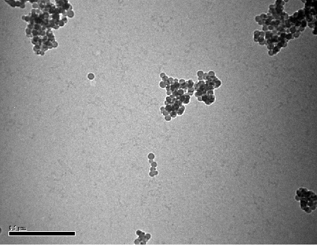
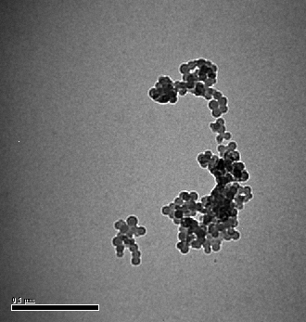
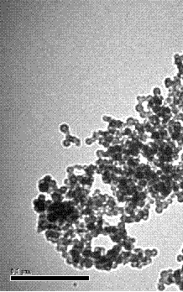

TEM images of PSNPs showing their size & shape
    - Scanning Electron Microscopy
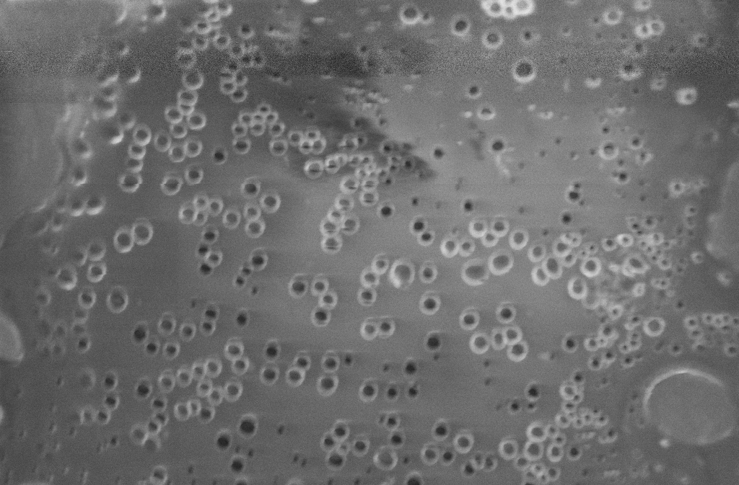
The scanning electron microscope (SEM) was used to image the sample surface by scanning with a high-energy beam of electron in a raster scan pattern. Hitachi S-5500 in-lens Field Emission SEM was used for imaging a specimen area about 60 nm wide with resolution up to 0.4 nm. The captured image showed the surface morphology of AT cut quartz crystal after immobilization of polystyrene nanoparticles. Almost homogenously distributed polymeric nanoparticle explores the possibility of attachment of large number of Ab with crystal surface for better attachment (Figure-3). The hypothesis of attachment of more Ab on nanomaterial immobilized surface seems to be in the right direction.

SEM image of polystyrene nanoparticles immobilization on gold surface
  - Development of Biosensor
The first step in development of a specific biosensor for IBDV was the crystal surface modification with PSNPs in order to create the free sites for the immobilization of IBDV antibody. A PSNPs thin film was developed on crystal by incubating the crystal for ~18 hrs in PSNPs suspension to get self assembled monolayer on the surface. The bare crystal has the average fundamental frequency of about 4996575.28 Hz. A base line was developed with 100 µl methanol. The average frequency at this stage was 4996040.55 Hz. A 100 µl methanol supension containing the PSNPs was the added to crystal. As some mass deposited on the quartz surface, the fundamental frequency decreased and acquire a minimum frequency of 4995957.01 Hz after a total decrease of 17.84 Hz in ~1 ½ h (figure-4). After that, crystal was placed for incubation.

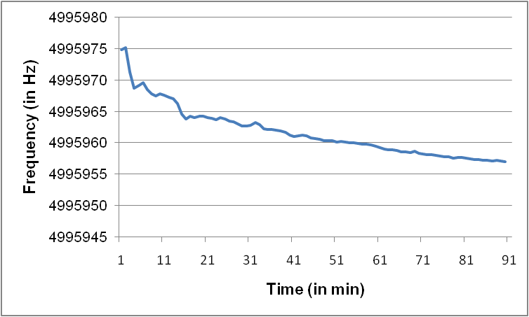
Immobilization of PSNPs on quartz crystal. Frequency shift accompanying the PSNPs immobilization in CH₃OH on bare crystal monitored by QCM
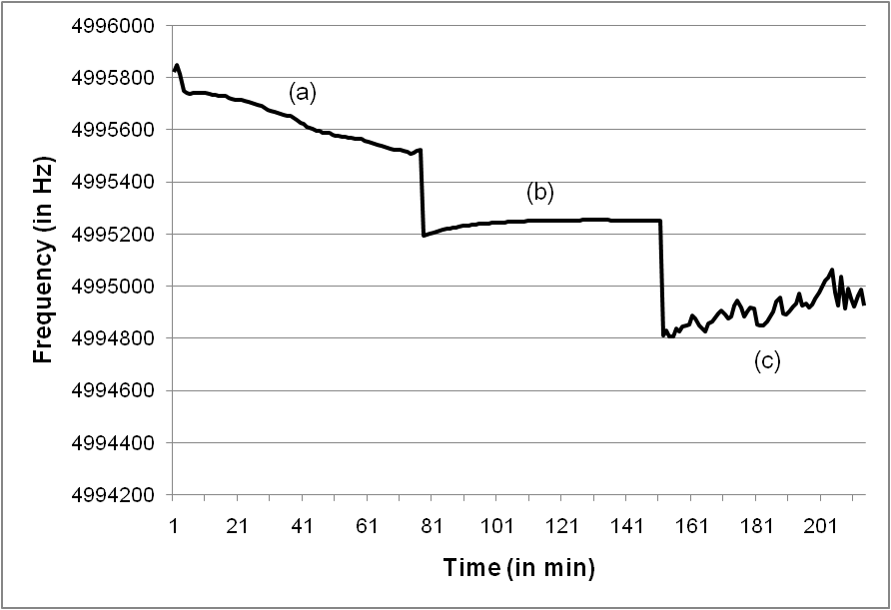
This modified quartz crystal was then exposed for the immobilization of IBDV antibody. The average frequency observed associated with this step was 4995636.871Hz. The free site was then blocked with 1% BSA solution in order to reduce the false and non-specific signals. This modified crystal then exposed to non-specific RK₂ antigen (Specific to Cd-Rhizobacteria) for checking the specificity of the developed biosensor. It was observed that there is no interaction in between antibody and RK₂ antigen even after a total expose of crystal for ~1 h. The average frequency monitored this time was 4995241.304Hz. Now this crystal was washed with PBS buffer in order to taken away RK₂ antigen from crystal. Finally, this modified crystal was exposed to corresponding IBDV antigen. The frequency changes associated with different steps was shown in figure 5.

Trend of frequency change associated with different steps monitored by QCM. (a) the upper portion of the graph shows the decrease in frequency during the immobilization of IBDV antibody. (b) middle part of the graph correspond to the specificity checking of biosensor with non-specific RK2 antigen (c) the lower portion of graph correspond to the interaction with specific IBDV antigen.
It was observed in our previous study that the frequency decreases as the crystal was exposed to specific antigen due the complex formation in between Ag-Ab. Instead of decrease in frequency, in this study we observed that the frequency gets increased as the interaction gets started. This is quite possible due to the detachment of some material from the surface. This process of detachment speeds up after ~15 min of the expose to IBDV antigen.

Effect of different dilution on biosensor development:
Effect of dilution on surface modification and consequent steps was also studied by developing the surface with 100 µl PSNPs solution from 20, 50 and 100 ml methanol PSNPs suspensions (Figure 6). It was observed that the pattern of the attachment is similar in each case except the amount of PSNPs attached to the surface. It is clear from the figure that as the dilution increases the attachment becomes fast and systematic as there is limited interaction between the particles.

Development of PSNPs surface using different concentrations in methanol
Table 1 is the summary of the frequency of the quartz crystal after each step of modification. The data from table 1 confirmed that a large quantity of PSNPs attached to the crystal surface in the case of 20 ml methanol suspension and the least in the case of 100 ml methanol suspension. It means the amount of PSNPs attached directly proportional to concentration.
Process | 20 ml | 50 ml | 100 ml
Bare crystal | 4996577.53 | 4996581.749 | 4996593.415
Methanol Base line | 4996047.833 | 4996052.325 | 4996031.195
PSNPs immobilization | 4992595.137 | 4994743.485 | 4995499.01
Antibody immobilization | 4992227.594 | 4994262.605 | 4995204.54
After detachment | 4994216.621 | 4995080.376 | 4996000.974

Table 1. Average frequency of crystal associated with different steps during biosensor development. This average frequency was calculated after the incubation followed by washing with solvent/buffer and air drying.
From the first step data, it was expected that the surface contains the larger amount of PSNPs will provide the maximum surface for immobilization during the exposure of the crystal to IBDV immobilization. But the observation was not as expected. Maximum antibodies were immobilized in the case of 50 ml methanol suspension. It means that this provide a smooth & larger surface area to antibodies. The minimum amount of antibody was immobilized in the case (iii) as was expected. The reason for the attachment of lesser amount of antibody in case (i) than case (ii) may be hazy deposition of PSNPs.
The crystal thus modified was exposed to specific IBDV antigen. As it was observed that some material started to detach from the surface led to increase in frequency. This process of detachment speeds up after ~15 min of the expose to IBDV antigen. After ~1h, the system seems to get saturate. The crystal was washed with PBS and the frequency of the system was noticed.
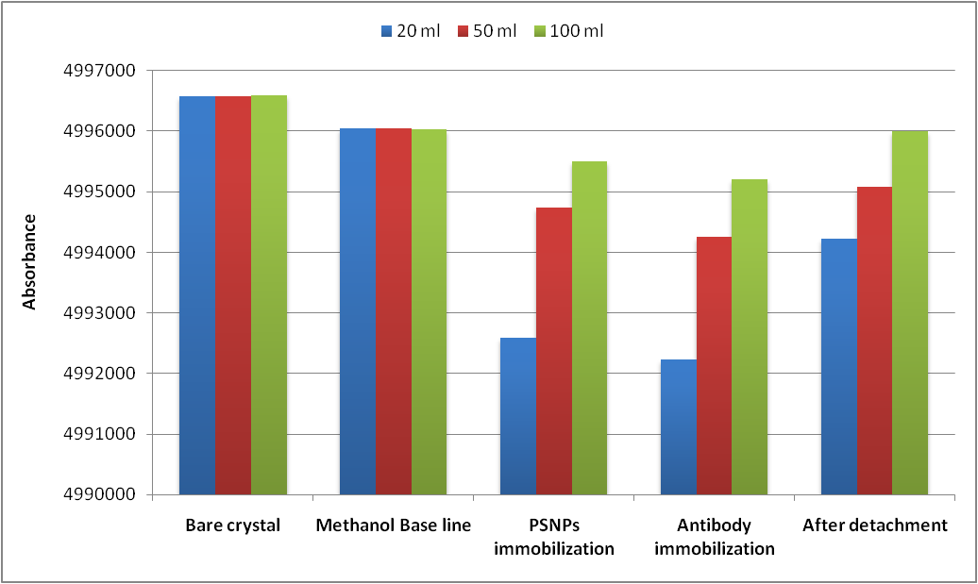
In the case of 100 ml methanol almost all the PSNPs immobilized on crystal get detached from the crystal surface during the antibody-antigen interaction leaving behind almost bare crystal. The system acquired a frequency of 4996000.974 Hz as compared to fundamental frequency of 4996593.415 Hz and quite below the base frequency of 4996031.195 Hz. Similarly, in the case of 50 ml methanol, a greater amount of material is removed from surface as compared to first one. The detachment of antibodies with polystyrene nanoparticles may due to the greater force exhort during the course of complex forming in between antibody and antigen. As there is no force that can hold the nanoparticles on surface due to this the antibodies can take them away to solution from crystal surface. Consequently, it can be concluded that antibody attachment to PSNPs modified surface more firmly than the attachment of PSNPs to the gold surface.

Graphical representation for the average frequencies associated with different steps monitored by QCM.
- Conclusion
Polymer nanoparticles are taking a remarkable place and almost replacing metallic nanoparticles in various applications in nanotechnology due to their low cost and easy synthesis process. Polystyrene nanoparticles can be used in drug and pharmaceutical industries, sensor technology, sputtering etc. Therefore, standardization of its synthesis along with desired nanosized can be of great importance. The micro – emulsion polymerization process was studied for the synthesis of PSNPs. The size of the prepared polystyrene nanoparticles was determined with the help of TEM and attached software. The TEM confirms that the nanoparticles are monodispersed and spherical in shape. The scanning electron microscope (SEM) was used to identify the surface morphology of polystyrene distributed on to the crystal surface. Our future study focus on the surface modification of PSNPs so that these can be firmly bound to crystal surface and the problem of detachment can be solved out.
- Acknowledgment
Authors acknowledge the receipt of grant provided by Uttarakhand State Council for Science and Technology (UCOST), Dehradun, Uttarakhand (India) for the research work.
- References:

[] K.K. Jain, Clin. Chim. Acta 358 (2005) 37.
[] V.V. Demidov, Exp. Rev. Mol. Diagn. 4 (2004) 267.
[] C.P.Y. Chan, W.S. Cheng, J.F.C. Glatz, D.V.D. Voort, J.E. Sanderson, A. Hempel, M. Lehmann, I. Renneberg, R. Rennerberg, Anal. Letter 36 (2003) 1987.
[] E.P. Diamandis, T.K. Christopoulos (eds.), Immunoassay (Academic, New York, 1996)
[] F. Darain, K.L. Gan, S.C. Tjin; Biomed Microdevices 11(2009) 653.
[] F. Darain, P. Yager, K.L. Gan, S.C. Tjin, Biosens. Bioelectr. 24 (2009) 1744.
[] J. Kaur, K.V. Singh, M. Raje, G.C. Varshney, C.R. Suri, Anal. Chim. Acta 506 (2004) 133.
[] P.L. Kuo, N.J. Turro, C.M. Tseng, M.S. El-Aasser, J.W. Vanderhoff, Macromolecules 20 (1987) 1216.
[] J. Jang, H. Ha, Langmuir 18 (2002) 5613.
[] W. Ming, F.N. Jones, S. Fu, Macromol. Chem. & Phys. 199 (1998) 1075.
[] X.J. Xu, C.H. Chew, K.S. Siow, M.K. Wong, L.M. Gan, Langmuir, 15 (1999) 8067.
[] C.H. Zhang, Q. Wang, H.S. Xia, G.H. Qiu, Eur. Poly. J. 38 (2002) 1769.
[] G. He, Q. Pan, Macromolecular Rapid Commun. 25(17) 1545.
[] B. Capek, A. Chitu, C. Janickova, B. Kostic, M. Luby, D. Satka, Chem. Papers 59 (2005) 41.
[] T. Ngai, C. Wu, Langmuir 21(2005) 8520.
[] S.K. Amir Hossain, Sarder N. Uddin, M.S. Rahman, A. Wadud, M.H. Khan, J. Biological Sci. 6 (2006) 146.
[] K.K. Kar, P. Paik, Indian patent No. 3161, November 25 (2005)
[] E.J.C. Kellar, C. Galiotis, E.H. Andrews, Macromolecules 29(10) (1996), 3515-3520.
[] Z. Li, J. Zhou, Z. Zhang, H. Dang, Chinese Journal of Chemistry 22(2004), 1133-1137.

