Fintech v/s Bank Lending in India: Threats & Opportunities

Gargi Sharma¹
Ph.D. Research Scholar
Management
TAPMI School of Business, Manipal University Jaipur,
Dehmi Kalan, Jaipur-Ajmer Expressway, Jaipur (Raj.) – 303007

sgargi@ymail.com

Dr. Umesh Solanki²
Associate Professor
Management
TAPMI School of Business, Manipal University Jaipur,
Dehmi Kalan, Jaipur-Ajmer Expressway, Jaipur (Raj.) - 303007

*philanthropist_umesh85@rediffmail.com
Abstract:
If a need or demand arises, new creation takes place…. Technology is the one of those. In today’s context every part of society is influenced by the technology. The first and foremost base of a country’s economy, that is financial sector, is not remained untouched worldwide with technology. Finance with technology together revolutionized the present scenario of world economy. In this voyage, the banking sector is passing through a new route where a new milestone called Fintech is putting ahead a path full of prickles. There are some threats to the financial service industry in the upcoming future because of this fintech exposure and hence, it must be the area to look upon. In this paper, Fintech’s effect on traditional banking is analyzed with special reference to lending activities of both. The kind of threat, the fintech services are imposing on traditional players is a prominent area of research in finance and this must be well taken care of. The kinds of opportunities opening for the financial services to tap those into the unbanked area are also opening the roads ahead for financial inclusion. With these objectives in mind, threats and opportunities for the banking sector and financial inclusion are analyzed. Some suggestions are made for the traditional players to consider improvising themselves and the impact of the same on financial inclusion is also touched upon.

Key Words:
Fintech, Fintech lending, Traditional lending, Financial inclusion
Introduction
“Fintech” is undoubtedly a product of financial nature blended with technology. Easy to access with finger touch on a screen has put the traditional banking way behind. The following graph is showing the continuously increasing size of fintech global market that will reach to $310 B till 2022.
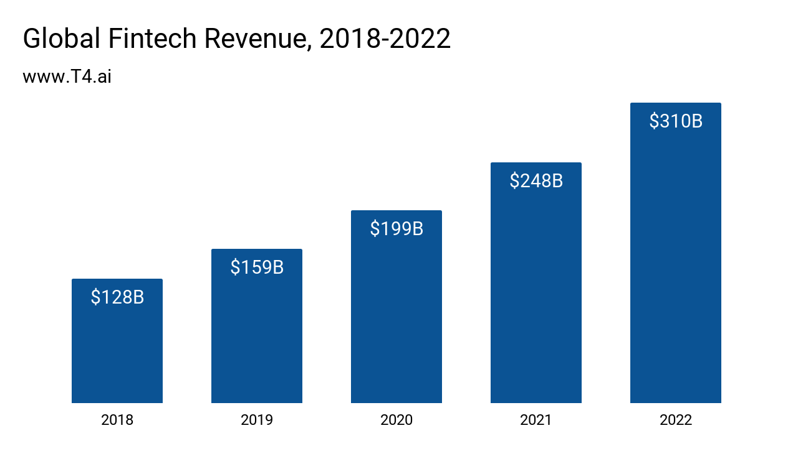
A NASSCOM report says that the fintech programming and administration advertising in India is increased 1.7 times in 2020 from $8 billion in 2016. The growth curve of fintech showed 300% of increase in Indian fintech sector by 2018.
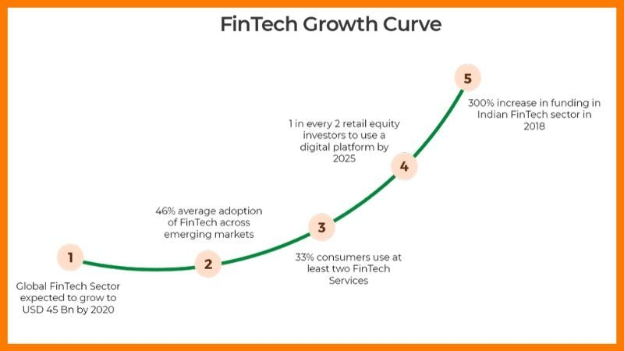
(SHRIVASTAVA, 2020)
Literature Review
The Fintech speedily spread through mobile technology, big data, predictive analytics, cloud infrastructure, self-learning algorithms, personalization, and the growing dominance of information and communication technologies (The world economic forum, 2015). Fintech has improved the productivity of mortgage lending (J.M. Fuster, 2019). The traditional players are having upper hand in trust and reach to customers’ data. Fintech strengths that they are faster service providers. The collaboration is the key to success. Financial inclusion can gain more pace due to new entrants with low-cost transactions. (Karagiannaki, Vergados, & and Fouskas, 2017).
Financial service providers that do not responded according to the changes in technology, struggles to enjoy long term sustainability (Prof. Dr. Jörg Gundel, 2019). Financial inclusion can be directly proportionate to the increasing access of these lenders, but the stability of economy will be at risk (Cornelli, 2020). Fintech is creating risk as well as opportunities for the economy. Risk for traditional banks can be handled through tie-up with tech-firms to develop the technical services, but this will hand over a big risk of data privacy (Giulio Cornelli, 2020).
Several online lenders and fintech companies have applied for an ILC but withdrew this year with the intention of resubmitting later (WITKOWSKI, 2018).
Objectives
- To study the fintech lending services in the financial sector.
- To study the lending services of banking sector.
- To compare the Fintech and Traditional banking lending activities.
- To analyze the risk imposed by Fintech on Public and Private banks.
- To Analyze Opportunities for Financial Inclusion.
Discussion
Fintech services are spread across the financial sector. Fintech services are basically categorized as under. The following classification shows the roots that fintech is strengthening.
Payments, Clearing & Settlement | Deposits, Lending & Capital Raising | Market Provisioning | Investment Management | Data Analytics & Risk Management
Mobile and web-based payments  Digital currencies Distributed ledger | Crowd-funding Peer to peer lending  Digital currencies Distributed Ledger | Smart contracts Cloud computing e-Aggregators | Robo advice Smart contracts e-Trading | Big data Artificial Intelligence & Robotics
(https://www.rbi.org.in/Scripts/PublicationReportDetails.aspx?UrlPage=&ID=892)
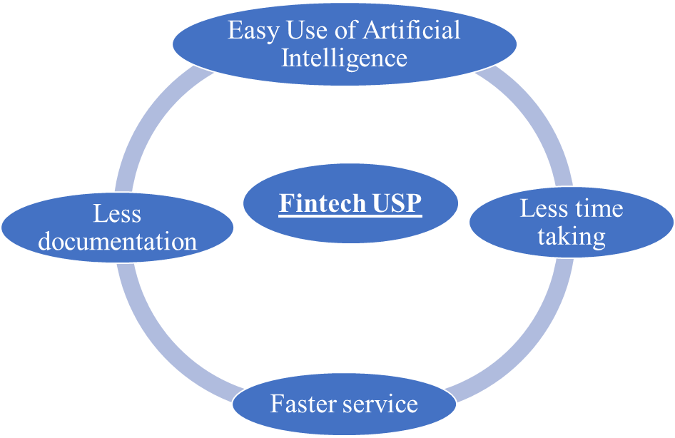
Fintech lending
Fintech lending is advanced in many aspects. Fintech brought digital lending concept and applied it firmly. As discussed, the USP of Fintech enables it to be the favourite take for the user. The following features of fintech prove its acceptability over traditional banking approach.
- Documents: These firms follow basic principle of less paper requirement approach and sometimes paperless also. The required documents are confined to the extent that it is easy to access.
- Tech Platform: All the formalities of the loan are processed on the technical platform wherein the report of credit worthiness to loan documents, bank statement and contract is also accomplished on the click basis.
- Verification: All types of verification and authentication is done using the databases.
- TAT: As these Fintech’s handles all the queries on real time basis the turnaround time of the proposal is always less.
- Simple Process: Fintech kept its applications easy so that anyone can find it less complicated.
In spite of huge success under opening accounts in PMJDY, JAM (Jan Dhan, Aadhar and Mobile) and adding the rural unbanked people to banking, still India has the second largest unbanked population in the world. Fintech players started capturing the untouched area of banking, the tired MSMEs from the rigid traditional banking process and smart urban customers for lending activities. According to BIS paper in 2019 the total global credit provided through fintech is USD 223 billion that is 28% of the total credit volume. (Cornelli, G, J Frost, L Gambacorta, R Rau, R Wardrop and T Ziegler (2020): ‘Fintech and BigTech credit: a new database’, BIS Working Papers, no 887, September)
According to a sample study by RBI, in India digital lending is at its primary stage in respect of banks. Banks offered ₹1.12 lakh crore via digital mode as comparative to ₹53.08 lakh crore via physical mode. As comparative to govt banks, private banks and NBFCs are claiming 55% and 30 % share in digital lending. Banks through digital mode offering SME and personal loans. BUY NOW AND PAY LATER (BPNL) is the kind of loans provided by private sector banks. Fintech created more competitive market for all the players of financial market. In this process, as technology is implemented at high level, the Fintech has evolved different models to cater different segments, has applied some models for different categories of customers.
Models in Queue:
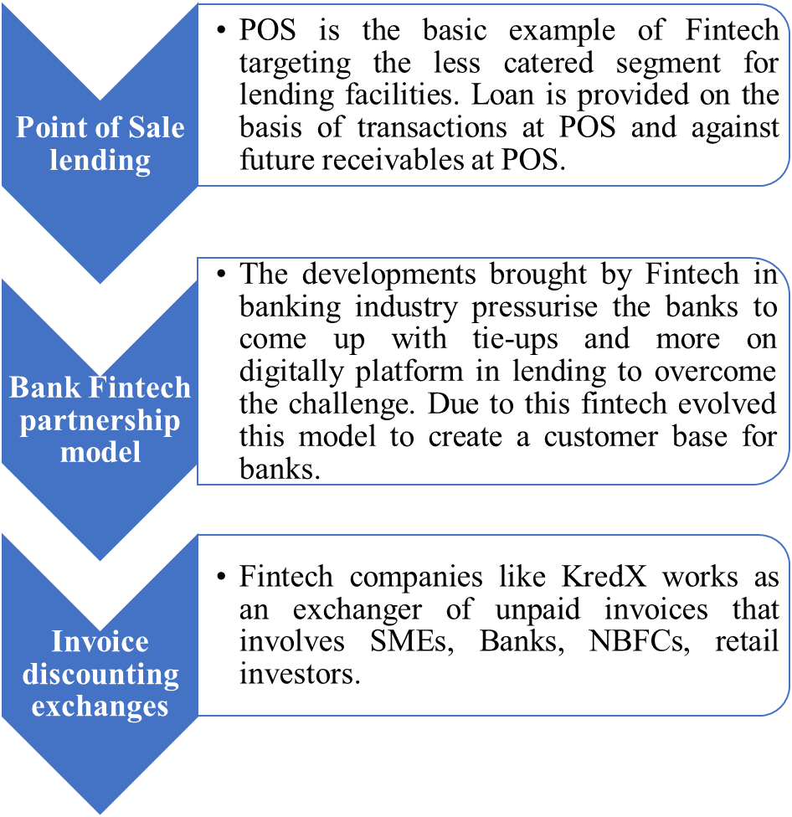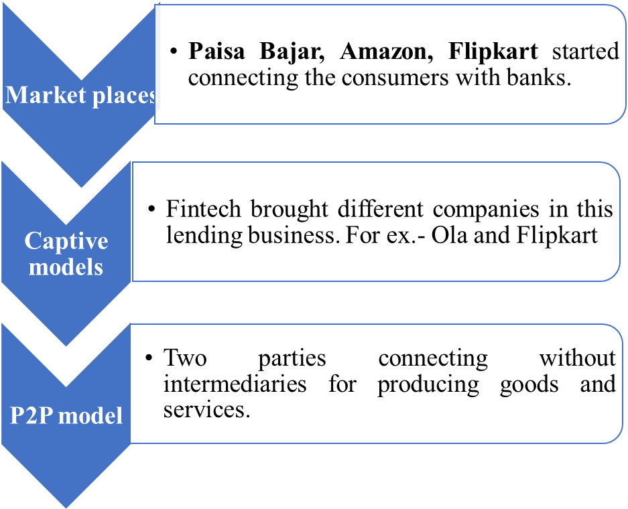
All these models are catering the need for every type of consumers in the lending space. Applying these models fintech is creating competition and pressure on traditional banking players to be more proactive.
Traditional Lending:
The basic process of lending that existed and still followed is the conventional lending by banks. All types of banks followed the same processes. Neither the customer nor the bankers can forget the cumbersome procedure followed. The process combines the following:
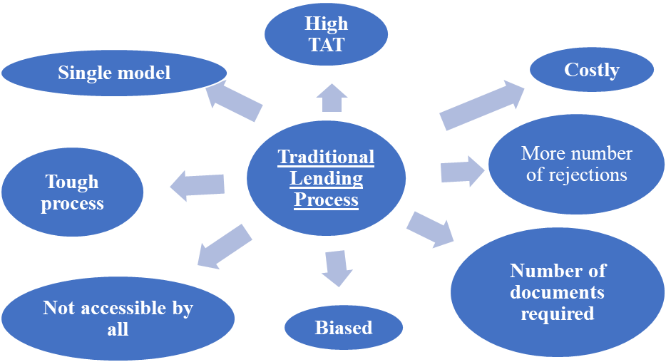
Bank USP
- Large Database
- Faith
- Regulated
- Network
Fintech opportunities
India is in the process of financial inclusion, wherein the financial literacy, to some extent, is reaching to layman but banking literacy is not even known to educated customer. These new developments in easy access to lending are attracting the basic level people to reach to the mainstream. This present situation of COVID 19 played an important role in the process. As per a Report, India achieved the adoption rate of 87% for fintech in 2020 and that was the highest among countries. The annual growth rate is predicted ≈ 24.56 % compounded annually as the Indian fintech market will be valuing ₹8.35 lakh crore by 2026 in comparison to ₹2.3 lakh crore in 2020. At the beginning stage of digitization conventional lending was followed by banks. The traditional banking loopholes are overcome by these fintech like time, cost, and outreach. But with that some risks are also imposed by these Fintech for the banking sector and economy as well. The Fintech is challenging the banking sector to the great extent. But gradually after the introduction of Fintech, banks also changed their ways to some extent. Some of the govt as well as private banks outsourced their lending platform through tie-ups and came up with some customized online loan products segment wise. Banks are initially offering particular lending facility like personal loans and SME loans. But fintech, as discussed is offering immense range of products.
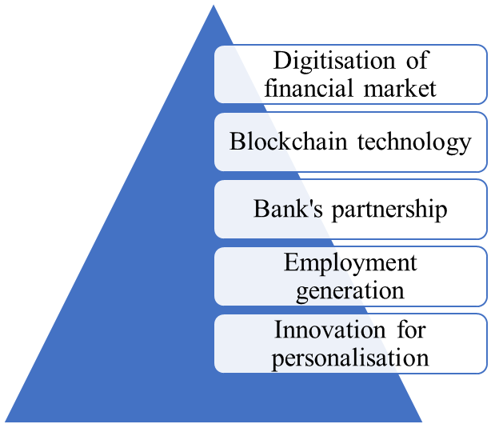
Fintech Threats
Technology is more risk prone area. On one hand fintech is creating immense opportunities and on the other hand it is proving threats to the economy. Major threats imposed by fintech are as below:
- Unregulated market: As technology evolves it brings complications for regulators as well. Cybercrime is the term associated already with the online banking. So, to have command on fintech worldwide and country wise rules and regulations are made and still in progress. As far as fintech is concerned, it’s having different-different arena services and is not comes under a single or two regulators, but Banks are much more compacted and regulated than fintech. In some of the cases fintech companies are using imperious ways of recovery that tends to suicides of many customers. Without regulations miss-selling of products and online crime can take place also.
In India every online transaction comes under the followings act and regulations: -
- Banking Regulation (BR) Act, 1949
- Reserve Bank of India (RBI) Act, 1934
- Companies Act, 2013
- State Money Lenders Acts
- Chit Funds Act, 1982
- Others: Some online and lending activity comes under State Finance Corporations, Regional Rural Banks, Life Insurance Corporation of India, and Credit Societies.
Due to its vast coverage of many types of services this is not enough to cover the whole fintech area. Globally also the rules and regulatory to deal with the digital lending is in continuously improving.
Like in one case to tackle the compliance issues reporting through regulated entities experimented in UK may be a path to look upon by Indian regulators. But in India it is in its starting phase, so threat is more.
- Economic Instability: According to Prof. William, the unregulated, less experience with no history providing the lending services, if any downfall or unforeseen situations occur it could affect economic or financial stability.
- Increasing Number of players: According to a report of venture capital, 2018 fintech market was worth $127.66 billion and annual growth expected till 2022 to $ 309.98. New entrants are increasing because of the growth prospectus of market. Due to scattered market, handling so many different entrants are a challenge to any country. Those many new players audit issues can take the situation to money laundering. To verify the fraud or genuine participant is also the area that is imposing big threat.
- Data Privacy: Fintech is totally techno depended as every part of it is technology oriented. So, it is vulnerable to internet and mobile app attacks. Data of so many persons is free flowing with many players without regulation can help the criminals and fraud person to misuse the same.
- Delinquencies: As per a RBI financial stability report 2021, delinquencies level increased to 4.56% in 2021 as compared to 1.82% in 2020 in loans sanctioned by fintech. As far as public sector banks are concerned it remained at 5.03%. This is also alarming for the regulators.
Conclusion
Fintech lending came with lots of risk and opportunities for the banks and economies. As discussed above, the risk could be to the extent that some of the enemies can use this as an indirect weapon. The leakage of data of countries financials is a major risk for the overall economy. When risk exists, a risk management tool should be implemented for the same. To develop the risk management practices, govt. should come up with some regulation of data privacy, working and a monitoring of the same. As far as banks are concerned, rather than going into tie-ups with tech firms (that too is developing as a market as below) should enhance their technical efficiency. Though RBI has been working upon this, but it will require time to get implemented.
References
- F. e. (2019). Role of Technology in Mortgage Lending
- Cornelli, G. J. (2020). "Fintech and Big Tech Credit: A New Database”
- Giulio Cornelli, J. F. (2020). Fintech and Big Tech Credit Markets around the World
- J.M. Fuster, R. B. (2019). Role of Technology in Mortgage Lending
- Karagiannaki, A., Vergados, G., & and Fouskas, K. (2017). "The Impact of Digital Transformation in the Financial Service Industry
- Gundel J., P. D. I. (2019). Digitalisation in Finacial Service Industry Fostering Innovation Through Fintechs and Services
- T. F. (2015). The world economic forum.
- Shrivastava, D. (2020). Fintech Industry in India | History, Growth, and Future of Fintech in India
- Witkowski, R. (2018). Nonbanks' Rapid Growth poses Risks to Industry: FDIC's McWilliams
- Magnuson, W. (2017). “The Next Crisis Will Start in Silicon Valley: Forget Wall Street. Worry about FinTech”
- https://www.rbi.org.in/Scripts/PublicationReportDetails.aspx?UrlPage=&ID=892

