IOT Enabled Smart Automobile Advanced Safety System for Passengers
A.Abdul Hayum¹ R.Karuppusamy² A.Vidhyasekar³ B.Paulchamy⁴
Assistant Professor, Department of Electronics and Communication Engineering^{1,2,3}
Professor and Head, Department of Electronics and Communication Engineering⁴
Hindusthan Institute of Technology, Coimbatore - 641 032, Tamil Nadu, India^{1, 2, 3, 4}
Corresponding author mail id: aabdulhayum@gmail.com

Abstract-This proposed system presents a real-time display by Smart Automobile Safety System for Passengers using IOT remotely monitoring the cleanliness status of restrooms. This is to allow for cleaners to be dispatched as needed, rather than at fixed intervals. The Auto hygiene monitoring system allows the building owner, FM and cleaning companies to monitor usage across multiple restrooms and use the data to plan resources ahead of time based on usage patterns. Thus the restrooms visit monitoring system is the efficient way to allocate resources for building owners, FM and cleaning industries. As soon as the mq145 detects, an extra cistern having phenol is flushed to remove the smell and maintain the freshness till the toilet is cleaned.
Keywords: - IoT Technology, Automobile, Real Time Application.

INTRODUCTION
With 1.35 billion people and a 39% sanitation coverage, India has the second-largest population in the world. In October 2014, the government unveiled a new program. Community sanitary complexes are suggested as part of this effort to eradicate open defecation in communities. The incidence of diseases that are frequently caught or spread through excrement or contaminated water will be decreased by hygienic practices. However, these restrooms frequently lack of cleanliness [1].
Even though there are things like smart urinal pots, using them on a wide scale is not very cost-effective [2]. Smart monitoring and control utilizing an IoT strategy, however, are expected to be considerably easier and cheaper to implement. H2, 30% of N H3, 14% of H2S, and organic solvent vapors are the main constituents of urine odor detection are just a few of the indicators for auto hygiene [3–4]. For the purpose of monitoring auto hygiene, odor might be employed as a signature [5–9]. A calibrated apparatus is used to measure these gases, and it is positioned vertically at a height of 1.2 meters [10]. Pumping the sample gases into the detecting unit at a 1.5L/min flow rate allows the concentration of these gases to be determined. The metal oxide gas sensor in the identification unit analyzes the concentration appropriately [3]. Since the requirements for personal cleanliness vary from community to community, gas sensors cannot be calibrated universally.
We suggest a technique to detect the presence of hydrogen sulfide and ammonia traces in restroom complexes and provide this information to the network. A mobile app was created to allow users to rate how clean the restroom facilities are. This method was created to map user response to the concentration ranges for ammonia as well as hydrogen sulfide using sensor information along with user feedback. Each installation of a gas sensor requires calibration against these parameters because, in traditional design, measurements from gas sensors rely on their sensitivity, site of installation, and supported kind of ventilation. Additionally, considering vehicle hygiene standards differ from community to community, using an auto hygiene scale that is benchmarked to pertinent community norms may be useful. As a result, we categorize and correlate the user ratings of the sensor data to create a model of device auto-calibration. In the m2x platform, these metrics are shown graphically and sent to the cloud as well.
PROJECT OBJECTIVE
In this paper to maintain the proper auto hygiene sanitation in toilets. The toilet is monitored automatically and also provides with good hygienic conditions. It prevents excessive use of water and it also improves the productivity of cleaning companies. Furthermore, this idea serves as a foundation for an "Indian zone that is properly clean, sanitary, and disease-free."

Fig.1 Global Impact

LITERATURE REVIEW
K.Elavarasi et.al has proposed developing smart toilets using IoT. This paper examines one proposed solution to monitor the toilet and also deals with the IoT using image processing in a public toilet.
Using water in place of toilet paper is indeed more hygienic, clean and environmentally friendly. Every single public restroom needs to be hygienic and clean. As he introduced the initiative known as Swachh Bharat Mission at Rajpath in New Delhi, Shri Narendra Modi, the Prime Minister, stated that a clean India would be the best tribute, India could give to the memory of Mahatma Gandhi on his 150th birthday in 2019. On October 2, 2014, the whole nation was exposed to the Swachh Bharat Mission, which is a nationwide initiative. The initiative wants to achieve its objective of establishing a "Clean India" by October 2nd, 2019. One of the goals of the Clean India initiative is to maintain clean restrooms. This program may play a significant role in the clean India initiative in the future [2]. They are primarily concerned with recognizing the dirt in the toilets under the current system. A significant part of the envisaged facilitation mechanism would be played by Invest India. Smart toilets are something we can create ourselves.
Task 1: The filth in the restroom is found using an IR sensor in the initial stage. Here, a collection of sample photos is provided as input. The sensor detects the toilet basin after someone uses it. The sensed information is then related to the input image. The alert is raised if dirt is present. The person using the device then wishes to pick up the trash.
Task 2: The Figaro sensor is employed in the subsequent stage to detect the unwelcome gases found inside the bathroom. A specific range must be stable early in the Figaro sensor. It has the ability to warn that the sweeper if the range is increased. They then used the appropriate fragrance to disinfect it.
Task 3: The actions of the cleaners are monitored in the next step using an RFID reader (Radio Frequency Identification). The cleaner initially wishes to display his or her identity badge facing the direction of the RFID reader. The bathroom can be exhibited prior to as well as following cleaning.
EXISTING SYSTEM
One of the emerging technologies for the means of communication between various devices is through cloud. This is not implemented in the existing system. There was a research study run to determine the first threshold value. After an entire week of data collection, participants were asked to submit comments. These comments are initially processed and captured. The calibrations and calculations of data are represented by OBS (Odour Banding Spectrum) differ when the same group of users are at various locations.
Disadvantages:
They are not focused on uploading the data on cloud for data analysis. There is a chance for the failure of LCD, which is the major role of that project.

WORKING PRINCIPLE
The node created using MQ135 Sensor and the ESB8266 integrated inside a bulb will read the values from toilet. This node will send the values to the master controller cc3200 using Wi-Fi server and Client communication. The cc3200 will process the data from the connected client and upload the values to the M2X cloud. And also shows the Auto hygiene level of toilet using LCD. The Nexmo and Twilio cloud services will make calls to the cleaning people whenever the value exceeds the cutoff point. The feedback button provided in cc3200, So that the user can notify if the cleaning is not done at the correct time. The RFID is used to scan the cards of the workers who are cleaning the toilets at what time of the day. The gyro sensor is used for theft protection and xyz axis of the node is noted. The Current In order to assess how much current is consumed and how fast the water is flowing through a motor, a sensor is utilized. The sensor that measures the water level and will display the amount of water in the water reservoirs as well as the flow of water via the toilet's faucets and pipes.
DESIGN OF THE PROPOSED SYSTEM

SYSTEM DESIGN

Fig.2: Block diagram of Master

Fig.3: Block diagram of Node

A. Sensor Node
Micro-controllers, gyroscopes, current sensors, water flow sensors, and MQ135 ammonia sensors are all included in the sensor node. According to research, strange gases are produced in public restrooms, and hydrogen can be provided by these gases [11].
Municipality Hazardous Waste's main component is ammonia [12–13]. Continuously detecting the surroundings in terms of ammonia levels in PPM is the role of the microcontroller.
Fig.4 Sensor Node
B. Android Application
Application development for Android can be broadly categorized into two groups: client side and feedback side.
Feedback Application: The Feedback Side program will concentrate mostly on feedback and the sensor's result at that timestamp. The device needs to be Bluetooth-connected in order to access the sensor's information. The mean value related to the sensors and ratings is going to be modified using the data received from the device and recorded in the system's database. Device ID helps to determine every user in order to conceal their personal data. Without the involvement of the client application, a flag is going to be set if the mean value of any critical falls below a threshold.
Client Application: Cleaner and admin are the two divisions of Client Side. Based on user comments, administrators can utilize it to keep an eye on the situation at any bathroom. It will give the ability to choose whether to send cleaners to a specific place. Every time one of these choices is made, the cleaner is notified.
Fig.5 Client Application

B. Cloud Server
Data Server and Auto-Calibration Module are the two subcategories of Cloud Server.
1) Data Server: Significant information that is essential to the operation of the system as a whole is kept in databases. We use the firebase database that is constantly updated to manage the information, and the firebase authentication engine that handles authorization.
2) Auto-Calibration Module: We are putting out a prototype for calibrating our sensor regardless of the sensor's requirements in an effort to do away with the need to perform calibration on every deployment. This auto-calibration tool determines the adjusted OBS limit for each class based on the evaluation and PPM value of ammonia provided by the user.
Fig.6 Specifications

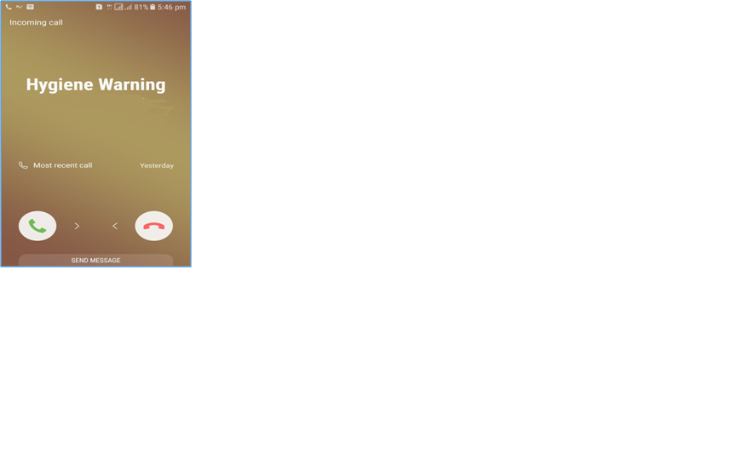
EXPERIMENT ANDRESULTS

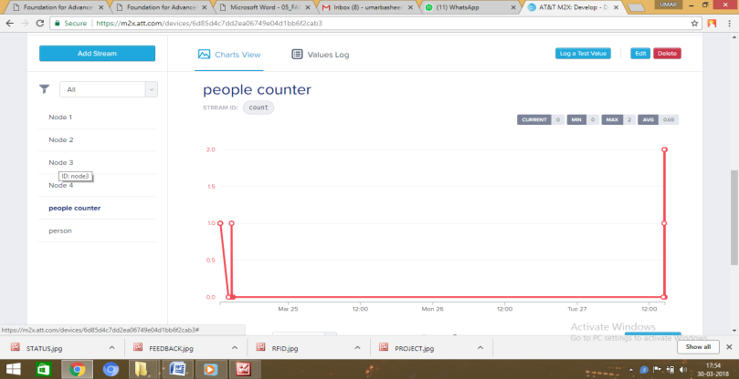

Fig. 7 Simulation Results

CONCLUSION
In this paper we conclude to provide a automation sanitation monitoring system for toilets to provide the clean society and better environment and support the Swachh Bharat Moment.

REFERENCES

- Shubham Chandra, Sanjay Srivastava, “Anil Roy Public Toilet Hygiene Monitoring and Reporting System”, IEEE, 10.1109/ICSENS.2018.8589894, 2018.
- Elavarasi K, Suganthi V, Jayachitra J, Developing “Smart Toilets Using IOT, International Journal of Pure and Applied Mathematics”, 2018.
- Anthony Fleury, Michel Vacher, Norbert Noury, “SVM-Based Multimodal Classification Of Activities Daily Living in Health Smart Homes: Algorithms and First Experimental Results, IEEE Transactions on Information Technology in Biomedicine”Volume: 14, Issue: 2, March 2010
- Chanda Rajurkar, S. Prabaharan, S. Muthulakshmi, “IoT Based Water Management”, DOI:10.1109/ICNETS2.2017.8067943, 2017.
- Masaya Kurahashi, Kazuya Murao, Tsutomu Terada, Masahiko Tsukamoto, “Personal Identification System Based on Rotation of Toilet Paper Rolls”, DOI: 10.1109/PERCOMW.2017.7917617, 2017.
- Ravi Kishore Kodali, Siva Ramakrishna P Modern “Sanitation Technologies for Smart Cities”, DOI: 10.1109/R10-HTC.2017.8289055, 2017.
- Ji-Jer Huang, Sheng-I Yu, Hao-Yi Syu, “Development of the smart toilet equipment with measurements of physiological parameters”, DOI: 10.1109/UIC-ATC.2012.143, 2012.
- Mei Chen, Linghan Zhu, The Application of “Intelligent Control Algorithm in Sanitation Monitoring System”, DOI: 10.1109/ICRAE.2017.8291391, 2017.
- Ade Asmi; Jouvan Chandra Pratama Putra; Ismail Bin Abdul Rahman, “A Study of Indoor Air Quality of Public Toilet in University’s Building”, DOI: 10.1109/CHUSER.2012.6504347, 2012.
- Phuntsho Choden, Thara Seesaard, Ugyen Dorji, Chutintorn Sriphrapradang, Teerakiat Kerdcharoen, ”Urine Odor Detection by Electronic Nose for Smart Toilet Application”, DOI: 10.1109/ECTICon.2017.8096205, 2017.
- Ummer Iqbal, M. Dar, Syed Nisar Bukhari, “Intelligent Hospitals based on IOT”, DOI:10.1109/AEEICB.2018.8480947, 2018.
- W. Sherine Mary S. Muthukumar A. Manisha; K. Nandhini; R. Vanitha, “Sensor based automated washroom monitoring system”, DOI: 10.1109/ICEDSS.2018.8544266, 2018.
- Klaiwad Boonyakan; Naratsaporn Heamra; Attawit Changkamanon, “Water Efficient Toilet : Setting a Suitable Automatic Flushing Duration”, DOI: 10.1109/ICDAMT.2018.8376512, 2018.
- S. Vinoth Kumar; T. Senthil Kumaran; A. Krishna Kumar; Mahantesh Mathapati, “Smart Garbage Monitoring and Clearance System using Internet of Things”, DOI: 10.1109/ICSTM.2017.8089148, 2017.

