Predicting Cryptocurrency Trends with AI and ML: Enhancing Accuracy through LSTM and RNN on the Blockchain
Dr. Jasmine Sabeena, Associate Professor, Department of CSE, SVCE, , Tirupati, India.
S. Latha Rani, Assistant Professor, Department of CSE, SVCE, , Tirupati, India.
Abstract:
Computerized or virtual money known as "cryptographic money" makes use of strict encryption techniques to validate transactions and regulate the generation the units. The trend of cryptocurrency is on a constant rise in today's world. It has become a significant topic in the financial sector, and making accurate predictions is crucial to gain profits. To achieve this, deep analysis of the dataset has been done to comprehend market conduct using an assortment of AI techniques. Cryptocurrencies rely on a decentralized network of computers to keep track of transactions and to prevent fraud, making them a potentially more secure and transparent form of currency. The market capitalization of cryptocurrencies increased at an exponential growth. This paper discusses the use of LSTM and RNN models for time-series data prediction, with a focus on their application to cryptocurrency trend forecasting. During the training process, the model's loss or error is calculated and minimized by adjusting the model's weights. Typically, a plot of the loss against the model's performance is tracked by counting the training epochs or iterations. While a steady or growing trend may point to overfitting or underfitting problems, a decreasing trend in the loss shows that the model's performance is improving. To evaluate the success of the model, additional performance measures like accuracy and F1 score can also be shown.. It's important to note that training graphs can vary based on the dataset, model architecture, and hyperparameters used. Therefore, careful monitoring of the training process and adjustments to the model may be necessary to achieve optimal performance.
Introduction:
A cryptocurrency [23is a form of virtual currency that serves as a careful means of trade and resource movement. These are very quite similar to real-world currency yet they have no actual epitome. Forecasting of prices in the case of cryptocurrency remained as a provoking situation for some specialists because of its dynamic nature. Decentralized advanced digital assets, currencies, and tokens stand out from scholastics and specialists in virtually every academic discipline. In basically all monetary exchanges these days, digital currencies [27] are deep rooted and broadly acknowledged as an elective type of trade; In this regard, it is generally regarded as an optional method of exchanging and paying for money. Even though these virtual currencies couldn't replace conventional currencies, they can still occupy 25% of national currencies by the year 2030 it suggests that a significant portion of the globe would start to value cryptographic money as a medium of exchange or trading mechanism. It will be progressively recognized by merchants and clients. These digital currencies' popularity is due to their innovative qualities, including as simplicity, ease of use, and growing global recognition. They are typically used for cross-planetary business venture transfers. Decentralized, or operating without the control of a central bank, is how cryptographic money operates. This means it is free from governmental or institutional control. The prediction of the cryptocurrency values has great depth in terms of research. The fundamental detriment that various experts face is that it can work capably just in unambiguous conditions where the expense change in any cryptocurrency[28] is essentially a direct result of the evident costs that people get used to see before exchanging their crypto. On April 19, 2019, the virtual cash market esteem is near 90 billion dollars The virtual money market value was close to 90 billion dollars on April 19, 2019, however, it changes occasionally. Bitcoin [35], Ether [36], Litecoin[37], and Monero[38] are some of the popular cryptocurrencies. Bitcoin (BTC) was first used in 2008 and turned into an open-source project in 2009 by a man by the name of Satoshi Nakamoto; at this time, it became notably well-known in 2017. In terms of market capitalization, clientele, and notoriety, Bitcoin continues to stand out among cryptographic forms of money [29]. The market capitalisation of bitcoin can be accessed at any moment through an open door. Over 71 billion dollars have been made continuously available to the public.Other virtual currencies, for example, Ethereum[39] are assisting to create decentralized financial (DeFi) system frameworks. The absolute first option as opposed to bitcoin in our rundown, The goal of Ethereum (ETH) is to create a decentralized system of financial services that anybody on Earth can access without restriction based on identity, ethnicity, or confirmation. In 2014, Ethereum launched a presale for ether, which received a staggering reaction because of the explanation that it will in general be used to group, decentralize, secure, trade, and exchange. Litecoin (LTC), launched in 2011, relies on an open-source global payment network that isn't controlled by a central authority and employs scrypt as a PoW that can be cracked with consumer-grade computer processors. Litecoin is the 21st-largest digital currency in the world as of Walk 14, 2022, with a market valuation of $7.4 billion and a symbolic value of about $106. Buying and selling result in a change in the price of any cryptocurrency [30] because of its volatile nature. This study mainly concentrate mostly focuses on estimating the cost of a cryptocurrency by taking into consideration all the trading features like price, volume, open, close, low, and high values present in a real-time data set. This study shows a significant impact by helping investors and traders to identify cryptocurrency sales and purchasing, even under adverse market conditions. This paper suggests the technique of utilizing Recurrent Neural Networks [31] (RNN) algorithms like LSTM and GRU[13] along with Bi-LSTM[21]. In this study, the researchers assert that the proposed models are anticipated to yield superior predictions compared to other models is calculated by the Root Mean Square Error (RMSE) and Mean Outright Rate Error (MAPE) measures. The accuracy of the model's viability is often evaluated using these measurements.

Related Work:
Many explore have been done on the prediction of digital currencies using deep learning and AI algorithms. Our literature survey mainly focuses on the work done on bitcoin[35] (BTC), Litecoin[37] (LTC), Additionally, Ethereum[39] (ETH) price predictions are made using a variety of techniques, the necessity for and evaluation of repeated brain organization (RNN) and its support architecture. Tian et al.'s [1] focus was on the fluctuations in bitcoin prices caused by its trade-like execution orders. Numerous analysts have been attracted in recent years by variations in the cost of cryptographic currency. This investigation focused on relapse mechanisms and developed a time series model that also used the Gaussian time model to predict the values of digital money. Nevertheless, they showed that their model works well with time series data. Anshul et.al [2] used the LSTM model for forecasting the bitcoin price. LSTM allows training of the bitcoin prices as time series data efficiently and effectivelyThat is what their analysis showed, and even though the LSTM model requires more time to set up than the current ARIMA model, it appears to be more accurate overall. Lahmiri and others [3], applied RNN (Recurrent Neural Network) along with GRNN (Generalized Regression Neural Network) to obtain a higher rate of prediction of cryptocurrencies such as BTC, ripple, and digital cash. Here, predicting the extent of the daily cost of highly accessible digital currencies will be a key goal of using AI and deep learning models. The future stock cost expectation using the LSTM AI computation was introduced by Nivethitha et al. [4]. This focus was mostly on time series expectation in relation to the main objective and other financial forecasting models. When compared to the present ARIMA model, LSTM calculations produce useful and accurate results. Derbentsev et al. [5] used a few sophisticated expectation models to focus on the transient aspects of the three most popular cryptographic forms of money, namely Bitcoin, Ethereum. Performance is evaluated for an Artificial Neural Network (ANN), a Random Forest (RF), and a Binary Auto-Regressive Tree (BART) model. Madan et al. [6] attempted to use machine learning to predict the price of bitcoin and examined cases of BTC incorporation. They predicted the daily variance in a cryptocurrency's price using 25 variables associated with bitcoin.[7] developed a mixed digital currency expectation method that primarily focuses on the digital currencies Litecoin and Monero. The suggested model is based on RNN engineering, which employs layers of LSTM and GRU [14]. They used Monero data from 30 January 2015 to 23 February 2020 and standard Litecoin data from 24 August 2016 to 23 February 2020 to determine the average cost, open cost, closing worth, high and low costs, and the number of exchanges. The point-by-point testing demonstrated that the suggested crossbreed model outperformed regular LSTM networks, which had shown some encouraging results. The LSTM model is employed in [8] to anticipate and track down methods for examining Bitcoin on the exchange trade through Yahoo Finance that might foresee a delayed effect of more than 12,600 USD in the days after projection. Researchers have concentrated on more inventive models as a result of the significance of the development of an active and dependable technique for anticipating advanced monetary expenses. They compile [9] evaluations of the employment of neural networks (NN), support vector machines (SVM), and random forests (RF) in brain structure. The findings demonstrate that NN outperforms other models and that AI and opinion research may be used to predict digital currency markets, with Twitter data alone having the ability to predict specific currencies.
Proposed Model:
The suggested method suggests two different expectation models based on profound learning [33] for calculating the daily value of the digital currency [25]. In applying both the models for the cryptographic money forecast, we can figure out which model best suits the expectation given by estimating the exhibition of models. As Cryptocurrencies [26] are volatile in nature, the volatility issues in price should be handled within a short period of time. The suggested approach utilizes Recurrent Neural Networks (RNN)[32] for prediction and price forecasting, namely Long Short Term Memory (LSTM)[18] and Gated Recurrent Unit (GRU)[16]. The process of prediction starts from the collection of data set till the forecasting of price. This involves six major modules such as data set collection, data set visualization, data splitting for training, testing and validation, building the model training the model using LSTM[19] and RNN, and finally for price forecasts. The models should show amazing predictions relying upon the Mean Absolute Percentage Error (MAPE) as these models are the most recent and productive methods for estimating the digital currency cost.
RNN:
RNN is a powerful deep neural network that remembers its contribution due to internal memory, thereby reducing the complexity of parameters and remembering each previous result by contributing each result to the upcoming hidden layer, making it best suited for machine learning problems that involve sequential data. Although RNN excels at handling sequence or time-series data, it has a difficulty with long-term dependent data that results in discontinuity. When predictions were made on one or more hundred dates, the number of predictions that came close to being accurate was as shown in the table1. According to table1, 84 of the RNN model's predictions were within 90% to 100% of the true value [10]. It is a formula that has been used in the backdrop of several incredible deep learning achievements in recent years.

LSTM:

Recurrent neural networks of the Long Short-Term Memory (LSTM)[20] type are capable of learning demand dependency in sequence estimation problems. They always act in a way that allows them to recall information for long periods of time. Long Short-Term Memory (LSTM) can handle a variety of tasks that were unsuitable for Recurrent Neural Networks (RNNs) in the past.Subsequently, This problem has no effect on "Long Momentary Memory" (LSTM), another paradigm. By applying a stable error course using "consistent mistake carrousels" (CECs) inside unique units, referred to as cells, LSTM may determine an acceptable approach for partner irrelevant delays across 1000 discrete timesteps [11]. the extent of applicable information that standard RNNs can will is before long exceptionally confined. The issue is that the effect of the given contribution on the secret layer, and accordingly on the organization yield, either rots or explodes dramatically as it cycles around the organization's intermittent associations. This weakness is alluded to in the writing as the disappearing angle issue. Long Momentary Memory (LSTM) is a RNN engineering explicitly intended to address the disappearing slope problem[12].

GRU:

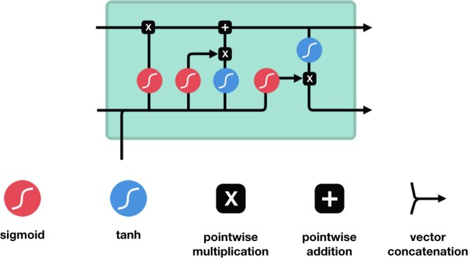

Fig 1: LSTM Architecture
For a particular repeating brain network model that aims to employ relationship through plan of center points to execute AI tasks related to memory and gathering, a gated intermittent unit (GRU) is essential. GRU destroyed the cell state and sent data using the secret state. GRU consolidates the two- entryway working systems called Update gate and Reset gate. GRU is utilized when you have less memory utilization and need quick result helps in making the dataset more suitable for machine learning problems .
Update Gate:
The update gate is in charge of determining how much historical data is necessary to transmit to the subsequent stage. The forget and input gates of an LSTM behave very similarly to the update gate. It chooses what data to discard and what fresh data to include.

Reset Gate:
The reset door is employed in the model to close whether or not the previous cell state was enormous and to complete how much the previous information is meant to be ignored.

Data Set Preparation:
The act of gathering, integrating, structuring, and organizing data so that it may be examined as part of data visualization, analytics, and machine learning applications is known as data preparation. A series of steps called "data preparation"
In a larger sense, selecting the appropriate data gathering method is part of the data set preparation process.

The following algorithm may be used to divide a data collection into training and testing sets.
Algorithm1: Splitting dataset into training and testing sets
Input: Data

Output: X_train, y_train, X_test, y_test

- Define a function split_data(data) that takes the input data and returns two lists X and y.
- Initialize empty lists X and y.

- For each element in the range from 0 to the length of data with a step size of 3, do the following: a. Check if the next 3 elements are within the range of data. b. If yes, then append the first 2 elements of the range to the X list and the third element to the y list.
4.Return the X and y lists
5. Using the train dataset, use the split_data function, and then assign X_train and y_train the values that were returned.
6. Call the split_data capability with the test dataset and out the returned values to X_test and y_test.

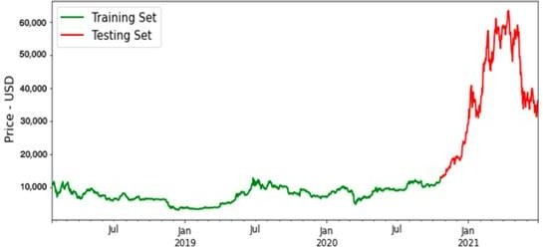

Fig 2. Training and testing dataset for BTC
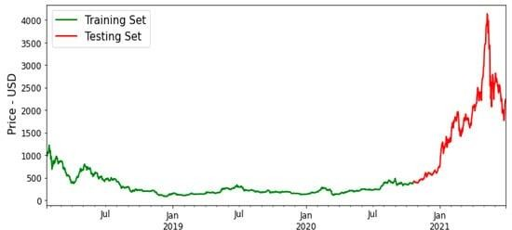

Fig 3. Training and testing dataset for ETH
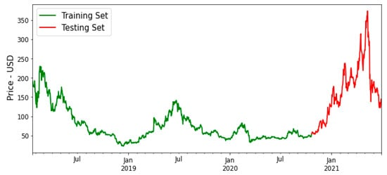
Fig4. Training and testing dataset for LTC

Table 1. Comparison of the length of time needed to compile both Deep Learning models:
Model | Compilation Time | Epoch count
LSTM | 53 | 100
GRU | 5 | 100

The dataset used for this research consists of daily price values collected from the Kaggle website https://www.kaggle.com.The overall data assortment period is from January 1, 2014 till February 20, 2018. In this dataset, there are seven limits including opening cost, extravagant cost, low cost, and closing expenses, and also the market cap of public noteworthy offerings.
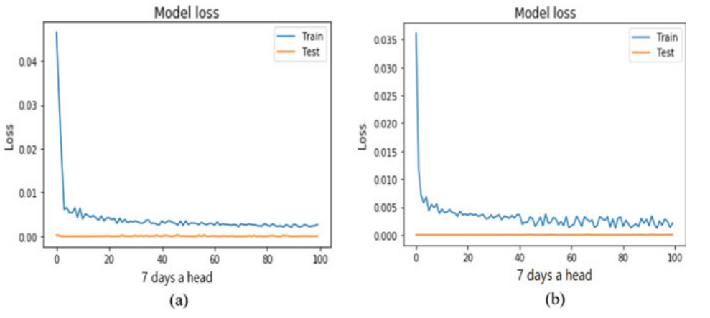
Fig 5 i. MSE graph obtained using LSTM model ii. MSE graph obtained using GRU model
The RMSE esteem acquired for 7 days ahead the data is plotted and displayed from both models in the above figure, and it is plainly seen that GRU is converging quicker and consistent than the LSTM model. It is discovered that the variation between the actual price and In LSTM, more money is expected to be spent than in GRU.
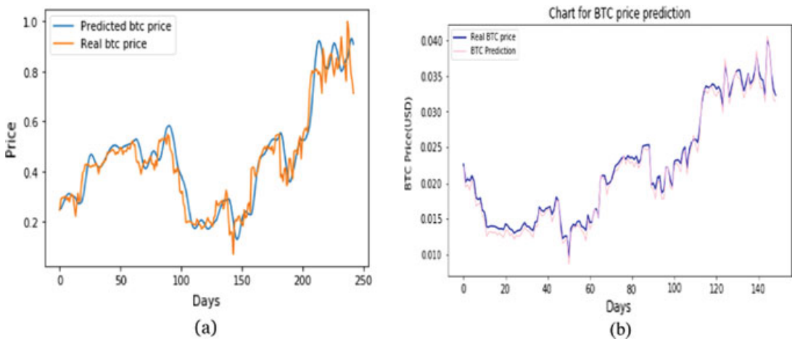
Fig 6 : Correlation between actual and predicted bitcoin prices while the LSTM and GRU are being prepared (a)
With regard to well-known cryptographic currencies like Bitcoin (BTC), Litecoin (LTC), and Ethereum (ETH), LSTM and GRU models were created. Finding the root mean square error (RMSE) and mean outright rate error (MAPE), two measures of precision, are used to compare the suggested LSTM and the GRU model's accuracy. The resulting Table 1 showed that the LSTM model required more investment than the GRU model.

Performance Measures:

One of the most popular methods for comparing time series models is by estimating the exhibitions for short and long term expectations. We have used MAPE (Mean Outright Rate Error) and RMSE (Root Mean Square Error) as a presentation metric to validate the show of these two models. Table 2 lists the errors calculated using the LSTM and GRU models.

Table 2 shows the results of RMSE and MAPE calculations using the LSTM and GRU models
Window size | Number of days ahead | LSTM |  | GRU
 |  | RMSE | MAPE | RMSE | MAPE
1 | 1 | 0.092 | 0.068 | 0.075 | 0.065
5 | 3 | 0.079 | 0.057 | 0.065 | 0.046
7 | 5 | 0.081 | 0.060 | 0.087 | 0.062
12 | 7 | 0.045 | 0.030 | 0.051 | 0.035
15 | 15 | 0.067 | 0.048 | 0.067 | 0.058

.
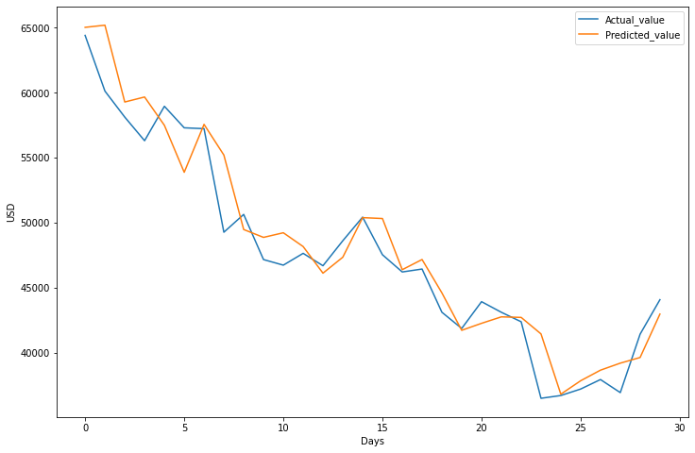
Fig 7. Actual and Predicted values for BTC using LSTM and GRU models
The GRU-based expectation model is still used in this evaluation to measure time-series data that is often excessive. cost uncertainty. When the window size is 12 and the days preceding 7 are included, the LSTM's exactness accuracy is superior. However, in the remaining window widths and days to come, the GRU model is more capable than LSTM models, and the relationship between the actual and expected bitcoin price obtained.
Algorithm for displaying the plotted graph containing the actual and predicted values of specific cryptocurrency
Algorithm2: Plotting the predicted and actual values of cryptocurrency prices
  - Input: sub_df, y_test, y_pred, scaler

  - Convert the 'Date' column of sub_df to a datetime format using pd.to_datetime().
  - Group the 'Closing Price (USD)' column of sub_df by month using sub_df.groupby() and store the mean values in a new dataframe.
  - Use plt.figure(figsize=(12,8)) to create a figure with dimensions of 12 x 8
  - Use plt.xlabel() to change the X-axis label to "Days."
  - Use plt.ylabel() to change the Y-axis label to "USD."

  - Plot the actual cryptocurrency prices using plt.plot() with the 'y_test' variable as input, and label it as 'Actual_value'.
  - Plot the predicted cryptocurrency prices using plt.plot() with the 'y_pred' variable as input, and label it as 'Predicted_value'.
  - Invert the scaling of the 'y_test' and 'y_pred' variables using scaler.inverse_transform().
  - Add a legend to the plot using plt.legend().
  - Show the plot using plt.show().

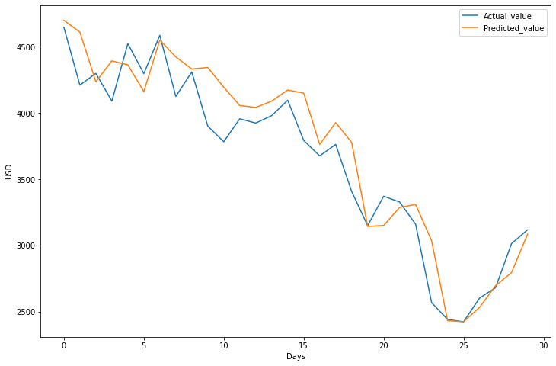
Fig 8. Actual and Predicted values for ETH using LSTM and GRU models
Algorithm for calculating the accuracy of GRU model can be described as below:
Algorithm 3: Building and assessing a GRU model for predicting bitcoin prices
X_train, Y_train, X_test, Y_test as input
Gru_acc (the GRU model's accuracy) is the output.
1. Add the GRU layer to your model using tensorflow.keras.layers.
2. Using Sequential(), construct the 'gru' Sequential model.
3. Using Glu, add an input layer to the model with the shape of (2,1).add(Input(shape=(2,1))).
4. Include a 20-unit GRU layer with the'relu' activation function in the model.add(GRU(units=20,activation='relu')).
5. Use gru to add a Dense output layer with a single unit to the model.add((Dense(1))).
6. Using gru, compile the model using the Adam optimizer and mean squared error loss.compile(loss='mean_squared_error',optimizer='adam').
7. Use gru.summary() to output a summary of the model's architecture.
8. Use the GRU model to predict bitcoin prices by executing lstm.predict(X_test) and assigning the outcomes to y_pred_gru.
9. Calculate the R2 score between the predicted and real cryptocurrency prices using the formula gru_acc=(r2_score(y_test,y_pred_gru)) to assess the model's performance.
10. Use print("Accuracy of the model is ",gru_acc) to display the model's accuracy.
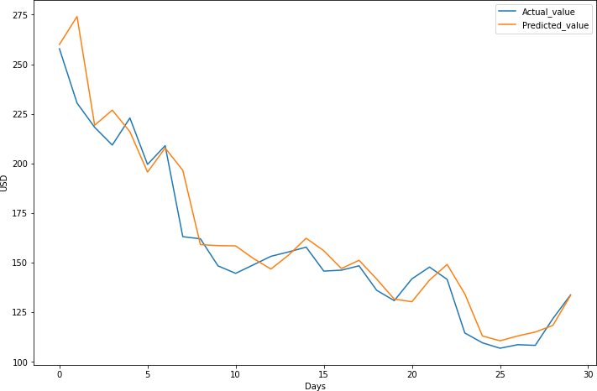
Fig 9. Actual and Predicted values for LTC using LSTM and GRU models
The value of cryptographic currency is projected for the upcoming 30 days using LSTM and GRU models based on the historical data of three digital currencies, specifically Bitcoin, Litecoin, and Ethereum. The most reliable estimate for LTC MAPE paces is provided by GRU, which is 0.2454%, 0.8267%, and 0.2116% for BTC, ETH, and LTC, respectively. The precise results close to the actual costs of cryptographic forms of currency are addressed by the expectation models in this study.

Conclusion and Future Work:

The crypto currency industry gradually merged with conventional company sectors as more seasoned financial supporters entered it. Around 2018, more than 16,000 different digital payment methods become available. Given their current level of development, more is likely to happen in the upcoming years. By the year 2030, public monetary standards would contain more than 25% of cryptographic forms of money, indicating that a significant portion of the world would start to value digital currency as a means of exchange. Financial institutions that invest in digital currencies view them as a risky investment, similar to tech stocks. Therefore, the review's main goal is to develop a model utilizing deep learning for estimating the prices of the three most well-known digital currencies, specifically Bitcoin, Litecoin, and Ethereum. As it is increasingly recognised by traders and clients worldwide, this will aid financial backers as well as strategy creators to some extent. Longer-term situations are better suited for LSTM and GRU. The analysis reveals that GRU surpasses time series expectations since it costs less money for gathering and provides a better system. Regardless, the model needs be further investigated by considering various boundaries in addition to the ones we have already included in our assessment. By the way, applying profound learning models for estimating the value of digital money can be effective in specific situations where the cost change is due to verifiable information and factors like a country's political structure, marketing plan, and market strategy can affect and determine the value unpredictability of digital money. Other cryptographic forms of payment like swell, z-money, doge, and others are not included in our review. In further work, we will improve the model by using it with these digital currencies, turning it into a steady model. In subsequent work, we use regular language processing techniques and opinion assessment to analyze tweets in order to focus on the impact that virtual entertainment and tweets expressly can have on the price and transaction volume of digital currency.
References:

- Tian Guo, Nino Antulov-Fantulin, "Predicting short-term Bitcoin price fluctuations from buy and sell orders" Machine Learning , arXiv:1802.04065, Feb 2018

- Anshul Saxena, T.R. Sukumar, "Predicting bitcoin price using lstm And Compare its predictability with arima model", International Journal of Pure and Applied Mathematics Volume 119 No. 17 2018.

- Lahmiri S, Bekiros S (2019) Cryptocurrency forecasting with deep learning chaotic neural networks. Elsevier, 35–40 .

- Nivethitha P, Raharitha P (2019) Future stock price prediction using LSTM machine learning algorithm. Int Res J EngTechnol (IRJET) 1182–1186 .
- Derbentsev, V.; Matviychuk, A.; Soloviev, V.N. Forecasting of Cryptocurrency Prices Using Machine Learning. In Advanced Studies of Financial Technologies and cryptocurrency Markets; springer: Berlin/Heidelberg, Germany, 2020; pp. 211-231.

- Madan I, Saluja S, Zhao A(2015) Automated bitcoin trading via machine learning algorithms. 1–5.
- Patel, M.M.; Tanwar, S.; Gupta, R.; Kumar, N. A Deep Learning-based Cryptocurrency Price Prediction Scheme for Financial Institutions. J. Inf. Secur. Appl. 2020, 55, 102583.
- Ferdiansyah, F.; Othman, S.H.; Radzi, R.Z.R.M.; Stiawan, D.; Sazaki, Y.; Ependi, U. A LSTM-Method for Bitcoin Price Prediction: A Case Study Yahoo Finance Stock Market. In Proceedings of the ICECOS—3rd International Conference on Electrical Engineering and Computer Science, Batam, Indonesia, 2–3 October 2019; pp. 206–210.
- Valencia, F.; Gómez-Espinosa, A.; Valdés-Aguirre, B. Price Movement Prediction of Cryptocurrencies Using Sentiment Analysis and Machine Learning. Entropy 2019, 21, 589.
- A. Bernal, S. Fok and R. Pidaparthi. "Financial Market Time Series Prediction with Recurrent Neural Networks." 2012.
- Felix A. Gers, et al., Learning to Forget: Continual Prediction with LSTM, 2000
- Alex Graves, et al., A Novel Connectionist System for Unconstrained Handwriting Recognition, 2009.
- Cho, K., Van Merriënboer, B., Gulcehre, C., Bahdanau, D., Bougares, F., Schwenk, H., & Bengio, Y. (2014). Learning phrase representations using RNN encoder-decoder for statistical machine translation. arXiv preprint arXiv:1406.1078.
- Chung, J., Gulcehre, C., Cho, K., & Bengio, Y. (2014). Empirical evaluation of gated recurrent neural networks on sequence modeling. arXiv preprint arXiv:1412.3555.
- Yao, X., & Zhong, P. (2019). Long short-term memory and gated recurrent unit for time series prediction. Journal of Systems Science and Complexity, 32(5), 1438-1459.
[16]Li, J., Li, Y., Li, W., & Li, Y. (2020). A comparative study of LSTM, GRU and attention mechanisms for time series prediction. arXiv preprint arXiv:2002.04004.
- Hochreiter, S., & Schmidhuber, J. (1997). Long short-term memory. Neural computation, 9(8), 1735-1780.
- Greff, K., Srivastava, R. K., Koutník, J., Steunebrink, B. R., & Schmidhuber, J. (2015). LSTM: A search space odyssey. IEEE transactions on neural networks and learning systems, 28(10), 2222-2232.
- Zhang, Z., Song, H., Chen, Y., & Shi, Y. (2020). A comparative study of LSTM, GRU, and BiLSTM for traffic flow prediction based on big data. Journal of Advanced Transportation, 2020.
[20]Sun, J., Feng, B., & Zhang, Y. (2020). An LSTM-based prediction model for temperature and relative humidity in greenhouse environment. Journal of Physics: Conference Series, 1529(3), 032063.
- Armstrong, J. S., & Collopy, F. (1992). Error measures for generalizing about forecasting methods: Empirical comparisons. International Journal of forecasting, 8(1), 69-80.
- Graves, A., Fernández, S., Gomez, F., & Schmidhuber, J. (2006). Connectionist temporal classification: labelling unsegmented sequence data with recurrent neural networks. Proceedings of the 23rd international conference on Machine learning, 369-376.
- Handbook of Blockchain, Digital Finance, and Inclusion: Cryptocurrency, FinTech, InsurTech, and Regulation" edited by David Lee Kuo Chuen and Robert Deng (2020).
- Cryptocurrencies: A Review of Blockchain Technologies and Applications" by James E. David and Krista S. Li (2018).
- "Bitcoin and Cryptocurrency Technologies: A Comprehensive Introduction" by Arvind Narayanan, Joseph Bonneau, Edward Felten, Andrew Miller, and Steven Goldfeder (2019).
- "Cryptoassets: The Innovative Investor's Guide to Bitcoin and Beyond" by Chris Burniske and Jack Tatar (2019).
- An Analysis of Cryptocurrency, Bitcoin, and the Future" by Gurumeet Singh (2015)
- "Cryptocurrencies as an Asset Class" by Chris Burniske and Adam White (2017)
- "The Rise of Cryptocurrencies in the Global Market" by Steven Ongena, Ibolya Schindele, and Dzsamila Vonnak (2018)
- Blockchain Technology and cryptocurrencies: Challenges and Opportunities “ by Omri Ross, David Kinitsky , and Aaron Wright (2018)

- Li, X., Chen, Y., Li, Y., & Yang, Y. (2021). A review of recurrent neural networks: LSTM, GRU, and beyond. ISPRS International Journal of Geo- Information, 10(2), 87.
- Lipton, Z. C., Berkowitz, J., & Elkan, C. (2015). A critical review of recurrent neural networks for sequence learning. arXiv preprint arXiv:1506.00019.
- Chollet, F. (2018). Deep Learning with Python. Manning Publications.
- Geron, A. (2017). Hands-On Machine Learning with Scikit-Learn and TensorFlow. O'Reilly Media, Inc.
- Nakamoto, S. (2008). Bitcoin: A peer- to-peer electronic cash system.
- Wood, G. (2014). Ethereum: A secure decentralised generalised transaction ledger. Ethereum Project Yellow Paper, 151, 1-32.
- Lee, C. (2011). Litecoin: An Early Bitcoin Alternative, Based on the Scrypt Algorithm. Litecoin Wiki. Retrieved from https://litecoin.info/index.php/Litecoin.
- Noether, S. (2014). CryptoNote v 2.0. Monero Project . Retrieved from https://cryptonote.org/whitepaper.pdf .
- Wood, G. (2014). Ethereum: A secure decentralised generalised transaction ledger. Ethereum Project Yellow Paper, 151, 1-32.

