Environmental Monitoring Plan for MSRDC

DPR Package No.: 02
CP No. 07: December 2021

“Samruddhi Mahamarg”
From 296 + 000 Km to 347 + 190 Km
Village Banda to Village Sawargaon Mal
District(s): Buldhana
M/s. Reliance Infrastructure Limited / Roadway Solutions India Infra Limited.
Appointed Date : 13. 04. 2019
Scheduled Completion Date : 09. 10. 2021


Submitted to MSRDC & CSIR – NEERI

Prepared By | Reviewed By | Approved By
EHS Head  (Signature)  T S Damor | Project Head  (Signature)  Venkata Rama Rao Kaza | Authority’s Engineer  (Signature)  Dilip Salunke
Environmental Monitoring Plan for MSRDC

DPR Package No.: 02

CP No.: 07 December – 2021

“Samruddhi Mahamarg”

From 296 + 000 Km to 347 + 190 Km
Village Banda to Village Golegaon
District (s): Buldhana

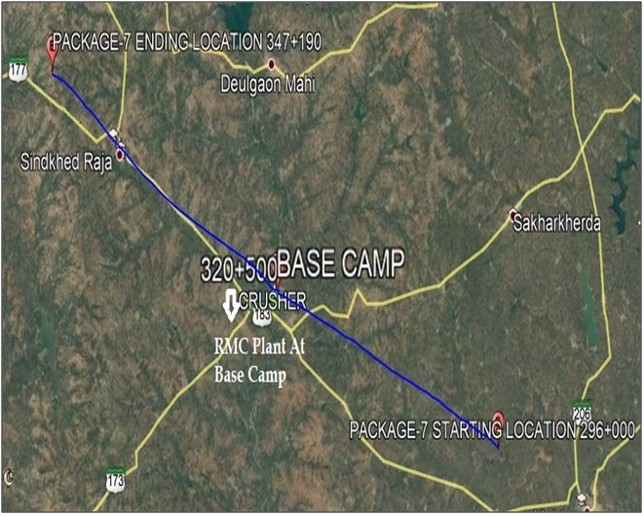

EPC CONRTACTOR NAME: Roadway Solutions India Infra LTD.

Submitted to MSRDC & CSIR – NEERI

Environmental Monitoring Plan Summary

Sr. No. | Parameters | Frequency | Remarks (if any)
1. | Ambient Air Quality Monitoring; | Once in Three Months | -------
2. | Surface Water Quality Monitoring; | Once in Three Months | -------
3. | Ground Water Quality Monitoring; | Once in Six Months | If any sites change then the EPC has to carry out on a monthly or quarterly basis, depending on site or location specification.
4. | Batching Plant Effluent Treatment Plant (BPETP) Monitoring; | Once in Three Months | -------
5. | Sewage Treatment Plant (STP) Monitoring; | Once in Three Months | -------
6. | Soil Quality Monitoring; | Once in Six Months | If any sites change then the EPC has to carry out on a monthly or quarterly basis, depending on site or location specification.
7. | Ambient Noise Monitoring; | Once in Three Months | -------
8. | Solid & Construction and Demolition Waste; | Once in Three Months | -------

Ambient Air Quality Monitoring (Once in Three Months)

The air monitoring locations should be identified on the following basis:

- Source: The exposure to the construction activity emissions are severe and would be the impact in terms of RSPM, HC, SO_{X} and NO_{X}.
- Path: The meteorology and the wind flow affect the impact on the receiver. The impact is higher during night time and low in daytime (for the same intensity of pollution produced by source). Likewise, the impact is high during inversion conditions or on locations lying at the downwind of the alignment.
- Receiver: The impact is higher if the receiver is considered to be sensitive w. r. to the “National Ambient Air Quality Standards” (NAAQM). Such sensitive receptors. The villages in vicinity to the alignment.

Frequency of Monitoring: Once in Three Months till End of Construction, Continuous 24 Hours for 2 Days (48 Hours).

Sr. No. | Location | Location ID | Geographical Location | Longitude | Latitude | AAQMS Standards | Ambient Air Quality Monitoring Parameters Measured/ Observed
 |  |  |  |  |  | Analysis Protocol
 |  |  |  |  |  | Parameters | PM₁₀ | PM_{2.5} | SO_{X} | NO_{X} | CO
1. | Ready Mix Concrete Plant/ Batching Plant/ Asphalt Mix Plant | 320 + 000 (Base Camp) | Tadhegaon | 76.28’48.24”E | 20.01’36.63” N | 90 – 100 µg/ m³ | 81.3 | 41.7 | 9.2 | 31.7 | 0.217
2. | Stone Crusher | 320 + 000 (Base Camp) | Tadhegaon | 76.28’48.24”E | 20.01’36.63” N | 90 – 100 µg/ m³ | 81.3 | 41.7 | 9.2 | 31.7 | 0.217
3. | Wet Mix Macadam | N/A | N/A | N/A | N/A | ------- | ------- | ------- | ------- | ------- | -------
4. | DG Stack | 320 + 000 (Base Camp) | Tadhegaon | 76.28’48.24”E | 20.01’36.63” N | 90 – 100 µg/ m³ | 81.3 | 41.7 | 9.2 | 31.7 | 0.217
5. | Quarry | 328 + 000 | Shelgaon Raut | 76.21’06.35”E | 20.00’80.87 “ N | 90 – 100 µg/ m³ | 68.8 | 34.5 | 5.8 | 27.7 | 0.118
6. | Camp/ Labour Site | 320 + 000 (Base Camp) | Tadhegaon | 76.28’48.24”E | 20.01’36.63” N | 90 – 100 µg/ m³ | 81.3 | 41.7 | 9.2 | 31.7 | 0.217
7. | Stretch of the road where construction is in progress at minimum 4 locations – (4 Locations as per EIA):
 | 7 (a) Location 1 | 328 + 000 | Shelgaon Raut | 76.21’06.35”E | 20.00’80.87 “ N | 90 – 100 µg/ m³ | 68.8 | 34.5 | 5.8 | 27.7 | 0.118
 | 7 (b) Location 2 | 320 + 000 | Tadhegaon | 76.28’48.24”E | 20.01’36.63” N | 90 – 100 µg/ m³ | 81.3 | 41.7 | 9.2 | 31.7 | 0.217
 | 7 (c) Location 3 | 316 + 800 | Dusrabid | 76.41’43.86”E | 76.41’43.86” N | 90 – 100 µg/ m³ | 74.4 | 37.2 | 5.5 | 20.6 | 0.110
 | 7 (d) Location 4 | ------- | ------- | ------- | ------- | ------- | ------- | ------- | ------- | ------- | -------
8. | Baseline monitoring locations as per the EIA, if applicable:
 | 8 (a) Location 1 | 340 + 000 | Sindkhed Raja | 76.07’00.88”E | 19.58’55.08” N | 90 – 100 µg/ m³ | 76.6 | 38.3 | 8.7 | 29.5 | 0.194
 | 8 (b) Location 2 | ------- | ------- | ------- | ------- | ------- | ------- | ------- | ------- | ------- | -------

NOTE:

Minimum 4 Locations should be selected for Monitoring of Ambient Air Quality:

- If locations Sr. No.: 1 to 6 are in the vicinity of 50 – 100 m from each other, only 1 monitoring location can be considered.
- If any baseline monitoring locations are present in the package then it is to be considered as one of the selected locations.
- Photographs while monitoring and analysis should be attached wherever possible.
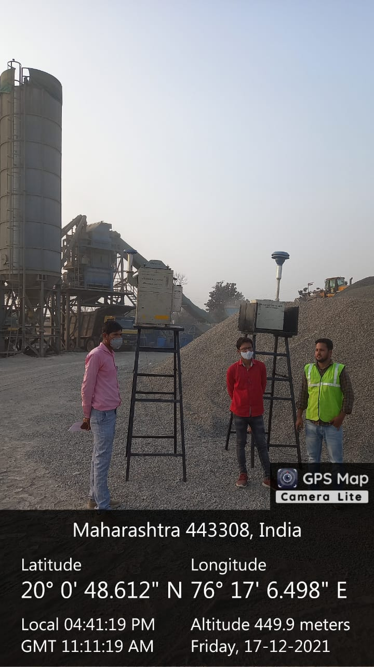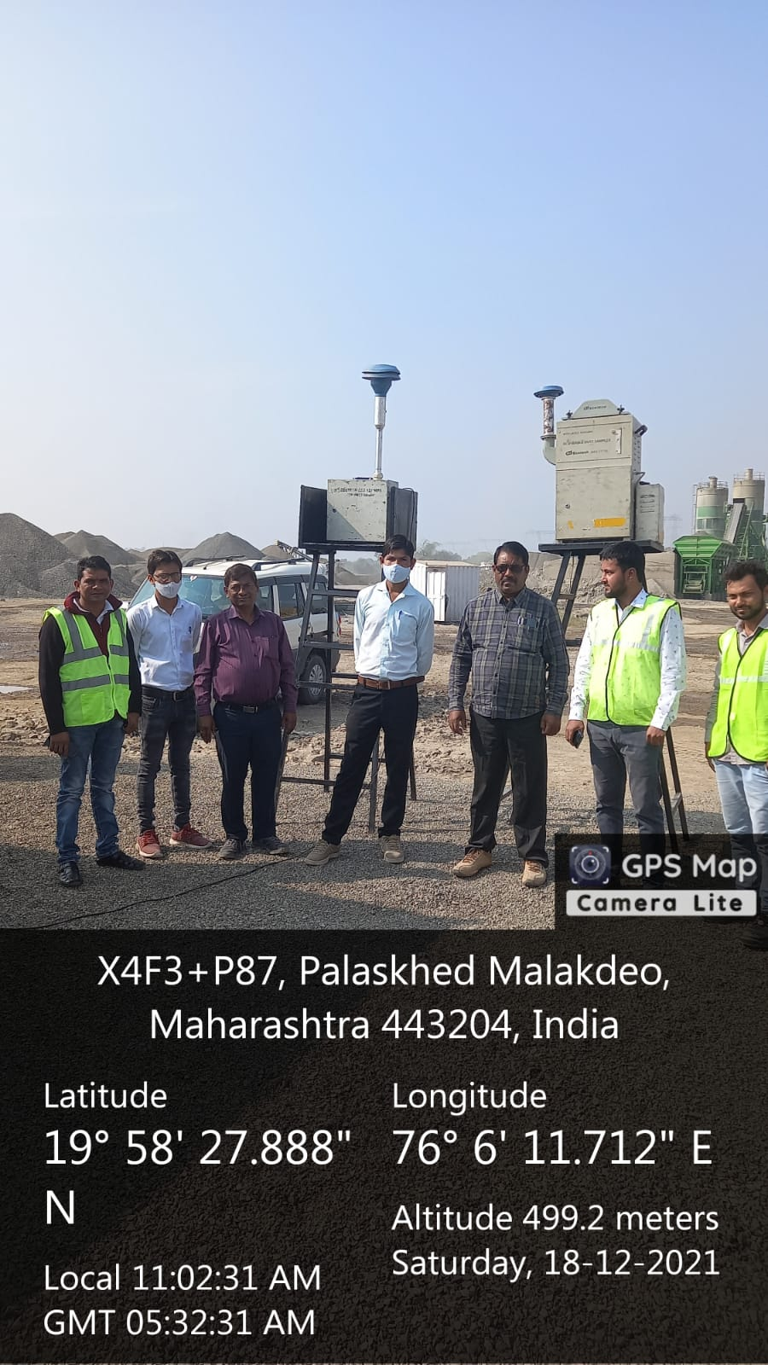
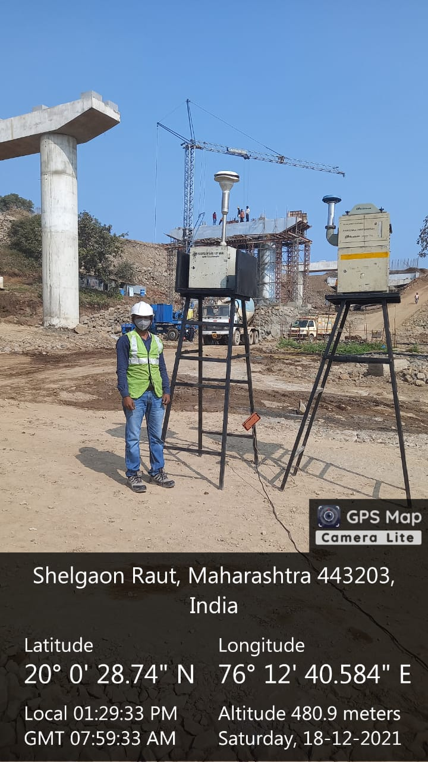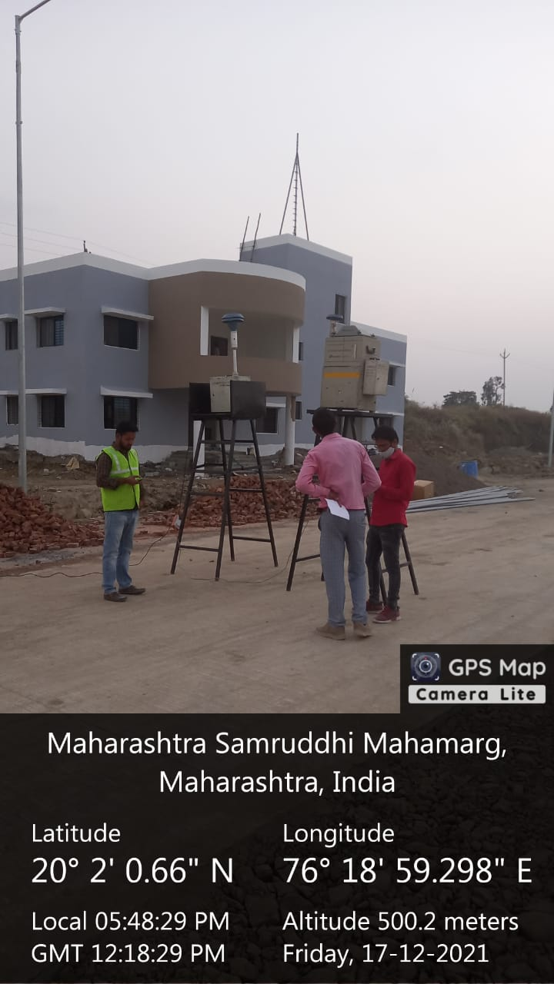
Ambient Air Monitoring @ Km 328 + 060 - Viaduct
Ambient Air Monitoring @ Km 316 + 550

Surface Water Quality Monitoring (Once in Three Months)

- Monitoring is to be carried out Once in Three Months.
- At least 4 locations in the area adjacent to the alignment on both the side should be selected as monitoring location (200 m from either side).
- To identify potential effects of road construction and operation activities on groundwater and any potential effects of groundwater quality on road construction and integrity.
- To identify residual effects of road construction and operation activities on groundwater in the project area.

Frequency of Monitoring: Once in Three Months during construction phase to grab Sample:

Monitoring Location Specification
Sr. No. | Location | Name of the Geographical Location | Location ID  (LID___) | Longitude | Latitude
1. | Cross Drainage/ Bridge (MNB) | Sindkhed Raja | Ch = 340 + 260 | 76.101996 E | 19.971138 N
2. | River Purna (Baseline) | Tadhegaon | Ch = 321 + 400 | 76.2737517 E | 20.17155 N
3. | Cross Drainage/ Bridge (MNB) | ------- | ------- | ------- | -------
4. | Cross Drainage/ Bridge (MNB) | ------- | ------- | ------- | -------
5. | Other Water Bodies, if Any, Specify | ------- | ------- | ------- | -------
6. | Other Reservoirs if Any, Specify | ------- | ------- | ------- | -------

Sr. No. | Parameters | Analysis Protocol | Standards (IS: 10500: 2012) | Cross Drainage/ MNB  Ch. = 340 + 260 | River  (Purna)  Ch. = 321 + 400 | Cross Drainage/ MNB | Cross Drainage/  MNB | Other Water  if any, Specify  (LID____) | Other Reservoirs  if any, Specify  (LID____)
1. | pH | IS: 2296 | 6.5 – 8.5 | 7.50 | 7.90 | N/A | N/A | N/A | N/A
2. | Temperature | IS: 2296 | ------- | 17 | 17 | N/A | N/A | N/A | N/A
3. | Total Dissolved Solids (TDS) | IS: 2296 | 1,500 | 276 | 252 | N/A | N/A | N/A | N/A
4. | Total Suspended Solid (TSS) | IS: 2296 | ------- | 292 | 14 | N/A | N/A | N/A | N/A
5. | Total Hardness | IS: 2296 | ------- | 148 | 124 | N/A | N/A | N/A | N/A
6. | Chloride | IS: 2296 | 600 | 16.3 | 17.3 | N/A | N/A | N/A | N/A
7. | Nitrate | IS: 2296 | 50 | 3.5 | 3.0 | N/A | N/A | N/A | N/A
8. | Iron (as Fe) | IS: 2296 | 50 | 0.090 | 0.085 | N/A | N/A | N/A | N/A
9. | Sulphate (as SO₄) | IS: 2296 | 400 | 14.5 | 13.0 | N/A | N/A | N/A | N/A
10. | Turbidity | IS: 2296 | ------- | 17 | 3.0 | N/A | N/A | N/A | N/A
11. | DO | IS: 2296 | 4 | 5.6 | 6.0 | N/A | N/A | N/A | N/A
12. | BOD | IS: 2296 | 3.0 | 4.3 | 3.8 | N/A | N/A | N/A | N/A
13. | COD | IS: 2296 | ------- | 19.4 | 17.4 | N/A | N/A | N/A | N/A
14. | Lead (as Pb) | IS: 2296 | 0.1 | <0.001 | <0.001 | N/A | N/A | N/A | N/A
15. | Oil and Grease | IS: 2296 | 0.1 | <0.1 | <0.1 | N/A | N/A | N/A | N/A
16. | Total Coliform | IS: 2296 | 5,000 | 62 | 70 | N/A | N/A | N/A | N/A
 | *IS: 10500: 2012 – BIS – Indian Standards Specification (Second Revision);
NOTE:

- If any baseline monitoring locations are present in the package then it is to be considered as one of the selected locations.
- Photographs while monitoring and analysis should be attached wherever possible.

Brief interpretation and justification of the above monitoring report with all monitoring location details and site conditions.

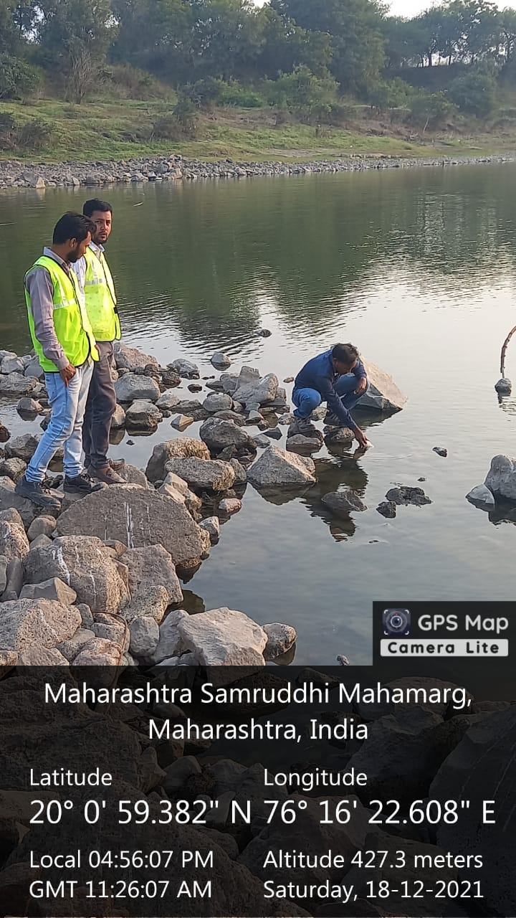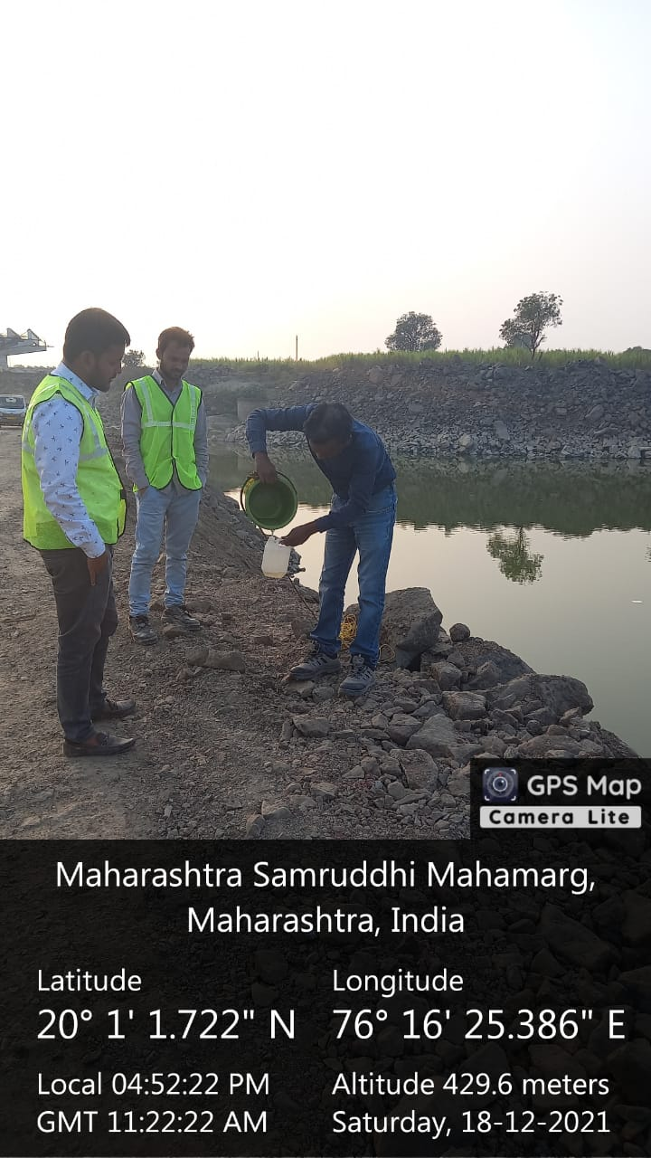
Surface Water (Outlet) Monitoring @ Km 321 + 450 (Baseline)
Surface Water (Inlet) Monitoring @ Km 321 + 450

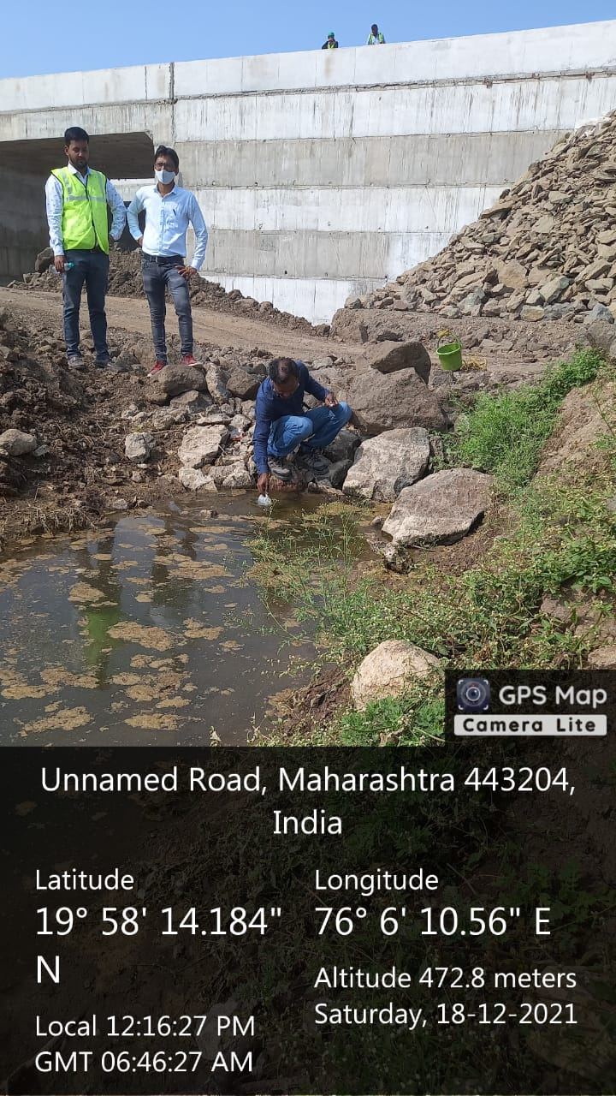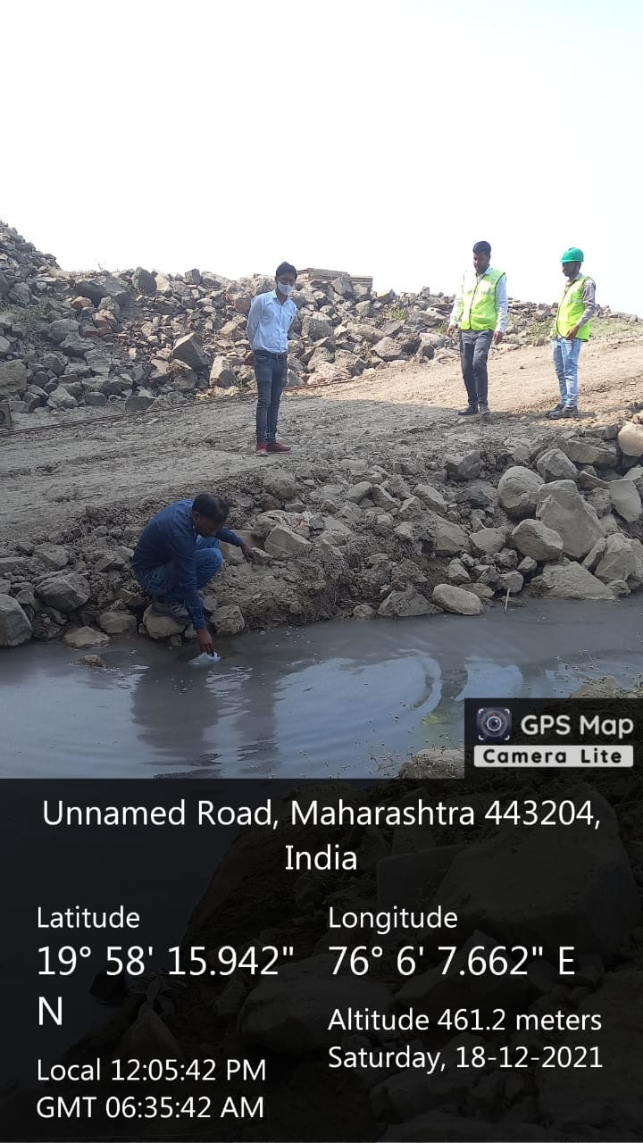
Surface Water (Outlet) Monitoring @ Km 340 + 260

Surface Water (Inlet) Monitoring @ Km 340 + 260

Ground Water Quality Monitoring (Once in Six Months)

- # - Monitoring is to be carried out once in every six months, if any sites change then the EPC has to carry out on monthly or quarterly basis, depending on site specification.
- @ - If groundwater extraction system is near any Septic Tank/ Soak Pit/ Material Storage Area then the monitoring is to be carried out on every mentioned site, on quarterly basis.
- At least 4 location in the area adjacent to the alignment on both the side should be selected as monitoring location (200 m from either side).
- To identify potential effects of road construction and operation activities on groundwater and any potential effects of groundwater quality on road construction and integrity.
- To identify residual effects of road construction and operation activities on groundwater in the project area.
Frequency of Monitoring: Once in Six Months during the construction phase, Grab Sample#@:

Monitoring Location Specification
Sr. No. | Location | Name of Geographical Location | Location ID (LID_____) | Longitude | Latitude
1. | Open Well | Tadhe Gaon | 320 + 000 | 76.28’48.24” E | 20.01’36.63” N
2. | Open Well | Sindkhed Raja | 340 + 000 | 76.07’00.88” E | 19.58’55.08” N
3. | Open Well | ------- | ------- | ------- | -------
4. | Septic Tank | ------- | ------- | ------- | -------
5. | Material Storage Area | ------- | ------- | ------- | -------

Sr. No. | Parameters | Analysis Protocol | Standards (IS: 10500: 2012) | Open Well  (320 + 000) | Open Well  (340 + 000) | Open Well | Septic Tank (LID____) | Soak Pit (LID____) | Material Storage Area (LID____)
1. | pH | 6.5 – 8.5 | IS: 10500 | 7.85 | 7.70 | ------- | ------- | ------- | -------
2. | Temperature (°C) | Instrumental | Not Specified | 24 | 26 | ------- | ------- | ------- | -------
3. | Total Dissolved Solids (TDS) | 500 Mg/ L | IS: 10500 | 492 | 484 | ------- | ------- | ------- | -------
4. | Total Suspended Solid (TSS) | Mg/ L | IS 3025 | <10 Mg/ L | <10 Mg/ L | ------- | ------- | ------- | -------
5. | Total Hardness | 200 Mg/ L | IS: 10500 | 210 | 196 | ------- | ------- | ------- | -------
6. | Chloride | 250 Mg/ L | IS: 10500 | 16.7 | 14.2 | ------- | ------- | ------- | -------
7. | Nitrate | 45 Mg/ L | IS: 10500 | 2.30 | 2.20 | ------- | ------- | ------- | -------
8. | Iron (as Fe) | 0.3 Mg/ L | IS: 10500 | 0.115 | 0.092 | ------- | ------- | ------- | -------
9. | Sulphate (as SO₄) | 200 (400) Mg/ L | IS: 10500 | 13.5 | 12.4 | ------- | ------- | ------- | -------
10. | Turbidity | 1 (5) NTU | IS: 10500 | 0.5 | 0.2 | ------- | ------- | ------- | -------
11. | DO | Mg/ L | IS 3025 | 5.2 | 5.2 | ------- | ------- | ------- | -------
12. | BOD | Mg/ L | IS 3025 | <2 | <2 | ------- | ------- | ------- | -------
13. | COD | Mg/ L Mg/ L | IS 2488 | 4.3 | 4.3 | ------- | ------- | ------- | -------
14. | Lead (as Pb) | 0.01 Mg/ L | IS: 10500 | <0.001 | <0.001 | ------- | ------- | ------- | -------
15. | Oil and Grease | Mg/ L | USEPA: 1664 | <.4 | <.4 | ------- | ------- | ------- | -------
16. | Total Coliform | CFU 100 ML | IS: 10500 | 16 | 9 | ------- | ------- | ------- | -------
*IS: 10500: 2012 – BIS – Indian Standards Specification (Second Revision);
NOTE:

- If any baseline monitoring locations are present in the package then it is to be considered as one of the selected locations.
- Photographs while monitoring and analysis should be attached wherever possible.
Brief interpretation and justification of the above monitoring report with all monitoring location details and site conditions.
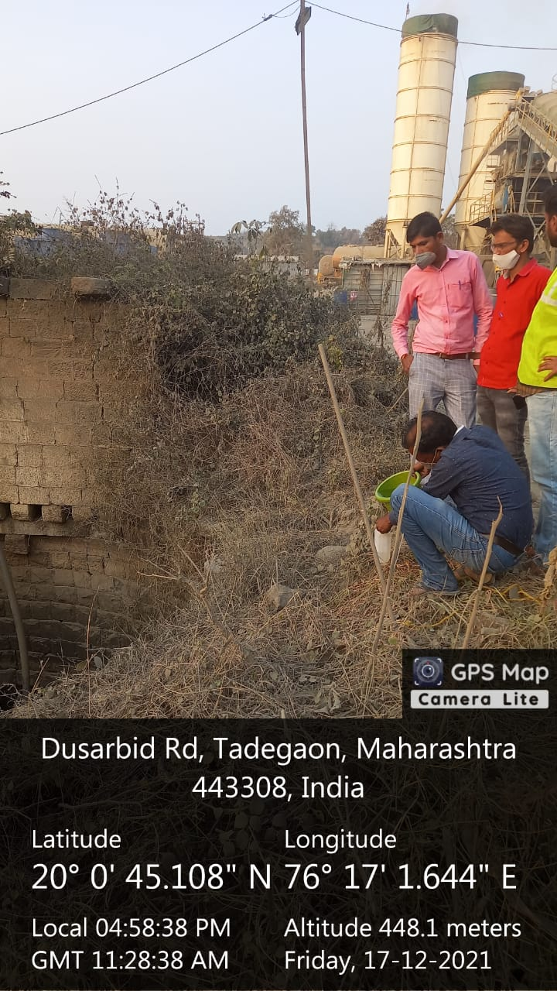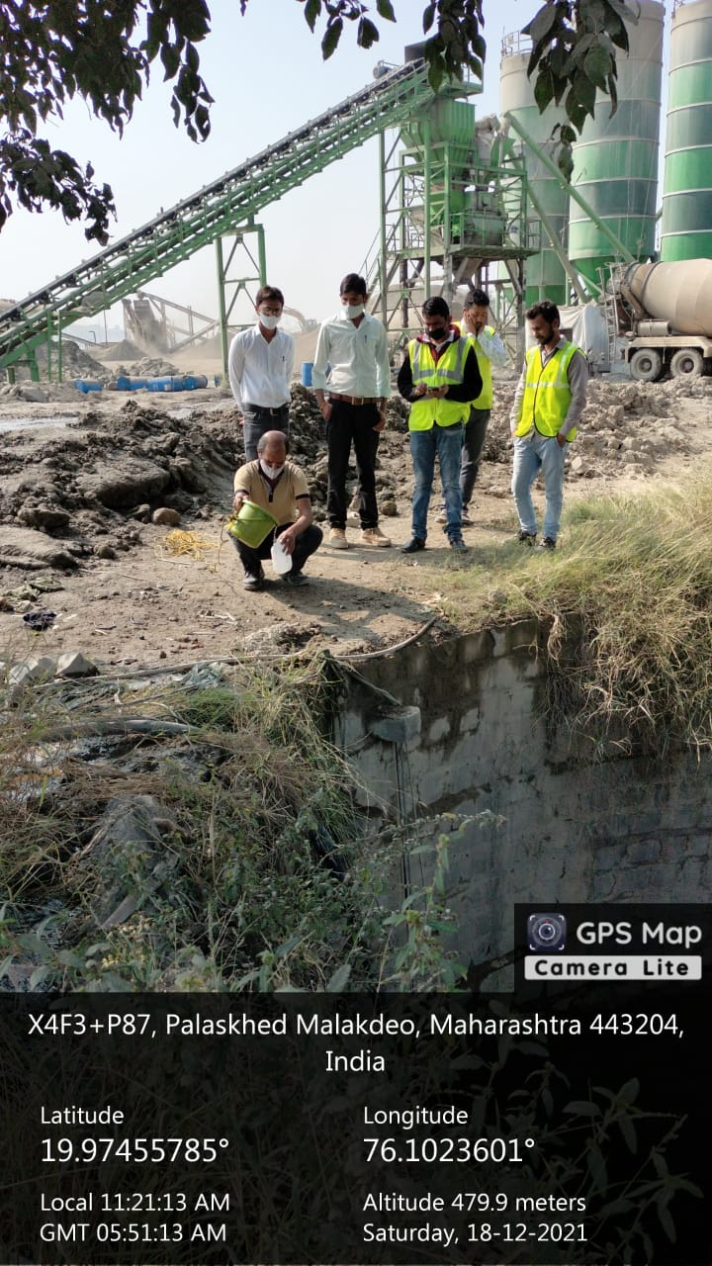
Ground Water Monitoring @ Km 320 + 000
Ground Water Monitoring @ Km 340 + 000
Batching Plant Effluent Treatment Plant (BPETP) Monitoring
(Once in Three Months)

- Quantity of Water Treated in the Month  - Location of BPETP (Longitude/ Latitude)  - Treatment Facility/ Process used at BPETP  - Number of BPETP Operational in Package  - Capacity of BPETPs | :  :  :  :  : | 07.5 Lakh Litre  76.25’56.00” E and 20.00’84.00” N  N/A  02  120 and 90

Frequency of Monitoring: Once in Three Months, Inlet and Outlet Grab Sample:

Sr. No. | Parameters | Analysis Protocol | MPCB Standard for Treated Effluent Quality* | BPETP – 1:  (320 + 000) |  | BPETP – 2:  (340 + 000)
 |  |  |  | Inlet | Outlet | Inlet | Outlet
1. | pH | IS: 3025 | Between 5.5 – 9.0 | 8.10 | 8.0 | 7.90 | 7.75
2. | Total Dissolved Solids (TDS) | IS: 3025 | Not to Exceed 2,100 Mg/ L | 1,190 | 1,158 | 1,202 | 1,180
3. | Total Suspended Solid (TSS) | IS: 3025 | Not to Exceed 100 Mg/ L | 1,625 | 76 | 178 | 82
4. | BOD (3 days) | IS: 3025 | Not to Exceed 30 Mg/ L | 14.7 | 10.8 | 15.3 | 11.6
5. | COD | IS: 2488 | Not to Exceed 150 Mg/ L | 158.6 | 58.4 | 166.7 | 72.8
6. | Oil and Grease | USEPA: 1664 | Not to Exceed 10 Mg/ L | 6.0 | 1.5 | 8.0 | 3.5
*Draft Guidelines for Ready Mix Concrete (RMC) Plants;

NOTE:

- If any baseline monitoring locations are present in the package then it is to be considered as one of the selected locations.
- Photographs while monitoring and analysis should be attached wherever possible.

Brief interpretation and justification of the above monitoring report with treatment plant conditions.

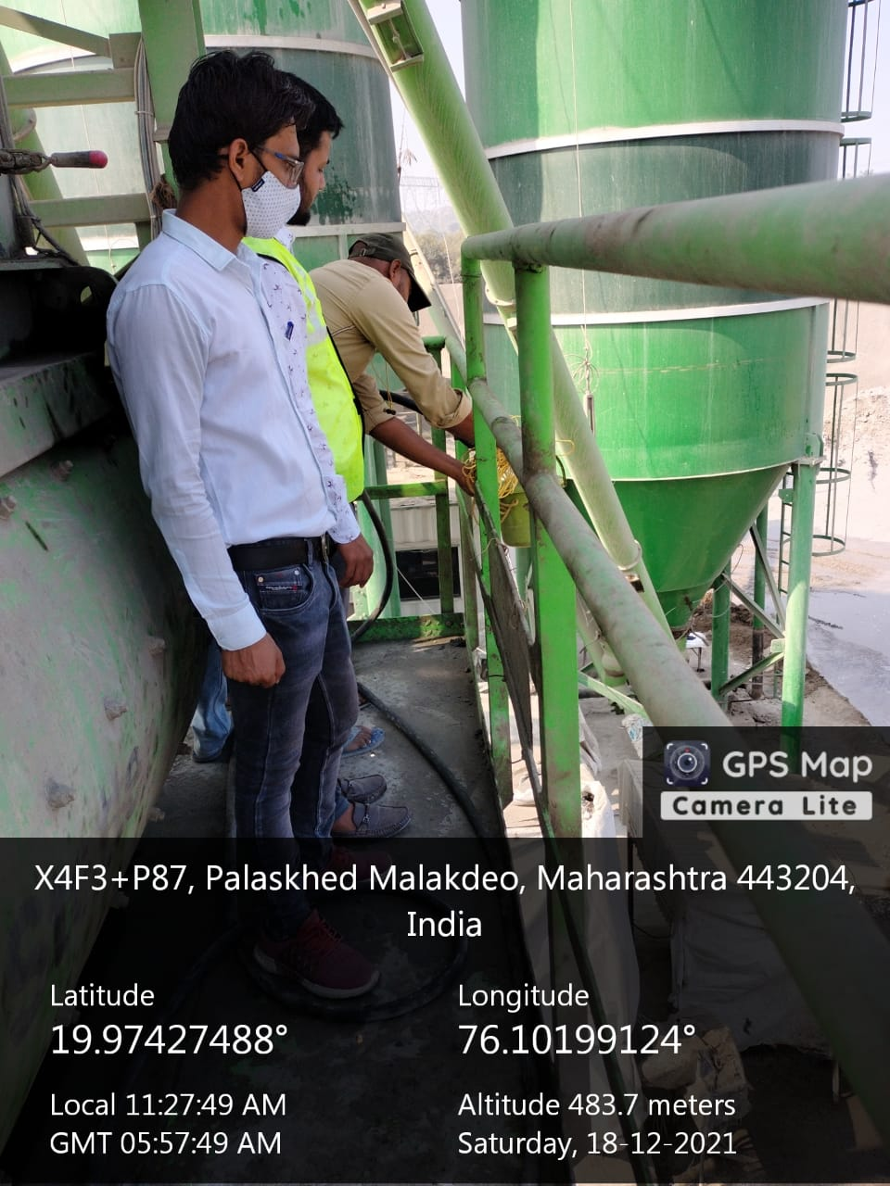
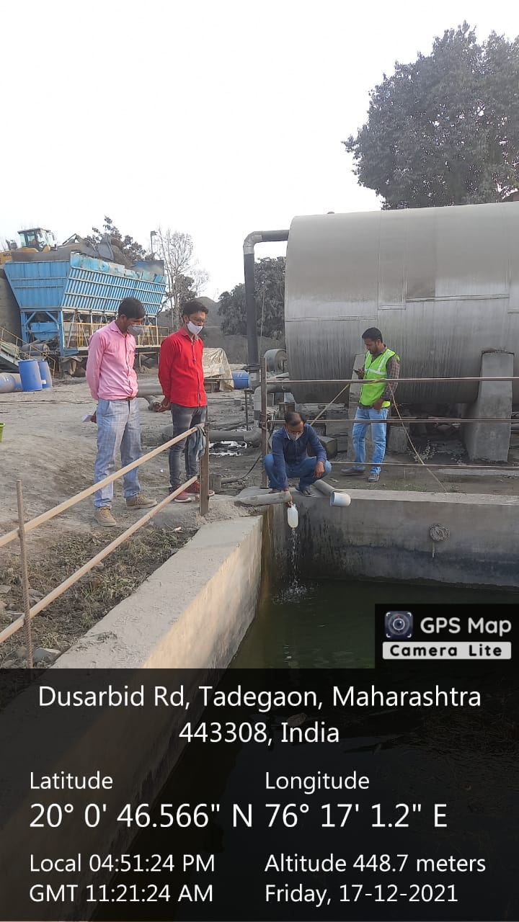
Batching Plant Monitoring Testing (Inlet) @ Km 340 + 000
Batching Plant Monitoring Testing (Outlet) @ Km 340 + 000

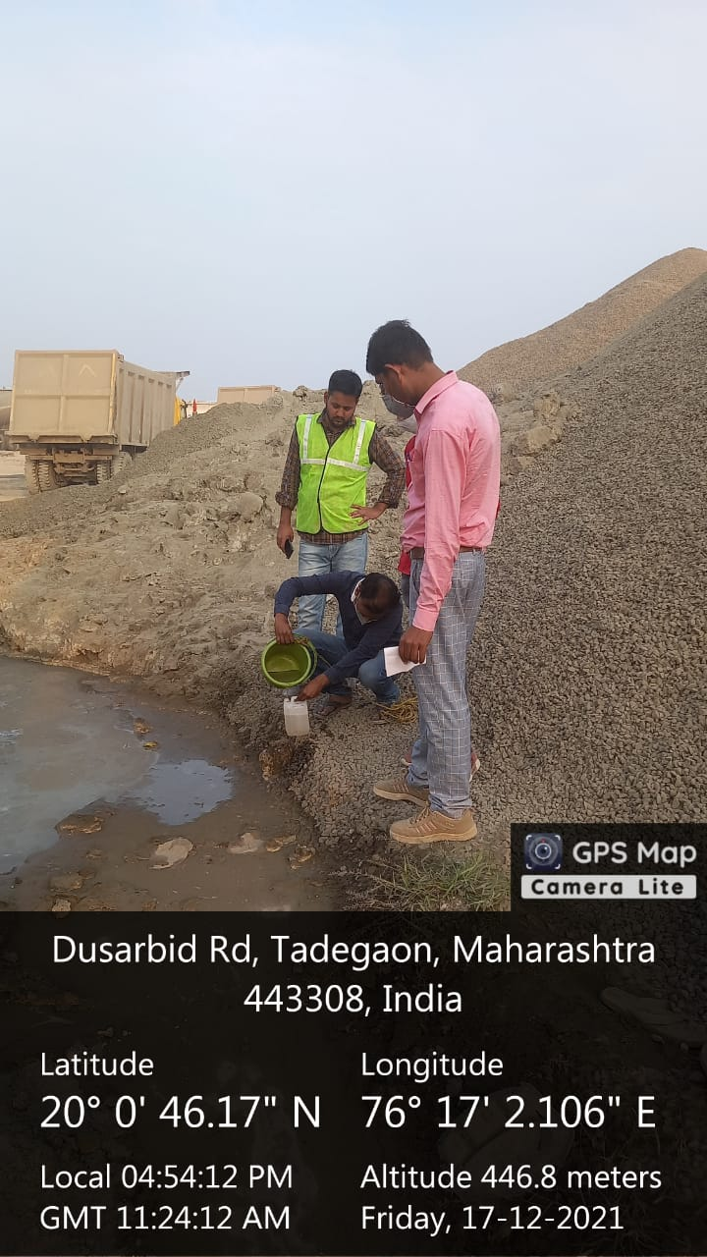
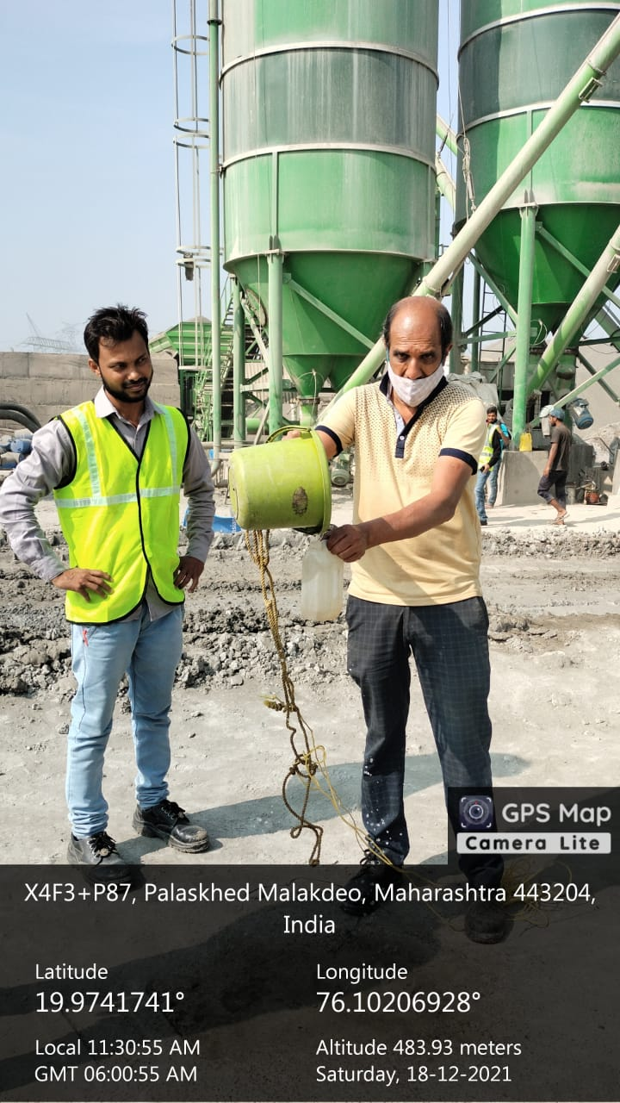

Batching Plant Monitoring Testing (Inlet) @ Km 320 + 000

Batching Plant Monitoring Testing (Outlet) @ Km 320 + 000

Sewage Treatment Plant (STP) Monitoring (Once in Three Months)

- Quantity of Water Treated in the Month  - Location of STP (Longitude/Latitude)  - Treatment Facility/ Process used at BPETP  - Number of STP operational in Package  - Capacity of STPs | :  :  :  :  : | 03 Lakh Litre  Base Camp 76.28’19.05” N/ 20.01’29.06” E  N/A  01 No.  05 Lakh Litre

Frequency of Monitoring: Once in Three Months, Inlet & Outlet Grab Sample:

Sr. No. | Parameters | Analysis Protocol | CPCB Standard* | STP 1 (LID____) |  | STP 2 (LID____)
 |  |  |  | Inlet | Outlet | Inlet | Outlet
1. | Colour and Odour | IS: 3025 | ------- | 12 | 5 | ------- | -------
2. | pH | IS: 3025 | 5.5 – 9.0 Mg/ L | 8.00 | 7.90 | ------- | -------
3. | Electrical Conductivity | IS: 3025 | ------- | 1032 | 994 | ------- | -------
4. | Total Dissolved Solids (TDS) | IS: 3025 | 2,100 Mg/ L | 762 | 710 | ------- | -------
5. | Total Suspended Solid (TSS) | IS: 3025 | 100 Mg/ L | 174 | 54 | ------- | -------
6. | BOD | IS: 3025 | 100 Mg/ L | 48.0 | 16.0 | ------- | -------
7. | COD | IS: 3025 | 250 Mg/ L | 230 | 74.40 | ------- | -------
8. | Oil and Grease | IS: 3025 | 10 – 20 Mg/ L | 20 | 6 | ------- | -------
9. | Phosphate | IS: 3025 | ------- | 1.14 | 0.30 | ------- | -------
10. | Ammonia Nitrogen | IS: 3025 | 120 Mg/ L | 0.58 | 0.20 | ------- | -------
*CPCB Effluents Standards for Public Sewer/ Inland Surface Water as Applicable – GENERAL STANDARDS FOR DISCHARGE OF ENVIRONMENTAL POLLUTANTS PART – A: EFFLUENTS [SCHEDULE – VI];

NOTE:

- If any baseline monitoring locations are present in the package then it is to be considered as one of the selected locations.
- Photographs while monitoring and analysis should be attached wherever possible.

Brief interpretation and justification of the above monitoring report with treatment plant conditions.
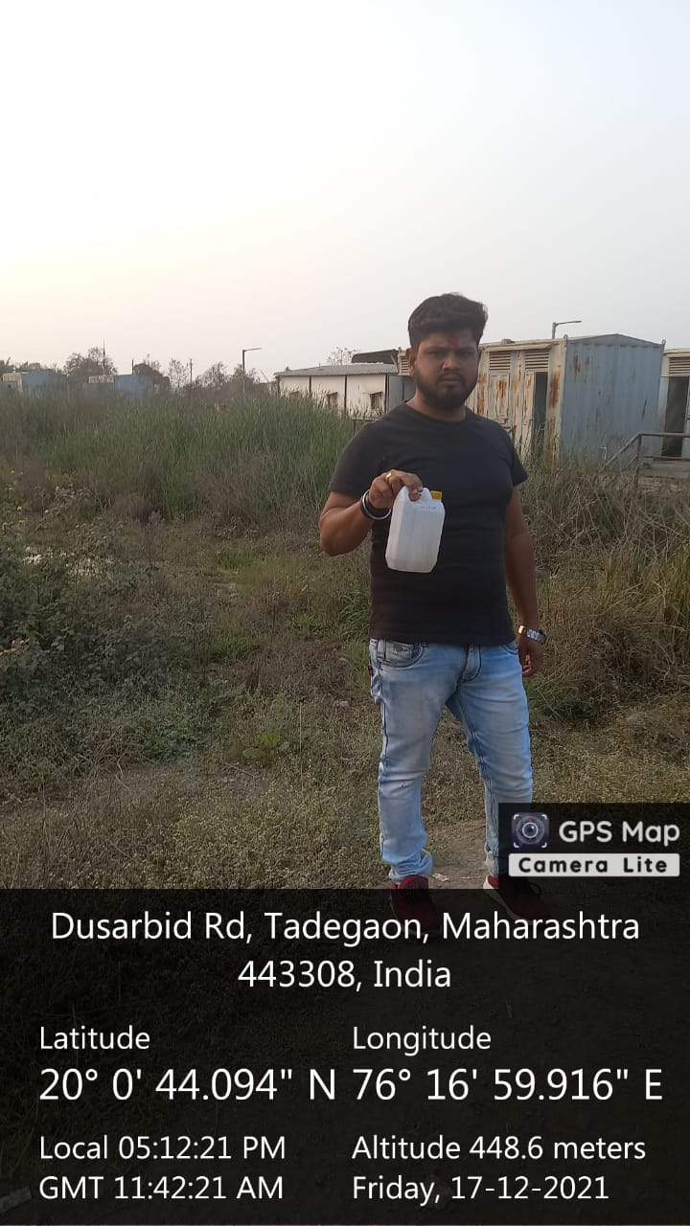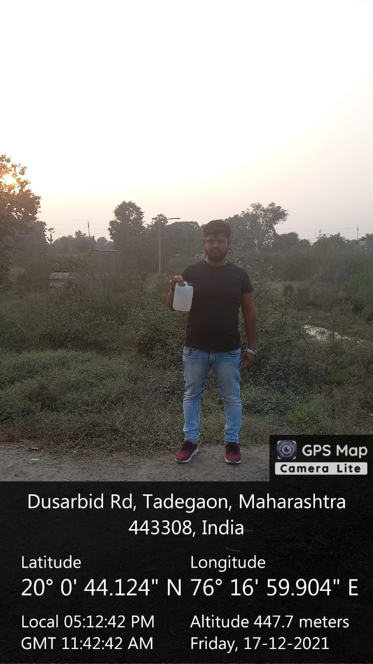
Sewage Treatment Plant (Inlet) Monitoring @ Km 320 + 000
Sewage Treatment Plant (Outlet) Monitoring @ Km 320 + 000

Soil Quality Monitoring (Once in Six Months)#

- # - Monitoring is to be carried out Once in Every Six Months, if any site changes then the EPC has to carry out on monthly or quarterly basis, depending on site specification.
- Identify the different types of soil on site and their location Frequency of Monitoring: Once in Six Months during the construction phase.

Sr. No. | Parameters | Analysis Protocol | Standards | Near Plant Site  (320 + 000) | Near Camp/ Labour Site | Near Construction Site  (340 + 000) | Accident Spill Site (LID____)
1. | pH | As per Agriculture Manual | Not Specified | 7.85 | ------- | 7.95 | -------
2. | Electrical Conductivity | As per Agriculture Manual | Not Specified | 407 | ------- | 552 | -------
3. | Calcium  (as Ca) | As per Agriculture Manual | Not Specified | 6,704 | ------- | 7,058 | -------
4. | Magnesium (as Mg) | As per Agriculture Manual | Not Specified | 3,089 | ------- | 3,377 | -------
5. | Sodium Absorption Ratio | As per Agriculture Manual | Not Specified | 0.51 | ------- | 0.57 | -------
6. | Texture | As per Agriculture Manual | Not Specified | Coarse Sand | ------- | Coarse Sand | -------
7. | Lead (as Pb) | As per Agriculture Manual | Not Specified | <0.1 | ------- | <0.1 | -------
8. | Oil and Grease | USEPA: 1664 | Not Specified | Not Detected | ------- | Not Detected | -------
9. | Nitrogen  (as N) | As per Agriculture Manual | Not Specified | 0.152 | ------- | 0.144 | -------
10. | Phosphorus (as P) | As per Agriculture Manual | Not Specified | 0.16 | ------- | 0.13 | -------
11. | Potassium (as K) | As per Agriculture Manual | Not Specified | 0.118 | ------- | 0.090 | -------

NOTE:

- If any baseline monitoring locations are present in the package then it is to be considered as one of the selected locations.
- Photographs while monitoring and analysis should be attached wherever possible.

Brief interpretation and justification of the above monitoring report with treatment plant
conditions.
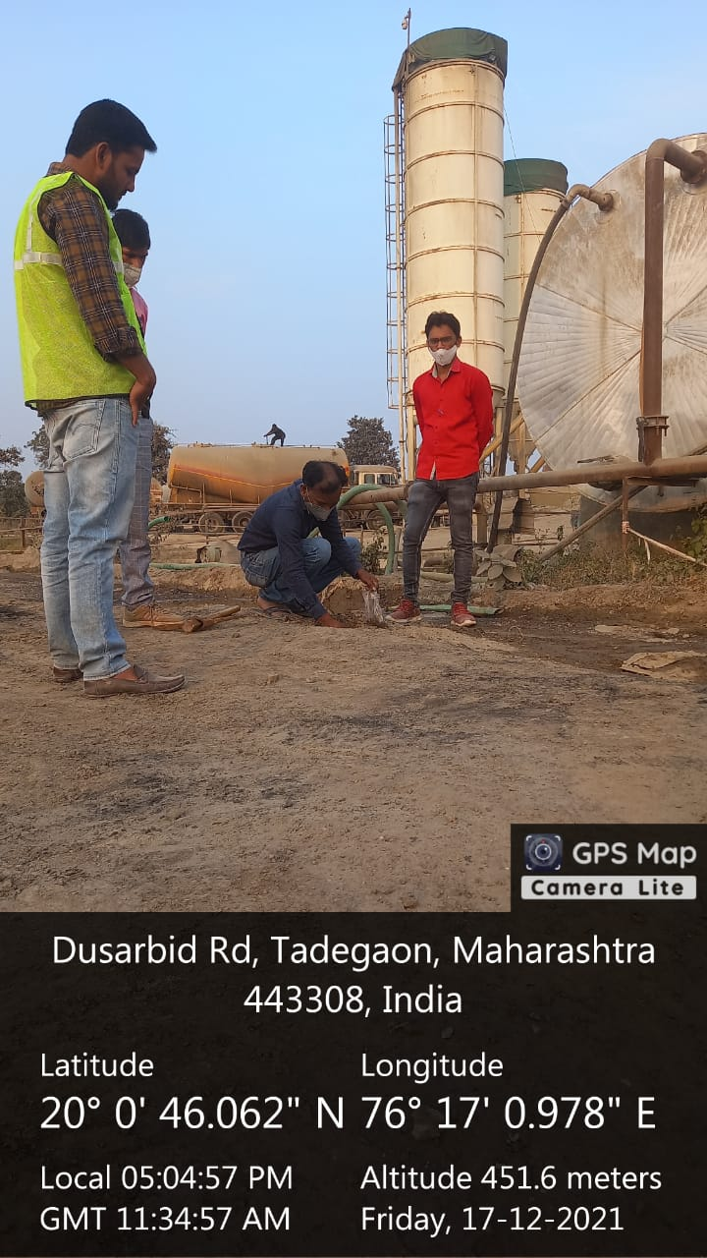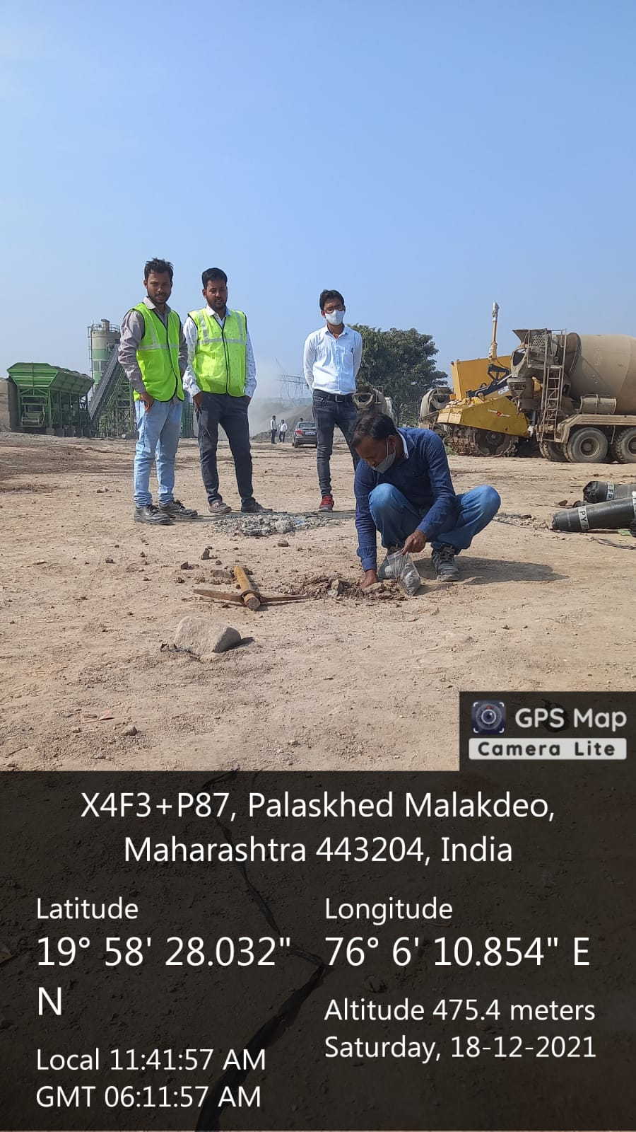
Ambient Soil Monitoring @ Km 320 + 000
Ambient Soil Monitoring @ Km 340 + 000

Ambient Noise Monitoring (Once in Three Months)

The noise monitoring locations should be identified on the following basis:
- Source: The proximity of the villages to the alignment. The closer the villages are the severe would be the impact.
Sr. No. | Monitoring Location Specification | Latitude/ Longitude | Location ID | Analysis Protocol  Standards
 |  |  |  | Parameters  Values in dB | Leq* Day  (6 AM to 10 PM) Values in dB (A) | Leq* Night  (10 PM to 6 AM) Values in dB (A)
1. | Quarry | 20.00’80.87” N/ 76.21’06.35” E | Ch. = 328 + 000 | 70 – 75 | 56.5 | 43.3
2. | Near Plant Site Chainage = 320 + 000 Crusher Area | 20’01’14.02” N/ 76’27’10.89” E | Ch. = 320 + 000 | 70 – 75 | 64.7 | 51.3
3. | Near Equipment Yard | 20’01’14.02” N/ 76’27’10.89” E | Ch. = 320 + 000 | 70 – 75 | 64.7 | 51.3
4. | Near Camp Site | 20’01’14.02” N/ 76’27’10.89” E | Ch. = 320 + 000 | 70 – 75 | 64.7 | 51.3
5. | DG Set | 20’01’14.02” N/ 76’27’10.89” E | Ch. = 320 + 000 | 70 – 75 | 64.7 | 51.3
6. | Tunnel Location | NA | NA | NA | NA | NA
7. | Residential Area in the Vicinity of the Alignment | 20’01’14.02” N/ 76’27’10.89” E | Ch. = 320 + 000 | 70 – 75 | 64.7 | 51.3
8. | Construction Site | 19’58’55.08” N/ 76’07’00.88” E | Ch. = 340 + 000 | 70 – 75 | 60.4 | 47.4
9. | Construction Site | 20.017155N/76.2747083E | Ch. = 321 + 400 | 70 – 75 | 64.7 | 51.3
10. | Construction Site | 20.06’11.41” N/ 76.41’43.86” E | Ch. = 316 + 800 | 70 – 75 | 563.7 | 45.1
Leq* Day and Leq* Night = Leq (Equivalent Noise Level) Values are in Leq dB (A);
- Path: The meteorology and the wind flow affects the impact on the receiver. The impact is higher during night time and low in daytime (for the same intensity produced by source). Likewise the impact is high during inversion conditions or on locations lying at the downwind of the alignment.

- Receiver: The impact is higher if the receiver is considered to be sensitive w.r.t. the CPCB Standards for noise. Such sensitive receptors could be hospital, school, libraries etc. Also a high duration low intensity impact can be as detrimental as low duration high intensity impact.
Frequency of Monitoring: Once in Three Months till End of Construction, Continuous 24 Hours for 2 Days (48 Hours).

NOTE:

- If the above locations are in the vicinity of 50 – 100 m from each other, only 1 monitoring location can be considered or multiple locations at the periphery of the vicinity.
- Minimum 4 locations should be selected for monitoring of Ambient Noise.
- If any baseline monitoring locations are present in the package then it is to be considered as one of the selected locations.
- Photographs while monitoring and analysis should be attached wherever possible.

Brief interpretation and justification of the above monitoring report with all monitoring location details and site conditions.
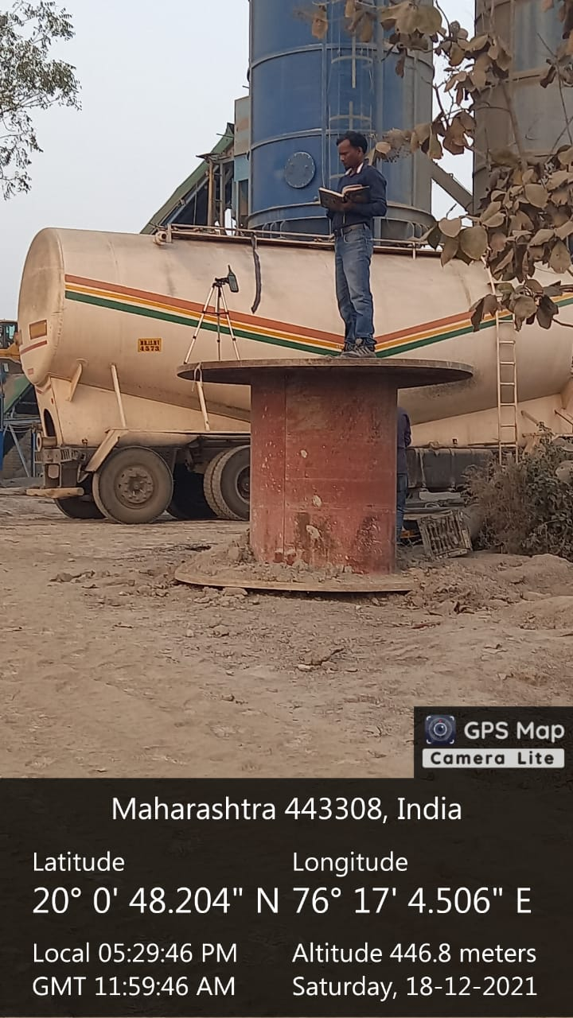
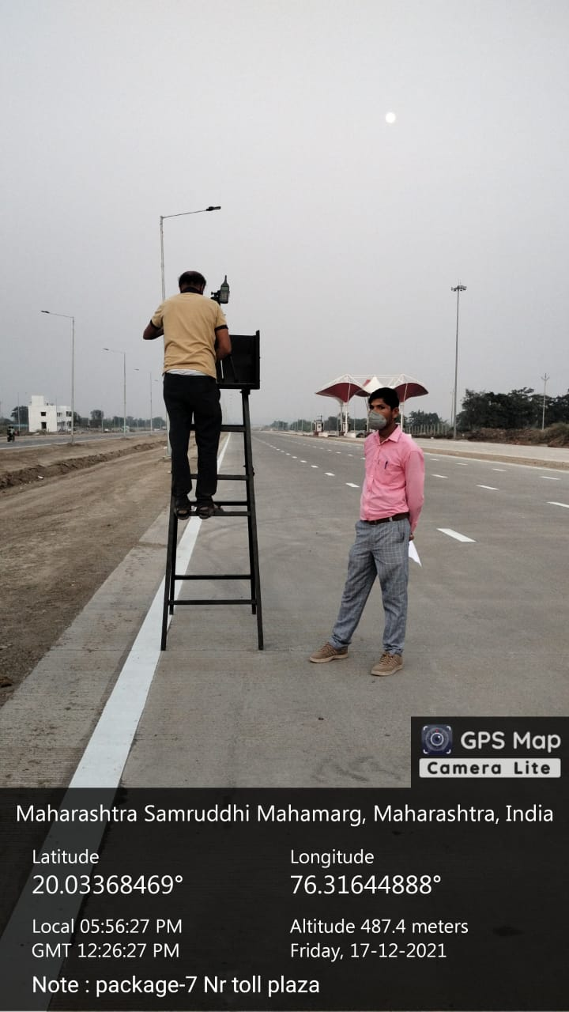

Ambient Noise Monitoring @Km- 316+550 (Baseline)

Ambient Noise Monitoring @ Km 320 + 000 (Base Camp)
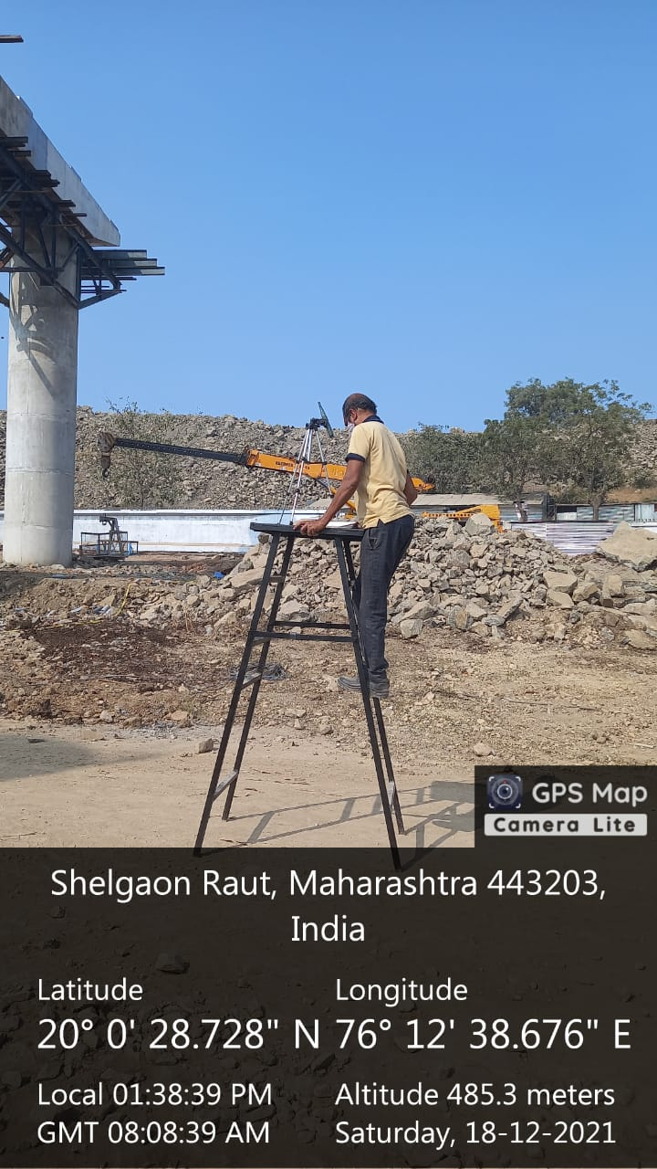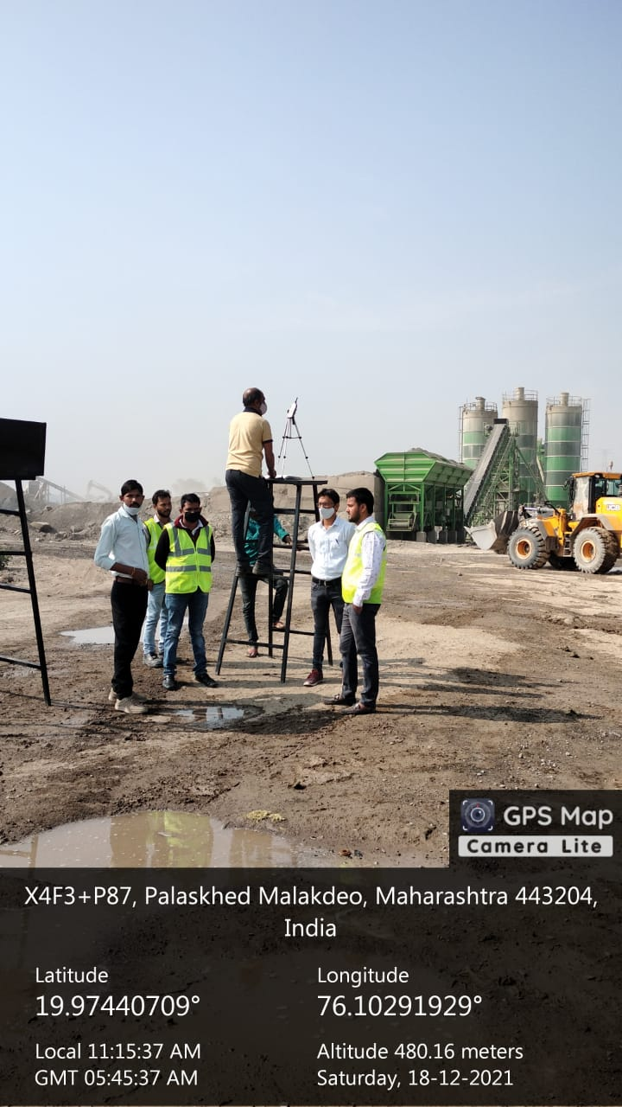
Ambient Noise Monitoring @ Km 328 + 000
Ambient Noise Monitoring @ Km 340 + 000

Solid and Construction and Demolition Waste Details by EPC (Once in Three Months)

SR. NO. | SOLID WASTE |  | CONSTRUCTION AND DEMOLITION WASTE
1. | Quantity of Waste Generated | 13,100 Kg 0.17 to 5.7 Kg per Person/ Day (Approximately) | Quantity of Waste Generated | N/ A
2. | Location of Disposal | Km 320 + 000 within Base Camp Location but at the Edge of Boundary Wall Which is Far Away from Dwelling Units | Location of Disposal | N/ A
3. | Characteristics of Waste  (% Degradable, % Non – Degradable) | 100% Degradable | Characteristics of Waste | N/ A
4. | Technology Used for Disposal | Composting | Technology Used for Disposal | N/ A

